Effect of Reduced Joint Strength and Semi-Rigid Joints on Cold-Formed Steel Portal Frames
Colin Jacksonª, Andrzej M. Wrzesien^{b}, Ross P. Johnstonª, Asraf Uzzaman^{c}, James B.P. Limª
^{e} SPACE, Queen’s University, Belfast, UK
^{b} Department of Civil and Environmental Engineering, University of Strathclyde, Glasgow, UK
^{c} Department of Mechanical and Aerospace Engineering, University of Strathclyde, Glasgow, UK
Abstract: This paper considers the effect of semi-rigid joints and finite connection length on the design of cold-formed steel portal frames sized using a rigid joint and full joint strength assumption, and whether it can offset the fact that the joints cannot sustain the full moment capacity of the sections. The paper shows that for frames of modest span (around 10 m), sized using a rigid joint and full joint strength assumption, that the frames are unsafe under gravity load and do not satisfy the ultimate limit state. Designers should therefore take the semi-rigidity and partial strength of the joints when analysing such frames, particularly when stressed skin action is also used in the design.

INTRODUCTION

Cold-formed steel portal frames (see Fig. 1) can be a viable alternative to conventional hot-rolled steel portal frames for low rise commercial, light industrial and agricultural buildings of modest span (around 10 m) . Whilst it is well-known that the eaves and apex joints of such frames possess a reduced moment capacity (compared to that of the channel-sections) and that the joints are semi-rigid and have a finite connection-length , these effects are seldom taken into account by practicing engineers. They argue that the beneficial effects of redistribution of forces in the frame (owing to joint flexibility) and stressed-skin action (which is often ignored in design) offset the need to take such joint effects into account in frame analysis. Thus cold-formed steel portal frames, in practice, are often designed and analysed on the basis of a rigid joint and full joint strength assumption, with zero connection-length.

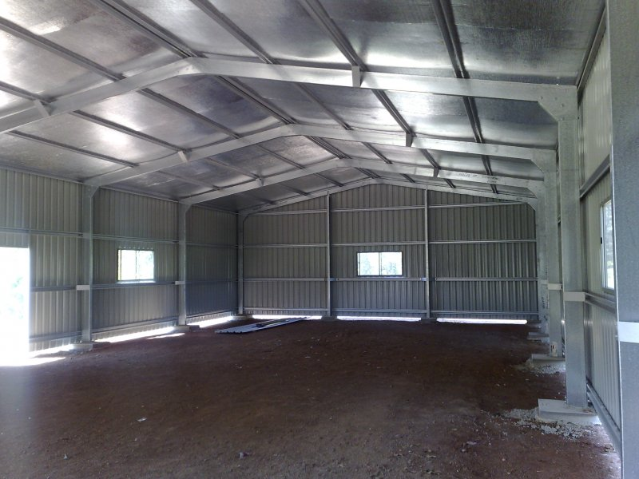
Fig. 1: Cold-formed steel portal frame

Recent research using modern roof panels has demonstrated that stressed-skin diaphragm action (see Fig. 2a and for details of stressed-skin diaphragm action) can indeed help reduce (or virtually eliminate) frame deflections owing to wind in the horizontal transverse direction for cold-formed steel portal frames . However, for load acting in the vertical / gravity direction (see Fig. 2b) (which in the UK would be considered as being snow load), whilst stressed-skin diaphragm action does indeed have an effect when the roof pitch is steep, for flat roofs it has virtually no effect. With the trend of modern roofs becoming flatter, there is therefore the risk that cold-formed steel portal frames in the UK could be unsafe, in some cases, under snow load, when sized assuming that stressed-skin diaphragm action takes into account the transverse wind load.
This paper considers the reduction in load carrying capacity of portal frames as a result of the joint effects described above, and its effect on both ultimate as well as serviceability limit states. Four frames are considered with spans of 5 m and 10 m and heights of 3 m and 6 m. The frames are designed and the members sized using a full joint strength and rigid joint assumption, to satisfy both ultimate as well as serviceability limit states. The joint details are adopted from joints currently used in industry in which bolt-group length is usually equal to sections depth. The section sizes are then checked under only the vertical / gravity load case, with the joint effects taken into account.

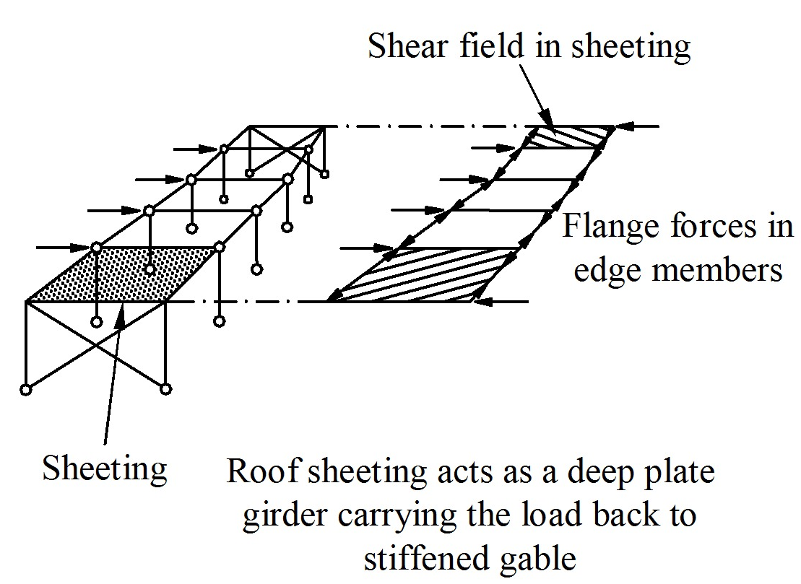 | 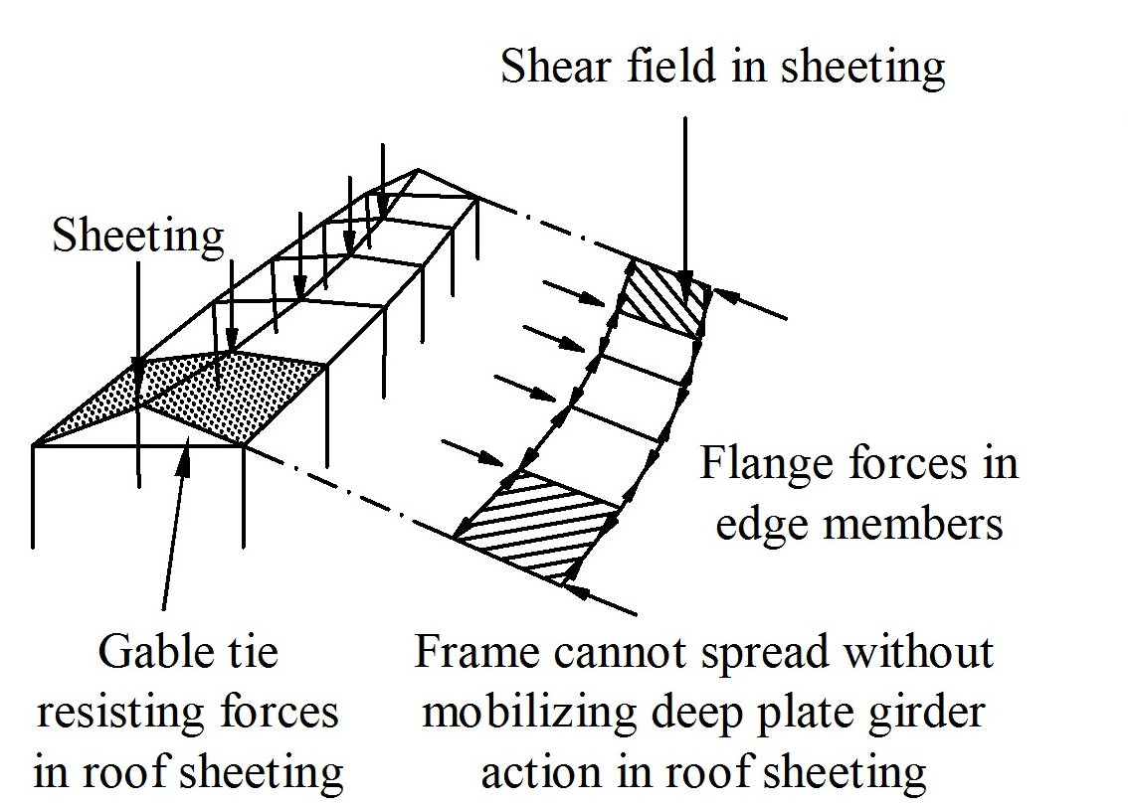
a) Transverse wind load | b) Vertical / gravity load
Fig. 2: Stressed skin action in a portal frame

serviceability limite state deflections

Serviceability limit state deflections for portal frames are not specified in the British Standards (and other national standards), and the decision as to whether or not a portal frame satisfies serviceability deflections is left to the judgement of the engineer. A typical explanation for this specific exclusion of deflection limits for portal frames is that deflections of portal frames have no direct significance on the serviceability of the frame itself. Although this explanation is technically correct, excessive deflections will affect, among other things, the serviceability of the cladding, water tightness and the visual acceptability of the building in general.
Discussions by the authors with Building Control Engineers and practicing engineers in Northern Ireland have identified a set of deflection limits that are generally acceptable. These deflection limits and the parameters used for the frame are defined in Table 1.

Table 1: Serviceability deflection criteria
 | Absolute  deflection | Differential deflection  relative to  adjacent frame
Lateral deflection at eaves | ≤ h_{f} /100 | ≤ h_{f} /150
Vertical deflection at apex | - | L_{f} / 200

design loads

Dead and live loads

The dead and live loads applied to the frame are as follows:
Dead load due to the self-weight of the cladding (DL) 0.18 kN/m²
Live load due to snow (LL) 0.60 kN/m²

Load combinations

In accordance with BS5950: Part 1, the frames are sized at the ultimate limit state for the following ultimate limit state load combination:
Load combination ULC1 = 1.4DL + 1.6LL
The frames are also checked to ensure that the serviceability limit state is satisfied for the following two serviceability load combinations:
Load combination SLC1 = 1.0DL + 1.0LL (used for absolute deflection in Table 1)
Load combination SLC2 = 1.0LL (used for differential deflection in Table 1)

Joint effects

Description of joint

Fig. 3 shows details of typical eaves and apex joints. As can be seen, the joints are formed through brackets, bolted to the channel sections used for the column and rafter members.

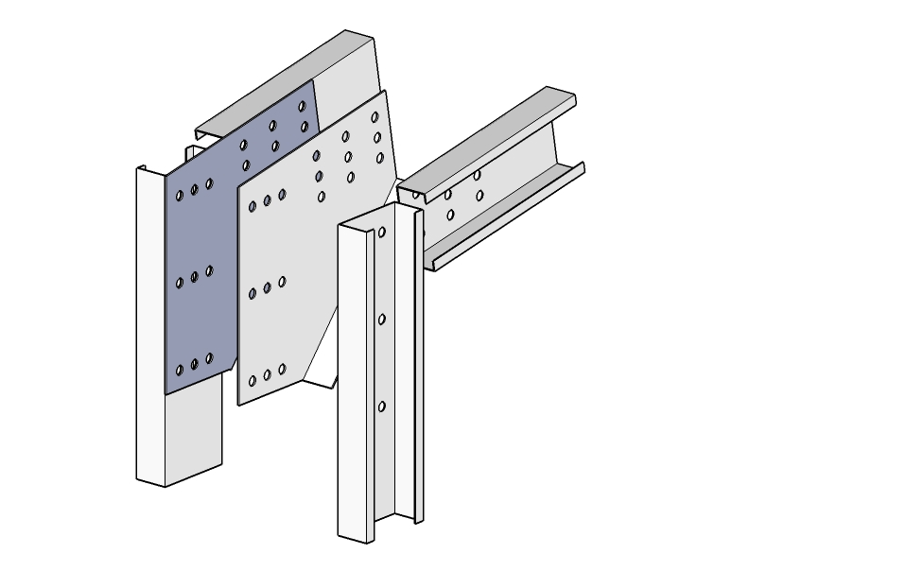 | 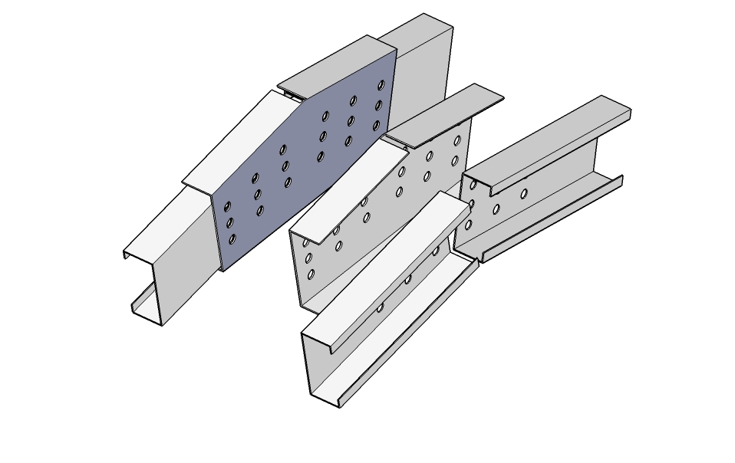
a) Eaves joint | b) Apex joint
Fig. 3: Portal frame joints
It should be noted that the length of the bolt-group for the column to the bracket joint was assumed as twice the depth of the channel section. The connections at the eaves and the apex rafter use a bolt array of the length a_{B} equal to the depth of the channel section following industry practise. All the connections use the 3x3 bolt array and M16 Grade 8.8 bolts with fully threaded bolt shank.

Reduced strength of joint

As described in , if the length of the bolt-group (a_{B}) is short (see Fig. 4), compared with the depth of the section, the channel-section will fail through premature web buckling; this mode of failure is shown in Fig. 5. This mode of failure can be taken into account using method presented in and described in Fig. 4. The forces in the member are calculated base on elastic joint design principle and static equilibrium. The channel section is therefore examined based on combine effect of bending and transverse force at the critical cross section (right-hand side of the cross section 1). Based on findings presented in the strength of each joint is examined based on standard interaction equation between bending and web crippling and steel plate bearing capacity as shown in Fig. 4. The assumption was also made that members are restrained against lateral-torsional buckling in such frequency that only local capacity check need to be considered.

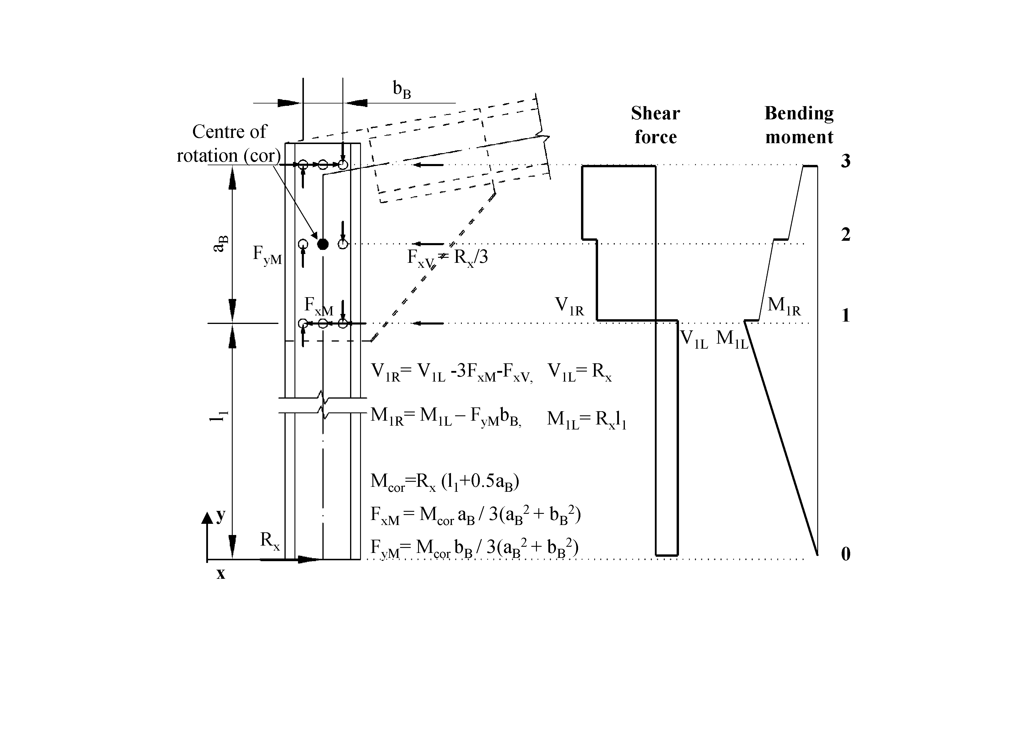 | Member capacity:  F_{c}/P_{cs} + M/M_{c} ≤ 1  Joint capacity:  F_{rb}/P_{bs} ≤ 1 ,  F_{w}/P_{w} ≤ 1 where F_{w}=V_{1R} ,  M/M_{c}≤ 1 where M=M_{1R} ,  1.1 F_{w}/P_{w}+ M/M_{c} ≤1.5 | (1)  (2)  (3)  (4)  (5)
Fig. 4: Analytical prediction of design capacities

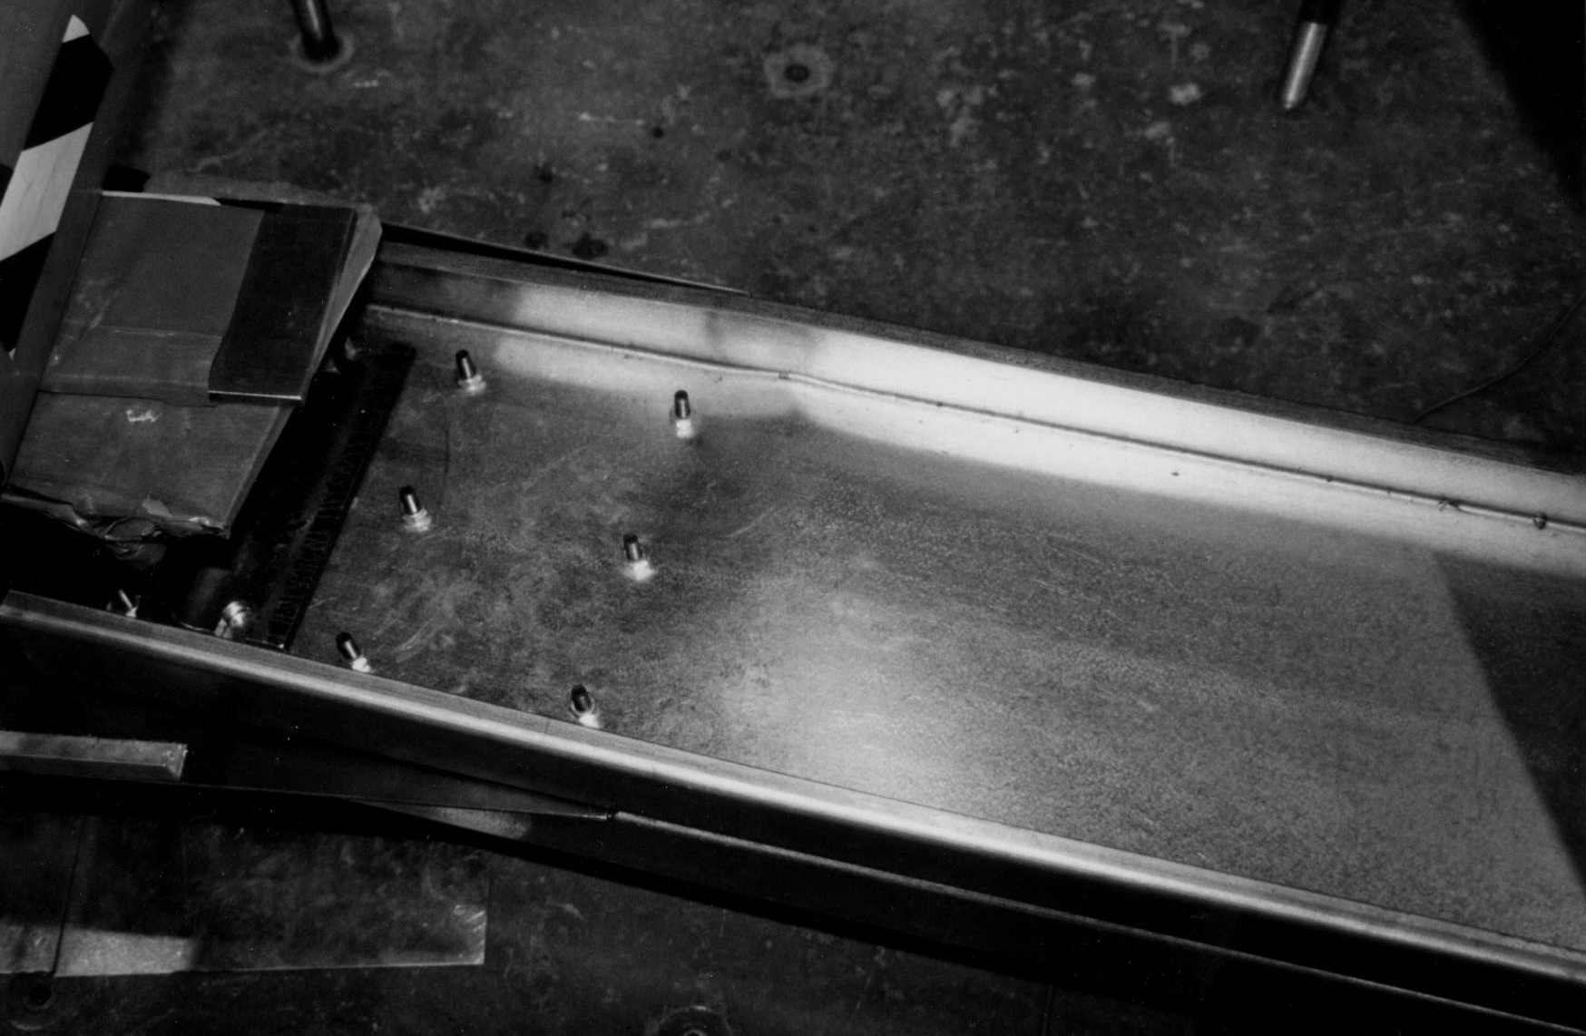 | 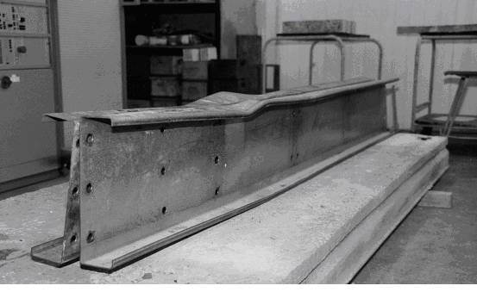
a) Typical joint test under pure bending | b) Typical failure of joint
Fig. 5: Photograph of channel sections before and after failure in pure bending test

Semi-rigidity of joint

The semi-rigidity of the joints is attributed to bearing of the bolt holes around the bolt shank. From the bolt-hole elongation stiffness , the rotational stiffness of the connection can be determined, as described in Fig. 6

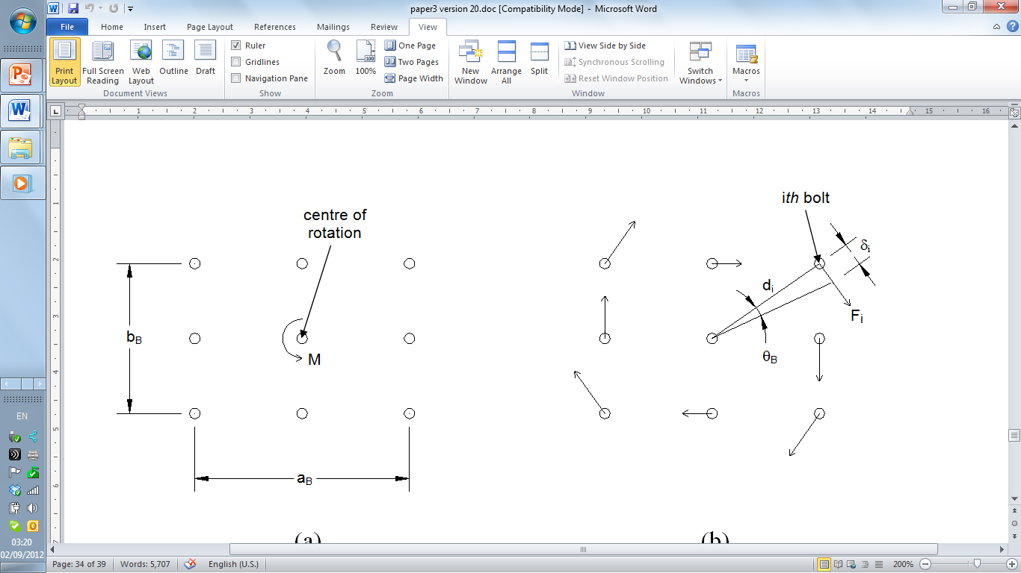 | δ/F =15 (10/t₁ + 10/t₂ - 2) 10⁻³ (mm/kN)  (6)  k=3/2 (a_{B}²+b_{B}²) F/δ  (7)
Fig. 6: Rotation of the bolt-group around centre of rotation

parametric study

Details of frames

Four frames of modest span are considered having different spans and heights: 5 m x 3 m, 5 m x 6 m, 10 m x 3 m and 10 m x 6 m. The section sizes for the column and rafter members of the frames are designed to satisfy the ultimate and serviceability limit state load combinations. For each frame, the back-to-back channel-sections used for the column and rafter members of each frame are selected from a database of 20 channel-sections available in the UK. Table 2 shows the back-to-back channel sections used for each frame. Table 3 shows the properties and dimensions of the channel sections.

Table 2: Cold-formed steel sections used for the column and rafter
L_{f} x h_{f} | Column | Rafter
5 x 3 | BBC15014 | BBC15014
5 x 6 | BBC15016 | BBC15016
10 x 3 | BBC25025 | BBC25025
10 x 6 | BBC25025 | BBC25025

Table 3: Channel-section properties and dimensions
Section | M_{c}  (kNm) | P_{cs}  (kN) | Mass  (kg/m) | D  (mm) | B  (mm) | t  (mm) | EI  (kNmm²) | EA  (kN)
C15014 | 6.49 | 106.22 | 3.29 | 152.00 | 64.00 | 1.40 | 3.14E+08 | 85895
C15016 | 7.91 | 132.64 | 3.76 | 152.00 | 64.00 | 1.60 | 3.57E+08 | 98195
C25025 | 27.03 | 273.32 | 8.21 | 254.00 | 76.00 | 2.50 | 2.01E+09 | 214430
*Values given are for single lipped channel section, for back-to-back sections multiply values by factor of 2.

Details of semi-rigidity of joints of partial strength and finite connection length

Table 4 shows details of the rotational stiffness, partial strength and finite connection lengths of the back-to-back channel sections at each connection. The frames are analysed using a beam idealisation, taking into account the rotational stiffness and effective connection length. Fig. 7 shows the beam idealisation of the eaves joint. Further details of the beam idealisation model can be found in .

Table 4: Rotational stiffness of channel-sections
Section | k_{ec}  (kNm  /rad) | k_{er}  (kNm  /rad) | k_{ar}  (kNm  /rad) | a_{B,ec}xb_{B,ec}  (mm) | a_{B,er}xb_{B,er}  (mm) | a_{B,ar}xb_{B,ar}  (mm) | l’_{ec}  (mm) | l’_{er}  (mm) | l’_{ar}  (mm)
BBC15014 | 1137 | 341 | 341 | 300x80 | 150x80 | 150x80 | 121 | 196 | 123
BBC15016 | 1271 | 381 | 381 | 300x80 | 150x80 | 150x80 | 121 | 196 | 123
BBC25025 | 5295 | 1779 | 1779 | 500x180 | 250x180 | 250x180 | 178 | 303 | 182

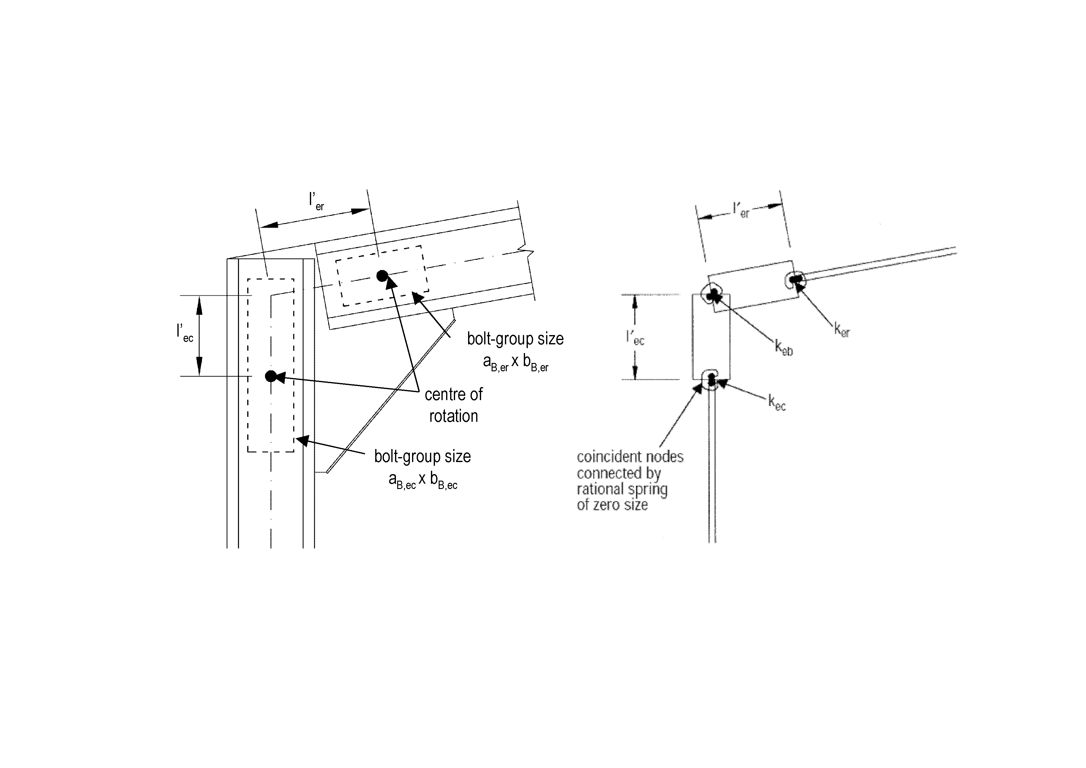
Fig. 7: Beam idealisation of eaves joint

parametric study

Unity factors

Table 5 shows the unity factors for the frames calculated using a rigid and full joint strength assumption and that with the semi-rigid and partial-strength assumption. As can be seen, the rigid and full joint strength assumption passes both ULS as well as SLS checks. However, when the semi-rigidity and partial strength of the connections are taken into account three out of four frames fail ULS check and all of them fail SLS checks.

Table 5: Unity factors of frames for rigid joint and full joint strength
L_{f} x h_{f} | Rigid and full-strength |  | Semi-rigid and partial strength |  | ULS_{S} /ULS_{R} | SLS_{S} /SLS_{R}
L_{f} x h_{f} | ULS_{R} | SLS_{R} | ULS_{S} | SLS_{S} | ULS_{S} /ULS_{R} | SLS_{S} /SLS_{R}
5 x 3 | 0.92 | 0.73 | 1.45 | 1.28 | 1.57 | 1.77
5 x 6 | 0.88 | 0.89 | 1.18 | 1.52 | 1.34 | 1.71
10 x 3 | 0.97 | 0.61 | 0.90 | 1.05 | 0.92 | 1.73
10 x 6 | 0.89 | 0.91 | 1.14 | 1.45 | 1.29 | 1.60

7 Conclusions

The main conclusions are:
- It has been shown that frames designed with the assumption of rigid joints and full joint strength to satisfy the gravity load case can potentially be unsafe by as much as 60%. Three out of four frames failed at the apex joint where bending moment has dominant effect.
- Such frames will only arise if wind load cases are eliminated (owing to stressed-skin action). The wind load however will be transfer to the gable frame thus combination of load need to be checked so the strength of the gable frame is not compromised.
- Designers should take into account the semi-rigidity and partial strength of the joints in frame analysis.

Notation

a_{B} | Length of bolt group
b_{B} | Depth of bolt group
B | Width of flange of channel section
D | Depth of channel section
EI | Axial rigidity of column and rafter members
EA | Flexural rigidity of column and rafter members
F_{c} | Applied axial load
F_{rb} | Resultant force in critical bolt
F_{w} | Concentrated web load
h_{f} | Height of frame
k | Rotational stiffness of bolt-group
k_{ec} | Rotational stiffness of column to eaves connection
k_{er} | Rotational stiffness of rafter to eaves connection
k_{ar} | Rotational stiffness of rafter to apex connection
L_{f} | Span of frame
l’_{ar} | Effective length of bracket pertaining to rafter to apex connection (see Fig 7)
l’_{ec} | Effective length of bracket pertaining to column to eaves connection (see Fig 7)
l’_{er} | Effective length of bracket pertaining to rafter to eaves connection (see Fig 7)
M | Applied bending moment
M_{c} | Moment capacity of member
M_{1R} | Applied bending moment at the right-hand side of the cross section 1
P_{bs} | Bearing capacity of connected plate
P_{w} | Concentrated load resistance
s_{f} | Length of rafter
t | Thickness of cold-formed steel channel-section
t₁ | Thickness of first connected plate
t₂ | Thickness of second connected plate
V_{1R} | Applied shear force at the right-hand side of the cross section 1

References

[1] A. H. Baigent and G. J. Hancock, "The behaviour of portal frames composed of cold-formed members," University of Sydney, School of Civil Engineering, Sydney1978.
[2] P. Kirk, "Design of a cold formed section portal frame building system," in 8th International Specialty Conference on Cold-Formed Steel Structures, St. Louis, Missouri, USA, 1986, pp. 295-310.
[3] D. Dubina, et al., "Monotonic and cyclic performance of joints of cold formed steel portal frames," in 4th International Conference on Thin-walled structures, Loughborough, UK, 2004, pp. 381-388.
[4] M. Dundu and A. R. Kemp, "Strength requirements of single cold-formed channels connected back-to-back," Journal of Constructional Steel Research, vol. 62, pp. 250-261, 2006.
[5] W. K. Yu, et al., "Analysis of bolted moment connections in cold-formed steel beam–column sub-frames," Journal of Constructional Steel Research, vol. 61, pp. 1332-1352, 2005.
[6] J. B. P. Lim and D. A. Nethercot, "Ultimate strength of bolted moment-connections between cold-formed steel members," Thin Walled Structures, vol. 41, pp. 1019-1039, 2003.
[7] J. B. P. Lim and D. A. Nethercot, "Design and development of a general cold-formed steel portal framing system," The Structural Engineer, vol. 80, pp. 31-40, 5 November 2002 2002.
[8] J. M. Davies and E. R. Bryan, Manual of stressed skin diaphragm design. London: Granada, 1982.
[9] BS 5950-9, "Structural use of steelwork in building - Part 9: Code of practice for stressed skin design," ed London: British Standards Institution, 1994.
[10] ECCS, European recommendations for the application of metal sheeting acting as a diaphragm. Brussels: European Convention for Constructional Steelwork, 1995.
[11] A. M. Wrzesien, et al., "The ultimate strength and stiffness of modern roof systems with hat-shaped purlins," in Sixth International Conference on Advances in Steel Structures Hong Kong, China, 2009, pp. 480-487.
[12] A. M. Wrzesien, et al., "Stressed skin effects on cold-formed steel portal frames with semi-rigid joints," in The 2012 Borneo Engineering Symposium on Cold-formed Steel Innovations, Kuching, Malaysia, 2012, pp. 12-43.
[13] D. Dubina, et al., "Ultimate design capacity of pitch-roof portal frames made by thin-walled cold-formed members.," in Fifth International Conference on Thin-Walled Structures. Recent Innovations and Developments., Brisbane, Australia, 2008, pp. 387-394.
[14] BS 5950-5, "Structural use of steelwork in building - Part 5: Code of practice for design of cold formed thin gauge sections," ed London: British Standards Institution, 1998.
[15] F. Zadanfarrokh and E. R. Bryan, "Testing and design of bolted connections in cold-formed steel sections.," in 11th International Specialty Conference on Cold-Formed Steel Structures, St. Louis, Missouri, USA, 1992, pp. 625-662.

