The strength of plants: theory and experimental methods to measure the mechanical properties of stems
Darshil U Shah¹, Thomas PS Reynolds^{1,2}, and Michael H Ramage¹
¹Department of Architecture, University of Cambridge, 1-5 Scroope Terrace, Cambridge CB2 1PX, UK
²Present address: School of Engineering, University of Edinburgh, 1.22 William Rankine Building, Edinburgh EH93JL, UK
Contact details: DUS - dus20@cam.ac.uk, darshil.shah@hotmail.co.uk, +44-1223760124;
TPSR – t.reynolds@ed.ac.uk; MHR - mhr29@cam.ac.uk

Highlight
Reliable mechanical testing methods are essential to plant science research today. We review how to test plant stems and what we can learn from such tests.

Abstract
From the stems of agricultural crops to the structural trunks of trees, studying the mechanical behaviour of plant stems is critical for both commerce and science. Plant scientists are also increasingly relying on mechanical test data for plant phenotyping. Yet there are neither standardised methods nor systematic reviews of current methods for the testing of herbaceous stems. We discuss the architecture of plant stems and highlight important micro- and macro-structural parameters that need to be controlled and accounted for when designing test methodologies, or that need to be understood to explain observed mechanical behaviour. Then, we critically evaluate various methods to test structural properties of stems, including flexural-bending (two-, three- and four-point bending) and axial-loading (tensile, compressive and buckling) tests. Recommendations are made on best practices. This review is relevant to fundamental studies exploring plant biomechanics, mechanical phenotyping of plants, and the determinants of mechanical properties in cell walls, as well as to application-focussed studies, such as in agro-breeding and forest-management projects, aiming to understand deformation processes of stem structures. The methods explored here can also be extended to other elongated, rod-shaped organs (e.g. petioles, midribs and even roots).
Keywords: bending; biomechanics; cell wall; metrology; phenotyping; stem; stiffness; strength; structure-property relations; tensile properties

Introduction
A recent special issue on ‘Plant Biomechanics and Mechanobiology’ in The Journal of Experimental Botany (Raines and et.al., 2013) conveyed that there is increasing interest amongst biologists to examine the effects of mechanical forces on biological systems, including those from the phylum Plantae. In living plants, the multi-scale interplay of growth, morphology, and external (viz. biotic and abiotic interactions) and internal mechanics continues to fascinate scientists. Improvements in the field of mechanical metrology (i.e. science of mechanical measurement), particularly at smaller length-scales (e.g. cell wall and down to macro-molecules), now enable closer inspection of plant development from a biomechanics perspective, including in an evolutionary and materials science framework (viz. structure-property-function relations) (Raines and et.al., 2013, Spatz et al., 1997, Niklas, 1992, Spatz et al., 1998, Gibson, 2005, Smith, 1950, Fournier et al., 2013). Mechanical characterisation is also an important and now frequently used tool for phenotyping of plants, in the wider quest of crop improvement, as well as basic plant research (Pieruschka and Lawson, 2015). The inherent mechanical properties of the plant cell wall and stem are relevant to agro-breeding studies (Robertson et al., 2015, Kokubo et al., 1989) aiming to tackle issues such as crop-loss due to lodging by up-rooting or stem breakage (Skubisz, 2002, Crook and Ennos, 1996). This even applies to larger tree trunks, which are susceptible to damage from wind-loads (e.g. wind-throw and wind-snap), a major cause of concern in forest management (Hale et al., 2012). With regards to harvest and processing of plant stems and their derivatives for eventual use as materials, knowledge of the bulk deformation behaviour of the stem and its interaction with machines (due to mechanical loads exerted by the latter) is critical in process optimisation and yield efficiency (Leblicq et al., 2015). In this context, the force-response of stems not only has economic implications, but may also provide insights into the evolution of land plants, as force-response must be a driver in natural selection (Smith, 1950, Rowe and Speck, 2005). Reliable testing of plant stem structures is critical for both commerce and scientific research.
However, the result (and accuracy) of a mechanical measurement is only as good as the quality of the measurement method. It is noteworthy that conventional measurement tools and engineering concepts are not always entirely applicable to testing biological systems, including plant stem structures, without modification, given the complexities in external and internal morphologies of the stem (e.g. irregular cross-sections, presence of nodes and branches), conditions during testing (e.g. turgor pressure, moisture content), as well as response (e.g. anisotropic, non-linear, time-dependent mechanical behaviour). These specifications become particularly important when comparing results between studies and more-so between studies from different research groups. Some form of standardised practices and accepted methods would help in ensuring reliability and repeatability of measurements.
A number of diverse materials are derived from plant stems: fibres, yarns, paper and textiles, reinforced polymer composites, as well as wood and wood products. There are established standards (primarily international, American ASTM, and European EN), if not well-accepted methods, for testing micro-scale elementary fibres and fibre bundles extracted from the plants e.g. (ISO, 1995, 1974), processed textile yarns and fabrics e.g.(ISO, 1988, 1989, 2013, ASTM, 2013), and macro-scale plant-based materials, such as wood products and fibre reinforced polymer composites e.g. (ASTM, 2012, ISO, 2003, 2015). In contrast, despite there being numerous studies in plant science literature on the mechanical testing of whole, herbaceous plant stems, there are no standardised testing methods, with the exception of those for tree stems, known as roundwood (e.g. (BSI, 2005)).
Here, we critically review the literature to evaluate mechanical testing methods for plant stem structures. We highlight important factors based on stem morphologies and other structural properties that require consideration when designing tests for plant stems. We then describe best practise from our own experience and that of others. Furthermore, we envisage that these discussions may also extend as useful guidance for the mechanical inspection of any elongated, rod-shaped plant organ, such as petioles, mid-ribs and roots.
Box 1 and Fig. 1-2 describe and define key mechanical engineering terms that will be used throughout this review. These lists are not exhaustive, and the readers are referred to The Journal of Experimental Botany’s special issue (Raines et.al., 2013) and (Moulia, 2013) for a more comprehensive list.
Box 1. Key terms from the fields of structural engineering and materials science
Loading Forces in a material may act to extend the material in the direction of the force - denoted tension - or to shrink the material in the direction of the force - denoted compression. A shear force causes sliding of parallel planes in the material relative to one another. When a structural element is subjected to bending forces, this induces tension at one extreme of the cross-section, compression at the other, and a variation between the two throughout the cross-section. This variation in stresses requires shear in the cross-section as well. A stem in bending may therefore fail either in tension, compression or shear. Table 1 summarises the tests methods used to apply these forces, and the properties they can be used to estimate.
Elasticity The theory of elasticity describes how materials deform under the application of forces, and is founded on the work of Hooke (1678). The force per unit initial area in a material is denoted engineering stress, and engineering strain is its extension per unit original length. While true stress is determined based on the true, deformed cross-section area at that load (rather than on the initial, undeformed cross-section area), we principally refer to the engineering stress as ‘stress’, and engineering strain as ‘strain’. Stiffness is the ratio of force to displacement, and is a property of a structure, with stiffer structures deflecting less for a given load. The stiffness of a structure is affected by the material properties and the geometry of the structure. In experimental work, we commonly use the stiffness measured in a test to estimate the elastic modulus, a property of the material being tested, as shown in Figure 1. The elastic modulus, or Young’s modulus, is the ratio of the stress applied to a material to the linear strain it exhibits. Stems are made from a combination of materials formed into cells, and a combination of different cell types combined into tissues. The elastic modulus of the stem material, therefore, reflects the combination of properties contributed by the different materials. Methods for using the properties of individual components to describe the behaviour of the whole stem are discussed in Sections 2.1.1 and 2.1.2. The inverse of stiffness is compliance.
Failure The failure of a material may be either by yield or fracture. At yield, a stress is reached in the material at which its stiffness greatly reduces, so it deforms substantially for a small increase in stress. In fracture, a crack, beginning at a flaw in the material, grows until it prevents the material from carrying load. A system which exhibits large deformations is referred to as a mechanism rather than a structure. Once part of the stem yields or fractures, it may form a mechanism causing the stem to collapse, known as a failure mechanism. Stems have evolved strategies to avoid particular failure mechanisms, as described throughout Section 2. Strength is the maximum total stress a material can withstand before failure. Because bending tests are such a common way of estimating structural properties, there is a specific term for the strength measured in this test. The Modulus of Rupture is, therefore, the estimated peak stress for a stem at failure, as measured using a bending test such as three-point bending.
Buckling When a compressive force is applied to a slender structure such as a plant stem, it does not fail by pure crushing of the material. Before the force necessary for pure crushing is reached, any lack-of-straightness (however small) will cause an initially straight stem to bend. The bending deformation increases the bending forces on the stem, and eventually the stem will become unstable, and fail in bending. The force at which this happens is called the buckling load. This process can occur in entire stems, as illustrated in Figure 2, but also in individual cells, if they are sufficiently long and slender. In hollow stems, the Brazier effect (Brazier, 1927) may occur, in which, as it bends, the stem cross-section becomes more oval, reducing its ability to resist bending and further reducing the buckling load. Research into buckling of plant stems is described in Section 2.2.2.
Fibre-reinforced composite Slender fibres can have extremely high strength and stiffness. In compression, however, these fibres alone do not exhibit their full strength because they are susceptible to buckling. If the fibres are instead used as reinforcement in a matrix of material capable of restraining against buckling and suitable to distribute the load around the fibres, then the strength and stiffness of the fibres can be effectively used. Stems may be described as fibre-reinforced composites at two scales. At the cellular scale, the ‘fibres’ may be long slender sclerenchyma with thick cell walls with low microfibril angle, in a ‘matrix’ of shorter, stockier and softer parenchyma. Within the secondary cell wall, cellulose fibril aggregates may be the aligned ’fibres’, in a matrix of other polysaccharides. Often, the matrix has isotropic material properties, while the fibres and the resulting aligned-fibre composite exhibit anisotropy.

Table 1: Mechanical test types typically used on plant stems. Example references are also provided which readers can access to explore methods and protocols.
Test type |  | Properties measured | Examples
Cantilever bend | 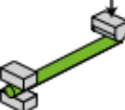 | Bending strength, elastic modulus | (Henry and Thomas, 2002; Caliaro et al., 2013)
Three-point bend | 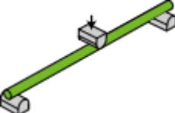 | Bending strength, elastic modulus | (Skubisz, 2001, 2002; Petutschnigg and Katz, 2004; Green et al., 2006; Lim et al., 2011; Christoforo et al., 2012; Ampofo et al., 2013; Slater and Ennos, 2013; Lemloh et al., 2014)
Four-point bend | 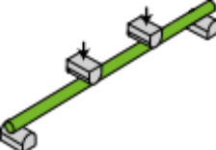 | Bending strength, elastic modulus | (Goubet et al., 2009; Robertson et al., 2015)
Tension |  | Tensile strength, elastic modulus | (Spatz et al., 1998; Ryden et al., 2003; Cavalier et al., 2008; Abasolo et al., 2009)
Buckling |  | Critical buckling load | (Niklas, 1998; Spatz et al., 1998; Frese and Blass, 2014)
Compression |  | Compressive strength, elastic modulus | (Niklas, 1998; Wright et al., 2005; Frese and Blass, 2014)
Short-beam shear and torsion | 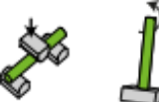 | Shear strength, shear modulus | (Vogel, 1992, 1995; Niklas, 1997a; Spatz et al., 1997; Skubisz, 2001; Goodman et al., 2002)

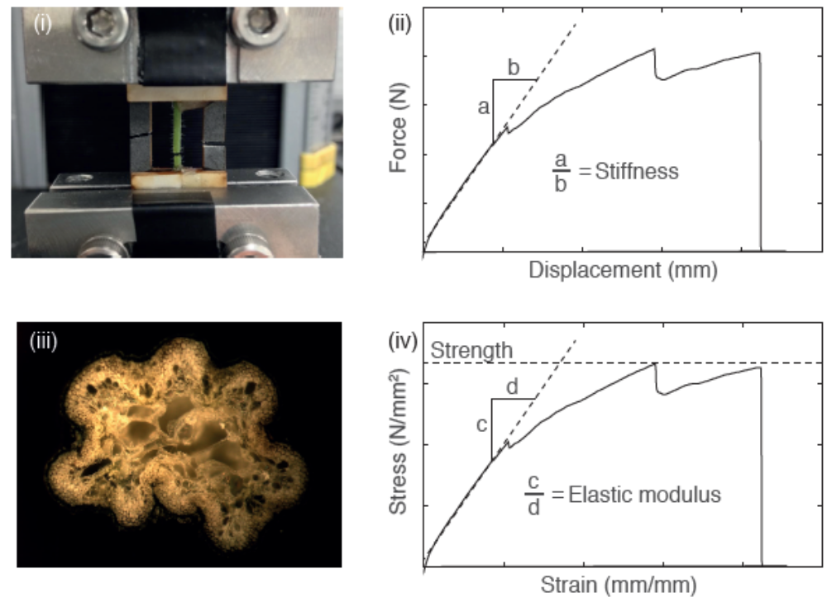
Figure 1: Tensile testing a scenesced, dry stem of Arabidopsis thaliana: force and displacement are measured during the test (i), from which stiffness of the structure can be calculated (ii). Measurement of the cross-sectional area (iii), in this case by microscopy post-testing, allows the force to be converted to stress, and the material strength and elastic modulus to be calculated (iv).
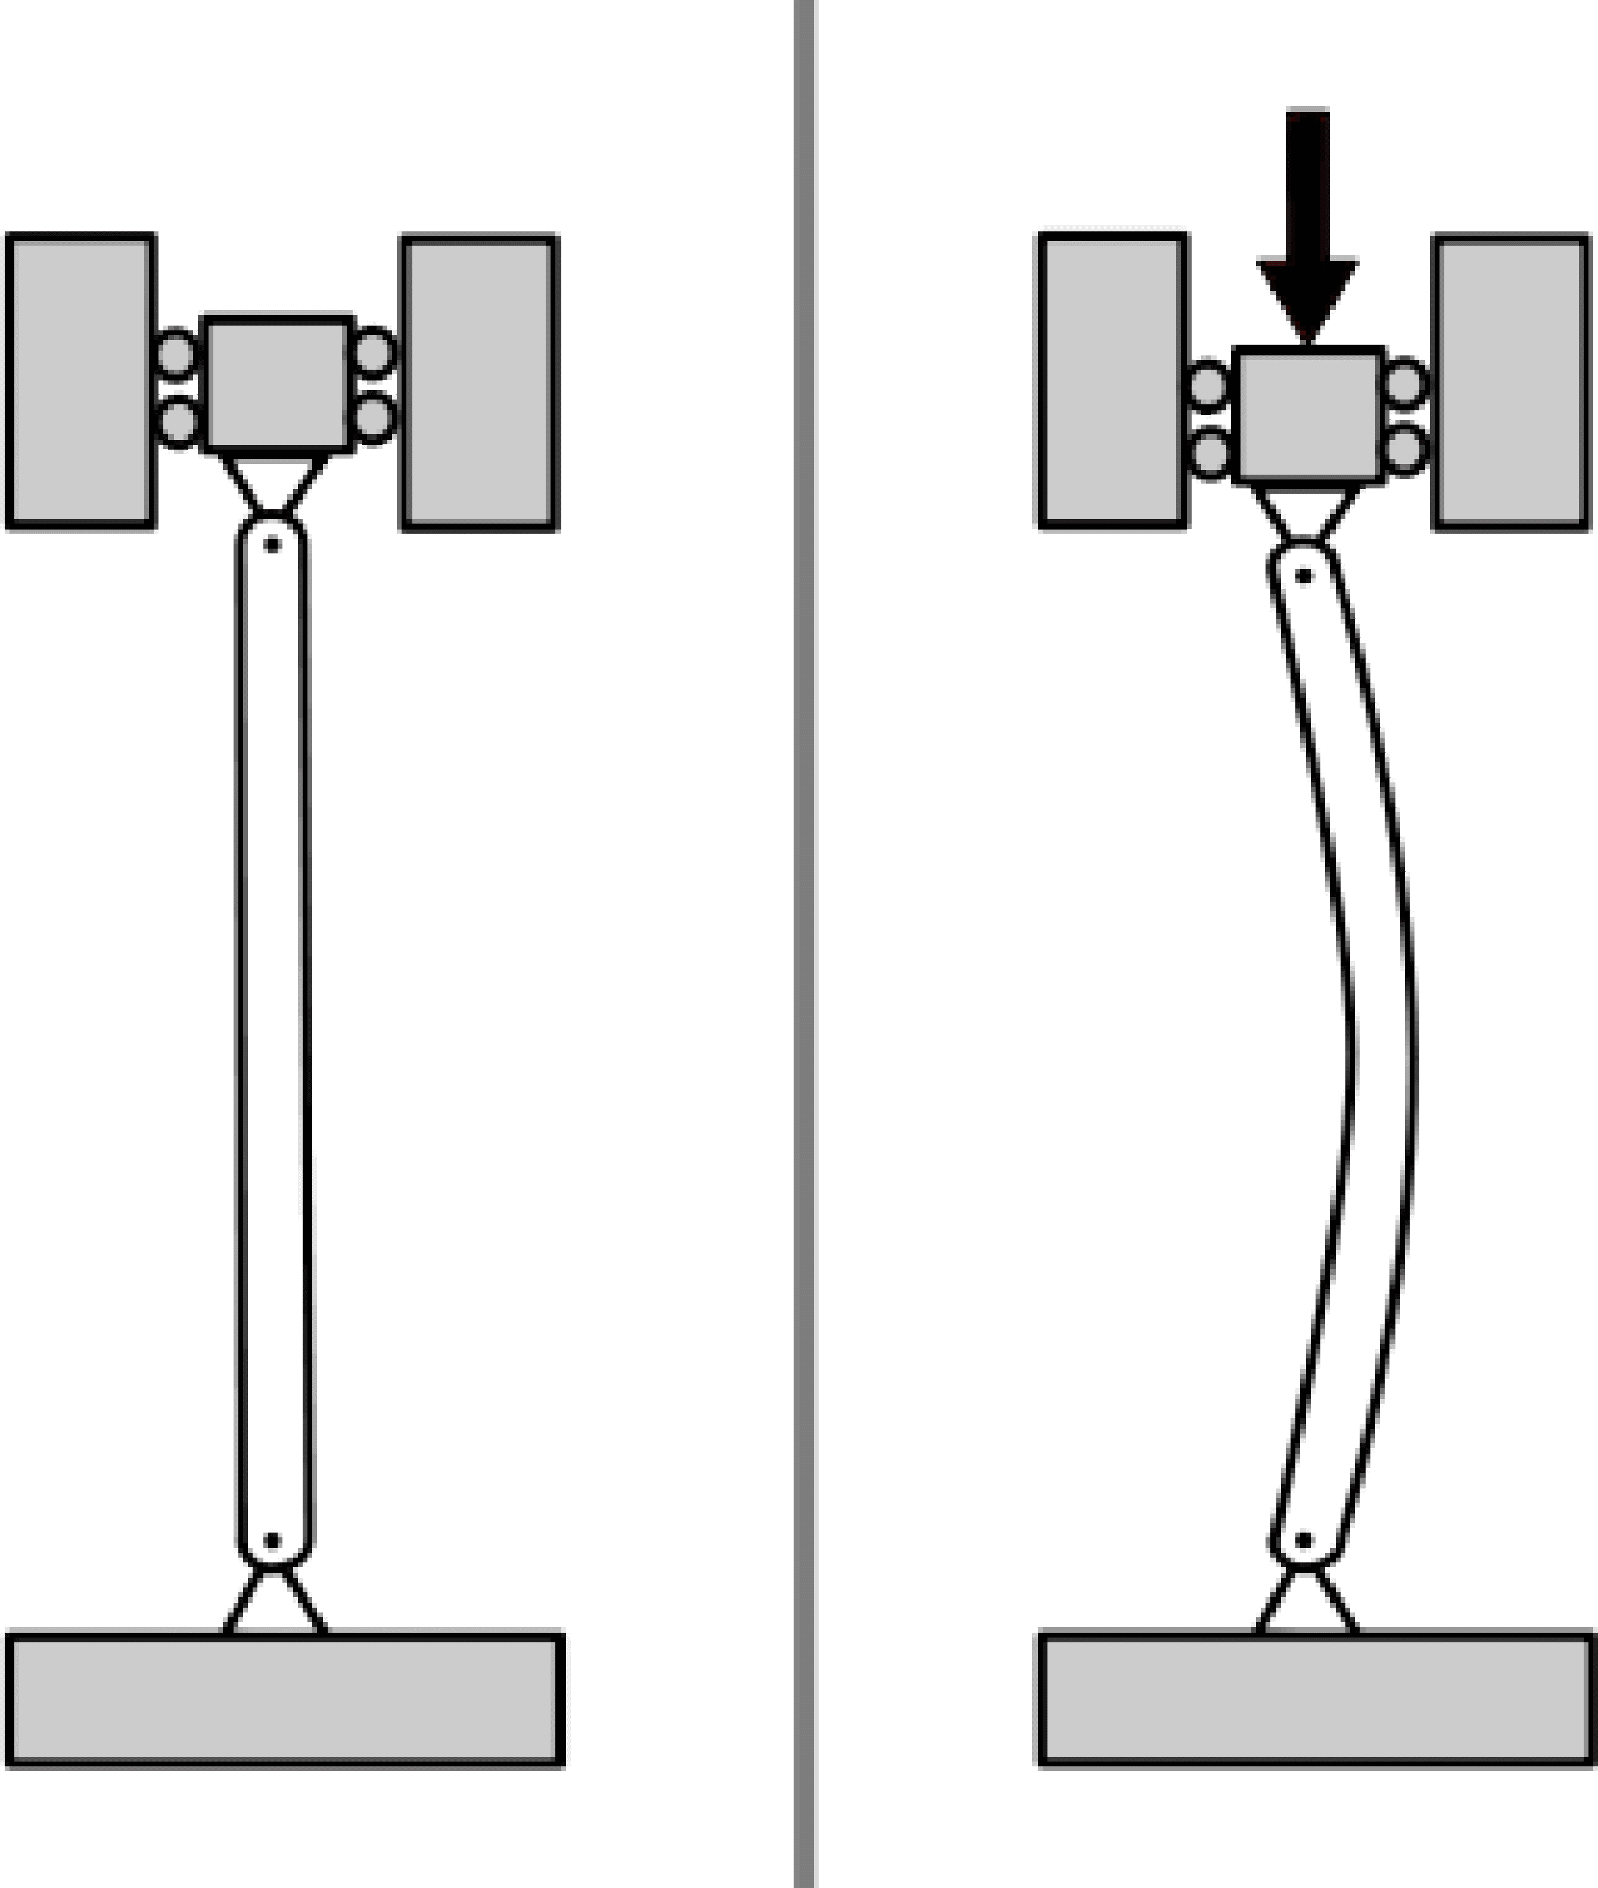
Figure 2: An initially straight slender member, such as a stem, bends under vertical load, a process known as buckling - the direction in which it bends depends on the initial lack-of-straightness of the member

Stem architecture and its relation to mechanical properties
Many of the stem mechanics-governing factors are based on the stem architecture, which manifest at both the microstructure and the macrostucture scales. These factors need to be accounted for when designing testing methodologies, and understood to explain observed mechanical behaviour. In addition, knowledge of the stem structural hierarchy may be useful in inferring material properties (at the tissue and cell wall level) from measured properties of the stem structure.

Microstructure: at the tissue- and cell-level
Stems and roots are the two main structural axes of all vascular plants: a group which includes gymnosperms, angiosperms and ferns. Ferns typically lack vertical, over-ground stems. All gymnosperm stems are woody, and they tend to form near-cylindrical, solid stems. Angiosperms can be further categorised as i) herbaceous monocots including grasses like bamboo, ii) herbaceous dicots such as flax and the model plant Arabidopsis thaliana, and iii) woody dicots including trees (Table 2). Angiosperms display a wide variety of strategies for structural resistance, both in the arrangement of stiffer and more flexible cells, and in their global geometry, as depicted by the schematics in (Table 2. While upward, primary growth, mediated by the shoot (apical meristem), is common for vascular plants, dicots also have the ability of secondary growth, which means that their stems can get thicker. The proliferative activity of the vascular cambium, a group of dividing cells located between and giving rise to xylem (water-conducting tissue positioned towards the inside of the cambium) and to phloem (tissue responsible for transfer of nutrients positioned on the outside of the cambium), governs ‘wood’ formation (Ramage et al., 2017). Here, we focus on herbaceous stems, while also drawing relevant knowledge from existing work on mechanical characterisation of woody stems.
At the micro-structure scale, all stems have the same three primary tissue types (Table 2) : i) dermal tissue as a protective surface layer, ii) ground tissue, which typically makes up the largest fraction of a stem’s volume, for photosynthesis, storage and support, and iii) vascular tissue for water and nutrient transport, but also structural support (Davison et al., 2013, Speck and Burgert, 2011, Gibson, 2012). Each tissue type is composed of various cell types, with the structure of the cells having evolved for specific functions (Table 2).
Table 2: The structure of three principal categories of angiosperm plant stems (at a macro-scale), and the functions of principal tissue and principal cell types that exist in stems. Schematics of plant stems adapted from (Kirkby, 1996). Schematics of cells adapted from (Taiz and Zeiger, 2010)
Stem types | Herbaceous monocot |  | Herbaceous dicot |  | Woody dicot
Schematic | 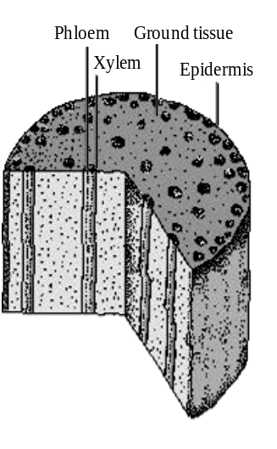 |  | 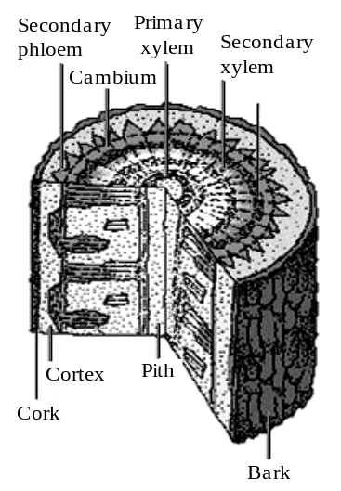  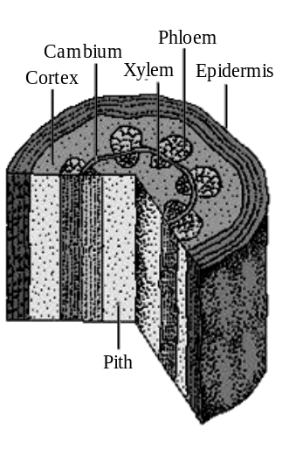
Description | Bundles of vascular tissue (phloem and xylem) are scattered throughout the ground tissue. |  | Bundles of vascular tissue (phloem and xylem) form a ring, separating the ground tissue into cortex and a central pith. |  | Epiderm is replaced by periderm (bark and cork). Ring of vascular tissue (phloem and xylem) develops secondary growth, and separates the ground tissue into cortex and pith.
Example plants | Grains and grasses, bamboo |  | Arabidopsis, flax |  | Trees (poplar, oak)
Tissue types | Dermal tissue |  | Ground tissue |  | Vascular tissue
Function | Protection and support; Reduce water loss |  | Photosynthesis; Food storage; Regeneration; Support |  | Transport (of food, water, minerals); Support
Cell types in tissue | Epidermal cells (Guard cells, Parenchyma) |  | Parenchyma, Collenchyma, Sclerenchyma (fibres) |  | Parenchyma, Sclerenchyma, Xylem and Phloem tissues (fibres, vessels, tracheids)
Cell types | Parenchyma | Collenchyma |  | Sclerenchyma |  | Xylem | Phloem
Schematic | 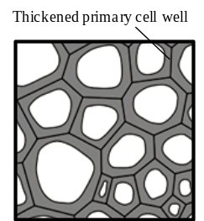  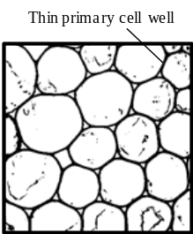 | 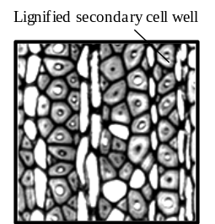 |  |  |  | 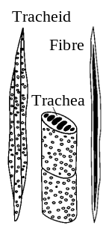 | 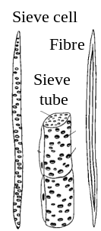
Description | Living cells with a thin primary cell wall, and low axial aspect ratio | Elongated cells with non-uniformly thickened primary cell walls |  | Dead cells with thick, lignified secondary cell walls. Exist as sclerids and fibres |  | Dead cells with thick, lignified secondary cell walls. Exist as tracheids, fibres, vessels and tubes

Parenchyma cells in the ground tissue have a soft, thin, flexible primary cell wall. The primary cell wall layers are typically lignin-deficient and contain a low content of stiff cellulose fibrils. Through cell pressure probes and mechanical (tensile or bending) tests on parenchymatic tissue, such as plugs of potato tubers (Niklas, 1992) and Caladium petioles (Caliaro et al., 2013), the reported elastic modulus of parenchyma cells falls in the range of 0.001-4 GPa (Karam and Gibson, 1994). The presence of large vacuoles in these thin-walled cells implies that turgor pressure has a substantial effect on its measured mechanical response (Niklas, 1992, Leroux, 2012). Collenchyma cells in the ground tissue have unevenly-thickened primary cell walls with higher cellulose content, and therefore can offer some rigidity to young stems (Leroux, 2012). Typically, the principal structure-supporting cells are specialised sclerenchyma fibre cells found to some extent in the ground tissue, but primarily in the vascular tissue. In addition to primary cell walls, these elongated cells have thick, lignified, cellulose-rich secondary cell wall layers.
Vascular cells with secondary cell walls, such as in the xylem as fibres and vessels (e.g. in hardwood) or tracheids (e.g. in softwood), and in the phloem as fibres, sieve elements (e.g. in softwood) or tubes (e.g. in hardwood) also offer substantial structural support. These cells have elastic moduli, measured typically through tensile tests, in the range of 10-35 GPa (the higher modulus being that of wood cell walls) (Karam and Gibson, 1994), but even up to 70 GPa in the dry state (such as in flax phloem fibres) (Shah, 2013). For comparison, the elastic moduli of native cellulose, hemicellulose and lignin, which are the principal polymer constituents in plant cell walls, are estimated using computational models to be in the range of 74-168 GPa, 7-8 GPa and 2-4 GPa, respectively (Shah, 2013).
While measuring the exact properties of the different tissue and cell types is difficult (Karam and Gibson, 1994), an appreciation of their relative contributions to the mechanical properties of a stem has been reflected in experimental investigations. For example, testing grasses with a dense outer-shell (comprising of sclerenchyma, vascular bundles and collenchyma) and a pithy core (comprising mainly of parenchyma, but also some collenchyma and vascular bundles), Karam and Gibson (1994) measured the stiffness ratio of the shell to the core to a range between 10 and 100. Similarly, Kohler and Spatz (2002) separated the outer tissues and inner core of the herbaceous dicot Aristolochia macrophylla, and measured the tensile stress-strain curve of each of these for comparison with that of the complete stem, as shown in Figure 3. Their results show the outer strengthening tissues (made up of collenchyma, parenchyma and sclerenchyma) to have an elastic modulus and strength approximately four times higher than the core tissues (phloem, xylem, interfascicular parenchyma and pith). Niklas and Paolillo (1997) also demonstrate that the mature epidermis (inclusive of an underlying layer of collenchyma cells) of monocot tulip flower stems are an important stiffening agent in turgid stems, contributing as much as 50% to overall stem bending stiffness. All these studies validate the idea that collenchymatous and sclerenchymatous tissues are the principle structure supporting cells against tension and bending loads - n.b. parenchymatous core cells, much like foam cores in sandwich-structured composites, provide resistance to buckling of the stem (Gibson, 2005, 2012). In woody dicots, Onoda et al. (2010) found that while most species have a thick bark (including outer bark, phloem and cambium), the contribution of bark to stem stiffness was small.
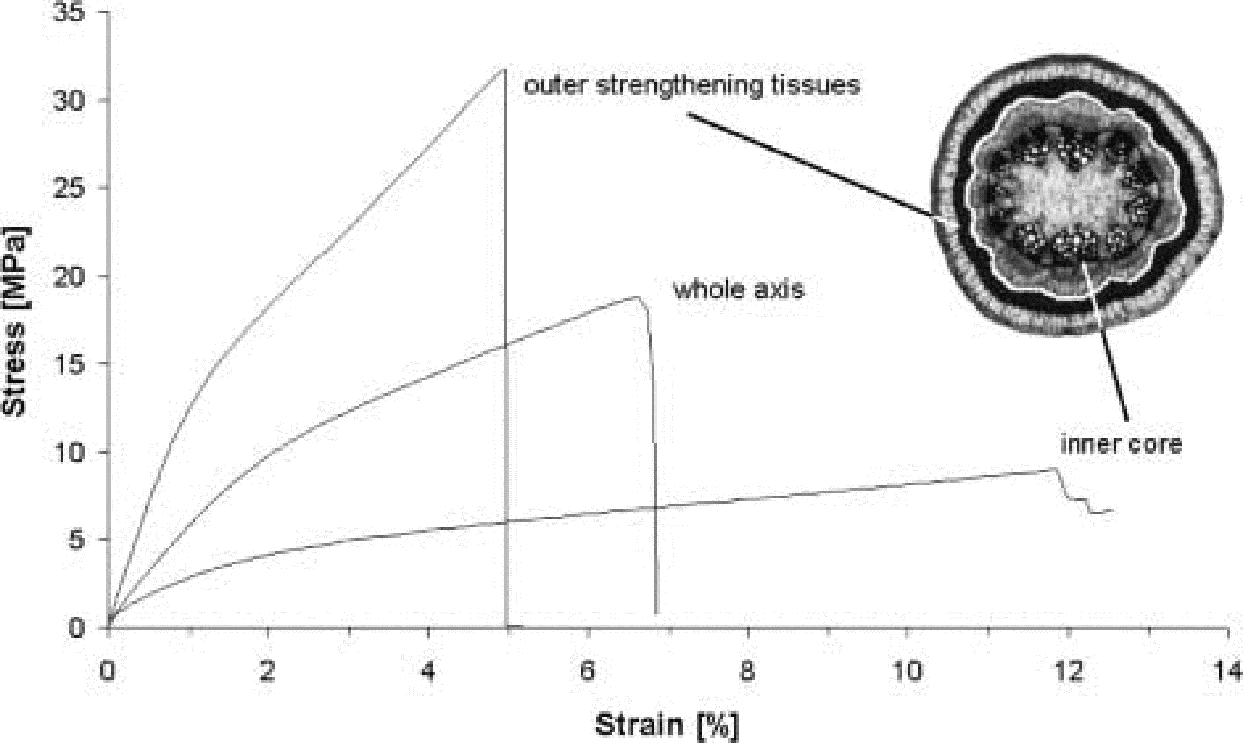
Figure 3: Stress-strain curves for parts of a stem of Aristolochia macrophylla (Kohler and Spatz, 2002)
Figure 4 illustrates the hierarchical and multi-phase nature of stems. From the view of micro-mechanics, stems can be analysed as laminated fibre-reinforced composites (Speck and Burgert, 2011, Gibson, 2012, Hofstetter and EK, 2009, Faisal et al., 2013) or as cellular solids (Gibson, 2005, 2012, Karam and Gibson, 1994).
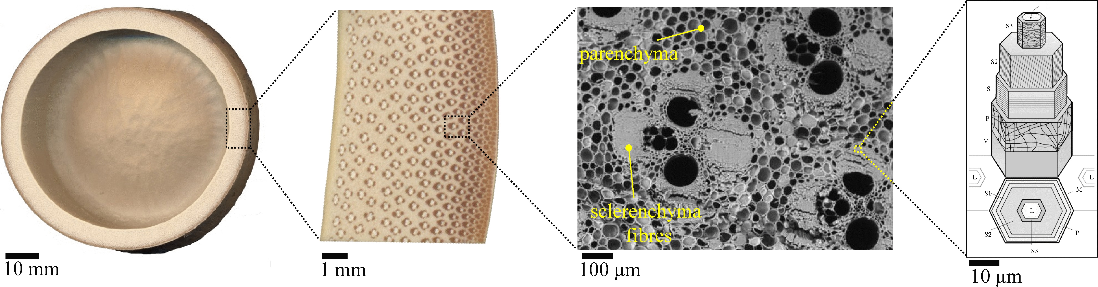
Figure 4: Plant stems have a hierarchical structure (Phyllostachys pubescens bamboo, a herbaceous monocot, as an example). The stem comprises of multiple cell types and therefore can be analysed as a cellular solid. Stems may also be considered as multi-scale composite structures, with sclerenchyma fibres in a matrix of parenchyma cells, and the fibres themselves as multi-layered cellulose fibril-based composites.

Analysing plant stems as composite materials
As fibre-reinforced composites, one can simplistically consider vascular tissue bundles (e.g. fibres and tracheids) as the primary load-bearing elements in a monocot stem, and that mechanical properties (e.g. elastic modulus, E) of the stem are dominated by the properties of these vascular bundles (E_{V}) and their differential distribution across the stem (V_{v}) (Eq. 1, Figure 4 of a monocot bamboo stem) (Ruggeberg et al., 2010, 2008).
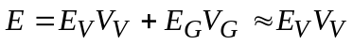 Eq. 1
where E represents elastic modulus, V represents the (solid) volume fraction, and the subscripts V and G denote vascular and ground tissue, respectively.
Alternatively, one can consider the plant stems to have a multi-lamellar composite structure (Gibson, 2012, Leroux, 2012), with the different cell types composed of multiple primary and/or secondary cell wall laminae (Figure 4). Each laminate is then regarded as a fibre-reinforced composite composed of helically-wound cellulose microfibrils, oriented at specific angles to the cell axis, embedded in a pectin-hemicellulose (in primary cell walls) or lignin-hemicellulose (in secondary cell walls) matrix (Leroux, 2012, Bledzki and Gassan, 1999, Gassan et al., 2001, Placet et al., 2012). Cellulose fibrils are substantially (up to 40 times) stiffer than pectin, hemicellulose and lignin (Shah, 2013). In sclerenchymatous cells, since the S2 cell wall layer, which is the second sub-layer of the secondary cell wall, is typically substantially thicker than all other layers combined, one could simplify this model (Gassan et al., 2001, Pickering, 2008, Shah et al., 2012a). The principal governing factors in such a model (Eq. 2) are the cellulose content and microfibril orientation in the S2 layer (Bledzki and Gassan, 1999, Shah, 2013).
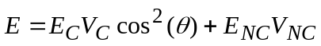 Eq. 2
where E represents elastic modulus, V represents the volume fraction, the subscripts C and N C denote cellulosic and non-cellulosic solid components in the cells, and θ denotes the microfibril angle in the S2 cell wall layer.

Analysing plant stems as cellular materials
On the other hand, given the cellular and (in some cases) porous nature of plant stems, describing their behaviour through cellular solid micro-mechanics is attractive (Figure 4c) (Gibson, 2005, 2012, Karam and Gibson, 1994). Sclerenchymatous cells are tube-like (long, slender and often tapered), forming a honeycomb-like structure, while parenchymatous cells are box-like (short and flat), forming a polyhedral, closed-cell foam-like structure. Their mechanical properties can be described by the properties of the solid material and the relative density of the cell (Eq. 3) (Gibson, 2005, 2012, Karam and Gibson, 1994). The relative density of the cell ρ/ρ_{S} (ratio of basic density to absolute density) is representative of the cell geometry and proportion of solid material in the cell.
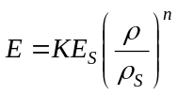 Eq. 3
where E represents elastic modulus, ρ represents density, the subscript S denotes solid material, and K and n are constants dependent on cell geometry and loading configuration (Gibson, 2005, 2012).

Macrostructure: at the stem-level
At the macro-structural level, the key parameters that affect stem mechanical properties and behaviour fall broadly in three categories: i) composition, ii) geometry, and iii) structural features.

Effects of composition
Basic dry density (dry mass per unit of fresh volume) is a useful indicator of composition in biological systems. The density of a plant stem increases with solid fraction (i.e. a larger proportion of thicker cells with secondary growth), as well as cellulose content and cellulose crystallinity (Shah, 2013). Apparent through Eq. 3, there is a strong, positive correlation between density and mechanical properties, both stiffness and strength (Fournier et al., 2013). Indeed, density is considered as an easy-to-measure property for structural timber, and therefore it is used as one parameter to segregate timber into structural grades, based on extensive empirical data (Forest Products Laboratory, 2010, Ridley-Ellis, 2011).
Moreover, density affects both longitudinal and transverse mechanical properties, and therefore anisotropy: in comparison to dense stems, light stems tend to have a lower transverse strength relative to longitudinal strength (i.e. higher anisotropy). Consequently, when bent, stems of lower density fail by local buckling in the compression zone, while stems of higher density break by tensile fracture, exhibiting longitudinal cracks (Ennos and van Casteren A, 2010). This explains why plant stems grown in shaded-environments, having lower density, fail by buckling in the compression zone, while stems of the same species grown in artificially-adjusted light, having higher density, break via catastrophic longitudinal crack propagation (Ludwig et al., 2009). Notably, this serves as an example of how difference in growing conditions and habitats may have a non-trivial impact on the mechanical behaviour of plant stems. Indeed, the relationship between growth and density is more complex. Softwoods with very wide growth rings have a lower density than softwoods with small growth rings. In ring-porous hardwoods it is vice-versa.
Living plant stems are dynamic structures and this makes mechanical measurements more challenging, including in comparison to senesced or ‘dead’ stems, as well as isolated and processed stem material (e.g. timber). In fresh stems in particular, not only the effects of turgor pressure and water content, both of which are discussed in more detail later, but also the molecular and cellular responses to mechanical loads, in the form of changing cell wall compositions, biochemical properties, and water influx/efflux, can have a marked effect on measured properties. These effects, of course, tend to be larger in longer-running and time-dependent tests, such as creep and cyclic loading. Consequently, such tests can be very informative in revealing important information of cell/stem growth and morphogenesis (Park and Cosgrove, 2012, Cosgrove, 1993, 2010).
Within a certain range, the moisture content and drying/moisture-regain of stems has been shown to have a strong effect on mechanical properties. In wood science, it is well known that ‘green wood’ (i.e. the unprocessed stem of a tree) has moisture content above the ‘fibre saturation point’. The fibre saturation point refers to the point in the drying/moisture-regain process below which there is no free-water in the pores of cells (only bound-water in the cell walls), and above which there is both free- and bound-water (Ramage et al., 2017). In wood, the fibre saturation point is around 25-30 wt.% moisture content (ratio of mass of moisture in the material relative to its dry weight) (Forest Products Laboratory, 2010). The fibre saturation point also defines the point above which any change in moisture content has little effect on mechanical properties, but below which strength and stiffness increase substantially with decreasing moisture content (Forest Products Laboratory, 2010). The existence of a fibre saturation point in other plant stems is expected, although yet to be investigated in detail, and humidity and temperature (and consequently moisture content) would therefore be expected to influence mechanical properties. While a fresh or living stem would be above the fibre saturation point, once cut for testing, moisture content may drop rapidly, reaching equilibrium moisture content typically below the fibre saturation point. Systematic stem tests would require control of these moisture-influencing factors, including dwell-times between stem preparation and testing, and conditions during preparation, storage and testing.
An important consequence of the living nature of plant stems, and the dependence of growth, morphology, composition, properties on environmental conditions is that any analysis of stem mechanical properties, and resulting statistical analysis of the data, should be based on several repeats (at least ten) over a number of biological replicas (at least three).

Effects of geometry
Geometric factors, such as the stem cross-section shape and dimensions, can affect stress development within a stem, and consequently its failure behaviour and properties.
There is a large diversity in stem sectional shape: stems can have circular and elliptical (as in Euphorbia peplus), polygonal (including triangular as in Carex pensylvanica, square as in Mentha piperita, hexagonal as in Dipsacus sylvestris, octagonal as in Sericocarpus asteroides) and even non-polygonal cross-sections (Smith, 1950).
For solid, isovolumetric stems, the orientation of load (and the neutral axis as a result; see Figure 5) determines which cross-section shape is more efficient in bending (i.e. will deflect less upon load application). For example, while square cross-section stems with the neutral axis through opposite vertices (i.e. load applied on an edge; Figure 5(a)) would be less rigid than circular cross-section stems, square cross-section stems with the neutral axis perpendicular to the surfaces (Figure 5(b)) would more rigid than circular cross-section stems (Smith, 1950). Consequently, stems with square cross-sections often have most of the strengthening material (i.e. thicker collenchyma and sclerenchyma).
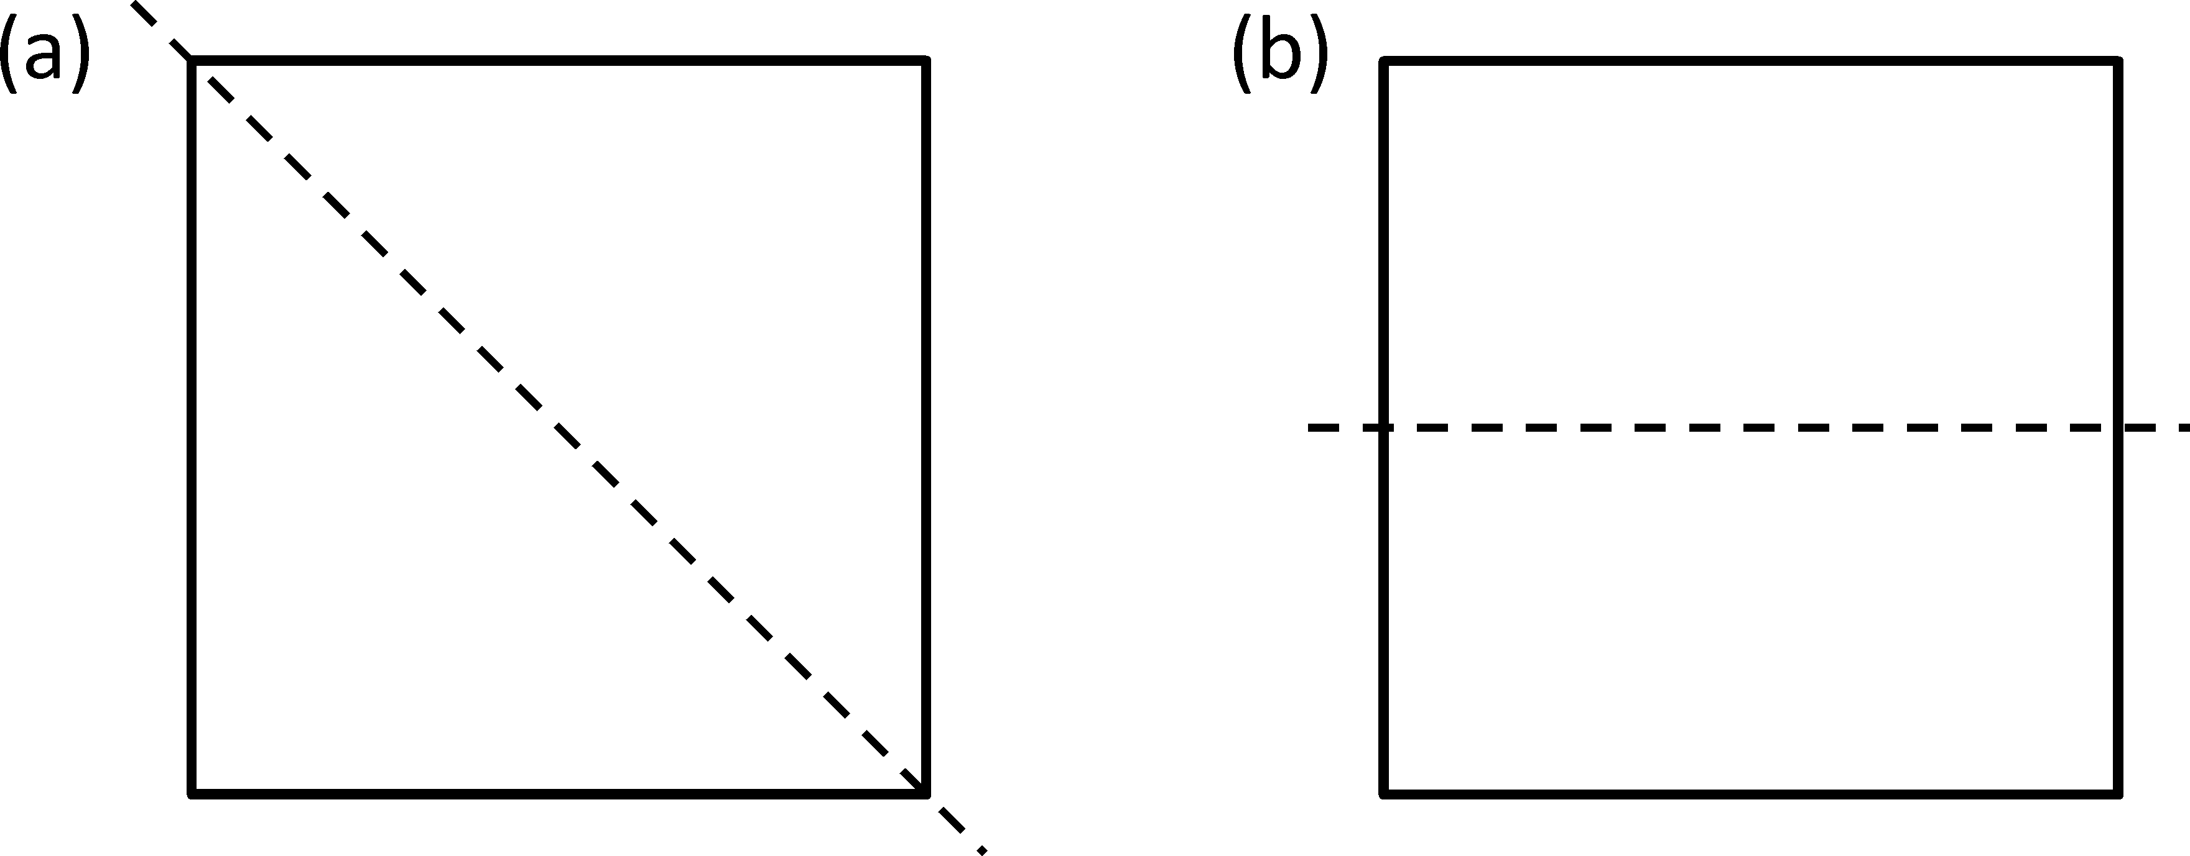
Figure 5: Schematic of a square cross-section stem with the neutral axis (a) passing through diagonal vertices, and (b) bisecting opposite sides’ cells) at the corners, to support bending stresses that arise when the neutral axis passes through opposite vertices (as in Figure 5(a)) (Smith, 1950).
It has been experimentally shown that non-circular stems are characterised by higher twist-to-bend ratios (Niklas, 1992), which is a strategy against typical stresses, such as buckling and bending (Etnier, 2001, Etnier and Vogel, 2000, Vogel, 1995, 1992, 1997). The ‘twist-to-bend ratio’ is a ratio of flexural rigidity to torsional rigidity, which indicates the relative resistance of a stem to bending versus twisting; a higher ratio implies that the stem twists more readily than it bends. Specifically, higher ratios, as in triangular cross-section stems of sedges, enable the stems to shed wind loads by twisting readily into low-drag configurations (i.e. facing down-wind), thereby reducing the possibility of damage (Etnier and Vogel, 2000).
Other than the cross-section shape, which is usually irregular and can change with factors such as moisture content (e.g. dry stems can collapse), cross-section dimensions are important in determining mechanical properties. The effect of inaccurate dimension measurements on the second moment of area would be even more substantial (due to a fourth power effect), leading to grossly incorrect bending stiffness and strength.
Upon experiencing mechanical loading, such as during wind flexing, plants actively modify growth and development processes; this phenomenon is well known as thigmomorphogenesis. Thigmomorphogenesis significantly influences stem mechanical behaviour (Badel et al., 2015). Not only do modifications in cell differentiation and wood tissue anatomy, such as formation of ‘flexure wood’ and increase in microfibril angle (Telewski, 1989), change the properties of the stem material, in-most cases, the over-riding influence on stem rigidity arises from large increases in radial growth (and therefore second moment of area of the stem cross-section), as well as local ovalisation (Badel et al., 2015).Stems may also have a taper in their cross-section with increasing height. In general, in the absence of critical defects and constant material properties, mechanics would dictate failure to occur where stress is maximum, i.e. at the smallest cross-section. The extent of taper would dictate ideal gauge lengths to use during testing.
A critical aspect of stem sectional properties is their hollowness ratio. Evidence suggests that hollow stems can grow 26% taller than the equivalent solid stem (Niklas, 1992). This is a logical solution when biomass production is a constraint. While not all plant stems have a central cavity (e.g. tree trunks), many stems are naturally hollow (e.g. bamboo culm), or have a pithy core (e.g. Arabidopsis thaliana) that does not contribute to mechanical properties and even hollows out when the plant matures or reaches senescence. The hollowness ratio represents the ratio of rind thickness to stem diameter. This ratio determines whether the stem is thin-walled or thick-walled, thereby governing its failure mechanism (Wegst and Ashby, 2007). For example, when subjected to compressive or bending stresses, thin-walled stems (with a rind thickness to stem diameter ratio less than 0.15 (Mattheck, 1995)) break due to Brazier buckling (Brazier, 1927, Niklas, 1992)), whereas thick-walled stems fail due to material yield or fracture (Mattheck, 1995, Leblicq et al., 2015, Wegst and Ashby, 2007). The presence or lack of a core (or a ‘core-rind’ structure), therefore, also affects the failure behaviour. The core is a foam-like, parenchymatous, compliant material, whereas the dense, sclerenchymatous outer shell (rind) is stiff. Despite being compliant, the core provides buckling resistance under axial compression and resistance to kinking failure under bending load. The improvement in buckling and bending capacity of the stem is related to the hollowness ratio and the ratio of the elastic modulus of the core material to the rind material (Gibson, 2005).

Effects of structural features
Stems can improve both local and global properties by incorporating and modifying structural features, such as nodes and preferential distribution of stiffening fibres to the outer-most parts of the stems.
If stems are analysed purely on the basis of their overall bending stiffness, then locating stiff fibres towards the outer edge of the stem is advantageous, as tensile and compressive stresses under bending load increase away from the central axis (Figure 6). Schulgasser and Witztum (1997) showed, however, that this encourages failure by local compressive buckling or kinking, both of which involve the buckling of groups of fibres within the stem, rather than the stem as a whole. This can be shown by the theory of composite materials to occur because the shear strength of the outer material does not increase as rapidly as its compressive strength (Schuerch, 1966). Local compressive buckling may be particularly prevalent in hollow stems such as reed and bamboo (Niklas, 1998). Such stems have often developed to be septate, where diaphragms at nodes act to restrain the wall against this form of failure (Robertson et al., 2015). Nodes are a common feature in many hollow stems, particularly grasses, that prevent local buckling and provide transverse reinforcement. Nodes can also act as spring-like joints to store and release energy when subjected to axial or transverse forces (Niklas, 1997b, 1998b). However, stress and strain gradients at the interface of nodes and anti-nodes results in these being likely sites for failure when subjected to axial or bending loads. The stress and strain gradients are a result of changes in microstructure (e.g. cellulose micro-fibril angle) and physical properties (e.g. density), and therefore mechanical properties.
Junctions and nodes (e.g. steam-leaf, stem-petiole, stem-branch) are also likely points of failure in stems. This is well known in wood science, where knots (stem-branch junctions in trees) are counted to assess the quality of the wood. Knots have a local increase in micro-fibril angle and density to improve local fracture toughness and density (by promoting mixed-modities in failure) (Speck and Burgert, 2011). However, once again, stress/strain gradients at the vicinity of these defects results in failure upon loading at the junctions.
Some herbaceous stems are supported, at least in part, by ‘hydro-skeletons’ (Niklas, 1992). This refers to a system where turgor pressure from internal fluids withstands compressive loads, while the sclerenchymatous rind supports tensile loads. A drop in turgor pressure, visually observed as the wilting of a stem when a plant is not watered, leads to buckling. Turgor pressure can also pre-stress and stretch the internal cell walls of the stem (Karam and Gibson, 1994).
When measuring the mechanical properties of stems that do rely on turgor pressure for support, it is important to control the turgor pressure of the system, or account for it when analysing the data. For example, Paul-Victor and Rowe (2011) conducted turgor tests on Arabidopsis stems prior to mechanical testing. Excised stems were tested for bending properties at regular intervals to examine the effect of loss of turgor pressure on mechanical properties. They observed a 10% drop in stiffness after 15 minutes, extending to 25 minutes when the segment ends were sealed with wax. Sealing segment ends, and either rapid testing or significantly delayed testing segment extraction (Robertson et al., 2015) are recommended ways to minimise the effect of changing turgor pressure. Some researchers have also submerged plant stem tissues into osmotic solutions to adjust the turgor pressure before testing (Caliaro et al., 2013, Falk et al., 1958, Niklas and Paolillo, 1997). There are also methods to predict and back-calculate the properties of the solid cell wall material for any turgor pressure (Nilsson et al., 1958, Karam and Gibson, 1994). In general, the models suggest that relative stiffness ratio between the cell walls and the stem is proportional to the ratio between the internal turgor pressure and the stem stiffness. For reference, turgor pressure varies between 0.1-2 MPa for a range of stems, leading to a ratio between turgor pressure and stem stiffness of the order of 10⁻³ to more than 10⁻² (Karam and Gibson, 1994, Caliaro et al., 2013).

Approaches to testing plant stems
Table 1 lists typical tests that stems are subjected to for mechanical property measurement. In nature, plant stems most commonly fail due to a bending moment by either yield or local buckling on the compression edge (Figure 6(a)) or combined tensile and interlaminar shear failure (Figure 6(b)). Both of these failure types originate from the axial stress (dashed straight arrows in Figure 6(c)) and associated shear stress which develop due to the bending moment (solid curved arrows) in the stem. Consequently, flexural testing has become an important tool to assess stem mechanical properties.
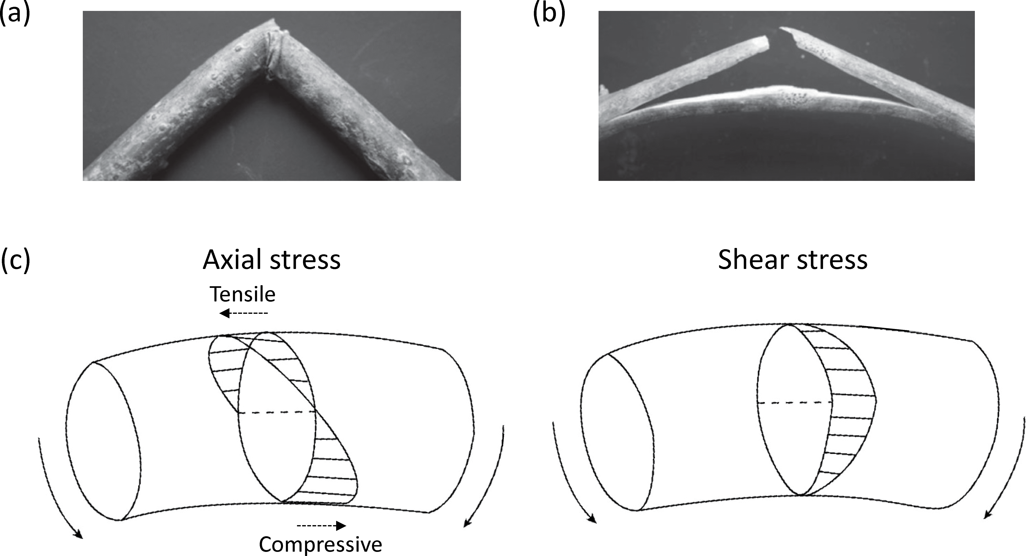
Figure 6: Typical failure of stems in bending: stems may (a) kink and buckle on the compressive surface (typically for low-density, thin-walled stems) or (b) exhibit ‘green-stick failure’ where a transverse crack originates on the tensile surface and propagates longitudinally along the plane of maximum shear stress (typically for high-density, thick-walled stems). (c) Bending results in the development of a combination of axial (compressive and tensile) and shear stresses. Bending moment is represented by the solid curved arrows at the beam ends. Adapted from (Ennos and van Casteren A, 2010)
A pure bending test does not fully replicate conditions in nature, however, where failure may be due to a combination of axial overload, from the weight of the plant and anything supported by it (e.g. snow), and adverse bending loads resulting from weather conditions (e.g. wind-loading and rain-beating) (Niklas, 1992). An understanding of the response to combined loads may be gained through modelling or calculation based on the fundamental properties of the stem material.
In flexural tests, specimens are subjected to mixed-mode conditions with tensile and compressive stresses arising linearly on opposite sides of the neutral axis, and shear stresses increasing to a maximum towards the neutral axis (Figure 6(c)). It can be difficult, therefore, to identify the fundamental mechanical properties of the stem material from such a test. Axial load testing has therefore been used to measure the elastic modulus (or stiffness) and tensile strength (or failure load) of stem tissue material (or stem structures), which may be different in tension and compression.
Furthermore, plant materials exhibit time-dependent, viscoelastic behaviour, as they are based on polymeric building blocks (viz. cellulose, hemicellulose and lignin). The full mechanical characterisation of stems, therefore, requires tests which include a time component of load. This can be in the form of creep (sustained constant loading), stress relaxation (sustained constant deformation) or cyclic loading (as in oscillation due to wind-loading).
Here, these various possible testing methods are discussed and evaluated. Recommendations are also given in designing suitable test procedures.

Cross-section morphometry
To estimate stresses in the material due to an applied force to the structure, some geometric properties of the stem cross-section are required. As discussed earlier, the accuracy of these cross-section properties can have a significant impact on the accuracy of stress estimations.
In flexural tests, the second moment of area of the cross-section is required, so not only the transverse area, but also the shape of the cross-section must be measured or assumed. In shear, the cross-section shape also affects the distribution of stress. In the literature, it is most common to assume a cylindrical stem, and measure its diameter (or width) and possibly rind thickness (if hollow), at one or more points along its length (Skubisz, 2002, Lemloh et al., 2014). Microscopy may be used to justify the assumed section shape after testing (Lemloh et al., 2014). A more direct assessment of second moment of area, and of the contribution of the different tissues to bending stiffness through image analysis is possible (Moulia and Fournier, 1997). We recommend this to become more common practice.
Under axial loading, only the cross-sectional area is required, which may be determined either indirectly or directly. There are two principal indirect methods. One approach is to determine the total volume of a stem segment of known length by a volume displacement technique (Skubisz, 2001); this, alongside a known mass of the segment, would yield an estimate of the average cross-section area. Another indirect measurement technique, borrowed from textile engineers (Shah et al., 2012b), is to use the ’mass per unit length’ of the stem segment as an indication of the area of material resisting the applied load. This, combined with either a measured density of solid cell wall material (using gas pycnometry, for instance) or a assumed density, would give an estimate of the average cross-section area of solid cell wall material resisting the applied load (neglecting the hollow lumen) (Cosgrove, 2010, Shah et al., 2012b). Direct measurement techniques, in the case of small stems (less than a few mm in diameter), include the use of X-ray micro-CT scanning prior to testing (Zeng et al., 2015), or optical microscopy post-testing. The latter can be done by mounting stems vertically onto card frames and even casting these into resin blocks which are then polished for imaging (Thomason et al., 2011) (Figure 7). For larger stems (e.g. bamboo culms), section properties are easier to measure using callipers, but it may also be possible (for accuracy) to scan the surfaces (e.g. using high resolution X-ray) (McElrone et al., 2013, Masselter and Speck, 2008, Brereton et al., 2015, Charra-Vaskoua et al., 2016).
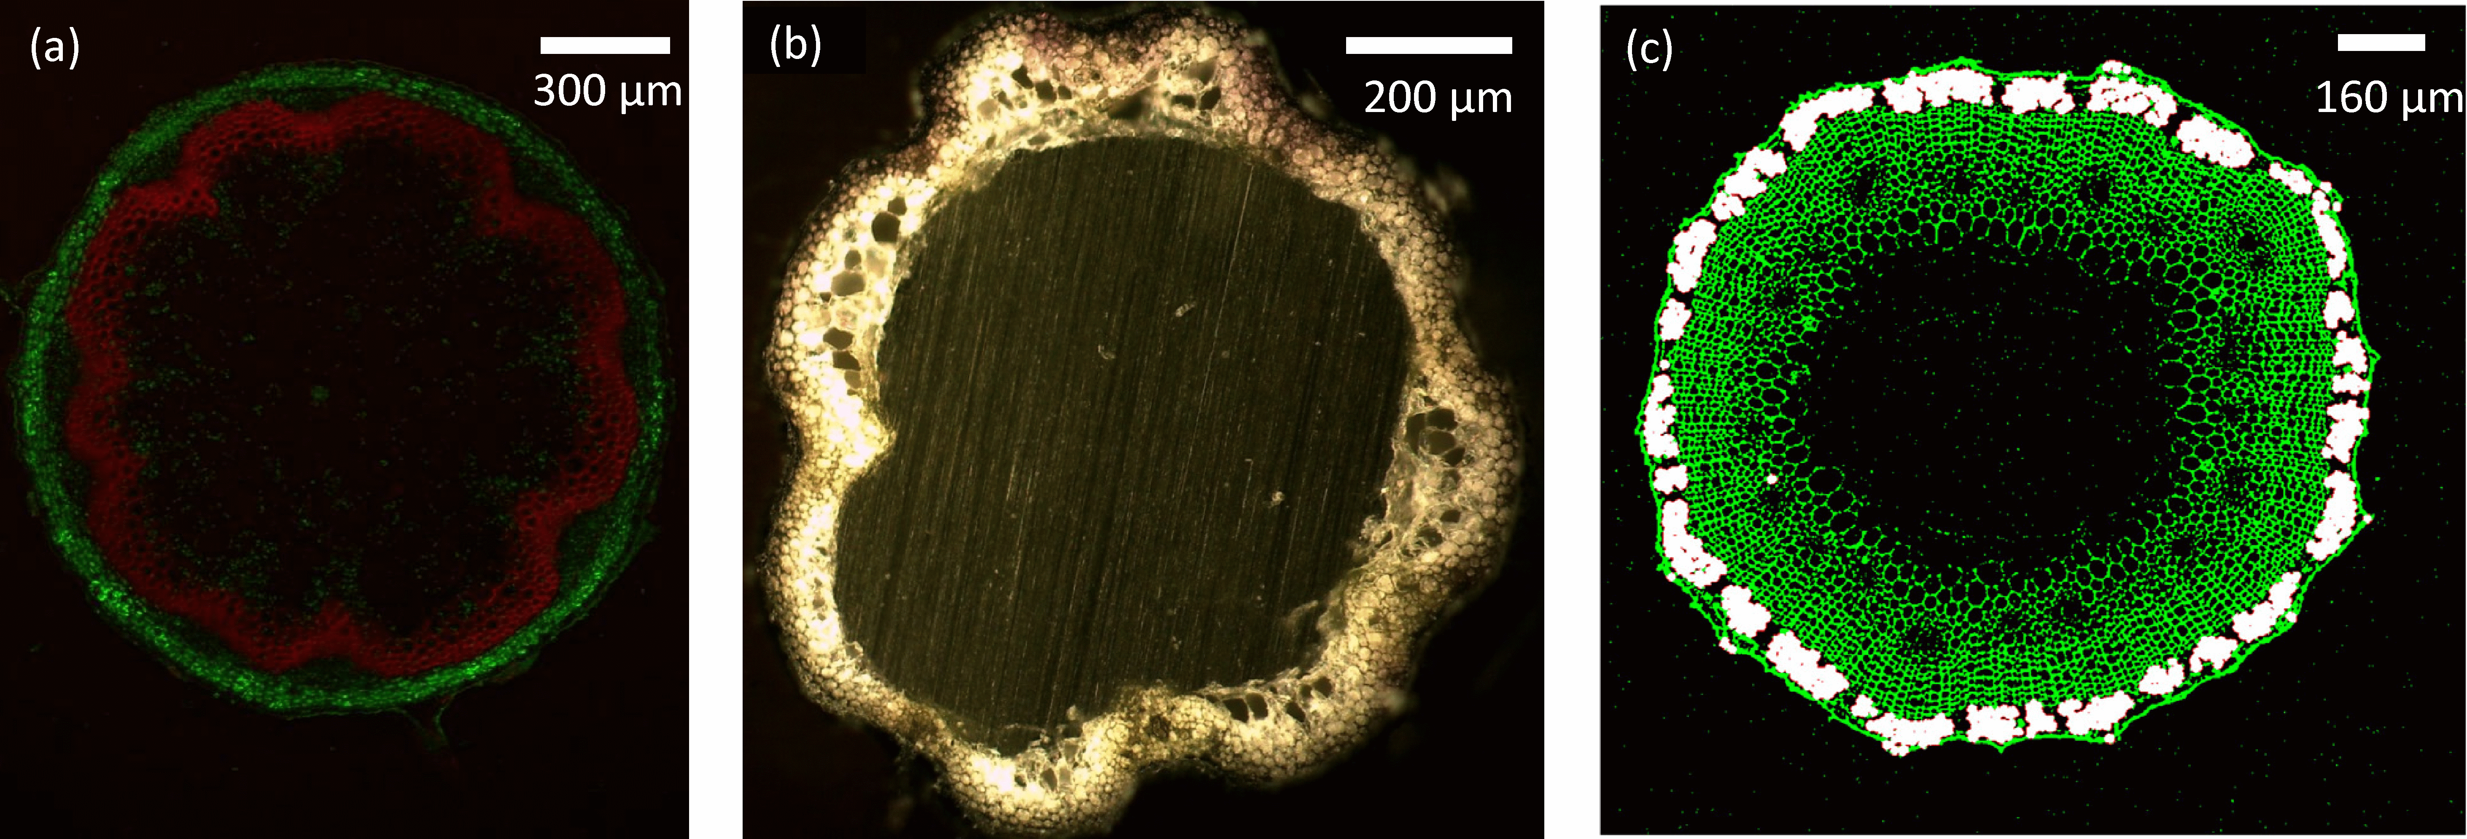
Figure 7: Direct measurement of stem cross-section area can be done by confocal microscopy (a) (of a fresh Arabidopsis stem), optical microscopy (b) (from (Shah et al., 2015) of a scenesced, dried Arabidopsis stem) or X-ray micro-CT scanning (c) (from (Zeng et al., 2015) of a flax stem).

Flexural bending tests

Cantilever bending
Flexure can be induced in a stem by any applied load which includes a pair of loads forming a couple. This is most simply done using a cantilever fixed at one end and loaded at the other. Cantilever, or two-point, bending can be carried out on in vivo stems in a pot (Caliaro et al., 2013) and even on leaves (Moulia et al., 1994). This is particularly useful where turgor pressure is expected to play a significant part in the mechanical resistance of the stem, as was the case for the Abutilon theophrasti tested by Henry and Thomas (2002) and Caladium bicolor by Caliaro et al. (2013). The American standard test method for flexural testing of tree stems is a cantilever test (ASTM, 2012).
The drawback of this technique is that the largest shear stress occurs in the same area as the largest bending stresses, making it difficult to isolate the two effects to estimate the fundamental properties of the material under test. In addition, elementary beam theory is only applicable for small deflections; as a rule-of-thumb, this is when tip deflections (for end-loaded stems) are less than 10% of their length. For large deflections, more complex equations and computational methods may be required to determine the mechanical properties (Morgan and Cannell, 1987, Vogel, 1992). This is because the equilibrium equations based on the undeformed shape are no longer valid after substantial deformation. Alternatively, paired measurements of (change in) curvature and bending moment can be made (Moulia et al., 1994); this approach has the advantage of accounting for sagging and initial curvature. The latter arises from self-weight and tip-load of some stems.

Three-point bending
In three-point bending, the largest bending deflection is at mid-span, and the highest shear near the supports. This is the most common form of mechanical test carried out on stems (Skubisz, 2001, 2002, Lim et al., 2011, Christoforo et al., 2012, Ampofo et al., 2013, Slater and Ennos, 2013, Lemloh et al., 2014, Robertson et al., 2015). The deformation is characterised by a single displacement measurement (at mid-span), and no clamping is required: the stem rests on two simple supports, and is subject to a point load. This test set-up has been applied for spans from a few millimetres (Lemloh et al., 2014) up to several metres (Lim et al., 2011).
The stem segment to be tested must be sufficiently slender that the contribution of shear to the measured deflection is small. Shear leads to an under-estimation of strength and elastic modulus (van Casteren et al., 2012). Standards for tests on small timber specimens use a span-to-depth ratio of 14 (BSI, 1957). The span-to-depth ratio (i.e. where span is the distance between supports, and depth representative of a diameter or thickness of the stem) may, however, depend on the hollowness ratio of a stem. For example, for solid stems researchers have suggested a minimum span-to-depth ratio of 20 (van Casteren et al., 2012), while for hollow stems (such as in the reed Arundo donax) a minimum span-to-depth ratio of 10 to 15 may be appropriate (Spatz et al., 1997). In a mechanical study of 42 grass species (which included hollow and solid stems), Evans et al. (2007) suggest that a span-to-depth ratio of 10 would make the contribution of shear negligible. Other studies have suggested that, for example when testing the stems of the herbaceous dicot Arabidopsis thaliana, a span-to-depth ratio of 35-40 should be used (Paul-Victor and Rowe, 2011). We recommend that, if an initial pilot study to test the effect of span length is not feasible, a minimum span-to-depth ratio of 20 should be used. Of course, longer span-to-depth ratios would further minimise cross-section deformation from shear (Robertson et al., 2015), but this may be limited by the presence of nodes, for example, or the sagging of a non-rigid stem. Note that the four-point bending method may be used to eliminate the contribution of shear deformation altogether.
A drawback of the three-point bending method is the stress concentration at the loading point, which may lead to a local bearing failure of the stem, or a local deformation of the section which in turn leads to a change in cross-section during the test. An example of this can be seen in Figure 8, where a kink has formed at the loading point. The resulting ovalisation and buckling reduce stiffness significantly and need to be accounted for (through the use of cumbersome equations) when determining mechanical properties, as described by Leblicq et al. (2015). In septate stems, where a diaphragm across a node reinforces against local buckling, stems are shown to be stronger in these bending tests when loaded at the node (Robertson et al., 2015). Increasing the span-to-depth ratio as well as selection of an appropriate loading anvil shape (e.g. rounded anvil is preferred over a knife-edge anvil) may help in reducing stress-concentrations (Robertson et al., 2015).

Four-point bending
Four-point bending results in a region between the two loading points where there is no shear in the specimen and the bending moment is constant. Any failure in this region can therefore be classed as a bending failure at a known bending moment. The absence of shear stresses enables assessment of the longitudinal elastic properties. However, this method requires more instrumentation than three-point bending to isolate the component of deflection that occurs in between the two loading points. Robertson et al. (2015) use the region of constant bending to observe variations of stiffness in septate stems, showing that there is no clear reduction in stiffness at the nodal points.
Tree stems, referred to as roundwood, have been widely tested in four-point bending (Ross et al., 2001, Vestøl and Høibø, 2010). This is one area of stem testing where standard methods have been developed in Europe (BSI, 2005). The taper and ovality of the stem is taken into account in calculating elastic modulii and strength from bending tests. Standards also recommend a shaped loading head to reduce local crushing (BSI, 2005, ASTM, 2012).
For small stem specimens, displacement measurement may require bespoke approaches. A modified four-point bending method is used by Goubet et al. (2009) to investigate the effect of various genetic modifications on the strength and stiffness of stems of Arabidopsis thaliana. They encase the stem outside of the loading points in steel tabs, as shown in Figure 9, so that the deflection measured at the loading points is due to the bending of the stem between them.
As stem materials are viscoelastic and have rate-dependent properties (particularly strength and stiffness), the rate of loading is controlled. Standard tests on wood commonly require failure to occur after five minutes of loading (BSI, 1957, 2005). Rate-dependency is an important factor to consider when comparing literature with dissimilar loading rates.
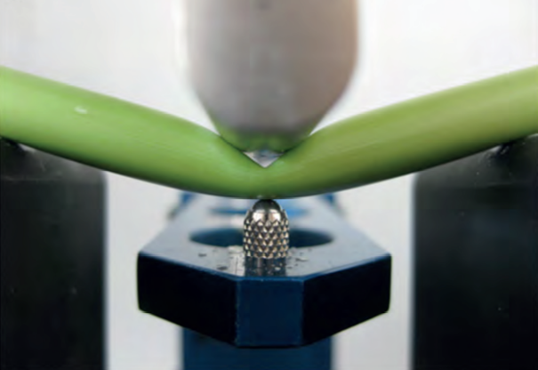
Figure 8: Three-point bending test on a stem of Sorghum bicolor (Lemloh et al., 2014)
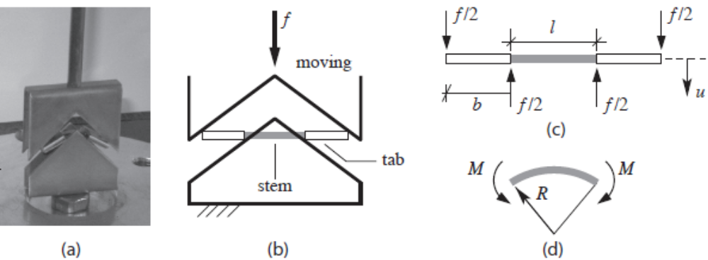
Figure 9: Test setup for four-point bending of Arabidopsis thailiana stems (Goubet et al., 2009)

Axial loading
A major advantage of bending tests is that specimen clamping is not required. However, as they induce mixed-modes of stress across the stem cross-section, one cannot obtain fundamental material properties, for example the distinct tensile and compressive elastic modulus. Axial loading tests are therefore attractive to isolate these properties. In addition, unlike bending tests, axial tests do not require the measurement of the second moment of area to determine geometry-normalised properties. Rather, they rely on transverse cross-section area, which is easier to determine accurately. Axial loads can be applied in either tension or compression.

Tensile testing
In tensile tests, a key component of the experimental method is the way in which the specimen is held at each end, i.e. specimen gripping. While some researchers do grip stem segments without any specimen preparation (Usherwood et al., 1997), it should be noted that clamping points may initiate failure in the specimen, resulting in a lower measured strength. This is of particular concern in (hollow) stems which may resist substantial loads along their length, but crush at much lower loads across the stem.
Some researchers choose to test rectangular strips of the stem wall (Spatz et al., 1998, 1997, Ruggeberg et al., 2010), assuming it to be representative of the mechanical properties of the stem wall material. Testing of strips is not uncommon in wood science and technology. In such an approach, it is possible to remove layers of the stem wall (e.g. scrape off parenchymatous cells) to test the contribution of different tissue types (Spatz et al., 1998).
When testing the whole stem, it is advised to protect the stem at the grips. One possibility is to encapsulate the stem with a rigid, thermoset polymer block or tubing. Thereafter, the polymer block can be gripped on a tensile-tester, with the load transferring from the block to the stem. Zeng et al. (2015), for example, use a polyurethane tubing at both clamp ends, which is bound to segments of flax stem using Araldite epoxy resin. To further protect the hollow stems from crushing and to avoid resin wicking through the hollow stem, Zeng et al. (2015) also insert 0.5-1.5 mm steel cores, as deep as the clamping length. Zeng et al. (2015) comment that this methodology prevented premature fibre damage in the clamping region and ensured failure in the gauge length. In a similar approach, Wright et al. (2005) prepared special end-grips that consisted of metal pins to fill the core of the hollow stems to protect from crushing, and a sleeve-like self-adhesive heat shrink-wrap on the outside to protect the surface of the stem from damage. Yet another technique is to sandwich the stem ends between aluminium tags using a cyanoacrylate-like polymer (i.e. non-shrinking upon curing) or metal-filled epoxy-like gap-filling adhesive (Altaner et al., 2014). Note that some polymers may require high-temperature curing; ambient-curing and low-exotherm adhesives are preferred, to avoid damaging the biological specimen through heat. Selecting a suitable adhesive also involves ensuring that slippage (i.e. debonding and subsequent sliding of the stem relative to the adhesive) does not occur during testing. The use of gap-filling glues and low cure-shrinkage adhesives may aid in ensuring intimate contact between the adhesive and the stem. Prior to gluing, cleaning stem ends (e.g. with water or alcohol to remove natural waxes on the surface) may also be recommended. To avoid physical gripping at the ends, one could even use end-tabs with holes; metallic pins through the holes can be used to align, hold and load the specimen (Altaner et al., 2014).
In contrast, some studies have used a more basic approach wherein stems are held by pneumatic clamps (at a prescribed pressure); the stem surface is protected by thick plastic, and to avoid slippage at the clamps, rough grind paper is used (Kromer, 2009).
The use of mounting frames is attractive for thin stems with low stiffness, for example those which can deform substantially (and probably irreversibly) by the presence of metallic or polymeric inserts and sleeves at the ends. For example, etiolated hypocotyls of Arabidopsis thaliana, producing smaller than 0.2 mm stems with exclusively primary cell walls, have been tested using microtensile test methods developed by Burgert et al. (2003) for single-cell-thick foils of wood, shown in Figure 10a (Cavalier et al., 2008, Abasolo et al., 2009). Foliar frames are used to set the gauge length, protect the specimen during installation in the loading machine, and to provide the connection to the loading head. Instead of foliar frames, one could use frames based on paper, cardboard, acetate sheets, or aluminium foil, depending on the stiffness of the frame required. For our tests on Arabidopsis stems, we are currently using 1 mm thick cardboard frames (Shah et al., 2015) (Figure 10)b. The ends of the frames have 0.5mm deep grooves to enable the stems to slot into. The laser-cut grooves enable alignment, but more importantly ensure that the stem does not crush when the frame is externally gripped. In all frames, the specimen is attached to the frame by a polymer adhesive which is required to set rapidly, have gap-filling properties, and have high shear strength. Some adhesives that fit this specification include slow-setting epoxy (e.g. Araldite Precision), and a combination of glass ionomer luting cement (for gap-filling) and cyanoacrylate (e.g. Loctite 454).
A particular challenge in testing specimens in tensile mode is the measurement of extension. On non-frame-mounted specimens, it is common to simply rely on cross-head extension. In that case, initial tests should be conducted to ensure that compliance of the test frame and grips has been accounted for. On frame-mounted specimens, slippage is another possibility which can skew the extension reading. For large stems, it may be possible to use contact methods (such as clip-on extensometer) for strain measurement. However, special collars may be needed to be placed around the stem (in the gauge length) at the extensometer contact points, to provide attachment but also protect the stem from local transverse loads (Wright et al., 2005). For thin, non-stiff stems, non-contact strain measurement methods are preferred. One approach is to use digital image processing. Burgert et al. (2003) track ink lines on their folial frames, while Ryden et al. (2003) sprinkled the hypocotyls with coal dust to produce a high-contrast field for digital image tracking. In our methodology (Shah et al., 2015), we are using a laser extensometer, which tracks the relative displacement of retro-reflective tape that is mounted onto the stems directly (Figure 10).
Specimen test length and loading rate are important parameters that would affect the properties measured. Just as observed in single fibre tests (Shah, 2013), longer stem segments will show lower strength than shorter segments as the former have more defects. In addition, selection of an appropriate gauge length to minimise effects of tapering, presence of junctions and other structural features, may be necessary. Higher test extension rates will show higher strength and stiffness, as viscoelastic materials tend to have rate-dependent properties.
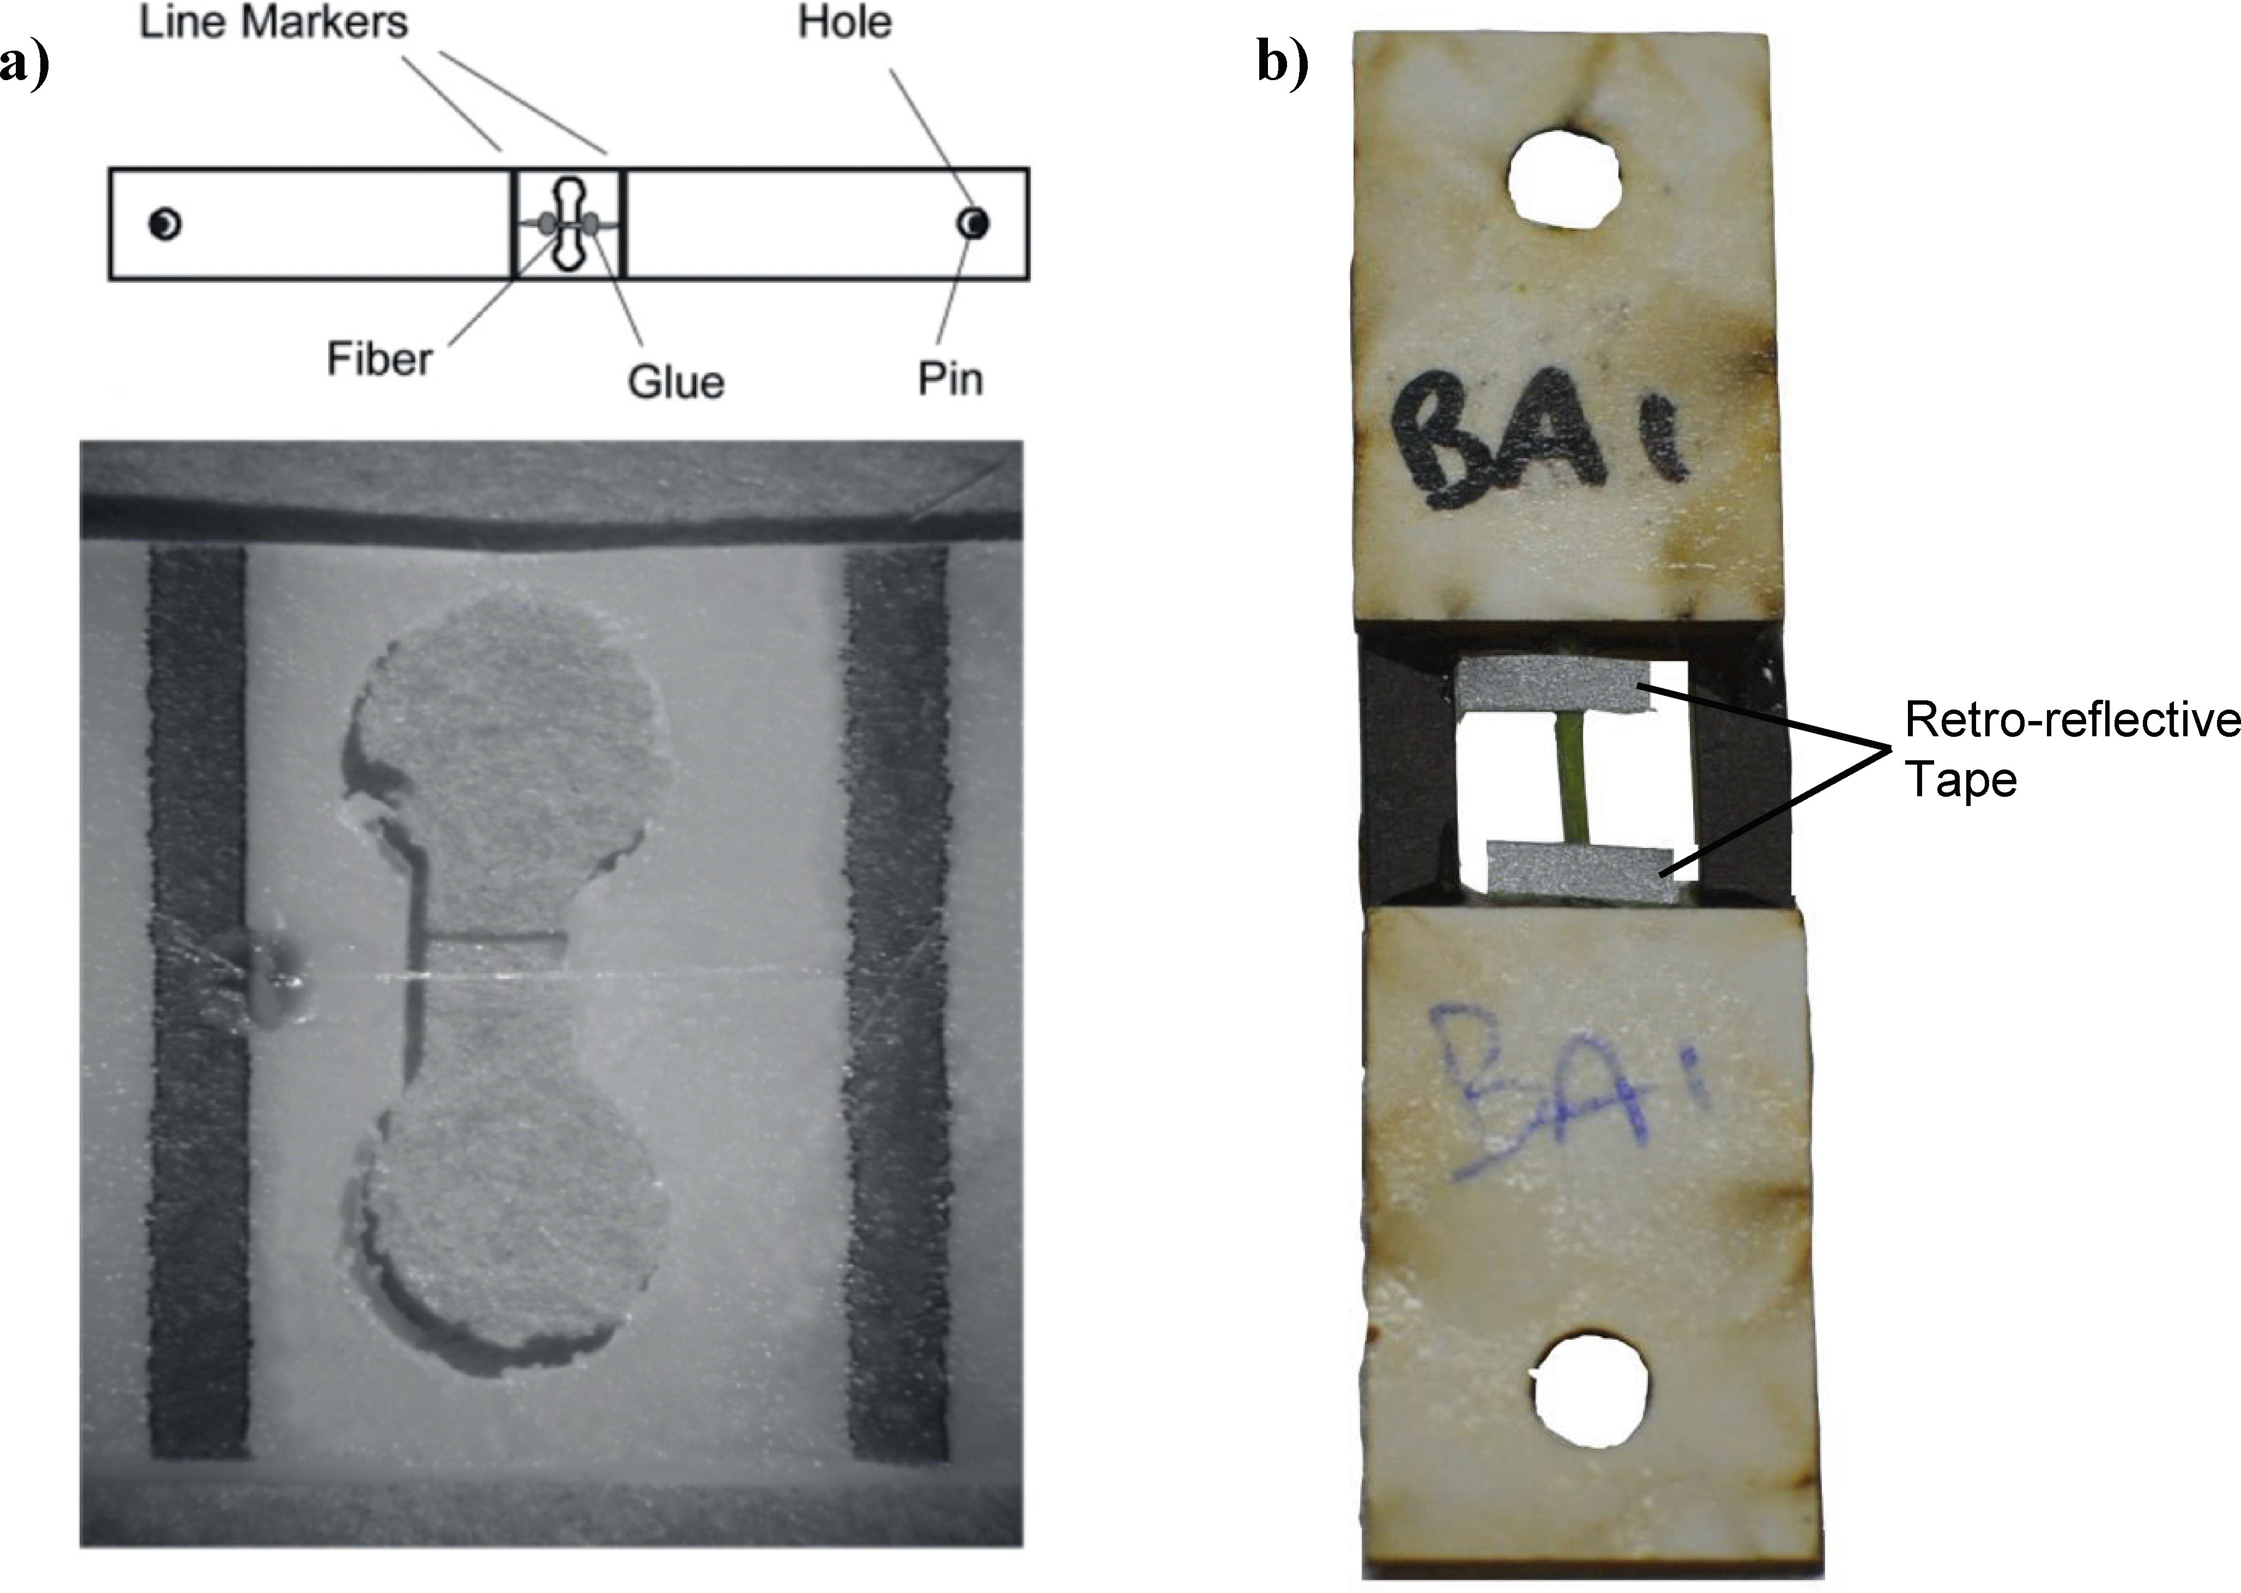
Figure 10: Tensile testing of stems may require the use of mounting systems. a) Foliar frames, made from a single-cell-thick foils of wood, used in a microtensile test tester for testing etiolated hypocotyls (Burgert et al., 2003). b) Card frame, with laser-cut grooves at the end, used for testing genetically modified Arabidopsis stems (Shah et al., 2015). Retro-reflective tapes are used for strain monitoring using a laser extensometer.

Pure compression testing
As far as we know, stems in nature do not fail in pure compression. However, comparing tensile properties with compressive properties (obtained through compression tests at low length to diameter ratios, say 1:1 (Wright et al., 2005), where bending doesn’t occur) can help determine which of the modes (viz. tensile or compressive) is more detrimental in bending, which is a mixed-mode of loading. One should, however, be cautious when comparing compressive properties of one species with another, as loading conditions and specimen geometry have a significant effect on compressive behaviour. One such factor is the straightness of the specimen.

Compression buckling testing
Compressive buckling tests are useful in understanding the failure process of stems. Such tests also elucidate aspects of plant biomechanics, such as determining the tallest self-supporting stem length. Buckling tests have been carried out on tree stems of European chestnut (Castanea sativa), European oak trees (Quercus robur) and black locust (Robinia pseudoacacia) by Frese and Blass (2014). Their results highlight the importance of measuring the lack of straightness in the specimens, which reduces their failure buckling load.
The failure mode of stems in buckling depends on their geometry. In stocky stems, it is typically by ovalisation and kinking of the wall of hollow stems, or microbuckling of fibres. This is corroborated by compression loading of hollow septate stems of the giant reed Arundo donax, at specimen length to diameter ratios of approximately 50, where ovalisation of the stem cross-section leads to longitudinal splitting of the stem wall (Spatz et al., 1997). In slender stems, failure is by global buckling. For instance, Spatz et al. (1998) suggest that at length to diameter ratios of around 200-250, living hollow stems of Equisetum giganteum fail by global buckling, unless they find external support.
The possibility of longitudinal splitting is higher in hollow stems than in solid stems (Spatz et al., 1998). This is because circular cross-section hollow stems become elliptical when subjected to buckling loads. This ovalisation and large decrease in the apparent diameter of the stem leads to a reduction in second moment of area, and consequently, a drop in bending moment is observed even before critical strains of the material are reached. The three critical findings from any compression buckling test are i) the elastic modulus in the linear region, ii) the critical curvature, and the maximum bending moment/load. These can then be used to find useful information such as the critical compressive strain, which is often in the range of 0.5-1.5%, similar to that of the strengthening sclerenchymatous tissues in plant stems (Spatz et al., 1998).
The presence of nodes can also alter the modes of failure in compression. It is well-accepted that nodes operate as transverse struts and braces to reduce the possibility of Brazier wall buckling (Brazier, 1927) (refer to Box 1 for definition). However, due to the large stress-strain gradients at the vicinity of a node, nodes may also act as stress-concentrators.

Anisotropy and properties in transverse directions
In its natural state, a stem predominantly resists forces along its axis and, as a result, it is far weaker in the direction orthogonal to the axis of the stem. Where the stem branches, there may be a component of force in this direction, and experimental methods have been developed to study the properties of that junction (Masselter et al., 2011, Slater and Ennos, 2013). Robertson et al. (2015) tested corn, giant reed and bamboo in compression in the orthogonal direction. Where whole stems are used or processed for other purposes, the mechanical properties in this direction may be important. An example of this is the use of full-culm bamboo in construction (Sharma et al., 2013).
Plant materials, when subjected to uni-axial tensile or compressive loads, will not only extend or contract in that direction, but will also contract or expand in orthogonal directions. This phenomenon is captured by the ‘Poisson’s ratio’, which is a ratio of the negative transverse strain to the axial strain resulting from a load. Of course, multi-axial loading will lead to combined effects. The Poisson’s ratio can be used to inform other useful material properties such as bulk modulus, which is the resistance of a material to change in volume when subjected to ’hydrostatic loads’, or uniform loading from all directions. Hejnowicz and Sievers (1995) measured the Poisson’s ratio of tissues from herbaceous plants using microphotography, by measuring changes in transverse and longitudinal dimensions as a function of applied strain.
Plant stems, much like aligned fibre-reinforced composite structures, exhibit anisotropy. The anisotropy exists in morphology and structure (viz. slender morphology of stems, and aligned, high-aspect ratio (fibre) cells within the stem, and cellulose microfibrils within the cells), stress distribution, and growth and development (Baskin, 2015, Baskin and Jensen, 2013). Studies on anisotropy are therefore crucial in stem growth and morphogenesis. Anisotropy can be measured through a ratio in mechanical properties orthogonal directions (such as elastic modulus in the transverse and longitudinal direction); this is common in wood science and technology (Forest Products Laboratory, 2010). It is also possible to compare measured stresses and strains in orthogonal directions (Baskin, 2015, Silk and Abou Haidar, 1986, Hejnowicz and Sievers, 1995, Hejnowicz et al., 2000).

Other forms of loading
Shear properties of stems are commonly evaluated by torsion tests (Vogel, 1992, 1995b, Niklas, 1997a, Spatz et al., 1997). In larger torsion tests, a metal bar may be screwed (Vogel, 1995), or glued (Niklas, 1997a) to the end of the horizontal stem at its centreline, and a torsion applied by an offset mass. In smaller stems, the ends of the stem may be mounted vertically, and glued into caps loaded by wires to apply torsion (Vogel, 1992).
Peel and tear tests, or short-beam shear tests (a three-point bending set-up with a small span-to-depth ratio) can be performed on stems to ascertain the inter-facial or inter-laminar properties (Skubisz, 2001). These include interfaces between primary and secondary phloem tissue, and can even be monitored over the life-cycle of a plant (Goodman et al., 2002). Such tests reveal information on optimal harvest time, for example, as well as enabling to monitor the effects of dessication.
To assess mechanical properties at the cell-wall level (micro- and nano-scale), methods such as nanoindentation, atomic force microscopy, and cellular force microscopy are commonly used. These nanomechanical tests have been reviewed by Burgert and Keplinger (2013) and Milani et al. (2013). Nanoindentation hardness testing involves penetration of an indenter tip with known geometry (e.g. Berkovich, spherical, and power-law indenters) onto the sample surface, and simultaneous measurement of a load-displacement curve. From these measurements, estimates of surface hardness, a measure of resistance to plastic deformation from indentation loads, and elastic modulus in compression can be obtained. Atomic force microscopy measures properties at an even smaller scale, through the use of a tip that is mounted onto a cantilever-loaded spring. The force and deflection of the cantilever as it scans over the sample surface is measured to then produce images based on mechanical property measurements. Both these nanomechanical testing methods rely on substantial sample preparation, particularly as flat surface are required. This often includes the embeddment of samples into resins and subsequent surface polishing. Furthermore, these tests are often carried out on only a small region of a plant cell wall, and therefore conclusions on the properties of a whole stem or even tissue, which are naturally variable and heterogeneous structures, should be made with care.

Time-dependent and cyclic-loading behaviour
Tests on the time-dependent behaviour of stems have been used to investigate the processes responsible for growth of plants, and have therefore often been carried out on living plants (in vivo) or on plants submerged in water (in vitro). As has been expressed previously, living plants are especially dynamic structures with active cell walls. The turgor pressure produces the irreversible expansion of the cell wall which is part of the process of growth (Lockhart, 1965), although growth is not purely a mechanical process (Cosgrove and Jarvis, 2012). The extension and expansion of cells due to turgor pressure in vivo is time-dependent and has been investigated using creep test methods, also referred to as well extension assays, particularly by Cosgrove et al (Park and Cosgrove, 2012, Cosgrove, 1993, 2010). The deposition of the secondary cell wall occurs after this expansion is completed (Nishitani and Demura, 2015), and so the study of the irreversible deformation producing growth uses stems with predominantly primary cell walls, such as etiolated hypocotyls.
Creep under constant load in stems has been commonly measured, both in vivo and in vitro, with a set of masses suspended over a low-friction lever attached to the specimen (Kutschera and Schopfer, 1986, Kutschera and Briggs, 1987, Nonami and Boyer, 1990, Edelmann and Kohler, 1995, Suslov and Verbelen, 2006). The shape of the living plant may provide a convenient location for load application, such as the hypocotyl hook in soybean stems (Nonami and Boyer, 1990). For tests on epidermal strips, Kutschera and Briggs (1987) left the part of the stem to be clamped intact, while peeling the remainder to leave just the epidermis. Kutschera and Schopfer (1986) glued stem sections into hollow steel needles at either end, and the same method was followed by Edelmann and Kohler (1995), and then Suslov and Verbelen (2006).
Tests under cyclic load show the recoverable and irrecoverable components of deformation, as well as hysteresis resulting from plastic and viscoelastic behaviour. There may therefore be differences in the paths on a force-displacement diagram for first loading and an unload-reload cycle, as shown in Figure 11. Further cycles of loads may be applied at the same load (i.e. constant amplitude loading) or higher loads (i.e. progressive loading). The differences in properties extracted from the first and subsequent cycles of loading may highlight variations between plants; these differences would otherwise not be observed through monotonic/static tests.
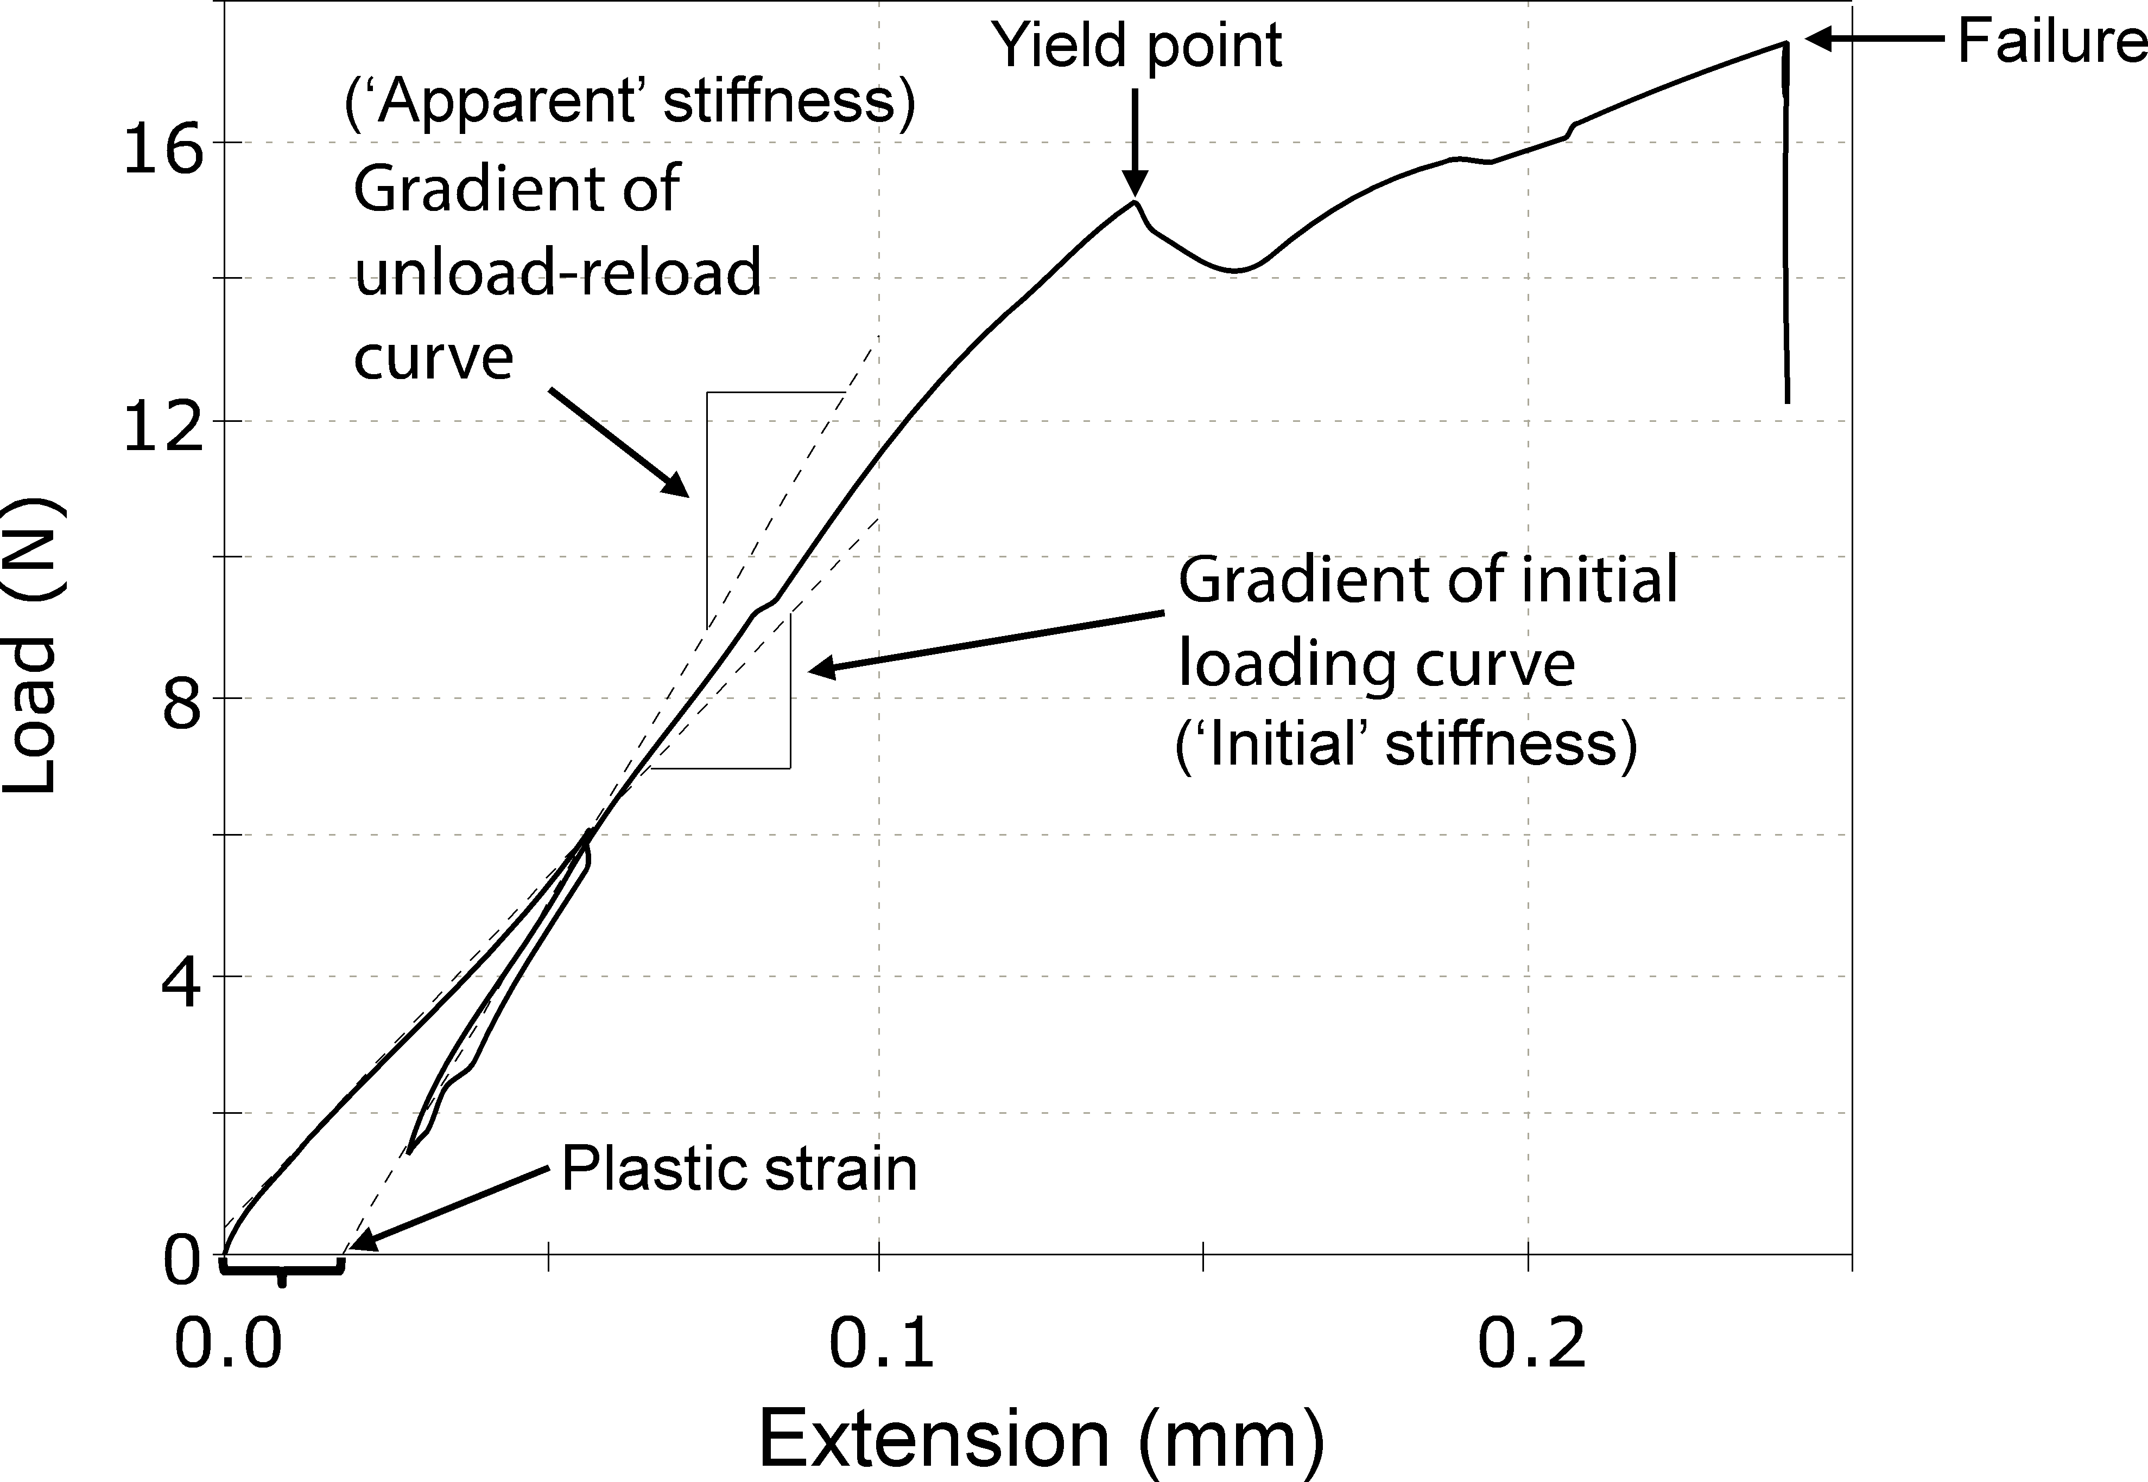
Figure 11: A typical load-displacement curve obtained from a single-cycle tensile test carried out on a basal stem section of Arabidopsis thaliana, showing an increase in stiffness and the development of irreversible ‘plastic strain’ after the first unload. The stress (or strength) at yield and failure can also be determined. Adapted from (Shah et al., 2015).
Several researchers (Kohler and Spatz, 2002, Shah et al., 2015, Abasolo et al., 2009, Nolte and Schopfer, 1997) have considered cyclic loading of stems. Kohler and Spatz (2002) noted the increase in hysteresis under cyclic load in plants with reduced lignin in the secondary cell wall, using chemically modified Aristolochia macrophylla and transgenic Arabidopsis thaliana. Many plant materials show a higher stiffness on the second and subsequent cycles of load. Abasolo et al. (2009) tested etiolated hypocotyls of Arabidopsis thaliana and noted the effect of altered pectin content on this stiffening. Studying the cyclic loading behaviour of living plants in particular demonstrates that it is not just polymer remodelling that causes this type of differential material behaviours in cyclic loading, but also the cellular responses to alter the cell wall deposition and composition.
In modal testing, one can measure the dynamic response of a structure to an applied force, as a function of frequency. Such an analysis determines information such as the resonant (natural) frequencies of vibration, damping ratios and mode shapes of a structure. Modal analysis of plants has been used to isolate the reversible elastic behaviour which results in a set of natural frequency. The branched systems of plants in vivo have a high modal density, making the identification of individual modes challenging (Rodriguez et al., 2008, Langre et al., 2012). Der Loughian et al. (2014) found that the frequency of local modes, rather than global ones, were less sensitive to the size of the plant, and therefore may be more useful for phenotyping.

Summary
Different test methods can reveal different properties of stems (Table 1). Three-point bending is the most common form of mechanical test carried out on stems, with its single biggest advantage being that no clamping is required, resulting in a simple test set-up. However, to ensure that shear contributions are not significant, a minimum span-to-depth ratio (of 20) is recommended. A four-point bend test is attractive as shear deformation is entirely eliminated, although relatively more instrumentation is required. Both three- and four-point bending result in large stress-concentrations at the loading point, which lead to significant changes in cross-section (due to ovalisation) and result in premature stem failure due to local crushing. The selection of an appropriate anvil shape (e.g. rounded anvil) is therefore recommended.
Although bending is a common mode of failure of stems in their natural environment, plants have developed structural strategies which balance twisting, shear, and local and global buckling. In buckling tests, specimen eccentricity and specimen length-to-diameter ratio (slenderness ratio) are important factors, particularly when comparing results from one study with another.
Even though it is not a natural mode of failure, tensile loading may give an insight into fundamental material properties in the stem. Furthermore, the error associated in determining cross-section area (for tensile properties) is much lower than than determining second moment of area (which is required for flexural properties), and therefore tensile properties can be more accurately measured. However, testing stems in tensile mode requires substantial specimen preparation. It is recommended that the stem ends are not clamped directly, as this is likely to result in premature failure at the grips. Rather, the use of frames (e.g. folial, or card) on which the stem is mounted for testing or other techniques to protect the ends from damage during gripping (e.g. encapsulating the ends in polymer blocks or tubing) is recommended. If mounting frames are being used, which are particularly attractive for small, non-stiff stems, adhesives with gap-filling properties, high shear stiffness, and low-exotherm ambient-curing properties should be utilised. The use of direct strain-measurement techniques, such as laser extensometry, is also recommended, to ensure that extension upon load application is due to elastic/plastic deformation of the stem and not slippage at the clamps. Specimen gauge length needs to be specifically noted in tensile tests, and should be accounted for when comparing studies together.
Plant stems, like all materials made from polymeric building-blocks, are viscoelastic in nature. Consequently, their properties are time- and rate-dependent. Therefore, in any testing methodology, testing rates need to be appropriately controlled; as a rule of thumb, failure time should be around 60-90 seconds. In addition, the use of time-dependent loading regimes, such as in cyclic (low- and high-cycle fatigue) or creep/stress-relaxation tests, would inform us of the micro-mechanisms governing the viscoelastic behaviour of the stem material.
Finally, in mechanical testing, measurement and interpretation of geometry is required to ensure that test results and conclusions are meaningful. The use of imaging techniques, including optical microscopy (post-testing) and non-destructive X-ray scanning (prior to testing), would enable accurate assessment of geometry, particularly in the case of hollow and/or irregular cross-section stems. Parameters such as bulk and absolute density are also useful in evaluating the ratio of solid (structure-supporting) material in the cellular stems.

Afterword
The field of experimental botany has become increasingly interdisciplinary, promoting dialogue and collaboration between biologists, engineers, physicists and mathematicians. We ourselves, as architects, structural engineers and materials scientists, engage with plant cell-wall biochemists and chemists in across-the-scales research to understand and manipulate molecular organisation within plant cell walls to inform the development of high-performance buildings in timber and bamboo for a sustainable built environment (Ramage et al., 2017).
As such collaborations become increasingly common, offering new opportunities to obtain important experimental information that was not available before, there is a growing need to standardise, or at least offer guidelines, for the experimental testing and reporting of botanical structures. This methodological review was therefore written for a cross-disciplinary audience, particularly for biologists interested in measuring mechanical properties of their biological materials, for example for phenotyping (e.g. transgenic or cell-wall mutant plants, database generation by core collection of genotypes), and engineers, who frequently test man-made materials, and are interested in studying biological materials, which however require specific considerations and even a re-think in measurement approach in comparison to man-made materials. We have tried to provide an overview on stem biology and mechanics, particularly how they relate to each other, and address the questions of how to test plant stems and what can we learn from such tests?
The principal discussions and recommendations in this review on appropriate methodology for mechanical metrology of plant stem structures can be further extended to any rod-shaped plant organ, such as petioles, midribs and roots.
An appropriate test method, combined with an understanding of the structural strategies employed by a plant stem, can reveal opportunities for improved use of crops, biomimicry in man-made materials, the best use of materials derived from plant stems, and significant development in the field of plant sciences and cell-wall research.

Acknowledgements
This work is part of a project funded by the Leverhulme Trust (Project title: ‘Natural material innovation’). The project forms a collaboration with the Dept. of Applied Mathematics and Theoretical Physics, Dept. of Biochemistry, Dept. of Chemistry, and Dept. of Plant Sciences at the University of Cambridge. We specially thank our collaborators at the Dept. of Biochemistry (Prof Paul Dupree, Dr Marta Busse-Wicher, Dr Li Yu and Mr Jan Lyczakowski) for introducing us to the challenge of testing plant stem materials. We also thank Dr Bruno Moulia (Institut National de la Recherche Agronomique, INRA, France) and the reviewers for their valuable comments on the drafts of this manuscript.

References
Abasolo, W., Eder, M., Yamauchi, K., Obel, N., Reinecke, A., Neumetzler, L., Dunlop, J., Mouille, G., Pauly, M., Hofte, H., and Burgert, I. (2009). Pectin may hinder the unfolding of xyloglucan chains during cell deformation: Implications of the mechanical performance of arabidopsis hypocotyls with pectin alterations. Molecular Plant, 2(5):990–999.
Altaner, C., Thomas, L., Fernandes, A., and Jarvis, M. (2014). How Cellulose Stretches: Synergism between Covalent and Hydrogen Bonding. Biomacromolecules, 15:791–798.
Ampofo, J., Ofori, E., and Ibrahim, A. (2013). Mechanical properties of plantain pseudostem and implications for susceptibility to lodging. Journal of Agriculture and Environment for International Development, 107(1):3–11.
ASTM (2012). ASTM D1036 - 99(2012): Standard test methods of static tests of wood poles.
ASTM (2013). D5034 – 09 Standard Test Method for Breaking Strength and Elongation of Textile Fabrics (Grab Test).
Badel, E., Ewers, F.W., Cochard, H., and Telewski, F.W. (2015). Acclimation of mechanical and hydraulic functions in trees: impact of the thigmomorphogenetic process. Frontiers in Plant Science, 6: 266.
Baskin, T. (2015). Anisotropic expansion of the plant cell wall. Annual Review of Cell and Developmental Biology, 21:203–222.
Baskin, T. and Jensen, O. (2013). On the role of stress anisotropy in the growth of stems. Journal of Experimental Botany, 64:4697–4707.
Bledzki, A. and Gassan, J. (1999). Composites reinforced with cellulose based fibres. Progress in Polymer Science, 24:221–274.
Brazier, L. (1927). On the Flexure of Thin Cylindrical Shells and Other ‘Thin’ Sections. Proceedings of the Royal Society A: Mathematical, Physical and Engineering Sciences, 116(773):104–114.
Brereton, N., Ahmed, F., Sykes, D., Ray, M., Shield, I., Karp, A., and Murphy, R. (2015). X-ray micro-computed tomography in willow reveals tissue patterning of reaction wood and delay in programmed cell death. BMC Plant Biology, 15:83.
BSI (1957). BS 373 Methods of testing small clear specimens of timber.
BSI (2005). BS EN 14251:2003 Structural Round Timber. Test Methods.
Burgert, I., Fruhmann, K., Keckes, J., Fratzl, P., and Stanzl-Tschegg, S.E. (2003). Microtensile testing of wood fibers combined with video extensometry for efficient strain detection. Holzforschung, 57(6):661–664.
Burgert, I. and Keplinger, T. (2013). Plant micro- and nanomechanics: experimental techniques for plant cell-wall analysis. Journal of Experimental Botany, 64:4635–4649.
Caliaro, M., Schmich, F., Speck, T., and Speck, O. (2013). Effect of drought stress on bending stiffness in petioles of Caladium bicolor (Araceae). American Journal of Botany, 100(11):2141–2148.
Cavalier, D., Lerouxel, O., Neumetzler, L., Yamauchi, K., Reinecke, A., Freshour, G., Zabotina, O., Hahn, M., Burgert, I., Pauly, M., Raikhel, N., and Keegstra, K. (2008). Disrupting two arabidopsis thaliana xylosyltransferase genes results in plants deficient in xyloglucan, a major primary cell wall component. The Plant Cell, 20(6):1519–1537.
Charra-Vaskoua, K., Badela, E., Charrier, G., Ponomarenko, A., Bonhomme, M., Foucat, L., Mayr, S., and Ameglio, T. (2016). Cavitation and water fluxes driven by ice water potential in juglans regia during freeze–thaw cycles. Journal of Experimental Botany, 67:739–750.
Christoforo, A., Lahr, F., Morales, E., Zangiacomo, A., and Panzera, T. (2012). Influence of Displacements on Calculus of the Longitudinal Modulus of Elasticity of Pinus caribaea Structural Round Timber Beams. International Journal of Agriculture and Forestry, 2(4):157–160.
Cosgrove, D. (1993). Wall extensibility: its nature, measurement and relationship to plant cell growth. New Phytologist, 124:1–23.
Cosgrove, D. and Jarvis, M. (2012). Comparative structure and biomechanics of plant primary and secondary cell walls. Frontiers in Plant Science, 3:204.
Cosgrove, D. J. (2010). Measuring in vitro extensibility of growing plant cell walls. In The Plant Cell Wall, pages 291–303. Humana Press, Totowa, NJ.
Crook, M. and Ennos, A. (1996). Mechanical differences between free-standing and supported wheat plants, Titicum aestivuml. Annals of Botany, 77:197–202.
Davison, B., Parks, J., Davis, M., and Donohoe, B. (2013). Plant cell walls: Basics of structure, chemistry, accessibility and the influence on conversion. In Wyman, C. E., editor, Aqueous pretreatment of plant biomass for biological and chemical conversion to fuels and chemicals. John Wiley & Sons, Ltd, Chichester, UK.
Der Loughian, C., Tadrist, L., Allain, J., Diener, J., Moulia, B., and de Langre, E. (2014). Measuring local and global vibration modes in model plants. Comptes Rendus Mecanique´, 342(1):1–7.
Edelmann, H. and Kohler, K. (1995). Auxin increases elastic wall-properties in rye coleoptiles: implications for the mechanism of wall loosening. Physiologia Plantarum, 93:85–92.
Ennos, A. and van Casteren A (2010). Transverse stresses and modes of failure in tree branches and other beams. Proceedings of the Royal Society B, 277:1253–1258.
Etnier, S. (2001). Flexural and Torsional Stiffness in Multi-Jointed Biological Beams. Biological Bulletin, 200:1–8.
Etnier, S. and Vogel, S. (2000). Reorientation of daffodil (Narcissus: Amaryllidaceae) flowers in wind: Drag reduction and torsional flexibility. American Journal of Botany, 87(1):29–32.
Evans, L., Kahn-Jetter, Z., Marks, C., and Harmoney, K. (2007). Mechanical properties and anatomical components of stems of 42 grass species. The Journal of the Torrey Botanical Society, 134(4):458–467.
Faisal, T., Rey, A., and Pasini, D. (2013). A multiscale mechanical model for plant tissue stiffness. Polymers, 5:730–750.
Falk, S., Hertz, C., and Virgin, H. (1958). On the relation between turgor pressure and tissue rigidity. I Experiments on resonance frequency and tissue rigidity. Physiologia Pantarum, 11:802–817.
Forest Products Laboratory, editor (2010). Wood handbook: Wood as an engineering material, volume 47. Department of Agriculture, Forest Service, Forest Products Laboratory, Madison, WI.
Fournier, M., Dlouha, J., Jaouen, G., and Almeras, T. (2013). Integrative biomechanics for tree ecology: beyond wood density and strength. Journal of Experimental Botany, 64:4793–4815.
Frese, M. and Blass, H. (2014). Naturally Grown Round Wood – Ideas for an Engineering Design. In Materials and Joints in Timber Structures, pages 77–88. Springer Netherlands, Dordrecht.
Gassan, J., Chate, A., and Bledzki, A. (2001). Calculation of elastic properties of natural fibers. Journal of materials science, 36:3715–3720.
Gibson, L. (2005). Biomechanics of cellular solids. Journal of Biomechanics, 38:377–399.
Gibson, L. (2012). The hierarchical structure and mechanics of plant materials. Journal of Royal Society Interface, 9:2749–2766.
Goodman, A., Ennos, A. R., and Booth, I. (2002). A mechanical study of retting in glyphosate treated flax stems (Linum usitatissimum). Industrial Crops and Products, 15:169–177.
Goubet, F., Barton, C., Mortimer, J., Yu, X., Zhang, Z., Miles, G., Richens, J., Liepman, A., Seffen, K., and Dupree, P. (2009). Cell wall glucomannan in Arabidopsis is synthesised by CSLA glycosyltransferases, and influences the progression of embryogenesis. The Plant Journal, 60:527–538.
Hale, S., Gardiner, B., Wellpott, A., Nicoll, B., and Achim, A. (2012). Wind loading of trees: influence of tree size and competition. European Journal of Forest Research, 131:203–217.
Hejnowicz, Z., Rusin, A., and Rusin, T. (2000). Tensile tissue stress affects the orientation of cortical microtubules in the epidermis of sunflower hypocotyl. Journal of Plant Growth Regulation, 19:31–44.
Hejnowicz, Z. and Sievers, A. (1995). Tissue stresses in organs of herbaceous plants I. Poisson ratios of tissues and their role in determination of the stresses. Journal of Experimental Botany, 46:1035–1043.
Henry, H. and Thomas, S. (2002). Interactive effects of lateral shade and wind on stem allometry, biomass allocation, and mechanical stability in Abutilon theophrasti (Malvaceae). American Journal of Botany, 89(10):1609–1615.
Hofstetter, K. and Gamstedt, E.K. (2009). Hierarchical modelling of microstructural effects on mechanical properties of wood: A review. Holzforschung, 63:130–138.
Hooke, R. (1678). Lectures de Potentia Restitutiva. Royal Society.
ISO (1974). ISO 3060:1974 Textiles – Cotton fibres – Determination of breaking tenacity of flat bundles.
ISO (1988). ISO 6939:1988 Textiles – Yarns from packages – Method of test for breaking strength of yarn by the skein method.
ISO (1989). ISO 9073-3:1989 Textiles – Test methods for nonwovens – Part 3: Determination of tensile strength and elongation.
ISO (1995). ISO 5079:1995 Textile fibres – Determination of breaking force and elongation at break of individual fibres.
ISO (2003). ISO 16978:2003 Wood-based panels – Determination of modulus of elasticity in bending and of bending strength.
ISO (2013). ISO 13934-1:2013 Textiles – Tensile properties of fabrics – Part 1: Determination of maximum force and elongation at maximum force using the strip method.
ISO (2015). ISO 16616:2015 Test methods for natural fibre-reinforced plastic composite (NFC) deck boards.
Karam, G. and Gibson, L. (1994). Biomimicking of animal quills and plant stems: natural cylindrical shells with foam cores. Materials Science and Engineering C, 2:113–132.
Kirkby, R. (1996). Chloroplasts. Microsoft Corporation, Oxford Scientific Films.
Kohler, L. and Spatz, H. (2002). Micromechanics of plant tissues beyond the linear-elastic range. Planta, 215(1):33–40.
Kokubo, A., Kuraishi, S., and Sakurai, N. (1989). Culm strength of barley: Correlation among maximum bending stress, cell wall dimensions, and cellulose content. Plant Physiology, 91:876–882.
Kromer, K. (2009). Physical properties of flax fibre for non-textile-use. Research in Agricultural Engineering, 55:52–61.
Kutschera, U. and Briggs, W. (1987). Differential effect of auxin on in vivo extensibility of cortical cylinder and epidermis in pea internodes. Plant Physiology, 84(4):1361–1366.
Kutschera, U. and Schopfer, P. (1986). Effect of auxin and abscisic acid on cell wall extensibility in maize coleoptiles. Planta, 167(4):527–535.
Langre, E., Rodriguez, M., Ploquin, S., and Moulia, B. (2012). The multimodal dynamics of a walnut tree : experiments and models. Journal of Applied Mechanics, 79:044505.
Leblicq, T., Vanmaercke, S., Ramon, H., and Saeys, W. (2015). Mechanical analysis of the bending behaviour of plant stems. Biosystems Engineering, 129:87–99.
Lemloh, M., Pohl, A., Weber, E., Zeiger, M., Bauer, P., Weiss, I., and Schneider, A. (2014). Structure-property relationships in mechanically stimulated Sorghum bicolor stalks. Bioinspired Materials, 1:1–11.
Leroux, O. (2012). Collenchyma: a versatile mechanical tissue with dynamic cell walls. Annals of Botany, 110:1083–1098.
Lim, J., Yeo, H., and Lee, J. (2011). Study on the Evaluation of Performance for Pitch Pine Round Timbers as Safety Barrier Beam Members. Journal of the Korean Wood Science and Technology, 39(5):390–397.
Lockhart, J. (1965). An analysis of irreversible plant cell elongation. Journal of Theoretical Biology, 8(2):264–275.
Ludwig, F., de Bruyn, G., Thielen, M., and Speck, T. (2009). Plant stems as building material for living plant constructions. In 6th Plant Biomechanics Conference.
Masselter, T., Eckert, S., and Speck, T. (2011). Functional morphology, biomechanics and biomimetic potential of stem–branch connections in Dracaena reflexa and Freycinetia insignis. Beilstein Journal of Nanotechnology, 2(1):173–185.
Masselter, T. and Speck, T. (2008). Quantitative and qualitative changes in primary and secondary stem organization of Aristolochia macrophylla during ontogeny: functional growth analysis and experiments. Journal of Experimental Botany, 59:2955–2967.
Mattheck, C. (1995). Biomechanical optimum in woody systems. In Gartner, B., editor, Plant Stems: Physiology and Functional Morphology, pages 27–52. Academic Press Limited, London, UK.
McElrone, A., Choat, B., Parkinson, D., MacDowell, A., and Brodersen, C. (2013). Using high resolution computed tomography to visualize the three dimensional structure and function of plant vasculature. Journal of Visualised Experiments, 74:50162.
Milani, P., Braybrook, S., and Boudaoud, A. (2013). Shrinking the hammer: micromechanical approaches to morphogenesis. Journal of Experimental Botany, 64:4651–4662.
Morgan, J. and Cannell, M. (1987). Structural analysis of tree trunks and branches: Tapered cantilever beams subject to large deflections under complex loading. Tree Physiology, 3:365–374.
Moulia, B. (2013). Plant biomechanics and mechanobiology are convergent paths to flourishing interdisciplinary research. Journal of Experimental Botany, 64:4617–4633.
Moulia, B. and Fournier, M. (1997). Mechanics of the maize leaf: a composite beam model of the midrib. Journal of Materials Science, 32(10):2771–2780.
Moulia, B., Fournier, M., and Guitard, D. (1994). Mechanics and form of the maize leaf: in vivo qualification of flexural behaviour. Journal of Materials Science, 29(9):2359–2366.
Niklas, K. (1992). Plant biomechanics: An engineering approach to plant form and function. University of Chicago Press, Chicago, USA.
Niklas, K. (1997a). Relative Resistance of Hollow, Septate Internodes to Twisting and Bending. Annals of Botany, 80:275–287.
Niklas, K. (1997b). Responses of Hollow, Septate Stems to Vibrations: Biomechanical Evidence that Nodes Can Act Mechanically as Spring-like Joints. Annals of Botany, 80(4):437–448.
Niklas, K. (1998). Modes of Mechanical Failure of Hollow, Septate Stems. Annals of Botany, 81(1):11–21.
Niklas, K. and Paolillo, D. (1997). The role of the epidermis as a stiffening agent in tulipa (liliaceae) stems. American Journal of Botany, 84(6):735–744.
Nilsson, S., Hertz, S., and Falk, S. (1958). On the relation between turgor pressure and tissue rigidity. 2. Theoretical calculations on model systems. Physiologia Pantarum, 11:818–837.
Nishitani, K. and Demura, T. (2015). Editorial: An emerging view of plant cell walls as an apoplastic intelligent system. Plant and Cell Physiology, 56(2):177–179.
Nolte, T. and Schopfer, P. (1997). Viscoelastic versus plastic cell wall extensibility in growing seedling organs: a contribution to avoid some misconceptions. Journal of Experimental Botany, 48:2103–2107.
Nonami, H. and Boyer, J. (1990). Wall extensibility and cell hydraulic conductivity decrease in enlarging stem tissues at low water potentials. Plant Physiology, 93(4):1610–1619.
Onoda, Y., Richards, A., and Westoby, M. (2010). The relationship between stem biomechanics and wood density is modified by rainfall in 32 Australian woody plant species. New Phytologist, 185(2):493–501.
Park, Y. and Cosgrove, D. (2012). A revised architecture of primary cell walls based on biomechanical changes induced by substrate-specific endoglucanases. Plant Physiology, 158(4):1933–1943.
Paul-Victor, C. and Rowe, N. (2011). Effect of mechanical perturbation on the biomechanics, primary growth and secondary tissue development of inflorescence stems of Arabidopsis thaliana. Annals of Botany, 107(2):209–218.
Pickering, K. (2008). Properties and performance of natural-fibre composites. In Hodzic, A. and Shanks, R., editors, Properties and performance of natural-fibre composites. CRC Press LLC, Boca Raton.
Pieruschka, R. and Lawson, T. (2015). Special issue on phenotyping in plants - preface. Journal of Experimental Botany, 66:5385–5387.
Placet, V., Trivaudey, F., Cisse, O., Gucheret-Retel, V., and Boubakar, M. (2012). Diameter dependence of the apparent tensile modulus of hemp fibres: A morphological, structural or ultrastructural effect? Composites Part A: Applied Science and Manufacturing, 43(2):275–287.
Raines, C. et.al. (2013). Special Issue: Plant Biomechanics and Mechanobiology. Journal of Experimental Botany, 64:4617–4827.
Ramage, M., Burridge, H., Busse-Wicher, M., Fereday, G., Reynolds, T., Shah, D., Wu, G., Yu, L., Fleming, P., Densley-Tingley, D., Allwood, J., Dupree, P., Linden, P., and Scherman, O. (2017). The wood from the trees: The use of timber in construction. Renewable and Sustainable Energy Reviews, 68:333–359.
Ridley-Ellis, D. (2011). Introduction to timber grading: The european system of machine strength grading. In Strategic Integrated Research in Timber (SIRT) Research Update Workshop.
Robertson, D., Smith, S., and Cook, D. (2015). On measuring the bending strength of septate grass stems. American Journal of Botany, 102(1):5–11.
Rodriguez, M., Langre, E., and Moulia, B. (2008). A scaling law for the effects of architecture and allometry on tree vibration modes suggests a biological tuning to modal compartmentalization. American Journal of Botany, 95:1523–1537.
Ross, R., Wang, X., Mattson, J., Erickson, J., Forsman, J., Geske, E., and Wehr, M. (2001). Comparison of several nondestructive evaluation techniques for assessing stiffness and MOE of small-diameter logs. Research Paper. Madison, WI: US, Department of Agriculture, Forest Service, Forest Products Laboratory.
Rowe, N. and Speck, T. (2005). Plant growth forms: an ecological and evolutionary perspective. New Phytologist, 166:61–72.
Ruggeberg, M., Burgert, I., and Speck, T. (2010). Structural and mechanical design of tissue interfaces in the giant reed Arundo donax. Journal of Royal Society Interface, 7:499–506.
Ruggeberg, M., Speck, T., Paris, O., Lapierre, C., Pollet, B., Koch, G., and Burgert, I. (2008). Stiffness gradients in vascular bundles of the palm Washingtonia robusta. Proceedings of the Royal Society B, 275:2221–2229.
Ryden, P., Sugimoto-Shirasu, K., Smith, A., Findlay, K., Reiter, W., and McCann, M. (2003). Tensile properties of Arabidopsis cell walls depend on both a xyloglucan cross-linked microfibrillar network and rhamnogalacturonan II-borate complexes. Plant Physiology, 132(2):1033–1040.
Schuerch, H. (1966). Prediction of compressive strength in uniaxial boron fiber-metal matrix composite materials. AIAA Journal, 4(1):102–106.
Schulgasser, K. and Witztum, A. (1997). On the Strength of Herbaceous Vascular Plant Stems. Annals of Botany, 80(1):35–44.
Shah, D. (2013). Developing plant fibre composites for structural applications by optimising composite parameters: a critical review. Journal of Materials Science, 48(18):6083–6107.
Shah, D., Reynolds, T., Busse-Wicher, M., Yu, L., Dupree, P., and Ramage, M. (2015). Probing the role of xylan in irreversible deformation of stems of (Arabidopsis thaliana). In 8th Plant Biomechanics International Conference.
Shah, D., Schubel, P., Clifford, M., and Licence, P. (2012a). The tensile behavior of off-axis loaded plant fiber composites: an insight on the non-linear stress-strain response. Polymer Composites, 33(9):1494–1504.
Shah, D., Schubel, P., Licence, P., and Clifford, M. (2012b). Hydroxyethylcellulose surface treatment of natural fibres: the new ‘twist’ in yarn preparation and optimization for composites applicability. Journal of Materials Science, 47:2700–2711.
Sharma, B., Harries, K., and Ghavami, K. (2013). Methods of determining transverse mechanical properties of full-culm bamboo. Construction and Building Materials, 38:627–637.
Silk, W. and Abou Haidar, S. (1986). Growth of the stem of pharbitis nil: Analysis of longitudinal and radial components. Physiologie vegetale, 24:109–116.
Skubisz, G. (2001). Development of studies on the mechanical properties of winter rape stems. International Agrophysics, 15(3):197–200.
Skubisz, G. (2002). Method for the determination of the mechanical properties of pea stems. International Agrophysics, 16:73–77.
Slater, D. and Ennos, A. (2013). Determining the mechanical properties of hazel forks by testing their component parts. Trees, 27(6):1515–1524.
Smith, R. (1950). The role of mechanics in the evolution of the herbaceous plant stem. Botanical Gazette, 111(3):262–286.
Spatz, H., Beismann, H., Bruchert, F., Emanns, A., and Speck, T. (1997). Biomechanics of the giant reed Arundo donax. Philosophical Transactions of the Royal Society B, 352:1–10.
Spatz, H., Kohler, L., and Speck, T. (1998). Biomechanics and functional anatomy of hollow-stemmed sphenopsids. I. Equisetum giganteum(equisetaceae). American Journal of Botany, 85(3):305–314.
Speck, T. and Burgert, I. (2011). Plant stems: Functional design and mechanics. Annual Review of Materials Research, 41:169–193.
Suslov, D. and Verbelen, J. (2006). Cellulose orientation determines mechanical anisotropy in onion epidermis cell walls. Journal of Experimental Botany, 57(10):2183–2192.
Taiz, L. and Zeiger, E. (2010). Plant Physiology. The Benjamin Cummings Publishing Company.
Telewski, F.W. (1989). Structure and function of flexure wood in Abies fraseri. Tree Physiology. 5: 113–121.
Thomason, J., Gentles, F., and Brennan, A. (2011). Natural fibre cross sectional area effects on the determination of fibre mechanical properties. In 15th European Conference on Composite Materials (ECCM-15).
Usherwood, J., Ennos, A., and Ball, D. (1997). Mechanical and anatomical adaptations in terrestrial and aqautic buttercups to their respective environments. Journal of Experimental Botany, 48:1469–1475.
van Casteren, A., Sellers, W., Thorpe, S., Coward, S., Crompton, R., and Ennos, A. (2012). Why don’t branches snap? the mechanics of bending failure in three temperate angiosperm trees. Trees, 26:789–797.
Vestøl, G. I. and Høibø, O. (2010). Bending Strength and Modulus of Elasticity of Squares with Wane as Compared with Round Timber of Scots Pine (Pinus sylvestris). Forest Products Journal, 60(1):40–47.
Vogel, S. (1992). Twist-to-bend ratios and cross-sectional shapes of petioles and stems. Journal of Experimental Botany, 43(256):1527–1532.
Vogel, S. (1995). Twist-to-bend ratios of woody structures. Journal of Experimental Botany, 46(8):981–985.
Vogel, S. (1997). Relative Resistance of Hollow, Septate Internodes to Twisting and Bending. Annals of Botany, 80:275–287.
Wegst, U. and Ashby, M. (2007). The structural efficiency of orthotropic stalks, stems and tubes. Journal of Materials Science, 42:9005–9014.
Wright, C., Pryfogle, P., Stevens, N., Steffler, E., Hess, J., and Ulrich, T. (2005). Biomechanics of Wheat/Barley Straw and Corn Stover. Applied Biochemistry and Biotechnology, 121-124:5–19.
Zeng, X., Mooney, S., and Sturrock, C. (2015). Assessing the effect of fibre extraction processes on the strength of flax fibre reinforcement. Composites: Part A, 70:1–7.

