Analysis of a Single Point Tensioned Mooring System for Station Keeping of a Contra-rotating Marine Current Turbine
Joe Clarke, Gary Connor, Andrew Grant, Cameron Johnstone, Stephanie Ordonez-Sanchez
Energy Systems Research Unit,
Department of Mechanical Engineering,
University of Strathclyde,
Glasgow, UK
E-mail: esru@strath.ac.uk

Abstract
The Energy Systems Research Unit within the Department of Mechanical Engineering at the University of Strathclyde has developed a novel contra-rotating tidal turbine (CoRMaT). Novel aspects of this turbine include two contra-rotating sets of rotor blades directly driving an open-to-sea permanent magnet generator. The balancing of reactive forces by the use of contra-rotation enables the use of a single point compliant mooring system for station keeping. A series of tank and sea tests have led to the deployment and demonstration of a small stand-alone next generation tidal turbine.

The stability of a single-point mooring system is examined and power quality from the direct drive generator is evaluated. It is noted that good stability from a single point mooring can be achieved within a real tidal stream; however from sea testing of the turbine off the west coast of Scotland in the Sound of Islay, it is shown that some instabilities in device station keeping may have an effect on the output electrical power quality. Finally, the scaling up of the power take-off and delivery options for a 250kW production prototype are described and assessed. It was concluded that the most promising option was an enlarged version of the system already tested, namely a direct-drive contra-rotating permanent magnet generator.

Keywords: contra-rotating, stability, tidal, turbine.
Nomenclature
a = axial flow factor
C_{P} = power coefficient
C_{T} = thrust coefficient
η = efficiency
γ = yaw angle

Abbreviations
BEM = Blade Element Momentum
CAD = Computer Aided Design
CFD = Computational Fluid Dynamics
CoRMaT = Contra Rotating Marine Turbine
FFT = Fast Fourier Transform
IG = Induction Generator
IGBT = Insulated Gate Bipolar Transistor
PMG = Permanent Magnet Generator
PWM = Pulse Width Modulation
Rpm = Revolutions per minute
SCR = Silicon Controlled Rectifier
TSR = Tip Speed Ratio

- Introduction
A contra-rotating marine current turbine has been developed by the Energy Systems Research Unit (ESRU) at the University of Strathclyde. The concept and its realisation have been widely reported [1-2], and it is claimed that a major advantage of the contra-rotating configuration is the elimination of reactive torque. Thus it has been postulated that a neutrally buoyant turbine could be ‘flown’ from a simple single point compliant mooring and provide good station keeping performance. Such an arrangement has a number of significant advantages:
- The cost of installation and recovery is significantly reduced over 1st generation pile or jacket mounted turbines.
- The device is free to yaw and align with the tidal flow (which is unlikely to be strictly bi-directional), and therefore energy capture is increased for all states of the tide.
- Opting for a single point mooring facilitates the deployment within sites in deep water and yet still allows operation in the upper section of the water column where the tidal velocity is greater, thus maximising power output.

- Tidal Turbine Station Keeping
One of the main concerns regarding marine current energy converters is the station keeping system. Up to this point the most common structure adopted by designers has been the use of rigid fixtures as in devices such as the Openhydro’s Open-centre Turbine or MCT’s Seagen device. This is an acceptable if rather expensive solution for full-scale demonstrations in shallow waters of less than 40m depth. Present technology does not permit the use of piled foundations in deeper waters, >40m. It is likely that deeper water turbines would probably need to avoid the use of piled foundations in any case, due to difficulties with their natural periods [3]. In order for a step change in the reduction of tidal turbine costs to be realised, cheaper and more versatile mooring systems are urgently required: marine energy technology needs to prove that it can produce green energy at a low cost in order to be a competitive supplier [4].
The fundamental concept of ESRU’s CoRMaT design is a neutrally-buoyant turbine that can be supported from a single-point flexible mooring. The drag force on the turbine would ensure alignment with the flow, and the absence of any significant reaction torque (as a result of the contra-rotating turbine configuration) would confer stability. The system may operate in deep or shallow water, at any chosen height within the water column, as shown in Fig 1.

A stable underwater device must have its centre of gravity vertical to the centre of buoyancy. This would be an inconvenience in the design of our desired neutrally buoyant system due to the large mass of the power conversion mechanism. Even at small scales, the device would require an extra float to add sufficient buoyancy [5]. If the wave environment is not critical the extra float might not be a problem; however, it has been shown in [3] that many locations with high tidal currents have high wave energy densities. This means that during the design stage, it is important to consider the natural frequencies of the system, for the float, the turbine, and the mooring lines; and to ensure that oscillations will not be excited by the wave patterns.

The design of the CoRMaT device enables it to ‘weather-vane’ with the direction of the flow; thus response of the system during slack water and to changes in direction of the tidal current is of great importance. This response also needs to be able to accommodate the potential for contact between the mooring lines themselves and with the rotor blades of the device. Initially a number of solutions were considered and included the use of a powered yaw control system (a small propeller) or even the use of the turbine itself as a thruster to keep the lines in tension [5]. However, in order to maintain simplicity and keep the control systems passive, with careful design and referencing approaches used in the offshore marine engineering industry, buoyancy effects alone have proven sufficient to control slack-water behaviour.

The dynamic response of a flexibly moored marine current turbine would also be affected by naturally occurring disturbances in the stream and the wake effects of neighbouring devices. These effects may lead to oscillations of the device or of its mooring system. Thus, it is of fundamental importance to predict, quantify and eliminate (where possible) the instabilities of the system in order to achieve an optimal design. The additional use of hydrofoil dampers could be a way to reduce instabilities; however, these would increase the complexity of the system. The use of an active control mechanism [6] would do likewise. In the case of modern wind turbines, these are commonly fitted with variable-pitch blades as a performance control mechanism. They also require active yaw control. Therefore, the same possibilities are applicable to marine current turbines but in this case, the harsh environment restricts the access to site. As such, it is helpful to reduce technical complexity wherever possible. Ideally the main tuning mechanisms for a marine turbine might be reduced to torque control and the use of compliant elements in the mooring system.

The dynamic response of the mooring system will be influenced by the location and configuration of the lines. A line mooring can be classified into two main categories: catenary and tension leg moorings. Many researchers have explored the use of catenary arrangements for wave energy converters [7] and offshore wind turbines [8]. The main advantage of this configuration is that the anchor and mass of the mooring line just needs to withstand horizontal forces; although, the trade-off is that these fixtures demand a large footprint to operate properly. Furthermore, in shallow water conditions with harsh wave energy densities and high current velocities, it is likely that drag forces will cause the line to become taut [9]; thus, losing its restoring properties. Also, wear on the line from movement over a rocky seabed will reduce its fatigue life [13].

In [9], [10] and [11], comparisons of several mooring line configurations can be found. Specifically, [9] found that a hybrid taut line composed of synthetic ropes and steel wire was the best option in terms of footprint, mechanical impedance and overall weight. Furthermore, [12] observed that synthetic materials such as nylon are good absorbers of wave frequency motions; but it is important to find the most suitable configuration of stiffness and damping, because this could affect the performance of the whole system. It is clear that taut lines are a promising mooring system but further research into engineering materials is required. During strain, the friction between fibres causes high hysteresis damping in synthetic materials [9]. Also, effects such as marine growth, corrosion and fish bites will decrease the breaking load of the lines; in such extreme cases, it is predicted that it may be necessary to change them every year. The aforementioned problem denotes one of the biggest challenges: if marine technology is intended to follow existing standards and guidelines, the mooring systems will need to have an engineering working life of 30 years with maintenance visits every 5 years [13].

- CoRMaT Test Planning
The CoRMaT testing programme consisted of three phases of development as identified in Table 1. The first saw a 0.82m diameter turbine being tested in the University’s tow tank. This provided information and data on turbine performance which was used to scale up the device to 2.5m diameter for the second phase of the programme, in-sea testing to appraise rotor dynamics and blade loadings. The third phase of the testing programme focused on a complete scaled tidal turbine system with a rotor diameter of 1.1m, directly coupled to a contra-rotating permanent magnet generator and supported by a single point mooring. This third phase was undertaken to evaluate the integrated system performance with a specific focus on the stability of the system when operating in real sea conditions. Before deploying the device in the sea, the 1.1m diameter turbine and generator were initially tested in a towing tank facility, and then by towing alongside a research vessel. The device was initially trialled in a low-energy tidal stream at the Kyles of Bute in the Clyde Estuary, Scotland, before moving to a more energetic site in the Sound of Islay.
This complete stand-alone system comprised a high density concrete based gravity foundation; a compliant single riser mooring tensioned by a surface piercing floatation buoy; and a contra-rotating turbine directly coupled to an open-to-sea, permanent magnet generator. The electrical output (collected by slip-rings) was dissipated into a resistive dump load, with the relative rotor speeds controlled by means of the power electronics, onboard controller and telemetry. High resolution data was logged to determine the tidal velocity, power output, rotor speeds, and the alignment and stability of the turbine and other parts of the system. Although Figure 1 illustrates the basic concept of the CoRMaT tidal system, given the scale of the device tested, a surface piecing buoy attached to the turbine mooring was required to permit transmission of telemetry data and provide sufficient buoyancy to prevent the turbine from striking the bottom under any forseeable conditions of operation. At larger scales, sufficient buoyancy may be provided within the turbine nacelle alone.
 | Turbine Tank Tests | Turbine Sea Tests | System Sea Tests
Turbine diameter (m) | 0.82 | 2.5 | 1.1
Scale | 1/30th | 1/10th | 1/25th
Test location | University Tow Tank | Clyde Estuary | Sound of Islay
Rotor operations | Non-coupled, contra-rotating | Non-coupled, contra-rotating | Non-coupled, contra-rotating
Power take off | Independent mechanical friction drive via a differential gearbox | Independent mechanical friction drive per rotor | Prototype contra-rotating permanent magnet generator with slip rings

Table 1: Turbine development test programme
- System Sea Testing
A sealed pod was attached below the buoy (and hence subsea) to contain the electrical resistive load and provide access to natural cooling from the surrounding seawater. Additionally, the pod contained the power electronics for voltage smoothing and pulse width modulation control to regulate the load on the generator, and thus enable the tip speed ratio to be held constant; a single 8 channel high speed (1000Hz) stand-alone data recorder with 1GB data storage card; and a microprocessor to provide data processing and control functionality. Instrumentation, power and communications cables accessed the pod through IP68 cable glands backed up by a polyurethane resin back-fill. The sensors installed aboard the turbine were: Rotor 1 speed (rev/min), Rotor 2 speed (rev/min), Turbine inclination - Roll (°), Turbine inclination - Pitch (°), and Velocity - tide (ms⁻¹). The sensors contained within the submerged pod included: Permanent Magnet Generator Voltage (V), Permanent Magnet Generator Current (A), Surface piercing buoy roll (°), and Surface piercing buoy pitch (°). The microprocessor monitored the same data as the solid state recorder but turned it into an RS232 stream which was sent to both the data recorder (for back-up purposes) and via the antenna mounted on the surface piercing buoy as telemetry to the support vessel. Additionally, a Global Positioning System logger was installed to gain additional information on movement of the device in response to changes in the tidal flow direction. The deployed system can be seen in Figure 2.System Sea Testing
In-sea testing of the CoRMaT system took place over a 5 month period spanning June 2008 – October 2008. A progressive test programme was chosen which involved the system being deployed and tested initially in a lower energetic tidal site to test the durability and functionality of the instrumentation and data monitoring and control systems, before progressing to a higher energetic test site of the West coast of Scotland. The low-energy site chosen was the Kyles of Bute within the River Clyde Estuary, Scotland (55° 55.476’ N, 5°10.11’ W) as it provided easy access relative to Glasgow and the University, good shelter from wave motion, mean Spring tide velocities of 1.5 ms⁻¹, and a range of depths from 6m–10m. Testing at this site enabled the performance of the integrated mooring, turbine and generator systems to be assessed without exposing them to more extreme conditions in the first instance. The more energetic tidal site was east of Bunnahabhainn Bay, in the Sound of Islay, Scotland (55° 53.15’ N, 6°06.46’ W). This provided reasonable shelter from wave motion, mean Spring tide velocities of 2.8 ms⁻¹, and a range of depths from 12m–25m.

A crucial factor was identified to be the dynamic behaviour of the turbine when ‘flown’ from the tethered mooring system, in the context of continuous variations in device pitch and roll. Testing of the system within the less energetic site in 1 ms⁻¹ waters in the Kyles of Bute demonstrated it to be stable, with little variation in pitch and yaw and as demonstrated in Figure 3. The turbine roll is 2.5º ± 0.5º while the pitch is -0.5º ± 0.5º. Later tests at the more energetic site in the Sound of Islay demonstrated increasing levels of pitch and roll motion as demonstrated in Figure 4. Turbine roll was now 17º ± 10º while the pitch was 7º ± 3º. The surface piercing buoy experienced roll of -3º ± 4º while the pitch was 6º ± 5º. These high frequency fluctuations illustrate the importance of high frequency sampling of the tidal current speed. Variations in pitch may of course have an impact on the hydrodynamic performance of the rotors, and hence the power output. Given the 100 Hz sampling frequency used throughout the test programme, these unsteady influences could clearly be seen in the records of rotor speeds.

Wave-induced motion may of course disturb a flexibly-moored turbine, especially in shallow water and with a surface buoy to tension the line. Wave conditions in both tests were very moderate, but were not monitored as the necessary equipment was not available.

When testing in the Sound of Islay, due to a forecast of stormy weather the turbine was deployed immediately on arrival at the East of Bunnahabhainn Bay. The turbine was sited in around 12m of water and the tender vessel St Hilda was stationed in the adjacent anchorage (to the south west). The tide was observed to be flowing at around 2.1 knots from north to south, 1.5 hours into the ebb tide. The telemetry from the turbine observed that CoRMaT was functioning as predicted, however after an additional 1 hour period no power was observed being generated from the system. As all instrumentation was consistent in this evaluation the St. Hilda’s rigid inflatable was launched to check the turbine. On arrival it was found that the area of water in which the turbine was deployed was at the ‘calm’ centre of what appeared to be a significant eddy – a phenomenon produced by a combination of bathymetry, both the vertical and horizontal positioning at this specific site within the bay at Bunnahabhainn and a specific point in the tidal cycle. This experience underlines the requirement for detailed three dimensional site surveys to be conducted both upstream and downstream of the proposed site at all stages of the tidal cycle before deployment!

The turbine was rapidly recovered and redeployment was swiftly and successfully undertaken at a second pre-identified location in around 16m of water, within a 2.3 ms⁻¹ tidal stream. The St Hilda then stood off at anchor in the adjacent area monitoring the turbine operation. At the end of the deployment the benefits of earlier practice in the retrieval of the gravity foundations, buoys and turbine within the calmer waters of the Kyles of Bute showed themselves: the procedure was safely completed in a highly energetic, dynamic sea environment in less than 10 minutes, with the successful retrieval of all items of equipment and a comprehensive data-set for the conditions encountered.

- Analysis of Dynamic Flow Conditions from Sound of Islay Testing
Analysis of the high frequency data captured during the fluctuations in pitch was undertaken to establish the impact this has on the electrical power, specifically the dynamic variations in voltage and current. Figure 5 illustrates the power generated during the four specific periods of variations in the devices initial deployment within the Sound of Islay:
- Deployment at the first location and gradual decline of power output as the eddy forms and uniform tidal flow diminishes.
- Moving to and deployment at second location .
- Operation of CoRMaT within the Sound of Islay.
- Retrieval of CoRMaT onto the St Hilda.

In contrast, window E in Figure 6 displays the resulting data under ‘normal’ operating conditions for CoRMaT in the Islay tidal stream.

It is notable that in both Figures 5 and 6 there are continuous variations in voltage over very short periods of time. This is likely to be the result of turbulence contained within the tidal stream. Unfortunately, the specific turbulence intensity and its variations in the x, y and z planes were not measured within this programme. For any turbine operating within dynamic tidal flow fields, turbulence will cause fluctuations in power output due to changes in the magnitude and direction of the stream velocity, which affect the hydrodynamic performance of the rotor blades. But for a turbine on a compliant flexible mooring, turbulence may have a secondary effect: it may induce unsteady pitching motions of the turbine itself which in turn may exacerbate the fluctuations in generated voltage. This in conjunction with any misalignment of the turbine to the on coming tidal flow will degrade turbine energy capture proportionately to the square of the cosine of the yaw angle [14]:
$C_{P}=4a(\text{cos}γ−a)^{2}$ (Eqn 1)

The resulting power is plotted as negative in Figures 5 and 6 due to the direction of the electrical current flow (DC) through the resistive dump load. This of course varies in accordance with voltage fluctuation. The only exception to this is the small power spike (Figure 6) when the load on the turbine is increased using the PWM load controller. In order to suppress these fluctuations and facilitate comparative analysis, a 5-point moving average power value (i.e. recorded at 20 Hz) has been added to both Figures.

The recorded tidal current speed is seen to vary from just below 0.5ms⁻¹ to 0.67ms⁻¹. This when related to the electrical power output (using a moving average to suppress fluctuations) indicates that the non-optimised CoRMaT device produces C_{p} values of between 0.21 and 0.28. This is in line with predictions made at the design stage [14]. In terms of hydrodynamic performance, this CoRMaT device is far from optimal, incorporating as it does a number of components from the previous Phase 1 test programme. This 1m diameter device with a 0.4m diameter nacelle resulted in a nacelle to swept area ratio of 0.16:1; much higher than is desirable. By contrast, the 2.5m diameter turbine with a hub diameter of 0.6m gave power coefficients consistently in excess of 0.4.

- Stability of a Moored Device
The high frequency turbine and mooring inclinometer data as presented in Figures 3 and 4 must be viewed in the light of the non-optimal turbine geometry described above. However the testing enabled the provision of the following key results:

- Increased thrust loading on the turbine results in greatly increased dynamic stability.
- Stability in a low-turbulence tidal stream (Kyles of Bute) is good and only very small dynamic fluctuations are noted.
- Operation in an unsteady and wave affected tidal stream (Sound of Islay) introduces dynamic instabilities and potentially fatigue-inducing forces: although for this programme these were well within design limits. In this test configuration, the surface piercing buoy could be a critical influential parameter in generating these instabilities. In subsequent designs a submerged main float might be desirable. A smaller surface float could be added if necessary.

In order to get a better understanding of the influential factors impacting upon the dynamic stability of the device during testing in the Sound of Islay, a Fast Fourier Transform analysis was undertaken on the recorded turbine inclinometer data.

Figure 7 displays and Table 2 lists the dominant CoRMaT pitching frequencies during a sample 30 minute period of testing in the tidal stream in the Sound of Islay. As expected, some small rotor dynamic frequencies are observed (F1 and F2) due to a slight blade misalignment in the experimental prototype. However, frequencies Fn and F3 are of an amplitude that would demand system modification. Fn is the dynamic instability present due to the non-idealised size of the nacelle relative to blade length, necessitated by the re-use of existing blades from the Phase 1 testing programme. It is possible to use a proportionally smaller nacelle as the device is scaled up to a commercial sized unit and this mode would then greatly diminish. This change has already been made in the next stages of the development programme, with a revised hub-to-tip ratio of 0.23 being used. F3 was found to be due to vortex shedding behind the vertical tubular section connecting the turbine to the surface buoy, this again has been substantially reduced since the next device has a strut blockage area relative to the rotor area diminished by a factor of almost 100.

Pitch | Fn | F1 | F2 | F3
Hz | 0.597 | 1.792 | 3.885 | 8.167
Source | Oversize nacelle | Fundamental rotor 1 speed | Combined rotor speed | Karman vortex shedding

Table 2: Dominant CoRMaT pitching frequencies.

Figure 8 and Table 3 lists displays the dominant CoRMaT roll frequencies during the same sample 30 minute period of testing covered by Figure 7. Frequency F1 is again observed, and F4 at five times the frequency of F1. The presence of F4 is hard to explain, but it is barely discernible. The inaccuracies in production of the ‘hand-built’ prototype axial flux generator are deemed to be responsible for the relatively minor effects at F5 and F6. These can be substantially reduced by more accurate manufacture of the PMG, as would occur in full-scale industrial production.

Roll | F1 | F4 | F5 | F6
Hz | 1.859 | 9.362 | 35.657 | 47.742
Source | Fundamental rotor 1 speed | 5*F1 | PMG stator non uniformities (9*F2) | Blade- blade interactions (12*F2)

Table 3: Dominant CoRMaT rolling frequencies.

The contra-rotating permanent magnet generator allowed torque balancing magnetically across its flux gap. This proved to work well with reactive torque neutralised to a very high degree as evidenced by the stable and constant roll angle of the device during all modes of operation.

- Direct Drive Electrical Generator Design
The relatively slow prime mover rotational speed of a tidal turbine generally necessitates a gearbox to increase the speed suitably for connection to a common four-pole generator. However, if not constrained by hub diameter and volume, another option is a direct drive generator with a large number of poles. The latter has the distinct advantages of:
- a higher overall power take off efficiency of typically 90% near rated load [15], compared to around 85% for a costly multi-stage high torque gearbox (4-stage efficiency of 94%) and generator (90%) combination [16];
- greater reliability;
- a diminished maintenance requirement;
- reduced environmental considerations.

In the case of the CoRMaT design, the increased relative rotor speeds make it ideal for the use of direct drive generator and thus a contra-rotating generator (CRG) was developed to compliment the contra-rotating rotors. The design involves one of the turbine rotors driving the generator ‘rotor’ in one direction while the second rotor drives the generator ‘stator’ in the opposite direction resulting in the magnetic field being cut at approximately twice the velocity of a conventional direct drive system. This increase in rotor speed reduces the diameter of the device and the magnetic material used therefore making savings in dedicated generator volume, weight and costs. The laboratory manufactured, direct drive CRG built for this test programme has an axial magnetic field created by 24 Neodymium-Iron-Boron (Nd-Fe-B) N50 grade permanent magnets. These are distributed on the 2 rotors making up 12 magnetic poles, and sandwiching the stator which contains 9 copper windings. Nd-Fe-B magnets have been used since they offer vastly superior magnetic properties over traditional Ferrite magnets. The remanence flux density B_{R} of the chosen magnets is 1.42T. The maximum operating temperature (150 ºC) of Nd-Fe-B magnets is unlikely to be an issue in a submerged tidal generator. Figure 9 is a CAD drawing of the generator showing the critical components.

The generator is of axial-flux configuration (the lines of magnetic flux passing through the windings are parallel to the axis of rotation) and is wired to provide a 3-phase electrical output, collected by slip rings This is converted to DC via a 3-phase rectifier. The energy may therefore be efficiently transmitted underwater via a two core cable to the shore and inverted at the grid end, or in this experimental case, fed into a resistive dumped load by a Pulse Width Modulated (PWM) driven Insulated Gate Bipolar Transistor (IGBT). This allows the turbine microcontroller to regulate the load placed on the generator, which in turn regulates the overall turbine speed in order to attain the maximum C_{p} throughout the tidal cycle. The contra-rotating prime mover torque balance critical to maintaining the zero reactive torque and thus providing turbine hydrodynamic stability is provided inherently by the magnetic flux linkage across the stator-rotor air gap.

In addition it was decided to experiment with a submersible generator, that is, the rotors and stator both operate in sea-water. Although the magnetic properties of sea-water and air are not significantly different, the electrical insulating properties and corrosive abilities are. The rotors and nickel coated permanent magnets are therefore coated in a hard wearing polymer to provide corrosion protection. The stator is constructed from polyurethane resin into which the copper coils are hermetically sealed with glands allowing the electrical output cables to exit the generator. The advantages of such a generator are:

- ease of construction;
- generator/nacelle casing leaks are non issues;
- cooling is naturally provided;
- no complex sealing requirements;
- no large diameter shaft seal friction.

Before being deployed in the sea trials the system was tested within the University’s fresh water tow tank to ensure that operational reliability was maintained while the device operates in submerged conditions. Following the success of these tank tests, the device was used in both sea trials conducted at the Kyles of Bute and the Sound of Islay. These further demonstrated the workability of the concept: the generator performed efficiently without any problems throughout the trials.

- Scaling to a 250kW Production Prototype: Power Take-off Options
Following the scaled stand-alone CoRMaT sea trials, engineering analysis and design was undertaken for a large commercial prototype system with a power output rating of 250kW. Previous CoRMaT scaled test-bed versions have utilised either simple friction braking and heat dissipation, or a direct drive permanent magnet electrical generator with resistive dumped load heat dissipation. The commercial production versions would however be required to produce grid compliant electricity at lowest cost and with highest reliability.

Parameter | Value | Unit
Generator Rated Power | 250 | kW
Maximum Springs Tidal Velocity | 2.5 | ms-1
Rotor Diameter | 10 | m
Maximum nacelle diameter | 2 | m
Front rotor blades (no.) | 3
Rear rotor blades (no.) | 4
Combined design TSR | 7
Transmission voltage | 33 | kV
Table 4: Parameters for Prototype CoRMaT Tidal Turbine

The turbine design parameters used in the design of a commercial production version are summarised in Table 4. A number of options are available to achieve these ends and a number of factors must be borne in mind. These are described below.

- Turbulence, Drive Train and Power Quality
As shown previously, any tidal device’s power train components are likely to be subject to highly irregular torque loading due to the same turbulent conditions as observed during the sea trials reported here. As with wind turbines, this will lead to wear on the mechanical parts (especially gearbox bearings and gear teeth) and produce failure rates greater than perhaps expected.

With regard to gearbox failure, Swedish wind turbine statistics [17] reveal that although turbines have greater than 98% availability in any year, and although there are components more likely to fail (electrical system and blades), the failed component that produces highest overall downtime is the gearbox. This is due to their large and cumbersome nature requiring specialist equipment for replacement, and the fact that entire rebuilds may be required around the failed gearbox component. Such downtimes are likely to be highly exacerbated in the offshore marine environment.

The Swedish statistics also reveal that over the period 2000 – 2004 the average number of gearbox failures per turbine per year was 0.045. Therefore over a 15-20 year turbine lifetime a turbine is extremely likely to suffer a gearbox fault or failure. It should also be noted that some particular turbine types have failure rates significantly higher than the average; therefore if a gearbox is to be adopted in a tidal system, good (over)design will be absolutely critical.

The power output test-data from the Islay sea trials would suggest that in extreme situations, unsteady flow and tethered turbine pitching may lead to fluctuating power output which would require conditioning before being acceptable for direct electricity grid connection: particularly to weak rural grids. This, together with the general preference for adopting a DC operating voltage for offshore, sub-sea applications suggests that there is little choice but to provide power electronics to condition the output for grid connection compliance.

- Fixed Pitch Rotor Blades
In order to simplify operation and increase reliability, fixed pitch rotor blades have been selected for CoRMaT. Studies [18] have concluded that due to the relatively small variations in velocity during the tidal cycle, pitching blade energy production performance ranges from providing up to 7% more power to 1% less than its fixed pitch counterpart when reliability and availability are taken into account. The capital costs of a pitching blade are also significantly higher than a fixed pitch version. To gain good efficiency from a fixed pitch rotor it is necessary that the TSR and hence rotor rotational speed can be varied. A variable speed turbine would typically yield 20-30% more energy than a fixed speed turbine. This variation in the range of rotor speed and thus electrical frequency implies that the generator is not directly grid connected. Therefore, a consequence of using fixed pitch blades is that all generation options will require power electronic conditioning and conversion to provide grid compliant electricity.

- Contra-Rotating Rotors
CoRMaT embodies 2 contra-rotating sets of rotors. The increase in the number of rotors is for the sake of reducing the overall system costs associated with the absorption of reactive torque. The torque must however be allowed to balance: either naturally (passively) somewhere within the drive system, i.e. by means of a differential gearing system or in the case of the contra-rotating generator, across the magnetic gap; or by means of carefully controlling the individual rotors separately.

It should be noted that variable-pitch blades are already appearing on certain large-scale demonstration tidal turbines, but are essential to provide acceptable performance in solely bi-directional flows. The free-yawing CoRMaT design has no need of this feature and has the ability to track the tidal diamond without encountering the energy loses associated with solely bi-directional turbines.

- Overall Electrical Generator Efficiency
Typically, a PMG is more efficient than an equivalent rated IG as there are no field winding losses, accounting for 20-30% of all wound IG losses. Additionally, the higher efficiency due to reduced winding (heating) losses reduces the cooling requirement for a PMG. This coupled with a simpler more robust solution provides for a lower maintenance demand and maximum reliability. Table 5 illustrates the likely efficiencies of the possible generation topologies. It is clear that the most efficient is a direct drive PMG and this can be used as a benchmark against which to judge the economic performance of the other options, specifically with regard to the increased direct drive PMG costs weighed against the additional energy output and reliability. For example, at the current UK Renewable Obligation Certificate price and with the new 2 times multiplier for marine renewables, marine energy is likely to attract at least £100/MWh [19], which equates to an income difference of (340 – 202) * 100 = £13800 per annum between a direct drive 500kW PMG and 500kW gearbox/IG combination. Obviously, other additional significant cost savings will be forthcoming should this improved reliability lead to fewer interventions for maintenance or repair.

Component | η (%)
Permanent Magnet Generator (PMG) | 98
Induction Generator (IG) | 94
3-stage gearbox | 95
Rectifier (SCR) | 95
Inverter Bridge and harmonic filters | 95
Drive Combination
Direct drive PMG | 88
PMG and 3-stage gearbox | 84
IG and 3-stage gearbox | 81
Table 5: Efficiency of Power-train Options for Prototype CoRMaT

9 Summary of Power Take-off Options
In scaling up to a commercial sized CoRMaT device a number of power take off options have been assessed in the context of robustness, cost availability and reliability. These are summarised in Figure 10.

Option A – utilises separate power take-off systems for each rotor; the torque balancing must therefore be undertaken utilising external sensors and a control loop. Specifically this is likely to involve field excitation control for a wound induction generator to modulate the speed and hence torque; or in the case of a permanent magnet machine, full converter/rectifier current control. Additionally, smaller off-the-shelf high speed generators (IG or PMG) may be utilised with adapted standard gearbox designs.

Option B – utilises a single generator (IG or PMG) and a single epicyclical differential gearbox where the central sun-wheel is connected to the front rotor and the annulus ring is connected to the rear rotor. The output shaft from the gearbox is connected to the generator as normal, however it is noted that this would then become the gearbox structural support – putting very great stresses on that shaft. This gearbox would therefore be of a new specialised and bespoke design.

Option C – utilises 2 directly driven generators (PMG or IG). The torque balancing must therefore again be undertaken utilising external sensors and a control loop.

Option D - utilises a single direct drive generator (IG or PMG) and balances the torque across the generator magnetic air-gap. This option requires some means by which the electrical power from the rotating generator may be transferred to the stationary cables – normally a set of electrical slip rings.

Option | Reactive Torque  Control | Complex | Cost | Reliability
A: IG | Active | Medium | Low | Medium
A: PMG | Active | Medium | Medium | Medium
B: IG | Passive | High | High | Medium
B: PMG | Passive | High | High | Medium
C: IG | Active | Low | Medium | High
C:PMG | Active | Low | Medium | High
D: IG | Passive | Medium | Medium | High
D: PMG | Passive | Medium | Medium | High
Table 6: Summary of Drive-train Options for Prototype CoRMaT

Table 6 attempts to summarise the basic parameters for both IGs and PMGs in order to make an engineering analysis decision for power train configuration. More detailed specific costings would require exploration, although for the more bespoke contra-rotating generator or differential gearbox these costings would require an amount of engineering design before costs could be defined with accuracy.

Due to the very high cost of intervention at sea, and the duration of downtime likely when waiting for suitable recovery weather windows, reliability is of the utmost concern. A bespoke sub-sea slip-ring for CoRMaT was specifically designed by specialist manufacturers. Not only do such components add to capital costs, with a standard design life of 10 million cycles this means a replacement every 3.2 years should a failure not occur beforehand. But even with these considerations, Option D is a potentially acceptable reliable and cost effective option.

As previously discussed even well-designed and mass produced gearboxes have high levels of failure in wind turbines and contribute very significantly to costs. A large wind turbine gearbox rebuild is likely to cost in the region of £50,000, to which should be added the costs of the lost revenue during device downtime. A bespoke new gearbox design is very likely to suffer from reliability and ‘teething’ problems, and therefore Option B is considered to be less than ideal.

The economy of scale of a single larger generator over two smaller generators would be easily negated by the increased costs of complex gearbox or slip-ring systems. Therefore Options A and C are not disadvantaged by having two sets of generators. However, the need for a gearbox in Option A means that increased maintenance will be required; and there is an increased likelihood of device failure and subsequent down time. For these reasons Option A is considered to be less than ideal. In the case of Option C, the lower primary drive speeds would require a larger diameter of generator to achieve the desired relative velocities. This increased radius is likely to increase the hub-to-tip ratio, which in turn will introduce increasing levels of dynamic instabilities into device operations. Therefore for these considerations Option C may be considered to be less than ideal.

It is an attractive idea to use an option which incorporates the concept of passive reaction torque balancing. However, it should be noted that all options (A-D) would require full power conversion and control due to the aforementioned characteristics associated with a fixed pitch rotor blade design, and consequent rotor torque fluctuations. The elements for active rotor speed and thus torque (balancing) control therefore already exist within each system and incur no additional cost.

The choice is therefore Option D: the evaluation trade-off being between the simplicity and the improved reliability of a direct drive system, the size (stator diameter) of the nacelle and the need for maintenance on the slip rings, changed as part of a biennial service. For a 250kW turbine the design limit for the nacelle has been set to 2m (i.e. around 20% of rotor diameter) and it would be expected that the maximum diameter for a generator would therefore be 1.8m. At a nominal relative contra-rotational speed of around 30rpm to produce a frequency of 20Hz, the number of pole pairs required would be 40. As no standard IG is likely to exist at the required power levels with this number of poles, and as they are generally less efficient, the option of a PMG becomes very attractive. Equation 2 may be rearranged to provide an estimation of generator radius: where J is the conductor maximum current density, r_{I} is the inner core radius, r_{O} is the outer core radius, B is the average flux density in the winding, n is the rotational speed, and t is the winding axial thickness.

$P=4π^{2}J\text{.}r_{I}B\text{.}n\text{.}t\left(r_{O}^{2}−r_{I}^{2}\right)$ (Eqn. 2)

r_{O} was set to be √3 r_{I} thus optimising the power for a given outside diameter and loading. For a 250kW machine with B_{av} = 0.4T, n = 30 rpm, J_{max} = 3,000,000 A/m², t = 0.1m and adding an extra 30% to the diameter for the support structure we may deduce the outer PMG diameter to be around 1.5m - well within the available nacelle diameter.

Thus the most efficient and reliable option, Option D, the contra-rotating direct drive PMG has been identified as the configuration for which a full electro-mechanical design and costing will be undertaken. Full consideration of the need for increased fault currents in a PMG will be included in the design work.

10 Summary of Electrical System Options
In addition to the chosen power take-off topology, the electrical system must deliver the power from the generator to the grid. The electrical system options for more than one CoRMaT are outlined in Table 7. As it is relatively uncertain how tidal farms are likely to operate, and as instantaneous flow velocities on to devices will be different, it cannot be guaranteed that each turbine will operate at similar speeds during any period – therefore the most economic system allowing independent turbine operation should be chosen. This is the first option in the table; the active DC link.

System | Description | Comments
Active DC Link | Each CoRMaT variable frequency electrical output is rectified within the nacelle to 3.3kV DC - output to a common farm DC link – inverted to grid quality AC at the shore by a network bridge converter. | Most economic option allowing independent operation of all CoRMaTs in a farm.
Multiple CoRMaTs to a Single AC:AC Converter | Each CoRMaT generator outputs to a common synchronised AC bus and cable link – converted to grid quality AC at the shore and transformed to grid voltage levels. | Assumes that all farm IGs produce similar frequency output (i.e. rotate at similar speeds). Lowest cost.
All CoRMaTs have own AC:AC Converters | Each CoRMaT generator outputs via its own AC:AC converter to a common grid-quality AC bus – transformed to grid voltage levels at the shore. | Allows independent turbine operation but is costly.

Table 7: Electrical configuration options for a farm of CoRMaT devices

11 Further Work
Technical development and scaling up of the CoRMaT device is being undertaken in order that a commercial sized system can be built and deployed in the sea for an extended monitoring and system analysis programme. A full component and system design has been completed for a production prototype with planned development in a number of specific areas:
- Further flume and tow-tank tests with respect to optimising the stability and dynamic properties of moored and freely ‘flying’ turbines.
- Long term testing of a CoRMaT device and refinement of its systems in a tidal stream over an extended 1 year period of operation.
- Investigations of the impact of turbulence and wave interaction on tidal device performance
- Down stream wake monitoring and analysis of wake diffusion characteristics.
- Continued analytical and testing programmes for rotor blade materials and design configurations to provide structural integrity and resistance to the harsh marine environment.

12 Conclusions
The stability of a single point compliantly moored tidal turbine has been investigated, and a complete system has been successfully trialled at sea. It may be concluded that it is possible to achieve acceptable dynamic stability of such a device in a tidal stream, although further investigations into the effects of turbulence and surface wave interaction are required.

Performance measurements in an energetic tidal stream (Sound of Islay) indicated pitch motion and rapid fluctuations in electrical power output. The principal pitch and roll frequencies have been extracted from the data and their causes identified: all can be eliminated or substantially reduced by up-scaling and with minor modifications to the system design. The contra-rotating generator was found to be very effective in minimising reactive torque from the turbine and this will be scaled up for inclusion within a commercial size device.

The qualitative analysis of CoRMaT power take off and conversion options for the near future concludes that the most reliable, efficient and hence cost effective option is likely to be a directly driven contra-rotating PMG with PWM control of turbine speed to maintain an optimum TSR. The torque will be equally split between the two rotors via the generator magnetic air-gap; and rectification of the power output will enable DC power take off to be achieved via two slip rings. A farm of such devices would be linked to the grid via a DC link and fed into the onshore National Grid by use of a shore based AC power converter and conditioning system.

The contra-rotating turbine thus possesses a number of unique features that make it very attractive as a reliable and cost-effective next generation solution to extracting power from tidal flow. The basic concepts have been proven in real sea conditions and a pre-production prototype of 250kW capacity is now planned for longer term deployment and operation.

REFERENCES
[1] J.A. Clarke, G Connor, A D Grant and C M Johnstone, ‘Design and testing of a contra-rotating tidal current turbine’, IMechE Journal of Power and Energy Special Edition on Tidal Energy, May 2007, UK.
[2] J. A. Clarke, G. Connor, A. D. Grant, C. M. Johnstone and D. Mackenzie: Design and initial testing of a contra-rotating tidal current turbine. Proceedings of the World Renewable Energy Congress 2006, Florence, Italy, 2006.
[3] Nielsen, F. G., Hanson, T. D., and Skaare, B., “Integrated Dynamic Analysis of Floating Offshore Wind Turbines” Proceedings of OMAE2006 25th International Conference on Offshore Mechanics and Arctic Engineering, 4–9 June 2006, Hamburg, Germany [CD-ROM], Houston, TX: The American Society of Mechanical Engineers (ASME International) Ocean, Offshore and Arctic Engineering (OOAE) Division, June 2006, OMAE2006-92291.
[4] Johanning, L., Wolfram, J., 2005. “Challenging tasks on moorings for floating WECs” International Symposium on Fluid Machinery for Wave and Tidal Energy: State of the Art and New Developments, IMechE 2005, 19 October 2005, London, UK.
[5] Clarke, J., Connor, G., Grant, A., and Johnstone, C., “Development and in sea performance testing of a single point mooring supported contra-rotating tidal turbine”. 28th International Conference on Ocean, Offshore and Arctic Engineering. May 31 - June 5, 2009, Honolulu, Hawaii, USA
[6] Bir, G.; Jonkman, J. “Aeroelastic Instabilities of Large Offshore and Onshore Wind Turbines” Journal of Physics: Conference Series 75 (2007).
[7] Johanning, L.,Smith, G., H.,Wolfram, J. “Mooring design approach for wave energy converters” Journal of Engineering for the Maritime Environment; 2006, Vol. 220 Issue 4, p159-174, 16p.
[8] Jonkman, J. M. and Buhl, M. L., Jr., “Loads Analysis of a Floating Offshore Wind Turbine Using Fully Coupled Simulation,” American Wind Energy Association, Windpower Conference and Exhibition, June 2007.
[9] Fitzgerald J., Bergdahl L., “Considering mooring cables for offshore wave energy converters”, 7th European Wave and Tidal Energy Conference, 11-13 September 2007, Porto, Portugal.
[10] Johanning, L.,Smith G., H., “Station Keeping Study for WEC Devices including Compliant Chain, Compliant Hybrid and Taut Arrangement”. 27th International Conference on Offshore Mechanics and Arctic Engineering. Estoril, Portugal, 15-20 June, 2008.
[11] Wayman, E., Sclavounos, P. D., Butterfield, S., Jonkman, J. and Musial W.,“Coupled Dynamic Modeling of Floating Wind Turbine Systems.” Offshore Technology Conference, Houston, 2006.
[12] Fonseca, N, Pascoal, R., Morais, T., Dias, R., “Design of a mooring system with synthetic ropes for FLOW wave energy converter”. 28th International Conference on Ocean, Offshore and Arctic Engineering. May 31 - June 5, 2009, Honolulu, Hawaii, USA
[13] Harris, R.E., Johanning, L., Wolfram, J. “Mooring systems for wave energy converters: A review of design issues and choices.” Proceedings of World Renewable Energy Congress VII, Denver USA. 2004.
[14] W.M.J. Batten, A.S. Bahaj, A.F. Molland, J.R. Chaplin: Power and Thrust Measurements of Marine Current Turbines under various Hydrodynamic Flow Conditions in a Cavitation Tunnel and Towing Tank. Renewable Energy 32 (3), pp 407-426. Elsevier 2007.
[15] Nilsson K, Segergren E, Sundberg J, Sjostedt E, Leijon M.: Converting Kinetic Energy in Small Watercourses Using Direct Drive Generators. Proceedings of OMAE04 23rd International Conference on Offshore Mechanics and Arctic Engineering (2004), Vancouver, British Columbia, Canada. 2004.
[16] J.A. Cotrell: Preliminary Evaluation of a Multiple-Generator Drivetrain Configuration for Wind Turbines, 21st American Society of Mechanical Engineers (ASME) Wind Energy Symposium, Reno, Nevada, January, 2002.
[17] J. Ribrant, L.M. Bertling: Survey of Failures in Wind Power Systems With Focus on Swedish Wind Power Plants During 1997-2005, IEEE Transactions on Energy Conversion. Vol. 22, no. 1, March 2007.
[18] Alstom Power Ltd, WUMTUA, and LOG+1 Ltd for the DTI: Economic Viability of a Simple Tidal Stream Energy Capture Device, URN Number: 07/575. 2007.
[19] UK DTI, May 2005: Marine Renewables Wave and Tidal-stream Energy Demonstration Scheme. www.dti.gov.uk/files/file23963.pdf 2005.

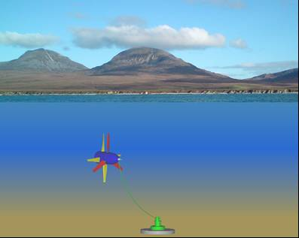
Figure 1: schematic showing tensioned mooring.

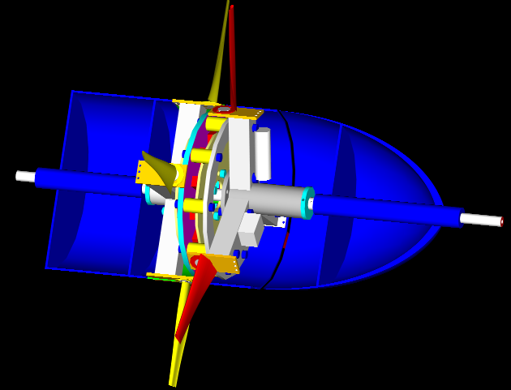
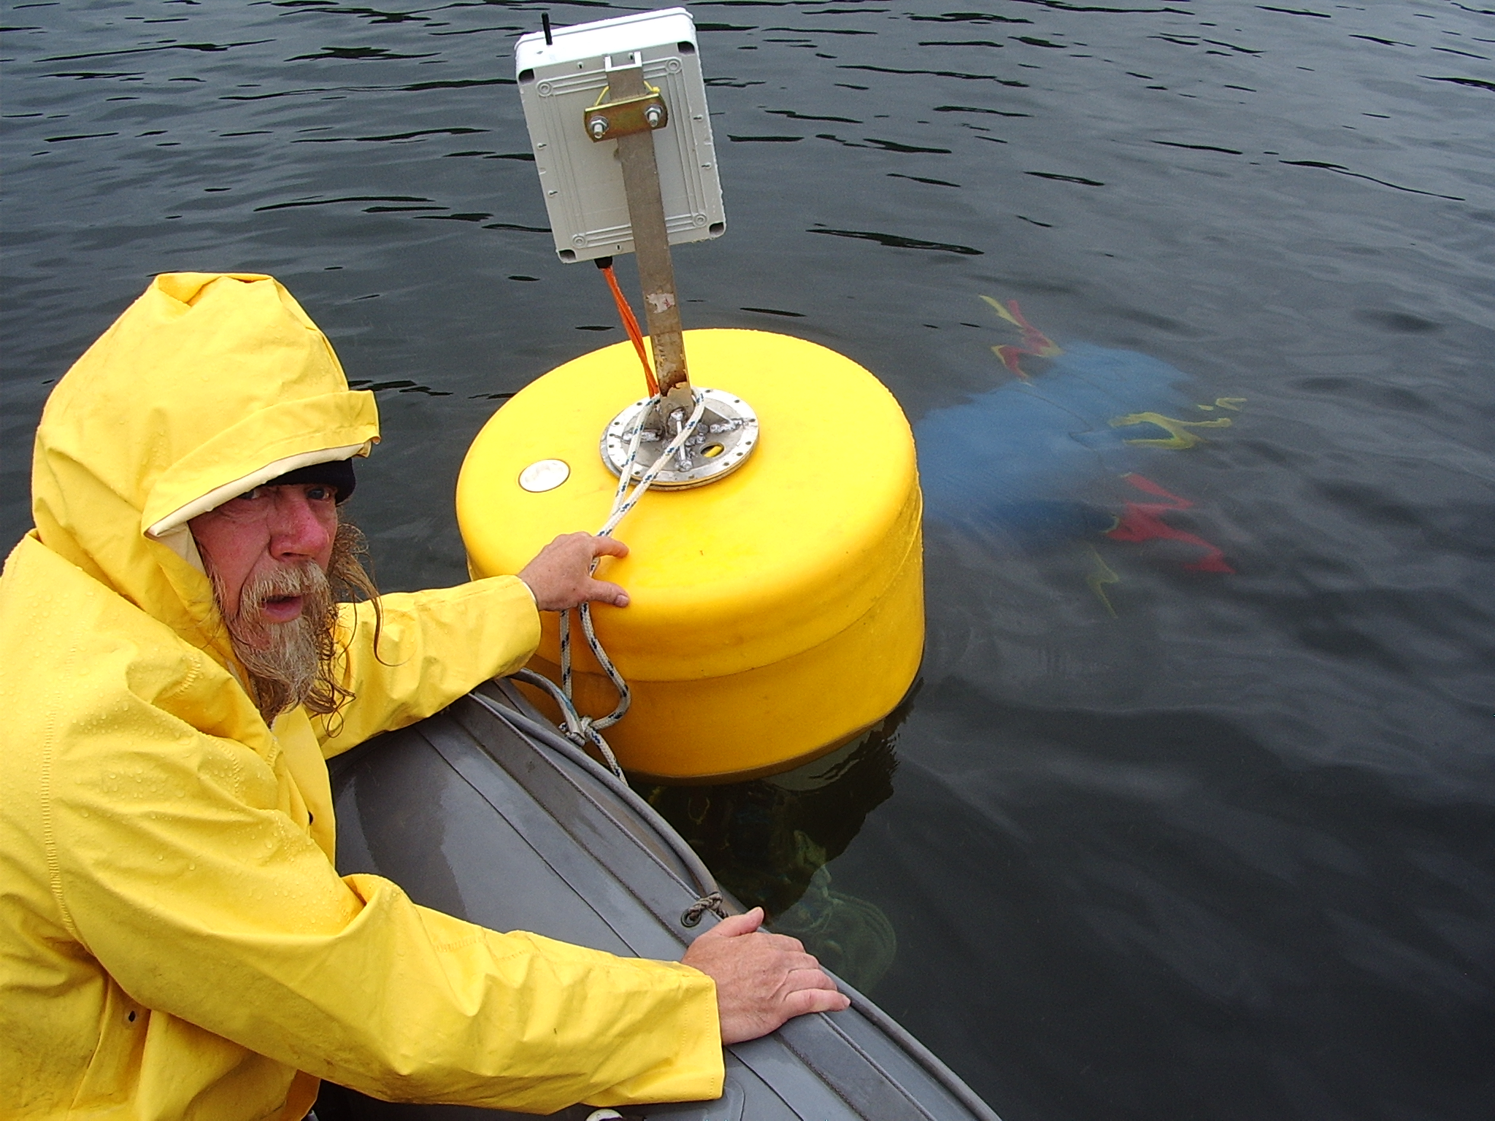
Axial Flux Generator
Contra-rotating Blades
Rear Buoyancy
Front Buoyancy
To Tether
Figure 2: Photo of CoRMaT stand-alone system being deployed.

Figure 3: Turbine pitch and roll fluctuations during testing at the Kyles of Bute, River Clyde Estuary

Figure 4: Turbine and surface piercing buoy pitch and roll fluctuations during testing in the Sound of Islay

B
A
C
D
Figure 5: CoRMaT operational overview at Sound of Islay

E
Figure 6: CoRMaT operation at Sound of Islay test site.

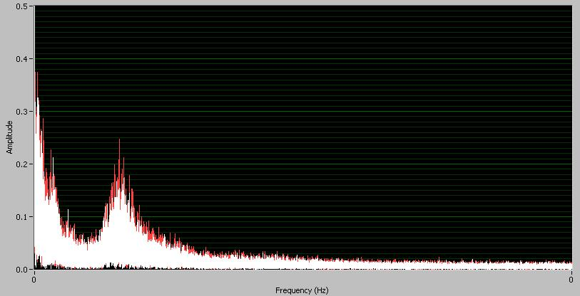
F1
F2
Fn
F1
F3

Figure 7: FFTs of CoRMaT pitch data showing the dominant frequencies at Islay.

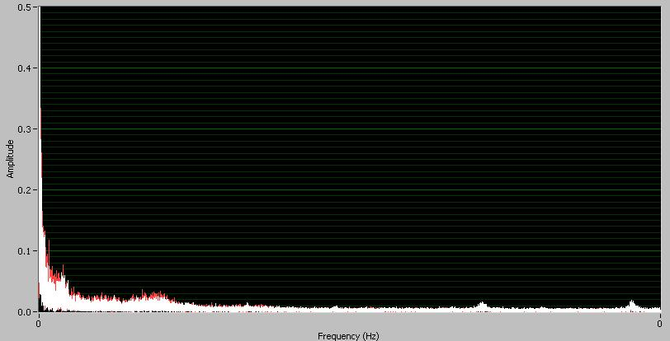
F3
F5
F6
F4
F1

Figure 8: FFTs of CoRMaT roll data showing the dominant frequencies at Islay.

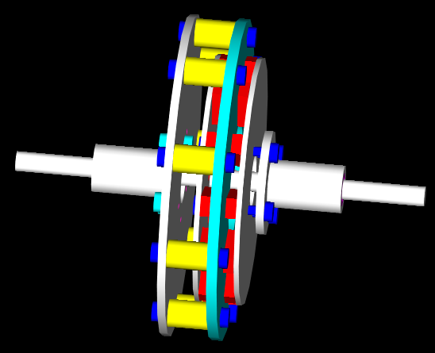
Spine
Rotors
Ne-Fe-B Magnets
Stator
Prime Mover 1
Shaft
Prime Mover 2
Shaft

Figure 9: CAD rendering of contra-rotating axial flux generator.

G
Gearbox
G
Gearbox
A)
G
Diff. Gearbox
B)
G
G
C)
D)
G

Figure 10: Power Take-off Options for a 250kW system

 

