Submitted to Biopolymers

Hexamer Oligonucleotide Topology and Assembly under
Solution Phase NMR and Theoretical Modelling Scrutiny
By

Maxim P. Evstigneev¹*, John A. Parkinson²*, Anastasia O. Lantushenko¹, Viktor V. Kostjukov¹, Valery I. Pahomov¹
¹ Sevastopol National Technical University, Department of Physics, Sevastopol 99053, Ukraine.
² University of Strathclyde, WestCHEM, Department of Pure and Applied Chemistry, 295 Cathedral Street Glasgow, G1 1XL, United Kingdom.

*Co-authors MPE and JAP made equivalent contribution to this work and are represented here as joint corresponding authors. Correspondence addresses are provided below:
Dr. John A. Parkinson
WestCHEM, Department of Pure & Applied Chemistry
University of Strathclyde
295 Cathedral Street
Glasgow G1 1XL
United Kingdom

Email: john.parkinson@strath.ac.uk
Tel: +44 (0) 141 548 2820
Fax: +44 (0) 141 548 4822
Prof. Dr. Maxim P. Evstigneev
Sevastopol National Technical University
Department of Physics
Sevastopol 99053
Ukraine

Email: max_evstigneev@mail.ru
Tel: +38 (0) 692 435 110
Fax: +38 (0) 692 443 590

ABSTRACT:
The entire family of non-complementary hexamer oligodeoxyribonucleotides d(GCXYGC) (X and Y = A, G, C, or T) were assessed for topological indicators and equilibrium thermodynamics using a priori molecular modeling and solution phase NMR spectroscopy. Feasible modeled hairpin structures formed a basis from which solution structure and equilibria for each oligonucleotide were considered. ¹H and ³¹P variable temperature (VT) and concentration dependent NMR data, NMR signal assignments and diffusion parameters led to d(GCGAGC) and d(GCGGGC) being understood as exceptions within the family in terms of self-association and topological character. A mean diffusion coefficient D_{298K} = (2.0 ± 0.07) × 10⁻¹⁰ m²⋅s⁻¹ was evaluated across all hexamers except for d(GCGAGC) (D_{298K} = 1.7 × 10⁻¹⁰ m²⋅s⁻¹) and d(GCGGGC) (D_{298K} = 1.2 × 10⁻¹⁰ m²⋅s⁻¹). Melting under VT analysis (T_{m} = 323 K) combined with supporting NMR evidence confirmed d(GCGAGC) as the shortest tandem sheared GA mismatched duplex. Diffusion measurements were used to conclude that d(GCGGGC) preferentially exists as the shortest stable quadruplex structure. Thermodynamic analysis of all data led to the assertion that, with the exception of XY = GA and GG, the remaining non-complementary oligonucleotides adopt equilibria between monomer and duplex, contributed to largely by monomer random-coil forms. Contrastingly d(GCGAGC) showed preference for tandem sheared GA mismatch duplex formation with an association constant K = 3.9 × 10⁵ M⁻¹. No direct evidence was acquired for hairpin formation in any instance although its potential existence is considered possible for d(GCGAGC) on the basis of molecular modeling studies.

KEYWORDS: Hexamer DNA topology, Diffusion NMR, Thermodynamics, Molecular Modeling, Tandem mismatch
INTRODUCTION

Investigating the structure and thermodynamics of short DNA sequences under physiological conditions has been of considerable interest during the past decade or so in various aspects of molecular biology. Short oligodeoxyribonucleotides (ODNs) serve as excellent models for studying unusual secondary structures at an atomic level. Indeed DNA and RNA oligomers are known to have the propensity to adopt wide and varying topological features such as hairpins and base-pair mismatches, by acting as recognition sites for certain ligands, or existing as tandemly repeated triplets, which are considered to be responsible for several genetic diseases. Short DNA structures are now emerging as basic structural elements within the fields of nano- and biotechnology including as probes for highly specific nucleic acid recognition,, DNA memory devices and potent antiviral drugs among a wider distribution of uses. The versatility of the structure of short ODNs has recently been proven by the discovery of a new principal mode of DNA hexanucleotide d(GCTAGC) recognition by a metallosupramolecular helicate. In the formation of this assembly, selective alteration of the topological equilibrium has been achieved away from the standard double-stranded structural form towards the formation of a three-way hexamer DNA junction.
Review of the scientific literature shows that the structural properties of ODNs longer than hexamers have been well studied and characterized by various experimental techniques both as a function of nucleotide composition (including sequence and nucleotide distribution) as well as the number of nucleotide units present. The set of known topological forms include random-coil, hairpin, duplex (both regular and mismatched)^{1,-}, multiplex and junction^{8,}. Additional structural motifs include quadruplex, triplex, I-motif, Holliday junction as well as knotted and supercoiled structures in the context of more extensive oligomeric nucleic acids. It is a commonly held view that hexamer or shorter ODNs as well as high order self-complementary deoxypolynucleotides exist in a simple two-state equilibrium form (duplex ↔ random-coil), a condition that has been successfully exploited in considering nearest neighbour thermodynamics. In this paper we draw specific attention to non-complementary DNA hexamers. To the best of our knowledge, these have not to date been comprehensively and systematically studied in topological equilibrium thermodynamic terms. These hexamers lie midway between two-state tetra- and dinucleotides and multi-state polynucleotides, which allows speculation to be made about the formation of structures other than random-coil or slipped duplexes under physiological conditions. Two indirect pieces of evidence confirm this expectation: (i) the possibility of compact hairpin-like structure formation in the self-complementary hexamer d(GC[TA or AT]GC); (ii) formation of hairpin structures in the d(CGCXYGCG) family of octamers where the XY loop [reviewed in Ref. ] can in principle be expected at the hexamer level too.
In the present work, the full set of 5′-d(GCXYGC)-3′ non-complementary hexamer ODNs (where XY = AA, AC, AG, CA, CC, CT, GA, GT, TC, TG, TT, GG) have been studied experimentally by ¹H and ³¹P NMR spectroscopy. The results are considered in terms of the thermodynamics of assembly, the topologies formed and the part played by sequence on their formation. The non-complementarity of XY nucleotides allows strong background signals from regular duplex structures to be avoided whereas complementary GC flanking dinucleotides are included, being known to stabilize various structural forms very strongly if any inter- or intra-molecular interaction occurs¹⁶. These principles guided the choice of ODNs selected for investigation within this study.

EXPERIMENTAL

Materials
The family of non-complementary hexamer oligodeoxyribonucleotides 5′-d(GCXYGC)-3′ where XY represent AA, AC, AG, CA, CC, CT, GA, GT, GG, TC, TG and TT together with IA (I = Inosine), were supplied by AlphaDNA (Montreal, Canada) based on a 15-μmol scale synthesis. Samples were HPLC purified at source, solubilized in D₂O on receipt and lyophilized once to remove carry-over volatiles from the synthesis stage. Deuterium Oxide (D₂O), TSP, (3-(trimethylsilyl)propionic acid-d₄ sodium salt) and the buffering salts KD₂PO₄ and K₂DPO₄ were supplied by Sigma-Aldrich and used without further purification. NMR tubes (∅ = 5 mm, New Era NE-UP5-7 and Wilmad 535-PP-7) were supplied by CortecNet (Voisins-le-Bretonneux, France).

Sample Preparation
Stock phosphate buffer solution was typically prepared in 10 mL batch quantities for a pD = 7.4 (135.5 mg of K₂DPO₄ and 31.2 mg of KD₂PO₄ in 10 mL D₂O) to provide stock buffer solution at a concentration of 100 mM. A TSP solution was prepared (17.22 mg TSP in 1 mL D₂O) to provide a stock concentration of 100 mM. Oligonucleotide stock solutions were prepared according to the following scheme in which d(GCTCGC) serves as a typical example. d(GCTCGC) (6.33 mg) was solubilized in D₂O phosphate buffer (100 mM, 550 μL) to which was added TSP (1 μL from 100 mM stock solution) to provide an internal NMR reference standard. The stock oligonucleotide solution was admitted to an NMR tube and used for NMR data acquisition. The sample was subsequently diluted within the NMR tube and the solution divided as necessary to provide the relevant concentrations at which NMR data were required. Typically samples were prepared at concentrations of 5.8, 5.1, 4.4, 3.8, 3.2, 2.7, 2.2, 1.8, 1.4, 1, 0.7, 0.4, 0.2, 0.1 and 0.05 mM providing a total of 16 ODN concentrations on which NMR data were acquired.

NMR Spectroscopy
NMR data were acquired under Topspin (version 2.0, Bruker Biospin, Karlsruhe) using a Bruker AVANCE III 600 NMR spectrometer operating at a proton resonance frequency of 600.13 MHz and equipped with a TBI [¹H, ¹³C, X = ³¹P-¹⁵N]-z triple resonance probehead fitted with an actively shielded gradient coil for delivery of pulsed-field gradients. 1D ¹H NMR data were typically acquired using a single pulse presaturation approach (Bruker pulse program zgpr) on samples equilibrated at a calibrated temperature of 298 K. Data were accumulated centered at the solvent resonance with 64 transients over a frequency width of 7.22 kHz into 32 K data points for an acquisition time aq = 2.27 s with a recycle delay d1 = 2 s between transients using a 90° radiofrequency (r.f.) pulse (p1 = 10.48 μs at a power level of 0.9 dB). 1D ³¹P-{¹H} NMR data were accumulated with 512 transients over a frequency width of 2.4 kHz into 2 K data points for an acquisition time aq = 421.5 ms with a recycle delay d1 = 0.5 s between transients and centered at 0 ppm relative to an external ³¹P reference standard of 85% phosphoric acid. In each case, further transients were accumulated with increasing sample dilution in order to build adequate signal-to-noise for the purposes of signal recognition. 2D [¹H, ¹H] NOESY and TOCSY NMR spectra were typically acquired for the purposes of non-exchangeable proton NMR signal assignments on the highest concentration samples. 2D [¹H, ¹H] NOESY NMR data were acquired in phase sensitive mode with solvent presaturation using a States-TPPI mode of acquisition. Data were acquired centered at the residual solvent resonance with 48 transients for each of 512 t₁ increments over a frequency width (ω₂ and ω₁) of 6 kHz into 4 K data points (aq = 341 ms) with a recycle delay d1 = 2.6 s and a mixing time τ_{m} = 240 ms. 2D [¹H, ¹H] TOCSY NMR data were acquired in phase sensitive mode with solvent presaturation using a States-TPPI mode of acquisition. Other conditions were as described for the 2D [¹H, ¹H] NOESY NMR data acquisition with the exception of the mixing time which was delivered by means of a DIPSI-2 spinlock pulse train for a period of 70 ms. 1D ¹H and in some cases 1D ³¹P-{¹H} NMR data were acquired as a function of temperature on oligonucleotide sample concentrations of 2.2 mM and 0.2 mM. Data were acquired at sample temperatures in the range 278 – 353 K at 5 K intervals under full automation with temperature equilibration periods, lineshape and solvent suppression optimization at each sample temperature.
For the case of d(GCGAGC), a 2 mM sample was freeze dried and re-suspended in 90% H₂O / 10% D₂O for which 2D [¹H, ¹H] NOESY and TOCSY NMR data were acquired with excitation sculpting (Bruker pulse programs noesyesgpph and dipsi2esgpph respectively) centered at the solvent resonance frequency with 32 transients for each of 512 t₁ increments over a frequency width (ω₂ and ω₁) of 12 kHz in the case of the NOESY and 6 kHz in the case of the TOCSY NMR data acquisitions for which the sample temperature was regulated at 283 K. In addition natural abundance 2D [¹H, ¹⁵N] HSQC NMR data were acquired centered at the solvent resonance in ω₂ and at 125 ppm in ω₁. Data were acquired with 360 transients for each of 100 t₁ increments over an ω₂ frequency width of 12 kHz and an ω₁ frequency width of 250 ppm for a total data accumulation time of 17 hours. 1D ¹H-{³¹P} and 2D [¹H, ³¹P] HSQC NMR data were acquired to confirm the identity of phosphorous atoms within the backbone sequence of d(GCGAGC) in particular.
Diffusion Ordered NMR data were acquired using a bipolar LED pulse routine incorporating the facility for solvent suppression by presaturation (Bruker pulse program ledbpgppr2s). Data were acquired for samples at concentrations of 3.2 or 4.1 mM at sample temperatures of both 298 and 343 K. Typically 128 transients were accumulated for each of 32 gradient increments in which gradient strength was set linearly in the range 2 - 95% of maximum using a sine-shaped gradient profile that provided a maximum gradient strength of 32 G⋅cm⁻¹ for a 10% gradient pulse. Diffusion data were acquired over a ω₂ frequency width of 6 kHz and processed within the T1/T2 data processing module of Topspin. All other NMR data were off-line processed using standard NMR data handling protocols within Topspin (version 2.1).

Molecular Modeling
The spatial structures of DNA hexamer hairpins were calculated by molecular mechanics using XPLOR (version 3.1). Initial structures were built using HyperChem (Hypercube Inc.). The aqueous environment was modeled using water molecules in the TIP3P form and placed in a cubic box with sides of length 35 Å (1423 molecules). Parameters for non-valent interactions between atoms corresponded to the CHARMM27 force field. Neutralization of the excess phosphate electric charges was provided by six Na⁺ counter-ions initially placed 6 Å from the corresponding phosphorous atoms along the bisectors of the O1P-P-O2P angles.
Calculation of the conformational dynamics (MD) of the DNA oligomers was carried out with X-PLOR using an initial input structure obtained at the molecular mechanics stage. Switching and shifting functions were used for treating van der Waals and electrostatic interactions respectively using a 12 Å cutoff. The conjugate gradient method of potential energy (PE) minimization was used to geometry optimize DNA hexamer structures.
Energy minimization proceeded in two stages. In stage one, the coordinates of hexamer atoms and counter-ions remained fixed, thereby allowing the water molecules to relax to their equilibrium positions. In stage two, only ODN atoms were fixed. The final phase of geometry optimization was carried out without constraints on atom motions within the system.
Following PE minimization, MD simulations were performed using the Verlet algorithm employing a constant temperature of 298 K. In order to reach a 2-fs time step, motional restraints to all hydrogen atoms were introduced using the SHAKE procedure. During MD simulations molecules of the external water shell were fixed to prevent water molecules going out into the external vacuum. The free (unfixed) water layer corresponded to the thickness of the nearest hydration shell, i.e. a bimolecular layer of ca. 4 Å. The total evolution time was equal to 2 ns. Coordinates of all atoms were saved every picosecond.

RESULTS AND DISCUSSION

The initial aim of this study was to gather experimental evidence supportive of the formation of stable hairpin structures for non-complementary hexamer ODNs. As outlined, at least two indirect pieces of evidence suggest the possibility of hairpin-like structure formation at the ODN hexamer level. The first piece of evidence (i) discussed in Ref. 17 relies on the fact that NMR proton chemical shifts for flanking nucleotides in self-complementary d(GCATGC) and d(GCTAGC) hexamers experience shifts to low chemical shift (upfield) upon reducing sample concentration, an unexpected feature within a common two-state monomer ↔ duplex equilibrium system. The report suggests that a hairpin structure begins to dominate over a duplex structure at low concentrations, being characterized by a d(GC)₂ stem and corresponding duplex-like shielding of ¹H NMR chemical shifts, although no further supporting experimental evidence for this suggestion is supplied by the authors. The second piece of evidence (ii) provides direct experimental observation for both hairpin and duplex structure formation in solution and suggests the possibility of a loop consisting of a sharp turn made of only two nucleotides¹⁸. These observations led to a pilot a priori molecular modeling of such hairpin structures within the d(GCXYGC) family of hexamers in order to test the principal possibility of such structures existing on the nanosecond timescale. It was then followed by experimental assessment to enable comparison to be made of the behaviour of each ODN within the family under physiological conditions in a search for evidence of the existence of hexamer hairpins.

A Priori Molecular Modeling Study of d(GCXYGC) Family of Hairpins

The initial conformation of the d(GC)₂ stem in all cases was set up as a B-type helix, which is typical of short hairpins. Initial conformations of the loop nucleotides X and Y in the d(GCXYGC) hairpins were set up in all combinations of anti (χ = 144˚) and syn (χ = 324˚) to take account of all possible dinucleotide loop structures known^{18,}. Energy minimised hairpin structures were subjected to molecular dynamics simulations over a 2 ns timescale to test both stability and possible structural transformation.
The results show that the majority of loop nucleotides set up initially in the syn conformation experience transformation to the anti conformation over the course of each MD simulation (Table 1). Although the starting hairpin structures used in simulations are ‘artificial’ in the sense that they are not linked to experiment, this result generally agrees with reports concerning the conformation of loop nucleotides in sheared purine-purine or purine-pyrimidine base pairs^{1,10,11}. Importantly, no significant distortion of the hairpin structures is observed over the course of MD simulations suggesting that hexameric hairpins of the form d(GCXYGC) may in principle exist in solution. The recently discovered three-way DNA junction structure made by single-stranded hexamers of sequence d(GCTAGC)⁸ is of interest in this respect. Normally such a junction would not occur in solution but this work shows its potential existence and actual materialization under specific ligand-binding conditions. This leads to speculation that alternative topological outcomes may in theory be expected for other d(GCXYGC) DNA sequences. NMR spectroscopy was used to explore this possibility.

NMR Analysis of Non-Exchangeable Protons.
Evaluation of ¹H NMR signal assignments for each ODN studied were made to allow subsequent determination of the likely structural forms adopted in solution. Information associated with aromatic proton resonances could also be used to evaluate thermodynamics associated with topological equilibrium processes that exist in each case. Data arising from non-exchangeable protons were assigned from 2D [¹H, ¹H] NOESY NMR spectra supplemented with data from 2D [¹H, ¹H] TOCSY NMR spectra using well established sequential resonance assignment techniques. Examples are shown for X = purine, Y = purine ODNs d(GCAGGC) and d(GCGAGC). For d(GCAGGC), regions typical of the assigned 2D [¹H, ¹H] NOESY NMR spectra are shown (Figure 1) together with full ¹H NMR signal assignment (Table 2). Similar patterns of assignments mapped for all ODNs in the series are tabulated (see Supporting Information Tables S1-S9). Details of aromatic resonance assignments for all ODNs are also provided (Table 3). The exception to these data are the pattern of assignments found for d(GCGAGC) where the order of XY purine-purine nucleotides is reversed relative to d(GCAGGC). 2D [¹H, ¹H] NOESY NMR data for the non-exchangeable proton resonances of d(GCGAGC) are shown (Figure 2) together with ¹H NMR signal assignments (Table 4).
It is notable that in all cases relatively strong nOe responses are observed together with good signal dispersion. Additionally, data assignment is possible through both intra- and inter-residue nOes arising between sugar H1′ and aromatic H6/H8 atoms. Such features are ordinarily characteristic of data arising from structured molecules. Instances in which monomer ODNs exist as random-coil or partially ordered single strands do not give rise to inter-residue nOes and may not show intra-residue nOes either. Appearance of the data therefore initially provides evidence for some well structured forms in solution, with the possibility that the hairpin form may be represented (vide infra).
What is especially striking about the data for d(GCGAGC) is its quality and larger dispersion of resonances relative to all other ODNs studied in the series even in spite of the previous comment. Examination and comparison of 1D ³¹P-{¹H} NMR data for the series of ODNs shows the same feature (Figures 3 and 4). Exceptionally, dispersion of ³¹P chemical shifts for d(GCGAGC) is much larger than for all other oligonucleotides (727 Hz at a magnetic field strength of 14.1 T). Consideration of the distribution of H2′ chemical shifts reveals self-consistency according to the central XY nucleotide sequence in d(GCXYGC) (Figures S1-S4 in the Supporting Information). Where X and Y are both pyrimidines for instance (C or T residues), H2′ chemical shift values consistently increase in the nucleotide sequence order Y⁴ < X³ < C² < C⁶ < G¹ < G⁵. Similar consistent ordering of chemical shifts is apparent for other combinations of X and Y. The exception is d(GCGAGC) when compared with d(GCAGGC) or d(GCAAGC). In particular H2′ for A⁴ in d(GCGAGC) is far out of character (δ¹H = 1.07 ppm) compared with the other two XY = purine-purine oligonucleotides (δ¹H_{av} = 2.525 ± 0.025 ppm, representing an average chemical shift for H2′ at Y⁴ in this instance). Such a significant difference in chemical shift (Δδ = 1.46 ppm) is only consistent with a significant structural perturbation that is the result of aromatic ring current shielding effects on the H2′ atom in question. Interestingly, the aberrant nature of the chemical shift values for sugar ring proton resonances throughout d(GCGAGC) are not restricted to those associated with H2′ protons. A plot of H2′ vs H1′ chemical shifts for all nucleotides across the family of hexamer ODNs consistently shows data at odds with the norm for d(GCGAGC) for which either H1′ or H2′ or both chemical shifts show extreme values relative to the general trend across the family (Figure 5). This is evident not only for the central two nucleotides but also for nucleotides that are two residues removed (i.e. 5′ and 3′ terminal nucleotide residues - see Figure 5 inset). Indications are that the effects caused by any structural perturbation at the centre of the oligonucleotide are sensed two residues away in either direction.
Variable temperature and concentration dependent behaviour of the aromatic proton resonances across the set of ODNs throws into sharp relief the unusual character of d(GCGAGC) compared with the remaining sequences. Data for d(GCAGGC) and d(GCGAGC) (Figure 6) are remarkable for the strong contrast shown. Whilst the concentration dependence of chemical shifts show some variation for d(GCAGGC), especially at lower concentrations where change may be more anticipated (Figure 6a), virtually no change is observed for chemical shifts associated with any of the aromatic proton resonances for d(GCGAGC) (Figure 6b). This is consistent across all other ODNs examined as part of this study (Supporting Information Figures S5-S14). Contrastingly, the difference observed in the temperature dependence of aromatic ¹H NMR chemical shifts between these oligonucleotides and d(GCGAGC) is dramatic. Resonances for d(GCAGGC) show gradual changes over the course of the temperature range used as for all other sequences. Those for d(GCGAGC) show little change until broadening effects are observed followed by very large changes in chemical shift, in particular for G³H8 and A⁴H8. These resonances swap position from unusual chemical shifts at room temperature to more usual chemical shifts at high temperature. At 298 K, δ(¹Η)G³H8 = 8.23 ppm for d(GCGAGC) compared with δ(¹Η)G^{x}H8_{av} = 7.93 ± 0.05 ppm over all remaining G^{x}H8 chemical shifts in this study‡. Similarly at room temperature, δ(¹Η)A⁴H8 = 7.42 ppm for d(GCGAGC) compared with δ(¹Η)A^{x}H8_{av} = 8.17 ± 0.1 ppm over all remaining A^{x}H8 chemical shifts in this study‡. These features taken together for d(GCGAGC) point towards a melting transition and indicate a highly stabilized structure existing for this unit at room temperature which undergoes melting to a typical random-coil arrangement at high temperature.
Several structural possibilities might explain these observations, the ODN potentially existing as a stable hairpin, a stable duplex or some other stable structure that on heating undergoes a melting transition. Literature survey regarding these observations recovered mention of a study examining the interaction of a cobalt complex with d(GCGAGC). In this context d(GCGAGC) is mentioned by the authors by reference to a structure containing a tandem sheared GA mismatch base pair in a duplex DNA form. No supporting evidence for the existence of this structure is provided in the published context. However, ¹H and ³¹P NMR data presented there are consistent with those data presented here. Without further investigation the data are open to interpretation and may arise either from a tandem sheared GA mismatch duplex or from a short, stable hairpin loop. Since significant precedent for stable short hairpin structures exists in the literature it is essential that this point is firmly clarified for d(GCGAGC). Earlier work by Orbons et al. was carried out on the polymorphous behaviour of the DNA octamer d(m⁵CGm⁵CGAGm⁵CG) whose central, modified d(GCGAGC) sequence is very similar to the hexamer being considered here. Interesting parallels exist between our data for d(GCGAGC) and those presented by Orbons et al. for the octamer. For instance, an unusually located H2′ resonance for residue A⁵ is reportedly attributed to an unusual structure at this position in which A⁵H2′ lies within the shielding cone of a neighboring nucleotide baseError: Reference source not found. Also A⁵H8 resonates at 7.418 ppm and G⁴H8 at 8.182 ppm (corrected for reference to TSP-d₄ from TMA at 0 ppm from the original article)Error: Reference source not found. These values are in keeping with those found here and by Chen et alError: Reference source not found. ³¹P NMR data reported for d(m⁵CGm⁵CGAGm⁵CG)Error: Reference source not found also show large dispersion of resonance frequencies. The ³¹P NMR resonance for the G⁴pA⁵ step reportedly occurs at a large downfield shift and is ascribed to a transition from a gauche-gauche or gauche-trans to a trans-gauche conformation with a change in direction of the backbone being reported as “drastic”Error: Reference source not found. Although no further structural interpretation of these data are reported by Orbons et al, the observations are ascribed to an unusual structure, critically a duplex DNA incorporating a mismatched GA base pair. Data from these two sources are strongly consistent with those reported here.
Further supporting evidence of similarity arises from the assignment of aromatic resonances for each d(GCXYGC) hexamer (Table 3). Direct comparison of chemical shifts of different nucleotides is only possible if neighbouring nucleotides belong to the same group of purines or pyrimidines. Unambiguous comparison can only be made here therefore for G¹C² and G⁵C⁶. The resonance behaviour of two particular protons fall outside the set of d(GCXYGC) hexamers, namely C²H6 and C²H5 for d(GCGAGC). These show remarkable shielding (indicated in bold font, Table 3). This observation is consistent with findings for the sugar proton resonances and provides further evidence for the unusual character of the d(GCGAGC) hexamer within the d(GCXYGC) family of non-complementary oligonucleotides. To the best of our knowledge, the pronounced shielding of aromatic proton resonances of nucleotides flanking “GA” mismatches in DNA duplexes has not been reported to date. In Ref. the authors present experimental dependencies of proton chemical shifts as a function of the concentration of hairpin-forming DNA heptamer d(GCGAAGC), a very close analogue of the DNA hexamer d(GCGAGC). Data are presented for C²H6 and C²H5 which occur in the same highly shielded region as in the present work, although the authors did not pay attention to this fact. The possibility that d(GCGAGC) preferentially adopts a stable hairpin structure in solution is therefore tangible but further interrogation of the data are necessary to confirm or reject this conjecture.

Self-Diffusion Study

Measurement of self-diffusion coefficients allows size and shape to be considered as a parameter by which the structural character of the d(GCXYGC) family of ODNs may be assessed. Values were measured for the available ODNs at both room temperature, where structural differences might be significant, and at temperatures far beyond melting, at which all of the oligonucleotides would be expected to behave in a similar random-coil manner. Analysis of the self-diffusion coefficients measured at T = 298 K (Table 5) suggests that d(GCGAGC) is atypical. Excluding d(GCGAGC), the mean value for the self-diffusion coefficient D = (2.07±0.07) × 10⁻¹⁰ m²⋅s⁻¹. Two conclusions may be drawn. Firstly, all hexamers except for d(GCGAGC) exhibit qualitatively similar exchange equilibria, almost certainly being a mixture of monomer and duplex forms. Secondly, d(GCGAGC) is characterised by lower mobility which indicates duplex as the dominant form in solution. This result is in full agreement with the preliminary conclusions drawn from consideration of the non-exchangeable ¹H NMR data analysis.
Assumption that the magnitude of the self-diffusion coefficient measured for d(GCGAGC) is associated with duplex may be verified against published empirical interrelation between D and the number of base-pairs, n, in duplex DNA, D~n^{(-0.67)} . Using as reference the value D = 1.2 × 10⁻¹⁰ m²⋅s⁻¹ measured for a dodecamer DNA duplex, it is possible to derive the estimated value of the self-diffusion coefficient for a hexamer DNA duplex (n = 6) as D ≈ 1.9 × 10⁻¹⁰ m²⋅s⁻¹, which is in very good agreement with the value obtained in this work for d(GCGAGC) (Table 5) and indirectly confirms duplex formation.
The idea that GA-containing partly self-complementary ODN sequences form tandem sheared GA mismatched base-pairs and lead to highly stable duplexes has long been recognized although for sequences longer than hexamerError: Reference source not found^{,10}. In Ref. Error: Reference source not found the authors use this fact in their study but without any proof and make the assumption that d(GCGAGC) predominantly exists in duplex form at room temperature. The results of the present work confirm that d(GCGAGC) is the only oligonucleotide capable of forming a highly stable duplex within the d(GCXYGC) family of non-complementary hexamers.
A further atypical diffusion coefficient was found for d(GCGGGC) (Table 5). This was incapable of being studied in the manner applied to the remaining members of the d(GCXYGC) ODN family due to resonance broadening. Nevertheless it is characterized by a self-diffusion coefficient D = 1.2 × 10⁻¹⁰ m²⋅s⁻¹, a value much lower even than that measured for d(GCGAGC). Free guanine monophosphates as well as guanine-repeating oligonucleotides are known to form stable G-quadruplexes in solution, suggesting that d(GCGGGC) in our study is, to the best of our knowledge, the shortest known stable quadruplex structure. This assumption is supported by the fact that a longer d(TGGCGGGT) sequence with central cytosine forms a quadruplex under similar solution conditions. It is also worth noting that a self-diffusion coefficient, D = 1.2 × 10⁻¹⁰ m²⋅s⁻¹ (see Table 5), was obtained for a dodecamer DNA duplexError: Reference source not found. Neglecting the factor of shape, and considering just molecular weight, this suggests that d(GCGGGC) may form a quadruplex structure. Unfortunately 2D NMR spectra of d(GCGGGC) in our study were very broadened and could not be analyzed under the conditions utilized in our experiments, presumably due to intermediate exchange of d(GCGGGC) single strands occurring on the NMR timescale. At elevated temperatures (T > 335 K) the NMR data become well-resolved and are characteristic of d(GCGGGC). Recovery of the same broadened NMR spectra on cooling of the sample to ambient room temperature indicates the reversible and reproducible nature of the structure formed. Further investigations into this phenomenon are in progress within our laboratory and will be reported in due course.

NMR Analysis of Labile Protons.
To explore the tandem sheared GA mismatch duplex vs monomer hairpin hypothesis further, NMR data were acquired on a sample of d(GCGAGC) solubilized in 90% H₂O buffered with 100 mM phosphate to allow observation of the exchangeable proton resonances. For a sheared GA mismatch within a duplex setting, data should reveal significant inter-strand, through-space correlations via nOe. 1D ¹H NMR data acquired using two alternative solvent suppression techniques at both 278 K and 283 K are presented (Figure 7). Under conditions where the solvent signal is suppressed through excitation sculpting (double pulsed field gradient spin echo – dpfgse), two relatively intense signals are observed at 13.08 and 10.44 ppm, the latter being unusual for duplex DNA. Existence of imino proton resonances in the region of 11 ppm has been reported for guanosine in the context of a hairpin loop structure although previous reports for NMR data from tandem sheared GA mismatches have associated the same signal to the imino proton of the G residue in the tandem GA mismatchError: Reference source not found. Appearance of this resonance alone is therefore insufficient to rule hairpin formation in or out of the argument at this stage and further analysis is therefore required. The appearance of this region of data alters when solvent signal is suppressed instead through presaturation prior to data capture. Under these conditions the signal at 10.44 ppm is simultaneously suppressed through saturation transfer but the signal at 13.08 ppm is retained, albeit at a reduced relative intensity compared with the dpfgse spectrum (Figures 7a and 7b). Under presaturation conditions, a new low intensity, broad resonance appears at 9.45 ppm. At slightly elevated temperature (283 K) the intensity of the signal at 10.44 ppm reduces relative to the signal at 13.08 ppm using the dpfgse approach. At the same temperature with presaturation, the signal at 10.44 ppm is suppressed by saturation transfer and the presence of signals at 13.08 and 9.45 ppm are maintained, although the latter signal is significantly more broadened at the slightly elevated temperature of 283 K. This suggests an environment in which the proton is more freely accessible for solvent exchange than the environment for the proton giving rise to the signal at 13.08 ppm. Since dpfgse uses a spin-echo approach to suppress solvent, broad signals eliminate through T₂ relaxation effects and may be easily lost if the echo period is long, which is the case here (4 ms). Loss of the broader resonance at 9.45 ppm can therefore be explained. Loss of signals through saturation transfer occurs when the rate of labile proton exchange is relatively rapid. Although still slow on the NMR timescale, this condition enables distinction of unique ¹H NMR responses to be made for specific nuclei. Loss of the signal at 10.44 ppm shows this response to be associated with a proton that is more labile than either of the protons associated with signals at 13.08 ppm or 9.45 ppm, in the latter case despite its broad characteristic appearance.
Assignments of these labile proton resonances are made on the basis of 2D [¹H, ¹H] NOESY NMR data acquired with both solvent presaturation and with excitation sculpting in order to capture information for all types of proton resonance. Patterns of nOes enable resonances of labile protons to be assigned where possible (Table 6). Unusually for an ODN ¹H NMR spectrum, these nOe patterns allow assignment of NMR responses to A⁴N6 amino protons, a G³N2 amino proton as well as designation of imino proton resonances to be made. The signal at 13.08 ppm is thus assigned to imino proton G⁵NH by virtue of the nOes displayed to surrounding protons that are assigned from the non-exchangeable proton ¹H NMR data: e.g. G⁵H1-C⁶H1' (intra-strand). Crucially an inter-strand nOe (G⁵H1-G⁹H1') fits with a duplex DNA structure. Modeling of such a structure suggests that G⁵H1 is solvent exposed in a manner consistent with the greater lability revealed in our data. Natural abundance 2D [¹H, ¹⁵N] HSQC NMR data for d(GCGAGC) (Table 6 and Figure S15 in the Supporting Information) allows the ¹H NMR resonance at 10.45 ppm to be firmly associated with an imino NH, the unusual ¹H NMR chemical shift being attributed to the lack of inter-nucleotide hydrogen bonding in a sheared GA tandem mismatch with ¹⁵N chemical shifts for imino nitrogens occurring in the δ¹⁵N = 140 ppm region of the ¹⁵N NMR spectrum. With the assistance of a molecular model, assignment of other exchangeable proton resonances may be confirmed. Protons that are hydrogen bonded in nucleotide amino groups resonate at higher ppm compared with non-hydrogen bonded partners. In each case, the hydrogen bonded partners show expected nOes to near neighbours. Of most significant interest are inter-strand nOes that can only occur for a tandem sheared GA duplex. Thus G³H1 shows a strong nOe to G⁹H8; G³H22 and G³H1 show strong nOes to both G⁹H2′ and G⁹H2′′ and both A⁴N6 amino protons show exclusively inter-strand nOes to protons associated with the G⁸ and largely the G⁹ nucleotide residues.
To firmly establish that duplex and not hairpin is the stable form of d(GCGAGC), the sequence was modified. Stabilization of a tandem sheared GA mismatch is assumed to occur through formation of the hydrogen bonds A^{x}N6(H)-G^{y}N3 and G^{y}N2(H)-A^{x}N7. This was tested by modification of the oligonucleotide sequence to incorporate inosine in place of guanosine at the mismatch site, thereby forming d(GCIAGC). This modification eliminates scope for formation of a G^{y}N2(H)-A^{x}N7 hydrogen bond. The behaviour of the resulting oligonucleotide is wholly consistent with the remaining members of the d(GCXYGC) family of oligonucleotides with the exception of d(GCGAGC) as shown (Figure 3) and gives rise to a diffusion coefficient D_{298K} = 1.99 × 10⁻¹⁰ m²⋅s⁻¹ consistent with a random-coil/duplex equilibrium with small duplex component. These pieces of evidence taken together with nOe, temperature (melting) and concentration dependent ¹H NMR chemical shift data, the behaviour of the exchangeable proton resonances, the diffusion data and all of the ³¹P NMR data conclusively support the assertion that d(GCGAGC) exists at pH 7.4 in 100 mM phosphate buffer at T = 298 K as a stable tandem sheared GA mismatched duplex structure.

Monomer as Hairpin or Random-Coil?
It being the case that d(GCGAGC) is firmly established as duplex form in buffered solution, it remains important to establish whether any of the experimental evidence supports hairpin formation from d(GCGAGC) monomer as well as in the remaining d(GCXYGC) ODNs. Assessment is assisted by consideration of NMR data acquired for d(GCGAGC) at low concentration in the absence of salt. Under these conditions, at [d(GCGAGC)] = 0.4 mM, a set of new signals appear in the ¹H NMR spectrum simultaneously in the presence of signals for the now established duplex form of the molecule. Two coexisting sets of resonances result from two forms of the ODN undergoing slow exchange on the NMR timescale. Assignment of the new signals is therefore achieved using 2D [¹H, ¹H] EXSY NMR data. Further reduction in the concentration of the salt free solution of d(GCGAGC) results in virtually complete elimination of NMR signals from the duplex form of the molecule and dominance of the new set of signals. Melting studies of d(GCGAGC) carried out in both the presence and absence of salt (Figure S16 in the Supporting Information) show substantial differences. In the absence of salt, no melting transition is observed. 2D [¹H, ¹H] NOESY NMR data under these conditions lacks any cross-peaks. Evaluation of the diffusion coefficient for d(GCGAGC) in the absence of salt at a concentration of 0.1 mM yields a value D = (2.18 ± 0.05) × 10⁻¹⁰ m²⋅s⁻¹, substantially different to that measured for the duplex form (D = 1.7 × 10⁻¹⁰ m²⋅s⁻¹). Lack of nOe data, increase in diffusion coefficient value, no melting transition on heating the solution and virtually no change in chemical shift over the relatively narrow range of concentrations for which the new set of resonances could be measured are all indicative of a monomer random-coil form of d(GCGAGC). This establishes D = (2.18 ± 0.05) × 10⁻¹⁰ m²s⁻¹ for the monomer form of a hexamer ODN at 298 K. Further indirect confirmation of this comes from Ref. in which the authors qualitatively measured the mobility of d(GCGAGC) by gel electrophoresis and conclude that its mobility is normal, which in the context of their paper means that this hexamer does not form a stable hairpin structure.
Since data for the remaining ODNs was assignable through inter- and intra-molecular nOes which would not occur for monomer single strand, and assessment of their melting profiles against those for d(GCGAGC) in both duplex and monomer forms (Figure S16 in the Supporting Information), it follows that the NMR data for the remaining ODNs represent monomer ↔ duplex equilibria in which duplex is sufficiently present to allow sequential data assignment to be achieved. This assumption may then be used to approximate the contribution of monomer and duplex to the equilibrium based on weighted average diffusion coefficients. Since diffusion coefficient scales inversely as the cubed root of molecular weight, consideration may be given to an apparent average molecular weight that reflects the position of the monomer ↔ duplex equilibrium. Assuming that diffusion coefficient is also a weighted average, a plot of (apparent molecular weight)^{1/3} vs diffusion coefficient enables the contribution of monomer and duplex hexamer forms to the equilibrium to be visualized (Figure 8, Table 5). Variable temperature ¹H NMR data for d(GCTGGC) shows the closest resemblance to a melting profile next to that of the duplex d(GCGAGC) although its diffusion coefficient value does not support hairpin formation but rather a higher contribution of the duplex form in solution. In the absence of unusual nOes that would fit with a hairpin structure and in view of the correlation associated with diffusion coefficient, it is concluded that hairpin formation for non-complementary hexamer ODNs is not readily apparent through the NMR data acquired.

Thermodynamic Analysis.
To consider this by an alternative route, insight into the discrimination of structural forms present in solution may be had by numerical analysis of the concentration and temperature dependencies of proton chemical shift information gathered in this study (Figure 6 and Figures S5-S14 in the Supporting Information).
Qualitative insight can be had into the behavior of each ODN by reference to the data presented in Table 7. d(GCXYGC) hexamers, for which XY = CT, AG, TG and GT, exhibit relatively strong concentration dependent chemical shifts of certain protons, whereas all other hexamers are characterized by slight concentration dependence of chemical shifts. Concentration dependence of an experimentally observed parameter under equilibrium conditions and in non-saturated solutions provides good evidence of duplex formation. Counter to this and for these ODNs, with the exception of d(GCGAGC), no sigmoidally-shaped temperature curves are observed, which are normally associated with duplex predominance in solution. It follows that the family of hexamers characterized by a mean diffusion coefficient of (2.07 ± 0.07) × 10⁻¹⁰ m²⋅s⁻¹ (excluding d(GCGAGC) – vide supra) is a mixture of monomer and duplex forms with predominance of the monomer form in each case.
An important result emerging from Table 7 for d(GCGAGC) is only slight concentration dependence of its proton chemical shifts and the pronounced sigmoidal shape of the temperature curves (Figure 6), the latter making this hexamer remarkably different from the other members of the d(GCXYGC) family. Slight concentration dependence of the aromatic ¹H chemical shifts for the remaining ODNs indicates a predominance of the monomer state which could either be random-coil or monomolecular folded hairpin. By contrast the sigmoidally-shaped temperature curves apparently indicate the existence of some cooperative two-state process which can only be understood in terms of a predominance of duplex and/or hairpin meltingError: Reference source not found,Error: Reference source not found,,. Formally this means that a d(GCGAGC) hairpin structure can exist in solution along with the duplex form. Although not evidenced in the NMR data from this work, the assumption about hairpin formation is in accord with our molecular modeling study vide supra coupled with the well-known fact that DNA hairpins with loops bracketed by sheared GA mismatched base pairs are extraordinarily temperature stable11,Error: Reference source not found. Unfortunately papers citing discussion of the thermodynamics of hairpin/duplex equilibria do not resolve the problem because hairpin and duplex forms of oligonucleotides longer than hexamer sequences commonly exist in slow duplex-hairpin exchange on the NMR timescale, which makes it possible to trace the signals from hairpin and duplex separately during the course of a melting transition study by NMR. An exception is the heptameric hairpin d(GCGAAGC), which exists in fast exchange with a minor contribution from a duplex structure but which displays expected behaviourError: Reference source not found. To explain the slight concentration dependence in the monomer-duplex equilibrium for d(GCGAGC) one may speculate two possibilities. In the first, the random-coil form of the hexamer may be considered as negligible and the main equilibrium is then governed by fast exchange between tandem sheared GA mismatch duplex and GA mismatch hairpin. In such a case the shielding of the stem and (in part) loop protons should approach that of the duplex form, making their concentration dependence negligible as seen in Figure 6. Alternatively, concentration dependence of signals from the duplex form may be negligible if the duplex form is extraordinarily stable. Data supports the latter assertion given the clear melting profile that exists for d(GCGAGC) at low concentration in the presence of buffer (Figure S16 in the Supporting Information). It is, however, worth noting that the self-complementary hexamer d(GCTAGC) with major duplex and minor hairpin form as discussed in Ref. Error: Reference source not found also showed a small concentration dependence of proton chemical shifts but sigmoidally-shaped temperature curves typified by duplex melting. By way of contrast, the heptameric hairpin d(GCGAAGC), which existed predominantly as hairpin, displayed moderate concentration dependence, which was interpreted as a minor contribution from the duplex formError: Reference source not found.
The proposed energy minimised structure for a d(GCGAGC) hairpin is presented in Figure 9. Although the G and A nucleotides adopt anti conformations, the resultant GA base-pairing does not conform to any of the known sheared structures of a GA mismatch. The most important feature of such a hairpin is good stacking between the stem GC and loop GA nucleotides with one reliable H-bond between A⁴N7 and G³H22 as indicated in Figure 9.
A thermodynamic analysis model for the simple two-state monomer (N) to duplex (N₂) equilibrium may be considered without distinguishing between hairpin and random-coil forms for N:
$N+N\vec{K}N_{2}$, (1)
where K is the equilibrium constant of duplex formation.
Using the standard van’t-Hoff relation, $K=\text{exp}\left[−\left(ΔH−TΔS\right)/\text{RT}\right]$, and following interconnection of the enthalpy and entropy at the melting point for a 1 M concentration at temperature T_{m} using the relationship $ΔH=T_{m}ΔS$, it is possible to derive the dependence of the equilibrium constant on temperatureError: Reference source not found:
$K=\text{exp}\left[−ΔS\left(T_{m}/T−1\right)/R\right]$. (2)
The equation describing the proton chemical shift under the condition of fast exchange on the NMR timescale for the simple equilibrium eqn.(1) has been derived previouslyError: Reference source not found as
$δ=δ_{d}+\frac{2\left(δ_{m}−δ_{d}\right)}{1+\sqrt{1+8⋅K⋅N_{0}}}$, (3)
where δ_{m} and δ_{d} are proton chemical shifts in monomer and duplex forms, respectively and N₀ is the total concentration of single-stranded hexamer. The substitution of eqn.(2) into eqn.(3) enables the dependence of δ on temperature to be obtained and further used in the non-linear fitting of experimental temperature curves using a set of adjustable parameters.
The quantity δ_{d} is often considered invariable with temperatureError: Reference source not found, and can therefore be assumed to be constant in any analysis of temperature curves. The principal limitation of using eqn.(3) for thermodynamic analysis of short DNA oligonucleotides is the dependence of δ_{m} on temperature which has long been recognised,. In the present work this is clearly seen in the δ(T) curves for readily non-complexing d(GCCCGC) and d(GCAAGC) hexamers (see Supporting Information). Some authors completely neglect this dependenceError: Reference source not found whilst others use empirical approximations for δ_{m}(T) which increase the total number of adjustable parameters in the analysisError: Reference source not found. In the present work, in order to exclude δ_{m}(T), we have used two sets of variable temperature data measured at high, N₀₂, and low, N₀₁, concentrations of oligonucleotide. Applying eqn.(3) to both sets of data, δ₁(T) and δ₂(T), allows the δ_{m} quantity to be eliminated from the analysis. In such an approach the equation for the high concentration dataset takes the form
$δ_{2}\left(T\right)=δ_{d}+\left[δ_{1}\left(T\right)−δ_{d}\right]\frac{1+\sqrt{1+8⋅K⋅N_{\text{01}}}}{1+\sqrt{1+8⋅K⋅N_{\text{02}}}}$. (4)
In this form there are only three adjustable parameters in eqn.(4) namely δ_{d}, T_{m} and ΔS. The equilibrium constant for duplex formation is calculated at 298 K from the known values T_{m}, ΔS and eqn.(2). The complete set of thermodynamic parameters is presented in Table 7.
From these data it may be seen that both the equilibrium constant, K, and the enthalpy, ΔH, of d(GCGAGC)₂ duplex formation are very much higher than the same values for all other non-complementary hexamer oligonucleotides in the series. The conclusion is that the tandem sheared GA mismatch base pair formation in a d(GCGAGC)₂ duplex is the strongest compared with all other possible mismatches in the set of non-complementary duplexes of the form d(GCXYGC)₂ including the inverted d(GCAGGC) sequence. For sequences longer than hexamer this fact is well recognized10,Error: Reference source not found. The energetics of tandem sheared GA mismatch duplex formation for the hexamer are lower than those for the tandem sheared GA mismatched octamer d(CGCGAGCG), slightly lower than for d(GCGCGC) dimerization and notably higher than duplex formation for either the heptamer d(GCGAAGC) or the self-complementary hexamers d(GC[TA or AT]GC). Such a thermodynamic profile is therefore to be expected in light of the stable tandem sheared GA mismatch duplex formation in d(GCGAGC), which is known to give thermodynamic parameters just slightly lower than those for normal CG Watson-Crick base-pairsError: Reference source not found. In contrast, other known sheared mismatched pairs such as AA, AC and GTError: Reference source not found,Error: Reference source not found, result in only minor contribution of the duplex form to the overall equilibrium in solution as evidenced from Table 7.
Unfortunately the thermodynamic analysis of d(GCGGGC) remains incomplete due to intermediate exchange being encountered on the NMR timescale, which is reversibly transformed to fast exchange at T > 335 K. This suggests that the structure formed in solution from hexamer d(GCGGGC) features outstanding thermodynamic stability, higher by melting temperature T_{m} than any other hexameric duplex from the d(GCXYGC) family of oligonucleotides (Table 7), indirectly suggesting the presence of a G-quadruplex structure in our hands. Further investigations of this feature are in progress.

CONCLUSIONS
This work has reported that within the family of non-complementary hexamer ODNs d(GCXYGC) the sequences d(GCGAGC) and d(GCGGGC) possess extremely high thermodynamic stability compared with all other hexamer ODNs in the set. The NMR, self-diffusion and thermodynamic data analyses all suggest that d(GCGAGC) forms a tandem sheared GA mismatch duplex in solution under physiological conditions, whereas d(GCGGGC) apparently forms the shortest ever known G-quadruplex structure based on the experimental findings presented. All other hexameric oligonucleotide sequences, even allowing for alternative sheared pur-pur or pur-pyr base-pairing, do not exert such stability and exist in predominantly monomer form with minor contribution being made from the duplex form.
Evidence sought within the NMR data for the occurrence of hexamer monomer hairpin structures was not found despite predictions from modeling studies that such structure could form in a stabilized manner. Although the NMR data do not provide conclusive evidence, the small concentration dependence of proton chemical shifts for hexamer d(GCGAGC) as compared with other duplex-forming hexamers of the d(GCXYGC) family, and a priori molecular modeling study, enable speculation to be made on the principal possibility that monomer d(GCGAGC) prefers to adopt hairpin rather than a random-coil form in solution, although other explanations for the appearance of the data are also entirely reasonable. If present in nature, recognition of such a “GA” hexameric hairpin by certain ligands or under certain conditions may be highly significant in a manner similar to that recently reported for recognition of the DNA three-way junction hexamer d(GCTAGC) by a metallosupramolecular helicateError: Reference source not found. Although the experimental evidence reported here does not support hexamer hairpin formation, there is no reason to suggest that in the context of genome structures such forms cannot exist and may in fact be common under suitably stabilizing conditions.

Acknowledgement
The authors gratefully acknowledge the support of Prof. David Davies of Birkbeck College, University of London U.K. for financial support and stimulating discussion and guidance in relation to this program of research work. We gratefully acknowledge the support of the Royal Society for an International Incoming Travel Grant to support this work together with support through the University of Strathclyde Research Development Fund (RDF1477).
REFERENCES

Table 1: Conformational transformation of XY-loop nucleotides in the d(GCXYGC) family of hairpins during the course of molecular dynamics simulations

Conformation
Initial | Final | Initial | Final
d(GC-A_{anti}G_{syn}-GC) | d(GC-A_{anti}G_{anti}-GC) | d(GC-A_{syn}G_{syn}-GC) | d(GC-A_{syn}G_{anti}-GC)
d(GC-A_{syn}T_{syn}-GC) | d(GC-A_{ani}T_{syn}-GC) | d(GC-G_{anti}A_{syn}-GC) | d(GC-G_{anti}A_{anti}-GC)
d(GC-G_{syn}A_{anti}-GC) | d(GC-G_{ani}A_{anti}-GC) | d(GC-G_{syn}G_{syn}-GC) | d(GC-G_{anti}G_{syn}-GC)
d(GC-G_{anti}T_{syn}-GC) | d(GC-G_{anti}T_{anti}-GC) | d(GC-C_{anti}A_{syn}-GC) | d(GC-C_{anti}A_{anti}-GC)
d(GC-C_{anti}C_{syn}-GC) | d(GC-C_{anti}C_{anti}-GC) | d(GC-C_{anti}G_{syn}-GC) | d(GC-C_{anti}G_{anti}-GC)
d(GC-C_{anti}T_{syn}-GC) | d(GC-C_{anti}T_{anti}-GC) | d(GC-T_{anti}A_{syn}-GC) | d(GC-T_{anti}A_{anti}-GC)
d(GC-T_{syn}C_{anti}-GC) | d(GC-T_{syn}C_{syn}-GC)

Table 2: ¹H NMR signal assignments for the non-exchangeable protons of d(GCAGGC) in 100 mM D₂O phosphate buffer at 298 K and a concentration of 6.5 mM
 | Proton designation and ¹H NMR chemical shift assignment (ppm)
Base | H8 | H6 | H5 | H2 | H1′ | H2′ | H2′′ | H3′ | H4′ | H5′ | H5′′
G¹ | 7.89 |  |  |  | 6.02 | 2.61 | 2.61 | 4.82 | 4.21 | 3.74 | 3.74
C² |  | 7.41 | 5.63 |  | 5.91 | 1.68 | 2.13 | 4.71 | 4.08 | 3.98 | 3.98
A³ | 8.14 |  |  | 7.97 | 5.79 | 2.52 | 2.56 | 4.88 | 4.28 | 4.00 | 3.93
G⁴ | 7.81 |  |  |  | 5.63 | 2.55 | 2.55 | 4.93 | 4.28 | 4.07 | 4.07
G⁵ | 7.85 |  |  |  | 5.99 | 2.66 | 2.66 | 4.96 | 4.35 | 4.14 | 4.14
C⁶ |  | 7.59 | 5.66 |  | 6.21 | 2.30 | 2.21 | 4.53 | 4.19 | 4.09 | 4.09

Table 3: Assignment of aromatic ¹H NMR resonances in the d(GCXYGC) family of non-complementary hexamer oligonucleotides in phosphate buffer at 298 K and at solute concentrations of 6.5 mM

XY | G¹ | C² |  | X³ |  |  |  | Y⁴ |  |  |  | G⁵ | C⁶
XY | H8 | H6 | H5 | H8 | H6 | H5 | H2 | H8 | H6 | H5 | H2 | H8 | H6 | H5
purine-pyrimidine
GT | 7.95 | 7.50 | 5.55 | 7.91 | - | - | - | - | 7.33 | - | - | 7.97 | 7.58 | 5.62
AC | 7.89 | 7.43 | 5.62 | 8.31 | - | - | 7.97 | - | 7.45 | 5.71 | - | 7.95 | 7.68 | 5.79
purine-purine
GA | 7.95 | 7.08 | 5.10 | 8.25 | - | - | - | 7.46 | - | - | 8.00 | 7.94 | 7.40 | 5.35
AG | 7.89 | 7.42 | 5.63 | 8.14 | - | - | 7.96 | 7.80 | - | - | - | 7.86 | 7.60 | 5.66
AA | 7.88 | 7.45 | 5.68 | 8.12 | - | - | 7.83 | 8.10 | - | - | 7.75 | 7.87 | 7.65 | 5.75
Pyrimidine-purine
TG | 7.96 | 7.59 | 5.54 | - | 7.48 | - | - | 7.88 | - | - | - | 7.87 | 7.55 | 5.56
CA | 7.93 | 7.64 | 5.72 | - | 7.53 | 5.92 | - | 8.18 | - | - | 8.02 | 7.92 | 7.65 | 5.72
pyrimidine-pyrimidine
CC | 7.95 | 7.69 | 5.75 | - | 7.81 | 6.05 | - | - | 7.62 | 5.90 | - | 7.98 | 7.71 | 5.83
TT | 7.98 | 7.67 | 5.61 | - | 7.80 | - | - | - | 7.57 | - | - | 7.98 | 7.58 | 5.58
TC | 7.95 | 7.72 | 5.74 | - | 7.63 | - | - | - | 7.60 | - | - | 7.97 | 7.67 | 5.77
CT | 7.94 | 7.66 | 5.65 | - | 7.89 | 6.00 | - | - | 7.50 | - | - | 7.97 | 7.62 | 5.65
Note: Assignment for GCGGGC hexamer was not possible

Table 4: ¹H NMR signal assignments for the non-exchangeable protons of d(GCGAGC) in 100 mM D₂O phosphate buffer at 298 K and a concentration of 6.5 mM

 | Proton designation and ¹H NMR chemical shift assignment (ppm)
Base | H8 | H6 | H5 | H2 | H1′ | H2′ | H2′′ | H3′ | H4′ | H5′ | H5′′
G¹ | 7.95 |  |  |  | 5.93 | 2.54 | 2.72 | 4.82 | 4.22 | 3.70 | 3.70
C² |  | 7.07 | 5.06 |  | 6.13 | 1.56 | 2.27 | 4.83 | 4.18 | 4.25 | 4.09
G³ | 8.23 |  |  |  | 6.11 | 2.92 | 2.77 | 5.09 | 4.59 | 4.19 | 4.10
A⁴ | 7.42 |  |  | 7.97 | 5.71 | 1.07 | 2.35 | 4.82 | 4.40 | 4.11 | 4.11
G⁵ | 7.94 |  |  |  | 5.60 | 2.64 | 2.64 | 4.96 | 4.39 | 4.25 | 4.08
C⁶ |  | 7.38 | 5.30 |  | 6.21 | 2.18 | 2.18 | 4.49 | -† | 4.24 | 4.07
† Resonance could not be unambiguously assigned

Table 5: Self-diffusion coefficients measured for d(GCXYGC) hexamers in aqueous solution together with estimates of the percentage of monomer and duplex forms based on diffusion coefficient analysis.

XY | D, m²s⁻¹×10⁻¹⁰ |  | Estimated Equilibrium Distribution at 298 K
XY | 298 K | 343 K | % Duplex | % Monomer
GAª | 1.70 | 6.3 | 100 | 0
AG | 2.00 | 6.7 | 33 | 67
AA | 2.13 | 6.0 | 12 | 88
TG | 1.93 | 5.9 | 49 | 51
CT | 2.04 | 6.7 | 24 | 76
TT | 2.19 | 6.1 | 0 | 100
AC | 2.10 | 6.7 | 12 | 88
TC | 2.17 | 6.6 | 0 | 100
CC | 2.07 | 6.6 | 18 | 82
GG | 1.21 | 6.6 | ^{b} | -
GT | 2.02 | 6.2 | 28 | 72
CA | 2.02 | 6.9 | 28 | 72
ª For comparison d(GCIAGC) yielded diffusion coefficients of 1.99 × 10⁻¹⁰ m²s⁻¹ and 6.8 × 10⁻¹⁰ m²s⁻¹ at 298 K and 343 K respectively. ^{b}Quadruplex form assumed.

Table 6: Observed nOes from exchangeable protons in d(G¹C²G³A⁴G⁵C⁶)·d(G⁷C⁸G⁹A¹⁰G¹¹C¹²) together with chemical shift assignments for ¹H NMR data acquired at T = 278 K

nOes from G³ |  |  | nOes from A⁴ |  |  | nOes from G⁵
G³H22-G⁹H2′′ |  |  | A⁴H61-G⁹H3′ |  |  | G⁵H1-G⁹H4′
G³H22-G⁹H2′ |  |  | A⁴H61-G⁹H4′ |  |  | G⁵H1-A⁴H62
G³H22-A¹⁰H62 |  |  | A⁴H61-G⁹H5′ |  |  | G⁵H1-G⁹H1′
G³H22-G⁹H1′ |  |  | A⁴H61-G⁹H2′′ |  |  | G⁵H1-C⁶H1′
G³H22-C²H42 |  |  | A⁴H61-G⁹H2′ |  |  | G⁵H1-C⁶H42
G³H22-A¹⁰H8 |  |  | A⁴H61-G⁸H2′′ |  |  | G⁵H1-C⁸H42
G³H22-G⁹H8 |  |  | A⁴H61-G⁹H2′ |  |  | G⁵H1-A⁴H8
G³H22-A¹⁰H61 |  |  | A⁴H61-C⁸H41 |  |  | G⁵H1-A⁴H2
G³H22-C²H41 |  |  | A⁴H62-G⁹H3′ |  |  | G⁵H1-C⁶H41
G³(H1-H22) |  |  | A⁴H62-G⁹H4′ |  |  | G⁵H1-A⁴H61
G³H1-C²H41 |  |  | A⁴H62-G⁹H5′ |  |  | G⁵H1-G⁸H41
G³H1-A⁴H61 |  |  | A⁴H62-G⁹H2′
G³H1-G⁹H8 |  |  | A⁴H62-G⁹H2′′
G³H1-A⁴H8
G³H1-C²H42
G³H1-G⁹H1′
G³H1-G⁹H2′′
G³H1-G⁹H2′
 | ¹H (¹⁵N) NMR Assignments (ppm)
Residue | H1 | H22 |  | H41 | H42 | H61 | H62
C2 | - | - |  | 8.54 6.78  (97.5) |  | -
G3 | 10.44  (144.9) | 9.45 |  | - |  | -
A4 | - | - |  | - |  | 8.27 5.65  (79.2)
G5 | 13.08  (146.3) | - |  | - |  | -
C6 | - | - |  | 8.14 5.30  (95.9) |  | -

Table 7: Thermodynamic parameters for the monomer-duplex equilibrium in the d(GCXYGC) family of hexamers

Hexamer | Character of δ(N₀) | T_{m}, K | -ΔH, kJ/mol | -ΔS, J/mol∙K | -ΔG, kJ/mol | K₂₉₈,  l/mol | Ref.
GCTTGC | Slight | 277 | 113 | 356 | 6.7 | 15 | this work
GCTCGC | Slight | 269 | 90 | 283 | 5.3 | 8 | this work
GCACGC | Slight | 280 | 131 | 416 | 7.4 | 23 | this work
GCAGGC | Strong | 287 | 132 | 407 | 10 | 59 | this work
GCGAGC | Slight | 321 | 227 | 655 | 32 | 390000 | this work
GCAAGC | Slight | 262 | 76 | 238 | 4.9 | 7 | this work
GCCAGC | Slight | 274 | 110 | 350 | 6.1 | 12 | this work
GCCCGC | Slight | 276 | 118 | 375 | 6.5 | 14 | this work
GCCTGC | Strong | 293 | 84 | 235 | 13.5 | 228 | this work
GCTGGC | Strong | 292 | 151 | 466 | 12.2 | 137 | this work
GCGTGC | Strong | 285 | 125 | 387 | 9.9 | 55 | this work
GCGCGC | - | - | 248 | - | - | - | (45)
GCATGC |  | 323 | 173 | 486 | 29.1 | 126000 | (17)
GCTAGC |  | 312 | 182 | 531 | 23.8 | 17200 | (17)
GCGAAGC |  | 323 | 169 | 471 |  | 113000 | (29)
CGCGAGCG |  | 337 | 285 | 794 | 48.4 |  | (28)
Notes: T_{m} values were recalculated for N₀ = 2 mM; computation of thermodynamical parameters for the d(GCGGGC) hexamer was not possible

FIGURE CAPTIONS
Figure 1: Regions of the 240 ms 600 MHz 2D [¹H, ¹H] NOESY NMR spectrum of 6.5 mM d(GCAGGC) in 100 mM D₂O phosphate buffer at pH = 7.4 and T = 298 K. a) Aromatic to H2′/H2′′ cross-peak region; b) Aromatic to H3′ cross-peak region; c) Aromatic to H1′/H5 cross-peak region. Cross-peak assignment annotations are shown where G¹ represents the 5′-terminal nucleotide and C⁶ represents the 3′-terminal nucleotide. The sequential assignment pathway is mapped for each region by vertical and horizontal lines

Figure 2: Regions of the 240 ms 600 MHz 2D [¹H, ¹H] NOESY NMR spectrum of 6.5 mM d(GCGAGC) in 100 mM D₂O phosphate buffer at pH = 7.4 and T = 298 K. a) Aromatic to H2′/H2′′ cross-peak region; b) Aromatic to H3′ cross-peak region; c) Aromatic to H1′/H5 cross-peak region. Cross-peak assignment annotations are shown where G¹ represents the 5′-terminal nucleotide and C⁶ represents the 3′-terminal nucleotide. The sequential assignment pathway is mapped for regions (a) and (c) by vertical and horizontal lines

Figure 3: 1D ³¹P-{¹H} NMR spectra of the oligonucleotides examined during this study in phosphate buffer at pH 7.4 and T = 298 K. Sequences are shown to the left of each spectrum. Spectrum (l) enables comparison to be made for the Inosine-containing oligonucleotide d(GCIAGC), the analogue of d(GCGAGC) (spectrum i)

Figure 4: Plot of the distribution of H2′ chemical shifts vs the extent of ³¹P resonance frequencies for each oligonucleotide categorized according to the order of the central pair bases. H2′ resonance in each case are for nucleotides as follows: G¹ (); C² (); X³ (); Y⁴ (); G⁵ (); C⁶ (). Vertical lines and attached labels indicate the oligonucleotide in question according to the central X³Y⁴ nucleotide sequence

Figure 5: Plot of H2′ vs H1′ ¹H NMR chemical shifts in each oligonucleotide according to nucleotide sequence: G¹ (); C² (); X³ (); Y⁴ (); G⁵ (); C⁶ (). Inset: clustering of correspondence between H2′ and H1′ ¹H NMR chemical shifts for 5′ and 3′ terminal residues. Data points corresponding to d(GCGAGC) are circled red and labeled for each residue in the sequence

Figure 6: Concentration (T = 298 K) and variable temperature (N₀ = 2 mM) dependence of the aromatic proton ¹H NMR chemical shifts for d(GCAGGC) and d(GCGAGC)

Figure 7: 600 MHz 1D ¹H NMR spectra of d(GCGAGC) in 90% H₂O / 10% D₂O phosphate buffer at pH 7.4 in the chemical shift region 5.2-14.0 ppm using two different solvent suppression techniques namely either excitation sculpting (dpfgse) or presaturation. a) at T = 278 K using dpfgse; b) at T = 278 K using presaturation; c) at T = 283 K using dpfgse; d) at T = 283 K using presaturation

Figure 8: Plot relating (molecular weight)^{1/3} to self-diffusion coefficient. Experimental point (red triangles) are shown for d(GCGGGC) as quadruplex, d(GCGAGC) as duplex and d(GCGAGC) as monomer random-coil. The line represents a best fit between the experimental points. Calculated points (open circles) determined by a fit to the expression representing the fitted line and using experimentally measured self-diffusion coefficients

Figure 9: Energy minimised structure of d(GCGAGC) as a hairpin. The H-bond in the loop is indicated by means of a dashed line
Fig. 1
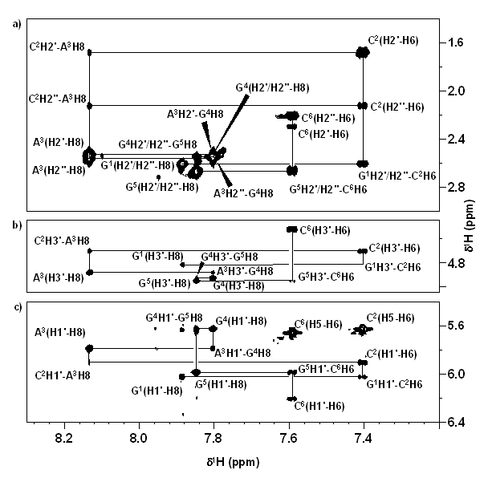
Fig. 2
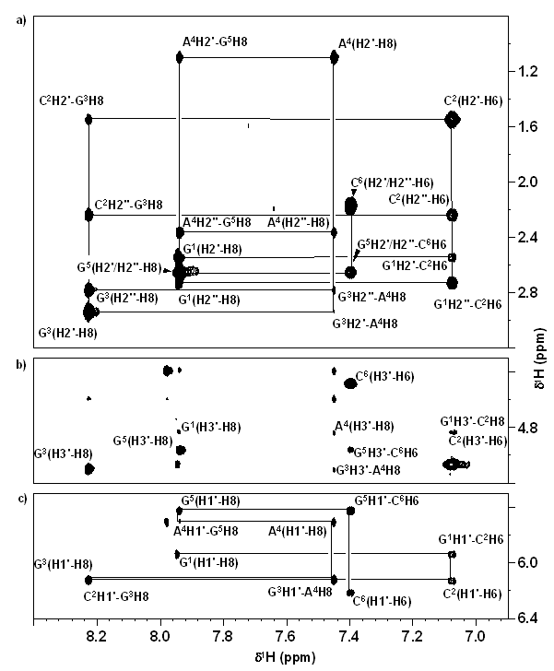
Fig. 3
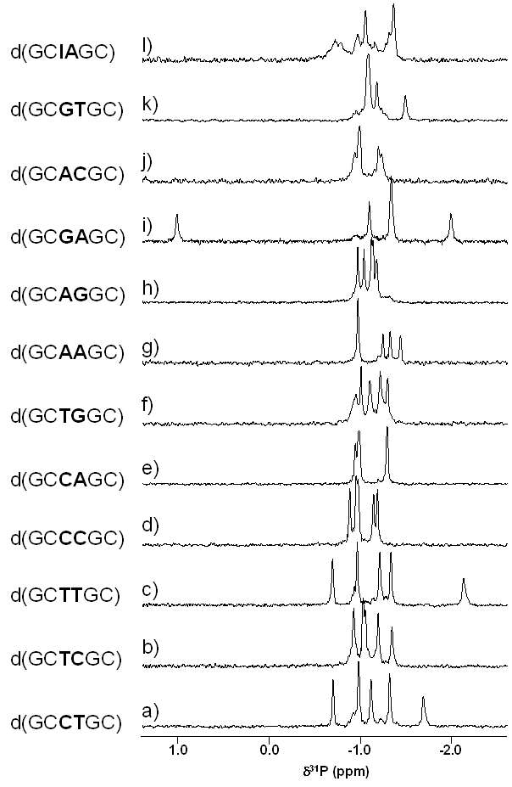
Fig. 4
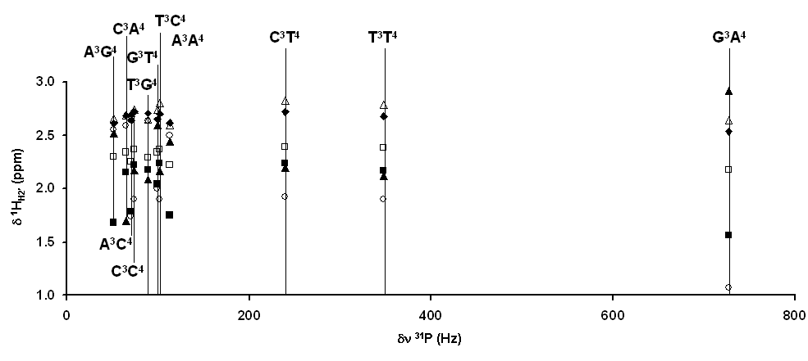
Fig. 5
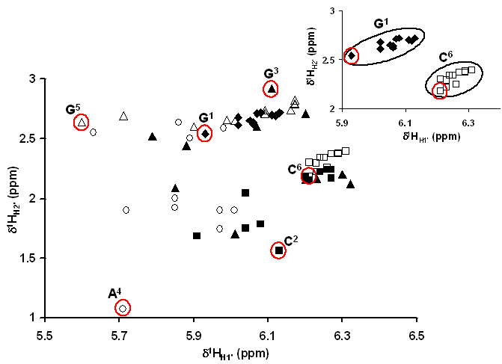
Fig. 6
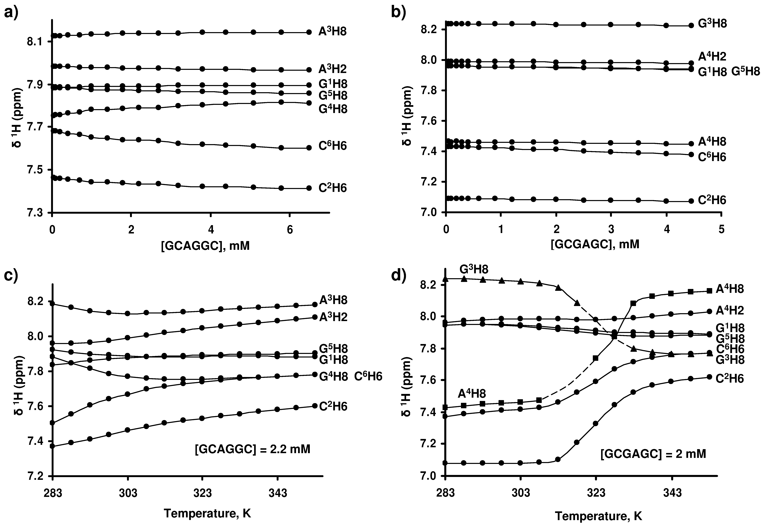
Fig. 7
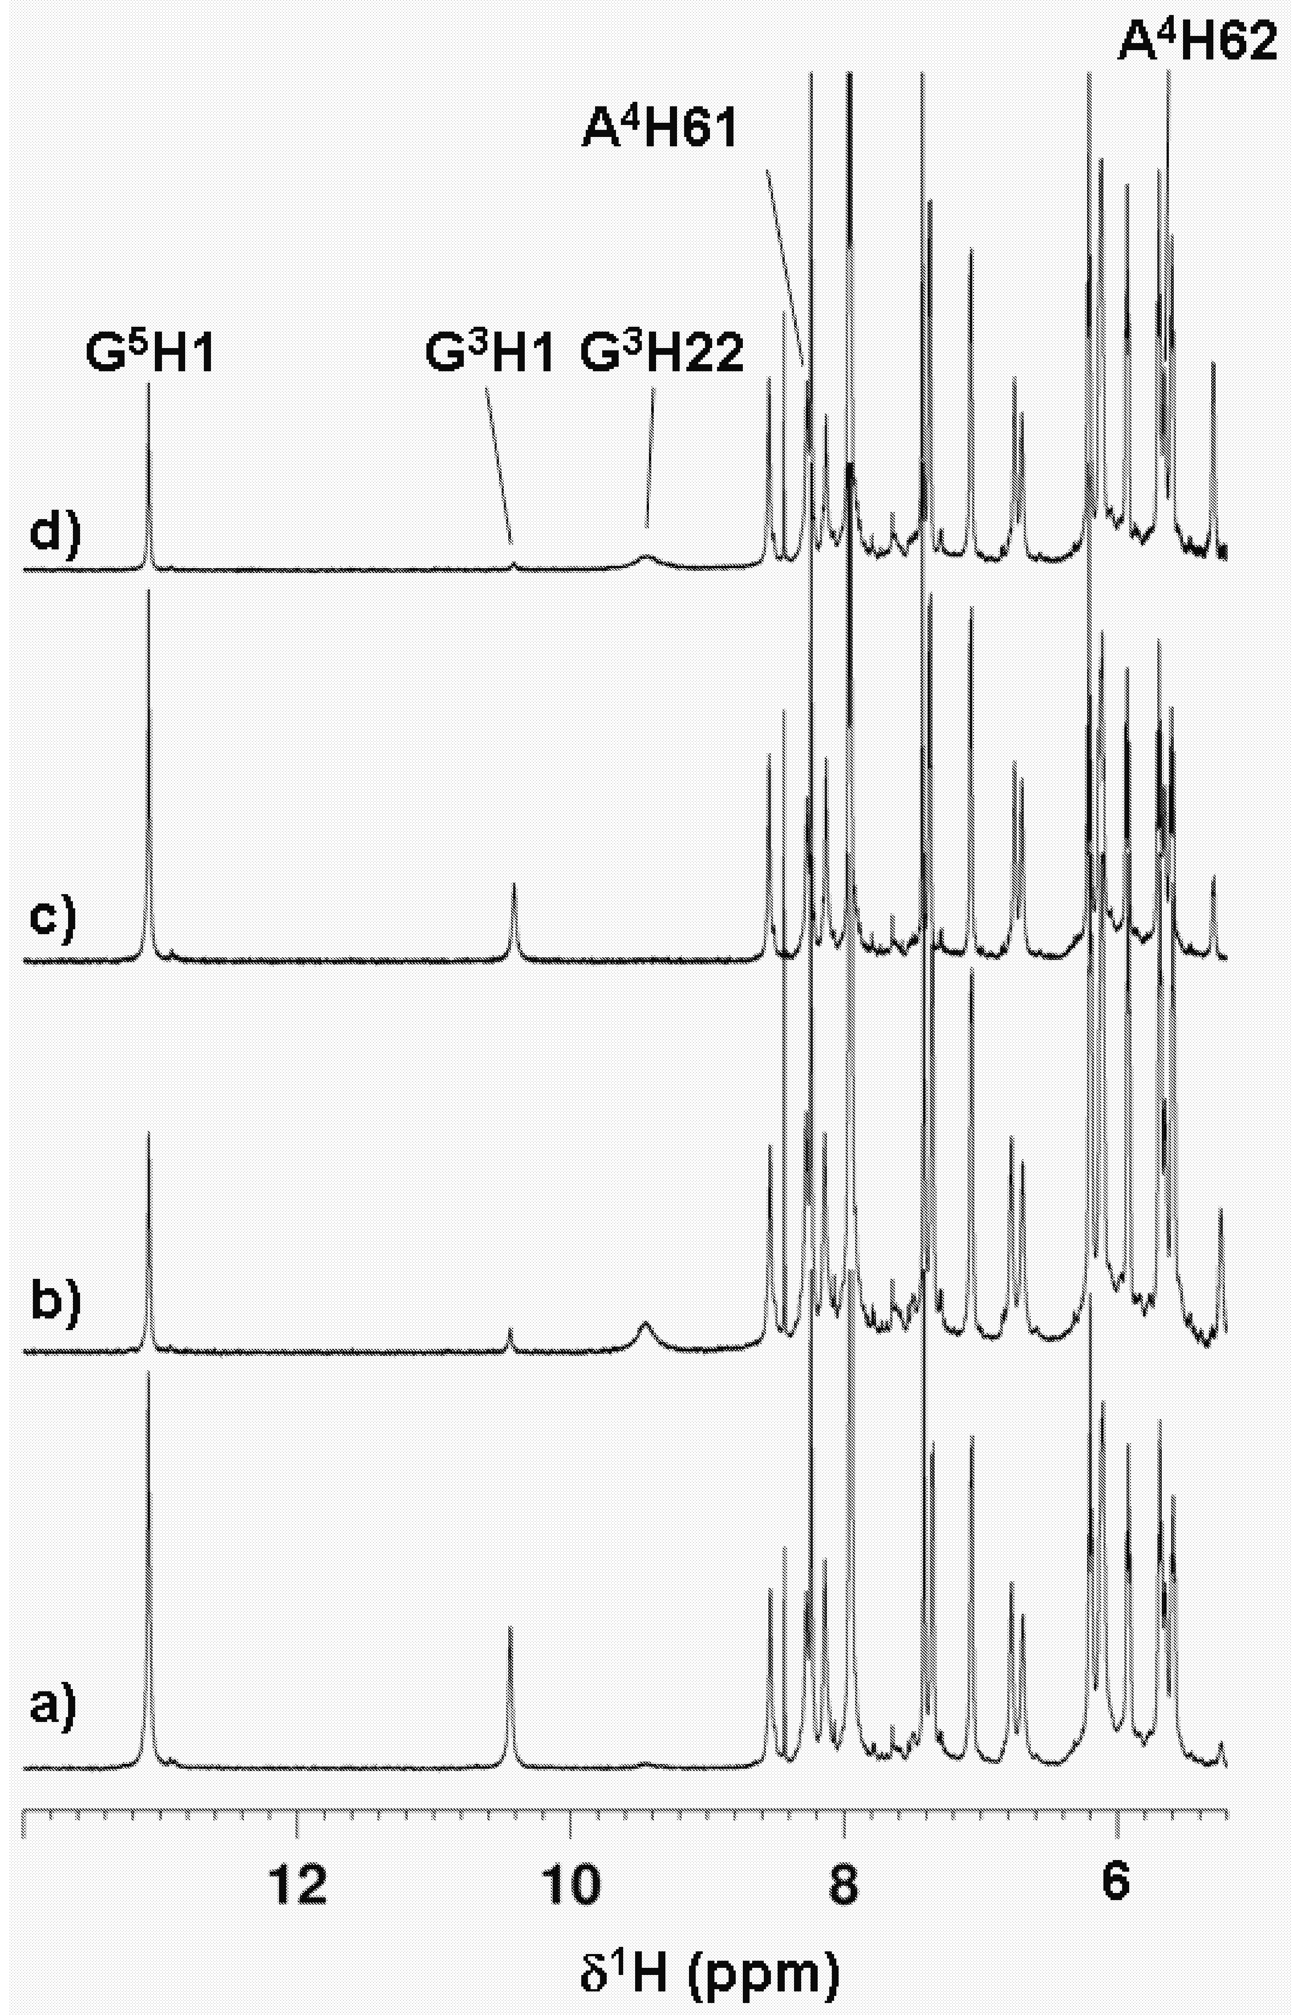

Fig. 8
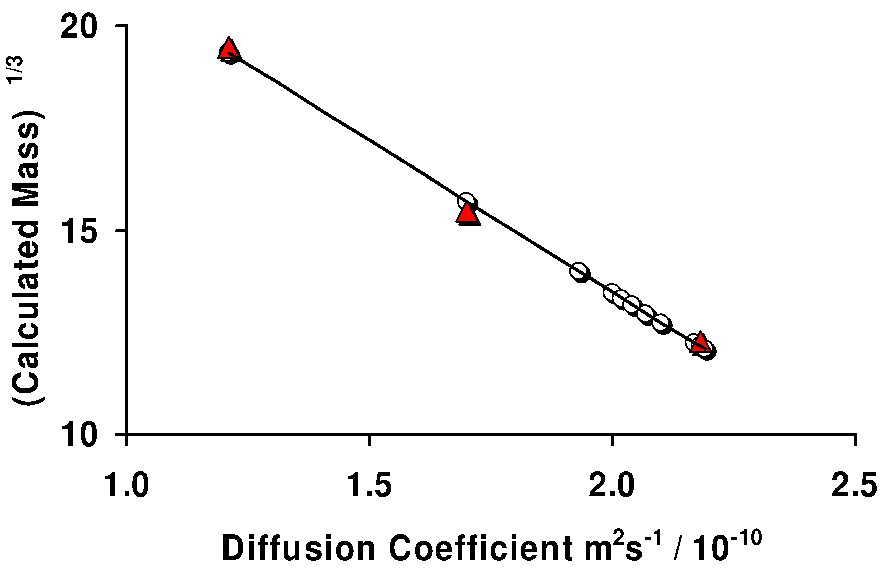

Fig. 9
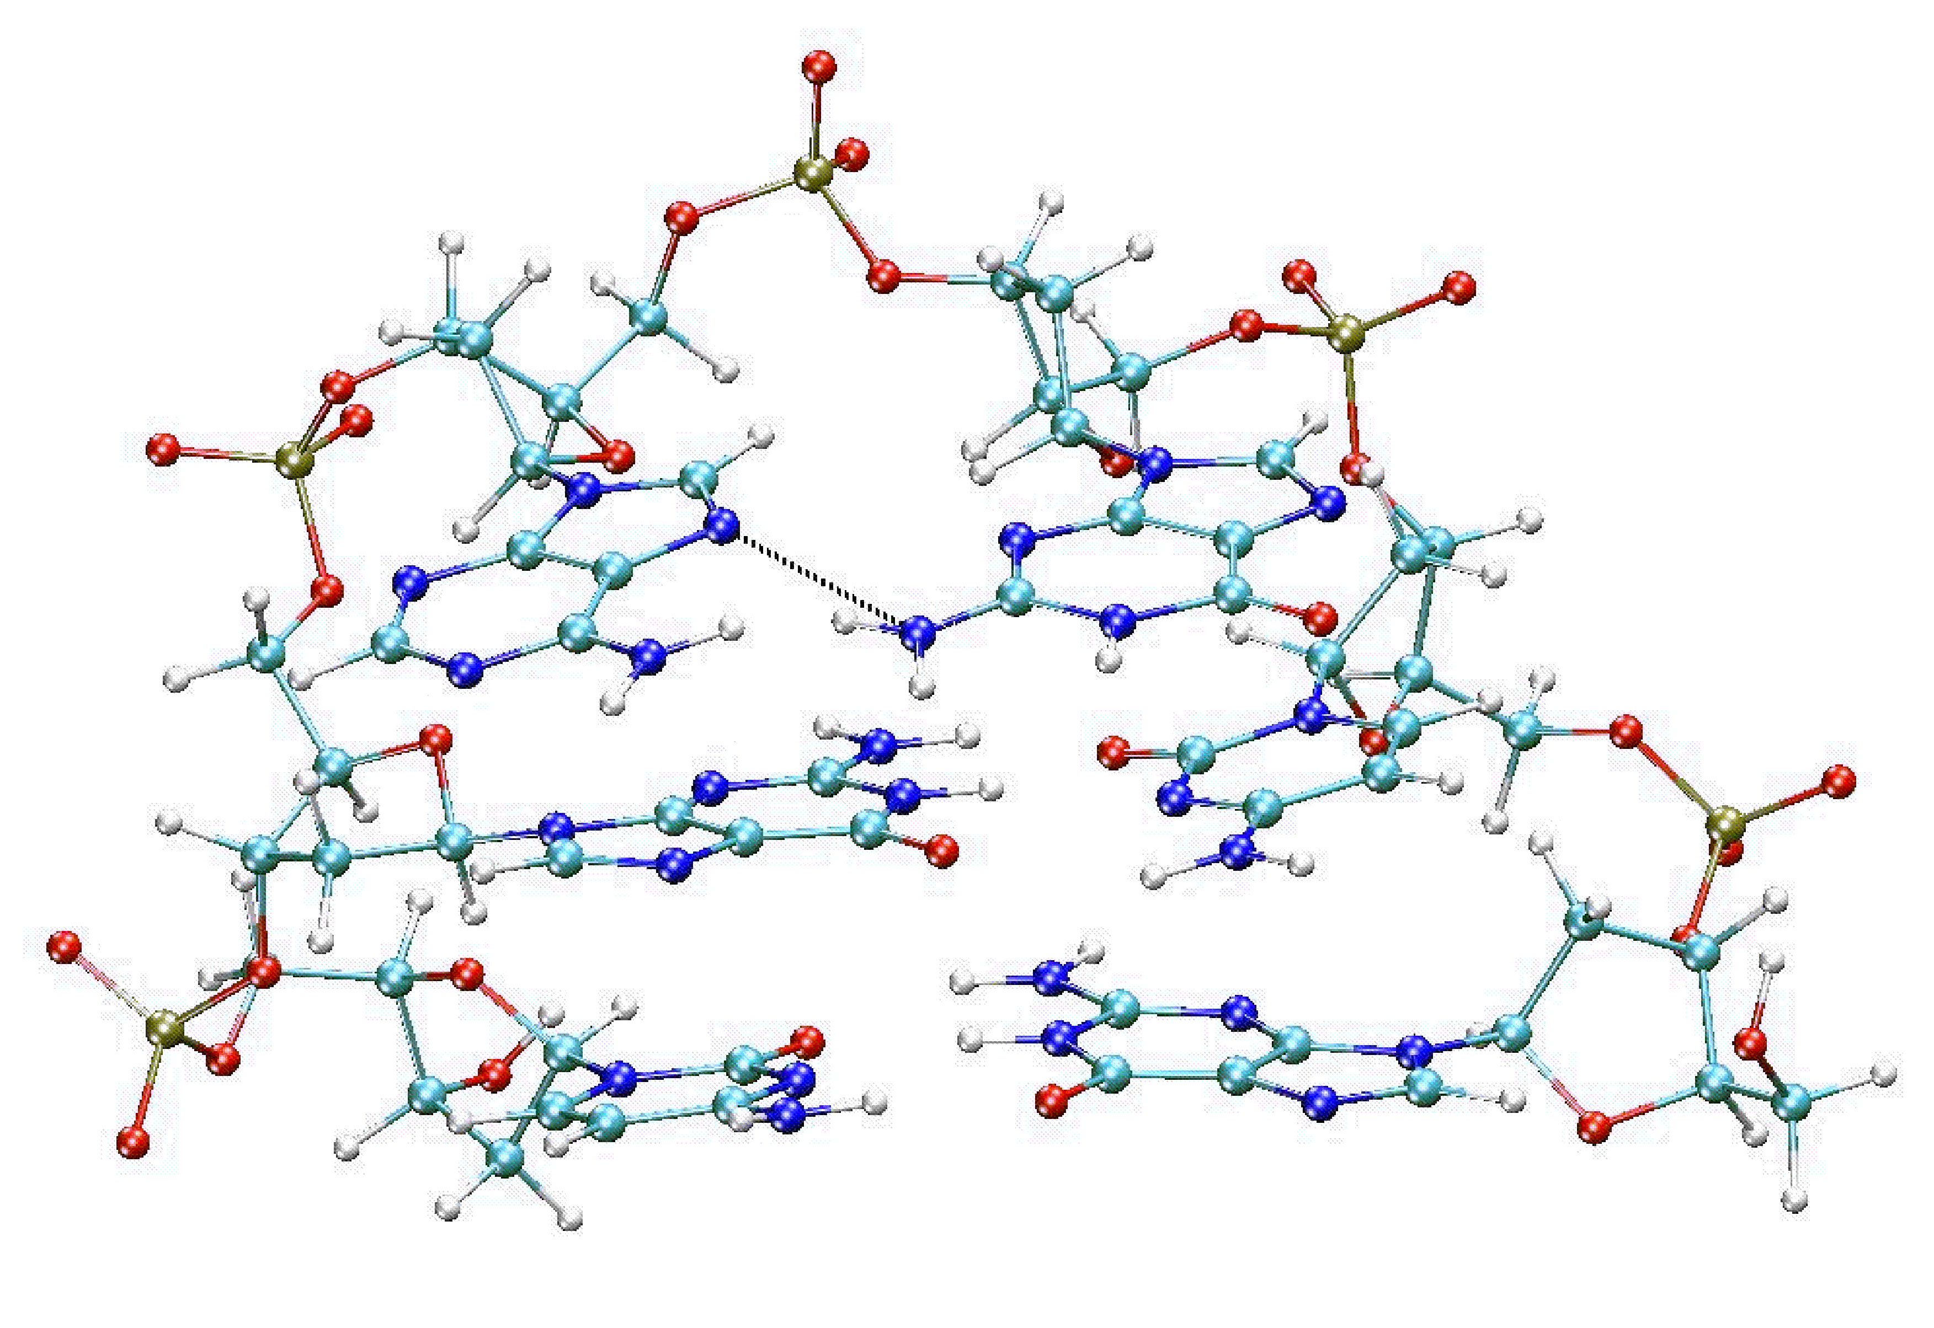

‡ Here the average values G^{x}H8_{av} and A^{x}H8_{av} are calculated over 25 values for G and 5 values for A respectively for residues distributed throughout the oligonucleotide sequences in this study
. Chou, S.-H.; Chin, K.-H.; Wang, A.H.-J. Nucleic Acids Res 2003, 31, 2461-2474.
. Balkwill, G. D.; Williams, H. E. L.; Searle, M. S. Org Biomol Chem, 2007, 5, 832-839.
. Lee, B. J.; Barch, M.; Castner, E. W.; Volker, J.; Breslauer, K. J. Biochemistry, 2007, 46, 10756-10766.
. Kolpashchikov, D. M. J Am Chem Soc, 2006, 128, 10625-10628.
. Kim, Y.; Yang, C. J.; Tan, W. Nucleic Acids Res, 2007, 35, 7279-7287.
. Takinoue, M.; Suyama, A. Small, 2006, 2, 1244-1247.
. Moelling, K.; Abels, S.; Jendis, J.; Matskevich, A.; Heinrich, H. FEBS Lett, 2006, 580, 3545-3550.
. Oleksi, A.; Blanco, A. G.; Boer, R.; Uson, I.; Aymami, J.; Rodger, A.; Hannon, M. J.; Coll, M. Angew Chem Int Ed, 2006, 45, 1227-1231.
. Cheng, J.-W.; Chou, S.-H.; Reid, B. R. J Mol Biol, 1992, 228, 1037-1041.
. Chou, S.-H.; Zhu, L.; Reid, B. R. J Mol Biol, 1996, 259, 445-457.
. Chou, S.-H.; Zhu, L.; Reid, B. R. J Mol Biol, 1997, 267, 1055-1067.
. Yoshizawa, S.; Kawai, G.; Watanabe, K.; Miura, K.-I.; Hirao, I. Biochemistry, 1997, 36, 4761-4767.
. Nakano, S.-I.; Kirihata, T.; Fujii, S.; Sakai, H.; Kuwahara, M.; Sawai, H.; Sugimoto, N. Nucleic Acids Res, 2007, 35, 486-494.
. Gallego, J.; Chou, S.-H.; Reid, B. R. J Mol Biol, 1997, 273, 840-856.
. Altona, C.; Pikkemaat, J. A.; Overmars, F. J. J. Curr Opin Str Biol, 1996, 6, 305-316.
. SantaLucia, J. PNAS, 1998, 95, 1460-1465.
. Kostyukov, V. V.; Rogova, O. V.; Pakhomov, V. I.; Evstigneev, M. P. Biophysics, 2007, 52, 375-382.
. Ippel, H. H.; van den Elst, H.; van der Marel, G. A.; van Boom, J. H.; Altona, C. Biopolymers, 1998, 46, 375-393.
. Brunger, A. T. Univ. Press, Yale. 1992.
. MacKerell, A. D.; Banavali, N. J Comput Chem, 2000, 21, 105–120.
. Young, M. A.; Ravishanker, G.; Beveridge, D. L. Biophys J, 1997, 73, 2313–2336.
. Chalikian, T. V.; Sarvazyan, A. P.; Breslauer, K. J. Biophys Chem, 1994, 51, 89–109.
. Nakamura, S.; Hirose, H.; Ikeguchi, M.; Shimizu, K. Chem. Phys. Lett., 1999, 308, 267-273.
. Avizonis, D. Z.; Kearns, D. R. Nucleic Acids Res, 1995, 23, 1260–1268.
. Znosko, B. M.; Barnes, T. W.; Krugh, T. R. J Am Chem Soc, 2003, 125, 6090-6097.
. Chen, H.; Yang, P.; Yuan, C.; Pu, X. Eur J Inorg Chem, 2005, 15, 3141-3148.
. Hirao, I.; Kawai, G.; Yoshizawa, S.; Nishimura, Y.; Ishido, Y.; Watanabe, K.; Miura, K.-I. Nucleic Acids Res, 1994, 22, 576-582.
. Orbons, L. P. M.; van der Marel, G. A.; van Boom, J. H.; Altona, C. Eur J Biochem, 1987, 170, 225-239.
. Davies, D. B.; Pahomov, V. I.; Veselkov, A. N. Nucleic Acids Res, 1997, 25, 4523-4531.
. Stellwagen, N. C.; Magnusdottir, S.; Gelfi, C.; Righetti, P. G. Biopolymers, 2001, 58, 390-397.
. Leporc, S.; Mauffret, O.; El Amri, S.; Convert, O.; Lescot, E.; Tevanian, G.; Fermandjian, S. J Biomol Str Dyn, 1998, 16, 639-649.
. Wong, A.; Ida, R.; Spindler, L.; Wu, G. J Am Chem Soc, 2005, 127, 6990-6998.
. Kaucher, M. S.; Lam, Y.-F.; Pieraccini, S.; Gottarelli, G.; Davis, J. T. Chem Eur J, 2005, 11, 164-173.
. Bhavesh, N. S.; Patel, P. K.; Karthikeyan, S.; Hosur, R. V. Biochem Biophys Res Commun, 2004, 317, 625-633.
. Mariappan, S. V. S.; Catasti, P.; Chen, X.; Ratliff, R.; Moyzis, R. K.; Bradbury, E. M.; Gupta, G. Nucleic Acids Res, 1996, 24, 784-792.
. Znosko, B. M.; Barnes, T. W.; Krugh, T. R.; Turner, D. H. J Am Chem Soc, 2003, 125, 6090-6097.
. Hirao, I.; Nishimura, Y.; Tagawa, Y.-I.; Watanabe, K.; Miura, K.-I. Nucleic Acids Res, 1992, 20, 3891-3896.
. Orbons, L. P. M.; van der Marel, G. A.; van Boom, J. H.; Altona, C. Nucleic Acids Res, 1986, 14, 4187-4196.
. Rentzeperis, D.; Alessi, K.; Marky, L. A. Nucleic Acids Res, 1993, 21, 2683-2689.
. Li, Y.; Zon, G.; Wilson, W. D. PNAS, 1991, 88, 26-30.
. Davies, D. B.; Karawajew, L.; Veselkov, A. N. Biopolymers, 1996, 38, 745-757.
. Petersheim, M.; Turner, D. H. Biochemistry, 1983, 22, 256-263.
. Davies, D. B.; Baranovsky, S. F.; Veselkov, A. N. J Chem Soc Faraday Trans, 1997, 93, 1559-1572.
. Chou, S.-H.; Tseng, Y.-Y.; Wang, S.-W. J Mol Biol, 1999, 287, 301-313.
. Marky, L. A.; Breslauer, K. J. Biopolymers, 1982, 21, 2185-2194.

