SOME UNUSUAL SOLUTIONS FOR EUROPEAN NETWORKS
Vernescu V., Goia M.L., Golovanov N.
CNR/WEC- Bucharest, Romania

Abstract. Authors present several non-conventional solutions unused in Europe which are, however, frequently adopted in some medium (M) and low (L) voltages (V) networks from North-American and Australian countries, especially in low density areas of consumption in rural and urban distribution. The proposed solutions may assure diversified supply possibilities in our middle and South–Eastern regions, as regards modernizing and upgrading the distribution networks. The solutions try to propose to adapt our European practice to the North-American experience, aiming at developing more flexible, cheaper and safer supply of the consumers, both at MV and at LV networks. Several original solutions promoted in Romanian networks and their peculiarities are also described. The paper presents distribution schemes at medium voltage in connection with low voltage supply in different condition of neutral treatment at MV or LV. It also shows the measures to be adopted in order to diminish the investment expenses in low voltage at the supplied consumers. The technical condition of co-existence of OHEL at MV and LV on the same poles, without jeopardizing the LV equipment, is necessary. Among the solutions proposed, the authors also describe the unconventional one, consisting in the supply of isolated monophase consumer at MV by ground return and also the conditions necessary for sure and safe operation of this particularly connection. Finally, there are shown some conclusions about the necessity to assure imposed environmental conditions.
Keywords: consumers supply, small transformers, schemes, safety operation.

UNELE SOLUŢII NESTANDARDE PENTRU REŢEAUA EUROPEANĂ
Vernescu V., Goia M.L., Golovanov N.
CNR/WEC- Bucureşti, România
Rezumat. Autorii prezintă câteva soluţii non-convenţionale ce nu sunt utilizate în Europa, dar care deseori sunt acceptate în reţelele de medie (M) şi joasă (J) tensiune (T) din America de Nord şi ţările Australiene, în special în zonele cu densitatea scăzută a consumului în distribuţia rurală şi urbană. Soluţiile propuse pot asigura diverse posibilităţi de alimentare în regiunea noastră de mijloc şi sud-estică în ce priveşte modernizarea şi renovarea reţelelor de distribuţie. Soluţiile propuse încearcă să adapteze practicile noastre europene la experienţa nord-americană având ca scop dezvoltarea unei alimentări a consumatori mai flexibilă, ieftină şi sigură atât pe tensiune medie cât şi joasă. Câteva soluţii originale promovate în reţelele româneşti precum şi particularităţile acestora sunt descrie de asemenea. Lucrarea prezintă schemele de distribuţie medie de tensiune în conexiune cu alimentarea în tensiune joasă la diferite condiţii de tratare a neutrului la JT şi MT. De asemenea se arată, măsurile necesare de întreprins pentru a diminua capitalul de investiţie a tensiunii joase la consumatorii alimentaţi. Sunt necesare condiţiile tehnice a coexistenţei LEA la MT şi JT pe aceleaşi poluri fără a pune în pericol echipamentul de JT. Printre soluţiile propuse autorii mai descriu şi una non-convenţională, ce constă în alimentarea monofazată izolată a consumatorului la MT prin împământarea returului şi de asemenea sunt necesare condiţii tehnice pentru funcţionarea sigură a acestei conexiuni particulare. În final, sunt prezentate câteva concluzii privind necesitatea asigurării condiţiilor de mediu impuse.
Cuvinte-cheie: alimentarea consumatorilor, transformatoare mici, scheme, funcţionare sigură.

НЕКОТОРЫЕ НЕСТАНДАРТНЫЕ РЕШЕНИЯ ДЛЯ ЕВРОПЕЙСКИХ СЕТЕЙ
Вернеску В., Гоя М.Л., Голованов Н.
РНК/ВЭС – Бухарест, Румыния
Аннотация. Авторы приводят несколько нетрадиционных решений, которые не используется в Европе, однако, часто применяются в сетях среднего (С) и низкого (Н) напряжения (Н) Северной Америки и стран Австралии, особенно в районах с низкой плотностью потребления в сельском и городском распределение. Предлагаемые решения может обеспечить диверсифицированные возможности поставки в нашем Среднем и Юго-Восточном регионе, что касается модернизация и обновление распределительных сетей. Предложены решения попытаться адаптировать нашу европейскую практику к североамериканскому опыту, имея целью развитие более гибкого, дешевого и надежного снабжения потребителей электроэнергией, как среднего напряжения, так и низкого напряжения. Описаны несколько оригинальных решений, а также особенности их внедрения в румынских сетях. В статье представлены схемы распределительных сетей среднего напряжения. Для схем электроснабжения низкого напряжения для различных условий подключения нейтрального провода, показаны меры, которые необходимые принять, чтобы уменьшить инвестиции в низковольтные сети напряжения. Среди предлагаемых решений, авторы описывают одно нетрадиционное, которое состоит в питании однофазного изолированного потребителя на СН путем изолирования обратного провода, и также технические условия необходимые для надежной и безопасной эксплуатации для этого частного случая. Представлены несколько предложений по обеспечению экологических требований.
Ключевые слова: электроснабжение потребителей, трансформаторы малой мощности, схемы, надежное функционирование.

1. Medium Voltage Solutions

Electricity supply of consumers, under safety and economic conditions, is one of the major concerns of electricity suppliers. The solutions adopted to supply various types of users should comply with their installed capacity, the distance from the supply point, required safety level, possibility to recover the expenses for the delivered electricity, etc.
The accomplishment of monophase small-power (MV/0.23 kV) oil or dry transformers, with competitive technical characteristics has enabled finding out specific solutions to supply small installed capacity users, concentrated or dispersed in urban or rural areas. The solutions developed on the basis of new transformer types represent a new stage of several studies and achievements on high voltage use (1000/230 V) in order to supply small users, while diminishing the active losses in the electric supply power grid.
The solutions of bi/three phase transformers begin to be ever more considered when supplying rural consumers living in areas across which a MV electric line is passing, leading to important advantages on reduction losses in distribution network, by eliminating the low voltage network. As for the dispersed users or those grouped in small communities, the solutions with oil-insulated mono/ bi phased transformers, can offer advantageous technical-economic conditions as compared to the present ones. Locating the mono/bi-phase transformers close to the load weight center ensures loss reduction in the low voltage network, cutting down investment in the medium voltage network and providing advantageous economic parameters of the supply. In many cases, medium voltage accomplishment is possible with only one conductor (phase), leading to a substantial reduction (with 66%) of the investment in line conductors and, practically with 50% of the investment in line.
Depending on the neutral grounding of the medium voltage lines, various solutions can be adopted for the supply of rural localities nearby those lines.

2. Connection diagrams of monophase transformers

The following solutions can be considered:
- three-phase medium voltage line, passing nearby a low power consumer who has to be supplied with electricity
- three-phase line passing nearby some small power consumers who need a three-phase voltage
- small power consumer located at a relatively small distance from the three-phase medium voltage electric line which requires a single-phase supply
- small power consumer located at a relatively small distance from the three-phase medium voltage consumer requiring a three-phase supply
- load symetrization in the medium voltage network by the distributed supply of the consumers groups (low voltage distributed network). Are possible the following variants for supply the consumers which need electrical energy: a)MV lines in a resistor grounded network, passing close or not far to small users; b)The same case but in an network by Petersen coil treated neutral. In the case of resistor grounded neutral, is necessary analizing of the return circuit in normal or transient permanent regime. It is possible to consider the variant with physical conductor or by ground return, if those few amperes of ground circuit currents remain compatibles with neighboring installations or equipments. Final solution will adopted upon a calculus of the transient created by monophase load, but upon authors opinion in south-east conditions is preferable to adopt the first variant with physical return conductor, to avoiding EMC complications.
In the case of monophasic consumers, close or not so far from MV line is recommended to assure the balance of the phase load at MV network by users groups distributed connection for load symmetrization (LV network distributed load).
In the cases of resistor grounded neutral, the user may be connected on like in the schemes presented in fig.1, 2, 3, 4 by a monophase transformer TM 11,5/0,23 kV. The line is completed with one neutral conductor ground connected at the MV substation grounded resistor R and at the place of TM too.
R
A
B
C
T
TS
N
F
N
TM
l
Fig.1. The solution for a monophase user close to MV line in a network by resistor neutral grounded
R
A
B
C
T
TS
N
A
B
C
N
TM
l
Fig. 2. Solution for three phase consumer close to MV line in by resistor neutral grounded network
The cost of the return conductor assures the competitivity of this solution even in the case of the low power users situated at relative short distance of MV line. Neutral conductor is designed for one monophased fault at the TM terminal, load current (almost few amperes) impose only mechanical criteria. The monophase TM transformer is presented in photo A and B.
For the users who need three phase, are necessary three transformers, connected at three phases of the line. This may be initial realized or like an extension of those monophased. Fig.2 is a solution for this situation.
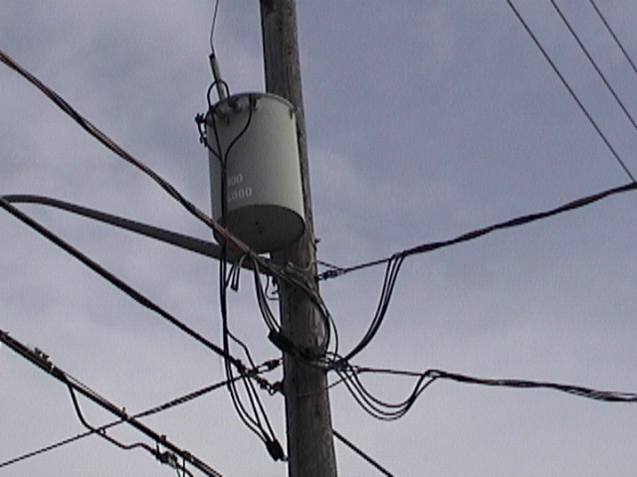
Photo A. Monophase transformer MV/LV

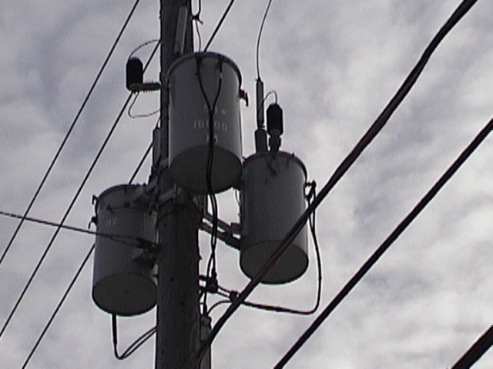
Photo B. Solution for three phase user
The neutral point of LV networks connected to the same earthing like the return conductor of MV network. In the diagram from fig.5 is presented one dispersed LV network without the interconnection possibility of consumers to the same power, that assuring the same load on three phase. This solution corresponds to feed a rural locality following one river valley, with consumers to the same load with. The neutral conductor in permanent regime has the current of disequilibria created by monophased transformers, connected to the MV line (some few amperes, which flow by ground in absence of the return neutral).

3. Connection schemas with biphase transformers
These connections correspond to Peterson coil treated neutral. The connection is more simple and no need neutral conductor. May be the next variants:
- monophase user close to the MV line
- user who need 400 V
- three-phase user
- dispersed users along the MV line
- dispersed users situated relative close to the MV line (isolated farm)
In practice may find and other situations where may be used biphase small power transformers to feed some reduced load zones.
R
A
B
C
T
TS
l₁
l₂
TM
11,5/0,23 kV
F
N
Fig. 3 Solution for one monophase user at small distance from MV line in an neutral by resistor grounded network

R
A
B
C
T
TS
N
A
B
C
N
TM
l₁
l₂
Fig.4 .Solution for three or monophase phase users at the l₂ distance from MV line in a neutral by resistor grounded network

Fig. 5 − One or some consumers disposed at different distances from the T and TS sources
4. Technical limits for using small power transformers.
Monophased or biphased loads connected to three phased MV line must be monitorised and designed to not create an asymmetry factor exceeding admissible limits and significant perturbing the normative values of phase voltages at all the users in normal regime and in a load gap. Proper inequality of aerian MV line may amplify the asymmetry of phase currents. In respect of those is recommended that before transformers connect need to analyze network asymmetry to establish the phase with the greatest voltage due to natural network lack of balance. Mono (bi) phase transformers will be connected at the phases with the greatest voltage, avoiding amplifying the permanent line asymmetry. The voltage fall on return circuit must be limited at the imposed values, especially in the case is used the ground return of current. The design of the return conductor imposes only mechanical conditions because the small value of the return current (Table 1). Often is sufficient the ST/AL 25 mm².

L
A
B
C
T
TS
F
N
TB
20/0,23 kV
l
Fig. 6 − Monophase user close a MV line in Petersen coil treated network.

L
A
B
C
T
TS
TB
20/0,23 kV
l
C
B(N)
A
TB
20/0,23 kV
Fig. 7 − Monophase and poliphased users close to a MV line in an Petersen coil treated network.

Fig. 8 − Monophased dispersed users close to MV line in Petersen coil treated network

Table 1. Electric current in monophase transformers
Nominal power  kVA | Current  A
5 | 0,433
10 | 0,866
15 | 1,3
20 | 1,732
25 | 2,165
30 | 2,6
35 | 3,03
40 | 3,464

5. Original alternative.
The small power single-phase consumers may be supplied from new renewable power sources, like the wind, solar or from combustion cell ones.
Such solutions became classical and have promising development perspectives in the industrial countries. In our country, some successful experiments concerning the electric power supply from such sources have been adopted, but the solutions seem not yet acceptable for the village consumers, not so much as concerns the cost price of the power supplied from renewable sources (15¢ / kWh from photovoltaic cells, 20¢ / kWh at the wind supplied central stations) but especially because of the initial prohibitive investment. That is why the authors adopted the local power system supply.
Paper idea is based on the practical need of the supply for Poiana Florilor (PF) single-phase low voltage consumer situated at about 3 km distance from LEA 20 kV connection Aleşd Aştileu Pădurea Neagră, in Bihor county.
The mentioned line is supplied from the Aleşd station (I_{SC}=4,35 kA on bus bars), has the section of 120 mm² Al-ST and the from the line is situated at about 5,7 km from Aleşd station and has the section of 35 mm² Al-ST and a length of 1 km.
The power required by the consumer situated at 3 km from PT 63 KVA is of 30 kW at cos φ = 0,8.
The area where the consumer is situated in the second zone from meteo point of view, but is considered difficult from white frost layers point of view and frequently endangered from atmospheric discharges.
The network from which the connection is supply has the neutral point grounded with Petersen coil (BS) and network earthing capacitive current for which the ground plate is calculated of 10A.
The route the electric power supply LEA line should follow is parallel to the aces road to the “PF” consumer from reasons related to Romsilva agreement.
Starting from this real problem was treated in a more general context the electrification of single-phase small consumers distributed in areas with low consumption.
The real electrification solution in this case was selected from following main alternatives:
- Three phase/single phase medium/low voltage line
- Two phase medium (low) voltage line
- Single phase line with current return by the ground
From the constructive point of view, the lines can be achieved on concrete or wood poles with ordinary or insulated wires, in simple suspended or twisted system.
The performed analysis excluded the alternative with underground cable supply, which is by far not competitive.
From the comparative analysis following data supplied by S.C. ELECTRICA related to the specific costs of the three-phase aerial lines of the different types and compositions was chosen the solution with single phase and ground return current, at 6kV rate. The arguments and technical conditions for this selection were largely presented in [1].
The scheme and parameters for calculation is presented in fig. 9 and the diagram for PT1 and PT2 at the beginning and the terminal point of this connection in the fig.10.

Fig. 10. Diagrams for PT1 and PT2 at 20 (6) kV connection
1. Wood pole (H type or in concrete foundation), 2. Transformer 20/20 (6) kV 40 KVA TMD, 3. Polycarbonate cabinet with current reducer, relays and d.c. battery, 4. Voltage transformer 20(6)/0,1 kV, 5. Single phase connector 24 kV in vacuum, 6. Single phase Ampact disconnector (ELCO), 7. OZn discharger (surge arrester) 8. OL AL wire 50 mm insulated, 9. Wood terminal pole (H type or in concrete foundation), 10. Fuse frame 24 kV+single phase discharger SSFED (ELCO), 11. Single phase transformer 20 (6)/0,231 kV 40 KVA TMD, 12. Insulator 24 kV, 13. Insulator 24 kV, P1, P2 Earthing 20, R Earthing 12.

5. Conclusions
The use of the monophase or biphasic low power transformers (max 100 KVA) may represent a very smart solution who leads to important economy of investments in network and in electrical losses. The conductors and isolation costs are reduced with 2/3 and the poles may be more simply and light.
The technical limits results from the accepted network asymmetry factor and from the permanent return current, especially in the case of using the ground in this purpose.
To achieve an electrification of some isolated single phase low power consumers was possible to adopt the solution with single MV phase with ground return. For this purpose was adopted an isolation transformer from the 3F-MT network and create an isolated network who has grounded neutral.
The connections to earthling of the transformers at the both ends of the monophasic racord was realized with very good isolated wires, to prevent touch and step voltages in normal and isolation defection. The condition of design for the earthling of both transformers is very special.

References
[1] COROIU N., GOIA M. L., UNCONVENTIONAL SOLUTION FOR LOW POWER SINGLE-PHASE CONSUMER SUPPLY, CIRED Torino, 2005, 0389
[2] de la Rosa F., Mak S. T., A Look into Steady State and Transient Performance of Power Lines Integrating Single Wire Earth Return Circuits, PESGM 2007, Tampa, Florida, Rap.000471
[3] VILLOT A.V., ZAPATA A. H., GURUMETA E. M.,ENVIRONMENTAL TRANSFORMER SUBSTA-TION , CIRED Torino, 2005, 0103
[4]Wolfs P.J., Hosseinzadeh N., Senini S.T., Capacity Enhancement for Aging Distribution Systems using Single Wire Earth Return, PESGM 2007, Tampa, Florida, Rap.000388

*Este recomandată de colegiul de redacţie a culegerii de lucrări a Conferinţei Internaţionale „Energetica Moldovei-2012” Aspecte regionale de dezvoltare. Ediţia a II-a.

