The effect of the grooved elastic damping component in reducing friction-induced vibration

D.W. Wang ª, J.L. Mo ^{a,} *, Q. Zhang ª, J. Zhao ª, H. Ouyang ^{b}, Z.R. Zhou ª
ª Tribology Research Institute, School of Mechanical Engineering, Southwest Jiaotong University, Chengdu 610031, China
^{b} School of Engineering, University of Liverpool, Liverpool L69 3GH, UK

Abstract:
In this work, the effect of the grooved elastic damping component on the friction-induced vibration is investigated by using both experimental and numerical analysis. Experimental results show that the Styrene Butadiene Rubber (SBR) with grooves on its surface can reduce the vibration level, suppress the generation of vibration frequency and alleviate the effect of disc surface run-out. To reveal the role of the grooves in modifying friction-induced vibration, three SBR components with grooves distributed on three different regions are tested. The results show the grooves in the middle region can reduce the vibration amplitude, while the grooves in both the leading and trailing regions can eliminate higher vibration frequency. Numerical analysis is performed to provide reasonable explanations on experimental phenomenon.

Key words: Friction-induced vibration; Damping; Grooves; Numerical analysis.

- Introduction
Friction-induced vibration is a typical self-excited vibration phenomenon, which can be commonly observed in many mechanical applications, such as powertrains, automobile clutches, vehicle brake systems, lead screw drives, frictional belts and mechanical gear systems [1-7]. This vibration generated from the contact interface will cause wear and damage of the contact interface and even failure of mechanical systems. It is reported that more than three quarters of failure events of machine parts are caused by friction-induced vibration and its related problems [1]. Therefore, a thorough comprehension of friction-induced vibration and consequent seeking of an effective method to reduce and eliminate it is extremely significant.
Over the last decades, much meaningful research work has been conducted to identify the critical factors for the generation of friction-induced vibration [8-12]. Comprehending the mechanisms that generate friction-induced vibration phenomenon will be an important contribution to the extensive research and industrial applications. Up to present, various experimental and numerical methods have been conducted to investigate this subject and its related issues [13-25]. However, due to the fact that the friction-induced vibration is very sensitive to many variables, such as the stiffness of the components, surface topographies, physical and chemical properties of the materials in frictional contact and the interface, usage history and many operating and environmental conditions, friction-induced vibration is characterized by immense complexity [13]. Until now, there is no fully satisfactory and well validated general theory of friction-induced vibration.
Considering the fact that friction-induced vibration is originated from the unstable vibration of the contact interface, an efficient way to improve the vibration behavior is to modify the contact characteristics of the contact interface. Much related research work has been reported [26-32]. Oberst and Lai [26] numerally verified that adding single vertical slot on the pad surface can considerably suppress the unstable friction-induced vibration and consequently reduce the acoustic power amplitude. Gweon et al. [27] experimentally proved that the brake friction materials with chopped glass fibers would lead to lower amplitude friction-induced vibration. Wang et al. [28] confirmed that the brake disc sample with a certain configuration of grooves could modify the contact pressure distribution, which consequently stabilize the friction system. Dufrénoy et al. [29] introduced a realistic rough surface of asperities at the brake-pad interface, and found that the contact pressure and unstable vibration could be reduced with the decrease of the surface roughness magnitude. Abubakar and Ouyang [30] found that locating the piston towards the trailing side of the pad was an efficient way to symmetrize the pressure distribution at the disc/pads interface, and thus helped stabilize a brake system.
On the other hand, the vibration caused by friction can be affected by introducing damping components to the friction system [33-39]. In the automobile industry, many schemes of adding damping have been implemented to stabilize the brake system. Triches Jr et al. [33] selected a constrained damping layer deliberately, and introduced it to the brake system. They found that the damping component could effectively dissipate the energy and consequently reduce squeal of the brake system. Kang et al. [34] numerically investigated the relationship between the damping shim and the unstable modes of the brake system, and proved that the damping shim could effectively reduce squeal generated by the dominant out-of-plane modes, however, it could not suppress the squeal associated with the in-plane disc modes. Festjens et al. [35] gave an overview of the actual role of multi-layered viscoelastic damping shim in suppressing brake squeal noise. Their results exhibited the fact that the damping shim could effectively suppress the brake eigenmodes in a certain frequency range. Massi et al. [36] found that introducing a homogenous distribution of damping could stabilizes a brake system, while a non-uniform repartition of damping would facilitate the generation of unstable vibration. Sinou et al. [37] numerically studied the effect of damping on the stability of a friction system, and confirmed that the damping components should be added carefully, and there existed threshold value of the damping factor which can help obtain the largest stable region.
The above mentioned studies indicate that there are two effective approaches for reducing vibration of the friction system: the first one is optimizing pressure distributions between the contact pairs by modifying the contact states, and the second is adding appropriate damping components in the friction system. However, the research work on reducing friction-induced vibration by simultaneously combining these two methods, i.e. using damping components to modify the contact characteristics of the interface, and consequently reduce friction-induced vibration, is rarely reported.
Nowadays, elastic damping components with grooves have been widely used in many industrial equipment [40-42], however, the related research work is mainly focused on the ability of grooved damping components in isolating the vibration transmission as well alleviating impact, and the knowledge of the relationship between the grooved damping components and the contact characteristics of the interface is limited. Moreover, the mechanism on how the grooved damping component affects the friction-induced vibration behaviour of the contact interface remains somehow mysterious. Therefore, a thorough comprehension of the effect of grooved damping components on friction-induced vibration is extremely worthwhile, which is of considerable importance for the optimal design of damping components to reduce friction-induced vibration.
In this work, the friction-induced vibration phenomenon of a system is studied in which a damping component is introduced for reducing vibration and modifying the contact pressure which in turn will enhance vibration reduction performance, by means of both the experimental and numerical methods. The aim of this work is to provide the theoretical basis for the design of grooved damping components with the purpose of reducing the vibration of the contact interface. A new test bench, which is able to reproduce the friction-induced vibration phenomenon in controlled environment easily, is developed. Damping component surfaces with different kinds of groove configurations are tested in this test system, and the capabilities of these grooved damping components in reducing friction-induced vibration are estimated by comparing their dynamic performance and a possible physical explanation for them is also provided.

- Experimental details
2.1 Details of test bench
To reproduce the friction-induced vibration phenomenon and accordingly perform related research, a new test bench is developed. This test bench is characterized by a pad-on-disc system, in which a friction contact is established between the disc and pad samples. Thanks to the simple mechanical structure, this test bench permits the occurrence of friction-induced vibration at the contact surface easily and the test results can exhibit high repeatability. Moreover, the controlling parameters, such as disc rotating speed, normal pressure and atmospheric conditions can be easily adjusted, which are used to reproduce the friction-induced vibration phenomenon in different working conditions.
The test bench mainly consists of a rotating disc sample and a small friction pad sample which is pressed against the disc by constant pressure, as shown in Fig. 1. The disc is assembled with the shaft by two flange plates, which rotates in a horizontal plane. The rotating speed of the disc can be adjusted by the 3 KW AC servo motor from 5 rpm to 75 rpm. The friction pad sample is hosted by the support, which is connected with the 2-D strain-gauge force sensors. The loading device mainly consists of a linear bearing, a push rod, a buffer spring and a cylinder. At the start of the test, the cylinder provides a constant pressure to the push rod, which pushes the rod to go through the linear bearing and accordingly presses the pad sample against the rotating disc sample. The 2-D strain-gauge force sensors are used to measure the normal and tangential force of the friction system. A three-axis acceleration sensor is located on the support to measure the vibration signals generated from the friction system.
Before testing, both the disc and pad surfaces are cleaned by acetone. A running-in procedure is conducted for the pad samples to obtain a well flat-on-flat contact. All tests are performed in a strictly controlled ambient environment (24~27 °C and 60±10% RH). In the tests, the imposed constant normal load is 550 N (equivalently an average contact pressure of 0.08 MPa), the rotary motor velocity is 14 rpm, and the whole testing period is 120 s. Each test presented in this experimental study is conducted more than three times to obtain experimental results with good repeatability. Between consecutive tests, there is a 60 s idle duration to dissipate the heat of the disc surface. In addition, acetone is also used to clean the samples’ surfaces to avoid the influence of residual wear debris.

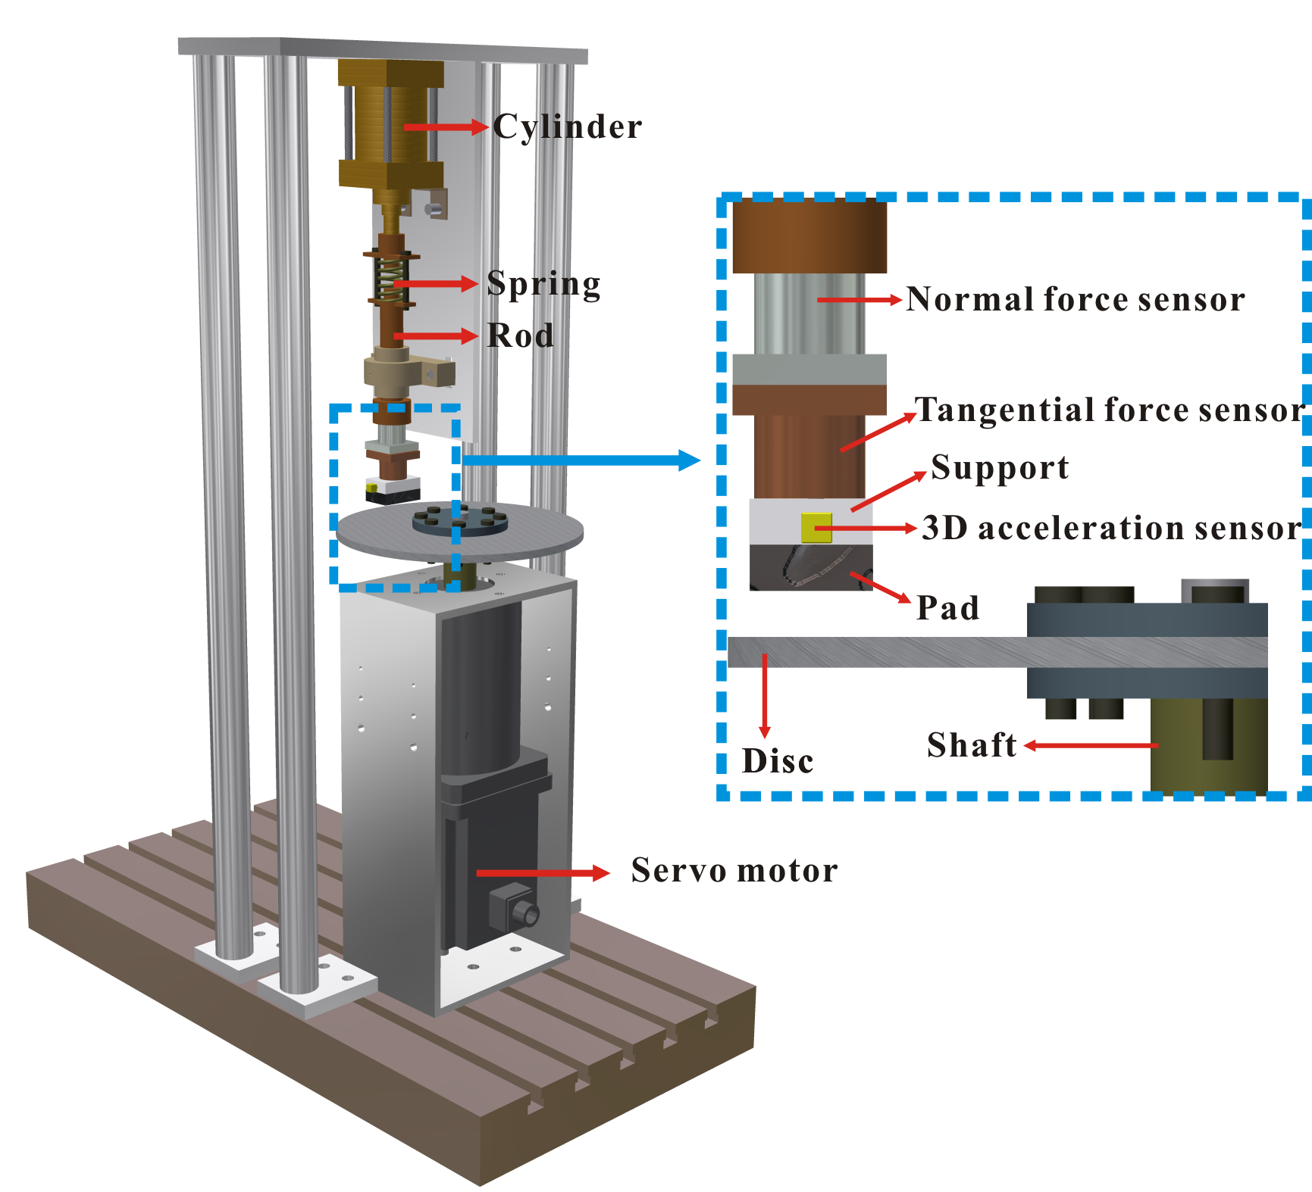
Fig. 1. View of the experimental test bench.

2.2 Sample preparation
In this study, the disc sample is made of Q345 steel, which possesses the internal diameter 80 mm, external diameter 316 mm and thickness 15 mm. The pad sample with height of 20 mm (without the damping component to be described below) and rectangular cross section of 60 mm×40 mm is used as the counterpart, which is composed of steel backplate and friction material.
In this study, relatively hard Styrene Butadiene Rubber (SBR) is selected as the damping component, to investigate the role of elastic damping component in modifying the friction-induced vibration behaviour. The first main reason to select SBR in this study is that the SBR is widely used as the material for cushions, tires, electric wires, etc; however, it is not certain whether SBR can affect the friction-induced vibration [43-44], the second main reason is that the damping property of SBR is not affected by the external force or structural modifications, which affect the friction-induced vibration of the contact interface. The initial contact position of the contact pairs is shown in Fig. 2(a), in which the distance between the disc centre to the inner edge of pad surface is 110 mm. Firstly, two different structures of SBR are introduced into the space between the pad and support samples (through glued connection with the pad and the support): SBR with smooth surface, and SBR with grooves spread across its surface at a regular interval, to test the ability of grooved SBR in reducing the friction-induced vibration. Then, to further identify the role of grooves in modifying the friction-induced vibration performance, and consequently verify the region where grooves can significantly affect the friction-induced vibration of the contact surface, three customised SBR with grooves distributed on three different regions (leading side, middle and trailing side of the pad surface) are manufactured, as shown in Fig. 2(b).
To distinguish SBR with different structures, some abbreviations are defined as the following: D-S indicates the damping component with a smooth surface, D-G indicates the damping component with grooves across the whole surface; D-L-G, D-M-G and D-T-G indicate the damping components with grooves cut on the leading side, middle side and trailing side of the surface, respectively. The damping components are a cube with the dimension of 60 mm×40 mm×5 mm, and the grooves in this study have width of 3 mm and depth of 2 mm, the ridge between grooves is 5 mm wide.

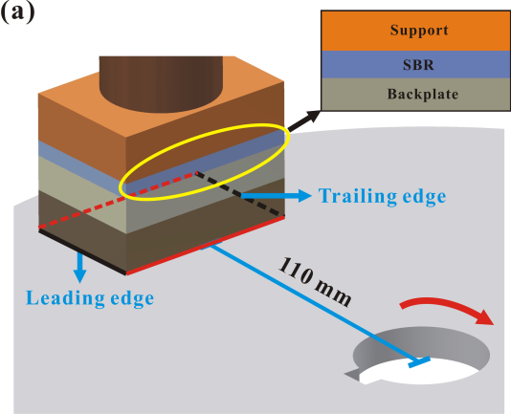
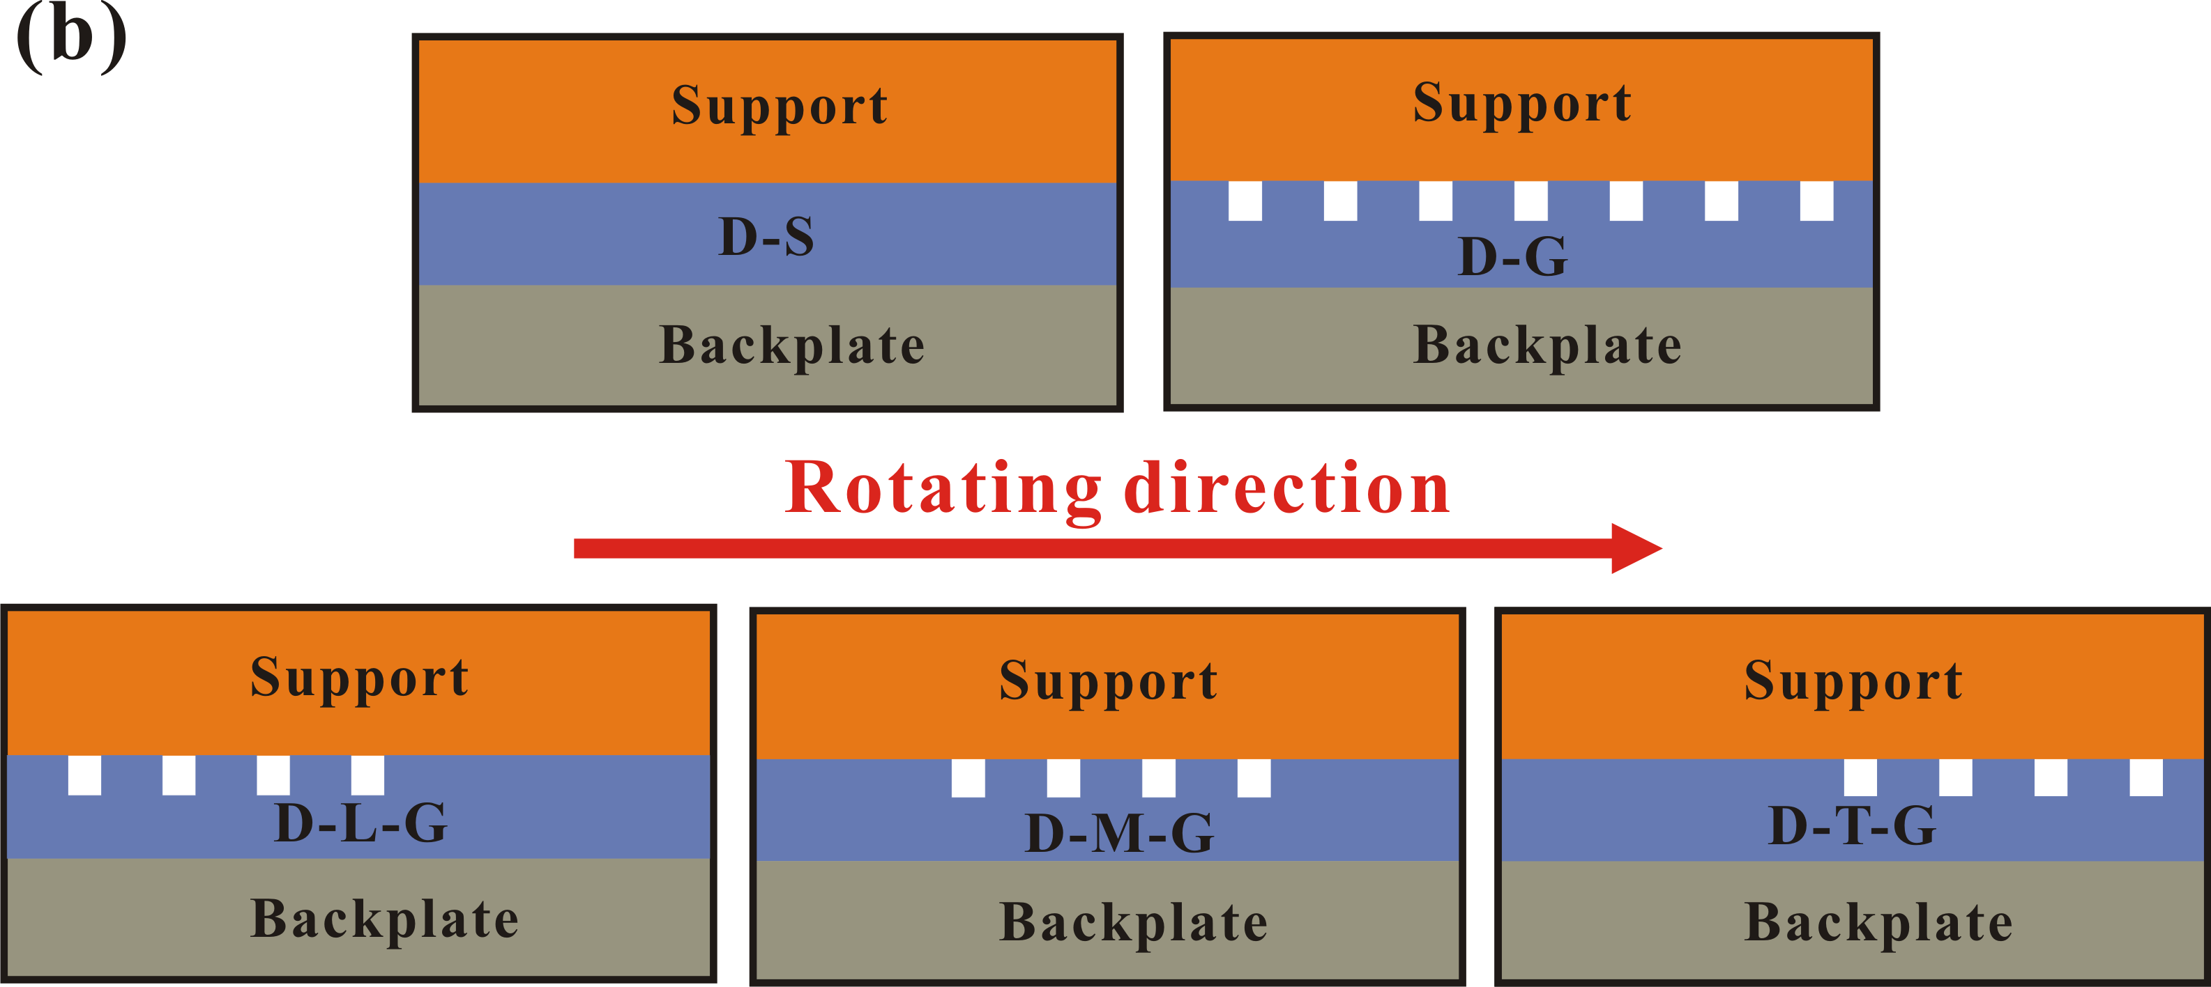
Fig. 2. The initial contact position between pad and disc (a) and five different structures of damping components (b).

2.3 Finite element (FE) model of the test bench
The FE model created in this study is shown in Fig. 3(a), which is composed of seven main components: a disc sample, a pad sample, a pad support, two force sensors, a push rod and a top part. For the contact pairs, the disc surface is defined as the master surface since it possesses a relative coarser mesh and harder material than that of pad surface, the pad surface is accordingly defined as the slave surface. The contact interface is assumed to be perfectly flat, and the thermal effects of the materials in contact are neglected. This FE model uses up to 71656 brick elements and approximately 78000 degrees of freedom. All the components created in this model are meshed by using eight-node (C3D8) brick elements.
Fig. 3(b) shows the constraint conditions of this FE model. The shaft hole of the disc is rigidly constrained except in the rotational direction around the Y axis. A constant normal force is imposed to the top part surface, which facilitates the friction contact between the pad and disc samples. Moreover, springs are set at the local region of the push rod where it is constrained by a set linear bearing, which holds the push rod Z (radial) direction but allows movement in the X direction, to model the contact between the push rod and linear bearing in the test bench. Nearly all of the boundary conditions defined in this FE model can represent the real test bench, apart from the thread and glue connections between components, which are set as tie constrains.

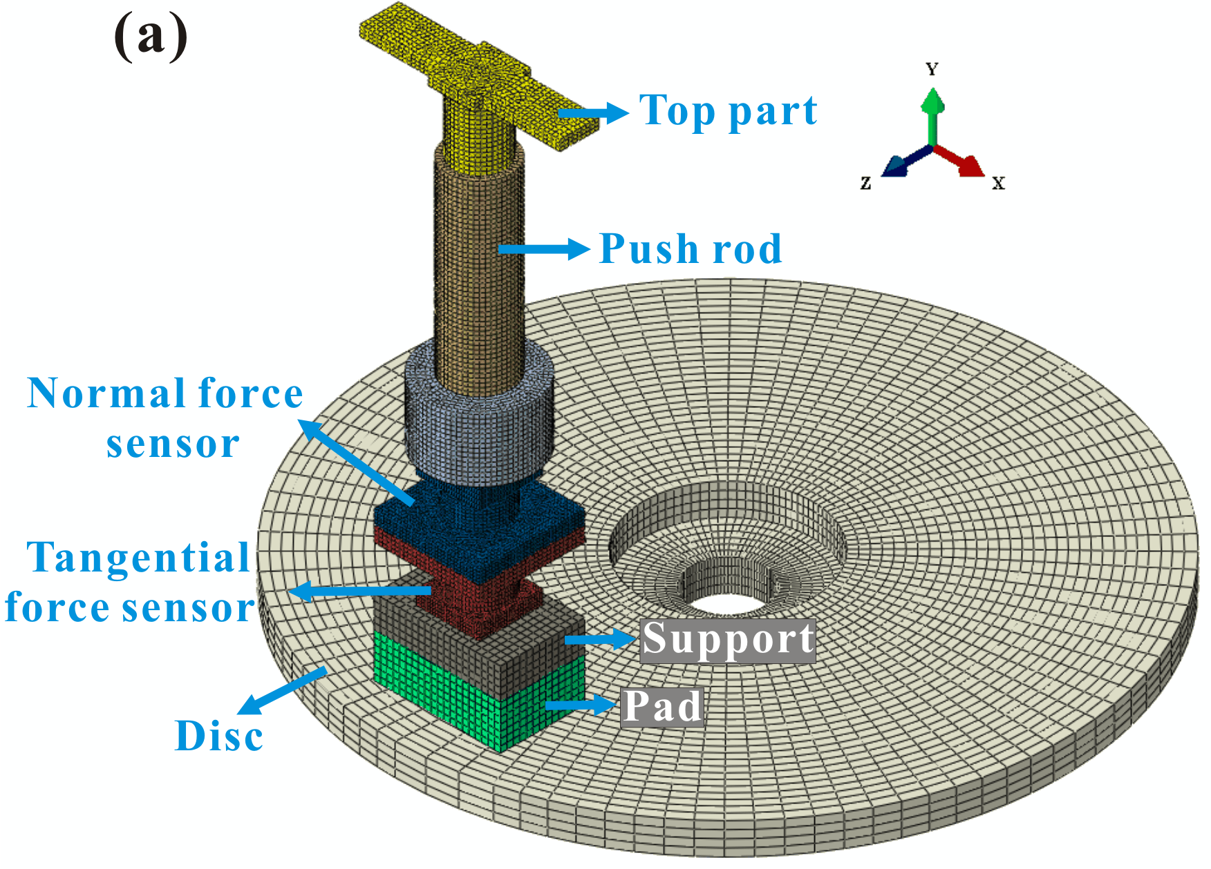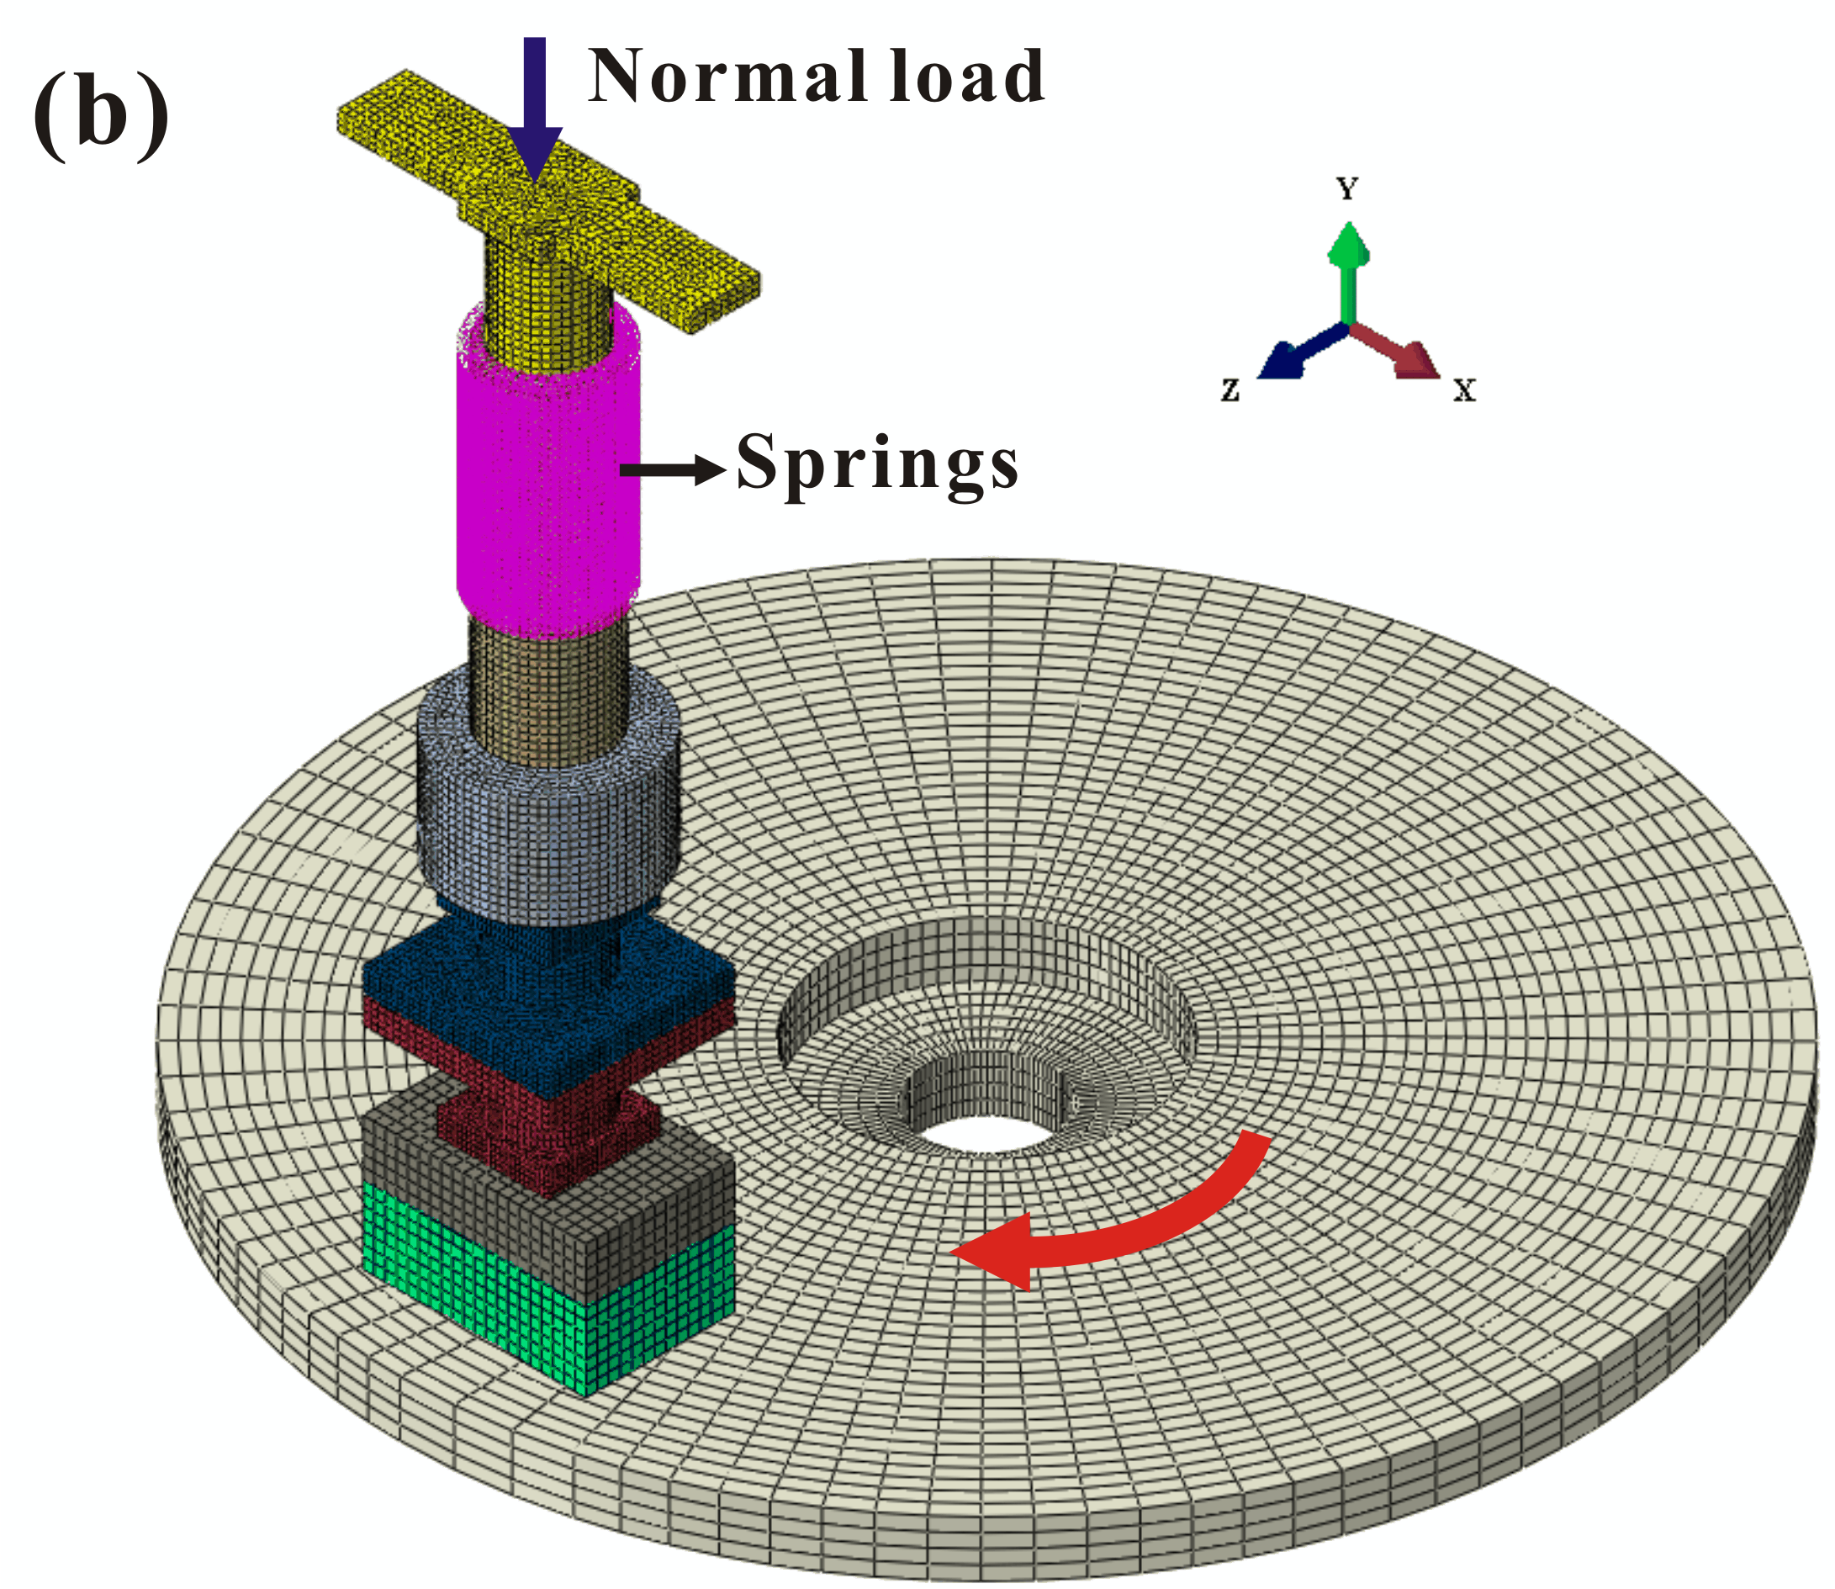
Fig. 3. The FE model of the test bench (a) and the load and boundary conditions of the friction system (b).

- Comparison of the D-S and D-G friction systems
3.1 Experimental test results and discussion
Before carrying out the formal tests, the surface run-out property of the disc sample is measured by using a clock gauge, as shown in Fig. 4. The surface run-out property indicates the surface irregularity of the disc surface, thus the height distribution of the disc at every five degrees in the circumferential direction is recorded. The measured vibration accelerations signals in both the normal and friction (tangential) directions from 100 s to 120 s are shown in Fig. 5. The time period corresponds to the steady stage in which friction-induced vibration generated from the original friction system (without the damping component introduced) is steady. For the original friction system, the vibration acceleration signals in these two directions exhibit visible oscillations in this period, which indicates the generation of intense friction-induced vibration at the interface. On the other hand, due to the effect of surface run-out, 5 visible bursts of abrupt oscillations in both the vibration signals can be observed. For the D-S friction system, the amplitudes of vibration acceleration signals show smaller values compared with the original friction system, which suggests a lower level of friction-induced vibration. In addition, the effect of surface run-out on the abrupt oscillations of vibration signals is alleviated, and the amplitudes of the abrupt oscillations decrease significantly. Nevertheless, the vibration accelerations of the D-G friction system exhibit the lowest amplitude, and no visible abrupt oscillations of the vibration signals can be detected. Therefore, the D-G friction system can significantly reduce the friction-induced vibration and alleviate the effect of surface run-out, which consequently help prevent the generation of the bursts of vibration.

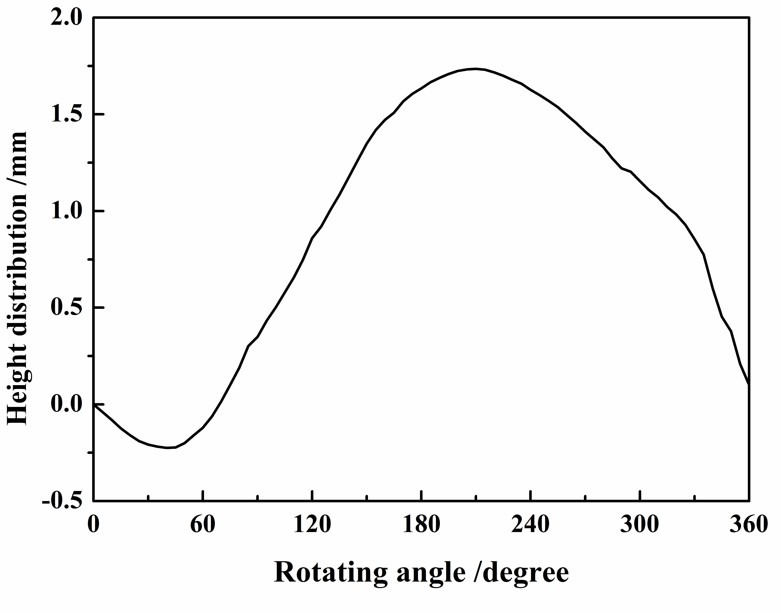
Fig. 4. The height distribution of the disc sample.

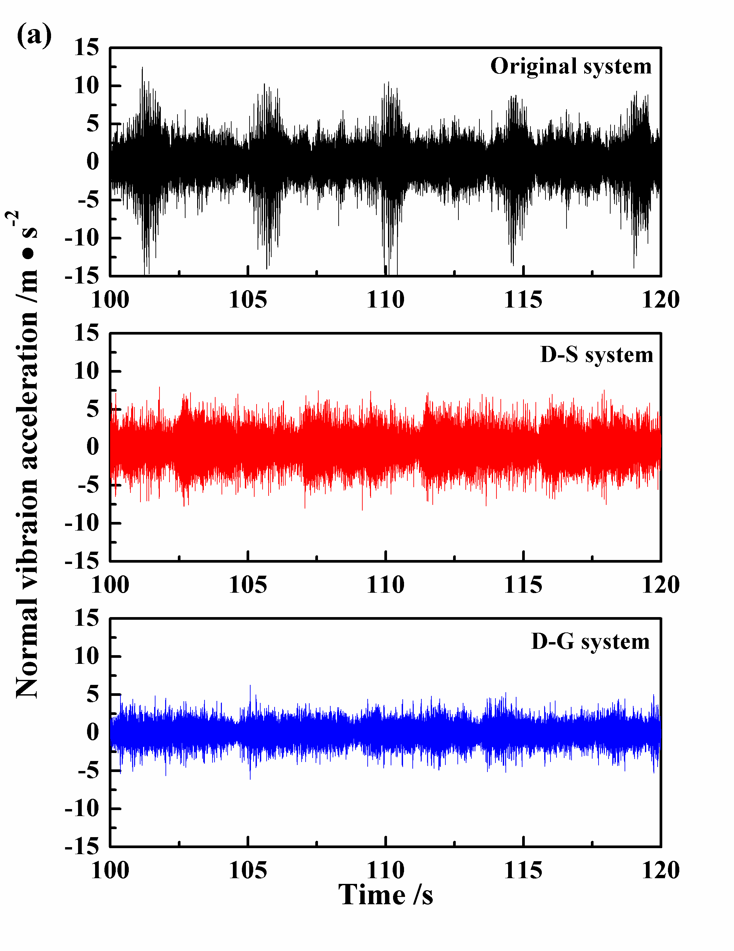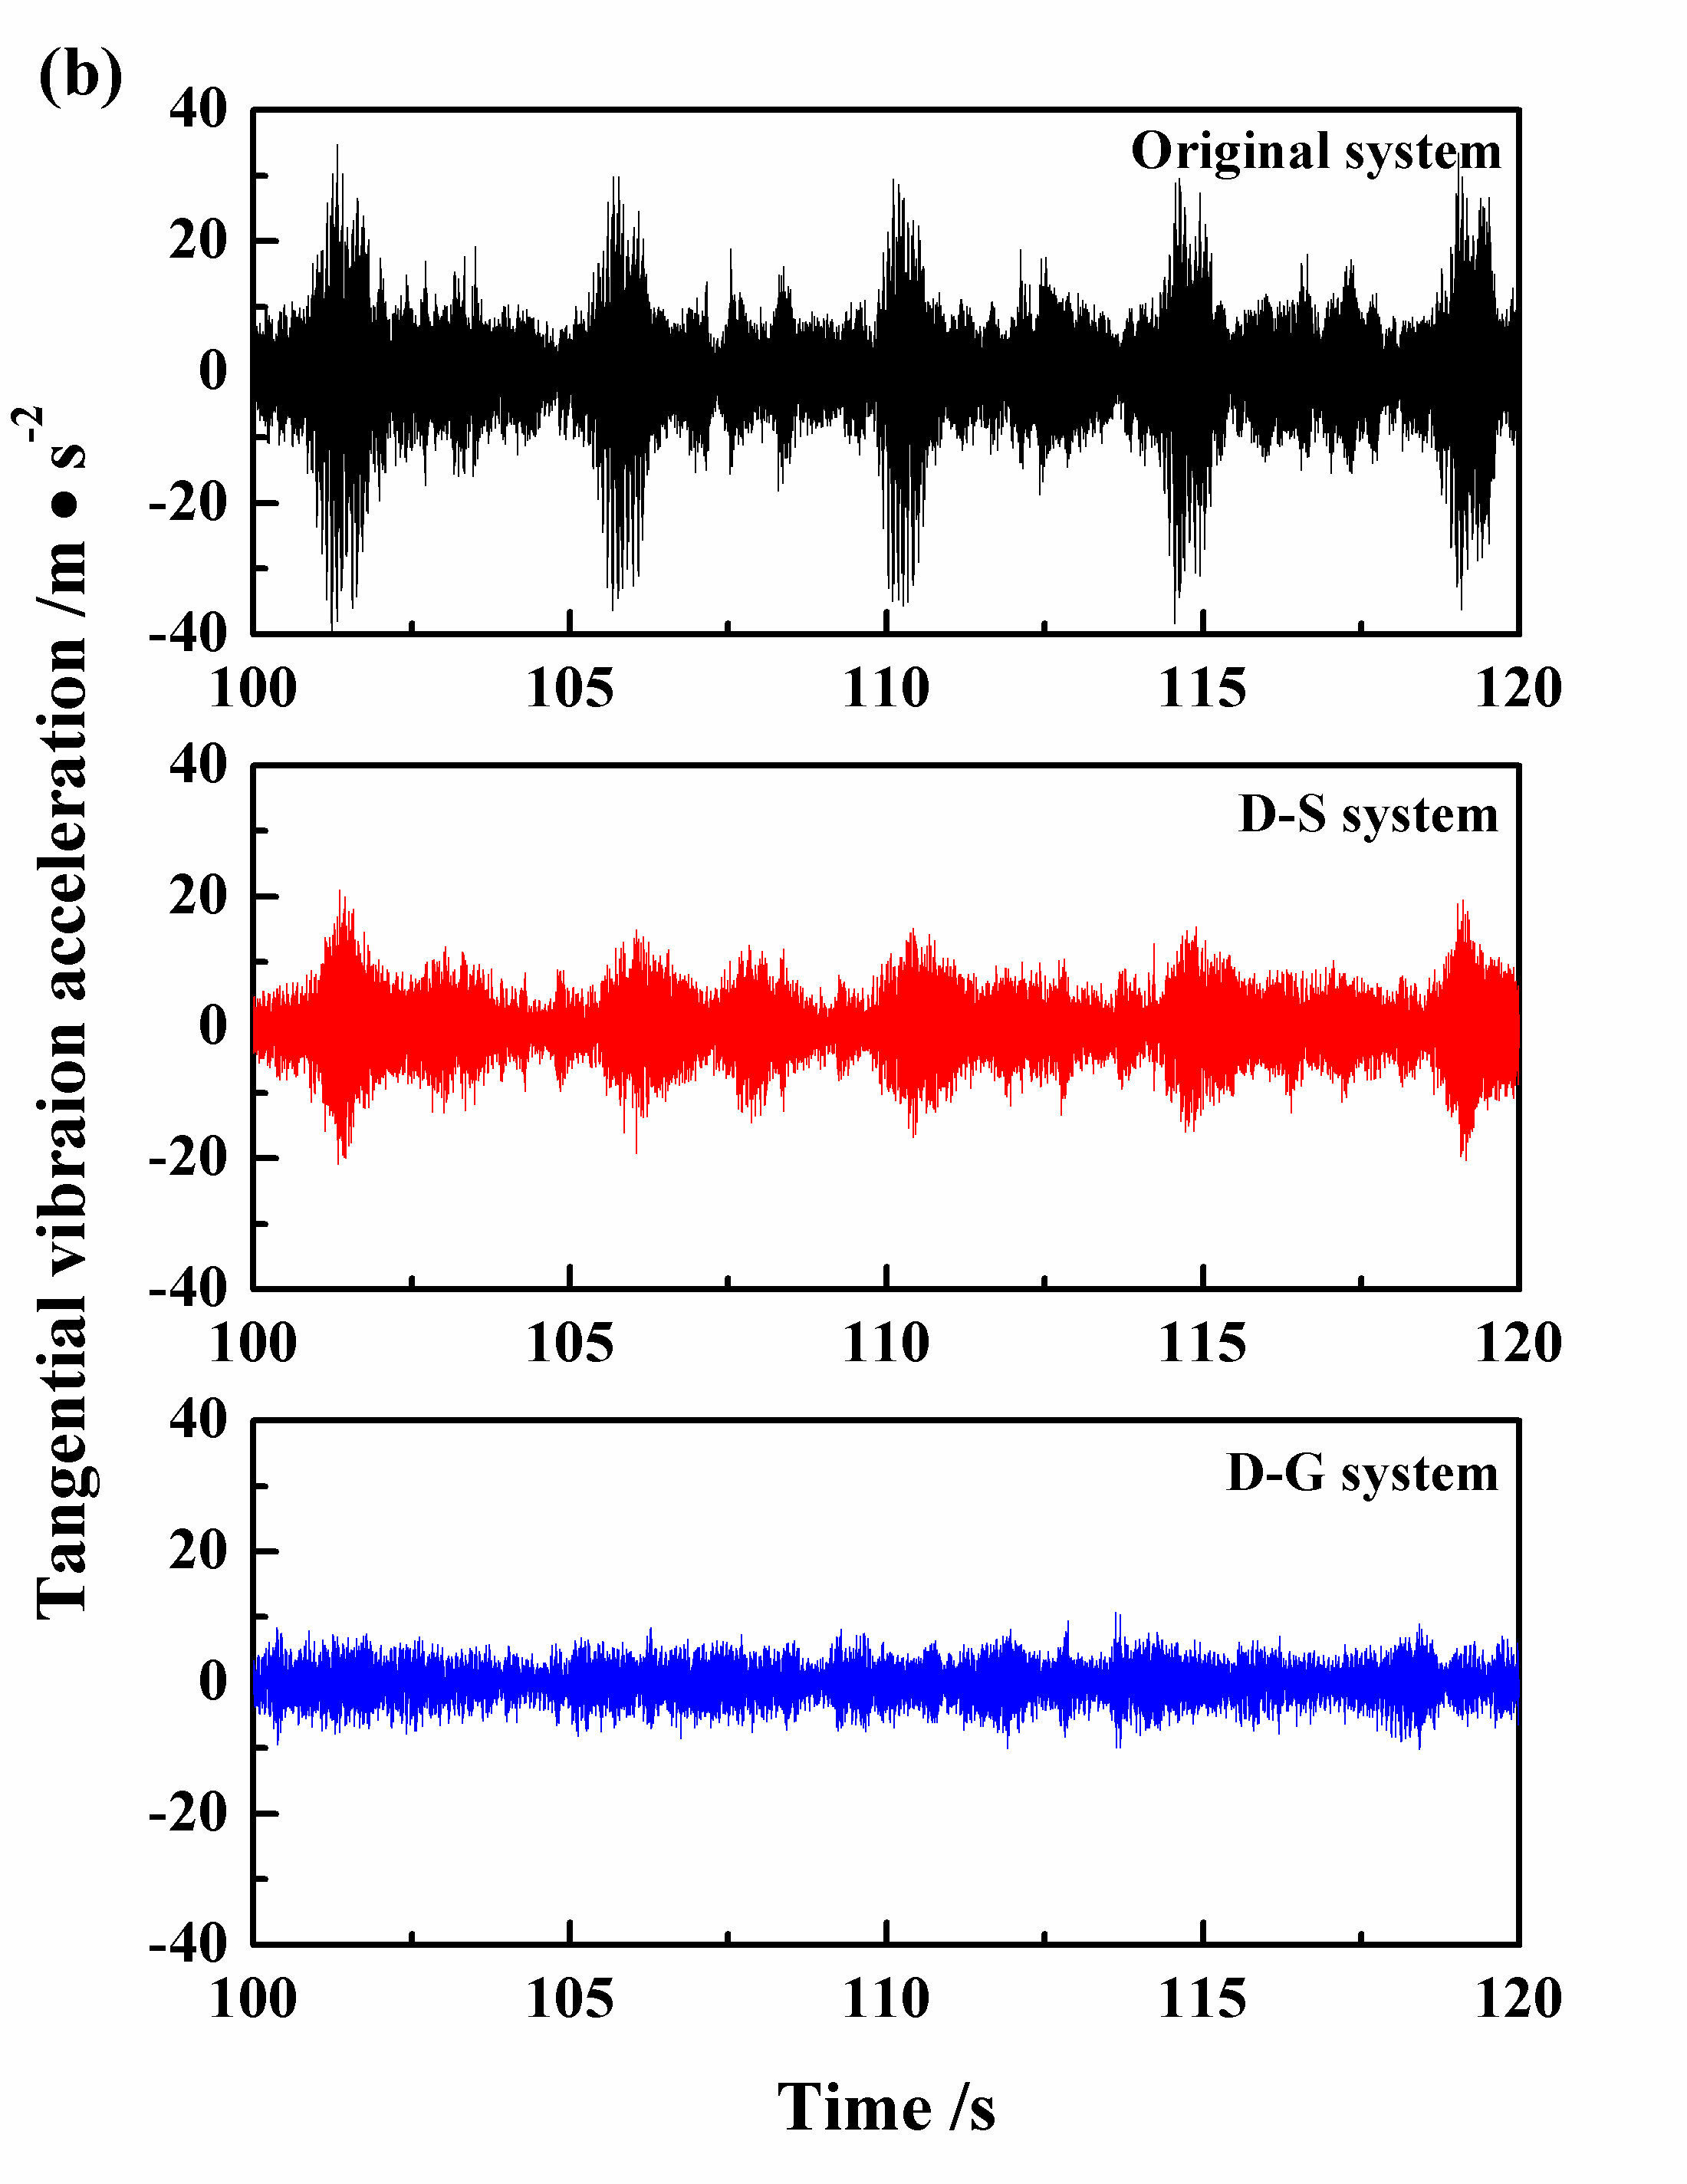
Fig. 5. Time history record of vibration accelerations in the normal (a) and tangential (b) directions.

In order to better show the effect of the grooved damping component on reducing the friction-induced vibration, the root-mean-square (RMS) values of the vibration accelerations for all the friction systems in both the normal and tangential directions are calculated, as shown in Fig. 6. A total of six groups of test data are recorded (without and with damping components). It can be found that adding damping into the friction system can significantly reduce the friction-induced vibration intensity (RMS values), and the grooved damping component possesses the best potential in reducing the friction-induced vibration intensity.

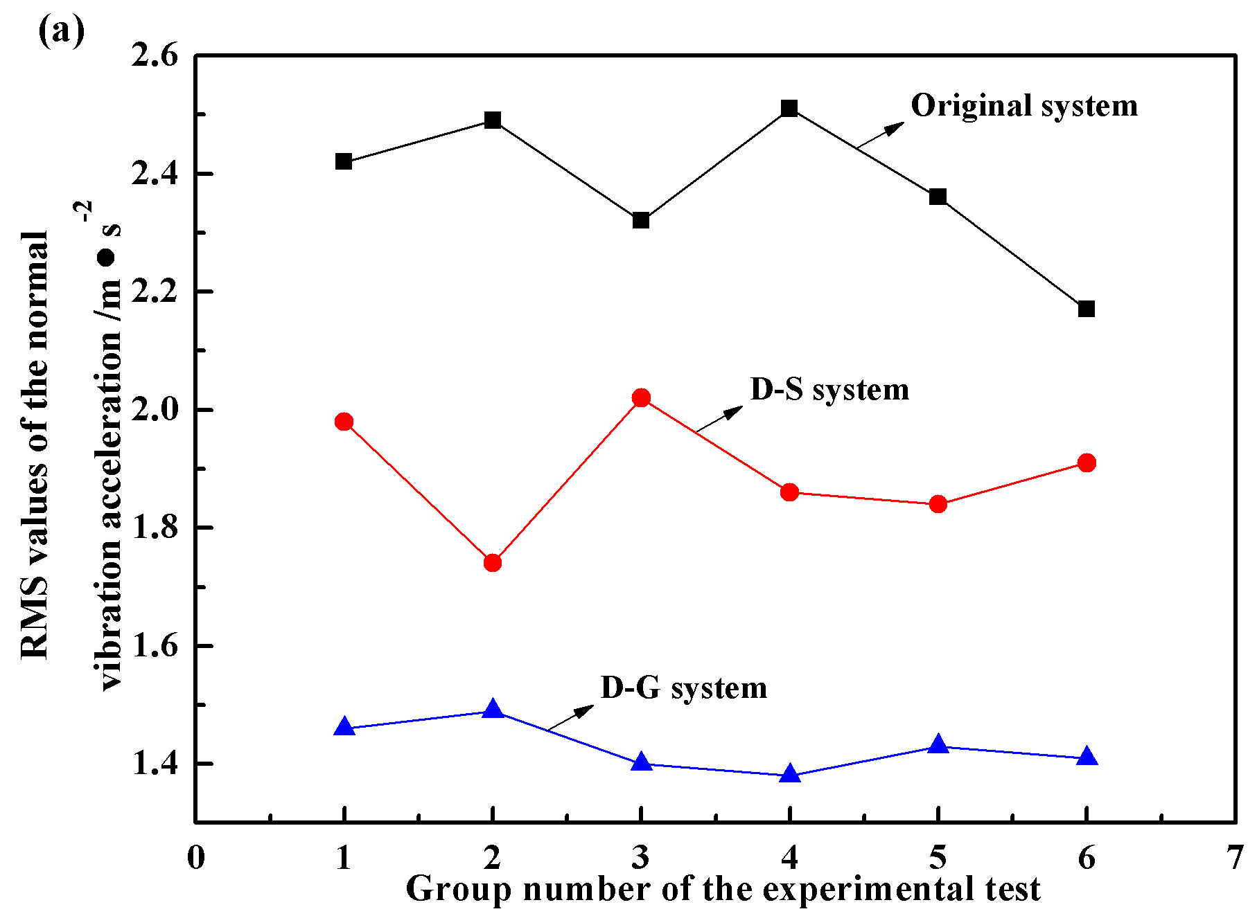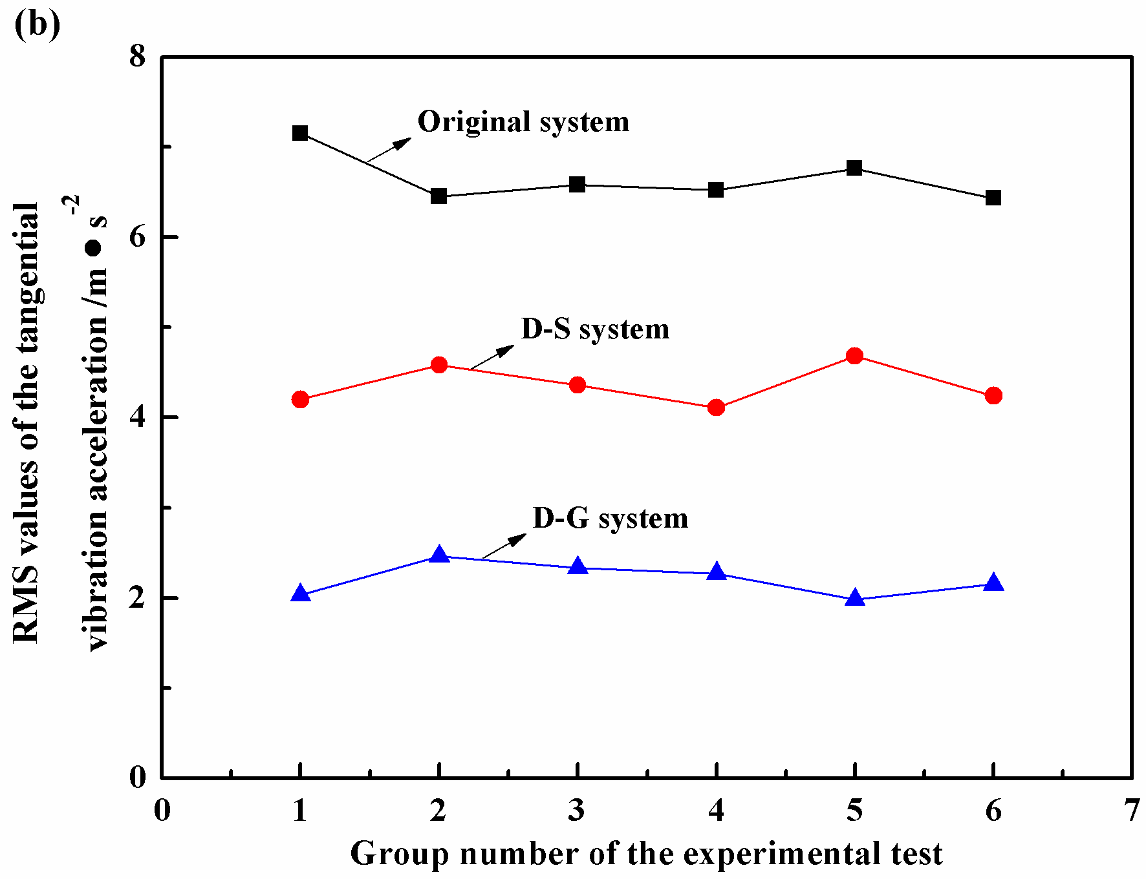
Fig. 6. The RMS values of the vibration acceleration records in the normal (a) and tangential (b) directions.

The power spectral density (PSD) analysis of the tangential vibration acceleration is performed for all the three friction systems, as shown in Fig. 7. For the original friction system, the tangential vibration acceleration signal is characterized by two main frequencies, i.e. 125 Hz and 475 Hz. While for the damped friction system, the vibration frequency with lower value and energy can be detected, this phenomenon indicates that the damping components contribute to reducing the friction-induced vibration level significantly. It is noted that the damping components have little effect on the values of vibration frequencies, this may because that the natural frequencies of the friction system is strongly related to the properties of system structures and materials, and the relatively small and soft damping components have little effect in modifying the properties of system structures and materials. Thus, the damping components may not significantly affect the fundamental vibration frequency of the friction system. Therefore, introducing damping components into the friction system would not significantly affect the fundamental frequency of friction-induced vibration, while it can reduce the energy levels contained in the excited frequencies and accordingly help stabilize the friction system.

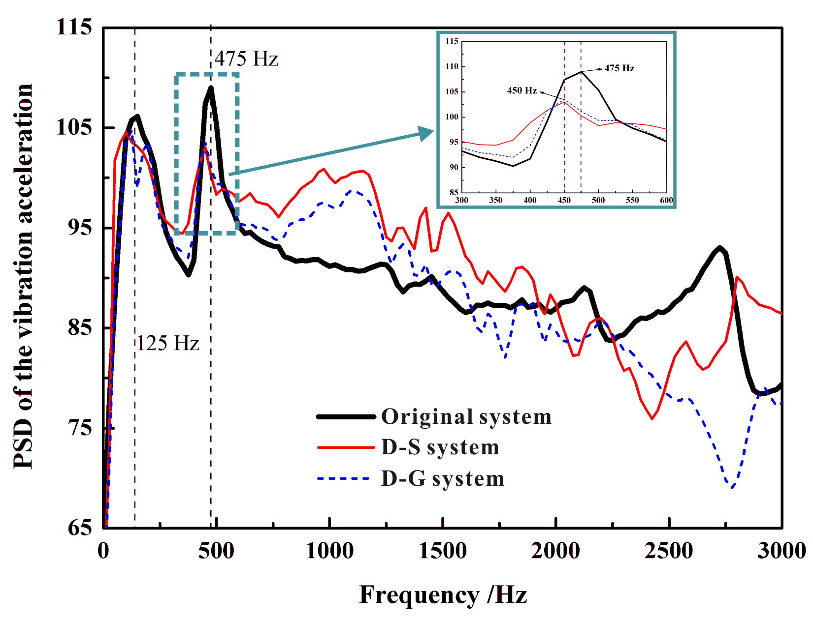
Fig. 7. The PSD analysis of the vibration acceleration for the three friction systems.

3.2 Numerical simulation results and discussion
3.2.1 Validation of the FE model
In order to ensure that the created FE model can well reflect the dynamic characteristics of the real experimental system, two steps of validation are performed, i.e.: (a) validate the material parameters of the individual components, such as the disc, pad and SBR samples (then the identified material parameter values will be used in the FE model); (b) validate the accuracy of the FE model at assembly level, based on the measured frequencies of the whole system (but without rotating the disc).
Firstly, a hammer impact test is carried out to excite the natural frequencies of the disc and pad samples to identify their material parameters. To reduce relative errors between the experimental results and predicted frequencies, FE model updating is conducted. Table 1 exhibits the predicted natural frequencies of the disc and pad samples, which are quite close to those measured in the hammer impact test. For the damping components, the SBR is assumed to be characterized by hyperelastic material and follow the Mooney-Rivlin model. A uniaxial tensile test is performed and the corresponding Mooney-Rivlin parameters are calculated. All the material parameters of the FE model are listed in Table 2.

Table 1 Comparison between the predicted results and the measured data of disc and pad
Component | Mode | Testing values (Hz) | FEA values (Hz) | Error (%) | Mode shape
 | 1 | 737 | 735.5 | -0.2 | 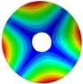
Disc | 2 | 1812.5 | 1790.3 | -1.2 | 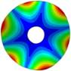
 | 3 | 3162.5 | 3114.5 | -1.5 | 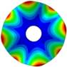
 | 1 | 337 | 339.3 | 0.69 | 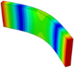
 | 2 | 600 | 604.4 | 0.74 | 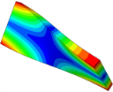
Pad | 3 | 912 | 924. 4 | 1.32 | 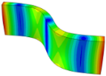
 | 4 | 1237.5 | 1256.6 | 1.5 | 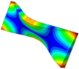
Note: the pad sample used in the hammer test is larger than that used in the friction-induced vibration test.

Table 2. The material parameters of the components used in the analysis.
Component | Density (kg/m³) | Young’s modulus (GPa) | Poisson’s ratio | Viscous Damping factor | Mooney-Rivlin  Parameters
Disc | 7800 | 230 | 0.27 | — | —
Pad backplate | 7000 | 180 | 0.3 | — | —
Pad friction material | 4500 | 20 | 0.29 | 0.02 | —
Support | 7670 | 196 | 0.3 | — | —
Force sensor | 7850 | 190 | 0.28 | — | —
Push rod | 7800 | 200 | 0.3 | — | —
Top part | 7800 | 200 | 0.3 | — | —
SBR | — | — | 0.499 | 0.04 | C₁₀=1.86  C₀₁=2.76

The second validation step is conducted at the assembly level, using the corresponding boundary conditions with the normal load (but without rotating the disc sample). In this validation step, a hammer impact test is conducted on the disc, because of its more regular shape than the other components. Good agreement is found between the measured data and the predicted results, as shown in Table 3.

Table 3. Comparison between the predicted results and the measured values for the assembly model
Mode | Testing values (Hz) | FEA values (Hz) | Error (%) | Mode shape
1 | 1062.5 | 1125 | -5.8 | 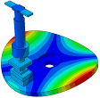
2 | 1362 | 1320.8 | -3.0 | 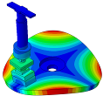
3 | 1962.5 | 2036.8 | 3.8 | 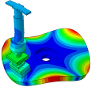
4 | 2137 | 2123.8 | -0.6 | 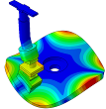
5 | 3300 | 3236.7 | -1.9 | 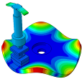
6 | 4800 | 4577.1 | -4.6 | 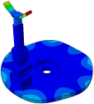

3.2.2 Complex eigenvalues analysis results
In this section, the complex eigenvalues analysis (CEA) method is adopted to identify the unstable dynamic propensity of the friction systems and validate the reliability of this numerical model. Calculating the eigenvalues of the friction system is an efficient approach to evaluate the tendency of unstable vibration of the friction system, the system will generate unstable vibration when the eigenvalues possess positive real parts. The positive real parts indicate the growth rate of unstable vibration, while the corresponding imaginary parts indicate the excited vibration frequencies, respectively. In this section, the CEA is carried out in ABAQUS 6.10. The reliability of the FE model is verified through comparing the calculated main frequency of unstable vibration with the measured friction-induced vibration main frequency. For the detail calculation process of this method, Ouyang et al. [45] and Massi et al. [46] made a detailed description in their publications.
Fig. 8 indicates the imaginary parts (frequency) of complex eigenvalues of the three friction systems, with the increase of friction coefficient (μ) from 0 to 0.7. For all the friction systems, two different frequencies star to converge to one value when the friction coefficient reaching a certain value. This phenomenon suggests that all of the three friction systems can generate unstable vibration under the friction. It can be found that for the original friction system, the unstable vibration frequency of 480 Hz calculated by the CEA is quite close to the measured noise frequency of friction-induced vibration of 475 Hz. The slight difference between test and simulated results is attributed to the simplifications of the FE model. Whilst for the damped friction systems, the unstable vibration frequency obtained by CEA is also close to the test data. Moreover, it is noticed that the calculated unstable vibration frequencies of the damped friction systems are slightly lower than that of the original friction system, which is consistent with the test results. It is worth noting that the lower measured unstable vibration frequency of 125 Hz is not predicted by using the CEA. This is thought to be because CEA in ABAQUS is designed to predict mode-coupling-type dynamic instability while the 125 Hz noise is not due this type of instability. In general, the FE model can well reflect the dynamical property of the friction system.

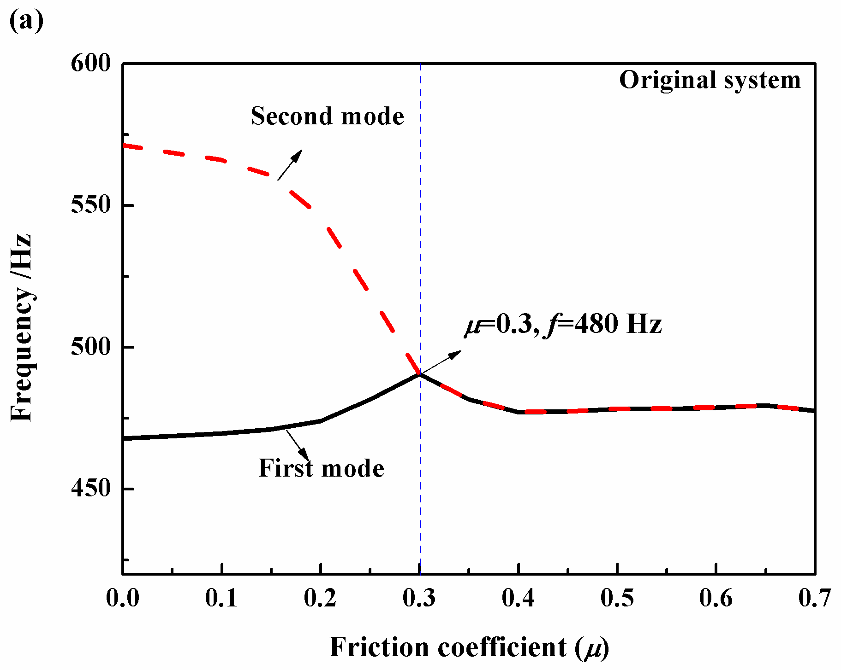
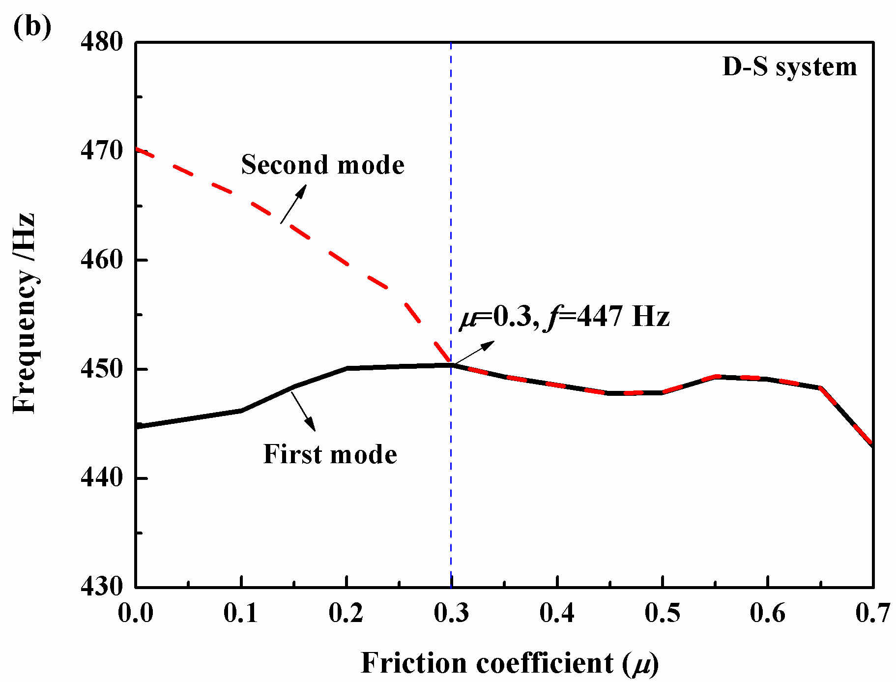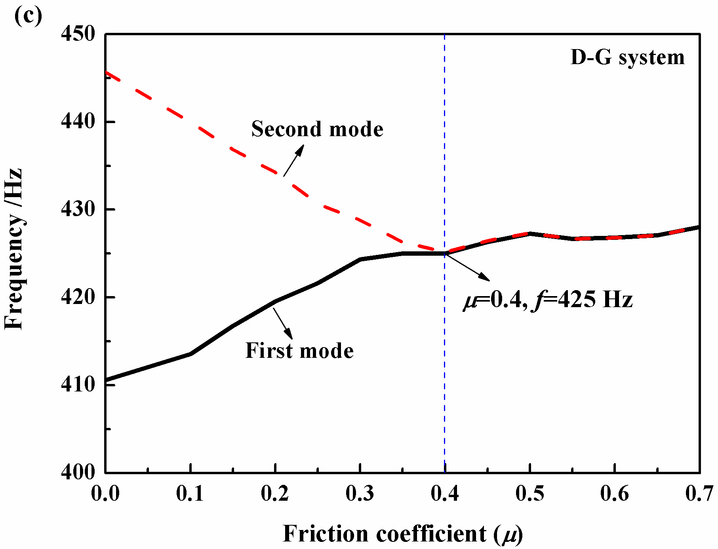
Fig. 8. Mode coalescence of the original friction system (a), D-S friction system (b) and D-G friction system.

3.2.3 Physical explanation for the experimental phenomenon
The test results have shown that the D-G friction system exhibits the best performance in suppressing the friction-induced vibration, and adding damping components can effectively alleviate the effect of surface run-out on the friction-induced vibration, and consequently avoid the occurrence of bursts in the acceleration signals. In this section, a possible physical explanation on the above mentioned phenomenon is provided, by using the numerical analysis.
Fig. 9 illustrates the unstable mode shapes of the three friction systems when the friction coefficient μ=0.45. For the original friction system, it is seen that self-excited vibration mainly takes place on pad-subsystem, which can be depicted as the flexural motion of the pad subsystem sliding along the friction (X) direction. Therefore, the original friction system has a strong potential in generating unstable vibration in this mode shape. While for the damped friction systems, although the pad sub-system also exhibits the flexural motion, the unstable mode shape mainly contains the deformation of the damping component. Unlike the unstable mode shape of the original friction system in which the pad sample deforms to form a certain angle with respect to the disc surface, the pad samples in the damped friction systems almost remain parallel to the disc surface. This phenomenon indicates that the damped components can suppress the flexural motion generated from the pad sample, and consequently keep the pad sample in good contact with the disc sample. Therefore, it can be speculated that the damping component plays a significant role in influencing the contact state during the process, that is, helps the contact pairs maintain a good contact condition with each other, and accordingly alleviates the effect of surface run-out.

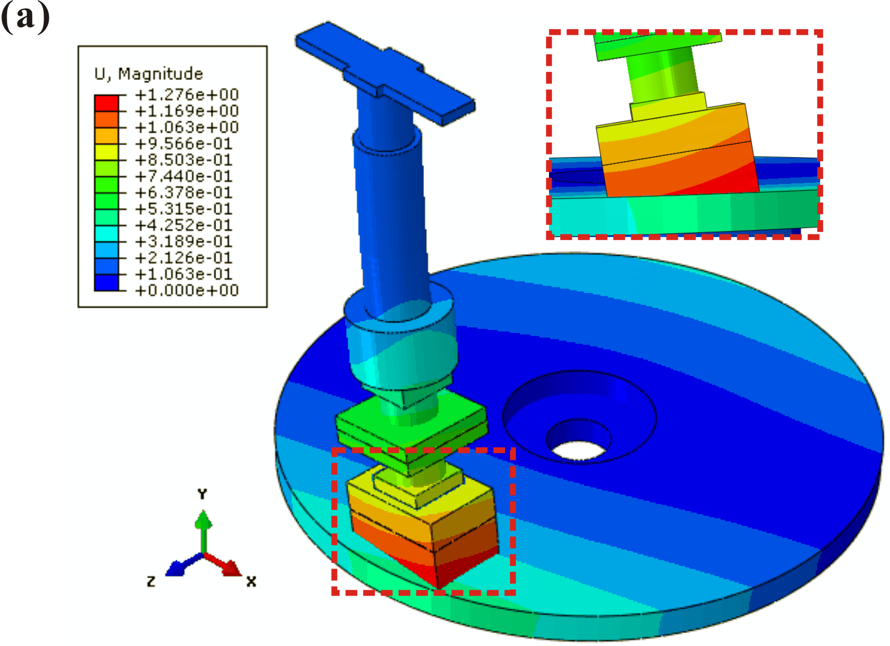
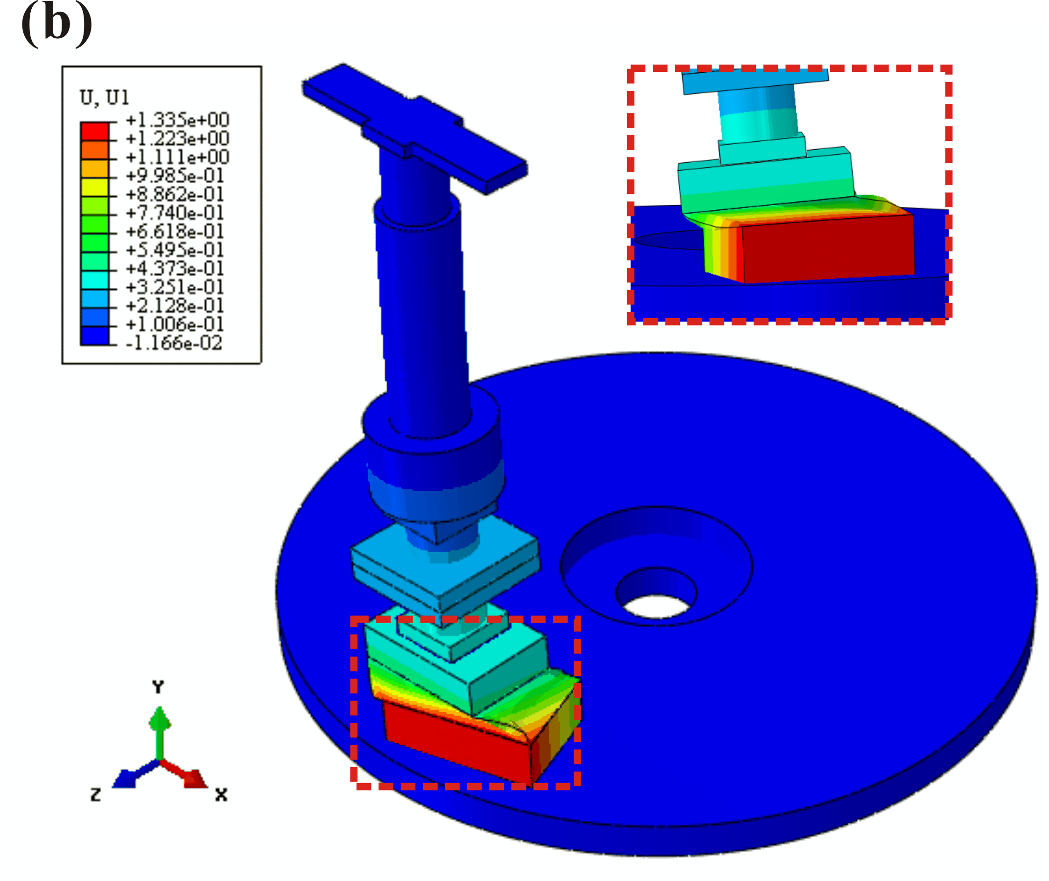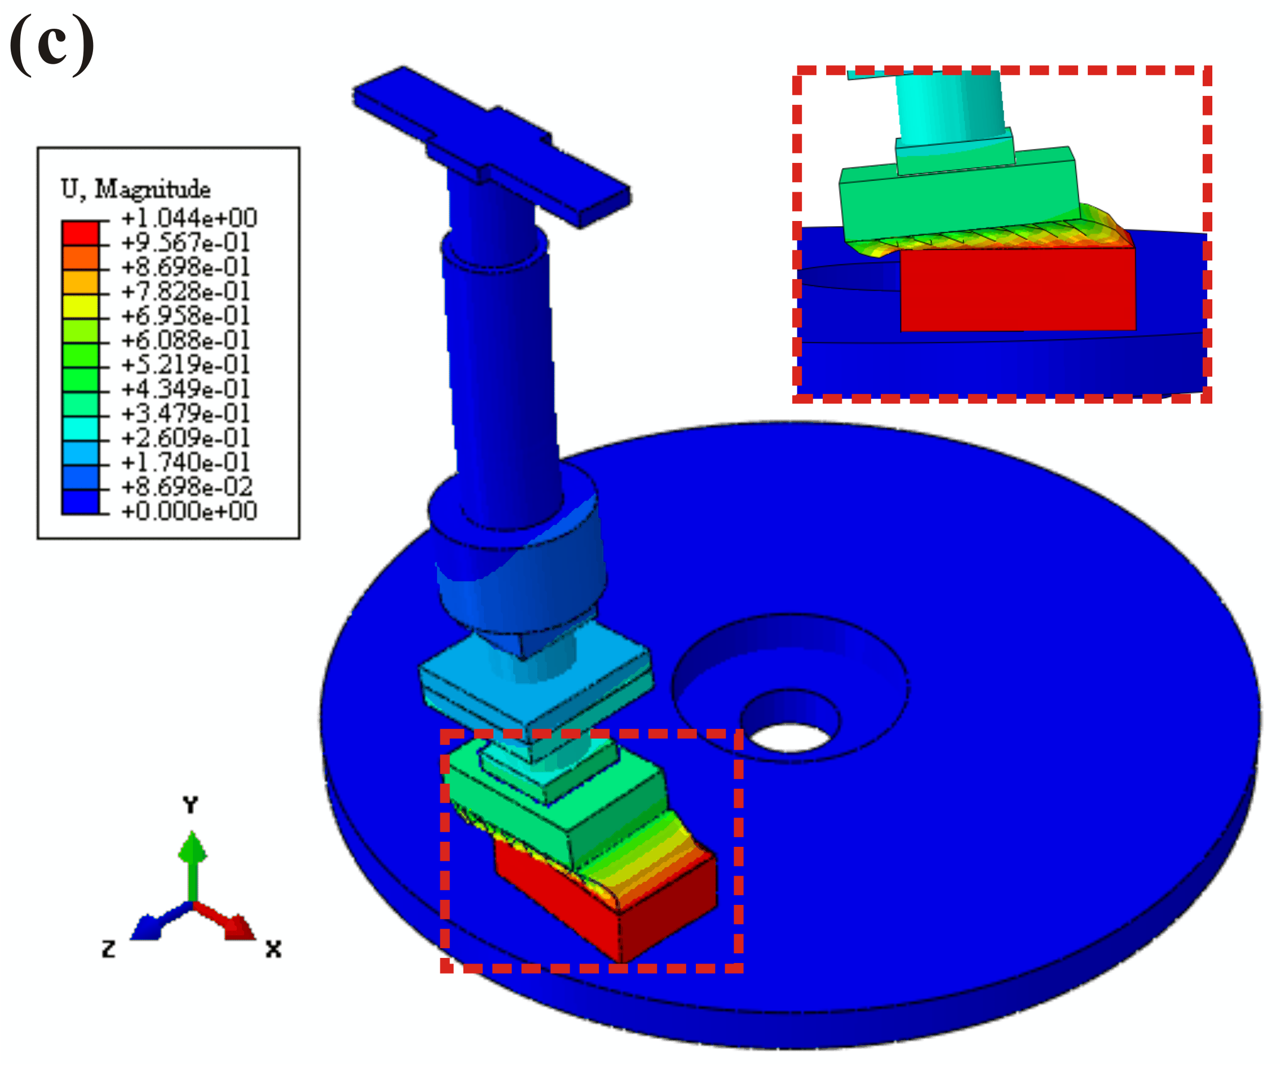
Fig. 9. Unstable mode shape of the original friction system (a), D-S friction system (b) and D-G friction system (c) at the case of friction coefficient μ=0.45.

The effective damping ratios (ξ) of the friction systems are plotted in Fig. 10, the corresponding friction coefficient (μ) is ranged from 0.3 to 0.7. In the CEA results, the smaller the effective damping ratio (ξ), the easier for the corresponding unstable vibration to occur. It is found that the effective damping ratio (ξ) of the original friction system is smaller compared with the damped friction systems, which suggests that the original frictions system may generate unstable self-excited vibration more easily. While for the D-G friction system, the values of the effective damping ratio (ξ) are larger, thus the D-G friction system exhibits better stability and may not easily generate intense self-excited vibration.

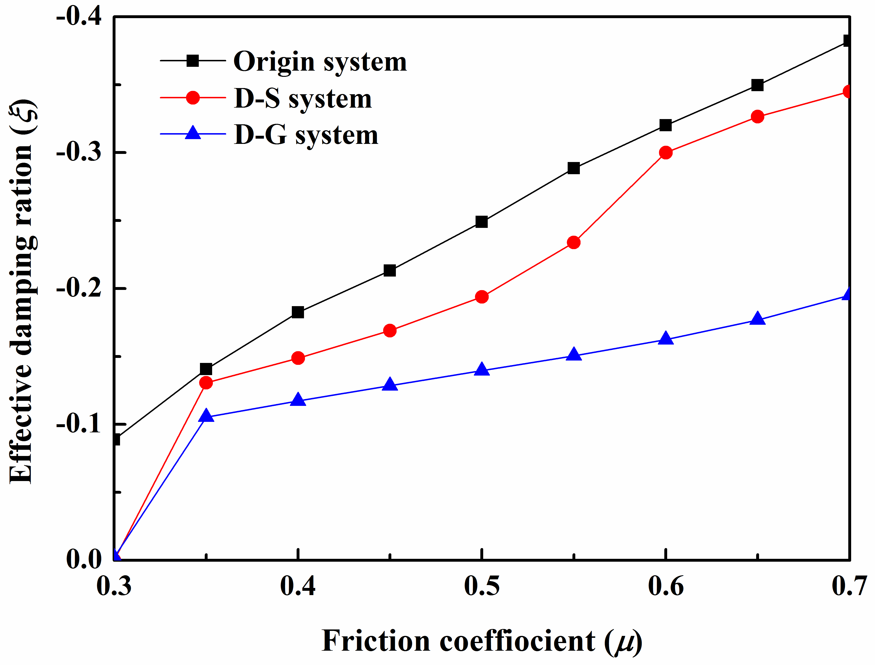
Fig. 10. The effective damping ratios (ξ) of the three friction systems.

To explain the test phenomenon that why the D-G friction system exhibits the best potential in suppressing the friction-induced vibration, the contact pressure distributions of pad surfaces for all the three friction systems are provided, as shown in Fig. 11. The criterion to evaluate the ability of a friction system in suppressing the friction-induced vibration is a more uniform distribution of contact pressure with a larger contact area but lower values [28, 47, 48]. For the original friction system, the contact pressure is spread over only a small contact area, most of the pressure is concentrated at the pad surface’s leading edge and the maximum contact pressure (in red colour) is placed at the leading point. While for the damped friction systems, the pad surfaces exhibit significantly lower pressure values and more uniform of pressure distribution compared to the case of the original system. Moreover, the contact pressure of the D-G friction system shows a higher uniformity distribution, and its maximum value is found to be lower than that of the D-S friction system. Considering that the more uniform distribution and lower value of the contact pressure is helpful stabilizing a friction system, thus the D-G friction system has a great potential in suppressing friction-induced vibration.

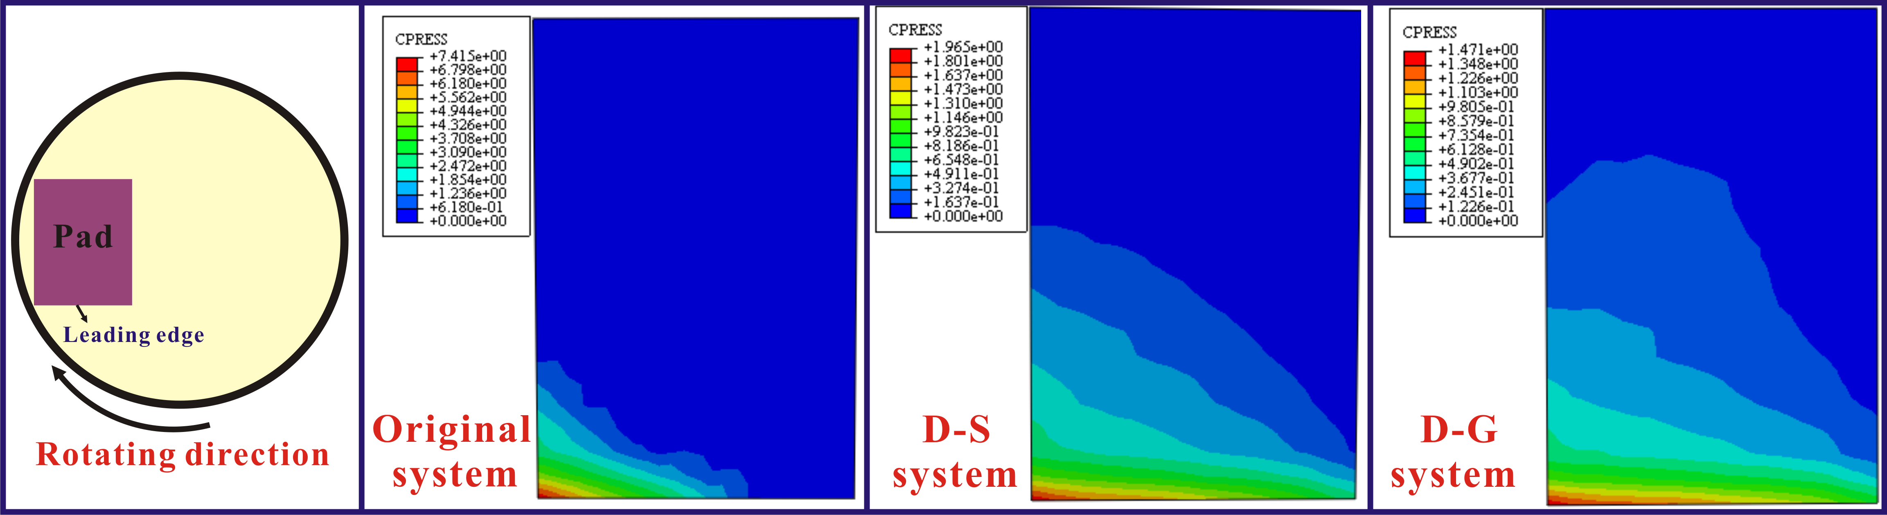
Fig. 11. Contact pressure distribution for all the three friction systems.

- Comparison of the D-L-G, D-M-G and D-T-G friction systems
The above results show that adding grooved damping component in the friction system can significantly suppress the level of friction-induced vibration. However, the role of the grooves in modifying the dynamic behaviour of friction system still seems mysterious, and the effect of the grooves on the friction-induced vibration still need to be further revealed. Only a thorough comprehension of the role that grooves play in modifying the dynamic behaviour of the friction system, can a better design for the damping component is produced, which may consequently provide the theoretical basis for the optimal design of damping component to reduce and suppress the friction-induced vibration.

4.1 Experimental results and discussion
Considering that the grooves in different regions of SBR surface may withstand different forces and thus produce different deformations, the grooves in different regions may play different roles in modifying the dynamic behaviour. In order to further reveal the role of the grooves, three customised SBR components with grooves distributed on three different regions of the surface are prepared. The testing parameters and conditions for these kinds of samples are the same as mentioned above.
Fig. 12 shows the vibration acceleration of the three friction systems in both the normal and tangential directions during the period of 100-120 s. For both the D-L-G and D-T-G friction systems, the vibration acceleration magnitude maintains at a high level during this period, while the vibration amplitudes of the D-M-G systems are visibly lower than that of the D-L-G and D-T-G friction systems, indicating that the D-M-G friction system has a better performance in suppressing the magnitude of friction-induce vibration. Therefore, it can be speculated that the grooves in the middle region of the damping surface play a significant role in reducing the vibration intensity, while cutting grooves on the leading/trailing side of the damping surface may weaken the effect of the middle grooves in reducing the amplitude of vibration.

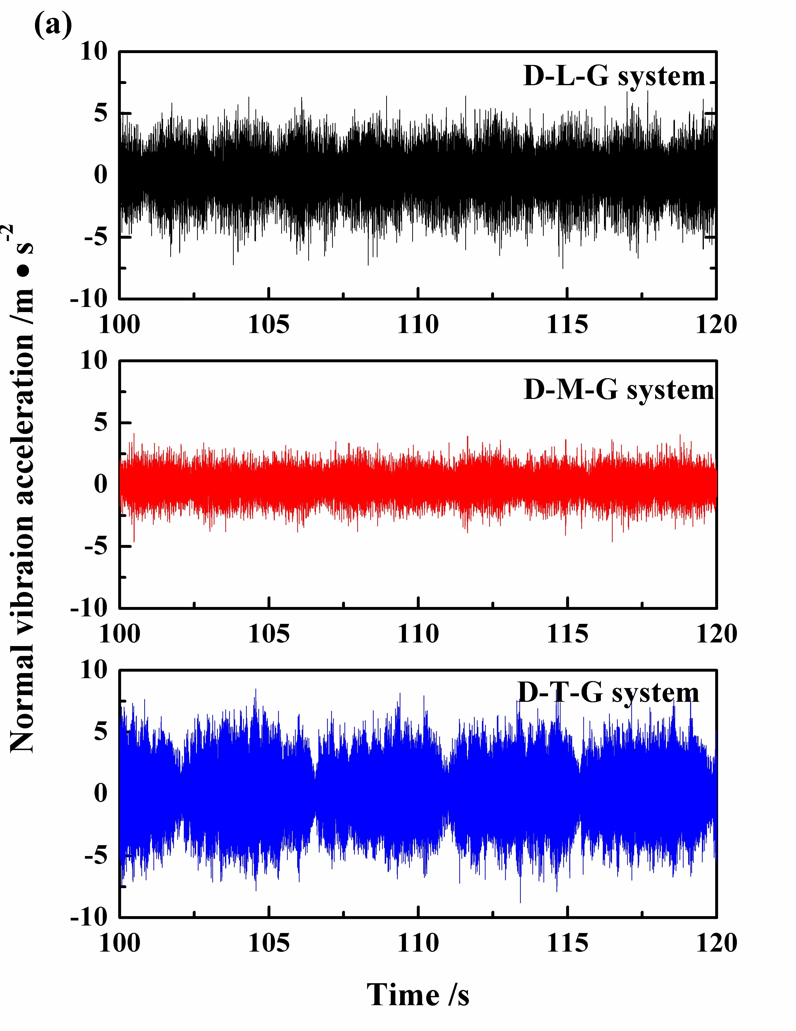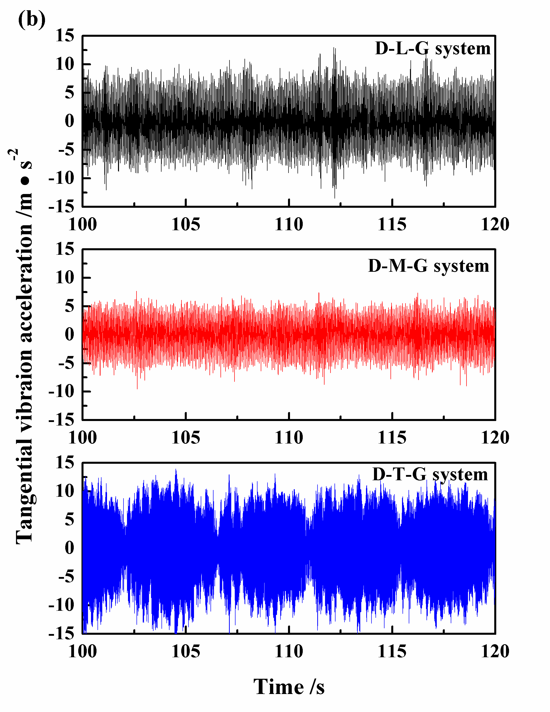
Fig. 12. The recorded vibration accelerations signal in the normal (a) and tangential (b) directions for all the three friction systems.

The power spectral density (PSD) analysis of the vibration acceleration is carried out for the three friction systems, as shown in Fig. 13. Although the D-M-G friction system exhibits the best performance in reducing the vibration intensity, the main vibration frequency of this friction system cannot be thoroughly eliminated. Comparing with the D-G system, although the energy level contained in the 125 Hz is slightly reduced (from 106 dB to 102 dB), the visible main frequency of vibration of 475 Hz is still prominent. While neither of the D-L-G and D-T-G friction systems performs as well as the D-M-G friction system in reducing the vibration magnitude, they exhibit good potential in suppressing generation of vibration frequency at 475 Hz. Nevertheless, both exhibit higher energy levels at the frequency of 125 Hz. Therefore, it can be deduced that the grooves in different regions of damping material surface play different roles in modifying the dynamic behaviour. The grooves in the middle region of the surface can reduce the vibration amplitude of the contact interface, but shows no ability in eliminating the vibration frequency, while the grooves in both of leading and trailing regions of the surface can eliminate higher vibration frequency to some extent, but they cannot help reduce the vibration amplitude, as shown by the higher energy level in the lower vibration frequency range. The specific PSD results of the D-G, D-L-G, D-M-G and D-T-G friction systems are summarized in Table 4.
For these three friction systems, although the grooves are distributed on the different regions of damping material, the natural frequency of the friction system will not be strong affected, thus the friction-induced vibration frequencies of these three friction system are almost the same with each other. On the other hand, it is speculated that the different values of the PSD results may be attributed to the symmetry pad subsystem. When cutting grooves on the middle region of damping component, the pad subsystem is still symmetrical as the origin pad subsystem, thus grooves in the middle region of the surface shows no ability in eliminating the vibration frequency. While cutting grooves on both of leading and trailing regions of the surface, the symmetrical property of the pad subsystem is broken down, thus the energy level distribution in different vibration frequencies will be modified.

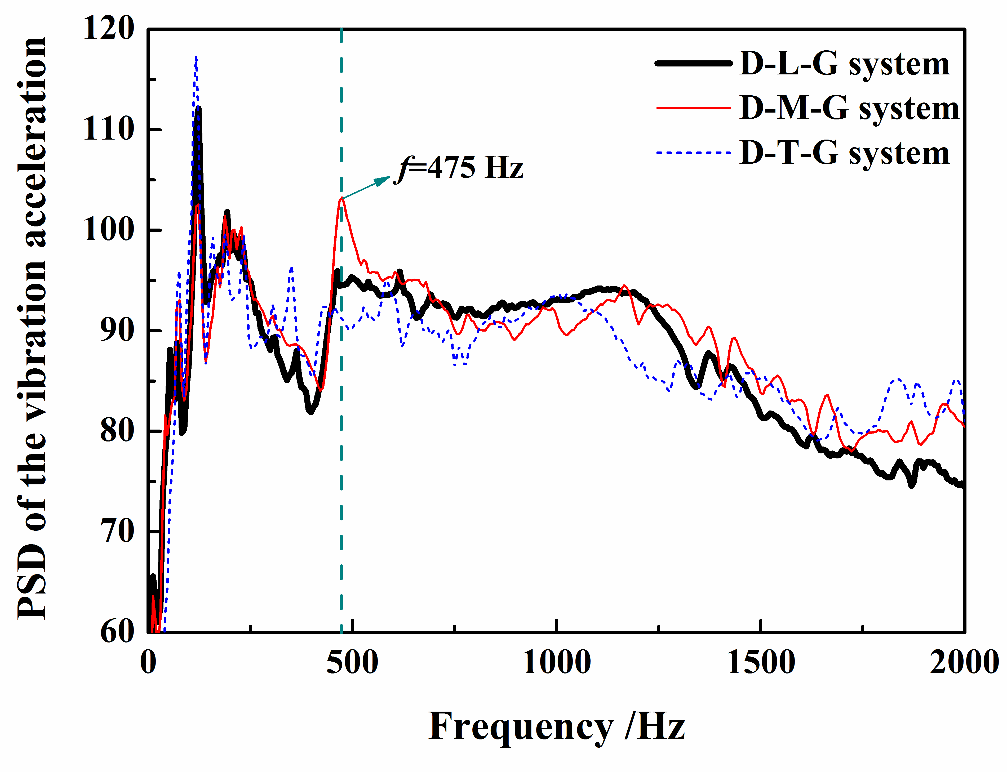
Fig. 13. The PSD analysis of the vibration acceleration for the three friction systems.

Table 4. Summary of the PSD results of the D-G, D-L-G, D-M-G and D-T-G friction systems
Results summary | D-G | D-L-G | D-M-G | D-T-G
PSD results (at 125 Hz) | 124 Hz  106 dB | 125 Hz  112 dB↑ | 125 Hz  102 dB↓ | 123 Hz  117 dB↑
PSD results (at 475 Hz) | 470 Hz  103 dB | 470 Hz  96 dB↓ | 475 Hz  103 dB | 435 Hz  93 dB↓
Tangential vibration magnitude (RMS) | 1.42 | 1.76↑ | 0.87↓ | 2.23↑

Fig. 14 plots the normal and tangential forces of the three friction systems, which are measured by the 2-D strain-gauge force sensors. It can be found the normal force signals of the three friction systems are almost similar with each other, while the tangential force signals show visible differences among them. For the D-L-G friction system, the amplitude of the tangential force is significantly larger compared with the D-M-G and D-T-G friction systems, and the D-T-G friction systems exhibit the lowest tangential force among them.

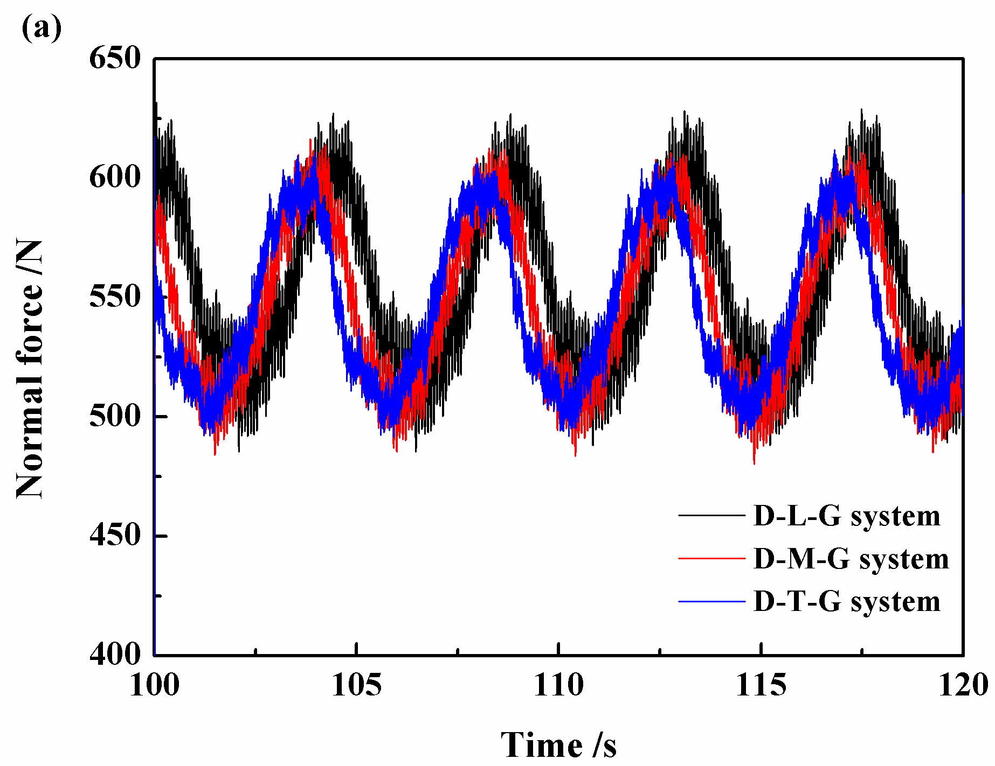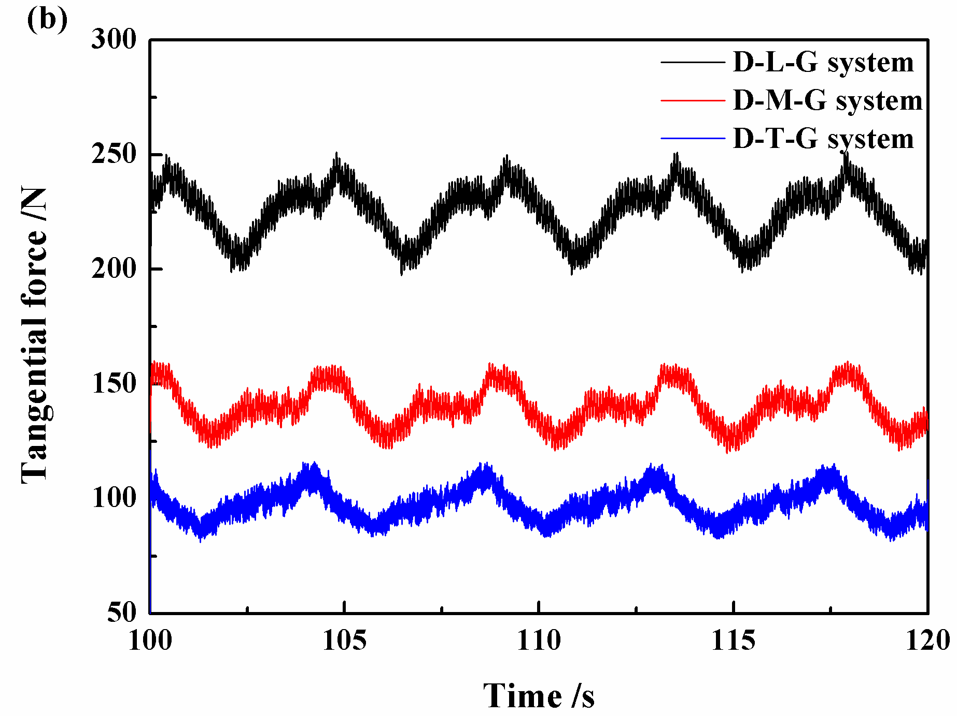
Fig. 14. The normal (a) and tangential (b) forces for the three friction systems.

4.2 Numerical Methodology
In this study, ABAQUS/Standard solver is selected to simulate the dynamic friction process of the friction systems in the time domain. In the simulation process, the Coulomb’s friction law is used to calculate the friction forces between the contact pairs.
The equation of motion of the friction systems can be written as [49, 50]:
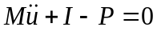. (1)
In Eq. (1), M represents the consistent mass matrix, represents the internal force vector, which takes into account the effect of friction coupling, andis the applied force vector.
The implicit integration operator replaces Eq. (1) with a balance of d'Alembert forces at the end of the time step and a weighted average of the static forces at the beginning and end of the time step, thus Eq. (1) can be expressed as:
. (2)
where 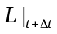 is the sum of all Lagrange multiplier forces associated with all degrees of freedom N. The Newmark formulae for displacement and velocity integrations are
, (3)
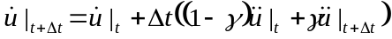. (4)
with:
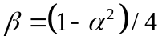, 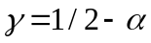 and 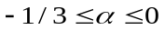.
In the implicit dynamic analysis procedure, the ratio between the maximum time step and the minimum period 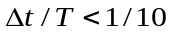 is a good criterion to obtain reliable results. The maximum time step 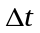 is set to 0.0001 s (equivalent to 10000 Hz) in this study. This integration frequency is much higher than the main frequency of friction-induced vibration (about 470 Hz) of the friction system. Two main steps are required to simulate the dynamic behaviour of the friction system. Firstly, a nonlinear static analysis step is used to apply the normal load on the surface of the top part and the static contact pressure at the disc-pad interface is determined. Secondly, the implicit integration is run to calculate the dynamic response of the friction system.

4.3 Numerical simulation results and discussion
4.3.1 Vibration response analysis
In the implicit dynamic analysis, the sliding formulation is finite sliding and the friction formulation is the penalty method. Firstly, a normal force of 550 N is applied on the surface of the top part. Thereafter, the disc starts to rotate at a constant rotational speed of 1.413 rad/s. The friction coefficient (μ) is set at 0.4. An observation point is set on the support surface to record the vibration signals, and the point position is consistent with the 3-D acceleration sensor located in the experimental test.
Fig. 15 shows the simulated vibration accelerations in two (normal and tangential) directions for the three systems. For the cases of D-L-G and D-T-G systems, the accelerations signals in these two directions exhibit visible and intense fluctuations at the start and develop over a period of time, which suggests that high-amplitude vibrations are generated in these two friction systems. In addition, it can be observed that vibration levels of both friction systems are very similar. While for the D-M-G system, although visible fluctuations are observed for the vibration acceleration signals, the magnitudes of the vibration accelerations exhibit a visible reduction in comparison with those of the D-L-G and D-T-G systems. These simulated results are qualitatively consistent with the experimental results, as shown in Fig. 12. Therefore, the vibration level of the D-M-G system is lower than those of the D-L-G and D-T-G system.

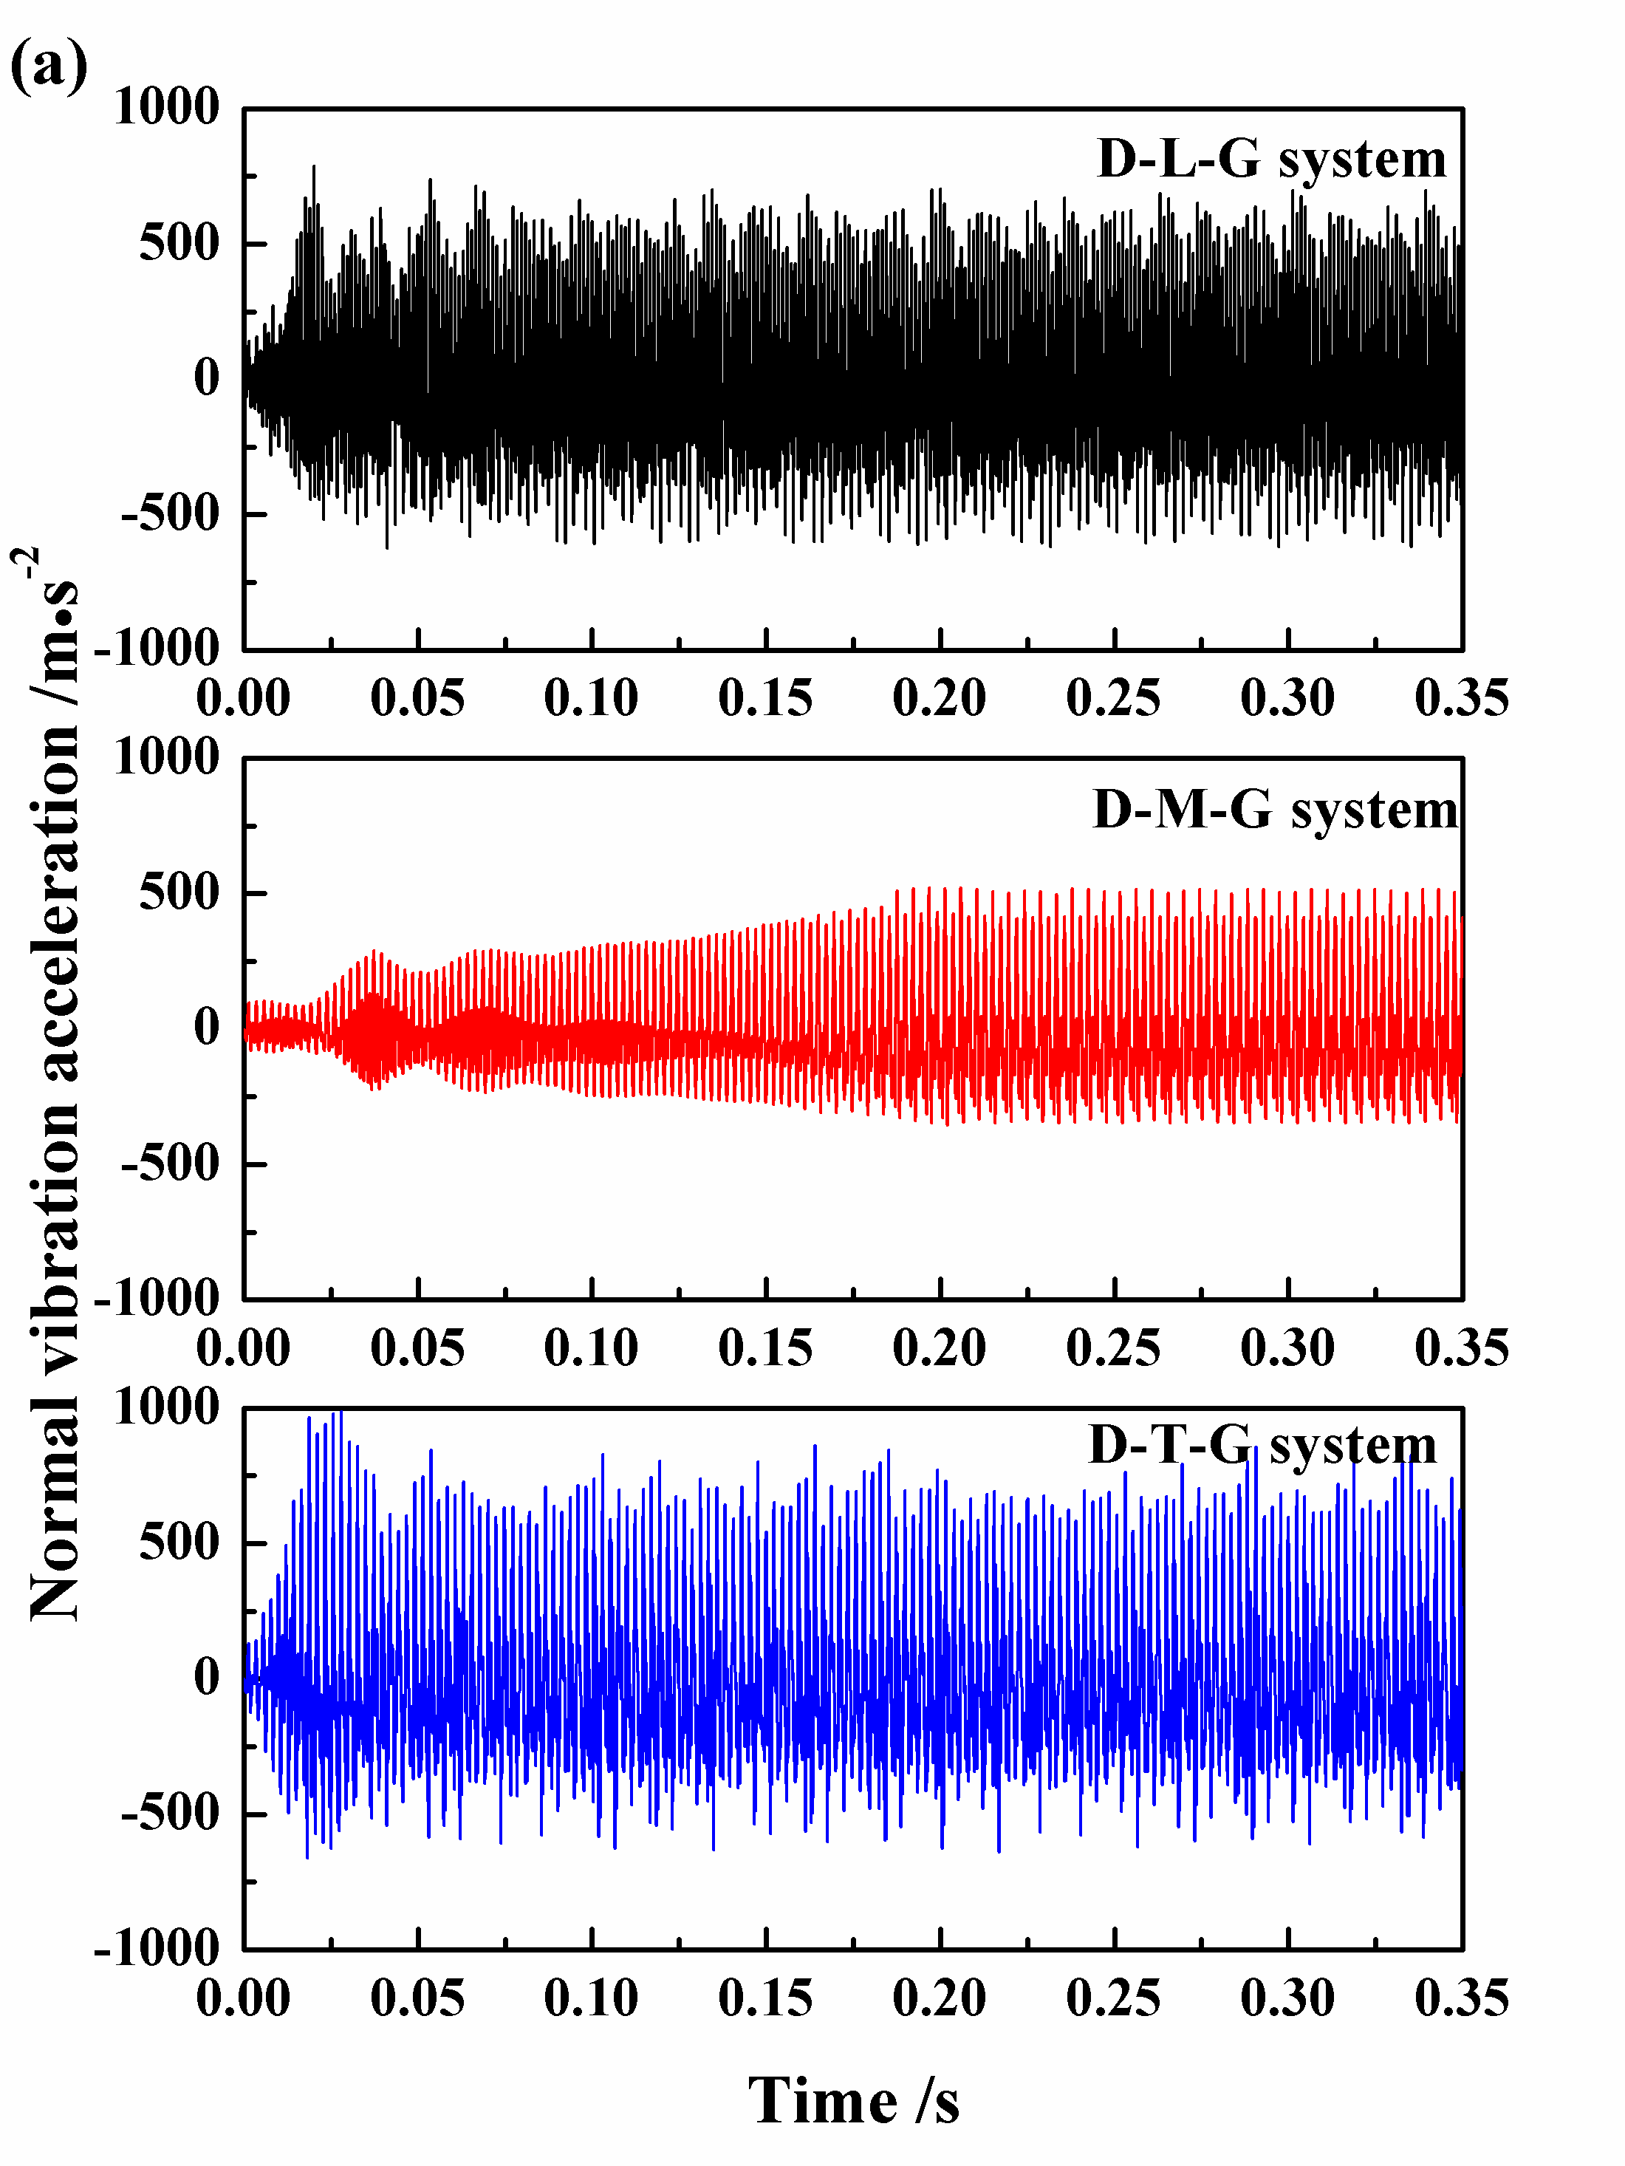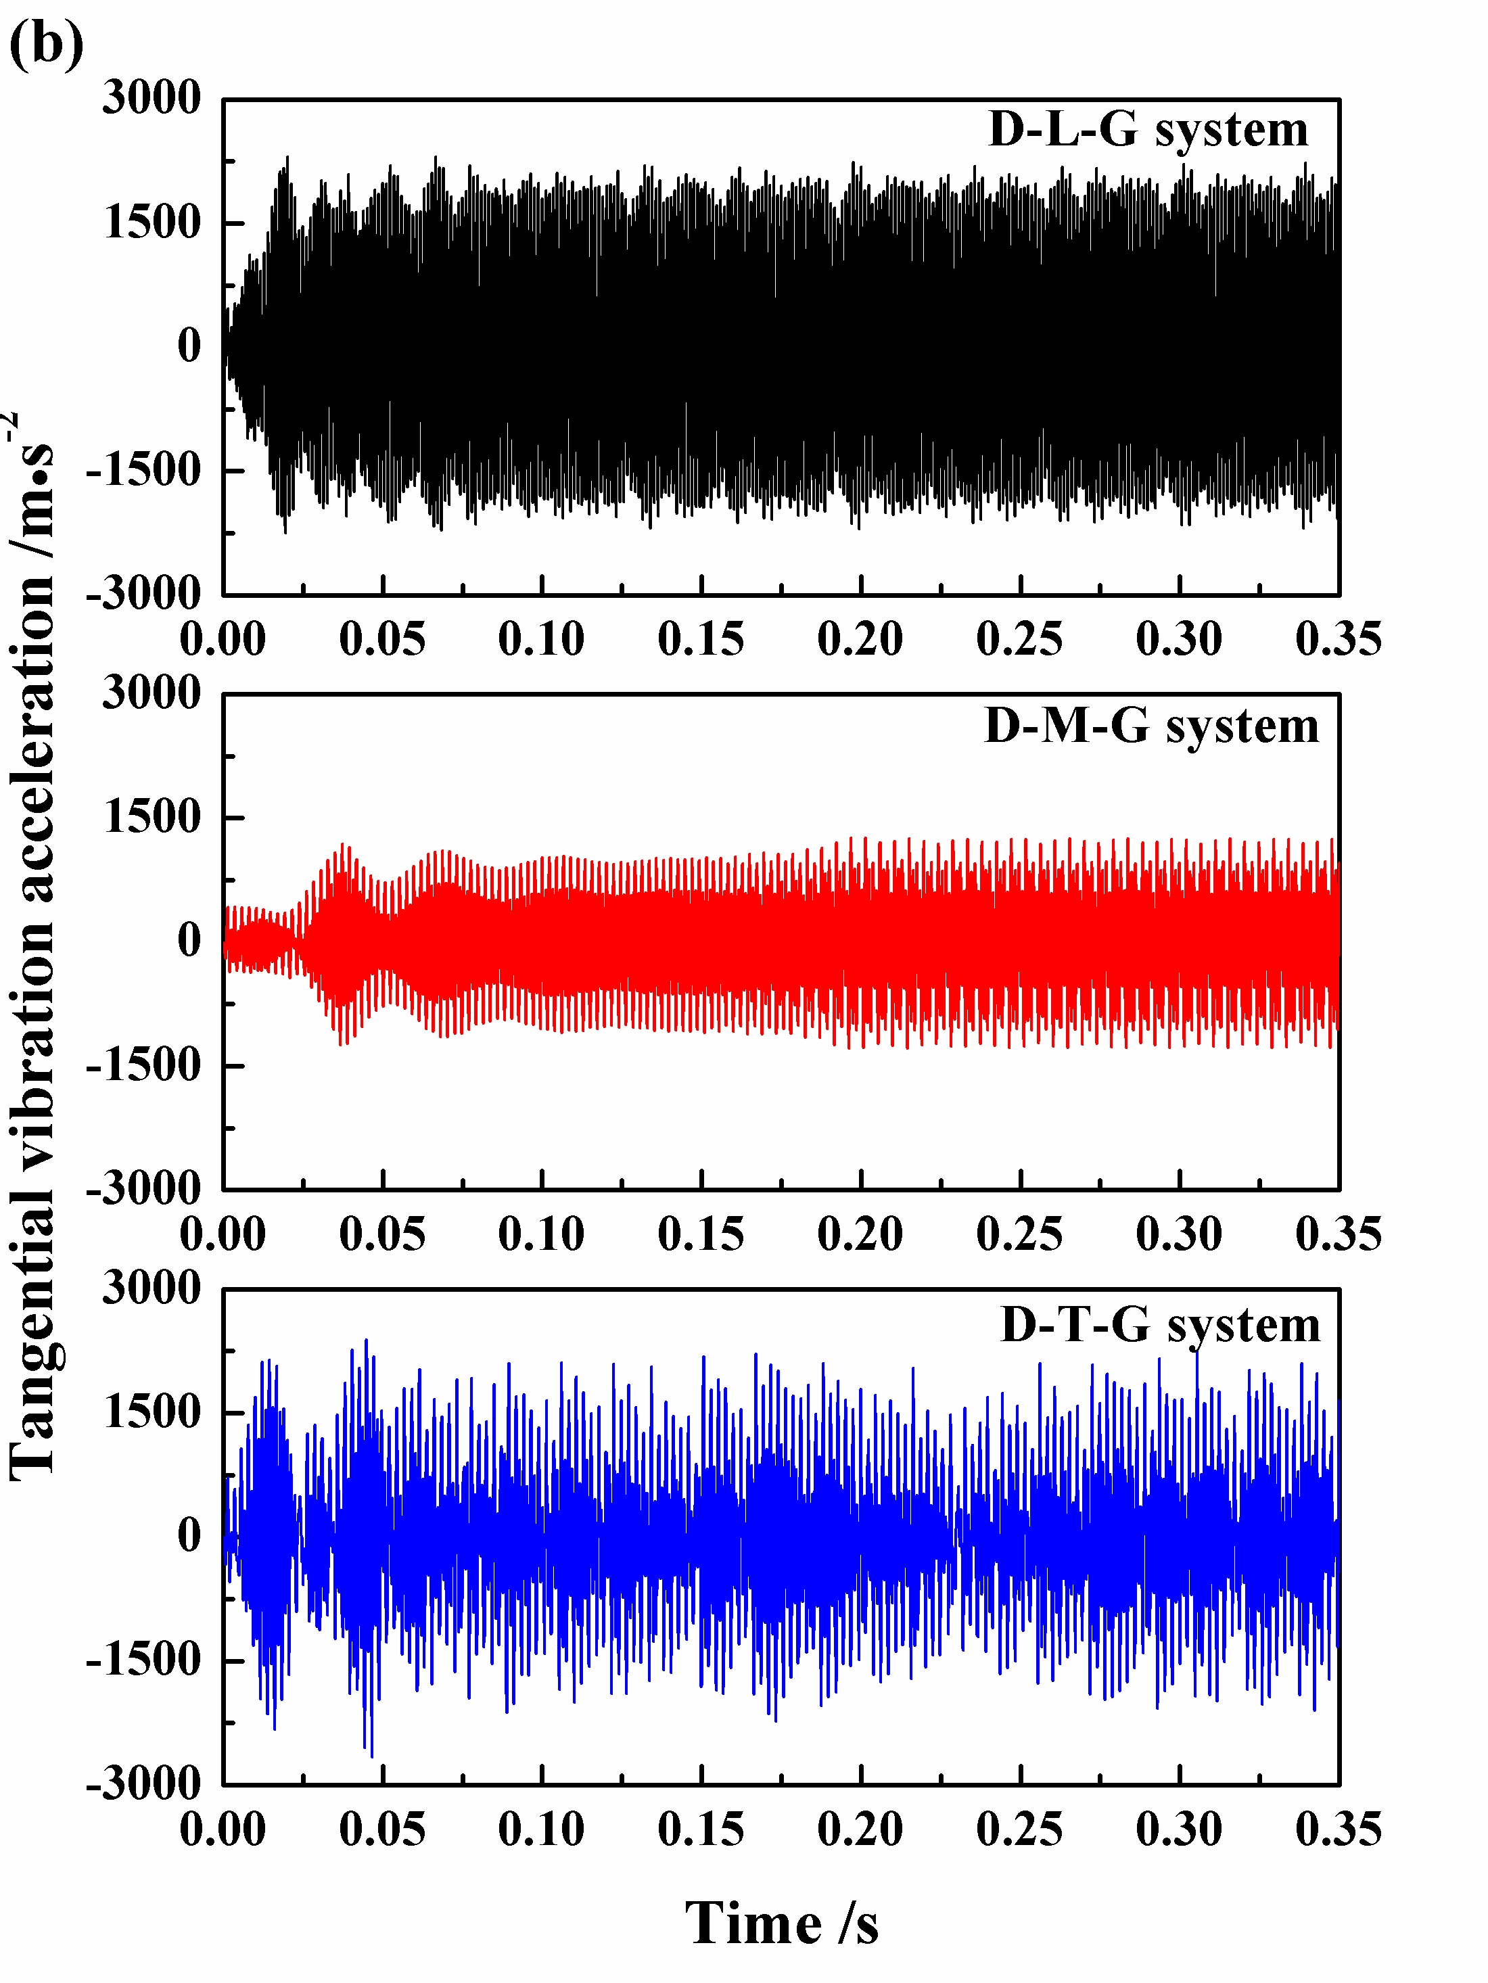
Fig. 15. Numerical results of normal (a) and tangential (b) vibration accelerations for the three friction systems.

It has been demonstrated that brake-type friction systems tend to generate unstable vibration when highest contact pressure is concentrated at the leading edge [28, 47, 48, 51]. Considering this, the contact pressure distributions of pad surfaces for the three friction systems are summarised, to reveal the underlying mechanism and explain why the D-M-G system possesses a better potential in reducing the vibration level. Fig. 16 plots the local contact pressure calculated by dynamic analysis at four different time steps. For both the D-L-G and D-T-G systems, the pad’s leading edge becomes the main region of pressure concentration, and the highest pressure always occurs at the leading point in this period (Fig. 16(a) and (c)). While for the D-M-G system, the contact pressure distributions is remarkably different from those of the other two systems. Apparently, the highest pressure of pad surface varies its location constantly and does not always occur at the leading point (Fig. 16(b)). This phenomenon suggests that the cutting grooves in the middle region of damping component can reduce pressure concentration of contact interface and consequently create a favourable contact pressure distribution to reduce the unstable vibration level.

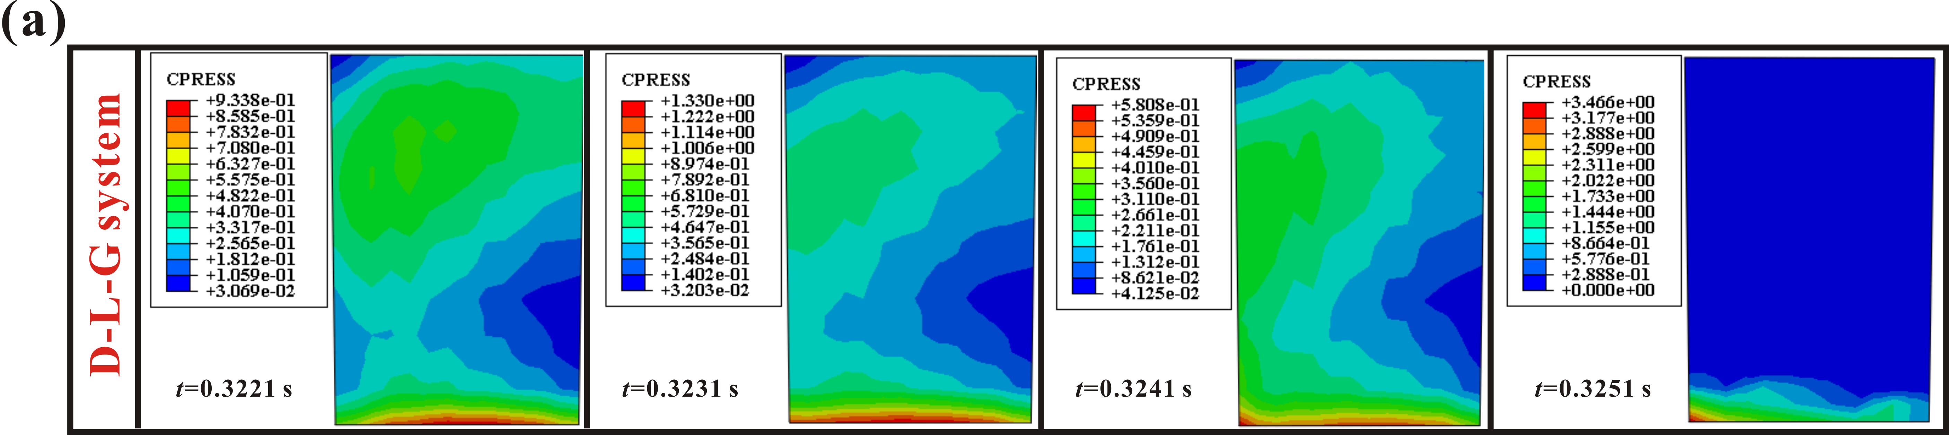

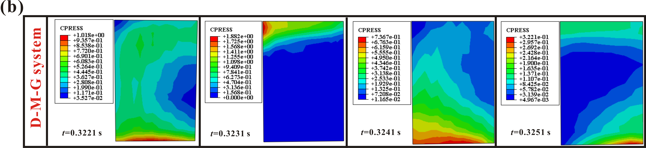

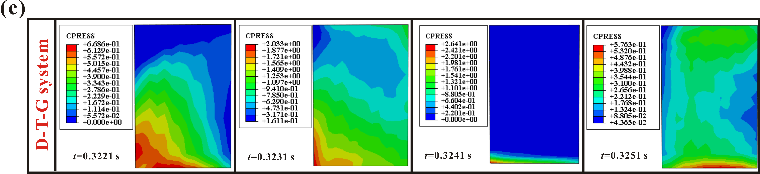
Fig. 16. The contact pressure distribution calculated at the pad surface of D-L-G system (a), D-M-G system (b) and D-T-G system (c) for four different time steps.

4.3.2 Physical explanation for the different tangential forces
The experimental results shown in Fig. 14 indicate that the friction force signals of D-L-G friction system are visibly larger than those of the D-M-G and D-T-G friction systems, and the D-T-G friction system exhibits the lowest value among them. Considering that there is strong relationship between the friction force and the contact area between the disc and pad samples, thus it is necessary to observe the wear topography to try to relate groove distributions with the real contact features.
The real contact area of the pad surface is shown in Fig. 17. For the leading side of the pad surface which exhibits relatively complicated wear morphologies, a noticeable amount of surface damage and material exfoliation can be observed. This indicates that the leading side of pad surface undergoes severe wear. While for the trailing side of pad surface, the surface is relatively well preserved, no visible severe ploughing and material exfoliation is found. This indicates that there is a local separation between pad’s trailing side and disc surface. Therefore, it is necessary to evaluate the value of the lateral deformation (X direction) of point A, as shown in Fig. 18, the larger magnitude of the lateral deformation indicates the larger deformation of the strain gauge and accordingly higher friction force. In this section, the lateral displacement of point A for these three friction systems are extracted and analysed.

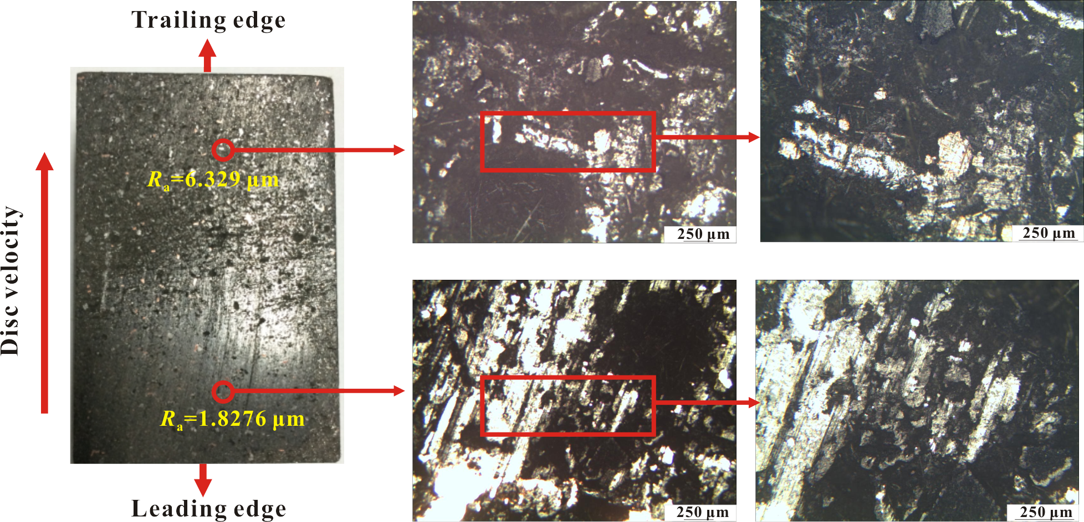
Fig. 17. Optical images of the pad surface after the test.

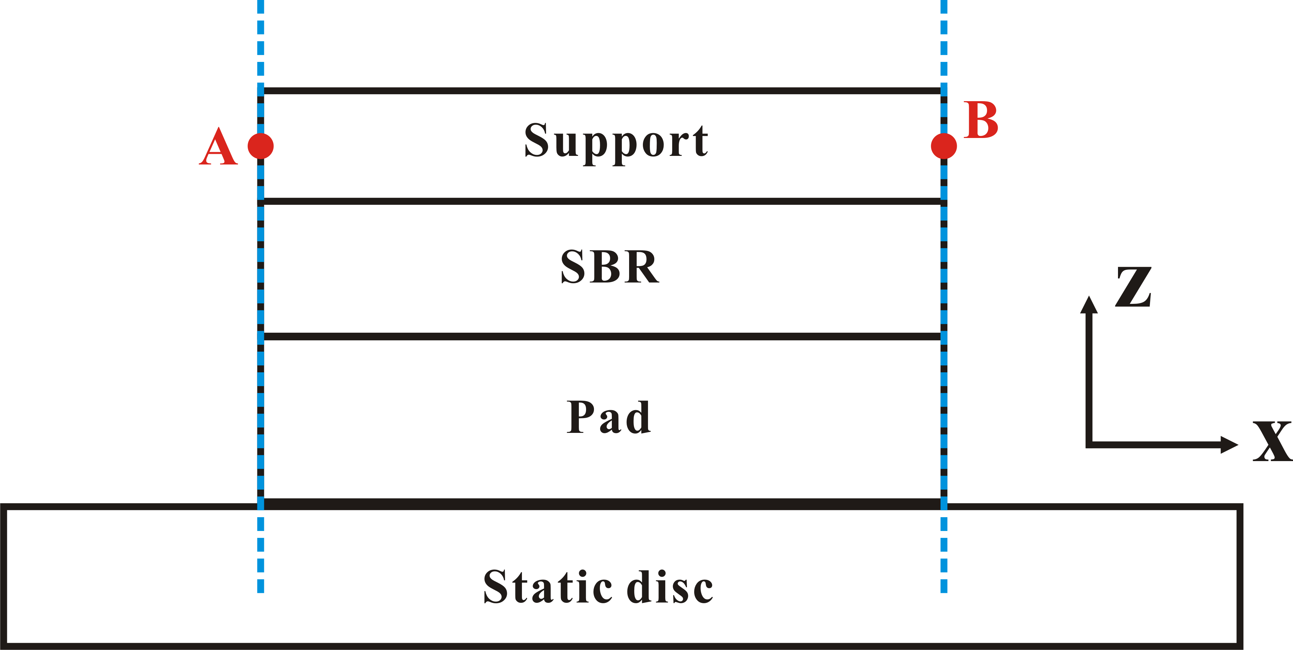
Fig. 18. The schematic view of the contact state between the pad and disc.

Fig. 19(a-c) shows the simulation results of lateral displacements of point A for all the three friction systems in time domain. For the D-L-G system, the displacement signal shows visible continuous fluctuations, and the magnitude of the displacement signal stays at a higher level in this duration (Fig. 19(a)). While for the D-M-G and D-T-G systems, the magnitudes of lateral displacement signal show relatively small value compared with the D-L-G system, which are responsible for the lower friction force. Moreover, it can be found that the displacement magnitude of the D-T-G systems is visibly lower than those of the D-M-G and D-T-G friction systems (Fig. 19(b-c)), thus the D-T-G system shows the lowest value of friction force, which is in good agreement with the experimental results shown in Fig. 14(b). Furthermore, the frictional dissipation energies of the three friction systems are calculated, as shown in Fig. 19(d). The frictional dissipation energy of D-L-G system is found to be significantly larger compared with the D-M-G system and D-T-G system, which suggests the D-L-G system exhibits the largest magnitude of friction force. While for the D-T-G system, the frictional dissipation energy shows that lowest value, which further demonstrates the lowest friction force from the D-T-G system.

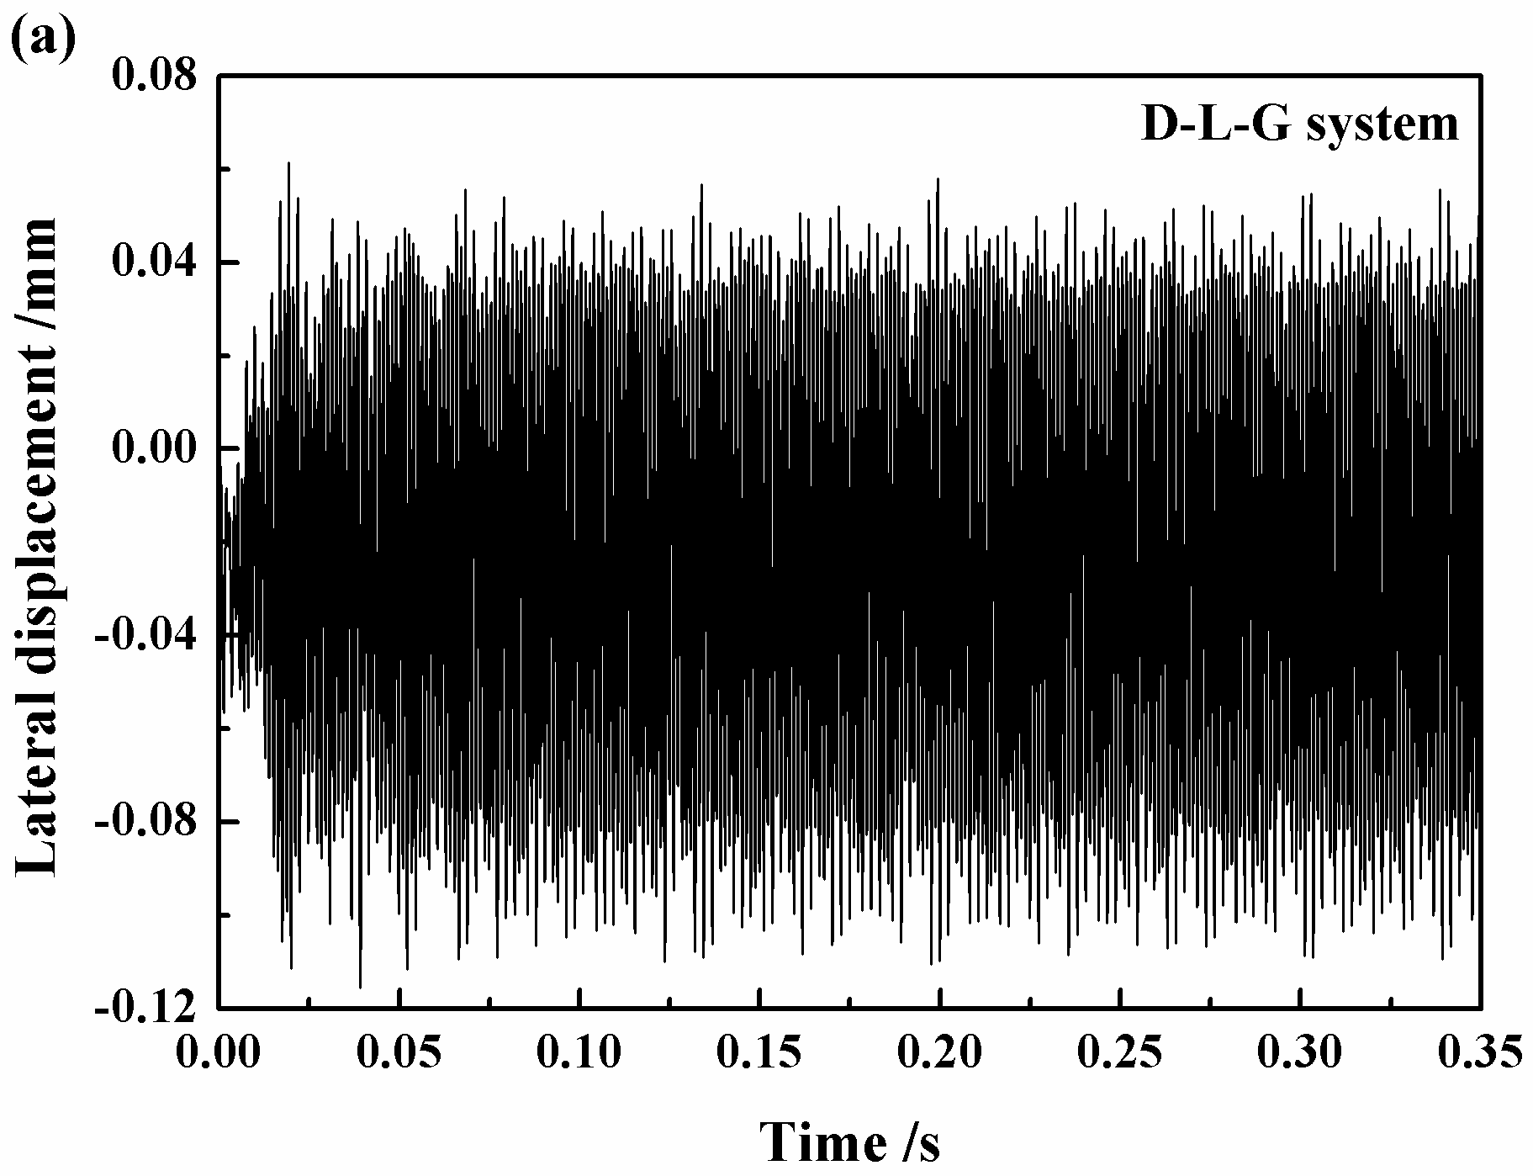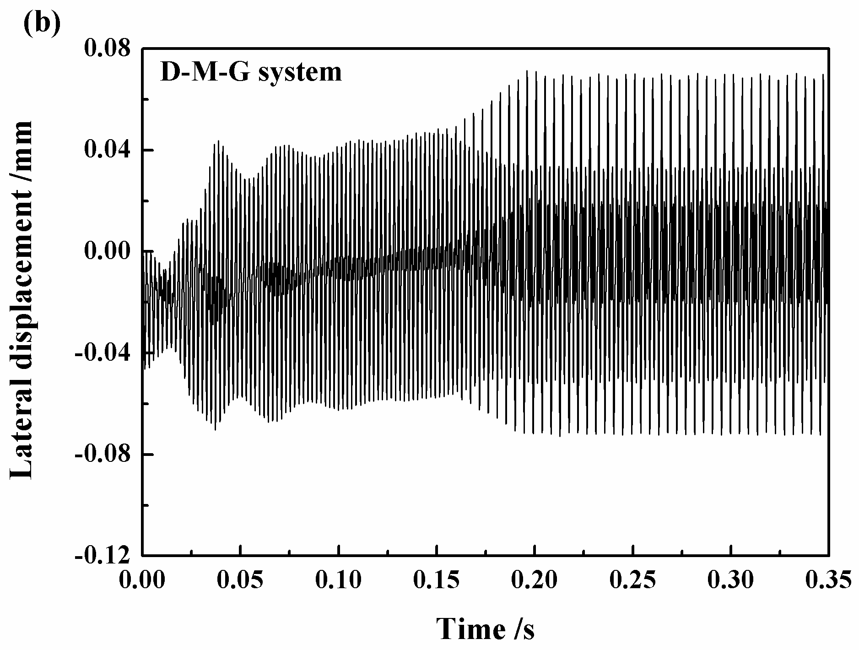
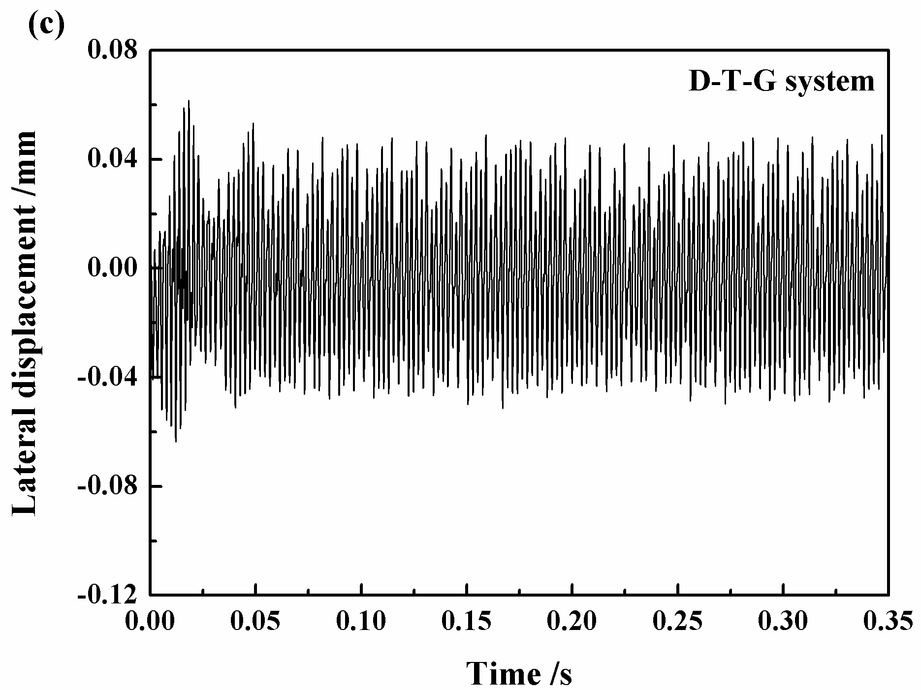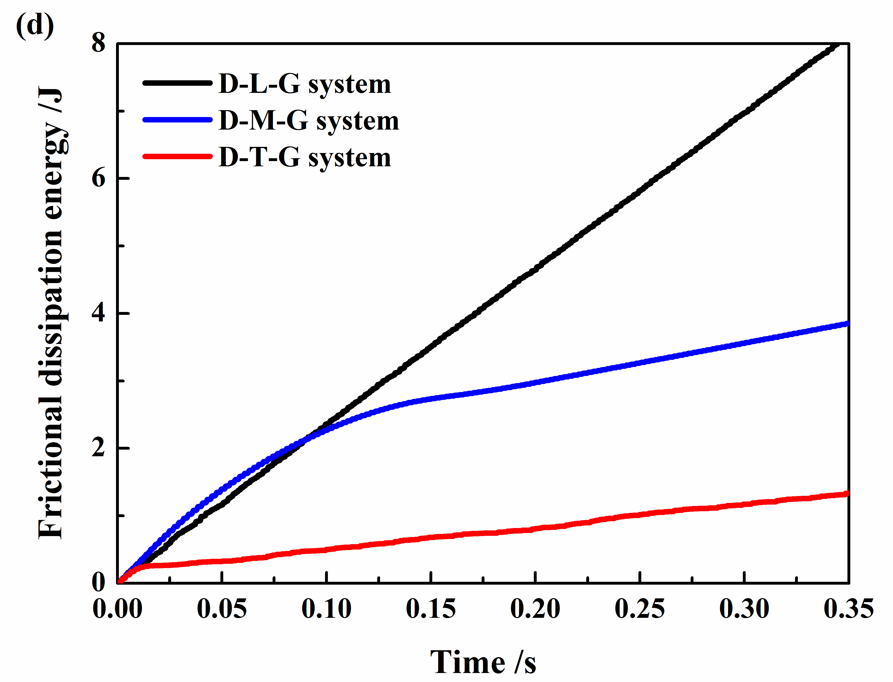
Fig. 19. The lateral displacements of point A for D-L-G system (a), D-M-G system (b), D-T-G system (c) and frictional dissipation energies of the three systems (d) in time domain.

- Conclusions
In this study, the effect of grooved damping component (SBR) on the friction-induced vibration behaviour is studied by using both the experimental and numerical analysis. Firstly, SBR with smooth surface (D-S) and SBR with grooves spread across its surface at a regular interval (D-G) are introduced to the friction system, respectively, to investigate their different ability in reducing friction-induced vibration. Then, the SBR with grooves distributed on three different regions of surfaces (D-L-G, D-M-G and D-T-G) are tested, to detect the different roles of different regions’ grooves in modifying the friction-induced vibration performance. The conclusions of this work are made as follows:
(1) Both the D-S and D-G can reduce the friction-induced vibration of friction system. Moreover, it is found that D-G has a better performance in reducing the friction-induced vibration level, suppressing the generation of vibration main frequency and alleviating the effect of disc surface run-out.
(2) The damping component can adjust the contact surface during the process, this adjust behaviour help the contact pairs maintain a good contact condition with each other, and alleviate the effect of surface run-out. Moreover, the contact pressure of the D-G friction system shows a more uniform distribution and relative lower values, comparing to the D-S friction system, thus the D-G friction system has a better potential in reducing the vibration level.
(3) The grooves in the different regions of damping component surface play different role in modifying the friction-induced vibration behaviour. The grooves in the middle region of the surface can reduce the vibration amplitude, but cannot supress the vibration frequency. While the grooves in both of leading and trailing regions of the surface can eliminate higher vibration frequency to some extent, but neither can help reduce the vibration amplitude, as shown by the higher energy levels in the lower vibration frequency range.
(4) The grooves in different regions can significantly affect the amplitude of the friction force. The friction force of the D-L-G friction system is significantly larger compared to the D-M-G and D-T-G friction systems, and the D-T-G friction systems exhibit the lowest value among them. Numerical results indicate that the lateral displacement of the pad sample is strongly correlated to the friction force.

- Acknowledgements
The authors would like to thank Professor G.X. Chen, of Southwest Jiaotong University, for helpful discussions. The authors are grateful for the financial support of the National Natural Science Foundation of China (No. 51675448, No. 51375408), and the Program for New Century Excellent Talents in University (NCET-13-0974). This work is also partly supported by the National Natural Science Foundation of China (No. 11672052).

Reference
[1] R.A. Ibrahim, Friction-induced vibration, chatter, squeal, and chaos–part I: mechanics of contact and friction, ASME Appl Mech Rev 47 (7) (1994) 209–226.
[2] R.A. Ibrahim, Friction-Induced Vibration, Chatter, Squeal, and Chaos—part II: dynamics and modelling, ASME Appl Mech Rev 47(7) (1994) 227–253.
[3] N.M. Kinkaid, O.M. O'Reilly, P. Papadopoulos, Automotive disc brake squeal, J Sound Vib 267(2003) 105–166.
[4] B. Hervé, J.-J. Sinou, H. Mahé, L. Jézéquel, Analysis of squeal noise and mode coupling instabilities including damping and gyroscopic effects, European Journal of Mechanics 27 (2008) 141–160.
[5] O. Vahid-Araghi, F. Golnaraghi, Friction-Induced Vibration in Lead Screw Drives, Springer, New York, 2011.
[6] G. Sheng, J.H. Lee, V. Narravula, D. Song, Experimental characterization and analysis of wet belt friction and the vibro-acoustic behavior, Tribol Int 44 (2011) 258–265.
[7] M. Vaishya, R. Singh, Sliding friction-induced non-linearity and parametric effects in gear dynamics, J Sound Vib 248(4) (2001) 671–694.
[8] D. Hochlenert, G. Spelsberg-Korspeter, P. Hagedorn, Friction induced vibrations in moving continua and their application to brake squeal, ASME J Appl Mech 74(3) (2007) 542–549.
[9] S. Oberst, J. Lai, A critical review of brake squeal and its treatment in practice, in: Internoise, Shanghai, 2008.
[10] N.M. Ghazaly, M. El-Sharkawy, I. Ahmed, A review of automotive brake squeal mechanisms, J Mech Des Vib 1(1) (2014) 5–9.
[11] Y. Liang, H. Yamaura, H. Ouyang, Active assignment of eigenvalues and eigen-sensitivities for robust stabilization of friction-induced vibration, Mech Syst Signal Process 90 (2017) 254–267.
[12] H. Ouyang, Moving-load dynamic problems: A tutorial (with a brief overview), Mech Syst Signal Process 25(6) (2011) 2039–2060.
[13] N. Hoffmann, L. Gaul, Friction induced vibrations of brakes: research fields and activities, SAE Technical Paper Series 2008–01–2579.
[14] F. Dalzin, A. Le Bot, J. Perret-Liaudet, D. Mazuyer, Tribological origin of squeal noise in lubricated elastomer-glass contact, J Sound Vib 372 (2016) 211–222.
[15] Ashesh Saha, P. Wahi, B. Bhattacharya, Characterization of friction force and nature of bifurcation from experiments on a single-degree-of-freedom system with friction-induced vibrations, Tribol Int 98 (2016) 220–228.
[16] T. Butlin, J. Woodhouse, Sensitivity studies of friction-induced vibration, Int J Veh Des 51(1/2) (2009) 238–257.
[17] H.Q. Do, F. Massa, T. Tison, B. Lallemand, A global strategy for the stability analysis of friction induced vibration problem with parameter variations, Mech Syst Signal Process 84 (2017) 346–364.
[18] J.-J. Sinou, O. Dereure, G.B. Mazet, F. Thouverez, L. Jezequel, Friction-induced vibration for an aircraft brake system-part 1: Experimental approach and stability analysis, Int J Mech Sci 48(5) (2006) 536–554.
[19] K. Popp, P. Stelter, Stick-slip vibrations and chaos, Phil Trans R Soc Lond A 332 (1990) 89–105.
[20] N. Hinrichs, M. Oestreich, K. Popp, On the modelling of friction oscillators, J Sound Vib 216(3) (1998) 435–459.
[21] Z.L. Li, H. Ouyang, Z.Q. Guan, Friction-induced vibration of an elastic disc and a moving slider with separation and reattachment, Nonlinear Dyn 87 (2017) 1045–1067
[22] D. Tonazzi, F. Massi, A. Culla, L. Baillet, A. Fregolent, Y. Berthier, Instability scenarios between elastic media under frictional contact, Mech Syst Signal Process 40(2) 2013 754–766.
[23] N. Hoffman, M. Fischer, R. Allgaier, L. Gaul, A minimal model for studying properties of the mode-coupling type instability in friction induced oscillation, Mech Res Commun 29 (2002) 197–205.
[24] J. Kang, C.M. Krousgrill, F. Sadeghi, Dynamic instability of a thin circular plate with friction interface and its application to disc brake squeal, J Sound Vib 316(1) (2008) 164–179.
[25] A. Elmaian, F. Gautier, C. Pezerat, J.-M. Duffal, How can automotive friction-induced noises be related to physical mechanisms?, Appl Acoust 76 (2014) 391–401.
[26] S. Oberst, J.C.S. Lai, Numerical prediction of brake squeal propensity using acoustic power calculation, ACOUSTICS (2009) 111–118.
[27] J.H. Gweon, B.S. Joo, H. Jang, The effect of short glass fiber dispersion on the friction and vibration of brake friction materials, Wear 362 (2016) 61–67.
[28] D.W. Wang, J.L. Mo, M.Q. Liu, H. Ouyang, Z.R. Zhou, Noise performance improvements and tribological consequences of a pad-on-disc system through groove-textured disc surface, Tribol Int 102 (2016) 222–236.
[29] P. Dufrénoy, V. Magnier, Y. Waddad, J-F. Brunel, G.D.Saxce, A multiscale model of a disc brake including material and surface heterogeneities, SAE Technical Paper Series 2016–01–1911.
[30] A.R. AbuBaker, H. Ouyang, Q. Cao, Interface pressure distribution through structural modifications, SAE Technical Paper Series 2003–01–3332.
[31] L. Hammerström, S. Jacobson, Surface modification of brake discs to reduce squeal problems, Wear 261 (2006) 53–57.
[32] F. Bergman, M. Eriksson, S. Jacobson, The effect of reduced contact area on the occurrence of disc brake squeals for an automotive brake pad, Proc Inst Mech Eng Part D: J Automob Eng 214(5) (2000) 561–568.
[33] M. Triches Jr, S.N.Y. Gerges, R. Jordan, Reduction of squeal noise from disc brake systems using constrained layer damping, J Braz Soc Mech Sci Eng XXVI (3) (2004) 340–348.
[34] J. Kang, Finite element modelling for the investigation of in-plane modes and damping shims in disc brake squeal, J Sound Vib 331 (2012) 2190–2202.
[35] H. Festjens, C. Gaël, R. Franck, D. Jean-Luc, L. Remy, Effectiveness of multilayer viscoelastic insulators to prevent occurrences of brake squeal: A numerical study, Appl Acoust 73 (2012) 1121–1128.
[36] F. Massi, O. Giannini, Effect of damping on the propensity of squeal instability: An experimental investigation, J Acoust Soc Am 123 (2008) 2017–2023.
[37] J.-J. Sinou, L. Jézéquel, On the stabilizing and destabilizing effects of damping in a non-conservative pin-disc system, Acta Mech 199 (2008) 43–52.
[38] G. Fritz, J.-J. Sinou, J.-M. Duffal, L. Jézéquel, Investigation of the relationship between damping and mode-coupling patterns in case of brake squeal, J Sound Vib 307(3) (2007) 591–609.
[39] M.D. Rao, Recent applications of viscoelastic damping for noise control in automobiles and commercial airplanes, J Sound Vib 262(3) (2003) 457–474.
[40] C.W. De Silva, Vibration Damping, Control, and Design, Taylor & Francis, Boca Raton, 2007.
[41] D.I.G. Jones, Handbook of viscoelastic vibration damping. John Wiley & Sons, 2001.
[42] Reinhall P. Composition for vibration damping: U.S. Patent 5,335,463. 1994–8–9.
[43] M.P. Stevens, Polymer chemistry, New York: oxford university press, 1990.
[44] S.C. George, K.N. Ninan, G. Groeninckx, S. Thomas, Styrene–butadiene rubber/natural rubber blends: morphology, transport behavior, and dynamic mechanical and mechanical properties, J Appl Polym Sci 78(6) (2000) 1280–1303.
[45] H. Ouyang, W. Nack, Y. Yuan, F. Chen, Numerical analysis of automotive disc brake squeal: a review, Int J Vehicle Noise Vib 1(3/4) (2005) 207–231.
[46] F. Massi, L. Baillet, O. Giannini, A. Sestieri, Brake squeal: linear and nonlinear numerical approaches. Mech Syst Signal Process 6 (2007) 2374–2393.
[47] A.R. AbuBakar, H. Ouyang, L. Li, A combined analysis of heat conduction, contact pressure and transient vibration of a disk brake, Int J Veh Des 51 (2009) 190–206.
[48] J.D. Fieldhouse, N. Ashraf, C. Talbot, T. Pasquet, P. Franck, R. Gabriel, Measurement of the dynamic center of pressure of a brake pad during a braking operation. SAE Technical Paper, 2006–01–3208.
[49] H.M. Hilber, T.J.R. Hughes, R.L. Taylor, Improved numerical dissipation for time integration algorithms in structural dynamics, Earthquake Eng Struct Dyn 5 (1977) 283–292.
[50] A. Czekanski, N. El-Abbasi, S.A. Meguid, Optimal time integration parameters for elastodynamic contact problems. Commun Numer Methods Eng 17 (2001) 379–384.
[51] Y. S. Lee, P. C. Brooks, D. C. Barton, D. A. Crolla, A Predictive Tool to Evaluate Disc Brake Squeal Propensity. Part 3: Parametric Design Studies, Int J Vehicle Design 31(3) (2003) 330–353.

*Corresponding author. Tel.: +86-28-87600601; fax: +86-28-87603142. E-mail address: jlmo@swjtu.cn (J.L. Mo)

