How do grooves on friction interface affect tribological and vibration and squeal noise performance

D.W. Wang ª, J.L. Mo ^{a,} *, Z.Y. Zhu ª, H. Ouyang ^{b}, M.H. Zhu ª, Z.R. Zhou ª
ª Tribology Research Institute, Southwest Jiaotong University, Chengdu 610031, China
^{b} School of Engineering, University of Liverpool, Liverpool L69 3GH, UK

Abstract:
Experimental studies on the effect of grooved disc on tribological properties, and vibration and noise properties are performed in two different contact configurations: ball-on-disc and pad-on-disc configurations. Experimental results show that certain sizes of grooves on the disc surface are capable of significantly affecting tribological behaviour and reducing squeal noise. Moreover, the grooves are found to play different roles in reducing squeal noise in these two different contact configurations. A disc sample with just one groove on the disc surface sufficiently validates the different abilities of grooves in suppressing squeal noise in both contact configurations. In addition, numerical analysis is performed to further demonstrate the effect of grooves in affecting squeal instability in both contact configurations.

Key words: Tribological; grooved disc; friction; noise; contact configuration.

- Introduction
Self-excited vibration caused by friction is one of the most challenging concerns encountered in many engineering applications. To cite a few, typical examples are brake systems, mechanical gear systems, wiper blade systems, lead screw drives, and engines and power trains, et al [1-6]. These vibrations are responsible for different noises and stress concentrations. In the case of automobile braking, brake noises are given different names in terms of the noise frequency, such as groaning and moaning (100-500 Hz), howl (500-1000 Hz) and squealing (1-20 kHz) and so forth [1]. Among them, squeal noise with high sound intensity and high pitched tone has received extensive attention by researchers, due to its negative effect on human ears and the general public [2].
The generation mechanism of noise caused by friction has been the challenging problems for many researchers. Over the past few decades, significant progress has been made in gaining physical insight into the squeal phenomenon, and many new research methods have been developed for analysing its properties. Comprehensive reviews of vibration and noise caused by friction were given by Kinkaid et al. [1] and Ibrahim [7-8]. In addition, Akay [9] presented a clear insight into friction acoustics and discussed the contact problem related to friction in general. As reviewed in some investigations, several mechanisms of friction-induced vibration and noise have been identified, including stick-slip, sprag-slip, the negative gradient of the friction coefficient with the sliding velocity, flutter instability owing to mode coupling, hammering and moving load theory, et al [10-14]. These mechanisms are essential for better understanding of friction-induced vibration and noise, and may consequently further help control and eliminate friction noise to a certain extent. However, as pointed out by Tonazzi et al. [15], these mechanisms related to both the contact and structure scales are presented simultaneously generally in the case of friction noise generation, and thus an exact separation of their effects is often difficult. Therefore, no fully satisfactory and well validated general theory of friction-induced vibration and noise has yet been demonstrated.
Considering that friction noise is a result of unstable vibration of frictional interface, a large amount of work has been conducted to study the effect of interface properties on friction noise [16-34]. As emphasized by Hoffmann and Gaul [16], surface properties, such as surface topographies, wear debris and physical and chemical properties of the interface, all play significant roles in the occurrence of friction noise. Remarkable experimental work on the connection between surface topography and squeal noise instability of a brake system was carried out by researchers at Uppsala University [17-19]. In addition, Lyu et al. [20] found that a disc sample with smoother surface would emit higher sound pressure, and the sound pressure generated in the severe wear region was approximately 10 dB higher compared to with that of the mild wear region. Gweon et al. [21] investigated the relationship between brake friction materials containing glass fibres and brake noise, and found that the brake materials with milled glass fibres had strong potential in generating brake instability. Dalzin et al. [22] studied the squeal noise properties of a water-lubricated elastomer sliding against a glass specimen, and concluded that the contact was highly heterogeneous and the number of contact spots decreased with the increase of sliding velocity during squeal. Mat Lazim et al. [23] introduced silica sand particles to the brake pad interface and found that the embedment of particles in the friction layer would result in the generation of new flat area, which might consequently be responsible for squeal occurrence. Renault et al. [24] performed experimental investigations for uncertainty quantification in brake squeal analysis, and found that the topography of the pad surfaces played a significant role in the squeal generation, which could directly affect the spectrum of unstable frequencies.
Fuadi et al. [25] performed creep groan experiments and confirmed that the oscillation of friction force was strongly affected by the surface contact stiffness. Graf and Ostermeyer [26] found that the tendency of squeal instability depended on the parameters of the tribological layer of the brake pad, and the brake system had a stronger potential in generating squeal noise when increasing the inertias of the boundary layer at the disc-pad interface. AbuBakar and Ouyang [27, 28] introduced the real surface topography of brake pad to the finite element model, and they found that their numerical results were well correlated with the test results. Butlin and Woodhouse [29, 30] performed sensitivity analysis to verify the best contact parameters for the generation of friction-induced squeal. Oberst and Lai [31, 32] identified the unstable vibration modes and calculated the acoustic power of a simplified brake system with five different pad shapes, and found the squeal noise behaviour of the brake system could be significantly changed by introducing different slots on the pad surface.
The above mentioned studies shed light on the role of surface properties in friction noise instability. However, uncertain interface conditions will cause difficulties in predicting noise performance. Different dynamic behaviour is frequently found even when performing experiments under nominally identical conditions. As commented by Eriksson and Jacobson [35] after performing a series of tests, ‘despite careful planning and well-controlled experiments, the general relationships between squeal generation and pad surface were not able to be revealed’. As a consequence, looking for a special surface which possesses relatively regular surface properties to investigate the squeal noise related to surface topography is absolutely essential.
Nowadays, groove-textured surfaces have received much attention from tribologists because of their good geometric repeatability and tribological properties. Much progress has been made to better comprehend the ability of grooves in changing the tribological performance of interface [36-40]. Meine et al. [36, 37] conducted a series of tests to study the influence of grooved surfaces on the friction force in a ball-on-flat configuration, and they demonstrated that the friction force would experience abrupt changes as the ball passed over the grooves, and the amplitude of friction force was related to the density of grooves on the flat surface. Wu et al [38] investigated the effect of groove-textured surfaces on the tribological characteristics under high frictional temperature, and found that the grooves could alleviate the wear and reduce the energy consumption under most experimental conditions. Ripoll et al. [39] analysed the contact behaviour of groove-textured surfaces under reciprocating sliding using finite element simulation, and they estimated the effect of surface texturing on the lifetime of the surface by observing the regions of plastic deformation. These studies are better for capturing the correlation between grooves and tribological behaviour. However, the knowledge of the relationship between grooved surfaces and friction-induced vibration and noise are limited, and a systematic knowledge on how grooves affect the tribological behaviour and accordingly the vibration and noise behaviour of the contact interface remains unknown and somehow mysterious. Therefore, a further understanding of the effect of groove-textured surfaces on noise is extremely worthwhile, which in consequence might help to further investigate the generation of friction noise, and is of considerable importance for the optimal design of surface topography to reduce the friction noise.
In the authors’ previous work, both experimental studies and numerical simulations have been performed to investigate the friction-induced vibration and noise related to grooved surfaces by using ball-on-flat and pad-on-disc configurations, respectively. It is found that a specific groove configuration on the contact surface could significantly reduce squeal noise [40-42]. The results are essential for better understanding the connection between grooves and friction noise. However, the different tribological behaviour between ball and pad sliding across grooves still needs a deeper investigation, and the different roles of the grooves in affecting the friction noise in both contact configurations should be further verified.
Therefore, the motivation behind this work is to thoroughly understand the role that grooves play in both cases of the ball and pad sliding across grooves on disc surfaces. A special kind of groove-textured surface configuration is manufactured on disc samples: grooves with different widths run radially at regular angle intervals. Experimental studies on the effect of grooved discs on tribological properties and vibration and squeal noise properties are performed in both contact configurations. By combining the experimental and numerical results, the effect of grooved disc surfaces on the tribological and noise performance is systematically studied, and the different roles of grooves in reducing squeal in ball and pad sliding across grooves are presented.

- Experimental rig and tests
2.1 Details of experimental setup
Two types of contact configurations are involved in this work. The first one is a ball-on-disc configuration, which allows a point contact between the counterface ball and the rotating disc samples. The other one is a pad-on-disc configuration, which establishes a surface-to-surface contact. It should be noted that both contact configurations have been widely used to investigate the tribological properties and noise performance of contact interfaces, which are proved to be able to provide repeatable results with measurable and controllable dynamics.
The images of the setups are shown in Fig. 1. A disc sample is laid in a horizontal plane and fixed on the disc table of a rotational motion device. A ball/pad sample is fastened to the ball/pad sample holder, which is connected to a suspension with a 2-D strain-gauge force sensor attached. The ball subsystem and the pad subsystem are to be placed in contact with the rotating disc separately. A 3-D acceleration sensor is used to record the vibration signals of the friction system. A microphone is mounted 40 mm away from the contact interface to detect the noise signals. More detail parameters of the sensors used in the experimental tests can be seen in the previous work [41].
At the start of an experimental test, the moving stage gradually descends and helps the ball/pad samples touch the disc surface, thereafter a certain amount of normal force is applied during the rotating process. A Müller-BBM 32-channels MKII PAK equipment is used to acquire and analyse all the vibration and noise signals measured from sensors synchronously, at a sampling frequency of 12.8 kHz.

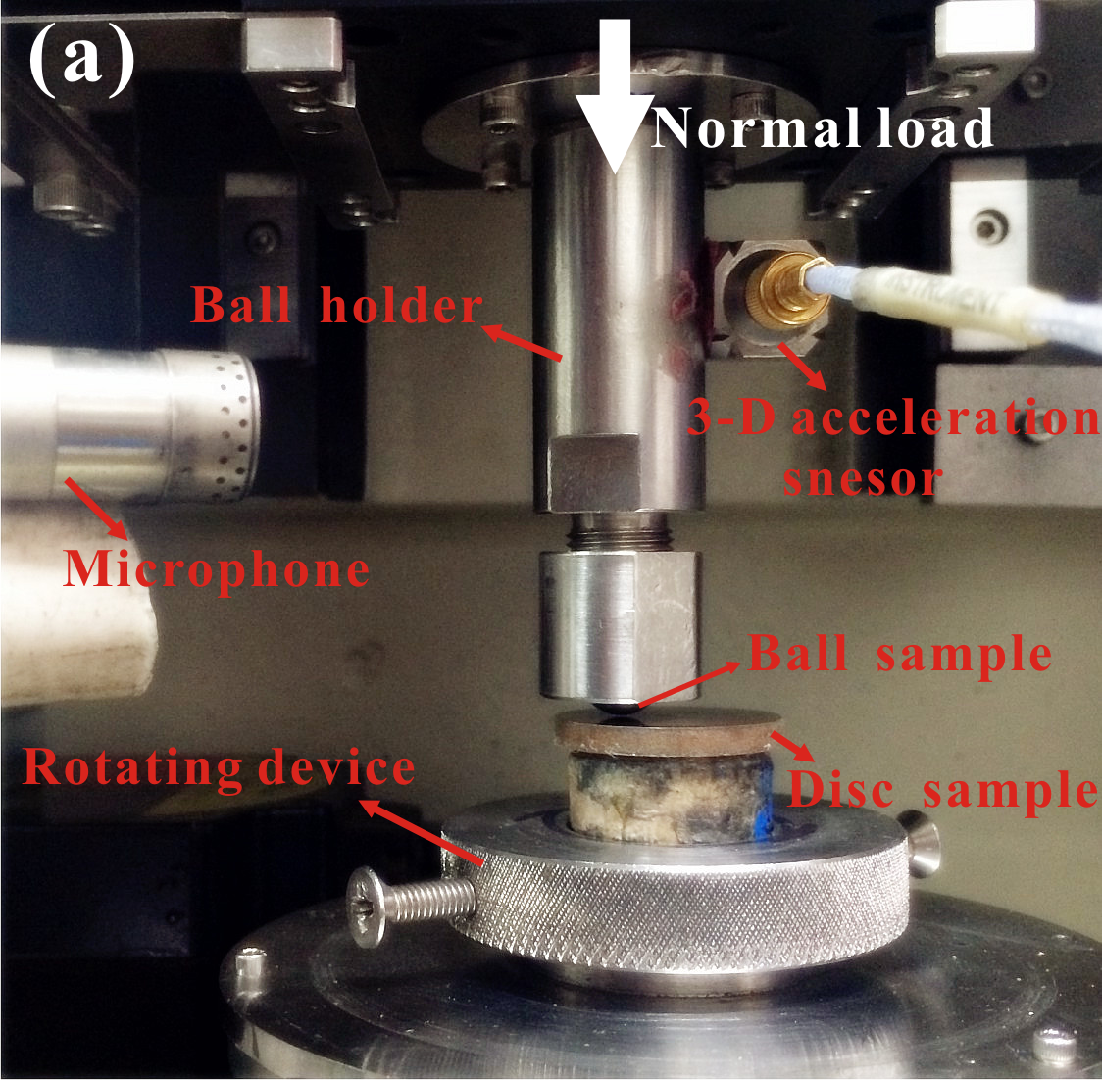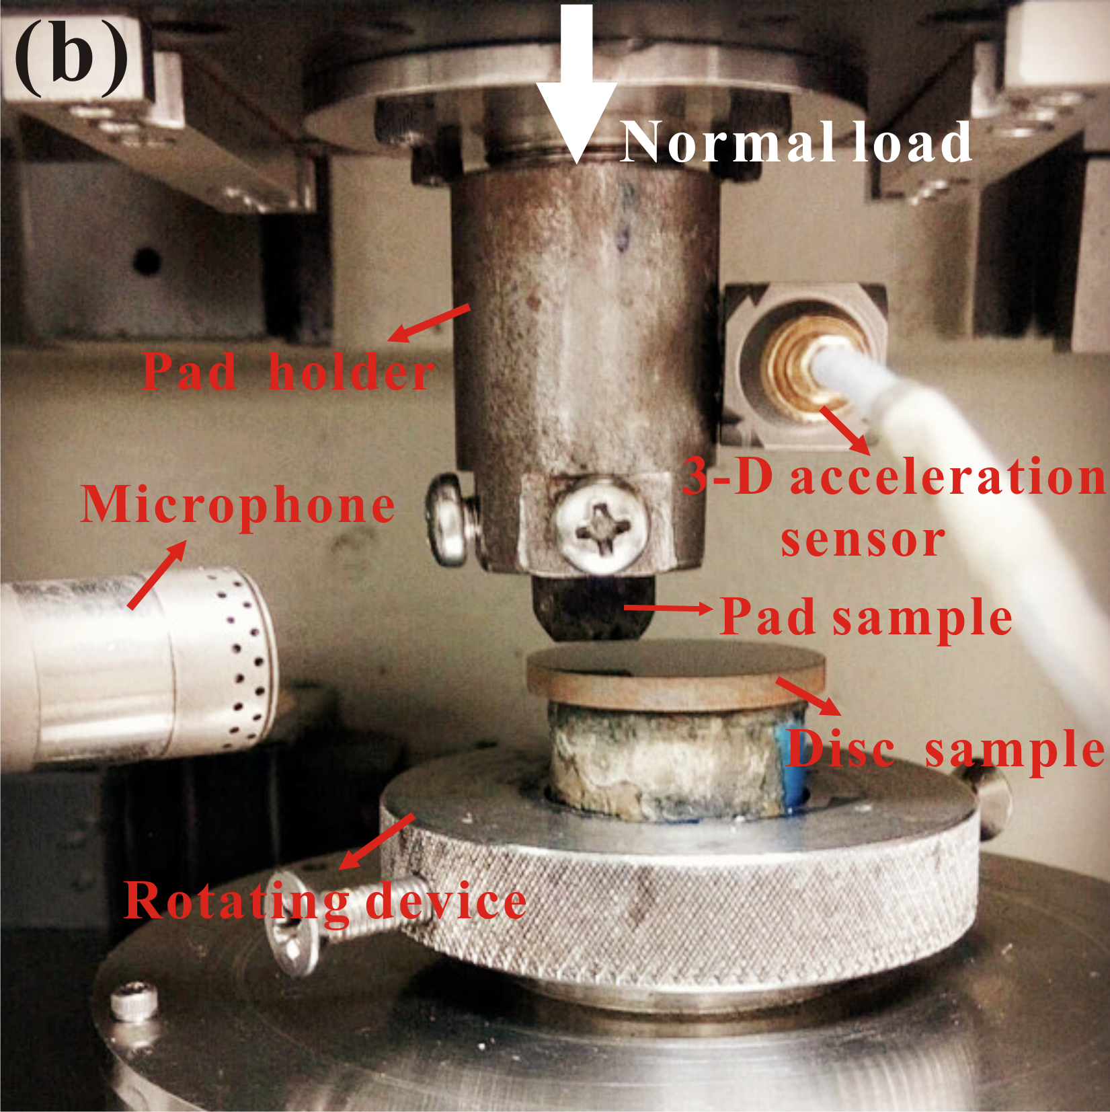
Fig. 1. The experimental setups of ball-on-disc (a) and pad-on-disc configurations (b).

2.2 Samples preparation
The ball sample used in the ball-on-disc configuration is a chromium bearing steel ball (AISI 52100, HV_{0.05} 510 kg/mm², E=210 GPa, ~0.02 mm R_{a}) with a diameter of 10 mm. The pad sample used in the pad-on-disc configuration is cut from a train brake pad (a kind of composite material, ρ≈2200 kg/m³, E≈1 GPa, HR 50~90) to a length of 15 mm and cross section of 10 mm×10 mm.
For the disc samples, all of them are cut from real train brake disc material (HV_{0.05} 240 kg/mm² and E=158 GPa), their corresponding diameter and thickness are 25 mm and 3 mm, respectively. All the disc surfaces are polished to a surface roughness of approximately 0.04 mm R_{a} by using 800-grit and 1500-grit silicon carbide abrasive paper, respectively. A special kind of groove-textured surface configuration is manufactured on the disc samples: radial grooves at regular angular intervals of 30 degree. Three different kinds of groove widths are produced. Moreover, a customised sample with only one groove on the disc surface is manufactured. The dynamical signals when the ball or pad slides across the groove are recorded, to further verify the influence of grooves on the dynamical performance of contact surface in both contact configurations. The images of the grooved disc samples and the sketch of the ball-on-disc and pad-on-disc configurations are shown in Fig. 2, and the dimension parameters of the grooved disc samples are listed in Table 1. In order to well distinguish different samples, abbreviated names are introduced. Here, S represents smooth disc surface, abbreviation T-30-w represents grooved disc surface with a circumstantial angle of 30° in between and groove width of w mm, and T-c represents the groove-textured surface with only one groove.

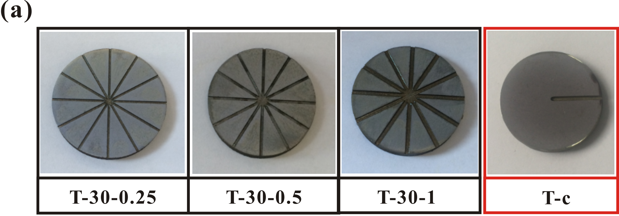

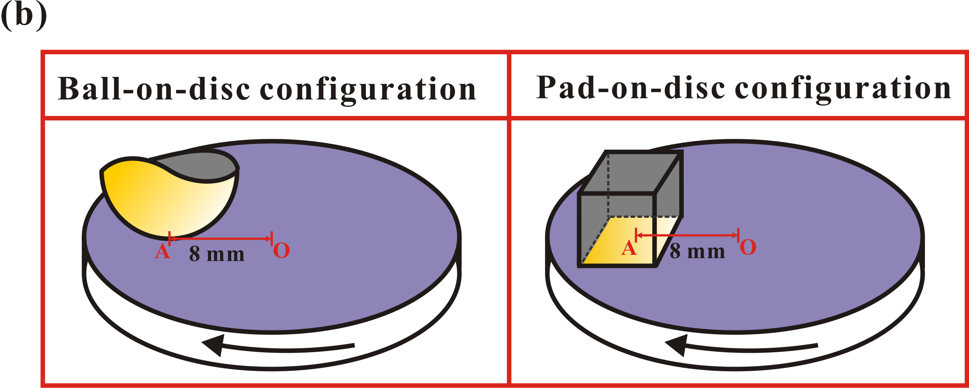
Fig. 2. Geometrical sketch of the groove-textured surfaces (a) and the ball-on-disc and pad-on-disc configurations (b).

Table 1. Dimension parameters of the grooved disc samples
Disc sample (T-30-w) | Angle | Width w (mm) | Depth h (mm)
T-30-0.25 | 30±1 | 0.25±0.02 | 0.3±0.02
T-30-0.5 | 30±1 | 0.5±0.02 | 0.3±0.02
T-30-1 | 30±1 | 1±0.02 | 0.3±0.02
T-c | — | 1±0.02 | 0.3±0.02

2.3 Test procedures
Considering the different contact situations in these two experimental configurations, a series of preliminary tests are performed to address the tribological parameters, which can be seen in Table 2. Each test for the two configurations is conducted as long as sound pressure becomes steady.
Before testing, the discs’ surfaces are cleaned by using acetone to minimise the influence of contaminants, and a procedure of running-in is performed for the pad samples to ensure a good flat-on-flat contact. All tests are performed in a strictly controlled ambient environment (24~27 °C and 60±10% RH). The background sound pressure level is measured which is only about 66.4 dB (A). Considering the ‘capricious’ nature of the friction noise performance, each test presented in this experimental analysis is run more than three times to obtain experimental results with good repeatability. Wear scars are observed by using optical microscopy after the tests.

Table 2. Tribological parameters for the ball-on-disc and pad-on-disc configurations.
Condition | Ball-on-disc | Pad-on-disc
Normal load (N) | 10 | 100
Rotating speed (rpm) | 180 | 60
Testing time (s) | 900 | 1800

- Different tribological performances and vibration and noise performances of the two configurations
3.1 Sound pressure level (SPL) and time-frequency analysis
Fig. 3 depicts the time history of equivalent sound pressure level (ESPL) for the ball-on-disc and pad-on-disc configurations. The friction noise recorded in this study is defined as squeal noise, because the dominant frequencies of the noise are above 1K Hz. The frequency spectrum analysis of the noise signals will be shown in the following section. The capability of a grooved surface in reducing squeal is validated by comparing the noise performances between the smooth and grooved disc samples. For the ball-on-disc configuration (Fig. 3(a)), a relative low SPL is found for both the smooth and T-30-0.25 surfaces in the initial stage. As testing time increases, the SPL of these two disc samples significantly increases. However, the SPL generated from both the T-30-0.5 and T-30-1 surfaces stays at a steady level throughout the whole test, which is significantly lower than the SPL measured from both the smooth and T-30-0.25 surfaces in the steady stage. The sound pressure generated from T-30-0.5 surface stays at the lowest level of about 86 dB during the whole experimental process. Therefore, T-30-0.5 surface modification of the disc exhibits the best capability in reducing the squeal noise tendency in the ball-on-disc-configuration.
For the pad-on-disc configuration (Fig. 3(b)), all the grooved disc samples exhibit a good capability in supressing friction squeal noise, and the SPL are found to be reduced with the increase of the groove width. Notably, T-30-1 surface shows the greatest capability in supressing squeal noise among all the disc samples. According to the noise results for both contact configurations, it can be found that grooves on a disc surface play a significant role in affecting the squeal noise and grooves at certain sizes are able to help reduce the SPL.

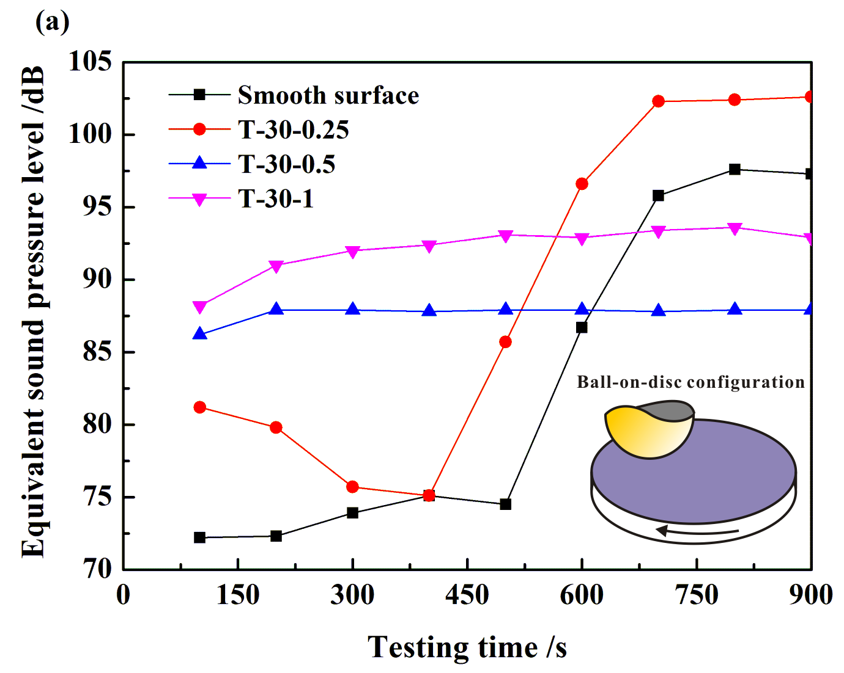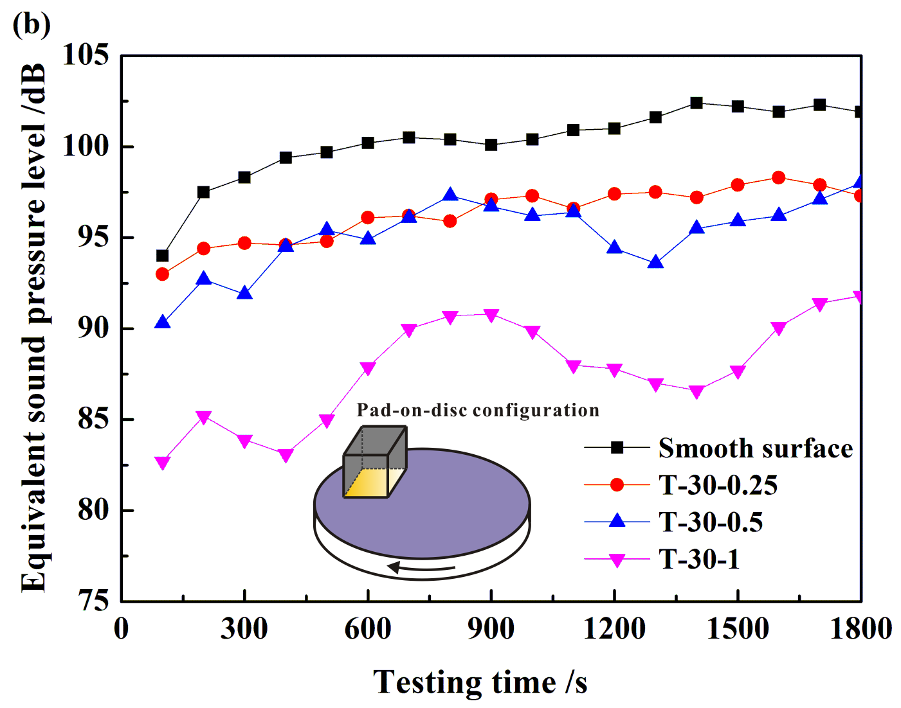
Fig. 3. Equivalent sound pressure level for the ball-on-disc (a) and pad-on-disc (b) configurations.

The frequency spectrum analysis of the sound pressure signals in the steady period is performed for both contact configurations, to further investigate the influence of grooved discs on the frequency distribution. Fig. 4 shows the time-frequency spectrum of sound pressure of smooth surface and T-30-0.5 surface in the case of ball-on-disc configuration. The dominant frequencies of squeal generated from the smooth surface are composed of one fundamental frequency (3250 Hz) and its subharmonics (Fig. 4(a)), which highlights the significant effect of nonlinear friction contact. For the T-30-0.5 surface which shows the best potential in reducing squeal propensity, similar frequency distribution can be observed in Fig. 4(b), but the dominant frequencies have much lower energy levels compared with the smooth surface.

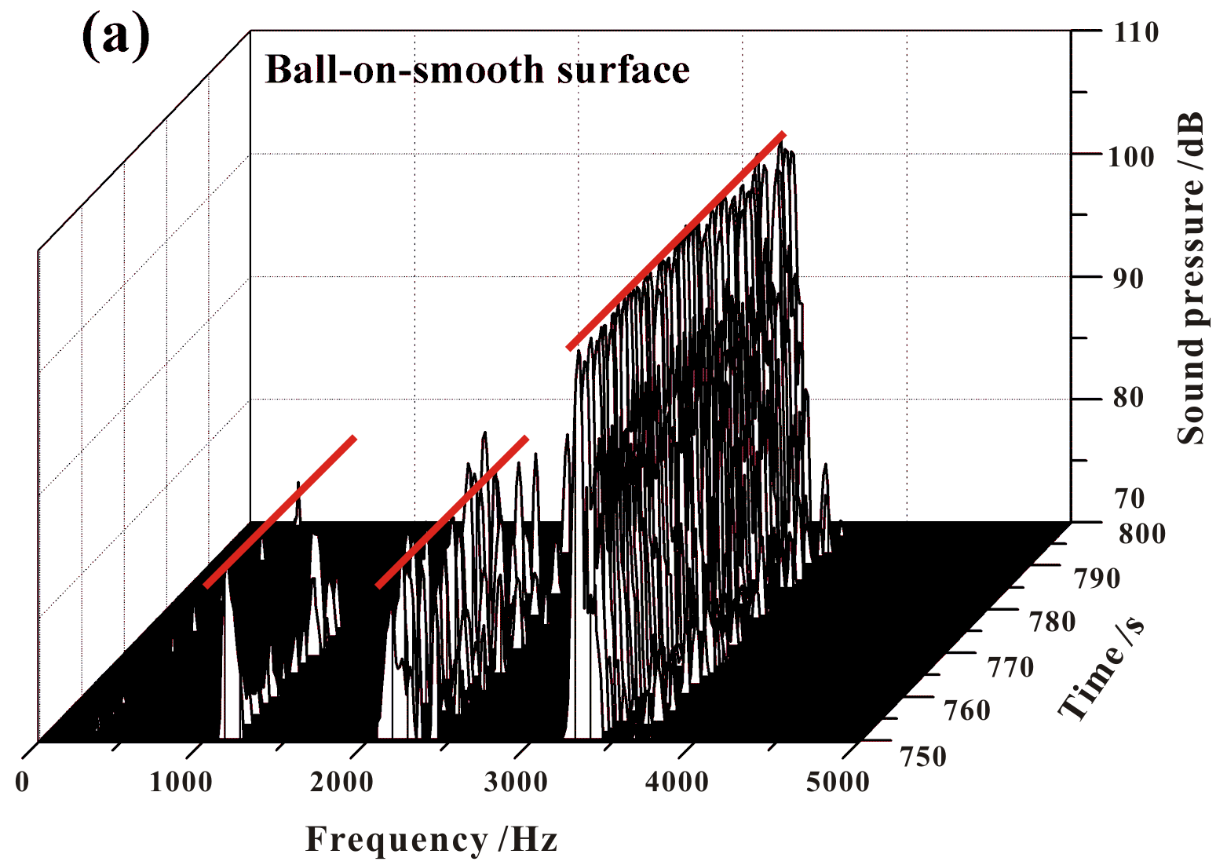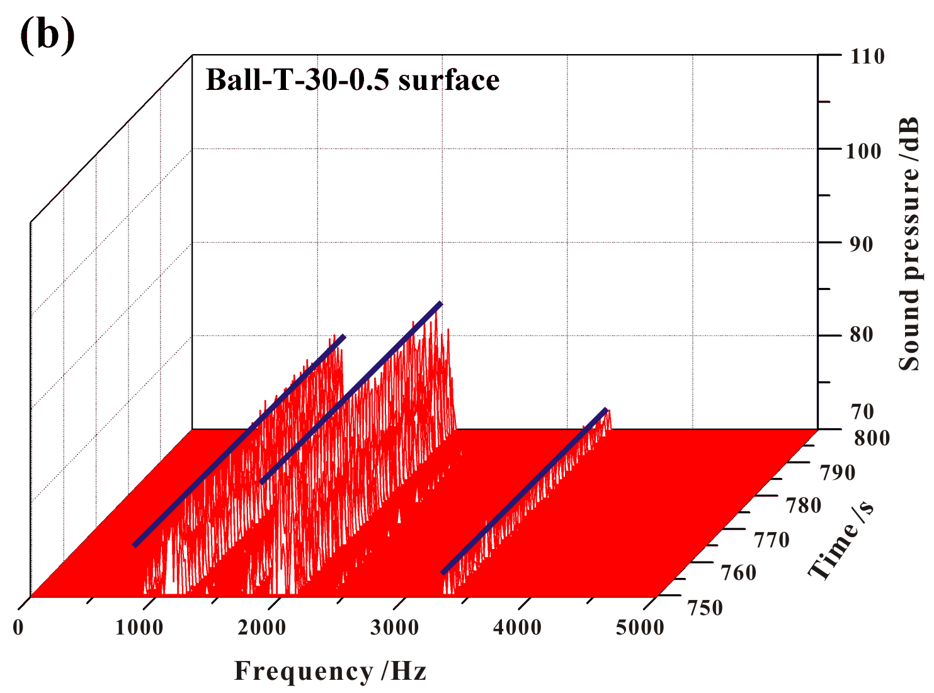
Fig. 4. Time-frequency spectrum of sound pressure of smooth (a) and T-30-0.5 (b) surfaces in the ball-on-disc configuration.

Accordingly, considering that T-30-1 surface shows the best performance in reducing squeal in the case of pad-on-disc configuration, the spectrum analysis of sound pressure of both the smooth surface and T-30-1 surface in pad-on-disc configuration are shown in Fig. 5. Compared with the smooth surface, a similar frequency distribution with lower energy contained can be observed for the T-30-1 surface. Moreover, no frequency is detected in the frequency range above 4 KHz, which indicates a relative lower SPL emitted from the T-30-1 surface. Therefore, for both ball-on-disc and pad-on-disc configurations, disc with a certain groove-textured surface can decrease the energy levels of the excited frequencies, which helps suppress the appearance of some high-frequency components of squeal, and consequently stabilize the friction system.

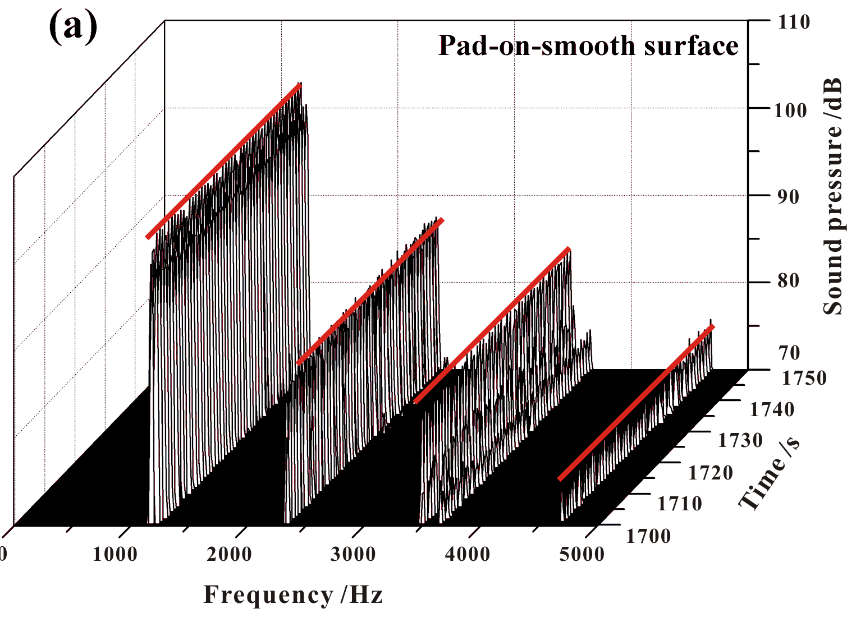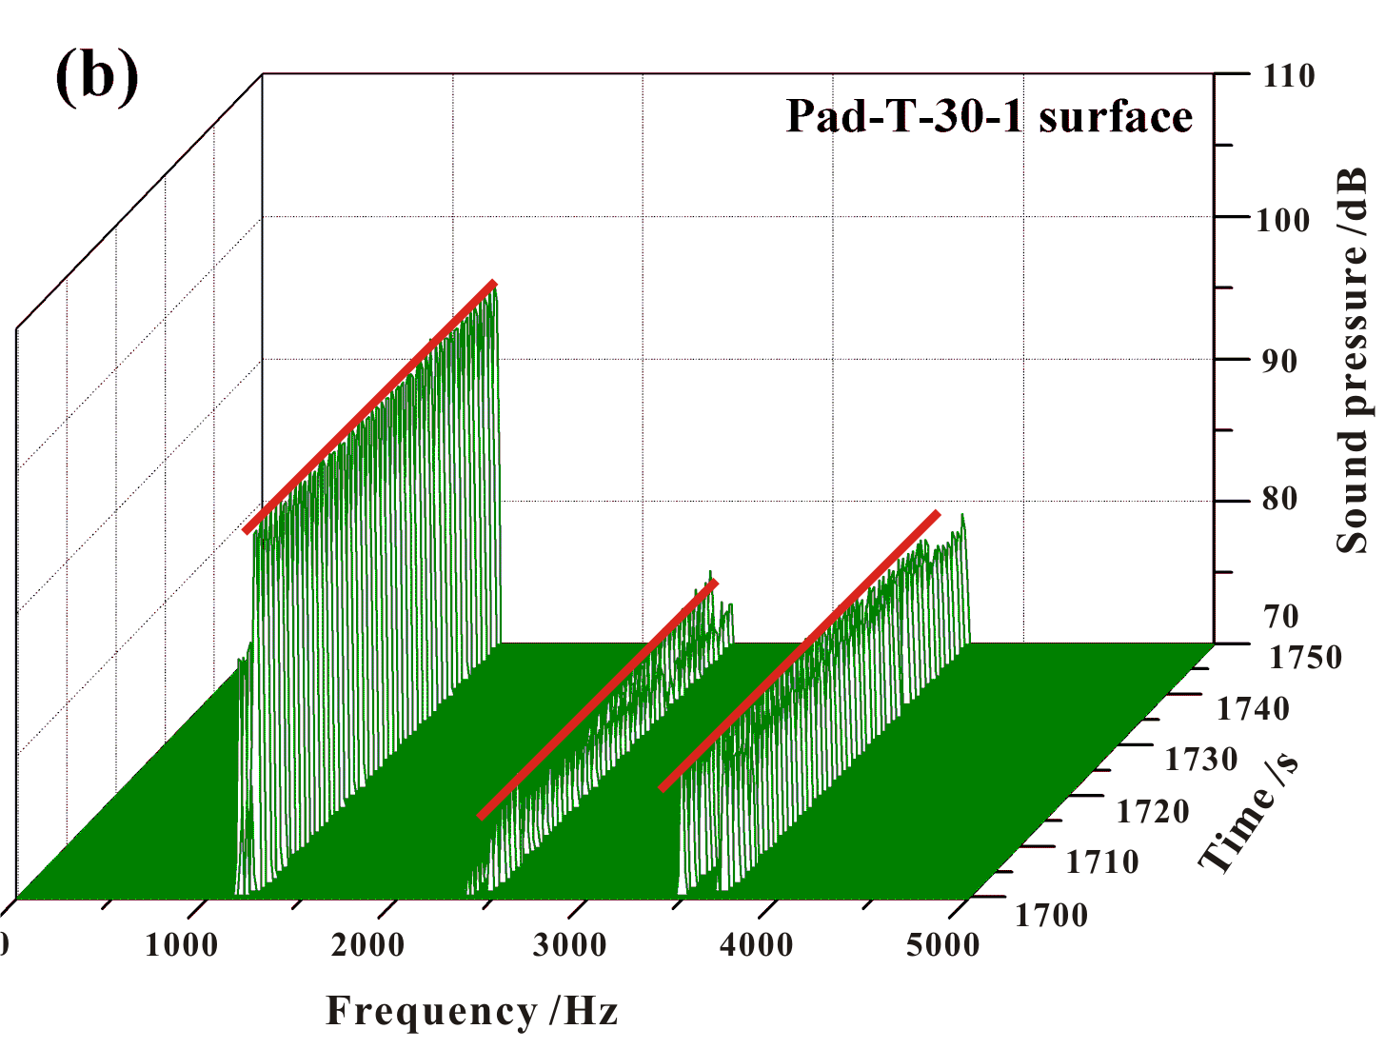
Fig. 5. Time-frequency spectrum of sound pressure of smooth (a) and T-30-1 (b) surfaces in the pad-on-disc configuration.

3.2 Analysis of interface vibration and noise characteristics
3.2.1 Ball-on-disc configuration
The evolution of friction force, vibration accelerations and noise signals from both the smooth and grooved surfaces are analysed. Fig. 6 shows the one-cycle time history records of friction force, tangential vibration acceleration and sound pressure signals for the ball-on-disc configuration in both the initial (Fig. 6(a-c)) and steady (Fig. 6(d-f)) periods. In the initial period, about 12 cycles of wave-like fluctuations can be observed in the friction force curves for both the T-30-0.25 and T-30-0.5 surfaces, which is consistent with the number of grooves in the sliding travel. While no wave-like fluctuations is found from the curve of friction force of the smooth surface. This may be attributed to the fact that the existence of grooves on the contact interface changes the contact states between ball and disc samples. In addition, about 12 cycles of wave-like oscillations can be observed in both the vibration acceleration and sound pressure curves. Therefore, it can be speculated that there exists collision behaviour between the ball and the edge of the groove, which results in the abrupt change of the vibration accelerations and intermittent periodic vibrations.
In the steady period, higher intensity sound pressure is detected from both the smooth and T-30-0.25 surfaces, correspondingly, significant continuous high-frequency oscillations are observed from the vibration acceleration signals. In contrast, nearly no high-frequency oscillations can be detected from the vibration acceleration signals of the T-30-0.5 surface with low sound pressure level. About 12 cycles of wave-like oscillations can still be found from the friction force curve of this grooved disc surface. Accordingly, the wave-like oscillations appear in the friction force signals is thought to play a crucial role in exciting and suppressing the generation of continuous high-frequency fluctuations of vibration accelerations, and consequently the generation of squeal.

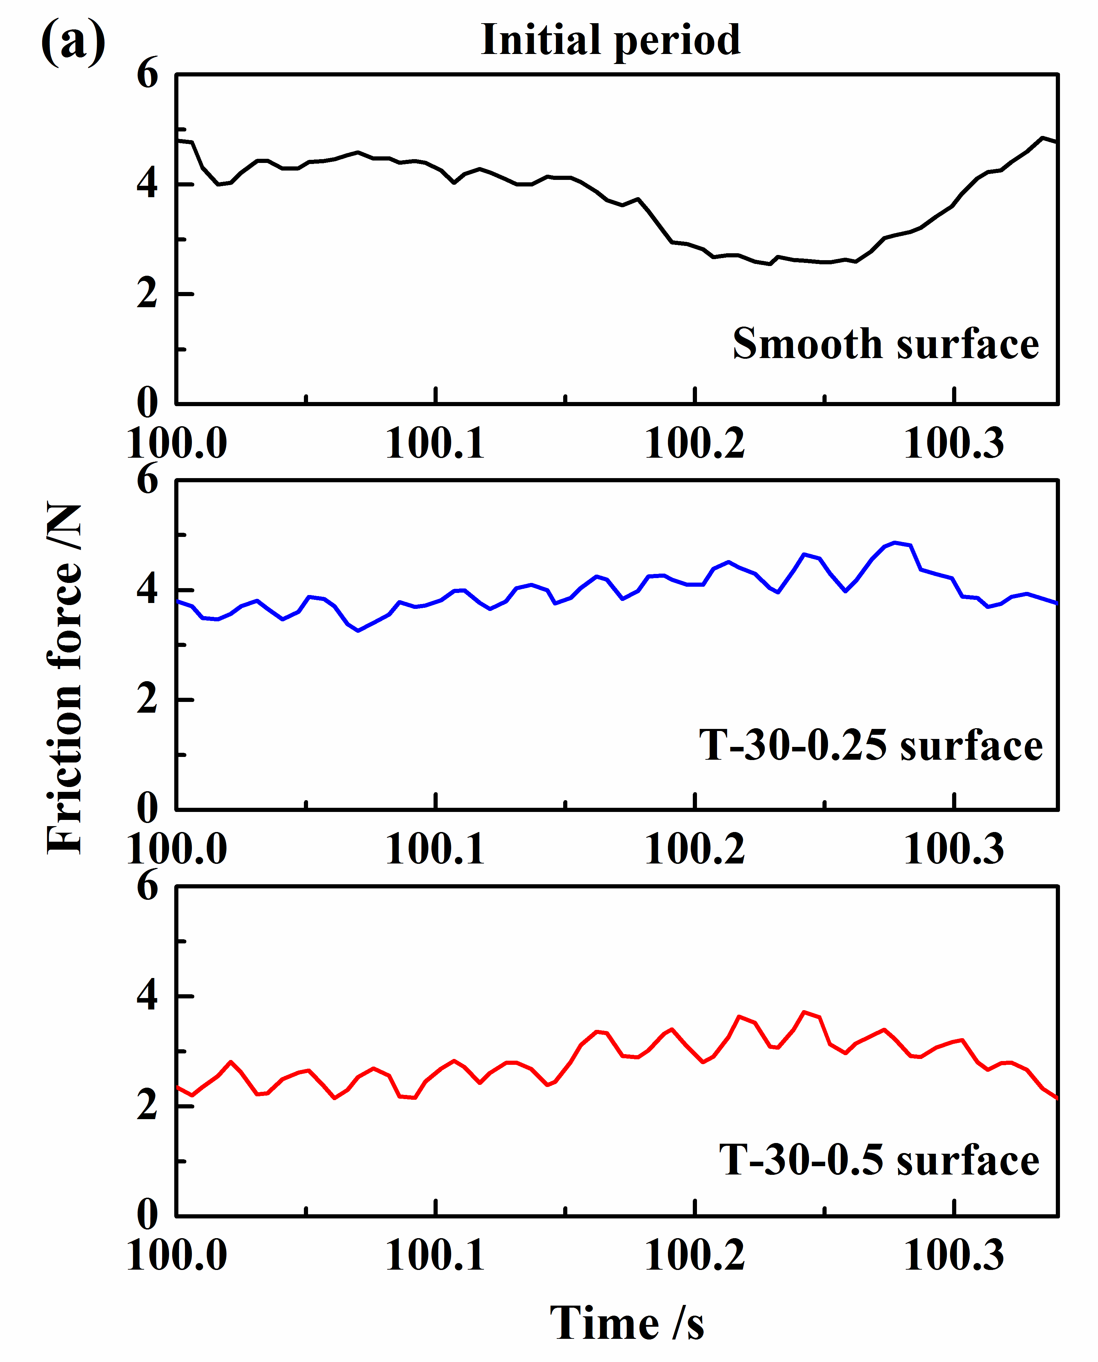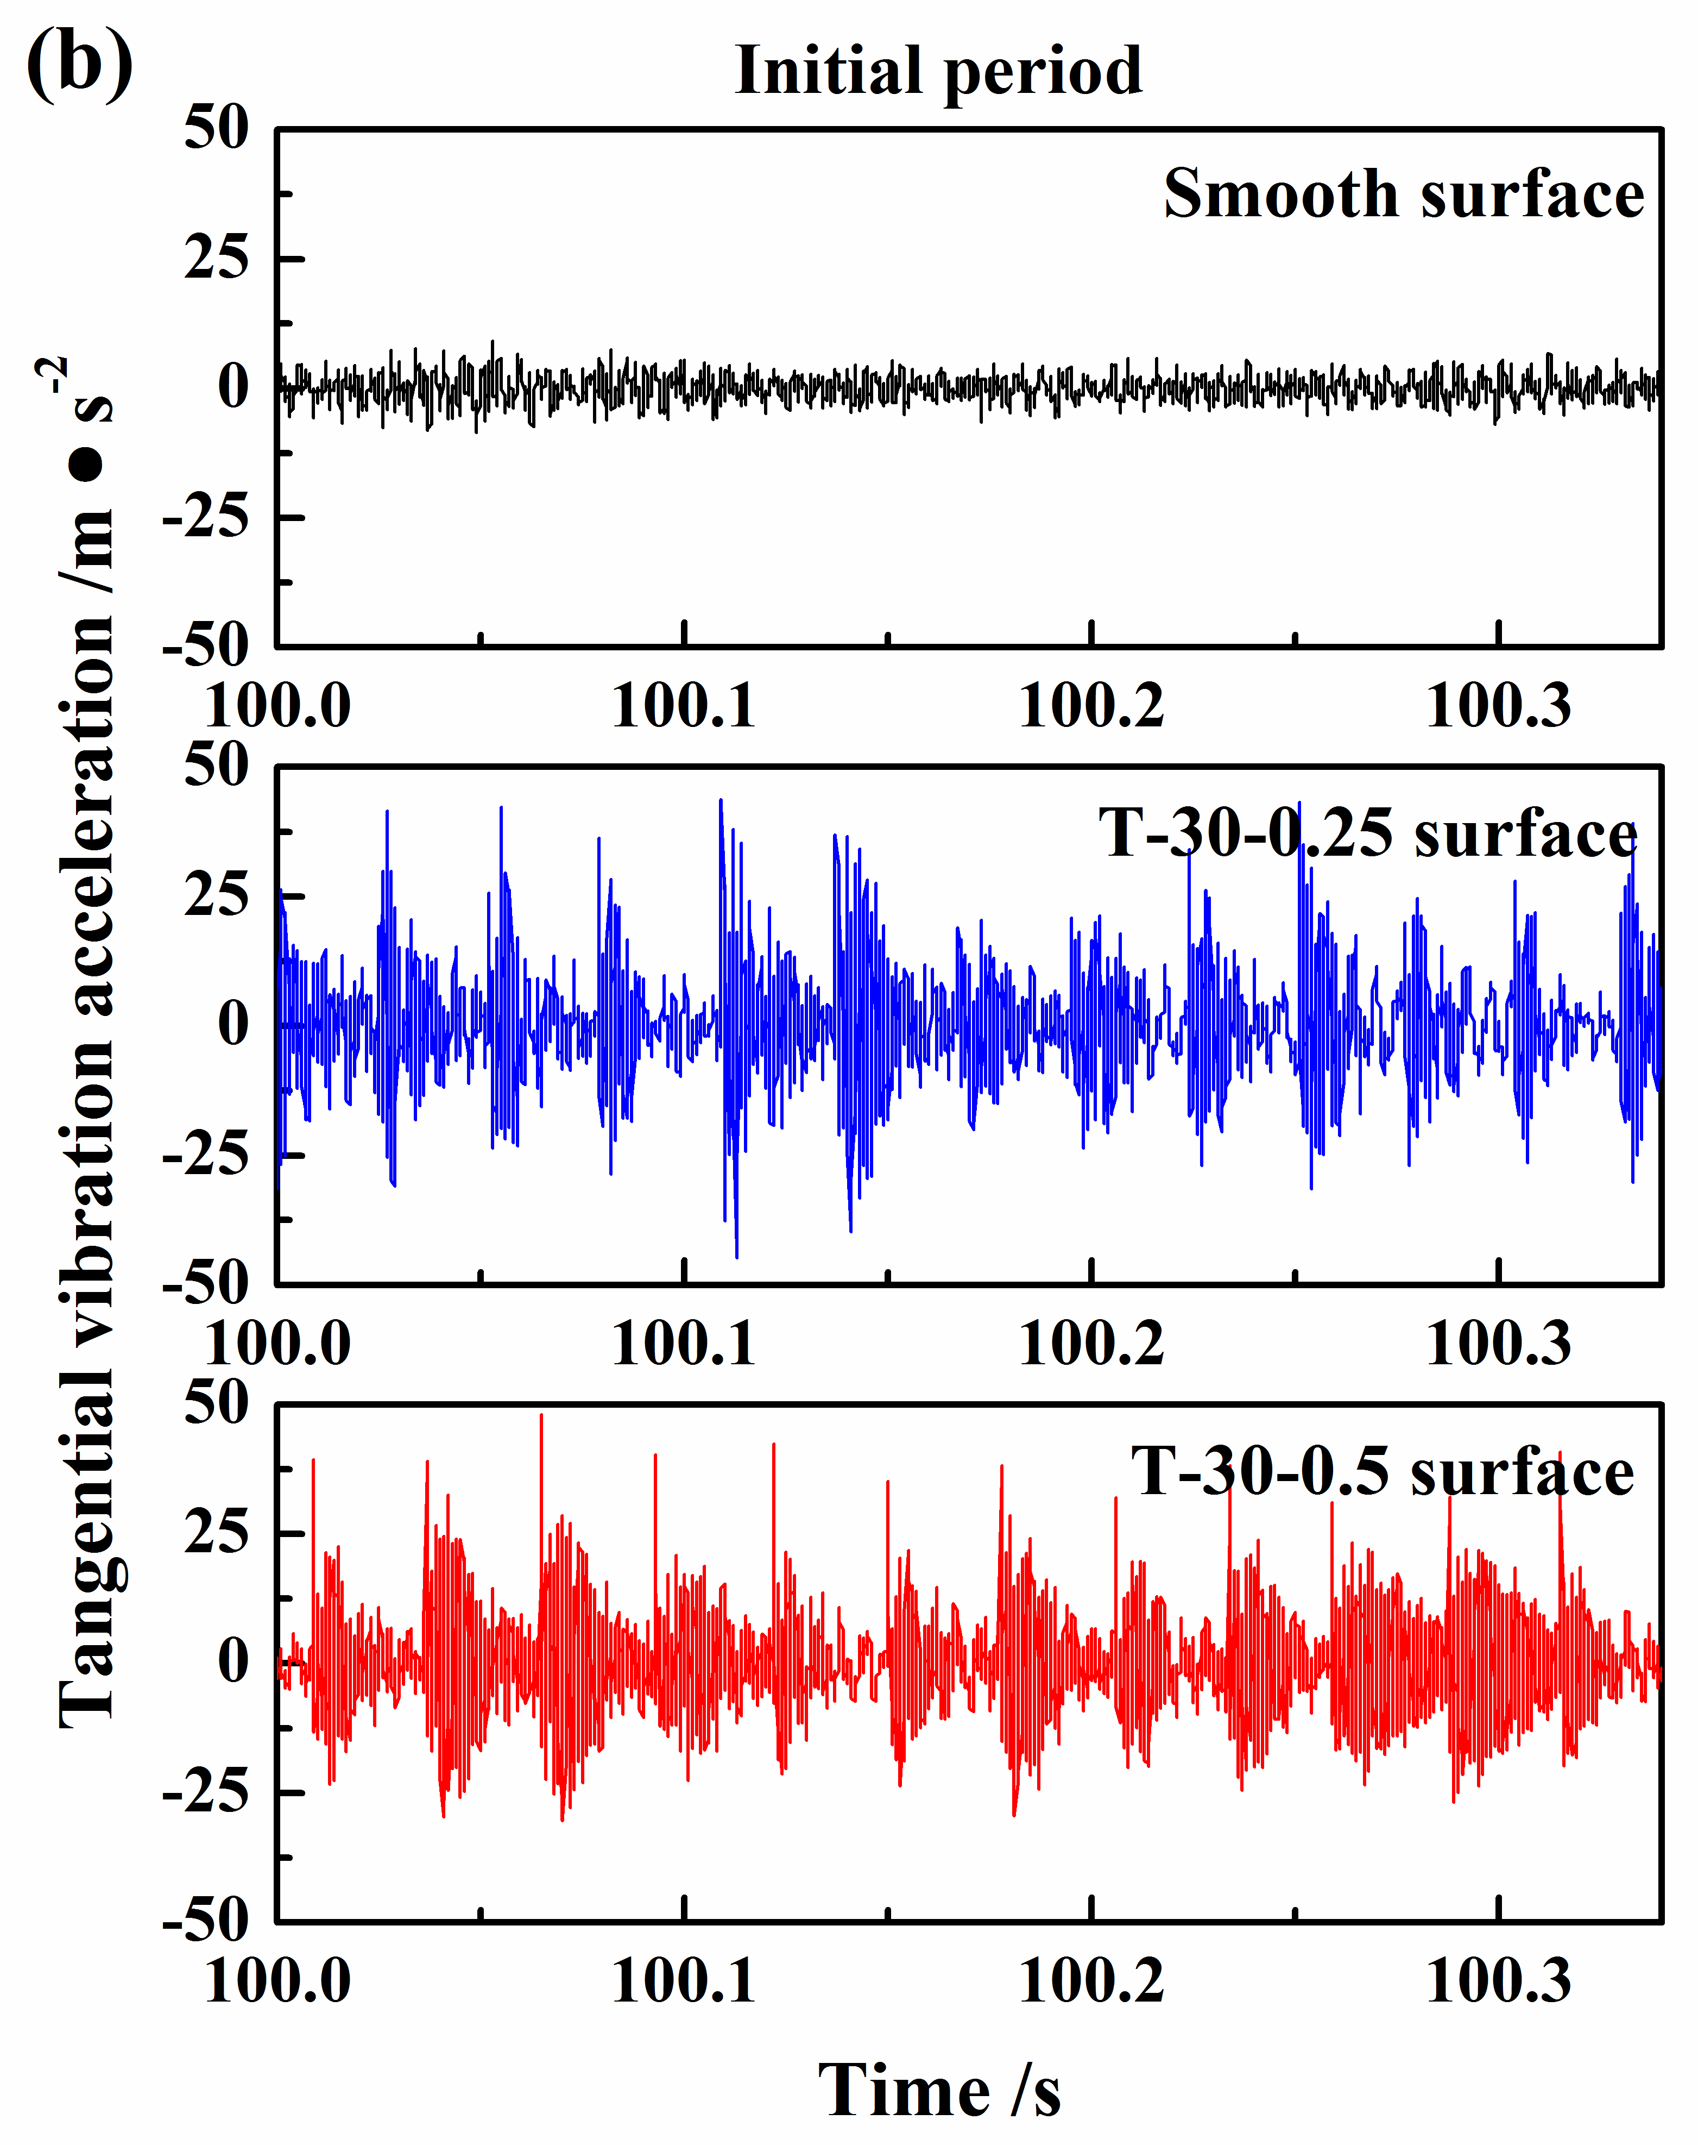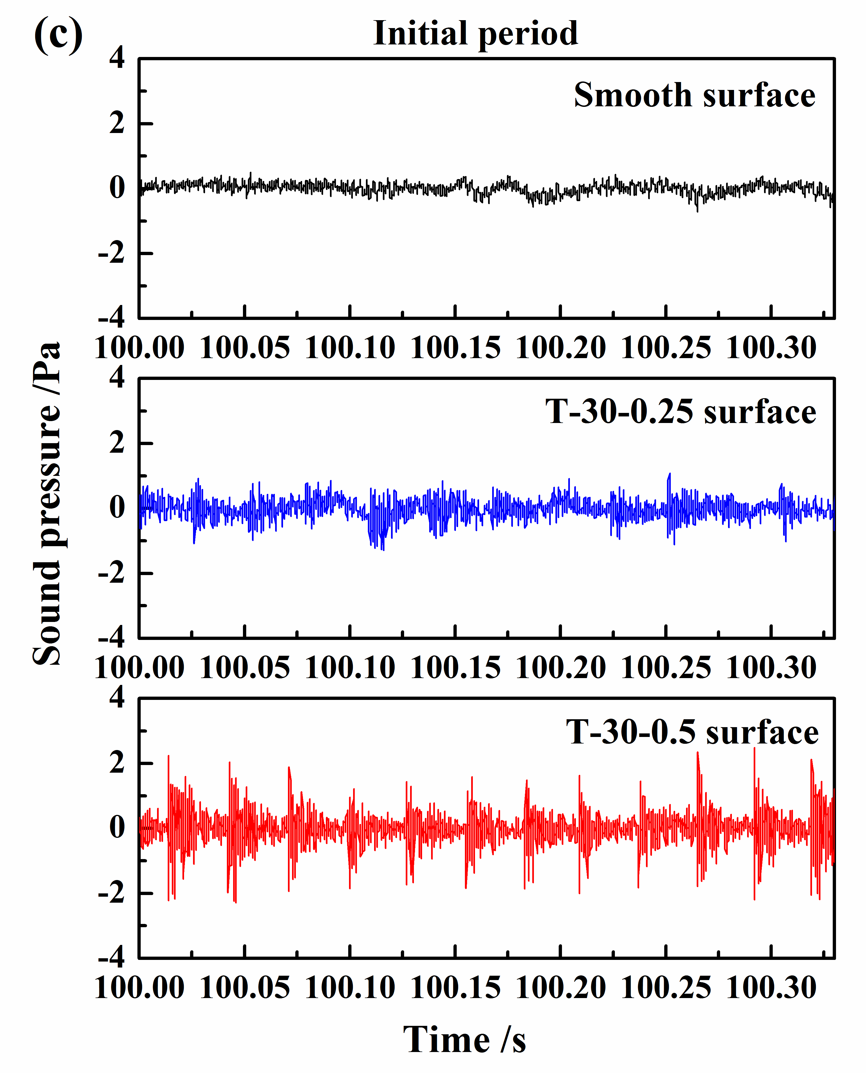
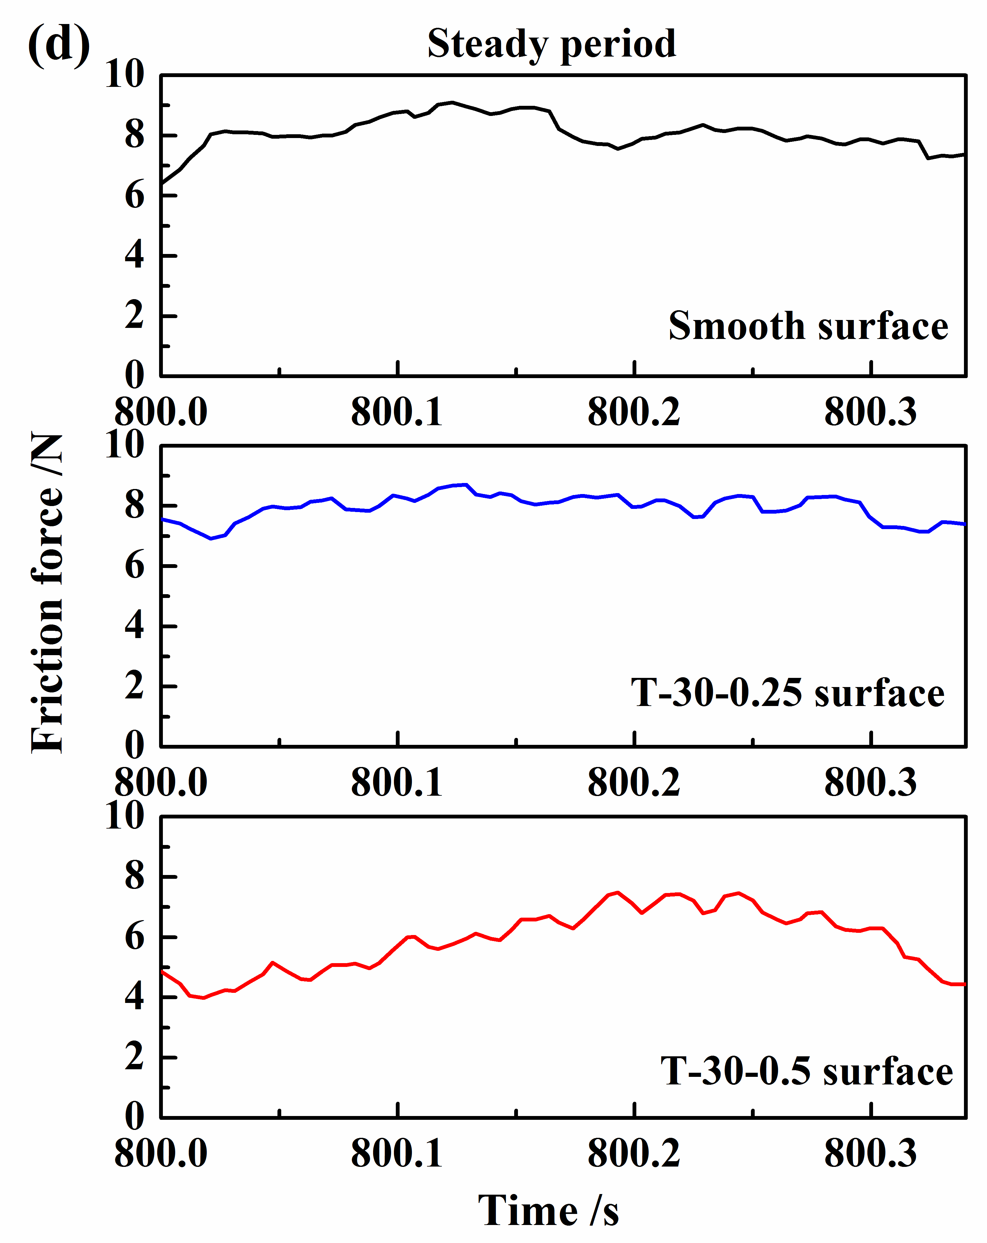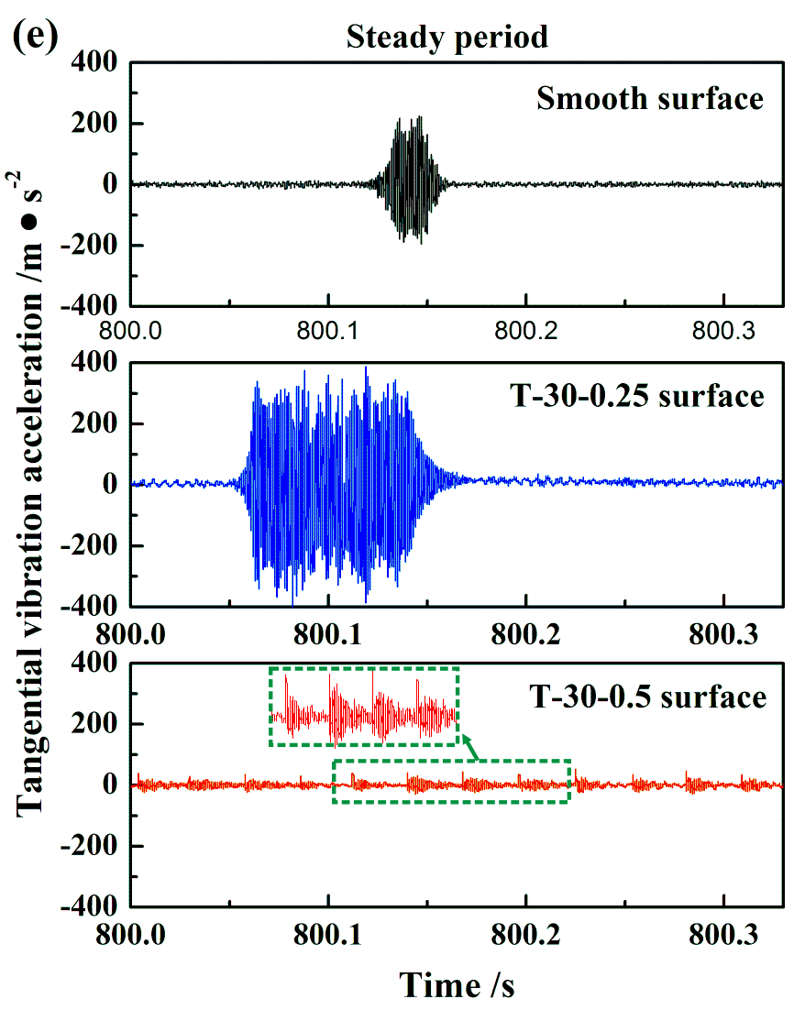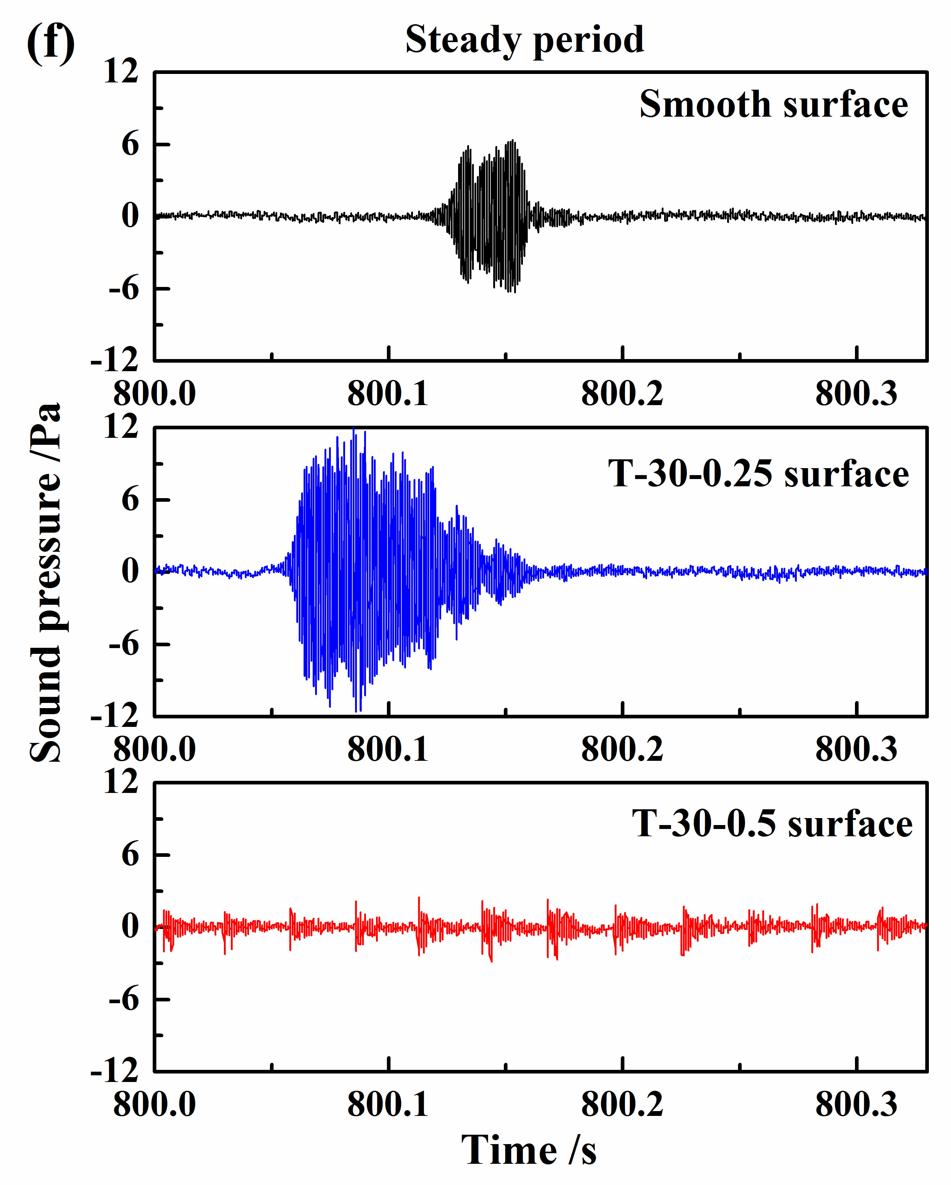
Fig. 6. The curves of friction force, tangential vibration acceleration and sound pressure in the initial (a-c) and steady (d-f) periods for the ball-on-disc configuration.

3.2.2 Pad-on-disc configuration
Considering that the sound pressure generated from all the disc samples stays at a relatively stable state throughout the whole test in the pad-on-disc configuration, the time history records of vibration and noise signals generated from the smooth and T-30-1 surfaces in the steady stage are selected and presented in Fig. 7. The T-30-1 surface shows a relatively smaller friction force and significantly different friction force curve tendency, in which some wave patterns can be detected (Fig. 7(a)). This phenomenon may be caused by the variation of contact states during the period of pad sling across the grooves. In addition, the tangential vibration acceleration signals for both smooth and T-30-1 surfaces display sustained high-frequency fluctuations, and the T-30-1 surface shows a relatively lower vibration amplitude, which corresponds to the lower sound level (Fig. 7(b-c)). The grooved disc surface is found to significantly suppress the amplitude of high-frequency oscillation and reduce the sound level in the pad-on-disc configuration.

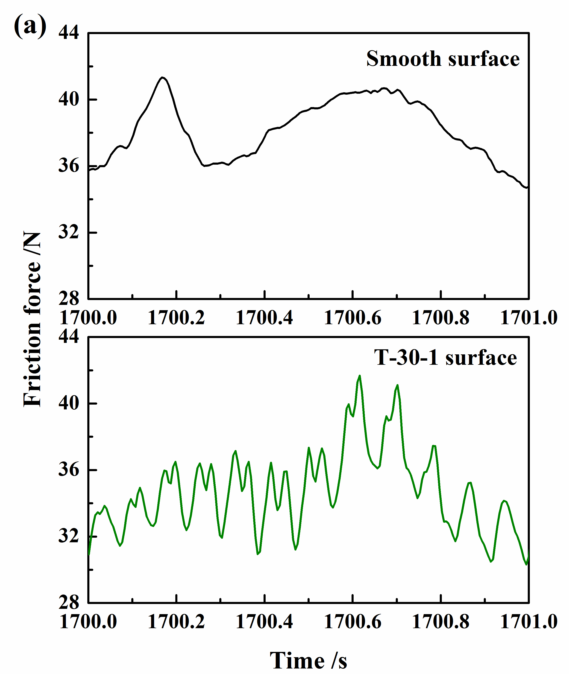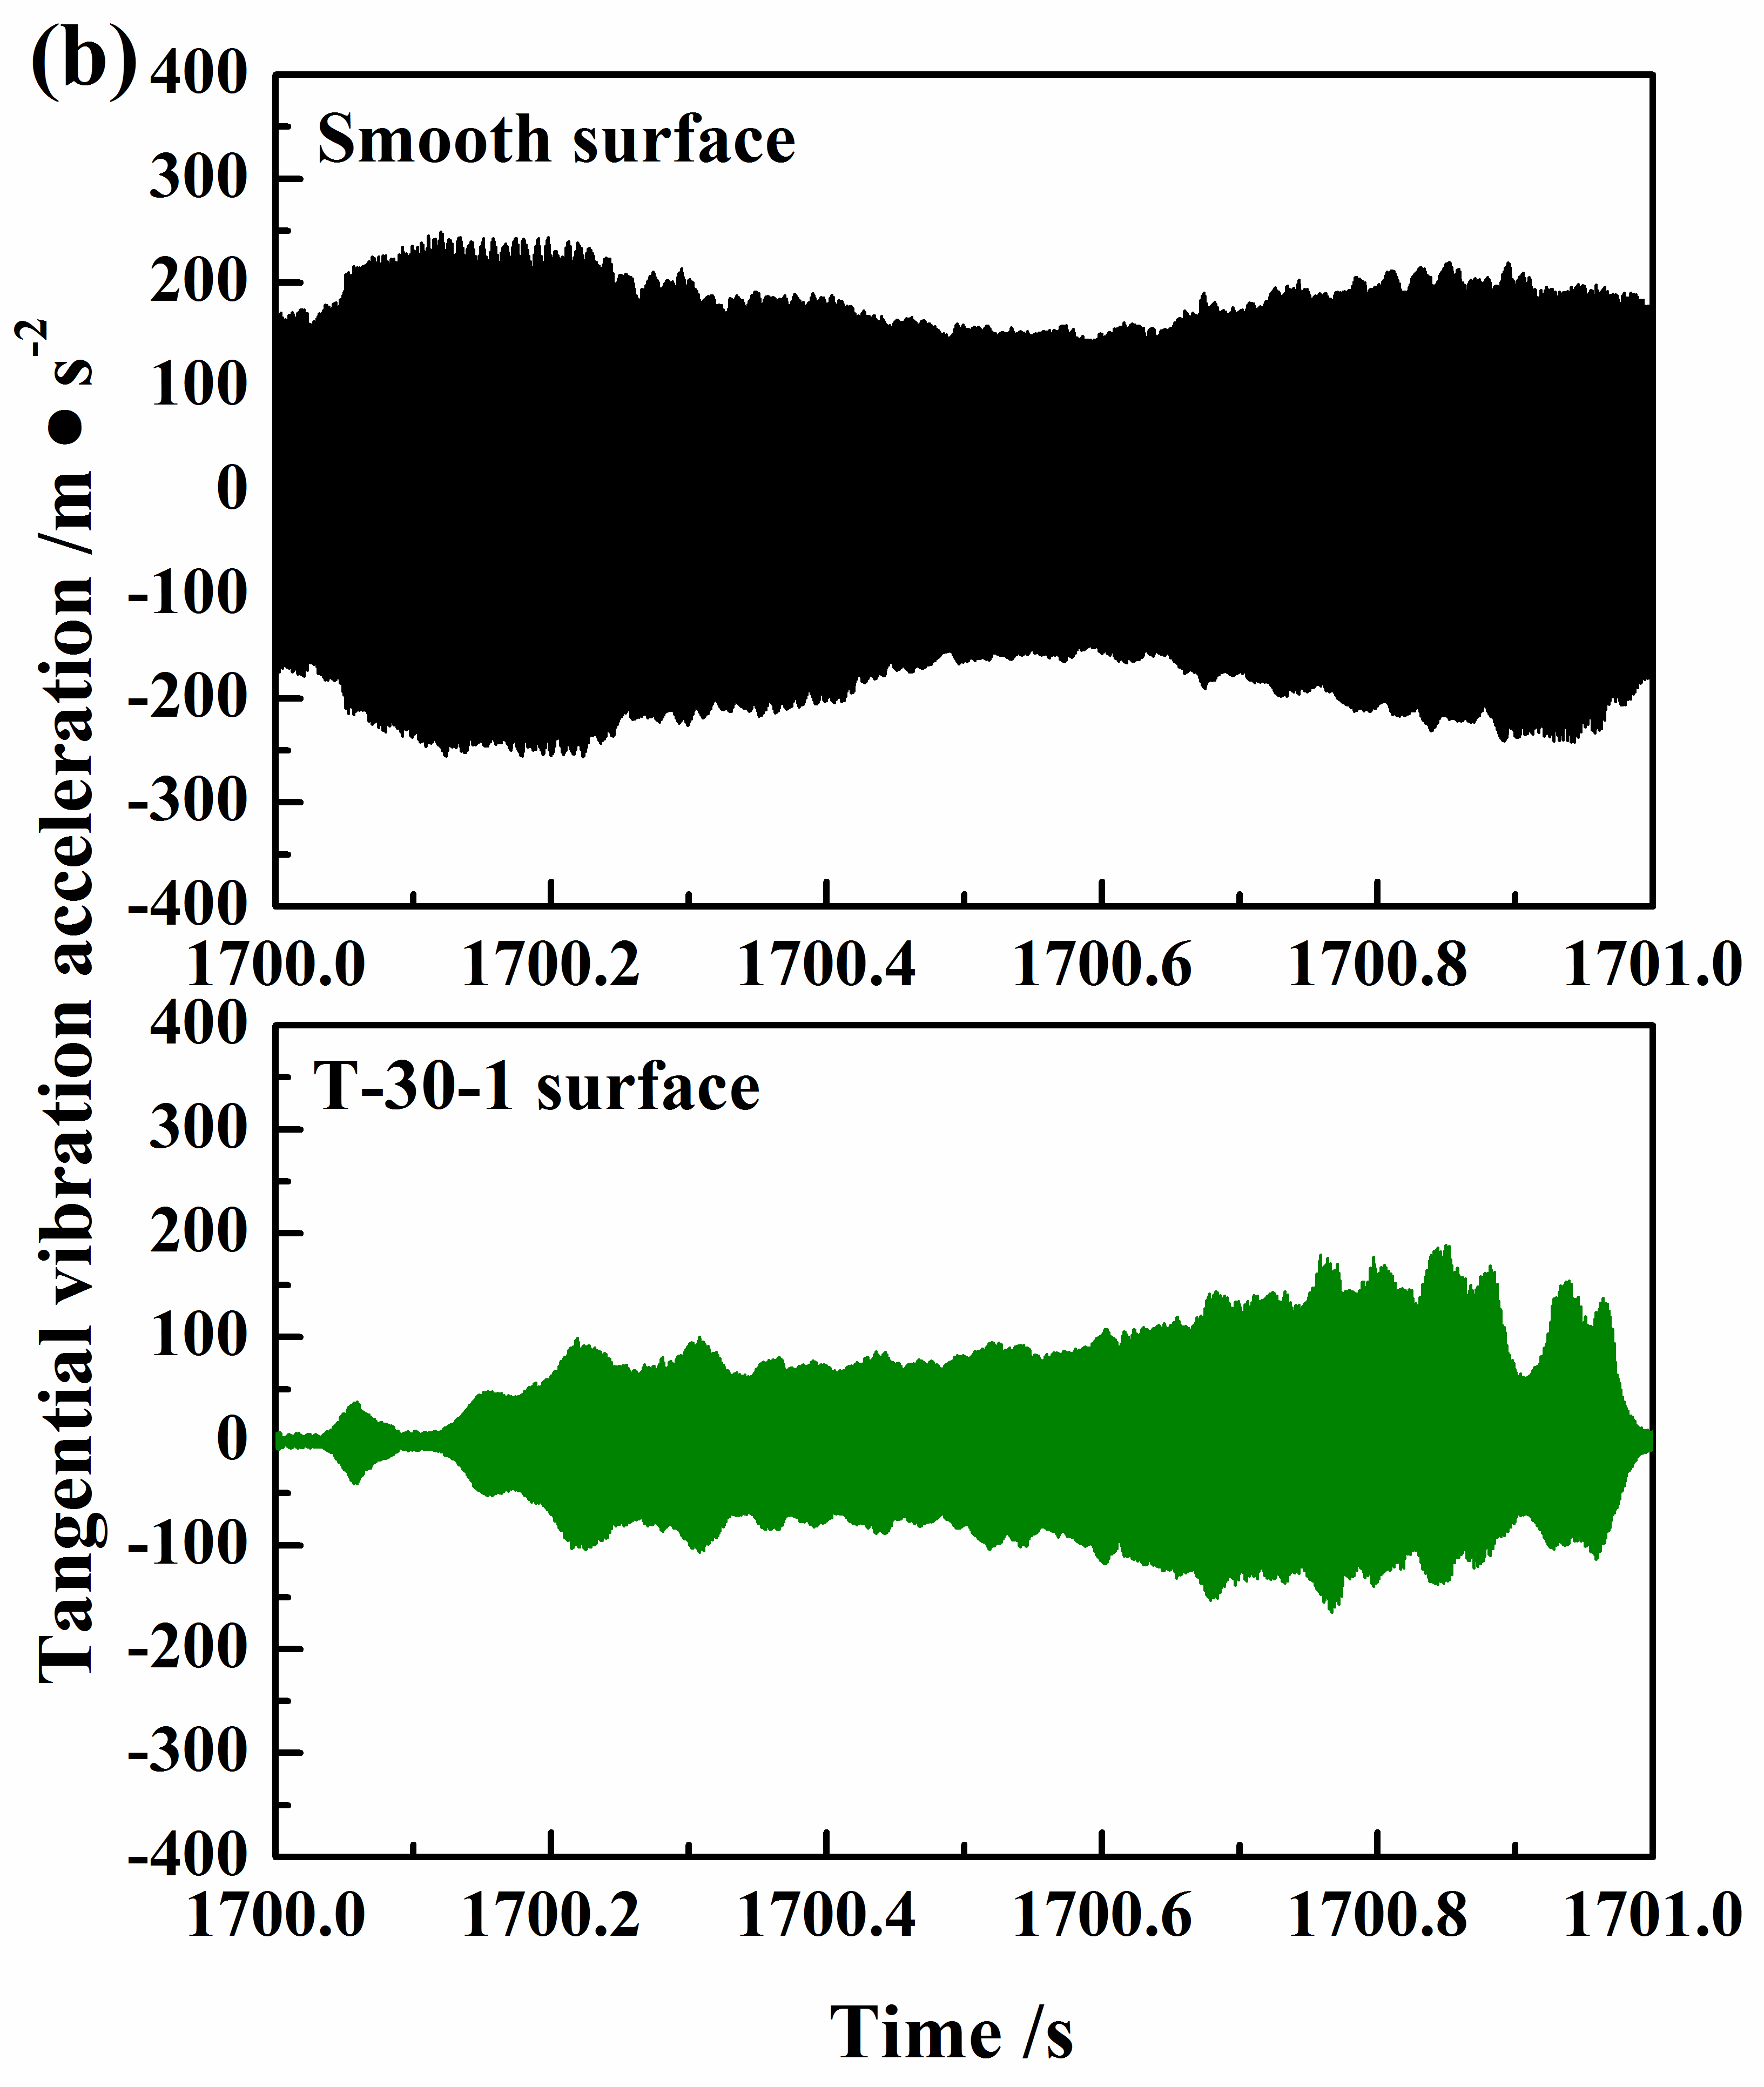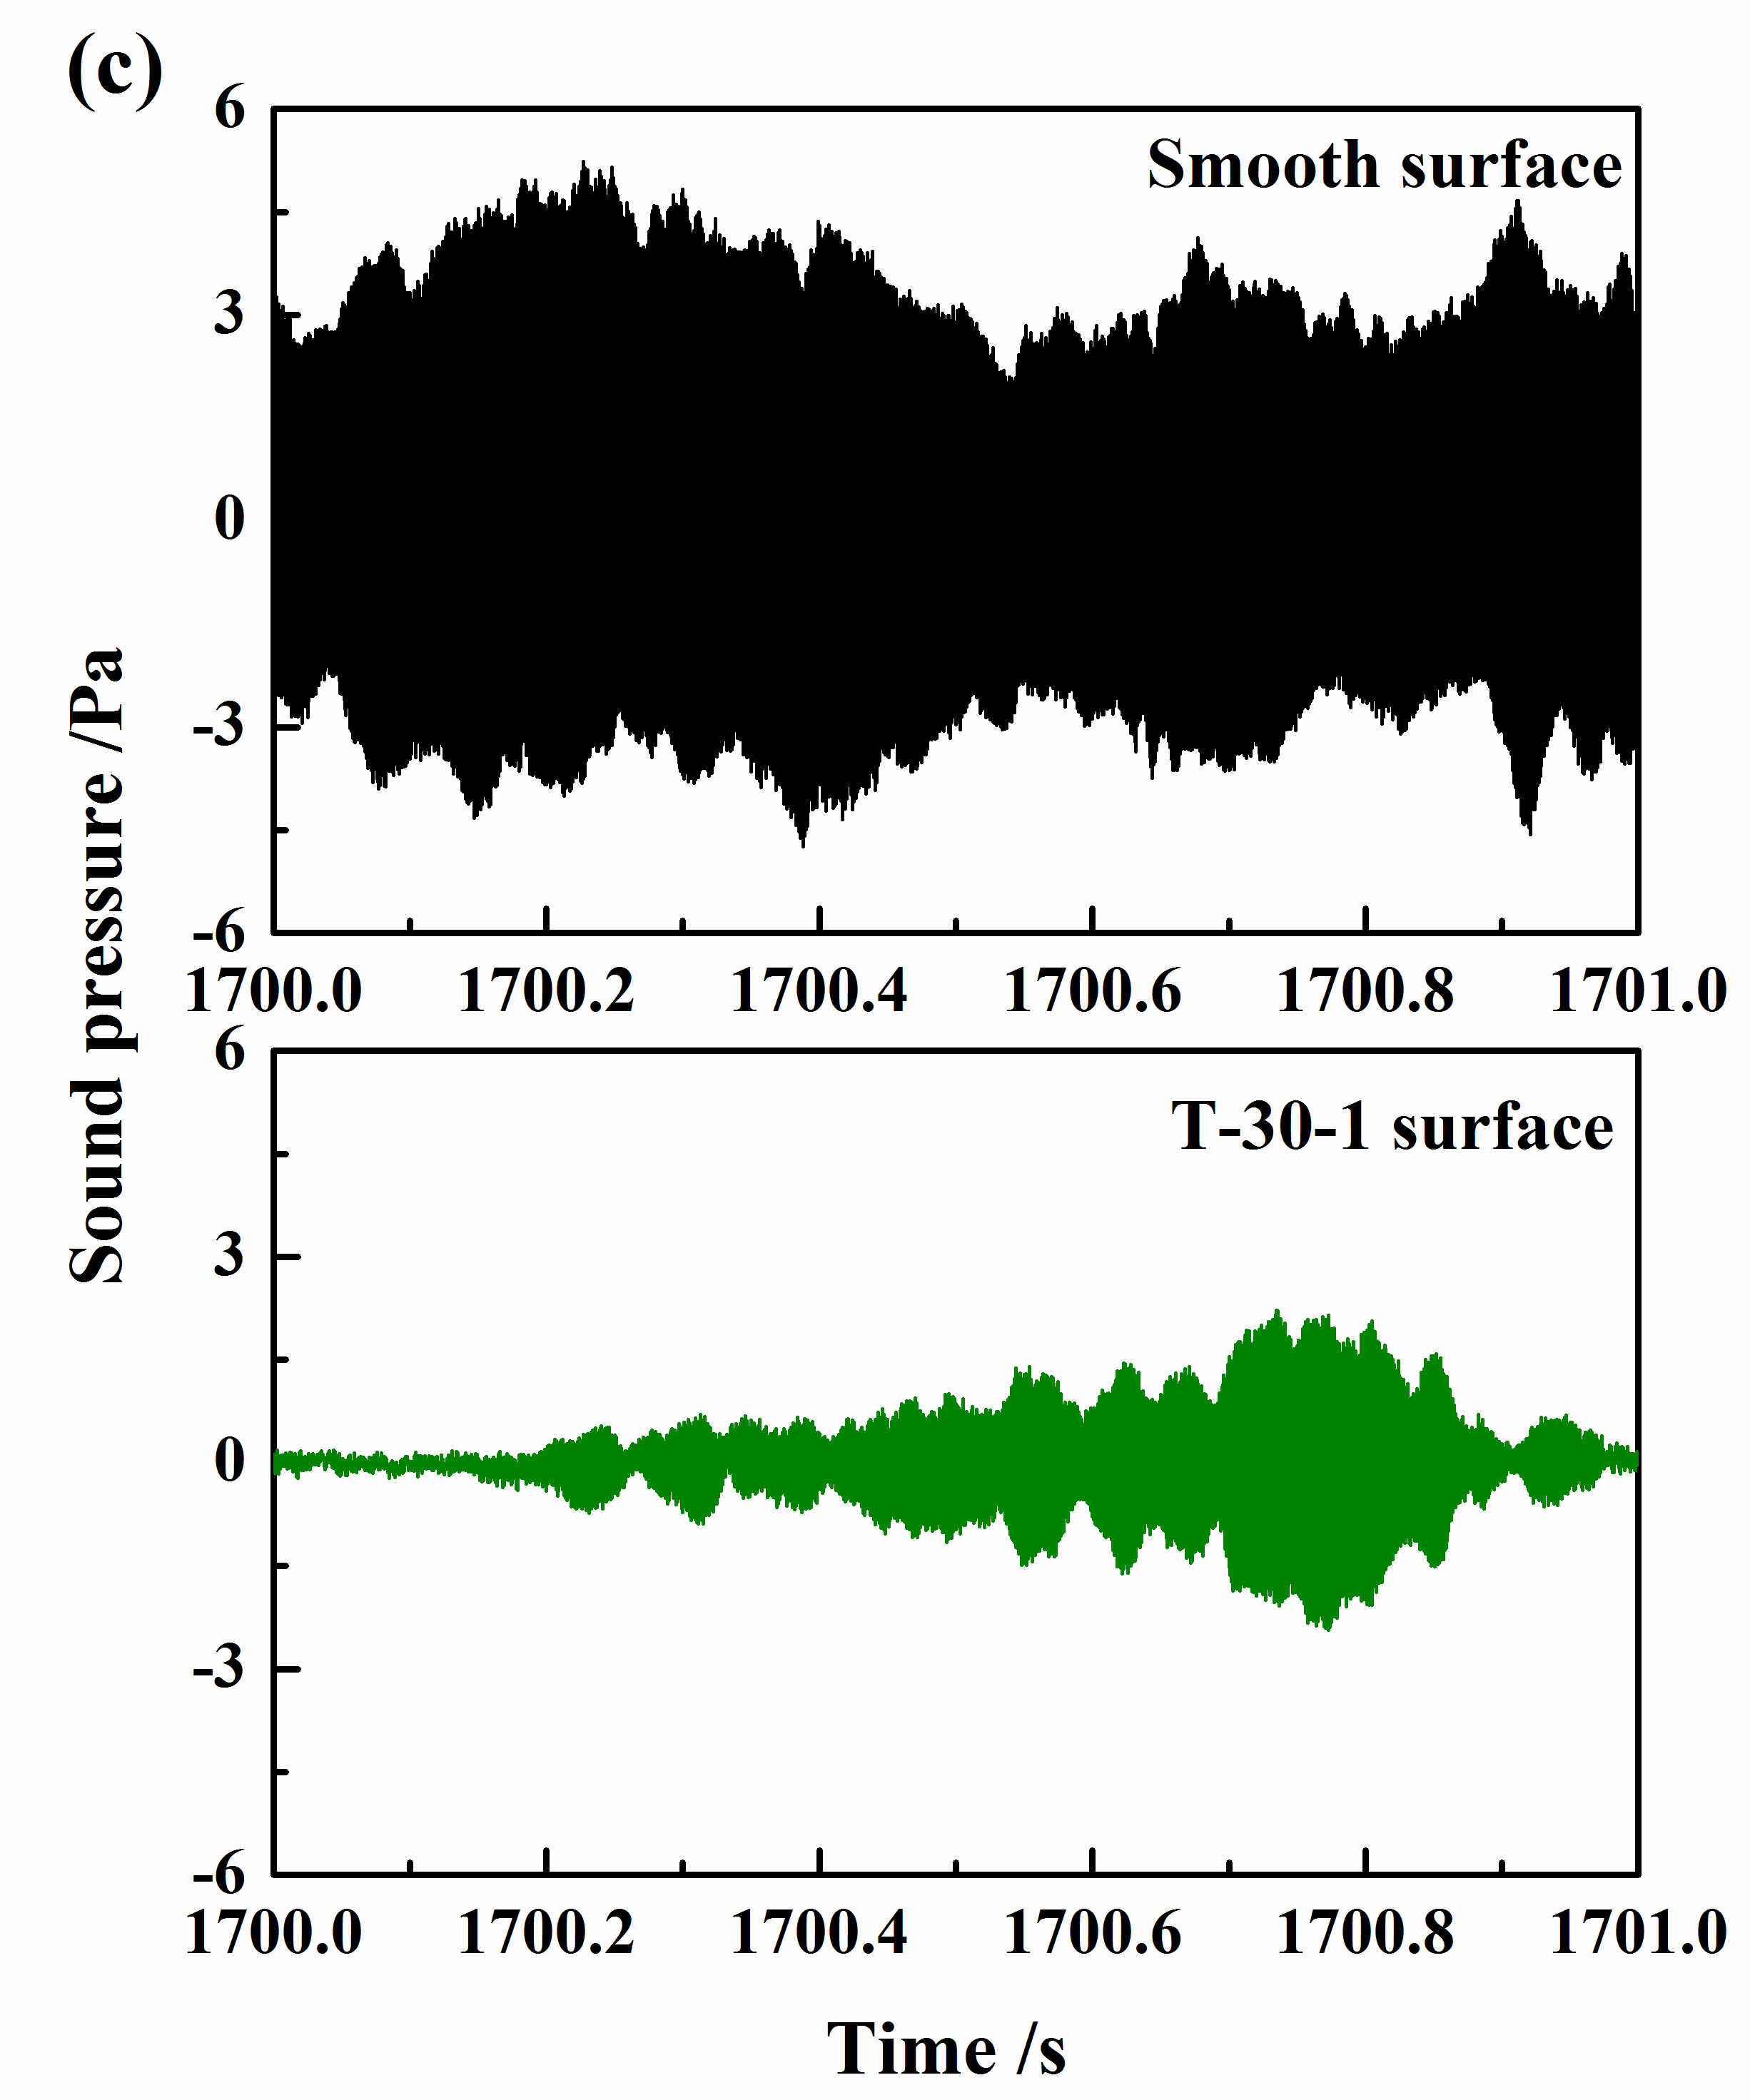
Fig. 7. The curves of friction force (a), tangential vibration acceleration (b) and sound pressure (c) in the steady period for the pad-on-disc configuration.

Although the grooved discs in both contact configurations can significantly affect the noise performance, the recorded dynamic signals are totally different between the ball-on-disc and pad-on-disc configurations. Compared with the case of ball-on-disc configuration, no visible sudden increase in the vibration acceleration curves can be observed for the pad-on-disc configuration, although certain cycles of wave-like oscillations can be found in the friction force curves for both the configurations. Therefore, it can be deduced that grooves play different roles in reducing squeal instability in these two configurations, and the hidden mechanism of the grooves in affecting the squeal noise in both the configuration will be further analysed in the following sections.

3.3 Wear analysis
To further illustrate the different dynamical behaviour of the grooved surface between the ball-on-disc and pad-on-disc configurations, worn surface morphologies are observed. Fig. 8 shows the worn surface morphologies of the smooth, T-30-0.25 and T-30-0.5 surfaces in the ball-on-disc configuration. Wear morphologies of the smooth surface are complicated, and a noticeable amount of ploughing and material exfoliation can be found in the wear track. This indicates that the smooth surface undergoes severe wear, which promotes the occurrence of growing vibration and the emission of squeal. The worn surfaces of the T-30-0.25 and T-30-0.5 surfaces exhibit relatively slight wear compared to the smooth surface, with no severe ploughing and material exfoliation being found in the wear track. This may be attributed to the fact that grooves are able to trap wear debris and change the wear status. However, it is worth noting that the groove edges of T-30-0.25 surface are destroyed after repeated collision from the ball, with high intense squeal being emitted from this surface. The groove edges of the T-30-0.5 surface are still well preserved despite wear, with squeal being well suppressed from this surface. Considering the fact that both the groove edges of T-30-0.25 and T-30-0.5 surfaces exhibit no visible wear damage in the initial stage, which is responsible for the generation of 12 cycles of wave-like oscillations in the friction force and vibration acceleration curves, it can be speculated that the collision between the ball and groove edges disturbs the self-excited vibration and consequently reduces the tendency of squeal generation.

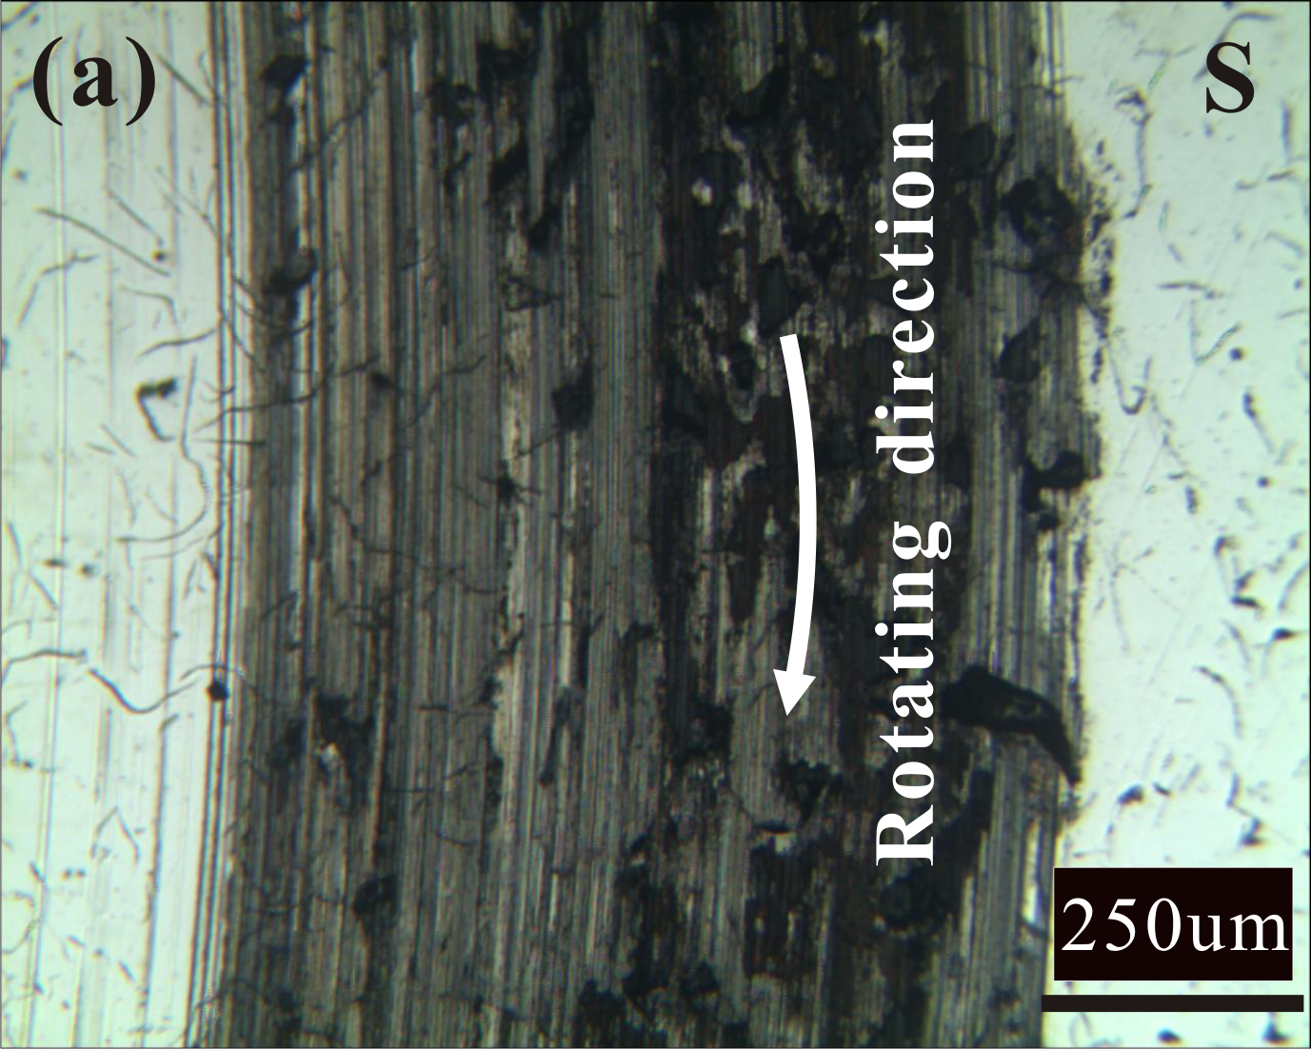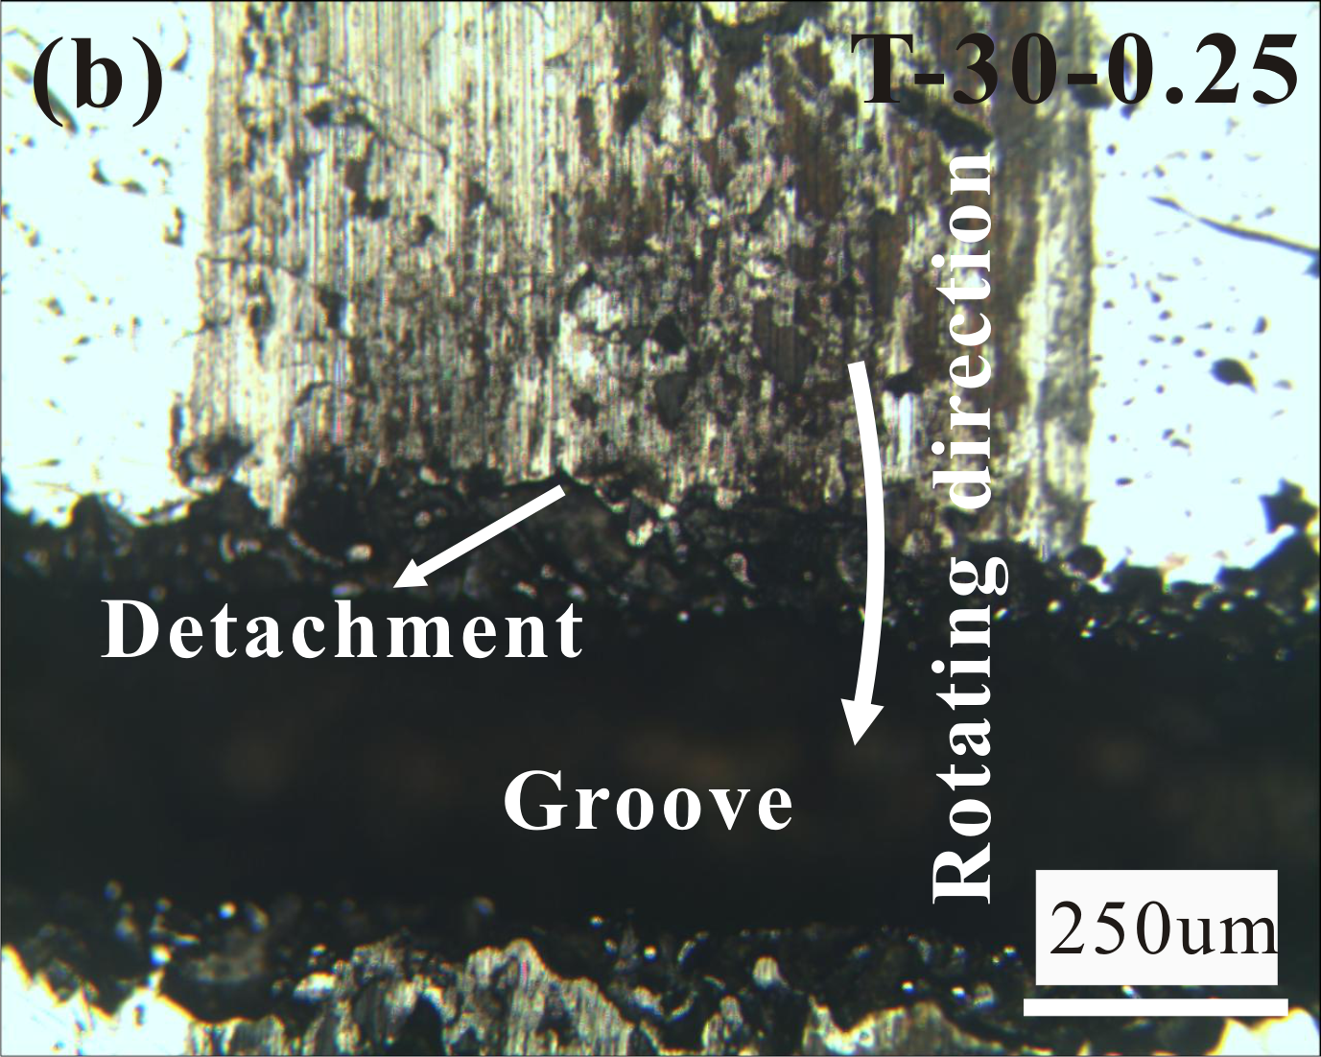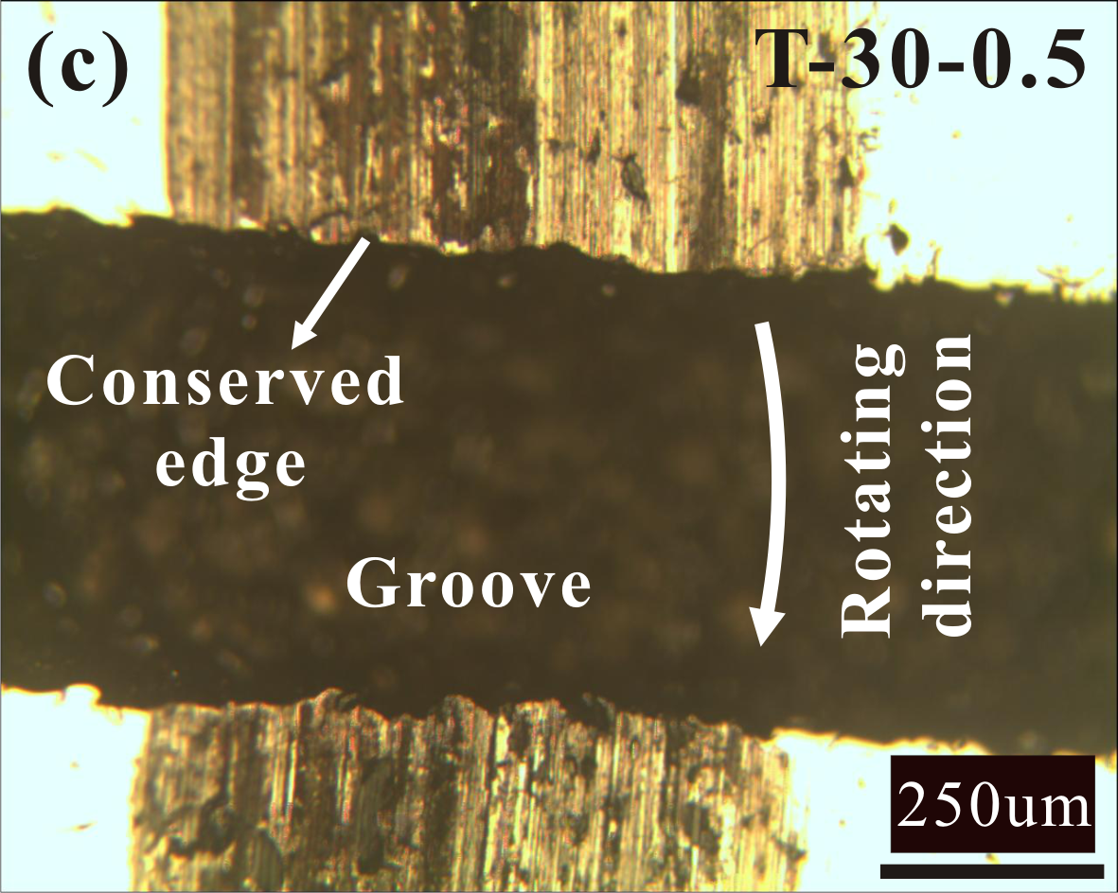
Fig. 8. Optical images of the smooth surface (a), T-30-0.25 surface (b) and T-30-0.5 (c) after the test in the ball-on-disc configuration.

For the pad-on-disc configuration, the worn surface morphologies of the smooth and T-30-1 surfaces are shown in Fig. 9. Both worn surfaces exhibit typical abrasive wear features. Moreover, the groove edges of the T-30-1 surface remain nearly unaffected. It is worthwhile to note that although both the T-30-0.5 surface in the ball-on-disc configuration the T-30-1 surface in the pad-on-disc configuration possess intact groove edge shape after the test and show good potential in reducing squeal, they exhibit very different dynamic behaviour during the friction process. The vibration acceleration signals show visible wave-like oscillations for the T-30-0.5 surface in the ball-on-disc configuration. In contrast, no sudden increase in oscillations can be found in the vibration acceleration curves for the T-30-1 surface in the pad-on-disc configuration. Therefore，it can be concluded that the grooves play different roles in reducing squeal noise in these two different contact configurations.

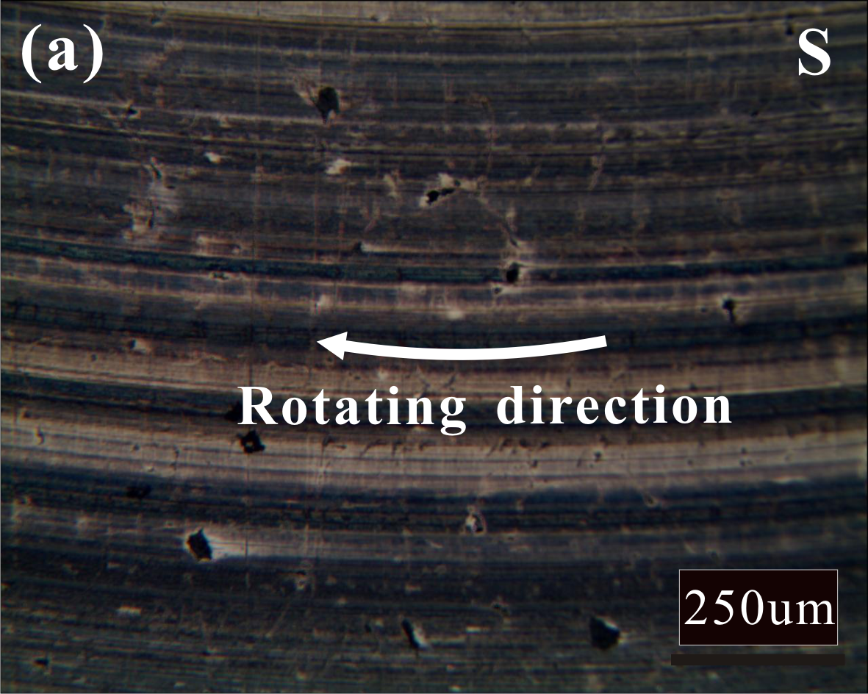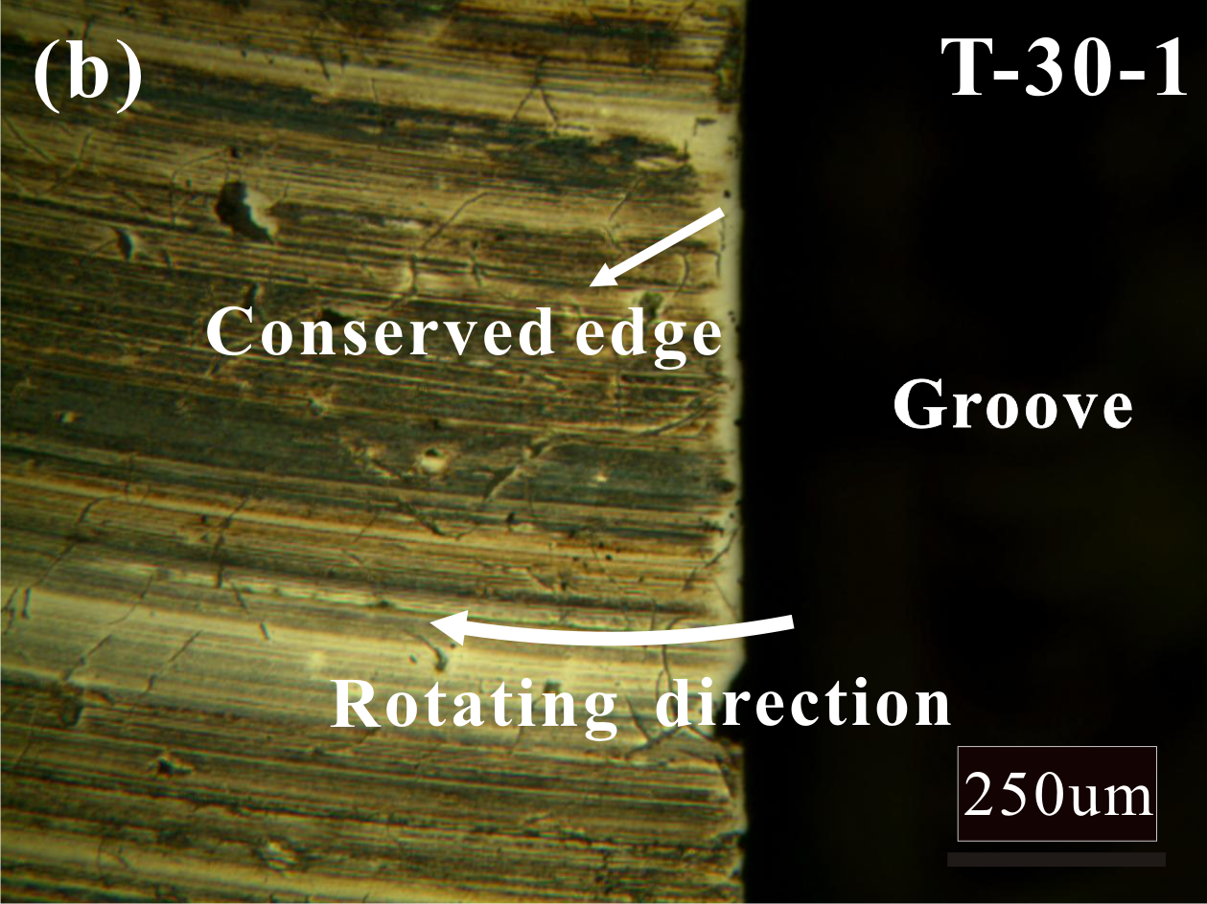
Fig. 9. Optical images of the smooth surface (a) and T-30-1 (b) after the test in the pad-on-disc configuration.

- Further validation of the effect of groove on tribological and vibration characteristics
To further shed light on the influence of grooves on the tribological behaviour and accordingly the squeal noise performance in both the ball/pad-on-disc configurations, tribological tests are performed by using a customised disc sample (T-c) with only one groove on the disc surface. Two rotating speeds of 0.2 and 20 rpm of the disc are set, which are suggested to be used to investigate the tribological and vibration dynamics of the grooved surface, respectively, and a relatively low normal load of 6 N is adopted to avoid unexpected discontinuous dynamic behaviour.

4.1 Ball-on-disc configuration
Fig. 10 shows the typical displacement and force curves when the ball slides across the T-c surface at the speed of 0.2 rpm, in which the displacement and force signals experience a visible wave-like fluctuation. Five representative contact states are depicted to illustrate the process. Before the ball encountering the groove edge (state A), no significant change can be observed in both the displacement and force signals. When the ball just passes the first edge of the groove (state B), normal displacement, normal force and friction force are found to decrease and last for a short period until the ball encounters the second edge of the groove. In state C, the ball moves between the two groove edges, it is found that the normal force and friction force start to increase because of the collision between the ball and the second edge. After that, the ball leaves the first edge of the groove and passes over the second edge of the groove (state D), the contact between the ball and the second edge of the groove results in the increase of normal and friction force signals. This phenomenon highlights the existence of interaction between the ball and the groove. Finally, the ball leaves the groove (state E), the contact state comes to be the same as state A. It is noted that although the variations of the displacement and force signals indicate interaction between the ball and the groove, no visible sudden increase oscillation can be observed in vibration acceleration signal, as shown in Fig. 11. Considering that the interaction between the ball and the groove at this low speed may not form a real collision because of its weak energy, further test at a relatively higher speed is conducted.

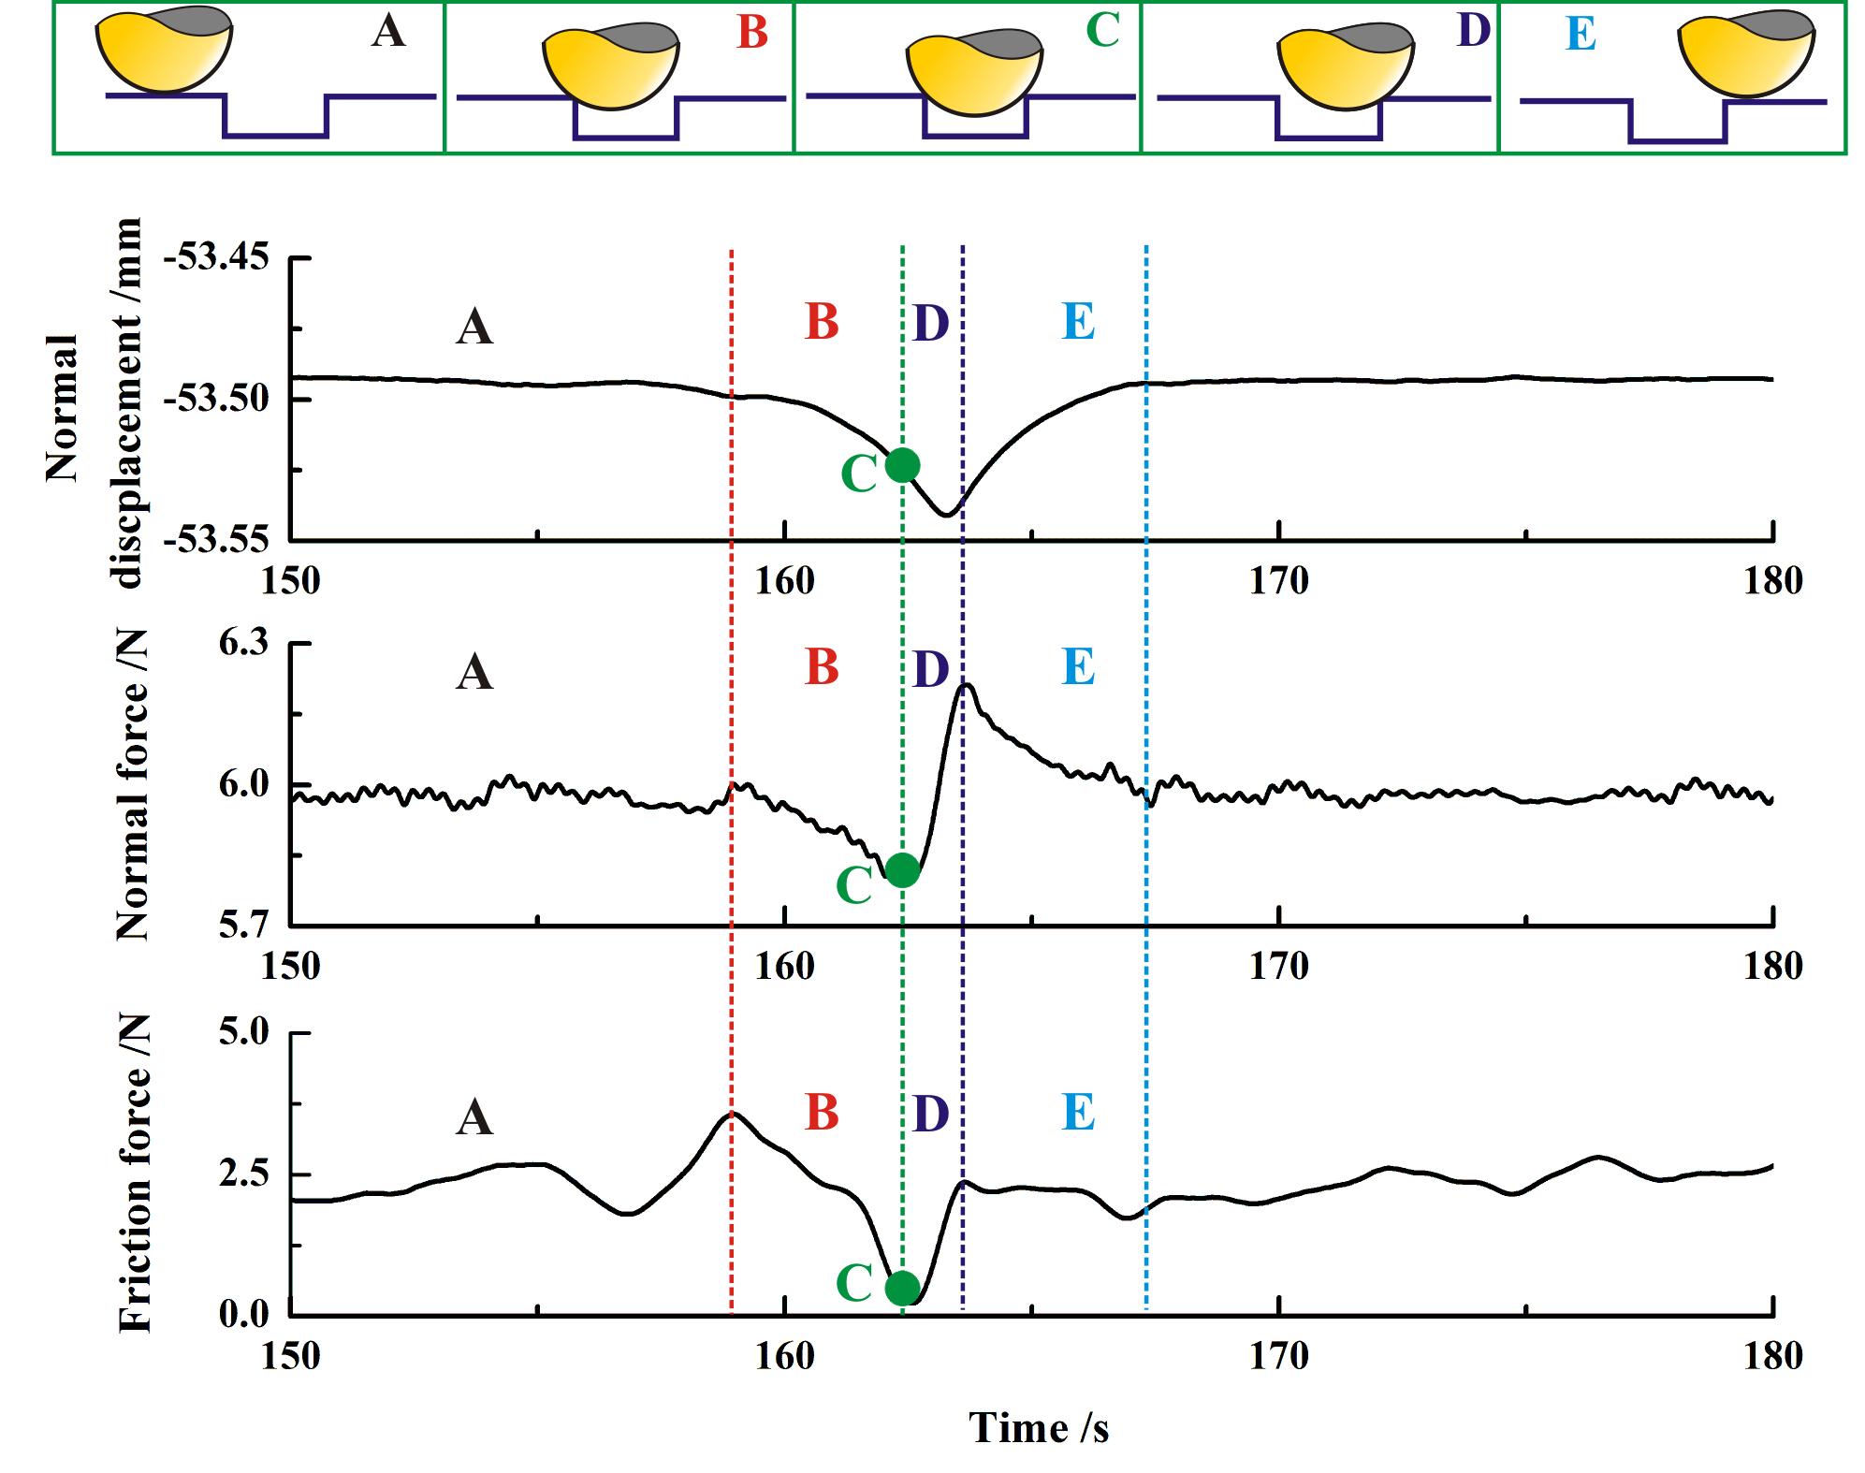
Fig. 10. Displacement and force curves at the speed of 0.2 rpm of the T-c surface in the ball-on-disc configuration.

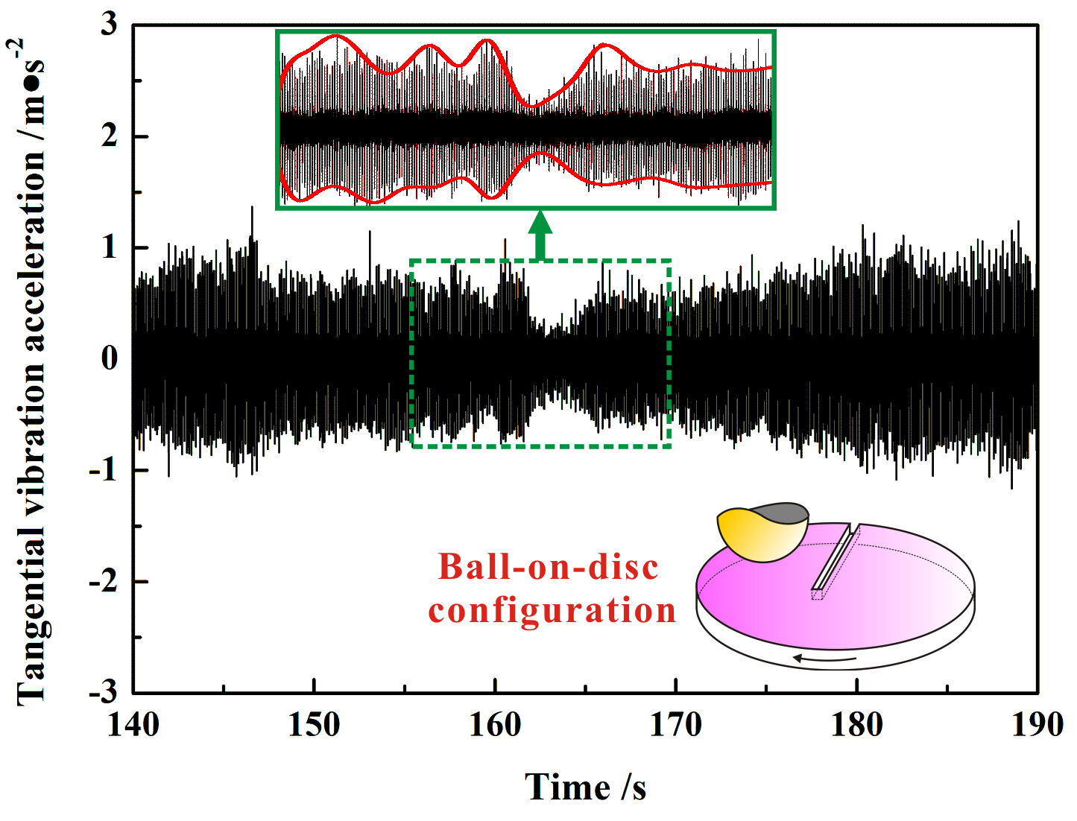
Fig. 11. The tangential vibration acceleration at the speed of 0.2 rpm in the ball-on-disc configuration.

Fig. 12 shows the force and vibration acceleration signals at the speed of 20 rpm. Both the normal and friction forces curves firstly show significant decrease during the ball’s sliding down the groove and consequently increase during the ball moving up the groove, which is similar to the results obtained at the lower speed of 0.2 rpm shown in Fig. 10. However, for the vibration acceleration curves, visible wave-like fluctuations can be found when the ball slides across the groove, which indicates the occurrence of strong collision behaviour between the ball and the groove. This collision may disrupt the continuous self-excited vibration of the friction system and accordingly suppress the generation of squeal.

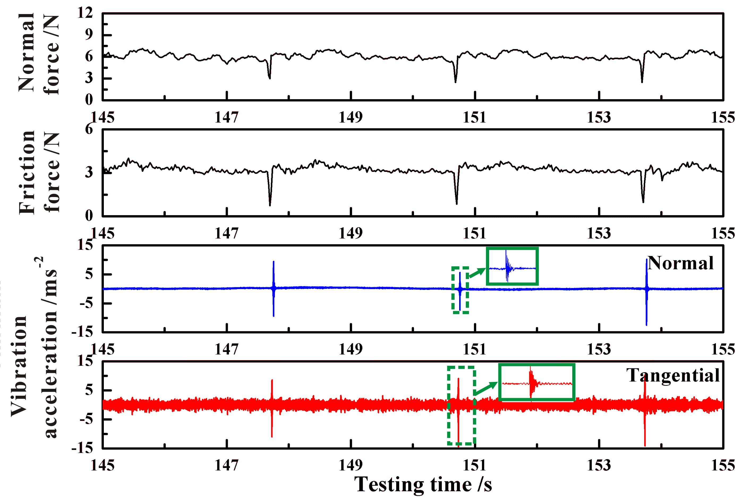
Fig. 12. Force and vibration acceleration curves at the speed of 20 rpm in the ball-on-disc configuration.

4.2 Pad-on-disc configuration
The displacement and force curves obtained from a pad sliding across the T-c surface at the speed of 0.2 rpm are shown in Fig. 13. Four representative contact states are depicted as well. In contact state A, i.e. the pad sliding against the smooth region, no visual change can be observed in both the displacement and force signals. When the pad just encounters the first edge of groove, contact state B is arrived at. The friction force signal starts to rise and this lasts for a short period until the pad encounters the second edge of the groove. In contact state C, when the pad crosses both edges of the groove, the friction force signal starts to decrease and drop down to the similar value as shown in contact state A. When the pad leaves the first edge of groove, and state D arrives, no visible signal shift can be found in this state. Therefore, the friction force signal experiences an abrupt change when the pad just encounters the other edge of the groove. The tangential vibration acceleration of the pad-on-disc configuration in this condition is shown in Fig. 14. A significant decrease and consequently increase can be observed in vibration acceleration signal during the pad’s sliding across the groove. Considering that the aim of this study is to compare the different squeal suppression mechanisms between these two contact configurations, a further test at a relatively higher speed is conducted for the pad-on-disc configuration.
Fig. 15 shows the vibration acceleration signals at the speed of 20 rpm. Sustained oscillation can be found in the vibration acceleration signal throughout the test period. Unlike the vibration acceleration signal generated from the ball-on-disc configuration, no visible sudden increase oscillation is observed from the vibration acceleration curve. This indicates that no visible and strong collision is generated between the pad and the groove. Therefore, the groove plays a different role in reducing squeal noise in both the pad-on-disc and ball-on-disc configurations. Considering that the grooves on the disc surface mainly changes the contact states during the friction process, the friction shear stress is modified in the case of pad sliding across the groove, which may result in the reduction of the squeal instability of the friction system.

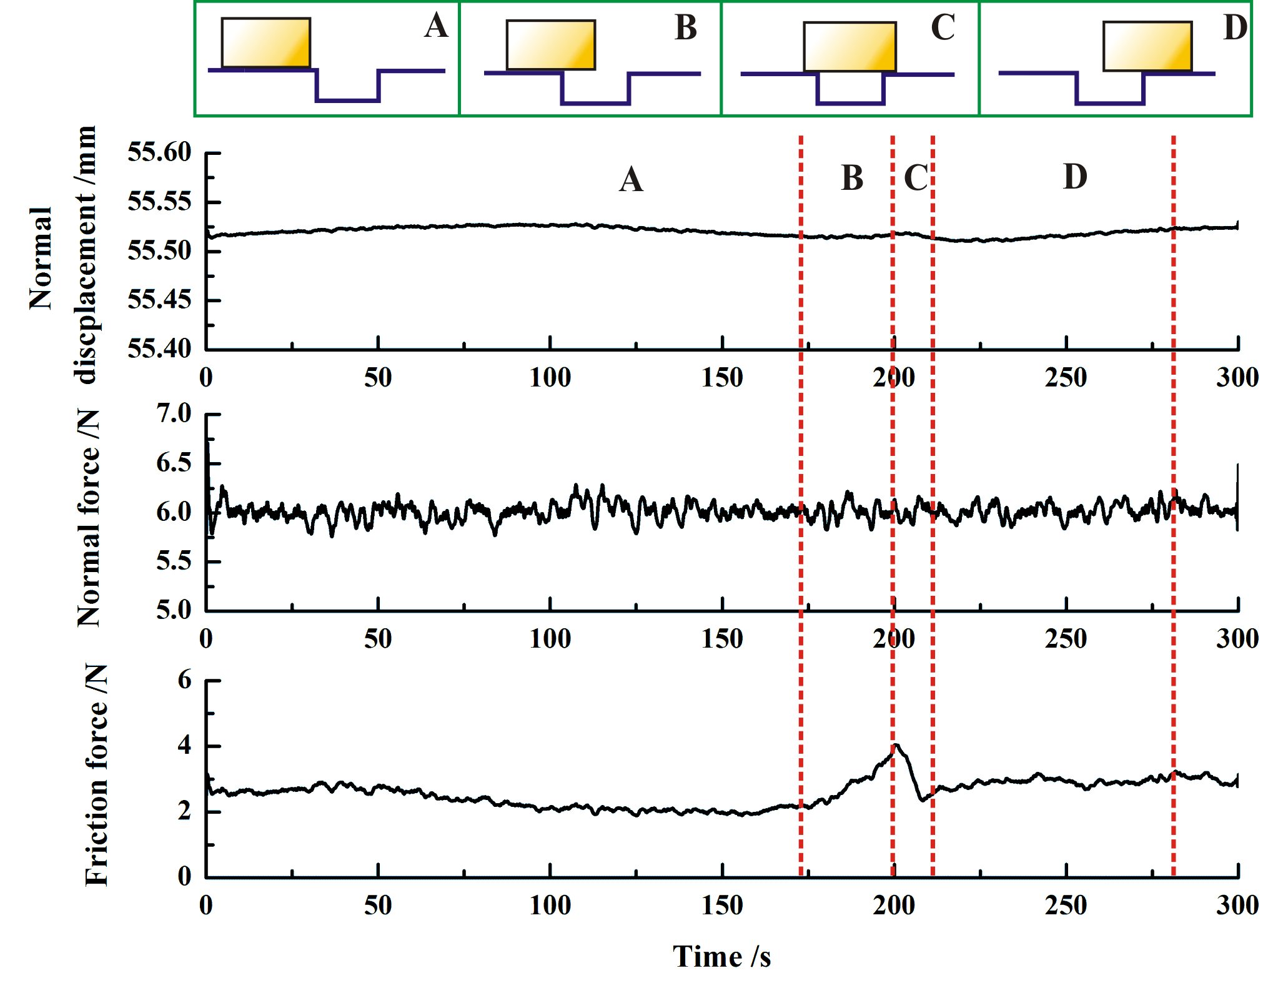
Fig. 13. Displacement and force curves of the pad-on-disc configuration accompany with the contact states between pad and T-c disc surface.

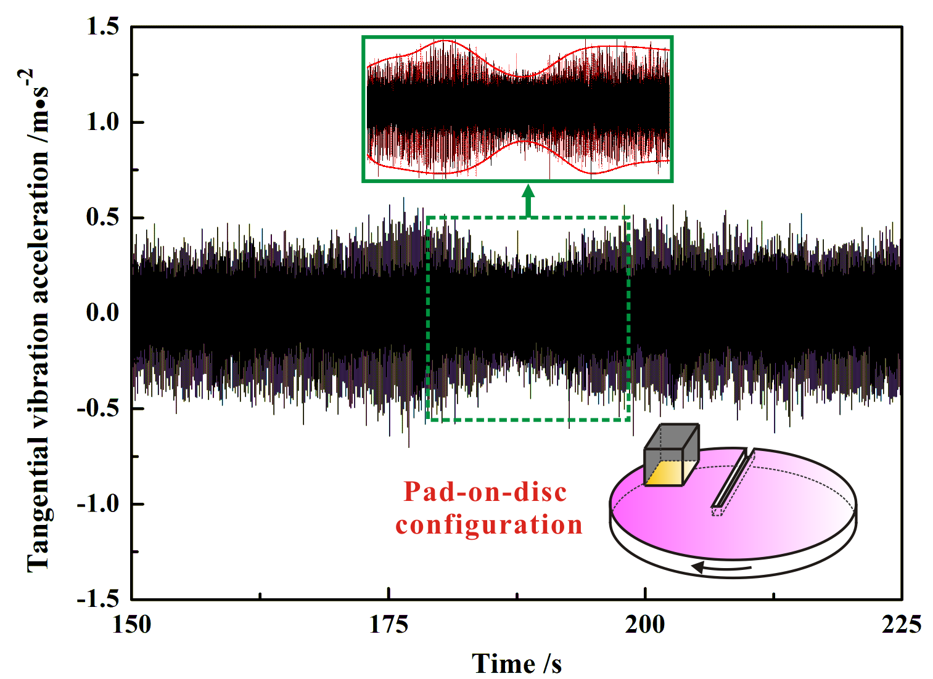
Fig. 14. The tangential vibration acceleration of the pad-on-disc configuration in the rotating speed of 0.2 rpm.

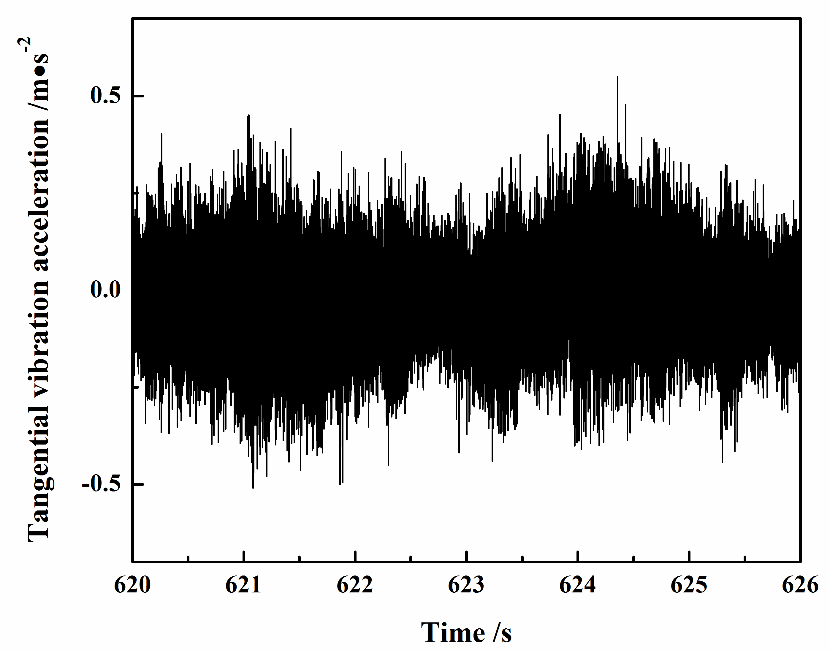
Fig. 15. The tangential vibration acceleration of the pad-on-disc configuration in the rotating speed of 20 rpm.

- Dynamic behaviour verification of ball/pad sliding across groove
In this section, a numerical study is performed by using ABAQUS 6.10 to further verify the dynamic behaviour of the ball/pad sliding across the groove. The goal of this numerical analysis is to capture the basic features of the dynamic behaviour of ball/pad sliding across groove and reveal the role of groove in affecting squeal noise in two different contact configurations, but it is not aimed to reproduce quantitatively the test results. By comparing the numerical and experimental results, the reason why the grooved discs can help supress the squeal noise tendency in different contact configurations is provided.
The finite element models of both the ball-on-disc and pad-on-disc configurations are shown in Fig. 16. These simplified finite element models cover seven main components of the real experimental system. The material parameters defined for all the parts of these models can well reflect the real experimental system, as listed in Table 3. The disc is rigidly constrained onto the disc table, which is in frictional contact with the ball/pad surface. An encastre boundary condition is applied on the top surface of the force sensor, on which a constant normal load is applied. The screw holes of the disc table are rigidly constrained except in the circumferential direction, and the velocity boundary condition is applied on it around the y-direction. All the parts of the models are meshed with 3D hexahedral elements. It is worth noting that in the model of ball-on-disc configuration, the disc surface is defined as the slave surface because the disc is made from softer material and has a finer mesh than those of the ball. On the other hand, in the model of pad-on-disc configuration, the disc surface is defined as the master surface because the disc is made from harder material than the pad.

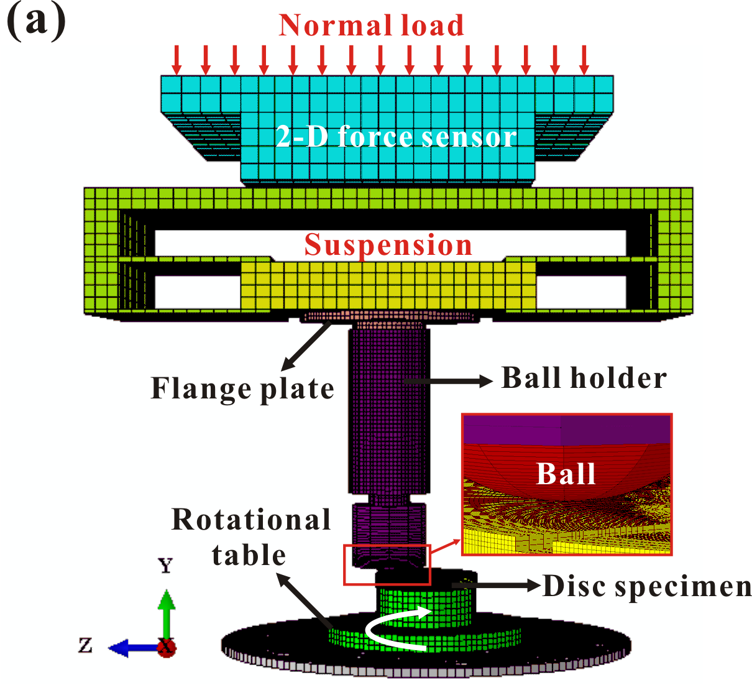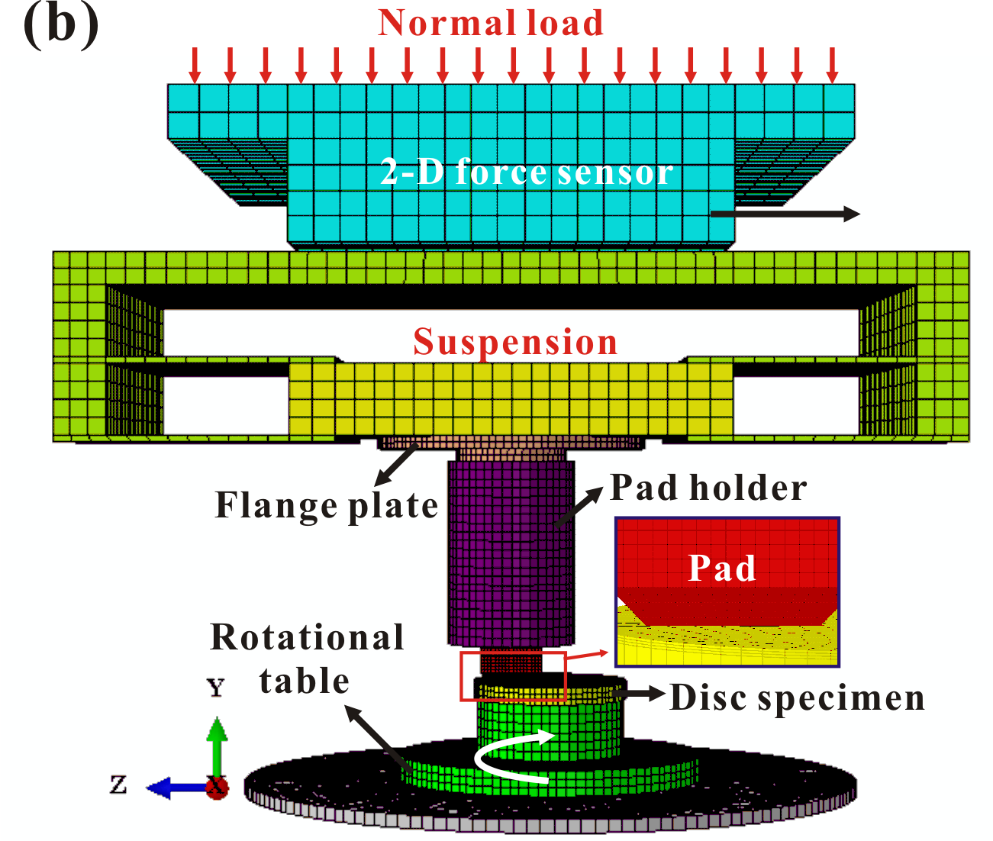
Fig. 16. The finite element model of the ball-on-disc configuration (a) and pad-on-disc configuration (b).

Table 3. The material parameters of the finite element model
Parts | Density (kg/m³) | Young’s modulus (GPa) | Poisson’s ratio | Damping
Load cell | 2700 | 60 | 0.27 | —
Suspension (plate) | 7800 | 172 | 0.305 | —
Suspension (shim) | 1500 | 0.5 | 0.27 | —
Flange plate | 7800 | 172 | 0.305 | —
Ball/pad holder | 7800 | 190 | 0.3 | —
Ball specimen | 7850 | 207 | 0.3 | —
Pad specimen | 2200 | 1.5 | 0.27 | α=20 s⁻¹  β=2e-8 s
Disc specimen | 7200 | 158 | 0.275 | —
Disc table | 7800 | 172 | 0.305 | —

Transient dynamic analysis is performed by using ABAQUS/Explicit solver to calculate the vibration during frictional sliding in the time domain. This approach allows researchers to observe the evolution of the signals of displacements, velocities and accelerations, and consequently help evaluate the events during the friction process [43-45]. Fig. 17 illustrates calculated vibration acceleration results of the ball-on-disc configuration in time domain. One wave-like oscillation in the vibration curve is observed, which is in good agreement with the experimental results, confirming the collision behaviour between the ball and the groove. Therefore, it can be concluded that the collision behaviour between the ball and the groove can cause the interruption of the continuous contact of the contact surfaces, which disrupts the self-excited vibration of the friction system, and consequently reduces the friction noise.

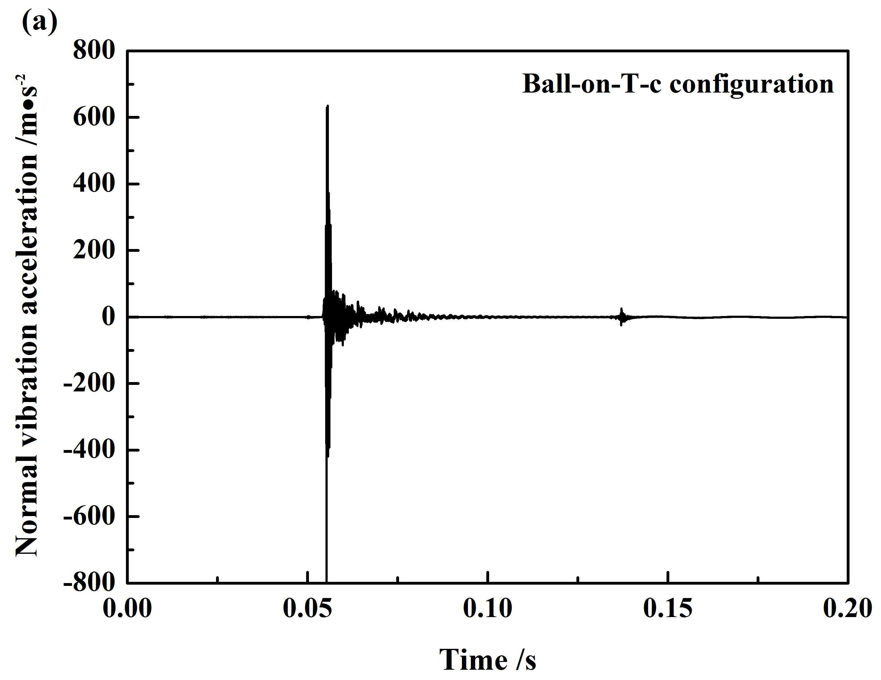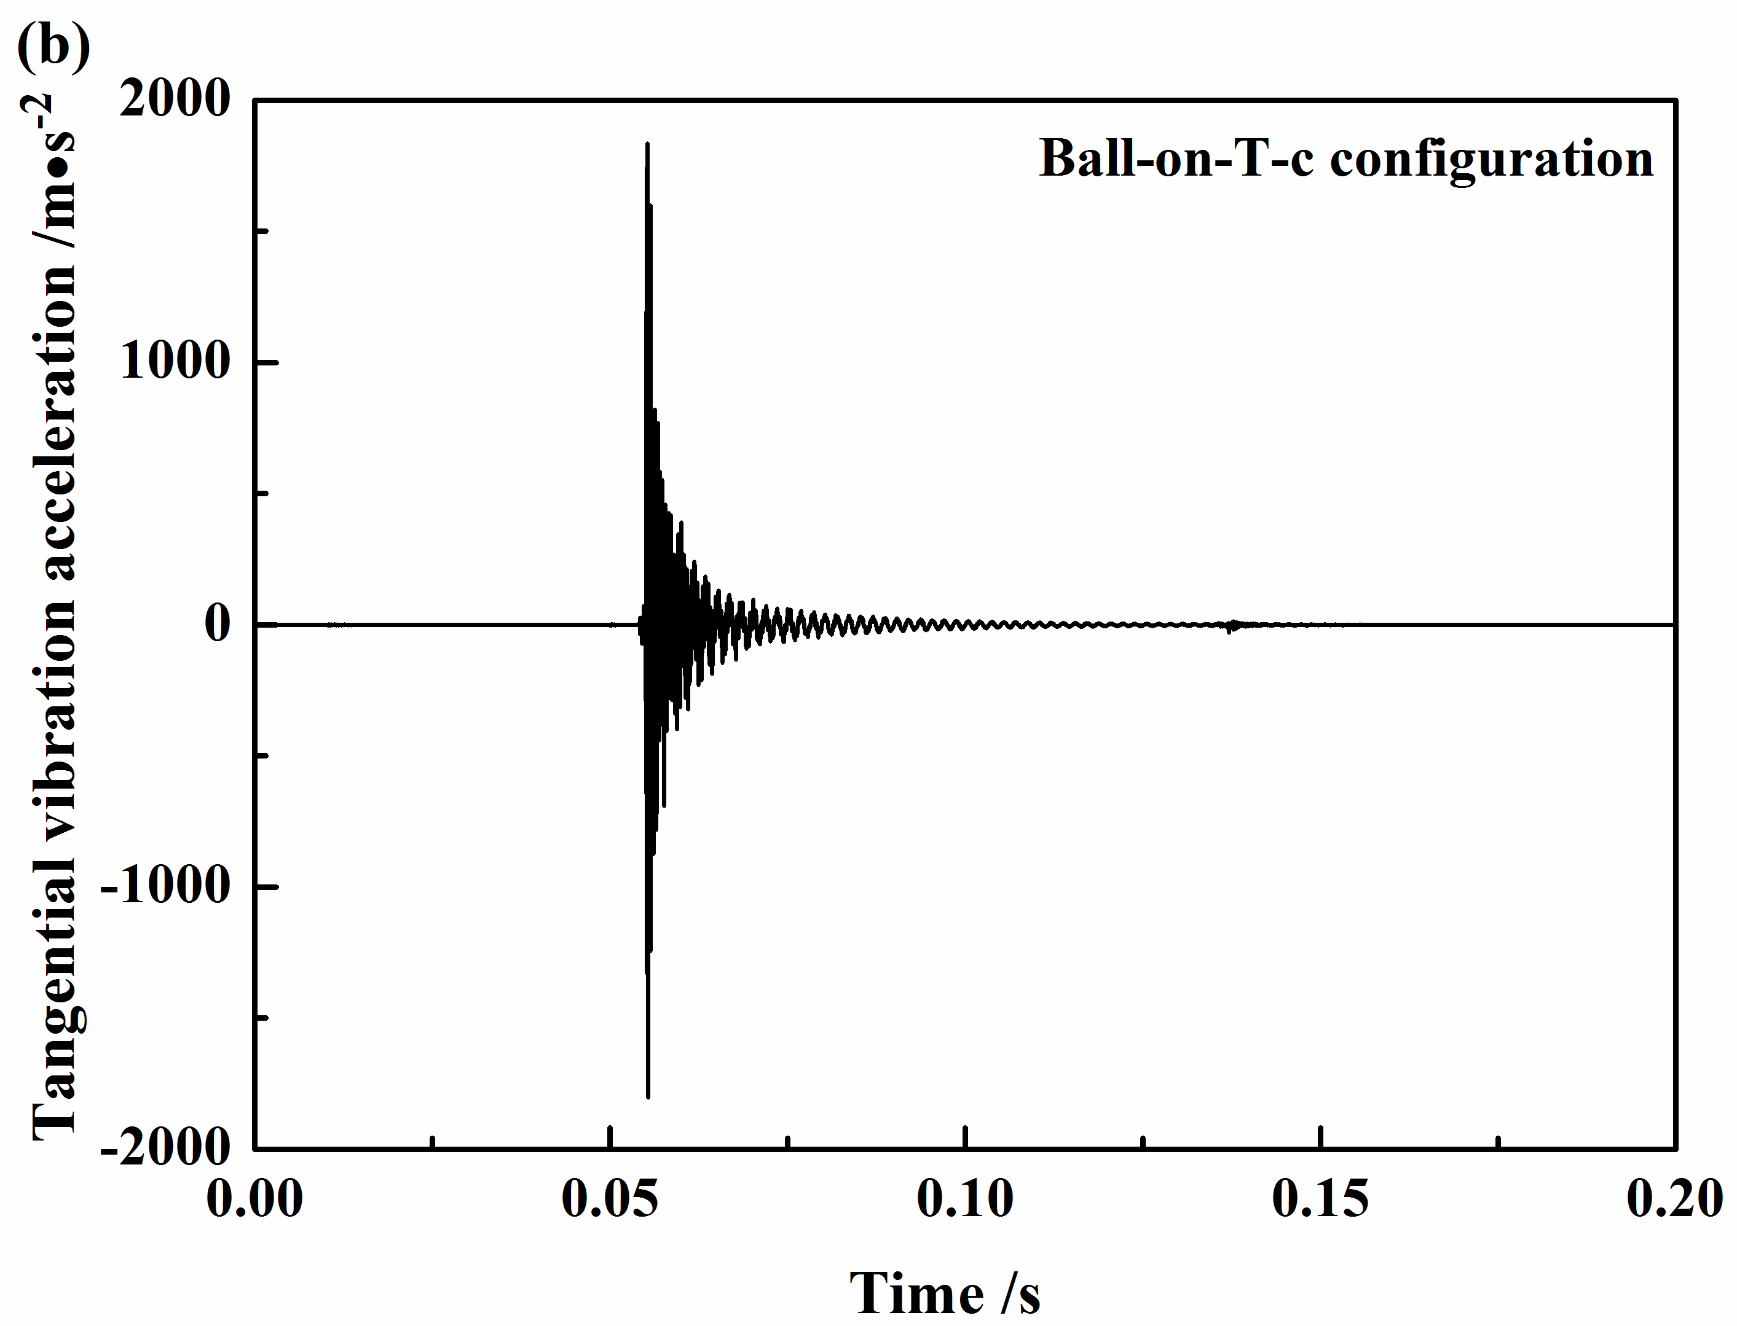
Fig. 17. Numerical results of normal vibration acceleration (a) and tangential vibration acceleration (b) of ball-on-T-c configuration in time domain.

The calculated results of the vibration accelerations for the pad-on-disc configuration are shown in Fig. 18. Strong fluctuations with exponential growth appear at the start and develop throughout a period of time for the vibration accelerations in both directions of the smooth surface, which suggests that the friction system has a strong potential in generating unstable vibrations and consequently emitting squeal. However, for the T-c surface, the amplitudes of the vibration accelerations in both directions exhibit a visible reduction, in addition, when the pad encounters the groove on the disc surface, the value of the vibration amplitude starts to show further decrease and then returns to the highest value again. This vibration phenomenon is different from the case of ball sliding across groove, which further verifies that no visible collision behaviour exists between the pad and the groove edge.
It has been reported that the leading edge of the pad surface is the main region of contact pressure concentration during braking, and the pad leading edge is more involved than trailing edge during squeal event [46]. In addition, it has been demonstrated that contact pressure distribution can significantly vary friction squeal propensity. When the contact pressure is still concentrated at the leading edge of pad surface during braking, the squeal tendency will increase [42, 47-49]. Considering the fact that when the pad sliding across the grooves on the disc surface, the change in the contact region will cause the variations and redistributions of the contact pressure, it can be speculated that that the redistribution of contact pressure which used to be concentrated at the pad leading edge is a major reason for the reduction of the squeal tendency.

Fig. 18. Numerical results of normal vibration acceleration (a) and tangential vibration acceleration (b) of pad-on-disc configuration in time domain.

- Conclusions
A systematic study on how the grooved disc surfaces affect tribological properties and vibration and squeal noise behaviour is performed, by using both a ball-on-disc and pad-on-disc configurations. The main conclusions can be expressed as follows:
(1) Regardless of the contact configurations, grooves on the disc surface can significant affect the tribological behaviour and squeal noise performance, and grooves of a certain width show good potential in reducing squeal.
(2) When the ball slides across the groove, the normal displacement, normal force and tangential force signals show an abrupt change during the ball’s sliding across the groove. However, for the case of the pad’s sliding across the groove, only the friction force signal shows an abrupt change, and no visible change can be observed in either the normal displacement or normal force signals.
(3) The grooves play different roles in affecting the friction-induced vibration and noise for the ball-on-disc and pad-on-disc configurations. For the ball-on-disc configuration, the collision behaviour between the ball and the edge of the groove helps suppress the friction squeal. For the pad-on-disc system, no visible collision behaviour can be found between the pad and the edge of groove, and the variation and redistribution of contact pressure during pad’s sliding across the grooves on the disc surface may be the major reason for the reduction of squeal instability of friction system.

- Acknowledgements
The authors would like to thank Professor G.X. Chen, of Southwest Jiaotong University, for helpful discussions. The authors are grateful for the financial support of the National Natural Science Foundation of China (No. 51375408), and the Program for New Century Excellent Talents in University (NCET-13-0974). The fourth author is grateful to the travel grant provided in the form of Changjiang Scholar Professorship.

Reference
[1] N.M. Kinkaid, O.M. O’Reilly, P. Papadopoulos, Automotive disc brake squeal, J. Sound Vib. 267 (2003) 105-166.
[2] A. Papinniemi, J.C.S. Lai, J.Y. Zhao, L. Loader, Brake squeal: a literature review, Appl. Acoust. 63 (2002) 391-400.
[3] I. Howard, S. Jia, J. Wang, The dynamic modelling of a spur gear in mesh including friction and a crack, Mech. Syst. Signal Process 15 (5) (2001) 831-853.
[4] J. Le Rouzic, A. Le Bot, J. Perret-Liaudet, M. Guibert, A. Rusanov, L. Douminge, F. Bretagnol, D. Mazuyer, Friction-induced vibration by Stribeck’s law: application to wiper blade squeal noise, Tribol. Lett. 49 (2013) 563-572.
[5] J. Kang, K. Kim, Squeak noise in lead screw systems: self-excited vibration of continuous model, J. Sound Vib. 329 (2010) 3587-3595.
[6] A.R. Crowther, N. Zhang, Torsional finite elements and nonlinear numerical modelling in vehicle powertrain dynamics, J. Sound Vib. 284(3) (2005) 825-849.
[7] R.A. Ibrahim, Friction-induced vibration, chatter, squeal, and chaos–part I: mechanics of contact and friction, ASME Appl. Mech. Rev. 47 (7) (1994) 209-226.
[8] R.A. Ibrahim, Friction-Induced Vibration, Chatter, Squeal, and Chaos—part II: dynamics and modelling, ASME Appl. Mech. Rev. 47(7) (1994) 227-253.
[9] A. Akay, Acoustics of friction, J. Acoust. Soc. Am. 114 (2002) 1525-1548.
[10] S. Oberst, J. Lai, A critical review of brake squeal and its treatment in practice, in: Internoise, Shanghai, 2008.
[11] D. Hochlenert, G. Spelsberg-Korspeter, P. Hagedorn, Friction induced vibrations in moving continua and their application to brake squeal, ASME J. Appl. Mech. 74(3) (2007) 542-549.
[12] N.M. Ghazaly, M. El-Sharkawy, I. Ahmed, A review of automotive brake squeal mechanisms, J. Mech. Des. Vib. 1(1) (2014) 5-9.
[13] S.K. Rhee, P.H.S. Tsang, Y.S. Wang, Friction-induced noise and vibration of disc brakes, Wear 133 (1989) 39-45.
[14] H. Ouyang, Moving-load dynamic problems: a tutorial (with a brief overview), Mech. Syst. Signal Process 25(6) (2011) 2039-2060.
[15] D. Tonazzi, F. Massi, A. Culla, L. Baillet, A. Fregolent, Y. Berthier, Instability scenarios between elastic media under frictional contact, Mech. Syst. Signal Process 40(2) 2013 754-766.
[16] N. Hoffmann, L. Gaul, Friction induced vibrations of brakes: research fields and activities, SAE Technical Paper Series 2008-01-2579.
[17] F. Bergman, M. Eriksson, S. Jacobson, Influence of disc topography on generation of brake squeal, Wear 225–229 (1999) 621-628.
[18] M. Eriksson, F. Bergman, S. Jacobson, Surface characterisation of brake pads after running under silent and squealing conditions, Wear 232 (1999) 163-167.
[19] L. Hammerström, S. Jacobson, Surface modification of brake discs to reduce squeal problems, Wear 261 (2006) 53-57.
[20] Y. Lyu, E. Bergseth, U. Olofsson, A. Lindgren, M. Höjer, On the relationships among wheel–rail surface topography, interface noise and tribological transitions, Wear 338-339 (2015) 36-46.
[21] J.H. Gweon, B.S. Joo, H. Jang, The effect of short glass fiber dispersion on the friction and vibration of brake friction materials, Wear 362 (2016) 61-67.
[22] F. Dalzin, A. Le Bot, J. Perret-Liaudet, D. Mazuyer, Tribological origin of squeal noise in lubricated elastomer-glass contact, J. Sound Vib. 372 (2016) 211-222.
[23] A.R. Mat Lazim, M. Kchaou, M.K. Abdul Hamid, A.R. Abu Bakar, Squealing characteristics of worn brake pads due to silica sand embedment into their friction layers, Wear 358-359 (2016) 123-136.
[24] A. Renault, F. Massa, B. Lallemand, T. Tison, Experimental investigations for uncertainty quantification in brake squeal analysis, J. Sound Vib. 367 (2016) 37-55.
[25] Z. Fuadi, K. Adachi, H. Ikeda, H. Naito, K. Kato, Effect of contact stiffness on creep-groan occurrence on a simple caliper-slider experimental model, Tribol. Lett. 33 (2009) 169-178.
[26] M. Graf, G-P. Ostermeyer, Instabilities in the sliding of continua with surface inertias: an initiation mechanism for brake noise, J. Sound Vib. 330 (2011) 5269-5279.
[27] A.R. AbuBakar, H. Ouyang, A prediction methodology of disk brake squeal using complex eigenvalue analysis, Int. J. Veh. Des. 46 (2008) 416-435.
[28] A.R. AbuBakar, H. Ouyang, S. James, L. Li, Finite element analysis of wear and its effect on squeal generation, IMechE J. Automob. Eng., 222(7) (2008) 1153-1165.
[29] T. Butlin, J. Woodhouse, Friction-induced vibration: should low-order models be believed? J. Sound Vib. 328(1) (2009) 92-108.
[30] T. Butlin, J. Woodhouse, Sensitivity studies of friction-induced vibration, Int. J. Veh. Des. 51(1/2) (2009) 238-257.
[31] S. Oberst, J.C.S. Lai, Numerical prediction of brake squeal propensity using acoustic power calculation, ACOUSTICS (2009) 111-118.
[32] S. Oberst, J.C.S. Lai, Statistical Analysis of Brake Squeal Noise, J. Sound Vib. 330(12), (2011) 2978-2994.
[33] F. Massi, Y. Berthier, L. Baillet, Contact surface topography and system dynamics of brake squeal, Wear 265 (2008) 1784-1792.
[34] T. Butlin, J. Woodhouse, A systematic experimental study of squeal initiation, J. Sound Vib. 330 (21) (2011) 5077-5095.
[35] M. Eriksson, S. Jacobson, Friction behaviour and squeal generation of disc brakes at low speeds, Proc. Inst. Mech. Eng. Part D: J. Automob. Eng. 215 (2001) 1245-1256.
[36] K. Meine, T. Schneider, D. Spaltmann, E. Santner, The influence of roughness on friction Part I: The influence of a single step, Wear 253 (2002) 725-732.
[37] K. Meine, T. Schneider, D. Spaltmann, E. Santner, The influence of roughness on friction Part II: The influence of multiple steps, Wear 253 (2002) 733-738.
[38] W. Wu, G.M. Chen, B.X. Fan, J.Y. Liu, Effect of groove surface texture on tribological characteristics and energy consumption under high temperature friction, PloS one 11(4) (2016) e0152100.
[39] M.R. Ripoll, B. Podgornik, J. Vižintin, Finite element analysis of textured surfaces under reciprocating sliding, Wear 271 (2011) 952-959.
[40] J.L. Mo, Z.G. Wang, G.X. Chen, T.M. Shao, M.H. Zhu, Z.R. Zhou, The effect of groove-textured surface on friction and wear and friction-induced vibration and noise, Wear 301(1) (2013) 671-681.
[41] D.W. Wang, J.L. Mo, H. Ouyang, G.X. Chen, M.H. Zhu, Z.R. Zhou, Experimental and numerical studies of friction-induced vibration and noise and the effects of groove-textured surfaces, Mech. Syst. Signal. Process. 46 (2014) 191-208.
[42] D.W. Wang, J.L. Mo, M.Q. Liu, H. Ouyang, Z.R. Zhou, Noise performance improvements and tribological consequences of a pad-on-disc system through groove-textured disc surface, Tribol. Int. 102 (2016) 222-236.
[43] S. Oberst, J.C.S. Lai, Nonlinear transient and chaotic interactions in disc brake squeal, J. Sound Vib. 342 (2015) 272-289.
[44] H. Ouyang, W. Nack, Y. Yuan, F. Chen, Numerical analysis of automotive disc brake squeal: a review. Int. J. Veh. Noise. Vib. 1(3/4) (2005) 207-231.
[45] A. Meziane, L. Baillet, B. Laulagent, Experimental and numerical investigation of friction-induced vibration of a beam-on-beam in contact with friction, Appl. Acoust. 71 (2010) 843-853.
[46] Fr. Renaud, G. Chevallier, J. L. Dion, G. Taudire, Motion capture of a pad measured with accelerometers during squeal noise in a real brake system. Mech. Syst. Signal Process. 33(2012) 155-166.
[47] F. Massi, L. Baillet, O. Giannini, A. Sestieri, Brake squeal: linear and nonlinear numerical approaches, Mech. Syst. Signal Process. 6 (2007) 2374–2393.
[48] J.D. Fieldhouse, N. Ashraf, C. Talbot, T. Pasquet, P. Franck, R. Gabriel, Measurement of the dynamic center of pressure of a brake pad during a braking operation, SAE Technical Paper, 2006-01-3208.
[49] M. Z. Hassan, P. C. Brooks, D. C. Barton, A predictive tool to evaluate disk brake squeal using a fully coupled thermo-mechanical finite element model, Int. J. Veh. Des. 51(1-2) (2009) 124-142.

*Corresponding author. Tel.: +86-28-87600601; fax: +86-28-87603142. E-mail address: jlmo@swjtu.cn (J.L. Mo)

