Synthesis, in vitro and in vivo evaluation of 1,3,5-triazines as cannabinoid CB2 receptor agonists

Sari Yrjölä^{a*}, Mirkka Sarparanta^{b}, Anu Airaksinen^{b}, Maria Hytti^{c}, Anu Kauppinen^{c,d}, Sanna Pasonen-Seppänen^{e}, Barbara Adinolfi^{f,g}, Paola Nieri^{g}, Clementina Manera^{g}, Antti Poso^{a,h}, Tapio J. Nevalainenª, Teija Parkkariª

ªSchool of Pharmacy, Faculty of Health Sciences, University of Eastern Finland, PO Box 1627, FI-70211 Kuopio, Finland
^{b} Laboratory of Radiochemistry, Department of Chemistry, PO Box 55, FI-00014 University of Helsinki, Finland
^{c} Department of Ophthalmology, Institute of Clinical Medicine, University of Eastern Finland. P.O.B. 1627, FI-70211 Kuopio, Finland
^{d} Department of Ophthalmology, Kuopio University Hospital, P.O.B 100, FI-70029 KYS, Finland
^{e} School of Medicine, Institute of Biomedicine, Faculty of Health Sciences, University of Eastern Finland
^{f} Institute of Applied Physics "Nello Carrara", National Research Council, Via Madonna del Piano 10, 50019 Sesto Fiorentino (FI), Italy
^{g} Department of Pharmacy, University of Pisa, Via Bonanno 6, 56100 56126 Pisa (PI), Italy
^{h} Division of Molecular Oncology of Solid Tumors, Dept. of Internal Medicine I, University Hospital Tuebingen, Otfried-Mueller-Strasse 10, 72076 Tuebingen, Germany

*Corresponding author. Tel. +358 ???, fax: +358 17 16 2424
E-mail address: sari.yrjola@uef.fi (S.Yrjölä)

Keywords:
Cannabinoid receptor
CB2R agonists
Triazines
Radioligand

Graphical abstract
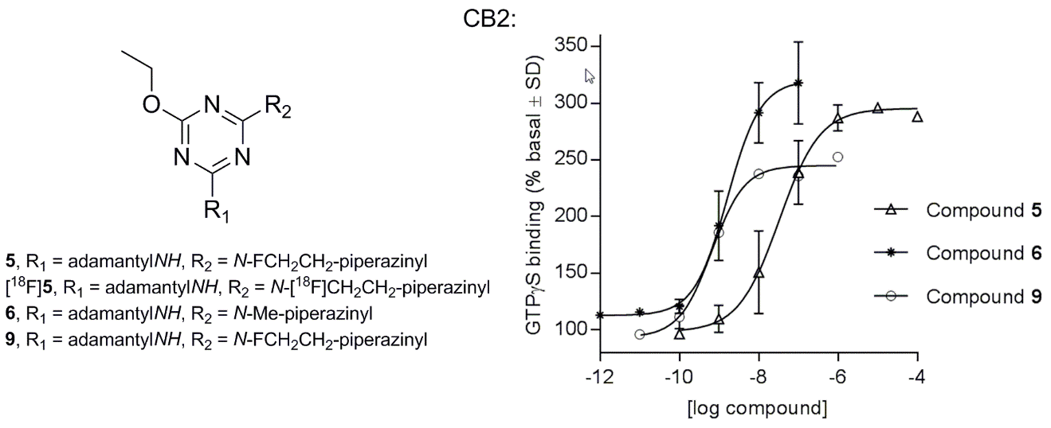
Abstract
The cannabinoid receptors type 2 (CBR2) are attractive therapeutic targets of the endocannabinoid signaling system (ECS) as they are not displaying the undesired psychotropic and cardiovascular side-effects seen with cannabinoid receptor type 1 (CB1R) agonists. In continuation of our previous work on 2,4,6-trisubstituted 1,3,5-triazines as selective CB2 agonists, we synthesized an additional series of more polar analogues (1-10), which were found to possess high CB2R agonist activity with enhanced water solubility. The most potent compound in the series was N-(adamantan-1-yl)-4-ethoxy-6-(4-(2-fluoroethyl)piperazin-1-yl)-1,3,5-triazin-2-amine (9) with EC₅₀ value of 0.60 nM. To further evaluate the applicability of the compounds as pharmacological tools, the selected compounds were tested in vitro against four different cell lines. A human retinal pigment epithelial cell line (ARPE-19) was used to evaluate the cytotoxicity of the compounds whereas an androgen-sensitive human prostate adenocarcinoma cell line (LNCaP), a Jurkat leukemia cell line and a C8161 melanoma cell line were used to assess the antiproliferative activity of the compounds. The most interesting results were obtained for N-(adamantan-1-yl)-4-ethoxy-6-(4-methylpiperazin-1-yl)-1,3,5-triazin-2-amine (6), which induced cell viability decrease in prostate and leukemia cell lines, and diminished proliferation of C8161 melanoma cells. The results could be reversed in leukemia cells with the selective CB2R antagonist AM630, whereas in prostate cells the AM630 induced a significant cell viability decrease with a mechanism probably unlinked to CB2 cannabinoid receptor. The antiproliferative effect of 6 on the melanoma cells seemed not to be mediated via the CB1R or CB2R. No cytotoxicity was detected against ARPE-19 cell line at concentrations of 1 and 10 µM for compound 6. However, at 30 µM concentration the compound 6 decreased the cell viability. In addition, ¹⁸F labelled PET ligand, N-cyclopentyl-4-ethoxy-6-(4-(2-fluoro-18-ethyl)piperazin-1-yl)-1,3,5-triazin-2-amine ([¹⁸F]5) was synthesized and its biodistribution was determined in healthy male Sprague-Dawley rats. As a result, the tracer showed a rapid (<15 minutes) elimination in urine accompanied by a slower excretion via the hepatobiliary route. In conclusion, we further demonstrated that 1,3,5-triazine scaffold serves as a suitable template for the design of highly potent CB2R agonists with reasonable water solubility properties. The compounds may have application as pharmacological tools to study the role of the endocannabinoid system in different diseases. The triazine scaffold is also a promising candidate for the development of new CB2R PET ligands.

1. Introduction
The endocannabinoid signaling system (ECS) participates in numerous diseases affecting humans and thus it offers many potential targets for drug development. The ECS is known to consist, at least, of two cannabinoid receptors (CB1R and CB2R), their endogenous ligands (endocannabinoids), the enzymes synthesizing and degrading the endocannabinoids, and the putative endocannabinoid transporters (Lambert and Fowler 2005; Pacher et al., 2006). Even though, the major players of the ECS have already been known for quite some time, there is still a significant amount of research that needs to be done to fully understand their roles in the system.
CB1R-mediated psychotropic side effects is the main drawback in the ECS based drug development. However, one possible strategy is to selectively modulate only the peripheral CB2R which is anticipated to be devoid of the central nervous system (CNS) side effects (Han et al., 2013). The CNS and peripheral CB2R expression levels are increased in various diseases in a tissue- and time-dependent manner (Pacher and Kunos, 2013; Pacher and Mechoulam 2011; and the references cited therein). This may enable the design of well-targeted therapeutics, and the CB2R may also serve as a potential biomarker for disorders (Evens et al., 2012).
In our previous study, we reported a series of 2,4,6-trisubstituted 1,3,5-triazines which act as potent and selective CB2R agonists (Yrjölä et al., 2013). However, high lipophilicity of these ligands limited their applicability in in vitro and in vivo experiments. We decided to solve the problem by incorporating polar functional groups to the triazine skeleton, which lowered lipophilicity and beneficially retained potency and selectivity of the compounds for the CB2R. Overall, in this study we have synthesized a new more polar series of triazine analogues (1-10) and determined the distribution coefficients (logD) and water solubilities for 3, 6, 7 and 10. To evaluate the applicability of the compounds as pharmacological tools, the selected compounds were tested in vitro using four different cell lines that have been shown to express CB1 and/or CB2 receptors. A human retinal pigment epithelial cell line (ARPE-19) was used to evaluate the cytotoxicity of the compounds, whereas an androgen-sensitive human prostate adenocarcinoma cell line (LNCaP), a Jurkat leukemia cell line and a C8161 melanoma cell line were used to assess the compounds’ antiproliferative activity (Wei et al. 2009; Sarfaraz et al. 2005; Rieder et al., 2010; Blázquez et al., 2006). Finally, in order to estimate in vivo behavior of these compounds, we synthesized fluorine-18 labelled triazine derivative ([¹⁸F]5) and determined its biodistribution in healthy rats.

2. Materials and methods
2.1. Design of the 2,4,6-trisubstituted 1,3,5-triazines
The structures of a small library of 10 new triazine derivatives (1-10) are outlined in Fig. 1. The structures were designed based on the results of our previous structure-activity relationship study of 2,4,6-trisubstituted 1,3,5-triazines as CB2R agonists (Yrjölä et al., 2013). The original hit structure, N-cyclopentyl-4-ethoxy-6-(4-methylpiperidin-1-yl)-1,3,5-triazin-2-amine (11), is also presented in Fig. 1 (Yrjölä et al., 2011). The ethoxy group was maintained in all new compounds (1-10) and the N-cyclopentyl substituent was kept intact in five structures (1-5). The N-cyclopentyl was replaced with N-adamantyl group in four compounds (6-9) as it is known to be beneficial for the CB2R activity (Lu et al., 2005). Physicochemical properties of the compounds were modified by introducing more polar substituents, morpholine (1), thiomorpholine-1,1-dioxide (2, 7, 10), piperazine (4, 8) and 1-methylpiperazine (3, 6) on the triazine sekeleton. All ten compounds were screened for their ability to activate the CB1R/CB2R (Table 1).
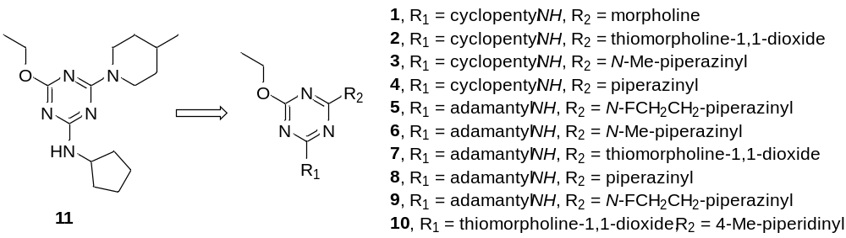
Fig. 1. The hit structure (11) used as a starting point to create a series of 2,4,6-trisubstituted 1,3,5-triazines (Yrjölä et al. 2011).

2.2. General synthetic procedures
Synthesis procedures of all compounds are based on methods reported in literature (Coburn et al., 2009). Commercially available chemicals were used without further purification. Reactions were monitored by thin layer chromatography (TLC) which was performed on Merck silica gel F254 precoated aluminium sheets. Petroleum ether-ethyl acetate (PE-EA; 9:1, 5:1 or 1:1) or dichloromethane-methanol (DCM-MeOH; 6:1) was used as an eluent and spots were detected by UV light and ninhydrin stain. The products were purified by column chromatography using silica gel. Elution was performed using PE-EA or DCM-MeOH with gradient elution increasing the proportion of a polar solvent. Yields were not optimized.
NMR spectra were recorded on a Bruker Avance instrument (500.1 MHz for ¹H, 125.8 MHz for ¹³C). Chemical shifts are reported in δ (ppm) values with tetramethylsilane or the solvent resonance as an internal standard. Coupling constants J are given in Hz. Multiplicities are described as singlet (s), doublet (d), triplet (t), quartet (q), and broad (br). ESI mass spectra were performed on Finnigan MAT LCQ quadrupole ion trap mass spectrometer. Elemental analyses were carried out using a ThermoQuest CE Instruments EA 1110 CHNS-O elemental analyser. The purity (> 95%) of compounds 2, 5 and 8-10 were determined by using Agilent 1100 series HPLC with DAD detector (254 nm). Column: Zorbax Eclipse XBD-C18, 4.6 x 50mm, 1.8 µm, Agilent Technologies.
2.3. Intermediates A, B and C
The synthesis of intermediates 2,4-dichloro-6-ethoxy-1,3,5-triazine (intermediate A), 4-chloro-N-cyclopentyl-6-ethoxy-1,3,5-triazin-2-amine (intermediate B) and N-(adamantan-1-yl)-4-chloro-6-ethoxy-1,3,5-triazin-2-amine (intermediate C) have been described earlier (Yrjölä et al., 2013).
2.4. General procedure for synthesizing intermediate D and final products 1-4, 6, 7 and 10.
A mixture of an appropriate amine and N,N-diisopropylethylamine (DIPEA) or triethylamine (Et₃N) in THF was added to a solution of cyanuric chloride or compound derived from cyanuric chloride in THF. The mixture was stirred at a sufficient temperature (0°C to refluxing) and the reaction was monitored by TLC. After product formation was detected, the solvent was evaporated and the residue was diluted with water, extracted with EA or DCM and dried with Na₂SO₄. The solvent was evaporated again and the crude product was purified by column chromatography. If the product was crystallized before or during the extraction, the product was filtered and purified by column chromatography.
2.4.1. 4-(4-Chloro-6-ethoxy-1,3,5-triazin-2-yl)thiomorpholine 1,1-dioxide (intermediate D)
1,1-Dioxothiomorpholine (0.42 g, 3.1 mmol), DIPEA (0.54 ml, 3.1 mmol) and intermediate A (0.60 g, 3.1 mmol) were stirred at 0 °C for 1 h. The product was a white solid (0.92 g, 101 %) and it was used without further purification. ¹H NMR (CDCl₃): δ 1.42 (3H, t, J=7.1 Hz), 3.09 (4H, m), 4.38 (4H, br s), 4.44 (2H, q, J=7.1 Hz).
2.4.2. N-Cyclopentyl-4-ethoxy-6-morpholino-1,3,5-triazin-2-amine (1)
Morpholine (0.27 ml, 3.1 mmol), DIPEA (0.40 ml, 2.3 mmol) and intermediate B (0.50 g, 2.1 mmol) were refluxed for 5 h. The product was a light yellow solid (0.45 g, 75 %). ¹H NMR (CDCl₃): δ 1.36 (3H, br s), 1.44 (2H, br s), 1.61 (2H, m), 1.70 (2H, m), 2.01 (2H, m), 3.66-3.84 (8H, m), 4.30 (2H, br s), 4.35 (1H, br s), 4.98 (1H, br d); ¹³C NMR (CDCl₃): δ 14.6, 23.7, 33.3, 43.8, 52.6, 62.4, 66.9, 166.1, 166.9, 170.7; ESI-MS 294.27 [M+H]⁺; Anal. Calcd for C₁₄H₂₃N₅O₂ ∙ 0.04 H₂O: C 57.18, N 23.81, H 7.91; found: C 57.43, N 23.42, H 7.98.
2.4.3. 4-(4-(Cyclopentylamino)-6-ethoxy-1,3,5-triazin-2-yl)thiomorpholine 1,1-dioxide (2)
1,1-Dioxothiomorpholine (0.20 g, 1.5 mmol), DIPEA (0.24 ml, 1.4 mmol) and intermediate B (0.30 g, 1.2 mmol) were refluxed for 48 h. The product was a white solid (0.20 g, 47 %). ¹H NMR (CDCl₃): δ 1.38 (3H, m), 1.45 (2H, m), 1.62 (2H, m), 1.72 (2H, m), 2.02 (2H, br s), 3.04 (4H, br s), 4.20-4.40 (7H, several m); ¹³C NMR (CDCl₃): δ 14.6, 23.8, 33.4, 42.0, 51.9, 52.6, 62.9, 165.9, 167.0, 171.1; ESI-MS 342.24 [M+H]⁺; >95 % purity, determined by HPLC method (eluent: ACN/acetate buffer pH=5 (40/60)).
2.4.4. N-Cyclopentyl-4-ethoxy-6-(4-methylpiperazin-1-yl)-1,3,5-triazin-2-amine (3)
1-Methylpiperazine (0.34 ml, 3.1 mmol), DIPEA (0.50 ml, 2.9 mmol) and intermediate B (0.50 g, 2.1 mmol) were refluxed for 6 h. The product was a light yellow oil which solidified in vacuum (0.42 g, 67 %). ¹H NMR (CDCl₃): δ 1.35 (3H, br s), 1.43 (2H, br s), 1.61 (2H, m), 1.70 (2H, m), 2.01 (2H, m), 2.32 (3H, s), 2.41 (4H, br s), 3.81 (4H, br m), 4.29 (2H, br s), 4.34 (1H, br s), 4.96 (1H, d, J=7.3 Hz); ¹³C NMR (CDCl₃): δ 14.6, 23.8, 33.4, 43.2, 46.3, 52.6, 55.0, 62.3, 166.0, 166.9, 170.8; ESI-MS 307.22 [M+H]⁺; Anal. Calcd for C₁₅H₂₆N₆O ∙ 0.1 H₂O: C 58.45.18, N 27.27, H 8.57; found: C 58.68, N 26.90, H 8.64.
2.4.5. N-Cyclopentyl-4-ethoxy-6-(piperazin-1-yl)-1,3,5-triazin-2-amine (4)
Piperazine (0.37 g, 4.3 mmol), DIPEA (0.55 ml, 3.2 mmol) and intermediate B (0.70 g, 2.9 mmol) were refluxed overnight. The product was a white solid (0.34 g, 40%). ¹H NMR (CDCl₃): δ 1.35 (3H, br s), 1.44 (2H, br s), 1.61 (2H, m), 1.70 (2H, m), 1.81 (1H, s), 2.01 (2H, m), 2.87 (4H, br s), 3.77 (4H, br m), 4.29 (2H, br s), 4.34 (1H, br s), 4.94 (1H, d, J=5.3 Hz) ; ¹³C NMR (CDCl₃): δ 14.7, 23.8, 33.4, 44.6, 46.1, 52.6, 62.3, 166.1, 167.0, 170.8; ESI-MS 293.25 [M+H]⁺; Anal. Calcd for C₁₄H₂₄N₆O ∙ 0.15 H₂O: C 56.98, N 28.48, H 8.30; found: C 57.38, N 28.09, H 8.61.
2.4.6. N-(Adamantan-1-yl)-4-ethoxy-6-(4-methylpiperazin-1-yl)-1,3,5-triazin-2-amine (6)
1-Methylpiperazine (0.27 ml, 2.4 mmol), DIPEA (0.28 ml, 1.6 mmol) and intermediate D (0.5 g, 1.6 mmol) were refluxed overnight. The product was a light yellow solid (0.26 g, 43%). ¹H NMR (CDCl₃): δ 1.35 (3H, br s), 1.68 (6H, br s), 2.09 (9H, br s), 2.32 (3H, s), 2.41 (4H, br m), 3.82 (4H, br s), 4.28 (2H, br s), 4.88 (1H, br s) ; ¹³C NMR (CDCl₃): δ 14.7, 29.6, 36.7, 42.0, 43.6, 46.4, 55.0, 62.3, 165.9, 170.5 (2C) ; ESI-MS 373.28 [M+H]⁺; Anal. Calcd for C₂₀H₃₂N₆O ∙ 0.1 H₂O: C 64.18, N 22.45, H 8.67; found: C 63.82, N 22.12, H 8.80.
2.4.7. 4-(4-Adamantan-1-ylamino)-6-ethoxy-1,3,5-triazin-2-yl)thiomorpholine 1,1-dioxide (7)
1,1-Dioxothiomorpholine (0.24 g, 1.8 mmol), DIPEA (0.28 ml, 1.6 mmol) and intermediate D (0.50 g, 1.6 mmol) were refluxed for 48 h. The product was a white solid (0.17 g, 26%). ¹H NMR (CDCl₃): δ 1.38 (3H, br), 1.71 (6H, m), 2.09 (9H, m), 3.02 (4H, br), 4.30 (4H, br), 4.37 (2H, br), 5.01 (1H, br); ¹³C NMR (CDCl₃): δ 14.6, 29.6, 36.6, 41.8, 42.0, 51.8, 52.0, 63.0, 165.8, 166.7, 170.7; ESI-MS 408.27 [M+H]⁺; Anal. Calcd for C₁₉H₂₉N₅O₃S ∙ 0.08 H₂O: C 55.80, N 17.12, H 7.19, (S 7.84); found: C 56.23, N 16.68, H 7.20, (S 6.43).
2.4.8. N-(Adamantan-1-yl)-4-ethoxy-6-(piperazin-1-yl)-1,3,5-triazin-2-amine (8)
Piperazine (0.69 g, 8.0 mmol), Et₃N (0.49 ml, 3.5 mmol) and intermediate C (0.99 g, 3.2 mmol) were refluxed overnight. The product was a white foam (1.12 g, 35%). ¹H NMR (CDCl₃): δ 1.35 (3H, br s), 1.69 (6H, br s), 1.80 (1H, s), 2.09 (9H, br s), 2.88 (4H, br s), 3.76 (4H, br s), 4.29 (2H, br s), 4.88 (1H, s); ¹³C NMR (CDCl₃): δ 14.7, 29.7, 36.7, 42.0, 44.6, 46.0, 51.5, 63.4, 166.0, 170.5, 172.0; ESI-MS 359.32 [M+H]⁺; ]⁺; >95 % purity, determined by HPLC method (eluent: ACN/acetate buffer pH=5 (40/60)).

2.4.9. 4-(4-Ethoxy-6-(4-methylpiperidin-1-yl)-1,3,5-triazin-2-yl)thiomorpholine 1,1-dioxide (10)
4-Methylpiperidine (0.12 ml, 1.0 mmol), DIPEA (0.13 ml, 0.8 mmol) and intermediate D (0.20 g, 0.7 mmol) were refluxed for 2 h. The product was a white solid (0.17 g, 70 %). ¹H NMR (CDCl₃): δ 0.96 (3H, d, J=6.4 Hz), 1.12 (2H, m), 1.38 (3H, t, J=7.1 Hz), 1.65 (1H, m), 1.69 (2H, br m), 2.82 (2H, m), 3.03 (4H, m), 4.31 (4H, br s), 4.34 (2H, q, J=7.1 Hz), 4.68 (2H, br m); ¹³C NMR (CDCl₃): δ 14.6, 21.9, 31.3, 34.1, 42.0, 43.9, 51.9, 62.8, 165.7, 166.0, 171.1; ESI-MS 356.31 [M+H]⁺; >95 % purity, determined by HPLC method (eluent: MeOH/acetate buffer pH=5 (60/40)).
2.5. N-Cyclopentyl-4-ethoxy-6-(4-(2-fluoroethyl)piperazin-1-yl)-1,3,5-triazin-2-amine (5)
A mixture of 4 (0.20 g, 0.7 mmol), 1-bromo-2-fluoroethane (0.05 ml, 0.7 mmol), K₂CO₃ (0.28 g, 2.1 mmol) and NaI (2 mg) in dioxane was refluxed overnight. The solvent was then evaporated and the residue diluted with ethyl acetate and washed with water. Organic layer was dried with Na₂SO₄ and the solvent was evaporated. The product was purified by column chromatography. The product was a light brown solid (0.08 g, 35 %). ¹H NMR (CDCl₃): δ 1.35 (3H, br s), 1.44 (2H, br s), 1.61 (2H, m), 1.70 (2H, m), 2.02 (2H, m), 2.54 (4H, br s), 2.72 (2H, dt, J_{HH} = 4.6 Hz, ³J_{HF} = 28.2 Hz), 3.75-3.90 (4H, br m), 4.29 (2H, br s), 4.33 (1H, br s), 4.59 (2H, dt, J_{HH} = 4.8 Hz, ²J_{HF} = 47.7 Hz), 4.91 (1H, d, J = 7.3 Hz); ¹³C NMR (CDCl₃): δ 14.7, 23.8, 33.4, 43.2, 52.6, 53.5, 58.4 (²J_{CF} = 19.9 Hz), 62.5, 82.0 (¹J_{CF} = 167.8 Hz), 166.0, 166.9, 170.6; ESI-MS 339.28 [M+H]⁺; >95 % purity, determined by HPLC method (eluent: acetonitrile/acetate buffer pH=5 (50:50)).
2.6. N-(Adamantan-1-yl)-4-ethoxy-6-(4-(2-fluoroethyl)piperazin-1-yl)-1,3,5-triazin-2-amine (9)
A mixture of 8 (0.30 g, 0.8 mmol), 1-bromo-2-fluoroethane (0.06 ml, 0.8 mmol), K₂CO₃ (0.35 g, 2.5 mmol) and NaI (2 mg) in dioxane was refluxed for 48 h. The solvent was then evaporated and the residue diluted with ethyl acetate and washed with water. Organic layer was dried with Na₂SO₄ and the solvent was evaporated. The product was purified by column chromatography. The product was a light brown solid (0.05 g, 6 %). ¹H NMR (CDCl₃): δ 1.35 (3H, br m), 1.68 (6H, br s), 2.08 (9H, br s), 2.55 (4H, br m), 2.72 (2H, dt, J_{HH}= 5.0 Hz, ³J_{HF} = 28.6 Hz), 3.82 (4H, br s), 4.29 (2H, br m), 4.60 (2H, dt, J_{HH} = 4.6 Hz, ²J_{HF} = 47.6 Hz), 4.89 (1H, br s); ¹³C NMR (CDCl₃): δ 14.7, 29.7, 36.7, 42.0, 43.4, 51.6, 53.5, 58.4 (d, ²J_{CF} = 19.5 Hz), 62.28, 82.1 (d, ¹J_{CF} = 168.8 Hz), 165.9, 170.5 (2C); ESI-MS 405.30 [M+H]⁺; >95 % purity, determined by HPLC method (eluent: acetonitrile/acetate buffer pH=5 (65:35)).
2.7. Distribution coefficients of 3, 6, 7 and 10 in octanol/water
The distribution coefficients (logD) of the compounds 3, 6, 7 and 10 were determined based on the distribution of the compounds between 1-octanol and 50 mM phosphate/acetate/HCl buffer (pH=7.4, 4 or 1.1, respectively). The amounts of used buffer solutions and 1-octanol are listed in Table 2. The table also summarizes the HPLC eluent systems for the compounds.
General procedure. A sample was dissolved in 50 mM phosphate/acetate/HCl buffer (pH=7.4, 4.0 or 1.1, respectively) and the solution was filtered (Millex 0.45 µm). The filtrate was then divided in four sample tubes and a sufficient amount of 1-octanol, which was saturated with desired buffer before use, was added in three of the tubes. The two-phase systems were shaken for 0.5-2 h. Concentrations of the compound in the buffer phases were analyzed by HPLC (see 2.2. General synthetic procedure for details of the equipment).

Table 2. The amounts of sample solutions in buffers and 1-octanol when determining the logD values.
 |  | 3 | 6 | 7 | 10
pH 1.1 | HCl buffer | 0.5 ml | 0.5 ml | - | 5 ml
pH 1.1 | 1-octanol | 5 ml | 5 ml | - | 25 µl
pH 4 | acetate buffer | 10 ml | 5 ml | - | 5 ml
pH 4 | 1-octanol | 25 µl | 25 µl | - | 25 µl
pH 7.4 | phosphate buffer | 5 ml | 5 ml | 5 ml | 5 ml
pH 7.4 | 1-octanol | 25 µl | 25 µl | 25 µl | 25 µl
HPLC eluent | acetate buffer pH 5 | 72 % | 50 % | 40 % | 45 %
HPLC eluent | acetonitrile | 28 % | 50 % | 60 % | 55 %

2.8. Water solubility of 3, 6, 7 and 10
Samples and 50 mM phosphate/acetate/HCl buffer (pH=7.4, 4 or 1.1, respectively) were mixed so that saturated solutions were obtained (compounds were added up to >5 mg/ml). The mixtures were shaken overnight after which pH-values were checked and adjusted if needed. The suspensions were filtered (Millex 0.45 µm) and the concentrations of the dissolved compounds were analyzed by HPLC.
2.9. In vitro studies
2.9.1. [³⁵S]GTPγS binding assay
Compounds 1-10 were tested for their CB2 receptor activity by using the [³⁵S]GTPγS binding assay according to procedures described in literature (Savinainen et al., 2003; Savinainen et al., 2005). Dose-response curves were determined for compounds that demonstrated activity over 140 % basal at 10 µM concentration. Nonlinear regression analysis with the equation for a sigmoidal concentration-response curve was used to calculate EC₅₀ and E_{max} values (GraphPad Prism® software, version 4.0). Data are presented as mean with range of at least two independent experiments performed in duplicate.
2.9.2. Human retinal pigment epithelial (RPE) cell line
ARPE-19 cells originated from human retinal pigment epithelium were purchased from the American Type Culture Collection (ATCC). Cells were maintained in a humidified 10% CO₂ atmosphere at 37 ⁰C in Dulbecco’s modified Eagle’s medium (DMEM)/nutrient mixture F-12 (1:1, Life Technologies, Carlsbad, CA) supplemented with 10% HyClone fetal bovine serum (FBS; Thermo Fisher Scientific, Waltham, MA), 100 U/ml penicillin, 100 µg/ml streptomycin, and 2 mM L-glutamine (Lonza, Basel, Switzerland).
For experiments, cells were plated on 96-well plates (Corning, NY) at a density of 15 000 cells/well in 0.1 ml of complete growth medium for 24 h. Thereafter, cells were washed once with medium containing 1% FBS, and CB2 agonist dilutions prepared in the same medium were added into appropriate wells. Cells were incubated at 37 ⁰C/10% CO₂ for 72 h. Cells treated with 0.3% DMSO served as controls.
Cell viability test on ARPE-19 cell. Neutral Red solution was prepared according to the previously published protocol (Repetto et al., 2008). Following the incubation of cells with test compounds, culture medium was replaced by 0.1 ml neutral red solution and incubated at 37 ⁰C/10% CO₂ for 2 h. Thereafter, cells were washed once with Dulbecco’s phosphate buffered saline (DPBS), and 0.15 ml of neutral red destain solution (50 % ethanol, 49% MilliQ water, 1% glacial acetic acid) was added to each well. The plate was incubated at room temperature for 10 min with shaking before the absorbance values were measured at the wavelength of 550 nm using a microplate reader (Model 550, Bio-RAD, Hercules, CA).
2.9.3. Androgen-sensitive human prostate adenocarcinoma cell line
Compounds 3, 5 and 6 were evaluated for their anticancer activity on the human prostate adenocarcinoma LNCaP obtained from the American Type Culture Collection (ATCC, Rockville, MD). Cells were cultured in RPMI-1640 medium supplemented with l-glutamine (2 mM), 10 % fetal bovine serum (FBS), 50 IU/ml penicillin and 50 μg/ml streptomycin (Sigma-Aldrich, Milan, Italy) and maintained at 37°C in a humidified atmosphere containing 5 % CO₂. Low cell passages were used in the study. Exponentially growing cells (5x10³/well) were seeded into 96-well plates in medium supplemented with 10 % FBS for 24 h to allow cell adhesion to the plate. Then, the medium was substituted with that containing the test compounds containing only 1 % FBS to avoid interactions of serum proteins with the cannabinoid compounds. In parallel to the SY compounds, the known selective CB2 receptor agonist (6aR,10aR)-3-(1,1-dimethylbutyl)-6a,7,10,10a-tetrahydro-6,6,9-trimethyl-6H-dibenzo[b,d]pyran (JWH-133) was also evaluated. All the compounds were tested in a concentration range of 0.01-30 µM and their effects evaluated after 72 h exposure. Compounds were dissolved in DMSO and diluted in culture medium immediately before the experiments. DMSO in the culture wells did never exceed 0.5 % of total volume. Cell viability was measured through the uptake and accumulation of neutral red stain in the lysosomes of living cells, according to Repetto et al. (2008). Briefly, after 72 h exposure, cell medium was removed and substituted with 100 μL NR diluted 1:2 with PBS; then, the plates were incubated for 2 h at 37 °C. NR taken up by LNCaP cells was extracted and solubilized with a solution containing acetic acid and 96 % ethanol. Plates were read at 540 nm using a microplate reader Victor2TM (Wallac Victor II, Perkin-Elmer, MA, U.S.A.). Optical density values from vehicle-treated cells were considered as 100 % of cell viability.
Each experiment was carried out in triplicate and the data, reported as mean±SE from three experiments, were graphed using the non-linear regression function (GraphPad Prism® software). The potency of each active compound was expressed by the IC₅₀ value that is the concentration able to inhibit cell viability by 50 %, calculated by the same GraphPad software.
Comparison between IC₅₀ mean values was obtained by the Student’s t test analysis for unpaired data. A P-value less than 0.05 was taken to be significant.
2.9.4. Leukemia cell line
Jurkat leukemia cells were obtained from the American Type Culture Collection (ATCC) and cultured in RPMI 1640 medium supplemented with L-glutamine (2 mM), 10 % fetal bovine serum, 50 IU/mL penicillin, and 50 µg/mL streptomycin (Sigma-Aldrich). Cells were maintained at 37 °C in a humidified incubator under 5 % CO₂.
The effect of the compounds 3, 5 and 6 on Jurkat cell viability was evaluated by using the colorimetric assay based on WST-1 (4-[3-(4-iodophenyl)-2-(4-nitrophenyl)-2H-5-tetrazolio]-1,3-benzene disulphonate) (Roche, Mannheim, Germany). Cells were seeded onto 96-well plate at a density of 2 × 10⁴ per well and incubated at 37 °C with 5% CO₂. After 24 h incubation, cells were exposed for 72 h with 3, 5 or 6 compound, in the range 0.01–30 μM; the compounds were added in RPMI 1640 medium supplemented with only 1% fetal bovine serum to avoid excessive interactions of the compounds with serum proteins. At the end of the treatment time, WST-1 was added at 1/10 of the total volume and, after 60 min incubation at 37 °C, the absorbance was measured at 450 nm in a microplate reader (Wallac; PerkinElmer, Wellesley, MA, USA). The known CB2 selective agonist JWH133 was used as standard. The effect of 6 compound at 30 µM (~IC₅₀ value) was also evaluated after 72 h of treatment in the presence of the selective CB2 antagonist, AM630 (1 µM, added 2h before 6 compound) to confirm the role of the CB2 receptor. The inhibition of cell viability was assessed as the percentage reduction of ultraviolet absorbance of treated cells versus vehicle-treated cells (control) and the 50% inhibitory concentration of cell growth (IC₅₀) was calculated by nonlinear least squares curve fitting (GraphPad Prism® software). Each experiment was carried out in triplicate and the data, reported as mean±SE from three experiments, were graphed using the the non-linear regression function (GraphPad Prism® software). Comparison between IC₅₀ mean values was obtained by the Student’s t test analysis for unpaired data. A P-value less than 0.05 was taken to be significant.
2.9.5. Melanoma cell line
C8161 melanoma cell line was used to evaluate the possible antiproliferative effect of compounds 3 and 6. C8161 melanoma cell line, originally isolated from abdominal wall metastasis (Welch et al. 1991) was cultured in Dulbecco’s Modified Eagle Medium, DMEM (high glucose; Gibco, Paisley, UK) supplemented with 10 % inactivated FBS (HyClone, Thermo Scientific, Epsom, UK), 2 mM L-glutamine (Euroclone, Pavia, Italy) and penicillin-steptomycin (50 µg/ml streptomycin, 50 U/ml penicillin; Euroclone). Melanoma cells were subcultured three times a week at 1:6.
C8161 cells (35 000 cells/well) were seeded in 12-well plates and incubated for 24 h in their normal culture medium. In the following day, fresh DMEM medium (containing 1 % FBS) was changed for three hours (=pre-incubation) and thereafter medium containing CB2 receptor ligand (6, 10 µM) with or without its antagonist (SR144528 0.5 µM, 1 µM) was added (duplicate wells). The cells were counted using a hemocytometer 1, 2, 3 and 4 days after plating. The experiment was repeated three times.

2.9.6. In vitro stability study
To demonstrate the chemical and enzymatic stabilities of 5 under physiological conditions the compound was exposed to degradation in 50% (v/v in TRIS buffer pH=7.4) rat liver homogenate. The compound 5 was incubated at 37°C, and 50 μl aliquots were withdrawn at regular time intervals. The withdrawn samples were analyzed by protein precipitation with 100 μl of cold acetonitrile, and after mixing, the samples were centrifuged for 5 min (14,000 rpm at 4°C). The HPLC analysis was performed to determine the amounts of intact compound in the supernatant.
2.10. Radiosynthesis of [¹⁸F]5
All reagents for the radiolabeling synthesis were of reagent grade from Sigma-Aldrich (St. Louis, MO, USA) and used without further purification unless otherwise stated. Radiosynthesis was performed on a semi-automated synthesis unit (DM Automation, Stockholm, Sweden). [¹⁸F]5 was synthesized from the corresponding piperazine precursor (4 ) by ¹⁸F-fluoroethylation via [¹⁸F]2-fluoroethyl tosylate (Scheme 1). ¹⁸F was produced in a ¹⁸O(p,n)¹⁸F reaction on an IBA Cyclone 10/5 cyclotron. [¹⁸F]F⁻ was trapped on a Sep-Pak QMA Light anion-exchange cartridge (Waters) and eluted as a ¹⁸F⁻/Kryptofix2.2.2/K⁺ complex to a 10-mL conical reaction vial (Grace Davison Discovery Sciences, Deerfield, IL, USA). The ¹⁸F⁻/Kryptofix2.2.2/K⁺ complex was dried with azeotropic distillation at 120°C under an Ar flow (80 mL/min) and cooled to 40°C. Di-ethyltosylate (5 mg, 13.5 µmol) in 500 µL of DNA-synthesis grade anhydrous acetonitrile (Merck) was added and the mixture was heated closed at 84°C for 10 min. The reaction mixture was diluted with 9 mL of sterile mQ H₂O and passed through a C₁₈ Sep-Pak cartridge. The cartridge was dried under Ar flow at 60 mL/min for 10 minutes, after which the [¹⁸F]2-fluoroethyltosylate was eluted with 1.2 mL of warm DMSO to a second reaction vial charged with 1.7 mg (5.8 µmol) of 4 and 70 µl (0.5 µmol) DIPA in 200 µl of DMSO. The mixture was heated at 140°C for 15 minutes, cooled and the rection was diluted with 3.6 mL of 50 mM Na-acetate buffer (pH=5.0) and injected to a semi-preparative HPLC system. Product separation was carried out with a Waters µBondapak C₁₈ column (7.8 mm × 300 mm, 125Å, 10 µm) with 60:40 50 mM Na-acetate (pH=5.0)–100% ethanol as eluent at 4.5 mL/min. The product peak corresponding to [¹⁸F]5 (R_{t} = 11 min) was collected to a 50-mL conical flask, diluted with sterile mQ H₂O to ethanol concentration of <10 % (v/v), and was passed through a second C₁₈ Sep-Pak cartridge with Ar flow at 13 mL/min. The product was eluted from the cartridge manually with 1 mL of 100% ethanol through a 0.22-µm Millex GV filter (Millipore, Billerica, MA, USA) and formulated in 20% EtOH–1×PBS (pH=7.4).
Radiochemical purity of synthesized [¹⁸F]5 was analyzed with analytical HPLC on a Shimadzu Prominence UFLC liquid chromatography system (Shimadzu Corporation, Kyoto, Japan) consisting of two LC-20AD pumps, SIL-20AHT autosampler, CTO-20AC column oven, SPD-20A UV/VIS detector and an external NaI scintillation crystal radiodetector (Ortec, Oak Ridge, TN, USA) operated at +0.90 kV. Separation was carried out on a Waters µBondapak C₁₈ column (3.9 mm × 300 mm, 125Å, 10 µm) with 65:35 50 mM Na-acetate (pH=5.0)–100% acetonitrile with a flow rate of 2.5 ml/min. Amount of free ¹⁸F⁻ was determined with thin layer chromatography on a Merck Kieselgel 60 F₂₅₄ plate run with 4:1 ethyl acetate:methanol. The plate was imaged with digital autoradiography on a FLA-5000 scanner (Fujifilm, Japan) at a nominal resolution of 25 µm. Autoradiographic images were analyzed using AIDA 2.0 software (Raytest Isotopenmessgeräte GmbH, Straubenhardt, Germany).
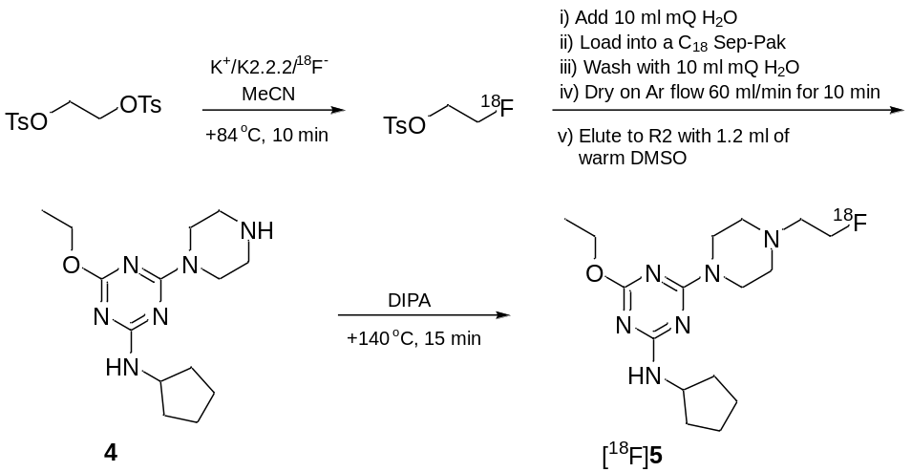Plasma stability of [¹⁸F]5 was investigated in anonymous donor human plasma (obtained from the Finnish Red Cross Blood Service, Helsinki, Finland, with institutional ethical permission for research use). Briefly, 1.2 MBq of [¹⁸F]5 in 20% EtOH–1×PBS (pH=7.4) was added to 0.5 mL of plasma and incubated at 37°C for 15–90 minutes. At the designated time points, 0.3 mL of 100% acetonitrile was added to precipitate the proteins, and the sample was centrifuged at 10000g for 5 minutes, and the radioactivities in the pellet (protein-bound fraction) and supernatant (free fraction) were measured on a dose calibrator (Capintec Inc.)

Scheme 1. Radiosynthesis of [¹⁸F]5
2.11. Ex vivo studies
All animal experimentation was performed according to the respective national and European legislation with an approved ethical license from the National Board on Animal Experimentation (Regional State Administrative Agency of Southern Finland, Hämeenlinna, Finland). Biodistribution of [¹⁸F]5 was investigated in male 8-10-week old Sprague-Dawley rats (strain Hsd:SD, Harlan, the Netherlands) after intravenous administration. The rats were group-housed in standard polycarbonate cages with aspen bedding with tap water and rodent feed (Harlan Teklad Global Diet 2018) available ad libitum. Lighting was set to a 12:12 rhythm and the temperature and humidity were controlled at a range of 21±1°C and 55±10%, respectively. For the intravenous injection, the animal was anesthetized with inhalation of isoflurane (IsoFlo Vet., Orion Pharma, Espoo, Finland) at 3.5% in 100% oxygen carrier at a flow rate of 1 L/min. Anesthesia was maintained with inhalation of 1.5-2% of isoflurane in 60:40 medical air-oxygen. The lateral tail vein was cannulated with a temporary 26-G catheter (BD Neoflon) that was flushed with 100 µl of 50 IU/mL heparin (Leo Pharma). [¹⁸F]5 was administered at a dose of 2.65±0.84 MBq (activity concentration 17.33-33.48 MBq/mL, 0.279-0.627 µg/mL) in 20% EtOH-1×PBS (pH=7.4) followed by a flush of the catheter with 100 µl of sterile 1×PBS (pH=7.4). The animals (n = 1-5 per group) were sacrificed by CO₂ asphyxiation followed by cervical dislocation at designated time points after tracer administration and samples of tissues and body fluids were collected for radioactivity measurements. Tissue samples were counted on an automated gamma counter (Wizard 3, PerkinElmer, Turku, Finland) for 60 seconds with three repeats for each sample. For the evaluation of the specificity of tracer uptake, three animals received a 3 mg/kg blocking dose of a selective CB₂ antagonist SR144528 (Cayman Chemical) intraperitoneally 10 minutes prior to the radiotracer administration.
3. Results and discussion
3.1. CB2R agonist activity
CB2 receptor activities of the compounds 1-10 were determined using [³⁵S]GTPγS binding assay as previously described (Table 1). The most potent compounds of the series were 6 and 9 which acted as full CB2R agonists (EC₅₀ 1.64 nM and 0.60 nM, respectively) in membranes prepared from human CB2-tranfected CHO-cells (Fig. 2A). CB2R-mediated response was verified by mock-transfected cell membranes. At rat cerebellar membranes, compounds 6 and 9 weakly stimulated CB1R-mediated G-protein activity (EC₅₀ 30.1 µM and 2.5 µM, respectively).

Table 1. The structures of the compounds 1-10 and their EC₅₀ values for the CB2R and CB1R agonist activity.
Entry | Structure | CB2 agonism  at 10 µM  (% basal)ª | CB2 E_{max}  (% basal) | CB2  EC₅₀ (nM) | CB1 agonism  at 10 µM  (% basal)ª | CB1 E_{max}  (% basal) | CB1  EC₅₀ (nM)
1 | 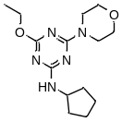 | 189  (182, 195) | 259* | 9017* | 101  (100, 102) | - | -
2 | 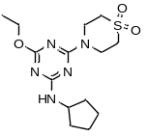 | - | 337  (312, 363) | 3755  (1876, 5633) | 103  (99,107) | - | -
3 | 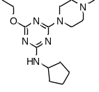 | - | 276  (272, 280) | 34.2  (26.8, 41.6) | 109  (102, 115) | - | -
4 | 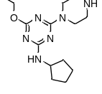 | 130  (127, 132) | - | - | 101  (96, 106) | - | -
5 | 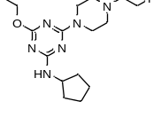 | - | 295  (295, 295) | 40.0  (18.0, 62.0) | 117  (115, 119) | - | -
6 | 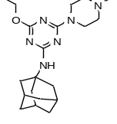 | - | 320  (293, 346) | 1.64  (1.38, 1.90) | - | 400  (397, 403) | 30140  (25110, 35170)
7 | 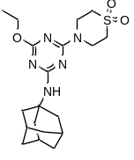 | - | 306  (305, 306) | 253  (173, 334) | 105  (103, 107) | - | -
8 | 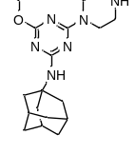 | - | 213  (190, 235) | 39.9  (4.87, 75.0) | 101  (97, 106) | - | -
9 | 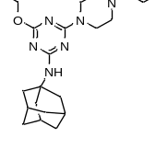 | - | 246  (246, 246) | 0.60  (0.57, 0.64) | - | 354  (351, 356) | 2472  (1929, 3015)
10 | 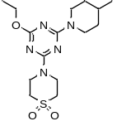 | - | 166  (164, 167) | 419  (331, 508) | 101  (98, 104) | - | -

ª CB1R or CB2R agonism at 10 µM ligand concentration. Values are mean with range of at least two experiments performed in duplicat,*except SY_106; n=1. The reference compound HU-210 was measured at 10 nM concentration and the CB2 agonism response was 275 ± 31 % basal (n=20).

Morpholinyl (1) and piperazinyl (4) substituted compounds, which are lacking the methyl group in R₂ ring of the hit structure 11, are only weak CB2R agonists. A great loss in CB2R activity was also observed when the methyl group of 11 was replaced with polar sulfonyl group (2), indicating the importance of the methyl in the R₂ ring structure. However, the N-adamantyl substituted compound 8, that is lacking N-methyl in piperazine ring, is a very potent CB2R agonist, and N-adamantyl thiomorpholine-1,1-dioxide substituted compound 7 was more potent than 2. This can be explained by the lipophilic nature of N-adamantyl substituent in position R₁. Nevertheless, adamantyl derivatives, due to high lipophilicity, are poorly soluble in water. The N-fluoroethyl substituted compounds 5 and 9 showed good CB2R agonist activity, indicating that larger moieties are allowed at the R₂ ring than just methyl. Replacing the N-methyl group of 3 with the N-fluoroethyl group of 5 resulted in nearly equal activity. When comparing N-methyl (6) and N-fuoroethyl (9) substituted compounds, the N-fluoroethyl seems to even increase the activity.
3.2. Distribution coefficients and water solubility of compounds 3, 6, 7 and 10
The measured distribution coefficients (logD) and water solubility of compounds 3, 6, 7 and 10 are shown in Table 3. Compound 3 is the most hydrophilic compound in all pH conditions whereas the compound 7 is so hydrophobic its logD values cannot be measured at pH=7.4 or pH 4. The compound 3 has also the highest water solubility at pH 7.4 (0.49 mg/ml) whereas in pH=4 and 1.2 both 3 and 6 are soluble (> 5.0 mg/ml).

Table 3. Measured logD values and solubilities for compounds 3, 6, 7 and 10.
LogD | 3 | 6 | 7 | 10
pH=7.4 | 2.78 ± 0.04 | 3.84 ± 0.06 | - | 2.89 ± 0.01
pH=4 | 1.07 ± 0.05 | 1.92 ± 0.04 | - | 2.75 ± 0.03
pH=1.2 | 0.02 ± 0.00 | -0.25 ± 0.02 | 1.74 ± 0.01 | 1.16 ± 0.03
Solubility (mg/ml) | 3 | 6 | 7 | 10
pH=7.4 | 0.49 ± 0.10 | 0.01 ± 0.00 | 8.7·10⁻⁶ ± 1.5·10⁻⁶ | 0.01 ± 0.00
pH=4 | > 5.0 | > 5.0 | 1.2·10⁻⁵ ± 2.5·10⁻⁶ | 0.01 ± 0.00
pH= 1.2 | > 5.0 | > 5.0 | 4.3·10⁻³ ± 1.7·10⁻⁴ | 0.73 ± 0.01

3.3. Human retinal pigment epithelial (RPE) cell line
Wei et al. (2009) have shown that the CB1R, CB2R and the endocannabinoid hydrolyzing enzyme FAAH are expressed in RPE cells, and that oxidative stress can upregulate CB1 and CB2 receptor expression whereas it downregulates FAAH expression. In addition, treatment of the RPE cells with the CB1R/CB2R agonist CP55,940 and the CB2R agonist JWH-015 have been shown to protect the cells from oxidative damage suggesting that cannabinoids may have therapeutic potential in the treatment of age-related macular degeneration (AMD). In our study, the RPE cells we used to test the cytotoxicity of the compounds 3 and 6.
Cells of human retinal pigment epithelium cell line ARPE-19 were exposed to several concentrations of CB2 receptor agonists 3, 6, and JWH-133, and the cell viability was measured using the neutral red methodology. As shown in Fig. 2B-D, this method did not reveal any cytotoxicity in ARPE-19 cells when used at concentrations 1 or 10 µM. Compound 6 and JWH-133 induced a significant decrease in the cell viability at the concentration of 30 µM. Instead, 3 was tolerated also at the 30 µM concentration (Fig. 2B-D).
3.4. Androgen-sensitive human prostate adenocarcinoma cell line
Cannabinoid receptor agonists have been suggested as potential therapeutics for the treatment of prostate cancer. Sarfaraz et al. (2005) reported that the expression of the CB1 and CB2 receptors are increased in human prostate cancer cells compared to the normal cells. They also showed that treatment of LNCaP cells with mixed CB1/CB2 agonist WIN55,212-2 results in inhibition of cell growth and induction of apoptosis whereas the treatment of normal prostate epithelial cells do not lead to apoptosis. The anticancer activity of the analogs 3, 5 and 6 created in this study were tested against the CB2R expressing LNCaP cell line.
Exposure to 6 for 72 h induced a concentration-dependent decrease in cell viability (Fig. 2E) with an IC₅₀ value of 7.30±1.41 µM (n=3). For compounds 3 and 5, the generation of a complete concentration-response curve was not possible in the range tested since they induced a significant effect only at the higher concentrations evaluated without reaching the 50 % of cell viability decrease. In the same experimental conditions, the known CB2R agonist JWH-133 induced a concentration-dependent cell viability decrease (Fig. 2E) with an IC₅₀ value of 12.40±1.38 µM (n=3) not statistically different from the value of compound 6. The possible antagonism by the CB2R selective antagonist AM630 (6-Iodopravadoline) could not be measured since this compound induced per se a significant cell viability decrease in this cell line (data not shown), with a mechanism probably unlinked to CB2 cannabinoid receptor.
3.5. Jurkat leukemia cell line
Human Jurkat leukemia cell line have been shown to express CB2 receptor whereas no significant levels of CB1 receptor have been detected (Rieder et al., 2010). Phytocannabinoids ∆⁹-tetrahydrocannabinol (THC) and cannabidiol are known to induce apoptosis of cancer cells with mechanisms including the CB2R (Rieder et al., 2010; Herrera et al., 2006).
In this study, compounds 3, 5 and 6 were evaluated in leukemia cells. As for prostate cells, we were unable to measure IC₅₀ values for compounds 3 and 5. On the contrary, compound 6 induced a cell viability decrease (Fig. 2F) with an IC₅₀ value of 29.06 ± 0.66 µM. The selective CB2R agonist JWH-133 induced a concentration-dependent cell viability decrease (Fig. 2F) with an IC₅₀ value significantly lower than that of compound 6 (5.95 ± 0.5 µM). In order to verify if the compound 6 cytotoxic activity was due to CB2 receptor activation, the selective CB2R antagonist AM630, was also tested at 1 µM; this concentration was not cytotoxic for these cells and completely reversed the effect of compound 6 (Fig. 2G)
3.6. Melanoma cell line
CB2 and melanoma. Melanoma cell lines B16 and A375 have been reported to express functionally active CB1 and CB2 receptors (Blázquez et al., 2006). The same study showed that the activation of the CB2R inhibits melanoma cell growth both in vitro and in vivo. In addition, based on in vitro studies the cannabinoids seemed to have antiproliferative effects selectively in tumor cells but not in nontumorigenic melanocytes (Blázquez et al., 2006). To study the effect of 3 and 6 on melanoma cell proliferation, human melanoma C8161 cells were treated with various concentrations of the CB2R ligands (1-100 µM) for three days. Cells were harvested and counted with hemacytometer after 24 h, 48 h and 72 h treatment. Compound 3 had only minor effect on C8161 melanoma cell proliferation, while 6 decreased cell number in a concentration-dependent manner (data not shown). 10 µM concentration of 6 diminished proliferation of C8161 melanoma cells to approximately 40 % and this concentration was used in experiments with the CB1R and CB2R antagonists. SR144528 (1 µM), an inverse agonist of the CB2R, and AM251 (1 µM), an inverse agonist of the CB1R, had no effect on C8161 melanoma cell proliferation, nor they were able to reverse the effect of 6 on cell proliferation (Fig. 2H). This suggests that antiproliferative effect of 6 on the C8161 melanoma cells is not mediated via the CB1R or CB2R, and high concentrations of 6 have nonspecific targets in these cells. Previous studies related to the ECS in the C8161 melanoma cells are sparse. It has been shown that the main metabolic enzyme of 2-arachidonoyl glycerol (2-AG), monoacylglycerol lipase (MAGL), is active in these cells (Nomura 2010, Aaltonen 2013). However, in the study of Aaltonen et al. selective inhibition of MAGL with JJKK-048 or JZL-184 did not affect proliferation, migration or invasiveness of C8161 melanoma cells (Aaltonen 2013). Whether this is an indication of the fact that these cells do not have functionally active cannabinoid receptors that are needed for the antiproliferative activity, remains to be clarified.
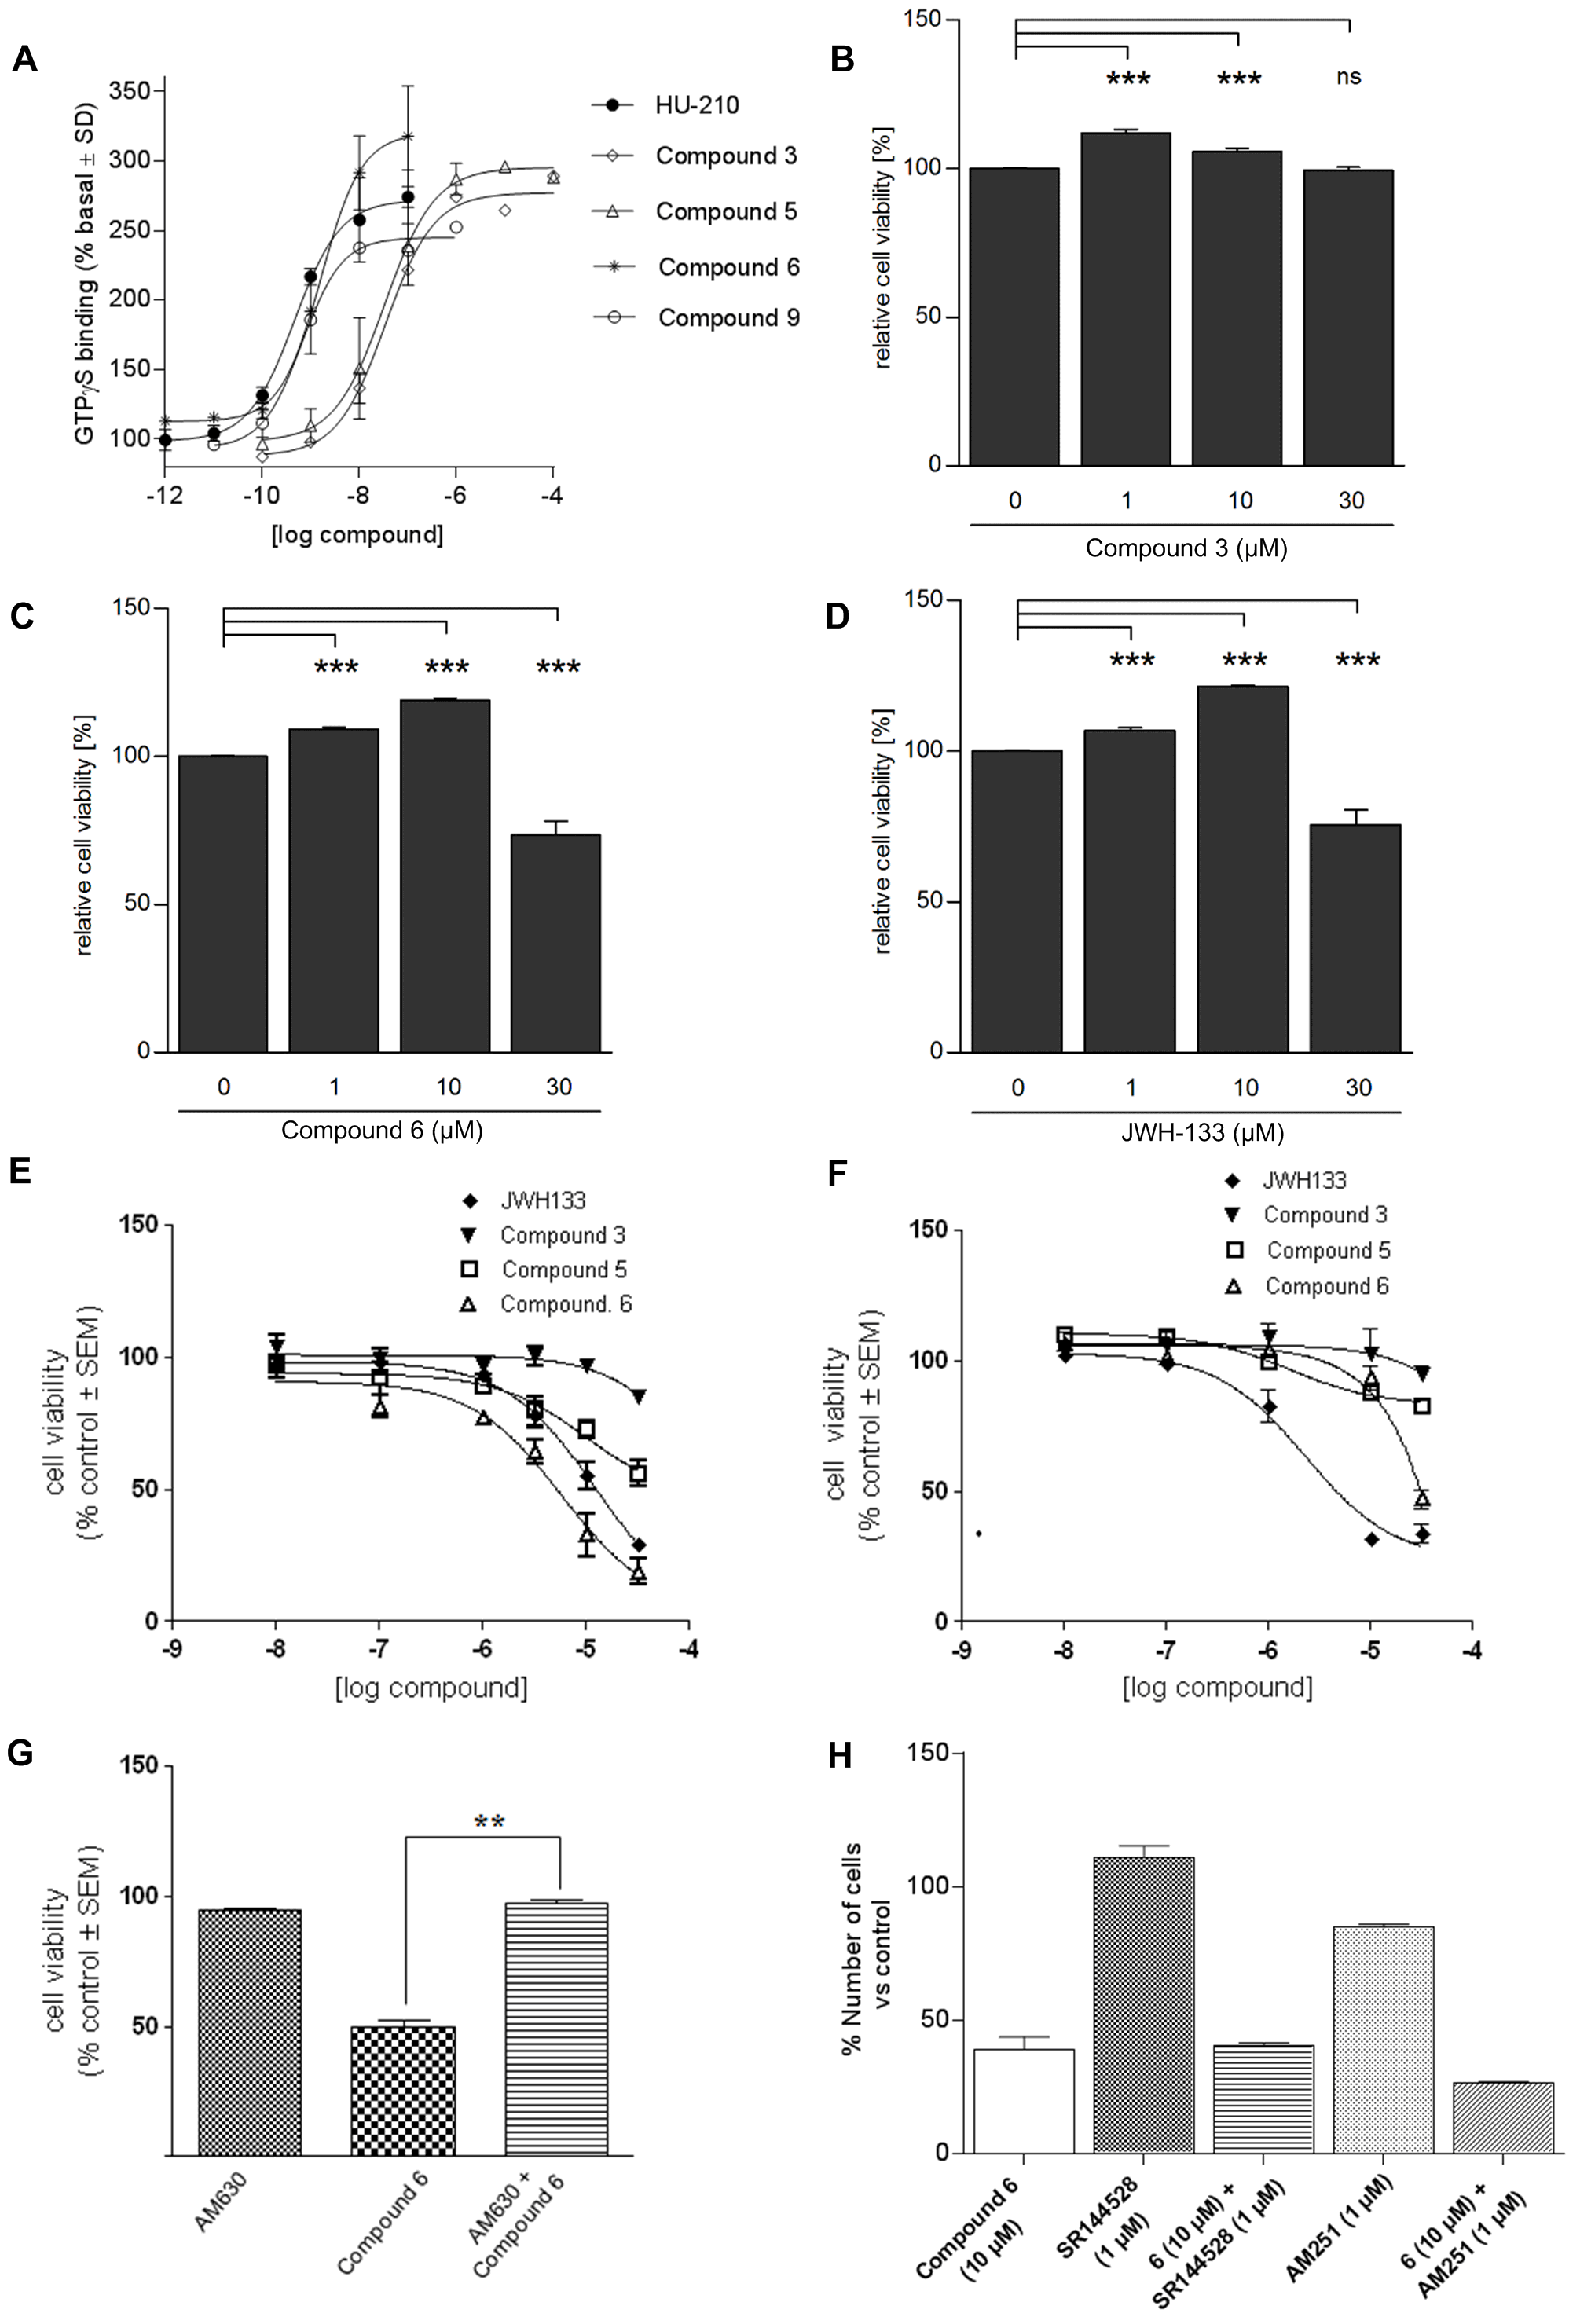

Fig. 2. (A) Dose-response curves for compounds 3, 5, 6, 9 and for a known full CB2 receptor agonist HU-210 determined by using [³⁵S]GTPγS binding assay. (B, C, D) Viability of ARPE-19 cells upon exposure to CB2 receptor agonists. ARPE-19 cells were treated with indicated concentrations of CB2 receptor agonists 3, 6, and JWH-133 for 24h. Data are combined from four independent experiments with six parallel samples in each group/experiment. Cells without the CB2 receptor agonist treatment were exposed to 0.3 % DMSO, which is corresponding to the highest DMSO concentration in CB2 receptor agonist dilutions. Results are presented as mean ± SEM. ***P < 0.001, ns - “not significant”, Mann-Whitney U-test. (E) Concentration-response curves to 3, 5, 6 and JWH-133 on LNCaP cells. Data are the mean+SE of three experiments carried out in triplicate. (F) Concentration-response curves to 3, 5, 6 and JWH-133 on Jurkat cells. Data are the mean+SE of three experiments carried out in triplicate. (G) Jurkat cell viability after 72h of treatment with 6 (30 µM), AM630 (1 µM) and 6 (30 µM) in the presence of AM360 (1 µM). Data are the mean+SE of three experiments carried out in triplicate. (H) C8161 melanoma cell number after 72 h treatment with 6 (10 µM) with or without SR144528 (1 µM) and AM251 (1 µM). Data represent the mean+SD of three experiments.

3.7. In vitro stability study
Compound 5 was intact after exposed to degradation in 50 % (v/v in TRIS buffer pH=7.4) rat liver homogenate for 4 h, indicating that the compound is metabolically stable.
3.8. [¹⁸F]5 radiolabeling and ex vivo biodistribution
Compound 5 was radiolabeled with [¹⁸F]fluoroethyltosylate with decay-corrected radiochemical yield of 0.89-2.15% (from ¹⁸F⁻, n=10) at high specific radioactivities of 109-438 GBq/µmol. The radiolabeling presursor [¹⁸F]fluoroethyltosylate, however, was produced consistently at yields ranging from 40-65 %, suggesting that the subsequent fluoroalkylation step was the culprit explaining the low overall radiochemical yield. Despite dire efforts to improve the yield of the fluoroalkylation by selection of the base used for the deprotonation of the piperazine nitrogen, only diisopropylamine (DIPA) resulted in yields exceeding 10 % (calculated from [¹⁸F]fluoroethyltosylate). However at this stage we decided that the obtained overall yield was satisfactory to give enough product for the preliminary in vivo evaluation of [¹⁸F]5, and further optimization of the radiolabeling procedure was left for the future warranted that the tracer proved successful in the selected animal model. [¹⁸F]5 was stable in human plasma for up to 90 minutes, displaying an increase in the fraction of plasma protein bound tracer from 4.72±0.10 % (15-30 min) to 5.95±0.16 % (60-90 min).
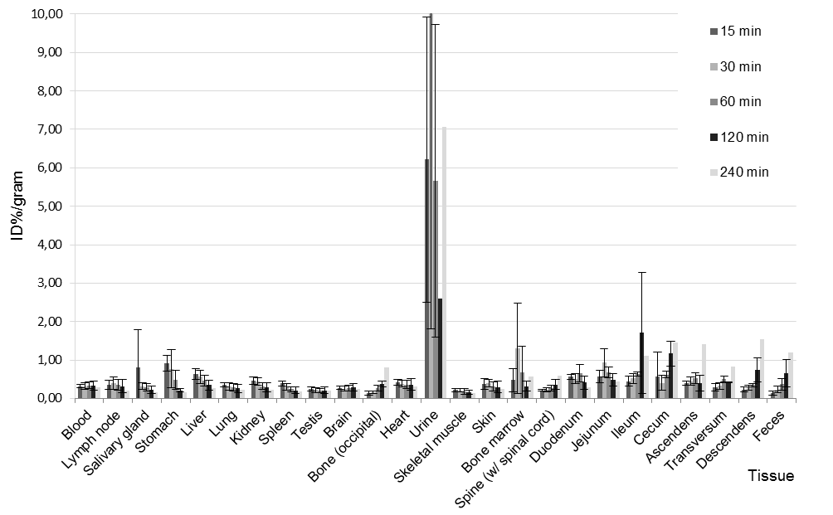
Fig. 3. [¹⁸F]5 biodistribution in male SD rats, 260-290 g after i.v. administration
After intravenous administration of [¹⁸F]5 to male Sprague-Dawley rats, the tracer showed a rapid (<15 minutes) elimination in urine accompanied by a slower excretion via the hepatobiliary route over time (Fig. 3). A slight defluorination of the tracer at the later time points is apparent from the results of occipital bone and spine, but this is at an acceptable level. In other tissues including the brain the detected radioactivity levels were only reflective of the respective plasma levels of the tracer at the designated time point. We did not observe pronounced uptake to the spleen (0.39±0.06 ID%/g, n=5, 15 minutes) a tissue known to express CB2R in multiple species including rats and mice based on mRNA expression levels (Pertwee, 1997). Curiously, the stomach showed even a higher accumulation of the injected dose (0.92±0.21 ID%/g, n=5, 15 minutes) compared to the spleen, possibly corroborating the presence of CB2R in the stomach under normal conditions (Duncan, 2008). It should be noted, however, that most of the evidence for the presence of CB2R in peripheral tissues in healthy animals is derived from mRNA expression rather than immunohistochemistry or molecular imaging, suggesting that the target might not be abundant enough to permit detection with antibodies or imaging agents in all cases, albeit the spleen is commonly used as a reference tissue for the CB2R specificity of radiotracers (Evens 2008, Horti 2010, Mu 2013). Furthermore, pretreatment with 3 mg/kg of SR144528 a selective CB2 antagonist did not block the binding of [¹⁸F]5 in the any of the tissues studied at 15 minutes after tracer administration. It could be that the radiotracer is simply eliminated so fast from the circulation that the transient binding to CB2R expressing organs could not be captured at the 15-minute time point which was the earliest at which the animals were sacrificed. A dynamic in vivo small animal PET study would be able to assess the tracer kinetics immediately upon administration better than a conventional ex vivo dissection setup, but the latter is warranted for rapid quantitative determination of tracer uptake in multiple organs. Recent studies with CB2R tracers radiolabeled with short-lived positron emitters have concerted their efforts for the imaging of CB2R expression in neuroinflammation in the central nervous system in animal models and human tissues in vitro, and the focus of the tracer development has been targeted towards attaining properties that are beneficial for brain imaging. The proof of concept was obtained with biodistribution studies of the [¹¹C] A-836339 which showed that the CB2 receptors binding in the neuroinflammation can be measured in vivo (Horti et al., 2010). However, only one compound, [¹¹C]NE40, has been tested in healthy humans and none in pathological conditions (Ahmad et al., 2013). In addition, many of the compounds reported as potential CB2R PET ligands have problems, such as poor in vivo stability, poor water solubility and problematic radiometabolites, or the compounds have not yet been fully characterized and further studied (Evens et al., 2008; Gao et al., 2010; Fujinaga et al., 2010; Evens et al., 2011; Rühl et al., 2012; Turkman et al., 2012; Mu et al., 2013). One of the latest reported candidates for a new CB2 radioligand is a ¹⁸F-labelled 1,3,5-triazine based compound (12, Fig. 4) (Hortala et al., 2014). Preliminary evaluation of the compound was made in rhesus macaque and baboon, and it was reported to show good brain uptake and moderate washout over time, the structure being metabolically stabilized with the addition of the [¹⁸F]fluorodeuteromethane in lieu of a [¹⁸F]fluoromethane group.

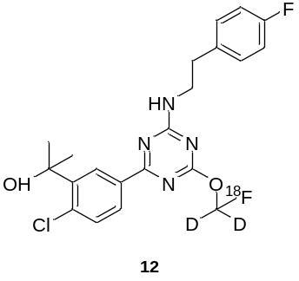
Fig. 4. 1,3,5-triazine based candidate for a new CB2 radioligand reported by Hortala et al. in 2014.

4. Conclusions
1,3,5-triazine scaffold offers an interesting and versatile template for CB2R agonist design. In this study, we continued our previous work and enhanced the water solubility of 2,4,6-trisubstituted 1,3,5-triazines by introducing polar groups. The resulted compounds turned out to be even more potent CB2R agonists than the previous analogs, the best compound (9) having the EC₅₀ value of 0.60 nM.
In order to evaluate the applicability of the analogs as pharmacological tools, the selected compounds were tested in retinal (ARPE-19) and various cancer cell lines. Tests with the ARPE-19 cell line showed that compounds 3 and 6 are not cytotoxic at concentrations of 1 and 10 µM as measured by the neutral red uptake inhibition assay. However, compound 6 caused a significant decrease in the cell viability at the concentration of 30 µM, concentration at which compound 3 was tolerated as well. The tests with cancer cell lines gave interesting results as compound 6 seemed to induce a concentration-dependent decrease in cell viability in androgen-sensitive human prostate adenocarcinoma cells and Jurkat leukemia cells, and to diminished proliferation of C8161 melanoma cells. However, the CB2R mediated response could be shown only with the case of leukemia cells as the results could be reversed with the selective CB2 antagonist AM630. In the case of prostate and melanoma cells, the mechanism of action of the compound 6 is still unclear. It also remains to be clarified whether the melanoma cells have functionally active cannabinoid receptors that are mediating the antiproliferative activity.
Based on our findings with [¹⁸F]5 it became apparent that the promising in vitro findings with the non-radiolabeled compound 5 were not being translated to good properties in vivo. The rapid elimination of the radiotracer likely results to a too low plasma levels of the circulating [¹⁸F]5 hampering efficient uptake to the spleen. We cannot, however, conclude that the elimination would be due to the rapid formation of a hydrophilic metabolite of [¹⁸F]5 upon administration, since the non-radioactive compound was deemed to be stable in rat liver homogenate for extended periods of time. Furthermore, we cannot rule out that the tracer would have performed better in an animal model with localized induced overexpression of the CB2R target (such as an LPS-induced inflammation model), as it could be that receptor density in the healthy conditions is not high enough to permit their detection especially if the tracer concentration in plasma is extremely low due to poor pharmacokinetic profile. In conclusion from our in vitro studies corroborated by the recent findings of Hortala et al., the 1,3,5-triazine scaffold is, however, an extremely promising candidate for the development of new CB2R PET ligands, but future efforts need to be targeted for the optimization of the circulatory properties and in vivo CB2R binding.
5. Acknowledgements
This work was supported by the Academy of Finland (decision nos. 128056 and 127653) and the National Graduate School of Organic Chemistry and Chemical Biology. The authors are grateful to Mrs Tiina Koivunen, Mrs Miia Reponen, and Mrs Helly Rissanen for technical assistance. Dr. A.J. Airaksinen acknowledges the Academy of Finland (decision nos. 136805 and 272908)

6. References
Aaltonen, N., Savinainen, J.R., Ribas, C.R., Rönkkö, J., Kuusisto, A., Korhonen, J., Navia-Paldanius, D., Häyrinen, J., Takabe, P., Käsnänen, H., Pantsar, T., Laitinen, T., Lehtonen, M., Pasonen-Seppänen, S., Poso, A., Nevalainen, T., Laitinen, J.T., 2013. Piperazine and piperidine triazole ureas as ultrapotent and highly selective inhibitors of monoacylglycerol lipase. Chem Biol. 20(3), 379-90.
Ahmad, R., Koole, M., Evens, N., Serdons, K., Verbruggen, A., Bormans, G., Van Laere, K., 2013. Whole-body biodistribution and radiation dosimetry of the cannabinoid type 2 receptor ligand [¹¹C]-NE40 in healthy subjects. Mol Imaging Biol. 15(4), 384-90.
Blázquez, C., Carracedo, A., Barrado, L., Real, P.J., Fernández-Luna, J.L., Velasco, G., Malumbres, M., Guzmán, M., 2006. Cannabinoid receptors as novel targets for the treatment of melanoma. FASEB J. 20(14), 2633-5.
Coburn, G.A., Han, A.Q., Provoncha, K.P., Rotshteyn, Y., Progenics Pharmaceuticals, Inc. WO/2009/091388 A2
Duncan, M., Mouihate, A., Mackie, K., Keenan, C.M., Buckley, N.E., Davison, J.S., Patel, K.D., Pittman, Q.J., Sharkey, K.A., 2008. Cannabinoid CB2 receptors in the enteric nervous system modulate gastrointestinal contractility in lipopolysaccharide-treated rats. Am J Physiol Gastrointest Liver Physiol. 295(1), G78-G87.
Evens, N., Bosier, B., Lavey, B.J., Kozlowski, J.A., Vermaelen, P., Baudemprez, L., Busson, R., Lambert, D.M., Van Laere, K., Verbruggen, A.M., Bormans, G.M., 2008. Labelling and biological evaluation of [(11)C]methoxy-Sch225336: a radioligand for the cannabinoid-type 2 receptor. Nucl Med Biol. 35(7), 793-800.
Evens, N., Vandeputte, C., Muccioli, G.G., Lambert, D.M., Baekelandt, V., Verbruggen, A.M., Debyser, Z., Van Laere, K., Bormans, G.M., 2011. Synthesis, in vitro and in vivo evaluation of fluorine-18 labelled FE-GW405833 as a PET tracer for type 2 cannabinoid receptor imaging. Bioorg Med Chem. 19(15), 4499-505.
Evens, N., Vandeputte, C., Coolen, C., Janssen, P., Sciot, R., Baekelandt, V., Verbruggen, A.M., Debyser, Z., Van Laere, K., Bormans, G.M., 1012. Preclinical evaluation of [11C]NE40, a type 2 cannabinoid receptor PET tracer. Nucl Med Biol. 39(3), 389-99.
Fujinaga, M., Kumata, K., Yanamoto, K., Kawamura, K., Yamasaki, T., Yui, J., Hatori, A., Ogawa, M., Yoshida, Y., Nengaki, N., Maeda, J., Zhang, M.R., 2010. Radiosynthesis of novel carbon-11-labeled triaryl ligands for cannabinoid-type 2 receptor. Bioorg Med Chem Lett. 20(5), 1565-8.
Gao, M., Wang, M., Miller, K.D., Hutchins, G.D., Zheng, Q.H., 2010. Synthesis and in vitro biological evaluation of carbon-11-labeled quinoline derivatives as new candidate PET radioligands for cannabinoid CB2 receptor imaging. Bioorg Med Chem. 18(6), 2099-106.
Han, S., Thatte, J., Buzard, D.J., Jones, R.M., 2013. Therapeutic Utility of Cannabinoid Receptor Type 2 (CB2) Selective Agonists. J Med Chem. 56(21), 8224-56.
Herrera, B., Carracedo, A., Diez-Zaera, M., Gómez del Pulgar, T., Guzmán, M., Velasco, G., 2006. The CB2 cannabinoid receptor signals apoptosis via ceramide-dependent activation of the mitochondrial intrinsic pathway. Exp Cell Res. 312(11), 2121-31.
Hortala, L., Arnaud, J., Roux, P., Oustric, D., Boulu, L., Oury-Donat, F., Avenet, P., Rooney, T., Alagille, D., Barret, O., Tamagnan, G., Barth, F., 2014. Synthesis and preliminary evaluation of a new fluorine-18 labelled triazine derivative for PET imaging of cannabinoid CB2 receptor. Bioorg Med Chem Lett. 24(1), 283-7.
Horti, A.G., Gao, Y., Ravert, H.T., Finley, P., Valentine, H., Wong, D.F., Endres, C.J., Savonenko, A.V., Dannals, R.F., 2010. Synthesis and biodistribution of [11C]A-836339, a new potential radioligand for PET imaging of cannabinoid type 2 receptors (CB2). Bioorg Med Chem. 18(14), 5202-7.
Lambert, D.M., Fowler, C.J., 2005. The endocannabinoid system: drug targets, lead compounds, and potential therapeutic applications. J Med Chem. 48(16), 5059-87.
Lu, D., Meng, Z., Thakur, G.A., Fan, P., Steed, J., Tartal, C.L., Hurst, D.P., Reggio, P.H., Deschamps, J.R., Parrish, D.A., George, C., Järbe, T.U., Lamb, R.J., Makriyannis, A., 2005. Adamantyl cannabinoids: a novel class of cannabinergic ligands. J Med Chem. 48(14), 4576-85.
Mu, L., Bieri, D., Slavik, R., Drandarov, K., Müller, A., Cermak, S., Weber, M., Schibli, R., Krämer, S.D., Ametamey, S.M., 2013. Radiolabeling and in vitro /in vivo evaluation of N-(1-adamantyl)-8-methoxy-4-oxo-1-phenyl-1,4-dihydroquinoline-3-carboxamide as a PET probe for imaging cannabinoid type 2 receptor. J Neurochem. 126(5), 616-24.
Nomura, D.K., Long, J.Z., Niessen, S., Hoover, H.S., Ng, S.W., Cravatt, B.F., 2010. Monoacylglycerol lipase regulates a fatty acid network that promotes cancer pathogenesis. Cell. 140(1), 49-61.
Pacher, P., Bátkai, S., Kunos, G., 2006. The endocannabinoid system as an emerging target of pharmacotherapy. Pharmacol Rev. 58(3), 389-462.
Pacher, P., Kunos, G., 2013. Modulating the endocannabinoid system in human health and disease -successes and failures. FEBS J. 280(9), 1918-43.
Pacher, P., Mechoulam, R., 2011. Is lipid signaling through cannabinoid 2 receptors part of a protective system? Prog Lipid Res. 50(2), 193-211.
Pertwee, R. G., 1997. Pharmacology of cannabinoid CB1 and CB2 receptors. Pharmacol Ther. 74(2), 129-80.
Repetto, G., del Peso, A., Zurita, J.L., 2008. Neutral red uptake assay for the estimation of cell viability/cytotoxicity. Nat Protoc. 3(7), 1125-31.
Rieder, S.A., Chauhan, A., Singh, U., Nagarkatti, M., Nagarkatti, P., 2010. Cannabinoid-induced apoptosis in immune cells as a pathway to immunosuppression. Immunobiology. 215(8), 598-605.
Rühl, T., Deuther-Conrad, W., Fischer, S., Günther, R., Hennig, L., Krautscheid, H., Brust, P., 2012. Cannabinoid receptor type 2 (CB2)-selective N-aryl-oxadiazolyl-propionamides: synthesis, radiolabelling, molecular modelling and biological evaluation. Org Med Chem Lett. 2(1), 32.
Sarfaraz, S., Afaq, F., Adhami, V.M., Mukhtar, H., 2005. Cannabinoid receptor as a novel target for the treatment of prostate cancer. Cancer Res. 65(5), 1635-41.
Savinainen, J.R., Saario, S.M., Niemi, R., Järvinen, T., Laitinen, J.T., 2003. An optimized approach to study endocannabinoid signaling: evidence against constitutive activity of rat brain adenosine A1 and cannabinoid CB1 receptors. Br J Pharmacol.140, 1451–1459.
Savinainen, J.R., Kokkola, T., Salo, O.M.H., Poso, A., Järvinen, T., Laitinen, J.T., 2005. Identification of WIN55212-3 as a competitive neutral antagonist of the human cannabinoid CB2 receptor. Br J Pharmacol. 45, 636-645.
Turkman, N., Shavrin, A., Paolillo, V., Yeh, H.H., Flores, L., Soghomonian, S., Rabinovich, B., Volgin, A., Gelovani, J., Alauddin, M., 2012. Synthesis and preliminary evaluation of [18F]-labeled 2-oxoquinoline derivatives for PET imaging of cannabinoid CB2 receptor. Nucl Med Biol. 39(4), 593-600.
Wei, Y., Wang, X., Wang, L., 2009. Presence and regulation of cannabinoid receptors in human retinal pigment epithelial cells. Mol Vis. 15, 1243-51.
Welch, D.R., Bisi, J.E., Miller, B.E., Conaway, D., Seftor, E.A., Yohem, K.H., Gilmore, L.B., Seftor, R.E., Nakajima, M., Hendrix, M.J., 1991. Characterization of a highly invasive and spontaneously metastatic human malignant melanoma cell line. Int J Cancer. 47, 227-237.
Yrjölä, S., Kalliokoski, T., Navia-Paldanius, D., Laitinen, T., Nevalainen, T., Poso, A., 2011. Ligand-based virtual screening for cannabinoid ligands. Poster session presented at: 21st Annual symposium of the International Cannabinoid Research Society 2011 Jul 5-10, St. Charles, IL, USA.
Yrjölä, S., Kalliokoski, T., Laitinen, T., Poso, A., Parkkari, T., Nevalainen, T., 2013. Discovery of novel cannabinoid receptor ligands by a virtual screening approach: further development of 2,4,6-trisubstituted 1,3,5-triazines as CB2 agonists. Eur J Pharm Sci. 48(1-2), 9-20.

