pre print draft of:
Crisci, A., Rota, A., Panzani, D., Sgorbini, M., Ousey, J.C., Camillo, F.
Clinical, ultrasonographic, and endocrinological studies on donkey pregnancy.
published in: Theriogenology
Volume 81, Issue 2, 15 January 2014, Pages 275-283

Clinical, ultrasonographic and endocrinological studies on donkey pregnancy

Angelica Crisciª, Alessandra Rotaª, Duccio Panzaniª, Micaela Sgorbiniª, Jenny C. Ousey^{b}, Francesco Camilloª

ª Department of Veterinary Sciences, University of Pisa, Via Livornese lato monte, 56010 San Piero a Grado (PI), Italy.
^{b} Rossdale & Partners, Newmarket, Suffolk, CB8 8JS, England.

Corresponding author: Alessandra Rota, Department of Veterinary Sciences, University of Pisa, Via Livornese lato monte, 56010 San Piero a Grado (PI), Italy. E-mail: alerota@vet.unipi.it

Abstract
Although donkey breeding has gained new interest in the last two decades, knowledge about donkey reproduction is still scarce, particularly on jennies pregnancy. The aim of this study was to describe the ultrasonographic and endocrine profiles of the physiological pregnancy in the jenny. The study was performed on 12 pregnancies of 7 Amiata donkeys from day 10 post-ovulation to delivery. As three pregnancies, respectively at weeks 42, 44 and 45, where considered pathologic and treated pharmacologically, data collected from 2 weeks before diagnosis to the end of pregnancy were removed from analysis. Average length of the normal pregnancies was 353.4±13.0 days (range: 339-370). Timing, dimensions and development during the first phases of embryonic growth, evaluated by transrectal ultrasound, were similar to that previously described in jennies and mares: first detection of embryonic vesicle was at 11.8 ± 1.3 days of gestation and diameter was 6.5 ± 1.9 mm, loss of spherical shape occurred at 18.5 ± 1.4 days while embryo and heart beat were first seen at 22.0 ± 1.1 and 25 ± 1.1 days, respectively. The intrauterine growth in the second half of pregnancy, evaluated both by the transrectal and transabdominal approach, also showed strong positive correlations, similar to that reported for the mare. The trends of the combined thickness of the utero-placental unit and the echogenicity of the amniotic and allantoic fluids are examples. The diameters (cm) of fetal chest, eye orbit and aorta increased throughout pregnancy and were 40.6 ± 2.9, 8.7 ± 1.5, 3.5 ± 0.7, respectively, at week 13 and 190.9 ± 12.0, 21.4 ± 1.5, and 30.6 ± 1.8 cm at the last evaluation before parturition. In contrast, heart rate decreased as pregnancy progressed. Regression analyses between these parameters and day of gestation were statistically significant (P<0.001). All fetuses consistently showed some intrauterine activity. Maternal plasma progestagens and estrone sulphate concentrations followed a pattern similar to that seen in mares, although the prepartal progestagen peak was lower in jennies. This study provides a range of ultrasonographic and endocrine values for normal pregnancy in jennies.

Keywords: donkey, pregnancy, ultrasound, fetus, progestagens, estrone sulphate.

1. Introduction

World donkey population is estimated to be 44 million [1]. They are located primarily in the regions of the world where the infrastructure is not well developed, where they are used as working animals. In contrast, donkey numbers are limited in the more industrialized countries, where autochthonous breeds are at risk of extinction. In Italy, a 96% decrease in the donkey population occurred between 1939 and 1996, but in the last two decades the interest in donkey breeding has increased because, among other reasons (e.g.: working or companion animals, pet-therapy) they have been used as milk producing animals [1, 2]. Thus, previously donkey reproduction was not much studied, but knowledge in this field has now increased in importance.

The use of ultrasound to evaluate pregnancy and fetal well being has been used in the horse since 1980 [3]. In donkeys, a limited number of studies evaluated the development of the equine conceptus up to day 60 of pregnancy [4-7]. There are no data, however, beyond this stage of pregnancy, with the exception of a study on fetal sex determination [8]. In the horse, however, clinical use of transabdominal ultrasound in later pregnancy established normal values for several fetal and maternal parameters, such as fetal size, growth and activity [9-13], and mother-fetus exchanges [10,11,13,14]. Recently, a study described the ultrasonographic features of the mule (hybrid derived from a horse mare and a donkey jack) embryo, fetus and fetal-placental unit throughout pregnancy [15]. This type of examination has clinical application by enabling the diagnosis of some abnormalities before parturition [9, 10, 16-18].

Endocrinology during gestation has been studied in depth in the mare [19-33]. In contrast, data for the donkey are scarce, mainly limited to the first half of pregnancy [19,20] or to its final phases [34,35], except for one study which describes the progesterone and estradiol profile throughout the entire jenny pregnancy [36]. In mares, the two hormones most frequently evaluated during pregnancy are progesterone/progestagens and estrogens. Progesterone is produced initially by the primary corpus luteum and later by the accessory corpora lutea; its role in maintaining the pregnancy is progressively taken by the progestagens of feto-placental origin, which are significantly elevated in the last weeks prior to parturition and decreasing in the 24-48 hours before parturition [21,22]. Progesterone is at basal levels (<1 ng/ml) from half of gestation on, while other progestagens may exceed 500 ng/ml in late gestation [23] and act on mammary gland development and electrolyte changes in milk [24]. All progestagens originate from pregnenolone, produced in large amounts by the fetus, released into the umbilical artery and converted by the utero-placental unit into different progestagens, some of which return to the fetus for further metabolism and some are excreted directly into the maternal circulation [25, 26]. Many clinical condition of the placenta or fetus may alter progestagen metabolism and hence plasma concentrations [24, 27-29]. Estrogens are present in high concentrations in the mid-phases of equine pregnancy (up to 1000 ng/ml) and they reflect the huge development and regression of the fetal gonads [22,30-31]. The main equine estrogens are estrone sulphate, estradiol-17β, equilin, equilenin, originating from dihydroepiandrosterone and related compounds [32]. Their main function is to stimulate blood flow in the placenta and endometrium, and the synthesis and storage of PGF2a in the myometrium [22-26]. As the precursor originates from the fetal gonads, measurement of plasma concentration of estrone sulphate which is the most abundant estrogen in equine pregnancy, may provide an estimate of fetal viability and well being [27, 29, 33]. Overall, the previous studies on endocrinology of pregnancy in donkeys showed similarities to that found in mares, although some differences (e.g. in serum eCG concentrations, or prepartal progestagen profile) were observed [19,20,35,36].

The aim of this study was to describe the physiological aspects of ultrasonograpic findings and endocrinology during pregnancy in jennies.

2. Materials and methods

2.1 Animals
The study was conducted between 2006 and 2009 on 12 pregnancies of 7 jennies belonging to the Amiata donkey breed. Jennies were 5-12 years old, weighed 300-350 kg and were kept in collective paddocks at the Veterinary Teaching Hospital, Department of Veterinary Sciences, Pisa University (43° 43’ N), fed with a balanced ration of meadow hay ad libitum and commercial equine feed. Close to parturition, jennies were kept in stables at night. All jennies were treated for gastrointestinal parasites and vaccinated for influenza and EHV 1 and 4 using the AAEP guidelines for horses.

2.2 Management of estrous cycle and parturition
Jennies in estrous were daily examined by ultrasound and either mated or inseminated every second day until ovulation was confirmed (day of ovulation: day 0). At parturition, presentation and viability of the foals was evaluated, and sex of the foals was registered.

2.3 Ultrasonographic assessment from pregnancy diagnosis to day 145 (week 21) = first phase

On 8 pregnancies from 7 jennies, transrectal ultrasonography (Toshiba JustVision 200, semiconvex probe PVF-738F, 5-7 MHz) was performed every second day between days 10 and 40 and weekly between days 40 and 145 (week 21) post-ovulation. Day 40 was considered the limit between embryonic and fetal phase [21]. The parameters evaluated on the embryonic vesicle (EV) were the following: appearance and diameter of the EV, day and size of the fixation of the EV, day of the loss of spherical appearance of the EV, first appearance and size of the embryo, onset of heart beat (HB), first appearance of the allantoic sac (AS) and of the umbilical cord (UC). In the fetus, the crown- rump length, the first appearance and size of the thorax, eye orbit and aorta, and the first appearance of the stomach were recorded.

2.4 Ultrasonographic assessment from day 150 (week 22) to term = second phase

Seven jennies, with a total of 12 pregnancies, were monitored weekly from day 150 to foaling by transrectal (TRU, Toshiba SSA-350A Corevision Pro, Toshiba semiconvex probe PVF-738F, 5-7 MHz) or transabdominal (TAU, Toshiba SSA-350A Corevision Pro, Toshiba convex probe PVF-375AT, 3Mhz) ultrasound. The following parameters were studied: Combined thickness of the utero-placental unit at the cervical pole (CTUP), measured both by TRU and by TAU, along the linea alba, in a 10x10 cm area cranial to the mammary gland [14]; echogenecity of amniotic (EAM) and allantoic fluid (EAL), both scored 1 to 4 [14]; foetal presentation (by TAU) classified as dorsosacral (DS), right dorso-ilial (DI-rg), left dorso-ilial (DI-lf) and dorsopubic (DP) based on the position of stomach and spinal cord of the foetus; the maximum chest transverse diameter, measured by TAU from rib to rib; diameter of foetal eye orbit (by TRU or TAU, perpendicular to the long axis of the crystalline lens; diameter of foetal aorta (by TAU) as previously described [13], foetal heart rate (FHR) measured by TAU by pulsated Doppler [37]; foetal motility (FM), scored 0 to 3, according to the proportion of time during the evaluation in which movements were present (0= no movement, 1=< 33%, 2=33-66%, 3=>66%) [11]. Values obtained for CTUP measured from TRU or TAU, chest, eye orbit and aorta diameters and FHR resulted from the mean of 3 measurements taken during the same session.

During the last two years of the study in the second phase of pregnancy, sexing of fetuses was attempted in five pregnancies. The gonads and external genitalia were evaluated by TAU, except when the foal was in posterior presentation when TRU was used [37].

2.5 Hormone analyses

Plasma concentrations of progesterone/progestagens ([Pr]) and estrone sulphate ([E₁S]) were evaluated in 7 pregnancies from 7 different jennies. Samples for [Pr] were collected every three weeks between week 9 and week 39 and weekly between week 40 and parturition. Samples for [E₁S] were collected every three weeks between week 9 and week 44 and weekly between week 45 and parturition. Blood samples were collected from the jugular vein in lithio-heparinized Vacutainer® vials, thereafter plasma was separated by centrifugation within 30 min from collection and stored at -18°C in eppendorf vials until evaluation. For the evaluation of [Pr] an ELISA-kit (Immulite Progesterone: Siemens Healthcare Diagnostics Camberley Surrey UK) was employed, as previously described [38] with the following antibody cross-reactivity: 100% progesterone, 1.6% 5α-dihydroprogesterone, 1.04% 17α-hydroxyprogesterone, 1.18% 11-deoxycorticosterone, 0.4 % corticosterone, 0.3% pregnenolone (3β-hydroxy-5α-pregnen-20-one or P5), 0.07 % cortisol and other progestagens <0.3%. Intra and inter-assay coefficients of variation were 8.2% and 9.3%, respectively. For the evaluation of [E₁S] an ELISA-kit was used (Demaditec Diagnostics GmbH, Kiel, Germany), with an automatic ELISA micro-plates analyser (Nexgen Four: Adaltis Italia S.p.A, Bologna, Italy) The standard curve was generated using a set of calibrators for the equine species (from 0 to 1000 ng/ml). All samples >1000 ng/ml were diluted 1:10 with standard zero and analysed again. The antibody cross reactivity was 100% oestrone-3-sulphate, 21.7% equilenin sulphate, 7.8% oestrone, 2.7% equilin sulphate, 0.9% equilin and <0.5% with the other tested hormones. Intra and inter-assay coefficients of variation were 7.2% and 7.3%, respectively. Analyses were performed at Beaufort Cottage Laboratories, Newmarket, Suffolk, CB8 8JS, UK. Concentrations are reported in ng/ml.

2.6 Diagnosis and management of abnormal pregnancies
Between weeks 42 and 45 of gestation, ultrasonographic alterations of the placenta (increased thickness and irregularity of the echotexture of the utero-placental unit at the cervical pole, with small areas of placental detachment) associated with a precocious increase of mammary gland were observed in three jennies. These animals were treated with a synthetic progestagen (altrenogest 0,088 mg/kg SID, PO), an anti-inflammatory drug (flunixin meglumine 1,1 mg/kg/BID, IV) and antibiotics (sulfamethoxazole/trimethoprim 30 mg/kg SID, PO for 15 days).

2.7 Statistical analyses

Pregnancy length was calculated from the day of ovulation (day 0) to parturition. The relationships between day of pregnancy and fetal growth parameters (chest, eye orbit and aorta diameters) both before and after day 150 of pregnancy or FHR, were evaluated by regression analysis. Paired t-test was used to evaluate the difference between the CTUP evaluated by TRU or by TAU. Echogenicity of fetal fluids was compared by chi-squared test, both for consecutive months within each fluid compartment, and between fluid compartments for each month of pregnancy. Finally, a one way ANOVA was employed to verify if FM had a significant effect on FHR. Ultrasonographic data arising from the three jennies with pregnancies considered to be pathologic were excluded from the analysis beginning from two weeks before the observation of the abnormalities until parturition, and their data are discussed separately. The same exclusion was applied to the hormonal analyses. Values for FHR and hormone profiles in the last 5 weeks before parturition were also normalised to the week of parturition, in order to evaluate if there were variations in proximity of foaling. Values are expressed as mean±standard deviation (SD). Differences were considered statistically significant when P<0.05. Statistical analyses were performed with the Minitab® software version 12.1 (Minitab Inc., State College, USA).

3. Results

3.1 Pregnancy length and foals
Mean pregnancy length in normal pregnancies was 353.4±13 days (range 339-370 days, n=9). Of the three abnormal pregnancies, two ended with the birth of live and healthy foals at 333 and 364 days of pregnancy, while one jenny died with her fetus at the 326th day due to an intestinal torsion. Of the 11 live foals born, 6 were females (54.5%) and 5 were males (45.5%); all were healthy and stood and suckled within normal time limits [39].

3.2 Ultrasonographic assessment
Table 1 describes the days of gestation corresponding to the first appearance of the different characteristics studied during the first phase of pregnancy, together with the associated dimensions of the EV, embryo or fetus, and diameter of chest, eye orbit and aorta. Only in 2/8 jennies was the EV already visible at day 10, while in 5/8 pregnancies it was first seen at 12 days and in one jenny at day 14. The site of fixation of the EV was the base of the left uterine horn in 3/8 pregnancies (37.5%) and the right in 5/8 (62.5%). In 3/8 pregnancies (37.5%) the fixation occurred ipsilateral to the ovulation.

Diameter of the EV between days 10 and 61 and crown-rump length of the embryo or fetus between days 22 and 89 are reported in Figures 1 and 2, respectively. These measurements were no longer possible after Days 61 and 89, due to the excessive sizes of EV and fetus, respectively.

Chest, eye orbit and aorta diameters measured up to day 145 of pregnancy are reported in Figure 3, while those measured from day 150 to term are reported in Figure 4. All three parameters increased progressively with the pregnancy and a regression analyses detected significant associations (P<0.001) between day of gestation and fetal chest diameter (y=42.27+1.251x, R²=96.2% and y=35.5+1.55x, R²=86.0%), fetal eye orbit diameter (y=52.44+4.645x, R²=86.7% and y=44.3+12.1x, R²=84.4%) and fetal aorta diameter (y=54.46+12.56x, R²=87.1% and y=87.6+11.7x, R²=86.0%) both up to 145 days and from day 150 to parturition, respectively.

Mean values for CTUP measured either by TRU or by TAU are reported in Figure 5. The CTUP obtained by TRU resulted in significantly lower values than those measured by TAU (7.53±1.4 vs 8.02±1.03; P<0.01).

Echogenicity of amniotic and allantoic fluids was always between 2 and 4 for both fluids. In amniotic fluid the evaluations were 25.4% grade 2, 62.9% grade 3 and 11.7% grade 4, while for allantoic fluid these were 6.3% grade 2, 70.0% grade 3 and 23.7% grade 4. Echogenicity of amniotic fluid decreased significantly between months 7 and 8 (P<0.05), and increased between months 9 and 10 (P<0.01). The same increase between months 9 and 10 was seen also for allantoic fluid (P<0.05). Amniotic fluid was significantly more echogenic than allantoic fluid in months 6, 11 and 12 (P<0.05), and tended to be more echogenic in months 9 and 10 (P<0.06).

The hippomane was observed as a free floating structure within the allantoic fluid,in 58.3-100% of the total of observations in each jenny. Their mean length and width was 52.5±13.7 and 12.5±5.0 mm, respectively.

At the time of parturition in the 11 pregnancies reaching term, fetuses were in anterior presentation. This presentation was reached by week 35±6.8 of gestation (range: weeks 23-46). Beyond week 46 no further change in fetal presentation occurred. The fetal position most often observed was dorso-ilial (right in 48.7% and left in 46% of all observations). Seldom were fetuses in DP position (5.3%) and never in DS position.

Foetal heart rate decreased with the progression of gestational age (Figure 4), but the mean value tended to increase in the week of foaling compared to the previous one (87.9 vs 80.2 BPM, respectively, P>0.2). Regression analysis showed a significant negative correlation between FHR and day of gestation (y=525.7–2.464x; R²=77.7% P<0.001). Foetal motility was always between grade 1 (22.4%) and 3 (21.2%), with a prevalence of grade 2 (56.4%), while the foetus was never totally immotile (grade 0). Moreover, a significant effect of motility on FHR was observed: FHR was significantly lower (P<0.05) with motility grade 1 compared to grade 3 (104.9±16.5 vs 114.2±23.1 BPM, respectively).

Fetal sexing was successful in all 5 cases and the results correct in 100% of cases. The mean efficiency (proportion of sessions where fetal sexing was possible), however, was 61.8% (42/68). The highest rate of successful determinations was between weeks 35 and 38. The last session at which fetal sexing was possible ranged between weeks 38 and 48 (mean: week 42.2).

3.3 Hormonal analyses
Mean progestagens and estrone sulphate from week 9 of pregnancy to parturition are shown in Figure 6. The mean [Pr] was 19±9.7 ng/ml at week 9 with a maximum value of 22.4±14.0 ng/ml at week 12. [Pr] remained above 5 ng/ml up to week 27, Thereafter, concentrations decreased below 5 ng/ml between weeks 30 and 46. When data were normalized to parturition (n=5), [Pr] increased in the penultimate week before parturition (7.6±2.7 ng/ml) and decreased again in the week of parturition (4.7±1.5 ng/ml).

Mean [E₁S] increased from week 15 and remained above 500 ng/ml between weeks 18 and 33 (with a maximum value of 1799.4±363.0 ng/ml at week 24), and decreased thereafter, reaching mean values below 100 ng/ml from week 42 onward.

There were marked individual variations for both [Pr] and [E₁S]: maximum mean values in [Pr] at week 12, for individual jennies ranged from 6.77 and 44.6 ng/ml, while the maximum mean values in [E₁S] at week 24 ranged from 1199-2302 ng/ml.

3.4 Abnormal pregnancies
In the abnormal pregnancies, all the measured parameters remained within the normal limits for those of the healthy donkey pregnancies until clinical signs and thickening of the CTUP were first detected. Thus, the data for the pregnancies considered to be abnormal were removed from the analysis only from 2 weeks before diagnosis to the end of pregnancy and are discussed in this section. The main difference observed in the abnormal pregnancies was the increased CTUP, with the highest value observed at the time of diagnosis or during the following week. By TRU, thickness reached 18.5, 15 and 9.5 cm when the mean value for normal pregnancies at the same time was 8.6 cm (Figure 7). By TAU, however, CTUP increased only in one abnormal pregnancy up to 16.2 cm, while for the other two it reached 8.5 and 8.9 cm, with mean normal values between weeks 42 and 46 being 8.7 cm. Echogenicity of amniotic fluid was always between 2 and 3 (45% and 50% of the evaluations, respectively), except for one occasion when amniotic fluid was graded 4. Echogenicity of allantoic fluid was also always between 2 and 3 (15% and 75% of the evaluations, respectively), except for two occasions when it was graded 4. Eye orbit and aorta diameters were similar to those observed in normal pregnancies, chest diameter was also similar, with two fetuses being in the larger range (mean values: 187 and 189 mm between weeks 43 and 47, when the mean value for normal fetuses was 173-176 mm). During the last 5 weeks of pregnancy, fetal heart rate in the pathologic animals was always in the range for normal pregnancies. Foetal motility was always comprised between grade 1 and 3, with a prevalence of grade 2 (60%), while grade 1 was observed in 30% of evaluations. Following therapy in the abnormal pregnancies, there was regression of the ultrasonographic and clinical signs within 2 weeks from the onset of treatment.

Hormonal analyses were performed only on samples collected from two of the three jennies with an abnormal pregnancy. Progestagens were below 5 ng/ml until 2 weeks before parturition in one jenny and until the day of intestinal torsion (when it reached 7.6 ng/ml) in the jenny that died. In this jenny, [E₁S] was the lowest, compared to all other jennies, from week 27 (600.2 ng/ml) to week 36 (121.1 ng/ml); the values, however, were within the mean ± 2 SD of all jennies mean (mean±SD: 1461.0±579.2 ng/ml and 238.2±62.2 ng/ml, respectively). In the last week [E₁S] increased from 56.6 to 94.9 ng/ml. In the other abnormal pregnancy [E₁S] was always in the range of values for the normal ones.

4. Discussion

This study has shown the presence of numerous similarities between the donkey and equine species, both for the ultrasonographic and the endocrinologic characteristics of pregnancy. Nevertheless, a number of key differences between the two species are present. First of all, pregnancy length, which in the jennies included in this study was on average longer than in mares [21] but shorter than the 374 days in average previously reported for jennies [40], although within the range (331-421 days) described in a larger number of jennies [41].

Ultrasonographic evaluation of the equine embryo and fetus has been described over three decades with the pioneer study by Palmer and Driancourt in 1980 [3]. In contrast, in the donkey species only a small number of studies are present in the literature [4-8], which describe either early pregnancy [4-7] or fetal sexing [8]. The results of the present study, for early development of the donkey embryo and fetus, are similar to those reported for the equine [3, 21, 42] and donkey [4-7] conceptus, although some aspects differed. The EV was detected at day 10 only in 25% of pregnancies, which is less than that observed in mares carrying a horse (68%) [43] or a mule (75%) [15], but similar to that described for the donkey species [5-7]. Moreover, the fixation of the EV and the appearance of the embryo, AS and UC occurred later in the present study compared to the mare [42, 43, 44] and jenny [5-7]. This difference might be due to the different frequency of evaluations, every two days in the present study and daily in the other studies, or to other differences in experimental conditions, such as the quality of the ultrasound machines or the wavelength of the probe employed for evaluation.

To our knowledge, there are no reports in literature of the ultrasound appearance and development of donkey fetal anatomical structures considered in this study (chest, eye orbit, aorta, stomach). The growth rate of the EV was similar to that described in both the horse and the donkey [3, 6, 42, 44], characterized in the present study by a very rapid growth during the mobility phase (3.0 mm/day), the presence of a plateau in development after the time of EV fixation and loss of spherical shape, between days 20 and 32 of pregnancy (0.1 mm/day); rapid growth occurred again between days 34 and 40 (2.5 mm/day) and in the following weeks. It was not possible to measure EV after the second month of pregnancy (day 61). The progression of embryo/fetus crown-rump length did not differ from that described previously and due to the rapid growth, it was not possible to measure these after the fourth month of gestation (> day 90).

The ultrasonographic data collected in the present study during the second phase of jennies pregnancy will be compared with reported values for the mare, because there are no published data in the donkey species. Recently, a study on the development of the mule conceptus from pregnancy diagnosis to birth was also described [15].

For efficient exchange of nutrition and oxygen between mother and fetus, optimal utero-placental apposition and function are necessary [13]. Placental problems represent the main cause of abortion in mares [45]. As most placentitis is ascending in origin, the first signs of placental alteration are in the portion close to the cervix, easy accessible with TRU, thus ultrasonographic evaluation of CTUP at the cervical pole is a useful diagnostic tool for the identification of placental alterations (oedema, detachments, placentitis) [14]. On the other hand, TAU is more appropriate for diagnosing placentitis of hematogenous origin and of the focal form by Nocardia asteroids complex [46]. The literature describes mean physiological reference values of CTUP measured by both TRU and TAU in different areas of the mother’s abdomen [11, 13, 14, 18, 47]. The present study resulted in reference values for CTUP that can be used in the donkey species. These results showed an increase during pregnancy and a similar range of values measured by TRU and TAU to those described in the mare [13-15]. This type of examination permitted diagnosis of 3 cases of placental alterations associated with other clinical signs of impending parturition (e.g. mammary gland enlargement) that were treated successfully (regression of symptoms) with a pharmacological protocol commonly employed in placentitis cases [48].

Volume of fetal fluids is the result of an equilibrium between production, mainly from the fetal lungs and kidneys, and removal by fetal swallowing [18]. Amniotic fluid originates from the amniotic epithelium, salivation, naso-pharangeal secretions and from sloughing of fetal skin, while allantoic fluid originates from the passage of urine through the urachus and may reflect renal function [14]. Abnormal echogenicity may be associated with the release of meconium, haemorrhage or inflammatory products, which in turn may reflect fetal hypoxia, or placental detachment or insufficiency [14]. In our study pathologic grades of echogenicity were never observed and, as described in the mare [14], amniotic fluid progressively increased in turbidity beginning from the 10th month, while allantoic fluid turbidity remained constant throughout pregnancy.

Some authors [10,11,14] reported the presence of the hippomane in the allantoic fluid of the mare, as described in the present study in jennies. The donkey hippomane showed a concentric appearance, with a hyperechoic central nucleus, and a peripheral area separated by a hypoechoic band,.The mean size, measured between weeks 22 and 53, was similar to that reported for the mare hippomane.

The evaluation of fetal presentation within the uterus may allow the clinician to predict dystocia ante-partum. The equine fetus is physiologically in anterior presentation at the time of parturition and, although it is often able to change presentation, this is no longer possible after the ninth month of pregnancy due to fetal size [13]. From the results of this study, in which all fetuses had the correct presentation at parturition, it appears that donkey fetuses may reach this presentation later during gestation, as presentation changed up to the 11th month. The equine fetus is able to rotate 360° around its major axis [9-11,18] and thus may change position. The donkey fetuses were more often observed in dorso-ilial (lateral) position and only seldom in dorso-pubic position. This data is similar to that observed in some studies in mares at term [49] but in contrast with others, in which the fetal position was predominantly dorso-pubic [10,11].

The organs that are commonly measured to estimate fetal size are the diameters of the chest, eye orbit and aorta. The normal increase in these parameters depends on the development and function of the placenta, as any alterations that cause a malfunction of the placenta may result in intra uterine growth retardation (IUGR) and probably are the main cause of the birth of dysmature foals [18]. The aortic diameter is the most reliable parameter used to estimate gestational age and fetal growth [18]. All three parameters studied in the jennies showed a positive correlation and were strongly related with gestational age, as reported for the mare[10-13, 18]. However, in donkey fetuses all three parameters evaluated were, at the end of the pregnancy, lower than for equine fetuses, due to the obvious interspecies size differences.

Presence or absence of fetal activity reflects the central nervous system (CNS) functionality [18]. A depressed CNS, as during episodes of hypoxia or acidemia , results in a decreased fetal activity [18] and one of the indicies that reflect CNS efficiency is FHR. In the horse, FHR during healthy pregnancies shows an overall decrease with the progression of gestation,but transient increases or decreases are associated with the phases of fetal activity or inertia; FHR also increases in the 48-72 hours before parturition [10,11,13]. Abnormalities include tachycardia, bradicardia and arrhythmias [13,18]. In the present study, a progressive decrease in mean FHR with the progression of pregnancy was observed, with a tendency to increase during the week of delivery. Moreover, there was a significant effect of fetal motility of FHR. Fetal mobility is of fundamental importance for the correct development of the musculo-skeletal system and for the normal adaptation to post natal life [10,13]. Phases of inactivity or rest are observed in all fetuses at all gestational ages and can last up to 60 minutes, but prolonged phases of inactivity or hyperactivity may suggest fetal disease [13]. The donkey fetuses were never observed to be constantly immotile during a scanning session, and were characterized by fetal activity at least during up to one third (grade 1) of the time, but often motility was seen for more than two thirds of the time (grade 3).

Fetal sexing by TAU approach has been described in the mare [37]. The method identifies ultrasonographic differences between male and female fetal gonads and the presence and distinction of the external genitalia: mammary glands, teats, vulva and clitoris in the female fetus and scrotum, penis and urethra in the male. The ideal diagnostic window for the fetal sexing in the mare is between 120 and 210 days of pregnancy, but it was possible to apply the technique up to the 8th month [37]. The determination of fetal sex was possible by TAU in the jennies studied, up to a mean age of 42 weeks; thereafter the size of the fetuses and of their pelvis made it difficult to reach and identify the organs. Although fetal sexing was possible from week 22, the highest rate of successful determinations was between weeks 35 and 38, which is 240-265 days of pregnancy, later than that described in mares [37]. This may have been due to the smaller size of jenny fetus compared to the horse fetus and to the longer gestation of the donkey. However, in a previous report on donkeys, the optimal time for sex determination was considered between 100 and 150 days of gestation [8].

The endocrinologic profiles described in the present study do not differ greatly from those reported for the mare [18-33] or jenny [19,20,35,36]. The elevated values of [Pr] in the first third of pregnancy, and the lower values thereafter, reflect the cross-reactivity of the assay employed which was 100% with progesterone and < 2% for other progestagens. The assays employed in the present study for [Pr] and [E₁S], however, were both validated and previously employed in the mare, thus it is possible to make a comparison between the two species. The mean [Pr] pre-partum peak in the mare is approximately 15 ng/ml in the last two days and decreases to less than 4 ng/ml on the day of parturition. The results of the present study seem to indicate that this elevation in the donkey, although present, might be closer to that seen in the pony [25], in which this peak is reduced compared to the horse. Furthermore, although blood sampling was only once weekly, on two occasions when jennies were sampled two days before parturition (n=2) [Pr] was decresed compared to their previous sample, similar to that reported previously in the donkey [35] and mare [25] in the 24-48 hours preceding parturition.

The [E₁S] concentrations were greater than 100 ng/ml between weeks 15 and 39 of pregnancy, with a peak of 1799.4 ng/ml at week 24. Meira et al. [36] measured oestradiol in donkeys and described a similar pattern to estrone sulphate, with values >100 ng/ml from day 90 of pregnancy to the month before parturition, with a peak value at week 24 of about 1200 ng/ml. In the present study, several samples between weeks 21 and 33 showed [E₁S] higher than 1000 ng/ml, above the limit of the assay’s calibration curve. Thus it appears that, in the donkey, peak [E₁S] concentrations under normal physiological conditions are more elevated (1800 ng/ml) compared to those of the mare (about 1000 ng/ml), measured using the same assay.

In the mare, any clinical condition that impairs the endocrine activity of the feto-placental unit may alter [Pr] and [E₁S] profiles. In particular, the evaluation of [Pr] may provide information about these impairments before the onset of other clinical signs [28]. Two of the three jennies that showed ultrasonographic alterations of the placenta underwent endocrine evaluations. [Pr] and [E₁S] data obtained were similar to those of the healthy jennies, except in the jenny who died at week 47 for uterine torsion in which both [Pr] and [E₁S] on the day of death were increased. This might have been due to placental impairment and/or to fetal distress. Moreover, in this jenny [E₁S] appeared to be the lowest among the evaluated jennies already 4 months before the clinical signs appeared and more than 5 months before her death. It is not clear if this finding represents a normal individual variation or was an early sign of placentitis or fetal stress [50].

In conclusion, this is the first study to evaluate normal growth and development of the donkey fetus and placenta throughout pregnancy by ultrasonography and the normal endocrine profiles from week 9 to term, thus providing the first set of reference values for this species, that can be used by clinicians to evaluate the development of the embryo and fetus, to estimate their gestational age and to identify alterations that may occur during pregnancy.

References

[1] Starkey P, Starkey M. Regional and world trend in donkey populations. In: Starkey P and Fielding D (eds), Donkeys, people and development. ACP-EU Technical Centre for Agricultural and Rural Cooperation (CTA), Wageningen, The Netherlands. 2004 Pp 10-21.
[2] Polidori P, Beghelli D, Mariani P, Vincenzetti S. Donkey milk production: state of the art. Ital.J.Anim.Sci. vol. 8 (Suppl. 2), 677-683, 2009.
[3] Palmer E, Driancourt MA. Use of ultrasonic echography in equine gynecology. Theriogenology 1980;13:203-16.
[4] Bessent C, Ginther OJ. Comparison of early conceptus mobility between mares and jennies. Theriogenology 1988;29:913-20.
[5] Gastal EL, Santos GF, Henry M, Piedade HM. Embryonic and early foetal development in donkeys. Equine Vet J 1993;Suppl 15:10-13.
[6] Meira C, Ferreira JCP, Papa FO, Henry M. Ultrasonographic evaluation of the conceptus from days 10 to 60 of pregnancy in jennies. Theriogenology 1998;49:1475-82.
[7] Carluccio A, Villani M, Contri A, Tosi U, Veronesi MC. Rilievi ecografici della gravidanza precoce nell’asina di Martina Franca. Ippologia 2005;16:31-5.
[8] Mancuso R, Scollo C, Torrisi C, Catone G. La determinazione del sesso fetale nell’asina (Fetal sex determination in donkey mare). Proceedings of the Annual Meeting of the Italian Association of Equine Veterinarians, Bologna, Italy 2007, pp 173-174.
[9] Pipers FS, Adams-Brendemuehl CS. Techniques and applications of transabdominal ultrasonography in the pregnant mare. Am J Vet Med Assoc 1984;185:766-71.
[10] Adams-Brendemuehl C, Pipers FS. Antepartum evaluations of the equine fetus. J Reprod Fert 1987;Suppl 35:565-73.
[11] Reef VB, Vaala WE, Worth LT, Spencer PA, Hammet B. Ultrasonographic evaluation of the fetus and intrauterine environment in healthy mares during late gestation. Vet Radiol Ultrasound 1995;36:533-41.
[12] Renaudin CD, Gillis CL, Tarantal AF, Coleman DA. Evaluation of equine fetal growth from day 100 of gestation to parturition by ultrasonography. J Reprod Fert 2000;Suppl 56:651-60.
[13] Bucca S, Fogarty U, Collins A, Small V. Assessment of feto-placental well-being in the mare from mid-gestation to term: Transrectal and transabdominal ultrasonographic features. Theriogenology 2005;64:542-57.
[14] Renaudin CD, Troedsson MHT, Gillis CL, King VL, Bodena A. Ultrasonographic evaluation of the equine placenta by transrectal and transabdominal approach in the normal pregnant mare. Theriogenology 1997;47:559-73.
[15] Paolucci M, Palombi C, Sylla L, Stradaioli G, Monaci M. Ultrasonographic features of the mule embryo, fetus and fetal-placental unit. Theriogenology 2012; 77:240-252.
[16] Rantanen NV, Kincaid B. Ultrasound guided fetal cardiac puncture: A method of twin reduction in the mare. Proc Am Ass Equine Pract 1988;34:173-79.
[17] Sertich PL, Reef VB, Oristaglio-Turner RM, Habecker PL, Maxson AD. Hydrops amnii in a mare. Am J Vet Med Ass 1994;204:1-2.
[18] Reef VB, Vaala WE, Worth LT, Sertich PL, Spencer PA. Ultrasonographic assessment of fetal well-being during late gestation: development of an equine biophysical profile. Equine Vet J 1996;28:200-8.
[19] Allen WR. The influence of fetal genotype upon endometrial cup development and PMSG and progestagen production in equids. J Reprod Fert 1975;Suppl 23:405-13.
[20] Urwin VE, Allen WR. Pituitary and chorionic gonadotrophic control of ovarian function during early pregnancy in equids. J Reprod Fert 1982;Suppl 32:371-81.
[21] Ginther OJ. Reproductive Biology of the Mare: Basic and Applied Aspects. Ed Cross Plaints, Wisconsin, Equiservices, 1992.
[22] Allen WR, Wilsher S, Stewart F, Ousey J, Fowden A. The influence of maternal size on placental, fetal and postnatal growth in the horse. II. Endocrinology of pregnancy. J Endoc 2002;172:237-46.
[23] Holtan DW, Houghton E, Siler M, Fowden AL, Ousey J, Rossdale PD. Plasma progestagens in the mare, fetus and newborn foal. J Reprod Fert 1991;Suppl 44:517-28.
[24] Rossdale PD, Ousey JC, Cottrill CM, Chavatte P, Allen WR, McGladdery AJ. Effects of placental pathology on maternal plasma progestagen and mammary secretion calcium concentrations and on neonatal adrenocortical function in the horse. J Reprod Fert 1991;Suppl 44:579-90.
[25] Ousey JC, Forhead AJ, Rossdale PD, Grainger L, Houghton E, Fowden AL. Ontogeny of uteroplacental progestagen production in pregnant mares during the second half of gestation. Biol Reprod 2003;69:540-48.
[26] Ousey JC. Peripartal endocrinology in the mare and foetus. Reprod Dom Anim 2004;39:222-31.
[27] Ousey JC, Rossdale PD, Cash RS, Worthy K. Plasma concentrations of progestagens, oestrone sulphate and prolactin in pregnant mares subjected to natural challenge with equid herpes-virus 1. J Reprod Fert 1987;Suppl 35:519-28.
[28] Stawicki RJ, Reubel H, Hansen PJ, Sheerin BR, O’Donnell LJ, Lester GD, Paccamonti DL, LeBlanc MM. Endocrinological findings in an experimental model of ascending placentitis in the mare. Theriogenology 2002;58:849-52.
[29] Ousey JC. Hormone profiles and treatments in the late pregnant mare. Vet Clin Equine 2006;22:727-47.
[30] Nett TM, Holtan DW, Estergreen VL. Oestrogens, LH, PMSG and prolactin in serum of pregnant mares. J Reprod Fert 1975;Suppl 23:457-62.
[31] Pashen RL, Allen WR. The role of the fetal gonads and placenta in steroid production, maintenance of pregnancy and parturition in the mare. J Reprod Fert 1979;Suppl 27:499-509.
[32] Pashen RL. Maternal and foetal endocrinology during late pregnancy and parturition in the mare. Equine Vet J 1984;16:233-38.
[33] Santschi EM, LeBlanc MW, Weston PG. Progestagen, oestrone sulphate and cortisol concentrations in pregnant mares during medical and surgical disease. J Reprod Fert 1991;Suppl 44:627-34.
[34] Forhead AJ, Smart D, Smith RF, Dobson H. Endocrine and metabolic responses to transportation in periparturient donkeys. Anim Reprod Sci 1994;36:315-27.
[35] Veronesi MC, Panzani S, Govoni N, Kindahl H, Galeati G, Robbe D, Carluccio A. Peripartal plasma concentrations of 15-ketodihydro-PGF_{2α}, cortisol, progesterone and 17-β-estradiol in Martina Franca jennies. Theriogenology 2011;75:752-9.
[36] Meira C, Ferreira JCP, Papa FO, Henry M. Ovarian activity and plasma concentrations of progesterone and estradiol during pregnancy in jennies. Theriogenology 1998;49:1465-73.
[37] Reef VB. Equine diagnostic ultrasound. Ed WB Saunders Company, Philadelphia, Pennsylvania, 1998.
[38] Ousey JC, Rossdale PD, Palmer L, Grainger L, Houghton E. Effects of maternally administered Depot ACTH₁₋₂₄ on fetal maturation and the timing of parturition in the mare. Equine Vet J 2000;32:489-96.
[39] Sgorbini M, Bonelli F, Rota A, Baragli P, Marchetti V, Corazza M. Hematology and Clinical Chemistry in Amiata Donkey Foals from Birth to 2 months of age. J Equine Vet Sci 2013;33:35-39.
[40] Fielding D. Reproductive characteristics of the jenny donkey – Equus asinus: a rewiew. Trop Anim Hith Prod 1988;20:161-166.
[41] J. Galisteo, C.C. Perez-Marin. Factors affecting gestation length and estrus cycle characteristics in Spanish donkey breeds reared in southern Spain. Theriogenology 2010;74:443-50.
[42] Ginther OJ. Ultrasonic imaging and reproductive events in the mare. Ed Cross Plains, Equiservices, Wisconsin, 1986.
[43] Ginther O. J. Embryo. In: Ultrasonic Imaging and Animal Reproduction: Horses, Book 2. Cross Plains WI: Equiservices, 1995; 123-155.
[44] Ginther OJ. Fixation and orientation of the early equine conceptus. Theriogenology 1983; 19: 613-623.
[45] Giles RC, Donahue JM, Hong CB, Tuttle PA, Petrites-Murphy MB, Poonacha KB, Roberts AW, Tromontin RR, Smith B, Swerczek TW. Causes of abortion, stillbirth and perinatal death in horse: 3527 cases (1986-1991). J Am Vet Med Ass 1993;203:1170-75.
[46] Ricketts S, Troedsson MHT. Fertility expectations and management for optimal fertility. In: Current therapy in equine reproduction, Samper JC, Pycock JF, McKinnon AO (Ed.), Saunders Elsevier, St Louis, Missouri, 2007, pp 53-69.
[47] Troedsson MHT, Renaudin CD, Zent WW, Steiner JV. Transrectal ultrasonography of the placenta in normal mares and mares with pending abortion: a field study. Proc AAEP 1997;43:256-58.
[48] C.S. Bailey, M.L. Macpherson, M.A. Pozor, M.H.T. Troedsson, S. Benson, S. Giguere, L.C. Sanchez, M.M. LeBlanc, T.W. Vickroy. Treatment efficacy of trimethoprim sulfamethoxazole, pentoxifylline and altrenogest in experimentally induced equine placentitis. Theriogenology 2010;74:402-12.
[49] Ginther OJ. Equine pregnancy: physical interaction between the uterus and conceptus. Proc AAEP 1998;44:73-104.
[50] Douglas RH. Endocrine diagnostics in the broodmare: what you need to know about progestins and estrogens. Proc of the Society for Theriogenology 2004; 106-115.

Table 1
First day of detection (mean±SD) and diameter (mm) at first detection of characteristics in 8 jenny conceptuses.
 | Days of gestation |  | Diameter (mm)
 | Mean ± SD | Range
Detection of EV | 11.8 ± 1.3 | 10 - 14 | 6.5 ± 1.9
Fixation of EV | 18.5 ± 1.4 | 16 - 20
Loss of spherical shape | 18.8 ± 1 | 18 - 20
Detection of embryo | 22 ± 1.1 | 20 - 24
Detection of HB | 25 ± 1.1 | 24 - 26
Detection of AS | 27.3 ± 1 | 26 - 28
Detection of UC | 46.5 ± 0.8 | 45 - 47
Detection of chest | 59.9 ± 2.8 | 54 - 64 | 17.2 ± 3.4
Detection of stomach | 66.5 ± 4.1 | 60 - 71 | ND
Detection of eye orbit | 80.6 ± 11 | 71 – 96 | 6.7 ± 1.3
Detection of aorta | 94.5 ± 8.7 | 79 - 109 | 3.5 ± 0.8
EV: embryonic vesicle; HB: heart beat; AS: allantois sac; UC: umbilical cord. ND No data

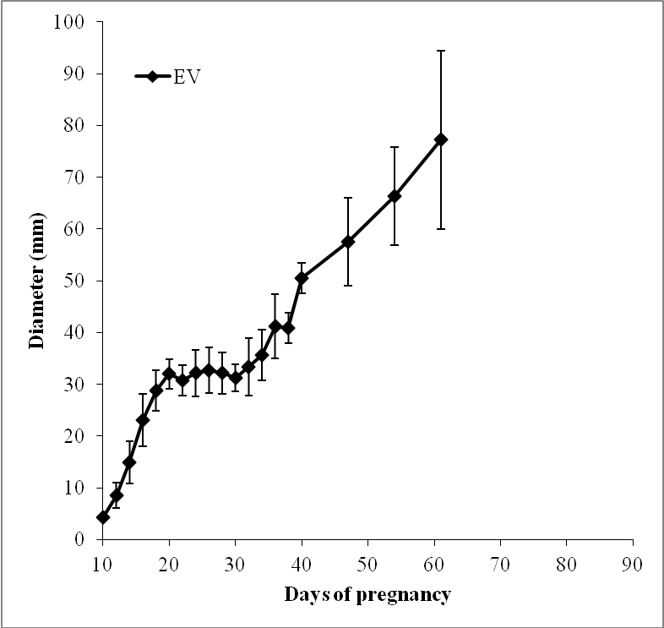

Figure 1 Mean (± SD) diameter (mm) of the embryonic vesicle (EV) from Days 10 to 61 of pregnancy measured in 8 jenny pregnancies. Measures were taken every second day up to day 40 and weekly thereafter.

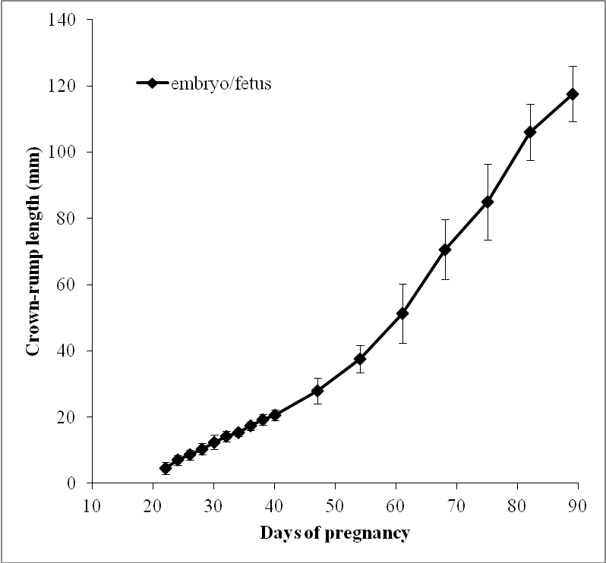

Figure 2. Mean (± SD) diameter (mm) of the crown-rump length of the embryo/fetus from Days 22 to 89 of pregnancy in 8 jenny pregnancies. Measures were taken every second day up to day 40 and weekly thereafter.

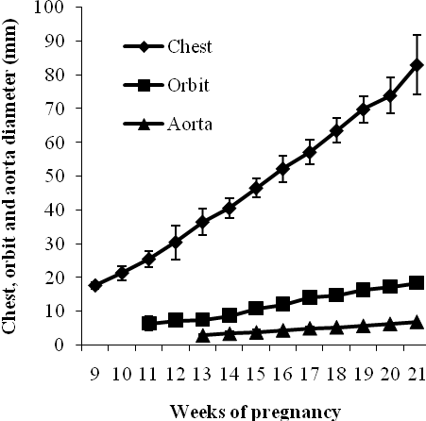

Figure 3. Mean (± SD) diameter of the fetal chest, eye orbit and aorta from Week 9 to Week 21 of pregnancy measured by transrectal ultrasound in 8 jenny pregnancies.

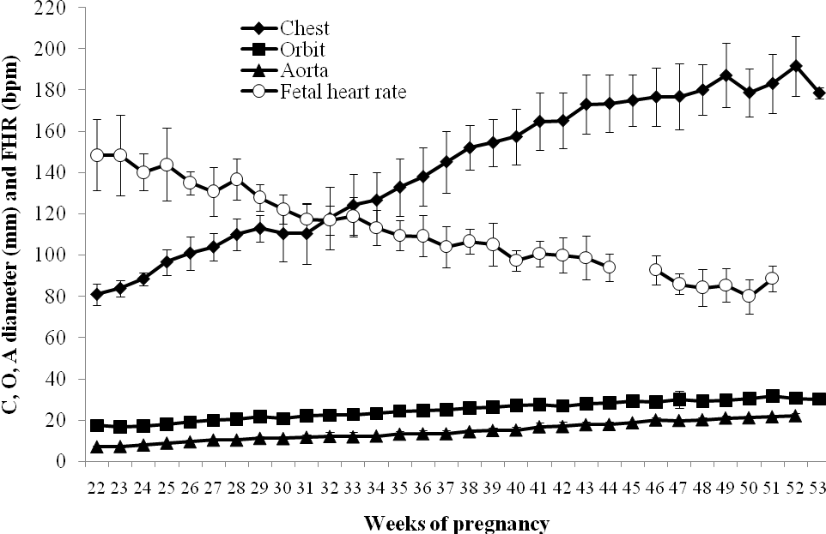
Figure 4. Mean (± DS) diameter of the fetal chest, eye orbit, aorta and heart rate measured by transabdominal ultrasound from Weeks 22 to delivery in 12 jennies. The fetal heart rate here shown has been normalised to the week of parturition in the last 5 weeks. Abnormal pregnancies were removed from the two weeks before diagnosis to parturition.

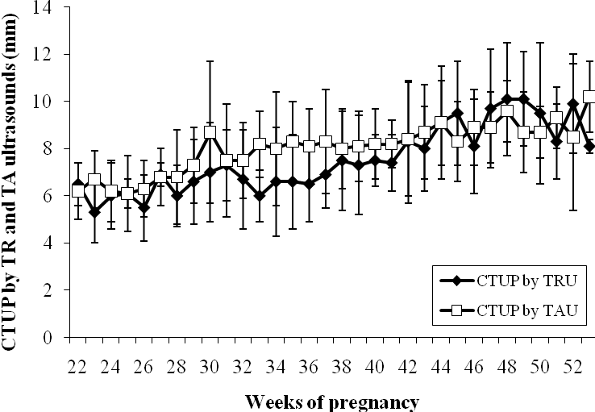

Figure 5. Mean (± DS) of the combined thickness of the utero and the placenta (CTUP) measured by transrectal (TRU) and transabdominal ultrasound (TAU) from Weeks 22 to delivery in 12 jenny pregnancies. Abnormal pregnancies were removed from two weeks before diagnosis to parturition.

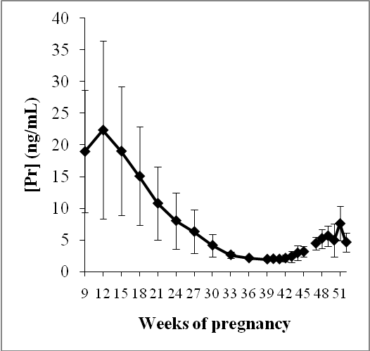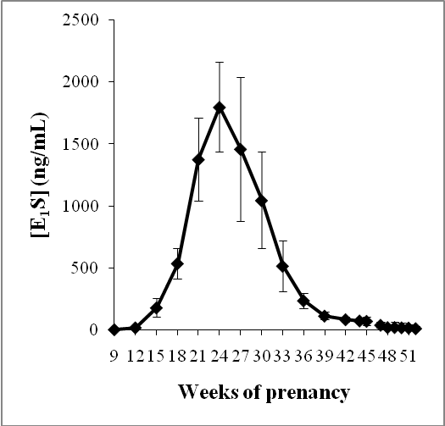
Figure 6. Mean (± SD) of the progestagens ([Pr]) and estrone sulphate ([E₁S]) plasma concentrations from Weeks 9 of pregnancy to delivery in 7 jennies. Values are normalized to the week of parturition during the last 5 weeks. Abnormal pregnancies were removed from two weeks before diagnosis to parturition.

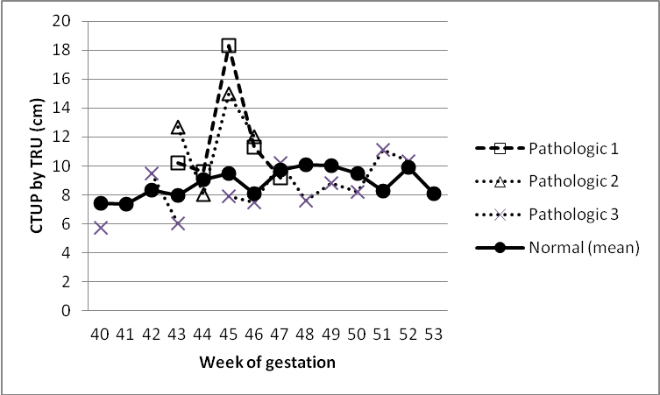

Figure 7. Mean (± DS) of the combined thickness of the utero and the placenta (CTUP) measured by transrectal (TRU) ultrasound (TAU) from Weeks 40 to delivery in 3 abnormal jenny pregnancies and mean value for the normal pregnancies.

