A Longitudinal Study of Systemic Inflammation and Recovery of Lean Body Mass among Malnourished HIV-infected Adults Starting Antiretroviral Therapy in Tanzania and Zambia

Authors and Institutional affiliations
George PrayGod^{1§}, Meridith Blevins^{2,3}, Susannah Woodd⁴, Andrea M Rehman⁴, Kidola Jeremiah¹, Henrik Friis⁵, Paul Kelly^{6, 7}, John Changalucha¹, Douglas C. Heimburger^{3,8}, Suzanne Filteau⁴, John R. Koethe^{3,8}

¹Mwanza Research Centre, National Institute for Medical Research, Mwanza, Tanzania
²Department of Biostatistics, Vanderbilt University School of Medicine, Nashville, TN, USA
³Vanderbilt Institute for Global Health, Nashville, TN, USA
⁴Faculty of Epidemiology and Population Health, London School of Hygiene & Tropical Medicine, London, UK
⁵Department of Nutrition, Exercise, and Sports, University of Copenhagen, Copenhagen, Denmark
⁶University Teaching Hospital, Lusaka, Zambia
⁷Barts & the London School of Medicine, Queen Mary University of London, London, UK
⁸Department of Medicine, Vanderbilt University School of Medicine, Nashville, TN, USA

Running title: Inflammation and body composition during early ART

§Corresponding author: Dr George PrayGod, Mwanza Research Centre, National Institute for Medical Research, Box 1462, Mwanza, Tanzania. Tel: +255 28 2503012. E-mail: gpraygod@yahoo.com

Abstract word count: 249

Main text word count: 2989

Funding support: This study was funded by European and Developing Countries Clinical Trials Partnership grant # IP.2009.33011.004. The funding body had no role in the design, conduct, interpretation or decision to publish results of this study.
Abstract:
Background: The effects of inflammation on nutritional rehabilitation after starting antiretroviral therapy (ART) are not well understood. We assessed the relationship between inflammation and body composition among patients enrolled in the Nutritional Support for African Adults Starting Antiretroviral therapy (NUSTART) trial in Tanzania and Zambia from 2011-2013.

Methods: HIV-infected, ART-eligible adults with body mass index (BMI) < 18.5 kg/m² enrolled in the NUSTART trial were eligible for this study. Anthropometric and body composition data were collected at recruitment and 6 and 12 weeks post-ART and C-reactive protein (CRP) was measured at recruitment and 6 weeks. The relationships between CRP and body composition were assessed using multiple regression.

Results: Of 1815 trial participants, 838 (46.2%) had baseline and 6 week CRP measurements. Median age was 36 years, 55% were females, and median CD4 count was 135 cells/µL. A one-log reduction in CRP at 6 weeks was associated with increased mid-upper-arm circumference (0.45 cm; 0.30, 0.61), calf circumference (0.38 cm; 0.23, 0.54), waist circumference (0.98 cm; 0.59, 1.37), BMI (0.37 kg/m²; 0.24, 0.50), fat-free mass (0.58 kg; 0.26, 0.91), but not with fat mass (0.09 kg; -0.17, 0.34). Fat-free mass gains persisted at 12 weeks and were more closely associated with 6 week CRP values than with baseline values.

Conclusions: Reduction in CRP shortly after ART initiation was associated with higher fat-free mass gains. Further studies are warranted to determine whether interventions to reduce systemic inflammation will enhance the gains in fat-free mass.

Key Words: HIV, inflammation, body composition, malnutrition, antiretroviral therapy
INTRODUCTION
Infection with Human Immunodeficiency Virus (HIV) continues to be a major public health problem in Sub-Saharan Africa. Despite efforts to promote early diagnosis and treatment initiation before the onset of advanced disease, over a third of HIV-infected patients initiate antiretroviral therapy (ART) after developing malnutrition (i.e., a body mass index [BMI] <18.5 kg/m²) and early mortality in this group is exceedingly high.^{(1, 2)} Prior studies in Africa investigating the effects of nutritional supplementation in the early ART period have not shown a mortality benefit, and some supplements may actually produce a disproportionate increase in fat mass.^{(3, 4)} A greater recovery of lean mass, as opposed to fat mass, during the early HIV treatment period may improve survival and reduce the long-term risk of developing chronic diseases, but the factors influencing lean mass gains among malnourished adults starting ART are poorly understood. ⁽⁵⁾

Malnutrition and HIV infection are accompanied by high levels of systemic inflammation, due in part to unchecked viremia, reduced mucosal defenses, and opportunistic infections.⁽⁶⁻⁸⁾ In advanced HIV infection, an elevated rate of protein turnover and inappropriately low muscle protein synthesis prevent weight gain despite sufficient intake of calories and protein.⁽⁹⁻¹¹⁾ With the initiation of ART and suppression of viremia, systemic inflammation normalizes to varying degrees, with a concomitant reduction in resting metabolic expenditures and improved weight gain in most undernourished patients.^{(12, 13)} However, abnormalities in factors related to body mass partitioning, such as an elevated rate of lipolysis, can persist in some patients despite viral suppression and may have effects on subsequent nutritional rehabilitation.⁽¹⁴⁾ In prior studies, aggressive parenteral nutrition in critically ill patients did not markedly improve lean body mass,⁽¹⁵⁾ and weight gain during treatment for pulmonary tuberculosis was primarily due to gains in adipose tissue rather than lean mass. ⁽¹⁶⁾

We hypothesized that a failure to normalize systemic inflammation after starting ART impairs recovery of lean mass and biases weight gain towards adipose tissue deposition. Using data from malnourished HIV-infected patients enrolled in a nutritional supplementation trial in Tanzania and Zambia, we analyzed the relationships between C-reactive protein (CRP) and fat and fat-free mass immediately before and during first 12 weeks of ART.

METHODS
This study was conducted as part of the Nutritional Support for Africans Starting Antiretroviral Therapy (NUSTART) trial (registration # PACTR201106000300631), a randomized, double blind, controlled trial of a lipid-based nutritional supplement (LNS; prepared by Nutriset, Malauney, France) in 1815 malnourished HIV-infected patients starting ART in Mwanza, Tanzania and Lusaka, Zambia. The study was conducted between August 2011 and December 2013. NUSTART participants were randomized to receive either the LNS alone (control arm) or fortified with additional vitamins and minerals (intervention arm; LNS-VM) in a two-stage nutritional intervention designed to mimic standard protocols for management of severe malnutrition in young children. From recruitment until 2 weeks after starting ART, participants received a low calorie (30 g) LNS, and during weeks 2-6 of ART participants received a high calorie (250 g or ~1400 kcal/d) LNS. Trial inclusion criteria were 18 years of age or older, ART-naive except for standard regimens to prevent maternal-to-child HIV transmission, BMI < 18.5 kg/m², and a CD4 count < 350 cells/µl or WHO stage 3 or 4 disease. Self-reported pregnancy was an exclusion criterion. In separate analysis LNS-VM compared to LNS did not increase fat mass or fat-free mass at 12 weeks of ART.

NUSTART participants underwent detailed body composition and laboratory studies as part of an intensive visit schedule. After recruitment, patients came to the clinic weekly until the start of ART, and again at weeks 1, 2, 4, 6, 8, and 12 after starting ART. Height was measured at recruitment using a stadiometer fixed to the wall and weight at each visit using a digital balance. At recruitment, 2, 6, and 12 weeks after starting ART patients underwent additional anthropometric evaluation. Waist circumference, mid-upper arm circumference (MUAC), hip and calf circumferences were measured using a flexible tape, and triceps and sub-scapular skinfold thickness using a caliper in Lusaka only. All measurements were done in triplicate and the median value was recorded for analyses. Participants also underwent bioelectrical impedance analysis (BIA) to estimate fat mass and fat-free mass (Tanita, Tokyo, Japan). Venous blood samples were taken at all scheduled visits for laboratory analyses. Serum CRP was measured at recruitment and week 6 by ELISA (AssayPro, St. Charles, MO, USA), and hemoglobin was measured by Hemocue and CD4 count by local central clinical services at recruitment. We did not determine viral loads due to the limited availability of testing at our sites, the high cost, and because testing is not routinely available for clinical care in these settings. Furthermore, while providers at clinical sites recorded their diagnoses of suspected opportunistic infections, the diagnostic capacity was very limited and confirmatory testing was often not available, and therefore these data were not included in this analysis.
Sample size
As part of the main study, we recruited 1876 patients ⁽¹⁷⁾.This number was sufficient to detect, at 5% significance, 90% power and 25% attrition by 12 weeks due to death or loss to follow-up, differences of 0.18 of a standard deviation in secondary continuous outcomes measured at 12 weeks. Since this was part of the secondary analyses we did calculate sample size a priori

Analyses were conducted using Stata 12.1 and R-software 3.0.2 (www.r-project.org). Demographics and clinical characteristics of the cohort were presented as percentages or medians with interquartile ranges (IQR). Participants included in the analysis cohort versus those deceased/lost prior to 6 weeks after starting ART or without complete laboratory values were compared using the Kruskal-Wallis and Chi-square tests. CRP and body composition measurements were compared pairwise across baseline and 6 week, and baseline and 12 week, time points using the Wilcoxon signed-rank test.
The primary analysis for this paper assessed the relationship between the change in CRP from baseline (pre-ART) to 6 weeks post-ART and the change in anthropometric and bioelectric impedance measurements over the same period using linear regression. CRP was log-transformed while the anthropometric and BIA outcome measurements remained on a linear scale. Models were adjusted for age, sex, CD4+ count, hemoglobin, treatment arm, country, and whether the subject was receiving treatment for tuberculosis before starting ART. Hemoglobin was missing for 8% of cases and was multiply imputed. To account for possible non-linear associations, continuous variables were modeled using restricted cubic splines with 4 knots. We also adjusted for the number of days between enrollment and ART initiation to reduce bias associated with longer pre-ART periods on supplement.

A second analysis assessed the effect of changes in CRP at 6 weeks with body composition at 12 weeks to determine whether CRP measurements during the LNS intervention predicted longer term nutritional status after the intervention ended. Using linear regression models, we first tested for a three-way interaction effect between CRP at enrollment, 6 weeks, and the intervention arm, but the interaction term was not statistically significant in any of the models (p>0.10 for all except calf circumference [p=0.08]). We then modeled a two-way interaction between CRP values and included the intervention arm as an additive effect. The regression coefficients for baseline and 6 week columns represent the average difference in 12 week body composition for a one-log difference around the median baseline and 6 week log-CRP values, respectively. Models were adjusted for age, sex, CD4+ count, hemoglobin, treatment for tuberculosis, site, and the number of days between enrollment and ART initiation, and continuous variables were modeled using restricted cubic splines with 4 knots.

The NUSTART trial was conducted according to guidelines laid down in the Declaration of Helsinki and all procedures were approved by the ethics committees of the London School of Hygiene and Tropical Medicine, the University of Zambia, and the National Institute for Medical Research, Tanzania. All patients provided written or thumbprint informed consent.

RESULTS
838 NUSTART participants survived beyond 6 weeks of ART and had serum CRP measurements performed at baseline and 6 weeks post-ART. The analysis cohort was 55% female with a median age of 36 years (IQR 30, 42), median pre-ART CD4+ T-cell count of 135 cells/µl (IQR 63, 225), and median BMI of 16.8 kg/m² (IQR 15.9, 17.6) (Table 1). Participants were equally distributed between the intervention and control arms, with a higher percentage (59%) enrolled in Lusaka (similar to the full cohort). Among those not included in the analysis cohort, 340 had died at 12 weeks, 156 had withdrawn or were lost to follow-up, and the remaining 481 alive at 12 weeks either did not have a baseline or 6 week CRP measurement (Table 2). In comparison to the analysis cohort, the excluded participants were more likely to be male, younger, and had a lower median CD4+ T cell count and lower median BMI (p<0.01 for all).

Table 3 shows median serum CRP at baseline and 6 weeks of ART, and anthropometric and BIA measurements at baseline and 6 and 12 weeks. Median CRP only decreased from 38.2 mg/l (IQR 8.9, 124) to 34.8 mg/l (IQR 12.2, 94.5) from baseline to six weeks, which was not statistically significant (p=0.91). The paired change from baseline to 6 weeks of ART for all of the body composition measurements was statistically significant (p<0.001 for all), and the paired change from 6 to 12 weeks was also significant (p<0.01 for all).

The intra-individual changes in serum CRP from baseline to 6 weeks were inversely associated with changes in several of the body composition measurements over the same period (Table 4). A one-log reduction in CRP was associated with a 0.37 kg/m² increase in BMI, a 0.45 cm increase in mid-upper arm circumference, a 0.98 cm increase in waist circumference, and 0.58 kg increase in fat-free mass at 6 weeks of ART (p<0.001 for all). Other anthropometric measurements were also inversely related to the change in CRP with the exception of BIA fat mass. These relationships appeared non-linear. While greater reductions in log-CRP were generally associated with greater body composition changes, a failure to reduce log-CRP or a rise in log-CRP on ART was generally associated with little change (Figure). The relationships of CRP at baseline and 6 weeks with body composition at 12 weeks were assessed using linear regression models incorporating baseline and 6 week values, in addition to a two-way interaction term between CRP values (Table 5). For the purpose of calculating the effects on body composition, the model for baseline CRP was adjusted to a median log-CRP value of 3.5, and the model for 6-week CRP was adjusted to a median log-CRP of 3.6. A one-log higher CRP at baseline was significantly associated with lower mid-upper arm and waist circumference at 12 weeks. However, a one-log higher 6- week CRP was significantly associated with lower BMI, mid-upper arm, waist, hip and calf circumference, and triceps skinfold thickness at 12 weeks. The relationship between 6 week CRP and 12 week BIA fat-free mass approached significance (p=0.06), while there was little evidence of an association of CRP with 12 week scapular skinfold thickness and BIA fat mass.

Due to the complicated nature of interaction effects, we summarized the statistical models of the combined effect of enrollment and week 6 log-CRP values on the change in 12 week body composition measurements using heat maps (Supplementary Figure). In these figures, deeper shades of blue represent larger increases in body composition measurements at 12 weeks corresponding to a pair of enrollment (x-axis) and week 6 (y-axis) log-CRP values, while deeper shades of violet represent smaller increases (or negative changes in some variables). The change in CRP was associated only with mid-upper arm, waist and hip circumference and triceps skinfold thickness (p<0.05), and approached significance for BMI (p=0.05; p-values refer to the effect of the two-way interaction term [log-CRP at enrollment and week 6] on outcome measurements). In general, larger increases in lean body mass metrics were seen in patients with moderate-to-high baseline CRP and lower 6 week CRP.

DISCUSSION
In this study of undernourished HIV-infected patients starting ART, we found that a failure to reduce excessively high levels of CRP in the early weeks following treatment initiation is associated with failure to accrue lean mass as measured by both anthropometry and BIA. Furthermore, the accumulation of adipose tissue did not appear dependent on CRP reduction, suggesting that weight gain in the setting of uncontrolled inflammation may actually represent an unhealthy shift towards adiposity, with potential consequences for metabolic disease in the future. These findings suggest the monitoring of inflammatory biomarkers in undernourished ART patients during the early treatment period, and additional interventions to identify and treat sources of inflammation, could improve the nutritional and other health outcomes of this population.

Restoring individuals with advanced HIV disease and malnutrition to health requires both the recovery of effective immune protection and the rebuilding of adequate stores of metabolically active muscle and other lean tissues.⁽¹⁸⁾ While the initiation of ART by undernourished HIV-infected adults is usually accompanied by weight gain to varying degrees, the composition of the newly deposited tissue is also an important factor in nutritional rehabilitation and the normalization of metabolic processes. Prior studies in diverse HIV-infected populations have found mixed effects of ART on body composition, with some showing no effect on fat and lean mass, and others suggesting that ART may lead to preferential increases in lean or fat mass.(4, 19-21) However, the factors responsible for this heterogeneous response have not been previously explored in detail.

Our baseline and follow-up levels of CRP were higher than those reported from studies in resource-rich settings and may reflect to the combination of untreated viremia, secondary infections related to immunosuppression or local factors (e.g., parasites), and enteropathy related to both HIV infection and malnutrition.⁽⁶⁻⁸⁾ HIV infection depletes lymphoid cells in the gastrointestinal mucosa integral to defense against bacterial, fungal, and parasitic pathogens, and impairs tight junctions between epithelial cells, resulting in altered intestinal integrity and increased translocation of microbes from the intestinal lumen to the circulation.⁽²²⁻²⁶⁾ Increased microbial translocation is posited as a major contributor to elevated, chronic inflammation in HIV-infected individuals, which is likely compounded in the setting of chronic malnutrition due to similar impairments in intestinal mucosal integrity and the adaptive immune response in the gut.^{(6-8, 27)}

Our observation that a higher CRP level is associated with lower lean mass gains may explain the finding in prior nutritional supplementation trials that some patients gained no weight or mainly fat mass during early ART, which has also been reported in patients with similar proinflammatory states such as tuberculosis, severe trauma and cancer .^{(15, 16),}(28) and indicates that across the spectrum of infectious and non-infectious diseases, inflammation may be a key determinant of nutritional depletion and recovery.
Elevated circulating inflammatory cytokines such as TNF-alpha and interleukin-6 are associated with reduced muscle protein synthesis and deposition, and may stimulate apoptosis in muscle cells precursors, suggesting that lack of lean mass gain associated with high inflammation may actually be due to failure of protein synthesis rather than excessive protein breakdown.^{(9, 10)} The finding that inflammation and lean mass recover are closely linked will be important for interpreting findings of future nutritional intervention trials in low-income settings, and it may be the case that any meaningful effects of nutritional interventions on lean mass will depend on first reducing inflammation. Of note, a recent trial in Ethiopia found that that presence of persistent HIV-1 viremia at 3 months was associated with preferential fat mass gain, while viral suppression was associated with lean mass gain. ⁽²¹⁾

In the present study, we noted that CRP levels were not closely associated with 6 or 12 weeks post-ART measurements of fat mass, which may indicate that the accrual of fat mass is driven by other factors independent of inflammation. In higher BMI populations, CRP is positively associated with fat mass. ⁽²⁹⁾ A similar relationship between fat mass and CRP was not observed in our patients; and we hypothesize that any contribution of adipose tissue to circulating inflammatory mediators may have been obscured by the more pronounced effect of advanced malnutrition and HIV infection on systemic inflammation. However, further work is needed to understand the directionality of the relationships between inflammation and body fat mass in low versus normal and high BMI individuals.

Prior studies in Africa have shown elevated CRP, interleukin-6, and other markers of systemic inflammation are associated with increased mortality on ART, but there are fewer data on the link between inflammation and long-term outcomes.⁽³⁰⁾ As the capacity of health systems to identify and treat cardiovascular, metabolic and other non-communicable diseases in HIV patients improves in sub-Saharan Africa, epidemiologic studies are needed to determine how very high levels of inflammation affect long-term health outcomes.

In this study we included in the analysis about half of the patients recruited for the trial. Patients not included in the analysis because of loss to follow-up, or death tended to be those who were severely malnourished, immunocompromised judged by CD4 count and had higher median CRP. Although a higher baseline CRP, in the excluded survivors would have potentially resulted in a large reduction in CRP from zero to 6 weeks, assuming that the patterns of correlation remained the same, this would probably not have significantly changed the associations given that we modelled the relation between CRP and body composition parameters on log rather than normal scale.

The strength of our study was the prospective design and large sample size, which permitted the assessment of longitudinal relationships between CRP and body composition between referral for ART and 6 and 12 weeks post-ART. The BIA method we used was well suited to clinical care in Africa and has been shown to correlate well with more complicated radiographic assessments in healthy patients, but there are fewer data comparing BIA versus DEXA and other radiographic methods in malnourished, HIV patients.⁽³¹⁾ However, a longer follow-up period may have also provided additional insights on trends of body composition changes during ART among undernourished patients on ART. Furthermore, our study could not assess the long-term implications of early changes in body composition on ART. We observed a 0.37 kg/m² rise in BMI at 6 weeks in patients with a one-log CRP reduction over the same period, which represents an approximately 2%-2.5% BMI increase (depending on the baseline BMI value). Prior studies have shown modest early increases in BMI are clinically important for long-term survival, but additional studies are warranted to understand how body composition, inflammation, and other nutritional factors interact to influence health outcomes.⁽³²⁾ Although additional LNS received by patients in the trial may have made them different from the rest of HIV population on ART, this difference would have disappeared a few weeks after starting ART as patients on treatment regained appetite and started consuming nutritionally diverse food. Thus, these findings can be generalized to all malnourished HIV-infected patients starting ART.

CONCLUSIONS
In conclusion, among HIV-infected adult patients, reductions in CRP over the first six weeks of ART were associated with higher lean body mass gains; and patients with lower CRP at 6 weeks continued to have greater lean mass up to 12 weeks. Promoting lean body mass gains in malnourished HIV patients starting ART is important for nutritional rehabilitation and may impact long-term survival and chronic disease risk. Future trials should consider interventions addressing both nutritional recovery and inflammation, to elucidate mechanisms and optimize outcomes in malnourished patients. Lastly, further studies on the effect of persistent high level of inflammation as well as fat mass gains on long-term chronic disease risk, including diabetes mellitus and cardiovascular conditions, are needed in sub-Saharan Africa.

ACKNOWLEDGEMENTS: This manuscript was prepared from data arising from the NUSTART trial. We are therefore grateful to the NUSTART study team which includes: Principal investigator: Suzanne Filteau; Senior investigators: Aase Bengaard Andersen, John Changalucha, Henrik Friis, Douglas C. Heimburger, Lackson Kasonka, Paul Kelly; Statisticians and other senior research fellows: John R. Koethe, Daniela Manno, Natasha Larke, Andrea M. Rehman, Susannah Woodd, Daniel Yilma; Steering group: David Thurnham, Andrew Tomkins; Mwanza trial manager: George PrayGod; Lusaka trial managers: Molly Chisenga, Joshua Siame; Mwanza senior clinic team: Jeremiah Kidola, Denna Michael, Kelvin Mussa, Charles Masilingi, Elizabeth Fue, Eva Masesa, Neema Mpandachalo; Lusaka senior clinic team: Anne Kanunga, Likando Munalula, Brenda Kapinda, Nellie Sikanyika; Laboratory technicians: Julius Mngara, George Ogweno, Piu Ikigo, Mutinta Muchimba, Memory Samwinga, Leo Beacroft, Harry Black, Celeste Gregg Smith; Postgraduate students: Caroline Chisenga, Marlene Hebie, Derek Munkombwe, Gemma Sampson; Administrators and data managers: Yolanda Fernandez, Gunda Wandore, Aswile Jonas, Hildah Banda Mabuda, Wakwoya Adugna; Pharmacists: Stephen Makandilo, Mwangana Mubita, Jessy Mulenga. We are grateful also to nurses, data entry clerks, drivers and other support staff at both NUSTART sites.

CONFLICT OF INTEREST: none declared by any authors

Supplementary information is available at the European Journal of Clinical Nutrition website
REFERENCES
1. Liu E, Spiegelman D, Semu H, Hawkins C, Chalamilla G, Aveika A, et al. Nutritional Status and Mortality Among HIV-Infected Patients Receiving Antiretroviral Therapy in Tanzania. J Infect Dis. 2011 Jul;204(2):282-90.
2. Gupta A, Nadkarni G, Yang WT, Chandrasekhar A, Gupte N, Bisson GP, et al. Early Mortality in Adults Initiating Antiretroviral Therapy (ART) in Low- and Middle-Income Countries (LMIC): A Systematic Review and Meta-Analysis. PLoS One. 2011;6(12):e28691.
3. Grobler L, Siegfried N, Visser ME, Mahlungulu SS, Volmink J. Nutritional interventions for reducing morbidity and mortality in people with HIV. The Cochrane database of systematic reviews. 2013;2:CD004536.
4. Ndekha MJ, van Oosterhout JJ, Zijlstra EE, Manary M, Saloojee H, Manary MJ. Supplementary feeding with either ready-to-use fortified spread or corn-soy blend in wasted adults starting antiretroviral therapy in Malawi: randomised, investigator blinded, controlled trial. BMJ (Clinical research ed. 2009;338:b1867.
5. Mulligan K, Harris DR, Monte D, Stoszek S, Emmanuel P, Hardin DS, et al. Obesity and dyslipidemia in behaviorally HIV-infected young women: Adolescent Trials Network study 021. Clin Infect Dis. 2010 Jan 1;50(1):106-14.
6. Marchetti G, Cozzi-Lepri A, Merlini E, Bellistri GM, Castagna A, Galli M, et al. Microbial translocation predicts disease progression of HIV-infected antiretroviral-naive patients with high CD4+ cell count. AIDS. 2011 Apr 18;25(11):1385-94.
7. Sandler NG, Wand H, Roque A, Law M, Nason MC, Nixon DE, et al. Plasma Levels of Soluble CD14 Independently Predict Mortality in HIV Infection. J Infect Dis. 2011 Jan 20;203(6):780-90.
8. Elia M, Goren A, Behrens R, Barber RW, Neale G. Effect of total starvation and very low calorie diets on intestinal permeability in man. Clin Sci (Lond). 1987 Aug;73(2):205-10.
9. Yarasheski KE, Zachwieja JJ, Gischler J, Crowley J, Horgan MM, Powderly WG. Increased plasma gln and Leu Ra and inappropriately low muscle protein synthesis rate in AIDS wasting. Am J Physiol. 1998 Oct;275(4 Pt 1):E577-83.
10. Macallan DC, McNurlan MA, Milne E, Calder AG, Garlick PJ, Griffin GE. Whole-body protein turnover from leucine kinetics and the response to nutrition in human immunodeficiency virus infection. Am J Clin Nutr. 1995 Apr;61(4):818-26.
11. Powanda MC, Beisel WR. Metabolic effects of infection on protein and energy status. J Nutr. 2003 Jan;133(1):322S-7S.
12. Grunfeld C, Pang M, Shimizu L, Shigenaga JK, Jensen P, Feingold KR. Resting energy expenditure, caloric intake, and short-term weight change in human immunodeficiency virus infection and the acquired immunodeficiency syndrome. Am J Clin Nutr. 1992 Feb;55(2):455-60.
13. Shevitz AH, Knox TA, Spiegelman D, Roubenoff R, Gorbach SL, Skolnik PR. Elevated resting energy expenditure among HIV-seropositive persons receiving highly active antiretroviral therapy. AIDS. 1999 Jul 30;13(11):1351-7.
14. van der Valk M, Reiss P, van Leth FC, Ackermans MT, Endert E, Romijn JA, et al. Highly active antiretroviral therapy-induced lipodystrophy has minor effects on human immunodeficiency virus-induced changes in lipolysis, but normalizes resting energy expenditure. J Clin Endocrinol Metab. 2002 Nov;87(11):5066-71.
15. Streat SJ, Beddoe AH, Hill GL. Aggressive nutritional support does not prevent protein loss despite fat gain in septic intensive care patients. The Journal of trauma. 1987 Mar;27(3):262-6.
16. Schwenk A, Hodgson L, Wright A, Ward LC, Rayner CF, Grubnic S, et al. Nutrient partitioning during treatment of tuberculosis: gain in body fat mass but not in protein mass. The American journal of clinical nutrition. 2004 Jun;79(6):1006-12.
17. Filteau S, PrayGod G, Kasonka L, Woodd S, Rehman AM, Chisenga M, et al. Effects on mortality of a nutritional intervention for malnourished HIV-infected adults referred for antiretroviral therapy: a randomised controlled trial. BMC medicine. 2015;13:17.
18. Mupere E, Malone L, Zalwango S, Chiunda A, Okwera A, Parraga I, et al. Lean tissue mass wasting is associated with increased risk of mortality among women with pulmonary tuberculosis in urban Uganda. Annals of epidemiology. 2012 Jul;22(7):466-73.
19. McDermott AY, Shevitz A, Knox T, Roubenoff R, Kehayias J, Gorbach S. Effect of highly active antiretroviral therapy on fat, lean, and bone mass in HIV-seropositive men and women. The American journal of clinical nutrition. 2001 Nov;74(5):679-86.
20. Silva M, Skolnik PR, Gorbach SL, Spiegelman D, Wilson IB, Fernandez-DiFranco MG, et al. The effect of protease inhibitors on weight and body composition in HIV-infected patients. AIDS (London, England). 1998 Sep 10;12(13):1645-51.
21. Olsen MF, Abdissa A, Kaestel P, Tesfaye M, Yilma D, Girma T, et al. Effects of nutritional supplementation for HIV patients starting antiretroviral treatment: randomised controlled trial in Ethiopia. Bmj. 2014;348:g3187.
22. Brenchley JM, Schacker TW, Ruff LE, Price DA, Taylor JH, Beilman GJ, et al. CD4+ T cell depletion during all stages of HIV disease occurs predominantly in the gastrointestinal tract. J Exp Med. 2004 Sep 20;200(6):749-59.
23. Mehandru S, Poles MA, Tenner-Racz K, Horowitz A, Hurley A, Hogan C, et al. Primary HIV-1 infection is associated with preferential depletion of CD4+ T lymphocytes from effector sites in the gastrointestinal tract. J Exp Med. 2004 Sep 20;200(6):761-70.
24. Sankaran S, George MD, Reay E, Guadalupe M, Flamm J, Prindiville T, et al. Rapid onset of intestinal epithelial barrier dysfunction in primary human immunodeficiency virus infection is driven by an imbalance between immune response and mucosal repair and regeneration. J Virol. 2008 Jan;82(1):538-45.
25. Brenchley JM, Paiardini M, Knox KS, Asher AI, Cervasi B, Asher TE, et al. Differential Th17 CD4 T-cell depletion in pathogenic and nonpathogenic lentiviral infections. Blood. 2008 Oct 1;112(7):2826-35.
26. Epple HJ, Schneider T, Troeger H, Kunkel D, Allers K, Moos V, et al. Impairment of the intestinal barrier is evident in untreated but absent in suppressively treated HIV-infected patients. Gut. 2009 Feb;58(2):220-7.
27. Welsh FK, Farmery SM, MacLennan K, Sheridan MB, Barclay GR, Guillou PJ, et al. Gut barrier function in malnourished patients. Gut. 1998 Mar;42(3):396-401.
28. McMillan DC. Systemic inflammation, nutritional status and survival in patients with cancer. Curr Opin Clin Nutr Metab Care. 2009 May;12(3):223-6.
29. Reingold J, Wanke C, Kotler D, Lewis C, Tracy R, Heymsfield S, et al. Association of HIV infection and HIV/HCV coinfection with C-reactive protein levels: the fat redistribution and metabolic change in HIV infection (FRAM) study. J Acquir Immune Defic Syndr. 2008 Jun 1;48(2):142-8.
30. Koethe JR, Blevins M, Nyirenda C, Kabagambe EK, Shepherd BE, Wester CW, et al. Nutrition and inflammation serum biomarkers are associated with 12-week mortality among malnourished adults initiating antiretroviral therapy in Zambia. Journal of the International AIDS Society. 2011;14:19.
31. Furstenberg A, Davenport A. Comparison of multifrequency bioelectrical impedance analysis and dual-energy X-ray absorptiometry assessments in outpatient hemodialysis patients. Am J Kidney Dis. 2011 Jan;57(1):123-9.
32. Madec Y, Szumilin E, Genevier C, Ferradini L, Balkan S, Pujades M, et al. Weight gain at 3 months of antiretroviral therapy is strongly associated with survival: evidence from two developing countries. AIDS (London, England). 2009 Apr 27;23(7):853-61.

Table 1. Clinical and demographic characteristics of patients surviving more than 6 weeks on antiretroviral therapy
 | All participants (n=838) | Completed 12 weeks follow-up (n=796) | Died after 6 weeks (n=25) | Withdrawn or lost to follow-up after 6 weeks (n=17) | p-value*
Female, n (%) | 462 (55%) | 439 (55%) | 10 (40%) | 13 (76%) | 0.07
Age, years | 36 (30, 42) | 36 (30, 42) | 41 (35, 47) | 33 (25, 39) | 0.02
CD4+ count, cells/µl | 135 (63, 225) | 135 (63, 226) | 69 (26, 154) | 201 (101, 250) | 0.02
BMI, kg/m² | 16.8 (15.9, 17.6) | 16.9 (15.8, 17.6) | 16.6 (16.1, 17.3) | 16.7 (15.9, 17.3) | 0.52
Hemoglobin, g/L | 98 (83, 113) | 99 (84, 113) | 92 (74, 101) | 101 (86, 112) | 0.11
Treatment arm, n (%) |  |  |  |  | 0.29
Active | 431 (51%) | 410 (52%) | 15 (60%) | 6 (35%)
Placebo | 407 (49%) | 386 (48%) | 10 (40%) | 11 (65%)
Study site, n (%) |  |  |  |  | <0.01
Zambia | 494 (59%) | 475 (60%) | 7 (28%) | 12 (71%)
Tanzania | 344 (41%) | 321 (40%) | 18 (72%) | 5 (29%)
TB treatment prior to ART, n (%) | 227 (27%) | 219 (28%) | 7 (28%) | 1 (6%) | 0.14
Time from recruitment to ART initiation, days | 21 (15, 29) | 21 (15, 28) | 23 (15, 32) | 25 (18, 33) | 0.18
Values expressed as percentages or median with (interquartile range) Abbreviations: ART, antiretroviral therapy; BMI, body mass index; TB, tuberculosis
*P-value refers to comparisons across the three study outcome groups, using chi-square tests for categorical variables and Kruskal Wallis tests for continuous variables.

Table 2. Clinical and demographic characteristics of patients included and excluded from the analysis
 | Analysis cohort (n=838) | Deceased prior to 12 weeks (n=340)† | Withdrawn / Lost to follow-up prior to 12 weeks† (n=156) | Alive at 12 weeks, missing baseline or 6 week CRP data (n=481) | p-value*
Female, n (%) | 462 (55%) | 146 (43%) | 75 (48%) | 217 (45%) | <0.01
Age, years | 36 (30, 42) | 35 (30, 42) | 32 (28, 38) | 34 (28, 39) | <0.01
CD4+ count, cells/µl | 135 (63, 225) | 80 (32, 159) | 157 (79, 219) | 144 (49, 211) | <0.01
BMI, kg/m² | 16.8 (15.9, 17.6) | 16.2 (15.0, 17.1) | 16.3 (15.5, 17.1) | 16.8 (15.7, 17.6) | <0.01
Treatment arm, n (%) |  |  |  |  | 0.86
Active | 431 (51%) | 171 (50%) | 80 (51%) | 243 (51%)
Placebo | 407 (49%) | 169 (50%) | 76 (49%) | 238 (49%)
Study site, n (%) |  |  |  |  | <0.01
Zambia | 494 (59%) | 163 (48%) | 130 (83%) | 324 (67%)
Tanzania | 344 (41%) | 177 (52%) | 26 (17%) | 157 (33%)
TB treatment prior to ART, n (%) | 227 (27%) | 55 (16%) | 42 (27%) | 127 (26%) | <0.01
Baseline CRP (mg/dl) | 38.2 (8.9, 124) | 133.4 (51.7, 178.7) | 71.5 (19.2, 160.0) | 57.9 (13.4, 155.3) | <0.01
Values expressed as percentages or median with (interquartile range) Abbreviations: ART, antiretroviral therapy; BMI, body mass index; TB, tuberculosis
*P-value refers to comparisons across the three study outcome groups, using chi-square tests for categorical variables and Kruskal Wallis tests for continuous variables.
†Includes participants deceased or lost to follow-up prior to 6 weeks in addition to those deceased or lost between 6 and 12 weeks, but missing baseline or 6 week CRP measurements.

Table 3. Median serum C-reactive protein, anthropometric, and bioelectric impedance measurements at study time points
 | N | Baseline | N | Week 6 | N | Week 12 | p-value | p-value
 |  |  |  |  |  |  | (0 to 6 week change) | (6 to 12 week change)
Serum CRP, mg/l | 838 | 38.2 (8.9, 124) | 838 | 34.8 (12.2, 94.5) |  | NA | 0.91 | NA
Body mass index, kg/m² | 838 | 16.8 (15.9, 17.6) | 836 | 18.0 (16.8, 19.1) | 664 | 18.5 (17.4, 19.6) | <0.001 | <0.001
Mid-upper arm circumference, cm | 833 | 21.7 (20.4, 23.1) | 832 | 23.1 (21.4, 24.4) | 653 | 23.8 (22.3, 25.1) | <0.001 | <0.001
Waist circumference, cm | 833 | 66.8 (63.5, 69.5) | 832 | 70.5 (66.7, 74.8) | 652 | 71.9 (68.1, 75.5) | <0.001 | <0.001
Hip circumference, cm | 833 | 79.6 (77.0, 82.5) | 830 | 82.6 (79.6, 86.0) | 651 | 84.3 (81.0, 87.5) | <0.001 | <0.001
Calf circumference, cm | 833 | 28.6 (27.4, 30.1) | 832 | 29.6 (28.2, 31.1) | 653 | 30.0 (28.6, 31.5) | <0.001 | <0.001
Triceps muscle skinfold, mm | 489 | 5.8 (4.6, 8.0) | 488 | 7.0 (5.2, 9.8) | 396 | 7.8 (5.8, 10.4) | <0.001 | <0.001
Scapular skinfold, mm | 489 | 6.6 (5.8, 7.8) | 489 | 7.6 (6.2, 9.0) | 397 | 8.0 (6.8, 9.8) | <0.001 | <0.001
BIA fat mass, kg | 721 | 5.0 (3.3, 7.1) | 766 | 6.8 (4.6, 9.1) | 630 | 7.5 (5.2, 10.0) | <0.001 | <0.001
BIA fat-free mass, kg | 721 | 38.3 (35.0, 44.1) | 766 | 40.0 (36.3, 46.7) | 630 | 40.2 (36.9, 46.9) | <0.001 | <0.01
Values expressed as median with (interquartile range) Triceps and scapular skinfold are collected only from patients in Zambia.
CRP and body composition measurements were compared pairwise across baseline and 6 week, and baseline and 12 week, time points using the Wilcoxon signed-rank test. Abbreviations: BIA, bioelectric impedance analyser; BMI, body mass index; CRP, C-reactive protein

Table 4. Relationship between the change in CRP and the change in body composition measurements from baseline until 6 weeks of antiretroviral therapy
 | Effect (95% CI) | p-value
Body mass index, kg/m² | 0.37 (0.24, 0.50) | <0.001
Mid-upper arm circumference, cm | 0.45 (0.30, 0.61) | <0.001
Waist circumference, cm | 0.98 (0.59, 1.37) | <0.001
Hip circumference, cm | 0.77 (0.43, 1.12) | <0.001
Calf circumference, cm | 0.38 (0.23, 0.54) | <0.001
Triceps skinfold, mm | 0.31 (0.05, 0.57) | 0.03
Scapular skinfold, mm | 0.25 (0.06, 0.45) | 0.02
BIA fat mass, kg | 0.09 (-0.17, 0.34) | 0.54
BIA fat-free mass, kg | 0.58 (0.26, 0.91) | <0.001
Effect size represents change in body composition for a one-log decrease in CRP. Models are adjusted for sex, treatment arm, country, age, CD4+ count, hemoglobin, and receipt of anti-tuberculosis therapy at treatment initiation. Abbreviations: BIA, bioelectric impedance analyser

Table 5. Associations of baseline and week 6 serum C-reactive protein with 12 week body composition measurements
 | Baseline CRP* |  | Week 6 CRP†
 | Effect (95% CI) | p-value | Effect (95% CI) | p-value
Body mass index, kg/m² | -0.13 (-0.40, 0.14) | 0.09 | -0.69 (-1.03, -0.35) | <0.001
Mid-upper arm circumference, cm | -0.33 (-0.65, -0.01) | 0.003 | -0.91 (-1.31, -0.51) | <0.001
Waist circumference, cm | -0.03 (-0.77, 0.71) | 0.02 | -2.10 (-3.03, -1.17) | <0.001
Hip circumference, cm | -0.71 (-1.44, 0.02) | 0.05 | -1.64 (-2.56, -0.72) | <0.001
Calf circumference, cm | -0.05 (-0.36, 0.25) | 0.26 | -0.69 (-1.08, -0.30) | <0.001
Triceps skinfold, mm | -0.80 (-1.49, -0.12) | 0.05 | -0.68 (-1.53, 0.17) | 0.01
Scapular skinfold, mm | -0.34 (-0.85, 0.18) | 0.42 | -0.64 (-1.28, 0.00) | 0.1
BIA fat mass, kg | -0.55 (-1.05, -0.04) | 0.34 | -0.84 (-1.51, -0.16) | 0.26
BIA fat-free mass, kg | 0.07 (-0.54, 0.69) | 0.76 | -0.96 (-1.79, -0.14) | 0.06
Associations of log-CRP at enrollment and week 6 log-CRP with week 12 body composition measures are summarized in this table. Models are adjusted for age, sex, treatment arm, country, time from enrollment to ART initiation, and CD4+ count, hemoglobin, and receipt of anti-tuberculosis therapy at treatment initiation.
*Model is adjusted to a median baseline log-CRP of 3.5 mg/l. The effect size estimate represents the average difference in 12 week body composition for two individuals with 4.0 versus 3.0 log-CRP at baseline (i.e., a one log-CRP increase around the median).
†Model is adjusted to a median week 6 log-CRP of 3.6 mg/l. The effect size estimate represents the average difference in 12 week body composition for two individuals with 4.1 versus 3.1 log-CRP at week 6 (i.e., a one log-CRP increase around the median).
The inclusion of a three-way interaction term between CRP at enrollment, six weeks and intervention arm was not statistically significant in any of the models (p>0.1 for all except calf circumference p=0.08). Abbreviations: BIA, bioelectric impedance; CRP, C-reactive protein

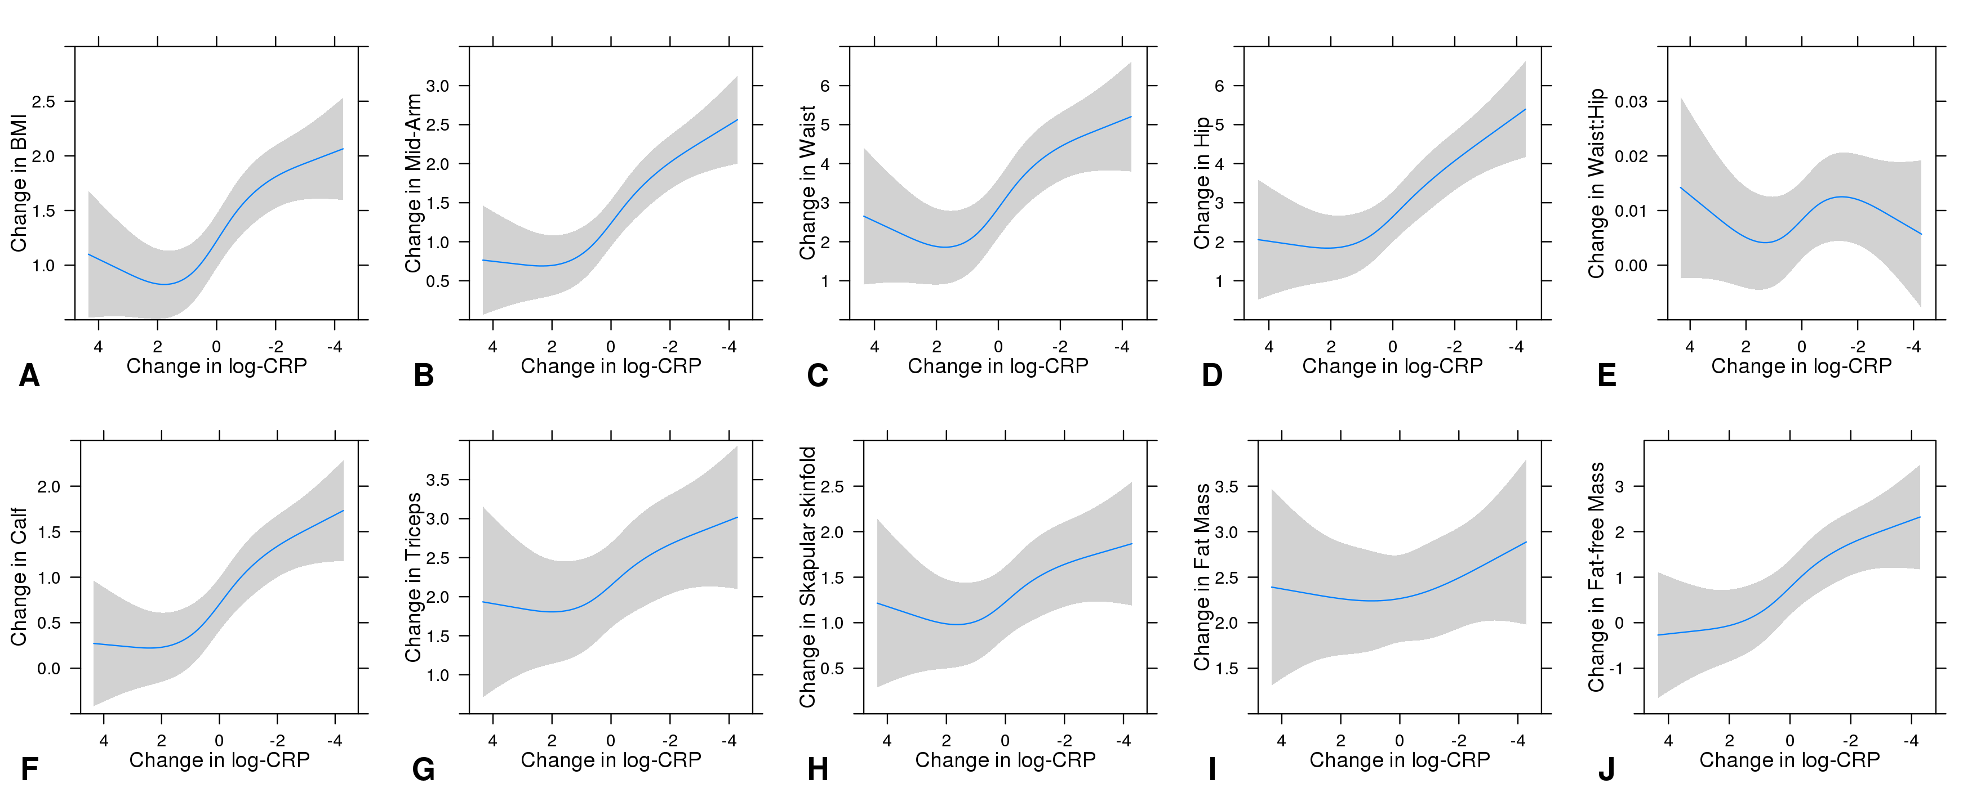

Figure. Relationship of the change in C-reactive protein and body composition measurements between baseline and 6 weeks of antiretroviral therapy.
Models adjusted for sex, treatment arm, country, and age, CD4+ count, hemoglobin, and receipt of anti-tuberculosis therapy at treatment initiation. CRP is log-transformed. Abbreviations: BMI, body mass index.

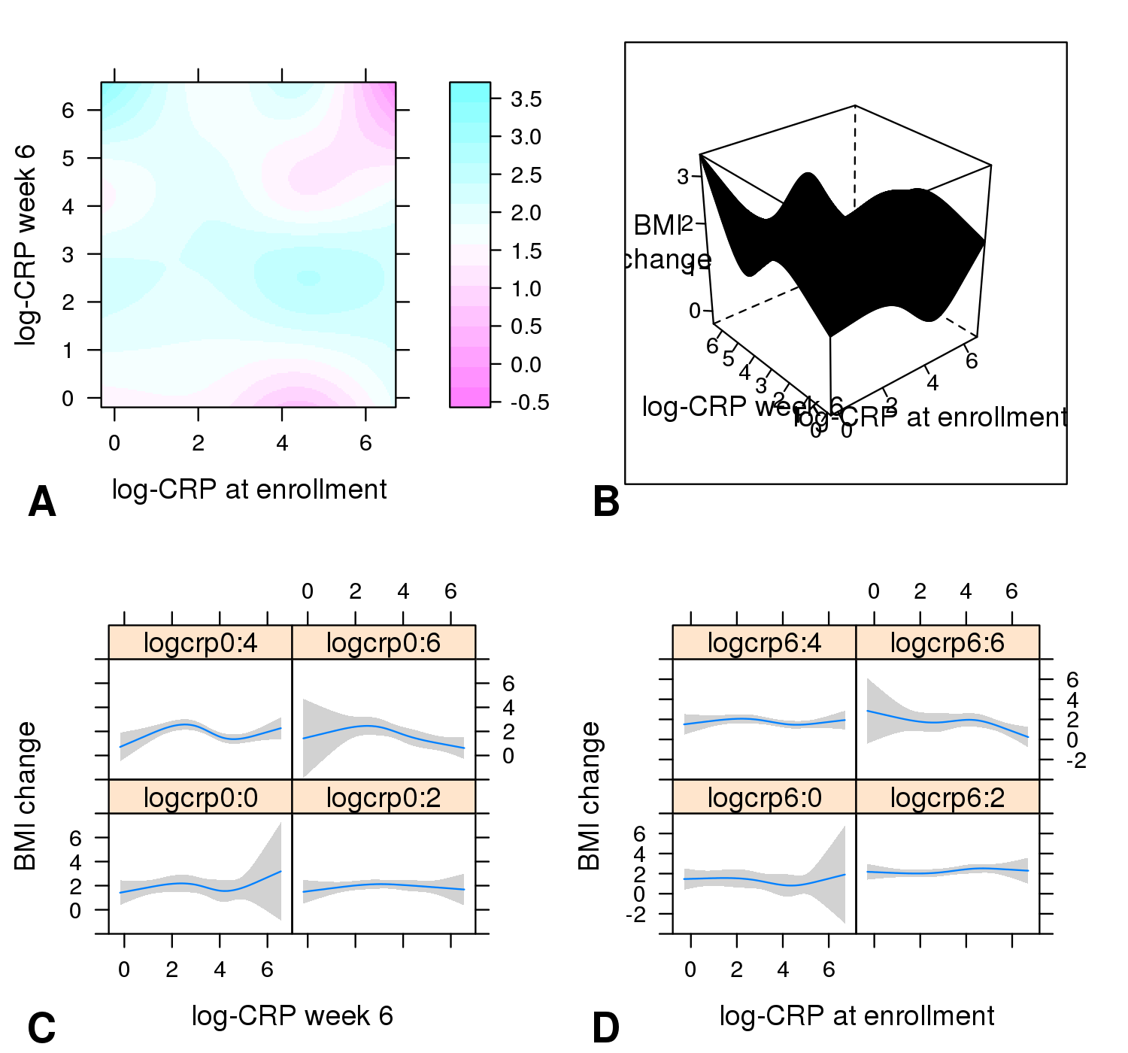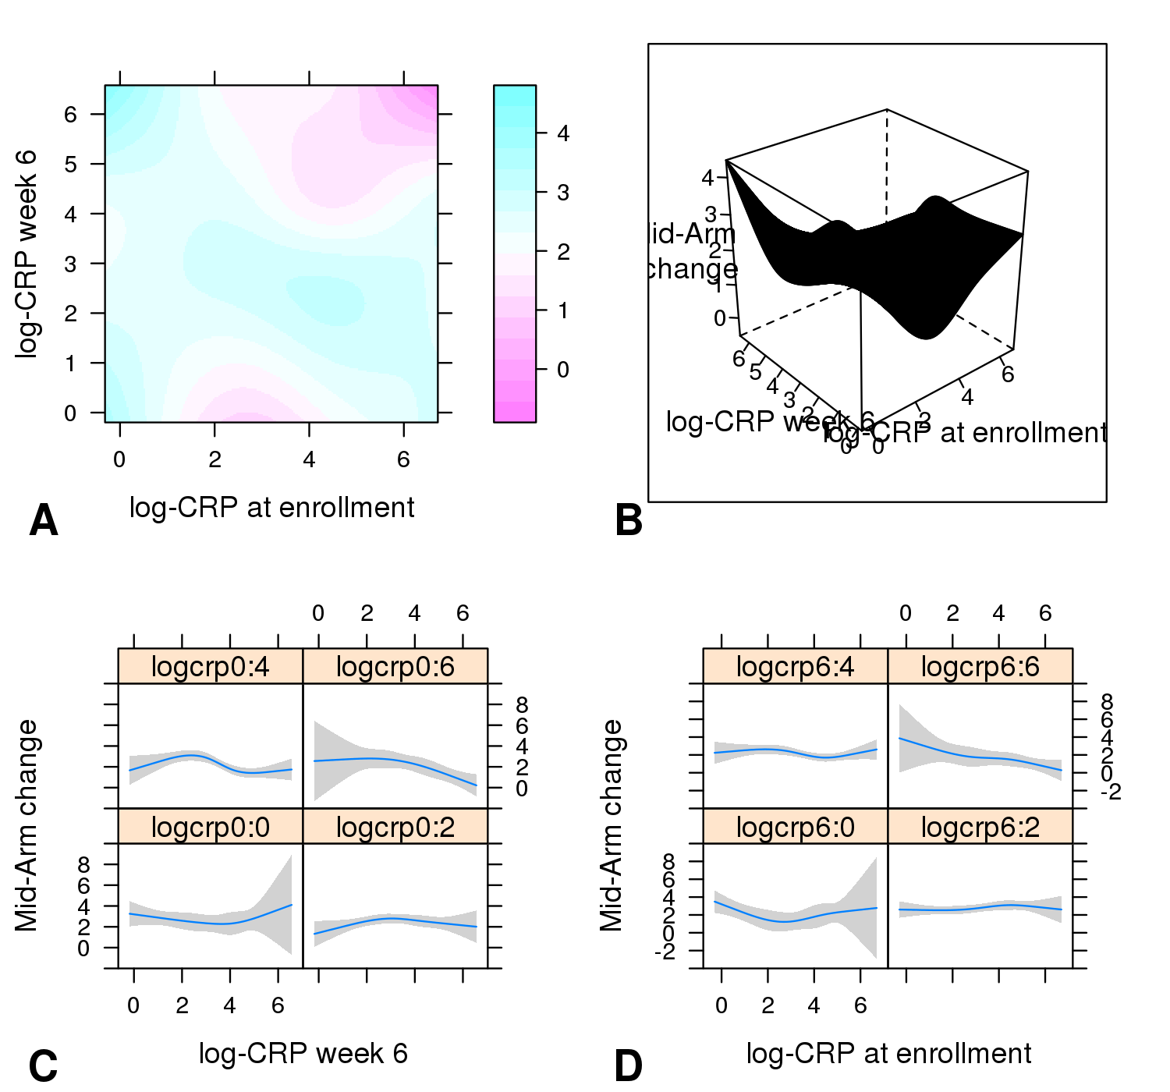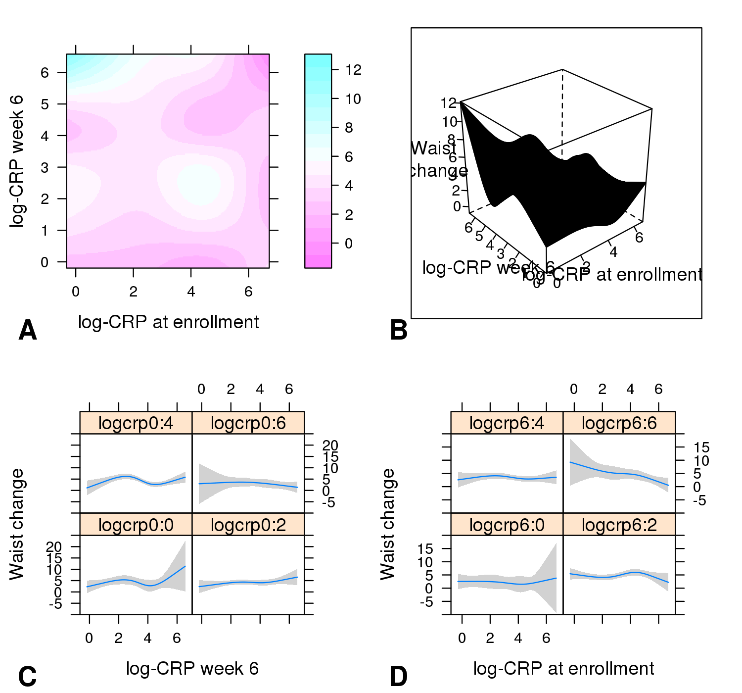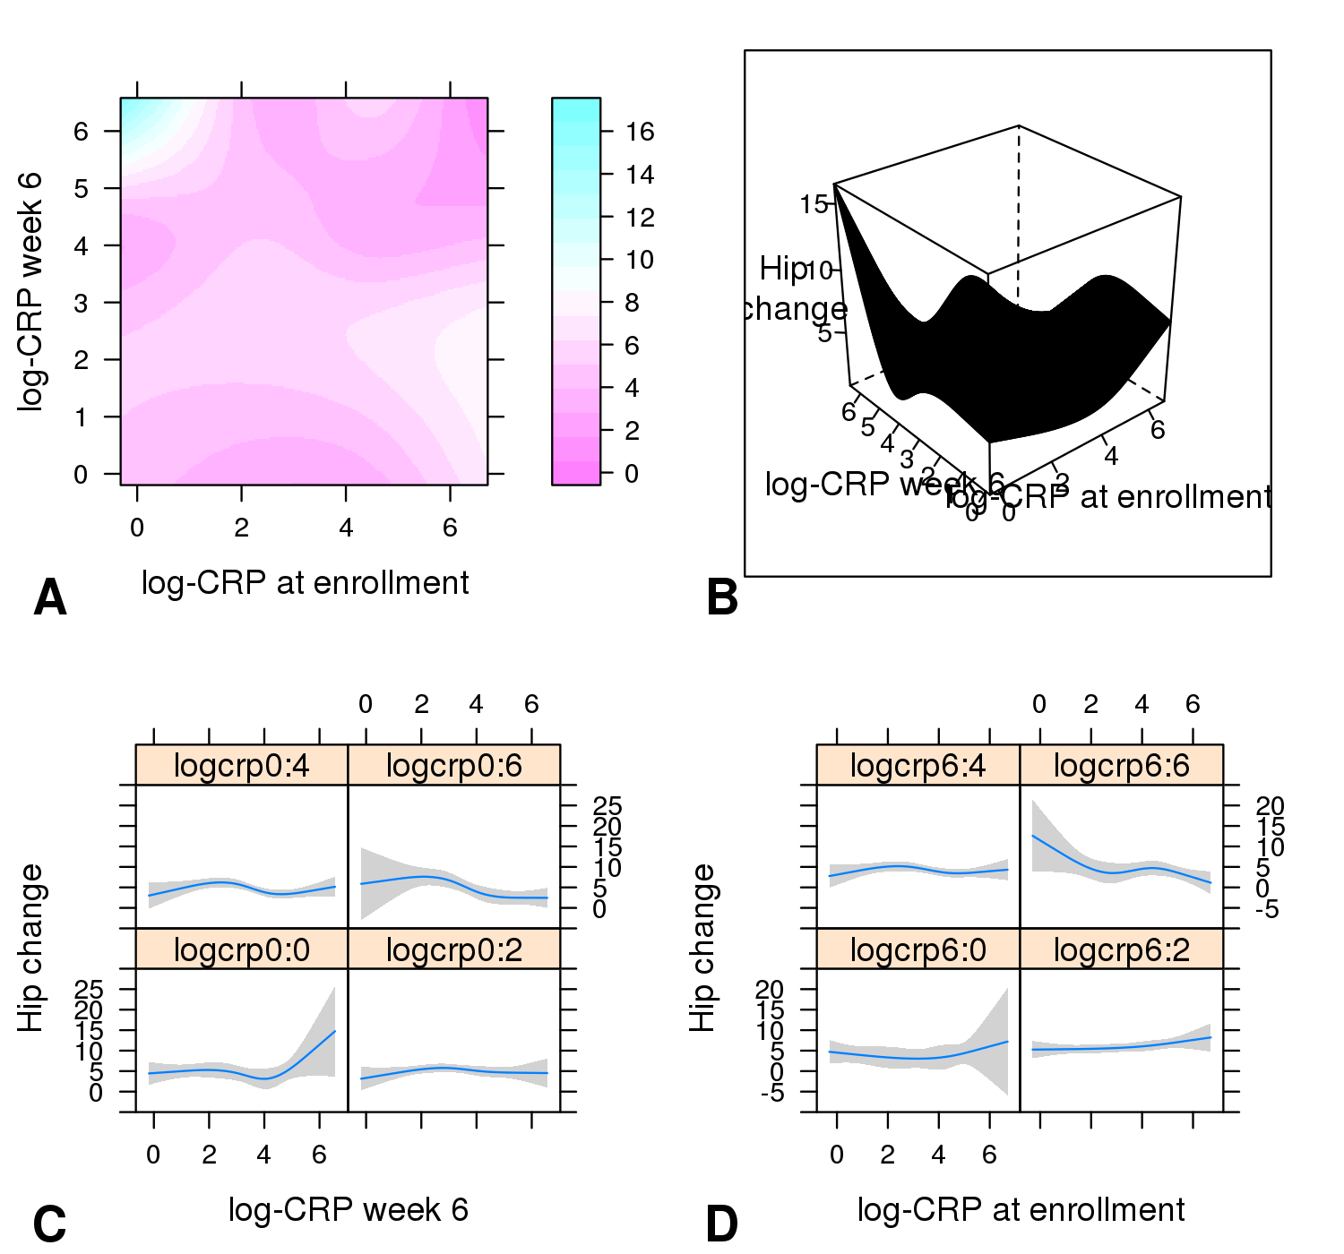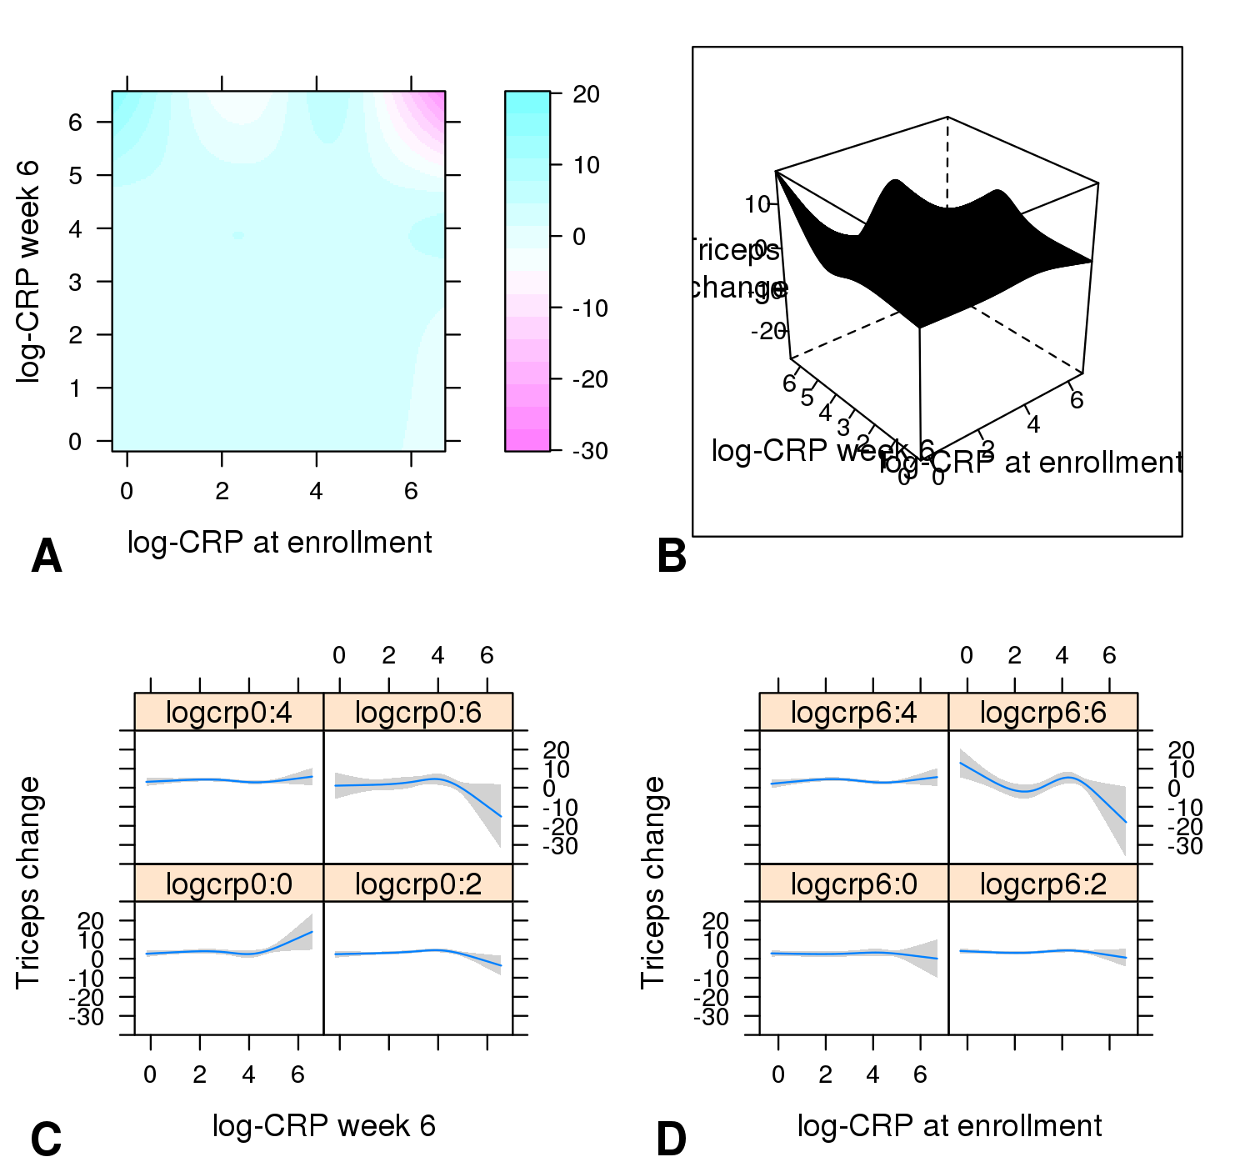
Change in BMI at 12 weeks
kg/m²
Change in waist circumference
at 12 weeks
Change in hip circumference
at 12 weeks
Change in mid-upper arm
circumference at 12 weeks
Change in triceps skinfold
at 12 weeks
cm
cm
cm
p=0.05
mm
p<0.01
p=0.05
p=0.02
p=0.04

Supplementary figure. Heat maps showing the effect of baseline and 6 week C-reactive protein on the change of body composition measurements at 12 weeks . Deeper shades of blue represents larger increases in body composition measurements corresponding to a pair of enrollment (x-axis) and week 6 (y-axis) log-CRP values, while deeper shades of violet represent smaller increases (or negative changes in some variables). P-values refer to effect of two-way interaction between log-CRP at enrollment and week 6 log-CRP on outcome measurements. Interaction terms for calf circumference, scapular skinfold, and bioelectric impedance measurements were not statistically significant. These models are adjusted for age, sex, treatment arm, country, time from enrollment to treatment, and CD4+ count, hemoglobin, receipt of anti-tuberculosis therapy at treatment initiation, and the median baseline value for each of the body composition metrics.

