F. Humber et al.
Madagascar’s marine turtles
Placing Madagascar’s marine turtle populations in a regional context using community-based monitoring
Frances Humber, Brendan J. Godley, Tanguy Nicolas, Olivier Raynaud Florence Pichon and Annette Cameron Broderick

Frances Humber* (Corresponding author), Tanguy Nicolas, Olivier Raynaud and Florence Pichon Blue Ventures Conservation, Level 2 Annex, Omnibus Business Centre, 39-41 North Road, London, UK. Email fran@blueventures.org
Brendan J. Godley and Annette Cameron Broderick Centre for Ecology and Conservation, University of Exeter, Penryn, UK
*Also at: Centre for Ecology and Conservation, University of Exeter, Cornwall Campus, UK

Received 18 June 2015. Revision requested 22 September 2015. Accepted 7 December 2015.

Abstract Madagascar is an important foraging ground for marine turtles in the Western Indian Ocean, yet the status of the country’s nesting aggregations remains poorly documented. We assess the current status and trend in nesting throughout Madagascar, including data recorded by a community-based monitoring project in the Barren Isles (western Madagascar). We contextualize the findings in comparison with data from Madagascar’s closest neighbouring states. Reports indicate that nesting levels have declined at many coastal sites, with no known recordings since 2000 at >░40 nesting sites. We estimate there are a minimum of 1,200 nests per year in Madagascar, with the largest recorded nesting aggregation (<░1,000 nests per year) found on islands off the west and northern coasts. The majority of nesting aggregations, including those recorded by the community-based monitoring project in the Barren Isles, are relatively small, in the order of <░50 nests per year, yet they are potentially important sources of regional genetic diversity. Nesting on many of the islands (e.g. Tromelin, Europa) around Madagascar has increased over the last 20 years, despite the fact that thousands of turtles probably originating from these sites are taken by fishers in the waters of Madagascar annually. We discuss the importance of protecting small nesting populations, and how community-based monitoring could be an important tool for conserving remote and vulnerable populations and building capacity for natural resource management.
Keywords Community-based monitoring, Madagascar, marine turtles, nesting, participatory monitoring, Western Indian Ocean
To view supplementary material for this article, please visit http://dx.doi.org/10.1017/S0030605315001398

Introduction
The conservation and management of marine megafauna is a global challenge, often hampered by a lack of financial and human resources, and there is significant data deficiency in relation to marine species (Schipper et al., 2008; Mangel et al., 2010; Broderick, 2015). The situation may be particularly complicated in more remote regions, such as offshore islands and archipelagos, which may be popular fishing grounds as well as hotspots for migratory marine species (Sullivan et al., 2006; Brotons et al., 2008; Capietto et al., 2014). Threatened marine mammals, turtles and seabirds are not only targeted directly but also suffer high mortality from bycatch (Lewison & Crowder, 2007; Pusineri & Quillard, 2008; Senko et al., 2014). Marine turtles face threats both in the sea and when nesting on land, and are particularly vulnerable if their nesting grounds are remote, attract a high number of fishers and are located in a region that lacks capacity for monitoring and enforcement.
The majority of marine turtle nesting sites in Madagascar are on the west coast, closest to the most suitable foraging habitats, with higher concentrations of nesting on some of the larger islands in the north-west (Rakotonirina & Cooke, 1994; Bourjea et al., 2006; Metcalf et al., 2007). Nesting rates in Madagascar may have been historically lower than on neighbouring islands (e.g. Europa, Mayotte) but are known to have declined in the latter half of the 20th century (Frazier 1975; Rakotonirina, 1987; Rakotonirina & Cooke, 1994; Walker & Roberts, 2005). One site that previously hosted dozens of nesting olive ridley turtles Lepidochelys olivacea on the west coast of Madagascar was reported to have had no nesting turtles since the mid 1980s (Rakotonirina & Cooke, 1994).
All five species of marine turtles found in Madagascar (green Chelonia mydas, hawksbill Eretmochelys imbricata, loggerhead Caretta caretta, olive ridley, and leatherback Dermochelys coriacea) are protected from domestic exploitation (Presidential Decree 2006–400). However, coastal fishing communities continue to take all five species, at an estimated rate of 10,000−16,000 year⁻¹ (Humber et al., 2011). National laws are not enforced for a number of reasons, including a lack of implementation capacity, a reluctance to manage a resource that is culturally important to many fishers, and the extent of the Malagasy coastline and territorial waters (Okemwa et al., 2005).
Conservation of small nesting aggregations of marine turtles is challenging because of the logistics of ensuring that a sufficient number of individuals are encountered or protected, especially in remote environments (Mellors et al., 2008; Danielsen et al., 2009; Pilcher & Chaloupka, 2013). Community-based monitoring and participatory research have been shown to be effective in providing reliable scientific data, and cost-effective if well designed (Holck, 2008; Carvalho et al., 2009), particularly for small populations or low encounter rates (Gaidet-Drapier et al., 2003; Humber et al., 2011).
Participatory monitoring and research has been widely used in the conservation of marine turtles, and has provided important data (Nichols et al., 2000; Humber et al., 2011; Garnier et al., 2012). Community-based conservation strategies are important within communities that have a vested interest in preserving turtles, especially where turtle fishing is a traditional livelihood and part of local cultural dynamics (Nichols et al., 2000; Havemann & Smith, 2007).
We present an overview of marine turtle nesting populations in Madagascar and the Western Indian Ocean, including new data recorded by the first community-based marine turtle nesting and protection programme in the Barren Isles, western Madagascar, a site about which little was known previously. To our knowledge there has been no similar programme focused on marine turtle nesting in Madagascar, although there are community-focused programmes that promote locally led conservation and monitoring of marine turtle fisheries (Humber et al., 2011; Gibbons, 2013) and forest and wetland resources (Andrianandrasana et al., 2005, Hockley et al., 2005, Jones et al. 2008).

Study area
The Barren Isles is an archipelago of 10 islands off the west coast of Madagascar in the Mozambique Channel (×Fig. 1). The archipelago includes c. 5,000 km² of marine and coastal habitats and some of the healthiest reefs in Madagascar, and supports a productive artisanal pelagic fishery (Leroux, 2007; Van Canneyt et al., 2010; Cripps, 2011). The Isles have no permanent residents or villages but during the austral winter (April−November) an estimated 4,000 Vezo and Sara migrant fishers from along the west coast of Madagascar set up temporary camps on the islands to exploit the relatively rich marine resources (Blue Ventures, unpubl. data; Cripps, 2009, 2011; Leroux et al., 2010). All the islands are inhabited during this period, although the island of Nosy Mboro has been protected since 2013 by a local law that prohibits people from staying overnight. Limited nesting surveys in the region suggested there was a small but significant nesting aggregation threatened by direct take from local and migrant fishers (Leroux, 2007).

Methods

Data were collected by a team of eight community members, who were selected through an interview process, having been recommended as turtle nest monitors by a resident researcher in 2011. Criteria for selection included motivation, trustworthiness and the ability to deal with the harsh conditions on the islands. All monitors were fishermen in their 20s to 40s and were paid a monthly salary. In December 2011 the team received 6 days’ training in identifying turtle species and nests, measuring curved carapace length, and photography. This included both office- and field-based training, and methods were based on those of Les tortues marines du Sud Ouest de l’Océan Indien (TORSOOI, 2015), developed to promote standardization of data collection. A month of trial data collection was completed in December 2011. The team was supervised by a project coordinator based in Maintirano, who also visited the teams on the islands at least once per season to check their monitoring methods. Refresher training sessions were held at the start of the 2012 and 2013 seasons.
Four islands were surveyed regularly, by two surveyors per island, during December−May each year during 2012−2014 (three seasons; ×Table 1). Previous accounts and reports suggested this was the main nesting season, and limited budgets prohibited year-long monitoring across the six islands that are not submerged at high tide. Islands were chosen based on accounts of nesting recorded by a previous research group (G. Leroux, Muséum d’histoire naturelle de la ville de Genève) and reports from the community, as well as size and the feasibility of camping. Three islands (Nosy Abohazo, Nosy Dondosy and Nosy Andrano) were monitored in all three seasons. Nosy Mboro was monitored in 2011–2012 but in 2013 a decree to protect nesting birds prohibited people from staying on the island. Consequently monitoring in 2012–2013 included the island of Nosy Mangily but, given the low nesting rates there, efforts in 2013–2014 were directed to the island of Nosy Lava. In 2012–2013 opportunistic trips were made to Nosy Mboro.
Surveys took place daily for 19−24 consecutive days, with c. 3−15 day intervals between monitoring periods for restocking of supplies and recovery from the difficult living conditions. Two-hour beach walks were conducted nightly during high tide and every morning before the first high tide, with each surveyor covering half of the island.
During surveys, new nesting activities were recorded. If the nesting adult was not observed then species and clutch deposition were ascertained from the size and shape of tracks. When a turtle was observed, she was left to lay her clutch before curved carapace length was measured. Nests were marked with wooden stakes.
On the first day of surveys at the beginning of the season or after the break between monitoring sessions, beaches were checked on arrival. Nests recorded on the first day of the survey period were excluded from temporal analyses as their lay date could not be determined accurately.

Interpolation of nest data To assess seasonality for the three islands monitored each season the data were interpolated to account for gaps in monitoring. A mean of 14 days of nesting counts (7 days before and after the monitoring gap) was calculated and used to estimate nesting counts for the days within the monitoring period when surveys were not conducted.

Current nesting overview We reviewed the current (post 2000) status of nesting populations across Madagascar and neighbouring countries in the Western Indian Ocean region (×Figs 2 & 3) through an extensive literature and database search (e.g. IOSEA, 2011; SWOT, 2012). We contacted key partners in Madagascar for additional or missing information, and current nesting activity was recorded at three Blue Ventures Conservation sites (sites 11, 12 & 13; Fig. 2) through participatory mapping exercises and key informant interviews during April−May 2011 and in March and May 2013.

Historical nesting reports To contextualize our findings we conducted an extensive search of peer-reviewed and grey literature (e.g. IOSEA, SWOT, Sea Turtle Online Bibliography, Google Scholar, Researchgate, seaturtle.org) for historical (pre 2000) accounts of nesting from across Madagascar. Historical records were also based on participatory mapping exercises and key informant interviews. Participatory mapping was carried out in the region around the village of Andavadoaka (Fig. 2, site 11) during April−May 2011. Elders in 10 villages were shown maps of the region and asked to indicate where they had last seen a turtle nest, in what year, and the species if known. Interviews were conducted in Belo-sur-Mer (Fig. 2, site 12) and Maintirano/Barren Isles in March and May 2013, respectively. The interviews were conducted in the local Malagasy dialect by a member of Blue Ventures and translated into French or English during the interview, and afterwards from notes taken. Interviews were informal, with individuals or small groups, and maps were provided for reference. Questions were open-ended to facilitate the natural flow of information and discussion. The Andavadoaka and Belo-sur-Mer regions are home to Vezo fishers, who rely almost exclusively on marine resources for their livelihoods.

Results

Current nesting in the Barren Isles A total of 173 nesting emergences were observed over three nesting seasons between January 2012 and May 2014, and 135 nests were recorded (Table 1). Over the three nesting seasons a mean of 33.6 green turtle nests per year (2011−2012, 19 nests; 2012−2013, 45 nests; 2013−2014, 37 nests) and 11.0 hawksbill turtle nests per year (2011−2012, 7 nests; 2012−2013, 15 nests; 2013−2014, 11 nests) were recorded at our study sites. The majority of nests were identified as belonging to green (74.8%, n░=░101) and hawksbill turtles (24.4%, n░=░33), with one olive ridley nest confirmed. Two loggerhead turtle nesting emergences were observed but no nesting was recorded.

Seasonality Nesting activity was detected in each month of the monitoring period (×Fig. 4). The number of green turtle nests peaked in February and March in the first two seasons but in December and May in the 2013–2014 season (Fig. 4; Supplementary Fig. S1). Hawksbill nesting was not recorded in every month in each season but peaked during December−February in each monitoring season (Fig. 4; Supplementary Fig. S1).

Location of nests Of the three islands monitored consistently the majority of nesting activity took place on Nosy Abohazo (60.7%, n░=░68), with all but four nests identified as those of green turtles (Table 1; Fig. 3). Nosy Andrano accounted for 32.1% (n░=░36) of nesting activity, with 58.3% (n░=░21) green and 41.7% (n░=░15) hawksbill turtles.

Adult turtles Throughout the survey period a total of 72 turtles were measured. The mean curved carapace length of nesting green turtles was 105.6░±░6.6 cm (range 94–126 cm, n░=░58), and of hawksbill turtles 84.4░±░12.2 cm (range 52–97 cm, n░=░13). The one olive ridley measured had a curved carapace length of 69 cm.

Loss of nests No removal of eggs or illegal killing of nesting females was observed on the islands while monitors were present. However, six nests may have been raided for eggs on Nosy Abohazo while monitors were not present, although it was not possible to confirm this. We received reports of nests being raided on unmonitored islands, as well as harvesting of adult turtles illegally by fishers for local consumption and to satisfy orders from local businessmen.

Historical nesting According to reports from interviews and the literature there are at least 44 known former nesting sites in Madagascar (Fig. 2; Supplementary Table S3). The size of nesting aggregations at these sites at the time of recording is likely to have been relatively small (<░10 nests per year). Interviews with elders in the regions around Andavadoaka and Belo-sur-Mer highlighted that there has been a decline in nesting since their earliest memories (1960s). In the Maintirano region it was reported that Nosy Dondosy previously hosted much larger numbers of nesting turtles but is now one of the most heavily populated by fishers, and elders attributed the decline in nesting to increased human presence since 1999. A similar situation was reported for the island of Nosy Vao, 70 km north of Maintirano, which now hosts fisher settlements. In the past, green and hawksbill turtles also nested on the mainland coast north and south of Maintirano but there are no reports of nests in this region at present.

National nesting Sites in Madagascar that still host regular nesting activity are concentrated in the north-west (Fig. 2), where there are nesting hotspots on islands. However, nesting is relatively low throughout Madagascar, with most sites estimated to have <░50 nests per year. In the south-west, reports of nesting consist of individual reports of sporadic nesting, in particular at two sites where interviews were conducted (Andavadoaka, site 11, and Belo-sur-Mer, site 12; Fig. 2; Supplementary Tables S1 & S3). We estimate a minimum nesting rate for all of Madagascar of c. 1,200 nests per year (c. 74%, n░=░888, green turtles; 18%, n░=░220, hawksbill turtles; 1%, n░=░11, loggerhead turtles; 7%, n░=░80, unidentified).

Regional nesting Madagascar is surrounded by protected nesting populations on islands, in particular the Îles Éparses (the Scattered Islands in the Indian Ocean: Tromelin, the Glorioso Islands and Europa; Fig. 3). At these sites nesting is in the range of 1,000–5,000 nests per year or nesting females per year. Similar nesting rates are reported for Mayotte and the north-east coast of South Africa (Supplementary Table S2). The majority (82%, n░=░18,636) of nesting activities recorded were of green turtles on the Îles Éparses, Mayotte and the Comores, with loggerhead turtles accounting for 89% (n░=░3,701) of recordings on mainland Africa (South Africa and Mozambique).

Discussion

Historical vs current nesting indicates a decline
Nesting numbers in Madagascar may have been low historically but there is currently only one nesting site estimated to have >░500 nests per year (Nosy Hara, Fig. 2, site 1). Nesting has declined in particular on the mainland as a result of systematic collection of eggs and nesting females (Rakotonirina & Cooke, 1994; Walker & Roberts 2005; Cooke et al., 2003). Furthermore at >░40 sites where nesting was recorded historically there has been no nesting since 2000. There were large numbers of loggerhead turtles nesting in the south-east during the 1970s but only 23 nests were recorded in the 2001–2002 nesting season, of which half were taken illegally (Gladstone et al., 2003). In this study declines were reported at all sites, including along the coastline adjacent to the islands where monitoring was carried out. Madagascar’s islands (e.g. Nosy Iranja, Nosy Hara) remain the most important nesting sites within national waters (Bourjea et al., 2006; Metcalf et al., 2007). However, on Nosy Ve, one of the five small islands on the west coast protected in 1923, nesting was last reported in 1986 (A. Cooke, unpubl. data), and nesting is no longer known to occur on Nosy Vao (fishers, pers. comm.).

Madagascar’s turtles in a regional context
There are significant turtle nesting aggregations on the islands around Madagascar, many of which are uninhabited and fully protected (e.g. Europa, Tromelin; Fig. 3; Supplementary Table S2). Green turtles nest in significant numbers in the South West Indian Ocean (e.g. Europa, 7,000–10,000 year⁻¹; Mayotte, 4,000–6,000 year⁻¹), making it an important region for this species (Bourjea et al., 2007, 2015; van der Elst et al. 2012), and the west coast of Madagascar is a known foraging ground for green turtles from these nesting sites, as demonstrated by tag returns (Fig. 3; Ifremer & Kelonia, 2014).
Although numbers of turtles taken by fishers in Madagascar’s waters appear to have remained at the same levels since the 1970s (Hughes, 1971; Frazier, 1980; Rakotonirina & Cooke, 1994; Humber et al., 2011), many rookeries in the South West Indian Ocean report increases in nesting since the estimate of <░5,500 nesting green turtles in the 1970s (Frazier, 1975), in particular where nesting turtles have had long-term protection, and there are now likely to be >░27,000 nesters per year in the region (van der Elst et al., 2012). The recovery of green turtle nesting populations has not been limited to the South West Indian Ocean but has occurred globally (Broderick et al., 2006; Chaloupka & Balazs, 2007; Stokes et al., 2014; Weber et al., 2014). Recoveries have also been reported for hawksbill, loggerhead, leatherback, olive ridley and Kemp’s ridley Lepidochelys kempii turtles (Márquez et al., 1999; Dutton et al., 2005; Richardson et al., 2006; Marcovaldi & Chaloupka, 2007; Metcalfe et al., 2015).
Despite regional and global recoveries as a result of increased protection and the cessation of commercial turtle harvesting, populations in Madagascar appear to have remained at the same level or decreased. Nesters in Madagascar may represent remnants of once larger nesting populations. Consistently high levels of harvesting may still be keeping nesting rates low in Madagascar. Small-scale fisheries can have a significant impact on mortality in marine turtles (Alfaro-Shigueto et al., 2011; Humber et al., 2011).

Importance of small nesting populations
Our results suggest that the Barren Isles is one of the few remaining important nesting sites in Madagascar, with at least 27−60 nests per year, as there are reports of nesting outside the monitoring season. Although larger nesting sites exist in northern Madagascar, there are no long-term studies to indicate whether these sites are in decline or recovering, with the exception of Nosy Iranja, where regular monitoring since 2000 has indicated an increase in nesting numbers (Bourjea et al., 2006; J. Bourjea, pers.comm.). Many smaller nesting populations in Madagascar have declined or been extirpated. Relatively small nesting populations (e.g. c. 100 nests per year) have been shown to be both nationally and regionally important (Rees et al., 2008; Richardson et al., 2009) and can recover rapidly if protected. Their protection should be encouraged, to reduce the risk of focusing on a few exceptional nesting beaches to the detriment of smaller, historically important sites (McClenachan et al., 2006; Bell et al., 2010).
Nesting in the Barren Isles is also likely to have declined as it is reported that all the islands except Nosy Ampasy, Nosy Marify and Nosy Manandra (which are sand banks) had larger nesting aggregations previously. Interviewees attributed the decline in nesting to increased human presence since c. 1999 and increasing numbers of migrant fishers. The Barren Isles are threatened not only by increasing fishing pressure but also by increasing commercial interests from semi-industrial and industrial fisheries, targeting high-value species such as sharks and sea cucumbers, and commercial mining operations targeting the islands’ guano deposits (Cripps, 2009, 2011).

Benefits of community-based monitoring
We present the results of the first long-term community-based monitoring of nesting turtles in Madagascar, providing data on the nesting activity of a small and remote nesting population. In line with Danielsen et al. (2009) the scheme could be categorized as Category 3: Collaborative Monitoring with External Data Interpretation, where communities are involved in data collection and decision making but analysis has been done externally by scientists.
There is a lack of up-to-date data on nesting in Madagascar, as well as a lack of capacity to carry out monitoring and research to address critical management gaps (Humber & Hykle, 2011; IOSEA, 2014). Compared with more scientific approaches, community-based monitoring has been shown to produce similar results on status and changes of species and natural resources, and is often more cost-effective (Danielsen et al., 2014a; Rovero et al., 2015; ×Table 2). Furthermore, incentive-based approaches to marine turtle conservation, where community members may be paid to monitor, report on or protect turtles, nests or hatchlings, have often improved conservation outcomes, such as reduced poaching of eggs and turtles (Ferraro, 2007; Ferraro & Gjertsen, 2009; Gjertsen & Niesten, 2010). The incentives offered in this programme (i.e. a stable, monthly wage during the rainy season and the prestige of working with an NGO) were sufficient for community members to work in potentially harsh conditions during the nesting season. Local stakeholders could also play an important role in providing data for multilateral environment agreements, such as IOSEA (Indian Ocean South East Asia Marine Turtle Memorandum of Understanding; Danielsen et al., 2014b; Table 2). For these benefits to be fully harnessed, a simple system for data collection, sharing and assimilation would be required, and would need to be appropriate to the capacity available at monitoring sites. However, it is clear that communities can play a pivotal role in filling gaps in data and conservation management, particularly at remote sites (Alfaro-Shigueto et al. 2012; Dutra & Koenen, 2014).
The benefits of community-based monitoring extend further than simply the means to generate data (Table 2). Community teams on nesting beaches can reduce incidences of nesting females, and nests, being taken both during and after the monitoring period (Smith & Otterstrom, 2009; Garnier et al., 2012; Girard & Breheret, 2013). Reports from the teams in this study indicate that the number of nests disturbed was low, and that a visit to Nosy Lava in the 2012–2013 nesting season (not part of regular monitoring that year) showed that all nests found had been disturbed, probably by fishers digging for eggs while staying on the islands. Reports from pre-2011 indicated that nests were raided frequently (G. Leroux, unpubl. data).
Community-based projects improve capacity to monitor and manage natural resources, and build trust and commitment to wider natural resource management (Danielsen et al., 2005, 2009; Carvalho et al., 2009). Engaging communities in monitoring has also been shown to increase local empowerment, either as a direct strategy or as an unexpected outcome (Constantino et al., 2012). Monitoring systems that involve local people have also been shown to be more effective than conventional monitoring done solely by scientists, leading to quicker decision making and more effective conservation management interventions (Danielsen et al., 2007, 2010). Although this can lead to greater autonomy in resource management, it may not translate into increased conservation impact, as decisions may be made contrary to the conservation agenda (Constantino et al., 2012; Funder et al., 2013). Increased empowerment is particularly important in this region as a community-managed marine protected area is under development. The NGO Blue Ventures is leading the capacity–building and has helped to remove a potential area of conflict by building trust and demonstrating that it does not facilitate or promote the prosecution of those that hunt turtles (Table 2). Legislation in Madagascar permits the transfer of natural resource management rights to communities, and there has been an increase in bottom-up conservation and management initiatives. There are currently >░150 locally managed marine protected areas, from none in 2007 (Rakotoson & Tanner, 2006; Rocliffe et al., 2014; MIHARI, 2015). However there are limitations to the amount of data that can be collected through community-based programmes (Table 2). In this case monitoring did not cover the whole nesting season, and year-round assessment is prohibited by the cost and the fact that community members need to return to fishing during the austral winter.

Conclusion
It is vital that Madagascar’s remaining nesting turtle populations are protected, as reports emerge of new markets for turtles and their shells (Repoblikan’i Madagasikara, 2013). To monitor and protect nesting of multiple species across small, scattered, remote sites would require significant financial resources and capacity, which are currently unavailable at the local or national levels. However, we have shown that focused months of fieldwork by community members can provide reliable and valuable data on the size of nesting, and protect nests and females.
Our recommendations for establishing similar programmes fall into three main categories. Firstly, before a programme is designed it is important to decide on the objective. If data are to be used to advise and support community management then community consultations should inform project design, and the monitoring and analysis can be adapted to suit the needs of the community. If the data are intended for more detailed analysis or to contribute to national or regional indicators, such as IOSEA, then it would be important to assess the methods and standards recommended. Secondly, sufficient and relevant training for monitors is vital, with regular follow-up in the field, and adaptation of methods based on feedback. Thirdly, communication is key. Depending on the level of participation in its design, communicating the reason for, and results of, the monitoring programme is essential to maintain support and reduce any potential misunderstandings.
The current project has protected a site of regional importance for green and hawksbill turtles in the Western Indian Ocean and made significant progress towards protecting this site in the longer term, with official temporary marine protected area status now granted (Blue Ventures Conservation, 2014). However, the fact that fishers in Madagascar take numerous foraging turtles could undermine conservation efforts elsewhere in the Western Indian Ocean (Mortimer et al., 2007). Nonetheless, these protected turtle populations could be the basis of a regional sustainable harvest, while also alleviating the pressure on Madagascar’s remaining nesting populations. To protect these nesting populations illegal take must be reduced through strengthening existing legislation and empowering communities and NGOs to manage marine turtle populations and other marine resources (Evely et al., 2011; Harris, 2011; Gibbons, 2013).

Acknowledgements
We thank in particular Audrey Campillo, a researcher affiliated with the La Réunion-based research group Kelonia (www.kelonia.org), who provided initial training for the community monitoring team in Madagascar. We also thank the eight community members of the monitoring team from Maintirano, Jean Berthieu Nomenjanahary and Armel Bezafy for their assistance, Charlotte Moffat, Jérémie Bossert and Marianne Teoh for assisting with community interviews and data organization, Samir Gandhi for helping to prepare Figs 1–3, the State of the World’s Sea Turtles, National Geographic’s Conservation Trust and The Rufford Foundation for supporting Blue Ventures’ marine turtle conservation and research work in Madagascar, and two referees for their helpful input.

References
Alfaro-Shigueto, J., Mangel, J.C., Bernedo, F., Dutton, P.H., Seminoff, J.A. & Godley, B.J. (2011) Small-scale fisheries of Peru: a major sink for marine turtles in the Pacific. Journal of Applied Ecology, 48, 1432–1440.
Alfaro-Shigueto, J., Mangel, J.C., Dutton, P.H., Seminoff, J.A. & Godley, B.J. (2012) Trading information for conservation: a novel use of radio broadcasting to reduce sea turtle bycatch. Oryx, 46, 332–339.
Allison, G. (2008) De la ponte à l’éclosion : suivi de la reproduction de deux espèces menacées de tortues marines, la tortue verte et la tortue imbriquée, sur l’île de Nosy Iranja, Madagascar. Master 2 Biodiversité des Ecosystèmes Tropicaux. Université de La Réunion, Saint-Denis, Réunion.
Andrianandrasana, H.T., Randriamahefasoa, J., Durbin, J., Lewis, R.E. & Ratsimbazafy, J.H. (2005) Participatory ecological monitoring of the Alaotra wetlands in Madagascar. Biodiversity and Conservation, 14, 2757–2774.
Bell, C.D., Blumenthal, J.M., Broderick, A.C. & Godley, B.J. (2010) Investigating potential for depensation in marine turtles: how low can you go? Conservation Biology, 24, 226−235.
Blue Ventures Conservation (2014) Indian Ocean’s largest community-managed MPA established. Http://blueventures.org/indian-oceans-largest-community-managed-mpa-established/ [accessed 30 November 2014].
Bourjea, J., Ciccione, S. & Ratsimbazafy, R. (2006) Marine turtle surveys in Nosy Iranja Kely, North-Western Madagascar. Western Indian Ocean Journal of Marine Science, 5, 209–212.
Bourjea, J., Frappier, J., Quillard, M., Ciccione, S., Roos, D., Hughes, G. & Grizel, H. (2007) Mayotte Island: another important green turtle nesting site in the southwest Indian Ocean. Endangered Species Research, 3, 273–282.
Bourjea, J., Mortimer, J.A., Garnier, J., Okemwa, G., Godley, B.J., Hughes, G. et al. 2015) Population structure enhances perspectives on regional management of the western Indian Ocean green turtle. Conservation Genetics, 16, 1069−1083.
Broderick, A.C. (2015) Grand challenges in marine conservation and sustainable use. Frontiers in Marine Science, 2, 1–3.
Broderick, A.C., Frauenstein, R., Glen, F., Hays, G.C., Jackson, A.L., Pelembe, T. et al. (2006) Are green turtles globally endangered? Global Ecology and Biogeography, 15, 21–26.
Brotons, J.M., Grau, A.M. & Rendell, L. (2008) Estimating the impact of interactions between bottlenose dolphins and artisanal fisheries around the Balearic Islands. Marine Mammal Science, 24, 112–127.
Capietto, A., Escalle, L., Chavance, P., Dubroca, L., Delgado de Molina, A., Murua, H. et al. (2014) Mortality of marine megafauna induced by fisheries: insights from the whale shark, the world’s largest fish. Biological Conservation, 174, 147–151.
Carvalho, A.R., Williams, S., January, M. & Sowman, M. (2009) Reliability of community-based data monitoring in the Olifants River estuary (South Africa). Fisheries Research, 96, 119–128.
CEDTM (2001) Mission a Manompana: Côte Est de Madagascar 3–9 août 2001. Centre d’Etude et de Découverte des Tortues Marines (CEDTM), Réunion.
Chaloupka, M. & Balazs, G. (2007) Using Bayesian state-space modelling to assess the recovery and harvest potential of the Hawaiian green sea turtle stock. Ecological Modelling, 205, 93109.
Ciccione, S. & Bourjea, J. (2006) Nesting of Green Turtles in Saint Leu, Réunion Island. Marine Turtle Newsletter, 112, 1–3.
Constantino, P.A.L., Carlos, H.S.A., Ramalho, E.E., Rostant, L., Marinelli, C., Teles, D. et al. (2012) Empowering local people through community-based resource monitoring: a comparison between Brazil and Namibia. Ecology and Society, 17, 22.
Cooke, A., Lutjeharms, J. & Vasseur, P. (2003) Marine and coastal ecosystems. In The Natural History of Madagascar (eds S. Goodman & J. Benstead), pp. 179–209. Chicago University Press, Chicago, USA.
Cripps, G. (2009) Understanding Migration Amongst Small-Scale Fishers in Madagascar. Blue Ventures Conservation Report for ReCoMaP. Blue Ventures Conservation, London, UK.
Cripps, G. (2011) Feasibility Study on the Protection and Management of the Barren Isles Ecosystem, Madagascar. Blue Ventures Conservation, London, UK.
Danielsen, F., Burgess, N.D. & Balmford, A. (2005) Monitoring matters: examining the potential of locally-based approaches. Biodiversity and Conservation, 14, 2507–2542.Danielsen, F., Burgess, N.D., Balmford, A., Donald, P.F., Funder, M., Jones, J.P.G. et al. (2009) Local participation in natural resource monitoring: a characterization of approaches. Conservation Biology, 23, 31–42.
Danielsen, F., Burgess, N.D., Jensen, P.M. & Pirhofer-Walzl, K. (2010) Environmental monitoring: the scale and speed of implementation varies according to the degree of people’s involvement. Journal of Applied Ecology, 47, 1166–1168.
Danielsen, F., Jensen, P.M., Burgess, N.D., Altamirano, R., Alviola, P.A., Andrianandrasana, H. et al. (2014a) A multicountry assessment of tropical resource monitoring by local communities. BioScience, 64, 236–251.
Danielsen, F., Mendoza, M.M., Tagtag, A., Alviola, P.A., Balete, D.S., Jensen, A.E. et al. (2007) Increasing conservation management action by involving local people in natural resource monitoring. Ambio, 36, 566–570.Danielsen, F., Pirhofer-Walzl, K., Adrian, T.P., Kapijimpanga, D.R., Burgess, N.D., Jensen, P.M. et al. (2014b) Linking public participation in scientific research to the indicators and needs of international environmental agreements. Conservation Letters, 7, 12–24.
Dutra, A. & Koenen, F. (2014) Community-based conservation: the key to protection of marine turtles on Maio Island, Cape Verde. Oryx, 48, 325.
Dutton, D.L., Dutton, P.H., Chaloupka, M. & Boulon, R.H. (2005) Increase of a Caribbean leatherback turtle Dermochelys coriacea nesting population linked to long-term nest protection. Biological Conservation, 126, 186–194.
Evely, A.C., Pinard, M., Reed, M.S. & Fazey, I. (2011) High levels of participation in conservation projects enhance learning. Conservation Letters, 4, 116–126.
Ferraro, P.J. (2007) Performance Payments for Sea Turtle Nest Protection in Low-income Nations: A Case Study from Tanzania. Submitted to the Southwest Fisheries Science Center, National Marine Fisheries Service, National Oceanic and Atmospheric Administration, La Jolla, USA.
Ferraro, P.J. & Gjertsen, H. (2009) A global review of incentive payments for sea turtle conservation. Chelonian Conservation and Biology, 8, 48–56.
Frazier, J.G. (1975) Marine turtles of the Western Indian Ocean. Oryx, 13, 164–175.
Frazier, J. (1980) Exploitation of marine turtles in the Indian Ocean. Human Ecology, 8, 329–370.
Funder, M., Danielsen, F., Ngaga, Y., Nielsen, M.R. & Poulsen, M.K. (2013) Reshaping conservation: the social dynamics of participatory monitoring in Tanzania’s community-managed forests. Conservation and Society, 11, 218–232.
Gaidet-Drapier, N., Fritz, H. & Nyahuma, C. (2003) A participatory counting method to monitor populations of large mammals in non-protected areas: a case study of bicycle counts in the Zambezi Valley, Zimbabwe. Biodiversity and Conservation, 12, 1571–1585.
Garnier, J., Hill, N., Guissamulo, A., Silva, I., Witt, M. & Godley, B. (2012) Status and community-based conservation of marine turtles in the northern Querimbas Islands (Mozambique). Oryx, 46, 359–367.
Gibbons, E. (2013) The Rufford Small Grants Foundation Final Report. FANO Project. Http://www.rufford.org/projects/emma_gibbons [accessed 10 November 2014].
Girard, A. & Breheret, N. (2013) The Renatura sea turtle conservation program in Congo. Munibe Monographs. Nature Series, 1, 65–69.
Gjertsen, H. & Niesten, E. (2010) Incentive-based approaches in marine conservation: applications for sea turtles. Conservation and Society, 8, 5–14.
Gladstone, N., Andriantahina, F. & Soafiavy, B. (2003) Azafady Project Fanomena – Marine Turtle Conservation and Research in Southeast Madagascar. Report on Activities and Findings in the 2001–2002 Nesting Season. Azafady, London, UK.
Harris, A.R. (2011) Out of sight but no longer out of mind: a climate of change for marine conservation in Madagascar. Madagascar Conservation and Development, 6, 7–14.
Havemann, P. & Smith, R. (2007) Community Based Management of Dugong and Turtle Fisheries. Safe-guarding Culture for Future Generations—Joining Together to Protect Dugong and Turtle Fisheries for the Torres Strait. Summary of TSRA Torres Strait Dugong and Marine Turtle Project Governance and Policy Review. James Cook University, Townsville, Australia.
Hockley, N.J., Jones, J.P.G., Andriahajaina, F.B., Manica, A., Ranambitsoa, E.H. & Randriamboahary, J.A. (2005) When should communities and conservationists monitor exploited resources? Biodiversity and Conservation, 14, 2795–2806.
Holck, M.H. (2008) Participatory forest monitoring: an assessment of the accuracy of simple cost-effective methods. Biodiversity and Conservation, 17, 2023–2036.
Hughes, G.R. (1971) Sea turtle research and conservation in South East Africa. In Proceedings of the 2nd Working Meeting of Marine Turtle Specialists, pp. 57–67. IUCNNR, Morges, Switzerland.
Humber, F. & Hykle, D. (2011) Report on the Workshop for the Adoption of a Management and Conservation Plan for Marine Turtles in Madagascar. Blue Ventures Conservation and IOSEA, London, UK.
Humber, F., Godley, B.J., Ramahery, V. & Broderick, A.C. (2011) Using community members to assess artisanal fisheries: the marine turtle fishery in Madagascar. Animal Conservation, 14, 175–185.
Ifremer & Kelonia (2014) Vidéos des migrations des tortues vertes. Http://wwz.ifremer.fr/lareunion/Les-projets/Tortues-Marines/DYMITILE/Trajectoires-en-video-des-tortues-vertes [accessed 30 September 2014].
IOSEA (Indian Ocean South East Asia Marine Turtle Memorandum of Understanding) (2011) IOSEA site/threats reporting system. http://iosea-reporting.org/test/reporting/ [accessed 24th November 2014].
IOSEA (Indian Ocean South East Asia Marine Turtle Memorandum of Understanding) (2014) Overview of IOSEA MoU Implementation. Synthesis of national reports as at 21 July 2014. MT-IOSEA/SS.7/Doc. 6 Agenda item 7a. Seventh Meeting of the Signatory States, pp. 33. Memorandum of Understanding on the Conservation and Management of Marine Turtles and their Habitats of the Indian Ocean and South-East Asia, Bonn, Germany.
Jones, J.P.G., Andriamarovololona, M.M., Hockley, N., Gibbons, J.M. & Milner-Gulland, E.J. (2008) Testing the use of interviews as a tool for monitoring trends in the harvesting of wild species. Journal of Applied Ecology, 45, 1205–1212.
Lauret-Stepler, M., Bourjea, J., Roos, D., Pelletier, D., Ryan, P.G., Ciccione, S. & Grizel, H. (2007) Reproductive seasonality and trend of Chelonia mydas in the SW Indian Ocean: a 20 yr study based on track counts. Endangered Species Research, 3, 217–227.
Lauret-Stepler, M., Ciccione, S. & Bourjea, J. (2010) Monitoring of marine turtles reproductive activities in Juan de Nova, Eparses Islands, South Western Indian Ocean, based on tracks count and width. Indian Ocean Turtle Newsletter, 11, 18−23.
Leroux, G. (2007) Tortues Marines: L’Espoir en Marche. Univers Maoré, 8, 32–43.
Leroux, G., Rakotonirina, B., Ciccione, S., Hawawini, S. & Campillo, A. (2010) First report of Chelonia mydas affected by cutaneous ﬁbropapillomatis on the west coast of Madagascar. Indian Ocean Turtle Newsletter, 11, 13–17.
Lewison, R.L. & Crowder, L.B. (2007) Putting longline bycatch of sea turtles into perspective. Conservation Biology, 21, 79–86.
Mangel, J.C., Alfaro-Shigueto, J., Van Waerebeek, K., Cáceres, C., Bearhop, S., Witt, M. & Godley, B.J. (2010) Small cetacean captures in Peruvian artisanal ﬁsheries: high despite protective legislation. Biological Conservation, 143, 136–143.
Marcovaldi, M.A. & Chaloupka, M. (2007) Conservation status of the loggerhead sea turtle in Brazil: an encouraging outlook. Endangered Species Research, 3, 133–143.
Márquez, R., Díaz, J., Sánchez, M., Burchfield, P., Leo, A., Carrasco, M. et al. (1999) Results of the Kemp’s ridley nesting beach conservation efforts in México. Marine Turtle Newsletter, 85, 2–4.
McClenachan, L., Jackson, J.B.C. & Newman, M.J.H. (2006) Conservation implications of historic sea turtle nesting beach loss. Frontiers in Ecology and the Environment, 4, 290–296.
Mealla, R.A. (2011) Investigating marine turtle nesting sites, local perceptions and conservation strategies in Northern Madagascar. MSc thesis. Imperial College London, London, UK.
Mellors, J.E., McKenzie, L.J. & Coles, R.G. (2008) Seagrass-Watch: engaging Torres Strait islanders in marine habitat monitoring. Continental Shelf Research, 28, 2339–2349.
Metcalf, J., Hampson, K., Andriamizava, A., Andrianirina, R., Ramiarisoa, C., Sondotra, H. et al. (2007) The importance of north-west Madagascar for marine turtle conservation. Oryx, 41, 232–238.
Metcalfe, K., Agamboué, P.D., Augowet, E., Boussamba, F., Cardiec, F., Fay, J.M. et al. (2015) Going the extra mile: ground-based monitoring of olive ridley turtles reveals Gabon hosts the largest rookery in the Atlantic. Biological Conservation, 190, 14–22.
MIHARI (2015) Madagascar Locally Managed Marine Area Network. Http://mihari-network.org/ [accessed 28 October 2015].
Mortimer, J.A., Meylan, P.A. & Donnelly, M. (2007) Whose turtles are they, anyway? Molecular Ecology, 16, 17–18.
Nel, R. (2010) Sea Turtles of KwaZulu-Natal: Data Report for the 2009/10 Season. Nelson Mandela Metropolitan University for Ezemvelo KwaZulu-Natal Wildlife, Pietermaritzburg, South Africa.
Nichols, W.J., Bird, K.E. & Garcia, S. (2000) Community-based research and its application to sea turtle conservation in Bahía Magdalena, BCS, Mexico. Marine Turtle Newsletter, 89, 4–7.
Okemwa, G., Muthiga, N. & Mueni, E. (2005) Proceedings of the Western Indian Ocean Region Marine Turtle Conservation Workshop. 16−17 September 2004, Mombasa, Kenya.
Pilcher, N. & Chaloupka, M. (2013) Using community-based monitoring to estimate demographic parameters for a remote nesting population of the Critically Endangered leatherback turtle. Endangered Species Research, 20, 49–57.
Pusineri, C. & Quillard, M. (2008) Bycatch of protected megafauna in the artisanal coastal fishery of Mayotte Island, Mozambique Channel. Western Indian Ocean Journal of Marine Science, 7, 195–206.
Rakotonirina, B.P. (1987) Les Tortues marines dans le Sud de Madagascar: Etude Bibliographique et enquêtes auprés des pêcheurs. Recherche sur la biométrie et l’alimentation de la tortue verte, Chelonia mydas Linnaeus. Mémoire de DEA d’Océanographie Appliquée, Université de Toliara, Toliara, Madagascar.
Rakotonirina, B. & Cooke, A. (1994) Sea turtles of Madagascar⎯their status, exploitation and conservation. Oryx, 28, 51–61.
Rakotoson, L. & Tanner, K. (2006) Community-based governance of coastal zone and marine resources in Madagascar. Ocean & Coastal Management, 49, 855–872.
Rasolofo, M. (2012) Country presentation: Madagascar. In Regional Workshop and Fourth Meeting of the Western Indian Ocean Marine Turtle Task Force, 4–7 December 2012. Port Elizabeth, South Africa.
Rees, A.F., Saad, A. & Jony, M. (2008) Discovery of a regionally important green turtle Chelonia mydas rookery in Syria. Oryx, 42, 456–459.
Repoblikan’i Madagasikara (2013) Réunion technique sur «les prises de mesures face au trafic de tortue marine à Madagascar». Note de presse. Mercredi 4 Décembre 2013. Comite National de Gestion Integree de la Zone Cotiere et marine (CN-GIZC), Antananarivo, Madagascar.
Richardson, J.I., Hall, D.B., Mason, P.A., Andrews, K.M., Bjorkland, R., Cai, Y. & Bell, R. (2006) Eighteen years of saturation tagging data reveal a significant increase in nesting hawksbill sea turtles (Eretmochelys imbricata) on Long Island, Antigua. Animal Conservation, 9, 302–307.
Richardson, P.B., Bruford, M.W., Calosso, M.C., Campbell, L.M., Clerveaux, W., Formia, A. et al. (2009) Marine turtles in the Turks and Caicos Islands: remnant rookeries, regionally significant foraging stocks, and a major turtle fishery. Chelonian Conservation and Biology, 8, 192–207.
Rocliffe, S., Peabody, S., Samoilys, M. & Hawkins, J.P. (2014) Towards a network of locally managed marine areas (LMMAs) in the Western Indian Ocean. PLoS ONE, 9(7), e103000.
Rovero, F., Mtui, A., Kitegile, A., Jacob, P., Araldi, A. & Tenan, S. (2015) Primates decline rapidly in unprotected forests: evidence from a monitoring program with data constraints. PLoS ONE 10(2), e0118330.
Sagar, J. (2001) The Ecology and Conservation of Sea Turtles in the Nosy Be Islands, Madagascar. Unpublished field mission report.
Schipper, J., Chanson, J.S., Chiozza, F., Cox, N.A., Hoffmann, M., Katariya, V. et al. (2008) The status of the world’s land and marine mammals: diversity, threat and knowledge. Science, 322, 225−230.
Senko, J., Mancini, A., Seminoff, J.A. & Koch, V. (2014) Bycatch and directed harvest drive high green turtle mortality at Baja California Sur, Mexico. Biological Conservation, 169, 24–30.
Smith, R. & Otterstrom, S. (2009) Engaging local communities in sea turtle conservation: strategies from Nicaragua. The George Wright Forum, 26, 39–50.
Stokes, K.L., Fuller, W.J., Glen, F., Godley, B.J., Hodgson, D.J., Rhodes, K.A. et al. (2014) Detecting green shoots of recovery: the importance of long-term individual-based monitoring of marine turtles. Animal Conservation, 17, 593–602.
Sullivan, B.J., Reid, T.A. & Bugoni, L. (2006) Seabird mortality on factory trawlers in the Falkland Islands and beyond. Biological Conservation, 131, 495–504.
SWOT (The State of the World’s Sea Turtles) (2012) Http://www.seaturtlestatus.org/ [accessed 10 January 2012].
TORSOOI (2015) Http://www.torsooi.com/ [accessed 12 August 2011].
Van Canneyt, O., Doremus, G., Laran, S., Ridous, V. & Watremez, P. (2010) Distribution et abondance de la mégafaune marine dans le sud-ouest de l’océan Indien tropical. Campagne REMMOA⎯Océan Indien. Universite de la Rochelle, La Rochelle, France.
van der Elst, R., Fennessy, S., Everett, B., Mackay, F., Floros, C., Schleyer, M. et al. (2012) Mainstreaming Biodiversity in Fisheries Management: A Retrospective Analysis of Existing Data on Vulnerable Organisms in the South West Indian Ocean. Report prepared for the South West Indian Ocean Fisheries Project (SWIOFP). Oceanographic Research Institute, Durban, South Africa.Videira, E.J.S., Pereira, M.A.M. & Louro, C.M.M. (2011) Monitoring, Tagging and Conservation of Marine Turtles in Mozambique: Annual Report 2010/11. Associação para Investigação Costeira e Marinha (AICM) and Centro Terra Viva, Maputo, Mozambique.
Walker, R.C.J. & Roberts, E. (2005) Notes on the status and incidental capture of marine turtles by the subsistence fishing communities of South West Madagascar. Western Indian Ocean Journal of Marine Science, 4, 219–225.
Weber, S.B., Weber, N., Ellick, J., Avery, A., Frauenstein, R., Godley, B.J. et al. (2014) Recovery of the South Atlantic’s largest green turtle nesting population. Biodiversity and Conservation, 23, 3005–3018.

Biographical sketches
Frances Humber is interested in increasing the knowledge of the status of traditional and artisanal fisheries, in particular the traditional shark and turtle fisheries of Madagascar, through community-based assessment. Brendan Godley in interested in the study and conservation of marine vertebrates. Tanguy Nicolas, Florence Pichon and Olivier Raynaud previously coordinated Blue Ventures’ Barren Isles and Maintirano Project. Tanguy currently works with the IUCN French Committee focusing on biodiversity in Mayotte and other EU member states overseas territories of the Indian Ocean, Florence is studying community-based climate change adaptation, and Olivier works for the Conservatoire du littoral in Saint Martin and Saint Barthélémy, focusing on coastal and insular land acquisition and ecosystem restoration. Annette Broderick’s research focuses on the exploitation and status of marine vertebrate populations, in particular marine turtles.

Table 1 Number of days of monitoring carried out on each of six islands in the Barren Isles, Madagascar (Fig. 1), and number of nests recorded during each of three seasons (with interpolated numbers, in parentheses, for the four islands monitored in all three seasons). Blank cells indicate that no monitoring took place on that island during that monitoring season.
Island (perimeter, km) | 2011–2012 |  | 2012–2013 |  | 2013–2014
Island (perimeter, km) | Total days monitoring | No. of nests (interpolated) | Total days monitoring | No. of nests (interpolated) | Total days monitoring | No. of nests (interpolated)
Abohazo (2.08) | 98 | 11 (14.9) | 99 | 26 (41.1) | 106 | 31 (42.9)
Andrano (2.13) | 98 | 7 (4) | 100 | 22 (26.3) | 106 | 7 (8.7)
Dondosy (0.83) | 102 | 2 (2) | 99 | 2 (3.6) | 106 | 4 (5.6)
Lava (2.46) |  |  |  |  | 106 | 6
Mangily (1.35) |  |  | 101 | 4
Mboro (1.16) | 99 | 7 | 4 | 6
Total | 397 | 27 (27.9) | 403 | 60 (80.9) | 424 | 48 (63.1)

Table 2 Positive and negative aspects of the community-based turtle nest monitoring programme in the Barren Isles, Madagascar (Fig. 1).
Aspects of community-based monitoring | Examples from this study
Positive

Facilitates monitoring of more remote nesting sites | Nesting sites were on remote islands with no water or electricity. Local fishers regularly spend weeks at a time on the islands & were therefore better placed to be monitors than external scientists.
Can produce similar results on status & trends of species or resources to those of trained scientists | Regular monitoring has provided the first multiyear information on changes in annual nesting levels on these islands.
Monitoring costs reduced; should be more cost-effective | Field costs were USD <░4000 per annum, with c. 400 monitoring days per season.
Valuable local knowledge can be incorporated into the programme & can improve monitoring design | Community members were aware of which islands were mostly likely to have nesting turtles, & who would be best for key informant interviews.
Provides employment opportunities & diversifies sources of income for community members | In this region, alternative employment opportunities are limited. This project provided employment for eight community members.
Increased protection & conservation of marine turtles in remote areas | In such a remote area, community monitors were able to provide increased protection to nesting turtles, & nests. Anecdotal reports indicated lower rates of nest loss & poaching on islands where monitors were based.
Engages community in turtle conservation | There is mistrust between the community & authority figures or groups in relation to marine turtles. The monitoring not only engaged community members directly but demonstrated that the NGO was not going to prosecute individuals for poaching or hunting & could engage the community in discussions on turtles through the monitors themselves & through dissemination events.
Provides information for use in national marine conservation & management plans | The data on nesting & improved nest protection could be relevant for The Indian Ocean South-East Asian (IOSEA) Marine Turtle Memorandum of Understanding, of which Madagascar is a signatory.
Increases stakeholder engagement in other conservation or marine management programmes | A community-managed marine protected area is under development in this region & community monitors have gained a greater understating of wider marine management issues through training with the local NGO, & have helped to disseminate information in their communities. Protecting a culturally important resource, such as marine turtles, could also provide a further opportunity to highlight the importance of marine management.
Negative

Limited in level of data that can be collected, as methods need to be relatively simple | Data collection was simplified to the main information required, such as date & number of nests. More detailed or complicated data collection (e.g. marking if a nest was likely to have been made during the period they were off the islands) was not feasible, & trials showed that such data were more likely to contain errors.
Training may take longer, & regular refresher sessions are paramount | New methods & information had to be introduced slowly, & regular refresher sessions were important to check that methods had been understood & remained consistent.
Monitoring not possible year round | Nesting numbers were too low during May−Nov. to warrant the cost, & community members need to return to fishing when this is more lucrative. Harsh conditions make year-round monitoring unfeasible.
May take longer to establish monitoring programme, as relationships must be built with community, especially where turtle hunting is illegal. | It was necessary to establish a relationship with the community before any research could take place, given that turtle hunting is illegal & there is mistrust of outside authorities. Project assistants from the local community helped to build this relationship more effectively.
Income from monitoring may not benefit community as a whole | Only a limited number of local people could read & write to the level needed to actively take part in natural resource monitoring. These same individuals may therefore be participating in multiple programmes or opportunities.
Understanding of wider marine turtle biology or conservation issues may be limited & could reduce overall impact of project | Most people were not aware that turtles revisit beaches to nest, or that adults return to the beaches where they hatched, which can limit incentives for protecting nesting adults. Furthermore, foreigners tagging turtles is not popular with local communities & creates mistrust.
May be difficult for monitors to report illegal activity by members of their own community | Although there was evidence of poaching it was not possible to discuss potential culprits with community monitors because of the risk of damaging the relationship with them & with the wider community.

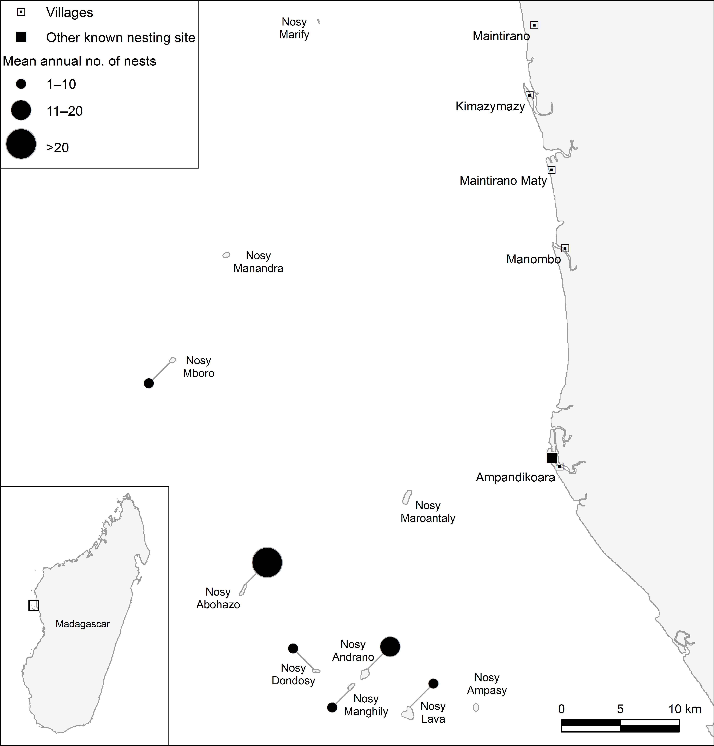

Fig. 1 Mean annual marine turtle nesting rates in the Barren Isles, Madagascar, during 2011–2014 (not all islands were monitored every year; see Methods). Nosy Marify, Nosy Manandra, Nosy Maroantaly and Nosy Ampasy do not support successful nesting as they are regularly submerged during spring tides. The community team members were based in Maintirano, the main town in the region, which is also where most migrant fishers return to restock during periods on the islands.

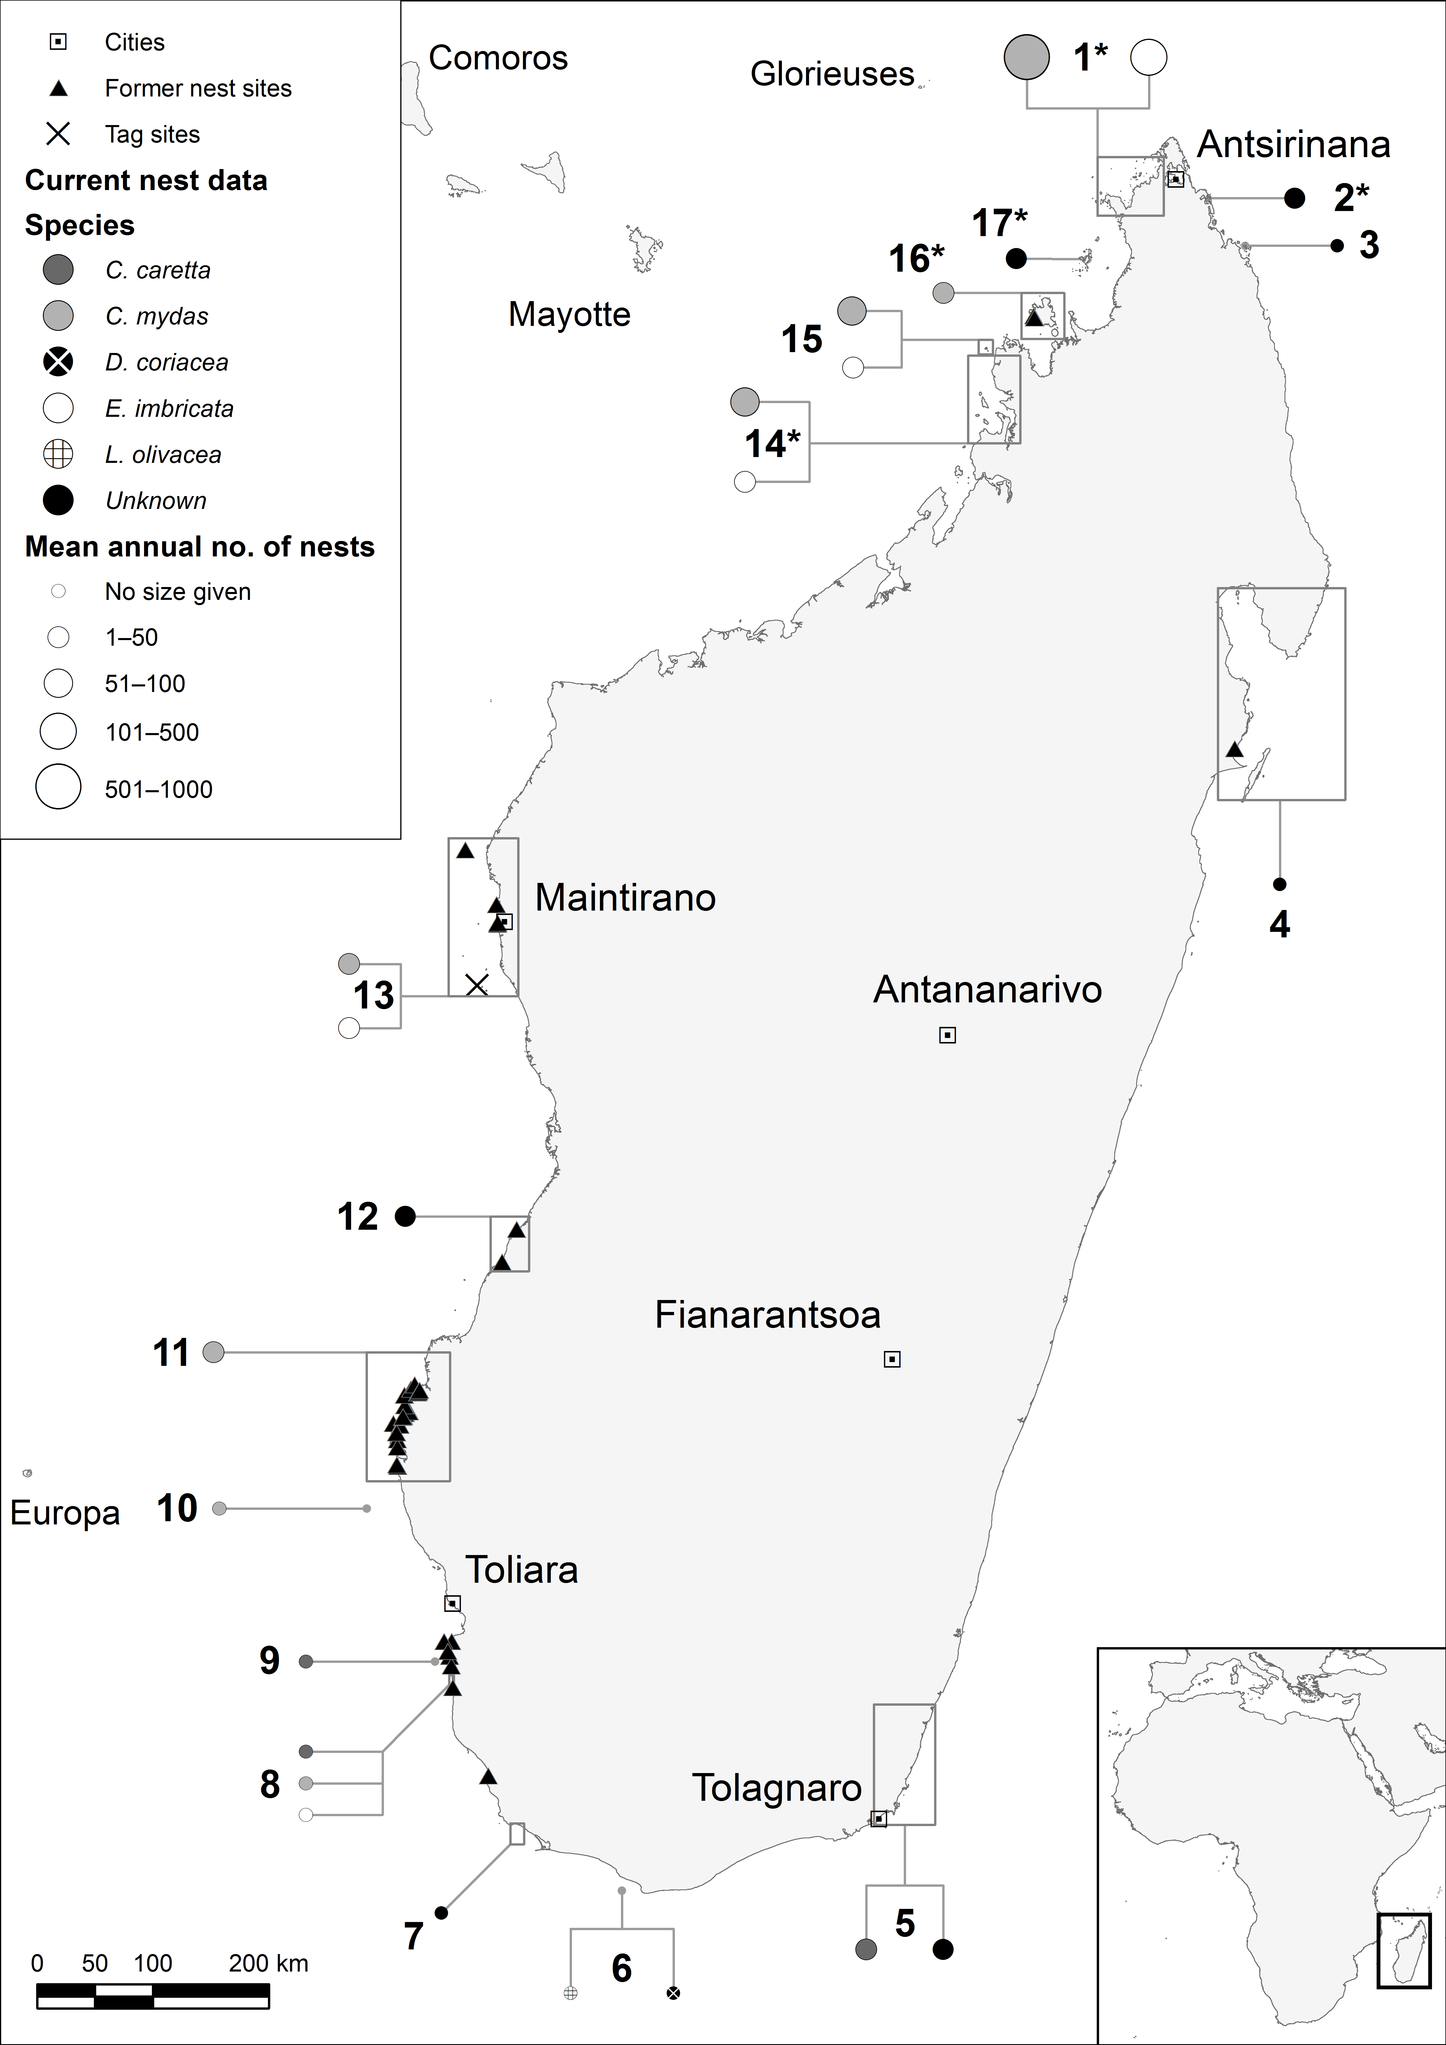

Fig. 2 Current and historical marine turtle nesting sites in Madagascar, with number of nests reported. . The site numbers refer to Supplementary Tables S1 & S3; * indicates data based on body pit count. No attempt was made to extrapolate nesting data for a period <░1 year. The tagging site for tags retrieved by Blue Ventures is indicated. Nest monitoring in this study was carried out at site 13.

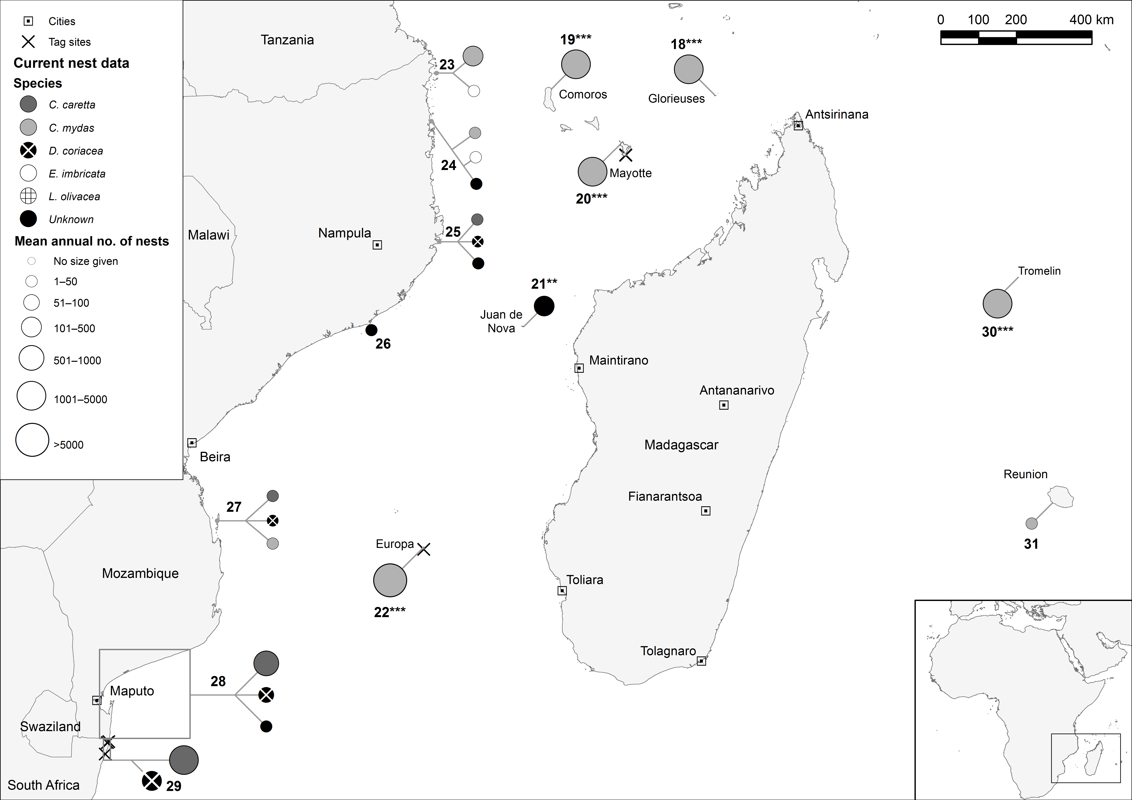

Fig. 3 Current known marine turtle nesting sites around Madagascar. The site numbers refer to Supplementary Table S2. Asterisks indicate data based on no. of nesting turtles per year (**) and track counts (***). No attempt was made to extrapolate nesting data for a period <░1 year. The origins of tags retrieved by Blue Ventures are indicated.

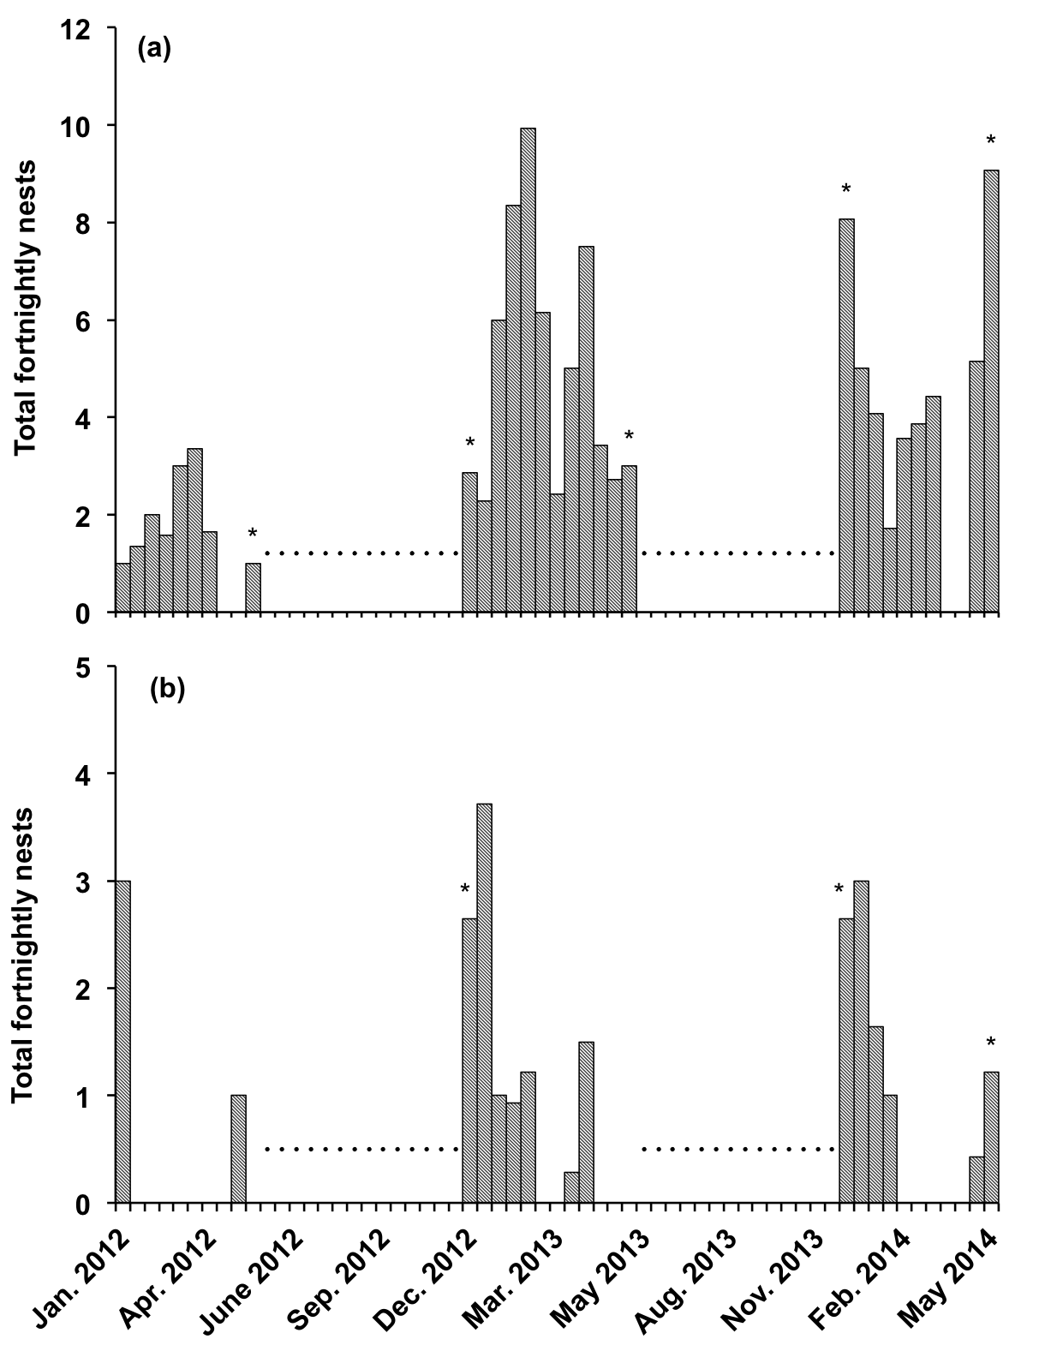

Fig. 4 Nesting counts for green Chelonia mydas (a) and hawksbill turtles Eretmochelys imbricata (b) by half month over the 3-year survey period for the three islands monitored each season (Nosy Abohazo, Nosy Andrano, Nosy Dondosy; Fig. 1). Data have been interpolated for the gaps in monitoring during the survey period. Dots indicate periods when there were no surveys; asterisks indicate incomplete 14 days of monitoring (i.e. data have been interpolated).

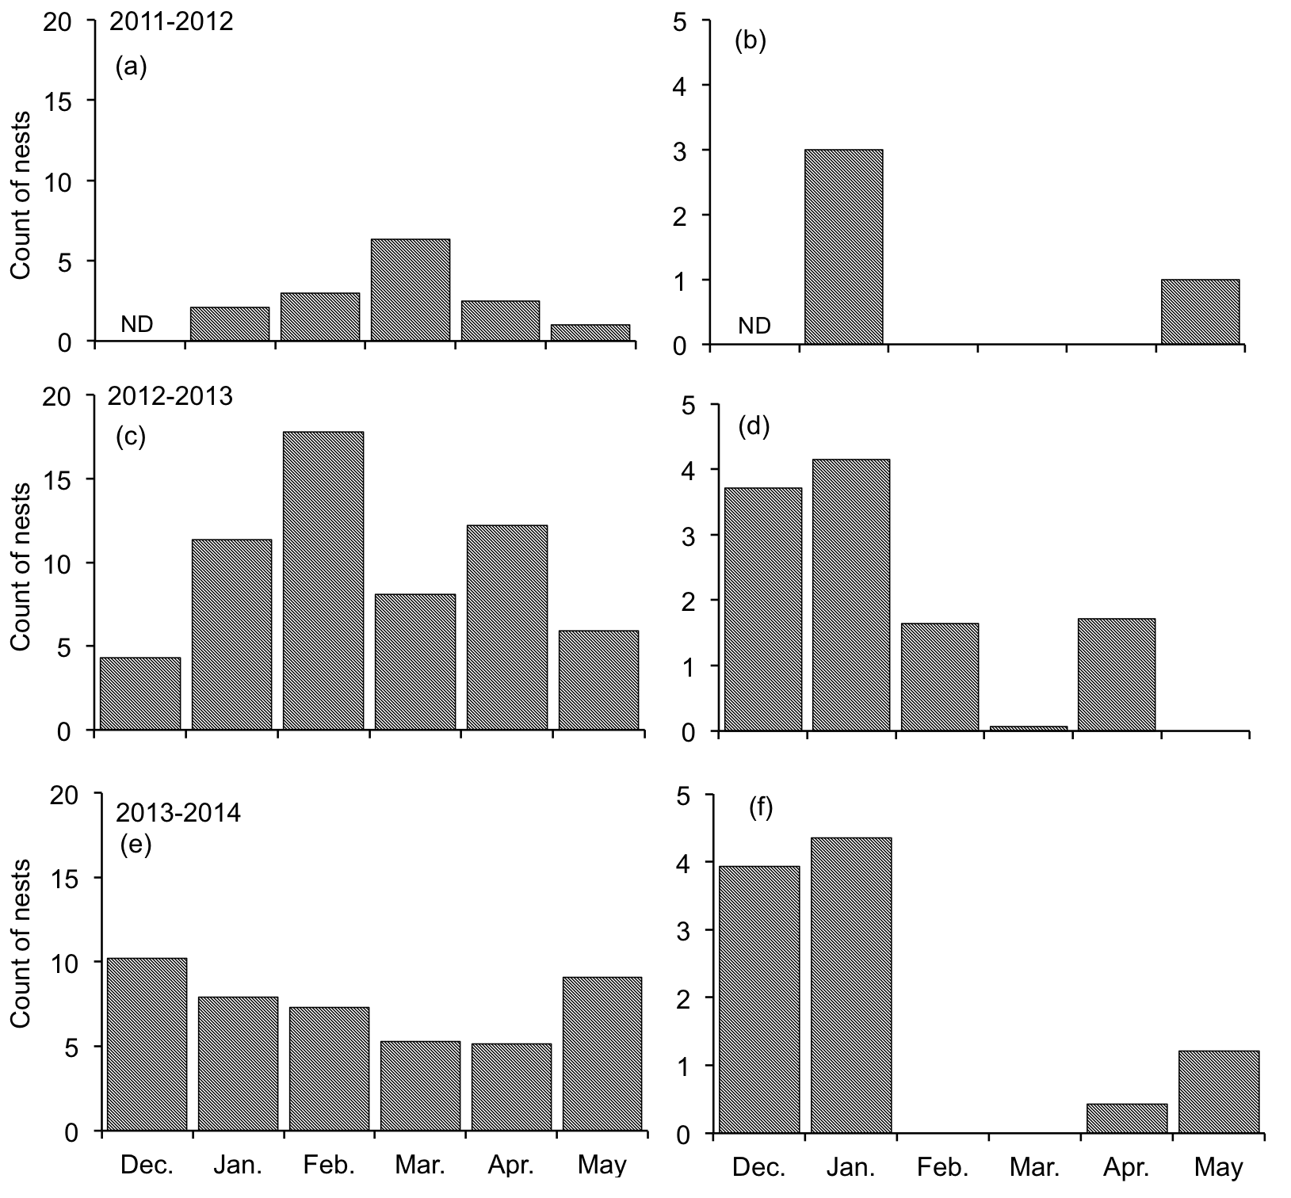
Fig. S1 Estimated total nests of green Chelonia mydas (a, c, e) and hawksbill Eretmochelys imbricata (b, d, f) turtles by month in each of the three survey periods (2011−2012, 2012−2013 and 2013−2014) on the islands of Nosy Abohazo, Nosy Andrano and Nosy Dondosy, Madagascar (Fig. 1). Data have been interpolated for the gaps in monitoring during the survey period. There were no surveys during 26 May−14 December 2012 and 19 May−13 December 2013 (ND, no monitoring occurred).

Table S1 Data on nesting marine turtles in Madagascar since 2000, with site no. (Fig. 2), region, species, no. of nests, month/year, data type, and reference.

Site no. | Region | Species | No. of nests | Month/year | Data type | Reference
1 | Nosy Hara region | Green turtle Chelonia mydas | <1,000 | July−Dec. 2000 | Body pit count | Metcalf et al., 2007
1 | Nosy Hara region | Hawksbill turtle Eretmochelys imbricata | <500 | July−Dec. 2000 | Body pit count | Metcalf et al., 2007
2 | Ambolobozokely region | Unknown | <50 | June 2011 | Body pit count | Mealla, 2011
3 | Archipel (Barralums) | Unknown | Not reported | Unknown |  | Rasolofo, 2012; van der Elst et al., 2012
4 | Analandrafia  Masoala  Baie d’Antongil  Ile Sainte Marie  Manambato | Unknown | Not reported | 2011 |  | CEDTM, 2001; Rasolofo, 2012
 |  |  |  | Unknown |  | CEDTM, 2001; Rasolofo, 2012
 |  |  |  | Unknown |  | CEDTM, 2001; Rasolofo, 2012
 |  |  |  | Unknown |  | CEDTM, 2001; Rasolofo, 2012
 |  |  |  | Unknown |  | CEDTM, 2001; Rasolofo, 2012
5 | 96 km coastline north of Tolagnaro | Loggerhead turtle Caretta caretta | <50 | 2001−2002 | No. of nests | Gladstone et al., 2003
5 | 96 km coastline north of Tolagnaro | Unknown | <50 | 2001−2002 | No. of nests | Gladstone et al., 2003
6 | Parc National Marin Nosy Ve-Androka | Olive ridley turtle Lepidochelys olivacea | Not reported | 2011 |  | IOSEA, 2011; van der Elst et al., 2012
6 | Parc National Marin Nosy Ve-Androka | Leatherback turtle Dermochelys coriacea
7 | Ambohibola-Nosy Manitse | Unknown | Not reported | Unknown |  | G. Tovondrainy, pers. comm.
8 | Beheloka-Besambay | Green | Not reported | 2002 |  | G. Tovondrainy, pers. comm.
8 | Beheloka-Besambay | Hawksbill | Not reported | 2002 |  | Walker & Roberts, 2005
8 | Beheloka-Besambay | Loggerhead
9 | Maromena | Loggerhead | Not reported | 2002 |  | Walker & Roberts, 2005
10 | Salary Nord | Green | Not reported | 2011 |  | IOSEA, 2011
11 | Ankitambanga-Belavenoke | Green | <50 | 2008 | No. of nests | Blue Ventures (this study)
12 | Lovobe-Antanimanimbo | Unknown | <50 | 2010−present | No. of nests | Blue Ventures (this study)
13 | Barren Isles | Green | <50 | Dec.−May (2011−2014) | No. of nests | Blue Ventures (this study)
13 | Barren Isles | Hawksbill | <50 | Dec.−May (2011−2014) | No. of nests | Blue Ventures (this study)
14 | Radama Islands region | Green | <100 | July-Dec. 2000 | Body pit count | Metcalf et al., 2007
14 | Radama Islands region | Hawksbill | <50 | July-Dec. 2000 | Body pit count | Metcalf et al., 2007
15 | Nosy Iranja region | Green | <100 | 2000−2008 | No. of nests | Bourjea et al., 2006; Allison, 2008
15 | Nosy Iranja region | Hawksbill | <50 | 2000−2008 | No. of nests | Bourjea et al., 2006; Allison, 2008
16 | Nosy Be region | Green | <50 | Nov. 2000−Jan. 2001 | Body pit count | Sagar, 2001
17 | Ankarana beach - Nosy Mitsio | Unknown | <50 | May 2011 | Body pit count | Mealla, 2011

Table S2 Records of known nesting sites of marine turtles on the islands around Madagascar and off the coast of Mozambique and northern South Africa, with site no. (Fig. 3), region, species, no. of nests, month/year, data type, and reference.
Site no. | Region | Species | No. of nests | Year | Data type | Reference
18 | Glorieuses | Green | <5,000 | 1987−2006 | Track counts | van der Elst et al., 2012; Lauret-Stepler et al., 2007
19 | Moheli (Comoros) | Green | <5,000 | Since 2000 | Track counts | Bourjea, pers. comm. in van der Elst et al., 2012
20 | Moya & Saziley sites (Mayotte) | Green | <5,000 | Jan. 1998−Dec. 2005 | Track counts | Bourjea et al., 2007
21 | Juan de Nova | Unknown | <500 | 1987−2008* | Nesting turtles/year | Lauret-Stepler et al., 2010
22 | Europa | Green | >5,000 | 1983−2006 | Track counts | van der Elst et al., 2012; Lauret-Stepler et al., 2007
23 | Vamizi (Mozambique) | Green | <500 | Oct. 2003−Sep. 2007 | Number of nests/year | Garnier et al., 2012
23 | Vamizi (Mozambique) | Hawksbill | <50 | Oct. 2003−Sep. 2007 | Number of nests/year | Garnier et al., 2012
24 | Quirimbas National Park (Mozambique) | Green | <50 | 2010−2011 | Number of nests/year | Videira et al., 2011
24 | Quirimbas National Park (Mozambique) | Hawksbill | <50 | 2010−2011 | Number of nests/year | Videira et al., 2011
24 | Quirimbas National Park (Mozambique) | Unknown | <50 | 2010−2011 | Number of nests/year | Videira et al., 2011
25 | São Sebastião (Mozambique) | Loggerhead | <50 | 2010−2011 | Number of nests/year | Videira et al., 2011
25 | São Sebastião (Mozambique) | Leatherback | <50 | 2010−2011 | Number of nests/year | Videira et al., 2011
25 | São Sebastião (Mozambique) | Unknown | <50 | 2010−2011 | Number of nests/year | Videira et al., 2011
26 | Primeiras e Segundas (Mozambique) | Unknown | <50 | 2010−2011 | Number of nests/year | Videira et al., 2011
27 | Bazaruto National Park (Mozambique) | Loggerhead | <50 | 2010−2011 | Number of nests/year | Videira et al., 2011
27 | Bazaruto National Park (Mozambique) | Green | <50 | 2010−2011 | Number of nests/year | Videira et al., 2011
27 | Bazaruto National Park (Mozambique) | Leatherback | <50 | 2010−2011 | Number of nests/year | Videira et al., 2011
28 | Ponta do Ouro to Macaneta (Mozambique) | Loggerhead | <1,000 | 2010−2011 | Number of nests/year | Videira et al., 2011
28 | Ponta do Ouro to Macaneta (Mozambique) | Leatherback | <100 | 2010−2011 | Number of nests/year | Videira et al., 2011
28 | Ponta do Ouro to Macaneta (Mozambique) | Unknown | <50 | 2010−2011 | Number of nests/year | Videira et al., 2011
29 | South Africa | Loggerhead | <5,000 | 2009−2010 | Number of nests/year | Nel, 2010
29 | South Africa | Leatherback | <500 | 2009−2010 | Number of nests/year | Nel, 2010
30 | Tromelin | Green | <5,000 | 1986−2006 | Track counts | van der Elst et al., 2012; Lauret-Stepler et al., 2007
31 | Réunion Island | Green | <50 | 2004−2006 | Number of nests/year | Ciccione & Bourjea, 2006
*Only data since 1992 used in analyses because of gaps in data collection

Table S3 Records of historical (defined as pre-2000) known marine turtle nesting sites in Madagascar, with site no. (Fig. 2), site, possible species, last year of sighting, year data collected, and reference. No nest numbers were given for any of these nesting sites.
Site no. | Site (nearest village)[Please check that all places in parentheses are in fact the nearest villages] | Species | Last year of sighting | Year data collected | Reference
4 | Pointe Mahela (Manompana) | Unknown | Pre-2001 | 2001 | CEDTM, 2001
9 | Itampolo | Green | Pre-2002 | 2002 | Walker & Roberts, 2005
9 | Anakao | Green | Pre-2002 | 2002 | Walker & Roberts, 2005
9 | Anakao | Hawksbill | Pre-2002 | 2002 | Walker & Roberts, 2005
9 | Anakao | Loggerhead | Pre-2002 | 2002 | Walker & Roberts, 2005
9 | Ambola | Green | Pre-2002 | 2002 | Walker & Roberts, 2005
9 | Andriangy | Green | Pre-2002 | 2002 | Walker & Roberts, 2005
9 | Nosy Ve | Green | Pre-2002 | 2002 | Walker & Roberts, 2005
9 | Befasy | Green | Pre-2002 | 2002 | Walker & Roberts, 2005
9 | Nosy Satrana | Green | Pre-2002 | 2002 | Walker & Roberts, 2005
11 | Andoe avaratre (Nosy Andragnombala) | Green | 1965 | 2011 | Blue Ventures (this study)
11 | Antsotsomoroy (Andavadoaka) | Hawksbill | 1991 | 2011 | Blue Ventures (this study)
11 | Ampasilava (Belavenoke) | Green | 1983 | 2011 | Blue Ventures (this study)
11 | Agnorontane (Bevato South) | Loggerhead | 1960 | 2011 | Blue Ventures (this study)
11 | Anboapasy (Bevato North) | Loggerhead | 1957 | 2011 | Blue Ventures (this study)
11 | Antsatsamondika (Bevato South) | Loggerhead | 1957 | 2011 | Blue Ventures (this study)
11 | Depandempa (Bevato South) | Loggerhead | 1965 | 2011 | Blue Ventures (this study)
11 | Anboake avaratre (Bevato North) | Loggerhead | 1966 | 2011 | Blue Ventures (this study)
11 | Anboapasy Ovant (Bevato North) | Green | 1966 | 2011 | Blue Ventures (this study)
11 | Agnorontare Ovant (Bevato North) | Green | 1966 | 2011 | Blue Ventures (this study)
11 | Depandempa Ovant (Bevato North) | Green | 1966 | 2011 | Blue Ventures (this study)
11 | Amoronolagma (Nosy Be) | Green | 1989 | 2011 | Blue Ventures (this study)
11 | Nosy lava (Morombe) | Green | 1971 | 2011 | Blue Ventures (this study)
11 | Nosi-dolo (Morombe) | Green | 1966 | 2011 | Blue Ventures (this study)
11 | Andromona (Morombe) | Green | 1971 | 2011 | Blue Ventures (this study)
11 | Ananamdrome (Morombe) | Loggerhead | 1985 | 2011 | Blue Ventures (this study)
11 | Mandaviraty (Morombe) | Loggerhead | 1974 | 2011 | Blue Ventures (this study)
11 | Anopandikovia (Morombe) | Loggerhead | 1975 | 2011 | Blue Ventures (this study)
11 | Ampototry (Ampasilava) | Green | 1990 | 2011 | Blue Ventures (this study)
11 | Belalanda (Antsepoke) | Loggerhead | 1995 | 2011 | Blue Ventures (this study)
11 | Ankoapasy (Antsepoke) | Green | 1983 | 2011 | Blue Ventures (this study)
11 | Belalanda (Antsepoke) | Green | 1980 | 2011 | Blue Ventures (this study)
11 | Anbijeo (Nosy Ve) | Loggerhead | 1984 | 2011 | Blue Ventures (this study)
11 | Abelamera andrefa (Nosy Ve) | Green | 1984 | 2011 | Blue Ventures (this study)
11 | Ambatoloake (Bevato South) | Green | 1962 | 2011 | Blue Ventures (this study)
12 | South of Begamela | Unknown | 1980s | 2013 | Blue Ventures (this study)
12 | Ankaotelo
13 | Nosy Vao | Unknown | Unknown | 2013 | Blue Ventures (this study)
13 | Near Manomba, Maintirano
13 | Ampasimandoro beach, Maintirano
13 | Ambalahonko, nr Maintirano
16 | West coast Nosy Be | Unknown | Pre-2001 | 2001 | Sagar, 2001
16 | Djamanzar, Nosy Be | Unknown | 1990 | 2001 | Sagar, 2001

