THE IMPACT OF RESERVOIR CONDITIONS AND ROCK HETEROGENEITY ON CO₂-BRINE MULTIPHASE FLOW IN PERMEABLE SANDSTONE

Samuel Krevor, Catriona Reynolds, Ali Al-Menhali, Ben Niu
Department of Earth Science & Engineering
Qatar Carbonates and Carbon Storage Research Centre
Imperial College London

This paper was originally prepared for presentation at the International Symposium of the Society of Core Analysts held in St. John’s Newfoundland and Labrador, Canada, 16-21 August, 2015

ABSTRACT
Capillary strength and multiphase flow are key parameter inputs for modeling CO₂ injection processes for enhanced oil recovery and CO₂ storage. Experimental observations of the flow properties reported over the past 10 years have raised important questions about the impact of reservoir conditions on flow through effects on wettability, interfacial tension, and fluid-fluid mass transfer. We report the results of an investigation aimed at resolving many of these questions for flow in sandstone rocks. The capillary pressure, relative permeability, and residual trapping characteristic curves have been characterized in Bentheimer and fired Berea sandstone rocks across a pressure range 5 – 20 MPa, temperatures 25 – 90 C and brine salinities 0-5M NaCl. In total over 30 reservoir condition core flood tests were performed evaluating these properties with techniques including the steady state relative permeability test, the semi-dynamic capillary pressure test and a novel test for the rapid construction of the residual trapping initial-residual (IR) curve. Test conditions were designed to isolate effects of interfacial tension, viscosity ratio, density ratio and salinity. The results show unequivocally that reservoir conditions have little impact on relative permeability and residual trapping, consistent with continuum scale multiphase flow theory for water wet systems. The invariance of the characteristic curves is observed across the range of conditions and in comparison with N₂-brine systems. Variations in capillary pressure curves are explained by corresponding changes in IFT. As with gas-brine systems, the low viscosity of CO₂ at certain conditions results in sensitivity to rock heterogeneity. We show that (1) heterogeneity is the likely source of much of the uncertainty around relative permeability observations for this system and (2) that appropriate scaling of the driving force for flow by a quantification of capillary heterogeneity allows for the selection of core flood parameters that eliminate this effect. Alternatively this scaling can be used to approximate the effect of small scale heterogeneity on flow for real reservoir systems.

INTRODUCTION
Fluid flow during CO₂-injection processes, for enhanced oil recovery and CO₂ storage, is governed by the multiphase flow properties - capillary pressure, relative permeability, hysteresis and residual trapping. A sketch of fluid flow during buoyant CO₂ migration in a reservoir is shown in Figure 1. The leading edge and upper portions of a plume maintain high capillary pressures and CO₂ saturation is high in these regions – leading to high values of relative permeability. In the lower and distal sections of the plume a capillary fringe will appear as saturation tapers to the residual. The disconnection of CO₂ ganglia results in hysteresis in the multiphase flow functions.

Figure 1. A sketch of key flow processes during CO₂ storage. During drainage, at the leading edge of the plume, CO₂ displaces resident brine to near the connate water saturation and relative permeability is high. Where the CO₂ plume is receding, brine imbibes and results in a disconnected fluid saturation. Ultimately, the saturation is lowered to residual immobile CO₂ which remains trapped. Figure from Krevor et al. (2015)

These relationships between the capillarity of a geologic system, and the saturation and permeability of the fluids have a direct bearing on the migration speed and reservoir sweep of a CO₂ plume (Figure 2, Golding et al. (2013)), immobilisation through capillary trapping (Hesse et al., 2008) and are used directly in assessments of the capacity of a storage site to contain CO₂ over geologic timescales (Szulczewski et al., 2012).

Figure 2. The impact of capillarity on multiphase flow – in systems with strong capillarity, i.e. strongly water wet systems, there is a larger plume sweep and lower forward propagation of CO₂ compared to systems with weaker capillarity, i.e. less strongly water wet systems. Figure adapted from Golding et al., 2013.

Previous and ongoing experience with industrial scale carbon dioxide injection has come mostly from operations of enhanced oil recovery in the United States although there are pilot CO₂ storage projects around the world (Global CCS Institute, 2014).

Despite the long history of the use of CO₂ for enhanced oil production there are longstanding uncertainties about the multiphase flow properties underlying descriptions and predictions of CO₂ migration and trapping in the subsurface. Major outstanding uncertainties include the impact of reservoir conditions of pressure, temperature and brine salinity on the wetting state and the relative permeability characteristic curve.

A large number of studies using sessile drop observations to characterise wetting have observed effects of pressure, temperature and brine salinity on wetting in this system with silicate and carbonate minerals, but the direction of the effects (increasing or decreasing wetting strength) and the magnitude have at times been contradictory (Chiquet et al., 2007; Espinoza and Santamarina, 2010; Jung and Wan, 2012; Wang et al., 2013; Kim et al., 2012; Broseta et al., 2012). A review of this issue has recently been published by (Iglauer et al, 2015).

Similarly, there are a large number of relative permeability curves reported in the literature (Figure 3, Benson et al., 2013). Based on these observations studies have variously described the CO₂-brine system as both less (Berg et al., 2011) and equivalently (Egermann et al., 2006; Krevor et al., 2012) water wetting than hydrocarbon systems, to have relative permeabilities sensitive to variation in reservoir conditions (Bachu and Bennion, 2008), and for the system to have unusually low endpoint CO₂ relative permeabilities (Levine et al., 2014).

The work of (Egermann et al., 2006) stands alone as a systematic evaluation of the sensitivity of the multiphase flow properties of the CO₂-brine system to reservoir conditions. In this approach, capillary pressure and relative permeability curves of rocks were characterised with mercury-air and nitrogen-water observations respectively. These properties were shown to lead to accurate modelled predictions of observations of unsteady state drainage, CO₂ displacing brine, at various temperatures and pressures. This lead to the conclusion that the CO₂-brine-rock system was water wet and the multiphase flow characteristics insensitive to reservoir conditions.

Figure 3. Compilation of drainage relative permeability curves published for CO₂-brine systems. From (Benson et al., 2013).

Characterisation of the capillary pressure characteristic curve can provide useful insight into the wetting state of a system and its impact on multiphase flow. Figure 4 shows sketches of capillary pressure primary drainage and secondary imbibition curves for water and mixed-wet CO₂-brine systems. In the mixed wet system during drainage there is a lower capillary entry pressure, a lower range of pressures required for full brine desaturation compared with the water wet system. During imbibition, there is more trapping in the water wet system and the residual is approached at capillary pressures close to zero. In the mixed-wet system, significant desaturation occurs at negative capillary pressures.

Figure 4. Primary drainage and secondary imbibition capillary pressure characteristic curves for water wet (left) and mixed-wet systems (right). See Anderson (1987).

Thus in addition to the capillary pressure curve, the residual trapping characteristic of a rock is sensitive to the wetting state of the system. As described above, it is also a key reservoir characteristic, with primary controls on plume migration and storage capacity. The characteristic curve – described by the initial residual relationship shown in Figure 5 – is also often used to parameterise hysteresis models for capillary pressure and relative permeability, i.e. the Land model shown in Figure 5 (Land, 1968).

Figure 5. Initial-residual characteristic curves are shown on the left, constructed from the Land model with various values of the constant C (Land, 1968). On the right are the corresponding relative permeability curves with hysteresis tracking curves constructed with the Land model.

In this study we have sought to address outstanding questions around the response of multiphase flow properties in the CO₂-brine-sandstone rock system to reservoir conditions. We have evaluated the drainage capillary pressure (Al-Menhali et al., 2015), steady state relative permeability (Reynolds and Krevor, 2015), and initial-residual curves characterising residual trapping (Niu et al., 2015) at a range of reservoir conditions. These curves were compared with observations of the characteristic curves using the N₂-water system, known to be water-wet.

MATERIALS AND METHODS
A homogenous Berea sandstone rock core was used for the studies on capillary pressure and residual trapping. The homogeneity of the rock was most evident in the highly uniform saturation distribution of CO₂ and brine during multiphase flow displacement. The core was 3.8cm in diameter and 20cm in length and had a porosity and permeability of 0.19 and 210 mD respectively. The rock core was heated in an oven at 700°C to stabilise mobile clays. A Bentheimer sandstone sample was used for the observations of relative permeability. The rock core was 3.8 cm diameter, 23 cm in length and had a porosity and permeability of 0.22 and 1.8 D respectively.

Observation | Pressures [MPa] | Temperature  [ºC] | Salinity [M NaCl] | Rock core | Technique
Capillary pressure (drainage) | 5-20 | 25, 50 | 0,1,3,5 | Berea sandstone | Semi-dynamic P_{c}
Relative permeability (drainage) | 10 – 21 | 30 - 90 | 0,1,3,5 | Bentheimer sandstone | Steady state
Residual trapping | 5- 20 | 25, 50 | 0,1,3,5 | Berea sandstone | (Niu et al., 2015)
Table 1. Conditions and rock samples used in the multiphase flow experiments.

The ranges of pressures, temperatures and brine salinities for all of the tests are summarised in Table 1.

We used a variation of the semi-dynamic capillary pressure method (Ramakrishnan and Cappiello, 1991; Lenormand et al., 1993; Pini et al., 2012) to measure the capillary pressure characteristic curves. A detailed description of the procedure is included in (Al-Menhali et al., 2015).

A steady state technique was used to characterise relative permeability. The saturation in the core sample was controlled by the ratio of injected phases, i.e. the fractional flow. In-situ saturation was measured along the entire sample with x-ray CT for each fractional flow once a constant pressure drop (i.e. steady state) was achieved. Evaluating the impact of reservoir conditions on multiphase flow in the CO₂-brine system is not a trivial task given that multiple fluid properties (density, viscosity) are changing over the same conditions of pressure, temperature and brine salinity. Experiments were designed to make observations of the relative permeability by varying interfacial tension while holding one or more of these parameters constant. Further details are provided in (Reynolds and Krevor, 2015).

To construct the initial-residual capillary trapping characteristic curve, a core flood test was used to exploit the presence of capillary end effects to rapidly observe the relationship across a wide range of saturations at reservoir conditions (Niu et al., 2015). In a given test, a range of initial CO₂ saturations along the length of the core were created by performing drainage at a flow rate that maximised the capillary end effect. Subsequently, imbibition was performed at a flow rate representative of reservoir conditions until the CO₂ saturation reduced to the residual. A range of residual saturations observed along the length of the core corresponded to the range in initial saturation existing prior to imbibition. As a result, a single core flood could be used to parameterise the initial-residual curve along a range of saturations.

RESULTS
One group of capillary pressure characteristic curves for tests evaluating the impact of pressure on capillarity are shown in Figure 6. In the right graph of the figure, the capillary pressures are scaled by the respective interfacial tensions for each condition. Variation in the capillary pressure characteristic curves are accounted for by the variation in interfacial tension for each condition suggesting that any variation in wettability is not making an impact on capillarity for this system. This was generally the case for all of the conditions tested, although there was some variation in the scaled curves. The consistency with the N₂-water system indicates that the CO₂-brine system is water wet during drainage. Further results are detailed in (Al-Menhali et al., 2015).

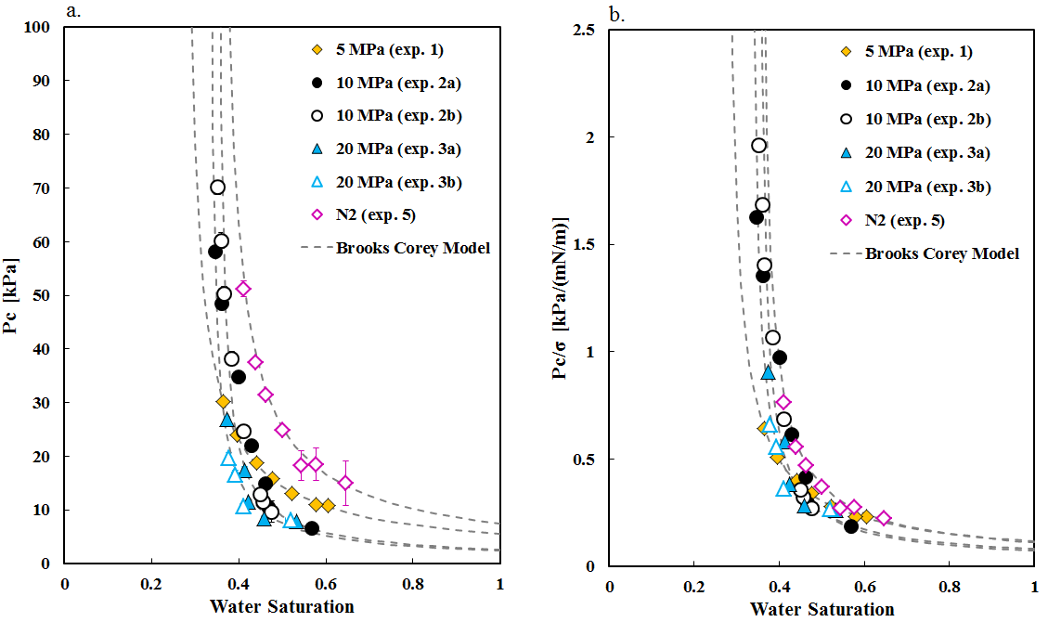
Figure 6. Capillary pressure characteristic curves evaluating the impact of pressure variation on capillarity in the system. Curves measured at pressures ranging from 5 MPa to 20 MPa are shown on the left and scaled by interfacial tension on the right.
In the relative permeability tests the relative permeability of the rock core obtained when fluid saturations were unaffected by end effects, gravity segregation, and rock heterogeneity, was found to be invariant with reservoir conditions and equivalent to the N₂-water relative permeability. This will be referred to as the intrinsic relative permeability, and was generally found when the pressure drive pushed the displacement into the viscous limit – where capillary heterogeneity is not significant in redistributing fluids, and has little bearing on the saturation distribution throughout the core.

One group of results is shown in Figure 7. The range of interfacial tension spanned from 29 mN m⁻¹ to 41 mN m⁻¹. The results show little variation in the relative permeability between the tests.
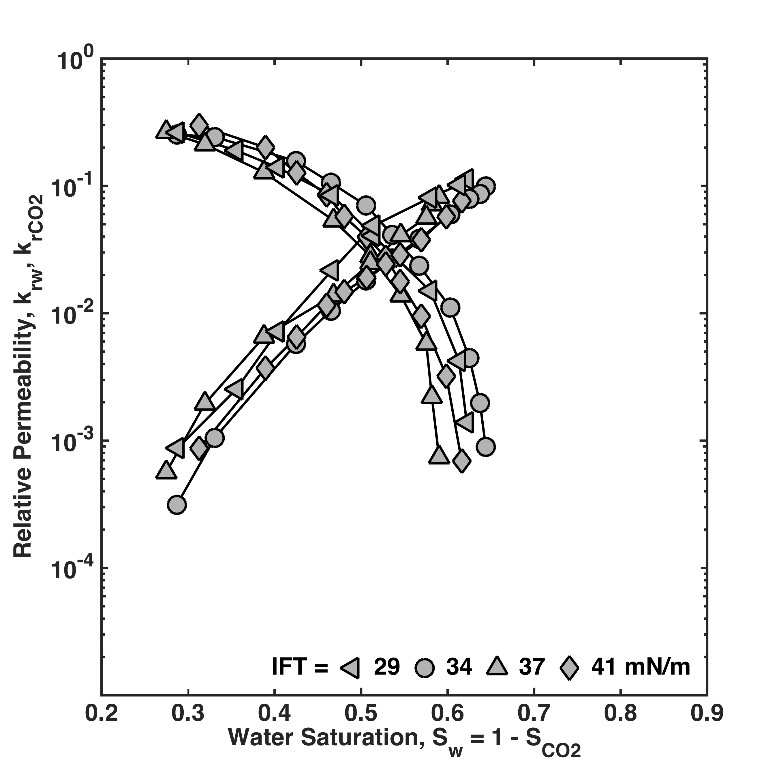
Figure 7. The intrinsic relative permeability of the rock core obtained in the viscous limit from CO₂ and N₂ systems (Reynolds and Krevor, 2015).

At conditions that resulted in CO₂ viscosities less than 30 μPa s, the fluid distributed heterogeneously throughout the core due to natural heterogeneity in the rock. Under these conditions, the derived relative permeability will be referred to as the effective relative permeability. We use this as the observational counterpart of a pseudo relative permeability. See (Yokoyama and Lake, 1981) for a study in which pseudos have been applied to investigate core scale rock heterogeneity.

These effective relative permeability curves were observed to be sensitive to the test conditions, pressure, temperature, brine salinity and fluid flow rate. This is consistent with past observations and modelling of the impact of rock heterogeneity on observed flow properties (Yokoyama and Lake, 1981). Figure 8 shows one example of the intrinsic curve measured compared with an effective curve in which the interfacial tension was constant, but the viscosity of the CO₂ was less than 30 μPa s in the measurement affected by rock heterogeneity.

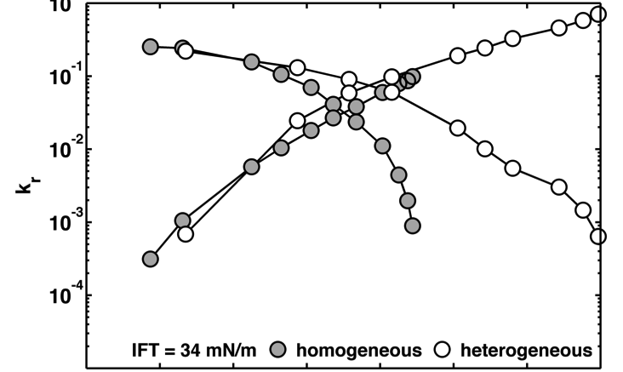
Figure 8. An intrinsic relative permeability curve (grey) and an effective relative permeability curve (white) measured at the same interfacial tension but distinct values of pressure and temperature. The difference in CO₂ viscosity led to homogenous and heterogeneous fluid distributions in the rock core (Reynolds and Krevor, 2015).

The relative permeability core floods were all performed at a constant total flow rate of 20 ml min⁻¹, this being sufficient to minimise capillary end effects. Thus the total viscous pressure differential across the core, ΔΦ = P_{inlet} – P_{outlet} [MPa] varied primarily depending on the viscosity of CO₂ for a given test. When the viscous force was high enough to support the capillary pressure gradients prevalent at constant saturation (Figure 9), a homogenous saturation was obtained and the intrinsic relative permeability was achieved. When the viscous force was low compared with the capillary heterogeneity in the core, capillary driven flow redistributed fluid towards a system with constant Pc, but heterogeneous saturation distribution and an effective relative permeability was observed.
Figure 9. Conceptualising heterogeneity in the rock core with distinct capillary pressure characteristic curves. Low viscous force leads to a system of constant capillary pressure, but heterogeneous saturation distribution. A high viscous force leads to a system of homogenous saturation but capillary pressure gradients.

This study confirms the importance of evaluating the capillary heterogeneity in reservoir rock cores. We recommend in particular a characterisation of spatial heterogeneity in capillary pressure characteristic curves, e.g. (Pini et al., 2012). A comparison of this with the estimated driving force for flow – e.g., pressure gradients, buoyancy - in a reservoir allows for one to design laboratory experiments either so that (1) an intrinsic relative permeability curve may be obtained or (2) effective flow functions representative of reservoir conditions can be observed. If capillary heterogeneity is significant, this provides quantitative guidance as to the conditions at which core tests should be operated to obtain representative effective relative permeabilities.
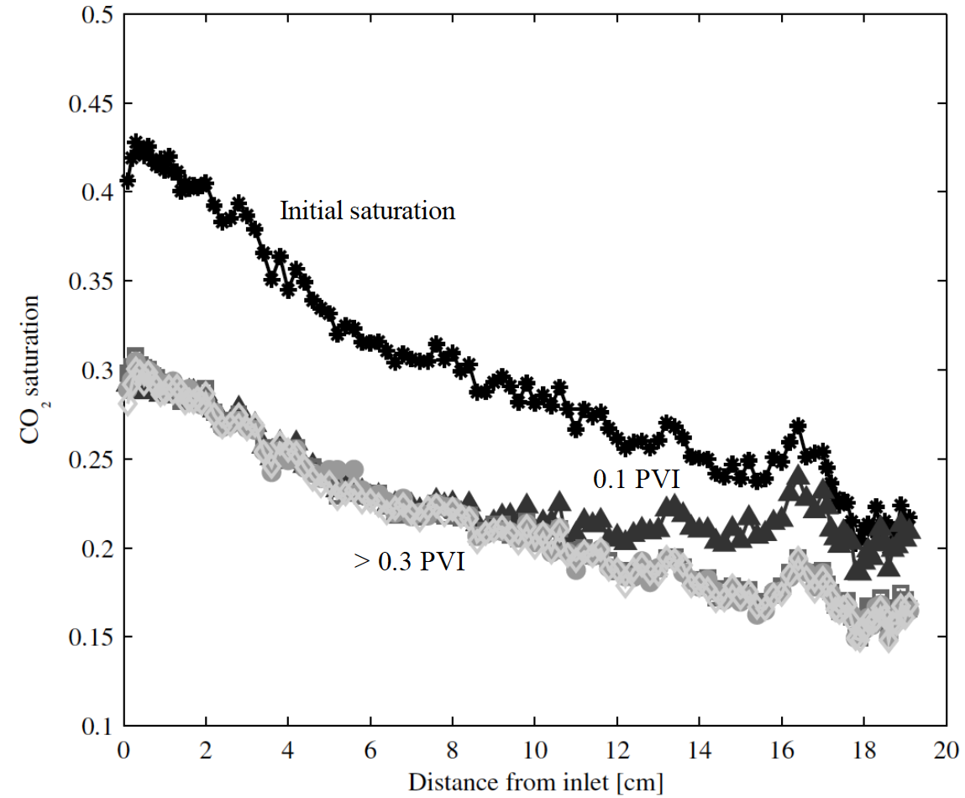
Figure 10. In-situ saturation profiles of CO₂ saturation after drainage (Initial saturation), after 0.1 pore volume of brine injection (PVI) and greater than 0.3 PVI showing the residually trapped saturation. From (Niu et al., 2015).

Observations of the saturation profile in a residual trapping experiment after drainage and during imbibition is shown in Figure 10. A compilation of the initial-residual data from all of the floods reported in (Niu et al., 2015) is shown in in Figure 11, along with the data obtained with an N₂-water system. There was little, if any, impact of reservoir conditions on the residual trapping characteristics of this system. The N₂-water curve was also indistinguishable from the CO₂-brine curves suggesting that this system was water wet during imbibition.
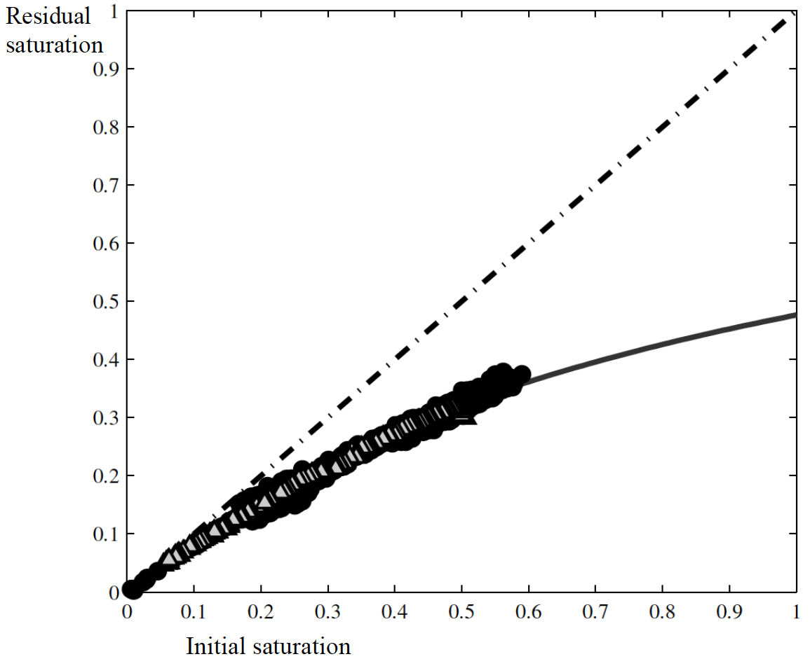
Figure 11. Initial-residual data from CO₂-brine core floods at all of the conditions are shown in black. Light colored symbols show trapping data obtained from a N₂-water system. From (Niu et al., 2015).

CONCLUSION
The body of observations demonstrate definitively that (1) the CO₂-brine system is water wet, and (2) the intrinsic multiphase flow properties – where rock heterogeneity is insignificant - are invariant across the range of pressure, temperature and brine salinity in subsurface reservoirs worldwide. These two conclusions are consistent with the findings of Egermann et al., (2006) where a comprehensive evaluation of CO₂-brine multiphase flow was evaluated in carbonate rocks. It was also observed that (3) the sensitivity of the relative permeability to capillary heterogeneity in the rock is likely the true source of reported observations of the impact of reservoir conditions or fluid pairs on relative permeability – not changes in the wetting state. Effective relative permeabilities should be obtained with appropriate scaling to reservoir conditions by comparing capillary heterogeneity to the viscous flow force at the scale of the rock core representative of the reservoir system.

ACKNOWLEDGEMENTS
The authors gratefully acknowledge funding support for this work from the Qatar Carbonates and Carbon Storage Research Centre provided jointly by Shell, Qatar Petroleum and the Qatar Science and Technology Park.
Norman Nicholls made invaluable contributions to the construction and maintenance of the experimental flow rig used for most of the work reported here.
The authors thank two anonymous reviewers and the editors of Petrophysics for their time and consideration of this manuscript.

REFERENCES

Al-Menhali, A., Niu, B., Krevor, S. (2015) Capillarity and wetting of carbon dioxide and brine during drainage in Berea sandstone at reservoir conditions. Water Resources Research, 51, 10, 7895-7914
Anderson, W.G. (1987) Wettability Literature Survey – Part 4: Effects of Wettability on Capillary Pressure. 39, 10, Journal of Petroleum Technology, 1283-1300
Bachu, S. and B. Bennion (2008) Effects of in-situ conditions on relative permeability characteristics of CO₂-brine systems. Environmental Geology. 54, 1707-1722
Benson, S., Pini, R., Reynolds, C., and Krevor, S. (2013) Relative permeability analyses to describe multiphase flow in CO₂ storage reservoirs. Global CCS Institute
Berg, S., Oedai, H., Ott, H. (2011) Displacement and mass transfer between saturated and unsaturated CO₂-brine systems in sandstone. International Journal of Greenhouse Gas Control. 12, 478-492.
Broseta, D., N. Tonnet, V. Shah (2012) Are rocks still water-wet in the presence of dense CO₂ or H₂S? Geofluids. 12, 4, 280-294
Chiquet, P., D. Broseta, S. Thibeau (2007) Wettability alteration of caprock minerals by carbon dioxide. Geofluids. 7, 112-122
Egermann, P., Chalbaud, C., Duquerroix, J.-P., Gallo, Y.L. (2006) An Integrated Approach to Parameterize Reservoir Models for CO₂ Injection in Aquifers. SPE Annual Technical Conference and Exhibition, San Antonio, Texas, 24-27 September 2006. SPE 102308
Espinoza, D.N. and J.C. Santamarina (2010) Water-CO₂-mineral systems: Interfacial tension, contact angle, and diffusion – Implications to CO₂ geological storage. Water Resources Research 46, 7, W07537
Global CCS Institute (2014) The Global Status of CCS: 2014
Golding, M.J., H.E. Huppert, J.A. Neufeld (2013) The effects of capillary forces on the axisymmetric propagation of two-phase, constant-flux gravity currents in porous media. Physics of Fluids. 25, 3, 036602
Hesse, M.A., F.M. Orr Jr., H.A. Tchelepi (2008) Gravity currents with residual trapping. Journal of Fluid Mechanics 611, 35-60
Iglauer, S., C. Pentland, A. Bush (2015) CO₂ wettability of seal and reservoir rocks and the implications for carbon geo-sequestration. Water Resources Research. 51, 1, 729-774
Jung, J-W. and J. Wan (2012) Supercritical CO₂ and Ionic Strenght Effects on Wettability of Silica Surfaces: Equilibrium Contact Angle Measurements. Energy & Fuels. 26, 9, 6053-6059
Kim, Y., J. Wan, T. J. Kneafsey, T. K. Tokunaga (2012) Dewetting of Silica Surfaces upon Reactions with Supercritical CO₂ and Brine: Pore-Scale Studies in Micromodels. Environmental Science & Technology. 46, 7, 4228-4235
Krevor, S.C.M., R. Pini, L. Zuo, S.M. Benson (2012) Relative Permeability and Trapping of CO₂ and Water in Sandstone Rocks at Reservoir Conditions. Water Resources Research. 48, 2, W02532
Krevor, S, Blunt, M.J., Benson, S.M., Pentland, C.H., Reynolds, C, Al-Menhali, A., Niu, B (2015) Capillary trapping for geologic carbon dioxide storage – From pore scale physics to field scale implications. International Journal of Greenhouse Gas Control. 40, 221-237
Land, C. (1968) Calculation of Imbibition Relative Permeability for Two- and Three-Phase Flow From Rock Properties. SPE Journal. 8, 02, 149-156
Lenormand, R., A. Eisenzimmer, C. Zarcone (1993) A Novel Method for the Determination of Water/Oil Capillary Pressures of Mixed-Wettability. Society of Core Analysts Conference Paper. SCA 1993-9322
Levine, J., Goldberg, D.S., Lackner, K.S., Matter, J.M., Supp, M.G., Ramakrishnan, T.S. (2014) Relative permeability Experiments of Carbon Dioxide Displacing Brine and Their Implications for Carbon Sequestration. Environmental Science & Technology. 48, 1, 811-818.
Niu, B., Al-Menhali, A., Krevor, S.C. (2015) The impact of reservoir conditions on the residual trapping of carbon dioxide in Berea sandstone. Water Resources Research. In Press. doi: 10.1002/2014WR016441
Pini, R., S.C.M. Krevor, S.M. Benson (2012) Capillary pressure and heterogeneity for the CO₂/water system in sandstone rocks at reservoir conditions. Advances in Water Resources. 38, 48-59
Ramakrishnan, T.S., Cappiello, A. (1991) A New Technique to Measure Static and Dynamic Properties of a Partially Saturated Porous Medium. Chemical Engineering Science. 46, 4, 1157-1163
Reynolds, C., Krevor, S. (2015) Characterising flow behaviour for gas injection: Relative permeability of CO₂-brine and N2-water in heterogeneous rocks. Water Resources Research, doi:10.1002/2015WR018046
Szulczewski, M.L., C.W. MacMinn, H.J. Herzog, R. Juanes (2012) Lifetime of carbon capture and storage as a climate-change mitigation technology. Proceedings of the National Academy of Sciences of the United States of America. 109, 14, 5185-5189
Wang, S., I.M. Edwards, A.F. Clarens (2013) Wettability Phenomena at the CO₂-brine-mineral interface: Implications for Geologic Carbon Sequestration. Environmental Science & Technology. 47, 1, 234-241
Yokoyama, Y., Lake, L.W. (1981) The Effects of Capillary Pressure on Immiscible Displacements in Stratified Porous Media. 56th Annual Fall Technical Conference and Exhibition of the Society of Petroleum Engineers of AIME, San Antonio, Texas, Oct. 5-7, 1981. SPE 10109

