Measuring indicators of ocean health for an island nation: the Ocean Health Index for Fiji
Elizabeth R. Selig^{1,*}, Melanie Frazier², Jennifer K. O’Leary^{2,3,}, Stacy D. Jupiter⁴, Benjamin S. Halpern^{2,5,6}, Catherine Longo², Kristin L. Kleisner⁷, Loraini Sivo⁸, and Marla Ranelletti²
¹Betty and Gordon Moore Center for Science and Oceans, Conservation International, 2011 Crystal Drive, Suite 500, Arlington, VA, 22202 USA, eselig@conservation.org
²National Center for Ecological Analysis and Synthesis, 735 State St, Santa Barbara, CA 93101, USA
³Hopkins Marine Laboratory, Stanford University, 120 Oceanview Blvd., Pacific Grove, CA 93950, USA
⁴Fiji Country Program, Wildlife Conservation Society, 11 Ma'afu Street, Suva, Fiji
⁵Bren School of Environmental Science and Management, University of California -Santa Barbara, Santa Barbara, CA, 93106, USA
⁶Imperial College London, Silwood Park Campus, UK
⁷Fisheries Centre, University of British Columbia, 2202 Main Mall, Vancouver, BC, V6T 1Z4, Canada
⁸Fiji Country Program, Conservation International, 3 Ma'afu Street, Suva, Fiji
*Corresponding author

Abstract
People depend on the ocean to provide a range of ecosystem services, including sustaining economies and providing nutrition. We demonstrate how a global ocean health index framework can be applied to a data-limited scenario and modified to incorporate the objectives and context of a developing island nation like Fiji. Although these changes did not have a major effect on the total index value, two goals had substantial changes. The artisanal opportunities goal increased from 46 to 92 as a result of changes to the model for Fiji, which looks at the stock status of artisanally-caught species. The lasting special places sub-goal decreased from 96 to 48, due to the use of Fiji-specific data and reference points that allow policymakers to track progress towards national goals. Fiji scored high for the tourism and recreation goal, but low for the production-oriented natural products goal and mariculture sub-goal, which may reflect national values and development priorities. By measuring ocean health across a portfolio of goals and re-calculating scores over time, we can better understand potential trade-offs between goals. Our approach for measuring ocean health in Fiji highlights pathways for improvements and approaches that may help guide other data-limited countries in assessing ocean health.
Keywords: data-limited assessment, Fiji, fisheries, ocean health, socio-ecological assessment
Introduction
Oceanic island nations like Fiji are highly reliant on healthy oceans for a wide range of benefits to their people. Fiji has a rich, strong cultural relationship with the ocean and has traditionally relied on marine resources for subsistence and livelihoods . Nationally, approximately 40% of animal protein in the Fijian diet is derived from marine sources . Tourism from vacationers alone generated $574 million USD for the Fijian economy in 2011 (Fiji Bureau of Statistics). Approximately 5-30% of reef tourism revenue in Fiji is connected to marine protected areas . However, Fiji’s marine environment is recognized to be under threat from increased fishing pressures , and land-based sources of pollution related to agricultural, forestry, and urban development . In response to the need to manage these pressures across sectors, approaches to management in Fiji have increasingly focused on ecosystem-based approaches, recognizing not only the interconnected nature of ecological systems , but also the feedback loops that exist between people and linked ridge-to-reef units over which indigenous Fijians have customary claims . This shift to a management approach based on coupled socio-ecological systems also more directly addresses the nutritional, cultural and economic importance of the marine environment to Fiji. To address these broad management goals, integrated ecological and socioeconomic assessments of the ocean health of Fijian waters are needed to determine how current status relates to the various goals that contribute to a healthy ocean ecosystem.
We developed a Fiji-specific application of an integrated assessment framework for determining ocean health. Our assessment utilizes a framework designed to assess ocean health, defined as the delivery of a range of benefits to people now and in the future (Halpern et al. 2012). The ocean health index (OHI) approach assesses 10 goals (several of which are comprised of two sub-goals) that people have for a healthy ocean (Table 1). The goals are calculated from indicators of the current status of the goal, its recent trend, the pressures or impacts that may be affecting it, and the resilience measures that could mitigate those impacts . The framework is designed to assess progress across a portfolio of benefits, identify potential focal areas for improvement, and assess trade-offs between goals if recalculated over time .
The ocean health index approach has been applied in several case studies, notably for the west coast of the US , and at the state level in Brazil . The national-scale application of the ocean health index for Fiji represents a relatively data-limited case study, although more data are available for Fiji than many other Pacific island nations. Local applications of the index like the one we have done for Fiji provide additional information that is important for management. The global application of the ocean health index is designed to assess the overall health of the ocean and to compare across countries’ Exclusive Economic Zones. Consequently, it lacks the resolution required for a high degree of accuracy at more local scales and is of limited use in tracking progress towards meeting national goals. However, the ocean health index framework is flexible and can be applied at finer scales, incorporating the best available local information and management targets. Wherever possible, we used Fiji-specific data and management targets based on national policies and targets that Fiji has established to track progress towards meeting those goals. This analysis is intended to be a “how-to” to illustrate how the ocean health index can be applied in data-limited countries.
This analysis demonstrates not only that a comprehensive index of ocean health can be calculated even when data are limited, but also the utility of doing so even when scores themselves do not change dramatically. Data-limited applications of the ocean health index approach may be particularly relevant because the social dimension of ocean health can be critical for consideration in areas that are often data-limited, but have a high reliance on ecosystems for human well-being . In many cases, the scores themselves may not change that much either due to the fact that global results are used when data are not available, similar models are used, or simply that the scores are robust to changes in both model or data. Nonetheless, adapting the ocean health index framework to incorporate local data and relevant models will ensure that results are more useful for management. Confidence may also be increased when results are relatively robust to changes in the model or data. Another outcome of a data-limited assessment is to help highlight key data gaps, which we highlight for Fiji, but which may also be relatively common in other contexts. We also discuss potential management applications of the Index framework and the results from this first assessment, limitations of the approach, and how data-limited countries may want to prioritize data collection using the ocean health index as a framework.

Methods
The ocean health index , hereafter ‘the Index’ was used as the overall framework for this analysis. The Index is made up of ten public goals for ocean health: Food Provision, Artisanal Fishing Opportunities, Natural Products, Carbon Storage, Coastal Protection, Coastal Livelihoods and Economies, Tourism and Recreation, Sense of Place, Clean Waters and Biodiversity (Table 1). Several of the goal models are unchanged from the most recent 2013 OHI calculation at the global scale . Here we summarize the overall methodology used, but focus on goals and sub-goals that were specifically modified for Fiji: food provision (fisheries and mariculture sub-goals), artisanal fishing opportunities, sense of place (lasting special places and iconic species sub-goals), biodiversity (habitats sub-goal only), and coastal protection. For full detailed methodology on global models and data, see Halpern et al. (2012; in review).

Overall index calculation
An overall index score for Fiji is calculated as the weighted sum of the scores for each goal assessed, G, in the Index (Halpern et al. 2012), as follows:
Fiji score = $\sum_{i=1}^{N}{α_{i}G_{i}}$, (Eq. 1)
where α is the importance (i.e., weight) placed on each goal G, which we assumed to be equal for all N goals, following Halpern et al. (2012). Ideally, goal weighting should be driven by expert consultation. We used equal weighting because we lacked a study or consultation process that would have elucidated what more appropriate weights would be. Each goal score ($G_{i}$) is calculated as the average of current (x_{i}) and likely future status (${\hat{x}}_{i,F}$). The current status of each goal, $x_{i}(t)$, is calculated as the present state, $x_{i}(p)$, calibrated to a target reference state, $x_{i}(R)$, such that:

$x_{i}(t)=\frac{x_{i}(p)}{x_{i}(R)}$. (Eq. 3)

We used a mix of different approaches for estimating reference points including mechanistic, spatial, temporal, or a known value . Likely future status is measured as current status, modified by the recent trend (T) in status over the past 5 years, cumulative pressures (p), and resilience (r), such that:
${\hat{x}}_{i,F}={\left(1+δ\right)}^{−1}\left[1+{βT}_{i}+(1−β)(r_{i}−p_{i})\right]x_{i}$, (Eq. 2)
where δ is the discount rate (δ = 0) and β is the relative importance of trend versus the difference between pressures and resilience in determining the likely future status (β = 0.67) . Beta (β) represents the relative importance of the trend versus the resilience and pressure terms in determining the likely trajectory of the goal status. We assume β=0.67 based on the idea that trend is a more direct measure of future condition than the indirect measures of pressure and resilience. We assume the discount rate, $δ$, is zero due to the 5-year time window , but we retain it in the equation structure to emphasize that it could be modified based on additional information. Sensitivity analyses for parameterizing both β and $δ$have been conducted at the global scale . For the Fiji analysis, we used data on pressures and resilience from the global 2013 study . For each goal (p_{x}), we evaluate both ecological (p_{E}) and social pressures (p_{S}), such that:

p_{x} = γ * (p_{E}) + (1 – γ) * (p_{S}) , (Eq. 4)

where γ is the relative weight for ecological vs. social pressures and is set equal to 0.5 . Pressures fell into 5 broad categories: fishing pressure, habitat destruction, climate change (including ocean acidification), water pollution, and species introductions (invasive species and genetic escapes). To calculate resilience for each goal (r_{x}) we assessed three types of measures: ecological integrity (Y_{E}), regulations aimed at addressing goal-specific ecological pressures (G), and social integrity (Y_{S}) . The first two measures address ecological resilience while the third addresses social resilience. When all three aspects are relevant to a goal, resilience is calculated as:

$r_{x}=γ∗\left(\frac{Y_{E}+G}{2}\right)+(1−γ)∗Y_{S}$ , (Eq. 5)

where the three types of measures are all scaled 0-1, and gamma is assumed to be 0.5. We chose γ = 0.5 so that the weight of ecological systems and social systems were equivalent .

Food provision goal
The status of the food provision goal was recalculated using new sub-goal calculations for fisheries and mariculture. The food provision goal is a weighted average of the two sub-goals based on their relative yields:
$X_{\text{FP}}=w∗x_{\text{FIS}}+(1−w)x_{\text{MAR}}$ (Eq. 6)
The weight, $w$, is calculated by dividing the fisheries yield by the total yield (fisheries plus mariculture). In this case, the weight was >0.999, reflecting the very small role of mariculture in Fiji for food production, relative to wild-capture fisheries.

Fisheries sub-goal
The fisheries sub-goal is based on the amount of wild-caught seafood that is sustainably caught within Fiji’s waters. We use biomass as a proxy for yield. Yields that are too low or too high were penalized. Yields that were too low were penalized because the goal is to sustainably catch available food to meet food security needs. Yields that were too high were penalized because they indicated overexploitation. In some cases, this penalty may unfairly penalize countries who are employing a precautionary management principle . However, the intent was to measure food provision with respect to sustainable production potential, rather than the performance of current fisheries management efforts.
We used the same reference point to assess the amount and sustainability of multi-species harvest (i.e., B/B_{MSY}) as was applied in the 2013 OHI global analysis , but we slightly modified the approach for taxonomic penalties in order to avoid over-penalization. The reference point for sustainable yield was based on an estimate of the ratio of the population biomass (B) relative to the biomass that can deliver maximum sustainable yield (B_{MSY}) for each taxa (B/B_{MSY}). We used a method known as ‘catch-MSY’ to calculate annual B/B_{MSY} time series for species-level taxa fished in Food and Agriculture Organization’s (FAO) regions 71 and 81 (i.e., the FAO regions in which Fiji is located). We used catch data that was originally provided to the Food and Agriculture Organization, but spatially allocated to EEZs by the Sea Around Us project (www.seaaroundus.org) . Each species fished in Fiji’s waters contributed to the overall fisheries score based on the proportion of its catch relative to the country’s overall catch. Species for which B/B_{MSY} could not be directly estimated because they were identified to a coarser taxonomic level than species (e.g., family or class level), had inadequate data, or experienced model failure were assigned the median B/B_{MSY} of species in the same year and FAO region. The B/B_{MSY} values were used to derive a status score, SS, where B/B_{MSY} = 1 is the best score. Each species’ status score (SS) was calculated as:

$\text{SS}=\left\{\begin{matrix}{\text{B/B}}_{\text{MSY}} & \text{if} & {\text{B/B}}_{\text{MSY}}<0\text{.}\text{95} \\ 1 & \text{if} & 0\text{.}\text{95}≤{\text{B/B}}_{\text{MSY}}≤1\text{.}\text{05} \\ \text{max}\left\{1−α\left({\text{B/B}}_{\text{MSY}}−1\text{.}\text{05}\right),β\right\} & \text{if} & {\text{B/B}}_{\text{MSY}}>1\text{.}\text{05}\end{matrix}\right.$ (Eq. 7)

For overharvested species, B/B_{MSY} < 1 (-5% buffer), SS declines with direct proportionality to the rate of decline of B with respect to B_{MSY}. For underharvested species, B/B_{MSY} > 1 (+5% buffer), SS declines at a rate α, where α = 0.5 ensures that the penalty for under-harvested species is half of that for over-harvested species (α = 1.0 would assign equal penalty), and β is the minimum score the species can get, and was set at β = 0.25.
For the global analysis, the B/B_{MSY} estimates were penalized when taxa were not reported at the species level in the catch data to reflect the fact that reporting at this taxonomic level suggests a lack of adequate management. However, given the diversity of species in the tropics, it is not uncommon for fisheries to be multi-species and for catch to be reported at the family level . Consequently, for the Fiji analysis, no penalties were applied for taxa reported at the species, genus, and family levels; however, penalties were applied for taxa reported at coarser taxonomic levels and these are slightly different from those applied in the 2013 OHI global analysis (Table 2).
Finally, status was calculated as the geometric mean of the stock status scores weighted by the average catch measured throughout the time series. We used catch data that was originally provided to the Food and Agriculture Organization, but spatially allocated to EEZs (www.seaaroundus.org) . The geometric weighted mean ensures that small stocks that are doing poorly will have a stronger influence on the overall score than they would using an arithmetic weighted mean. Status was calculated using the 2011 stock status scores, and trend used status values from 2007-2011.

Mariculture sub-goal
The mariculture sub-goal assesses the sustainability and productivity of mariculture. Higher mariculture yields that are sustainably produced resulted in a better score because the goal is to produce the greatest amount of food with the least negative ecological impact . We used the same model as the global 2013 OHI assessment, which included Anadara clams (Anadara spp.), flathead grey mullet (Mugil cephalus), green mussel (Perna viridis), pearl oyster (Pinctada spp.), and rabbitfishes (Siganus spp.). However, we replaced global data for blue shrimp (Litopenaeus stylirostris) and giant tiger prawn (Penaeus monodon) with local data for shrimp and prawn (Fiji Department of Fisheries, unpublished data). The sustainability of these individual taxa in Fiji was estimated using the global average sustainability measure for these taxa . The status of mariculture is calculated as follows:
$X_{\text{MAR}}=\frac{Y_{C}}{Y_{\text{ref}}}$ (Eq. 8)

The reference value ($Y_{\text{ref}}$) was defined as the 95th percentile of all the global OHI 2013 reporting regions ($Y_{\text{ref}}$ = 0.0147), and $Y_{C}$was calculated as:
$Y_{C}=\frac{\sum_{1}^{k}{(Y_{k}×S_{M,k})}}{P_{C}}$ (Eq. 9)
for all $k$ species that are currently or at one time cultured. $S_{M,k}$ is the sustainability score for each $k$mariculture species, and is based on 3 indicators from the Mariculture Sustainability Index (MSI). origin of seed, origin of feed, and wastewater treatment . $P_{C}$ is the population within the 25 km coastal strip of the country, which assumes that locally available workforce, coastal access and infrastructure needed for mariculture, as well as local demand for its products, are proportional to population density following methods described in Kleisner et al. (2013).

Artisanal Opportunities
The artisanal opportunity goal was designed to assess the opportunity and availability of fish caught for subsistence and as part of small-scale commercial fisheries. In the global model, the degree of access to artisanal scale fishing was a critical aspect of the calculation. However, in Fiji, access to subsistence fishing is not limited using certain permissible gear . Therefore our definition of availability was based on the sustainability of artisanally fished taxa. We used the same data and model as the fisheries sub-goal. However, for artisanal opportunities, the score was based only on the subset of taxa that are fished artisanally (Table S1). We used data from Zylich et al. (2012) to create the list of artisanally fished data. Stock status was based on the whole catch , not just artisanal catch levels and was calculated as in Eq. 7.

Sense of Place
Lasting Special Places
For the global analysis, the status of lasting special places was based on the percentage of protected areas within a 3 nm offshore region and a 1 km inland region in 2012. For Fiji, instead of using the 3 nm offshore boundary, we used the boundaries of traditional fisheries management areas, known as qoliqoli (Figure 1). These areas represent traditional fishing grounds that are legally demarcated by the iTaukei (indigenous) Lands and Fisheries Commission . Fiji has set a national goal of managing 30% of its traditional fisheries areas, which we used as a reference point for our analyses . The degree of protection within the managed areas of these regions varies. Spatial management types can range from unmanaged to permanent closures within the traditional fisheries management boundaries (Table 3). Mills et al. (2011) ranked the ecological effectiveness of these management types for a range of habitats, based on expert input. To capture this information, we weighted the area of each management type using the ecological effectiveness score of the least protected habitat (Table 3). For the inland region, we used the data from the 2013 global assessment data. Lasting special places status was calculated as the area weighted average of the percentage of offshore ($\text{\%}\text{op}$) and inland ($\text{\%}\text{ip}$) protected areas relative to the established reference point ($\text{\%}\text{Ref}$= 30% for both the offshore and inshore areas):

$X_{\text{LSP}}=\frac{\left[\left(\frac{\text{\%}\text{op}}{\text{\%}\text{Ref_op}}×A_{0}\right)+\left(\frac{\text{\%}\text{ip}}{\text{\%}\text{Ref_ip}}×A_{i}\right)\right]}{A_{0}+A_{i}}$ (Eq. 10)

where$A_{0}$ is the total area of all qoliqoli regions and $A_{i}$ is the total 1 km² inland area of Fiji. And,
$\text{\%}\text{op}=\frac{\sum_{1}^{k}{(A_{k}×W_{k})}}{A_{0}}$ (Eq. 11)
where k represents the different management strategies (Table 3), $A_{k}$ is the total area of each management strategy, and$W_{k}$ is the weighting coefficient that describes the minimum effectiveness of each management strategy. For the global assessments, the offshore and inland areas were weighted the same. For this assessment, we weighted them based on area.

Iconic species
For the iconic species sub-goal, we used the same model as the 2013 global analysis, but a different species list to assess the extinction risk of 33 species. Iconic species for Fiji were identified via regional experts and differed somewhat from those used in the global OHI analysis (Table S2). We were unable to assess the condition of five of these iconic species because local experts were unable to estimate status or population trends: giant trevally (Caranx ignobilis), bluefin trevally (Caranx melampygus), trumpet conch (Charonia tritonis), golden cowrie (Cypraea tigris), and egg cowrie (Ovula ovum). With the exception of loggerhead (Caretta caretta), leatherback (Dermochelys coriacea), and hawksbill (Eretmochelys imbricate) turtles where we had regional data on extinction risk , our assessment of extinction risk was based on global assessments because we had no local extinction risk assessments for Fiji. Therefore, extinction risk categories may not always reflect the local population condition of a species in Fiji waters.

Biodiversity (habitat sub-goal) and Coastal Protection: coral cover data
The habitat sub-goal and coastal protection goals rely on similar habitat data, which for Fiji included: mangroves , seagrasses , and coral reefs , and for the habitat sub-goal, soft-bottom . We used global data for mangroves, seagrasses, and soft-bottom, but updated the coral reef data. For coral reef status information we relied on surveys (N= 899) of the percentage of live coral cover for different reefs in Fiji between 1999-2011 (Wildlife Conservation Society and Conservation International, unpublished data). The data used to generate the coral health and trend data were compiled from several different sources . Many reefs were repeatedly measured over time. To calculate coral health and trend, we first averaged the percent cover data for reefs that were measured multiple times within the same year to ensure that each reef had only one value for each year (N=644). Then, we averaged the percent cover data for all the reefs for every year.
Regardless of health, coral cover can vary widely from year-to-year . Consequently, we took several steps to ensure the estimate of coral health was based on a representative sample of coral cover. We used the average of the last three years of coral cover data (2009-2011) to calculate current health. Instead of using the raw data, we used the predicted values of percent coral cover based on a linear regression model that included all years of data (Yearly average coral cover ~ Year; Predicted values: 2009=38.0, 2010=38.6, 2011=39.2; Fig. S1).
To convert coral cover to coral health, the average coral cover is divided by a reference value that represents the percent cover expected for healthy coral reefs within a given region. The Fiji coral data were collected too recently to obtain a historical reference point. We used the reference value from the 2013 global OHI for Fiji (reference = 29%), which was based on the historical data for neighboring country values. Fiji’s coral health received a value of 1 (which is the same status as in the 2013 global data) because current coral cover meets or exceeds the reference value.
To calculate coral trend, we used a mixed effects model to take advantage of the fact that many of the reefs were measured repeatedly over the years. The data used for this model included only data collected from 2007-2011 (N=600). For the model, the dependent variable was proportion of coral cover, the independent variable was year, and reef was included as a random effect. We multiplied the slope from this model by 5 to obtain the expected change in coral cover over the next five years, i.e. the trend score (trend=0.0073).

Results and Discussion
Our intent for conducting a regional-scale assessment of ocean health index for Fiji was not only to provide a more accurate assessment using local datasets and Fiji-specific models, but also to explore more broadly how ocean health index framework may be applied in relatively data-limited contexts. Our regional case study for Fiji resulted in a score of 72 compared to a score of 69 in the 2013 global analysis (Table 4; Fig. 2). Fiji’s scored a 68 for likely future state in this analysis (Table 4), slightly higher than its score of 65 in the 2013 global analysis. Although there were changes to how five of the goals (and five of the corresponding sub-goals) were assessed, these changes had a relatively small effect on the final index score. Most goal scores experienced relatively minor changes (i.e., < 2 points), even when local data were incorporated. The only significant changes were for the artisanal fishing opportunities and sense of place goals. The artisanal fishing opportunities goal increased from 46 to 92, due to changes in the model to better represent conditions in Fiji for artisanal fishing opportunity (Fig. 2). The sense of place goal decreased from 74 to 54 (Fig. 2). This decrease was largely due to the lasting special places sub-goal decreasing from 96 to 48 after we adapted the model to use a Fiji-specific reference point and incorporated measures of ecological effectiveness. As a result, changes in the lasting special places scores relative to the global OHI scores should not be interpreted as a temporal change in condition. Fiji’s regional case study scores may be negatively or positively biased both due to better data at the local scale and the poor quality of data available for some goals at the global scale, as discussed below. Understanding these issues may help guide data-limited countries toward the development of an OHI case study that is appropriately designed to assess ocean health relative to their specific national goals.

Lessons learned for data-limited regional applications
Our Fiji assessment provided several useful lessons for regional applications of the OHI, particularly for data-limited countries. Several factors may affect whether or not a regional application of the OHI can be effective. One key aspect to consider is what additional (i.e., higher resolution and/or region-specific) datasets are available and whether they can inform goals that are in the national interest of the case study region. For example, the fisheries sub-goal is relatively universally important because it measures the delivery of a key source of nutrition to coastal human populations. Similarly, the artisanal fishing opportunities goal measures whether those who need artisanal fisheries have the opportunity to access them.
Although we did not have local catch data to use in a recalculation of the fisheries sub-goal for Fiji, we were able to develop a more context-specific approach by reconsidering the taxonomic penalties that we applied. Many fisheries in Fiji are multispecies and are reported at approximately the family level , so we applied different penalties for poor taxonomic level reporting compared to what was used in the global 2013 analysis. For our analysis, 5 of the 63 stocks were above the family level. We used the catch-MSY method to calculate B/B_{MSY} for 26 stocks in two Food and Agriculture Organization statistical regions (Table S3). Of those 26 stocks, 11 stocks had <50% B/B_{MSY}, the threshold we used to defined ‘overfished’ (Table S3). One stock had <20% B/B_{MSY} and was considered to be collapsed (Table S3; Fig. 3). Of the 11 stocks that were overfished, 2 had positive trends in the last 5 years, which we defined as rebuilding in this analysis (Thunnus albacares, Makaira mazara) (Table S3; Fig. 3). If information about the local context can be incorporated into key goals like this, their recalculation can provide more accurate information, even if the core datasets remain the same as the global analyses and change the overall score relatively little.
Like the wild-capture fisheries sub-goal, we were also able to adapt the artisanal opportunities goal to better incorporate the Fijian context. In the global 2012 and 2013 analyses, status was a function of the economic need for artisanal fishing opportunities and the degree to which artisanal opportunities are permitted or encouraged institutionally . For Fiji, access is relatively open as long as the gear types are permissible . In other words, those that typically need to fish artisanally in Fiji are able to do so. Therefore, we focused on the status of artisanally fished species in Fiji , assuming that if species are fished sustainably, they will be available to artisanal fishers. This change in methods had a large impact on the score for the artisanal opportunity goal, resulting in an increase in the score from 46 to 92. The changes to this model reflect the importance of incorporating local conditions, laws and regulations into the index calculations wherever possible.
Production-oriented goal and sub-goal scores like those for tourism & recreation, natural products and mariculture may reflect country-specific priorities, and they should be interpreted with those priorities as context. For example, Fiji scored quite high for tourism & recreation (Table 4; Fig. 2). Tourism is a major economic driver for the Fijian economy and substantial resources have been devoted to its development . The score for this goal suggests those efforts have paid off, although our estimate does not capture whether the tourism industry in Fiji is sustainable because we were unable to determine a “carrying capacity” or otherwise measure whether current levels could or should be maintained. Conversely, Fiji scored relatively low for the natural products goal and the mariculture sub-goal (Table 4; Fig. 2). Mariculture had no impact on the food provision goal score (i.e., its impact on the food provision score was virtually zero because mariculture yield was so low compared to fisheries yield and the food provision goal is a yield-weighted average of the two sub-goals). The natural products score was the lowest of the goal scores and drove Fiji’s average score down by 5%. Low scores on production-oriented goals may reflect opportunities for growth, in which case a low score may be appropriate. However, low scores may also reflect conscious decisions to leave some production-oriented goals undeveloped or underdeveloped. In these cases, the reference point should ideally be set such that a good score can be achieved at a lower production value or if it is decided that a goal or sub-goal is not relevant, it can also be removed . At the outset of the application of a regional OHI, stakeholders should decide whether to remove a sub-goal or goal or to change goal weightings to reflect national priorities. For Fiji, we were not able to hold a broad stakeholder workshop to determine relevant goals or goal weightings.
A key goal of a regional application of the OHI should be to incorporate national or regional targets into the reference points used for each goal so that the OHI more effectively tracks progress towards meeting those goals. For the lasting special places sub-goal, we were able to assess Fiji’s progress towards meeting its protection targets based on their national target of protecting 30% of the area of qoliqoli offshore regions and weighting the marine protected areas by the ecological effectiveness of their management strategy (e.g., species’ responses to management actions based on their life histories and behavior). When global targets were used for the lasting special places sub-goal, the score was 96 because the target was the percentage of protected area in the offshore region within 3 nm , and all of the protected areas were considered to be 100% effective in protecting marine and inland species and habitats. However, protected areas differ greatly in their relative ecological effectiveness depending on the types of activities permitted within their boundaries . Using Fiji-specific targets, the lasting special places score was 48, in part because qoliqoli regions are much larger in area than the 3 nm offshore area, and also because the ecological effectiveness weightings down-weighted protection in managed areas where some extractive activities are permitted. An even more accurate accounting of the effectiveness of a protected area network would weight the protected areas by both the ecological effectiveness of the management strategy being applied and the management effectiveness (e.g., how well people are able to implement their management strategies to meet given objectives at that site) . In the global OHI analysis, countries that have large MPAs in the World Database on Protected Areas (WDPA), may score much higher simply because a greater percentage of coastal waters appear to be protected from extractive activities without any consideration of their ecological or management effectiveness, resulting in a positive bias in those countries’ scores for lasting special places. Over time, developing more accurate global reporting to the WDPA and objectively assessing the true protective value of MPAs will make the interpretation of Fiji’s lasting special places score in the global context more realistic.
Although lasting special places was the only goal in which we were able to tie the reference point to a specific national target, many other goals may also be useful for tracking national policies. For example, Fiji has ratified the Convention on Biological Diversity (CBD) Aichi targets, which include targets for halving habitat loss (Target 5) and managing fisheries sustainably (Target 6). Fiji, like other Pacific countries that are Parties to the CBD, are currently aligning their National Biodiversity Strategy and Action Plan (NBSAP) targets to the Aichi Targets . Progress towards those targets can be assessed using the some of the approaches from the habitats sub-goal and fisheries sub-goal. Before changing reference points to reflect national priorities, stakeholders must consider whether new reference points meet the SMART principles that we used when setting reference points – Specific, Measureable, Ambitious, Realistic, and Time-bound . If a reference point is not ambitious, a score could be artificially high. Adhering to SMART principles will help to ensure that regional targets are scientifically defensible and provide incentive towards sustainable management.

Data gaps and uncertainties
Depending on the scale and scope of decisions to be made within a country, applications of OHI in data-limited contexts may be restricted. Given data constraints, results for Fiji are not spatially variable, so it is not possible to track how well different areas of Fiji’s waters are doing. For Fiji, we used 50% of the goal scores from the 2013 global OHI analysis (Table 1). The scores for natural products, carbon storage, coastal livelihoods and economies, clean waters, and tourism & recreation were unchanged (Table 1). Because the global scale analysis was designed to track broad-scale patterns, there may be considerable uncertainty in the accuracy of these goals, limiting their ability to make informed decisions and to accurately track ecosystem change and progress towards meeting goals.
Even when we were able to change the goal model to better capture the local context, we sometimes still had to rely on global-scale data. For example, we used global-scale data for the fisheries sub-goal, the artisanal opportunities goal, the species sub-goal, and for the seagrass and mangrove data that underpin the coastal protection goal, habitat sub-goal, and carbon storage goal (Table 1). Using coarse-scale or global data increases the level of uncertainty in the interpretation of a goal score. For example, Fiji scored relatively low for carbon storage, which may reflect the relatively poor condition of key carbon storing habitats like mangroves and seagrasses within Fiji, or more likely, gaps in our ability to adequately assess those habitats based on the global datasets that we used. Global data were sometimes derived from models rather than in-country empirical data , making them potentially too uncertain for regional planning decisions. For example, data were often insufficient or unavailable for assessing the condition of key marine habitats . Global mangrove data for Fiji were from 2005 and generally were not based on quantitative surveys or remote sensing analyses .
Results can be considered more accurate than the global OHI results if global data were used with an improved goal model, but still warrant further examination and corroboration with local experts. The fisheries data that were used to calculate the fisheries sub-goal and artisanal opportunities goal were also global, and status was determined using the same catch-based approach as the global 2013 analysis. However, the taxonomic penalties were modified to better reflect Fiji’s fisheries management. Although it may provide a general guide for how key fisheries species may be doing, information for specific species should not be used for management without additional information including local knowledge, particularly for species that are fished artisanally. High scores for artisanal fishing opportunities in Fiji (Table 4; Fig. 2) may reflect the importance accorded to management of coastal waters by communities that have traditional fishing rights . However, other work suggests that many artisanal stocks are not doing as well as our results suggest , indicating further research is likely needed. Those that are doing well may not reflect good management, but rather the relatively low population density and generally limited access to long-range boats or efficient gear. With population growth and increasing wealth, it is likely that most Pacific island countries, including Fiji, may not be able to meet their food security needs from fisheries by 2030 (Bell et al. 2009) without re-allocating some of the exports for domestic consumption.
For other data-limited goals, when globally-derived values for the region are not adequate for a regional assessment, improving key datasets may be a priority. For Fiji, we were able to get additional surveys of coral cover to assess coral reef condition, but had to use a global reference point to assess status. Ideally the reference point would be the historical percent cover in Fiji, but we lacked data from the 1980s so we used a globally derived reference point, based on the average of neighboring countries’ values. This kind of proxy is not ideal, but will likely be needed in data-limited situations. Fiji’s coral health received a value of 1 (which is the same status as in the 2013 global data) because current coral cover meets or exceeds the reference value, which is supported by studies that suggest coral cover is relatively stable in Fiji . We were also able to calculate more robust trend data for calculations of the future likely status because many of the reefs were repeatedly sampled over time from 2007-2011 .
Regional assessments of OHI will always need to prioritize which datasets to develop or refine. For Fiji, we focused on improving goals that were thought to be national priorities, such as food provision, and datasets that were needed for multiple goals, such as coral condition data. Marine habitat condition data were used in up to three goals, depending on the habitat type: coastal protection, carbon storage, and biodiversity (habitats sub-goal). Although we could not use them here, regional IUCN red-list assessments can provide more specific information on the local extinction risk of key species, both for the biodiversity (species sub-goal) and sense of place (iconic species sub-goal) goals. In order to be useful for calculating trend, these assessments must be performed more frequently. Developing datasets that affect multiple goals or which are tightly tied to national priorities may help nations calculate more meaningful applications of the OHI. The use of the OHI framework can also help to identify data gaps most likely to influence ocean health, and thus can help national governments determine data collection priorities.
In some cases, the costs of improving data may be prohibitive. Determining the cost-benefit of trying to improve datasets will be an important consideration for data-limited OHI applications. The benefits of improved data may be increased accuracy and the ability to more effectively track the impacts of management. However, using proxy measures may be sufficient in some cases. The creation of new datasets may need to account for both feasibility and cost effectiveness. If the OHI is to be used to capture the potential outcomes of management actions, key data layers will need to be updated regularly. Nonetheless, even a one-time coarse assessment can provide an important baseline, and results can be used to highlight broad areas of improvement.

Conclusions
Our calculation of the OHI for Fiji is only a first step towards trying to assess ocean health at a country scale in data-limited context. Future work could explore trade-offs between goals if the index is recalculated. In this initial calculation, there are several findings that suggest how trade-offs may play out in the future. For example, natural products and mariculture scored relatively low, which could suggest a need to increase harvest and production. However, developing those industries can have negative impacts on biodiversity, particularly for coastal habitats that may require removal or development for the creation of mariculture facilities. Coastal habitats also play a key role in carbon storage and coastal protection, such that a decline in these scores may offset any gains in natural products or mariculture. Over time, if the OHI is recalculated for Fiji, trade-offs such as these can be further explored and help inform decision-making.
Future work should incorporate more local information on pressures and resilience measures, especially local governance effectiveness metrics, which may affect a range of goals and sub-goals. Given the importance of fisheries, habitats and species to these assessments, better data on these aspects of ocean health would also improve the quality of future efforts. For countries like Fiji, where tourism is important to the economy, a better understanding of the sustainability of this industry would improve the accuracy of the tourism & recreation goal. Results from the Fiji case study suggest several potential ways management could more efficiently and effectively track and prioritize actions and potential trade-offs among different goals as Fiji works towards improving its ocean health. In translating the results into recommendations for management implementation, local priorities and objectives for sustainable development and ocean conservation should be identified through comprehensive stakeholder engagement.

Acknowledgements
We would like to acknowledge the Fiji LMMA network for permission to use their spatial data on management areas. We thank Susana Waqainabete-Tuisese, Schannel van Dijken, Ginny Farmer, and Sue Taei for their support and input into the development of this study. Erich Pacheco, Tina Lee and Deb Zeyen assisted with outreach and communication. We thank Ben Best for assistance with analytical issues and Les Kaufman for scientific input. We would also like to acknowledge the Wildlife Conservation Society and and staff from Institute of Applied Science at the University of the South Pacific who conducted coral cover surveys. Support for this work has been generously provided by Jayne and Hans Hufschmid and Dan Sten Olsson, CEO of Stena AB. Beau and Heather Wrigley generously provided the founding grant for the Ocean Health Index, and the Pacific Life Foundation is the Founding Presenting Sponsor.
Table 1. Summary of changes made to the Fiji goal models and data relative to the global 2013 analysis. For goals comprised of sub-goals (Food provision, Biodiversity, Sense of place, and Coastal livelihoods and economies) the data and model are provided for the sub-goals (indented).

Goal or sub-goal | Benefit measured | Data | Model
Food provision | Sustainable food production
Fisheries, wild capture | Sustainability of harvested wild-capture seafood | Global | Catch-MSY model with different taxonomic reporting penalties
Mariculture | Sustainability and productivity of mariculture | Updated harvest data | Global
Artisanal fishing opportunities | Availability of fish to those who needed them (i.e., stock status of artisanally fished stocks) | Global (updated list of artisanally fished stocks) | Replaced model with the catch-MSY model to assess status of taxa that are artisanally fished
Biodiversity | Conservation of species and habitats for their existence value
Species | Conservation of species for their existence value | Global | Global
Habitat | Conservation of habitats for their existence value | Updated coral cover data | Global
Clean waters | Clean ocean waters free of trash and pollution | Global | Global
Sense of place | Conservation of relevant places and species for their cultural value
Lasting special places | Conservation of relevant places for their cultural value | Traditional fisheries management areas and closure boundaries | Weighted management and closure areas by the ecological effectiveness of their management strategy and relative extent. Area-weighting of offshore/inland areas (rather than average)
Iconic species | Conservation of species for their cultural value | Updated iconic species list and data | Global
Coastal livelihoods & economies | Employment (livelihoods) and revenues (economies) from marine sector
Livelihoods | Livelihoods from marine sector | Global | Global
Economies | Revenues from marine sector | Global | Global
Tourism & recreation | Number of tourists and quality of their experience | Global | Global
Coastal protection | Conservation of key protective habitats | Updated coral cover data | Global
Carbon storage | Conservation of key carbon storing habitats | Global | Global
Natural products | Amount of non-food sustainably harvested natural products | Global | Global

Table 2. Penalties for B/B_{MSY} estimates based on the level of taxonomic reporting for the Fiji analysis compared to the 2013 global analysis. Penalties were calculated as: the median B/B_{MSY} of stocks from the same FAO region and year multiplied by the penalty (a value of 1 indicates no penalty).
Taxonomic grouping | Fiji penalty | 2013 global penalty
Species | 1 | 1
Genus | 1 | 0.90
Family | 1 | 0.80
Order | 0.25 | 0.50
Class | 0.1 | 0.25
Other | 0.01 | 0.01

Table 3. Value used to weight the area of each management type. A value of one is considered the highest level of protection. These values were derived by using the minimum ecological effectiveness of each management strategy across ecosystems based on data from Table 1 of Mills et al. (2011).
Region | Management type | Weight
Traditional fisheries management areas (excluding area of spatial closures) | Unmanaged | 0
 | Other management: has other non-spatial management rules (e.g., gear restrictions, species restrictions; “other management” in Mills et al. 2011) | 0.15
Spatial closures within traditional fisheries management areas | Conditional closure with uncontrolled harvesting | 0.10
 | Conditional closure with controlled harvesting | 0.50
 | Permanent closure | 1.00

Table 4. Fiji goal and sub-goal scores for the Ocean Health Index case study. Sub-goals are indented. Rows highlighted in blue are unchanged from the 2013 global model. Pressures and resilience scores were unchanged from the global model .

Goal or sub-goal | Score | Status | Likely Future State | Trend | Pressures | Resilience
Overall Index | 72 |  | 68
Natural Products | 36 | 36 | 35 | -0.09 | 50 | 60
Artisanal Opportunities | 92 | 85 | 100 | 0.32 | 32 | 58
Food Provision | 90 | 80 | 100 | 0.31
Mariculture | 0 | 0 | 0 | 0 | 34 | 44
Fisheries | 90 | 80 | 100 | 0.31 | 34 | 56
Biodiversity | 78 | 87 | 69 | -0.38
Species | 77 | 83 | 72 | -0.26 | 39 | 50
Habitats | 78 | 91 | 66 | -0.49 | 36 | 54
Clean Waters | 74 | 75 | 73 | 0.11 | 76 | 44
Sense of Place | 54 | 57 | 52 | -0.17
Lasting Special Places | 48 | 48 | 49 | 0.02 | 45 | 44
Iconic Species | 60 | 66 | 54 | -0.36 | 38 | 57
Livelihoods and Economies | 66 | 78 | 53 | -0.5
Economies | 79 | 79 | 79 | -0.04 | 36 | 47
Livelihoods | 52 | 77 | 27 | -0.96 | 36 | 35
Tourism & Recreation | 97 | 100 | 93 | 0 | 66 | 44
Coastal Protection | 76 | 80 | 73 | -0.15 | 48 | 52
Carbon Storage | 56 | 82 | 31 | -1 | 39 | 52

Figure 1. Boundaries of qoliqoli and tabu areas in Fiji with their associated levels of protection. Lasting Special Places status was calculated by these areas and their associated weights from Table 3.
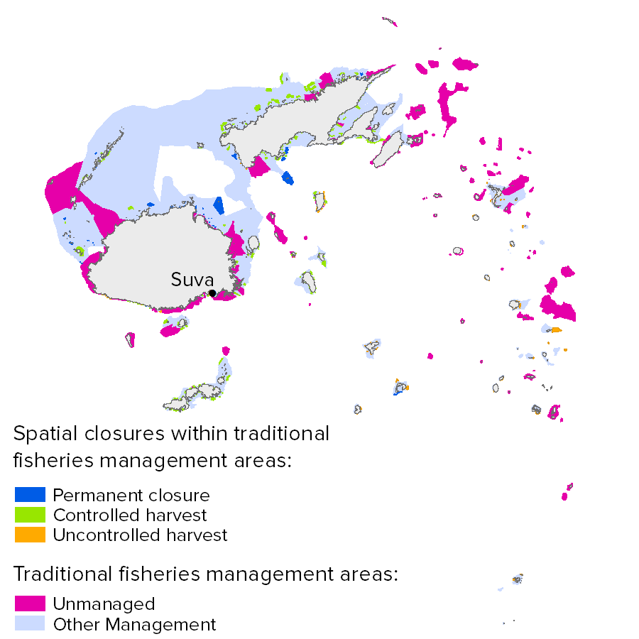
Figure 2. Summary of Ocean Health Index scores for Fiji from the (A) case study analysis using new data and goal models and (B) global 2013 analysis. The darker the blue, the higher the score. The outer ring is the maximum possible score for each goal, and the goal’s score and weight (relative contribution) are represented by the petal’s length and width, respectively, except for the food provision sub-goals which are weighted by relative actual yield when calculating the goal score even though the petals are equal width. In Fiji’s case, virtually zero mariculture yield means that the food provision score is equal to the mariculture score.
A.
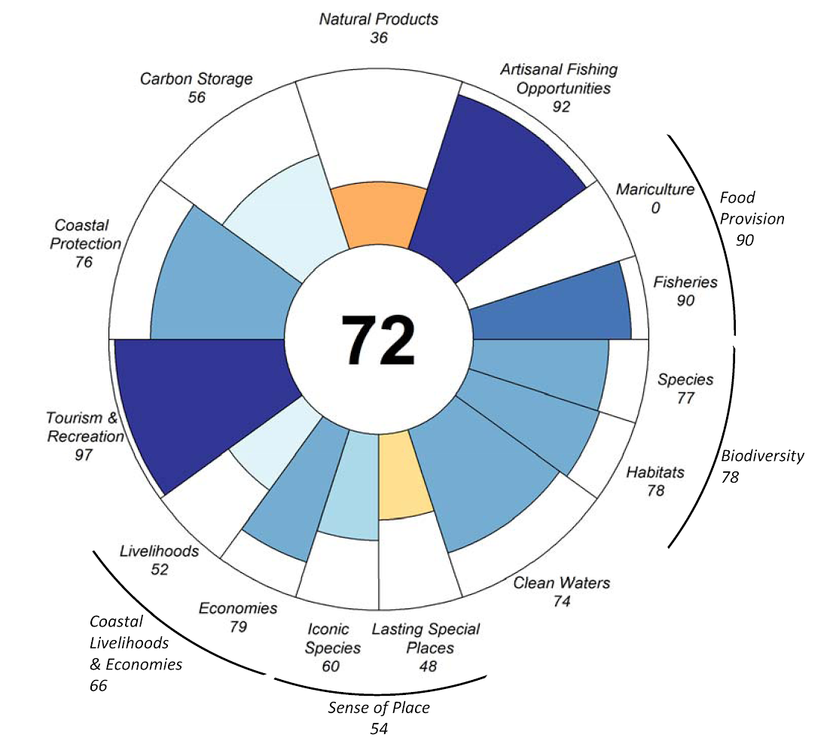

B.
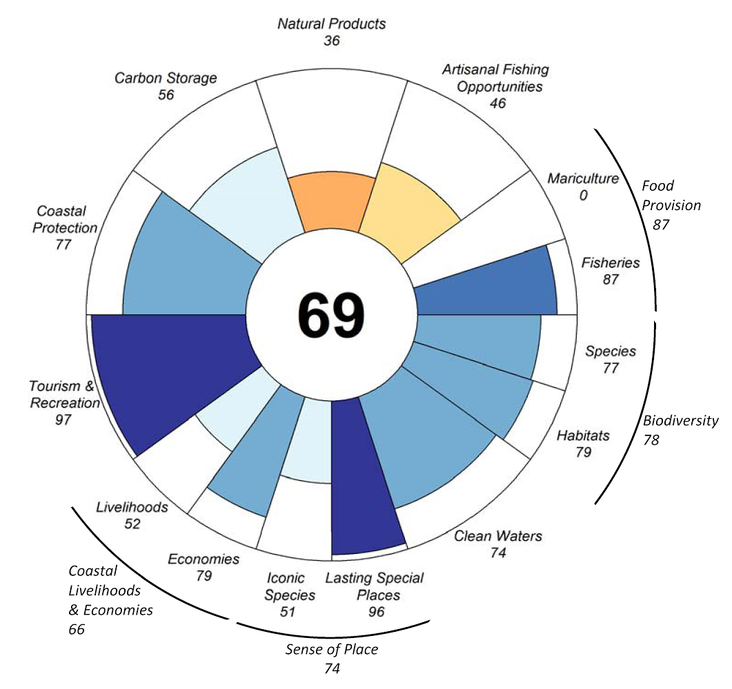

Figure 3. Distribution of B/B_{MSY} estimates for stocks in the Fiji analysis based on catch data from 2011. Trends were calculated from 2007-2011. Positive and negative trends were significantly different from zero; if the trend was not significantly different from zero it was labelled ‘none’. Species with a positive trend are indicated with a star. Stocks were considered collapsed if B_{MSY} <20% and overfished if 20% < B_{MSY} <50%.
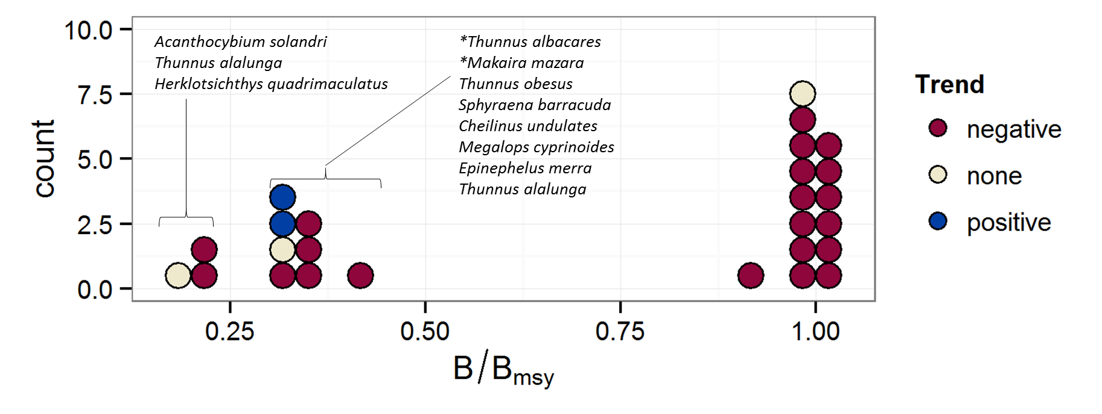
References
Supplementary Tables and Figures
Table S1. List of taxa identified as artisanally fished in Fiji.
Taxa | Common name
Acanthocybium solandri | Wahoo
Acanthuridae | Surgeonfishes, tangs, unicornfishes
Anadara | Anadara clams
Apogonidae | Cardinalfishes
Atherinidae | Silversides
Balistidae | Triggerfishes
Bivalvia | Clams
Brachyura | Marine crabs
Carangidae | Jacks and pompanos
Chanos chanos | Milkfish
Echinoidea | Sea urchins
Epinephelus | Groupers
Gerreidae | Mojarras
Gymnocranius | Large-eye breams
Hemiramphidae | Halfbeaks
Herklotsichthys quadrimaculatus | Bluestripe herring
Holothuriidae | Sea cucumbers
Labridae | Wrasses
Leiognathidae | Slimys, slipmouths, or ponyfishes
Lethrinidae | Emperors or scavengers
Lutjanidae | Snappers
Marine fishes not identified | Marine fishes not identified
Miscellaneous aquatic invertebrates | Miscellaneous aquatic invertebrates
Miscellaneous marine crustaceans | Miscellaneous marine crustaceans
Miscellaneous marine molluscs | Marine molluscs
Mugilidae | Mullets
Mullidae | Goatfishes
Octopoda | Octopuses
Panulirus | Tropical spiny lobsters
Perciformes | Perch-likes
Rastrelliger kanagurta | Indian mackerel
Sardinella | Sardinella
Scomberomorus commerson | Narrow-barred Spanish mackerel
Scombridae | Mackerels, tunas, bonitos
Scylla serrata | Indo-Pacific swamp crab
Serranidae | Sea basses, groupers, fairy basslets
Siganus | Rabbitfishes
Sphyraenidae | Barracudas
Spratelloides gracilis | Silverstriped round herring
Auxis | Frigate tuna
Caesionidae | Fusiliers
Carcharhinidae | Requiem sharks
Cephalopholis boenak | Chocolate hind
Cheilinus undulatus | Humphead wrasse
Clupeiformes | Herrings
Coryphaena hippurus | Common dolphinfish
Dasyatidae | Stingrays
Decapterus | Scads
Decapterus russelli | Indian scad
Elagatis bipinnulata | Rainbow runner
Epinephelus merra | Honeycomb grouper
Euthynnus affinis | Kawakawa
Exocoetidae | Flyingfishes
Haemulidae | Grunts
Istiophoridae | Billfishes
Katsuwonus pelamis | Skipjack tuna
Loligo | Common squids
Makaira indica | Black marlin
Makaira mazara | Indo-Pacific blue marlin
Megalops cyprinoides | Indo-Pacific tarpon
Muraenesox | Conger eels
Myliobatidae | Eagle and manta rays
Nemipteridae | Threadfin breams, Whiptail breams
Plectropomus leopardus | Leopard coralgrouper
Plotosus | Eel catfishes
Priacanthus | Bigeyes
Rajiformes | Skates and rays
Rastrelliger brachysoma | Short mackerel
Saurida tumbil | Greater lizardfish
Scaridae | Parrotfishes
Scolopsis | Monocle breams
Scorpaenidae | Scorpionfishes or rockfishes
Scyllaridae | Slipper lobsters
Sepiidae | Cuttlefishes
Seriola | Amberjacks
Shrimps, prawns | Shrimps, prawns
Sphyraena barracuda | Great barracuda
Sphyraena jello | Pickhandle barracuda
Sphyrnidae | Hammerhead, bonnethead, scoophead shark
Squalidae | Dogfish sharks
Tetrapturus audax | Striped marlin
Teuthida | Squids
Thunnus spp. | Tuna
Thunnus alalunga | Albacore tuna
Thunnus albacares | Yellowfin tuna
Thunnus maccoyii | Southern bluefin tuna
Thunnus obesus | Bigeye tuna
Trichiuridae | Cutlassfishes
Trichiurus lepturus | Largehead hairtail
Upeneus | Tropical goatfishes
Xiphias gladius | Swordfish
Kajikia audax | Striped marlin
Istiompax indica | Black marlin

Table S2. List of iconic species for the Fiji analysis and associated IUCN extinction risk category and population trend.
Scientific name | Common name | IUCN Category | Trend
Bolbometopon muricatum | Bumphead parrotfish | VU | Decreasing
Caranx ignobilis | Giant trevally | unknown | Unknown
Caranx melampygus | Bluefin trevally | unknown | Unknown
Carcharhinus albimarginatus | Silvertip shark | NT | Unknown
Carcharhinus amblyrhynchos | Grey reef shark | NT | Unknown
Carcharhinus leucas | Bull shark | NT | Unknown
Carcharhinus longimanus | Oceanic whitetip shark | VU | Decreasing
Carcharhinus melanopterus | Blacktip reef shark | NT | Decreasing
Caretta caretta | Loggerhead turtle | EN | Increasing
Charonia tritonis | Trumpet conch | unknown | Unknown
Cheilinus undulatus | Maori wrasse | EN | Decreasing
Chelonia mydas | Green turtle | EN | Decreasing
Cypraea tigris | Golden cowrie | unknown | Unknown
Dermochelys coriacea | Leatherback turtle | CR | Stable
Epinephelus fuscoguttatus | Brown-marbled grouper | NT | Unknown
Epinephelus lanceolatus | Giant grouper | VU | Decreasing
Epinephelus polyphekadion | Camouflage grouper | NT | Decreasing
Eretmochelys imbricata | Hawksbill turtle | CR | Decreasing
Galeocerdo cuvier | Tiger shark | NT | Unknown
Globicephala macrorhynchus | Short-finned pilot whale | DD | Unknown
Lepidochelys olivacea | Olive Ridley turtle | VU | Decreasing
Megaptera novaeangliae | Humpback whale | LC | Increasing
Ovula ovum | Egg cowrie | unknown | Unknown
Palola viridis | Balolo worm | DD | Unknown
Physeter macrocephalus | Sperm whale | VU | Unknown
Plectropomus areolatus | Squaretail leopard grouper | VU | Decreasing
Plectropomus leopardus | Fiji coral trout | NT | Decreasing
Sphyrna lewini | Scalloped hammerhead shark | NT | Unknown
Sphyrna mokarran | Great hammerhead shark | EN | Decreasing
Triaenodon obesus | Whitetip reef shark | NT | Unknown
Tridacna derasa | Giant clams | VU | Decreasing
Tridacna maxima | Giant clams | LC | Decreasing
Tridacna squamosa | Giant clams | LC | Decreasing

Table S3. Estimates of B/B_{MSY} for stocks in the Fiji analysis based on catch data from 2011. B/B_{MSY} values are from 2011. Trends were calculated from 2007-2011. ‘Positive’ and ‘negative’ trends were significantly different from zero; if the trend was not significantly different from zero it was labelled ‘none’. A stock was considered collapsed if B_{MSY} <20% and overfished if 20%< B_{MSY} <50%. If the stock had a significantly positive trend in the last five years, it was considered to be ‘overfished/rebuilding’. If the stock was not in one of these categories, it was left blank.
FAO region | Genus species | Common name | B/Bmsy | Trend | P value | Trend Category | Category
Southwest Pacific | Acanthocybium solandri | Wahoo | 0.197 | -0.003 | 0.132865 | none | collapsed
Southwest Pacific | Thunnus alalunga | Albacore tuna | 0.206 | -0.008 | 0.022064 | negative | overfished
Western Central Pacific | Herklotsichthys quadrimaculatus | Bluestripe herring | 0.214 | -0.014 | 0.049364 | negative | overfished
Southwest Pacific | Thunnus albacares | Yellowfin tuna | 0.319 | 0.014 | 0.000014 | positive | overfished/rebuilding
Western Central Pacific | Sphyraena barracuda | Great barracuda | 0.320 | -0.027 | 0.013587 | negative | overfished
Southwest Pacific | Thunnus obesus | Bigeye tuna | 0.328 | 0.004 | 0.064221 | none | overfished
Western Central Pacific | Makaira mazara | Indo-Pacific blue marlin | 0.330 | 0.005 | 0.000696 | positive | overfished/rebuilding
Western Central Pacific | Cheilinus undulatus | Humphead wrasse | 0.338 | -0.378 | 0.023548 | negative | overfished
Western Central Pacific | Megalops cyprinoides | Indo-Pacific tarpon | 0.348 | -0.085 | 0.000131 | negative | overfished
Western Central Pacific | Epinephelus merra | Honeycomb grouper | 0.367 | -0.282 | 0.010708 | negative | overfished
Western Central Pacific | Thunnus alalunga | Albacore tuna | 0.405 | -0.071 | 0.004570 | negative | overfished
Western Central Pacific | Tetrapturus angustirostris | Shortbill spearfish | 0.922 | -0.056 | 0.001784 | negative
Western Central Pacific | Istiompax indica | Black marlin | 0.970 | -0.071 | 0.002188 | negative
Western Central Pacific | Acanthocybium solandri | Wahoo | 0.977 | -0.099 | 0.004814 | negative
Western Central Pacific | Istiophorus platypterus | Indo-Pacific sailfish | 0.983 | -0.089 | 0.005334 | negative
Western Central Pacific | Thunnus obesus | Bigeye tuna | 0.984 | -0.015 | 0.081440 | none
Western Central Pacific | Coryphaena hippurus | Common dolphinfish | 0.990 | -0.115 | 0.001097 | negative
Western Central Pacific | Saurida tumbil | Greater lizardfish | 0.991 | -0.034 | 0.000884 | negative
Western Central Pacific | Rastrelliger kanagurta | Indian mackerel | 0.993 | -0.087 | 0.000049 | negative
Western Central Pacific | Xiphias gladius | Swordfish | 0.995 | -0.059 | 0.000263 | negative
Western Central Pacific | Euthynnus affinis | Kawakawa | 1.003 | -0.031 | 0.011409 | negative
Western Central Pacific | Scylla serrata | Mud crab | 1.005 | -0.084 | 0.000099 | negative
Western Central Pacific | Scomberomorus commerson | Narrow-barred Spanish mackerel | 1.007 | -0.049 | 0.000446 | negative
Western Central Pacific | Elagatis bipinnulata | Rainbow runner | 1.008 | -0.043 | 0.013238 | negative
Western Central Pacific | Katsuwonus pelamis | Skipjack tuna | 1.009 | -0.039 | 0.000701 | negative
Western Central Pacific | Thunnus albacares | Yellowfin tuna | 1.012 | -0.030 | 0.000711 | negative

Figure S1. Average yearly coral reef cover in Fiji. Red line represents the results of a linear regression model of the predicted Average % coral cover from 1999-2011, gray region represents 95% confidence interval, and dotted red line is the reference point indicating healthy coral cover.
