X-ray microtomography characterization of cellular SiC foams for their applications in chemical engineering

Xiaoxia Ouª, Xun Zhang^{b}, Tristan Lowe^{b}, Remi Blanc^{c}, Mansoureh Norouzi Radª, Ying Wang^{b}, Nelly Batail^{d}, Charlotte Pham^{d}, Nima Shokriª, Arthur Garforthª, Philip Withers^{b}, Xiaolei Fan^{a,}

ª School of Chemical Engineering and Analytical Science, The University of Manchester, M13 9PL, United Kingdom
^{b} Henry Moseley X-ray Imaging Facility, Materials Science Centre, School of Materials, The University of Manchester, M13 9PL, United Kingdom
^{c} FEI, 3 Impasse Rudolf Diesel, BP 50227, 33708 Mérignac, France
^{d} SICAT SARL, 20 Place des Halles, 67000 Strasbourg, France

Abstract
Open-cell SiC foams clearly are promising materials for continuous-flow chemical applications such as heterogeneous catalysis and distillation. Micro X-ray computed tomography characterization of cellular β-SiC foams at a spatial voxel size of 13.6³ μm³ and the interpretation of morphological properties of SiC open-cell foams with implications to their transport properties are presented. In-situ draining experiments were carried out in order to understand the nature of the residual static liquid hold-up in SiC foams enabling a better modeling and design of structured reactors based on SiC foams in the future. In order to see more practical uses, μ-CT data of cellular foams must be exploited to optimize the design of the morphology of foams for a specific application.
Keywords: Open-cell foam, SiC, X-ray microtomography (µ-CT), Morphometric parameters, transport properties, Static liquid hold-up

Graphical Abstract
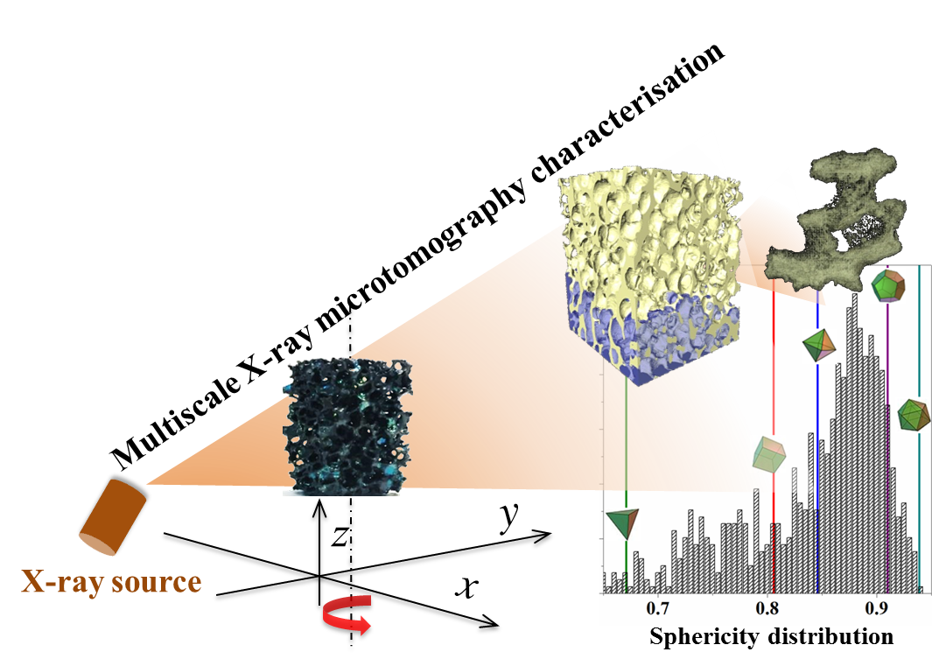

Research Highlights
- Tomography characterization for SiC foam using novel X-ray technology.
- Interpretation of structural properties of SiC foams regarding to their transport properties.
- Static liquid hold-up analysis of SiC foams through in-situ draining experiments.

Introduction
Cellular ceramic foams [1-5] have gained increasing popularity in chemical engineering, especially as catalyst supports, due to their irresistible combination of attractive features, such as, low pressure drop (in comparison with fixed beds with the same exchange area), and enhanced mixing (in comparison with monolithic reactors). Specifically, for continuous-flow catalytic processes with liquid-or multi-phases, in addition to the low pressure drop, enhanced transport phenomena such as mass and momentum transfer are also mandatory because the diffusivity of species in the liquid phase is generally five orders of magnitude lower than one in the gas phase. Therefore, cellular foams are attractive candidates for developing new multiphase catalytic processes.
Silicon carbide (SiC) is a popular substrate for the preparation of cellular foams due to its unique properties of light weight, high mechanical strength (hardness = ca. 2800 kg/mm²), high oxidation and chemical resistance and good thermal conductivity (360–490 W/m∙K) [6,7]. Various hierarchical catalysts/SiC foams materials (e.g. zeolites on SiC foams [4,8,9], nanostructures on SiC foams [4,10] and titania on SiC foams [6,7,11]) have been developed and investigated for a variety of applications as summarized in a recent review [12] demonstrating their potential as promising alternatives to conventional catalytic reactors (e.g. packed beds and monolithic reactors). From the process design point of view, hydrodynamic and transport properties of reactor beds based on open-cell foams need to be understood or predicted from a foam’s geometric structural parameters. Experimental investigations have been made to develop the knowledge on pressure drop of single phase flow through foams [13,14] and hydrodynamics (such as residence time distribution and radial dispersion within SiC foams) [15-17]. Combined experimental and numerical studies were also performed for the understanding of multiphase (e.g. characteristics of gas phase distribution) [18] and coupled reaction-heat transfer phenomena [19]. However, lot of aspects that have not been fully understood yet, in particular how morphometric parameters of cellular foams affect their hydrodynamic and transport properties.
Micro X-ray computed tomography (µ-CT) is a technique to perform the non-invasive and non-destructive investigation of the three dimensional (3D) interior structure of optically opaque materials at micron level spatial resolution [20-22]. µ-CT is a precise technique and it is acknowledged that the effect of the measurement resolution and segmentation parameters on morphometric parameters of materials is trivial when the structure size is much bigger than the measurement resolution [23]. µ-CT characterization of cellular foams was also carried out with the main focus on exploring morphometric properties and mechanical behaviors of materials [3,23-31] Transport and hydrodynamic properties of cellular foams are related closely to their morphological properties such as the cell size, porosity, strut thickness, etc. To date, only a few works endeavored to interpret µ-CT data of cellular foams for continuous-flow chemical applications [2,3,5].
In this work, β-SiC open-cell foams were characterized by micro X-ray computed tomography (µ-CT) and comprehensive geometric structural parameters of SiC foams were extracted. Considering the potential application of SiC foams in the chemical engineering, the effect of morphometric parameters on the fluid flow and transport phenomena in SiC foams were discussed. Furthermore, in-situ experiments with the air-water system through SiC foams were also performed allowing the non-intrusive investigation of the static liquid hold-up in the SiC foam packing.

Experimental

Materials and micro X-ray computed tomography characterization
SiC (β polymorph) cellular foams were provided by SICAT SARL (France). The materials (average pore sizes = 13 and 30 pores-per-inch, PPI; denoted as S13 and S30 respectively, bulk density = 360 g/cm³; void fraction ≈ 80%) were received as pellets (as seen in Fig. S1) then cut into cubes with the size of 20×20×20 mm. Cubic foams were scanned with a Nikon Metris 225/320 kV CT walk-in bay system (Fig. S2) equipped with a Perkin Elmer 1621-16-bit amorphous silicon flat-panel detector (2K×2K pixel). A tungsten X-ray target was used to generate the X-ray spectra at 55 kV and 300 μA. The sample was rotated through 360° using continuous mode during which 2001 projections were collected. The acquisition time for each projection was 1.5 seconds and the spatial voxel size is about 13.6³ μm³ allowing for fine differences in SiC foams to be distinguished.

In-situ micro X-ray computed tomography characterization of static liquid hold-up
In order to perform the draining experiment to determine the residual liquid hold-up in SiC foams, a sample holder was designed (Fig. 1), in which an u-shape silicone tube was connected to the bottom of a foam (via a 1/8 inch SS tube) to allow the fluid to drain from the foam. SiC foams were sit onto the sample holder and stabilized by gluing the lateral boundaries of the foam and sample holder (Fig. 1a). For the draining experiment, the perimeter (or lateral boundary) of the foam sample was also sealed by silicon (as illustrated in Fig. 1b) to prevent the water leak. The draining experiment was performed by varying the differential pressure head of a water-saturated foam (i.e. the pressure difference between the static water head in the foam and of the end of the silicon tube), which was achieved by moving the end of the silicon tube vertically with measurements to record the static differential pressure. As shown in Fig. 1b, by moving the end of the silicon tube vertically downward, the water level in the foam needs to change accordingly to maintain an equivalent static pressure letting the air penetrate into the open-cell structure from the top of the foam and hence draining the water out from the foam through the tube. Prior to the in-situ X-ray scanning experiments, water retention properties and critical pressure heads were determined in the laboratory under hydrostatic conditions following the procedure described by reference [32]. Saturated SiC foams (with water) were drained and scanned by μ-CT in-situ at these pressure heads. At each pressure head, sufficient time (> two hours) was allowed to achieve the equilibrium of three phases (i.e. air, water and solid).
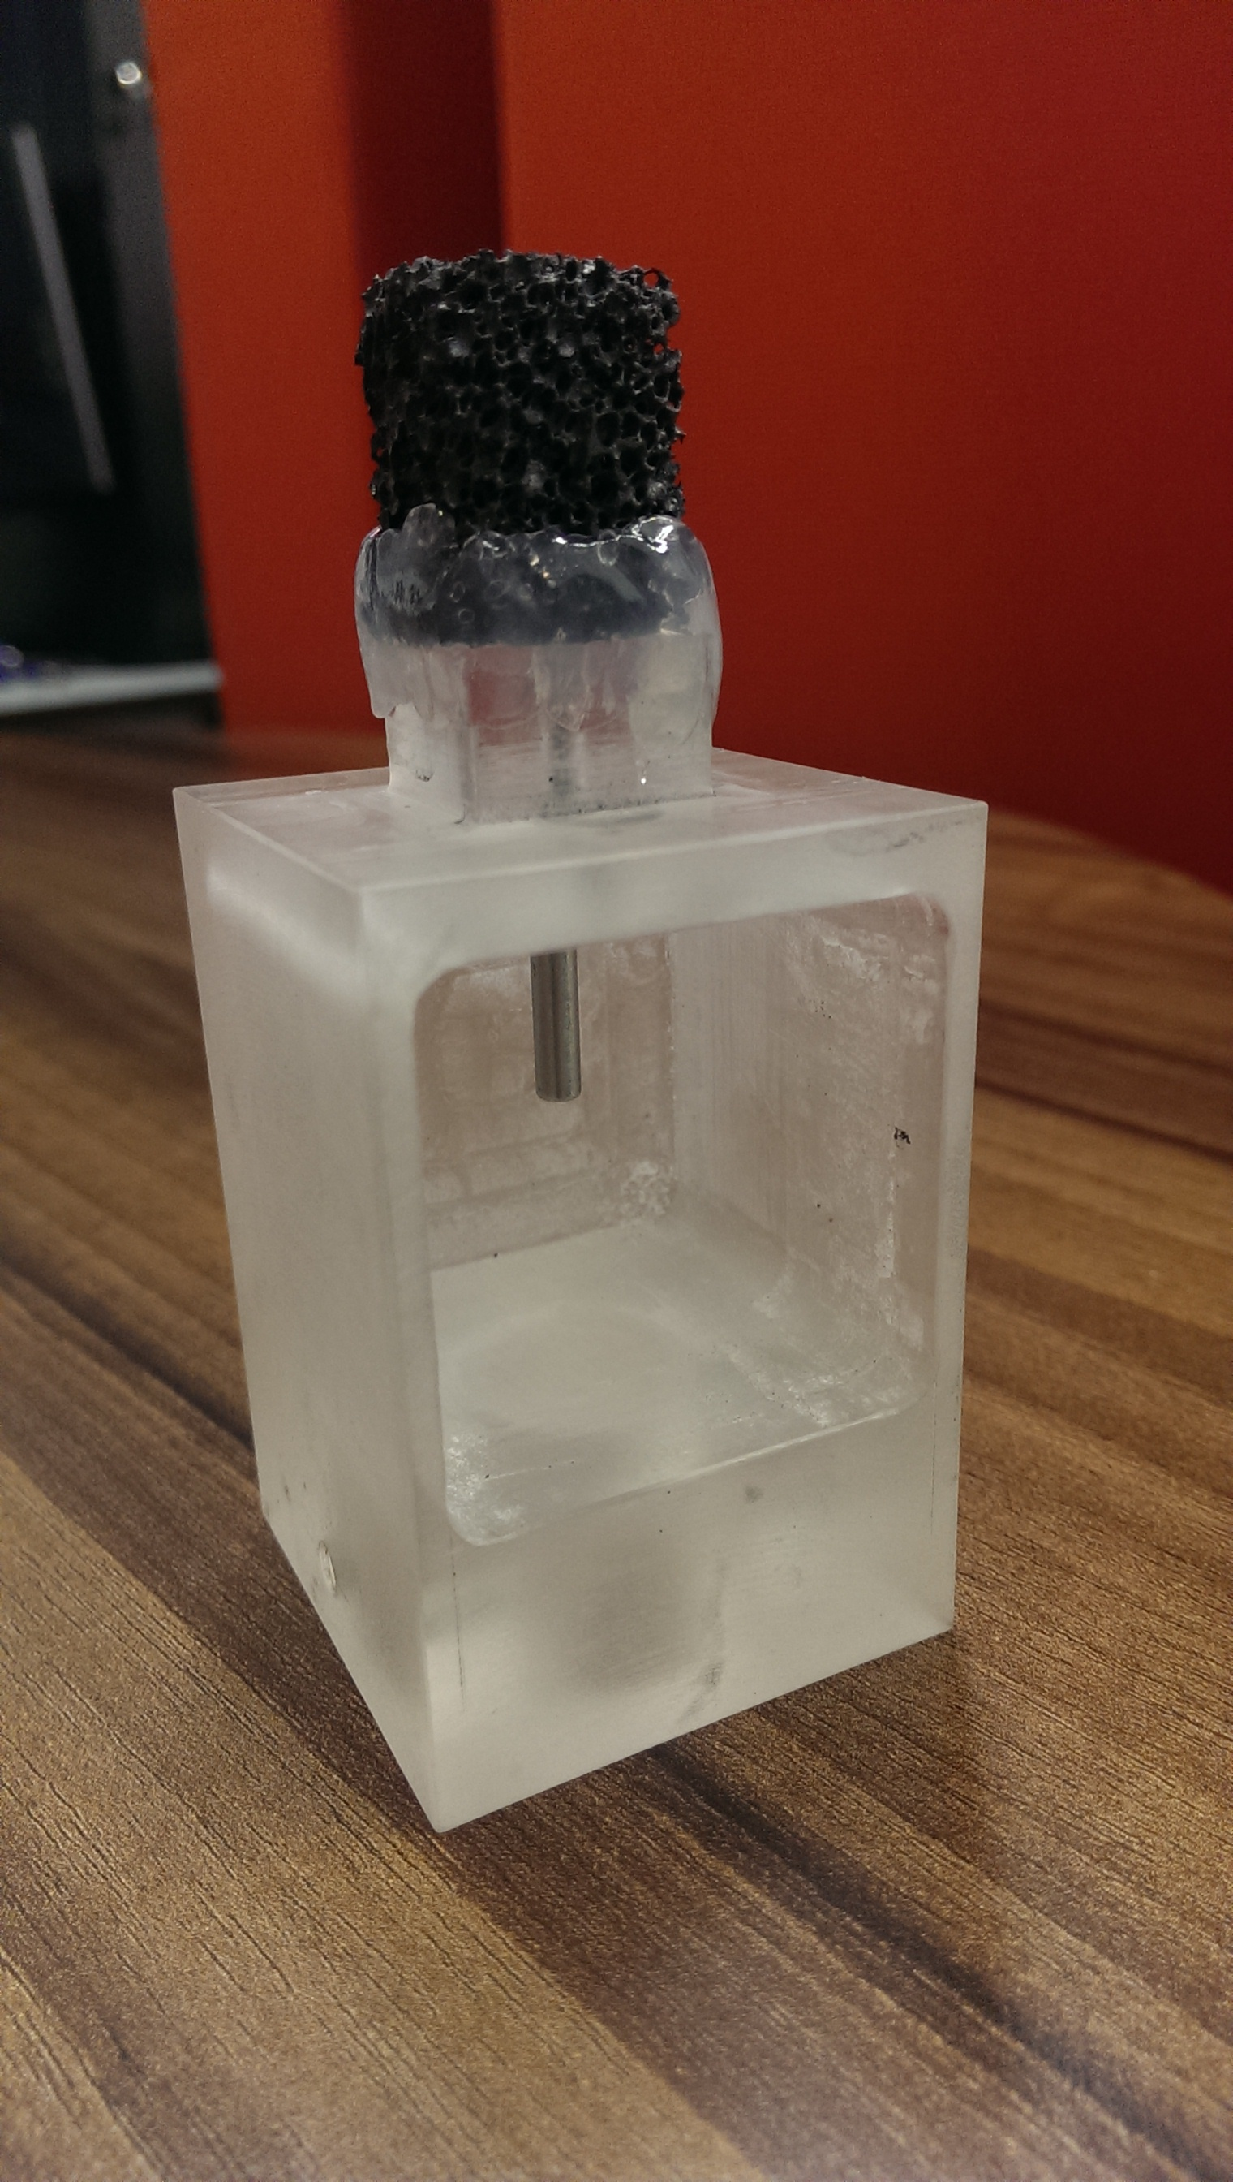  (a) | 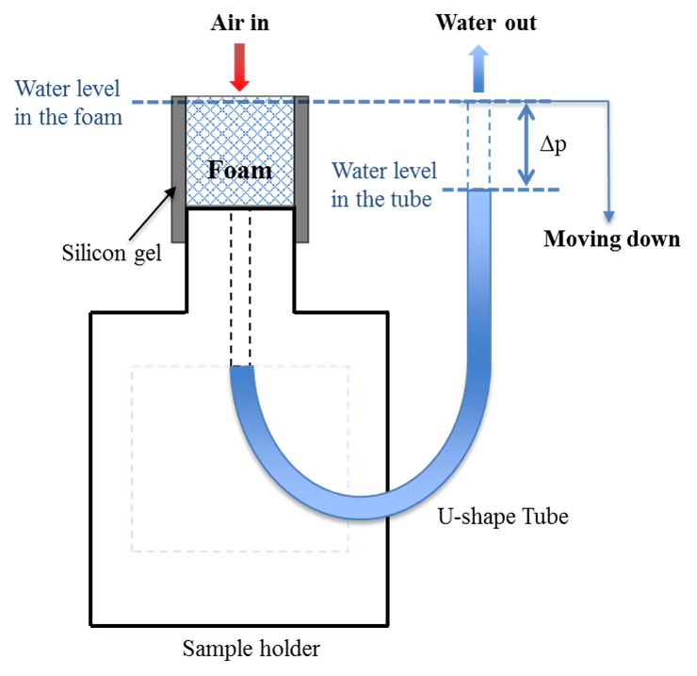  (b)
Fig. 1. (a) Sample holder with a SiC foam for in-situ draining experiments; (b) Schematic diagram of pressure-driven experiments.

Image processing and segmentation
Raw μ-CT data were firstly reconstructed by Nikon Metrolasis CT-Pro software (Metris XT 1.6), and then converted to a stack of .tiff images using an in-house code (a Matlab based GUI) [31] Resulting raw image data was loaded directly by the standard Avizo software (FEI, version 8) for subsequent image processing and segmentation based on the principles of morphological image analysis [33,34]. Batch processing of filter applications to raw image data was carried out using in-house developed scripts to save time. Detailed steps of image processing and segmentation are provided in the Supplementary Material. The results from the practice of μ-CT image processing (in terms of the open-cell and strut sizes) were compared to the measurement based on the microscopic images of foams showing a reasonable agreement (Fig. S9).

Results and Discussion

Open porosity
Cellular SiC foams consist of open-cells (that can be filled by either water or air) and solid (SiC struts), which have different geometric characteristics affecting various properties of cellular foams. Fig. 2a shows the volume grey level distribution in a foam specimen corresponding to the presence of different phases. As shown in the inset of Fig. 2a, the grey scale of different phases are distinguishable with SiC as the most attenuating phase having the highest value of ca. 115, while the grey value for water and air is ca. 30 and 3, respectively. The good contrast of the grey scale ensures the segmentation of solid phase and fluid phases during the image reconstruction. Owing to features of the preparation process, β-SiC struts are porous themselves (Fig. 2a) possessing fine cavities of various shapes and sizes. According to the mercury intrusion porosimetry measurement, the pore volume in the β-SiC phase was about 0.33 cm³/g for pores with sizes < 5 μm. Such a porous feature of β-SiC struts is essential for promoting catalytic surface reaction.
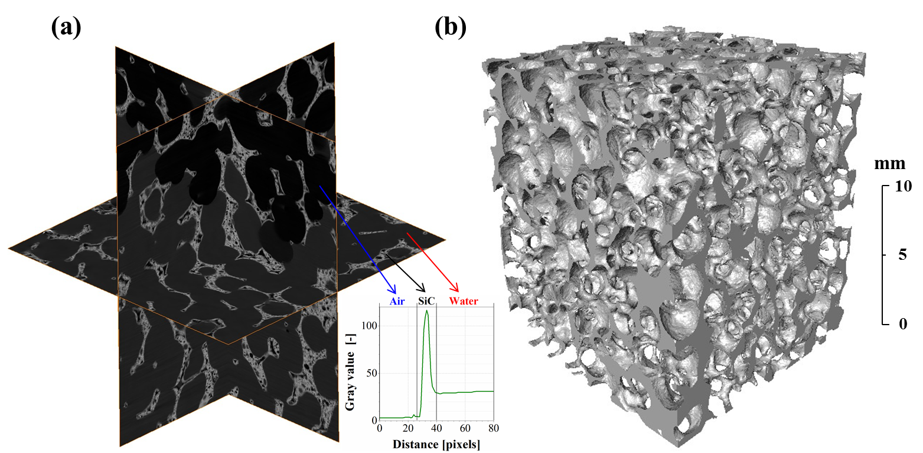
Fig. 2. (a) 3D view of grey level distribution in orthogonal slices of the S30 foam (inset: measured grey values of different phases with the foam); (b) 3D rendering of μ-CT data of the S30 foam.

Two types of porosities are usually considered when characterizing open-cell β-SiC foams, i.e. the open porosity (ε_{o}) and total porosity (ε_{t}). The open porosity only considers the void space (open-cells, Fig. 2b) while the total porosity also includes microscopic pores (cavities) within SiC struts [3]. However, due to the fact that the resolution of μ-CT in this study (the pixel size = 13.6 μm) was lower than sizes of certain microscopic pores (5 μm) in the SiC phase, only the open porosity of materials was characterized. To facilitate the determination of the open porosity of SiC foams, a series of images processing steps were applied to fill cavities within the solid struts of 3D foam reconstructions (refer to the Supplementary Material for details).
The open porosity is defined as the ratio of the open-cell volume to the total volume of materials and it is related to flow laws directly. Values of the open porosity (as summarized in Table 1) are obtained by measuring the remaining void volume after the artificial filling of cavities within the solid SiC phase. However, connections between the void space and microscopic cavities were found. These connections could be either real or artificially created by the segmentation of thin struts [26]. In this work, morphological operations were applied to measure the open porosity by dilating and eroding 3D binary images (i.e. making a dilation of binarized regions to fill cavities and reconnect separated regions; then applying the erosion to restore the original exterior shape). The limitation of this technique is the tomographic resolution compared to the hollow strut wall thickness [26]. However, values of the open porosity obtained in this study are comparable with the technical data of materials (ca. 80%). Two cellular SiC foams with different PPI values (or open-cell sizes) were studied in this work but exhibited similar open porosity values (within 5% margin of error, Table 1).
Table 1. Geometrical characterization results and permeability/drag force coefficients of open-cell β-SiC foams.
Sample | Open porosity  (ε_{o}, %) | Weighted average value  (mm) |  | Tortuosity  (τ, -) |  | k₁  (×10⁻⁷ m²) | k₂  (m⁻¹)
Sample | Open porosity  (ε_{o}, %) | Open-cell size  (d_{cell}) | Strut thickness  (d_{strut}) | Strut | Fluid | k₁  (×10⁻⁷ m²) | k₂  (m⁻¹)
S13 | 76.2 ± 3.21 | 2.61 ± 0.23 | 1.24 ± 0.053 | 1.94 | 1.14 | 3.55 | 361
S30 | 78.7 ± 3.34 | 1.48 ± 0.12 | 0.42 ± 0.019 | 1.65 | 1.07 | 1.57 | 517

Open-cell size and sphericity distribution
In addition to the measurement of the open porosity, it is also practical to obtain the specific sizes of open-cells and solid struts, which have different geometric characteristics affecting various properties of cellular foams. For example, the transfer of species and momentum within cellular structures is linked with structural characteristics of open-cells such as pore size distribution and sphericity distribution [26]. Therefore, the correct characterization of these specific sizes is essential for the effective prediction of intrinsic transport properties through foams. The mathematical morphology used for determining the equivalent diameter of open-cells in a SiC foam model is given in the Supplementary Material. The open-cell size distribution of the S30 and S13 foams is presented in Fig. 3 showing distinct features in the size of open-cells.
The S30 samples presented a monomodal distribution of open-cell sizes with a sharp peak centered at around 1.6 mm. The size distribution of open-cells in S30 foams is very narrow with the majority of open-cells (> 65%) having equivalent diameters in a range of 1.4 to 1.7 mm. In contrast, the size distribution of open-cells in the S13 samples was wide ranging from 0.5 mm to 4.4 mm. Several peaks with comparable frequencies (5% ±2%) were found between 1.6 mm and 4 mm suggesting a multimodal distribution of open-cell sizes. Based on μ-CT data, weighted average values of the open-cell size were calculated as 1.48 mm (for the S30 samples) and 2.61 mm (for the S13 samples), respectively.
According to PPI values of SiC foams, the S30 and S13 foam should have average open-cell sizes of 0.85 mm and 2.0 mm, respectively, which deviate significantly from values obtained by the μ-CT characterization. PPI values are commonly used to characterize and classify cellular materials. However, based on results obtained in this study, it was noted that PPI values may not reflect the accurate porous structures of open-cell foams.
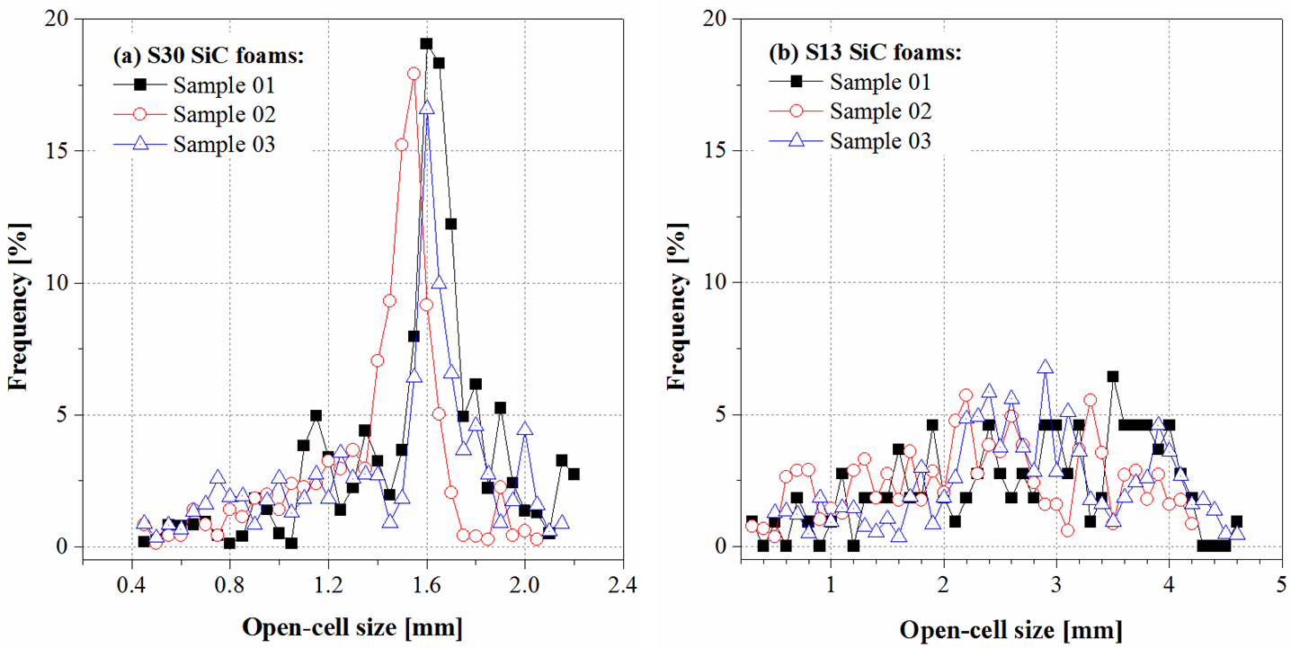
Fig. 3. Open-cell size distribution for cellular β-SiC foams measured by mathematical morphology on 3D foam models: (a) S30 SiC foams and (b) S13 SiC foams.

According to the Darcy-Forchheimer law [36-39], the pressure drop of a fluid across a porous medium is directly governed by the permeability and drag force coefficient coefficients (k₁ and k₂, as in the Eq. 1), which are all functions of the open-cell size distribution of cellular foams [37].
(1)
where μ and ρ is the fluid viscosity and density, respectively. ν is the volumetric flow-rate per unit bed cross-section.
The viscous term of Eq.1 (μν/k₁, Darcy’s law) describes the permeability of a porous element under low flow velocities, which was governed by the permeability coefficient k₁ (commonly known as the Darcyan permeability coefficient, defined as in Eq.2) [38,39]. k₁ is a macro-scale property and represents the ability of a porous medium to allow the fluid to flow through. It depends mainly on the geometrical characteristics of the porous medium reflecting its intrinsic permeation property. By comparing of the inertial term of the Darcy-Forchheimer law and the Ergun equation [37,38], the expression of the drag force coefficient (k₂) can be obtained as Eq.3, which is dependent on the structural properties but more on the interstitial physical flow conditions within the foam [40].
(2)
(3)
where d_{cell} is the average open-cell size of SiC foams. E₁ and E₂ are Ergun constants that depend on the nature of the porous medium and can be determined by fitting Darcy-Forchheimer law to the experimental data.
Therefore, the effect of the open porosity and open-cell size on coefficients k₁ and k₂ can be estimated (as shown in Table 1, values of E₁ and E₂ are adopted as 150 and 1.75 from the literature) [37] and values are in agreement with reported ones [36,37]. Though only marginal variation in the open porosity (ca. 5%) was measured between the two SiC foams with different PPI values, the resulting change in the permeability coefficient k₁ were not trivial (increased by 126% as in Table 1 when the S30 sample was replaced with the S13 sample), showing the significant effect of the open-cell size of foams on their permeability.
Sphericity (Ψ, refer to Supplementary Material for its definition) is an important parameter with regard to the spherical shape of cells [25,41]. For a spherical cell, its value is 1 and less for every other shape. The sphericity distribution of cells in cellular materials affects the available surface area and void space volume and hence the physical transport properties of cellular materials.
The μ-CT data of SiC foams was analyzed to determine the sphericity distribution of cells, as shown in Fig. 4. Values of sphericity lower than 1 were obtained for the S30 foam (Fig. 4a) with relatively predominant values at around 0.88 indicating that cells mostly have the spherical shape. Distributions of the measured sphericity of cells were compared to ideal unit cell models to evaluate the distribution of actual cell shapes in the S30 foam. Shapes of cells in the S30 foam are quite uniform with cylindrical (Ψ = 0.874), toroidal (Ψ = 0.894), dodecahedral (Ψ = 0.910) and octahedral (Ψ = 0.939) shapes. The relatively main appearance of dodecahedrons (ca. 26%) supports the general adoption of the Weaire–Phelan structure or the tetrakaidecahedron geometry (based on Kelvin unit cells) as the representation of cellular structures [42-48]. However, the predominant presence of round shapes, such as cylinder and torus, suggests that the unit cell topology in the S30 sample is more complex than the idealized dense polyhedron packings [46-48].
The cell sphericity distribution for the S13 sample is given in Fig. 4b showing no dominating cell shapes. Polyhedral cells (i.e. tetrahedrons, hexahedrons and octahedrons) are the frequently occurring shape in the real SiC foam (with the 13 PPI value) representing ca. 42% of the sphericity distribution. The scarcity of round shapes in the S13 foam (<2%) suggests that the space-filling in the S13 sample is arranged mainly by the close-packing of truncated polyhedrons. It was found possible to correlate the distribution of the cell sphericity (Fig. 4) with that of open-cell sizes (Fig. 3), since the size of strut has similar influences on both parameters affecting cell sizes and their corresponding shapes.
Findings on the shape of unit cells in SiC foams are different from previous studies where idealized geometrical cells (e.g. dodecahedrons) were normally proposed as model unit cells for investigating transport phenomena through cellular foams [42-50]. The characterization of cellular SiC foams by μ-CT revealed the accurate morphological information of cells in such materials, which is helpful to the generation of precise and photo-realistic computer models of cellular foams to simulate transport characteristics through them.
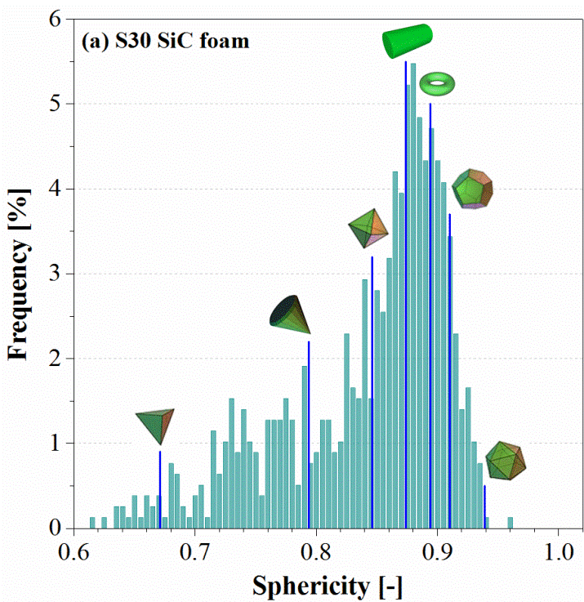 | 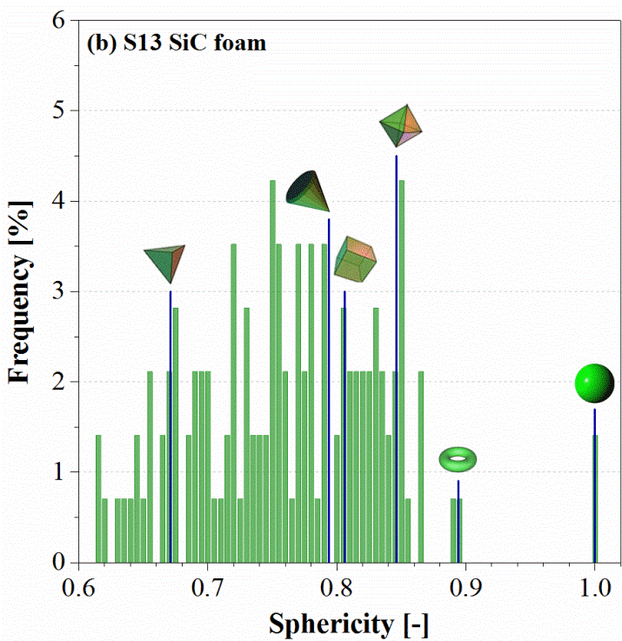
Fig. 4. Sphericity distribution of open-cells within β-SiC foams with different PPI values.

Strut thickness and tortuosity
The characteristic size of the SiC matrix such as the strut thickness and tortuosity were measured. According to the analytical model of solid foams [14,42], the strut thickness of cellular foams is an important parameter determining the heat conduction and pressure drop through foams and also closely related with the surface area of materials, which further affect the possible surface reactions. The comparison of measured strut thickness from μ-CT data of SiC foams is presented in Fig. 5 showing the variation in the strut thickness for a given sample of β-SiC foams. The average strut thickness was measured as decreasing with an increase in the PPI value of SiC foams, as expected, since more support is needed to sustain large cells in the S13 sample. The weighted average values of the strut thickness are 1.3 mm and 0.41 mm respectively for S13 and S30 samples. The strut thickness histogram measured on the solid phase of the S30 sample shows a monomodal distribution with a main peak centered at around 0.35 mm. For S13 sample with larger pores, the strut thickness distribution is wide and multimodal, ranging from 0.75−2.10 mm.
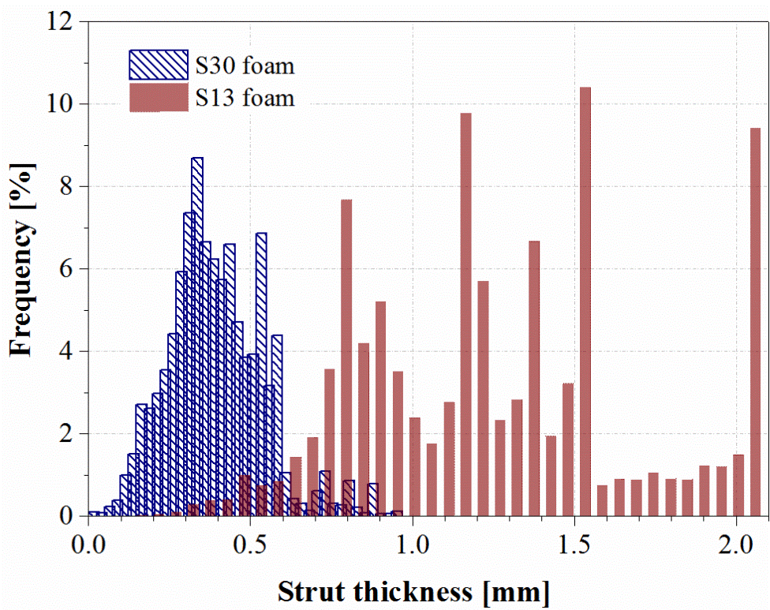
Fig. 5. Strut thickness distribution of β-SiC foams with different PPI values.
For cellular materials, geometrical tortuosity (τ) characterizes the sinuosity and interconnectedness of a phase (fluid or solid phase) [51]. It is a link relating the microstructure of cellular foams to relevant macroscopic transport properties through foams. Tortuosity is often used to evaluate transport properties either in the solid phase (e.g. heat conduction) or fluid phase (e.g. diffusion and fluid flow) [24]. For instance, the effective diffusivity (D_{e}) of species through cellular foams is proportional to the reciprocal of the square of the geometrical tortuosity [24,52], as shown in Eq. 4:
(4)
where D is the diffusion coefficient of species.
Values of the geometrical tortuosity were analyzed based on realistic 3D foam reconstructions and relevant data are summarized in Table 1. The tortuosity of SiC foams was found to have an inverse relationship with the open-cell porosity, i.e. the tortuosity (of both phases) decreases with an increase in the open-cell porosity, agreeing with the tendency measured by the acoustic [53] and electrochemical method [54] for the geometrical tortuosity of porous materials. Values of the open-cell porosity and geometrical tortuosity of open-cells obtained in this study were also found in good agreement with reported ones by Gommes et al using the computed tomography method [24] For continuous-flow chemical applications, the geometrical tortuosity (of open-cells) of cellular foams can affect the liquid-solid mass transfer step. By decreasing the open-cell size of SiC foams, a ca. 6% decrease in the geometrical tortuosity (of open-cells) was estimated based on μ-CT data leading to an increase of the effective mass transfer coefficient by ca.15%. The geometrical tortuosity of the solid phase is in principle more important in a purely conductive system, while it can be neglected for convectively dominated flows [55].
The open-cell tortuosity of solid foams was commonly estimated by using analytical approaches based on the idealized representative unit cells (e.g. as cubic cells) [14,56,57]. However, by comparing the analytical model prediction [14] with data from the experimental measurement [24,53,54], large discrepancies can be noticed. Therefore, more precise tortuosity data of solid foams obtained by μ-CT method would be essential to support the development of more accurate tortuosity expressions.

Static liquid hold-up (SLH) and pressure drop
For porous media, the static liquid hold-up (SLH) is the consequence of the balance between the gravity and capillary force [58], which is an important parameter for evaluating the total liquid hold-up, pressure drop, liquid residence time distribution and mass transfer steps in a reactor bed. X-ray tomographic technique has been proposed as an effective method to study the SLH in structural packing, such as Katapak-SP12TM [59], in gas–liquid–solid reactors. In this study, the static liquid hold-up of SiC open-cell foams was determined by in-situ bed draining experiments using μ-CT. Prior to the in-situ bed draining experiment, the effect of capillary pressure on the water content (ratio of the water volume remained in pores to the total sample volume) in the foam was investigated in the laboratory under the hydrostatic condition and the results are presented in Fig. 6.
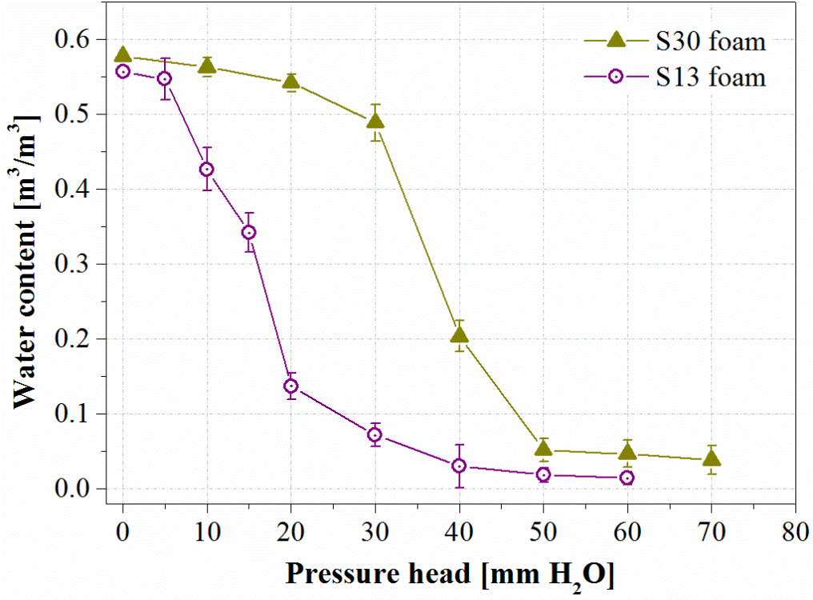
Fig. 6. Water content in β-SiC foams as a function of pressure head under hydrostatic conditions.
As expected, to drain the saturated open-cell foams required the pressure head to overcome the capillary forces within the open-cells, the so-called bubbling pressure or air entry value, h_{b} [32]. The air entry value observed was clearly linked with open-cell characteristics such as open-cell size. Based on Jurin’s law [59,60], with the consideration of the open porosity and characteristic length of the open-cell, a modified formula was proposed (Eq. 5) to estimate the air entry value of SiC open-cell foams.
(5)
where σ is the liquid surface tension; θ is the contact angle of the liquid on the strut (water contact angle on SiC surfaces is about 25°) [61]; ρ is the liquid density; g is the gravitational acceleration and L_{c} is the characteristic length of the open-cell.
If one simply uses the average diameter of open-cells in SiC foams as the characteristic length (d_{cell}, Table 1), the air entry value of two SiC foams can be estimated as 5.4 mmH₂O and 11 mmH₂O, respectively, for S13 sample and S30 sample, close to the experimental results as shown in Fig. 6. However, the draining experiment cannot provide the exact information on the liquid held within the porous structure of open-cell foams.
In-situ draining experiments under μ-CT scan, on the other hand, can give access to the non-perturbing measurement of the distribution and the exact amount of SLH. In-situ X-ray scans of multiphase systems with the SiC foam, water and air were conducted at predetermined pressures (Fig. 5), and the system was left for sufficient time to achieve the equilibrium between different phases. The reconstruction results are presented in Fig. 7 for S13 and S30 samples.
Fig. 7 shows that, under the hydrostatic condition, the residual SLH in SiC foams starts to emerge once air entry value was achieved. Considering the morphological characterization of SiC foams, SLH were mainly affected by the size of open-cells. SLH were commonly found in open-cells with diameters smaller than 1 mm, where capillary force dominates over gravity, and the spatial distribution of SLH is fairly uniform across the porous structure of SiC samples used in this study. By comparing voxels of the water held within a drained SiC foam with that of open-cell air phase in the dry sample, the residual SLH measured by μ-CT (after the complete draining) on two SiC samples are about 1.2% (for S13 foams) and 1.7% (for S30 foams), respectively.
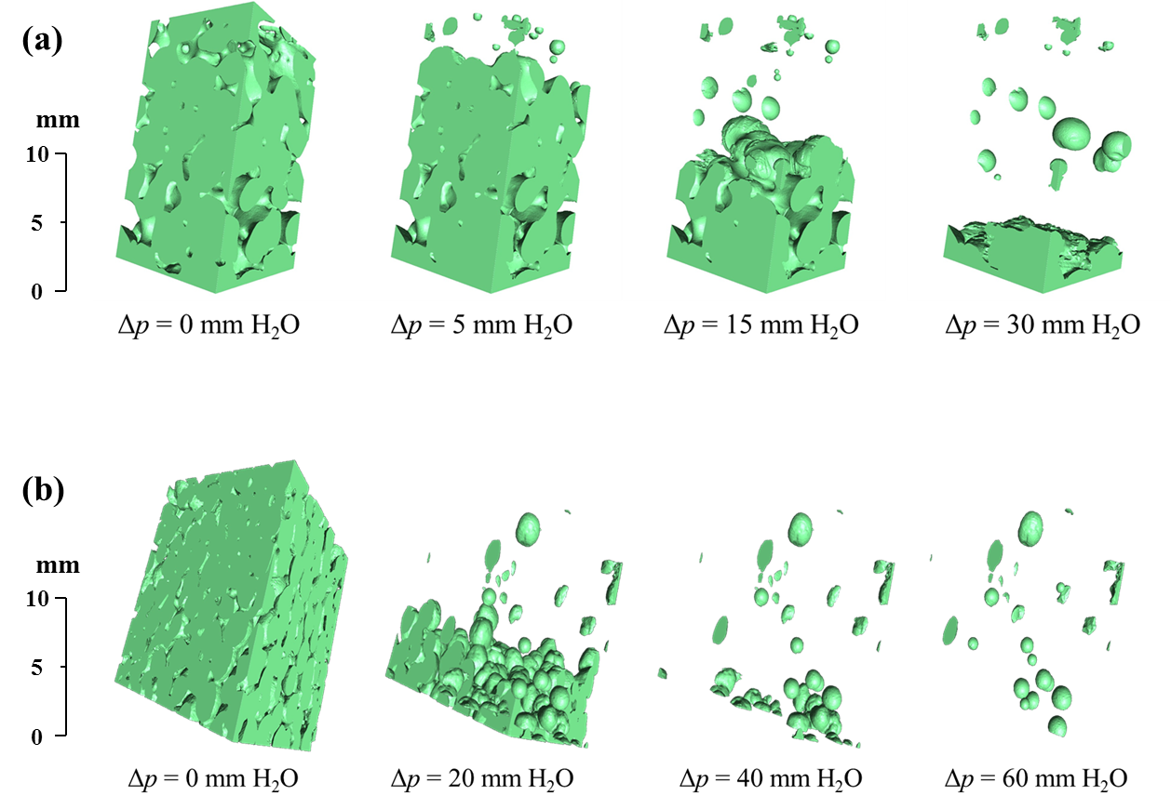
Fig. 7. 3D reconstruction of μ-CT data showing the static hold-up of water in (a) a S13 SiC foam sample and (b) a S30 SiC foam sample during in-situ draining experiments.

SLH is a key parameter in the modeling and design packed beds. Considering the hydrodynamics and transport phenomena of multiphase flows through a reactor bed, similar behaviors of SLH under hydrostatic conditions are normally assumed to remain under dynamic conditions, i.e. as stagnant or sluggish (at a velocity much lower than the liquid bulk) [58,62]. Therefore, the relevant fraction of the packing surface of the reactor bed can be affected, especially hindering the liquid-solid mass transfer and gas-liquid mass transfer steps. In this sense, it is still of importance to minimize the impact of SLH in multiphase processes based on open-cell foams, though the measured SLH of SiC foams (by μ-CT) was generally lower than conventional packing such as spheres, cylinder and Raschig rings [58]. Therefore, the pressure drop across a foam bed needs to be well above the air entry value of the foam material to minimize the presence of stagnate pore regions. Hence, based on Eq. 5, in order to avoid the adverse influence of SLH on mass transfer steps within SiC foams, we suggest to operate continuous-flow SiC foam reactors with pressure drop far above 26500 Pa/m (for S13 sample) and 53950 Pa/m (for S30 sample).
The pressure drop estimation was performed based on the geometrical characterization of foams and the modified Ergun model, which was developed using a cubic lattice approach of the foam structure [37], and the obtained results were presented in Fig. 8. As shown in Fig. 8, for a liquid medium (water), the pressure drop difference between S13 and S30 foams is obvious and becomes larger as the gas velocity increases. Considering the difference in the porosity and average open-cell size of two samples, clearly the pressure drop of a foam bed is more sensitive to the open porosity than the average open-cell size. By combining the Eq. 5 and Fig. 8, envelopes of the linear velocity (with 1 m/s as the maximum) was established for minimizing the SLH through the SiC foam beds under continuous-flow conditions.
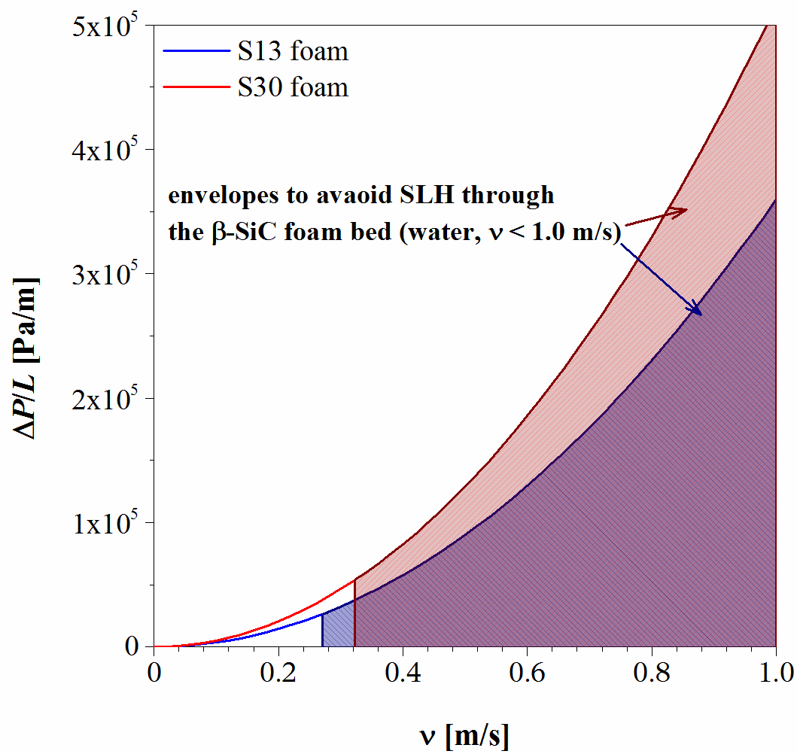
Fig. 8. Comparison between estimated pressure drops of β-SiC foams as a function of linear space velocity.

Conclusions
Micro X-ray computed tomography (μ-CT) characterization of open-cell SiC foams and multiphase systems in SiC foams were performed at a spatial voxel size of 13.6³ μm³. In comparison with other characterization techniques, μ-CT imaging and specialized image analysis software enable the comprehensive and quantitative extraction of realistic morphological and structural features of cellular materials. In this study, we focused on using μ-CT to obtain detailed information on open porosity, characteristic sizes (open-cell size and strut thickness), sphericity and tortuosity of two SiC foams that have been suggested for catalytic applications. Results showed that (i) the classification of open-cell foams (based on the same substrate SiC) using pores-per-inch is not precise and (ii) the differences (in terms of measured morphological and structural properties) are distinguishing between two SiC foams with the different open-cell sizes (i.e. 30 and 13 PPI).
Hydrodynamic and transport properties (i.e. pressure drop, permeability and mass transfer) were found to depend on these parameters, that means that the comprehensive information from μ-CT characterization can be used directly for estimating the performance of reactor beds based on cellular foams. Sphericity factor analysis of the cell shape showed the inherent irregularity of the real structure of open-cell SiC foams contradicting the common assumption of idealized geometries used for numerical simulations. Static liquid hold-up in SiC foams was investigated for the first time using μ-CT technique provided thorough 3D information about the amount and distribution of static liquid hold-up inside the foam packing.
Micro X-ray computed tomography offers a great opportunity to deliver comprehensive information of cellular foam materials all at once, which can be used for predicting transport phenomena and fluid flow properties of open-cell foams and hence understanding continuous-flow processes based on them. Therefore, μ-CT data should be exploited to (i) improve current and future models of open-cells matching the actual geometry of cellular foams and (ii) guide the design of future foams delivering their optimum functions.

Acknowledgements
The authors would like to thank the financial support from The University of Manchester through Higher Education Innovation Funded ‘Knowledge and Innovation Hub for Environmental Sustainability’. XO is grateful to the Guangzhou Elite Project scholarship and the CEAS postgraduate research scholarship, The University of Manchester. The Manchester (Henry Moseley) X-ray Imaging Facility was funded in part by the EPSRC (grants EP/F007906/1, EP/F001452/1 and EP/M010619/1).

Notation
d_{cell} | = | weighted average open-cell size, mm
d_{strut} | = | weighted average strut thickness, mm
D_{e} | = | effective diffusivity, cm²/s
D | = | diffusion coefficient of species, cm²/s
g | = | gravitational acceleration, m/s²
h_{b} | = | Bubbling pressure or air entry value, mm
k₁ | = | Darcyan permeability coefficient, m²
k₂ | = | Drag force coefficient, m⁻¹
L_{c} | = | characteristic length of the open-cell, mm
ΔP/L | = | pressure drop per unit length, Pa/m

Greek letters
ε_{o} | = | open porosity, %
ε_{t} | = | total porosity, %
ν | = | volumetric flow-rate per unit bed cross-section, m/s
μ | = | fluid dynamic viscosity, kg/m·s
ρ | = | fluid density, kg/m³
τ | = | Tortuosity, -
σ | = | liquid surface tension, N/m
θ | = | θ is the contact angle, °
Ψ | = | Sphericity, -

References
1. Ledoux MJ, Pham-Huu C. Silicon Carbide: A novel catalyst support for heterogeneous catalysis. CATTECH. 2001;5(4):226−246.
2. Buciuman FC, Kraushaar-Czarnetzki B. Ceramic foam monoliths as catalyst carriers. 1. Adjustment and description of the morphology. Ind Eng Chem Res. 2003;42(9):1863−1869.
3. Grosse J, Dietrich B, Garrido GI, Habisreuther P, Zarzalis N, Martin H, Kind M, Kraushaar-Czarnetzki B. Morphological characterization of ceramic sponges for applications in chemical engineering. Ind Eng Chem Res. 2009;48(23):10395−10401.
4. Jiao Y, Yang X, Jiang C, Tian C, Yang Z, Zhang J. Hierarchical ZSM-5/SiC nano-whisker/SiC foam composites: Preparation and application in MTP reactions. J Catal. 2015;332:70−76.
5. Fan X, Ou X, Xing F, Turley GA, Denissenko P, Williams MA, Batail N, Pham, C, Lapkin AA. Microtomography-based numerical simulations of heat transfer and fluid flow through β-SiC open-cell foams for catalysis. Catal Today. DOI: 10.1016/j.cattod.2015.12.012.
6. Liu Y, de Tymowski B, Vigneron F, Florea I, Ersen O, Meny C, Nguyen P, Pham C, Luck F, Pham-Huu C. Titania-decorated silicon carbide-containing cobalt catalyst for Fischer-Tropsch synthesis. ACS Catal. 2013;3(3):393−404.
7. Liu Y, Podila S, Nguyen DL, Edouard D, Nguyen P, Pham C, Ledoux MJ, Pham-Huu C. Methanol dehydration to dimethyl ether in a platelet milli-reactor filled with H-ZSM5/SiC foam catalyst. Appl Catal A Gen. 2011;409−410:113−121.
8. Ivanova S, Vanhaecke E, Louis B, Libs B, Ledoux MJ, Rigolet S, Marichal C, P, Pham C, Luck F, Pham-Huu C. Efficient synthesis of dimethyl ether over HZSM-5 supported on medium-surface-srea β-SiC foam. ChemSusChem. 2008;1(10):851−857.
9. Elamin MM, Muraza O, Malaibari Z, Ba H, Nhut J-M, Pham-Huu C. Microwave assisted growth of SAPO-34 on β-SiC foams for methanol dehydration to dimethyl ether. Chem Eng J. 2015;274:113−122.
10. Ba H, Liu Y, Truong-Phuoc L, Duong-Viet C, Mu X, Doh WH, Tran-Thanh T, Baaziz W, Nguyen-Dinh L, Nhut JM, Janowska I, Begin D, Zafeiratos S, Granger P, Tuci G, Giambastiani G, Banhart F, Ledoux MJ, Pham-Huu C. A highly N-doped carbon phase "dressing" of macroscopic supports for catalytic applications. Chem Comm. 2015;51(76):14393−14396.
11. Hajiesmaili S, Josset S, Bégin D, Pham-Huu C, Keller N, Keller V. 3D solid carbon foam-based photocatalytic materials for vapor phase flow-through structured photoreactors. Appl Catal A Gen. 2010;382(1):122−130.
12. Duong-Viet C, Ba H, El-Berrichi Z, Nhut JM, Ledoux MJ, Liu Y, Pham-Huu C. Silicon carbide foam as a porous support platform for catalytic applications. New J Chem. 2016. DOI: 10.1039/C5NJ02847G.
13. Edouard D, Ivanova S, Lacroix M, Vanhaecke E, Pham C, Pham-Huu C. Pressure drop measurements and hydrodynamic model description of SiC foam composites decorated with SiC nanofiber. Catal Today. 2009;141(3−4):403−408.
14. Ahmed J, Pham-Huu C, Edouard D. A predictive model based on tortuosity for pressure drop estimation in 'slim' and 'fat' foams. Chem Eng Sci. 2011;66(20):4771−4779.
15. Edouard D, Lacroix M, Pham C, Mbodji M, Pham-Huu C. Experimental measurements and multiphase flow models in solid SiC foam beds. AIChE J. 2008;54(11):2823−2832.
16. Saber M, Huu TT, Pham-Huu C, Edouard D. Residence time distribution, axial liquid dispersion and dynamic - static liquid mass transfer in trickle flow reactor containing β-SiC open-cell foams. Chem Eng J. 2012;185−186:294−299.
17. Huu TT, Philippe R, Nguyen P, Edouard D, Schweich D. Radial dispersion in liquid upflow through solid SiC foams. Ind Eng Chem Res. 2011;50(8):4329−4334.
18. Li H, Fu L, Li X, Gao X. Mechanism and analytical models for the gas distribution on the SiC foam monolithic tray. AIChE J. 2015;61(12):4509−4516.
19. Gräf I, Ladenburger G, Kraushaar-Czarnetzki B. Heat transport in catalytic sponge packings in the presence of an exothermal reaction: Characterization by 2D modeling of experiments. Chem Eng J. 2016;287:425−435.
20. Salvo L, Cloetens P, Maire E, Zabler S, Blandin JJ, Buffière JY, Ludwig W, Boller E, Bellet D, Josserond C. X-ray micro-tomography an attractive characterisation technique in materials science. Nucl Instr Meth Phys Res B. 2003;200:273−286.
21. Norouzi Rad M, Shokri N, Sahimi M. Pore-scale dynamics of salt precipitation in drying porous media. Phys Rev E. 2013;88(3):032404.
22. Trinh L, Lowe T, Campbell GM, Withers PJ, Martin PJ. Bread dough aeration dynamics during pressure step-change mixing: Studies by X-ray tomography, dough density and population balance modelling. Chem Eng Sci. 2013;101:470−477.
23. Olurin OB, Arnold M, Körner C, Singer RF. The investigation of morphometric parameters of aluminium foams using micro-computed tomography. Mater Sci Eng A. 2002;328(1–2):334−343.
24. Gommes CJ, Bons A-J, Blacher S, Dunsmuir JH, Tsou AH. Practical methods for measuring the tortuosity of porous materials from binary or gray-tone tomographic reconstructions. AIChE J. 2009;55(8):2000−2012.
25. Elmoutaouakkil A, Salvo L, Maire E, Peix G. 2D and 3D characterization of metal foams using X-ray tomography. Adv Eng Mater. 2002;4(10):803−807.
26. Vicente J, Topin F, Daurelle JV. Open celled material structural properties measurement: From morphology to Transport properties. Mater Trans. 2006;47(9):2195−2202.
27. Maire E, Gimenez N, Sauvant-Moynot V, Sautereau H. X-ray tomography and three-dimensional image analysis of epoxy-glass syntactic foams. Phil Trans R Soc A: Math Phys Eng Sci. 2006;364(1838):69−88.
28. Maire E, Colombo P, Adrien J, Babout L, Biasetto L. Characterization of the morphology of cellular ceramics by 3D image processing of X-ray tomography. J Eur Ceram Soc. 2007;27(4):1973−1981.
29. Bock J, Jacobi AM. Geometric classification of open-cell metal foams using X-ray micro-computed tomography. Mater Charact. 2013;75:35−43.
30. Maire E. X-Ray Tomography Applied to the characterization of highly porous materials. Annu Rev Mater Res. 2012;42(1):163−178.
31. Buffiere J-Y, Maire E, Adrien J, Masse J-P, Boller E. In situ experiments with X-ray tomography: An attractive tool for experimental mechanics. Exp Mech. 2010;50(3):289−305.
32. Shokri N, Lehmann P, Or D. Liquid-phase continuity and solute concentration dynamics during evaporation from porous media: Pore-scale processes near vaporization surface. Phys Rev E. 2010;81(4):046308.
33. Soille P. Morphological Image Analysis: Principles and Applications (2nd edition). Berlin: Springer-Verlag, 2004.
34. Serra J. Image Analysis and Mathematical Morphology, New-York:Academic Press, 1982.
35. Bradley RS. TomoTools: A Matlab based GUI for processing of X-ray tomography data. https://github.com/rsbradley/tomotools. Accessed March 2015.
36. Moreira EA, Innocentini MDM, Coury JR. Permeability of ceramic foams to compressible and incompressible flow. J Eur Cer Soc. 2004;24(10–11):3209−3218.
37. Lacroix M, Nguyen P, Schweich D, Pham-Huu C, Savin-Poncet S, Edouard D. Pressure drop measurements and modeling on SiC foams. Chem Eng Sci. 2007;62:3259−3267.
38. Ergun S. Fluid flow through packed columns. Chem Eng Prog. 1952;48:89–94,.
39. Teng H, Zhao TS. An extension of Darcy’s law to non-Stokes flow in porous media. Chem Eng Sci. 2000;55(14):2727–2735.
40. Woudberg S, DuPlessis JP. An analytical Ergun-type equation for porous foams. Chem Eng Sci. 2016;148:44−54.
41. Wadell H. Volume, shape, and roundness of quartz particles. J Geol. 1935;43(3):250−280.
42. Edouard D. The effective thermal conductivity for "slim" and "fat" foams. AIChE J. 2011;57(6):1646−1651.
43. Horneber T, Rauh C, Delgado A. Fluid dynamic characterisation of porous solids in catalytic fixed-bed reactors. Micropor Mesopor Mater. 2012;154(SI):170−174.
44. Huu TT, Lacroix M, Pham-Huu C, Schweich D, Edouard D. Towards a more realistic modeling of solid foam: Use of the pentagonal dodecahedron geometry. Chem Eng Sci. 2009;64(24):5131−5142.
45. Klostermann J, Schwarze R, Brücker C. Meshing of porous foam structures on the micro-scale. Eng Comput. 2013;29(1):95−110.
46. Horneber T, Rauh C, Delgado A. Numerical simulations of fluid dynamics in carrier structures for catalysis: characterization and need for optimization. Chem Eng Sci. 2014;117:229−238.
47. Kumar P, Topin F. Investigation of fluid flow properties in open cell foams: Darcy and weak inertia regimes. Chem Eng Sci. 2014;116:793−805.
48. von Rickenbach J, Lucci F, Narayanan C, Dimopoulos Eggenschwiler P, Poulikakos D. Multi-scale modelling of mass transfer limited heterogeneous reactions in open cell foams. Int J Heat Mass Transfer. 2014;75:337−346.
49. Suleiman AS, Dukhan N. Forced convection inside metal foam: Simulation over a long domain and analytical validation. Int J Therm Sci. 2014;86:104−114.
50. Suleiman AS, Dukhan N. Long-domain simulation of flow in open-cell mesoporous metal foam and direct comparison to experiment. Micropor Mesopor Mater. 2014;196:104−114.
51. Pardo-Alonso S, Vicente J, Solórzano E, Rodriguez-Perez MÁ, Lehmhus D. Geometrical tortuosity 3D calculations in infiltrated aluminium cellular materials. Procedia Mater Sci. 2014;4:145−150.
52. Satterfield CN. Mass Transfer in Heterogeneous Catalysis. Cambridge, Massachusetts, United States: M.I.T. Press; 1970.
53. Fellah Z, Berger S, Lauriks W, Depollier C, Aristégui C, Chapelon J. Measuring the porosity and the tortuosity of porous materials via reflected waves at oblique incidence. J Acoustic Soc Am. 2003;113(5):2424−2433.
54. Moreira EA, Coury JR. The influence of structural parameters on the permeability of ceramic foams. Braz J Chem Eng. 2004;21(1):23−33.
55. Sbutega K, Geb D, Catton I. Modeling of Multiscale Heat Transfer Systems Using Volume Averaging Theory. In: Sparrow EM, Abraham JP, Gorman JM, eds. Advances in Heat Transfer. Vol 47. San Diego, USA: Academic Press; 2015.
56. Bhattacharya A, Calmidi VV, Mahajan RL. Thermophysical properties of high porosity metal foams. Int J Heat Mass Transfer. 2002;45(5):1017−1031.
57. Fourie JG, Du Plessis. JP. Pressure drop modelling in cellular metallic foams. Chem Eng Sci. 2002;57:2781−2789.
58. Ortiz-Arroyo A, Larachi Fç, Iliuta I. Method for inferring contact angle and for correlating static liquid hold-up in packed beds. Chem Eng Sci. 2003;58(13):2835−2855.
59. Aferka S, Crine M, Saroha AK, Toye D, Marchot P. In situ measurements of the static liquid holdup in Katapak- packed column using X-ray tomography. Chem Eng Sci. 2007;62(21):6076−6080.
60. van Hasselt BW, Calis HP, Sie ST, van den Bleek TM. Liquid holdup in the three levels of porosity reactor. Chem Eng Sci. 1999;54:1405–1411.
61. Coletti C. Silicon Carbide Biocompatibility, Surface Control and Electonic ellular Interaction for Biosensing Applications: Department of Electrical Engineering, University of South Florida; 2007.
62. Schwidder S, Schnitzlein K. Predicting the static liquid holdup for cylindrical packings of spheres in terms of the local structure of the packed bed. Chem Eng Sci. 2010;65(23):6181−6189.

