Fetal-derived trophoblast utilize the apoptotic cytokine TNF--related apoptosis-inducing ligand (TRAIL) to induce smooth muscle cell death

Rosemary J. Keogh, PhD; Lynda K. Harris, PhD*; Abigail Freeman, BSc; Philip N. Baker, DM*; John D. Aplin, PhD*; Guy StJ. Whitley PhD; Judith E. Cartwright, PhD.

Centre for Developmental and Endocrine Signalling, Division of Basic Medical Sciences, St. George’s, University of London, Cranmer Terrace, London SW17 0RE, UK and *Division of Human Development, University of Manchester, St. Mary’s Hospital, Hathersage Road, Manchester M13 0JH, UK.

Subject codes:
[97] Other vascular biology
[115] Remodeling
[131] Apoptosis

Short title: A role for TRAIL in vessel remodeling in pregnancy
Word count: 5870
Abstract
Remodeling of uterine spiral arteries during pregnancy transforms them from high to low resistance vessels that lack vasoconstrictive properties. This process is essential to meet the demand for increased blood flow imposed by the growing fetus. Loss of endothelial and smooth muscle cells (SMC) is evident in remodeled arteries but the mechanisms underlying this transformation remain unknown. This study investigated the hypothesis that fetal trophoblast invading from the placenta instigate remodeling by triggering cell death in vascular SMC. Specifically, a role for trophoblast-derived death inducing cytokine TNF--related apoptosis-inducing ligand (TRAIL) was investigated. Expression of the activating TRAIL receptors R1 and R2 was detected by flow cytometry on human aortic SMC (HASMC) and by immunohistochemistry on spiral artery SMC. rhTRAIL induced HASMC apoptosis, which was inhibited by antibodies against TRAIL-R1 or -R2. Perfusion of denuded spiral artery segments with rhTRAIL also induced SMC apoptosis. Trophoblasts isolated from first trimester placenta expressed membrane-associated TRAIL and induced apoptosis of HASMC; apoptosis was significantly inhibited by a recombinant human TRAIL-R1:Fc construct. Trophoblast within the first trimester placental bed also expressed TRAIL. These data show that i) TRAIL causes SMC death, ii) trophoblast produce the apoptotic cytokine TRAIL and iii) trophoblast induce SMC apoptosis via a TRAIL-dependent mechanism. We conclude that TRAIL produced by trophoblast causes apoptosis of SMC and thus may contribute to SMC loss during spiral artery remodeling in pregnancy.

Key words: apoptosis, cell death, pregnancy, vascular remodeling, vascular smooth muscle
Introduction
Remodeling of the uterine spiral arteries commences during the first trimester of human pregnancy and is completed by around 20 weeks of gestation. During this time, vessels lose their vaso-responsiveness due to loss of endothelial and smooth muscle cells (SMC), which are replaced with fetal-derived trophoblast in a fibrinoid matrix. This process, termed physiological change, results in transformation of the vessels from narrow to large calibre conduits and is essential to enable the oxygen and nutrient demands of the growing fetus to be met.¹ Histological evidence suggests a role for trophoblast in this process, as shallow trophoblast invasion and incomplete remodeling have been associated with fetal growth restriction², early onset of labour³ and pre-eclampsia.^{4,5}

The mechanisms underlying spiral artery remodeling are still yet to be elucidated, largely due to the difficulty in obtaining tissue and the scarcity of suitable animal models that mirror the highly invasive nature of human haemochorial placentation.^{1,6} Much of the current understanding is derived from examination of histological specimens and studies of primate models. Trophoblast, derived from chorionic villi, migrate away from the placental villous tips forming a population termed extravillous trophoblast. These cells form two populations, defined by the route with which they invade the surrounding tissue. Interstitial trophoblast invade the decidual stroma, migrate across the endometrial-myometrial boundary and progress into the first third of the myometrium. Endovascular trophoblast invade via the lumens of spiral arteries, however the source of these cells is unclear. While it is possible that they may enter the vessel lumen directly and migrate against the flow of blood, it is more likely that they arise from an interstitial population that intravasate into the artery lumen.^{7,8} By adopting a vascular-like phenotype extravillous trophoblast are able to infiltrate the spiral arteries and interact with cells of the vessel walls.⁹ We have shown that endothelial cells and SMC are lost from spiral arteries by trophoblast-induced apoptosis through a mechanism involving activation of the Fas/Fas ligand (FasL) pathway.^{10,11} The aim of this study was to investigate other apoptotic ligands produced by trophoblast that may be involved in causing apoptosis of SMC in the vessel wall.

Tumour necrosis factor-related, apoptosis-inducing ligand (TRAIL) is a member of the TNF family of death-promoting ligands. It is expressed on the surface of cells in a membrane bound form, the carboxy-terminus of which can be cleaved by cysteine proteases generating a soluble form.^{12,13} TRAIL is known to be produced by the placenta, and mRNA for TRAIL was upregulated in two trophoblast cell lines following cytokine stimulation.¹⁴⁻¹⁶ TRAIL transduces its apoptotic signal via receptor trimerization and activation of the extrinsic pathway of apoptosis. The adaptor molecule Fas-associated death domain (FADD) binds to the intracellular death domain (DD) of the clustered receptors and recruits and activates caspase-8, which initiates activation of the caspase cascade leading to apoptosis (reviewed in^{13,17,18}).

TRAIL signaling is made more complex by the existence of five different receptors: TRAIL-receptor 1 (TRAIL-R1) and TRAIL-receptor 2 (TRAIL-R2) which contain intracellular DDs and can signal to cause apoptosis; TRAIL-receptor 3 (TRAIL-R3) which lacks a DD, and TRAIL receptor-4 (TRAIL-R4) which has a truncated DD, neither of which can signal and are thought to act as decoy receptors; and finally a fifth, soluble receptor, osteoprotegerin, which can bind and sequester TRAIL, although its importance in regulating TRAIL signaling is yet to be clearly defined.^{13,19} Despite the initial theory that the relative expression of activating and decoy receptors may determine a cell’s susceptibility to TRAIL-induced apoptosis, no such link has been definitively demonstrated.¹⁸
Much interest in TRAIL has arisen from the observation that TRAIL appears to selectively induce apoptosis in tumour or transformed cells, with no apparent effect on normal cells. This led to many studies examining the potential of using TRAIL in cancer treatment, exploiting two sought after attributes of selectivity and low toxicity compared to other pro-apoptotic cytokines such as FasL or TNFα.^{17,20,21} However, TRAIL has been found to induce apoptosis in normal human hepatocytes²² and normal human prostate epithelial cells²³, and its effects appear not only cell but species specific.^{19,21} Indeed, many normal human cells express the activating receptors TRAIL-R1 and TRAIL-R2^{24,25}, suggesting TRAIL may have physiological roles under normal conditions.

The effects of TRAIL on vascular cells have not been extensively investigated. Both endothelial²⁶ and SMC²⁷ have been shown to express TRAIL receptors, and survival and proliferation of both cell types has been reported to be stimulated by TRAIL.^{27,28} In direct contrast, TRAIL has also been found to induce apoptosis of endothelial cells²⁶ and SMC.²⁹ A recent paper has demonstrated that vascular SMC in atherosclerotic plaques are killed by TRAIL-expressing T cells.³⁰ Clear delineation of the impact of TRAIL on the vasculature is thus warranted, particularly given this recent interest in its role in atherosclerotic plaque stability.

This study examines the hypothesis that vascular SMC apoptosis plays a key step in remodeling uterine spiral arteries during human pregnancy. Specifically, we focussed on the interaction between trophoblast and SMC, and the potential involvement of TRAIL in trophoblast-induced SMC apoptosis. Our results define a physiological role for TRAIL during pregnancy and identify a mechanism that contributes to SMC loss during vessel remodeling. This finding has major implications for both the mechanism of vessel remodeling in normal pregnancy and for the pathogenesis of pregnancy complications such as pre-eclampsia and fetal growth restriction.
Materials and methods
Reagents
Full details of reagents used are provided in the online supplement available at http://circres.ahajournal.org.

Tissue, cell culture and labelling
Informed consent was obtained for all myometrial and placental tissue used in this study and ethical committee approval was in place. Normal first trimester placenta and decidua (8-13 weeks) was obtained at elective surgical termination of pregnancy. Term decidual/myometrial biopsies taken from non-placental bed tissue were obtained from women with normal pregnancies at elective caesarean section. Isolation and culture of first trimester primary cytotrophoblast (CTB), and culture and labelling of human aortic SMC (HASMC) are described in the online supplement.

Time-lapse microscopy
Apoptosis was monitored by time-lapse microscopy as described previously.^{10,11} Images were analysed using ImagePro Plus (Media Cybernetics, Silver Spring, MD, USA). Details are provided in the online supplement.

Immunoblotting
Preparation of HASMC lysates for analysis of cleaved PARP expression is described in the online supplement.

Preparation of spiral artery sections
Dissection of spiral arteries was performed as previously described.^{10,11,31} Details are provided in the online supplement.

Immunohistochemistry
Details of cell and tissue staining and microscopic analysis are provided in the online supplement.

Flow cytometry
Flow cytometric analysis of TRAIL expression on trophoblast and TRAIL receptor expression on HASMC is described in the online supplement. Data were analyzed using WinMDI 2.8 freeware (http://facs.scipps.edu/software.html).

Vessel explant model
Dissection and perfusion of spiral arteries was performed as previously described.^{10,11,31} Details are provided in the online supplement.

TUNEL staining
TUNEL staining of tissue sections was performed as previously described.¹⁰ Details are provided in the online supplement.

Measurement of TRAIL expression
Lysates and medium from primary CTB were analyzed for TRAIL, as described in the online supplement.

Statistics
Data were compared using either a repeated measures ANOVA or paired t test (parametric) or a Kruskal-Wallis test (non-parametric). Appropriate post-hoc tests were applied and all statistical analyses performed using GraphPad Prism software, version 4 (GraphPad Software, San Diego, CA, USA). Significance was taken as p<0.05. Data are presented as the mean±SEM from at least 3 independent experiments.
Results
TRAIL induces smooth muscle cell death
To investigate whether TRAIL can induce death of SMC, cultures of HASMC were treated with rhTRAIL and apoptosis was assessed. Using time-lapse microscopy, images of the cells were taken at 15 minute intervals over 65 hours. The time of onset of apoptosis, characterized by the first appearance of apoptotic morphology, was scored for 40 individual cells and a cumulative time course of apoptosis was derived. rhTRAIL instigated apoptosis of the cells in a concentration-dependent manner over 65 hours (Figure 1A). The percent apoptotic cells at 60 hours was significantly increased by rhTRAIL at concentrations of 0.01 µg/mL and above (Figure 1B).

To confirm cell death in response to TRAIL occurred by apoptosis, HASMC cultures treated with rhTRAIL were lyzed and analyzed by immunoblotting for the expression of cleaved poly(ADP-ribose) polymerase (PARP), a marker of apoptosis. Following 24 or 60 hours treatment with 0.1 µg/mL rhTRAIL, a significant increase in cleaved PARP protein was observed (Figure 2A). To further verify that cell death was apoptotic, time-lapse analysis of rhTRAIL-treated cells was repeated in the presence of the pan caspase inhibitor zVAD-fmk. As caspases are central in the execution of programmed cell death, blocking caspase activation should rescue cells from apoptosis. After 60 hours treatment with rhTRAIL (0.5 µg/mL), the percent apoptotic HASMC was significantly increased. This increase was significantly inhibited by zVAD-fmk (Figure 2B). This data provides further evidence to suggest that HASMC death in response to rhTRAIL occurs via apoptosis.

Receptor expression and involvement in TRAIL-induced apoptosis
TRAIL binds to five different receptors, two of which transduce an apoptotic signal. To investigate which receptors were involved in activating rhTRAIL-induced HASMC apoptosis, TRAIL-R1 and TRAIL-R2 expression on HASMC was first confirmed by flow cytometry (Figure 3A and B). Time-lapse microscopy was then used to assess HASMC apoptosis in the presence of antibodies that blocked activation of these receptors. Following stimulation with rhTRAIL (0.25 µg/mL) for 60 hours, HASMC apoptosis was significantly increased. In the presence of an antibody blocking either TRAIL-R1 or TRAIL-R2, rhTRAIL-induced apoptosis was significantly inhibited (Figure 3C and D, respectively). This indicates that both TRAIL-R1 and TRAIL-R2 are expressed on HASMC and that both are involved in apoptotic signaling.

As this study focuses on a role for TRAIL in vessel remodeling during pregnancy, it was necessary to demonstrate that receptors for TRAIL are expressed on spiral artery SMC in situ. Sections of first trimester decidua containing unmodified spiral arteries were stained using antibodies against TRAIL-R1 and -R2. Expression of both receptors was noted on a subset of spiral artery SMC (Figure 4A, B); receptor expression was also evident in the decidual stroma. Immunohistochemistry performed using an antibody against TRAIL indicated that first trimester extravillous trophoblast express this ligand in vivo (Figure 4C, D). These findings clarify that receptors for TRAIL are expressed on SMC in the placental bed, during the window when spiral artery remodeling takes place. At the same time, TRAIL-expressing trophoblasts are present within the decidua.

The role of the trophoblast in SMC apoptosis
The aim of this work was to examine interactions between trophoblast and vascular cells, specifically SMC, in order to determine the role that trophoblast play in the loss of SMC during remodeling. By monitoring primary first trimester human cytotrophoblast (CTB) and HASMC co-cultures by time-lapse microscopy, it was possible to examine these interactions.

A typical time-lapse sequence, highlighting a small segment of the total field of view, is shown in the accompanying video (http://circres.ahajournal.org). Six single images taken from this sequence are shown in Figure 5. It is apparent that direct contact is made between the two cell types, and that the primary CTB instigates this interaction (0-3 hours). As the primary CTB moves away (3-9 hours), a thin attachment extrudes out between the cells, indicated by the arrow. The HASMC then undergoes apoptosis, with a classic apoptotic blister forming after the primary CTB has departed (9-12 hours). Immunohistochemical staining of a parallel experiment using antibodies against smooth muscle actin (HASMC; red) and cytokeratin 7 (CTB; green) is also shown (Figures 5B - D). The time-lapse video sequence demonstrates that HASMC undergo apoptosis following interactions initiated by CTB, and that direct cell contact between the two cell types may be an important component of this process.

Time-lapse microscopy provides visual evidence for the involvement of CTB in HASMC apoptosis. Quantitative analysis of these sequences involved scoring the onset of apoptosis of HASMC in the presence or absence of primary CTB. The addition of primary CTB resulted in an increase in the rate of HASMC apoptosis over a 65 hour time course (Figure 6A). Comparison of the percent apoptotic cells at 60 hours shows a significant increase in HASMC apoptosis in the presence of primary CTB (Figure 6B).
Having demonstrated that the presence of primary CTB is sufficient to increase HASMC apoptosis, the involvement of TRAIL in this process was investigated. A construct consisting of the extra-cellular domain of recombinant human TRAIL-R1 (amino acids 24-239) fused to the Fc portion of human IgG1 (rhTRAIL-R1:Fc) was used. The construct acts as a soluble receptor and binds all ligand (both soluble and membrane attached), thus preventing TRAIL from interacting with any of its receptors and inhibiting TRAIL-induced apoptosis. When this construct was added in time-lapse experiments to co-cultures of HASMC, primary CTB-induced HASMC apoptosis was inhibited (Figure 6A). The percent of apoptotic HASMC in co-cultures with primary CTB at 60 hours was significantly reduced following the addition of rhTRAIL-R1:Fc (Figure 6B). This provides persuasive evidence that TRAIL is involved in primary CTB-induced HASMC apoptosis.

TRAIL production by trophoblast
The data presented here suggest that SMC death is instigated by trophoblast by a mechanism involving the apoptotic cytokine TRAIL, however, the source of this cytokine is unclear. TRAIL may be produced by the trophoblast, or may originate from the SMC in an autocrine manner, possibly in response to a trophoblast-derived signal. In SMC monocultures, the rate of apoptosis was not significantly altered in the presence of the TRAIL-R1:Fc blocking construct or antibodies against TRAIL-R1- or R2 , indicating that SMC-derived TRAIL does not contribute to basal SMC apoptosis in our system (% apoptotic cells at 60 hours: 26.7±3.6 (control) vs. 25.0±2.5 (TRAIL-R1:Fc), 28.3±2.2 (TRAIL-R1), 40.0±4.3 (TRAIL-R2), NS, n=3). Furthermore, immunoblot analysis of HASMC lysates derived from non-contact co-cultures with primary CTB showed no change in TRAIL expression (Figure 6C), and levels of TRAIL in the same SMC lysates, quantified by ELISA, were below the level of detection (detection limit 62.5 pg/mL). This data suggests that CTB do not stimulate TRAIL production by SMC.

We next sought to confirm that trophoblasts produce TRAIL. Cell lysates made from first trimester primary CTB cultured on Matrigel™ for 72 hours contained TRAIL in significant amounts, when measured by ELISA (572.4±160.3 pg TRAIL/mg protein, n=10). No TRAIL was detected in the medium collected from these cells. This suggested that TRAIL was expressed as the cell-associated form, rather than being cleaved and released in soluble form. To confirm this, flow cytometric analysis was performed on primary CTB cultured for 48 hours on Matrigel™. Non-permeablized first trimester primary CTB expressed TRAIL on the cell surface, confirming its presence as the membrane-bound form of this cytokine (Figure 6D).

TRAIL causes SMC apoptosis in spiral arteries
Having demonstrated using in vitro systems that SMC undergo apoptosis in response to either recombinant- or cell-derived TRAIL, we wished to confirm that the SMC present in spiral arteries were similarly sensitive to TRAIL-induced apoptosis. Denuded spiral arteries dissected from non-placental bed biopsies were perfused with TRAIL (0.5 µg/mL), tied off and cultured for 24 hours. Vessels were fixed, sectioned and co-labeled with TUNEL to detect apoptosis, and an anti-smooth muscle actin primary antibody to visualize SMC. Control vessels showed limited TUNEL-positive staining in the smooth muscle layers (Figure 7A, green staining), however, in vessels treated with TRAIL, significant apoptosis was observed in the smooth muscle layers (Figure 7B, C). Some TUNEL-positive staining was observed in the outer connective tissue of TRAIL-treated vessels, which may have been caused by disruption of the tissue architecture during dissection. Alternatively, apoptosis may have been induced in these cells by TRAIL-containing perfusate leaking into the bath before the ends of the vessels are tied off. To avoid the risk of contamination, control vessels are always perfused before the treated vessels. These data confirm that SMC present in the uterine spiral arteries are indeed susceptible to TRAIL-induced apoptosis, and support the role of trophoblast-derived TRAIL as a mediator of vascular SMC loss during spiral artery remodeling.

Discussion
In human pregnancy, the presence of the invading fetal trophoblast is a critical element that determines the outcome of spiral artery remodeling. Shallow or incomplete trophoblast invasion with limited vessel remodeling has been associated with complications such as pre-eclampsia⁵, pre-term labour³ and fetal growth restriction.² Some studies have focussed on defects that lead to adverse outcomes, but little work has been done to understand the basis of remodeling in normal pregnancy. This is largely due to the scarcity of appropriate tissue and the lack of suitable animal models. We have previously demonstrated that primary CTB and trophoblast cell lines can initiate endothelial and SMC apoptosis in spiral arteries via the Fas/Fas ligand pathway, and have proposed that a trophoblast-dependent apoptotic mechanism contributes to endothelial and SMC loss during remodeling in pregnancy.^{10,11} The current study identifies TRAIL as another important apoptotic ligand produced by trophoblast, that is able to induce SMC apoptosis. Here we propose that activation of the TRAIL pathway also contributes to SMC loss during spiral artery remodeling in human pregnancy. Spiral artery endothelial cells may also be sensitive to TRAIL-induced apoptosis; indeed, a previous study has shown that endothelial cells express the activating TRAIL receptors.²⁸ While not addressed in the current study, we have preliminary data showing that a human umbilical vein endothelial cell-derived cell line, SGHEC-7, undergoes apoptosis in response to TRAIL stimulation, and that spiral artery endothelial cells express TRAIL-R2 at term (Keogh and Cartwright 2006, unpublished observations).

The ability of TRAIL to cause SMC death by apoptosis is supported by several lines of evidence. Addition of rhTRAIL to HASMC cultures increased apoptosis in a concentration-dependent manner and was inhibited by pre-treatment of cells with a pan caspase inhibitor. Furthermore, increased PARP cleavage was observed in response to rhTRAIL. In agreement with our findings, another study demonstated that incubation of HASMC with rhTRAIL for 24 hours induced significant apoptosis and PARP cleavage.²⁹ Other work has reported that TRAIL is without effect on human vascular SMC.²³ In this instance the concentrations of TRAIL used are comparable, however, the time of exposure was limited to 6 hours or less, which may be insufficient to see significant cell death. It has been reported that vascular SMC sequester death receptors within the cytoplasm and that basal cell surface expression is relatively low.³² Prolonged exposure to an apoptotic ligand may be required to allow sufficient receptors to be trafficked to, or expressed on, the cell surface in order to see a significant increase in apoptosis. A recent paper has demonstrated that SMC are sensitized to Fas L-stimulated apoptosis by IFN which causes Fas to be trafficked to the cell surface.³³

Another important consideration is that apoptosis is a slow process involving individual cells and thus proceeds in an asynchronous manner. DNA fragmentation and changes in the cellular ultrastructure are estimated to occur at least 12-14 hours from an initial stimulus.³⁴ End point analysis such as TUNEL staining may only capture a few apoptotic cells at any one point, giving an impression that TRAIL has no effect. By using time-lapse microscopy, a cumulative picture of how apoptosis proceeds can be obtained. Whilst at any single time only a few cells may undergo apoptosis, by following a population it is possible to build a time course that shows the true effect of TRAIL, in this case on HASMC death. Our observation that TRAIL-R1 and -R2 are only expressed in a subset of spiral artery SMC in the first trimester placental bed imposes further spatial and temporal restrictions on TRAIL-induced apoptosis, thus helping to maintain vessel integrity during the remodeling process.

TRAIL was identified as a candidate for involvement in trophoblast-induced SMC apoptosis as it is produced by trophoblast. TRAIL protein immunoreactivity was detected in the cytotrophoblast, in sections from human placenta at 8 weeks gestation,¹⁴ and in the syncytiotrophoblast of first trimester placenta.¹⁵ TRAIL mRNA has been detected in the Jar and JEG-3 trophoblast cell lines,¹⁵ however, another study by this group failed to detect a TRAIL mRNA transcript in primary CTB¹⁶, in contrast to our own data. Two differences in the cell isolation procedure may have contributed to this result. We isolated first trimester CTB and cultured them on Matrigel to promote differentiation to an extra-villous phenotype, whereas Phillips et al. measured TRAIL mRNA immediately post-isolation in CTB isolated from term placenta.

The ELISA and flow cytometry data demonstrate that TRAIL is expressed as the cell-associated form in first trimester CTB. An additional observation in support of this is the direct interaction preceding apoptosis of HASMC, seen in the video sequence and the images captured from it. As apoptotic ligands such as TRAIL and FasL can be membrane bound or soluble, this suggests that, in the case of TRAIL, the cell-associated form may be the predominant form involved in initiating apoptosis. It is possible that the soluble form may be liberated in vivo and make a contribution to TRAIL-dependent apoptosis. Cleavage of TRAIL is initiated by cysteine proteases, of which the vessel wall is a rich source.³⁵ When trophoblast encounter SMC in the vessel wall, it is therefore possible that there is a localized release of soluble TRAIL. Furthermore, the results presented do not exclude the possibility that in utero, CTB may stimulate resident vascular cells to produce apoptotic factors, nor do they exclude the possibility that other cells present within the placental bed, such as macrophages or uterine natural killer cells, may release soluble TRAIL that could contribute to SMC apoptosis and vessel remodeling.
An immunological role for TRAIL in human pregnancy is the only one described to date. The feto-placental unit is a semi-allograft which must employ mechanisms to prevent attack from maternal immune cells. The killing of activated lymphocytes by trophoblast via a TRAIL-dependent mechanism has been proposed to contribute to the attainment of immune tolerance by the fetus.^{15,36} We propose that another physiological role in pregnancy can now be assigned to TRAIL, that is, an involvement in the mechanisms underlying remodeling of uterine spiral arteries.

This study shows for the first time that primary first trimester CTB and extravillous trophoblast in situ express the apoptotic cytokine TRAIL, and that CTB utilize the TRAIL pathway to induce SMC apoptosis. These findings are significant on two levels. First, the results demonstrate a role for TRAIL under normal physiological conditions. This is important as the potential use of TRAIL as a therapeutic agent relies on detailed knowledge of its actions in a non-pathological state. Secondly, in addition to its immunological role, a new function can be ascribed to TRAIL in human pregnancy, that is, as a contributor to SMC loss during remodeling. The demonstration that first trimester CTB use a TRAIL-dependent mechanism to induce SMC death further defines the mechanisms that underlie vessel remodeling in normal pregnancies. Elucidating the fundamental elements of this remodeling process is critical, since defects in vessel remodeling have been identified in pathological complications of pregnancy that compromise both maternal and fetal health. In order to develop treatments for compromised pregnancies it is essential to understand the basis of the vascular changes that occur in normal pregnancy.

Sources of funding
This work was supported by a grant from the Wellcome Trust, UK (069939).
References
1. Pijnenborg R, Vercruysse L, Hanssens M. The uterine spiral arteries in human pregnancy: facts and controversies. Placenta. 2006;27:939-58.
2. Khong TY, De Wolf F, Robertson WB, Brosens I. Inadequate maternal vascular response to placentation in pregnancies complicated by pre-eclampsia and by small-for-gestational age infants. Br J Obstet Gynaecol. 1986;93:1049-59.
3. Kim YM, Bujold E, Chaiworapongsa T, Gomez R, Yoon BH, Thaler HT, Rotmensch S, Romero R. Failure of physiologic transformation of the spiral arteries in patients with preterm labor and intact membranes. Am J Obstet Gynecol. 2003;189:1063-9.
4. Kadyrov M, Schmitz C, Black S, Kaufmann P, Huppertz B. Pre-eclampsia and maternal anaemia display reduced apoptosis and opposite invasive phenotypes of extravillous trophoblast. Placenta. 2003;24:540-8.
5. Meekins JW, Pijnenborg R, Hanssens M, McFadyen IR, van Asshe A. A study of placental bed spiral arteries and trophoblast invasion in normal and severe pre-eclamptic pregnancies. Br J Obstet Gynaecol. 1994;101:669-74.
6. Caluwaerts S, Vercruysse L, Luyten C, Pijnenborg R. Endovascular trophoblast invasion and associated structural changes in uterine spiral arteries of the pregnant rat. Placenta. 2005;26:574-84.
7. Bischof P, Irminger-Finger I. The human cytotrophoblastic cell, a mononuclear chameleon. Int J Biochem Cell Biol. 2005;37:1-16.
8. Kaufmann P, Black S, Huppertz B. Endovascular trophoblast invasion: implications for the pathogenesis of intrauterine growth retardation and preeclampsia. Biol Reprod. 2003;69:1-7.
9. Zhou Y, Fisher SJ, Janatpour M, Genbacev O, Dejana E, Wheelock M, Damsky CH. Human cytotrophoblasts adopt a vascular phenotype as they differentiate. A strategy for successful endovascular invasion? J Clin Invest. 1997;99:2139-51.
10. Harris LK, Keogh RJ, Wareing M, Baker PN, Cartwright JE, Aplin JD, Whitley GS. Invasive trophoblasts stimulate vascular smooth muscle cell apoptosis by a fas ligand-dependent mechanism. Am J Pathol. 2006;169:1863-74.
11. Ashton SV, Whitley GS, Dash PR, Wareing M, Crocker IP, Baker PN, Cartwright JE. Uterine spiral artery remodeling involves endothelial apoptosis induced by extravillous trophoblasts through Fas/FasL interactions. Arterioscler Thromb Vasc Biol. 2005;25:102-8.
12. Mariani SM, Krammer PH. Differential regulation of TRAIL and CD95 ligand in transformed cells of the T and B lymphocyte lineage. Eur J Immunol. 1998;28:973-82.
13. Kimberley FC, Screaton GR. Following a TRAIL: update on a ligand and its five receptors. Cell Res. 2004;14:359-72.
14. Chen L, Liu X, Zhu Y, Cao Y, Sun L, Jin B. Localization and variation of TRAIL and its receptors in human placenta during gestation. Life Sci. 2004;74:1479-86.
15. Phillips TA, Ni J, Pan G, Ruben SM, Wei YF, Pace JL, Hunt JS. TRAIL (Apo-2L) and TRAIL receptors in human placentas: implications for immune privilege. J Immunol. 1999;162:6053-9.
16. Phillips TA, Ni J, Hunt JS. Death-inducing tumour necrosis factor (TNF) superfamily ligands and receptors are transcribed in human placentae, cytotrophoblasts, placental macrophages and placental cell lines. Placenta. 2001;22:663-72.
17. de Thonel A, Eriksson JE. Regulation of death receptors-Relevance in cancer therapies. Toxicol Appl Pharmacol. 2005;207:123-32.
18. Almasan A, Ashkenazi A. Apo2L/TRAIL: apoptosis signaling, biology, and potential for cancer therapy. Cytokine Growth Factor Rev. 2003;14:337-48.
19. Yagita H, Takeda K, Hayakawa Y, Smyth MJ, Okumura K. TRAIL and its receptors as targets for cancer therapy. Cancer Sci. 2004;95:777-83.
20. Kim K, Fisher MJ, Xu SQ, el-Deiry WS. Molecular determinants of response to TRAIL in killing of normal and cancer cells. Clin Cancer Res. 2000;6:335-46.
21. Nagata S. Steering anti-cancer drugs away from the TRAIL. Nat Med. 2000;6:502-3.
22. Jo M, Kim TH, Seol DW, Esplen JE, Dorko K, Billiar TR, Strom SC. Apoptosis induced in normal human hepatocytes by tumor necrosis factor-related apoptosis-inducing ligand. Nat Med. 2000;6:564-7.
23. Nesterov A, Ivashchenko Y, Kraft AS. Tumor necrosis factor-related apoptosis-inducing ligand (TRAIL) triggers apoptosis in normal prostate epithelial cells. Oncogene. 2002;21:1135-40.
24. Daniels RA, Turley H, Kimberley FC, Liu XS, Mongkolsapaya J, Ch'En P, Xu XN, Jin BQ, Pezzella F, Screaton GR. Expression of TRAIL and TRAIL receptors in normal and malignant tissues. Cell Res. 2005;15:430-8.
25. Spierings DC, de Vries EG, Vellenga E, van den Heuvel FA, Koornstra JJ, Wesseling J, Hollema H, de Jong S. Tissue distribution of the death ligand TRAIL and its receptors. J Histochem Cytochem. 2004;52:821-31.
26. Li JH, Kirkiles-Smith NC, McNiff JM, Pober JS. TRAIL induces apoptosis and inflammatory gene expression in human endothelial cells. J Immunol. 2003;171:1526-33.
27. Secchiero P, Zerbinati C, Rimondi E, Corallini F, Milani D, Grill V, Forti G, Capitani S, Zauli G. TRAIL promotes the survival, migration and proliferation of vascular smooth muscle cells. Cell Mol Life Sci. 2004;61:1965-74.
28. Secchiero P, Gonelli A, Carnevale E, Milani D, Pandolfi A, Zella D, Zauli G. TRAIL promotes the survival and proliferation of primary human vascular endothelial cells by activating the Akt and ERK pathways. Circulation. 2003;107:2250-6.
29. Gochuico BR, Zhang J, Ma BY, Marshak-Rothstein A, Fine A. TRAIL expression in vascular smooth muscle. Am J Physiol Lung Cell Mol Physiol. 2000;278:L1045-50.
30. Sato K, Niessner A, Kopecky SL, Frye RL, Goronzy JJ, Weyand CM. TRAIL-expressing T cells induce apoptosis of vascular smooth muscle cells in the atherosclerotic plaque. J Exp Med. 2006;203:239-50.
31. Cartwright JE, Kenny LC, Dash PR, Crocker IP, Aplin JD, Baker PN, Whitley GS. Trophoblast invasion of spiral arteries: a novel in vitro model. Placenta. 2002;23:232-5.
32. Bennett M, Macdonald K, Chan SW, Luzio JP, Simari R, Weissberg P. Cell surface trafficking of Fas: a rapid mechanism of p53-mediated apoptosis. Science. 1998;282:290-3.
33. Rosner D, Stoneman V, Littlewood T, McCarthy N, Figg N, Wang Y, Tellides G, Bennett M. Interferon-gamma induces Fas trafficking and sensitization to apoptosis in vascular smooth muscle cells via a PI3K- and Akt-dependent mechanism. Am J Pathol. 2006;168:2054-63.
34. Suzuki K, Kostin S, Person V, Elsasser A, Schaper J. Time course of the apoptotic cascade and effects of caspase inhibitors in adult rat ventricular cardiomyocytes. J Mol Cell Cardiol. 2001;33:983-94.
35. Chapman HA, Riese RJ, Shi GP. Emerging roles for cysteine proteases in human biology. Annu Rev Physiol. 1997;59:63-88.
36. Jerzak M, Bischof P. Apoptosis in the first trimester human placenta: the role in maintaining immune privilege at the maternal-foetal interface and in the trophoblast remodelling. Eur J Obstet Gynecol Reprod Biol. 2002;100:138-42.

Figure legends
Figure 1. HASMC death is induced by rhTRAIL
HASMC were monitored by time-lapse microscopy and the time point at which cells underwent apoptosis was scored. A) Time course of HASMC apoptosis following stimulation with rhTRAIL: control (), 0.001 µg/mL (£), 0.01 µg/mL (s), 0.1 µg/mL (¯). B) % apoptotic HASMC at 60 hours, * p<0.05 and ** p<0.01, Kruskal-Wallis test, Dunn's post-hoc test (mean±SEM, n=4).

Figure 2. TRAIL-induced HASMC death occurs by apoptosis
A) Cultures of HASMC were treated with rhTRAIL (0.01 or 0.1 µg/mL) and apoptosis was assessed at 24 and 60 hours by immunoblot analysis of cleaved PARP expression. A representative auto-radiograph is shown. The bar chart shows the pooled densitometric data, * p<0.001, repeated measures ANOVA, Bonferroni’s post-hoc test (mean±SEM, n=3). B) HASMC were treated with rhTRAIL (0.5 µg/mL) in the presence or absence of zVAD-fmk (50 µmol/L) and monitored by time-lapse microscopy. The time point at which cells underwent apoptosis was scored. % apoptotic HASMC at 60 hours is shown, * p<0.001, repeated measures ANOVA, Bonferroni’s post-hoc test (mean±SEM, n=4).

Figure 3. Expression of TRAIL receptors on HASMC and the effect of blocking TRAIL receptors on rhTRAIL-induced apoptosis
A and B) TRAIL receptor expression on HASMC assessed by flow cytometry. The histograms show unpermeablized cells labelled with isotype control IgG (grey shading) and A) anti-TRAIL-R1 (open histogram) or B) anti-TRAIL-R2 (open histogram). C and D) HASMC were monitored by time-lapse microscopy and the time point at which cells underwent apoptosis was scored. Shown is % apoptotic HASMC at 60 hours following stimulation with rhTRAIL (0.25 µg/mL) in the presence or absence of either C) TRAIL-R1 blocking antibody (5 µg/mL) or D) TRAIL-R2 blocking antibody (5 µg/mL). * p<0.01 and ** p<0.001, repeated measures ANOVA, Bonferroni’s post-hoc test (mean±SEM, n=3).

Figure 4. TRAIL and its receptors are expressed in first trimester placental bed tissue
Sections of wax-embedded first trimester decidua immunostained with antibodies against A) TRAIL-R1, B) TRAIL-R2, C) TRAIL or D) cytokeratin-7 (brown). Sections are counterstained with haematoxylin (blue). A, B) 11 weeks gestation; g indicates positive cells. C, D) 12 weeks gestation. Pictures are representative of n=3 independent experiments.

Figure 5. Apoptosis of a smooth muscle cell in the presence of primary CTB
A) Still pictures taken from a sequence of images of a co-culture of primary trophoblast (CTB) and smooth muscle cells (SMC). 0-3 h) Primary CTB approaches and interacts with SMC. 3-9 h) Trophoblast moves away. A thin attachment is visible (indicated by g). 9-12 h) SMC undergoes apoptosis. A characteristic apoptotic blister is seen (indicated by f). B -D) Immunohistochemical staining shows SMC staining positive for smooth muscle actin (red) and primary CTB staining positive for cytokeratin 7 (green). E) IgG control.

Figure 6. HASMC apoptosis induced by primary CTB is blocked by a TRAIL-R1:Fc construct and TRAIL is expressed by primary CTB and HASMC
A) Contact co-cultures of HASMC alone () or HASMC and primary cytotrophoblasts (CTB, r) were treated with a TRAIL-R1:Fc construct (p, as indicated) and then monitored by time-lapse microscopy. The time point at which cells underwent apoptosis was scored. A) Time course of HASMC apoptosis. B) % apoptotic HASMC after 60 hours of co-culture. * p<0.001, repeated measures ANOVA, Bonferroni’s post-hoc test (mean±SEM, n=3). C) TRAIL expression by HASMC in the presence and absence of primary CTB was determined by immunoblot analysis. HASMC lysates were prepared at 24 and 60 hours from non-contact co-cultures of primary CTB and HASMC. A representative auto-radiograph is shown. D) Primary cytotrophoblast (CTB) 48 hours post-isolation were assessed for cell-surface TRAIL expression by flow cytometry. The histograms show unpermeablized cells labelled with isotype control IgG (grey shading) or anti-hrTRAIL (open histograms). A representative from n=4 experiments is shown.

Figure 7. rhTRAIL induces apoptosis of arterial smooth muscle cells in situ
Sections from a denuded spiral artery perfused with A) control medium or B, C) 0.5 µg/mL rhTRAIL. Vessels were tied off following perfusion and cultured for 24 hours before being frozen, cryosectioned and stained. TUNEL-positive cells are labeled with FITC (green) and medial SMC are stained for smooth muscle actin (red). Scale bar = 100µm. Pictures are representative of n=3 independent experiments.

Figure 1

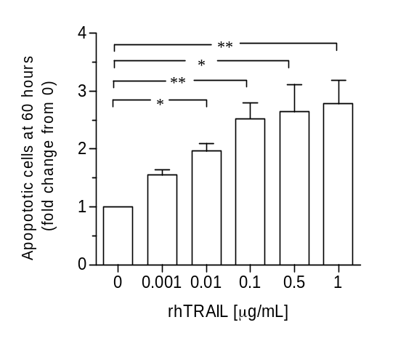
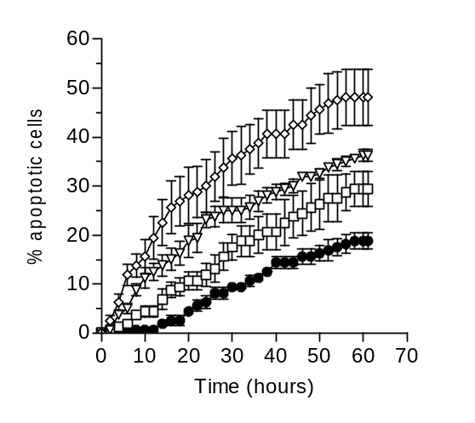
A
B

Figure 2

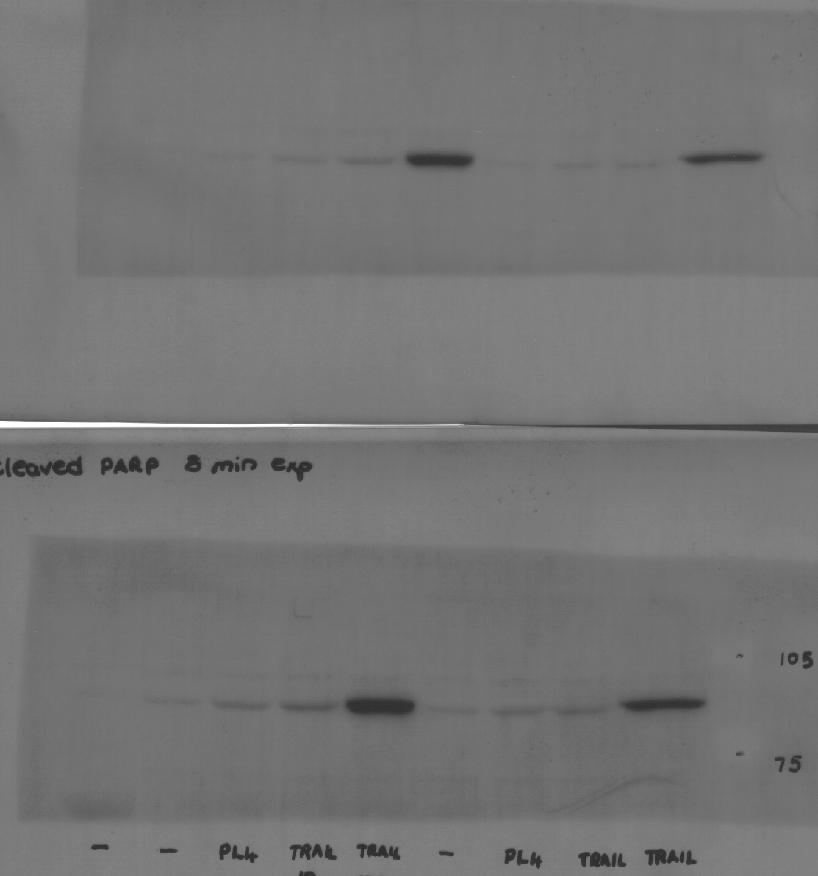
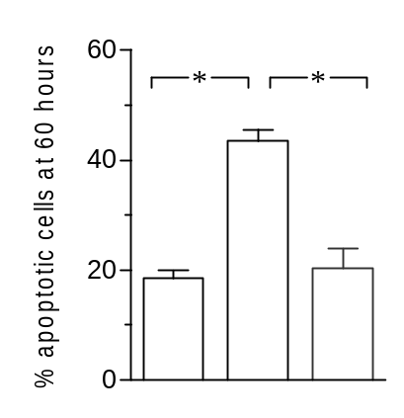
-
-
-
0.01
0.1
0.01
0.1
TRAIL
[μg/mL]
Time (h)
0
24
60
85 kDa •
A
– + + rhTRAIL
– – + zVAD-fmk
B
0
25
50
75
Density
(AU)
-
-
-
0.01
0.1
0.01
0.1
TRAIL
[μg/mL]
*
*
Time (h)
0
24
60

Figure 3

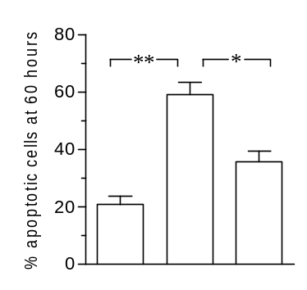
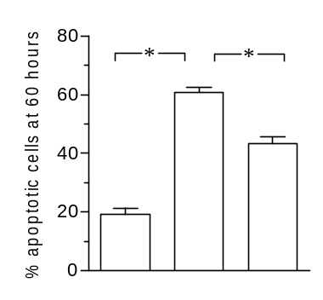
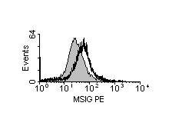
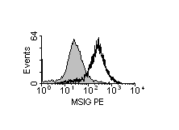
– + + rhTRAIL
– – + R1 blocking Ab
C
D
– + + rhTRAIL
– – + R2 blocking Ab
FL2 LOG
TRAIL-R1
A
FL2 LOG
TRAIL-R2
B
Figure 4

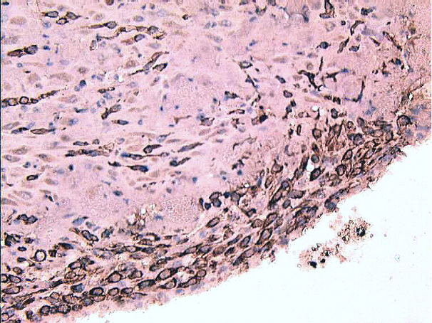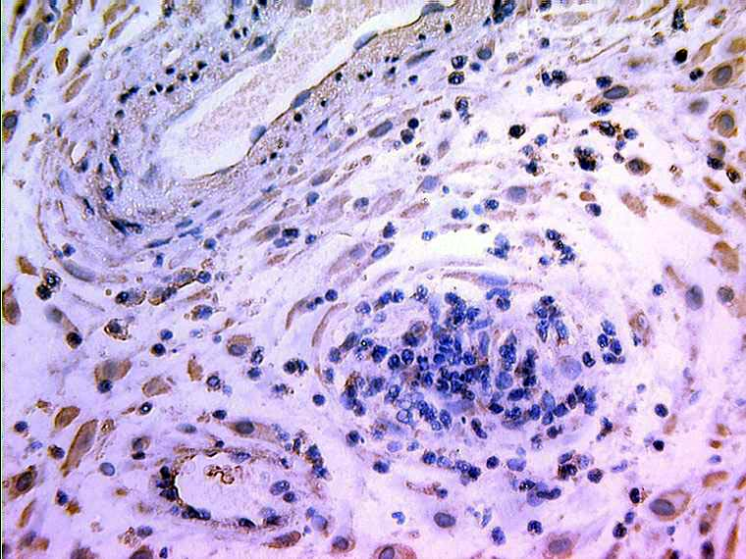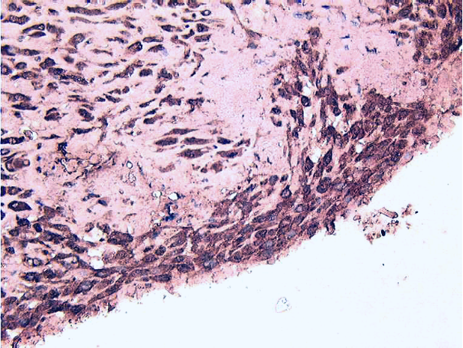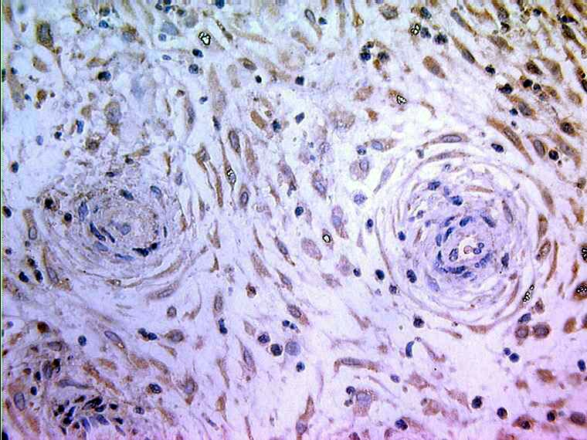
A
B
C
D

Figure 5

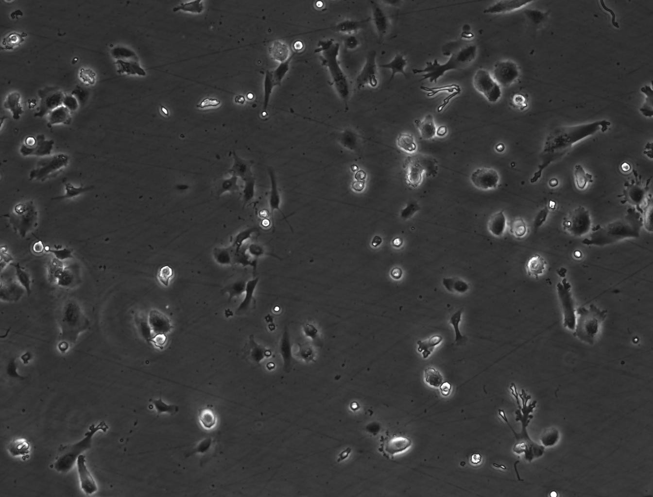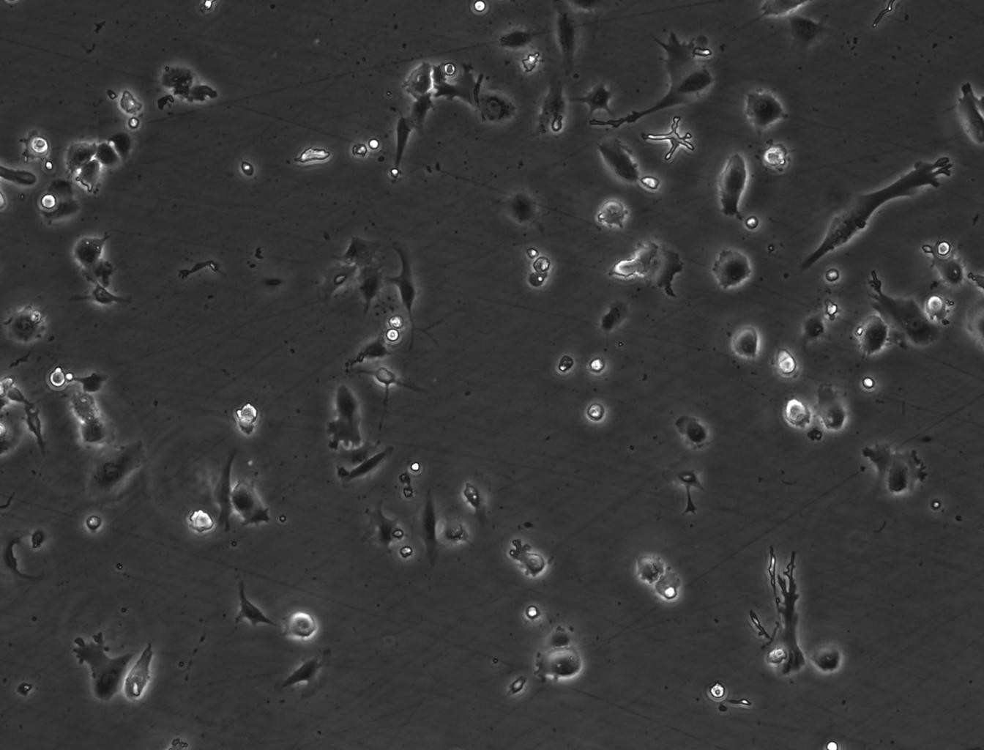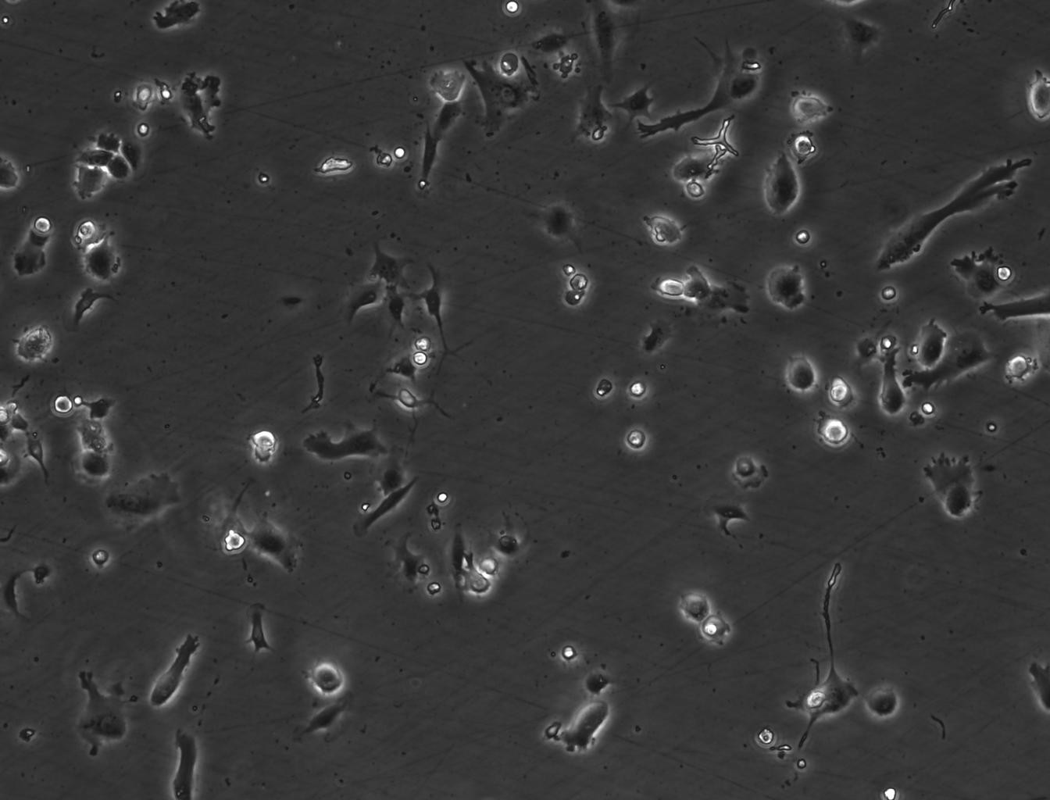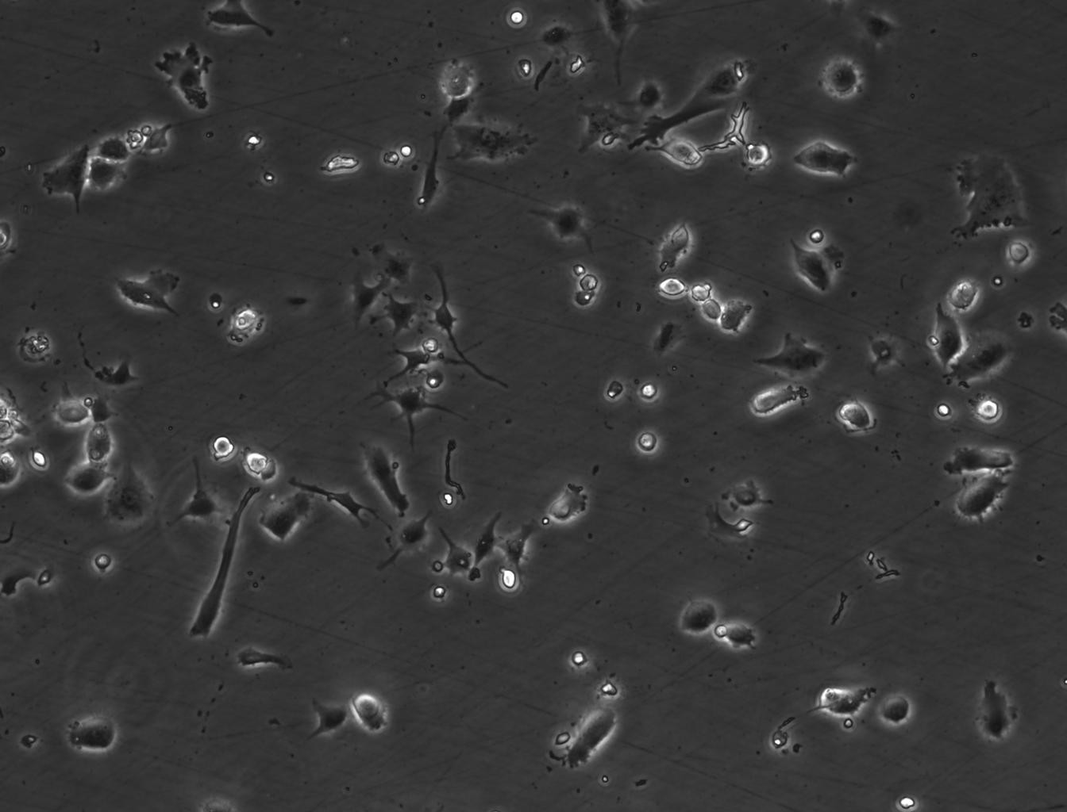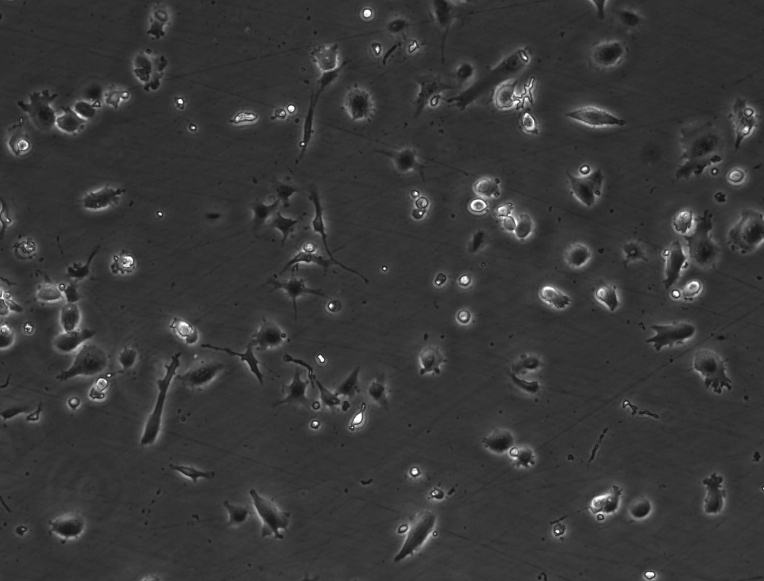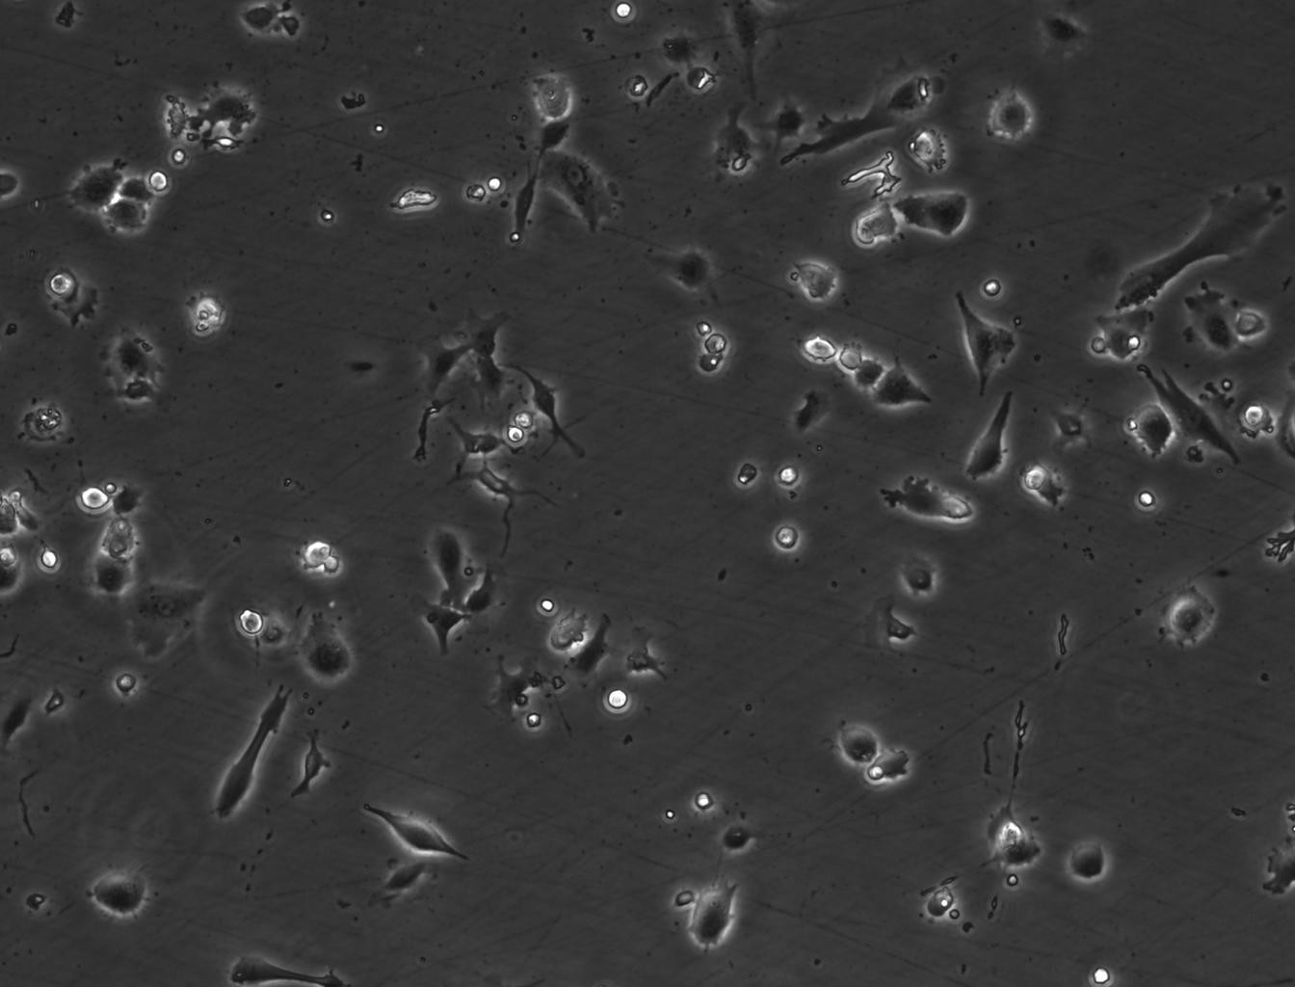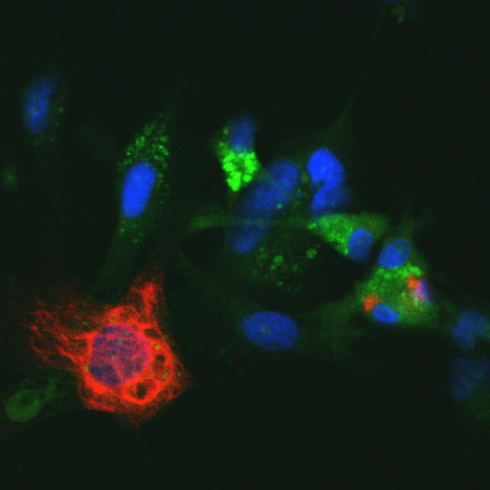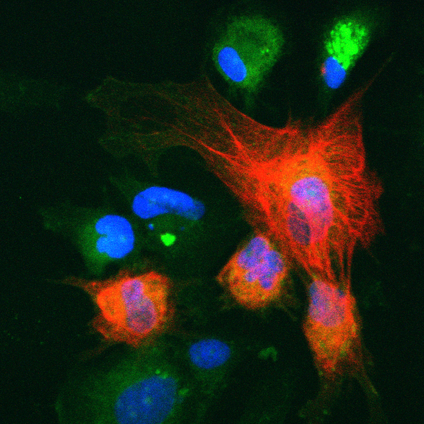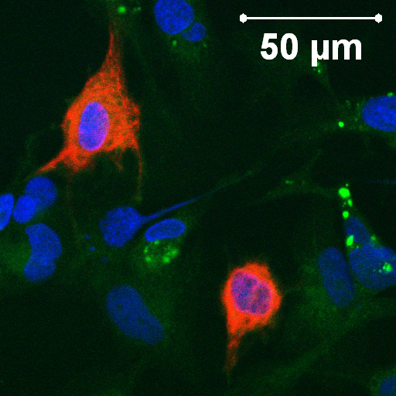
12 hours
A
SMC
CTB
9 hours
3 hours
0 hours →
C
B
E
D
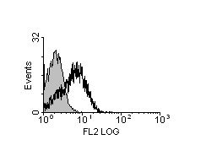
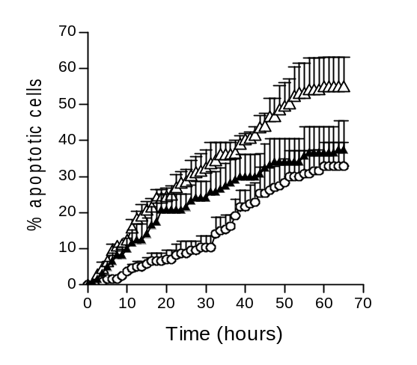
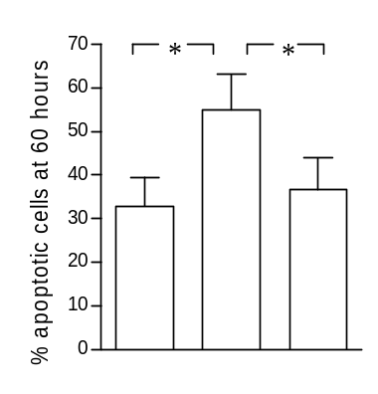
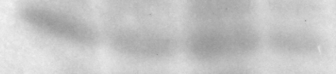
Figure 6
D
– + + Primary CTB
– – + TRAIL:R1:Fc
B
A
+ + + +
– – + +
26 kDa •
SMC
Time (h)
0
24
60
C
CTB

Figure 7

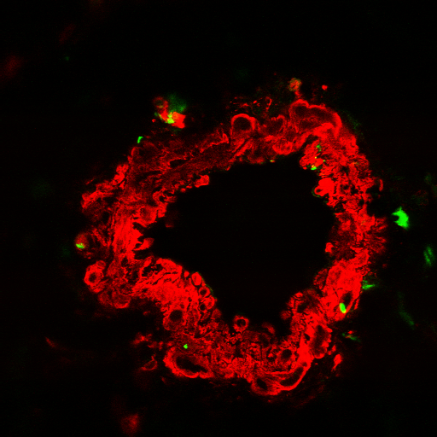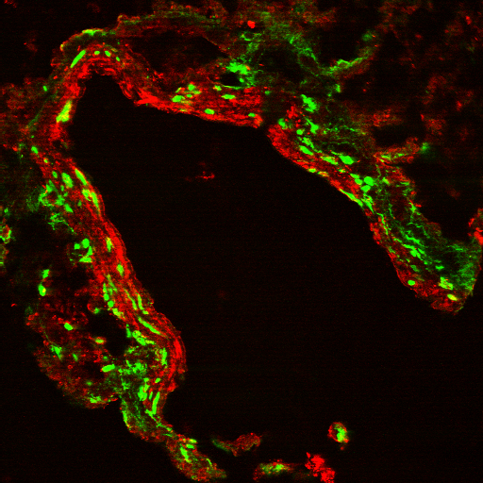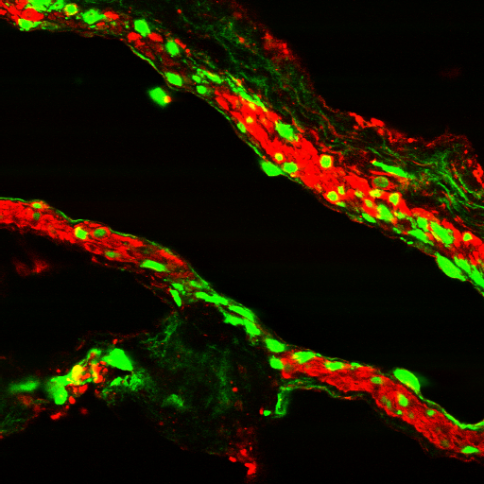
A
B
C

