The utility of information collected by occupational disease surveillance systems

Money, A, Carder, M, Hussey, L, & Agius R M
Centre for Occupational and Environmental Health, Centre for Epidemiology, Institute of Population Health, The University of Manchester

Abstract

Background: The Health and Occupation Research (THOR) network in the UK and the Republic of Ireland (ROI) is an integrated system of surveillance schemes collecting work-related ill-health (WRIH) data since 1989. In addition to providing information about disease incidence, trends in incidence and the identification of new hazards, THOR also operates an ‘ad-hoc’ data enquiry service enabling interested parties to request information about cases of WRIH reported to THOR.

Aims: To examine requests for information made to a network of surveillance schemes for WRIH in the UK.

Methods: Analysis via SPSS of data requests received to THOR between 2002 and 2014.

Results: 631 requests were received by THOR between 2002-2014. Requests were predominantly submitted by participating THOR physicians (34%) and the main THOR funder - the UK Health and Safety Executive (HSE) (31%). The majority (67%) of requests were for information about work-related respiratory or skin disease with relatively few requests for other diagnoses, such as musculoskeletal or mental ill-health. Requests frequently related to a specific industry and/or occupation (42%) and/or a specific causal agent (58%).

Conclusions: Data collected by occupational disease surveillance systems such as THOR are an extremely useful source of information, the use of which extends beyond informing government on disease incidence and trends in incidence. The data collected provide a framework which can assist a wide range of enquirers with clinical diagnoses, identification of suspected causative agents/exposures and to highlight growing risks in particular industrial and occupational sectors.

Key words: Surveillance; Work-related ill-health; utility; impact

Introduction
Most countries in the European Union (EU) have systems in place to monitor the occurrence of work-related ill-health (WRIH). [1] Such systems may have been established for compensation purposes and/or to provide information about disease incidence, trends in incidence or the identification of new hazards. However, many of these systems have been gathering data over several decades and are potentially valuable sources of WRIH information for purposes other than meeting these primary objectives.

One such system is The Health and Occupation Research (THOR) networks in the UK and (since 2005) the Republic of Ireland (ROI). THOR is an integrated system of surveillance schemes and is part of a suite of national statistics which has been collecting WRIH data since the establishment of the first (UK) scheme in 1989 [2, 3]. THOR is a non-mandatory, non-compensatory scheme in the UK and ROI with more than 1100 specialist physicians (including occupational physicians, respiratory physicians, dermatologists, general practitioners (GPs) and infectious disease specialists) currently voluntarily reporting cases of WRIH to THOR with approximately 200,000 cases reported during 2002-2014. Previous schemes have also included reports from psychiatrists, rheumatologists and audiologists. In addition to meeting the primary objective of providing information to the UK Health and Safety Executive (HSE) (and the Health and Safety Authority (HSA) in the ROI) on WRIH incidence and trends in incidence, THOR also operates an ‘ad-hoc’ data enquiry service enabling the HSE/HSA and other interested parties to request other information about the cases of WRIH reported to THOR.

This article aims to examine the information requests submitted to THOR between 2002-2014 and, in particular, to identify from whom requests were made, what specific information was asked for and where the information has been used. From this, the value of data collected by surveillance schemes such as THOR, for purposes other than informing on overall disease incidence and trends, can be assessed, thus helping to ensure that the data collected are relevant and useful to participants, funders and other interested parties.

Methods
THOR currently consists of five schemes in the UK. Chest physicians, dermatologists and consultants in communicable diseases can report to SWORD (Surveillance of Work-Related & Occupational Respiratory Disease) [4], EPIDERM (Occupational Skin Surveillance) [5], and SIDAW (Surveillance of Infectious Diseases at Work) [6], respectively, whilst occupational physicians can report any type of WRIH to OPRA (Occupational Physician Reporting Activity) [7]. Similarly, from 2005 GPs trained to diploma level in occupational medicine (DOccMed) have been able to report any case of WRIH to THOR-GP [8]. Analogous schemes for SWORD, EPIDERM, and OPRA also collect data in the ROI [9]. Further UK schemes (for which data collection has now ceased) included MOSS (Musculoskeletal Occupational Surveillance Scheme) [10] for rheumatologists, SOSMI (Surveillance of Occupational Stress and Mental Illness) [11] for psychiatrists and OSSA (Occupational Surveillance Scheme for Audiological Physicians) collecting data on work-related hearing loss and other audiological problems [12]. With respect to MOSS and SOSMI which stopped collecting data at the end of 2009 (funding ceased 2008), it was felt that THOR-GP data would furnish enough data on musculoskeletal and mental disorders for the HSE’s purposes.

Physicians participating in THOR are asked to report any new cases of WRIH seen within their reporting period that they believe to have been caused or aggravated by work. In addition to the diagnosis, physicians are asked to provide information about the age, gender, geographical region, occupation, industry, probable causal agent(s) and date of onset of symptoms associated with the case. GPs reporting to THOR-GP are also asked to provide information on sickness certification/fitness for work and any onward referral to other health practitioners [3].

Information requests are usually submitted to THOR in writing (letter or email) and the specifications of each request are recorded in an Excel spreadsheet by University of Manchester staff employed on the THOR project. Each request is given an identification number and the date received, title of the request, name and organisation of the enquirer, diagnostic category and any specific information regarding occupation, industry, suspected agent, mental event, task or movement is documented. Unless a particular time-frame or surveillance scheme is specified, the information provided in response to a request is usually derived from the last full ten calendar years of data and from each relevant scheme. However, in some instances, for example in response to an enquiry about a disease/exposure that is quite rare, data collected outside the ten year time-frame may be included. Requests are usually completed within a 2 week timeframe (the contractual limit is 3 weeks); however, last minute requests (for example, to answer parliamentary questions) are completed more quickly.

For this exercise, information requests for the period 2002-2014 were categorised by diagnosis, source of enquiry, type of request and presence/type of exposure. The data from the Excel spreadsheet was imported into SPSS (v20.0) and coded for the purpose of analysis.

Results
From 2002-2014, THOR received and answered 631 requests for information. The largest proportion of the requests submitted originated from the reporters to the scheme (34%) (i.e. specialist reporters such as dermatologists or chest physicians), followed by the HSE (31% - see case study 1 as an example request), requests from research institutions (24%), industry (6%), others (5%) and GPs (<1%). The origins of 5 requests were not recorded. Enquirers coded as ‘others’ include, for example, government bodies (other than HSE), journalists and members of the public.

<<box 1 here>>

The diagnostic category for which information was most frequently requested was respiratory disease (49% of total requests), followed by skin (18% see case study 2 as an example), with fewer requests for musculoskeletal (7%), infectious disease (6%), mental ill-health (5%), and audiological disease (2%). In some instances information on more than one diagnostic category was requested (for example a request for occupational respiratory and skin disease in hairdressers attributed to persulphate). A further 15% of enquiries requested information on all diagnostic categories reported to THOR. In contrast, the cases most frequently reported to THOR were work-related mental ill-health (34% of the 209,012 cases reported to THOR during 2002-2014) and musculoskeletal (27%) diagnoses (Figure 1).

<<figure 1 here>>

The majority of data requests were for information on a specific combination of disease, exposure and/or employment/industry sector. Of the 631 information requests received during 2002-2014, 27% were for disease and exposure, 26% were for disease and employment and 17% were for a specific disease alone. This was followed by requests categorised as exposure only (9%), ‘other’ (9%), employment only (8%), disease, exposure and employment (4%) and exposure and employment (1%). Table 1 provides examples of the different types of requests that have been received. During 2002-2014, data on disease and exposure and disease and employment were requested most frequently by all enquirer groups.

<<Table 1 here>>

Of the 631 information requests received, 266 (42%) specified an occupation or industry of interest. Of these, 22% requested information on a specific occupational group, and 20% requested information on a specific industry sector. For example, healthcare (12%), construction (10%), agriculture (7%) and personal service activities, which include hairdressing and beauty, (6%), were the most frequently requested industry sectors and hairdressers and beauticians (11%), welders (6%) and medical practitioners (6%) were the most frequently requested occupations.

Over half of all information requests (58%) received by THOR specified an interest in a suspected causative chemical agent or exposure, musculoskeletal task/movement or mental health precipitating event. Information on work-related respiratory or skin diseases attributed to a particular chemical agent/exposure (e.g. occupational asthma attributed to chlorine) was requested most frequently (80% of specified requests: most frequently isocyanates, oils, latex and rubber). This was followed by requests specifying an infectious agent (6%), (e.g. cases of brucellosis), specific musculoskeletal tasks and movements (5%) (e.g. upper limb repetitive strain injury in cooks), and smaller proportions of requests for mental health events (3%) (e.g. interpersonal difficulties with colleagues/management/clients) and noise (1%).

<<box 2 here>>

Discussion
Over 600 requests for information were submitted to THOR between 2002 and 2014. Requests predominantly arose from physicians participating in THOR (34%) and the (UK) THOR main funder, HSE (31%) with a further third of requests arising from other sources including industry and research institutions. The majority (67%) of the requests were for information about work-related respiratory or skin disease with relatively few requests for other diagnoses, such as musculoskeletal or mental ill-health. Requests frequently related to a specific industry and/or occupation (42%) and/or a specific causal agent (58%).

It is perhaps unsurprising that the HSE and the physicians participating in THOR were responsible for the majority of the requests for information, given their close association with the scheme. However it is notable that a sizeable proportion of the information requests came from more ‘external’ sources. This suggests that the value of data collected by occupational disease surveillance systems such as THOR extends beyond the immediate circle of funders and participating physicians. Of note, of the different physician groups participating in THOR, only one request arose from a GP. This may in part reflect the relative newness of THOR-GP (established in 2005) compared to the other, more long-standing schemes, it may also reflect the fact that GPs generally have less time to pursue research interests or happen upon an unusual exposure. However, in excess of 6,500 cases have now been reported to THOR-GP, therefore the scheme is in an excellent position to provide information on WRIH seen in general practice (including information on associated sickness absence and fit note adaptations, and onward patient referral).

Although requests were made for information on all the main diagnostic categories reported to THOR (respiratory, skin, musculoskeletal, mental ill-health, audiological and infectious disease), requests for skin, and in particular, respiratory disease predominated, with the latter being the most frequently requested diagnostic category amongst all groups of enquirers. This is in contrast to the proportion of cases reported to THOR, whereby work-related mental ill-health and musculoskeletal disease are the most frequently reported [7, 8]. The predominance of respiratory and skin information requests, particularly from the HSE, highlights the tendency for governments and other bodies to focus on chemical agents and exposure, rather than other areas such as mental ill-health. This is illustrated in the UK by numerous HSE led campaigns focusing on skin and respiratory diseases such as respiratory priority areas [15], occupational cancer exposure [16] and ‘bad hand day’ [17] compared to relatively few focusing on mental ill-health such as ‘stress’ [18]. In fact, the HSE have only submitted one data request concerning mental ill-health in the last ten years (the majority of mental ill-health requests came from research organisations and occupational physicians). This pattern might be due to skin and respiratory disease being relatively easier to attribute to a patients’ occupational exposure or that the regulations for exposure levels are more clearly regulated via workplace exposure limits [19] or national guidelines such as Control of Substances Hazardous to Health (COSHH) [20]. Occupational mental ill-health on the other hand, particularly ‘work stress’, (which is responsible for the largest proportion of working days lost) [13] has not been made statutorily reportable to the HSE or other regulatory bodies, and is often multifactorial in nature, thereby more difficult to confidently attribute to work [21].

Despite the large number of data requests made to THOR, it can be difficult to assess the enquirers’ motivation for making the enquiry (whether this be a diagnostic category, occupation/industry or suspected agent). Many requests from physicians are likely to originate from the physician encountering an unusual combination of disease, agent, occupation or industry during their clinical practice and seeking clarification as to whether fellow physicians have encountered patients in similar circumstances, these are routinely answered within a 2 week timeframe unless a speedier response is required by the clinician. However, other requests are the result of discussions originating from online forums/message boards on websites such as ANHOPS (Association of National Health Occupation Physicians) [22] or forwarded by reporting physicians who have been consulted by external parties for advice (for example, the Department for Work and Pensions).

Regarding government bodies such as the HSE in the UK, the value and potential impact of information provided by occupational disease surveillance systems such as THOR is illustrated by the numerous outputs based on THOR data. A search for THOR on the HSE’s website resulted in 439 returns [23], the majority of which were research reports and summaries of statistics and disease conditions. A similar search for references to THOR used in parliamentary papers resulted in 35 returns [24] including evidence and reports to particular committees in the House of Lords (e.g. Workplace Health and Safety) and evidence presented to commons debate sessions. This not only shows the various ways the data collected by surveillance systems such as THOR can be used but also the importance of the data collected in influencing policy at a government level.

In conclusion, data collected by occupational disease surveillance systems such as THOR are an extremely useful source of information, the use of which extends beyond informing government on disease incidence and trends in incidence. The data collected provide a framework which can assist a wide range of enquirers with clinical diagnoses, the identification of suspected causative agents/exposures and highlight growing risks in particular industrial and occupational sectors. In addition, data produced by systems such as THOR have many positive implications beyond those already outlined, including for example, investigating the impact and efficacy of legislation and interventions by comparing incidence data [25-27]. Future work (within THOR) aims to improve the value/usability of the collected data further by developing a web based visualisation tool enabling users to interrogate the data themselves, while respecting limitations such as those necessary to ensure non-identifiability of the cases.

Funding
THOR and THOR-GP are partly funded by the Health and Safety Executive in the UK and the Health and Safety Agency in the Republic of Ireland, as well as from charitable donations. This paper expresses the views of the authors and not necessarily the funding bodies.

Ethics
Multicentre Research Ethics Committee approval has been granted to THOR (MREC 02/8/72).

Acknowledgements
The authors would like to thank all the physicians who participate and report to THOR and THOR-GP.

References

1. European Commission. Report on the current situation in relation to occupational diseases' systems in EU Member States and EFTA/EEA countries, in particular relative to Commission Recommendation 2003/670/EC concerning the European Schedule of Occupational Diseases and gathering of data on relevant related aspects. Published May 2012. Available at: http://ec.europa.eu/social/BlobServlet?docId=9982&langId=en (last accessed December 2014)

2. The Health & Occupation Research network. The University of Manchester Last accessed February 2015
http://www.population-health.manchester.ac.uk/epidemiology/COEH/research/thor/

3. List of National Statistics sources, UK Statistics Authority. Last accessed February 2015 http://www.statisticsauthority.gov.uk/national-statistician/types-of-official-statistics/list-of-national-statistics/index.html

4. Meredith SK, Taylor VM, McDonald JC. Occupational respiratory disease in the United Kingdom 1989: a report to the British Thoracic Society and the Society of Occupational Medicine by the SWORD project group. Br J Ind Med 1991; 48:292–8.

5. Turner S, Carder M, van Tongeren M et al. The incidence of occupational skin disease as reported to The Health and Occupation Reporting (THOR) network between 2002 and 2005. Br J Dermatol (2007) 157, 713-722.

6. Turner, S, Lines, S, Chen, Y, Hussey, L and Agius, R Work-related infectious disease reported to the Occupational Disease Intelligence Network and The Health and Occupation Reporting network in the UK (2000–2003). Occup Med 2005 55 p.275-281

7. Cherry NM, Meyer JD, Holt DH et al. Surveillance of work-related diseases by occupational physicians 1996–1999. Occup Med 2000; 50:496–503.

8. Hussey L, Turner S, Thorley K, Mcnamee R, Agius R. Work-related ill-health in general practice, as reported to a UK-wide surveillance scheme. Br J Gen Pract (2008) 58, 637-640.

9. Money, A, Carder, M, Noone, P, Bourke, J, Hayes, J, Turner, S and Agius, R Work-related ill-health: Republic of Ireland, Northern Ireland, Great Britain 2005–2012 Occup Med 2015;65:15–21

10. Slovak A, Carder M, Money A, Turner S, Agius R. Work-related musculoskeletal conditions: evidence from the THOR reporting system 2002-2005. Occup Med (2009) 59, 447-453.

11. Carder M, Turner S, McNamee R, Agius R. Work-related mental ill-health and ‘stress’ in the UK (2002-2005). Occup Med (2009) 59, 539-544.

12. Money A, Carder M, Turner S, Agius R. Incidence of work-related occupational hearing loss in the UK: OSSA. Occup Med (2011) 61(4), 226-233.

13. Hussey L, Turner S, Thorley K, McNamee R, Agius. Work-related sickness absence as reported by UK general practitioners. Occup Med 2012 62(2): p.105-11.

14. McNamee, R., Chen, Y., Hussey, L. & Agius, R Time-sampled versus continuous-time reporting for measuring incidence. (2010). Epidemiology, 21(3), 376.

15. Respiratory priority areas, Health and Safety Executive, Last accessed February 2015 http://www.hse.gov.uk/aboutus/occupational-disease/respiratory-priority-areas.htm

16. Occupational Cancer and Exposure, Health and Safety Executive, Last accessed February 2015 http://www.hse.gov.uk/aboutus/occupational-disease/occupational-cancer.htm

17. Health and Safety Executive ‘Bad Hand Day’ campaign http://www.hse.gov.uk/hairdressing/bad-hand.htm Last accessed February 2015

18. Health and Safety Executive Focus on Stress http://www.hse.gov.uk/STRESS/index.htm Last accessed March 2015

19. Workplace Exposure Limits, Health and Safety Executive, Last accessed February 2015 http://www.hse.gov.uk/Toolbox/harmful/exposure.htm

20. Control of Substances Hazardous to Health (COSHH), Health and Safety Executive. Last accessed February 2015. http://www.hse.gov.uk/coshh/

21. A cluster of occupational mental illness in an NHS trust. Poole, CJM & Basheer, S, 2007. Clin Med 7:362-4

22. Association of National Health Occupational Physicians (ANHOPS) http://www.anhops.com/ Last accessed February 2015

23. Health and Safety Executive – Search for ‘THOR’ results; last accessed February 2015 http://www.hse.gov.uk/search/search-results.htm?q=THOR#gsc.tab=0&gsc.q=THOR&gsc.page=1

24. UK Parliament website – search for ‘THOR’ results; Last accessed February 2015 2014 http://www.parliament.uk/search/results/?q=THOR&page=0

25. Stocks JS, McNamee R, Turner S, Carder M, Agius R. Has European Union legislation to reduce exposure to chromate in cement been effective in reducing the incidence of allergic contact dermatitis attributed to chromate in the UK? Occup Environ Med (2012) 69, 150-152.

26. Stocks JS, McNamee R, Turner S, Carder M, Agius R. Assessing the impact of national level interventions on workplace respiratory disease in the UK: part 1 – changes in workplace exposure legislation and market forces. Occup Environ Med (2013) 70, 476-482.

27. Stocks JS, McNamee R, Turner S, Carder M, Agius R. Assessing the impact of national level interventions on workplace respiratory disease in the UK: part 2 – regulatory activity by the Health and Safety Executive. Occup Environ Med (2013) 70, 483-490

Table 1. Examples of request types received.

TYPE OF REQUEST | EXAMPLE
Disease only | Information requests specifying a particular disease only, e.g. work-related epicondylitis
Exposure only | Information requests specifying a particular exposure only, e.g. work-related ill-health due to aluminium sulphate.
Employment only | Information requests specifying a particular occupation and/or industry only, e.g. occupational ill-health in the railway sector.
Disease and exposure | Information requests specifying both disease and exposure in combination, e.g. skin cancer and exposure to cutting oil.
Disease and employment | Information requests specifying both disease and employment in combination, e.g. hepatitis B in prison officers.
Exposure and employment | Information requests specifying both exposure and employment, e.g. isocyanate exposure in the polyurethane industry.
Disease, exposure and employment | Information requests specifying a combination of particular disease, exposure and employment, e.g. respiratory disease in welders using oxyacetylene torches.
Other | Information requests not specifically relating to disease, exposure and/or employment. This includes requests for specific regions, e.g. work-related ill-health in Hull or ‘other’, e.g. mortality data in THOR.

Box 1. Case study 1, request received from Health and Safety Executive
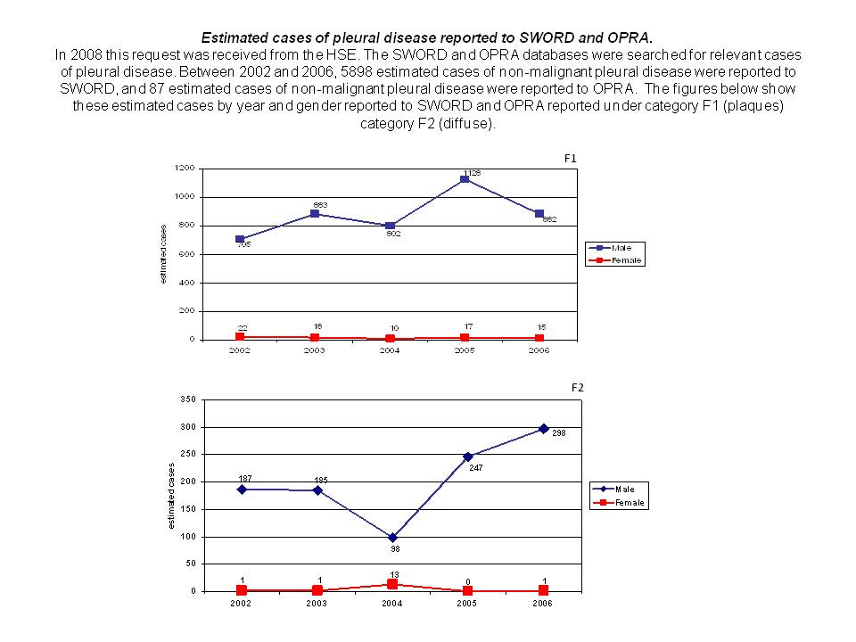

Box 2. Case study 2, skin data request example

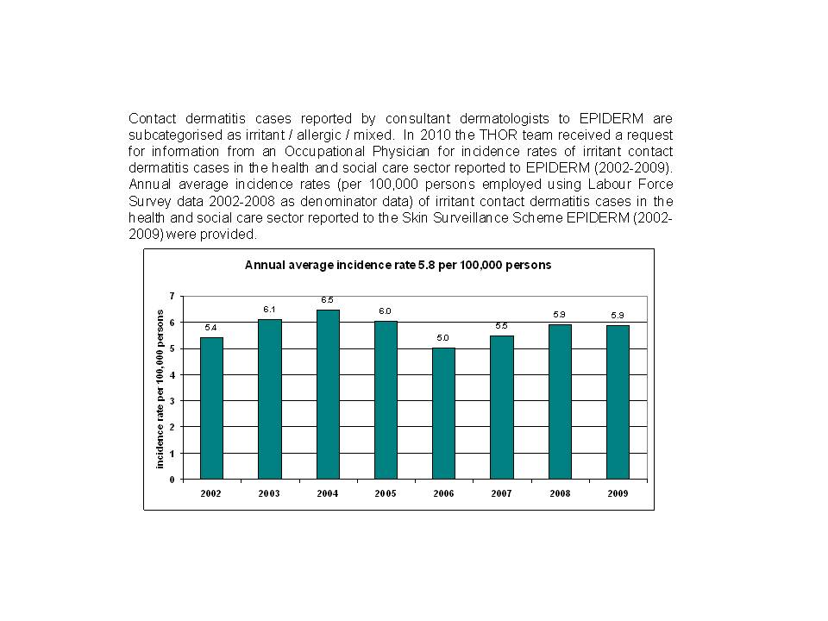

Figure 1. Proportion of information requests received versus proportion of cases reported to THOR by diagnostic category (2002-2014).

