Working Document for the ICES WGCEPH Subgroup Meeting on Cephalopod Fisheries and Life History. Vigo, Spain 27-30 April 2009.

Analysis of cephalopods’ abundance indices in the Southwest Atlantic fisheries. 2003-2008

Vilela R. and Portela J.

Instituto Español de Oceanografía
Centro Oceanográfico de Vigo,
Cabo Estay‐Canido. 36200 Vigo, Spain
raul.vilela@vi.ieo.es

Introduction

In the fishing grounds of the Patagonian Shelf occur some of the most important fisheries in the world, being two cephalopod species (Illex argentinus and Loligo gahi) among the main target ones for international fishing fleets. The higher concentrations of marine resources are found between 35º and 54º S and are associated with the Subtropical Convergence formed by the Brazil and the Falkland (Malvinas) currents. The mixing of the flow of La Plata River and the western branch of the Falkland (Malvinas) Current generates areas of high plankton production on the shelf.

The fishery for cephalopods in the Southwest Atlantic waters comprises two main target species: the shortfin squid Illex argentinus (Castellanos, 1960) (Cephalopoda: Ommastrephidae) and the Patagonian longfin squid Loligo gahi (Cephalopoda: loliginidae).

In 1988, the Long-Distance Fisheries Programme (LDFP) of Instituto Español de Oceanografía (IEO) based on its Oceanographic Centre in Vigo (IEO-COV) started the study of the fishing activities carried out by the Spanish bottom trawl fishing fleet in the Southwest Atlantic, setting in motion the Project for the Study of the Fisheries in the Southwest Atlantic (currently called ATLANTIS Project). In 1989 a Programme of Scientific Observers onboard commercial fishing vessels for collection of scientific and commercial data and monitoring of fishing activities, was implemented.

This working document presents a brief analysis of the spatio-temporal variability of abundance indices of cephalopods taken through the observers’ program of the IEO in the Southwest Atlantic between 2003 and 2008 paying particular attention to the High Seas (HS) area (Figure 1).

Shortfin squid occurs in waters of the Patagonian shelf from the coast of Brazil until Falkland (Malvinas) waters along the shelf and slope within a latitudinal range from 22º to 54ºS. Its distribution is closely linked to the influence area of the temperate-cold waters of subantartic origin, undertaking long-distance migrations during the austral summer-autumn south of 45ºS, finishing its spawning migration northwards to the nursery grounds South of Brazil by July-August (austral winter).

Longfin squid is a well studied neritic species that makes relatively short ontogenetic migrations. Loligo gahi is an important resource to the Falklands (Malvinas), were most of the catches are taken south of the islands. Two cohorts of Loligo recruit to the fishery around South and East of the Falkland (Malvinas) Islands, the first during austral summer-autumn and the second in winter-spring. Within the Falkland/Malvinas waters, the fishery is restricted to a prescribed area – the ‘‘Loligo box’’.

Methodology

The IEO Programme of Scientific Observers onboard commercial vessels have been compiling scientific and commercial data in a haul by haul basis, in close collaboration with the Spanish fishing industry since 1989. For each haul observers collected data related to catches and discards by species, fishing activities details (gear characteristics, haul length and location, depth etc.), environmental data, and finally, biological data of the main commercial species such as size, weight, sex, maturity state and stomach content.Data is integrated into a database and subsequently analysed at the IEO.

For this study abundance indices for Illex and Loligo were extracted from the database by means of monthly mean Catch per Unit Effort (CPUE) from 2003 to 2008 and grouped by semester.

The study area was also divided in three different subareas in accordance with the distribution of Illex argentinus andLoligo gahi (Figure 2):

High Seas (Illex and Loligo): This includes the waters situated off the Argentinean Economic Exclusive Zone (EEZ) and north of the Falkland (Malvinas) Islands until the depth limit of the commercial fishing activity (around 300 m depth). This area shows presence of both cephalopods species.

Falklands (Malvinas) north (Illex): Region of the Falkland (Malvinas) waters north of parallel 52ºS. This is the area were Illex argentinus distributes within the Falklands (Malvinas) waters and comprises the northern part of the FICZ (Falklands Interim Conservation Zone) and FOCZ (Falklands Outer Conservation Zone).

Falkland (Malvinas) south (Loligo): This region refers to the ‘Loligo-box’ area south of the FICZ, within the following limits: south of parallel 52ºS, and between meridians 58º30’ W and 61ºW.

Results and Discussion

Mean CPUE by species, semester and zone (2003-2008):

Loligo

For the period 2003-2008, Loligo gahi mean CPUE data in the Falklands (Malvinas) Southern area (the “Loligo box”) resulted very sparse since the licence system made difficult the acquisition of data from this area. It was only available for the first half of the year in 2003 and for the second half of the years 2004, 2007 and 2008, making difficult interannual comparisons for the whole period. Tabular data is shown in Table I, graphical data in Figure 3a and map representation in Figure 4.
However undoubtedly, mean CPUE recorded during the first half of 2003 in this zone was the higher of the entire dataset (Figure 3a) reaching a monthly CPUE peak up to 4 t/h in May 2003.

Conversely, Loligo gahi mean CPUE data within the High Seas (HS) waters presented no lacks during the entire period showing a slightly higher mean CPUE during the second half of the year (42 kg/h) than during the first half (36 kg/h) for the entire period 2003-2008 (Table I, Figure 3c and Figure 4).

Illex

In the other hand, a high seasonality was observed for Illex argentinus in both, Falklands/Malvinas (F/M) and HS waters, showing higher values during the first half of the year in both areas.

While mean CPUE values for the period 2003-2008 during the first half of the year reached 467 kg/h and 543 kg/h in F/M and HS waters respectively, results for the second half of the year can be almost assumed as null values (only 1 kg/h for F/M area and 9 kg/h for HS area) (Table I, Figures 3b and 3d and Figure 4).

Annual trends of the mean CPUE by semester and zone (2003-2008):

Since Loligo gahi data in F/M area should be carefully managed due to the lack of data for the first half of the year, trend of Loligo gahi mean CPUE during the second half of the year seems to be fairly related to the one in HS waters for the same semester (Table II and Figures 5a, 5b, 5c and 5d).

For Illex argentinus a general increasing trend can be observed in both areas for the first half of the year through the 2003-2008 period. A marked seasonality is observed in both areas; being this species almost absent from the fishery in the second half of the year (keep in mind the different scale of the Y axis for each graphic), (Table II and Figures 6a, 6b, 6c and 6d).

Figures and Tables
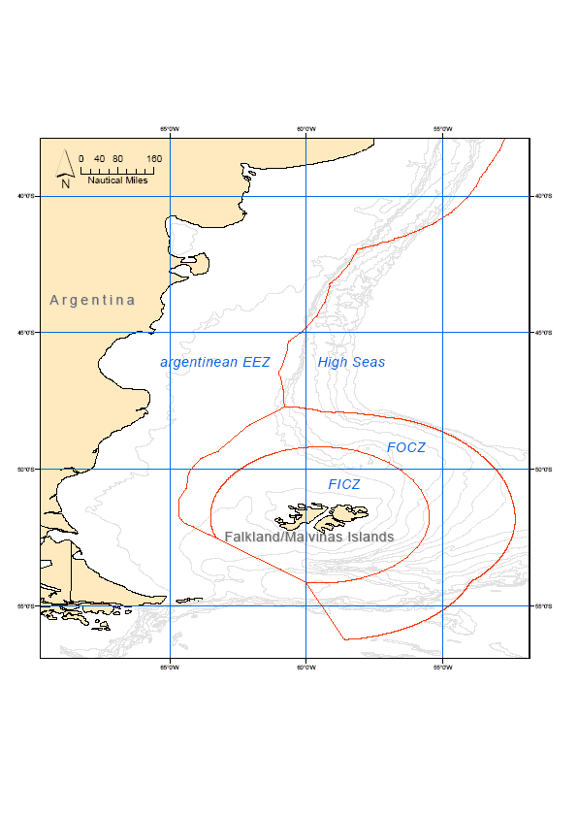
Figure 1. Southwest Atlantic Fisheries. Overview of the study area

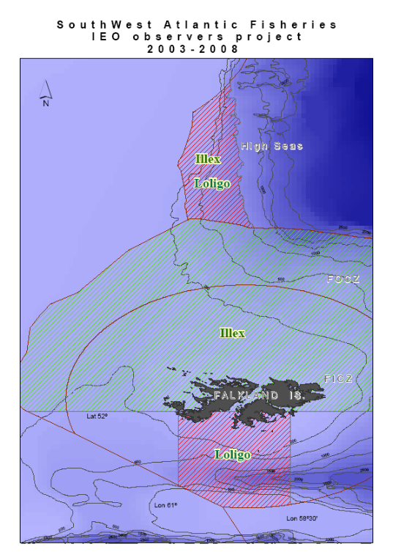
Figure 2. Cephalopods fisheries in Southwest Atlantic waters, highlighting areas of higher Illex and Loligo density.

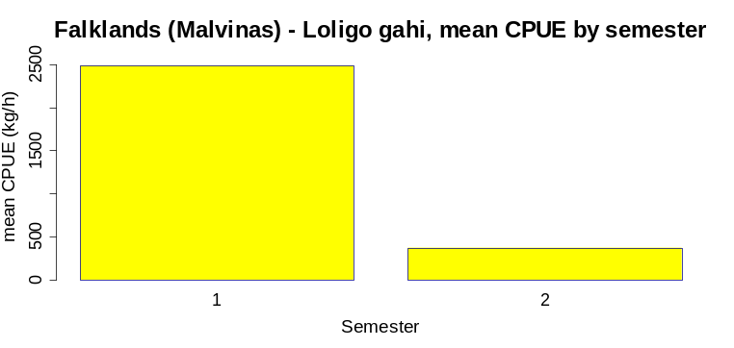
Figure 3a: Average 2003-2008 Loligo CPUE in southern Falklands waters for both semesters. Note different y axis scale than in the rest of Figure 3 graphics

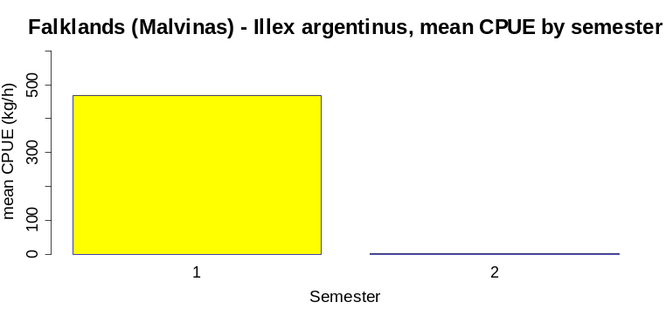
Figure 3b: Average 2003-2008 Illex CPUE in northern Falklands waters for both semesters.

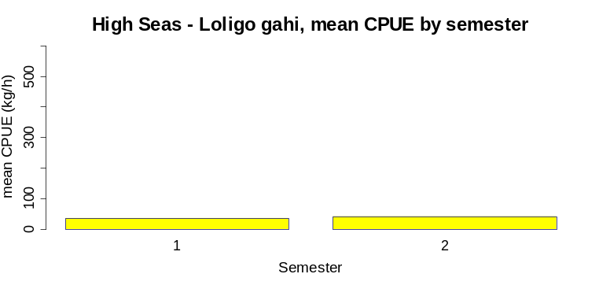
Figure 3c: Average 2003-2008 Loligo CPUE in HS waters for both semesters.

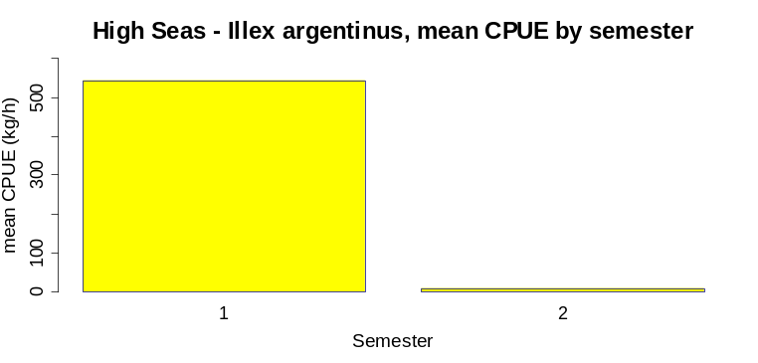
Figure 3d: Average 2003-2008 Illex CPUE in HS waters for both semesters.

Figure 3. Average 2003-2008 CPUE (kg/h) for both, Loligo gahi and Illex argentinus species, by semester and area.

Table I: 2003-2008 mean CPUE (kg/h) of Illex argentinus and Loligo gahi by area (Falklands/Malvinas: F/M and High Seas: HS) and semester.

Area | Species | 1st half | 2nd half
F/M | Loligo | 2487 | 368
 | Illex | 467 | 1
HS | Loligo | 36 | 42
 | Illex | 543 | 9

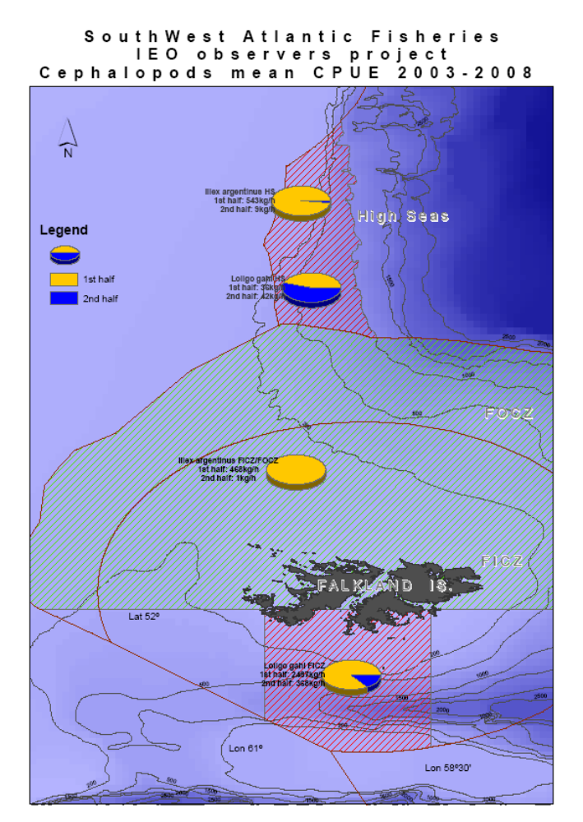
Figure 4: Map representation of the 2003-2008 mean CPUE (kg/h) of Illex argentinus and Loligo gahi by area and semester

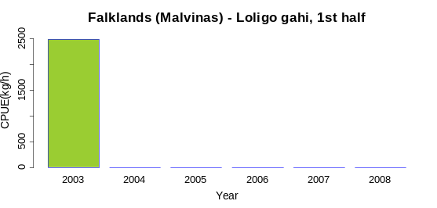 | 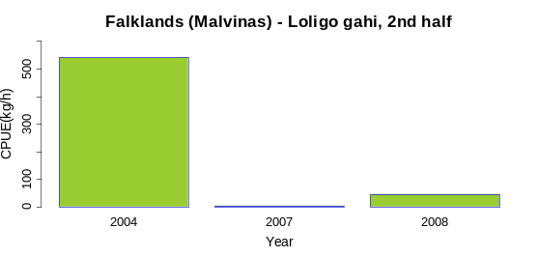
Fig 5a. Loligo 1st half, F/M waters.  Only data from 2003 is available. | Fig 5b. Loligo 2nd half, F/M waters
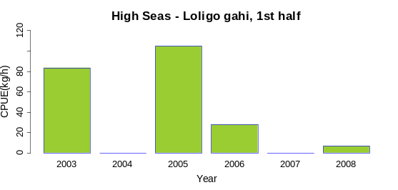 | 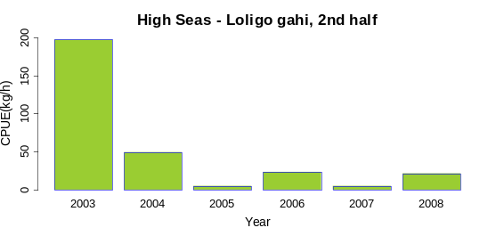
Fig 5c. Loligo, 1st half, HS waters | Fig 5d. Loligo 2nd half, HS waters
Figure 5: 2003-2008 annual mean CPUE (kg/h) of Loligo gahi by semester in the Falklands/Malvinas Southern area and high Seas

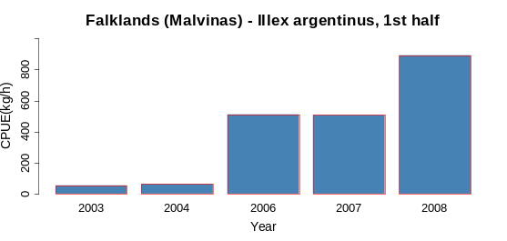 | 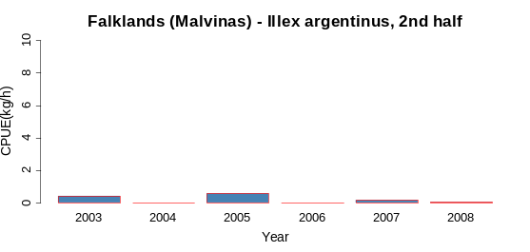
Fig 6a. Illex 1st half, F/M waters. | Fig 6b. Illex 2nd half, F/M waters.  Note different y axis scale
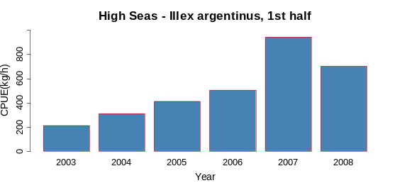 | 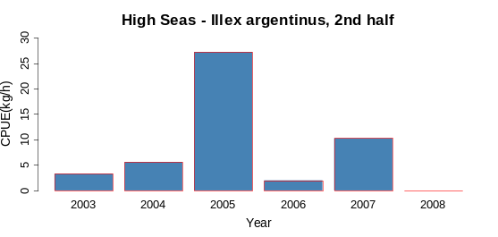
Fig 6c. Illex, 1st half, HS waters | Fig 6d. Illex, 2nd half, HS waters.  Note different y axis scale

Figure 6. 2003-2008 annual mean CPUE (kg/h) of Loligo gahi by semester in the Falklands/Malvinas Northern area and High Seas.

Table II: 2003-2008 annual mean CPUE (kg/h) of Loligo gahi and Illex argentinus by area (Falklands/Malvinas: F/M and High Seas: HS) and semester.

Species | area | Year | 1st half | 2nd half
 |  | 2003 | 2487 | -
 |  | 2004 | - | 541
 | F/M | 2005 | - | -
 |  | 2006 | - | -
 |  | 2007 | - | 3
 |  | 2008 | - | 45
Loligo
 |  | 2003 | 83 | 197
 |  | 2004 | 0 | 50
 | HS | 2005 | 105 | 5
 |  | 2006 | 28 | 23
 |  | 2007 | 0 | 5
 |  | 2008 | 7 | 21
 |  | 2003 | 54 | 1
 |  | 2004 | 62 | 0
 | F/M | 2005 | - | 1
 |  | 2006 | 511 | 0
 |  | 2007 | 509 | 1
 |  | 2008 | 894 | 0
Illex
 |  | 2003 | 212 | 3
 |  | 2004 | 311 | 6
 | HS | 2005 | 413 | 27
 |  | 2006 | 505 | 2
 |  | 2007 | 942 | 10
 |  | 2008 | 702 | 0

