

Hirschprung disease
Author(s)
Belo-Oliveira Pedro, Rodrigues Henrique, Belo-Soares Pedro

Patient
male, 12 year(s)

Clinical Summary
A 12-year-old boy presented with chronic constipation and abdominal distension.

Clinical History and Imaging Procedures
A 12-year-old boy presented with chronic constipation and abdominal distension. The passage of flatus and stool required great effort and the stools were small in caliber. The small bowel follow-through showed a separation of the small bowel loops at the hypogastrum. The delayed abdominal radiographs which were obtained, demonstrated the persistence of contrast in the colon. The barium enema, which was done showed that the distal segment of the rectum was narrowed compared to the dilated proximal bowel. These radiographic and clinical findings were suggestive of Hirschprung disease. A rectal biopsy was made and the diagnosis was that of an aganglionic megacolon.

Discussion
Hirschprung disease occurs due to a failure in the cephalocaudal migration of the parasympathetic myenteric nerve cells into the distal bowel. Therefore, the absence of ganglion cells always begins at the anus and extends to a varying distance proximally. The diseased part of the bowel is frequently narrowed or slightly diminished in caliber, and demonstrates an incomplete or an inadequate peristaltic activity. This part of the bowel is resistant to fecal passage and impedes spontaneous bowel evacuation. The normal proximal bowel progressively dilates and undergoes muscular hypertrophy. The point at which the bowel changes from a normal one containing ganglion cells to one not containing ganglion cells is usually abrupt. Males are affected five times more often than females. The long-segment disease is somewhat different since it manifests a definite familial incidence and a more equal sex ratio. The characteristic radiographic feature of Hirschprung disease is the presence of a narrow aganglionic distal segment followed proximally by a dilated colon. This disease may be suspected when abnormal contractions or abnormal peristaltic activity are observed in the distal colon. These appear as serrations or thumbprint contractions. The retention of barium within the proximal ganglionic colon on delayed abdominal radiographs, exposed 24 h after the original study, is another important diagnostic feature.

Final Diagnosis
Hirschprung disease.

References
- [1]
Mindelzum RE, Hicks SM Adult Hirschprung disease: radiographic findings Radiology. 1986 Sep; 160 (3): 623-625

- [2]
Erwin CR, Warner BW Hirschprung lost his nerve Gastroenterology. 2003 Dec; 125 (6): 1900-1902

Citation
Belo-Oliveira Pedro, Rodrigues Henrique, Belo-Soares Pedro (2005, Jul 13).
Hirschprung disease, {Online}.
URL: http://www.eurorad.org/case.php?id=3071
DOI: 10.1594/EURORAD/CASE.3071
To top

- Published 13.07.2005
- DOI 10.1594/EURORAD/CASE.3071
- Section Gastro-Intestinal Imaging
- Case-Type Clinical Case
- Difficulty Student
- Views 41
- Language(s)
- Figure 1
A small bowel follow-through
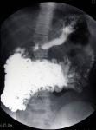
The image of a small bowel follow-through showing a separation of the bowel loops at the hypogastrum (indicated by an arrow).

- Figure 2
A delayed film
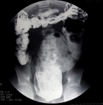
A delayed film taken 24 h after the small bowel follow-through showing the retention of barium.

- Figure 3
Barium enema
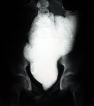
The image of a barium enema showing that the distal segment of the rectum is narrowed compared to the dilated proximal rectum and the sigmoideum.

- Figure 4
Barium enema
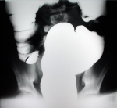
The image ofa barium enema showing the dilated proximal rectum and the sigmoideum.

Figure 1
A small bowel follow-through
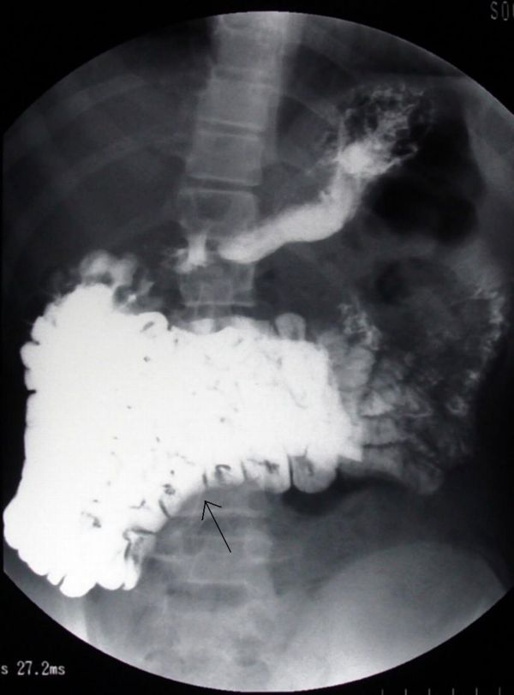
The image of a small bowel follow-through showing a separation of the bowel loops at the hypogastrum (indicated by an arrow).

Figure 2
A delayed film
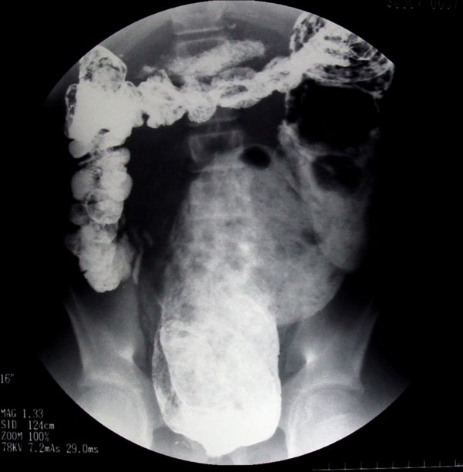
A delayed film taken 24 h after the small bowel follow-through showing the retention of barium.

Figure 3
Barium enema
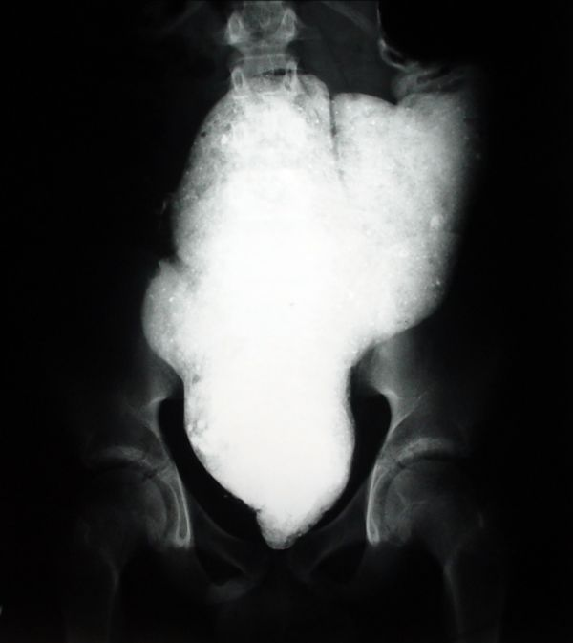
The image of a barium enema showing that the distal segment of the rectum is narrowed compared to the dilated proximal rectum and the sigmoideum.

Figure 4
Barium enema
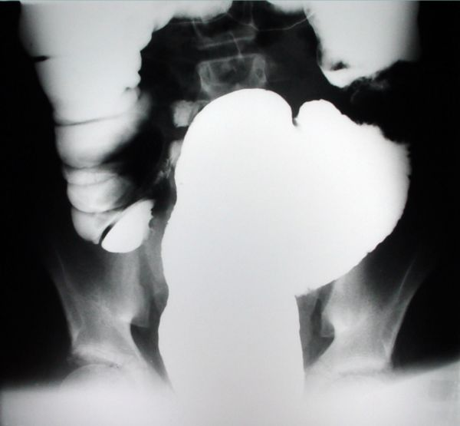
The image ofa barium enema showing the dilated proximal rectum and the sigmoideum.

To top

Home Search History FAQ Contact Disclaimer Imprint

