

Leriche syndrome – accidental CT diagnosis
Author(s)
Belo-Oliveira P, Rodrigues H, Gonçalves B, Belo-Soares P, Gomes P

Patient
male, 41 year(s)

Clinical Summary
A 41 years old male patient underwent a staging abdominal CT because of a pulmonary cancer.

Clinical History and Imaging Procedures
A 41 years old male patient underwent a staging abdominal CT because of a pulmonary cancer. The unenhanced CT showed the abdominal aorta with normal calibre until the renal arteries emergency. The aorta then presented a small calibre and extensive calcifications. These findings were confirmed with the contrast enhanced images where we could see that below the renal arteries there was no contrast within the aorta.

Discussion
Aortoiliac disease, often termed inflow obstruction to the lower extremity, usually is due to atherosclerosis or radiotherapy for pelvic malignancies. Concurrent with the development of lesions is the development of extensive inferior mesenteric or lumbar collaterals, which provide an autogenous bypass around the lesion. However, these only partially compensate for the decreased blood flow through the diseased vessel. As the number and severity of the lesions increase, the collaterals can no longer compensate, and symptoms develop. Aortoiliac disease presents with symptoms of lower-extremity claudication, usually of the hip, thigh, or buttock. It may coexist with femoral-popliteal disease, contributing to more distal symptoms as well. Leriche syndrome is a constellation of symptoms in men that results from the gradual occlusion of the terminal aorta. The main symptoms are inability to maintain penile erection, fatigue in the lower limbs, cramps in the calf area, ischemic pain of intermittent bilateral claudication; absent or diminished femoral pulse, pallor and coldness of the feet and legs. Onset is usually between 30 and 40 years of age. It is essential to examine the femoral and distal pulses in these patients at rest and after exercise. The absence of femoral pulses is indicative of aortoiliac disease. Segmental arterial Doppler readings with waveforms should also be performed in these patients, again preferably at exercise. The ankle-arm index (the ratio of the blood pressure in the leg to that in the arm) allows one to identify patients with severe ischemia. Patients without vascular disease have an index of more than 1.0, patients with claudication have an index of less than 0.6, and patients with rest pain and severe ischemia have an index of less than 0.4. Patients with incapacitating symptoms who are candidates for surgery should undergo arteriography to assess the extent of disease as well as the status of the renal arteries and distal vasculature. Short-segment lesions of the common iliac arteries identified on arteriogram may be treated by angioplasty.

Final Diagnosis
Leriche's syndrome

MeSH
- Aortic Diseases [C14.907.109]

References
- [1]
Images in vascular medicine. Collateral pathways perfusing Leriche's syndrome evaluated by multislice spiral computed tomography. Salerno M, Ambrosetti M, Pedretti RF, Bertoli G, Baldi M, Tramarin R. Vasc Med. 2004 May;9(3):229-30

- [2]
Bilateral renal artery stenting in a patient with Leriche syndrome. Dimitrios M, Achilles C, Andrew K, Charalampos L, Katsenis K, Vlachos L. Urol Int. 2004;73(3):283-4

- [3]
Images in cardiovascular medicine. Leriche syndrome visualized by 3-dimensional multislice computed tomography angiography. Iannaccone R, Catalano C, Danti M, Mangiapane F, Passariello R. Circulation. 2004 Aug 24;110(8):e77-8

Citation
Belo-Oliveira P, Rodrigues H, Gonçalves B, Belo-Soares P, Gomes P (2005, Jul 19).
Leriche syndrome – accidental CT diagnosis, {Online}.
URL: http://www.eurorad.org/case.php?id=3652
DOI: 10.1594/EURORAD/CASE.3652
To top

- Published 19.07.2005
- DOI 10.1594/EURORAD/CASE.3652
- Section Vascular Imaging
- Case-Type Clinical Case
- Views 190
- Language(s)
- Figure 1
Abdominal CT
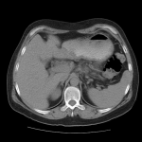
contrast unenhanced abdominal CT showing normal calibre abdominal aorta

- Figure 2
Abdominal CT
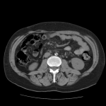
contrast unenhanced abdominal CT showing calcified reduced calibre distal abdominal aorta

- Figure 3
Abdominal CT
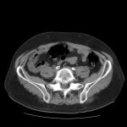
contrast unenhanced abdominal CT showing calcified small calibre iliac arteries

- Figure 4
Abdominal CT
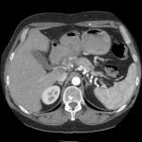
contrast enhanced abdominal CT showing normal calibre abdominal aorta

- Figure 5
Abdominal CT
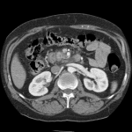
contrast enhanced abdominal CT showing normal calibre abdominal aorta

- Figure 6
Abdominal CT
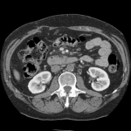
contrast enhanced CT showing the occluded abdominal aorta inferior to the renal arteries emergency

- Figure 7
Abdominal CT
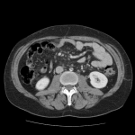
contrast enhanced CT showing the occluded abdominal aorta inferior to the renal arteries emergency

Figure 1
Abdominal CT
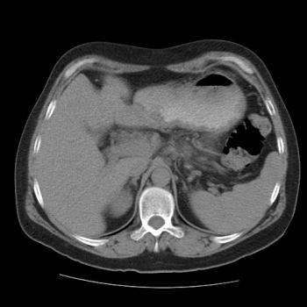
contrast unenhanced abdominal CT showing normal calibre abdominal aorta

Figure 2
Abdominal CT
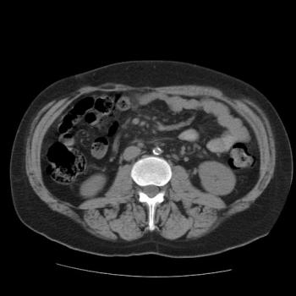
contrast unenhanced abdominal CT showing calcified reduced calibre distal abdominal aorta

Figure 3
Abdominal CT
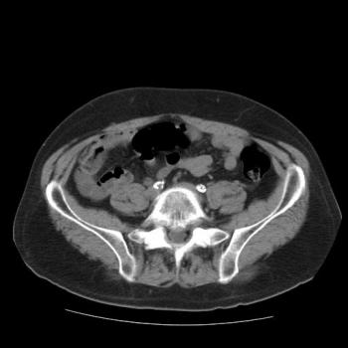
contrast unenhanced abdominal CT showing calcified small calibre iliac arteries

Figure 4
Abdominal CT
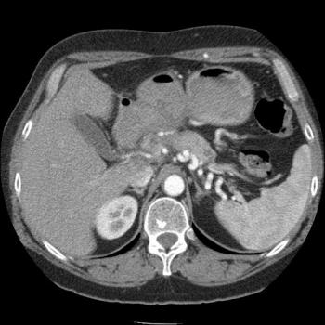
contrast enhanced abdominal CT showing normal calibre abdominal aorta

Figure 5
Abdominal CT
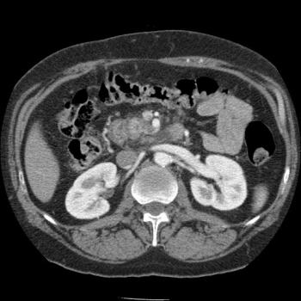
contrast enhanced abdominal CT showing normal calibre abdominal aorta

Figure 6
Abdominal CT
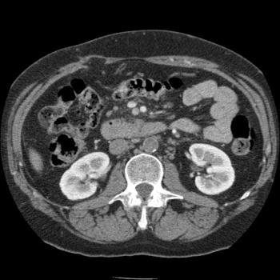
contrast enhanced CT showing the occluded abdominal aorta inferior to the renal arteries emergency

Figure 7
Abdominal CT
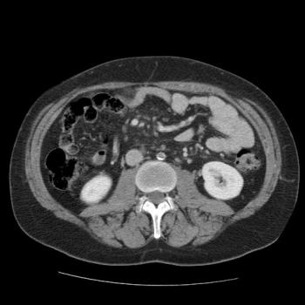
contrast enhanced CT showing the occluded abdominal aorta inferior to the renal arteries emergency

To top

Home Search History FAQ Contact Disclaimer Imprint

