

Deep venous thrombosis
Author(s)
Pedro Belo-Oliveira, Henrique Rodrigues, Pedro Belo-Soares, Elisabete Pinto

Patient
female, 57 year(s)

Clinical Summary
A 57 years old female presented to the emergency room with complains of pain and swelling of the right thigh and calf. There was associated increased warmth, redness, and tenderness of these areas.

Clinical History and Imaging Procedures
A 57 years old female presented to the emergency room with complains of pain and swelling of the right thigh and calf. There was associated increased warmth, redness, and tenderness of these areas. A venous ultrasonography showed inability to compress the right common femoral and popliteal veins, which appeared distended and filled with an echogenic thrombus. Doppler evaluation revealed absence of flow within these veins, establishing the diagnosis of deep venous thrombosis. There was also thrombosis of the great right saphenous vein.

Discussion
Most patients with acute DVT will initially develop symptoms of pain and swelling in the calf of one leg. There may be associated increased warmth, redness, and tenderness of the calf area. Fewer than 20% of patients with symptomatic DVT have thrombi that involve the calf veins alone. Venous ultrasonography has become the most widely used diagnostic modality, invasive or non-invasive, for the diagnosis and exclusion of acute DVT. Duplex ultrasound is considered to be the primary non-invasive diagnostic method for DVT. US of the lower extremity deep venous system is performed with the patient in the supine position, preferably with the head of the bed raised 20°–30° to promote venous pooling in the leg. Duplex Doppler or colour Doppler imaging or both are helpful to identify venous vessels but are not mandatory. The transducer is placed transversely in the groin area to identify the common femoral vein, just medial to the common femoral artery. In the absence of DVT, gentle pressure should cause the vein lumen to collapse and the anterior and posterior walls to become superimposed. In the presence of DVT, it is not possible to collapse the vein lumen even with the application of sufficient pressure to occlude the adjacent artery. During the procedure, the transducer is moved distally along the deep venous system, and light compression is applied at 1-cm intervals. The procedure extends from the most proximal aspect of the common femoral vein, along the superficial femoral vein and popliteal vein until the popliteal vein divides into the posterior tibial and peroneal branches (calf trifurcation). At each level, the vein is assessed for the presence or absence of compressibility. The technique for examining the calf veins for DVT involves scanning the patient in the supine position or with the patient in the sitting position with the affected leg hanging over the side of the bed. In the absence of DVT, the entire deep venous system between the common femoral vein and the trifurcation of the popliteal vein should collapse with complete apposition of the vein walls during gentle compression. The inability to completely compress the vein lumen is the principal criterion for the diagnosis of DVT. In patients with DVT, several adjunctive US findings may be observed that are less sensitive and less specific than vein compressibility as diagnostic parameters. Acute DVT usually causes distention of the involved vein, and Doppler evaluation may reveal absence of flow. If there is incomplete obstruction of the vein lumen, there is usually loss of the phasic respiratory venous flow pattern and a continuous flow wave may be observed that is minimally affected by augmentation. Acute DVT is often anechoic and cannot be distinguished from a normal vein. With time, the clot usually will become echoic. In the absence of DVT, internal echoes due to artefact of slow-flowing blood may be observed within vein lumina. Thus, lack of vein compression is required to confirm the presence of DVT.

Final Diagnosis
Deep venous thrombosis

MeSH
- Venous Thrombosis [C14.907.355.830.925]
The formation or presence of a thrombus within a vein.

References
- [1]
Does repeat duplex ultrasound for lower extremity deep vein thrombosis influence patient management? Ascher E, Depippo PS, Hingorani A, Yorkovich W, Salles-Cunha S Vasc Endovascular Surg. 2004 Nov-Dec;38(6):525-31

- [2]
Duplex-Doppler ultrasonography in the detection of lower extremities deep venous thrombosis and in the detection of alternative findings. Brkljacic B, Misevic T, Huzjan R, Brajcic H, Ivanac G Coll Antropol. 2004 Dec;28(2):761-7

- [3]
Ultrasound diagnosis of deep venous thrombosis. Tracy JA, Edlow JA Emerg Med Clin North Am. 2004 Aug;22(3):775-96, x.

Citation
Pedro Belo-Oliveira, Henrique Rodrigues, Pedro Belo-Soares, Elisabete Pinto (2005, Jul 19).
Deep venous thrombosis, {Online}.
URL: http://www.eurorad.org/case.php?id=3725
DOI: 10.1594/EURORAD/CASE.3725
To top

- Published 19.07.2005
- DOI 10.1594/EURORAD/CASE.3725
- Section Vascular Imaging
- Case-Type Clinical Case
- Views 82
- Language(s)
- Figure 1
Ultrasonography
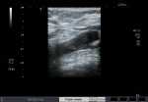
ultrasonography showing a thrombus in the common femoral vein

- Figure 2
Doppler ultrasound
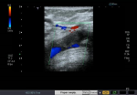
Doppler ultrasound confirming the presence of the thrombus

- Figure 3
Ultrasonography
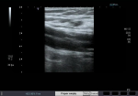
ultrasound showing the superficial femoral vein dilated, with echoes within

- Figure 4
Ultrasonography
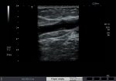
ultrasound showing the dilated popliteal vein with echoes within

- Figure 5
Doppler ultrasound
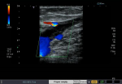
Doppler ultrasound confirming the popliteal vein thrombosis

- Figure 6
Ultrasonography
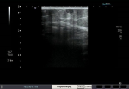
Ultrasound revealing thrombosed great saphenous vein

Figure 1
Ultrasonography
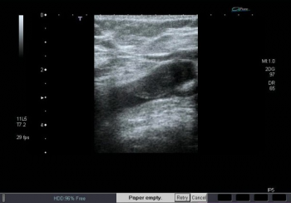
ultrasonography showing a thrombus in the common femoral vein

Figure 2
Doppler ultrasound
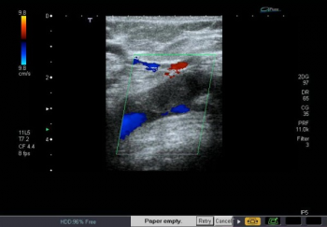
Doppler ultrasound confirming the presence of the thrombus

Figure 3
Ultrasonography
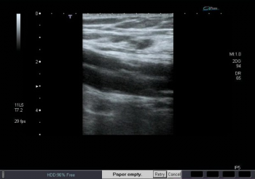
ultrasound showing the superficial femoral vein dilated, with echoes within

Figure 4
Ultrasonography
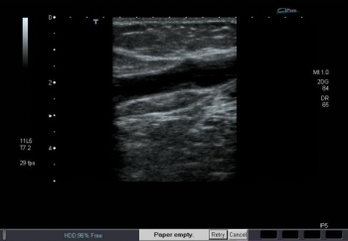
ultrasound showing the dilated popliteal vein with echoes within

Figure 5
Doppler ultrasound
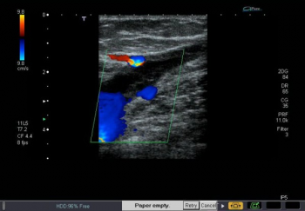
Doppler ultrasound confirming the popliteal vein thrombosis

Figure 6
Ultrasonography
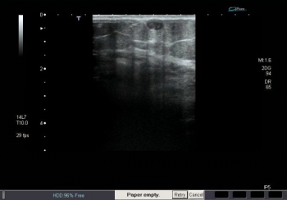
Ultrasound revealing thrombosed great saphenous vein

To top

Home Search History FAQ Contact Disclaimer Imprint

