

Sonographic and Computed tomographic demonstration of hepatic hydatid cyst communicating with the biliary tree
Author(s)
Belo-Oliveira P, Belo-Soares P, Martins M, Pinto E, Teixeira L

Patient
male, 30 year(s)

Clinical Summary
A 30 years old male patient presented to the emergency room with a three day history of right upper quadrant pain and jaundice.

Clinical History and Imaging Procedures
A 30 years old male patient presented to the emergency room with a three day history of right upper quadrant pain and jaundice. He had no history of trauma, surgery, biopsy, or known hepatic disease. Laboratory analyses revealed the following results: total bilirrubin - 2.3mg/dL; conjugated bilirrubin – 1.4 mg/dL; glutamyltransferase -400U/L, alkaline phosphatase - 315 U/L. A work-up was initiated with an abdominal ultrasound that identified a 6cm round, predominantly cystic lesion, with sharply defined margins at hepatic segment VIII. Doppler showed no flux within this lesion. The common bile duct was dilated, there was solid intrabiliary material without acoustic shadowing within, and a communication could be established with the cystic lesion. Contrast enhanced ultrasound showed that the lesion was avascular at the arterial, portal and late phases. Computed tomography confirmed the presence of the cystic lesion at the hepatic segment VIII, partially calcified, with no enhancement after intravenous contrast administration. On the basis of these findings we diagnosed a hydatid cyst that had ruptured into the biliary tree, and surgery was performed. Total pericystectomy was performed.

Discussion
Intrahepatic complications of hydatid cysts include cyst rupture and infection. Although rupture may be related to minor trauma, the natural history of hepatic hydatid cysts implies rupture as a complication in 50%–90% of cases. Passage of the cyst contents into the host's blood circulation can produce anaphylaxia due to the antigenic nature of the cyst fluid, although cyst rupture may be clinically silent. Lewall and McCorkell classified rupture of echinococcal cysts into 3 types: (1) contained, communicating, and direct. Contained ruptures occur when the endocyst ruptures but the pericyst remains intact. Endocyst detachment is seen at cross-sectional imaging as floating membranes within the cyst. Contained rupture may be related to degeneration, trauma, or response to therapy. Communicating rupture implies passage of the cyst contents into the biliary radicles that have been incorporated into the pericyst. Direct rupture occurs when both the pericyst and endocyst rupture, allowing free spillage of hydatid material into the peritoneal cavity, pleural cavity, hollow viscera, abdominal wall, and so on. Direct rupture is more frequent in lesions located near the edge of the liver, where there may be less protection for the cyst due to a deficient pericyst and little host tissue to offer support. In communicating and direct ruptures, the cyst empties and may become smaller and less spherical. As many as 90% of hepatic hydatid cysts are of the second type, usually silent. Communicating rupture of a cyst into the biliary system may occur through small fissures or bile-cyst fistulas or through a wide perforation that allows access to a main biliary branch. Rupture into the larger tree occurs in 5-15% of cases and, in this situation, obstructive jaundice or cholangitis is much more common than when communication is small. It is essential that imaging findings that suggest a biliary communication be reported to ensure adequate surgical management. Diagnosis of a hepatic hydatid cyst’s rupture into the biliary tree should be based on a clinical, laboratory, and imaging findings. Clinical symptoms and findings are non-specific, although nausea and vomiting, together with an alkaline phosphatase concentration greater than 144 U/L and a total bilirrubin concentration greater than 0.8 mg/dL are independent clinical factors for occult rupture. The presence or a history of jaundice is an independent predictor of frank rupture. Radiological signs of a hydatid cyst’s rupture into the biliary tree include demonstration of a defect in the cyst wall, a communication between the cyst and the biliary tree, and the presence of hydatid material within the biliary tree. On sonography, intrabiliary material appears as a hypoechoic or echogenic structures of varying sizes and shapes without acoustic shadowing. Fragmented membranes are seen as highly echogenic linear structures. At contrast enhanced ultrasound these lesions are hypo vascular at, portal, and late phases. On computed tomography an interruption in the cyst wall represents the communication between the cyst and the biliary tree. MR imaging may demonstrate interruption in the low-signal-intensity rim of the cyst wall as well as extrusion of contents through the defect.

Final Diagnosis
Hepatic hydatid cyst communicating with the biliary tree

MeSH
- Echinococcosis, Hepatic [C03.518.314]
Helminth infection of the liver caused by Echinococcus granulosus or Echinococcus multilocularis.

References
- [1]
Intrabiliary rupture: an algorithm in the treatment of controversial complication of hepatic hydatidosis. Erzurumlu K, Dervisoglu A, Polat C, Senyurek G, Yetim I, Hokelek M World J Gastroenterol. 2005 Apr 28;11(16):2472-6

- [2]
Management of intrabiliary ruptured hydatid disease of the liver. Koksal N, Muftuoglu T, Gunerhan Y, Uzun MA, Kurt R Hepatogastroenterology. 2001 Jul-Aug;48(40):1094-6

- [3]
The infected liver: radiologic-pathologic correlation. Mortele KJ, Segatto E, Ros PR Radiographics. 2004 Jul-Aug;24(4):937-55

- [4]
Echinococcal cysts of the liver: a retrospective analysis of clinico-radiological findings and different therapeutic modalities. Haddad MC, Al-Awar G, Huwaijah SH, Al-Kutoubi AO Clin Imaging. 2001 Nov-Dec;25(6):403-8

Citation
Belo-Oliveira P, Belo-Soares P, Martins M, Pinto E, Teixeira L (2005, Oct 19).
Sonographic and Computed tomographic demonstration of hepatic hydatid cyst communicating with the biliary tree, {Online}.
URL: http://www.eurorad.org/case.php?id=3856
DOI: 10.1594/EURORAD/CASE.3856
To top

- Published 19.10.2005
- DOI 10.1594/EURORAD/CASE.3856
- Section Liver, Biliary System, Pancreas, Spleen
- Case-Type Clinical Case
- Views 72
- Language(s)
- Figure 1
Abdominal ultrasound
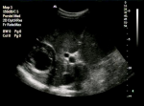
Abdominal ultrasound showing a 6cm round, predominantly cystic lesion, with sharply defined margins, at the hepatic segment VIII

- Figure 2
Abdominal ultrasound
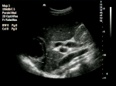
Abdominal ultrasound showing a 6cm round, predominantly cystic lesion, with sharply defined margins, at the hepatic segment VIII, and the dilated common bile duct

- Figure 3
Doppler ultrasound
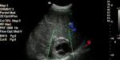
Doppler ultrasound showing no flux within the lesion

- Figure 4
Abdominal ultrasound
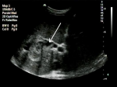
Abdominal ultrasound showing the dilated common bile duct communicating with the hepatic cystic lesion

- Figure 5
Abdominal ultrasound
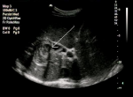
Abdominal ultrasound showing the dilated common bile duct communicating with the hepatic cystic lesion

- Figure 6
Contrast enhanced ultrasound
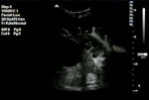
Contrast enhanced ultrasound showed that the lesion was avascular at the arterial, portal and late phases.

- Figure 7
Contrast enhanced ultrasound
Contrast enhanced ultrasound showed that the lesion was avascular at the arterial, portal and late phases.

- Figure 8
Contrast enhanced ultrasound
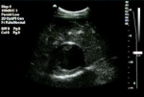
Contrast enhanced ultrasound showed that the lesion was avascular at the arterial, portal and late phases.

- Figure 9
Computed tomography
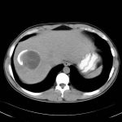
Unenhanced computed tomography confirmed the presence of the cystic lesion at the hepatic segment VIII, partially calcified

- Figure 10
Contrast enhanced computed tomography
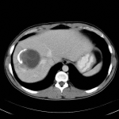
Contrast enhanced computed tomography showing no enhancement after intravenous contrast administration.

- Figure 11
Contrast enhanced computed tomography
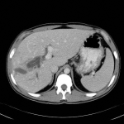
Contrast enhanced computed tomography showing the dilated common bile duct communicating with the hepatic cyst

- Figure 12
Kehr tube colangiography
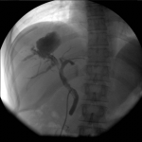
pos surgery Kehr tube colangiography confirming the communication between the common bile duct and the cavity occupied by the cyst

Figure 1
Abdominal ultrasound
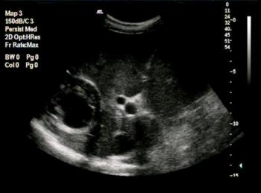
Abdominal ultrasound showing a 6cm round, predominantly cystic lesion, with sharply defined margins, at the hepatic segment VIII

Figure 2
Abdominal ultrasound
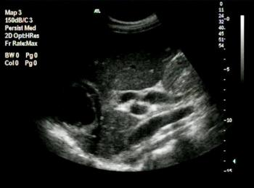
Abdominal ultrasound showing a 6cm round, predominantly cystic lesion, with sharply defined margins, at the hepatic segment VIII, and the dilated common bile duct

Figure 3
Doppler ultrasound
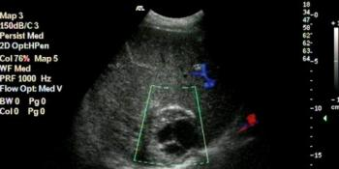
Doppler ultrasound showing no flux within the lesion

Figure 4
Abdominal ultrasound
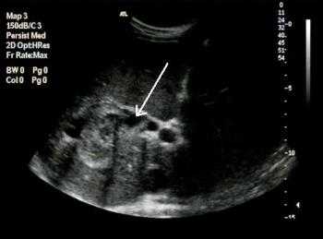
Abdominal ultrasound showing the dilated common bile duct communicating with the hepatic cystic lesion

Figure 5
Abdominal ultrasound
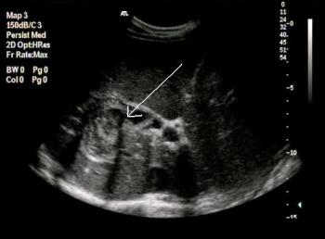
Abdominal ultrasound showing the dilated common bile duct communicating with the hepatic cystic lesion

Figure 6
Contrast enhanced ultrasound
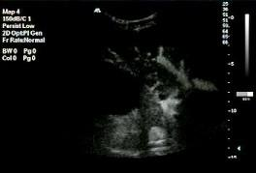
Contrast enhanced ultrasound showed that the lesion was avascular at the arterial, portal and late phases.

Figure 7
Contrast enhanced ultrasound
Contrast enhanced ultrasound showed that the lesion was avascular at the arterial, portal and late phases.

Figure 8
Contrast enhanced ultrasound
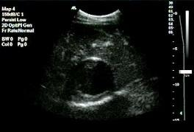
Contrast enhanced ultrasound showed that the lesion was avascular at the arterial, portal and late phases.

Figure 9
Computed tomography
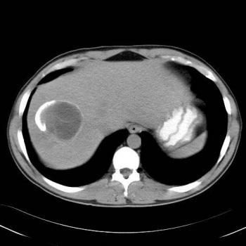
Unenhanced computed tomography confirmed the presence of the cystic lesion at the hepatic segment VIII, partially calcified

Figure 10
Contrast enhanced computed tomography
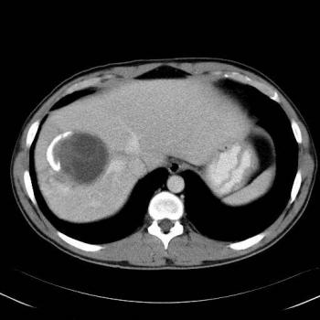
Contrast enhanced computed tomography showing no enhancement after intravenous contrast administration.

Figure 11
Contrast enhanced computed tomography
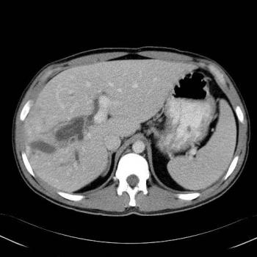
Contrast enhanced computed tomography showing the dilated common bile duct communicating with the hepatic cyst

Figure 12
Kehr tube colangiography
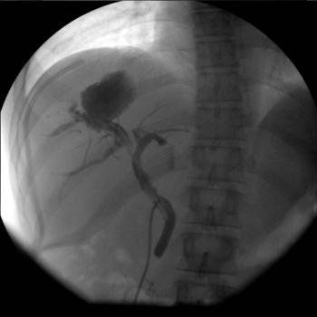
pos surgery Kehr tube colangiography confirming the communication between the common bile duct and the cavity occupied by the cyst

To top

Home Search History FAQ Contact Disclaimer Imprint

