Jejunal Stricture: single manifestation of Crohn’s Disease
Author(s)
João Filipe Costa, José Ilharco, Artur Costa

Patient
male, 60 year(s)

Clinical Summary
A 60 year-old male patient was admitted to our institution referring repeated episodes of abdominal cramps and distention, weight loss, fatigue and anorexia. Abdominal radiogram showed dilatation of small bowel loops with few gas-fluid levels.

Clinical History and Imaging Procedures
A 60 year-old male patient was admited to our institution referring repeated episodes of abdominal cramps and distention, weight loss, fatigue and anorexia. Abdominal radiogram showed dilatation of small bowel loops with few gas-fluid levels (figure1). One regular, concentric stenosis of distal jejunum was noted at enteroclysis (figure 2). The terminal ileum was normal (figure 3) and there were no signs of separation of small bowel loops (figure 4). He also performed a CT scan, which showed discrete small bowel dilatation and enhanced parietal thickening of a jejunal loop, with infiltration of the adjacent mesentery (figure 5). Lymphadenopathy was not present. The patient was submitted to segmental resection of small bowel and histology confirmed Crohn’s Disease.

Discussion
Crohn’s disease is most common in the developed countries and has a bimodal age distribution. The peak incidence is between the ages of 15 and 25 years with a lower peak between 50 and 80 years. Crohn's disease can involve any segment of the alimentary tract. However, the terminal ileum is nearly always involved in small bowel disease and is the only site in up 30% of patients. Only 15% of the cases of Crohn's disease appear in patients older than 50 years. The radiographic manifestations of Crohn's disease are well known and include thickened folds, nodules and aphtous ulcers, fissures and linear, deep ulcers, “cobblestoning”, sacculation of antimesenteric aspect, limited distensibility with thickening of walls, inflammatory pseudopolyps, sinus tracts and fistulae and narrowed lumen (“string sign”) (1). CT features are bowel wall thickening (usually between 1-2 cm), mural stratification giving a target or double-halo appearance and intense mucosal and serosal enhancement following IV contrast, in the acute phase. In chronic disease, mural stratification is lost as transmural fibrosis is established (2). Mesenteric changes include fibro-fatty proliferation, increased attenuation, small lymph nodes and hypervascularity giving a “comb sign”. CT is also valuable because of its ability in depicting extraluminal pathology (3). Strictures occur in 20% of patients with small bowel disease and 8% of patients with Crohn´s colitis. In the active stage of the disease the narrowing usually results from edema and spasm and is not permanent. In long-standing disease, fibrotic strictures predominate. Other complications are abscesses, fistulae formation, perforation and GI as well as extra-GI cancer.

Final Diagnosis
Crohn’s Disease

MeSH
- Crohn Disease [C06.405.469.432.500]
A chronic transmural inflammation that may involve any part of the DIGESTIVE TRACT from MOUTH to ANUS, mostly found in the ILEUM, the CECUM, and the COLON. In Crohn disease, the inflammation, extending through the intestinal wall from the MUCOSA to the serosa, is characteristically asymmetric and segmental. Epithelioid GRANULOMAS may be seen in some patients.

References
- [1]
Hans Herlinger. The Small Bowel Enema and the Diagnosis of Crohn’s Disease. Radiol Clin North Am. 1982; 20: 721-42.

- [2]
Mourad Boudiaf, Philippe Soyer, Carine Terem, Jean Pierre Pelage, Emmanuelle Maissiat, Roland Rymer. CT Evaluation of Small Bowel Obstruction. RadioGraphics 2001; 21: 613-624

- [3]
Margulis, Burhenne. Alimentary Tract Radiology vol.1, 1989

Citation
João Filipe Costa, José Ilharco, Artur Costa (2006, Oct 28).
Jejunal Stricture: single manifestation of Crohn’s Disease, {Online}.
URL: http://www.eurorad.org/case.php?id=5351
DOI: 10.1594/EURORAD/CASE.5351
To top

- Published 28.10.2006
- DOI 10.1594/EURORAD/CASE.5351
- Section Gastro-Intestinal Imaging
- Case-Type Clinical Case
- Views 46
- Language(s)
- Figure 1
Abdominal radiogram
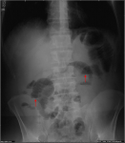
Dilatation of small bowel loops with few gas-fluid levels (arrows).

- Figure 2
Enteroclysis
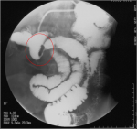
Regular, concentric stenosis of distal jejunum

- Figure 3
Enteroclysis
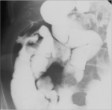
Normal terminal ileum

- Figure 4
Enteroclysis
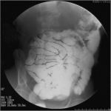
No signs of separation of small bowel loops

- Figure 5
CT scan
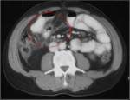
Enhanced parietal thickening of a jejunal loop, with infiltration of the adjacent mesentery

Figure 1
Abdominal radiogram
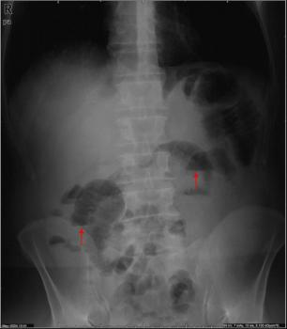
Dilatation of small bowel loops with few gas-fluid levels (arrows).

Figure 2
Enteroclysis
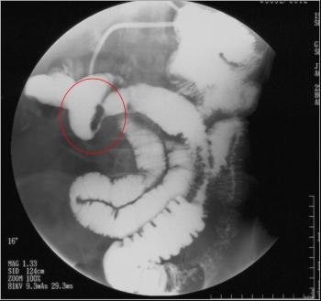
Regular, concentric stenosis of distal jejunum

Figure 3
Enteroclysis
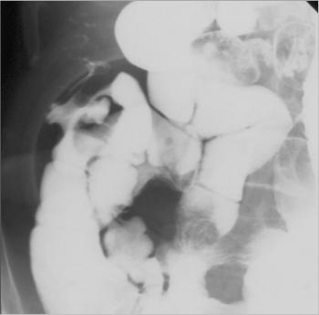
Normal terminal ileum

Figure 4
Enteroclysis
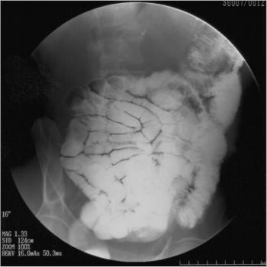
No signs of separation of small bowel loops

Figure 5
CT scan
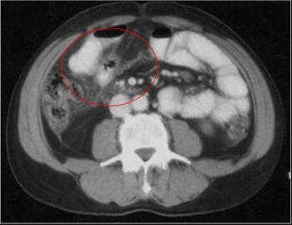
Enhanced parietal thickening of a jejunal loop, with infiltration of the adjacent mesentery

To top

