SDR Implementation of a Low Complexity and Interference-resilient Space-Time Block Decoder for MIMO-OFDM Systems

Morris Filippi1, Andrea F. Cattoni², Yannick Le Moullec², Claudio Sacchi1,

1 University of Trento, Department of Information Engineering and Computer Science, Via Sommarive 5,
I-38123 Trento, Italy
morris.filippi@hotmail.it, sacchi@disi.unitn.it

²Aalborg University, Aalborg DK-9220, Denmark,
{afc, ylmg}@es.aau.dk
Abstract. In the recent wireless systems, the MIMO technologies are largely used to increase data throughput. Many efficient solutions have been proposed for the classical 2 transmitting and 2 receiving antennas (2x2) configuration, such as: the Spatial Multiplexing (SM) and the Alamouti’s Space Time Block Coding (STBC). The extension of these techniques in terms of antennas number is a key topic in MIMO signal processing. In these cases, the computational burden increases due to the large number of elementary operations. Moreover, additional interference due to the non-perfect orthogonality of space-time coding may affect the decoder. In this paper an SDR implementation of 4x4 STBC configuration for MIMO-OFDM systems is considered. The aim is to introduce a low-complexity algorithm which reduces the interference due to the Quasi-Orthogonality of the STBC decoding. In literature, feedback techniques have been proposed to solve this problem. However, the algorithm introduced in this paper, has been conceived in order to avoid the transmission feedback, by estimating the interference factors and removing them. The related STBC decoder has been implemented on FPGA. The considered algorithm exhibits a low computational complexity and fulfills with requirements of HW feasibility, considering a trade-off execution time/area occupation.
Keywords: MIMO, OFDM, Space-Time Block Coding, Software-Defined Radio, MIMO signal processing
1 Introduction
Nowadays, wireless systems allow connecting people in almost every place in the world. By means of a mobile device it is also possible to surf the Web and to access many more services. The main issues to be tackled are related to the limitation in terms of functionality and speed involved by the difficulty of effectively managing the scarce available power and spectrum resources. Therefore, the objective of the designers is to propose solutions to speed-up the technical features to increase those functionalities. A valuable solution consists of the introduction of advanced digital signal processing techniques based on Multiple Input – Multiple Output (MIMO) concept. The key feature of MIMO is the capability to increase channel capacity without increasing transmitted power and RF bandwidth [1]. Nowadays, MIMO techniques present some well-promising applications in wireless standards like IEEE 802.11n and IEEE 802.16x (WiMax). Different space-time processing techniques have been proposed in literature in order to fully exploit potentialities of MIMO systems. The most popular one is Space-Time Coding [2], in which the time dimension is complemented with the spatial dimension inherent to the use of multiple spatially-distributed antennas. Commonly used ST coding schemes are ST-trellis codes and ST block codes (STBC). A well-known example of conceptually simple, computationally efficient and mathematically elegant STBC scheme has been proposed by Alamouti in [3]. Substantially Alamouti’s coding is an orthogonal ST block code, where two successive symbols are encoded in an orthogonal 2x2 matrix. The columns of the matrix are transmitted in successive symbol periods, but the upper and the lower symbols in a given column are sent simultaneously through the first and the second transmit antenna respectively.
The alternative solution to ST coding is represented by Spatial Multiplexing (SM) [4]. Spatial multiplexing is a space-time modulation technique whose core idea is to send independent data stream from each transmit antenna. This is motivated by the spatially white property of the distribution which achieves capacity in MIMO i.i.d. Rayleigh matrix channels [5]. SM is addressed to push up link capacity rather than to exploit spatial diversity.
The switch between Diversity (i.e.: Space-Time coding) and Multiplexing (i.e.: SM) has been theoretically studied by Heath and Paulraj in [5] and some simulation results have been shown for a switch criterion based on the minimum Euclidean distance of the received codebook. Such a criterion has been considered in [5], because this measure reveals dependencies on the channel realization and provides an approximate measure of error-rate performances.
In our opinion, the practical implementation of switchable MIMO systems able at adaptively select different transmission modalities and to dynamically reconfigure the MIMO receiver depending on the selected mode will be a very interesting topic in the framework of “4G and beyond” communication standards. In such a framework, Software Defined Radio (SDR) can provide interesting and innovative answer in order to efficiently implement receiver architectures characterized by modularity and adaptive reconfiguration capability with respect to channel conditions [6].
In this paper, it has been proposed and tested a practical solution for the implementation of a SDR-based Space-Time Block Decoder for a 4x4 MIMO-OFDM transmission system. This kind of SDR implementation is really challenging and presents some issues to be solved. The most relevant ones are related to the efficient implementation of the space-time diversity combiner at the receiver side. Such a block is very critical as in the 4x4 MIMO configuration it should be implemented by means of a pseudo-inversion of the channel matrix that is computationally expensive and may provide poor performance due to noise increasing. Therefore, a computationally-affordable and interference-robust subtractive combiner will be considered for the conceived receiver. The SDR-based implementation of the subtractive combiner will be motivated and discussed. Results will be shown in terms of FPGA resource requirements and real-time execution capabilities.
The paper is structured as follows: in Section II some related works about SDR-based MIMO implementation are presented. Section III is devoted at describing the signal processing architecture of the proposed SDR-based STBC MIMO system. Section IV will focus on the hardware implementation of the diversity combiner. Section V aims at presenting and discussing experimental results. Section VI will draw paper conclusions.
2 Related works
The SDR-based implementation of MIMO systems has recently become a hot topic of R&D in wireless communications. One of the first works dealing with SDR MIMO-OFDM prototyping has been proposed by Gupta, Forenza and Heat in [7]. The prototyping approach was targeted to the rapid deployment of a “ready-to-market” architecture based on flexible SDR and commercially available hardware. The software design of all main receiver functionalities added a great flexibility and ease of use to the designed architecture at the price of throughput expense. Very recent works like [8] and [9] are explicitly targeted at mapping the SDR architectural design of MIMO systems onto efficient commercial HW platforms able at supporting real-world wireless applications. In [8], the utilization of GNU Radio has been considered to program the PHY and DATA LINK layers of Universal Software Radio Peripheral (USRP) consisting of a motherboard for baseband processing, two daughter boards for RF frontend processing and an embedded Intel Core General Purpose Processing (GPP) unit hosting Linux OS. Using such a platform a variety of multimedia delivery applications can be effectively supported on MANETs. In [9], a 40 MHz MIMO OFDM system with Space Division Multiplexing has been mapped onto a multi-processor SDR platform using two instances of state-of-the-art ADRES embedded processor. It has been shown in [9] that when the parallelization is wisely performed, it is possible to achieve the theoretical gain factor of two with respect to the single-processor system.
Another interesting work has been proposed by Pan et. al. in [10]. The authors of [10] considered the implementation of reconfigurable antennas in multi-radio platform. The antenna developed in [10] is characterized by a high degree of reconfigurability and general-purpose features, so to be used to enable SDR cognitive radio, MIMO and phased-array antennas. By this preliminary state-of-the-art scanning, we can say that the emphasis of R&D in SDR-based MIMO systems is on the implementation of SW receiver architectures characterized by flexibility, adaptivity and high degree of reprogrammability, with the clear objective of achieving high performances while keeping hardware costs reasonably low.
Our work is perfectly inserted in this state-of-the-art framework. In fact, in this work, the problem of the implementation of a MIMO receiver has been addressed from a practical viewpoint, considering commercial HW platforms, characterized by a good tradeoff between efficiency and cost.

3 OFDM-MIMO signal processing
The MIMO-OFDM system considered in this paper is based on the IEEE 802.16d standard [11], extended with the MIMO section. The IEEE 802.16 is the telecommunication standard on which the Worldwide Interoperability for Microwave Access (WiMAX) and the Wireless Metropolitan Area Network (WMAN) are based. These two are wireless technologies which provides high bit rate to the system. In particular, the paper is focused on the IEEE 802.16d-2004, based on OFDM transmission with TDMA as multiple access. In particular, the analysis carried out relies on different parts: the first one related to software simulations and second about the hardware implementation and co-simulation. The simulation work deals with the test of MISO/MIMO encoding and decoding algorithms. The work done on the hardware concerns just the receiver side (decoder) and in particular considering the MIMO mode which has best simulation results between those treated (see Fig.1).

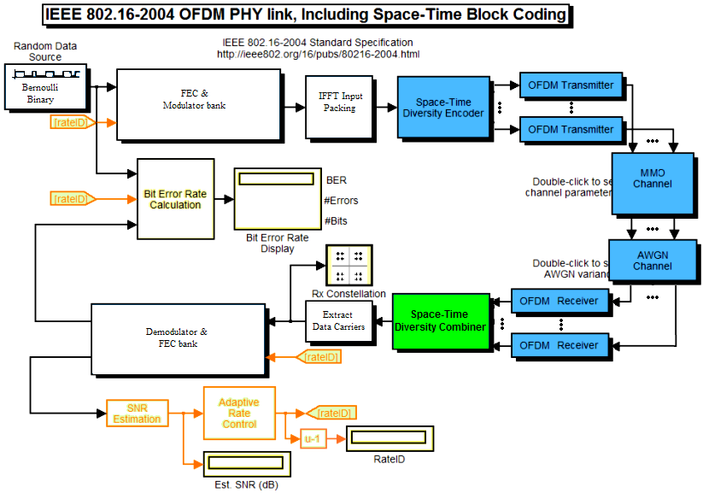
Fig. 1. IEEE 802.16-2004 OFDM PHY-layer SIMULINK scheme: the green blocks have been simulated and implemented on hardware; the blue blocks have been only developed for the software simulations.
In Fig. 2 a MIMO 4x4 system with Alamouti STBC algorithm is shown. The MIMO channels are shown in four colors to split them into four groups. The choice of a 4x4 MIMO instead of usual 2x1 or 2x2 is motivated by the necessity of increasing diversity in the space domain (and therefore robustness against fading effects) together with the spectral efficiency. Nowadays, a 4-element MIMO array can be implemented with affordable cost and the yielded performance improvement in terms of spectral efficiency may justify such an additional (non-prohibitive) cost.
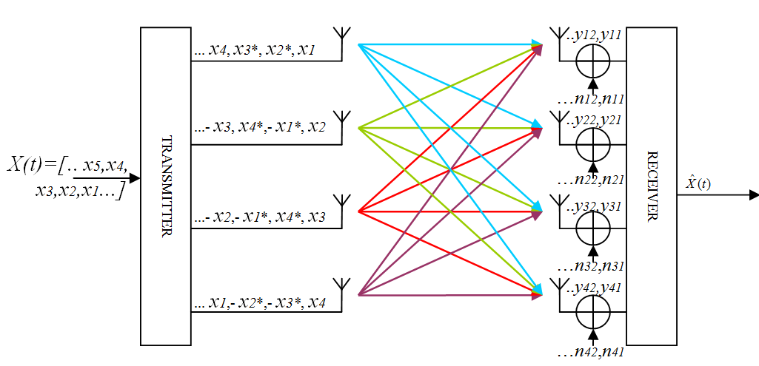
Fig. 2. The 4x4 MIMO-STBC system

The signal received during a MIMO symbol period is given as follow [12]:

$Y=\text{HX}+N$ (1)

denoting with H the non-squared channel matrix composed by 16 rows and 4 columns, X the 4x4 Alamouti STBC matrix containing the space-time encoded OFDM symbols:

$X=\left[\begin{matrix}x_{1} & x_{2} & x_{3} & x_{4} \\ x_{2}^{} & −x_{1}^{} & x_{4}^{} & −x_{3}^{} \\ x_{3}^{} & x_{4}^{} & −x_{1}^{} & −x_{2}^{} \\ x_{4} & −x_{3} & −x_{2} & x_{1}\end{matrix}\right]$ (2)

Finally N is the noise matrix, made of independent and identically-distributed Gaussian noise samples.
As the channel matrix is not square, the direct matrix inversion cannot be employed in order to perform the space-time combining at the receiver side. However, the pseudo-inversion can be computed [12] even for a non-squared matrix. The mathematical principle of this operation is given as follows:

$H^{+}={\left(H^{H}H\right)}^{−1}H^{H}$ (3)

$H^{H}$is the Hermitian channel matrix (i.e.: the transposed complex conjugate channel matrix). The resulting MIMO combining is given by:

$\tilde{X}= H^{+}Y = H^{+}\text{HX}+H^{+}N = X+H^{+}N$ (4)
Apparently, the operation is quite simple. However, the computation of the pseudo-inverse is computationally expensive (there is an operation of matrix inversion involving a 16x16 matrix) and the performance may degrade due to the increase of the noise level due to the multiplication of the noise matrix by the pseudo-inverse channel matrix.
A computationally-lighter combining methodology is the subtractive combiner proposed in [14] and [15]. The subtractive combiner is based on the utilization of the Hermitian channel matrix in order to combine the received signal:

$\tilde{X}=\frac{1}{α}H^{H}Y=\frac{1}{α}H^{H}\text{HX}+\frac{1}{α}H^{H}N=\tilde{I}⋅X+\frac{1}{α}H^{H}N$ (5)

The matrix resulting by the product of the channel matrix with its Hermitian will be quasi-identical, as shown in (6):

$\tilde{I}= \left[\begin{matrix}1 & 0 & 0 & β/α \\ 0 & 1 & {−β}/α & 0 \\ 0 & {−β}/α & 1 & 0 \\ β/α & 0 & 0 & 1\end{matrix}\right]$ (6)

being α and β defined as follows:
$\begin{aligned}α={\left|h_{\text{11}}\right|}^{2}+{\left|h_{\text{12}}\right|}^{2}+{\left|h_{\text{13}}\right|}^{2}+{\left|h_{\text{14}}\right|}^{2}+{\left|h_{\text{21}}\right|}^{2}+{\left|h_{\text{22}}\right|}^{2}+{\left|h_{\text{23}}\right|}^{2}+{\left|h_{\text{24}}\right|}^{2}+ \\ +{\left|h_{\text{31}}\right|}^{2}+{\left|h_{\text{32}}\right|}^{2}+{\left|h_{\text{33}}\right|}^{2}+{\left|h_{\text{34}}\right|}^{2}+{\left|h_{\text{41}}\right|}^{2}+{\left|h_{\text{42}}\right|}^{2}+{\left|h_{\text{43}}\right|}^{2}+{\left|h_{\text{44}}\right|}^{2}\end{aligned}$ (7)
$β=2⋅\text{Re}\left(h_{\text{11}}^{}h_{\text{41}}−h_{\text{21}}h_{\text{31}}^{}+h_{\text{12}}^{}h_{\text{42}}−h_{\text{22}}h_{\text{32}}^{}+h_{\text{13}}^{}h_{\text{43}}−h_{\text{23}}h_{\text{33}}^{}+h_{\text{14}}^{}h_{\text{44}}−h_{\text{24}}h_{\text{34}}^{}\right)$ (8)

The new decision vector is defined as follows:

$\left[\begin{matrix}{\underline{x}}_{1}+β/α⋅{\underline{x}}_{4} \\ {\underline{x}}_{2}−β/α⋅{\underline{x}}_{3} \\ {\underline{x}}_{3}−β/α⋅{\underline{x}}_{2} \\ {\underline{x}}_{4}+β/α⋅{\underline{x}}_{1}\end{matrix}\right]=\frac{1}{α}H^{H}Y= \left[\begin{matrix}x_{1}+β/α⋅x_{4} \\ x_{2}−β/α⋅x_{3} \\ x_{3}−β/α⋅x_{2} \\ x_{4}+β/α⋅x_{1}\end{matrix}\right]+\frac{1}{α}H^{H}N$ (9)

Assuming the knowledge of the Hermitian channel matrix (as done till now), the estimated symbols ${\underline{x}}_{1}$,${\underline{x}}_{2}$,${\underline{x}}_{3}$, and ${\underline{x}}_{4}$can be computed by solving a simple linear system of equations.
The two different algorithms described above, i.e. channel pseudo-inversion and subtractive combining have been tested by means of intensive simulation trials in MATLAB-SIMULINK environment and the simulation results have been shown in Fig.3. The IEEE 802.16-2004 system of Fig.1 has been simulated over Rayleigh fading MIMO channel, characterized by the following parameters: delay spread 10⁻⁶ sec. and Doppler spread 0.5 Hz. The simulation results are related to 100 average trials for each signal-to-noise ratio values. It is clear from Fig.3 that subtractive combining provides much better results with a reduced computational burden. For this reason, we decided to select this solution for practical SDR-based implementation.
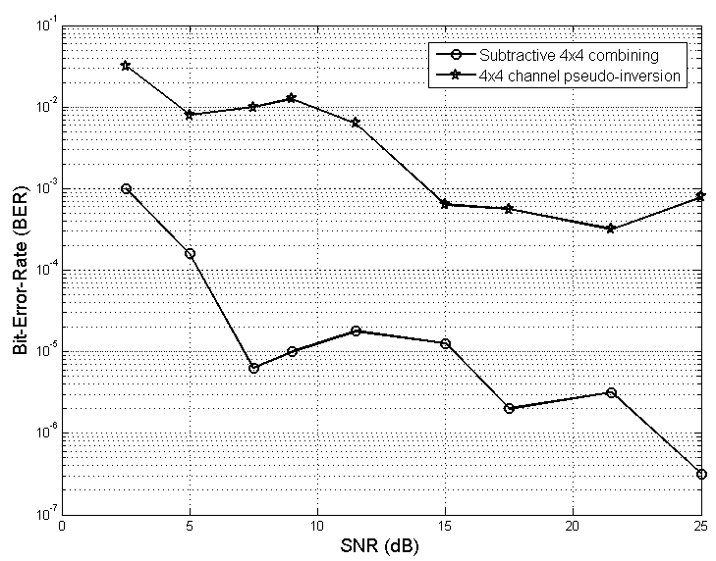
Fig.3. Comparative simulations for Subtractive 4x4 MIMO combining and 4x4 channel pseudo-inversion combining using the IEEE 802.16-2004 simulator of Fig.1: results achieved in terms of BER.

4 Emulated SDR implementation of the 4x4 subtractive MIMO combiner
There are several valuable approaches to implement the subtractive presented in section 3. In this paper, an efficient solution from a computational viewpoint has been presented. The architecture is designed by considering as cost function arguments the execution time and the FPGA resources. Note that it is often necessary to take account of trade-offs between these two items.
The proposed solution exploits the maximum operation parallelism as possible, in order to reduce the execution time. On the other hand, to minimize the resources basic real operators are used, such as multipliers, adders, CORDIC dividers [16]. Moreover, the use of integrated processors and high accuracy operators is avoided to preserve the initial trade-off.
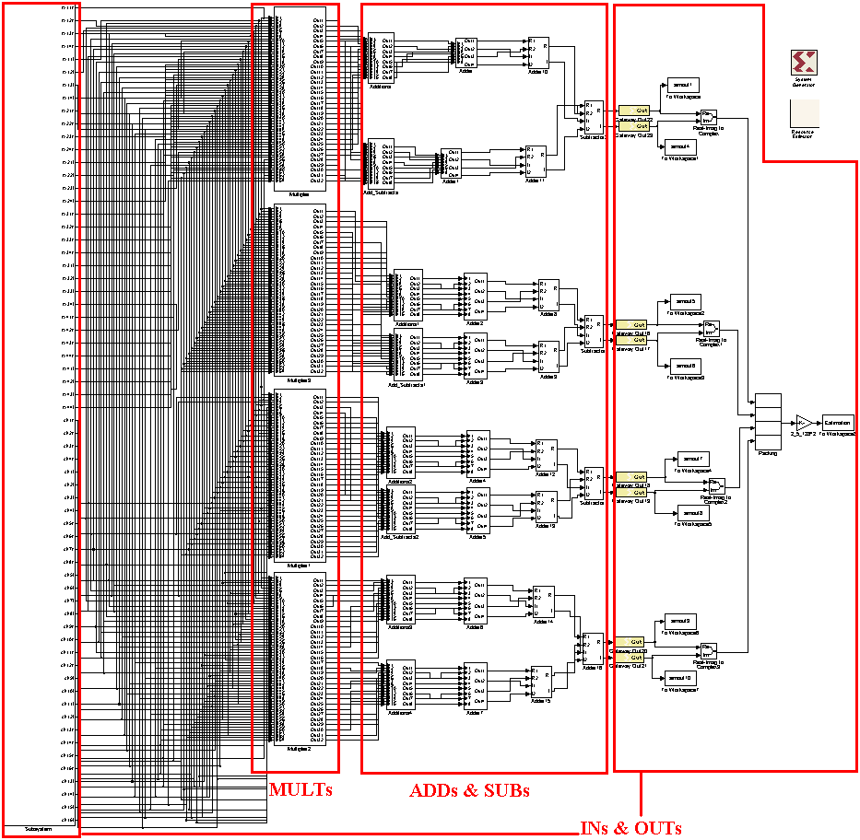

Fig.4. The STBC 4x4 subtractive combiner scheme which has been implemented in SysGen blocks. The INputs & OUTputs are on the left and right respectively, the MULTipliers on the the center-left and the ADDers SUBtractors on the center-right.

The inputs of the system are the received signal matrix Y and the estimated channel matrix H. All the signals are complex variables, so the real operators must be combined to perform this operation. This is done minimizing the operators, such as avoiding complex divisions (which would need a large amount of resources), by replacing them with complex multiplications followed by real divisions.
The architecture include the parallel operators which compute the decoding operation of (5) and the coefficients a and b of (7) and (8). The final outputs are the interference-free decoded OFDM symbols obtained by solving the linear system of (9). In order to evaluate the implementation of the subtractive 4x4 OFDM-MIMO combiner considered in this paper, a Xilinx Virtex 5 xc5vsx50t-1ff1136 FPGA has been used. For the synthesis, the tools Xilinx ISE and Core Generator have been exploited.
The OFDM-MIMO main scheme shown in Fig.1 has been adapted to provide the 4x4 transmission data to the MIMO combiner which has been implemented by System Generator.
In Fig. 4 the block scheme of the System Generator implementation is shown. The inputs are the received signals coming from the 4-antennas OFDM receivers, and the MIMO channel estimations. In order to allow the interface between System Generator and Standard MATLAB blocks, the signals must be splitted from floating point complex value into real-imaginary parts. Note that the System Generator input ports reduce the accuracy to 8-bit. This choice is due to the limited number of I/O ports of the FPGA (480 bit) and the number of slices. Moreover, note that the full amount of I/O ports is used with the aim of parallelizing the architecture, and then it’s necessary to avoid serial inputs.
The banks at the top of Fig. 4 execute the matrix product between the signal received and the channel estimation. The operators used maintain the 8-bit accuracy and their delays are set to exploit a pipelined cascade. The weighs for the interference cancellation are implemented by the blocks on the bottom of Fig. 4. The two parts computations are finally combined to obtain the final symbol estimation.
The System Generator MIMO combiner is synthesized and it is loaded on the FPGA. In order to manage the system in real time, the HW/WS co-simulation environment is set. The data transmitted from the computer to the FPGA are serialized by a point-to-point Ethernet connection. This testing environment allows a direct comparison between the software and the FPGA results.
5 Experimental results
The 4x4 MIMO decoder has been synthesized in FPGA hardware by the System Generator compiler. The scheme has been converted in HDL code. Finally, for the bitstream conversion, the Xilinx ISE tool has used.
The SW/HW co-simulation is supported by the following tools:
- MATLAB version 7.6.0.324 (R2008a);
- SIMULINK 7.1.1. (R2008a+);
- Xilinx ISE Design Suite 11.1 (including System Generator for DSP 11.1);
- ML506 platform for Virtex 5 xc5vsx50t-1ff1136 (see Fig.5);
- Ethernet cable;
- USB-JTAG cable;
- Power supply;
- Computer from the Embedded Laboratory of the Electronic Systems Department, AAU (performance 2 GHz single core, 1 GB RAM).
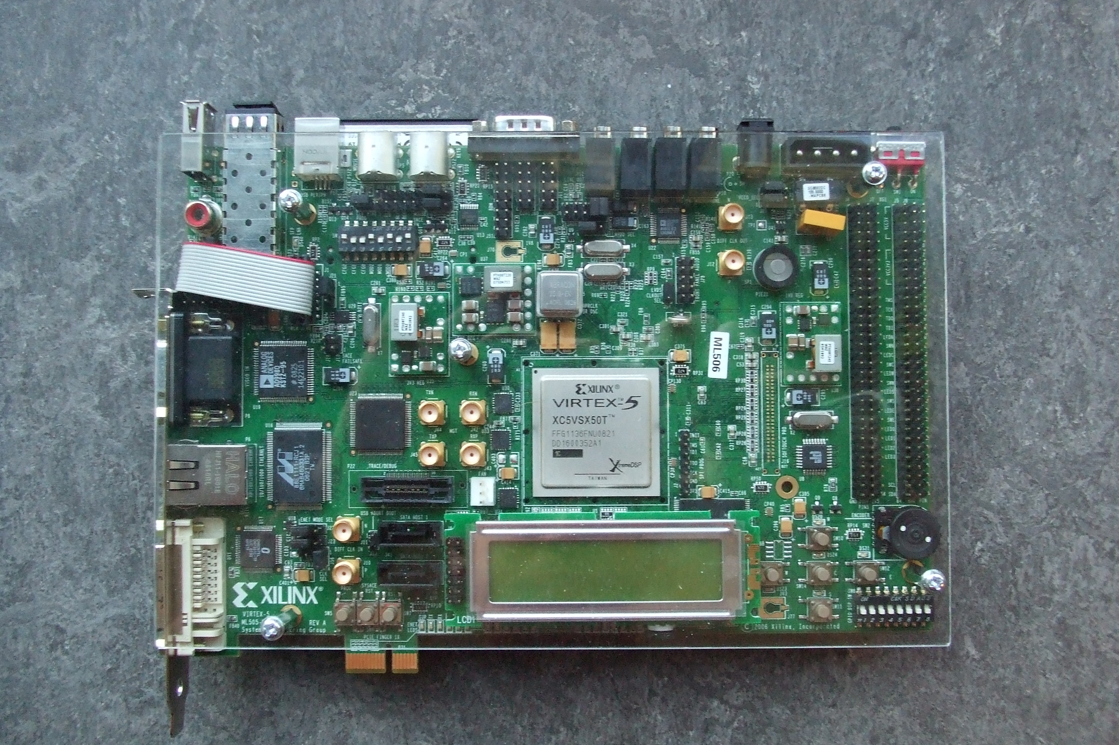

Fig.5. ML506 platform picture
In Fig.6 the result from the VHDL code generated by the SysGen synthesis is shown.

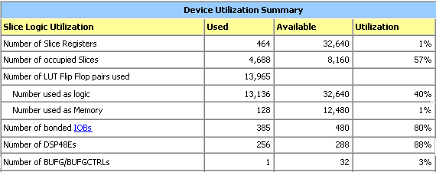
Fig.6. The results of the VHDL synthesis. The resources considered are the number of slice/slice registers, Flip-Flops, Memory usage, bits of I/Os, Embedded multipliers (DSP48E) and Buffers.
Looking at Fig.6 it is possible to conclude that every limitation is respected, with the 57 % of area occupation (slices). The most critical value, as expected, is the number of bonded I/O, which is at the 80% of usage. This can be the main problem if it is wanted to extend the hardware implementation. The number of DSP48E embedded multipliers is at 88 % but it is not so critical, because the multipliers can be implemented also by standard slices, so the number of multipliers can be reasonably incremented.
Another typical parameter is the working frequency of the system on FPGA. The co-simulation generation tool has allowed the using of 10 ns FPGA clock period, the maximum available by System Generator.

The longest path of the system implemented on FPGA falls within the allowed limit:

- FPGA clock period (co-simulation) = 10 ns;
- Longest path = 9.986 ns.

The time slack for this implementation is just 14 ps, that means the impossibility of adding at the design cascade other combinatorial operators. This, of course, obtained without introducing intermediate registers.
About that, can be useful to analyze the trade-off between latency and delay. The latency is the time needed to complete a cascade of combinatorial operations (in this case equal to the longest path). The delay is the additional time introduced by sequential devices (as registers). Analyzing this trade-off is possible to reduce the total execution time, depending on the case.
6 Conclusion
This paper has proposed an optimized implementation of a 4x4 decoder for OFDM-MIMO systems by a rapid prototyping approach for FPGA. The innovative design allows reducing the execution time and preserving the number of resources, as compared with other state-of-the-art implementations. The parallel computation allowed minimizing the clock period and the pipelining of the operations. The final results show the possibility of a hardware implementation.
The proposed solution can be implemented on ASIC or DSPs, moreover it allows a possible scalability of the system for instance increasing the number of antennas.

7 References
1. A.J. Paulraj, and C.B. Papadias, “Space-Time Processing for Wireless Communications”, IEEE Sig.Process. Mag., Nov. 1997, pp. 49-83.
2. D. Gesbert, M. Shafi, et. al., “From Theory to Practice: An Overview of MIMO Space-Time Coded Wireless Systems”, IEEE J. Sel. Areas in Comm., vol. 21, no. 3, Apr. 2003, pp. 281-301.
3. S.M. Alamouti, “A simple transmit diversity tecnique for wireless communications”, IEEE J. Sel. Areas in Comm., vol.16, no. 8, Oct,1998, pp. 1451-1458.
4. G.J. Foschini, “Layered Space-Time Architecture for Wireless Communication in a Fading Enviroment when using Multi-Element Antennas”, Bell Labs Tech. Jour., vol. 1, no.2, pp. 41-59, 1996.
5. R.V. Heath, and A.J. Paulraj, “Switching between Diversity and Multiplexing in MIMO Systems”, IEEE Trans. on Comm., vol.53, no.6, June 2005, pp. 962-968.
6. J. Mitola III, “Software Radio Architecture”, Wiley: New York 2000.
7. A. Gupta, A, Forenza, and R.W. Heat, “Rapid MIMO-OFDM Software Defined Radio System Prototyping”, Proc. of 2004 IEEE Workshop on Signal Processing Systems (SIPS 2004), Austin (TX), 13-15 October 2004, pp. 182-186.
8. X. Li, W. Hu, H. Yousefi’zadeh, and A. Qureshi, “A Case Study of a MIMO SDR Implementation”, Proc. of IEEE MILCOM 2008 Conf., San Diego (CA), 16-19 Nov. 2008, pp.1-7.
9. M. Palkovic, H. Capelle, M. Glassee, B. Bougard, and L. Van der Perre, “Mapping of 40 MHz MIMO SDM-OFDM Baseband Processing on Multi-Processor SDR Platform”, Proc. of 11th IEEE Workshop on Design and Diagnostics of Electronic Circuits and Systems (DDECS 2008), Bratislava (SK), 16-18 Apr. 2008, available on CD-ROM.
10. H.K. Pan, J. Tsai, S. Golden, V.K. Nair, and J.T. Bernhard, “Reconfigurable Antenna Implementation in Multi-radio Platform”, Proc. of IEEE Antennas and Propagat. Symp. (AP-S 2008), San Diego (CA), July 5-11, 2008, CD ROM available.
11. IEEE Standard 802.16-2004, “Part 16: Air interface for fixed broadband wireless access systems”, October 2004, http://ieee802.org/16/published.html.
12. T. Kaiser, A. Bourdoux, et. al. (eds.) “Smart Antennas – State of the Art”, EURASIP Series on Signal Processing and Communications, Hindawi: 2005.
13. W. H. Press, S. A. Teukolsky, W. T. Vetterling, and B. P. Flannery, “Numerical Recipes in C” Cambridge University Press, 2nd edition, 1992.
14. J. Kim, S. L. Ariyavistajul and N. Seshadri, “STBC/ SFBC for 4 Transmit Antennas with 1-bit Feedback”, Proc. of IEEE ICC’08 Conf., 2008, pp. 3493-3497.
15. B. Badic, M. Rupp and H. Weinrichter, “Adaptive Channel-Matched Extended Alamouti Space-Time Code Exploiting Partial Feedback”, ETRI Journal, Vol.26, no.5, Oct. 2004.
16. J. E. Volder, "The CORDIC Trigonometric Computing Technique", IRE Trans. On Electronic Computers, Vol. EC-8, 1959, pp. 330-334.

