AESO ACP
Third join Congresse

A "Network" and a "Dictum"
Leuven july 8 - 12 2003
Track 8-8 Shaping the urban landscape

Abstract:

Normally planners in countries such as Sweden, Netherlands and Denmark blame"modern life" and, in particular, the car and the lifestyle it brings formost of the spatial problems encountered in urban areas, for instance "sprawl", "the fragmented town" etc. However, the critic should concentrate more on a small "network" of a few architects and planners, including an inspector (C. D. Buchanan, UK) and a single police man (H. Alker Tripp, UK) who were heavily involved in the process of integrating the car as an element in the planning of urban areas and developing recommendations for road planning principles in urban areas.

These road planning principles were a spin-off of a pure urban planning ideology but was primarily used to solve the massive road safety and accessibility problems in the urban areas created by the car. The strong ideal shared by the people within the "network" were based on the dictum "forms follow function" about mans behaviour, the car and the structure of the urban areas and was based on very little empirical research. The use of
the urban planning thoughts expressed as road planning principles indicated and supported a changing perception of the urban areas, although people in the "network" (Le Corbusier, F. and Clarence S. Stein, US) had very different ideas about how the urban ideal itself should be expressed.

Basically, the recommendation concerning traffic and specifically the car was the same, segregation. This shift in perception had spatial implications: Firstly through the recommendation of turning the individual urban (residential) areas inwards or upwards i.e. away from the car traffic on the streets. Secondly the recommendation concerning the orientation of the individual (residential) buildings - the most important facades on (residential) buildings should face the sun or nature and not the street. Thirdly through the recommendation of combing particular functions in particular urban areas - schools in residential areas, business and industry in industrial areas etc. and thereby created highlysegregated urban areas and segregated traffic on the streets in the areas.

A "Network" and
a "Dictum"

Normally architects and planners in the Western World blame modern life, and especially the motor car, for must of the spatial problems they encounter in urban areas. But it can be shown that a small network of a few architects and planners (and a single policeman) was heavily involved in the process of initiating modern life, and especially the motor car, in planning urban areas. Now nearly one hundred years old, the network is still working, inspired by one simple strong idea (based on the dictum “Form follows function”) about man’s behaviour and the structure of the town based on very little empirical research.

On the following pages an example is presented of a network that has developed a number of “classical road planning references”. These “classical road planning references” are based on town planning, and it is clearly demonstrated how road planning is gradually developing into a discipline which is independent from town planning. This is happening as a consequence of the growing need for, and choice of, cheap transport, realised via a transport system in which the petrol-driven motor car and the road are the main elements and the town the context. The satisfaction of the need for cheap and efficient transport has come to affect the town to such an extent that today the road has possibly become – at the cost of the house – the dominant element in many new urban areas. At the same time it can be shown that the “classical road planning references”, from Raymond Unwin’s “garden city” to S. Olof Gunnarsson and the “SCAFT” town, lead to a demonstrated recommendation of a divided and fragmented town where the street facades of the houses are pulled back from the road or face inwards. It is proposed here that these “classical road planning references” are based on modern town planning and indeed the concept of the “functional planning method”, which contains some of the core considerations of - or perhaps even the idea behind – the “classical road planning references” and the use of road planning principles in urban areas. The concept can be briefly expressed as follows: “Form follows function” or “Function determines design, design determines behaviour, behaviour determines function, etc.” It is deemed here that this concept is transferred to road planning principles, and the idea is that conscious considerations (planning) with regard to coherence between the town’s roads and the town’s functions can create a situation with, for instance, a higher level of road safety and better traffic flow for people in urban areas than if no (road) planning is carried out. In practice this takes place in town planning (road planning) by dividing a geographical area or the town into a number of urban areas (zones) according to function and then placing these functions in a hierarchy. Figure 1, showing an overview and a selection of “classical road planning references”, represents one of several approaches to the subject – but at the same time an approach which is considered here to be the best possible and which attempts to draw together the entire subject field in accordance with current knowledge in the area. The key element in the majority of the selected “classical road planning references” is the desire to simultaneously create the greatest possible road safety and the greatest possible traffic flow. The means of doing this are the road and the road network, which are used to create “order” in the traffic and the town, for example by giving the road network – and thereby the town – an ideal form by establishing a hierarchy of roads in the town, or by dividing the traffic on the roads – according to its function – into through traffic and local traffic respectively. A review of these “classical road planning references” gives a clear indication of the fact that the purpose of “creating order” in the traffic has perhaps not always meant the same as it does today, and therefore in the future it may obtain yet another meaning – for us and for the town, as well as for architects and planners.
Figure 1: Overview of the “classical road planning references” and a “planner network”
Road planning, the motor car and the modern town: In order to gain an understanding of the concepts and problems in the town that are related to modern road planning in urban areas today, especially in Northern Europe, it is necessary, as already mentioned, to take a step back in time. Back to the first meeting of urban areas, the roads and the motor car, and to the creation of the modern town, and thereby the development which subsequently took place. It is from this that the road planning principles that are employed in the town today have evolved. It can be shown that road planning in urban areas in countries such as Sweden, the Netherlands and Denmark is time and time again based on a certain number of American and North European references when the town’s problems in relation to the motor car are to be described. There is nothing strange in this because it is indeed in these American and North European regions of the world that the town and the petrol-driven motor car first met. Figure 1 shows this relationship and gives one of the few complete overviews of the most important “classical road planning references”. Central for road planning in Sweden, the Netherlands and Denmark are, however, five references: Raymond Unwin (UK), Clarence S. Stein (USA), H. Alker Tripp (UK), Colin D. Buchanan (UK) and S. Olof Gunnarsson (SV). A sixth crucial reference exists which has had decisive influence on town planning and road planning in Sweden, the Netherlands and Denmark, as well as in most of the Western World. This reference is traditionally only mentioned indirectly in a road context. It is the reference to the functionalistic principles for road and town planning which were first formulated in the so-called “Athens Charter” from CIAM’s congress in 1933, see Le Corbusier (F). The reason that the principles are included in this review is that both Colin D. Buchanan (UK) and S. Olof Gunnarsson (SV) have been inspired by some elements of these principles and end up with solutions which are almost directly rooted or directly inspired by the principles in the “Athens Charter” from 1933. The first two references, Raymond Unwin (UK) and Clarence S. Stein (USA), take their starting points in the planning of new urban areas, but are relevant for later development since they are often subsequently referred to in connection with road planning in existing urban areas. The next three references, H. Alker Tripp (UK), Colin D. Buchanan (UK) and S. Olof Gunnarsson (SV), get their inspiration from the first two, but in this case the focus is on problems in both new and existing urban areas. The formal basis for these five selected classical road planning references and the so-called “Athens Charter” from 1933 is that the correct set of principles for road planning can, to a greater or lesser extent, solve traffic problems which are defined as important. However, the real basis is that behind each set of planning principles is a “trade-off between mobility and liveability”, or between “the access function” and “the traffic function”, which are coloured by the historical period, the prevailing attitudes and, in particular, the circumstances under which they were created. All six “classical road planning references” are inscribed in a positivistic tradition, which is characterised by a belief that through technical solutions, i.e. via road planning, it is possible to solve society-created problems. In this regard there is often a desire to increase road safety without disturbing traffic flow. Such a proposition may appear to have a paradoxical character today since the means (for example, physical changes to the road) which one wishes to employ may not be able to solve the problems alone. Indeed, the basis for these six “classical road planning references” may not be the search for the complete solution (although road planning principles in their original form do seem to have a utopian character) since in many cases their effects cannot be proved, only rendered probable. The basis for the six “classical road planning references” is perhaps more of an attempt to reduce the problems that the introduction of a particular new transport system based on a particular technology (the petrol-driven motor car) creates in a particular context (the town) and a particular type of society (the industrial society). The starting point, however, in all six cases is that certain solutions exist, i.e. road planning principles, that are better than others at reducing the problems that the introduction of the motor car into the urban environment creates. Finally, the six “classical road planning references” – with their different road planning principles – consist of several different layers, for example a historical/philosophical layer. As previously mentioned, road planning developed as an independent discipline from town planning in around 1900 and has thereby taken over several of this discipline’s fundamental conflicts – for example the philosophically-inspired clash between utilitarian-inspired and romantically-inspired planning. This conflict can in principle be followed right down to the practical/technical layer when planning principles are to be implemented. More utilitarian-inspired planners such as Le Corbusier work with grid layouts and straight road courses, whilst the more romantically-inspired planners such as Raymond Unwin acclaim the radial town and the varied and interrupted course of the roads as an ideal.

Several other attempts have been made to divide up the period of time covering the “classical road planning references” from 1900 until the present day (2002, ed.) into a series of paradigms in the best “Kuhnian” manner. The Swede, S. O. Gunnarsson, who is one of the fathers of the internationally famous “SCAFT” road planning principles, points out that in Sweden one has worked with three paradigms during the same period: “build” (the 1960s), “expose”(the 1970s) and “steer” (the 1980s). Table 1 shows a third

Table 1: An overview of paradigms and time based on the table “Development of road safety paradigms” (1991)
ASPECTS | PARADIGM I | PARADIGM II | PARADIGM III | PARADIGM IV
Decennia of dominating position | 1900 –1925/35 | 1925/35 – 1965/70 | 1965/70 – 1980/85 | 1980/85 -
Description | Control of motorised  carriage | Mastering  traffic situations | Managing the  traffic system | Managing the  transport system
Main idea and FOCUS | Use CARS as horse drawn carriages | Adapt people to manage traffic SITUATIONS | Eliminate risk factors from road traffic SYSTEM | Consider exposure of risks, regulate TRANSPORT
Motor vehicles/1000 people | Less than 25 | 25 – 250 | 250-500 | 500
Main disciplines involved | Law enforcement | Car and road engineering, psychology | Traffic engineering, traffic medicine, advanced statistics | Advanced technology,  systems analysis,  sociology, communications
Organisation of vehicle production | Craft-production,  Craftsmen’s manufacturing | Mass-production workers assembly | Lean production, group assembly, group assembly on subcontracting | Recycling materials
Terms used about undesirable events | Collision | Accident | Crash, casualty | Costs, suffering
Role of persons using motor vehicles | Ownership of vehicles: “Car owner” | User of motor power: “Motorist” | Active part of the system: “Driver” | Social partnership:  “Road-user”
Attitudes towards automobiles | Fearful curiosity | Blind admiration | Prudent tolerance | Calm consideration
Ideas concerning uncertainty in research | Transitional problem, passing stage of maladjustment | Individual problem, inadequate morals and skills | Defective traffic system | Risk exposure
Data ideals in research | Basic statistics: “What” | Causes of accidents:  “Why” | Cost/benefit ratio of means: “How” | Multidimensional
Organisational form of safety work | Separate efforts on trial and error basis | Co-ordinated efforts on voluntary basis | Programmed efforts, efforts authorised politically | Decentralisation, local management
Typical counter-measures | Vehicle requirements and inspection, school patrols | The three E's doctrine, screening of accident prone drivers | Combined samples of measures of diminishing risks | Networking and pricing transport costs
Effects/impacts | Gradual increase in both traffic and health risks | Rapid increase of health risk with decreasing traffic risk | Successive cycles of decrease of health and traffic risks | Continuous reduction of serious road accidents

proposal for a paradigmatic division in which a broader description of the development in the period is sought based on the number of vehicles per 1,000 inhabitants. In this context, however, it is deemed that there is no justification for working with more paradigms in the “Kuhnian sense” in order to describe the historical development of the road planning principles in urban areas. It is proposed here that it is simply a question of different developments within the same overall paradigm. The point is that the road planning idea itself, with its references to the “functional road planning method”, is a coherent paradigm which, from its liberation from town planning in around 1900 up until the present day (2002, ed.), has more or less survived intact and unchallenged. It is deemed here that road planning principles’ fundamental considerations, problems and solutions with regard to road safety and traffic flow associated with the road and the motor car in urban areas are the same today as in around 1900. In a brief and simplified form this can be expressed as follows: “low speed/high road safety and low traffic flow” – “high speed/low road safety and high traffic flow”, which is translated into the demands for “few vehicles /many vehicles” respectively on the given roads in the given urban areas. The only new acknowledgement is that today’s roads, and thereby road planning principles, cannot in themselves definitively solve people’s need for (car) transport in urban areas at the same time as addressing considerations in full with regard to both road safety and traffic flow for all types of road user. However, this acknowledgement was developed as far back as the middle of the 1960s and is very precisely described in C. D. Buchanan’s book “TRAFFIC IN TOWNS” from 1963. In this case, this acknowledgement is substantiated alone in a number of practical experiences with the hitherto explosive growth in the number of cars in existing urban areas and the problems which a forecasted development of the growth in the number of vehicles in these areas would lead to. This was a situation which for obvious reasons could not have been predicted at the time that the motor car made its breakthrough some 60 years previously since one could have had no idea of how key a technology the road and the motor car would eventually become in Western society. However, there is nothing to suggest that these “golden road-building days”, of which “TRAFFIC IN TOWNS” was a reflection, will return (even though in Denmark, for example, there have been periodic increases in public road investments and a continuous increase in road traffic). We are, in other words, always affected by the experiences and events which time has bestowed upon us, and we will clearly never experience the same explosive growth in the number of cars per 1,000 inhabitants which took place in Western Europe in the 1950s and 1960s. What the attempt with regard to the various divisions and “paradigmatic breakdowns” of the historical development of road planning principles clearly shows, however, is that the visions behind road planning principles and the weighting of the desired means are subject to change – and thereby so is the focus on the problems which road planning principles over time are designed to solve. At the same time, however, it is also deemed here that the central aspect of road planning principles, i.e. the weighing up of considerations with regard to road safety and traffic flow respectively and the consequences thereof for the individual road user and for the layout of the town of the future, is not challenged.

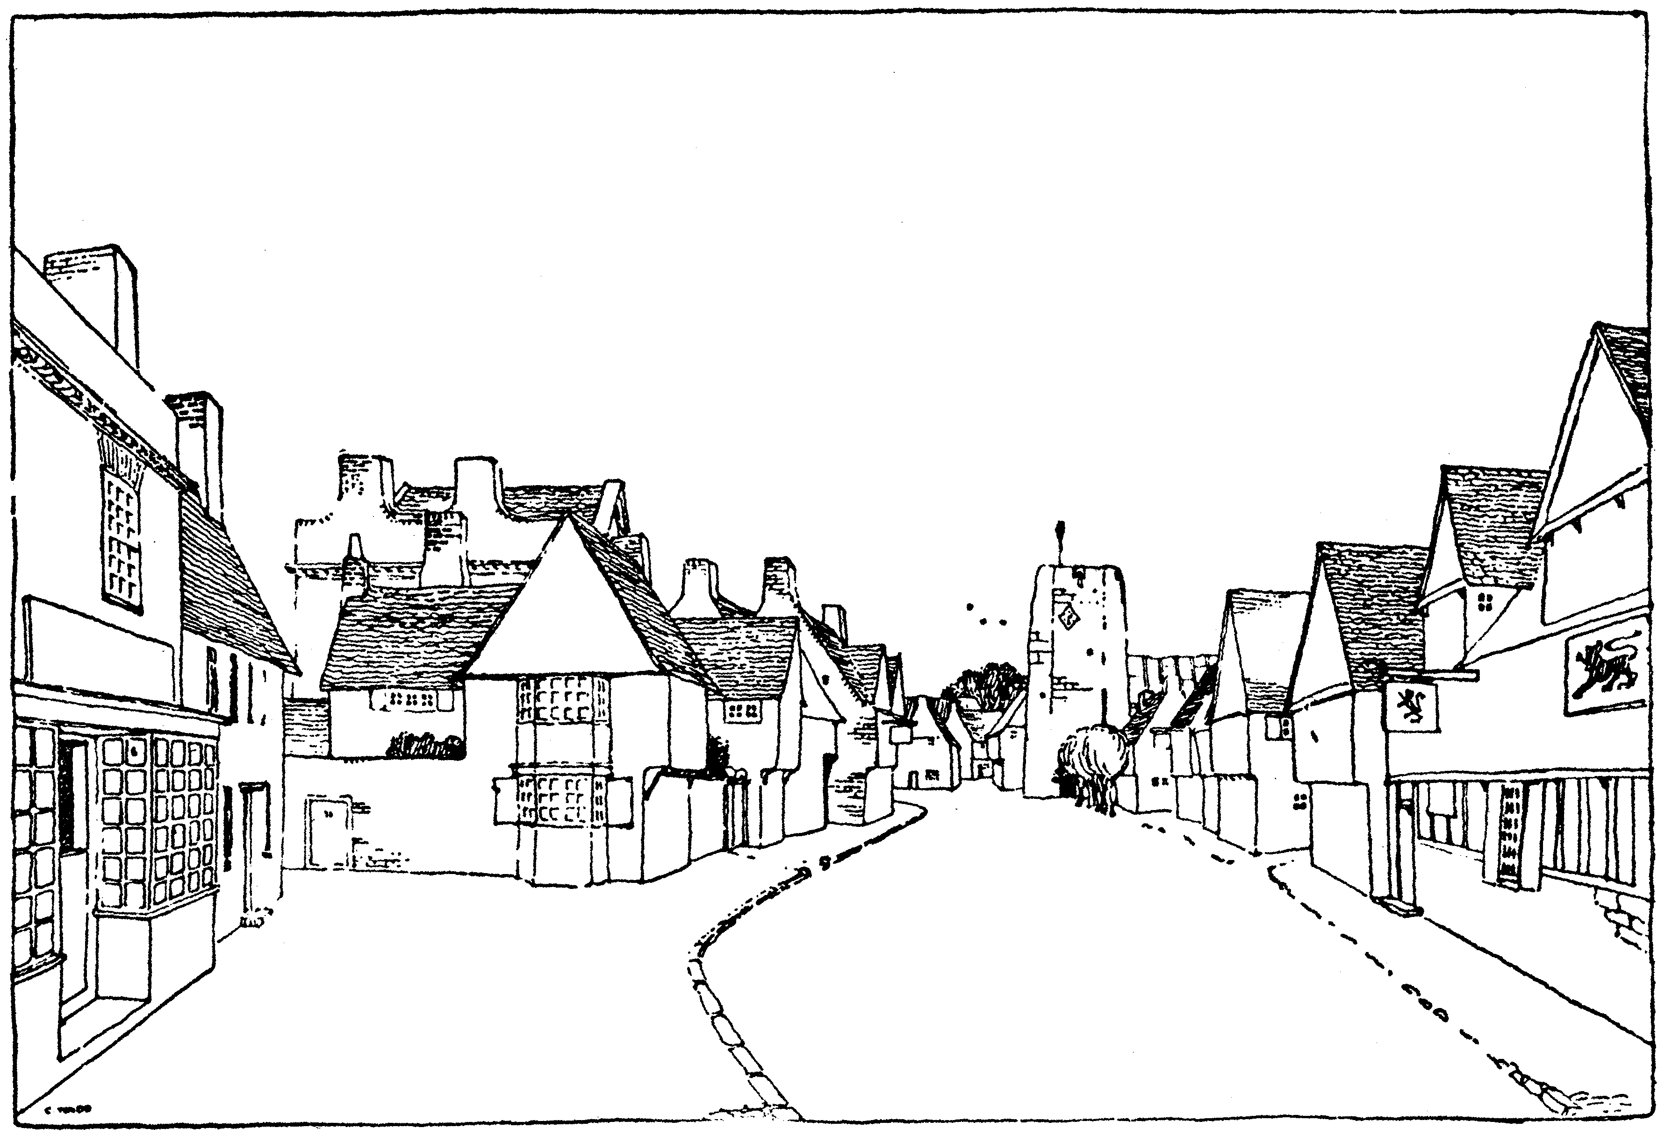
Raymond Unwin’s “garden city”: The starting point for Raymond Unwin was the (urban) planning of the new town or garden city with access to the open air and the countryside, in addition to the character of modern traffic. The garden city was located outside the old city (London) as it is described by Ebenezer Howard in “Garden Cities” and realised in the town of Letchworth from 1903, which Raymond Unwin was involved in planning - see figure 2. Raymond Unwin and Ebenezer Howard’s garden cities were intended to be placed in a satellite system surrounding major cities and based on “functional zoning”. In other words, in each town there were separate areas containing business and industry, educational establishments, and housing respectively. Inspired by the huge problems caused by the continued industrialisation of urban areas, Raymond Unwin himself says of the overall planning and zoning of the town: “We shall need the power to reserve suitable areas for factories, where they will have every convenience for their work and cause the minimum of nuisance for their neighbours.”
Figure 2: Example of the course of a road in a garden city

It is important to emphasise that Raymond Unwin’s town ends up consisting of several centres (as is the case for a modern town) containing, for example, industry or housing which are each placed in their respective area of the town. In these town planning considerations, the principle of the town divided up according to function is established as a boon. In other words, people now have to move between different areas of the town depending on their purpose. In this context, movement means traffic, and in 1909 Raymond Unwin presented a number of individual considerations with regard to the town and the “area” seen in relation to the road and the traffic - for example: “Roads are primarily for traffic. They serve also a secondary purpose in affording sites for buildings. They should therefore be considered in relation to both these functions, and in the order of their relative importance.”

Raymond Unwin thereafter takes as his starting point the work with the town’s physical layout defined by the sum of the roads, squares and buildings (“the oblong, the lots and the buildings”). Unwin draws parallels between the road through the town and the path of the railway line through a landscape, and on the basis of this metaphor tries to describe in more general terms how the traffic must be planned based on a road hierarchy: “For our most important and busiest highways we may well take a hint from the main railway lines, where central tracks are provided for the through expresses, and outside tracks for the slow stopping trains…… Leaving the track, only by those which have to pass right across it; and the number of points at which these crossings can take place may be restricted. In many of these roads special tracks are provided for tramways, for riding and for cycling, in addition to those for the ordinary fast and slow traffic of vehicles.”

Central to Raymond Unwin’s ideas are two types of road which he deems necessary to use in the town, “main roads (main arterias)” and “residential roads (crossroads)”, and the division of road users on the roads according to type and purpose. Raymond Unwin does not here define the roads’ function further, but he points out that the existing roads are in his opinion too wide, yet still do not provide enough space for all road users. With inspiration from America, Raymond Unwin specifies the need for producing a road cross section which has space for electrical or petrol-driven cars, trams and pedestrians, as well as the need for longer, straight streets. As previously mentioned, however, he is more interested in the course of the roads through the town and the town’s various centres and zones (residential area, railway station, industrial areas), and thus the town’s “beauty”, than in the division of the traffic itself on the road: “Except in cases where it is desirable to keep open distant views, straight roads indefinitely prolonged without change of direction or deviation of line are not only monotonous and destructive of satisfactory street pictures, but when running parallel to the direction in which high winds are liable to blow, are objectionable as developing their force to the utmost and creating a maximum of dust. Along these main roads a change of direction or a break in line must be managed in such a manner as not seriously to impede traffic.”

Where “main roads (main arterias)” cross each other, Raymond Unwin suggests large roundabouts as the ideal solution. Inspiration comes from France, e.g. “La Rue Soufflot” in Paris, but the central aspect for Raymond Unwin here is still the roundabout as a space or area within the town and not as a tool used solely for enabling traffic flow. Where roundabouts cannot be used in the town due to a lack of space, i.e. most often on “residential roads (crossroads)”, Raymond Unwin has written about the spaces, the roads and the houses in the town: “The essential thing is that every house should turn its face to the sun, whence comes light, sweetness and health. The direction of roads and the fronting to streets are details which must be made to fall in with this condition, or to give way to it.”

The central distinction between local and through traffic in town and road planning was, however, hardly Raymond Unwin’s own invention, but inspired from Germany, as can be seen from the following: “Unwin's desire to protect residents from through traffic brought a new dimension into British town planning and could be seen as a German influence.”

It is with Raymond Unwin, however, that the principle of the distinction between local and through traffic is adopted and positioned as the central element which would later be found in almost all road and town planning principles. Criticism of Raymond Unwin’s “aesthetic” and town planning ideas, and his lack of understanding of the time in which he lived is probably most clearly expressed by Le Corbusier: “Quite recently whole quarters have been constructed in Germany based on this aesthetic (around 1929, ed.). (For it was purely a question of aesthetics.) This was an appalling and paradoxical misconception in an age of motorcars. “So much the better,” said a great authority to me, one of those who direct and elaborate the plans for the extension of Paris; “motors will be completely held up”. But a modern town lives by the straight line: for the construction of buildings, sewers and tunnels, highways, pavements. The circulation of traffic demands the straight line; it is the proper thing for the heart of a town The curve is ruinous, difficult and dangerous; it is a paralyzing thing.”

Clarence S. Stein’s new American suburb: With inspiration rooted in the English “Garden Cities” and Raymond Unwin’s ideas, a new residential area was planned and built about 30 km outside New York by the architects Clarence S. Stein and Henry Wright in 1928. The suburb was called “Radburn”. The starting point here was the planning and construction of the “ideal” new town as a radical departure from the existing town such as, for example, New York. The principles for the design of Radburn are based in road planning terms on a desire to reduce the number of traffic accidents and create a peaceful town for people with motor vehicles.

The central element in Radburn is the idea of “the superblock”, a central, open area surrounded by houses, which in turn is placed around a number of “cul-de-sacs”, which all lead out onto a bigger road, which in turn surrounds a number of “superblocks”. In each house the kitchen thus faces the road and the living room faces the natural parkland surroundings, which meant that children’s games in any case took place in part on the kitchen side of the house and on the adjacent “cul-de-sacs” and not in the parkland surroundings. The planning of Radburn was the first attempt to produce a type of town in which the town and the motor car were considered in tandem. The planning of Radburn is based on five underlying principles.

“The Radburn Idea, to answer the enigma 'How to live with the auto', or, if you will, 'How to live in spite of it,' met these difficulties with a radical revision of relation of houses, roads, paths, gardens, parks, blocks, and local neighbourhoods. For this purpose, it used the following elements:

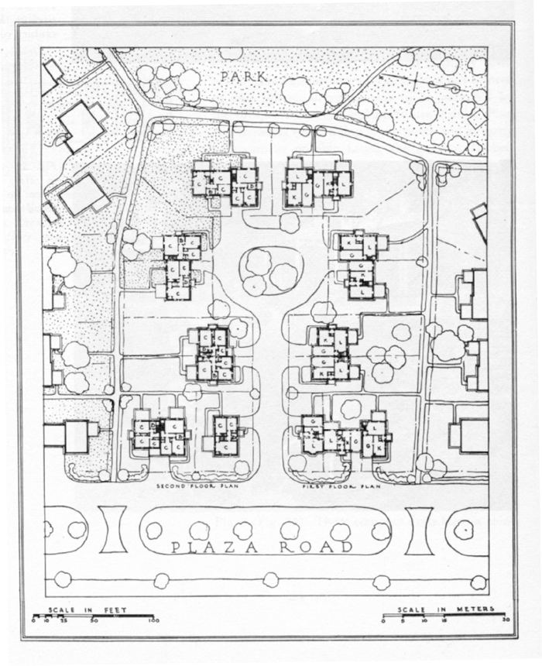
1. The SUPERBLOCK …..
Figure 3: Principle detail from Radburn, Burnham Place
2. SPECIALISED Roads PLANNED AND BUILT FOR ONE USER INSTEAD OF FOR ALL USERS…..
3. COMPLETE SEPARATION OF PEDESTRIAN AND AUTOMOBILE…..
4. HOUSES TURNED AROUND…..
5. PARK AS BACKBONE of the neighbourhood. …..”

In order to establish a town, a number of “superblocks” are combined to make up a “Neighbourhood Unit”, which according to Stein should contain about 10,000 people and a number of functions. In Radburn, which can be regarded as being a partly complete “Neighbourhood Unit”, there is an “Elementary school” (with access via footpaths) located centrally between the “the superblocks”, a “shopping centre” (with access via roads) located at a crossroads at the edge of “the superblocks”, and a sports field with tennis courts located by a railway station (with access via footpaths and roads). The characteristic feature of road planning in a collection of “Neighbourhood Units” is “the segregation” of traffic, expressed in the following:
“1. Homes must have direct access to a footpath system.
2. This footpath system must lead to all the gathering places of the inhabitants.
3. The motor vehicles will be completely separate from the path system, except at points of boarding and will serve areas through cul-de-sacs (or loops) with paths under, connected by a collector or ring road, with the outside world.”
The combination of these features is subsequently designated “the Radburn Principle” or “the Radburn layout”. Clarence S. Stein names Frederick L. Olmsted (the creator of Central Park from 1853 in New York) as the primary source of inspiration to “the Radburn layout” and the segregated roads and footpaths in the form of, for example, bridges, which separate pedestrian and motorised travel. Clarence S. Stein himself writes about the principles for road planning in Radburn:

“At Radburn we proposed to unscramble the varied services of urban streets. Each means of circulation would take care of its special job and no other: through traffic only on the main highways; with street intersections decreased about twofold; most parking as well as garages, delivery, and other services, on the lanes; walks completely separated from autos by making them part of a park instead of a street, and by under- or over-passing the roads; finally, children's play spaces in the nearby park instead of in busy roads. Specialised highways were in their infancy in the USA at the time that Radburn was conceived. Here was not much more than the differentiation of parkways and pseudo-expressways from the ordinary city or town street. To plan or build roads for a particular use and no other use required a predetermined decision to make specialised use permanent or rather long-lived. That was contrary to the fundamentals of American real estate gambling, to serve which the pattern of ordinary highways had become the basis of city planning. I say this in spite of the fact that the 1920s were the heyday of zoning. None of the realtors, and few city planners, who accepted zoning as their practical religion, seemed to have faith enough in the permanency of purely residential use to plan streets to solely that use. No, not even when the economy of so doing was clearly proved by Henry Wright and Raymond Unwin. Zone for dwellings? Yes, but don't give up the hope that your lot may be occupied some day by a store, gas station, or other more profitable use.”

The Radburn principle did not immediately gain acceptance in the USA. The Radburn principle and concept of “the Neighbourhood Unit” was, however, taken up in Europe after the Second World War, for instance in England, where it is referred to as a direct source of inspiration for “the New Towns” built in the period 1946-1950. However, “the Radburn layout” - see figure 3 can also be found as the source of inspiration in several other contexts associated with Colin D. Buchanan. The same is true of the idea concerning “segregation” of the traffic – see, for example, the Swedish “SCAFT” principles. In 1929 Geddes Smith describes Radburn as:

“A town built to live in - today and tomorrow. A town “for the motor age”. A town turned out-side-in without any backdoors. A town where roads and parks fit together like the fingers of your right and left hands. A town in which children need never dodge motor trucks on their way to school. A new town - newer than the garden cities and the first major innovation in town planning since they were built.”

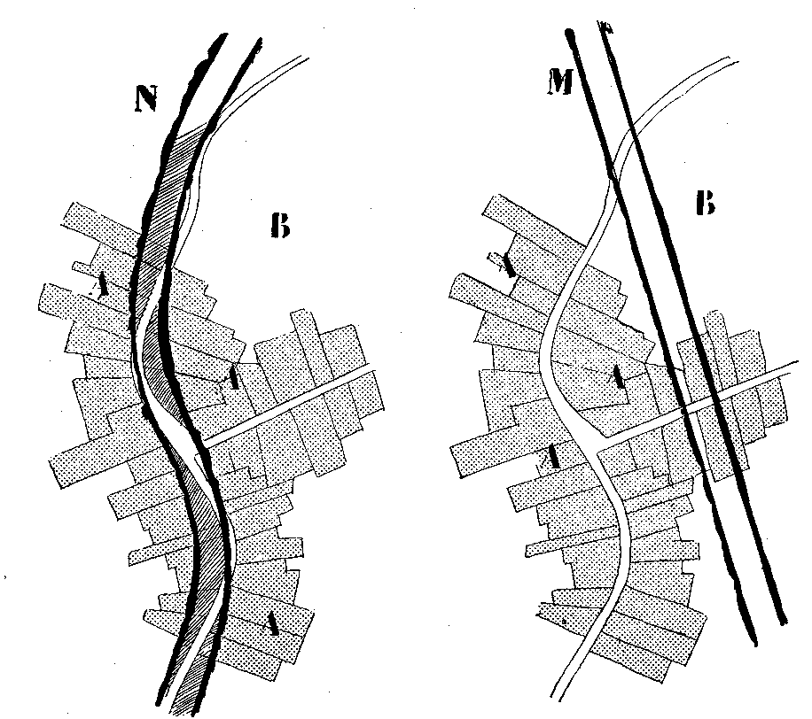
Le Corbusier and the functionalistic town: Le Corbusier and the functionalistic movement, which later represented the same planning ideals, formulated a radical proposal as long ago as 1933 for a different and new type of town that could solve the problems of the existing town. The principles behind the solution were called “Urban Functionalism” and are described by Le Corbusier in “The City of To-morrow and its Planning” from 1929 and the “Athens Charter” from 1933. The starting point for this type of town was in principle the same as for the romanticist Raymond Unwin, Clarence S. Stein and Henry Wright, etc. – a break with the polluted, dirty, dense industrial town and its traffic problems. Le Corbusier found his inspiration in the USA. The solution for him was to gather together the town and build it upwards. His aim was not to spread out the town as was the case for garden cities, which filled up the surrounding countryside, but instead to gather the town’s inhabitants into a few, very large, free-standing residential blocks with views of the countryside. “Therefore the centre of the city must be constructed vertically”. If one looks at the metaphors that Le Corbusier uses, it was his fascination with the machine that made Le Corbusier write of the town at the end of the 1920s: “A town is a tool”, and then of the house: “‘Citrohan’, not to say Citröen. That is to say, a house (should be) like a motor-car, conceived and carried out like an omnibus or a ship's cabin”, and finally of the road: “the street is no longer a track for cattle, but a machine for traffic, an apparatus for its circulation, a new organ”, and he continues: “The street is a traffic machine; it is in reality a sort of factory for producing speed traffic”.
Figure 4: Example of Le Corbusier traffic solutions
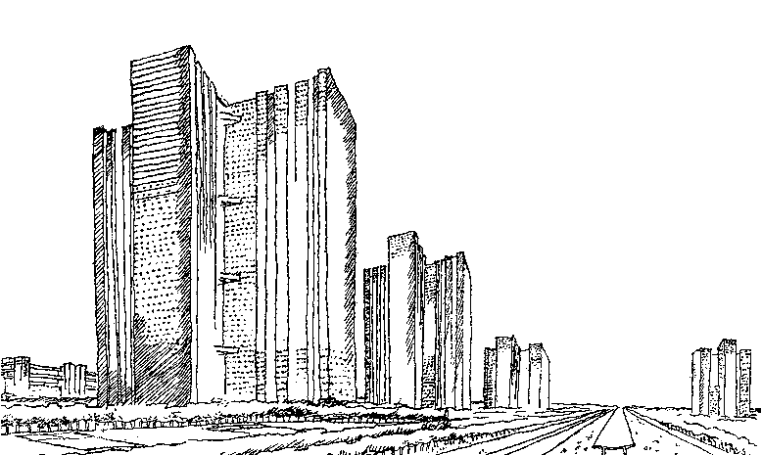
Figure 5: Le Corbusier's “City of Towers”
The starting point for Le Corbusier was his solid conviction that the existing city (Paris) was about to succumb to industrialisation, the growing number of cars and increased mobility. He therefore thought that: “It is time that we should repudiate the existing lay-out of our towns, in which the congestion of buildings grows greater, interlaced by narrow streets full of noise, petrol, fumes and dust; and where on each storey the windows open wide on to this foul confusion. The great towns have become too dense for the security of their inhabitants and yet they are not sufficiently dense to meet the new needs of “modern business”.

According to Le Corbusier, “Modern Business” demands “Speed” because one hundred thousand people have to be at work at 9.00 a.m. in the centre of the town. The key problems for Le Corbusier were the “congestion” and the “accidents” which the traffic from these one hundred thousand people created in the town. Therefore the existing old town centres had to be torn down, and new, straight roads had to be constructed which could ensure the necessary “Speed”, because “Speed is the very epitome of modern city” - see figure 5. Based on this, Le Corbusier described four principles on which the overall planning of the town should be based in the future: “1. We must de-congest the centres of our cities. 2. We must augment their density. 3. We must increase the means for getting about. 4. We must increase parks and open spaces”. The new centre of the town was, according to Le Corbusier, the town’s main traffic junction, “THE STATION”. The term “THE STATION” covers “aerodrome”, “highway junctions” and “subway station”. In order to solve the town’s pressing traffic problems, Le Corbusier proposed a classification of the traffic. This should be done directly, with reference to the fact that accidents, including those which involve pedestrians, could be avoided through such a classification. The solution was a transport system based on a grid layout and a classification of the road network in which the number of streets, and thereby intersections, could be reduced by 2/3 in relation to the traditional town because: “Traffic can be classified more easily than other things. Today traffic is not classified - it is like dynamite flung at hazard into the street, killing pedestrians. Even so, traffic does not fulfil its function. This sacrifice of the pedestrian leads nowhere.”

The road planning principles were further simplified by Le Corbusier and others at the CIAM congress in 1933, and are thereafter known as the “Athens Charter”. This charter contains 95 points and, in addition to requirements with regard to road planning in the town, specifies a number of other requirements concerning the planning and design of the town. These are reproduced here from “Via Constatation de IV CIAM” (About traffic):

We find:
51. The current traffic network within the towns is the sum of the branches that have been formed around the major main roads. In Europe the latter date all the way back to the Middle Ages, or in some cases as far back as ancient history.
52. The major traffic roads were originally designed for pedestrians and horse-drawn carriages, and therefore do not match the motorised forms of transport of today.
53. The width of the streets is often inadequate and prevents full utilisation of the new, motorised traffic’s speed and thereby prevents the town from gaining a corresponding lift.
54. The distances between road intersections are too short.
55. The widening of streets which are too small is often difficult, expensive and ineffective.
56. In the light of the motorised traffic’s speed, the current network of streets appears to be meaningless. It lacks precision, potential for adaptation, variation and coherence.
57. Pompous stretches of road for representative purposes have been, or can be, a considerable hindrance for traffic.
58. In many cases the development of towns has led to the railway network becoming a serious obstacle by confining residential areas and cutting them off from contact with the town’s vital areas.

We therefore propose:
59. that the town and region’s overall traffic is analysed on the basis of accurate statistics with the aim of ascertaining the major traffic arteries and their capacity.
60. that the traffic routes are classified according to their different functions, and that the roads are constructed according to the weight and speed of the vehicles using them.
61. that busy intersections are constructed with changes of level for continuous traffic.
62. that pedestrians must be able to follow different routes than the car.
63. that the streets are differentiated according to their purpose: residential roads, residential streets, main streets, through-traffic streets and streets for fast traffic.
64. that the major main traffic arteries are isolated using vegetation.

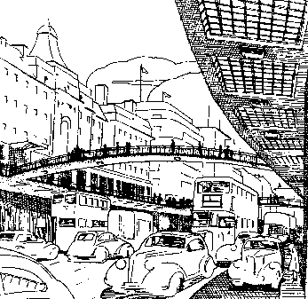
Criticism of Le Corbusier's planning has often stemmed from a reluctance to accept that one can change people’s behaviour via form, but also an appreciation that the world and people are not as rational as the impression that Le Corbusier gives in his analyses, and finally that the excessive use of the same form language, in this case functionalism/modernism, leads to fragmented and conformist cities: “This book (“The City of To-morrow and its Planning”, ed.) develops certain earlier ideas, some forcefully, some to the point of absurdity. The first three chapters attempt to show that a rectilinear geometry is not only functional, for speed, and beautiful, because clear, but the basis of the best culture as well. ‘Culture is an orthogonal state of mind’ is one of the absurd epigrams which typifies much of the argument, just as does the opening statement: “‘Man walks in a straight line because he has a goal and knows where he is going; he has made up his mind to reach some particular place and he goes straight to it....’” And: “For Le Corbusier, the barbaric disequilibrium of curved lines, jagged surfaces, and unclear decoration is inferior to the classical equilibrium of rectangles and pure volumes – ‘One is a symbol of perfection, the other of effort only.’ Behind these questionable views were two interesting ideas: first, the Purist concept that certain forms constitute a natural language, and second, that classicism was a natural result of modern industry” or “More important for the future, however, was the totally new conception of urban space proposed by Le Corbusier. The streets were, at least in principle, separated from the buildings, thus doing away with the corridor street. In spite of the very high population density, the apartment houses were surrounded by trees and lawns. Le Corbusier referred to it as a vertical garden city, but this idyllic image depended on the omission of contradictory features; like all his contemporaries, Le Corbusier left the noise and air pollution caused by motor cars and aeroplanes out of his picture.”
Figure 6: H. Alker Tripp's London

H. Alker Tripp’s road-safety town: With H. Alker Tripp the reference point is now 1940s England, and in particular London’s traffic problems, and the answer to the question of why people are killed and injured in traffic on the roads in existing urban areas. Tripp’s analysis is based on a redesign of the town’s “layout” and thereby on a number of planning considerations - see figure 6. His hypothesis is that: “Any town so planned that the citizens are killed and injured in vast numbers is obviously an ill-planned town”.

As previously mentioned, H. Alker Tripp’s point of reference is English urban areas and the town’s physical design, in particular London’s layout, and the analysis is clear and simple:
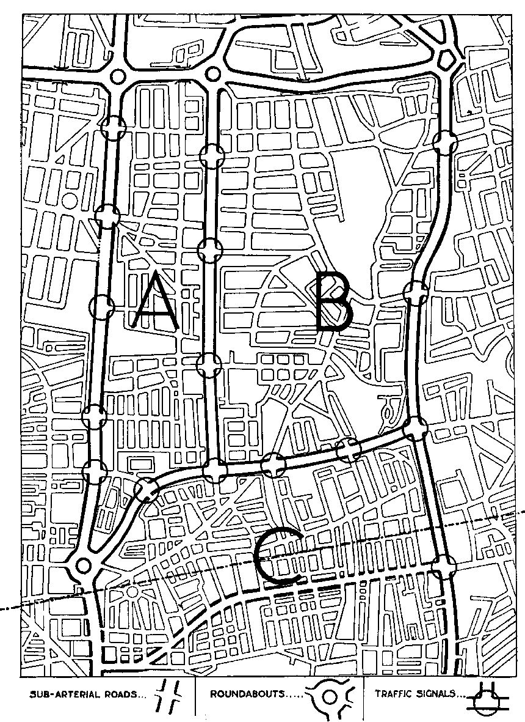
Figure 7: Principle sketch of road-planned urban area
“The whole trouble originates in unsuitable layout; the problem is fundamentally one of design and planning. On the railways, the toll of casualties is not comparable to that of the roads because the railways were from the outset designed for mechanical transport. The roads were not so designed. On the railways proper layout came first and high speeds afterwards; on the roads high speeds were introduced on primitive and unprotected tracks; and now, after more than a generation, the right kind of layout both in our towns and in the country at large is still awaited. All this will have to be changed. It is in the towns and built-up areas, which are the special field of the town planner, that the great majority of casualties are occurring”.

For Tripp, the solution to these problems is that via good road design it is possible to ensure control of movement on the roads: “The entire road system must be so designed as really to control movement, an end which has as yet been very seldom achieved”. This can be done by firstly carrying out a “zoning” of the town (according to function) and then a two-part “segregation” of the traffic between the zones in the town: “(i) Place-segregation” and (ii) “Time-segregation.”

H. Alker Tripp then proposes the creation of a road hierarchy consisting of three types of road defined on the basis of the type of traffic which the road shall accommodate:

(1) Arterial road – “These are the roads for long distance movement through the country, and for the heavy main traffic-flows in towns….(2) Sub-arterial road – “The sub-arterial, an intermediate class of road, is required to link up the main arteries with the various webs of minor roads…..(3) Local road – “The local roads are of quite a different category. In the country they are the lanes and byways; in towns they are the roads for residence, business and shopping. They will be so designed as to discourage through traffic of any kind from entering them at all.”

Figure 7 shows an example of Tripp’s division of an urban area. At the top is the “Arterial road”. There are 3 vertical “Sub-arterial roads” and the areas A and B are areas that are rebuilt, i.e. with few exits. Area C is only partly rebuilt according to Tripp’s principles and therefore has a lot of exits onto the bottom third “Sub-arterial road”.
The classification principle for the roads is supplemented by a number of intersection principles associated with each road type. Big roundabouts of up to approximately 180 metres in diameter are recommended for major roads. For minor roads T-junctions and “staggered crossroads” are recommended. Central to H. Alker Tripp is the reduction of the number of intersections on the so-called “Sub-arterial roads” in existing urban areas. Tripp describes very clearly which town he thinks is the ideal:

“Separation of existing residential, shopping or business areas from the lethal main traffic-streams. The ideal of planning is that people should be able to lead their daily lives without any contact at all with the through-traffic routes, save when they use the latter for purposes of transport. Daily life is lived in the precincts (three separate precincts, A, B and C, are shown in the diagram); it is there that shops and places of amusement should be located, not on the main roads. Where precincts are separated by a main artery (on which traffic is controlled by roundabouts), pedestrians and vehicles pass from one precinct to the other by means of subways; where, however, precincts border sub-arterial roads controlled by traffic signals, crossing is effected under protection of the signals.

The principles are elaborated in H. Alker Tripp’s description of the ideal town built on a radial design of roads, where in particular Tripp’s “Inner ring road” is the forerunner and inspiration for the later “inner ring roads”. However, the structuring of the town based on the road network leads to a number of recommendations – for example, with regard to “the main traffic flows”, which “should be regarded as sheer poison, to be completely isolated and on no account to be allowed to seep into the precincts”.

Tripp’s own answer to the question of how to increase road safety in the town, is in principle a town based on a railway-type road network laid out between a number of “precincts”. The town is turned around, and each urban area is, so to say, turned in on itself, or turned inside-out away from the railway-type road network. Interesting in this context are perhaps C. D. Buchanan’s remarks about Tripp’s ideas. C. D. Buchanan later says that Tripp’s considerations make up one of the most significant sources of inspiration to his book, “Traffic in towns”:
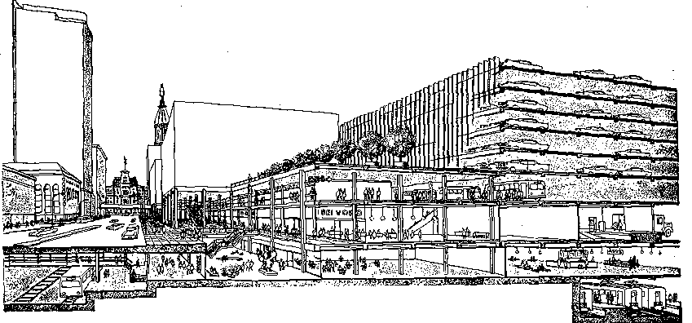
Figure 8: Colin D. Buchanan’s new year 2010 town
“Profound, too, was his notion of people leading their daily lives in the monastic seclusion of the precinct cells between the railway-like roads. From this was derived the idea of the self contained 'neighbourhood' of the post-war plans which some innate dislike of being compartmentalized seems to have blown out into ever looser and more nebulous forms. The financial implications, too, of some of these ideas were tremendous. The bold demand that shopping centres fronting on to arterials be 'turned round' to face a precinct street must have raised many an eyebrow amongst estate and valuation surveyors, for in fact this is an operation of extreme difficulty and protraction, except, and it is a very big exception, when the local authority is prepared to buy out the numerous interests and leases and assume redevelopment responsibility itself. It is when one considers carefully the full implications of H. Alker Tripp's theory - the searing of the town with a railway-like grid of roads and the literal turning of the place inside out - that the first qualms arise and one asks whether, if this is the price to be paid for the motor car, is it really worth having?”

Colin D. Buchanan’s modern town: It is, in fact, Colin D. Buchanan who ends up assuming the role of the originator of the road planning principles which for many have become synonymous with road planning’s ultimate attempt to destroy the classical European town. The starting point in this case was the analyses of four case studies: Newbury, Leeds, Norwich and a small section of central London. In “Traffic in towns” or “The Buchanan Report”, the English and the rest of the world get an idea – with radical examples – of how the town (the existing town and the new town) can be planned and thereby brought to function in a situation in the year 2010, when Colin D. Buchanan and others predict that there will be approximately 540 vehicles or 405 private cars per 1,000 inhabitants in England. Figure 8 shows an example of how the existing town could be rebuilt according to Colin D. Buchanan’s principles so that it could accommodate the huge increase in cars and traffic that would inevitably come.

Buchanan’s road planning principles were based on the perception of a town as consisting of a number of “buildings” where the activity of “traffic” begins and ends. Buchanan believes that: “In towns therefore, traffic can be said to be a function of buildings”. Note that “Traffic” in this case is synonymous with car/bus/truck and pedestrian traffic. A hospital is used as a metaphor for the town. Based on the traffic in the corridors between the rooms (kitchen, storeroom, day rooms and so on) in the hospital, a parallel is drawn to the traffic on the roads between the houses in the town. The main problem according to Buchanan is that the roads in the town – unlike the corridors in the hospital – often do not provide the opportunity for optimum “flow” to “traffic” due to the fact that they contain crossroads and stretches of road which are too narrow and which do not provide enough space for parking, and that access to “buildings” often takes place from the roadside, etc. All this creates a number of “environmental problems” such as “Safety, Noise, Fumes and Smell.” The central problem, “the essence of the problem”, is thereafter linked to three concepts: “accessibility”, “environment” and “pedestrian movement”. The concept of “accessibility” covers two aspects: “First, vehicle users should be able to move from one part of a town to another - or beyond – in safety and with reasonable speed, directness, and pleasantness from the 'driver’s eye view'. Second, on arrival in the vicinity of his destination the driver should be able to penetrate without delay close to his final destination and to stop there without restriction”.

The concept of “environment” covers: “A place, or an area, or even a street, which is free from the dangers and nuisances of motor traffic”.

The concept of “pedestrian movement” covers: “The simple act of walking plays an indispensable part in the transport system of any town”.

Buchanan then defines his problem starting from the 3 concepts of “accessibility”, “environment” and “pedestrian movement”: “…it is to contrive the efficient distribution, or accessibility, of large numbers of vehicles to large numbers of buildings, and to do it in such a way that a satisfactory standard of environment is achieved”.

The solution to the problem initially involves defining a road hierarchy consisting of two types of road in the urban areas: “distributors, designed for movement, and access roads to serve the buildings”. In this case there are four types of road in the urban areas: The Primary distributors, District distributors, Local distributors and Access roads. What remains between “the distributors” are urban areas which Colin D. Buchanan calls “the environmental areas”. The aspect that really characterises these areas is that they do not contain any through traffic: “It cannot be emphasised too strongly that the environmental areas envisaged here may be busy areas in which there is a considerable amount of traffic, but there is no extraneous traffic, no drifts of traffic filtering through without business in the area.”

In reality the “environmental area” is defined by how much traffic it generates: “The maximum size of an environmental area is governed by the need to prevent its own traffic building up to a volume that in effect necessitates sub-division by the insertion of a further distributory link in the network.”
According to Buchanan, this means in principle that in a given “environmental area” a sort of equilibrium can be established between the “traffic capacity” and “environmental capacity”. The relationship or equilibrium can be changed since “within any urban area as it stands, the establishment of environmental standards automatically determines the accessibility, but the latter can be increased according to the amount of money that can be spent on physical alterations”.

The “environmental areas”, which are “residential areas”, are recommended by Colin D. Buchanan to be planned directly on the basis of the Radburn principles: “(i) The creation of a superblock (or, as we would say, an environmental area) free from through traffic.” and “(ii) The creation of a system of pedestrian footpaths entirely separate from vehicular routes, and linking together places generating pedestrian traffic.”

Figure 9 shows a practical example of how roads can be led through an existing town, how wide they should be and where they should be located in the town. Colin D. Buchanan proposes that the ideal town should be designed around a cell-based hexagonal grid built-up around a three-way intersection. There is no doubt that “Traffic in towns” or “The Buchanan Report” had great impact; so much so that even 20 years after the publication of the report, Colin D. Buchanan himself concludes: “Yet, in spite of all the effort, it was widely misinterpreted, being taken by many people to be a blueprint for the total reconstruction of towns and cities with traffic circulations at different physical levels, costing a fortune and not very nice to look at into the bargain”, and “The principles were demonstrated by application to a number of real places: Newbury as a small town, Norwich as a larger town with a heritage of historic buildings, Leeds as a large industrial city, and a sector of London lying to the west of Tottenham Court Road and north of Oxford Street. These exercises were widely misunderstood to be firm recommendations, but in fact they were simply demonstrations to show what might be achieved for accessibility and environment for varying amounts of physical change (i.e. expenditure).”
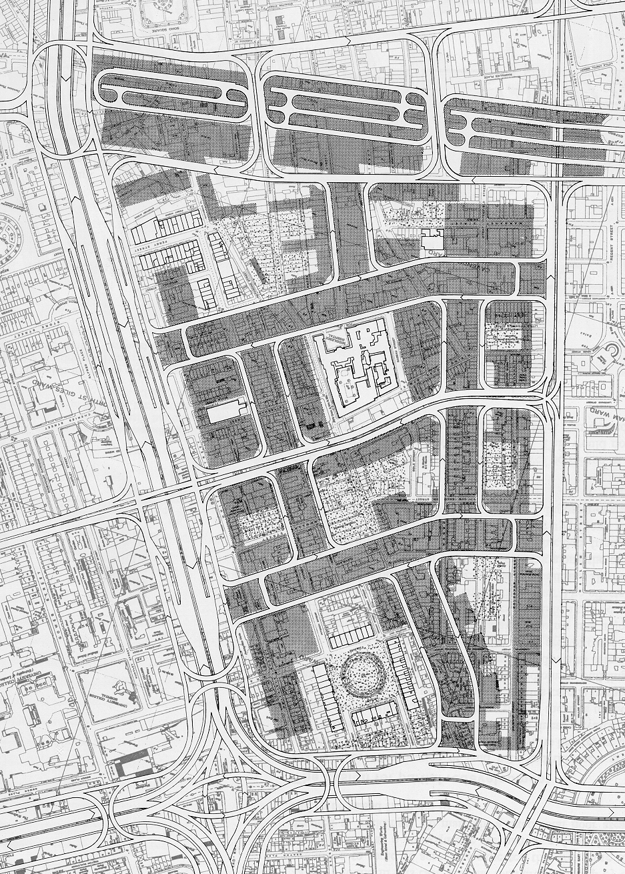
Figure 9: Colin D. Buchanan’s large-scale road planning
Buchanan himself subsequently points out what he found most important, and what the report led to: “They confirmed an earlier finding that in small towns it should be possible to accommodate most of the car usage that might be desired in the future, but the larger the town the more difficult and expensive it becomes to the point that restrictions on car usage emerge as realistic policy. This was a revolutionary finding at the time - the notion that there was no obligation on city authorities to try to accommodate all future traffic demands, indeed that it was impossible to do it, came as a shock to many in the engineering world. The very idea that a street had two capacities for the passage of traffic - a 'crude capacity', when considered simply as a channel for the passage of vehicles, and an 'environment capacity' when the effects of traffic on pedestrians, residents and so on were taken into account - was a rude intrusion into the engineers' world.”

The road planning principles described in “The Buchanan report” were, as previously stated, the subject of long-lasting debate. Even 20 years after its publication, the report’s conclusions still provoke opposition.

“The twenty years since Traffic in Towns has taught us a great deal about the urban transport problem. If the conceptual framework had not been expressed with such clarity, the learning would have been more difficult. The Report revealed the issues so well, and discreetly mapped out the economic, social and environmental matters, which were to steadily move up the urban policy maker's agenda. An inescapable conclusion from the experiences since the publication of Traffic in Towns is that too much is to be lost from the lack of integration of transport development and management, from failure to co-ordinate public and private transport planning, from inadequate treatment of the relationship between transport and the environment and poor integration of transport and land use development.”

Or expressed in a slightly different way from Sweden: “The American model (like Colin D. Buchanan’s, ed.) was built primarily on a system of urban freeways often brutally overlaid onto the existing town as, for instance, in the plan for Helsinki from 1968 (Smith, 1968). The European model was also based on urban freeways and radical measures, but still represented a more balanced approach with differentiation within the existing road network, the implementation of pedestrian streets and other traffic calming measures.”

But criticism has also come from other quarters and with other points of reference, namely that Colin D. Buchanan’s predictions on the increase in car ownership in major cities was simplified, and that the development should also be seen in the light of continued urbanisation – trends which were already on the way when “Traffic in Towns” was written, but which were overlooked. Major new highway projects in existing urban areas were, or are, therefore not always necessary, but should be seen in relation to the town in question’s potential for development: “The problem with Traffic in Towns is that it relied on a trend forecast in car ownership, but assumed in its analysis that the changes in urban form that were already strongly evident would not continue.”

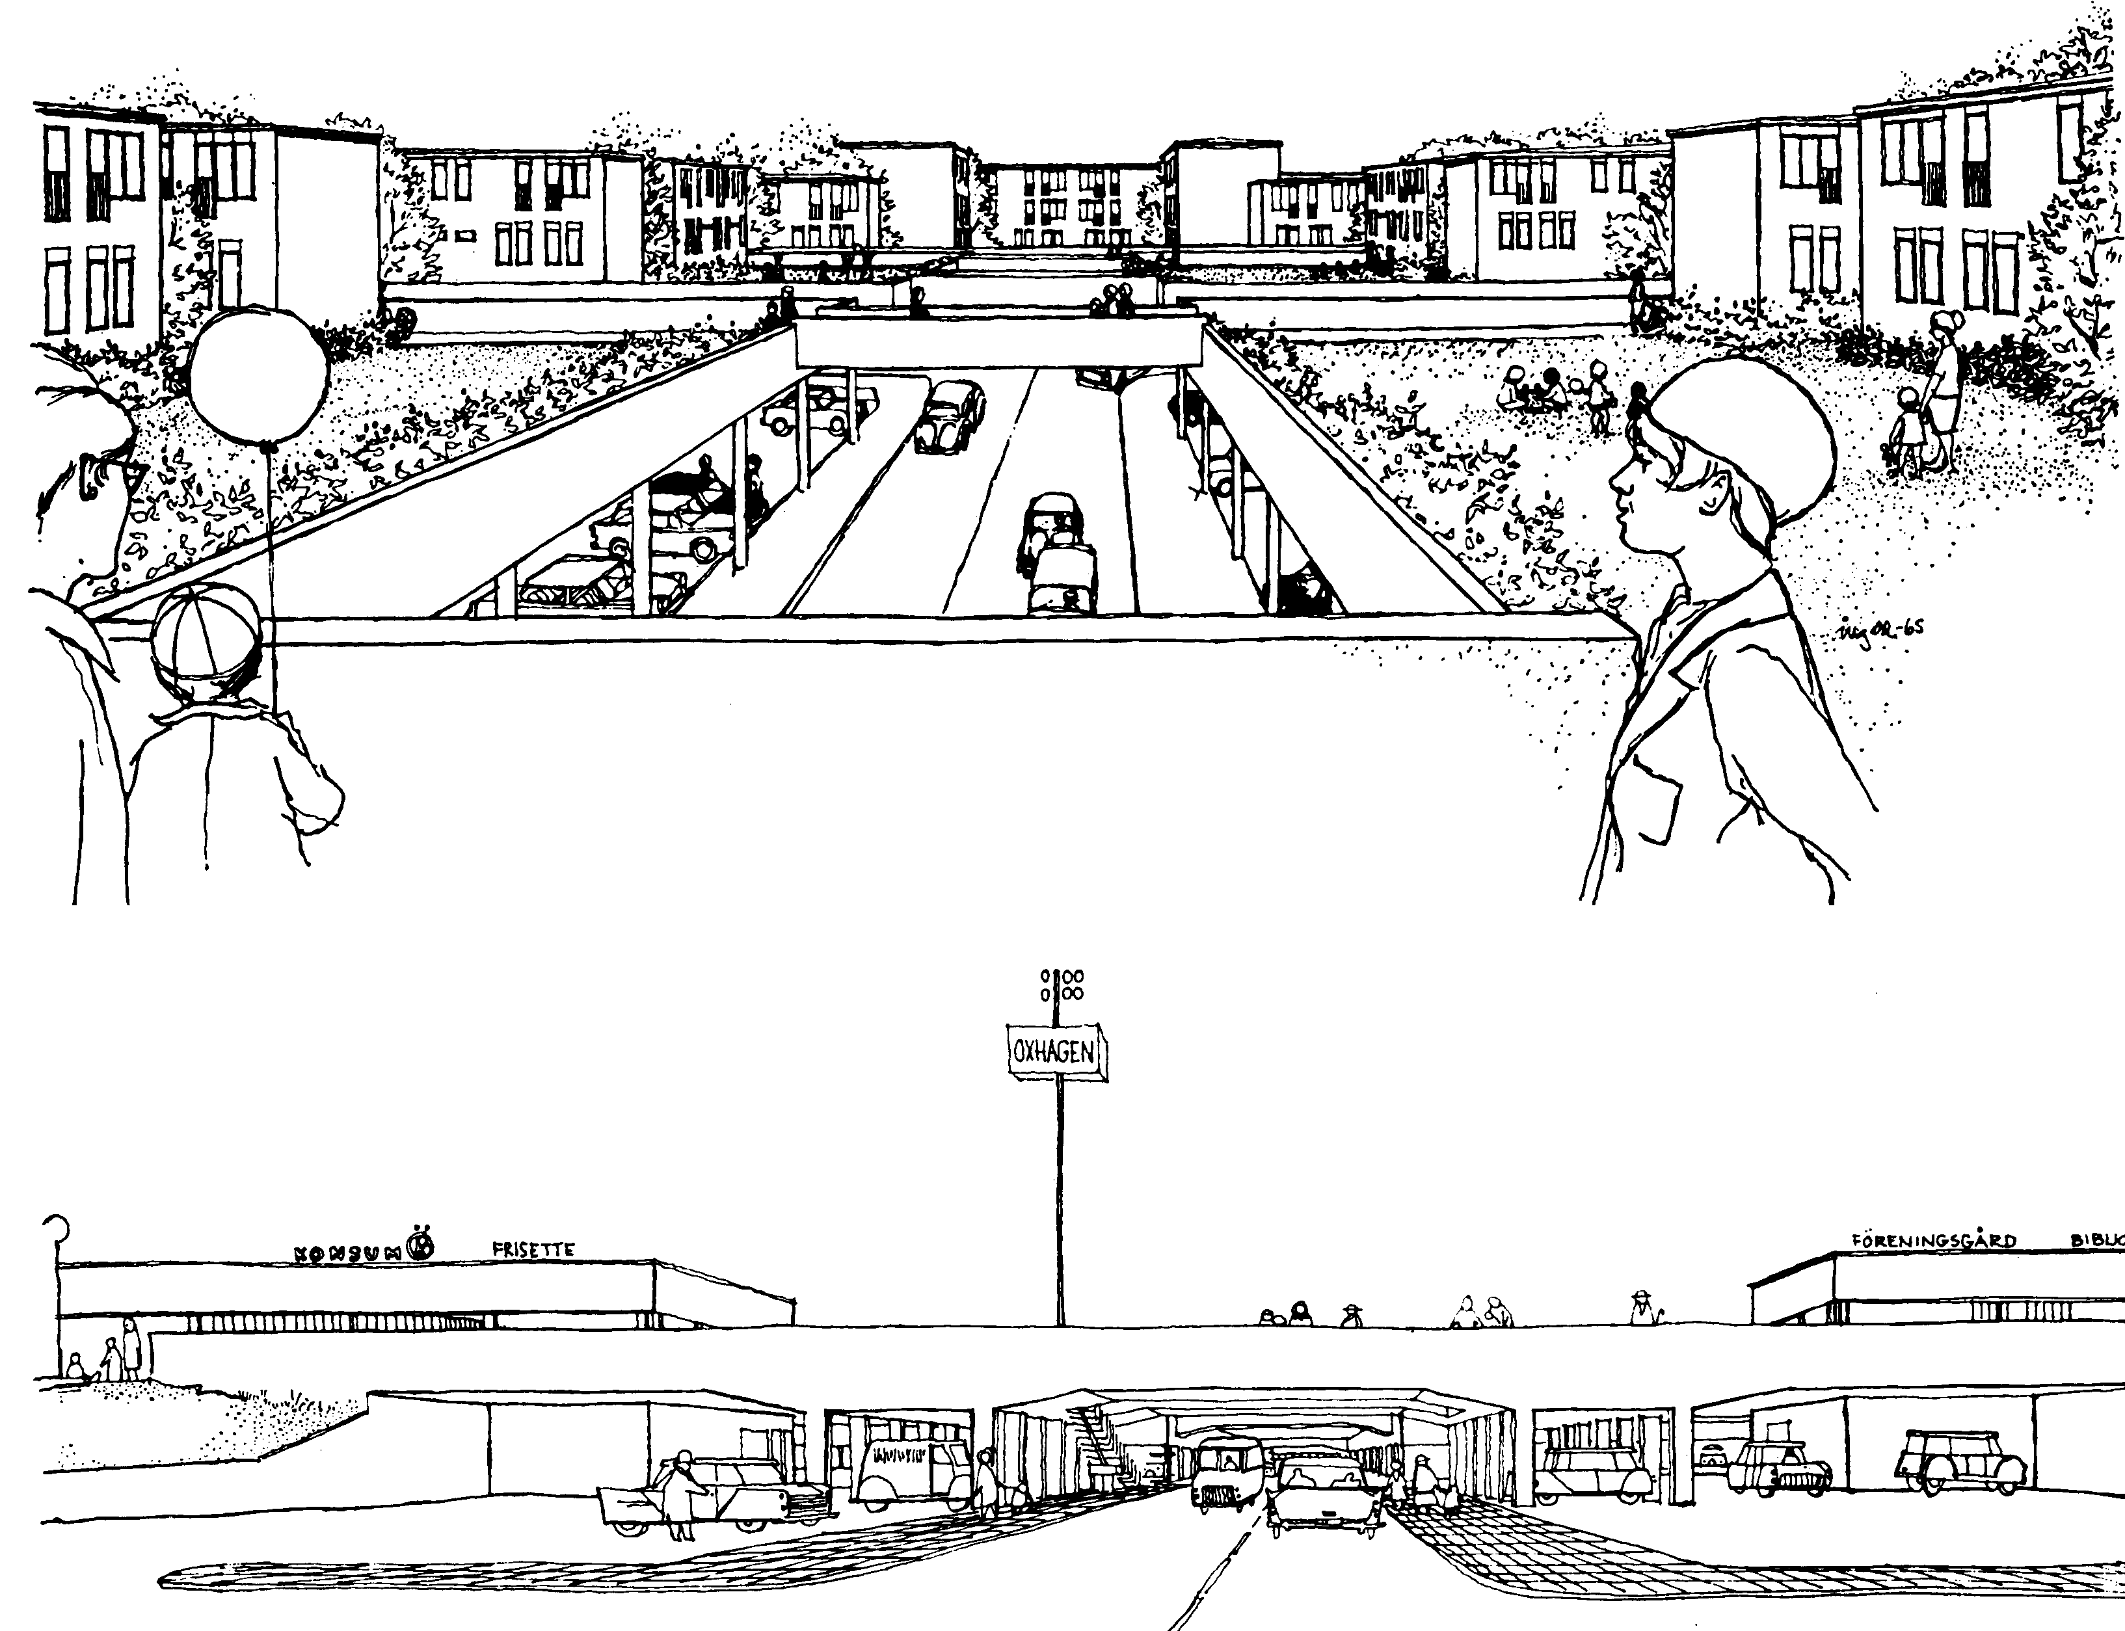
S. Olof Gunnarsson and the “SCAFT” town: S. Olof Gunnarsson, Sune Lindström et al began working in 1961 on new principles for Swedish road and town planning. This resulted in the so-called “SCAFT 1968” publication, which became known throughout the world, and which was also literally translated into Danish that very same year. The publication provides guidelines for “Town planning” with regard to the construction and planning of new urban areas, see figure 10. Then in 1972 S. Olof Gunnarsson et al published “PRINCIPLES FOR TRAFFIC CALMING WITH REGARD TO ROAD SAFETY”, hereinafter called “SCAFT 1972”, with road planning principles for existing urban areas which did not become as well known as the “SCAFT 1968” principles, but whose content is in actual fact just as revolutionary. This last publication was produced by a working group which called itself “SCAFT 1972”. The first point of reference for both the “SCAFT 1968” and “SCAFT 1972” principles was the attempt to improve road safety in the towns by reducing the number of “conflicts and disorder in the traffic”. These measures aimed to reduce the number of those killed and injured in traffic by 50 %. The second and third points of reference were that “it is not feasible to reduce the number of accidents simply by reducing the number of cars. We need the cars. Instead we should try to use then in the right manner”, and finally, “it is easier to adapt the environment to man, than to adapt man to the environment”. An example of the ideas’ practical realisation is shown in figure 11. The following section deals primarily with a review of the “SCAFT 1972” publication and the principles of how traffic calming in existing urban areas should be carried out. The starting point for the “SCAFT 1972” ideas on traffic calming in the existing town was – as for Colin D. Buchanan – recognition of the fact that a lot of urban areas lack the prerequisites to meet the demands resulting from increasing vehicular traffic. However, the aim in this case was not – as for Buchanan – to show how more space could be created for cars in the town. The preliminary realisation was that road planning cannot be carried out in existing towns in the same way as in new towns since the possibilities for “traffic segregation and traffic differentiation” in existing towns do not always exist. For example, according to S. Olof Gunnarsson et al it was almost impossible to imagine the vertical separation in existing urban areas required in order to achieve the road safety and environmental standards which could be achieved in new urban areas. Traffic calming measures were therefore needed, and traffic calming meant actual physical changes to the roads aimed at reducing vehicular traffic and its consequences for selected urban areas. The concept of “traffic calming” is defined here as: “Planning and implementation of a series of co-ordinated measures in order to improve the traffic environment within a built-up area primarily with respect to road safety and as far as possible reduce the traffic’s impact on its surroundings”.
Figure 10: New town according to SCAFT 1968 principles

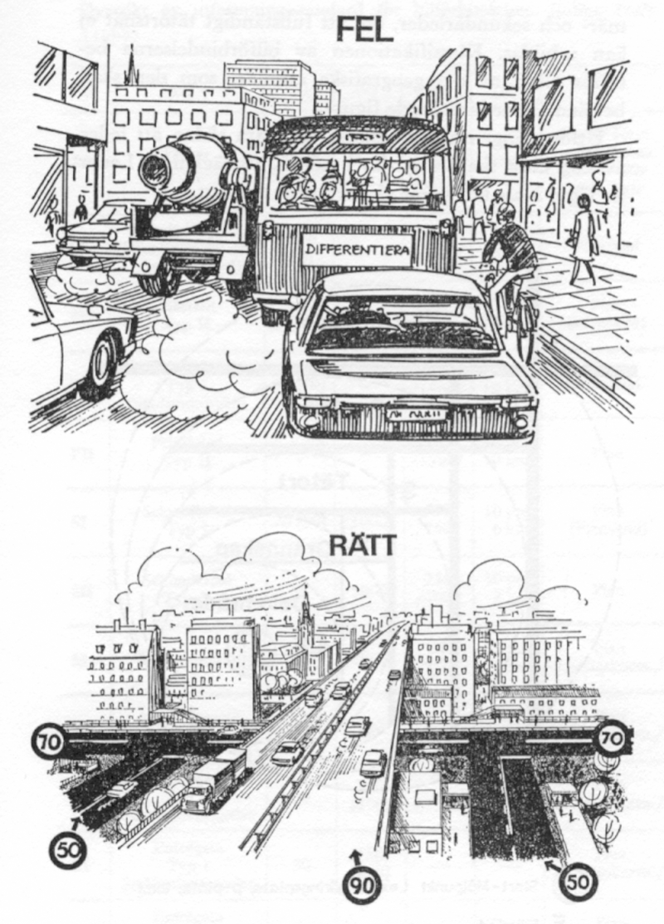
S. Olof Gunnarsson et al proposed that in the case of traffic calming, two types of plan could be used: plans for immediate traffic calming and plans for more long-term traffic calming of existing urban areas. Furthermore, the plans should be integrated into municipal planning. Proposals for traffic calming in these plans should be based on seven principles, see for example figure 12: “1. Schools’ and service functions’ catchment areas are co-ordinated with the traffic network’s layout so that conflicts between vehicular traffic and pedestrian and cycle traffic is reduced. Companies that generate serious conflict situations between different modes of transport are relocated if possible. This may apply to industry and similar which are situated in residential areas, and shops and playgrounds situated on streets carrying through traffic…. 2. Vehicular traffic is concentrated on a limited number of roads and streets. Through traffic is led around built-up areas through the systematic closing of streets or conversion to one-way streets…. .3. The footpath and cycle path network’s major routes are developed so that segregation is maintained between vehicular traffic and pedestrians and cyclists…. 4. Yards and plots are reorganised so that protected playgrounds and open spaces are maintained…. 5. Streets and intersections which have a high accident rate or which are expected to become critical as a result of changes in traffic flow, are regulated or rebuilt. A uniform, simple and clear traffic environment is aimed at…. 6. The standard of public transport is improved with higher journey speed, regularity, frequency, safety and comfort…. 7. In certain areas vehicular traffic is reduced through parking charges and parking restrictions. Kerbside parking is prohibited in general, at any rate on main roads, and parking is transferred instead to combined car parks with good connections to major roads.”
Figure 11: Town according to SCAFT 1972 principles

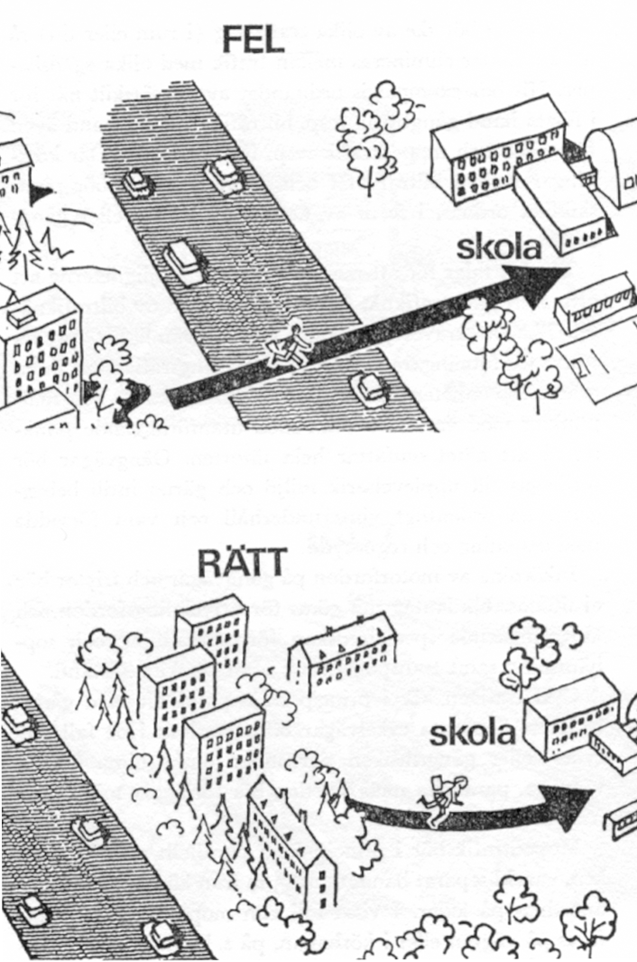
The principles were based on a number of theses which formed the foundation for work with road planning. The theses describe “the occurrence of road traffic accidents and their link to the traffic environment” and are the foundation on which the principles in the “SCAFT 1968” and “SCAFT 1972” publications are based. As was the case in “SCAFT 1968”, “SCAFT 1972” introduced a road classification scheme which was based on the differentiation of traffic as the method of implementing road planning in existing urban areas. The central aspect here is the relationship between the road’s function and the road’s standard. At the same time a number of coherent, independent, transverse networks were introduced: the “pedestrian and cycle network”, “bus network” and “car network”. For each network a number of special requirements were specified. For example, eighteen requirements are specified for the “car network” alone, where the first point is that: “1 The car network is designed with consideration of the existing built-up area and countryside and is subordinate to pedestrian and cycle traffic’s requirements.” With regard to traffic differentiation, on which road classification is based, it was expressed more generally that: “Traffic differentiation involves the division of traffic with different functions and characteristics within the same traffic network so that traffic flows are as homogeneous as possible. Traffic differentiation is a crucial principle in terms of reducing the conditions for disorder and conflicts occurring in and from the traffic. The advantages of such a function differentiation include: 1. Road safety is improved since traffic with different transport tasks and different distances between the point of departure and the destination is separated. 2. The average journey speed is improved since the traffic is homogenised with regard to purpose, speed and type of vehicle. 3. The environment is improved since large continuous areas free of disturbing vehicular traffic can be implemented. 4. The traffic network is clearly, uniformly and simply laid out. 5. Construction costs for the car network will be lower since the traffic is concentrated on a limited number of high-class roads.”
Figure 12: Result of application of SCAFT 1968/1972

With regard to the classification of the roads in Swedish urban areas, a general speed limit of 50 km/h in urban areas was introduced, although occasionally speed limits of up to 70 km/h were used. At places where the networks for cycles, pedestrians and cars overlapped each other, the speed limit was reduced to 30 km/h. In order to assist with road planning, a table containing four road types, each with their specific characteristics, was drawn up for use in existing towns - see table 2. The principles are processed and presented as a number of solutions for the implementation of traffic calming in urban areas directly inspired by the American Harold Marks, H. The first results from urban areas traffic-calmed according to the “SCAFT 1972” principles in Sweden were accompanied by the following remarks: “Traffic calming was implemented to a particularly high degree in the town centres where one had tried to reduce the amount of motorised traffic. In terms of accident rates, it was shown that the total number of accidents had fallen in the traffic-calmed areas. The number of accidents causing material damage had fallen, but it was difficult to say anything in general about the effect with respect to accidents causing personal injury. Overall, the accident picture was very inconsistent and a general increase in road safety for the more vulnerable road users could not be demonstrated. In terms of the environment, the removal of the through traffic had led to less noise and less carbon monoxide in the individual zones, even though the motorised traffic had to drive further owing to the closure of roads. There was an increase in the amount of traffic outside the zones, and the individual road user had to drive further in order to reach his or her destination.” And “The form of traffic differentiation operating very much according to the rules which “SCAFT” represents has, however, met some criticism during recent years. It has been pointed out that the guidelines from “SCAFT” do not solve the problems for the light road users (cyclists and pedestrians) or for public transport”

A more general criticism of the “SCAFT” principles, in particular “SCAFT 1968”, has been put forward by OECD and by the Swede Anders Hagson: “The “SCAFT” guidelines have recently (1979, ed.) been criticised for the relative dullness created by the uniformity of the street layout, the difficulties for public transport services and the lack of economic criteria”. And “ … the “SCAFT” paradigm is based on a flawed theory concerning traffic environment – traffic accidents in towns. It is not true that “older town planning” with a mix of businesses, a mix of traffic, exits from entrances, intersecting streets, anomalies in the layout of streets and kerbside-parked cars in itself leads to road user behaviour which results in many injuries and deaths. It is only when the speed of the vehicles is high that the problem occurs.

Table 2: Retrieved from “Meddelande 55-1972”
 | Type of network |  |  | Regional network |  | Local urban network |  |  | Neighbourhood network
 | Type of vehicle route |  |  | National road | Regional road | Primary local road | Secondary local road | Secondary street | Feeder road | Feeder street | Approach road | Local  Street | Access road * | Pedestrian street *
1 | Highest permitted speed (km/h) |  |  | 110 | 90 | 70 | 50 | 50 | 50 | 50 | 30 | 30 | 30 | 30
2 | Maximum driving distance (km) |  |  | - | 30 | 10 | 3 | 3 | 1 | 1 | 0.2 | 0.4 | 0.2 | 0.2
3 | Minimum distance between intersections (c/c m) |  |  | 2,500 | 1,000 | 500 | 250 | 200 | 50 (100) | 50 (100) | - | - | - | -
4 | Type of intersection between street or road of same or lower class |  |  | Flyover (level) | Flyover  (level) | Flyover (level) | Level | Level | Level, 3-way (level, 4-way) | Level, 3-way (level, 4-way) | Level | Level | Level | Level
5 | Parking restrictions: SF = stopping prohibited PF = parking prohibited P = parking permitted |  |  | SF | SF | SF | SF | SF (SP) | SF | PF (P) |  | PF |  | PF
6 | Direct connection to property, real estate |  |  | None | None | None | None | Occasional | None | Limited number | None | Yes | Yes | Yes
7 | Maximum amount of traffic (pe/dh) |  |  | - | - |  |  |  | 800 | 800 | 200 | 200 | 50 | 50
8 | Lane width (m) |  |  | 3.5 | 3.5 | 3.5 | 3.5 | 3.5 | 3 (3.25) | 3 (3.25) | 3 (3.25) | 3 (3.25) | 2.75 | -
9 | Protected area min. (m) |  |  | 25 | 25 | 10 | 5 |  | 5 | - | 3 | - | - | -
10 | Traffic in/ or immediately adjacent to road | Moped |  | No | No | No | No (Yes) | Yes | No | Yes | Yes | Yes | Yes | No (Yes)
10 | Traffic in/ or immediately adjacent to road | Cyclists |  | No | No | No | No | No (Yes) | No | Yes | No | Yes | Yes | No (Yes)
10 | Traffic in/ or immediately adjacent to road | Pedestrians | Primary pedestrian route | No | No | No | No | No (Yes) | No | No (Yes) | No | No (Yes) | No | Yes
10 | Traffic in/ or immediately adjacent to road | Pedestrians | Secondary pedestrian route | No | No | No | No | Yes | No | Yes | No | Yes | Yes | No
11 | Type of crossing between motorised vehicle routes and primary pedestrian and cycle routes |  |  | Pedestrian tunnel/ bridge | Pedestrian tunnel/  bridge | Pedestrian tunnel/  bridge | Pedestrian tunnel/  bridge | Regulated | Pedestrian tunnel/  bridge (Unregulated) | Regulated (Unregulated) | Unregulated | Unregulated | - | -

Appendix 3.13 Note: (Blank fields) New planning standard – In older built-up areas this standard may be in the very long term. (Shaded fields) Traffic calming standard – In older built-up areas this standard has been achieved within the general plan’s time horizon (15-20 years) - ( ) Special case - * Pedestrian and cycle priority streets.

Analysis and conclusions: A review of the six “classical road planning references” shows that road planning evolves over time, and that the functional road planning method, expressed through the idea that “Form follows function” by L. H. Sullivan, is in fact presented as early as 1909 by Raymond Unwin. Road planning is first and foremost seen as a method of reconstructing and strengthening the layout of the classical town (Raymond Unwin), although the town here is already planned with several centres and thus more transport. At this point in time, the motor vehicle has almost no significance. Road planning then becomes a method to avoid road traffic accidents and create continued traffic flow in the town (Clarence S. Stein, H. Alker Tripp, Le Corbusier). In particular, with Le Corbusier’s focus on traffic flow or “speed”, the references in terms of layout used in more classical town planning and road planning are removed, and the town is – so to say – blown to pieces. The motor car is the main problem, or part of the main solution, c.f. Le Corbusier. Finally, road planning is seen as a method to control vehicles’ impact – in the form of accidents and environmental nuisances – in certain parts of the town (Colin D. Buchanan and S. Olof Gunnarsson). With regard to the latter, a serious question mark was put against the continued legitimacy of the car’s presence in urban areas in 1972, but this notion had no major impact. The review shows clearly that even at a very early stage detailed formal requirements regarding individual road types had been formulated. The first of these involved requirements with regard to the width of the road (Raymond Unwin), then to the type of traffic on the road (Clarence S. Stein, H. Alker Tripp, Le Corbusier) and finally to the speed which one wanted the vehicle on the road to use (Colin D. Buchanan and S. Olof Gunnarsson).

The number and complexity of the requirements with regard to road planning increase over time and reach their peak with “SCAFT 1968” and “SCAFT 1972” (S. Olof Gunnarsson). At the same time the review shows that the individual road planning principles’ relationship to the town become increasingly influenced by the car. This occurs at the same time as the requirements with regard to the road network become increasingly detailed. Finally, the road planning principles contain no descriptions of what the town actually is (c.f. the reference to the layout of the hospital), or what is to happen to the town, or how it should be laid out in a classical town planning manner (see Colin D. Buchanan and S. Olof Gunnarsson). The focus has switched solely to focusing on solving the problems which the road, the motor car and the town create. This shift can be illustrated by the changing perception of the urban area. The urban area changes from being defined by its layout to being defined by its function - for example as a residential area (Raymond Unwin). Finally the urban area becomes something which is defined and limited solely by the amount of traffic it generates, and is called, for example, “the environmental area” (Colin D. Buchanan and S. Olof Gunnarsson).
This shift can be seen at three levels. Firstly, through the recommendation of turning the individual urban areas inwards, i.e. away from the traffic (Clarence S. Stein, H. Alker Tripp). Secondly in relation to the recommendations concerning the orientation of the individual buildings. Initially, it is recommended that the most important facade must face the sun and the roads laid out accordingly (Raymond Unwin). This evolves into a subsequent recommendation that the houses’ most important facades, and preferably the entire primary facade of the house, should face away from major roads with heavy traffic (Clarence S. Stein, H. Alker Tripp and Colin D. Buchanan). Finally, at a more general level the shift can be seen through a wish to gather and combine particular functions in particular areas – schools in residential areas, business and industry in industrial areas and so on (S. Olof Gunnarsson). However, this desire has already been noted before the car makes its presence felt in the town (Raymond Unwin), and the reason given here is a desire to accumulate, for example, businesses and industry in certain parts of the town due to a number of environmental considerations. The review also shows, however, that the principal argument in the six “classical road planning references” for using road planning is the potential for increasing road safety (all references), although references are also made to the fact that several other types of capacity, traffic flow and environmental problems will be able to be solved through the use of road planning (Le Corbusier, H. Alker Tripp, Colin D. Buchanan and S. Olof Gunnarsson). In this context it is worth noting that the solution of traffic flow problems is considered to be something positive (Le Corbusier, Colin D. Buchanan and S. Olof Gunnarsson), even though H. Alker Tripp, with his road safety vision, is the one who emphasises the road safety aspect in road planning the most. More generally it can be seen that in the majority of the six “classical road planning references” a number of common propositions are employed based on a desire to reduce the number of road traffic accidents. These involve, for example, the proposition with regard to the appropriateness of dividing the road network into roads for local and through traffic. These propositions are not often documented in the “classical road planning references”, but appear as logical and reasonable principles; see, for example, the idea that: “The entire road system must be so designed as really to control movement, an end which has as yet been very seldomly achieved”. (H. Alker Tripp). It is not until later that a methodical attempt, with a basis in empirical references, is made to account more scientifically for the value of these propositions (S. Olof Gunnarsson). In this regard it is worth noting that in a number of cases the propositions are initially formulated in the “classical road planning principles” and then (often much) later rendered probable.

As a result, it is here deemed that the “classical road planning references” should be seen as examples of a collection of “best practice” in which the implementation of the principles has been dependent on local conditions in the local context. The “SCAFT” principles (S. Olof Gunnarsson) are the only principles which systematically seek to refer to proper scientific studies. It is therefore beneficial to perceive the “classical road planning references” more as sources of inspiration for the local road planning principles of the future in urban areas, rather than as actual complete solutions. As will be seen on the next few pages, this is what in fact happens in practice. The experiments from real-life practice have, however, had good results overall. But what is this discussion between “classical road planning references” really all about?

It involves two disciplines, town planning and road planning, which aim to solve what they regard as problems in urban areas, and thereby create the basis for their legitimacy in their own and others’ eyes. The starting point for both disciplines is the wish to offer us all a life in “good and attractive towns” with “safe and efficient road systems”, something that we are all looking for to a greater or lesser degree. It is something which is perceived as being synonymous with towns with a few cars and towns with a lot of cars respectively. Each in their own way the disciplines try to meet this demand based on their own terms, but are bound by a common destiny since they take as their starting points the same geographical and physical area – namely the urban area or the town – and are in reality based on the same planning method – the functional method. This common destiny can be expressed as a number of propositions which seem to be mutually incompatible, but which efforts are made to reconcile. At the same time “good and attractive towns mitigate against safe and efficient road systems” and “safe and efficient road systems mitigate against good and attractive towns”. On the other hand, no-one demands “good and attractive towns without safe and efficient road systems” nor does anyone demand “safe and efficient road systems without good and attractive towns.” It is proposed here that it may be beneficial to perceive the “classical road planning references” as a concrete proposal for solutions for reconciling these two propositions, even though it can be shown that the point of reference here ends up being road planning principles which seek to create “safe and efficient road systems” which dominate that which one within the classical town planning tradition called, and still call, “good and attractive towns”. Solutions as to how one creates “good and attractive towns” and “safe and efficient road systems” respectively have in other words changed. However, it is proposed here that the underlying propositions, problems and dilemmas have not necessarily done so. Finally, it can be demonstrated that these classical references, with one exception (H. Alker Tripp), are based directly on architects’ and planners’ considerations, analyses and solutions based on the dictum “Form follows function” and a number of other North American considerations. European architects and planners should therefore take account of this fact before they give the car or others the blame for the development of the modern town that surrounds us today.

Table 3a: Summary description of the 6 classical road planning references:
 | Policy:  (Strategic level) | Planning:  (Tactical level) | Practice:  (Operational level) | Road safety and traffic flow: | Road planning and town planning ideals:
Raymond Unwin: “Town planning in practice” 1909:  The new town | The vision is to create beautiful urban spaces.  Road planning shall support a compact town with a Gothic-inspired village-look. | The roads shall connect the town centre and the districts of the town. In the districts in which there are residential areas, the roads shall express this. The curved road is preferred to the straight road. Radial town layout. | 2 road types:  1. “Main roads”  2. “Residential roads.”  Large roundabouts and T-junctions are used. | The function and course of the roads shall be subordinate to the requirements of the town, and thereby each house’s requirements and orientation towards light and fresh air. Attractive, classical spaces. | The town, the district and the houses must be attractive places in which to live and function.  The house turns its main facade towards the road.  “Area” = “The functional zone”
Clarence S. Stein (Radburn 1928):  The new town | The vision is to separate motorised traffic from pedestrians/playing children and cycle traffic in order to prevent road traffic accidents.  Road planning shall create an open town with few traffic accidents and help to create an open, low town surrounded by parkland scenery. | The road is integrated as a method of physically separating road users from each other. This can be done by leading the roads over cycle paths and footpaths.  Extensive use of no-through roads in residential areas.  (no well-defined layout). | 4 road types and a footpath system:  1. “Express highways (for movement)”  2. “Main through traffic roads (for collection).”  3. “Secondary collector roads (for collection).”  4. “Service lanes (for service and parking).”  5. “Walks (for cyclist and walking).”  Spatial segregation of road and footpath network. | The course of the roads shall ensure undisturbed life in residential areas.  At the same time, the roads shall ensure fast connections between districts and towns.  The majority of roads shall be located such that the town is perceived as a parkland area when seen from the road. | The town, the district and the house shall primarily fulfil a number of social and functional requirements, and secondly meet a number of aesthetic requirements, for example be situated in green surroundings.  The house’s facades are equally important and turn both towards the road and the garden.  “Area” = “Neighbourhood Unit”
Le Corbusier (“The City of To-morrow and its planning” 1929 and the “Athens Charter” from 1933):  The new town | The vision is to separate different types of traffic from each other on their own individual road networks in order to ensure “Speed.”  Road planning shall ensure the open but compact town and promote the efficiency of the high-rise town. | The road shall create the efficient connection in the town. The straight road is preferred to the curved road  Total physical separation of the traffic network on different transport levels in the town.  Grid urban layout. | 3 road types and a footpath system:  1. “Roads for heavy traffic (below ground)”.  2. “Roads for ordinary traffic (at ground level).”  3. “Roads for fast traffic (over ground on pillars).”  A footpath system (ground level). | The road is an independent machine that shall produce traffic. The road shall not function to create space, but as a road with the function of making room for transport.  The road shall ensure “speed” and be straight. | The town, the district and the houses shall be gathered together. The density of the town is increased, building shall take place upwards and everything shall function efficiently like machines. The high-rise block has no direction, and the residential house has equal facades.  “Area” = “the Cellular”

Table 3b: Summary description of the 6 classical road planning references:
H. Alker Tripp (“Town planning and Road traffic” 1942) :  The existing town | The vision is to ensure that people do not get hurt in the urban traffic.  Road planning must ensure a town with a road network in which only a few accidents happen. | The road system shall be developed around the principles for “Time and place segregation”.  Road planning shall control the consequences of “movement”.  Radial urban layout. | 3 road types:  1. “Arterial roads (for through traffic).”  2. “Sub-arterial roads (connection between arterial and local roads).”  3. “Local roads ( for local traffic).”  Large roundabouts and T-junctions. | The roads are regarded as 2 networks, each with its own function: either railway-type transport corridors for “through traffic” or local roads for “non-through traffic”.  “The sub-arterial roads” are linking roads between the 2 other road types. | The town shall be divided by “the arterial roads”. The districts are turned inwards towards “the local roads”. The houses shall turn their primary facades away from “the arterial roads” and towards “the local roads”.  “Area” = “the precinct”
Colin D. Buchanan (“Traffic in towns” 1963):  The existing town | The vision is to describe how space can be created for a growing number of cars in the town.  Road planning shall help to ensure a reduction of a number of problems: “The environmental problems with safety, noise, fumes and smell.” | The road system is classified and developed around the town’s areas, which are defined here as “environmental areas”.  Grid urban layout (hexagonal). | 3 road types:  1. “Primary distributors.”  2. “Secondary distributors.”  3. “Local distributors.”  “Flyovers” and T-junctions.  Several new transport levels are created in the town. | The roads shall meet the demands the car makes on them in order to continue to be an efficient means of transport. | If it is not possible to invest the necessary amount of money, demands must be placed on the traffic on the roads in the form of reductions in vehicular traffic. In other words a balance is created between the area’s “traffic capacity” and “environmental capacity.”  “Area” = “the environmental area”
S. Olof Gunnarsson (“SCAFT 1968” and “SCAFT 1972”):  The new and existing town | The vision is to ensure a marked fall in the number of road traffic accidents in new and existing urban areas.  Road planning shall, based on a few simple principles, ensure a town with few road traffic accidents. | The road system is based on a detailed road classification. The road types are defined by 11 variables – for example speed and distance between intersections.  In traffic calming areas, different combinations of one-way streets and closed roads are recommended.  Grid urban layout. | 5 road types:  1. “Primary local road 70 km/h”  2. “Secondary local road 50 km/h (Secondary streets)”  3. “Feeder road 50 km/h (Feeder street)”  4. “Approach roads 30 km/h (Local streets)”  5. “Access roads 30 km/h (Pedestrian streets)” | The road’s function, and thereby the relationship between traffic flow/road safety depends on the road type.  The town and the houses’ location shall be subordinate to the road’s/the traffic’s requirements. | The town, the district and the house shall primarily fulfil a number of social and functional requirements.  “Area” = “Neighbourhood”

References:

Alexander, C. (1965): “A CITY IS NOT A TREE”, (Part II), The Architectural Forum, Billboard Publications, (Publishers)

Andersen, H. (1998): “Klassisk og Moderne Samfundsteori”, ISBN 87-412-2885-5, Hans Reitzels forlag, (Publishers)

Appleyard, Donald (1981): “Liveable Streets”, Berkeley, University of California Press, (Publishers)

Baumeister, R. (1876): “Stadterweiterungen”, Berling, Ernst & Korn, (Publishers)

Bech-Danielsen, Claus et al., ed. (2001): “Modernismens genkomst”, ISBN 87-7407-253-6, Arkitektens forlag, (Publishers)

Bendtsen P. H. (1962): “Byplanlægning II”, 3rd edition, Akademisk forlag, (Publishers)

Bennet G. T. et al. (1978): “Road accidents in traditionally designed local authority estates”, Supplementary report 394, ISSN 0305-1315, TRL, (Publishers)

Brindle, R. (1996): “Living with traffic”, Special report, Arrb Transport Research Ltd. Special report No. 53, ISSN 05572-44x, ISBN 0-869-10-697), Arrb Transport Research Ltd., (Publishers)

Buchanan, C. D. (1958): “MIXED BLESSING THE MOTOR IN BRITAIN”, Leonard Hill Ltd., (Publishers)

Buchanan, C. D. (1963): “TRAFFIC IN TOWNS”, Reports of the Steering Group and Working Group appointed by the Minister of Transport, Her Majesty's Stationery office, (Publishers)

Burke, G. (1971): “Towns in the making”, ISBN 0-7131-5556-6, Edward Arnold Ltd., (Publishers)

Cameron , J. W. M. (1977): “The influence of the layout of the road network on road safety: a literature review”, Technical Report RF/3/77, National Institute for Transport Research, South Africa, (Publishers)

Cameron, J. W. M. (1977): “The influence of the layout of the road network”, RF/3/77, Technical Report, National Institute for Transport and Road Research, South Africa, (Publishers)

Camillo, C. Sitte (1945): “The Art of Building Cities According to Artistic Principles”, REINHOLD PUBLISHING CORPORATION, (Publishers)

Cherry, E. Gordon et. al. (1980): “Shaping an Urban World”, ISBN 07201-0903-5, Mansell, London, (Publishers)

Cherry, Gordon E. (1974): “THE EVOLUTION OF BRITISH TOWN PLANNING”, ISBN 0-249-44135-7, Leonard Hill Books, (Publishers)

Choay, Franqcoise (1969): “The modern city” LCCCN No. 77-90408, Gorge Braziller, New York, (Publishers)

Christaller, Walter (1966): “Central places in Southern Germany”, Prentice-Hall INC., Englewood Cliffs, N. J. , (Publishers

Collins, G. R (1965): “City Planning according to artistic principles, by Camillo Sitte”, (1889), Columbia University studies in art history and archaeology, Random house, New York, (Publishers)

Corbusier, Le (1987): “The City of To-morrow and its planning”, (1929) ISBN 0-486-25332, Dover Publications Inc., (Publishers)

Corbusier, Le, (1965): “La maison des hommes”, (1945), (Danish Translation: “Menneskenes bolig”, Translation: Grete Mikkelsen, Editing: Ole Buhl) Vintens Forlag, (Publishers)

Corbusier, Le, (1985): “Towards A New Architecture”, (1927), Paperback 85139-692-5, Briddles Ltd., (Publishers)

Dijkstra, Atze (1997): “A sustainably safe traffic and transport system: déja-vu in urban planning?”, D-97-12, SWOV Institute for Road Safety Re-search, The Netherlands, (Publishers)

Elvik., R, (1991): “Ulykkkesteori”, Metode-Teori, ISBN 82-7133-701-7 TØI, (Publishers)

Evans, Hazel (1972): “New Towns”, ISBN 85314-135-5, Charles Knight & Co. Ltd., (Publishers)

Goudaappel, H. M. og Perlot, J. A. (1965): ”Verkeer en stad”, Stedebouw-kundige studies 4, VUGA- BOEKERRIJ, (Publishers)

Giedion, S. (1967): “SPACE, TIME AND ARCHITECTURE”, fifth edition (1967), Harvard University Press, (Publishers)

Gunnarsson, S. O. (1968): “Att trafiksanera är nötvändigt”, Särtryck ur kommunal tidskrift nr. 7, 1968 , Kommunforbundet, (Publishers)

Gunnarsson, S. O. (1995): “Samhälle, livsstill, trafik och trafikplanering”, Meddelande 1995:4, Chalmers University of Technology, (Publishers)

Gunnarsson, S. O. (1995): “Vägtrafiken - et människa-maskin-miljö-system med stora riskvariationer”, Meddelande 1995:4, Chalmers University of Technology, (Publishers)

Gunnarsson, S. O. (1999): “TILBAKABLICK: “SCAFT” 1968 RIKTLINJER”, Meddelande 1999:2, Chalmers University of Technology, (Publishers)

Gunnarsson, S. O. et al., (1970): “Vägen til Trafiksäkerhet”, Rabén & Sjögren, (Publishers)

Hagson, Anders (2000): “Stads- och trafikplaneringsparadigm - om behov for nya principer och samverkande åtgärder för en bättre stadsmiljö”, (Förhandsutgåva), RAPPORT 2000:4, ISSN 1400-1888, Chalmers tekniske högskola, (Publishers)

Hall, Peter (2002): “Cities of Tomorrow”, ISBN 0-631-23264-8, Blackwell,, (Publishers)

Hart, D. A. (1976): “Strategic Planning in London”, Pergamon Press, (Publishers)

Hass-Klaus, C. (1990): “The Pedestrian and City Traffic”, ISBN 1-85293-121-3, Belhaven Press, (Publishers)

Holston, James (1989): “The modernist City”, ISBN 0-226-34978-0, University of Chicago Press, (Publishers)

Howard, E. (1945): “GARDEN CITIES OF TOMORROW”, (1998), FA-BER AND FABER LTD., (Publishers)

Jencks, Charles (1987): “LE CORBUSIER AND THE TRAGIC VIEW OF ARCHITECTURE”, PENGUIN BOOKS LTD., (Publishers)

Kain, John. F. (2001): “A tale of two Cities”, pp. 31-70, Journal of Transport Economics and Pohey, Volume 35, Part I, January 200I, pp. 31-70, JPE, (Publishers)

Kjærsdam, F. (1995): “Byplanlægningens historie”, ISBN 87-7307-475-6, Aalborg University, (Publishers)

Kornstra, M. J. ed. (1991): “Naar eeen duurzam veilig wegverkeer”, ISBN 90-801008-1-1, SWOV, (Publishers)

Kraay J.H. et al. (1982): “DE VERKEERSONVEILIGHEID IN WOON-WIJKEN”, Publikatie 1928-IN, SWOV, (Publishers)

Ling, Arthur (1967): “Urban form or Chaos”, APTI Journal 1967, Vol. 53 No. 3, APTI,(Publishers)

Leccese, Michael ed. et al. (1999): “CHARTER OF NEW URBANISM” ISBN 0-07-135553-7, McGRAW-Hill, (Publishers)

Maclcher, Fritz (1935): “The Steadyflow traffic system”, Cambridge Harvard University Press, (Publishers)

Marks, H. (1957): “Subdividing for Traffic”, Traffic Quarterly, Vol. 11, 1957 No. 11, pages 308-325

Michl, Jan (1995): “Form Follows WHAT? ”, 1995. “Form follows what? The Modernist notion of function as a carte blanche.” Page 31-20. 1:50 - Magazine of the Faculty of Architecture & Town Planning [Technion, Israel Institute of Technology, Haifa, Israel] (10, Winter), (Publishers)

Mumford, Lewis (1942): “Stadskultur”, Kooperativa Förbundets Bokförlag, (Publishers)

Neilsen, R. S. (1972): “Land transport systems for the future” in: Papers of the National Road Safety Symposium, Canberra, March 1972. (Canberra: Australian Government Publishing Service), (Publishers)

Nordquist, S. (1989): “Trafik & miljø i Stadskärnan”, ISBN 91-87246-48-1, Allmänna Förlaget, (Publishers)

Nordqvist, Stig, ed. (1966): “Sagt af Sune Lindström”, Rundqvists Boktryckeri, (Publishers)

Pak-Poy, P. G. (1968): “Some comments on principles which should govern the long-range planning of urban road systems”, 9th international study week in traffic engineering and safety, London, (Publishers)

Peponis, John (1989): “Space, culture and urban design in late modernism and after”, Ekstics 334 Jan/Feb 1989, ISBN 0013-2942, Athens

Rasmussen, S. E. (1975): “LONDON - DET NYE LONDON”, ISBN 87-00-96-921-4, Gyldendals bogklub, (Publishers)

Reichow, H.B. (1959): “Die autogerechte Stadt; Ein weg aus dem Ver-kehrs-Chaos”, Otto Maier Verlag, Ravensburg, (Publishers)

Ritter, P. (1964): “Planning for Man and Motor”, Pergamon Press Ltd., (Publishers)

Savage I . C. (1966): “An Economic History of Transport”, Hutchinson University Library, (Publishers)

Schaffer, D. (1982): “Garden Cities for America, The Radburn Experience”, ISBN 0-8722-258-4, Temple University Press, Philadelphia, (Publishers)

Schaffer, F. (1970): “The New Town Story”, ISBN 261-63170-5, MACGIB-BON & KEE, (Publishers)

Shoppert, D. W. (1957): “Predicting Traffic Accidents from Roadway Elements of Rural Two-Lane Highways With Gravel Shoulders”, Highway Research Board Bulletin, No. 158, p. 4-25 Washington DC, Highway Re-search Board, (Publishers)

Sitte, C. (1965): “City Planning according to artistic principles”, Columbia University studies in art history and archaeology, Random House, New York, (Reprinted), (Publishers)

Solomon, D. (1964): “ACCIDENTS on main rural highways RELATED TO SPEED, DRIVER, & VEHICLE”, US DEPARTMENT OF COMMERCE, BUREAU OF PUBLIC ROADS, US Government Printing Office, Washington DC, July 1964, (Publishers)

Stein, C. S. (1966): “Toward New Towns for America”, THE M. I. T. PRESS, (Publishers)

Strong, Ann L. (1971): “Planned Urban Environments”, ISBN-0-8018-1245-3, John Hopkins Press Ltd., London, (Publishers)

Sullivan, L. H. (1947): “The Tall Office Building Artistically Considered. ” in: Athey I., ed. “Kindergarten Chats (revised 1918) and Other Writings”. New York, Wittenborn, Schultz, (Publishers)

Sutcliffe, A. (1980): “The rise of Modern Urban Planning, 1800-1914”, ISBN 0-7201-0902-7, Mansell, (Publishers)

Sutcliffe, A. ed. (1984): “Metropolis 1890-1940”, ISBN 0-7201-1616-3, Alexandrine Press, Oxford, (Publishers)

Tetlow, J. et al. (1968): “Homes, Towns and Traffic”, S.B.N. 571-04014-4, FABER AND FABER, (Publishers)

Tripp, H. A. (1942): “TOWN PLANNING AND ROAD TRAFFIC”, Butler & Tanner Ltd., (Publishers)

Unwin, R. (1933): “Memorandum”, Second Report of the Greater London Regional Planning Committee, December, London: Knapp Drewitt & Sons Ltd., (Publishers)

Unwin, R. (1994): “Town Planning in Practice”, Second edition 1911, Princeton Architectural Press, New York, (Reprinted), (Publishers)

Whittick, A. (1974): “Encyclopaedia of Urban Planning”, 1974, ISBN 0-07-070075-3, Von Hoffmann Press Inc., (Publishers)

Åstroöm, Kell (1967): “ Svensk stadsplanering”, AB Byggmästarens Förlag, Stockholm, (Publishers)

“Athens Charter” (1985), (1942), Byplanhistoriske Note 3. Ernst Kri-stoffersen, ISSN 0900-3274, Dansk byplanlaboratorium, (Publishers)

“Built Environment” Volume 9, (1983), Number 2, “Buchanan Twenty Years After: Traffic in Towns Today”, Alexandrine Press, (Publishers)

“Færdselslov (The Danish Highway Code) §40” (1978), Subtitle: “Nye former for trafiksanering, Betænkning nr. 827”, ISBN 87-503-2350-4, Danish Ministry of Justice, (Publishers)

“Meddelande 55-1972”, Principer för trafiksanering med hänsyn til tra-fiksäkerhet, CHALMERS TEKNISKA HÖGSKOLA - INSTITUTIONEN FÖR STADSBYGGNAD, (Publishers)

“Meddelande 55-1973”, Trafiksanering - Erfarenheter 1973, CHALMERS TEKNISKA HÖGSKOLA - INSTITUTIONEN FÖR STADSBYGGNAD, (Publishers)

“SCAFT” 1968: Riktlinjer för stadsplanering med hänsyn till trafiksäkerhet”, (1968), Statens planverk publikation nr 5, Statens vägverk, (Publishers)

“Traffic safety in residential areas” (1979), subtitle: A REPORT PRE-PARED BY AN OECD ROAD RESEARCH GROUP, ISBN 92-64-12018-1, OECD, (Publishers)

“Uppföljning av riktlinjer SCAFT 1968” (1973) Chalmers Tekniska Hög-skola Institutionen för stadsbyggnad: Meddelande 64, Gothenburg, (Publishers)

Hass-Klaus, C. (1990): “The Pedestrian and City Traffic”. Note: See, for example, page 32.
Note: The relationship between being stationary and moving in the town has changed due to changes in our journey speed, see Giedion, S. (1967): “SPACE, TIME AND ARCHITECTURE” page 739 and page 771, which points out that this development, which is caused by, among other things, new transport technologies, can be dated back to the industrial development of Paris in around 1853 and Rambuteau’s work. This was followed by Hausmann’s work in 1867, when the problems with the traffic in Paris in actual fact superseded the problems with possible insurrection, etc. The first international road conference was held in Paris in 1908, see Nordquist, S. (1989): “Trafik & miljø i Stadskärnan”, page 9.
Pak-Poy, P. G. (1968): “Some comments on principles which should govern the long-range planning of urban road systems”, page 9 fig. 3. Note: The original figure was developed on the basis of one of the few original references in which the relationship between town and road planning is described.
Michl, Jan (1995): “Form Follows WHAT?”, section 3.: Note: there is also a clear departure from this “dictum” here. The original proposition, “Form follows function” is quoted from Sullivan, L. H. (1947): “The Tall Office Building Artistically Considered.” in: Athey I., ed. “Kindergarten Chats (revised 1918) and Other Writings”. New York, Wittenborn, Schultz, but can be dated back to considerations from around the 1750s and the Italian monk Carlo Lodoli.
“Athens Charter”, (1985): Note: It is deemed here to be the clear town planning basis and a good representative for “the functional method” in town planning. Note that “the functional method” can also be used with regard to a town divided up according to function; housing in one part, industry in another, etc. Inspiration comes from Kornstra, M. J. ed. (1991): “Naar eeen duurzam veilig wegverkeer”, page 67, in which a simplified model, but one which contains the same idea, is illustrated. See also Claus Bech-Danielsen et al. ed. (2001): “Modernismens genkomst”, page 14, where it is pointed out that the term “functional” is a Scandinavian interpretation of the term “the modern movement” within architecture.
Cameron, J. W. M. (1977): “The influence of the layout of the road network”, page 2. Note: An original account of the subject is given here based on particularly comprehensive literature studies.
Cameron, J. W. M. (1977): “The influence of the layout of the road network”, page 12. Note: The original figure appears in a modified form. The theoretical idea itself of an urban hierarchy is common in many professions in, for example, geography. Christaller, Walter (1966): “Central places in Southern Germany”, page 1 and pages 224 - 225. Here the terms Threshold, Hinterlands, Function, and Urban Hierarchy are used to describe a hierarchical distribution of “places”. However, his starting point for this unique idea of place/urban hierarchy was that the landscape was completely flat, that products and people were evenly distributed within this landscape and that everyone had the same income and that the distances to other places/towns were most important, but at the same time that everyone could in theory only travel in straight lines in the direction they wanted to. The final condition was that everyone would travel to the place/town which lay closest in order to get the product that they wanted – i.e. a very idealised situation. The question he wished to answer was: “Are there Laws Which Determine the Number, Size and Distribution of Towns?”
Note: The title of this section was originally “road planning, the modern town and history” and inspired by the book Sutcliffe, A. (1980): “The Rise of Modern Urban Planning, 1800-1914”, which points out that the planning of the town was institutionalised after 1914, see pages 2-3. But others, for example Giedion, S. (1967): “SPACE, TIME AND ARCHITECTURE”, page 14, point out that the birth of modern architecture, and thereby town planning, can in purely historical terms be dated back to 1908, when the mathematician Hermann Minkowski described space in 4 dimensions for the first time. This takes place in parallel with the disappearance of the central perspective in pictorial art, the dissolution of the hierarchical plan for the house and the problems involved in defining the town’s centre. The classical, hierarchically built-up town disintegrates. The town’s central square in front of the church or castle, for example, receives competition from the square in front of the railway station, the factory, etc. Raymond Unwin himself writes in 1909 that the town should now be built up around several centres, see Unwin, R. (1994): “Town planning in practice”, pages 187-189. The delimitation in this context has taken place by including town and road planning principles which were carried out whilst the car was developed from around 1885, see note 6.
Kjærsdam, F. (1995): “Byplanlægningens historie”, page 64. Note: Throughout the history of town planning there have been many examples of urban plans in which the road or street is incorporated as a central element in the layout of the town, but the car does not become the point of reference until the 1880s. Instead there were military, aesthetic or other considerations: See, for example, Hausmann’s plans from 1851 for pre-industrial Paris (military considerations) or the Baroque plan for Karlsruhe (aesthetic considerations). The examples are legion.
Burke, G. (1971): “Towns in the making”, page 8. Note: In 1888 the first “car” (a Mercedes Benz “3-wheeler”) was imported to England from the Continent. The car was developed in Germany in 1885.
Note: The figure is inspired by Brindle, R. (1996): “Living with traffic”, page 60. Ray Brindle himself has no review of his references, but draws on Hart, D. A. (1976): “Strategic Planning in London”. Here D. A. Hart briefly accounts for some of the references. The figure is supplemented by references from Hass-Klaus, C. (1990): “The Pedestrian and City Traffic”. Finally there is an overview of several of these references in Kraay J. H. et al. (1982): “DE VERKEERSONVEILIGHEID IN WOONWIJKEN”, page 29. A direct omission in Brindle’s original figure is the reference to Frederick Law Olmsted, who in 1853, in connection with the layout of Central Park in New York, is described as the originator of the idea of the segregation of the road and footpath network. This is discussed by Hass-Klaus, who believes that this cannot be proved, although Stein, C. S. (1966): “Toward New Towns for America”, page 47, refers directly to Olmsted’s plan for Central Park. Another omission in R. Brindle’s original figure is the absence of Le Corbusier and the Athens Charter from 1933 drawn up by Congrés Internationaux d'Architecture Modern. Finally, the German references are not represented in Brindle’s original figure, for example Baumeister, R. (1876): “Stadterweiterungen”, Sitte, C. (1965): “City Planning According to Artistic Principles” or Reichow, H.B. (1959): “Die autogerechte Stadt; Ein Weg aus dem Verkehrs-Chaos”. The connection between Le Corbusier, Alker Tripp, and Abercrombie's ideas and “Traffic in towns” or “The Buchanan Report” is described by Whittick, A. (1974): “Encyclopaedia of Urban Planning”, page 1974. A proper review of the road planning principles in the English “new towns”, does not appear here since in this case there are only indirect references which are not combined into general recommendations, as is the case for example in “SCAFT 1968: Riktlinjer för stadsplanering med hänsyn till trafiksäkerhet”, (1968). For a description of the functionalistic model town of Vällingby (NB: functionalistic town planning’s Swedish breakthrough is also associated with “Årsta Centrum” (part of Stockholm), which was planned by a project team under the leadership of Sven Markelius (and “Fasta”, “Skärholmen” and “Järva”)), a suburb of Stockholm built and planned in the 1950s, see Åstroöm, Kell (1967): “Svensk stadsplanering” pages 76-77. or Strong, Ann, L. (1971): “Planned Urban Environments”, pages 35-61. There is no doubt that this Swedish functionalistic vein, or “The Stockholm Alternative”, described, for example, by Hall, Peter (2002): “Cities of Tomorrow”, page 334, is based on “Årsta Centrum” and “Fasta”, “Skärholmen” and “Järva” and points directly at the “SCAFT” principles. Tetlow, J. et al. (1968): “Homes, Towns and Traffic”, page 112, describes the connection between developments in Sweden and England, where during the 1950s and 1960s there was a form of dialogue with regard to “urban development of the future”. A good description of two English new towns is found in Tetlow, J. et al. (1968): “Homes, Towns and Traffic”: 1) Cumbernauld, in which – as the first town in Britain – a road hierarchy is established (planned) (page 82 and page 100) and 2) Stevenage, the first “multi-level town” - page 100. Stevenage was, furthermore, based on a “cellular structure” and a particularly thorough segregation of the urban areas according to function, see Cherry, Gordon E. (1974): “THE EVOLUTION OF BRITISH TOWN PLANNING”, page 143. It can be discussed whether Milton Keynes should have been included in this figure. However, it is omitted because it is deemed that the traffic flow theme, in the form of the central discussion of private versus public traffic, is the important element here – and not road safety considerations. A few considerations concerning the location of functions in relation to the road network are, however, also associated with road safety, see Evans, Hazel (1972): “New Towns”, page 105 and 115. The reference toGoudaappel, H. M. og Perlot, J. A. (1965): ”Verkeer en stad”. page 98 and 134. central in a dutch context Det kan her vises, at de oprindelige nederlandske vejplanlægningsprincipper trækker på en række ”udsagn” og ”klassiske referencer” - for eksempel side 131 - på Marks, H. (1957) ”Subdividing for Traffic”, side 308-325. Se også side 134. hvor der er direkte referencer til Radburn og den engelske ”New town” Harlowis central in a dutch context - but here - at last there is the US conection which can not be underestimatied, in all western contries, found f.eks i National Highway Functional classification study majual (1968) page II-6 - showing the the relationship of functionally classified systems in serving traffic mobillity and land access.
Dijkstra, Atze (1997): “A sustainably safe traffic and transport system: déja-vu in urban planning?” Note: The reference is included here directly in a discussion of Dutch road planning history up until current road planning principles.
The “Athens Charter” (1985), page 3. Note: CIAM stands for “Congrés Internationaux d'Architecture Moderne”. The Athens Charter from 1933 represents the decisive overall, formulated break with classical town planning, and is groundbreaking, not only in the field of traffic planning, but in actual fact in the perception of what the modern town should look like and which qualities it should have. Note that the functionalistic idea of the division of the town is already well developed and is used by, for example, Unwin, R. (1994): “Town planning in practice”.
Note: see for example Buchanan, C. D. (1963): “TRAFFIC IN TOWNS”, page 39.
Brindle, R. (1996): “Living with traffic”, page 9. Note: Brindle describes Buchanan’s ideas as a “trade-off between traffic access and amenity”, which is difficult to interpret, but could be perceived as a weighing up of traffic access and quality of life.
Brindle, R. (1996): “Living with traffic”, page 9.
Gunnarsson, S. O. (1995): “Samhälle, livsstill, trafik och trafikplanering”, page 3, and Andersen, H. (1998): “Klassisk og Moderne Samfundsteori”, page 17. Note: There are also both practical and aesthetic limits for when road planning principles are not suitable for further use, and questions of how much influence the road layout actually has, or should have, on the behaviour of the individual road user as long there is an individual sitting behind the wheel of a car/riding a bicycle.
Note: See the section “Analyses and conclusions” for empirical references which render probable some of the most important themes in road planning principles.
Corbusier, Le (1987): “The City of To-morrow and its Planning”, page 168. Note: On the other side is, for example, Raymond Unwin, who as an urban planner is very inspired by “romanticism”, see Whittick, A. (1974): “Encyclopaedia of Urban Planning”, pages 988-990. This conflict can also be found in other fields, cf. Herbert Spencer’s clash with utilitarian moral philosophy and Andersen, H. (1998): “Klassisk og Moderne Samfundsteori”, page 43.
Kuhn, Thomas S. (1995): “Structure of Scientific Revolutions”, page 72. Note: Kuhn’s definition of a paradigm is as follows : “A paradigm is in general a recognised model or pattern…” and “Paradigms achieve their status because they are better than their competitors at solving a number of problems that experts now regard as pressing.”
Gunnarsson, S. O. (1984): “Mot ett nytt paradigm för trafikplanering”, page 5.
“Road Safety Principles and Models” (1997), page 29. Note: The Finn Valde Mikkonen is the author of the table, which was originally developed in an attempt to chart changes of focus in the field of road safety research. In the article: Mikkonen, Valde (1997): “PARADIGMS OF PRACTICE BEYOND TRAFFIC SAFETY THEORIES AND MODELS”, page 77, it is pointed out – with reference to the table – that today we in Western Europe are gravitating towards the fourth paradigm, “Managing the road transport system”. The complete overview is reproduced here because it also shows that fragments of former paradigms are carried through into the next phase. For example, today in Denmark there are not yet 500 cars per 1000 inhabitants, but some of the problems associated with this situation are beginning to be tackled. At the same time work is ongoing nationally with regard to road accidents. In 1993 the number of cars per 1000 inhabitants in Sweden, the Netherlands and Denmark was 410, 375 and 323 respectively. Tengström, Emin (1999): “Towards Environmental Sustainability”, page 174. See also Elvik, Rune (1991): “Ulykkesteori - historisk utvikling og status i dag”, page 39, which shows that today (1991) work is ongoing with the concepts of “Systems Theory and Epidemiological Accident Theory” which correspond very well to Valde Mikkonen’s ideas and, as we shall see later, in a research project in Sweden and the Netherlands.
Note: Hagson, A. (2000): “Stads- och trafikplaneringens paradigm - om behov for nya principper för en bättre stadsmiljö”, page 202. Note: In this case Hagson, A. and others argue that there are more paradigms, but critics (and Hagson) often fail to provide solutions to, for example, how the problems concerning the need for human accessibility by car shall in actual fact be met in urban areas.
Buchanan, C. D. (1958): “MIXED BLESSING THE MOTOR IN BRITAIN”, page 148. Note: Here it is pointed out that the problem actually existed before the motor car was invented. Later, in Buchanan, C. D. (1963): “TRAFFIC IN TOWNS”, the same author provides a solution to the problem, but in this connection completely overlooks the fact that the problem of limited space in urban areas can, in very simplistic terms, be solved in other ways than by rebuilding the urban areas, namely by expanding the town and establishing new urban areas, thereby reducing the number of cars per km².
“Tal om vejtrafik” (1998), page 59. Note: Construction costs for municipal roads today (1996) are lower than in 1972/73, and construction costs peaked in 1978 (measured in 1996 prices). For a more historical review and a description of the “bankruptcy” of the Danish demolition of buildings to make way for new streets, see Jørgensen, Steffen Elmer (2001): “Fra chaussé til motorvej”, pages 419-420.
Claus Bech-Danielsen et al. ed. (2001): “Modernismens genkomst”, page 9 and 55. Note: The architectonic and town planning solutions in 2002 now primarily get their inspiration from “modernism”. Based on a “simplified pedagogical model”, in the same reference, page 54, it can be demonstrated how themes, ways of thinking, solutions and inspiration change over time but generally return.
Jørgensen, Steffen Elmer (2001): “Fra chaussé til motorvej”, page 409 Note: There is a touch of irony here. It is deemed that it is in fact a number of town planning considerations concerning conservation that stopped the demolition of buildings to make way for new streets in Denmark at the end of the 60s and beginning of the 70s. The price of traffic flow was simply too high, not perhaps in economic terms, but in terms of town planning.
Unwin, R. (1994): “Town planning in practice”, page 317.
Unwin, R. (1994): “Town planning in practice”, page 249. Whittick, A. (1974) “Encyclopaedia of Urban Planning”, page 439 and page 1070. Note: It was the architects Raymond Unwin and Barry Parker who planned and drew Ebenezer Howard’s first “Garden City”, Letchworth, in 1903. Raymond Unwin was at this time primarily inspired by the layout of German towns from the Middle Ages, and did not draw on Sitte’s work until after 1905. Raymond Unwin’s ideas about the town after 1905 can be seen as a development of Sitte’s considerations in “The Art of Building Cities”, page 55, see Hass-Klaus, C. (1990): “The Pedestrian and City Traffic” page 58, but at the same time they also drew heavily on town planning from France.
Unwin, R. (1994): “Town planning in practice”, page xvii
Unwin, R. (1994): “Town planning in practice”, pages 9 and 141. Note: A reference is made to the planning of “Letchworth”, which is a product of Howard, E. (1945) “GARDEN CITIES OF TOMORROW”.
Note: This is done in the book Unwin, R. (1994): “Town planning in practice”, from page 154. It is perhaps worth noting that in none of the book’s 310 illustrations with houses and roads is there a single petrol-driven vehicle. In reality, Unwin’s book is an attempt to reconstruct an attractive, open town which is not uniform or “overcrowded”. This is done by showing alternative layouts of the big city (London). Raymond Unwin’s town is a town in the country, so the new town looks like that from which the newcomers from London originally came, i.e. the small village, see Unwin, R. (1994): “Town planning in practice”, page 10.
Unwin, R. (1994): “Town planning in practice”, page 235. Note: “the ebb and flow of particular tides of traffic”. In 1912 there were 245,235 motor vehicles in “Great Britain”, see Buchanan, C. D. (1963): “TRAFFIC IN TOWNS”, page 11. The rapid growth in the number of motor vehicles meant that “The Motor Car Act” was introduced in England with a speed limit of 10 m.p.h. “on narrow winding, or dangerous stretches of road”. The problems with vehicular traffic were thus beginning to be recognised, see Buchanan, C. D. (1958): “MIXED BLESSING THE MOTOR IN BRITAIN” page 119.
Note: “The oblong”, here understood as the road, and “the lots”, here understood as the square, and finally “the buildings”, here understood as buildings.
Unwin, R. (1994): “Town planning in practice”, page 241.
Unwin, R. (1994): “Town planning in practice”, page 235.
Unwin, R. (1994): “Town planning in practice”, page 235 Note: It was not until 1933 that Unwin put forward a number of supplementary considerations with regard to the characteristics of these two types of road: “Traffic therefore should be divided into different classes: (a) those, which are primarily required to provide movement from place to place, and (b) those which are intended to afford access to individual buildings”, see also Unwin, R. (1933): “Memorandum”.
Unwin, R. (1994): “Town planning in practice”, page 242.
Unwin, R. (1994): “Town planning in practice”, page 273.
Unwin, R. (1994): “Town planning in practice”, page 9.
Note: It was not until Unwin, R. (1933): “Memorandum” pages 12-29 that Unwin put forward an elaboration of these considerations.
Unwin, R. (1994): “Town planning in practice”, page 237.
Unwin, R. (1994): “Town planning in practice”, page 247.
Unwin, R. (1994): “Town Planning in Practice”, page xix.
Hass-Klaus, C. (1990): “The Pedestrian and City Traffic”, page 62.
Corbusier, Le (1987): “The City of To-morrow and its planning”, pages 9-10.
Whittick, A. (1974): “Encyclopaedia of Urban Planning”, page 938 and page 1169. Note: It is the architects Clarence S. Stein and Henry Wright who plan and draw Radburn and formulate the overall principles for Radburn’s layout in 1929. In 1925 at “The international Town, City and Planning Conference” in New York Clarence S. Stein met Raymond Unwin and was inspired by his pamphlet “Nothing Gained By Overcrowding”, see Schaffer, D. (1982): “Garden Cities for America, The Radburn Experience”.
Stein, C. S. (1966): “Toward New Towns for America”, page 47. Note: The term vehicles here means privately-owned cars, and it is very clear that town buses, etc., as we know them today in 2000 did not play any significant role, or were perhaps not even considered at all, in the design of “The Radburn Layout”. At the far left in figure 6 a railway station with a connection to New York is drawn. It was probably public transport.
Whittick, A. (1974): “Encyclopaedia of Urban Planning”, page 991. Note: The inspiration for Radburn comes from several sources. For example Mumford states here that: “The other innovation in urban design derived from the romantic movement is the superblock, a layout not attributable to any identifiable planner, but spontaneously introduced in the Boston area, in Cambridge and Long Wood, around the middle of the nineteenth century, and possibly preceded by Ladbroke Grove in London. The superblock not merely greatly enlarged the dimensions of the usual rectangular block, but, instead of placing houses only at the perimeter, grouped them in cul-de-sacs and clusters. The effect was not merely to diminish the capital outlay for needless traffic streets but to increase the area for gardens and ensure greater privacy and quietness. In an effort to adapt a modern town plan to the motorcar without being dominated by it, Wright and Stein reintroduced the superblock in the Radburn plan, using the cul-de-sac more uniformly; but perhaps the best example of this layout is Baldwin Hills Village, Los Angeles.” NB: Clarence S. Stein himself refers in Stein, C. S. (1966): “Toward New Towns for America”, page 44, to buildings in New Amsterdam (New York) in 1660 as the primary inspiration.
Brindle, R. (1996): “Living with traffic”, page 345. Note: It is pointed out that the inspiration may come from Raymond Unwin’s draft for his “New Earswick” garden city from 1902.
Bendtsen P. H. (1962): “Byplanlægning II” page 48. Note: Children’s games with scooters and similar are better suited to residential roads than grass lawns, etc.
Mumford, Lewis (1942): “Stadskultur”, page 485.
Stein, C. S. (1966): “Toward New Towns for America”, page 4 and page 44.
Ritter, P. (1964): “Planning for Man and Motor”, page 224.
Stein, C. S. (1966): “Toward New Towns for America”, page 47. Note: The reference to Frederick Law Olmsted is now clear enough and suggests that there might have been another very powerful underlying theme in Radburn, which has perhaps been a little underplayed, for example by Mumford, namely the longing for unspoilt countryside in the middle of the town. Perhaps this theme was in fact so powerful that in this built-up area it dominated the possibility for creating good social settings for the town’s citizens.
Stein, C. S. (1966): “Toward New Towns for America”, page 47.
Buchanan, C. D. (1963): “TRAFFIC IN TOWNS” page 47. Note: Buchanan’s opinion as to Radburn’s lack of impact is clear: “Probably the reason why they have had comparatively little influence in the USA is that so much of the development is so low in density that there is not a great deal of walking around in any case and what there is seems to be safeguarded by the comparatively mature and considerate behaviour of car drivers.”
Burke, G. (1971): “Towns in the making”, page 162. Note: The inspiration for the road planning principles used in “The New Towns” derives from several sources. G. Burke points at Radburn, but also at Alker Tripp.
Note: If one looks very closely at this plan from Stein, C. S. (1966): “Toward New Towns for America”, page 56, which shows a part of Radburn called “Burnham place”, one finds a more exclusive variant of “the cul-de-sac” with a little roundabout. The plan also shows that on the main roads “The Steadyflow traffic system” developed by Maclcher, Fritz (1935) is used: “The Steadyflow traffic system”, see “Plaza Road” at the bottom of figure 8.
Stein, C. S. (1966): “Toward New Towns for America”, page 44. Note: It is Geddes Smith who provides the quotation in 1929. In Bendtsen, P. H. (1962): “Byplanlægning II”, page 49, Radburn’s great influence on European and Danish planning is underlined, even though there are also problems. For example, a question mark is put against whether cycles fit in at all!!
Kjærsdam, Finn (1995): “BYPLANLÆGNINGENS HISTORIE”, page 116.
Corbusier, Le (1987): “The City of To-morrow and its Planning”, page 107. Note: In France there were 1,762 motorised vehicles in 1899. In 1922 this number had risen to 360,937. If one looks exclusively at the part of Le Corbusier’s town planning which concerns road layout, he takes as his starting point a design criticism of, among others, Camillo Sitte’s and Raymond Unwin’s “picturesque” roads following a curved path, which are not suitable for towns more than “1/2 a mile long”, see Corbusier, Le (1987): “The City of To-morrow and its Planning”, page 207.
Whittick, A. (1974): “Encyclopaedia of Urban Planning”, page 416.
Note: The Athens Charter is from CIAM’s congress in 1933 and sums up very clearly the ideas that Le Corbusier had about the new town. The Athens Charter was based on an analysis of 33 cities in 18 countries, see “Athens Charter” (1985), page 5. Le Corbusier, who himself took part in the drawing up of the charter in 1933, published it anonymously in 1942 under the title “La Charte d' Athénes”.
Corbusier, Le (1985): “Towards A New Architecture”, page 252.
Corbusier, Le (1965): “La maison des hommes”, page 20. Note: The garden city is rejected here because of the amount of space it takes up, but in actual fact Le Corbusier proposes that a variant of the garden city based on 3-4 storey housing be built.
Corbusier, Le (1987): “The City of To-morrow and its Planning”, page 107.
Corbusier, Le (1987): “The City of To-morrow and its Planning”, page xxi. Note: Everything goes a little fast for Le Corbusier here. On page 97 in “The City of To-morrow and its Planning” the town is described in a report from the “Town Planning Congress of Strasbourg” in 1923 with biological metaphors, and the town is compared to an athlete. Le Corbusier himself uses the term “lung” to describe the open spaces there must be in the town (parks, etc..) so that the town’s citizens can breathe, see page 166.
Corbusier, Le (1985): “Towards A New Architecture”, page 222.
Corbusier, Le (1987): “The City of To-morrow and its Planning”, page 123.
Corbusier, Le (1987): “The City of To-morrow and its Planning”, page 131.
Corbusier, Le (1985): “Towards A New Architecture”, page 55.
Corbusier, Le (1987): “The City of To-morrow and its Planning”, page 130.
Corbusier, Le (1987): “The City of To-morrow and its Planning”, page 116.
Corbusier, Le (1987): “The City of To-morrow and its Planning”, page 271 and Corbusier, Le, (1985): “Towards A New Architecture”, page 55. Note: There is no doubt that Le Corbusier was directly inspired by the American towns, but it was American engineers’ work and not American architects’ work he wanted to bring to Europe, see Corbusier, Le, (1985): “Towards A New Architecture”, page 42.
Corbusier, Le (1987): “The City of To-morrow and its Planning”, page 170.
Corbusier, Le (1987): “The City of To-morrow and its Planning”, page 171.
Corbusier, Le (1987): “The City of To-morrow and its Planning”, page 168.
Corbusier, Le (1987): “The City of To-morrow and its Planning”, page 168. Note: The town’s houses are placed on piles: “I say “below-ground”, but it would be more exact to say at what we call basement level, for if my town, built on concrete piles, were realised (see Towards a New Architecture, Chapter IV), this “basement” would no longer be buried under the earth.”
“Athens Charter”: (1985) pages 13-14. Note: The requirements are based on social indignation regarding the conditions for the individual in the previously mentioned 33 analysed cities. It is difficult to know whether H. Alker Tripp has any knowledge of the “Athens Charter” before 1942, when he published his book “Town planning and Road traffic”, nor does C. D. Buchanan mention either Le Corbusier or CIAM in his references in “MIXED BLESSING” from 1958, but obtains inspiration from the USA (highway) and Germany (autobahn).
Holston, James (1989): “The modernist City”, pages 31-41. Note: It was not Le Corbusier’s own sketches but Lucio Costa’s “blueprint” for a modernistic city like Brasilia which formed the basis for the building of the city. The inspiration from Le Corbusier was, however, clear enough. See also Hall, Peter (2002): “Cities of Tomorrow”, page 232, in which the city’s history is described as a “bizarre fable”.
Jencks, Charles (1987): “LE CORBUSIER AND THE TRAGIC VIEW OF ARCHITECTURE”, page 70.
Sutcliffe, A. ed. (1984): “Metropolis 1890-1940”, page 203.
Tripp, H. A. (1942): “TOWN PLANNING AND ROAD TRAFFIC”, page 27.
Tripp, H. A. (1942): “TOWN PLANNING AND ROAD TRAFFIC”, page 16. Note: Tripp himself states that 60% of those killed in road accidents in London were pedestrians, and that approximately 200 pedestrians a year were killed or injured every day in Great Britain at the time at which his principles were published. This corresponds to 1/3 of all deaths and injuries. There were also others in England who had been concerned for a long time about the increase in road accidents on the country’s roads, and as a result in 1935 a general speed limit of 30 m.p.h. was introduced in “built-up areas” in Great Britain, see Buchanan, C. D. (1963): “TRAFFIC IN TOWNS”, page 119.
Tripp, H. A. (1942): “TOWN PLANNING AND ROAD TRAFFIC”, page 79, Note: H. Alker Tripp was the “Commissioner of Police at Scotland Yard in charge of traffic”, when he published his book “TOWN PLANNING AND ROAD TRAFFIC” in 1942. The preface was written by the English Professor Patrick Abercrombie, who published his “Greater London Plan” in 1944. Patrick Abercrombie continues directly the road planning principles that Raymond Unwin had developed. In 1942 there were 2,227,099 motor vehicles in Great Britain, see BUCHANAN C. D. “TRAFFIC IN TOWNS”, page 11.
Tripp, H. A. (1942): “TOWN PLANNING AND ROAD TRAFFIC”, page 16.
Tripp, H. A. (1942): “TOWN PLANNING AND ROAD TRAFFIC”, page 35.
Tripp, H. A. (1942): “TOWN PLANNING AND ROAD TRAFFIC”, page 36.
Tripp, H. A. (1942): “TOWN PLANNING AND ROAD TRAFFIC”, page 26
Tripp, H. A. (1942): “TOWN PLANNING AND ROAD TRAFFIC”, page 41. Note: One of Tripp’s most important successes involved the changing of road types from an administrative tool to a tool that actively contributed to the organisation of traffic. As early as 1942 a road classification system with 3 road types (“Class I” or A and “Class II” or B and “unclassified”) existed in England. The basis for this system was made up of considerations with regard to “administrative purposes of maintenance and grant”, see Burke, G. (1971) “Towns in the making”, page 162. Tripp’s principles (road types and zoning) are mentioned here as the direct inspiration for planning of “The New Towns” in England built after 1946.
Tripp, H. A. (1942): “TOWN PLANNING AND ROAD TRAFFIC”, pages 42 and 43. Note: The classification is general and special road types are developed for rural and urban areas.
Tripp, H. A. (1942): “TOWN PLANNING AND ROAD TRAFFIC”, page 78. Note: H. Alker Tripp also provides a solution to a newly established “suburban layout” (a detached house area), whereby the area is closed and only has one exit.
Buchanan, C. D. (1958): “MIXED BLESSING THE MOTOR IN BRITAIN”, page 151. Note: In Vienna in Austria there is an example of an older very well known “Inner Ring Road” from 1858, namely “Ringstrasse”, see Sutcliffe, A. (1980) “The rise of Modern Urban Planning, 1800-1914”, page 36.
Buchanan, C. D. (1958): “MIXED BLESSING THE MOTOR IN BRITAIN”, page 153. Note: In “MIXED BLESSING” Buchanan has a thorough review of H. Alker Tripp’s principles on page 42.
Tripp, H. A. (1942): “TOWN PLANNING AND ROAD TRAFFIC”, page 79.
Buchanan, C. D. (1958): “MIXED BLESSING THE MOTOR IN BRITAIN”, page 153.
Buchanan, C. D. (1963): “TRAFFIC IN TOWNS”, page 42.
Buchanan, C. D. (1958): “MIXED BLESSING THE MOTOR IN BRITAIN”, page 153. Note: Even Buchanan has his share of problems with the consequences of turning the town inside-out.
Kain, John. F. (2001): “A tale of two Cities”, page 33. Note: A small historic town and a very large city respectively.
Buchanan, C. D. (1963): “TRAFFIC IN TOWNS”, page 2. Note: In 1962 there were 10,500,000 motor vehicles in Great Britain, Buchanan, C. D. (1963): “TRAFFIC IN TOWNS”, page 11.
Buchanan, C. D. (1963): “TRAFFIC IN TOWNS”, page 26. Note: 8 out of the 14 who participated in the drawing up of “Traffic in towns” (The Working Group) were architects, but Colin D. Buchanan was the leading, unifying figure, qua his book from 1958 on the car with the rather ambiguous title: “MIXED BLESSING THE MOTOR IN BRITAIN”.
Buchanan, C. D. (1963): “TRAFFIC IN TOWNS”, page 46. Note: There is a discussion of whether it is fair, or perhaps even misleading, to show this picture, figure 12, because it can only show one of the situations which it is possible to create in the town. Hass-Klaus: C. (1990), “The Pedestrian and City Traffic”, page 175, thinks that there is a disparity between the content in the report’s texts and pictures. It is therefore his assertion that the pictures appear to make the report’s text much more far-reaching than there was ever basis for in the text.
Buchanan, C. D. (1963): “TRAFFIC IN TOWNS”, page 35.
Buchanan, C. D. (1963): “TRAFFIC IN TOWNS”, page 65. Note: With reference to the USA, Buchanan assigns “a minor role” to the future of the cycle. Cycle traffic is either referred to areas in which pedestrians walk or is prohibited altogether, see the example of “A small town”. In this case cycle access to “the preprimary network” is restricted since “It would make the design of these roads far too complicated to build 'cycle tracks' into them, nor would this be likely to provide routes convenient for cyclists in any case. It would be very expensive, and probably impracticable to build a completely separate system of tracks for cyclists.”
Buchanan, C. D. (1963): “TRAFFIC IN TOWNS”, pages 20-21.
Buchanan, C. D. (1963): “TRAFFIC IN TOWNS”, page 39.
Buchanan, C. D. (1963): “TRAFFIC IN TOWNS”, page 39.
Buchanan, C. D. (1963): “TRAFFIC IN TOWNS”, page 39.
Buchanan, C. D. (1963): “TRAFFIC IN TOWNS”, page 39.
Buchanan, C. D. (1963): “TRAFFIC IN TOWNS”, page 40.
Buchanan, C. D. (1963): “TRAFFIC IN TOWNS”, page 44. Note: The road type “distributors” is subdivided into 3 further road types, “primary, district and local distributor”. C. D. BUCHANAN writes: “It is therefore necessary to introduce the idea of a 'hierarchy' of distributors, whereby important distributors feed down through distributors of lesser category to the minor roads which give access to the buildings. The system may be linked to the trunk, limbs, branches, and finally the twigs (corresponding to the access roads) of a tree. Basically, however, there are only two kinds of road distributors designed for movement, and access roads to serve the buildings”. Alker Tripp is referred to by BUCHANAN as the real originator of the idea, see Buchanan, C. D. (1963): “TRAFFIC IN TOWNS”, page 42.
Buchanan, C. D. (1963): “TRAFFIC IN TOWNS”, page 44.
Buchanan, C. D. (1963): “TRAFFIC IN TOWNS”, page 45.
Buchanan, C. D. (1963): “TRAFFIC IN TOWNS”, page 45
Buchanan, C. D. (1963): “TRAFFIC IN TOWNS”, page 45. Note: It is stated clearly by Buchanan that an “environmental area” is not a “Neighbourhood Unit” in the Radburnian sense, but simply a method of organising buildings for motorised traffic.
Buchanan, C. D. (1963): “TRAFFIC IN TOWNS”, page 45.
Buchanan, C. D. (1963): “TRAFFIC IN TOWNS”, page 47.
Buchanan, C. D. (1963): “TRAFFIC IN TOWNS”, page 147 Note: In Whittick, A. (1974): “Encyclopaedia of Urban Planning”, page 1078, it is pointed out that the ideas from Le Corbusier’s Ville Radieuse (1922) were taken up in “The New Towns” and later developed by Buchanan and others.
Buchanan, C. D. (1963): “TRAFFIC IN TOWNS”, page 43.
“Built Environment”: Volume 9 (1983), page 95.
“Built Environment”: Volume 9 (1983), page 96.
“Built Environment”: Volume 9 (1983), page 96.
“Built Environment”: Volume 9 (1983), page 126.
Nordquist, S. (1989): “Trafik & miljø i Stadskärnan”, page 11.
Kain, John. F. (2001): “A tale of two Cities”, page 60.
“SCAFT 1968: Riktlinjer för stadsplanering med hänsyn till trafiksäkerhet”, (1968), page 8.
“Meddelande 55-1972”.
“Meddelande 55-1972”, page 1.
“Meddelande 55-1972”, page 5. Note: This involves the processing and adaptation of the original “SCAFT 1968: Riktlinjer för stadsplanering med hänsyn till trafiksäkerhet”, (1968) by a working group called “SCAFT 1972”. Involved in the work with both “SCAFT 1968: Riktlinjer för stadsplanering med änsyn till trafiksäkerhet”, (1968) and “SCAFT 1972” were S. O. Gunnarsson and Sune Lindström. Back in 1944 Sune Lindström accounted for similar ideas in an article in the Swedish newspaper “Morgontidningen”, Nordqvist, Stig, ed. (1966): “Sagt af Sune Lindström”, page 41.
Gunnarsson S. O. et al. (1970): “Vägen til Trafiksäkerhet”, page 26.
Gunnarsson S. O. et al. (1970): “Vägen til Trafiksäkerhet”, page 26.
Gunnarsson S. O. et al. (1970): “Vägen till trafiksäkerhet”, page 65.
“Meddelande 55-1972”, page 1. Note: The reference to Buchanan here is, however, not entirely clear. On the other hand, it is in Gunnarsson, S. O. et al. (1970): “Vägen til Trafiksäkerhet”, page 74, in which Radburn is also put forward as a “separate traffic environment”. “SCAFT 1968: Riktlinjer för stadsplanering med hänsyn till trafiksäkerhet”, (1968), page 8. Note: Gunnarsson points at Radburn and English town planning until 1940 as the inspiration for the principal idea in “SCAFT 1968” on “traffic differentiation”. In Gunnarsson, S. O. (1995): “Vägtrafiken - et människa-maskin-miljö-system med stora riskvariationer”, moreover, a number of Swedish built-up areas and English “new towns” after the Second World War are highlighted as sources of inspiration.
“Meddelande 55-1972”, page 1.
“Meddelande 55-1972”, page v.
“Meddelande 55-1972”, Note: It is not expressed directly in many places in the text that the aim is to reduce traffic work in selected urban areas, see for example page 43. If, however, one looks at the result of traffic calming measures implemented according to the “SCAFT 1972” principles evaluated in “Meddelande 63-1973”, it can be seen that a genuine redistribution of traffic work has taken place within the selected traffic calmed road network.
“Meddelande 55-1972”, page 1. Note: A more thorough review with more critical requirements with regard to traffic calming is provided by one of the authors of “SCAFT” in 1968, see Gunnarsson, S. O. (1968): “Att trafiksanera är nötvändigt”. However, this publication has not met with much response.
Gunnarsson, S. O. et al. (1970): “Vägen til Trafiksäkerhet”, page 61.
“Meddelande 55-1972”, page vi.
“Meddelande 55-1972”, page 13.
“Meddelande, 55-1972”, page viii. Note: Traffic differentiation: “Division of traffic with different transport tasks and characteristics within the same traffic network, so that the traffic is homogenised with regard to purpose, speed and type of vehicle”. A reference is made to Buchanan, C. D. (1963): “TRAFFIC IN TOWNS”. See also Gunnarsson, S. O. et al. (1970): “Vägen til Trafiksäkerhet”. At the planning level and operational level, refer to, for example, Marks, H. (1957): “Subdividing for Traffic”.
“Meddelande, 55-1972”, page 19.
“Meddelande, 55-1972”, appendix 3:13.
“Meddelande 55-1972”, appendix 3:6. Note: 50 km/h in urban areas was implemented in 1957. In the “SCAFT 1972” principles, it was recommended that 70 km/h should only be used in towns with more than 25,000 inhabitants and 90 km/h in towns with more than 125,000 inhabitants.
“Meddelande 55-1972”, figure 6.3.
“Færdselslov (Danish Highway Code) §40” (1978), page 39-40.
“Færdselslov (Danish Highway Code) §40” (1978), page 40. Note: Gunnarsson has the following comments to the criticism of “SCAFT 1968”: “A lack of direction is pointed out in, among other things, how bus traffic should be planned. This was not taken up directly – we assumed that separate footpaths should be routed to bus stops on the major roads so that bus traffic could run at the same speed as the car traffic”.
“Traffic safety in residential areas” (1979), page 30.
Hagson, Anders (2000): “Stads- och trafikplaneringsparadigm - om behov for nya principer och samverkande åtgärder för en bättre stadsmiljö”, page 203.
Note: There can of course never be actual proof in the classical scientific sense of the word since these empirical studies are often impossible to reproduce exactly. However, six propositions will be highlighted here: 1. Differentiation between road users’ destinations (the distinction between local and through traffic) (1957). See Marks, H. (1957): “Subdividing for Traffic”. 2. The introduction of a road hierarchy (the use of road types) (1972). See Brindle, R. (1996): “Living with traffic”, page 57. 3. The introduction of different road designs (the distinction between roads with a simple layout (with few intersections) and more complicated layouts) (1957). See Shoppert, D. W. (1957): “Predicting Traffic Accidents from Roadway Elements of Rural Two-Lane Highways With Gravel Shoulders”, Highway Research Board Bulletin, No 158, page 4. 4. Segregation of types of road user (the distinction between cars, buses, pedestrians, cycles, etc.) (1956). See Schaffer, F. (1970): “The New Town Story”, page 58. 5. Making existing urban areas peaceful (the division of urban functions and areas with roads where one wants more or less traffic) (1957). See Marks, H. (1957): “Subdividing for Traffic”. 6. Speed (the distinction between the consequences of high and low speed) (1964). See Solomon, D. (1964): “ACCIDENTS on main rural highways RELATED TO SPEED, DRIVER, & VEHICLE.”
Leccese, Michael ed. et al. (1999): “CHARTER OF NEW URBANISM”, page 1.

