A Practical Approach
to Mode Change in Real-Time Systems

Authors: Hans Søndergaard
Anders P. Ravn
Bent Thomsen
Martin Schoeberl

Technical Report 08-001
Department of Computer Science
Aalborg University

Created April 28th, 2008
A Practical Approach to Mode Change in Real-Time Systems

Hans Søndergaard
University College
Vitus Bering Denmark
Denmark
hso@viauc.dk
Anders P. Ravn, Bent Thomsen
Department of Computer Science
Aalborg University
Denmark
{apr, bt}@cs.aau.dk
Martin Schoeberl
Institute of Computer Engineering
Vienna University of Technology
Austria
mschoebe@mail.tuwien.ac.at

Abstract

We present a contract for consistent mode change in a real-time system for control applications. The contract between the control engineer and the software developer guarantees that when a mode change is signalled, it will occur at a specific instant thereafter, and that the task sets for the modes are never mixed. The concept is illustrated by small examples, and efficient implementations in Safety Critical Java on two platforms are demonstrated.

1. Introduction

Many hard real-time systems control physical systems and are therefore often safety critical. This has motivated development of scheduling theory as a discipline with close links to control engineering. However, both control theory and scheduling theory have traditionally considered systems in a steady state, where a fixed control law is implemented by a set of periodic and sporadic tasks. In practice, the physical system does change between modes, e.g. a vehicle may be stopping, starting or changing direction, or an instrument may be idle or active. Yet, these changes are assumed to occur infrequently, and the transients are handled in ad-hoc ways. For many systems, this is not a valid assumption, because in order to have efficient, fault-tolerant and self-configurable controllers, the control laws must change more often and thus mode changes have to be considered when analyzing the total system for stability, optimality etc. A concrete example is a four wheel drive, four wheel steer vehicle for rugged terrain [2]. In order to have a no-slip, no-skid operation with arbitrary trajectories (Figure 1), e.g. where the vehicle is rotating around its axis, it has to change between control modes, as shown in Figure 2.

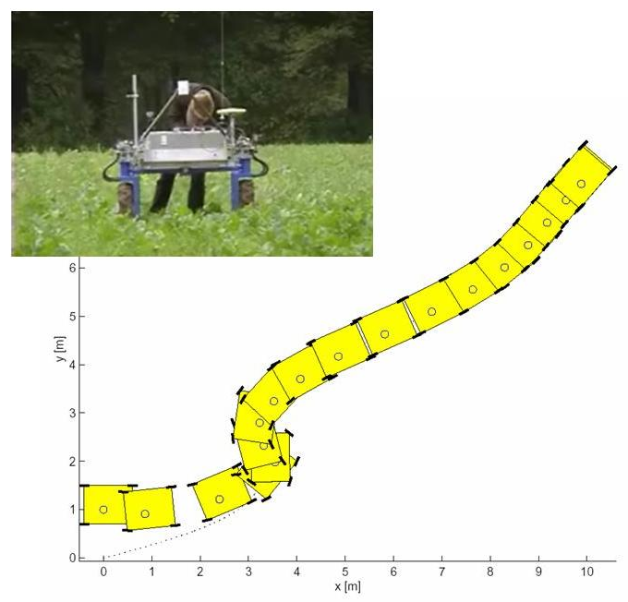

Figure 1. Trajectory for a vehicle. A complex vehicle trajectory (from [2]) that forces the vehicle to rotate (Stateflow simulation).

Such dynamic systems with a non-trivial interaction between discrete transitions (mode changes) and continuous evolutions are the topic of Hybrid System Theory, a discipline which is the theme of special sessions on most control conferences, and which has fostered interdisciplinary work between control theory and computer science.
From the last-mentioned point of view, the challenge is to find clean ways of modelling solutions to the mode changes so that the developers of real-time systems easily are able to implement such solutions.
There is extensive literature on mode change protocols (see section 5). However, most previous studies assume mode change to be implemented by an operating system.

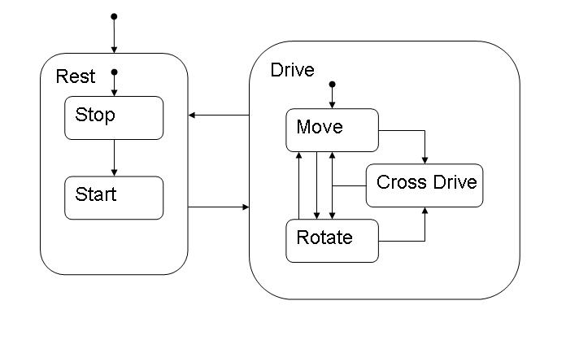
Figure 2. Control modes for the vehicle. The vehicle has two start/stop modes (to the left) and three operating modes (forward/backward, rotating, cross drive) – figure adapted from [2].

The target for our work is smaller embedded hard real-time systems with periodic and sporadic tasks where the controller typically has no operating system.
The contributions of this paper are thus
- an event-triggered synchronous mode change contract between the control engineers and the software developers
- a model of a software solution targeted at smaller embedded hard real-time systems with periodic and sporadic tasks only
- implementation of the mode change solution in Safety Critical Java on two different processors.

The remainder of this paper is structured as follows: In Section 2 the mode change contract is defined. In Section 3 we model our solution. Section 4 describes our implementations in Safety Critical Java. In Section 5 our solution is compared to related work. Section 6 completes the paper with a conclusion and future work.

2. The Synchronous Mode Change Contract

A mode defines the system under certain working conditions, and is represented by a collection of periodic and sporadic tasks with information about scheduling parameters and logic to execute.
Different modes means different working conditions of the system and can be represented by a state machine where a node represents a mode (a state) and an edge represents a mode change (a transition) from one mode to another mode. Figure 3 shows the generic state diagram (Figure 2 shows a specific example).

mode_{i} $∈$ {m₁, m₂,.., m_{n}}
init()
changeMode(nextMode)

Figure 3. A generic state diagram for mode change.

Mode change requirements. A transition from mode m_{i} to the next mode m_{j} must satisfy:
- When a Mode Change Request (MCR) has occurred, a transition from mode m_{i} to mode m_{j} must take place.
- Continuing tasks belonging to both mode m_{i} and mode m_{j} are permitted.
- A mix of old tasks from mode m_{i} and new tasks from mode m_{j} must not be concurrently active, cf. Figure 4.
- All real-time requirements of the system must be met (deadlines, periods, etc.).
- The mode changes of the system must happen within a bounded time δt.

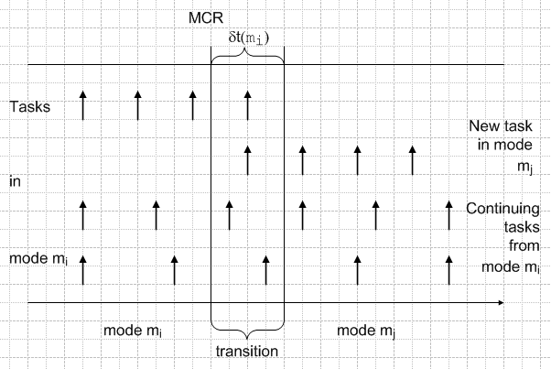

Figure 4. Inconsistent mode change with a mix of activities during the transition within the bounded time interval δt(m_{i}).

Mode change contract. These requirements are met by the following contract (also see Figure 5):
- Each mode m in {m₁,..,m_{n}} has a fixed set of periodic or sporadic tasks τ(m)which are individually schedulable under a given scheduling discipline.
- A specific event, MCR, is designated as request to change from a current mode m_{i} to a new mode m_{j}.
- When a MCR occurs, the task set τ(m_{i}) of the current mode m_{i} remains active in a time-interval, Δt_{idle}, with a maximal duration δt(m_{i}), after which the task set τ(m_{j}) of mode m_{j} is active.
- Periodic and sporadic tasks that occur in both m_{i} and m_{j} remain active over the mode change.

We will call this contract the event-triggered synchronous mode change contract.

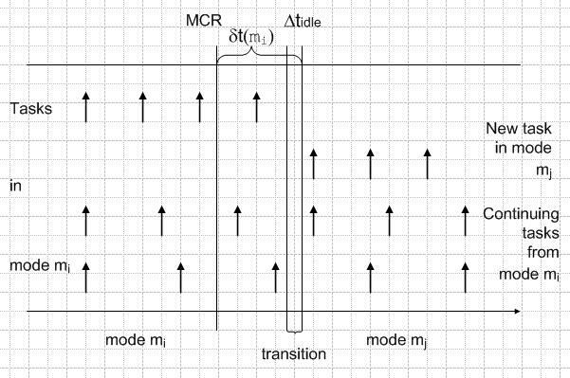

Figure 5. Consistent mode change when CPU is idle.

The mode change contract meets the requirements. It is obvious that the contract satisfies the requirements:
Contract point C3 ensures that R1 is satisfied. C4 ensures that R2 is met. C3 implies that R3 is satisfied, because the Δt_{idle} instant divides the active tasks in mode m_{i} from the active tasks in mode m_{j}. C1 and C4 ensure R4. Finally, R5 is met by C3.

Mode change contract during development. It is the obligation of
- the developer of the control laws
  - to define the modes and the task sets
  - for each mode change to check that the mode change delays, δt, are admissible for the control laws.
- the software developer to provide
  - a correct implementation of the mode change
  - an algorithm for computing δt for each mode.

3. Modelling a Software Solution

With the mode change contract in place, let us
consider correct implementations and algorithms
computing δt for each mode.

3.1. Mode change

The target for our mode change contract is hard real-time systems with periodic and sporadic tasks only, where all the tasks have deadlines, - besides periods/minimum inter-arrival times, and priorities.
This means that the scheduling algorithm must ensure that all the deadlines are met during the transition from mode m_{i} to mode m_{j}.
Therefore, we will use the most widely used scheduling algorithm for real-time systems: Fixed-Priority Scheduling (FPS) with preemptive task switch to higher-priority tasks.
A priority inversion control mechanism is also feasible, e.g. the priority ceiling protocol.
Here, mode change management can easily be done by a sporadic task with a priority less than all the other tasks in the system.
This sporadic mode change task we call τ_{mc}. The parameters of τ_{mc} have to be determined, i.e. priority P_{mc}, minimum inter-arrival time T_{mc}, and deadline D_{mc}:
- P_{mc} = min(P_{τ})-1, for all tasks τ in the current mode
- T_{mc} = R_{mc}
- D_{mc} = T_{mc}
where R_{mc} is the worst-case response time of task τ_{mc}.
This worst-case response time is determined in the following section 3.2.
A different approach is to support the mode change by the runtime system itself, as it is proposed for JOP. In that case the scheduler itself is responsible for performing the mode change and there is no need for a mode change task.

3.2. Time analysis

When a Mode Change Request (MCR) occurs, see Figure 6, the transition to the next mode can take place the first time after MCR when the system has some CPU-idle time, Δt_{idle}, with

t_{R} – t_{S} < Δt_{idle} (1)

where t_{s} and t_{R} are the Start time and Response time of the mode change respectively, cf. Table 1.
By this, the mode change, executed by τ_{mc}, does not interfere with the other tasks because τ_{mc} has the lowest priority.

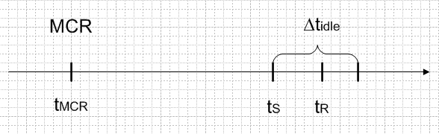

Figure 6. Time line for mode change.

Notation | Description
t_{MCR} | Time of MCR
t_{S} | Start time of mode change
t_{R} | Response time of mode change
S_{mc} | Worst-case start time (relative to t_{MCR}) of the mode changing task τ_{mc}
R_{mc} | Worst-case response time (relative to t_{MCR}) of the mode changing task τ_{mc}
T_{j} | Period of task j (or minimum inter-arrival time, if a sporadic task)
C_{j} | Worst-case execution time (WCET) of  task j

Table 1. The applied notation.

The worst-case delay, from a MCR to the mode change is completed, is determined by (2). If the mode change algorithm takes less than one time unit, this completes the analysis. This will often be the case in practice. However, if there is a fine-grained clock, the algorithm may take more than one time unit, and we should compute its response time using (3).

S_{mc} = $\sum_{\text{j }∈τ(m)}{\left\lceil \frac{S\text{mc}}{Tj}\right\rceil }$C_{j} (2)

R_{mc} = C_{mc} +$\sum_{\text{j }∈τ(m)}{\left\lceil \frac{R\text{mc}}{Tj}\right\rceil }$C_{j} (3)

where $\left\lceil \frac{S\text{mc}}{Tj}\right\rceil$= number of releases of task j within the time interval [t_{MCR},S_{mc}), and τ(m) is the set of tasks for mode m.

If the calculations of S_{mc} and R_{mc} show that

R_{mc} = S_{mc} + C_{mc} (4)

then the mode change can take place consistently using a low priority task. And R_{mc} is exactly our desired δt. Please observe that it depends on the active task set.

3.3. Instrument example

The FOSS WineScan™ System is an example of an industrial instrument which works in different modes during the analysis of wine. The system uses Fourier Transform Infrared Spectropy for the analysis, where up to 20 main quality parameters are determined in each grape sample [5]. Figure 7 shows the modes of the WineScan system.

Start Stop

Figure 7. Typical modes of the WineScan™ System

The Initialized mode includes warming up the instrument to a specific temperature; in the WaitForSample mode, the system is waiting for a wine grape sample; the Measure mode is the most time critical with up to 10⁵ detector readings in 30 secs. When it is finished analysing the samples, the system can change to Terminate mode (cooling down the instrument, etc.), before the instrument is stopped.
The system has different periodic and sporadic tasks, of which the most important are shown in Table 2.

# Tasks | Type | T  (ms) | D (ms) | C  (ms)
1 Detector reading | sporadic | 0.33 | 0.2 | 0.04
4 Temperature reading | periodic | 200 | 10 | 1
4 Temperature regulation | periodic | 1000 | 100 | 2.5
1 Monitoring | periodic | 333 |  | 30
1 Watchdog | periodic | 8000 |  | 80
1 External comm, output | periodic | 333 |  | 15
1 External comm, input | sporadic | 500 |  | 25

Table 2. WineScan tasks with time requirements.
T is the period or minimum inter-arrival time, D is deadline, C is worst-case execution time. If no deadline, D = T is assumed.
The periods and deadlines have been defined by the company based on earlier generations of the instrument, while the worst case execution times have been measured in a prototype implementation [3]. In the prototype implementation, all the tasks are active, and mode change is part of the application code, because the Ravenscar-Java Profile [18] does not support mode changes.
Deadline monotonic priority assignment is used, and response time analysis shows that the system is schedulable. However, a few changes to the set up will make concurrent detector reading and output communi- cation infeasible.
Thus a more robust implementation would have the detector reading task only active in the Measure mode, where the output communication task would be excluded. It would be confined to the WaitForSample mode. However, the four temperature reading tasks and the four temperature regulation tasks have to be active in all but the stop mode, and they should not be reset during mode changes.

4. Implementation of the Mode Change

In this section we will show how to implement our mode change contract in Java.

Software profile. The implementation is carried out in Safety Critical Java (SC-Java) [8] using the proposal of [16].
The specification of SC-Java started July 2006 as a Java Specification Request, JSR 302, under the Java Community Process at Sun.
It builds on the Real-Time Specification for Java (RTSJ) [4] which is a general framework for solving a wide variety of real-time programming problems.
However, because RTSJ is a general real-time framework, it is very complex. To overcome this complexity problem, the SC-Java specification creates a J2ME capability, based on RTSJ, containing minimal features necessary for safety critical systems capable of certification, e.g. DO-178B [9].
SC-Java inherits the scheduling algorithm from RTSJ which has the fixed-priority preemptive scheduling algorithm (FPS) as default. Furthermore, a priority inversion control mechanism is included. In SC-Java priority ceiling emulation is the only available protocol.
By this the scheduling approach in Section 3.1 is met.

Hardware profile. Two different processors are used: aJ-100, a commercial Java processor from aJile Systems [6], and JOP, a research FPGA implemented Java processor created by Martin Schoeberl [15].

Mode change modelling. Modelling the modes can be done in at least two ways [11]:

- All the modes have the same set of tasks, (5a)
but with different logics attached to a task depending of the mode.
- Each mode has its own set of tasks (5b)

See Figure 8 with sequence diagrams modelling the two ways of mode change.

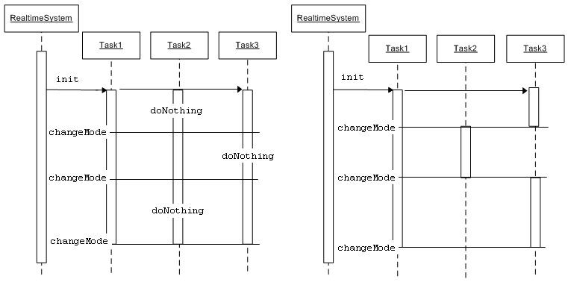
Figure 8. Sequence diagrams modelling mode changes.

In the first case, a task executes a doNothing-logic when it is "not-active" in a specific mode. This way to implement the modes is described in [17] and can easily be implemented at the application level.
On aJ-100, the periodic threads for all the modes must be defined and started at the beginning, because a cyclic scheduling table known as the “piano roll” must be initialized with priority bit masks for all the periodic threads before start. Therefore an implementation of the above mentioned type (5a) is applied.
On JOP it is possible to activate and deactivate the tasks, so that an implementation of type (5b) can be used.
In both cases all the tasks are created when the system is started.
A Mode class is defined in connection with the classes from SC-Java [16], see Figure 9.

Figure 9. Class diagram of SC-Java with Mode class

The other classes of the diagram are part of SC-Java. The RealtimeSystem class is a singleton class, representing the runtime system. The system is started by calling the start(Mode startMode) method, where startMode defines in which mode to start. The changeMode method changes the mode: it is to be used by the MCR of Section 2.
The RealtimeThread class has the two subclasses PeriodicThread and SporadicThread. All three classes are abstract. The abstract run method specifies the periodic or sporadic behavior of the threads and is implemented in the concrete application-dependent subclasses of PeriodicThread and SporadicThread.
The modes can be represented in different ways, depending of the way we choose to implement the modelling described in (5a) and (5b).

4.1. aJ-100 implementation using (5a)

In this implementation, the Mode class is a typesafe enum pattern [10] as shown in Figure 10.

public class Mode
{
private static int numberOfModes = 0;
private static Vector modes =
new Vector();
private int ordinal; //ordinal and
private String name; //name of the mode

private static Mode currentMode = null;
private static int currentModeIdx = -1;

public Mode (String name) {
this.name = name;
ordinal = numberOfModes++;
modes.addElement(this);
}
private static Object mutex =
new Object();
public static void changeMode(
Mode newMode)
{
synchronized (mutex) {
currentMode = newMode;
currentModeIdx =
newMode.getModeIdx();
}
}
public static int size() {..}
public static Mode getMode() {..}
public static int getModeIdx() {..}
}
Figure 10. class Mode on aJ-100.

The mode change can be done by a sporadic thread (mcThread), having a priority less than all the other threads in the current mode, cf. Section 3.1.
When it receives an event (a MCR), it is readied; but because it has the lowest priority, it is delayed until all the periodic and sporadic threads with higher priorities are in their wait state (waiting for next period or for next event).
Now, when the CPU is idle, mcThread can run and must change the mode in an atomic operation. This is ensured by the priority inversion control mechanism; and the above mentioned analysis, Section 3.2, ensures that it can be done consistently.
The minimum inter-arrival time T_{mc} of mcThread is set to:

T_{mc} = R_{mc}
D_{mc} = T_{mc}, - deadline equal T.

The sporadic thread, mcThread, which carries out the mode change has the run logic of Figure 11.

run()
{
Mode.changeMode(newMode);
}

Figure 11. run method of the sporadic mcThread.

This sporadic thread is created and initialized by the system during initialization, including determination of its priority and minimum inter-arrival time.
An interface Logic specifies the logic to be executed by the applications threads

public interface Logic
{
void runLogic();
}

As an example we will, in Figure 12, show the structure of a periodic application thread. It has as an attribute an array of Logic, which is initialized with the same number of Logic objects as the application has modes.

public class MyPeriodicThread extends
PeriodicThread
{
private Logic[] logics;

public MyPeriodicThread (..)
{
...
logics = new Logic[Mode.size()];

logics[0] = new Logic()
{
public void runLogic()
{
// do periodic work
}
};

logics[1] = new Logic()
{
public void runLogic()
{
// do periodic work
}
};
...
}

// impl. of run from RealtimeThread:
public boolean run() {
logics[Mode.getModeIdx()].runLogic();
return true;
}
}

Figure 12. Implementation of MyPeriodicTread.

It is initialized and started as shown in Figure 13.

public class MyRtSystem
{
public static void main (String[] args)
{
Mode m1 = new Mode ("MODE1");
Mode m2 = new Mode ("MODE2");
Mode m3 = new Mode ("MODE3");
...
new MyPeriodicThread (...);
...

RealtimeSystem.start(m1);
}
}

Figure 13. Structure of MyRtSystem on aJ-100.

4.2. JOP implementation using (5b)

JOP has the possibility of activation and deactivation of tasks, thus the mode class has been implemented differently than on the aJ-100 processor. The class provides just the constructor with the list of real-time threads to implement immutable mode objects. An immutable mode guarantees that the mode cannot be changed at runtime, Figure 14.

public class Mode
{
public Mode(RealtimeThread rt[]) {
// immutable Mode object
}
}

Figure 14. class Mode on JOP.

When switching from mode m_{i} to mode m_{j}, all threads that belong to both modes just continue to be scheduled. Threads part of mode m_{i} and not part of mode m_{j} have to be stopped. We use our approach to a clean shutdown of periodic threads, as described in [17], to perform the mode change. All threads that have to be stopped go through the same phases as during a shutdown. That means that the application logic of a single thread does not need to be changed when extending a single mode profile to a multi-mode system.
A current mode change can be queried by the application threads with RealtimeSystem.mode-ChangePending(). An application task should query this state before performing a long lasting state change where the application thread cannot be stopped. This query is not mandatory. However, it can help to perform the mode change in less time.
When all to-be-stopped threads have performed their cleanup function, the threads that are part of mode m_{j} and not part of mode m_{i} are added according to their release parameters to the schedule table. As this table is known at the initialization phase, it is easily built in advance, and this adding is just a switch between different tables. Performing this switch is the last step in the mode change.
Figure 15 shows a simple example with three modes. Each mode has attached some threads. Only thread th2 is shown in the example. Furthermore, thread th1 is part of all three modes.

public class MyRtSystem
{
static Mode m1;
static Mode m2;
static Mode m3;

public static void main(String[] args)
{
PeriodicThread th1 =
new PeriodicThread(..);

PeriodicThread th2 =
new PeriodicThread(
new RelativeTime(100, 0))
{
boolean finished;
protected boolean run() {
doWork();
if (finished) {
RealtimeSystem.changeMode(
m2);
}
return true;
}
protected boolean cleanup() {
// we need no cleanup as we
// triggered the mode change
return true;
}
private void doWork() {
// the periodic work
return true;
}
};

RealtimeThread rtm1[] = {th1, th2};
m1 = new Mode(rtm1);

RealtimeThread rtm2 [] = {th1, th3};
m2 = new Mode(rtm2);

RealtimeThread rtm3 [] = {th1, th4};
m3 = new Mode(rtm3);

RealtimeSystem.start(m1);
}
}

Figure 15. Structure of MyRtSystem on JOP.
For each mode we create a Mode object and add all threads that belong to that mode with the constructor during the initialization phase. The application then starts the system in mode m1 by calling RealtimeSystem.start(m1). When this phase has finished, a mode change is triggered by thread th2 with changeMode(m2). During this mode change th2 is stopped and th3 is started. The thread th1 just continues to run during the mode change and in the new mode.

5. Related Work

Our investigation into mode changes was motivated by our work with hybrid systems [2] as well as our development of a Profile for Safety Critical Java [16, 18]. This profile is intended for programming small embedded real-time applications; especially we have seen J2ME midlet [14] programmers as our prime programmer community. Mode change was also an issue in the industrial case used as the Instrument example in Section 3.3.
Previously, the need for a clear contract between control engineers and software developers was recognized in the Hybrid Systems context by the Giotto framework [7]. The main part of the Giotto contract is a guarantee against jitter in sampling and actuation. This is achieved by a one period delay of activation. Giotto also has a clear contract for mode changes: Each mode has a defined period and within each of these, a set of tasks are executed periodically an integral number of times. A mode change thus makes an instantaneous switch from one task set to another, in accordance with hybrid control theory. In other words, the mode period is the hyper-period of its task periods. Giotto implements its contract by means of a time triggered approach.
Giotto is a beautiful example of a clear division of concerns. It introduces a precise contract, as should be the case in development of safety critical systems. However, the contract is rigid, with the use of the hyper-period, and it may be hard to adapt it to sporadic events or to implement it on a standard real-time operating system with a fixed priority, preemptive scheduler.
Real and Crespo survey a number of mode change protocols and propose a new mode change protocol in [13]. They categorize the protocols into synchronous, where new mode tasks are released only when old mode tasks have all completed their last activation, and asynchronous, where a combination of old and new mode tasks execute during the transition.
As discussed in Section 2, a synchronous protocol is appropriate for control applications. Our particular protocol is thus synchronous. This enables a simple, yet rigorous analysis. The protocol is inspired by the Idle Time Protocol by Tindell and Alonso [19]. In their execution model they have, besides periodic and sporadic tasks, also background tasks; and they assume that the mode change operation is performed by the operating system. This is in contrast to our implementation on controllers which typically have no operating system.
The SC-Java profile is derived from RTSJ, but the profile is much simpler than RTSJ. The profile has three modes: initializing, mission and cleanup in the programming model. A similar model can be found in the J2ME MIDP (Mobile Information Device Profile) profile [14] where midlets have a set of possible states that the application can be in: paused, active, destroyed, with associated logic which will be executed upon state change.
Further development of mission modes has been done in [17], and the recent HIJA proposal [8] has similar states and state changes, with the addition of a possibility of reinitializing the system.
However, analysing and implementing such state changes correctly, especially with a safe close down/termination of a system, lead us to generalise the ideas to mode changes which have been investigated previously by several researchers.
Similarly, as shown in Section 4, the mode change implementation can be performed purely and easily by a sporadic task with a priority less than all the other tasks in the system, or implemented by modifying the scheduling algorithms from RTSJ.

6. Conclusion and Future Work

We have defined an event-triggered synchronous mode change contract for hard real-time systems where the operation mode can change over time, depending of the working conditions of the system. Our protocol is a generalization of mode change mechanisms in recent profiles for Safety Critical Java [16, 17, 8], where a fixed set of modes are proposed. We have found a need to formulate a mode change contract that can be accepted and applied by both engineers of control systems as well as software developers of real-time systems.
Two different implementations on top of SC-Java, on the aJ-100 Java processor [6] and the JOP [15], show that the mode change contract can easily be adapted to safety critical systems and implemented efficiently.
The immediate next steps include a full integration of the mode change contract in our SC-Java proposal [16], including the necessary analysis tool for pre-verifying that the contract is met in such real-time systems.
A very different idea is to investigate a class of real-time systems where the code for new-mode tasks may be loaded dynamically, but may need to run simultaneously for a while with old-mode tasks. In such cases we expect that an adaptation of one of the protocols in the category of asynchronous mode change protocols in [13] may facilitate this.
However, that class of real-time systems is typically outside control applications, and one is dealing with systems that need to upgrade their services or install bug-fixes, while in continuous use. Here we must assume that the functionality is unchanged by the change-over; it is not a mode change in the control systems sense, but a repair.
One example is telephone switches, which cannot be taken out of service without severe operational consequences. This idea is already deployed by Ericsson in telephone switches programmed in the Erlang language, where new modules can be loaded by a running system [12]. It is even possible to run the old service side-by-side with the new one. The old code handles all calls that were open when the request to load new code happened. When the new code is loaded it starts to handle new calls and the old code is loaded off the system when the last of the old calls finishes.
Dynamic repairs sound extremely dangerous in a real-time system. However, we envision a tool chain where all real-time, as well as functional, requirements are subjected to pre-verification before the code is loaded onto the embedded real-time system for operation, much in the spirit of the pre-verification taking place in J2ME midlets today. In this case dynamic code loading and the mode changes it entails will be analysed and verified to be as safe as the running code on the operational system.

7. References

[1] Alejandro Alonso, Juan Antonio de la Puente. Implementation of mode changes with the Ravenscar profile. ACM SIGAda Ada Letters. Volume XXI, Issue 1, pp. 27 – 32. 2001.

[2] Thomas Bak, Jan D. Bendtsen and Anders P. Ravn
Hybrid Control Design for a Wheeled Mobile Robot In Hybrid Systems: Computation and Control (HSCC 2003) (Eds.: O. Maler and A. Pnueli), LNCS 2623, pp. 50-65, 2003.

[3] Thomas Baron, Philippe Jean, and Gaël Mercier. Design and implementation of a real-time embedded application. M. Sc. Thesis, Departement of Computer Science, Aalborg University. 2007.

[4] Greg Bollella et al. The Real-Time Specification for Java™. Addison-Wesley, 2000.

[5] FOSS Analytical A/S, Denmark. www.foss.dk/, as of April 2007.

[6] David S. Hardin. Real-Time Objects on the Bare Metal: An Efficient Hardware Realization of the Java Virtual Machine. In Proceedings of the Fourth International Symposium on Object-Oriented Real-Time Distributed Computing, pp. 53-59. IEEE Computer Society, 2001.

[7] Thomas A. Henzinger, Benjamin Horowitz, and Christoph M. Kirsch. Embedded control systems development with Giotto. Proceedings of the International Conference on Languages, Compilers, and Tools for Embedded Systems (LCTES), ACM Press, 2001, pp. 64-72. An extended version appeared in Software-Enabled Control: Information Technology for Dynamical Systems (T. Samad, G. Balas, eds.), IEEE Press and Wiley-Interscience, 2003, pp. 123-146.

[8] HIJA. Safety Critical Java Proposal. Version 0.5, 25 May 2006, Draft. Open Group, available at: http://www.aicas.com/

[9] RTCA/DO-178B. Software Considerations in Airborne Systems and Equipment Certification. 1992

[10] Jeff Langer. Essential Java Style: Patterns for Implementation. Prentice-Hall. 2000.

[11] G. Lipari. Sistemi in tempo reale. Mode change. Scuola Superiore Sant'Anna. Pisa. Italy. http://feanor.sssup.it/~lipari/rtos/rtcs.html, as of April 2007.

[12] OTP Design Principles http://www.erlang.org/ doc/doc-5.5.4/doc/design_principles/part_frame.html, as of May 2007.

[13] Jorge Real and Alfons Crespo. Mode Change Protocols for Real-Time Systems: A Survey and a New Proposal. In Real-Time Systems, Volume 26, Number 2, pp. 161-197. Springer. 2004.

[14] Roger Riggs et al. Programming Wireless Devices with the Java™. 2 Platform, Micro Edition. Second edition. Addison-Wesley, 2003.

[15] Martin Schoeberl. JOP: A Java Optimized Processor for Embedded Real-Time Systems. Dissertation. Vienna University of Technology, January 2005.

[16] Martin Schoeberl, Hans Søndergaard, Bent Thomsen, and Anders P. Ravn. A Profile for Safety Critical Java. ISORC 2007.

[17] Martin Schoeberl. Mission Modes for Safety Critical Java. In 5th IFIP Workshop on Software Technologies for Future Embedded & Ubiquitous Systems, May 2007.

[18] Hans Søndergaard, Bent Thomsen, and Anders P. Ravn. A Ravenscar-Java Profile Implementation. In Proceedings of the 4th international workshop on Java technologies for real-time and embedded systems (JTRES 2006), pp. 38-47, Paris, France, October 2006. ACM Press.

[19] K. Tindell and A. Alonso. A Very Simple Protocol for Mode Changes in Priority Preemptive Systems. Technical report, Universidad Politécnica de Madrid. 1996.

