Production and Properties of Insulation Mats Made from Sea Grass

Carsten Pedersenª, Erling Ransby^{b}
ª Department of Building Design and Technology, Danish Building Research Institute,
Dr. Neergaards Vej 15, DK-2970 Hørsholm, Denmark.
cmp@sbi.dk http://www.sbi.dk
^{b} Syd-Tek Technology and Development Centre, Råhavegård, Maribovej 9,
DK-4960 Holeby, Denmark.
er@syd-tek.dk http://www.syd-tek.dk

Abstract: - Sea grass on the beaches is a problem for tourists who demand nice, clean beaches. Hence, in many tourist areas beaches are cleansed of sea grass; the resulting removal of the collected sea grass causes financial and environmental problems. This has initiated research into an alternative use of the sea grass collected. In this paper, a continuous process and equipment for production of mats for insulation in buildings based on sea grass fibres are presented. The material properties obtained is presented. The sea grass mats possess essential material properties that are comparable to those of other organic insulation materials, e.g. the thermal conductivity which is determined to be 0.0376 W/mK. Based on the test programme the viability of future CE marking of sea grass mats is evaluated in this paper. As a general rule all construction products to be sold on the market in the European Union have to be CE marked. The properties obtained indicate that sea grass mats can be CE marked when a stable production is obtained.

Key-words: - CE marking, Insulation mats, Production of sea grass mats, Sea grass, Thermal conductivity.

1 Introduction
The occurrence of sea grass (eelgrass, seaweed, algae) is a problem for bathing tourists, especially if it occurs in large quantities, which are carried away and washed ashore. There is an increasing demand from the tourists for nice, clean beaches and as a result financial and environmental problems in connection with the beach cleansing and removal of the sea grass collected. However, sea grass has a large potential for application as a raw material in existing or new products. On this background, Syd-Tek Technology and Development Centre in cooperation with Danish the Building Research Institute has participated in an international project regarding ”Sustainable development of European coastal regions and establishment of regional circuits”, see the project homepage www.life-seegras.de for further information. The project has created the basis for the application of sea grass for different types of insulation e.g. as mats. This study focuses on the application of sea grass for insulation mats and the material properties obtained. The paper describes the production line used for manufacturing insulation mats made from sea grass. The produced sea grass mats has been tested for the essential material properties. The paper states the obtained properties of the produced insulation mats and the testing method used.
2 Production of Sea Grass Insulation Mats
The production plant used was designed to accept rinsed sea grass as a raw material. The methods for collecting sea grass and cleansing the beaches depend on the character of the beaches and the specific sea grass deposit. In areas with big, broad beaches and deposits of mainly clean sea grass, the cleansing can be mechanised with tractor-driven beach cleansing and pick-up machines. In areas with different types of beaches, tide and heavily growing sea grass, the cleansing method is a combination of mechanical and manual work. In areas where the beaches are smaller and access more difficult (e.g. like on the island of Møn in Denmark) the collection and treatment of sea grass must to a large extent be based on manual work. The tested sea grass insulation mats were produced at the Syd-Tek production facilities on the Danish island of Møn as shortly described in this section. A more detailed description of the production process can be found in [1]. The production line facilitates all equipment necessary to prepare and meter the raw material in order to form the mat cross section, to bond the mat to a homogeneous texture, to cut the mat into standard sizes, and finally stack and pack the mats in bales ready for distribution to the end-user. Fig. 1 shows the plant layout and the production flow (blocks 1-12).

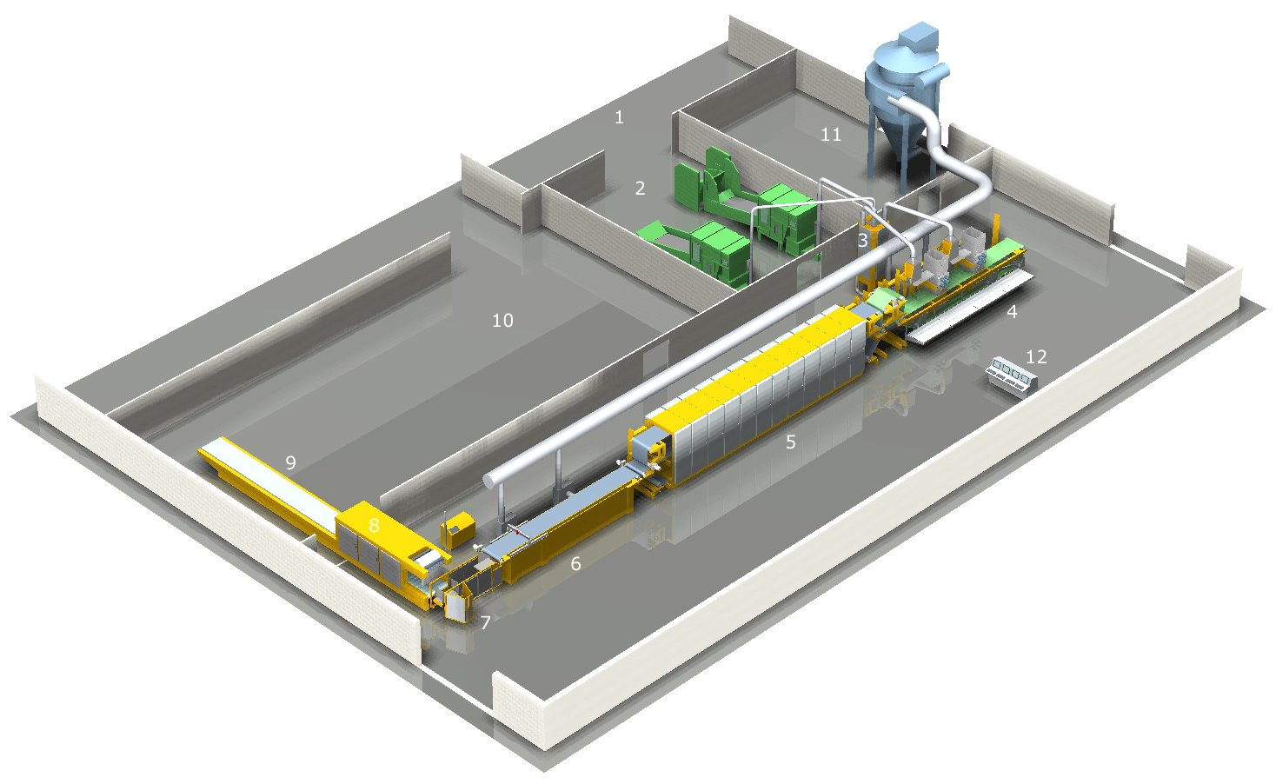
Fig. 1. Sea grass insulating mat production line.

The plant consists of the following functional blocks:
1) Facilities for handling sea grass raw material.
2) Fibre-handling section with two independent equipments to handle, meter and transport pre-cut sea grass and bonding fibres. Only results regarding reinforced sea grass insulation mats are presented in this paper.
3) Mixer tower.
4) Former section. The former section comprises two former heads that continuously form the fibre mixture to a uniform mat cross section on a wire run.
5) Oven section. By heated air flow the oven heats the continuously flowing mat to a temperature that melts the bonding fibres and thus binds the fibres to a homogeneous fabric. Furthermore, the oven enables the mat to be compressed, thus facilitating control of density and surface finish.
6) Cooling and cutting section. The hot mat is cooled by air to a low temperature. Prior to leaving the mat is cut into bats by a water jet cutter.
7) Packing section. The individual bats are separated and packed.
9) Wrapper section. The wrapper packs each stack in foil ready for shipment or storage.
10) Facilities for storage and shipment.
11) Filter section. Filter section for filtration of process air.
12) Control panel.

3 Results from Tests Carried out at the Danish Building Research Institute
The tests presented in this section were carried out at the Danish Building Research Institute. For an overview of the test results, see Table 3.
3.1 Determination of dimensional stability under specified temperature and humidity conditions
The purpose of this test was to assess dimensional changes of sea grass mats under specified conditions of temperature, relative humidity and duration of exposure. The test was carried out according to the European Standard [2].

The mean values of each dimensional change due to exposure in percentage of the initial dimensions are given in Table 1.

Table 1. Dimensional change in percentage of the initial dimension due to exposure.
Exposure/dimensions | Thickness | Length and width
Heat (60 °C) | -1.71 | -0.59
Coldness (-22 °C) | -0.05 | -0.05

For further details of test procedure and expression of results, see [3].

3.2 Determination of tensile strength parallel to faces
The purpose of this test was to determine the tensile strength of the sea grass mats. It can be used to assess whether the mats have sufficient strength to withstand stresses during transportation and application. The test was carried out according to the European Standard [4].
The average tensile strength of three test specimens was measured to be 41 kPa. In comparison, the tensile stress related to the weight of the product does not exceed 0.5 kPa for a mat with the dimensions 60 x 90 cm and a density of 55 kg/m³.

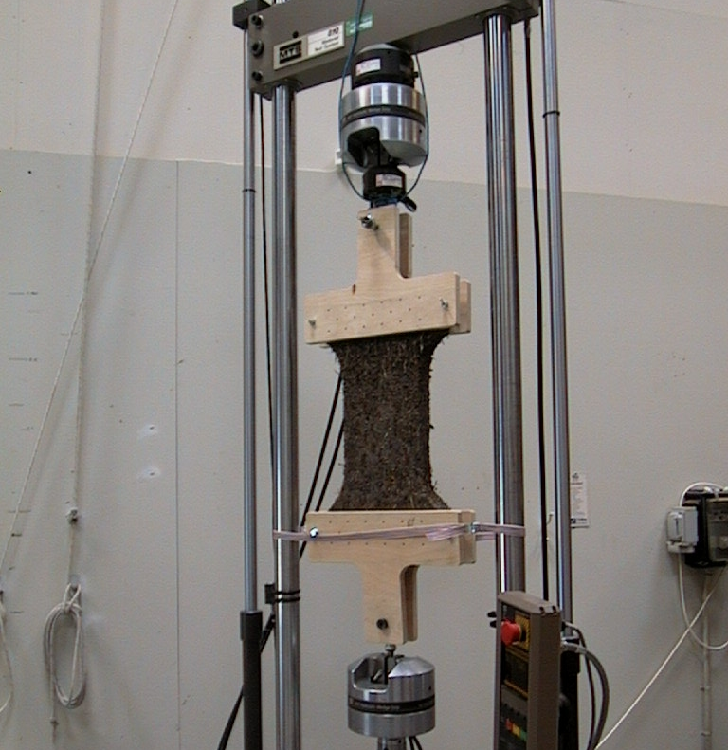
Fig. 2. The test specimen is fastened in a testing machine and pulled apart at a constant crosshead speed of 10 mm/min until failure occurs.

Fig. 3. Example of relation between tensile force and movement of the testing machine crosshead.
For further details of test procedure and expression of results, see [5].

3.3 Determination of short-term water absorption by partial immersion
The purpose of this test was to determine the short-term water absorption of the sea grass mats by partial immersion in water. The test was intended to simulate water absorption resulting from 24 hours constant rain during construction. The test was carried out according to the European Standard [5]. The average water absorption of three test specimens was measured to be 3.65 kg/m².
For further details of test procedure and expression of results, see [6] and [7].

3.4 Determination of water-vapour transmission properties
The purpose of this test was to determine the water-vapour transmission properties of sea grass mats in steady state under specified test condition. The test was carried out according to the European Standard [8].
The water-vapour transmission rate g, water-vapour permeance W, water-vapour permeability δ and water-vapour resistance are given in Table 2.

Test specimen | g [mg/ m²h] | W [mg/ m²hPa] | δ [mg/m hPa] | Z [m²h Pa/mg]
1 | 5639 | 4.0 | 0.31 | 0.25
2 | 6306 | 4.5 | 0.31 | 0.22
3 | 6509 | 4.6 | 0.30 | 0.22
4 | 5972 | 4.3 | 0.32 | 0.23
5 | 5509 | 3.9 | 0.32 | 0.26
Average | 5987 | 4.3 | 0.31 | 0.24
Table 2. Water-vapour transmission rate g, water-vapour permeance W, water-vapour permeability δ and water-vapour resistance.

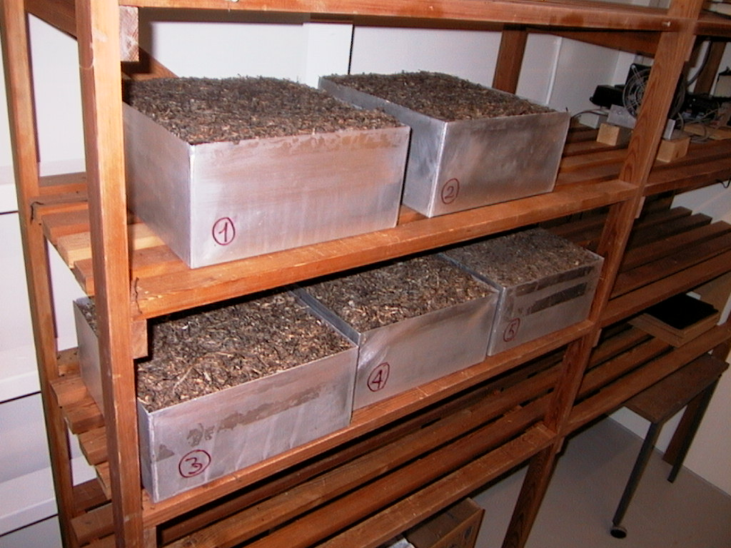
Fig. 4. The test specimen is sealed to the open side of a test box. The box is then placed in a test atmosphere with controlled temperature and humidity. Due to the difference between the partial water-vapour pressure, water-vapour flows through the test specimen. Periodic weighings of the assembly are made to determine the rate of water-vapour transmission.

For further details of test procedure and expression of results, see [7] and [9].

3.5 Method for testing corrosivity
The purpose of this test is to determine the level of corrosivity displayed by the sea grass insulation, where water may cause e.g. salt to migrate to thin copper or zinc-coated elements adjacent to the insulation. The test was carried out according to the British Standard [9]. No notches or perforations due to corrosion were found on any of the metal coupons.
For further details of test procedure and expression of results, see [10] and [11].

3.6 Determination of resistance to mould growth
The purpose of this test was to determine the resistance of the sea grass to mould growth. The test was carried out according to ÖNORM [11]. No visual signs of mould growth were found. However, the smell of the test specimens indicated possible microbiological activity. Tests carried out by the German Federal Institute for Materials Research and Testing also indicate the lack of resistance to moulds, see Chapter 4.3.
For further details of test procedure and results, see [12] and [13].

4 Results from Relevant Additional Tests
The following tests were carried out in the LIFE environment programme, see the project homepage www.life-seegras.de. For an overview of the test results, see Table 3.

4.1 Thermal conductivity
The thermal conductivity at 10 °C was determined to be 0.0376 W/mK. Average value of six sea grass mats, see [14].

4.2 Reaction to fire
The assessment of the reaction to fire of the sea grass mats carried out by the Danish Institute of Fire and Security Technology indicates that the sea grass mats can be classified "approximately" in Euroclass E according to [15], see [16].

4.3 Resistance to moulds
Visual signs of mould growth were found in tests carried out by the German Federal Institute for Materials Research and Testing. More than 25 % of the surface was covered with mould growth after 28 days, see [17]. The test was carried out according to DIN IEC 68 Teil 2.
5 Potential CE Marking of Insulation Mats Made from Sea Grass
As a general rule all construction products covered by the European Construction Products Directive 89/106/EC, and sold on the European market, have to be CE marked. This applies to products manufactured in countries within the EEA (European Economic Area – European Union plus Norway, Iceland and Liechtenstein).
A CE marking is normally based on a harmonised European standard. No relevant harmonised standards for sea grass insulation mats or related products exist. This is also the case for a number of other construction products. When no relevant harmonised standard exists, the CE marking can be granted on the basis of a European Technical Approval (ETA). In most cases an ETA for a product will be granted to a manufacturer based on the assessment principles set out in an ETA Guideline for the relevant product sector. For sea grass insulation mats or related products, no ETA guideline has been issued. Under certain circumstances it may be possible for an ETA to be issued on the basis of a common understanding of assessment procedure (CUAP). No CUAP has been issued for sea grass mats, but it is expected that the assessment principles in the future ETA guideline will be similar to the assessment principles outlined in the CUAP for thermal insulation materials made of hemp fibres and flax fibres. See Common Understanding of Assessment Procedure (German Building Technology Institute [18] and Austrian Building Technology Institute [19]). Hence the properties of the sea grass mats are compared with the assessment criteria stated in the CUAPs for hemp and flax fibres, see Table 3. According to the test results, the sea grass mats fulfil the assessment criteria stated in the CUAP for both hemp and flax fibres, see Table 3, except for water absorption, dimensional stability and biological resistance. For water absorption, the CUAP for flax fibres requires a limit value of 0.1 kg/m². This requirement is not met, as the water absorption is 3.65 kg/m². The CUAP for hemp fibres requires no limit value. For dimensional stability the CUAP for flax fibres requires a limit value of 0.1 %. This requirement is not fulfilled for some heat and coldness exposures. The CUAP for hemp fibres gives no limit value regarding dimensional stability. Apart from the fact that all relevant product characteristics met the requirements given by the CUAP for hemp and flax fibres, all requirements in the latest CUAP are met. The test results indicate that sea grass mats can be CE marked when a stable production is established.
Relevant product characteristics | Classification  methods | Test results. Sea grass mats | Limit value or classification.  CUAP, hemp fibres [18] | Limit value or classification.  CUAP, flax fibres [17]
Reaction to fire | EN 13501-1. | Euroclass E | Declared class | Declared class
Water absorption | EN 1609 method A | 3.65 kg/m² | Declared value | ≤ 0.1 kg/m²
Water-vapour diffusion resistance | EN 12086 | 0.24 m²hPa/mg | Declared value
Tensile strength | EN 1608 | 41 kPa | Tensile strength to support twice the weight of the product | Tensile strength to support twice the weight of the product
Corrosion-developing capacity | BS 5803-3, Appendix B | No notches or perforation | No notches or perforation within the central zone | No notches or perforation within the central zone
Thermal conductivity | EN 12667 | 0.0376 W/mK | Declared value | Declared value
Dimensional stability | EN 1604 | Length and width: 0.05 - 0.59 %  Thickness:  0.05 - 1.71 % | Declared value | ≤ 0.1 %
Biological resistance  Resistance to moulds | Önorm B 6010, Clause 3.22.  DIN IEC 68 Teil 2 | Indications of biological activity  Visual signs of moulds | 1) | No change in appearances after four weeks  1)
Table 3. An overview of the test results and the expected limit values required for CE marking. 1) More tests are needed to get clear indications of the resistance to moulds.

6 Conclusion
In this paper essential material properties for insulation mats made from sea grass has been presented. Furthermore a production line to form sea grass mats, to bond the mat to a homogeneous texture and to cut the mat into standard sizes has been presented. The tests carried out and the results led to the following findings:
A process as well as equipment for continuous production of insulation mats based on sea grass fibres has been developed. The developed working production plant comprises a weighing and feeding plant for sea grass fibres, mixing chambers and forming unit, heating oven, cooling section plus cutting and packing units. It has been demonstrated that the produced sea grass mats possess material properties which is comparable to those of other organic insulation materials.
The sea grass mats for insulation in buildings were tested with regard to essential material properties and the properties obtained are presented in this paper. The thermal conductivity of the sea grass mats is 0.0376 W/mK and the reaction to fire is at a Euroclass E level. The water vapour resistance and the water absorption were determined to be 0.24 m²hPa/mg and 3.65 kg/m² respectively. The sea grass mats have tensile strength giving robustness during handling at the building site and practical experience show that sea grass mats can be easily cut at the building site. The material causes no rust on metal parts in building constructions. As with other organic insulation material, the sea grass mats must be protected against moisture in order to avoid biodegrading.
The test results indicate that the sea grass mats can be CE marked when a stable production is established. As a general rule all construction products to be sold on the market in the European Union, covered by the European Construction Products Directive, have to be CE marked.

Acknowledgement
We thank the EU research programmes LIFE and CosCo for supporting this investigation.

7 References
[1] Syd-Tek Technology and Development Centre, Sea Grass Insulation Matt Production Line, Holeby, Denmark, 2005.
[2] European Standard EN 1604: 1996 + AC: 1997, Thermal insulating products for building applications – Determination of dimensional stability under specified temperature and humidity conditions, European Committee for Standardization, 1996.
[3] Danish Building Research Institute. Determination of dimensional stability under specified temperature and humidity conditions, Test report 452-120/D, Hoersholm, Denmark, 2003, (In Danish).
[4] European Standard EN 1608: 1996 + AC: 1997, Thermal insulating products for building applications – Determination of tensile strength parallel to faces, European Committee for Standardization, 1996.
[5] Danish Building Research Institute, Determination of tensile strength parallel to faces, Test report 452-120/E, Hoersholm, Denmark, 2003, (In Danish).
[6] European Standard EN 1609: 1996 + AC: 1997, Thermal insulating products for building applications – Determination of short term water absorption by partial immersion, European Committee for Standardization, 1996.
[7] Danish Building Research Institute, Determination of short term water absorption by partial immersion, Test report 452-120/A, Hoersholm, Denmark, 2003, (In Danish).
[8] European Standard EN 12086: 1997, Thermal insulating products for building applications – Determination of short term water absorption by partial immersion, European Committee for Standardization, 1996.
[9] Danish Building Research Institute, Determination of water vapour transmission properties, Test report 452-120/B, Hoersholm, Denmark, 2003, (In Danish).
[10] British Standard 5803-3:1985, Method of test for corrosivity, Appendix B, British Standards Institution, 1985.
[11] Danish Building Research Institute, Test for corrosivity. Test report 452-120/C, Hoersholm, Denmark, 2003, (In Danish).
[12] ÖNORM B 6010, Materials for thermal and/or acoustic insulation in building construction – test methods, clause 4.22, Austria Standards Institution, 1999, (In German)
[13] Danish Building Research Institute, Resistance to mould growth, Test report 452-120/F, Hoersholm, Denmark, 2003, (In Danish).
[14] Danish Technological Institute, Determination of thermal conductivity, Test reports 02154, 02155 and 02161, Taastrup, Denmark, 2002, (In Danish).
[15] European Standard EN 13501-1: 2002, Fire classification of construction products and building elements – Part 1: Classification using data from reaction to fire tests, European Committee for Standardization, 2002.
[16] Danish Institute of Fire and Security Technolog, Note regarding reaction to fire of sea grass insulation, Hvidovre, Denmark, 2002, (In Danish).
[17] Federal Institute for Materials Research and Testing (Bundesanstalt für Materialforschung und -prüfung), Resistance to mould fungus according to DIN IEC Teil 2, 2000, (In German).
[18] German Building Technology Institute (Deutsches Institut für Bautechnik), Common Understanding of Assessment Procedure, Thermal insulation material and/or acoustic insulation material made of flax fibres, 1997.
[19] Austria Building Technology Institute (Österreichishes Institut für Bautechnik), Common Understanding of Assessment Procedure. Thermal insulation material and/or acoustic insulation material made of hemp fibres, 2001.

