Supporting information
Facile synthesis of trisubstituted imidazoles from 1,2-di(furan-2-yl)-2-oxoethyl carboxylates and their chemiluminescence
Baozhi Li, Qiang Gu, Yuanhui He, Tianqi Zhao, Xiaodong Chen, Shuaijun Wang, Jing Kang, Yumin Zhang*
College of Chemistry, Jilin University, Changchun 130012, P. R. China
*Corresponding Author: Professor Yumin Zhang.
Tel: (+86)-431-85168470 (3).

¹H NMR and ¹³C NMR spectra of the synthesized compounds

1. ¹H NMR and ¹³C NMR for 4,5-di(furan-2-yl)-2-phenyl-1H-imidazole (3a) (Table 3, entry 1)

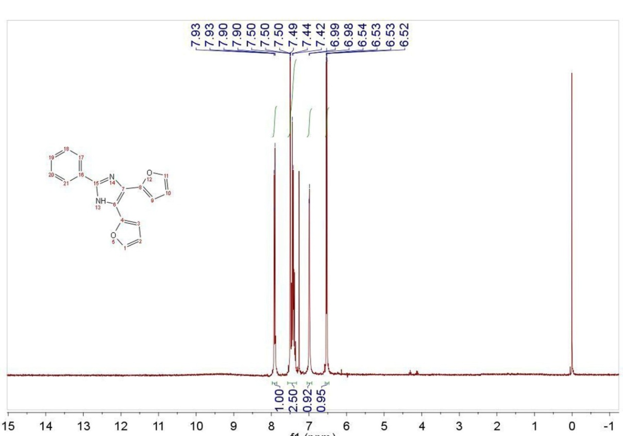
¹H NMR of 4,5-di(furan-2-yl)-2-phenyl-1H-imidazole

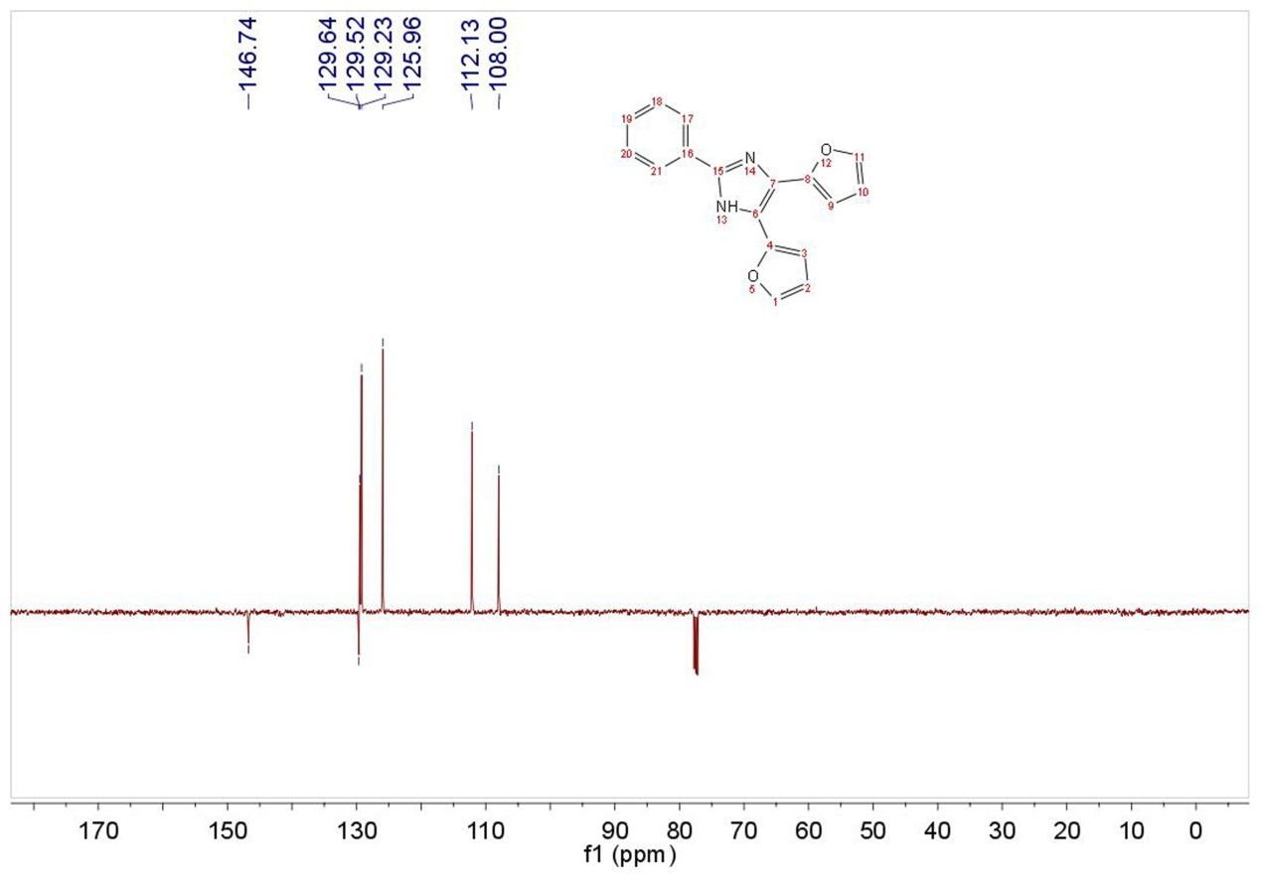
¹³C NMR of 4,5-di(furan-2-yl)-2-phenyl-1H-imidazole

2. ¹H NMR and ¹³C NMR for 4,5-di(furan-2-yl)-2-(4-methylphenyl)-1H- imidazole (3b) (Table 3, entry 2)

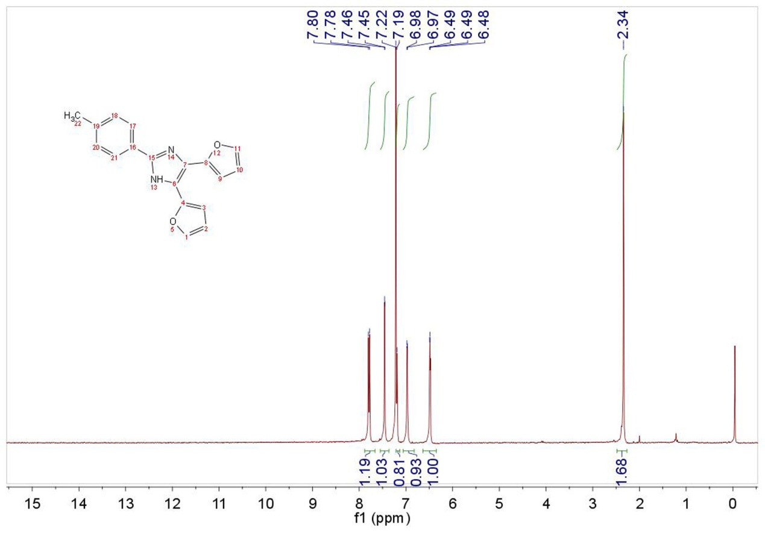
¹H NMR of 4,5-di(furan-2-yl)-2-(4-methylphenyl)-1H-imidazole

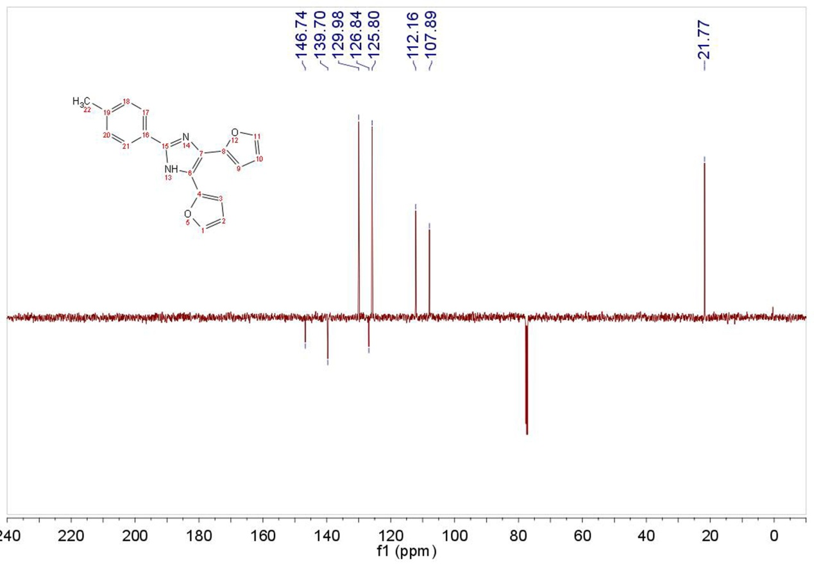
¹³C NMR of 4,5-di(furan-2-yl)-2-(4-methylphenyl)-1H-imidazole
3. ¹H NMR and ¹³C NMR for 4,5-di(furan-2-yl)-2-(4-chlorophenyl)-1H-imidazole (3c) (Table 3, entry 3)
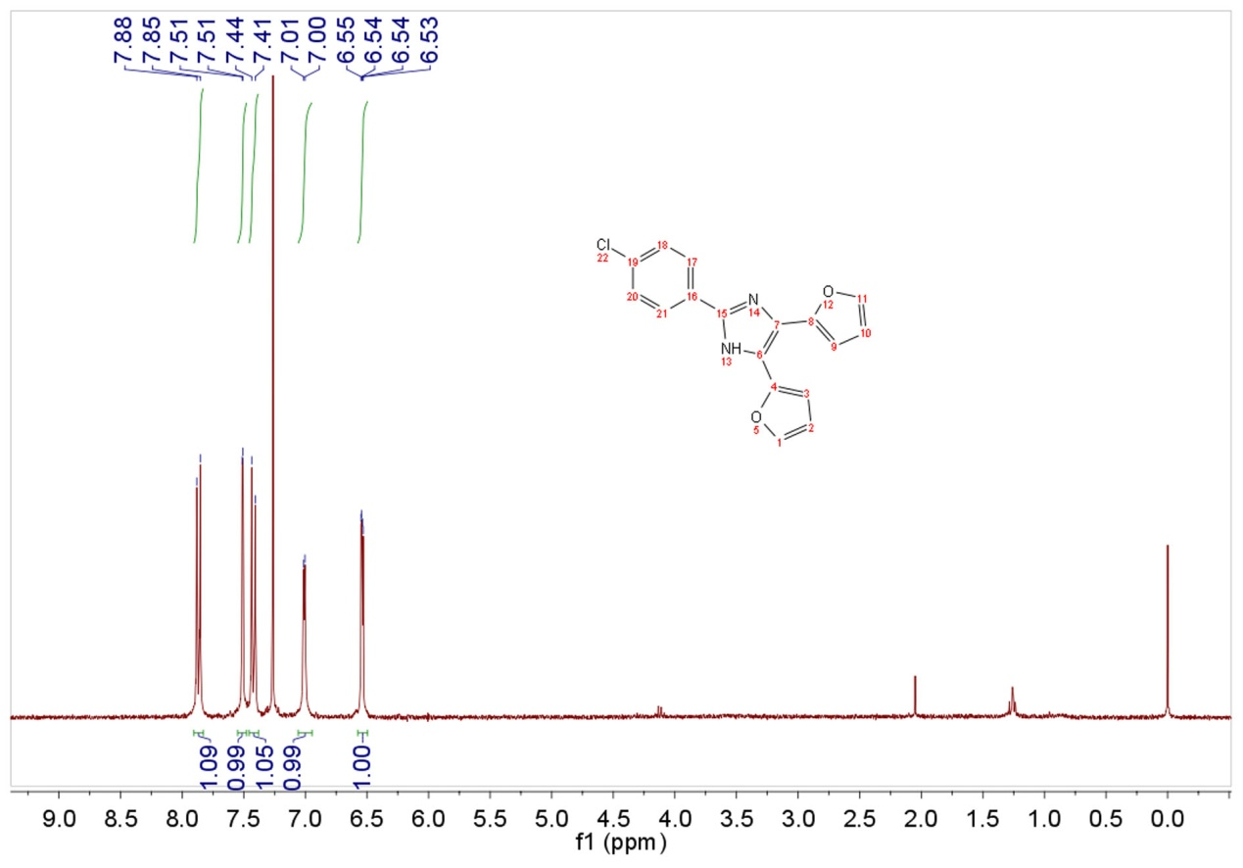

¹H NMR of 4,5-di(furan-2-yl)-2-(4-chlorophenyl)-1H-imidazole
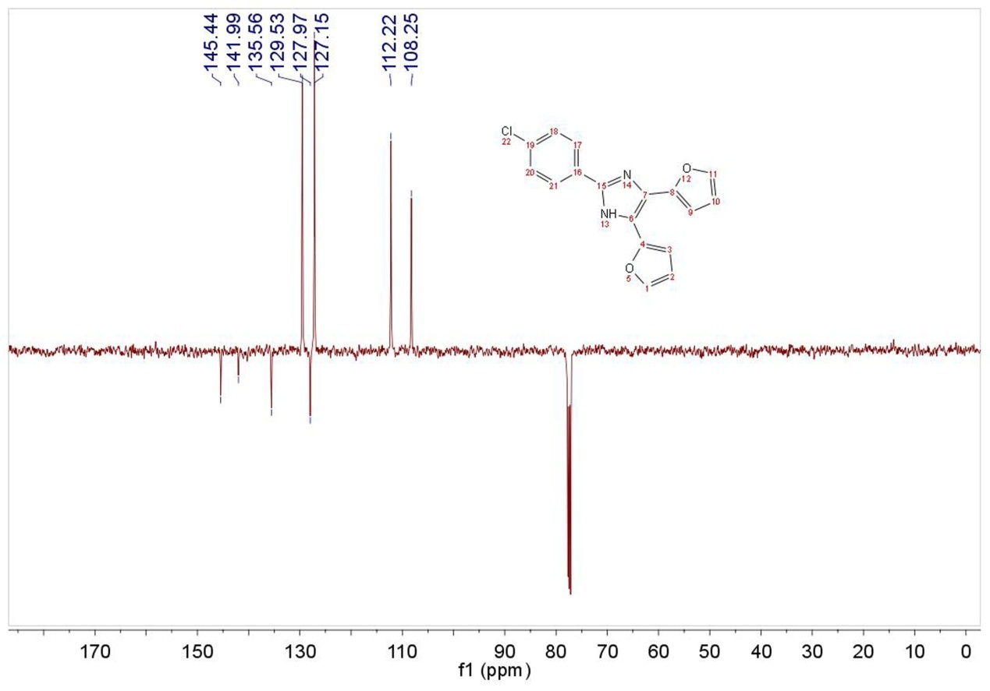
¹³C NMR of 4,5-di(furan-2-yl)-2-(4-chlorophenyl)-1H-imidazole

4. ¹H NMR and ¹³C NMR for 4,5-di(furan-2-yl)-2-(2-furylvinyl)-1H-imidazole (3d) (Table 3, entry 4)

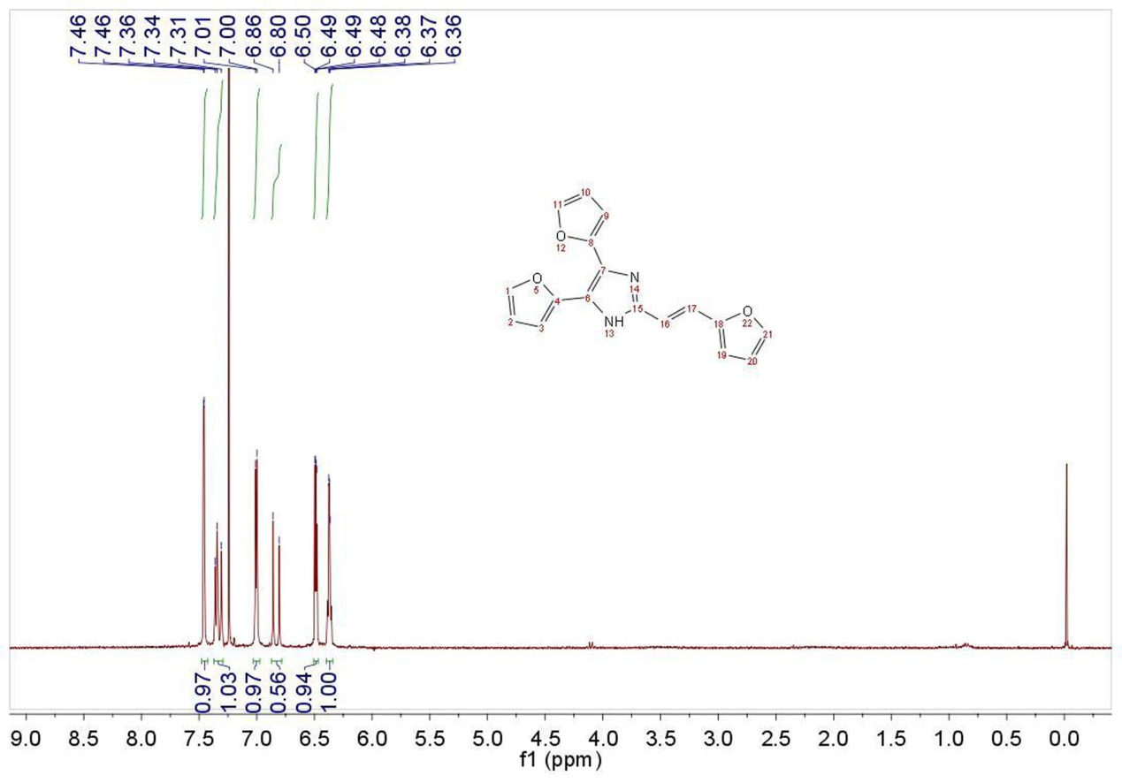
¹H NMR of 4,5-di(furan-2-yl)-2-(2-furylvinyl)-1H-imidazole

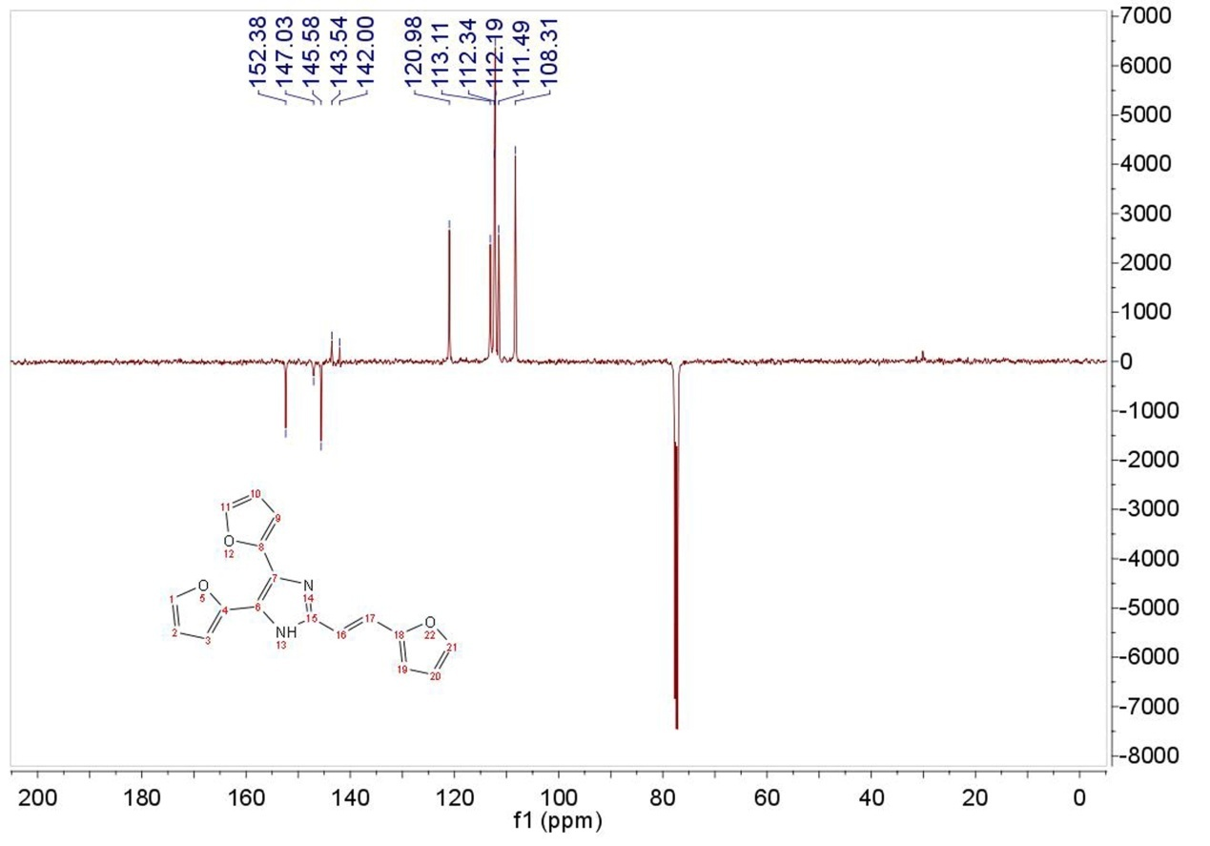
¹³C NMR of 4,5-di(furan-2-yl)-2-(2-furylvinyl)-1H-imidazole
5. ¹H NMR and ¹³C NMR for 4,5-di(furan-2-yl)-2-(1-chloro-2,2-dimethylethyl)- 1H-imidazole (3e) (Table 3, entry 5)

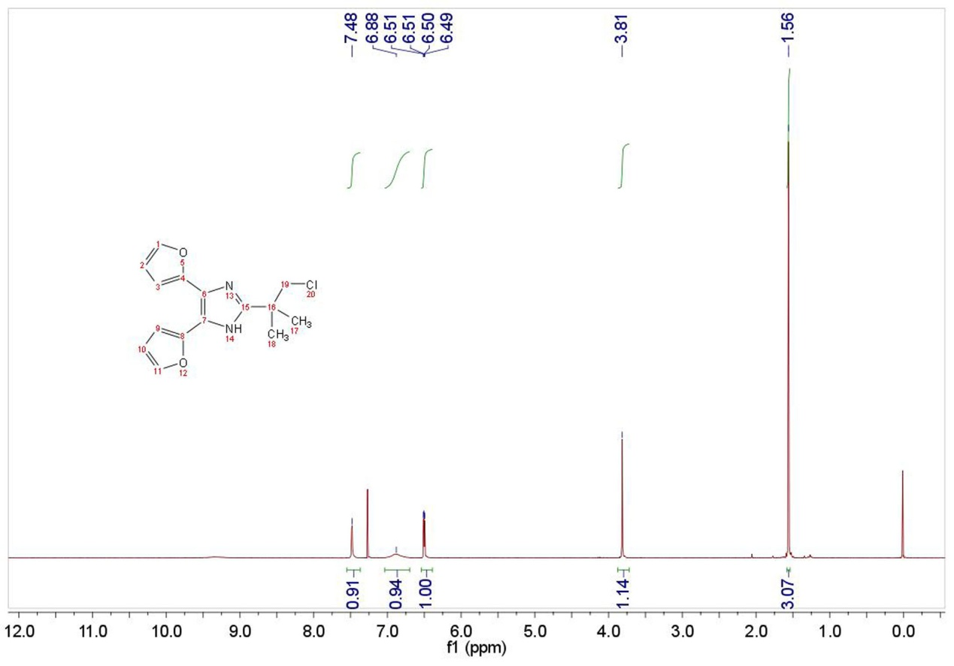
¹H NMR of 4,5-di(furan-2-yl)-2-(1-chloro-2,2-dimethylethyl)-1H-imidazole

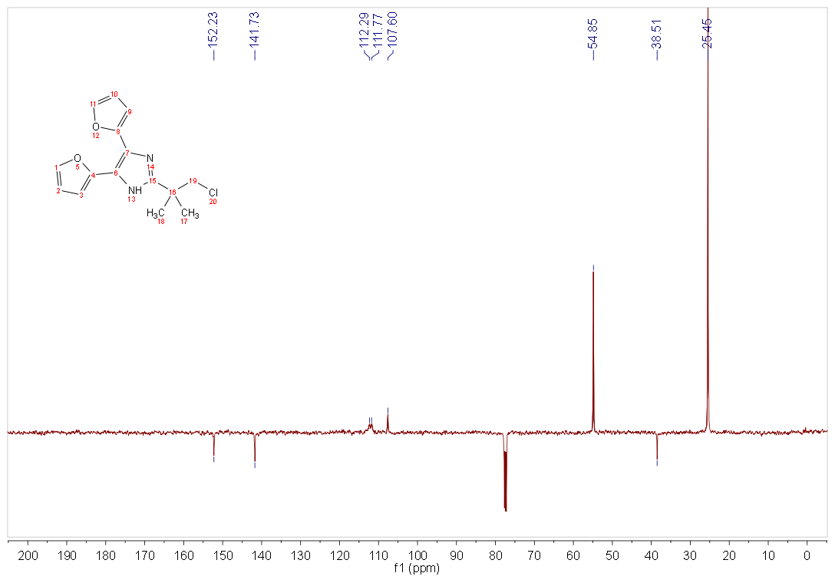
¹³C NMR of 4,5-di(furan-2-yl)-2-(1-chloro-2,2-dimethylethyl)- 1H-imidazole

6. ¹H NMR and ¹³C NMR for 4,5-di(furan-2-yl)-2-methyl-1H-imidazole (3f) (Table 3, entry 6)

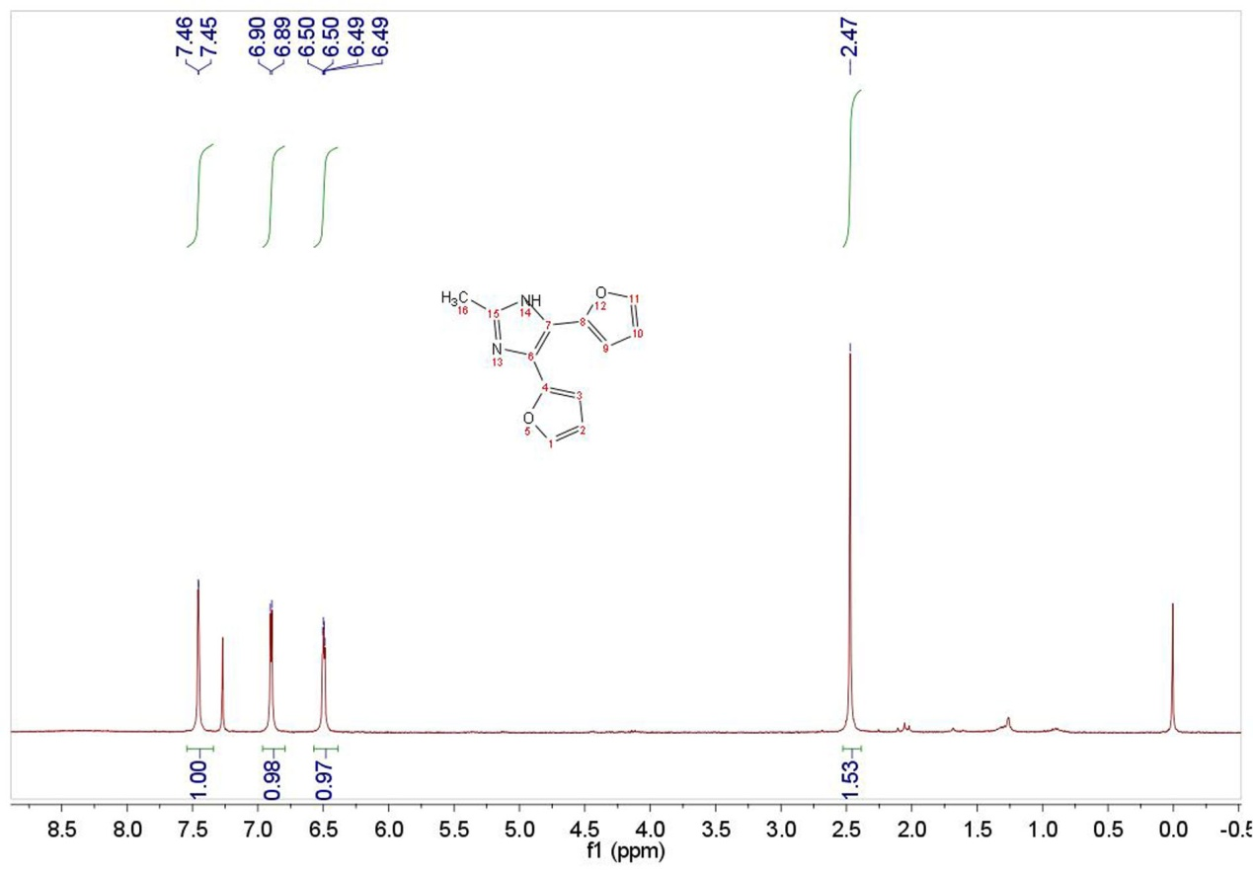
¹H NMR of 4,5-di(furan-2-yl)-2-methyl-1H-imidazole

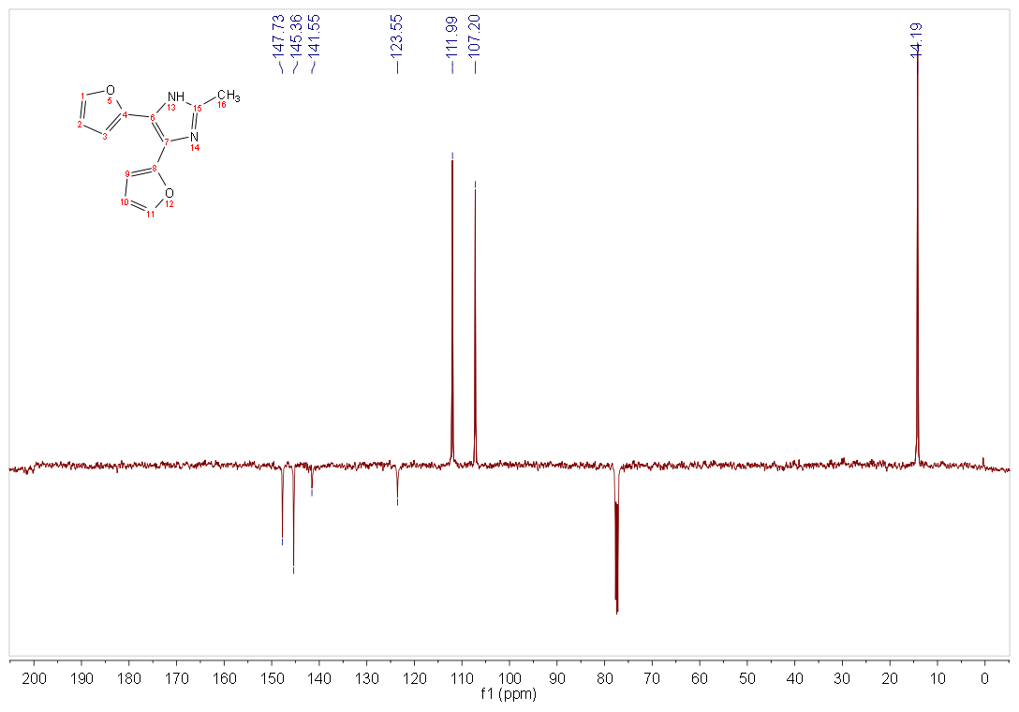
¹³C NMR of 4,5-di(furan-2-yl)-2-methyl-1H-imidazole
7. ¹H NMR and ¹³C NMR for 4,5-di(furan-2-yl)-2-(4-nitrophenyl)-1H-imidazole (3g) (Table 3, entry 7)
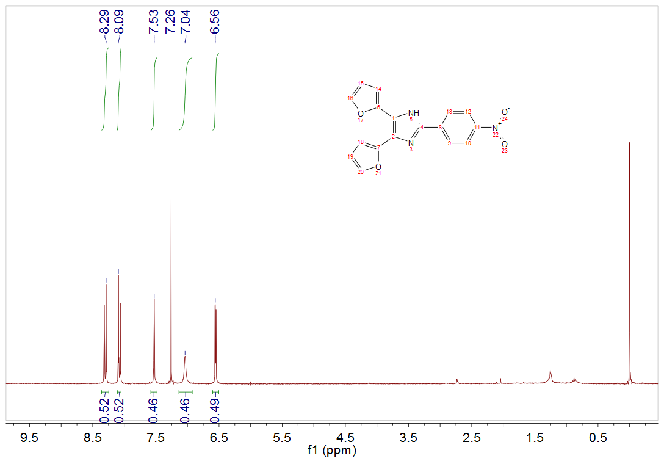
¹H NMR of 4,5-di(furan-2-yl)-2-(4-nitrophenyl)-1H-imidazole

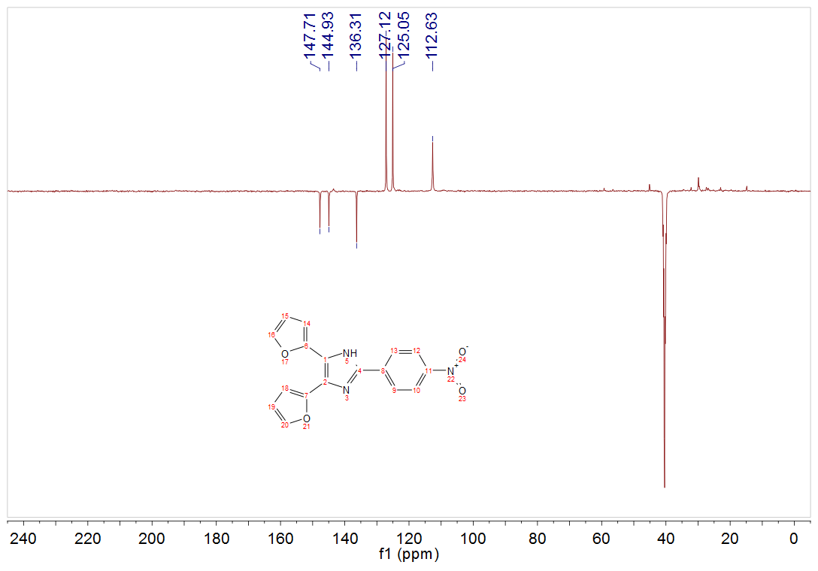
¹³C NMR of 4,5-di(furan-2-yl)-2-(4-nitrophenyl)-1H-imidazole

8. ¹H NMR and ¹³C NMR for 3-(4,5-di(furan-2-yl)-1H-imidazol-2-yl)pyridine (3h) (Table 3, entry 8)

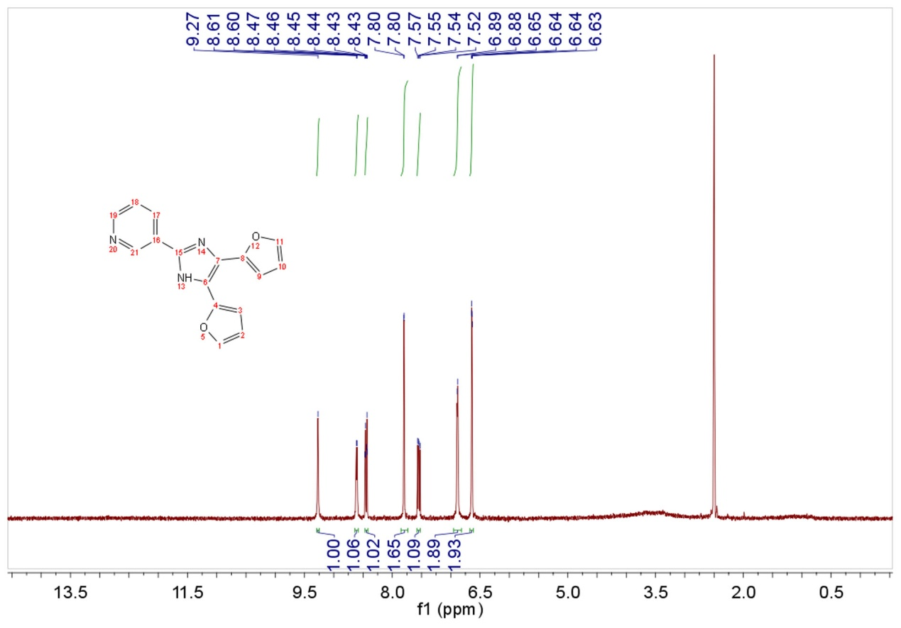
¹H NMR of 3-(4,5-di(furan-2-yl)-1H-imidazol-2-yl)pyridine

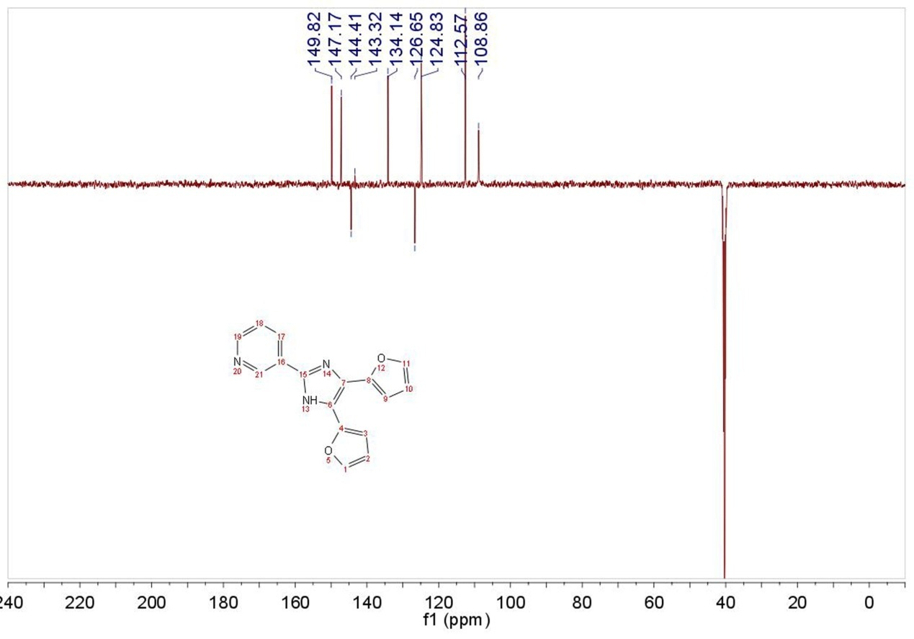
¹³C NMR of 3-(4,5-di(furan-2-yl)-1H-imidazol-2-yl)pyridine
9. ¹H NMR and ¹³C NMR for 4,5-di(furan-2-yl)-2-undecyl-1H-imidazole (3i) (Table 3, entry 9)

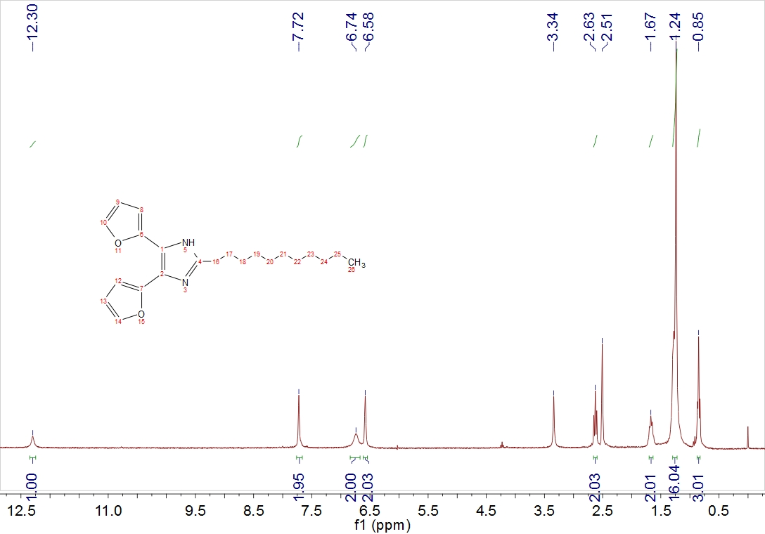
¹H NMR of 4,5-di(furan-2-yl)-2-undecyl-1H-imidazole

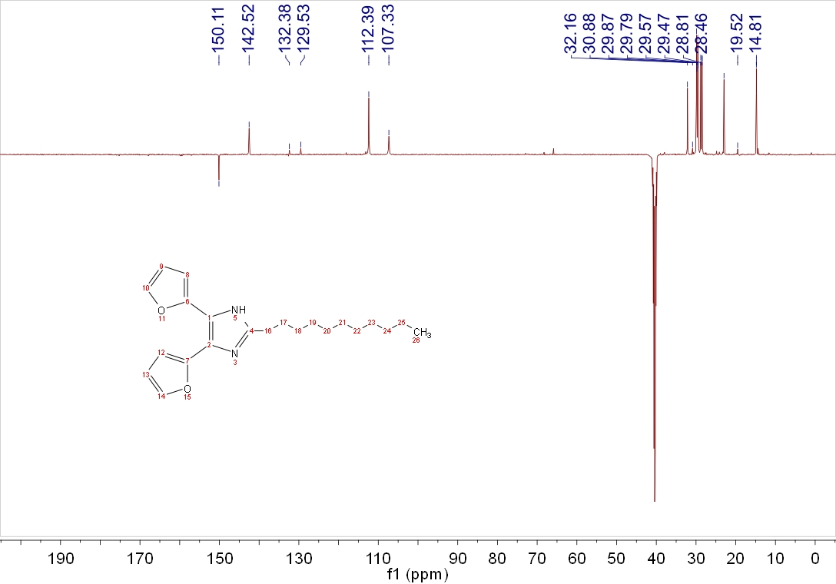
¹³C NMR of 4,5-di(furan-2-yl)-2-undecyl-1H-imidazole

10. ¹H NMR and ¹³C NMR for 2,4,5-tri(furan-2-yl)-1H-imidazole (3j) (Table 3, entry 10)
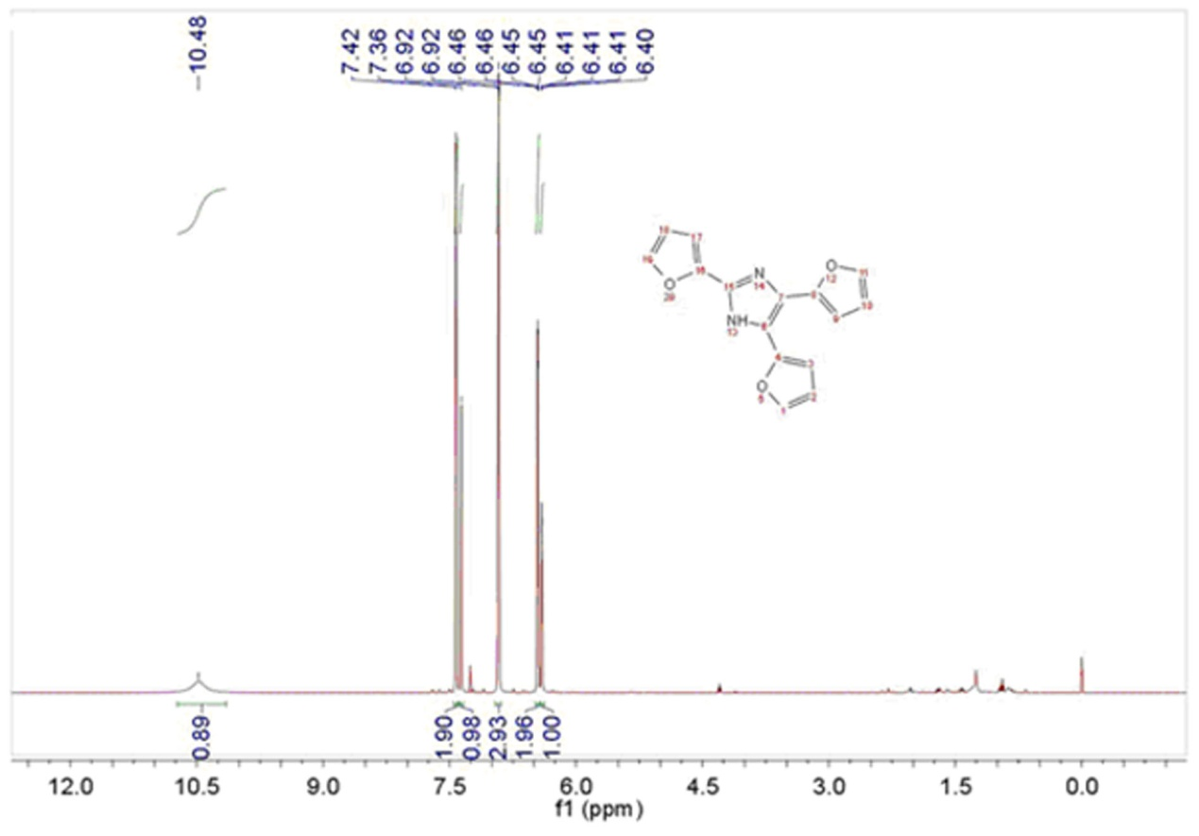
¹H NMR of 2,4,5-tri(furan-2-yl)-1H-imidazole

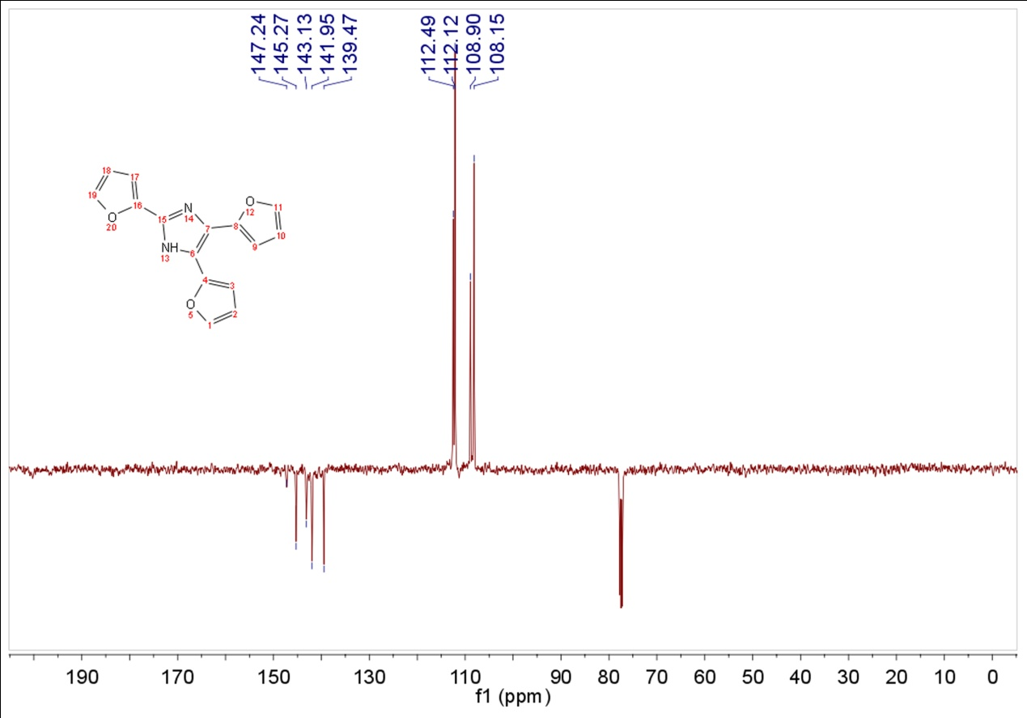
¹³C NMR of 2,4,5-tri(furan-2-yl)-1H-imidazole
11. ¹H NMR and ¹³C NMR for 4,5-di(furan-2-yl)-2-styryl-1H-imidazole (3k) (Table 3, entry 11)

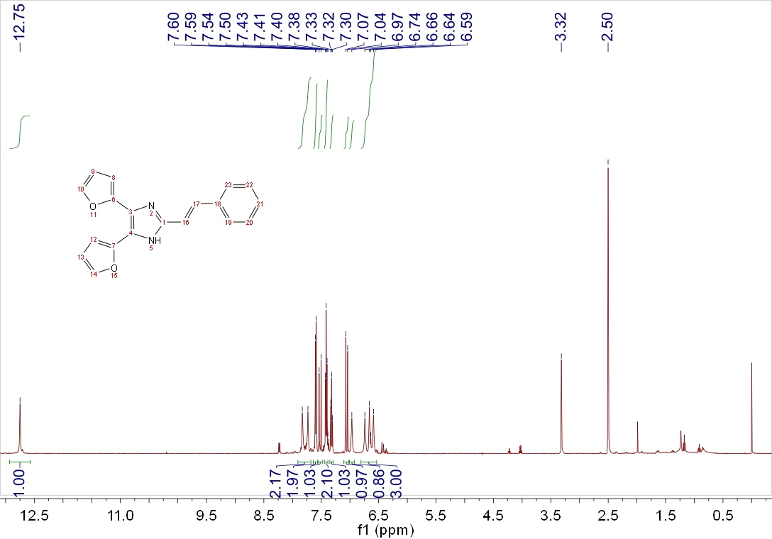
¹H NMR of 4,5-di(furan-2-yl)-2-styryl-1H-imidazole

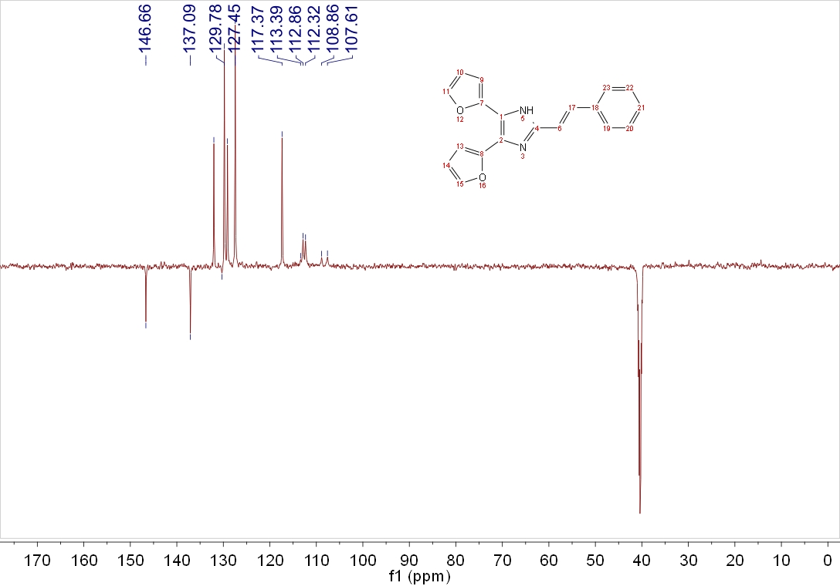
¹³C NMR of 4,5-di(furan-2-yl)-2-styryl-1H-imidazole

