Cross-cultural differences in drivers’ behaviour: a driving simulator study

Chinebuli Uzondu*
PhD Researcher
Dr Samantha Jamson*
Principal Research Fellow

Dr Daryl Hibberd*ª
Visiting Research Fellow
*Institute for Transport Studies
University of Leeds, United Kingdom.
ª AECOM Strategic Consultancy

Abstract
This paper presents the results of a cross-cultural study carried out with the intent of finding out which, among culture and road environment, has a greater influence on driver behaviour. To achieve this, the driving style of Nigerians with no experience of driving in the UK was compared to that of Nigerians with some experience of driving in the UK and to British drivers. It was hypothesised that those Nigerian drivers with no experience of driving in a highly regulated UK road system would not be encouraged to adopt a safe driving style. This would have implications for the use of road safety interventions in Nigeria that have been developed outside the Nigerian context. A driving simulator experiment was designed and carried out, comparing the driving style of these three groups of drivers in different conditions. The conditions varied depending on how much regulation was provided (low and high infrastructure). Data were analysed using R version 3.5.1 and SPSS version 24. Generally, results showed that there were distinct differences in behaviour between all the groups in most of the traffic scenarios. Nigerian drivers were more likely to engage in unsafe driving behaviours compared to other drivers. Improvements in the road environment did not bring about any significant changes in the behaviour of Nigerian drivers. There were no significant differences in the behaviour of Nigerian drivers with some experience of driving in the UK and that of British drivers in almost all scenarios. The results indicate that the behaviours of drivers are interpretable in relation to their traffic safety culture, and are partly influenced by their driving environment.

Keywords: cross-cultural differences, driving behaviour, driving simulator

1. Introduction
Regional differences in traffic safety are quite considerable. The nature of road safety issues in developing countries is significantly different from that in developed countries. While there has been a decrease in road traffic fatalities in some developed countries as a result of various countermeasures put in place, the situation is different in developing nations as RTCs do not get the attention it deserves. Countries such as Norway, Sweden, and the UK have recorded reductions in road traffic fatality rate while it continues to rise in most developing countries. Reducing road traffic injuries has a positive effect on national income growth (World Bank, 2017). Traffic safety records are much worse in Africa than in Northern and Western Europe. In its Global status report on road safety (2018), the World Health Organisation (WHO) reports that the highest road traffic fatality rates are in the developing countries, particularly the African and South-East Asian regions. Although the African region is the least motorised (2%) of the world, 16% of all recorded deaths as a result of road crashes is found there. Nigeria and South Africa have the highest fatality rates (33.7 and 31.9 deaths per 100,000 population, respectively) in the region which is above the regional average of 24 deaths per 100,000 population (WHO, 2013b).
In this study, Nigeria and the UK were used as sample countries. The distinct differences between the two countries in traffic safety performance provided the reason for choosing these two countries. Nigeria has one of the lowest traffic safety performances in the world while the UK is one of the countries with the best traffic safety performance. It is very important that greater information on the differences between these countries’ driving behaviour including level of performance, perception of hazard and adherence to road rules are identified so as to develop evidence-based strategies for improving the road safety profile in developing countries. This comparison may help to understand the role road safety culture plays as a contributory factor to road safety performance in these countries.
Road safety related indicators demonstrate the adverse safety profile of developing countries compared with developed countries. For instance, in 2016 Nigeria had 21.4 fatalities per 100,000 vehicles. This was far higher than the UK (3.1) with a very low number of fatalities. In 2016, the UK had a population of 65,788,572 with about 38 million registered vehicles and has a far better traffic safety situation compared to Nigeria with a population of 185,989,632 and an estimated 11 million registered vehicles (WHO, 2018). In the same year, there was a total of 2,019 traffic fatalities on British roads while in the same year there were 39,802 traffic fatalities Nigeria (WHO 2013a). In other words, the road fatality rate in Nigeria is about seven times higher than what is obtainable in the UK. These statistics of the number of road incidents in both countries, with their populations and registered vehicles, indicate that the UK is far ahead of Nigeria in road safety.

The road safety situation in Nigeria is generally poor. Most roads are poorly designed and in desperate need for repair. In addition, drivers engage in behaviours which are presumably unsafe and have been developed over the years due to the poor driving conditions. Problems such as lack of basic road furniture, poor driver education and training and lack of strict enforcement have all contributed to the poor road safety situation in Nigeria. A driver’s road environment could have a possible effect on driving behaviour, in that drivers from environments with stricter regulations, better roadways and very good driver training and tests could drive safer than those from environments characterised by frequency and high rate of crashes as a result of unsafe driving culture. Factor et al. (2007), in their “social accident” model, stated that drivers belonging to different social groups interpret a given situation differently and this varied interpretation could result in conflicting decisions, possibly leading to crashes. This could be linked to research examining systematic differences in traffic behaviour between drivers from different nationalities. Gregory (1985) and Edensor (2004) in different studies have shown that driving is dependent on culture and compared to the western countries, India and Egypt have a lower level of traffic regulation and enforcement which seems to have resulted in many culturally determined informal rules. In most middle/low-income countries, there is a paucity of formal rules which seems to be accepted, as drivers over the years have developed ways of communicating and interacting with each other informally.

Behavioural change isn’t easy to achieve but some unsafe behaviours could be overcome with a better transport system whilst some can’t. Road traffic crashes are preventable especially if the right intervention measures are put in place to counter them. Strong policies and enforcement, smart road design, and good public awareness campaigns are a few examples and can save millions of lives over the coming decades if implemented appropriately.

This study investigated the influence of road safety culture and road environment on drivers’ behaviour. This was achieved by using objective measures such as vehicle positioning/control, compliance with road rules and perception of hazards elicited via the driving simulator to examine the performance of three different groups of drivers. These groups of drivers are Nigerian drivers (NG), Nigerian/UK drivers (NG/UK) and UK drivers.
**In this study, driver behaviour was investigated across cultures- Nigeria and the UK. Road safety culture in this study is regarded as a general understanding of drivers’ behaviour and attitudes within the traffic environment in a specific country. The terms “Nigerian driver” (NG), “Nigerian/UK driver” (NG/UK) and “UK driver” refers to a driver who learned to drive and whose driving behaviour was shaped from one or two distinct traffic environments.

2. Method

Methodology and research environment
This research employed the motion-based high fidelity driving simulator of the University of Leeds Driving Simulator (UoLDS). The use of the simulator was suitable and permitted the creation of a realistic setting where behaviours relevant to safe driving could be examined. UoLDS is based on a 2005 Jaguar S-type vehicle model housed in a 4m spherical projection dome with a 300 ° field of view projection system. It has fully operational controls, including a steering wheel with force feedback and pedals, as well as rear view and side mirrors. A spherical screen projection area provides the road environment at 60 Hz and a resolution of 3x1920x1200 to the front and 1024x768 in the peripheral and rear views. The rear view and side mirrors provide a field view of 42°, which is displayed on and therefore only visible through these mirrors. While driving, the participant can perceive forces caused by braking and cornering. The software assumes an engine model from a 2002 Jaguar X-type and braking data from a Ford Mondeo. The simulator records data at 60 Hz, which is inferred from the driver’s inputs, the vehicle movement and position, as well as data related to other vehicles on the simulated roads. The vehicle has an automatic transmission so participants are not required to interact with the gear-shift lever.

Experimental design
A two-way (2x3) mixed design was employed. The within-subjects factor is infrastructure with 2 levels (low and high). The between-subject factor is the culture of the participants with 3 levels (NG, NG/UK and UK drivers), as participants were selected specifically for this purpose. Participants drove on roads with low and high infrastructure. They were asked to drive normally without instructions so that the drives can provide data to measure participants’ normal driving behaviour. The reason is that instructions could increase attentional resources and improve performance, as drivers deliberately control their behaviour (Trick and Enns, 2009).

Driving scenarios
The road layout for this study was 22km long and consisted of urban and rural road segments forming a single stretch for a 27-minute drive. It comprised of one lane road in each direction. The speed limits at different points were 30 (48km/h), 40 (64 km/h) and 60 mph (97 km/h). Description of the scenarios is shown in table 1.
Table 1: Description of driving scenarios
Please, note that the participant, leader and other road users in the sketch of driving scenarios are represented by:
Participant Leader/crossing car other road users

Road layout | Scenario description
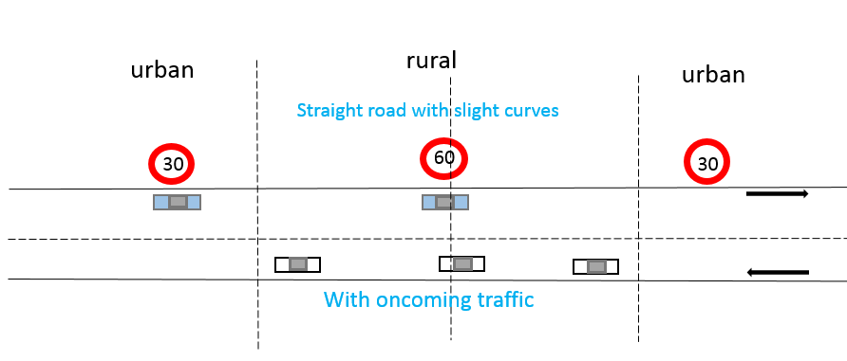 | Speed choice: This scenario started from a traffic light junction that remained green and was for a total of 6km. The speed limit changed from 30 mph (48 km/h) to 60 mph (97 km/h) halfway through the drive (at approximately 2800m). It was designed to measure speed choice and speed limit exceedance.
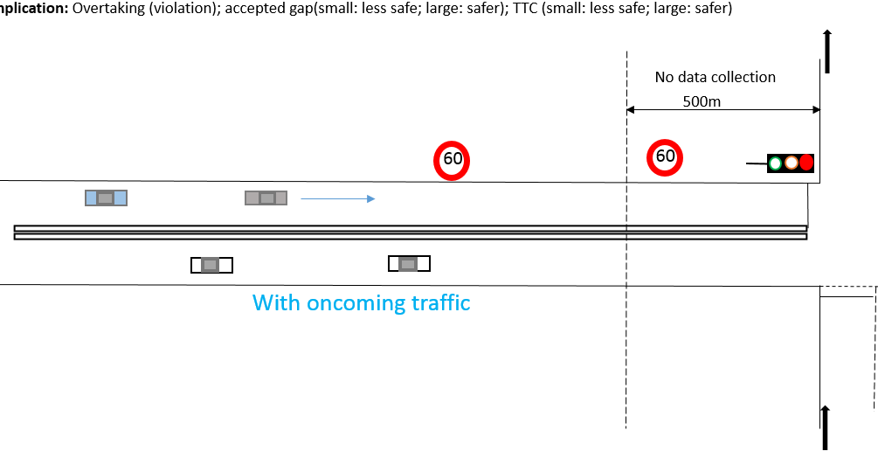 | Compliance with line marking: Double solid white lines show that overtaking is prohibited. The scenario started when a vehicle pulled in from the left into the major road in front of the participant and ended when the lane marking changed to single broken white lines. The leader varied its speed between 40 and 50 mph. It was designed to assess knowledge and adherence to road markings
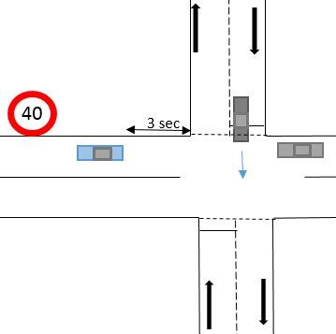 | Crossing car: This was a priority junction without traffic lights. It involved a car merging from the left and crossing the road in front of the participant even though the participant had priority. It began when the TTJ of the participant’s vehicle with the stop line of the junction was 3 seconds. Then the car which was stationary at its stop-line, crossed the road in front of the participant and accelerated to 40mph within 2.5 secs before clearing from the junction. This scenario was important to investigate participants’ reaction to unexpected hazards

Dependent variables
Several dependent variables were measured during the simulator experiment which is relevant for each of the longitudinal measures of interest. Longitudinal control involved speed control aimed to prevent collisions, keeping a steady flow of traffic and allowing the driver to be in control even when faced with sudden critical situations/events. These were studied by mean and standard deviation values for speed. Measures that relate the position of the participant’s vehicle to junctions and other vehicles were included in the analyses. Others included assessing compliance with basic road rules and perception of hazard. For perception of hazards, minimum speed reached on approach to the hazards and brake reaction time (BRT) were used as performance measures.

Participants
Participants were recruited specifically to fit into three groups – NG, NG/UK and UK drivers (NG Drivers: drivers from Nigeria who have never driven in the UK or any other developed country; NG/UK drivers: drivers who have driven in both Nigeria and the UK; UK drivers: drivers from the UK who have never driven in any developing country).
There were forty-eight participants with 16 participants per group (NG: 12 males, 4 females; NG/UK: 12 males, 4 females; UK: 11 males, 5 females) aged 19 to 55 years old. No significant age differences were found between the three cultures. Every participant held either a Nigerian and/or a full UK/EU license and had at least 2 years of driving experience (range 2-20 years). As a gesture of appreciation, all participants were given £20 or £25 depending on the number of drives they completed. This study received approval from the Faculty ethics committee (review reference AREA17-008) and accordingly, participants gave informed consent to take part in the research

Analysis
Descriptive statistics were performed on the data for each scenario, separated by Culture and Infrastructure.

A mixed methods ANOVA was performed with a between-subjects factor Culture (3 levels: NG; NG/UK; UK) and a within-subjects factor Infrastructure (2 levels: low and high). Where the assumption of sphericity was violated, the degrees of freedom were corrected using Greenhouse-Geisser estimates of sphericity. Main and interaction effects are reported, along with post hoc tests where appropriate. Bonferroni correction was used in all post hoc tests. Statistical significance was accepted at p < 0.05.

Where results were based on counts, Chi-square test was used to determine whether there are any associations between the variables. Post hoc tests using residual analysis were conducted on statistically significant variables to test the direction of association in each cell and to determine which cell differences contributed to the Chi-square result. The size of the standardized residuals was compared to the critical values that correspond to an alpha of 0.05 (+/- 1.96). For example, where significant differences were found in the Chi-square results, the standardised residuals were further examined to identify which cells were responsible for the differences (those larger than 1.96 indicate that the observed frequency was significantly different from that which would have been expected if there were no association between the variables in question).

**Unless otherwise stated, data analysis was conducted on the low and high infrastructure conditions.

3 Results

Speed choice
Mean speed
There was a significant main effect of Culture [F (2, 90) = 9.420, p < .001, ηp² = .173] on mean speed (Figure 1). Bonferroni pairwise comparison showed that NG drivers drove at a higher mean speed than NG/UK drivers (7.398 mph), p < 0.001 and UK drivers (4.28 mph), p = 0.043. There was no significant difference between NG/UK and UK drivers.
There was no significant main effect of Infrastructure on mean speed and no significant interactions between Culture and Infrastructure.
Figure 1: Effect of Culture on mean speed for different Infrastructure conditions

Speed limit exceedance
There was a significant main effect of Culture (F (2, 90) = 3.781, p < .026, ηp² = .078) on speed limit exceedance, Figure 2. Post hoc comparison showed that NG drivers exceeded the speed limits by 15.43%, p= 0.032 compared to the NG/UK drivers. There were no significant differences between either NG and UK drivers or NG/UK and UK drivers.
There was also a significant main effect of speed limit (F (1, 90) = 108.442, p < .001, ηp² = .546) on speed limit exceedance. Bonferroni pairwise comparison showed that speed limit exceedance was higher in the 30mph compared to the 60 mph by about 50%, p < .001.
In contrast, there was no significant main effect of Infrastructure on speed limit exceedance and significant interactions between Culture and Infrastructure.
Figure 2: Effect of Culture on speed limit exceedance for different Infrastructure conditions
Spot Speed
There was a significant main effect of Culture (F (2, 89) = 7.880, p = .001) on mean speed as depicted in Figure 3. Bonferroni pairwise comparison showed that NG drivers drove at a higher mean speed than NG/UK drivers (7.728), p < 0.001. There were no significant differences between NG and UK drivers and NG/UK and UK drivers.
In contrast, there was no significant main effect of Infrastructure on mean speed and no significant interactions between Culture and Infrastructure.
Figure 3: Effect of Culture on spot speed for different Infrastructure conditions
Low infrastructure

Compliance with road markings
In the high infrastructure scenario, there was a prohibition sign showing that drivers are not permitted to cross which was placed about 110km before the road marking but there was none in the low infrastructure condition.

Cross or not
Participants’ decision to cross or not to cross the double white lines was examined based on counts (Figure 4). Results revealed a statistically significant association between Culture and crossing violations for the low infrastructure (χ2= 7.807, p= .020 and df= 2) and high Infrastructure (χ2= 13.844, p= .001 and df= 2) conditions. Post hoc test using standard residuals showed that among drivers who violated the traffic rule, there were more NG drivers than would be expected for the low Infrastructure (3.7) and high Infrastructure (5.3) conditions respectively.
Figure 4: Effect of Culture on number of participants who crossed the double solid white line under different infrastructure conditions
SD. of speed
There was a significant main effect of Culture [F (2, 45) = 4.947, p < .011, ηp² = .180] on speed variation, Figure 5. Bonferroni pairwise comparison showed a significant difference between the variation in speed of NG and UK drivers (2.863), p < 0.009. There were no significant differences between NG and NG/UK and NG/UK and UK drivers.
Figure 5: Effect of Culture on speed variation
There was no significant main effect of Infrastructure on SD of speed and no interaction between Infrastructure and Culture.

Crossing car
Time to collision with crossing car
There was a significant main effect of Culture on TTC [(F (2, 45) = 4.723, p =.014], Figure 6. Bonferroni pairwise comparison showed that the TTC of NG drivers was lower than that of the NG/UK drivers by .77 seconds, p = .013. There were no significant differences between the UK and NG/UK drivers or NG and UK drivers.
There were no main effects of Infrastructure on TTC and no interaction between Infrastructure and Culture.

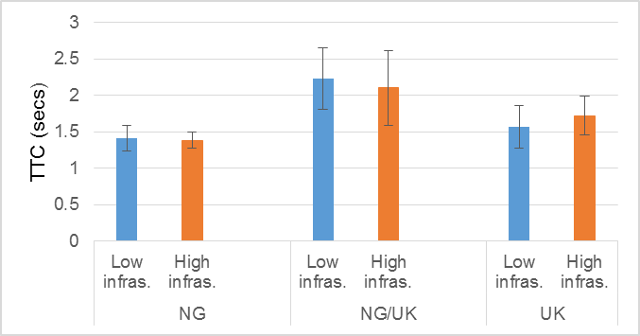
Figure 6: Effect of Culture on TTC with crossing car in different Infrastructure conditions

Spot Speed and BRT at TTC = 3secs
There was a significant main effect of Culture on spot speed [(F (2, 18) = 6.598, p = .007, n_{p}² = .423] and BRT [(F (2, 18) = 6.317, p = .008, n_{p}² = .412] as shown in Figure 7. Bonferroni pairwise comparison showed that the speed of NG drivers was higher than that of the NG/UK drivers by 10.19mph, p = .020 and UK drivers by 10.69mph, p = .014. Bonferroni pairwise comparison showed that there were significant differences between some groups of drivers. It took NG drivers a longer time to react to the hazard compared with NG/UK (.383 seconds, p = .026) and UK (.416 seconds, p = .015) drivers (Figure 7). There were no significant differences between UK and NG/UK drivers or NG and UK drivers
There was no significant main effect of Infrastructure on spot speed and no interaction between Infrastructure and Culture of participants.
**Note: in analysing the BRT, only participants’ first drives were included, this was because participants may become more cautious and would expect the hazard in the second drive (i.e. the hazard will no longer be a surprise in the second drive).
Figure 7: Effect of Culture on spot speed and BRT for different Infrastructure conditions

4 Discussion and conclusion
In this study, a range of driving tasks was designed to investigate whether there are any differences in behaviour between drivers from different cultures and to see if changes in the road environment would have an effect on drivers’ behaviour. To directly compare the behaviour of drivers, they were asked to drive normally in environments where varying amounts (low and high) of infrastructure and guidance was provided. Drivers’ behaviour was assessed by unsafe driving or behaviours made during the drives, which were analysed and compared. The emphasis was on behaviours such as speeding, reaction to hazards and complying with road rules. Several culture effects were found, but none of them could be attributed to the infrastructure and guidance provided. The primary differences were for NG drivers compared to NG/UK and UK drivers because, in almost all the scenarios, the performance of NG drivers differed significantly from those of NG/UK and UK drivers. Irrespective of the infrastructure conditions, UK and NG/UK drivers exhibited safer behaviours compared to the NG drivers. This means that when changes in the road environment were made (low and high infrastructure and guidance), drivers’ behaviour did not change. For instance, NG drivers drove faster and spent more time speeding in both conditions. Generally, NG/UK and UK drivers tended to keep these measures constant or lower, even though in some cases, UK drivers drove faster than the NG/UK drivers. Across all scenarios, the NG/UK and UK drivers tended to show safer patterns of performing the driving tasks compared to the NG drivers. NG/UK and UK drivers were grouped together in the discussion because even though there were slight differences in their behaviours in some of the scenarios, no significant differences were found.

Speed choice
Speed is a risk factor influencing both the risk of a crash and the severity of injuries resulting from road crashes (Nilsson, 2004). Drivers' speed choice has been a particular focus of road safety research, as high speeds have been found to increase the risk of crashes (Aarts and van Schagen, 2006). On the other hand, low speed is considered safe and known to reduce crash risk (Elvik et al., 2004; Nilsson, 2004). In all the scenarios where speed was measured, there were significant main effects of culture on mean speed, speed variation and in some instances, speed limit exceedance.
For example, in the speed choice scenario, there were significant main effects of culture on mean speed, speed limit exceedance and spot speed for the 30mph and 60mph zones. For the culture effect, NG drove at a higher mean speed, had the highest speed when spot speed was measured and spent more time exceeding the speed limit compared to the other groups. There were no significant differences in mean speed, spot speed and speed limit exceedance between the other two groups.
NG/UK and UK drivers showed a higher intention to comply with the speed limit as well as time spent complying compared with the NG drivers. It is well known that high and inappropriate speed is one of many factors contributing to the number and severity of road traffic crashes. According to FRSC (2018), 44% of road traffic crashes in Nigeria in 2017 were caused by speeding. It could be reasonable to believe that international differences in the number of road traffic crashes would partly be affected by drivers speed choice. WHO (2018) shows that the number of road traffic crashes is higher in Nigeria (21.4 fatalities per 100,000 population) compared to the United Kingdom (3.1 fatalities per 100,000 population). This is consistent with a study by Warner et al. (2009) where it was concluded that drivers who live in a country with fewer road traffic fatalities (i.e. Sweden), compared with drivers who live in a country with more road traffic fatalities (i.e. Turkey), report a more positive attitude towards complying with the speed limit, a higher intention and a larger proportion of the time spent complying.
There was also a main effect of speed limit on speed limit exceedance as results showed that drivers exceeded speed in the 30mph zone more than the 60mph zone. This corroborates past research which shows that more drivers report to drive above the speed limit when the speed limit is lower rather than higher and drivers exceed the speed limit to a relatively greater degree under a lower speed limit and to a relatively smaller degree under a higher speed limit (OECD/ECMT Transport Research Centre, 2006; Anastasopoulos and Mannering, 2016)
For the low infrastructure condition, there were no speed limit signs but the environment consisted of built-up areas and country-side. This is so that drivers would naturally select their driving speed but they were also expected to adjust speed based on their environments. It is very interesting to note that NG/UK and UK drivers adjusted their speed appropriately in the two environments, whereas NG drivers continued at high speeds in both environments. Consequently, low (high) Infrastructure and guidance did not affect drivers’ speed choice in any way. For all participants, mean speed remained almost the same in all drives both for the NG drivers who were speeding and for the NG/UK and UK drivers who drove slower and within the speed limit.

Compliance with road marking (double white line)
This scenario was used to examine knowledge and compliance with lane marking. The double solid white lines signify no crossing but the result of the analysis showed that some groups of drivers violated this rule. Statistical testing showed a significant association between the violation rates of different cultures for the low and high infrastructure conditions. More NG drivers violated this rule than would be expected. This could probably be because of lack of knowledge of what the lines represent. Even though in the high infrastructure condition, there was a sign indicating that the road ahead was marked, there was no significant main effect of infrastructure on the decision to cross or not. Subsequently, behaviour within cultures was the same irrespective of the infrastructure conditions. There was also a significant main effect of culture on speed variation. In line with the result from previous scenarios, NG drivers drove with high fluctuations in speed compared to other drivers.

Unexpected hazards
A critical part of traffic safety is a driver’s ability to detect and respond to emergency roadway hazards. In the car crossing scenario, the NG/UK and UK drivers reacted faster to the crossing car by stopping compared to NG drivers. Almost all the NG drivers crashed into the crossing car.
There was a significant main effect of culture on BRT as results showed that NG drivers were considerably slower to react to the hazard than NG/UK and UK drivers. This could be due to their high speed. Another possible explanation for the better performance of the NG/UK and UK drivers could be explained from greater participation in hazard perception training, as all NG/UK and UK participants would have practised for and passed the traditional hazard perception test in order to obtain their license (Lim, Sheppard and Crundall, 2004). A finding consistent with Bates et al. (2013) and McDonald et al. (2015) which shows that drivers who participated in hazard perception training could identify more hazards, scan their driving environment more effectively, anticipate hazards more quickly and slow down more when approaching hazards than those who did not participate in such training.
On the other hand, there was also a main effect of culture on TTC. TTC is closely related to headway and is defined as the time to collision with a lead vehicle in the travel path if the speeds of the vehicles remain unchanged. It measures the longitudinal margin to lead vehicles or objects. But TTC has the advantage of taking the speed difference between the vehicles into account, which is a safety-related factor. Results showed that the TTC of NG drivers was smaller than that of the other groups which according to Minderhoud and Bovy (2001) is a safety-critical approach and not a good indication of safety.

Behavioural change processes are more complicated than simply telling people how to think or what to do when they are using the road. There are no universal guidelines to change behaviour, but different groups of people need to be approached in different ways to optimise the likelihood of affecting behaviour change. Understanding how people perceive risk and how they behave accordingly is critical in designing road safety countermeasures that are effective in reducing road crashes. Even though research (Parker et al., 1996) has shown that changing the attitude of drivers is one of the most effective long‐term measures in dealing with crash involvement, Howard and Sweatman (2007) concluded that the change in road safety culture has proved to deliver better results when compared with other technology and enforcement approaches. Improving road safety Nigeria would involve a system-based approach. Interventions should be such that will be focused on improved education including enlightenment programmes and campaigns, training and retraining, engineering/infrastructure including signage, and traffic calming measures with more effective and stricter regulations and enforcement.

References
Aarts, L., and Schagen, I. van (2006). Driving speed and the risk of road crashes: A review. Accident Analysis and Prevention, 38, 215–224

Anastasopoulos, P.C. and Mannering, F.L. (2016). The effect of speed limits on drivers' choice of speed: A random parameters seemingly unrelated equations approach. Analytic Methods in Accident Research 10, 1–11. 10.1016/j.amar.2016.03.001

Bates, L., Filtness, A., Fleiter, J., Watson, B., Tones, M. and Williamson, A. (2013). How Would Changing Driver Training in the Queensland Licensing System Affect Road Safety? Deliverable 1: Trends in Driver Education and Training. Available from http://www.tmr.qld.gov.au/‐ /media/Safety/roadsafety/Road‐safety‐research‐reports/report‐1‐trends.pdf?la=en [Verified 29 January, 2019]

Crundall, D., Andrews, B., van Loon, E. and Chapman, P. (2010). Commentary training improves responsiveness to hazards in a driving simulator. Accident Analysis and Prevention 42, 2117–2124

Edensor T. (2004). Auto mobility and national identity: Representation, geography and driving practice. Theory, Culture & Society, 21(4/5), 101–120.

Elvik, R., Christensen, P. and Amundsen, A. (2004). Speed and road accidents. An evaluation of the Power Model. TØI report. Oslo, Norway: The Institute of Transport Economics (TOI)

Factor, R., Mahalel, D. and Yair G. (2007).The social accident: A theoretical model and a research agenda for studying the influence of social and cultural characteristics on motor vehicle accidents. Accident Analysis and Prevention 39, 914–921.

Federal Road Safety Corps (2018). 2017 FRSC Annual Report. Retrieved from: https://frsc.gov.ng/wp-content/uploads/2018/09/AnnualReport2017.pdf

Field, A. (2009). Discovering Statistics Using SPSS: Introducing Statistical Method (3rd ed.). Thousand Oaks, CA: Sage Publications
Gregory S. W. (1985). Auto traffic in Egypt as a verdant grammar. Social Psychology Quarterly, 48, 337–348.

Howard, E., Sweatman, P., 2007. Road safety culture development for substantial road trauma reduction. In: AAA Foundation for Traffic Safety (2007) Improving Traffic Safety Culture in the United States – The Journey Forward. AAA Foundation for Traffic Safety, Washington, DC

Lim, P.C., Sheppard, E. and Crundall, D. (2014). A predictive hazard perception paradigm differentiates driving experience cross-culturally. Transportation Research Part F: Traffic Psychology and Behaviour, 26, 210-217.

McDonald, C. C., Goodwin, A. H., Pradhan, A. K., Romoser, M. R., and Williams, A. F. (2015). A review of hazard anticipation training programs for young drivers. Journal of Adolescent Health, 57, S15‐S23.
Minderhoud, M.M. and Bovy, P.H.L (2001). Extended time-to-collision measures for road traffic assessment. Accident analysis and prevention, 33(1), 89-97

Nilsson, G. (2004). Traffic safety dimensions and the power model to describe the effect of speed on safety. Lund, Sweden: Lund University

OECD/ECMT Transport Research Centre, 2006. Speed management. OECD Publishing, Paris. http://www.itf.-oecd.org/sites/default/files/docs/06speed.pdf. Accessed 14 February 2019

Parker, D., Stradling, S. G. and Manstead, A. S. R. (1996). Modifying Beliefs and Attitudes to Exceeding the Speed Limit: An Intervention Study Based on the Theory of Planned Behavior1. Journal of Applied Social Psychology, 26, 1‐19.

Trick, L. M. and Enns, J. T. (2009). A Two-Dimensional Framework for Understanding the Role of Attentional Selection in Driving. In: Castro, 270 C. (ed.) Human factors of visual and cognitive performance in driving. Boca Raton, Florida: CRC Press.

UK Government Department for Transport. High way Code, road safety and vehicle rules _ GOV.UK. https://www.gov.uk/browse/driving/highway-code-road-safety (accessed April 28, 2019).
Warner, H. W., Ozkan, T. and Lajunen, T. (2009). Cross-cultural differences in drivers’ speed choice. Accident Analysis and Prevention, 41, 816-819.

World Bank (2017) https://data.worldbank.org/indicator/NY.GDP.PCAP.CD
World Health Organization. (2013a). Global status report on road safety 2013 - Supporting a Decade of Action. Luxembourg: World Health Organization. Retrieved from: http://www.who.int/violence_injury_prevention/road_safety_status/2013/en/
World Health Organisation (2013b). Road safety in the WHO African region: The Facts 2013.
www.who.int/violence_injury_prevention/road_safety.../2013/.../factsheet_afro.pdf
(World Bank, 2017

World Health Organization. (2018). Global status report on road safety 2018. Luxembourg: World Health Organization. Retrieved from: http://www.who.int/violence_injury_prevention/road_safety_status/2018/en/

