Playing And Learning Without Borders: A Real-time Online Play Environment
Sauvé, L.¹, Villardier. L. ¹,
Probst, W. ², Boyd, G.³, Kaufman, D. ⁴ et Sánchez Arias, V.G.^{5,} Power, M. ¹
Louisesauve@vif.ca; lvillard@teluq.uquebec.qc.ca; probst.wilfried@uqam.ca;
boydg@vax2.concordia.ca; dkaufman@sfu.ca; victor@lania.mx; mpower@teluq.uquebec.ca
¹Télé-université / SAVIE, 455 rue de l’Église, Québec (Québec), Canada G1K 9H5.
² Université du Québec à Montréal, C.P. 8888, Succ. C-V, Montréal (Québec), Canada H3C 3P8.
³Concordia University, 1455, boul. de Maisonneuve Ouest, Montréal (Québec), H3G 1M8.
⁴Simon Fraser University, 8888 University Drive, Burnaby, BC, V5A 1S6
⁵ Laboratorio Nacional de Informática Avanzada, Rébsamen 80, Xalapa Veracruz México, C.P. 91090

ABSTRACT

Funded by CANARIE Inc., the ENJEUX–S project (ENvironnement évolué de JEUX éducatifs et de Simulations en ligne) aims to develop a real-time communication interface that enriches the environments of educational games and simulations developed in the SAGE project. This interface allows for the exploration of a wealth of real-time interpersonal communications in educational situations which utilize online games and simulations. The elements of the interface are built on a Web services environment which rests on a SOA architecture. This novel approach permits universal broadcasting of games and simulations over the Web without any prior loading of software, assuring an increased accessibility of services, the interoperability of platforms and the re-utilization of components. The advances of the User-Controlled Light Paths (UCLP) CAnet*4 fiber optics network guarantee the ENJEUX-S project the instantaneity of communications and a wider visibility. The project is an extension of current work of the SAGE network. This article presents a brief description of the ENJEUX-S interface, its architecture and the design stages on which its development is based.

Keywords
Communication interface, Educational games, Simulations, Generic game shells, Web services, SOA (Services-Oriented Architecture), Synchronism.

INTRODUCTION

Online educational games and simulations, like video games on the Internet, are more and more demanding in bandwidth, in proportion to the integration of multimedia and communication components. The advances in the CAnet*4 technology in the domain of fiber optics and high-speed links with the possibility of completely optical routing via User-Controlled Light Paths (UCLP) as well as optical bridges, permit the experimenting of applications that facilitate instantaneous and simultaneous exchange of data.

It is in this context that the ENvironment for Educational Games (Fr: JEUX) and online Simulations (ENvironnement évolué de JEUX éducatifs et de Simulations en ligne, or ENJEUX–S) project has been financed by CANARIE Inc. The project goal is to develop a real-time communication interface based on the Web Services model that will enrich the environments of educational games and simulations developed in the SAGE project. By integrating the communication components in real time (video, voice, sound, chat, white board and online access management) into the environments of educational games and simulations on the Internet, the interface introduces the dimension of telepresence. This integration, which is one of the originalities of the project, permits the exploring of rich educational situations (retroactivity, direct dialogue, immediate assistance, shared strategies, help, etc.), where the real world meets the virtual world to exploit situations in 2D or 3D, simple or complex. The development of this interface also has the objective to increase the communication and interaction capacity of generic multi-station game and simulation shells developed within the SAGE university portal as well as existing games and simulations.

The ENJEUX-S project (http://enjeux.savie.ca) is part of the ongoing work of the Canadian research network SAGE. In this short paper we present a brief description of the ENJEUX-S interface, its architecture, and the design stages on which its development is based.

1. THE ENJEUX-S INTERFACE

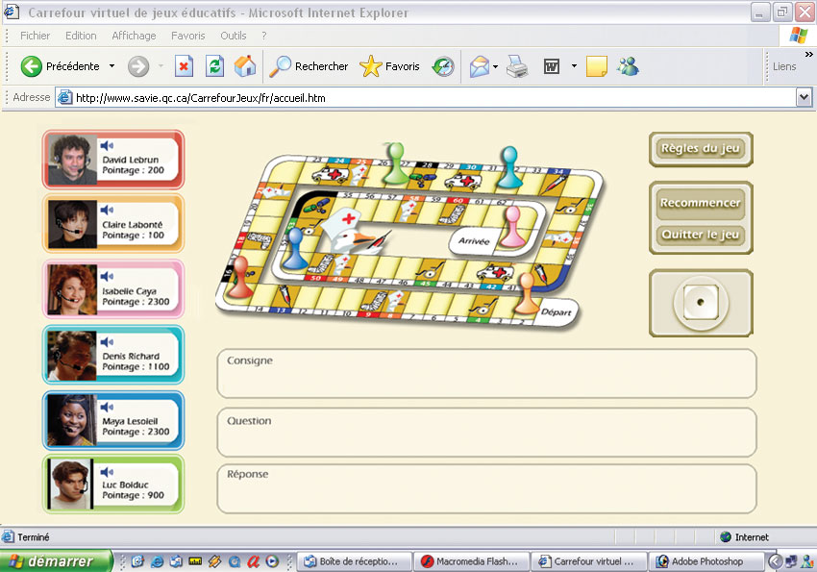
Combining the functionalities of collaborative working (Villardier et al., 2003; Probst et al., 2004), ENJEUX-S offers an environment that activates, among others (1) online games and simulations, (2) games developed by means of the generic shells of the Carrefour virtuel de jeux éducatifs (Virtual Crossroads of Educational Games), and (3) games and simulations of the SAGE portal. Functional, easily accessible and completely transparent to the user, ENJEUX-S uses Web services for the management and operation of online games and simulations, and real-time communication services (videoconferencing, audio and keyboard chat) to support a collaborative work environment between users. The only equipment required is a Web camera, headphones and a high-speed Internet connection to be transported into a virtual world of games and simulations. No downloading of special software is required.
Figure 1. A simulated screenshot of the collaborative ENJEUX-S environment

Among other things, the ENJEUX-S interface allows players to communicate between themselves privately, or in public during the unfolding of the game by means of specific functionalities. This real-time communication may be done in audio or video/audio modes, in addition to video chat on demand. Each player can also, at any time, access a white board that provides information on the evolution of the game according to certain parameters: list of active players, tally, unfolding of the game, rules, configuration of the environment of other online players, etc. This interface [Figure 1] also offers different display modes (skin) that allow players to adapt themselves to the game or simulation context, and that can be parameterized by them according to their needs. Studies are underway currently to develop translucent objects in Flash, which would be superimposed on the background of the interface that constitutes the game proper. This hypothesis would permit players to continue playing without exiting or loss of continuity of the ongoing game and to remain in full contact with the other players. On the graphical level, this solution offers the advantage of an improved visibility of the game or the simulation, while conserving all the elements of the audiovisual communication.

2. THE WEB SERVICES ARCHITECTURAL MODEL

The ENJEUX-S team has built an architecture that is essentially inspired by the development of Web services based on the SOA (Services-Oriented Architecture) model for the management and operation of games and simulations, and communication services (middleware) to support a collaborative work environment between users.

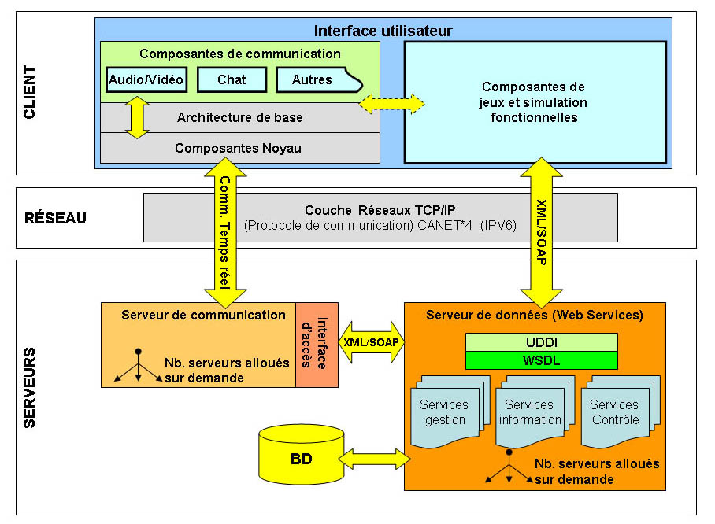
The diagram in Figure 2 shows the details of the SOA architectural model. This model is based on a series of hierarchical layers:
Figure 2. Model of the SOA Architecture of ENJEUX-S
(1) a client layer representing essentially the user interface, which contains two types of components - real-time communication components, and game and simulation components;
(2) a network layer that transfers the data to the servers; and
(3) a server layer containing different types of servers: a communications server for the purpose of managing and transmitting in real-time the communications flow (video, audio, data) between participants, as well as a data server (Web services) that executes the tasks or requests in a database. The database contains information on the participants and the unfolding of games and simulations (profile, authentication of participants, rules, movements of actors and objects, tally, etc.). Between the layers, the XML/SOAP language provides for encapsulation during an information exchange between two distant and different systems where a data conversion into a universal language is required. This encapsulation is done during the exchange of information in both directions between the client and the server, hence its representation in the links connecting certain components of the architecture. Let us examine in greater detail these components.

The client layer is composed of two types of components :
- The real-time communication components (videoconferencing, audio and keyboard chat), developed with Flash in this project, are based on an underlying framework (Component Framework) that structures the functionalities of each communication component and links them to the nucleus (Core Object Model), which manages the peripheral devices (microphone, camera, screen capture, etc.) and the main classes of the operating system using the FlashCom technology of Macromedia.
- The functional game and simulation components constitute the central portion of the client interface. They are composed of two types of products: (1) existing online games and simulations, the integration of which is transparent (independently of their development platform) and straightforward in our enhanced framework, and (2) games and simulations obtained from generic shells of SAVIE and the SAGE project.

The network layer uses the communication protocols and services of CA*net4 of CANARIE. This layer offers a bandwidth management with a multimedia and multipoint quality of service in real-time, while ensuring the reliability and the security of the network. Furthermore, it facilitates the transactional and interpersonal interactions between a large number of users of online games and simulations, which is what the SAGE project is looking for. It also allows interoperability with international high-speed networks.

The server layer integrates two types of servers:
- The communications server is based on the Macromedia solution of the Flash Communication MX Server which ensures the management of exchanges between the users and the communicational components developed in the project. An access interface connects the communications server to the data server in order to perform management tasks or requests.
- The data server (Web services), developed for this project, acts as intermediary between client requests and the ENJEUX-S database. It offers management services by processing requests related to the management of groups, of profiles and of user identification. As far as information services are concerned, they correspond to the requests of the various components of the architecture. A number of control services permit the management of certain actions made by the users during games or simulations. These last services are limited to the control of games or simulations developed within the SAGE project and which take into account our architecture.

3. THE DESIGN OF THE ENJEUX-S INTERFACE

In the first place our project is based on a collaborative approach (Desgagné, 1997; Miles & Huberman, 2003) and a participative procedure (Floch’lay, 1997; Mayer et al., 2000). This approach, which is primarily based on the collaboration between the researchers and the parties implicated in the formative evaluation of the interface, guides the evaluation protocol in order to associate the medium to the elaboration and the validation of the interface on the one hand, and on the other hand in the data collection process it favors the point of view of those who are users.

The development of ENJEUX-S [Figure 3] is based on an adaptation of McGriff’s (2000) iterative pedagogical design model (analysis, design, development, experimentation and evaluation), of the technique of testing with experts (Perron and Bordeleau, 1994), and of a sample of the target public produced by Sauvé et al., (2002, 2004) during the development of generic shells for educational games. The ENJEUX-S interface was developed by adapting the ADDIE (analyze, design, develop, implement, and evaluate) iterative design model (McGriff, 2000), with a feedback obtained by using the Learner Verification and Revision model (Sauvé et al., 2002) with both experts and small samples of the target audiences as illustrated in Figure 3.

Analysis
Design
Development
Formative
Evaluation (LVR)
Experimentation
Figure 3. Iterative Design Model for Generic Game Shells
Analysis
- Analysis of the target clientele and the experimentation contexts.
- Identification of the objects and functionalities forming the interface.
- Pedagogical and technological specifications of the ENJEUX-S interface.
- Validation by the researchers and partners associated with the project.

Design
- Scenarization of the conceptual model of the interface and validation by the members of the SAGE network.
- Writing of technical specifications.
- Infographic sketches of the environment.
- Scenarization of the screen pages and functionalities.
- Validation by the researchers and the partners associated with the project.

Development
The Object-Oriented programming approach (Document Object Mode) was adopted for the development of the interface. It facilitates, among others: (1) the rapid development of the application and its updating (Olsen, 1995); (2) the continuous revision and correction of the environment during its elaboration and technological evolution; (3) the testing of some of the parameters of the final system in a reduced amount of time, and (4) the optimization of variable parameters in real-time, the evaluation of ideas (subjective or other) and the convincing of the various potential partners of the final product’s usefulness (Lauwereins, 1995; Wirth, 1995). These are its main steps:
- Infographic design of the environment.
- Programming of the different functionalities.
- Functional integration tests of the ENJEUX-S interface with existing games and simulations, and those developed with the generic shells produced by SAVIE and the SAGE network.
- Parameterizing of the translation matrix.
- Establishment of the indicators of the functionalities.
- Technological Beta tests (technical team).
- Benchmark testing of the functionalities (with the partners associated with the project)
- Development of contextual help menus and self-instructional tools for the environment.
- Language adaptation of the interface and validation with samples of the target clienteles.

The use of standards defined by W3C (XML, SOAP, WSDL and UDDI) allowed us to develop objects corresponding to the norms and standards of accessibility, interoperability, reusability, durability and adaptability. These norms meet those of the Canadian computer industry. They permit to envisage a complete ubiquity of services, making them accessible and transparent to the majority of users. To access a game or a simulation, the players no longer need to download software and other components, but they simply type the URL address of the site.

Implementation and Formative Evaluation
- Development of the methodological framework.
- Development of experimentation tools and validation with the targeted public.
- Establishment of experimentation sites and work calendars.
- Experimentation in the various environments.
- Gathering and analysis of data for the codification of programming changes.
- Final programming of all revisions.
- Last validation of the functionalities with the partners

CONCLUSION

At the completion of the ENJEUX-S project, an enhanced environment integrating multi-station games and simulations will have been developed, accessible through Web services that offer real-time communication components. Combining the functionalities of collaborative working, the "ENvironnement évolué de JEUX and de Simulations" (ENJEUX-S) will provide a work area that activates, among others, (1) online games and simulations, (2) games developed by means of the generic shells of the Carrefour virtuel de jeux éducatifs (Virtual Crossroads of Educational Games), and (3) games and simulations of the SAGE portal. Functional, easily accessible and completely transparent to the user, our environment uses Web services for the management and operation of online games and simulations, and real-time communication services (videoconferencing, audio and keyboard chat) to support a collaborative work environment between users. The only equipment required is a Web camera, headphones and a high-speed Internet connection in order to be transported into a virtual world of games and simulations. No downloading of special software is required.

The results of the project will be: (1) the increased development and use of educational games and online simulations by Canadian teachers and educators, accessible to communities of learners in both of our official languages, (2) an improvement in the quality of education and research practices. The project is innovating thanks to its Web-based environment that will integrate multimedia components (video, voice) games and simulations. Furthermore, this environment will permit interactions between participants in real-time learning situations and the users, spread across Canada and the world, will be able to discuss, make decisions and cooperate in many different ways.

Canada will profit from this project because it brings together private and public partners with a view to promote the Canadian expertise in this domain, as well as the visibility of its research and educational communities at the international level.

BIBLIOGRAPHY

DESGAGNE, S. (1997). Le concept de recherche collaborative: idée d’un rapprochement entre chercheurs universitaires et practiciens enseignants. Revue des sciences de l’éducation, 23, pp. 371-394.

FLOCH’LAY, B. (1997), L'évaluation participative: une mise en œuvre du model de rationalité procédurale au service de la modernisation de l'action publique. Presented at the Conference of the Society for the Advancement of Socio-Economics (SASE), Montréal, École des HEC, July.

LAUWEREINS, R. et al. (1995). Grape-II: A System-Level Prototyping Environment for DSP Applications. IEEE Computer, Feb., 28 (2), pp. 35-43.

MAYER, R., OUELLET, F. SAINT-JACQUES M.C., TURCOTTE, D. et al. (2000). Méthodes de recherche en intervention sociale. Montréal: Gaëtan Morin.

MCGRIFF, S. (2000). Instructional System Design (ISD) using the ADDIE Model. Retrieved June 10, 2003, from http://www.personal.psu.edu/faculty/s/j/sjm256/portfolio/kbase/IDD/ADDIE.pdf.

MILES M. B. & HUBERMAN M. A. (2003). Analyse des données qualitatives. Paris: Deboeck, 2e édition, 626 p.
OLSEN, N. (1995). Survival of the Fastest: Improving Service Velocity. IEEE Software, Sept, 12 (5), pp. 28-38.

PERRON, L. & BORDELEAU, P. (1994). Modèle de développement d'ensembles didactiques d'intégration pédagogique de l'ordinateur. In P. Bordeleau, (Ed.), Des outils pour apprendre avec l'ordinateur (pp. 513-553). Montréal: Les Éditions Logiques.

PROBST, W., VILLARDIER, L. & SAUVÉ L. (2004). A Real-Time Configurable Web-based Tool for Teleconferencing and Telelearning, Proc.AACE-SITE 2004 Conference, Atlanta,GA, March 1-6, 2004.

SAUVÉ, L., POWER, M., ISABELLE, C., SAMSON, D., & ST-PIERRE, C. (2002). Rapport final - Jeux-cadres sur l’inforoute: Multiplicateurs de jeux pédagogiques francophones: Un projet de partenariat. Québec: Bureau des technologies d’apprentissage (SAVIE).

SAUVÉ, L. & SAMSON, D. (2004). Rapport d’évaluation de la coquille générique du Jeu de l’oie du projet Jeux génériques : multiplicateurs de contenu multimédia éducatif canadien sur l'inforoute. Québec: SAVIE et Fonds Inukshuk Inc., December.

VILLARDIER. L., SALIAH, H. & SAUVÉ, L., (2003).ECHO: A Synchronous Collaborative Environment for Distance Education and Teleworking, ITHET2003, Marocco, July 2003.

WIRTH, N. (1995). A Plea for Lean Software. IEEE Computer, Feb., 28 (2), pp. 64-68.

SAGE stands for Simulation and Gaming Environment for learning. It was translated from the French acronym ApprentisSAGE-JeS (Apprentissage par les jeux et simulations).
Five generic game shells have been developed by a team of researchers of the Centre d’expertise et de recherche of SAVIE thanks to funding from the following granting institutions: NSERC (Telelearning Centre of excellence), 1995-1999; Bureau des technologies d’apprentissage (HRDC), 2000-2002; Francommunautés virtuelles (Industry Canada), 2000-2001; Fonds Inukshuk (2002-2004). A sixth shell will be developed with a SSHRC-INÉ grant (2003-2007).

