Validation of SO₂ retrievals from the Ozone Monitoring Instrument (OMI) over NE China

N. A. Krotkov (1), B. McClure (2,3), R. R. Dickerson (2,3), S. Carn (4), C. Li(3),
P. K. Bhartia (5), K. Yang (1), A. Krueger (4), Z. Li (3), P. F. Levelt (6)
Hongbin Chen (7), Pucai Wang (7) and Daren Lu (7)

(1) Goddard Earth Sciences and Technology (GEST) Center, UMBC, Baltimore, MD
(2) Department of Chemistry, University of Maryland, College Park, MD
(3) Department of Atmospheric and Oceanic Sciences, University of Maryland, College Park, MD
(4) Joint Center for Earth Systems Technology (NASA/UMBC), UMBC, Baltimore, MD
(5) Laboratory for Atmosphere, NASA Goddard Space Flight Center
(6) Royal Dutch Meteorological Institute (KNMI), The Netherlands
(7) Institute of Atmospheric Physics, Chinese Academy of Sciences, Beijing, P.R. China

Short title OMI SO₂ Validation over NE China
To be submitted to Journal of Geophysical Research - Atmospheres

Revised version 28 August 2007

Author keywords OMI, SO₂, air quality, aerosols

Abstract
The Ozone Monitoring Instrument (OMI) launched on the NASA Aura satellite in July 2004 offers unprecedented spatial resolution, coupled with contiguous daily global coverage, for space-based UV measurements of sulfur dioxide (SO₂). We present a first validation of the OMI SO₂ data with in-situ aircraft measurements in NE China in April 2005. The study demonstrates that OMI can distinguish between background SO₂ conditions and heavy pollution on a daily basis. The noise (expressed as the standard deviation, σ) in the PBL SO₂ data is ~1.5DU (Dobson Unit, 2.69⋅10¹⁶ molecules/cm²) for instantaneous field of view (IFOV) data. By looking at the pristine South Pacific under optimal conditions we have determined that temporal and spatial averaging can improve the resolution of the instrument to σ ~ 0.3 DU; the long term average over this remote location was within 0.1 DU of zero. Under polluted conditions, however, Collection 2 data are higher than aircraft measurements by a factor of two in most cases. Parameterization of the airmass factor (AMF) appears to enhance the accuracy of the SO₂ data. Improved calibrations of the radiance and irradiance data (Collection 3) result in better agreement with aircraft measurements on polluted days. The re-processed and AMF-corrected Collection 3 data still show positive bias and sensitivity to UV absorbing aerosols. The difference between the in situ data and the OMI daily PBL SO₂ measurements within 30 km of the aircraft profiles was about 1 DU, equivalent to ~5 ppb from 0 to 3000 m altitude. Quantifying the SO₂ profile and spectral dependence of aerosol absorption between 310 and 330 nm are critical for accurate estimates of SO₂ from satellite UV measurements.

1. Introduction
Sulfur dioxide (SO₂) is a short-lived gas, produced primarily by volcanoes, power plants, refineries, metal smelting and burning of fossil and bio-fuels. It can be a noxious pollutant or a major player in global climate forcing, depending on altitude. Most fossil fuel burning occurs near the surface where SO₂ is released into the planetary boundary layer (PBL). When SO₂ remains near the Earth’s surface, it has detrimental health and acidifying effects but exerts little impact on global climate or radiative forcing. Emitted SO₂ is soon converted to sulfate aerosol by reaction with OH in air or by reaction with H₂O₂ in aqueous solutions (clouds) [Seinfeld, J. H., and S. N. Pandis 1998; Chin et al 2000]. The mean lifetime varies from ~1-2 days or less near the surface to more than a month in the stratosphere (e.g., [Krueger et al 2000; Benkovitz et al 2004]). The resulting sulfate aerosol, which can be transported distantly in the free troposphere, can have climate effects, including direct radiative forcing and aerosol-induced changes in cloud microphysics. The concentration and lifetime of SO₂, the meteorological mechanisms that loft it above the PBL, and the efficiency of those mechanisms remain major unanswered questions in global atmospheric chemistry and climate science [e.g. Dickerson et al 2007].

Emission inventories indicate that largest increases in tropospheric SO₂ emissions have occurred in Asia during the last 20 years [Streets and Waldhoff 2000; Streets et al. 2003; Larssen et al 2006; Ohara et al 2007]. These increased emissions resulted in positive winter trend (17% per decade) in sulfate aerosol loading over Asia between 1979 and 2000 detected by the NASA Total Ozone Mapping Spectrometer (TOMS) instrument [Massie et al 2004]. The TOMS aerosol trend is consistent with a pronounced regional increase in aerosol optical thickness over coastal areas of Asia detected using Advanced Very High Resolution Radiometer (AVHRR) satellite data [Mishchenko and Geogdzhayev 2007]. However, no historic satellite data are available for estimating trends in anthropogenic SO₂ emissions over same period. The TOMS sensitivity to gaseous SO₂ is limited by the available instrument wavelengths and low spatial resolution (~50km in nadir and ~100km average) to large SO₂ quantities in volcanic eruptions [Krueger et al 1995; 2000; Carn et al 2003] and exceptional SO₂ pollution events [Carn et al 2004]. Greatly improved sensitivity was demonstrated through the detection of volcanic and anthropogenic SO₂ in Global Ozone Monitoring Experiment (GOME) [Eisinger and Burrows 1998; Burrows et al 1999, Thomas et al 2005; Khokhar et al 2005] and Scanning Imaging Absorption Spectrometer for Atmospheric Cartography (SCIAMACHY) [Bovensmann et al 1999; Bramstedt et al 2004; Richter et al 2006] full spectrum UV data. However, GOME needs 3 days and SCIAMACHY 6 days to acquire a contiguous global map and hence could miss short-lived pollution events. The Ozone Monitoring Instrument (OMI) [Levelt et al 2006] launched on NASA Aura satellite [Schoeberl et al 2006] in July 2004 offers better spatial resolution, coupled with contiguous global daily coverage, for space-based UV measurements of SO₂. The OMI SO₂ data (Collection 2) are publicly available from the NASA's Goddard Space Flight Center Earth Sciences (GES) Data and Information Services Center (DISC) at http://disc.gsfc.nasa.gov/Aura/OMI/omso2.shtml. By using optimum wavelengths, the retrieval sensitivity is improved over TOMS by factors of 10 to 20, depending on location [Krotkov et al 2006]. The ground footprint of OMI is one-eighth the area of TOMS [Levelt et al 2006]. These factors produce two orders of magnitude improvement in the minimum detectable mass of SO₂. The improved OMI sensitivity permits daily observations of strong anthropogenic SO₂ emissions (from smelters and coal burning power plants) [Krotkov et al 2006; Carn et al 2007; Krotkov et al 2007]. These retrievals require validation against independent measurements.

Low-altitude aircraft in-situ profile measurements are important for validating satellite SO₂ retrievals and providing critical information about vertical profiles of gases (SO₂, ozone) and aerosols in the PBL. Although such measurements are available for several years over the Eastern US [Taubman et al 2006], no data were previously available over China. Here we present the first comparisons of the OMI SO₂ with in-situ aircraft measurements near Shenyang in NE China (Figure 1) [Dickerson et al 2007]. Aircraft and OMI PBL SO₂ datasets are briefly discussed in section 2 together with error estimates. Parameterization of the airmass factor (AMF) is suggested to improve the accuracy of the operational OMI data. Section 3 describes aircraft comparisons with operational OMI PBL SO₂ data for four days in April 2005 with different meteorological and air quality conditions. Several improvements to the operational OMI SO₂ data are discussed including new OMI radiance and irradiance calibration (Collection 3) and off-line AMF corrections based on aircraft measurements of altitude profiles of SO₂ and aerosols.

2. Data Collection
2.1. Aircraft data
The aircraft measurements were performed as part of the East Asian Study of Tropospheric Aerosols: an International Regional Experiment (EAST-AIRE) [Li et al 2007]. Eight flights were completed between 1 April 2005 and 12 April 2005. Only 4 days with different air quality and meteorological conditions (April 1, 5, 7 and 10) were selected for comparisons because of the optimal OMI observational conditions (no clouds, near nadir viewing directions). All flights departed from Taoxian International Airport (41.640ºN, 123.488ºE) in the Liaoning province of China. Flight paths were similar on Apr 5, 7 and 10 (Figure 1). Two profiling flight patterns (spirals) were performed daily over farmland, from about 300m up to 4,000m above sea level (asl) to the South (Liaozhong) and North (Xiaoming) of the Airport (Figure 1). The flight on April 1 was in a North-South direction (to Harbin) with only one measured SO₂ profile on the descent to the Taoxian International Airport. The flights were made on a Chinese Y-12 twin-engine turboprop plane. Two inlets were located on top of the cockpit in front of the engines: a forward-facing isokinetic inlet to collect aerosols and a backward-facing inlet for trace gas measurements. All instruments on board have been used on previous flights over the Eastern US [Taubman et al 2006] and are well characterized [Dickerson et al 2007]. SO₂ was measured using a commercially modified [Luke 1997] pulse-florescence detector with a detection limit of about 0.2 ppbv and an estimated absolute accuracy ~15% (95% confidence level). The contributions to this uncertainty include sampling line loss, instrument noise, and interference by other species. Relative humidity and temperature were measured with a solid-state probe (EIL Instruments Inc., Rustrak RR2-252, Hunt Valley, MD) and pressure was monitored with a Rosemount Model 2005 Pressure Transducer. Location was monitored with a Global Positioning System receiver (Garmin GPS-90). The temperature and pressure measurements (accurate within 1%) were used to convert the SO₂ mixing ratio to absolute concentration. The concentrations measured during each spiral were extrapolated to the surface and vertically integrated below maximal aircraft altitude ~4km to estimate SO₂ column amounts with overall uncertainty ~20% for column contents above about 0.3 DU. Other instruments on board have been previously described in more detail [Taubman et al 2006; Dickerson et al 2007]. Aerosol scattering coefficients at three wavelengths (450, 550, and 700 nm) were measured with an integrating nephelometer (TSI Model 3563) [Anderson et al 1996]. The non-ideal forward scattering truncation was corrected following Anderson and Ogren [1998]. The aerosol optical thickness (AOT) and Angstrom coefficient were estimated from the measured scattered coefficients assuming constant value of single scattering albedo (SSA~0.9). The Angstrom coefficient was biased high and AOT was biased low compared to the ground-based AERONET observations due to insufficient sampling of large dust particles. The estimated bias was ~20% for anthropogenic pollution (fine particles dominate), but could increase to 50-100% during dust storms (coarse particles dominate).
Figure 2 shows typical aircraft SO₂ data as a function of flight time (Local Time (LT): LT=UT+8hours) on April 5th. On that day, high concentrations of SO₂ (~10 ppbv) and aerosols (scattering coefficients ~4·10⁻⁴ m⁻¹) were observed within the PBL, below 1000 m asl. Above the PBL, pollutant levels dropped rapidly with altitude, but were still substantial compared to background levels, with SO₂ close to 1ppbv and aerosol scattering coefficients close to 10⁻⁴ m⁻¹ above 2000 asl.

2.2. OMI SO₂ data
In the OMI data three reported total SO₂ values correspond respectively to the a priori profile assumptions of SO₂ in the PBL (below 2 km) from anthropogenic sources, SO₂ distributed between 5 and 10 km emitted by passive volcanic degassing in the free troposphere, and SO₂ distributed between 15 and 20 km representing injection from explosive volcanic eruptions. The PBL data are processed with the Band Residual Difference (BRD) algorithm [Krotkov et al 2006], while all 5 km and 15 km data are processed with the Linear Fit (LF) algorithm [Yang et al 2007]. Both algorithms use the TOMS–like total ozone retrieval (OMTO3) [Bhartia and Wellemeyer 2002] as a linearization step to derive initial estimate of total ozone (assuming zero SO₂) and the wavelength independent Lambertian effective surface reflectivity (LER). The OMTO3 algorithm accomplishes this by matching the calculated radiances to the measured radiances at a pair of wavelengths (317.5 nm and 331.2 nm under most conditions). The residuals at the 10 other wavelengths are then calculated as the difference between the measured and the computed N-values (N=-100*log₁₀(I/F), I is Earth radiance and F is solar irradiance ) that account for the effects of multiple Rayleigh scattering, ozone absorption, Ring effect, and surface reflectivity. In the presence of SO₂, the residuals contain wavelength structures that correlate with the SO₂ absorption cross sections. The residuals also have contributions from other error sources. To reduce this interference, a median residual for a sliding group of SO₂-free pixels covering ±15º latitude along the orbit track is subtracted for each spectral band and cross-track position [Yang et al 2007]. This “sliding median” empirical correction essentially acts as high-pass filter forcing median residuals to equal zero for all the bands. Doing so, the cross-track and latitudinal biases are reduced.
Only operational OMI PBL data, processed with the BRD algorithm, will be discussed in this paper. The algorithm uses the differential residuals at the three wavelength pairs with the largest differential SO₂ cross-sections in OMI UV2 (310nm – 380 nm) spectral region to maximize measurement sensitivity to anthropogenic emissions in the PBL. Each pair residual is converted to SO₂ slant column (SC) density using differential SO₂ cross-sections data [Bogumil et al 2003] at constant temperature (275 K). The SCs of the three pairs are averaged and the average SC is converted to the total SO₂ vertical column in Dobson Units, (1DU=2.69⋅10¹⁶ molecules/cm²), using a constant air-mass factor (AMF) of 0.36:

${\text{totalSO}}_{2}(\text{operational})=\frac{\text{SC}}{\text{AMF}(\text{operational})=0\text{.}\text{36}}$ (1)

This operational AMF was estimated for cloud and aerosol free sky conditions, solar zenith angle 30º, nadir viewing direction, 0.05 surface albedo, 1013.3hpa surface pressure, 325 DU mid-latitude ozone profile [McPeters et al 2007] and a typical summer SO₂ vertical profile over Eastern US [Taubman et al 2006].

2.2.1 OMI SO₂ precision.

An estimate of the OMI SO₂ precision (noise) and detection limit can be obtained by examining the retrieval statistics over pristine oceanic regions, where SO₂ amounts are indistinguishable from zero (< 0.1 DU) [Seinfeld and Pandis 1998; Chin et al 2000]. Due to the measurement and retrieval errors the OMI Instantaneous Field of View (IFOV) SO₂ data have a statistical distribution in such background regions. The random noise plus the spatial variability plus temporal variability should contain all the variance in the IFOV data. If the retrieved OMI SO₂ signal is due to random fluctuations such as detector noise then the variability should decrease as the time for which the signal is averaged (and the area for which the signal is averaged) increase. The uncertainty in the average column content should decrease with the square root of the number of IFOV observations averaged (n). For example, consider the area in South Pacific Ocean inside the 40S-44S and 128E-134E region on April 6, 2005 (Table 1a). The region was chosen because of absence of SO₂ emissions, and similar observational conditions to the EAST-AIRE region (same orbit, same viewing geometry, absence of clouds). Table 1a shows that both region-mean and standard deviation (σ = 1.5DU) of the IFOV data do not change with size of the averaging area, so the region is spatially homogeneous. Assuming Gaussian noise statistics, each IFOV SO₂ retrieval is expected to be within +/-3DU (2σ) in ~95% cases. This noise level is too high to detect background SO₂ amounts or most anthropogenic SO₂ [Taubman et al 2006]. Therefore, spatial smoothing is recommended to reduce the noise (i.e. averaging all IFOV data within certain radius for a given location). The standard deviation of the means of the areas (SDM) can be taken as an estimate of the smoothed noise. Table 1b shows the smoothed noise statistics over the same area on April 6. As the number of radius –averaged IFOV data (n) increases with the radius, the SDM decreases, but more slowly than $\frac{\text{StdDev}(\text{IFOV})}{\sqrt{n}}$. For example, OMI noise in 30km averages (n~8) is estimated to be 0.6 DU, while taking 100km averages (n~90) would reduce the noise to ~0.3DU. Taking into account large day-to-day variability in area-mean values even over pristine locations (Table 1c), we double the OMI noise estimate to account for the temporal noise component. The OMI detection limit is therefore ~3 DU for IFOV data (± two StdDev(IFOV) ), but reduces to ~1.2 DU (± two SDM(n), n~90 Table 1b) for daily 100km averages. Time averaging further reduces the noise, enabling detection of weaker stationary SO₂ emissions not obvious in daily data (Figure 1). The long-term (one year) mean over the S. Pacific region is zero with standard deviation ~0.6DU, while over NE China the long-term mean value is 0.65DU with the standard deviation ~1.1DU (Table 1c). These results illustrate persistent SO₂ emissions over NE China (Figure 1). The high standard deviation over NE China is due to real SO₂ variability.

2.2.2. OMI SO₂ accuracy
The SO₂ retrieval accuracy depends on the uncertainty in both slant column (SC), $ε_{\text{SC}}$, and in average photon path, characterized by the error in assumed AMF: $ε_{\text{AMF}}$ (1). The combined error,$ε_{{\text{SO}}_{2}}$, can be expressed using equation (1) and assuming that $ε_{\text{SC}}$ and $ε_{\text{AMF}}$, are not correlated:

$\frac{ε_{{\text{SO}}_{2}}}{Ξ}=\sqrt{{\left(\frac{ε_{\text{SC}}}{\text{SC}}\right)}^{2}+{\left(\frac{ε_{\text{AMF}}}{\text{AMF}}\right)}^{2}}$ (2)

where Ξ is the total SO₂ value (vertical column), $\text{SC}=0\text{.}\text{36}⋅Ξ$ (1), and SC error,$ε_{\text{SC}}$, is estimated from the background noise statistics ($ε_{\text{SC}}$~0.2DU or 6·10¹⁵ molecules/cm² for a 2º by 2º area). The$ε_{\text{SC}}$error has additional systematic components due to uncertainty in laboratory measured SO₂ cross-sections [Bogumil et al 2003] and algorithmic assumption of constant PBL temperature. Assuming the effective PBL temperature ranges from 260K to 300K, the OMI operational PBL SO₂ values, derived by assuming constant effective temperature of 275K, are overestimated by 4% to underestimated by 8% at these two extremes. This error should be corrected off-line if SO₂ and temperature profiles are known from ancillary measurements or models (see section 3.2). The AMF error,$ε_{\text{AMF}}$, is systematic and increases with deviation of the observational conditions from those assumed in the operational algorithm. For a quantitative use of PBL SO₂ data (i.e. emissions estimate), the operational AMF should be corrected to account for the actual observational conditions. Given relatively high noise in SC values for EAST-AIRE conditions (30% -50% for regional averages (Table 2) and up to 200% for the individual cases (Table 3)), the AMF correction does not need to be exact. Here, we propose a simple parameterization based on forward radiative transfer calculations that can be used to estimate AMF from the OMI measurements of total ozone with ~20% uncertainty.

2.2.3. AMF parameterization.
The AMF depends on SO₂ vertical profile, surface albedo (R_{S}) observational geometry (viewing (θ) , solar zenith (θ₀) and relative solar azimuth (ϕ ) angles), total column ozone (Ω), aerosols and clouds:

$\text{AMF}=\int_{0}^{∞}{m(z,R_{S},Ω,θ,θ_{0},ϕ)n_{{\text{SO}}_{2}}(z)\text{dz}}$
(3)

$m(z)=\frac{∂\text{ln}(I_{\text{TOA}})}{∂τ_{\text{SO}2}(z)}$ (4)

where m(z, R_{S}, Ω, R, θ, θ_{0,} ϕ) is the vertically resolved OMI SO₂ sensitivity (i.e. local AMF), I_{TOA} is the OMI measured reflectance at the top of atmosphere, τ_{SO2}(z) is the SO₂ absorption optical thickness in a vertical layer between z [km] to z+dz [km], and n(z) is the dimensionless normalized SO₂ vertical profile (Figure 4). Since m(z) is weakly dependent on wavelength, we consider the spectrally averaged value over a narrow spectral window (i.e. 311 – 315nm) used by the OMI BRD algorithm [Krotkov et al 2006]. Figure 3 compares the summer median SO₂ profiles measured over the Eastern US [Taubman et al 2006] and over NE China during the EAST-AIRE campaign in April 2005. Both SO₂ profiles are normalized to a unit column SO₂ amount. Thus, the AMF can be interpreted as a profile weighted mean value of the vertically resolved OMI SO₂ sensitivity, m(z) (4). Although the typical SO₂ profile shapes are quite different for US and China, it turns out that the profile integrated AMF is close to ~0.4 in both cases. Therefore, AMF corrections due to the measured SO₂ profile shape for EAST-AIRE conditions are expected to be within ~10%. Changing the surface albedo from 0.05 to 0.1 increases the AMF by ~35% (Figure 3, right). However, land albedo is typically small at short UVB wavelengths (311-315nm), so using the default value R_{S} =0.05 will result in less than a 15% AMF error. A large increase in total ozone from 325DU to 425DU causes only a 10% decrease in the AMF, but this systematic effect can be easily taken into account using the OMI total ozone measurements. The AMF dependence on observational geometry (θ, θ_{0,} ϕ) can be combined with total ozone dependence using a simple linear regression with respect to the slant column ozone (SCO) (Figure 4):

${\text{SO}}_{2}(\text{corrected})=\frac{0\text{.}\text{36}}{\text{AMF}(\text{corrected})}{\text{SO}}_{2}(\text{operational})$ (5)

$\text{AMF}(\text{corrected})=r_{0}−r_{1}⋅\text{SCO}$ (6)

$\text{SCO}=Ω⋅\left(\text{sec}(θ)+\text{sec}(θ_{0})\right)$ (7)

where Ω is the total column ozone measured by OMI. The regression coefficients, r₀ and r₁ depend on the shape of the SO₂ vertical profile, the surface albedo, azimuth angle and the presence of aerosols and clouds. Figure 4 compares parameterized AMF values calculated with the regression (5)-(7) with the actual ones, calculated with the forward radiative transfer model [Dave 1964] for different ozone profiles and observational geometries. The operational AMF of 0.36 is underestimated by 20% for SCO < 700DU (Ω~300DU, small solar zenith and viewing angles), but overestimated by ~30% for SCO=1500DU. For larger SCO values (high ozone and/or high solar and viewing angles, mostly at high latitudes), the AMF becomes very small, so valid PBL SO₂ retrievals are not expected. The parameterization (6) does not account for AMF dependence on relative satellite-solar azimuth angle, ϕ. Due to the OMI polar sun synchronous afternoon orbit (1:45pm local equator crossing time), ϕ ranges between 0º and 30º for the cross-track positions 1-30, but ϕ ~150º –180º for positions 31-60 in the tropics. In the middle to high latitudes the ϕ angle approaches the range 60º –120º. The AMF typically decreases as ϕ increases from 0º to 180º, so in extreme cases a 20% error is possible. However, averaging regression coefficients for ϕ in the range 60º-120º reduces the error to +/-10%. Therefore, under cloud and aerosol free conditions the remaining AMF error should be within 20% , less than the noise in SC values. However, aerosols and clouds can affect the error differently depending on many factors. The assumption is that clouds screen SO₂, but no AMF correction is attempted to account for this “hidden” SO₂. To avoid this uncertainty, only cloud-free days are considered for validation, so that OMI area weighted reflectivity (LER) is less than 0.1 (Table 2). The aerosol AMF corrections are further discussed in section 4.

3. OMI SO₂ validations.
Figure 5 shows operational OMI PBL SO₂ values combined with high resolution MODIS RGB composites on the 4 days in April 2005 selected for validation: April 1, 5, 7 and 10. The MODIS instrument is on board the EOS AQUA polar orbiting satellite [King et al 2003], which orbits the Earth 15 minutes ahead of Aura along the same orbit. According to high resolution MODIS imagery the flight region (i.e. 451N-43N and 122E-124E) was cloud-free on all days as confirmed by low average OMI reflectivity (LER<0.1 Table 2). However, air quality was dramatically different on these days due to different meteorological regimes. Between April 5 and 7 and April 9 and 10 cold fronts traveled from continental China, over Korea to the Sea of Japan. Polluted SO₂ rich air was “pushed” ahead of the cold fronts and lofted above PBL. Mostly cloud-free and SO₂-free air was behind the cold fronts. For example, the location of the cold front on April 7 could be clearly identified in both MODIS cloud and OMI SO₂ maps (Figure 5c). Apparently high OMI operational SO₂ values >5DU over Korea and SE China on April 1 and April 7 provide evidence of the SO₂ pollution lofting above the PBL, where OMI SO₂ sensitivity increases (figure 3). Since the PBL OMI data are not corrected for the SO₂ lifting effect, the operational values are overestimated. When an elevated SO₂ plume travels above low-level meteorological clouds the OMI sensitivity is enhanced due to cloud reflection (Figure 3) and the operational data are further overestimated. Therefore, for elevated plumes, off-line correction is needed to account for both SO₂ plume height and underlying cloud reflectivity. Estimating the SO₂ amount for elevated plumes in the lower free troposphere (below 5km) needs special consideration and is the subject of future studies. In this paper, we only consider OMI data over the EAST-AIRE flight region (41N-43N and 122E -124E) where SO₂ was located predominantly in the PBL as confirmed by aircraft in situ profile measurements (Figure 2).

3.1. Area average comparisons.
Figure 6 shows smoothed operational OMI SO₂ data over the EAST-AIRE flight region on the comparison days. Qualitatively, operational OMI measurements of SO₂ agree with the aircraft in situ observations of high concentrations of SO₂ (ca. 1-2DU) ahead of the cold front (April 1 and 5) and lower concentrations behind it (April 7 and 10). This comparison demonstrates that OMI can distinguish between background SO₂ conditions and heavy pollution on a daily basis. Quantitatively, there are definite differences between aircraft and OMI operational measurements averaged over the flight region on both clean and polluted days as shown in Table 2. On clean days April 7 and 10 the aircraft vertically integrated in-situ SO₂ measurements (~ 0.1DU) were below the OMI detection limit (~1DU). The disagreement between aircraft and satellite observations could originate from a layer of SO₂ in the upper troposphere or lower stratosphere. There is no way to rule out high concentrations of SO₂ above the maximum flight altitude (4000 m), although this is unlikely. The difference between these days is that the April 5-6 cold front brought with it large amounts of desert dust as confirmed by a high OMI Aerosol Index on April 7 (AI ~3 Table 2), while the AI value was low on April 10, suggesting no dust. Dust aerosols typically have strong absorption enhancement in the shorter UVB wavelengths [d’Almeida et al 1991; Sokolik and Toon 1999; Alfaro et al 2004] and could interfere with OMI SO₂ retrievals. The dust interference is a subject of future study.

As opposed to clean days, April 1 and 5 represent polluted air masses ahead of cold fronts (Figure 5). Trajectory analysis [Draxler and Rolph 2003] suggests the air on April 1 was from NW at 500, 1000, and 2000 m above ground level (Figure 5a). The local meteorological records at the airport indicate weak winds with variable directions on that day. The trajectories on April 5 are mainly from the south west. Before arriving to the Shenyang area, the air passed over many emission sources in major industrial regions, including the Beijing [An et al 2007] and Shanghai areas. Aircraft measurements on April 5 show high SO₂ concentrations throughout the PBL (up to 19 ppbv) and in the lower free troposphere (FT) (Figure 2). The aircraft daily spiral averages were 1.3DU on April 1 (only one profile measured) and 1.7DU on April 5 (average of 3 spirals). The operational area average OMI SO₂ values (~2DU on April 1 and ~3DU on April 5) are substantially higher (up to factor of 2) than average aircraft measurements (Table 2).

One of the reasons for the OMI SO₂ noise and bias are algorithmic assumptions [Yang et al 2007]. The other reason is imperfect calibration applied to the OMI measured radiance and irradiance data available in the current operational Collection 2 Level 1b data. Recently level 1b data have been reprocessed (Collection 3 data) with several improvements applied to the calibration: (1) daily dark current maps subtracted from the measured radiance and irradiance data; (2) improved radiometric calibration in combination with modified stray light correction [Dobber et al 2007]. The preliminary analysis has shown that the improvement in handling the dark current (1) reduced “striping” in residuals. The improved stray light correction (2) is also expected to have a positive effect of reducing the bias in the operational SO₂ data. To demonstrate this, we re-ran the operational OMI SO₂ algorithm using collection 3 OMTO3 residuals without making any changes to the algorithm and software. These results are shown in Table 2 as Collection 3 OMI SO₂ data. As can be seen, the SO₂ noise and positive bias on clear days remain the same. However, Collection 3 SO₂ data are lower and in better agreement with aircraft measurements (within 15%) on both polluted days.

3.2. Individual case comparisons.

Comparisons with aircraft measurements for the individual profiling flight patterns (spirals) are summarized in Table 3. To reduce the noise, the OMI IFOV data were averaged within 30km of each spiral (n~4-9) and compared with vertically integrated (up to 4km) in-situ aircraft data. For such small samples, the OMI noise is estimated 1.2DU to 1.6DU (double SDM(n) in Table 1b) depending on the number of IFOV data averaged (n), not including a possible AMF error. Current OMI operational (Collection 2) SO₂ retrievals are larger than the aircraft measurements in all cases. The largest difference of 2.3DU (150%) is found over Taoxian International Airport on April 5 and the smallest difference (~0.4DU or 17%) over Liaozhong on the same day (Table 3). In other polluted cases OMI values are doubled compared to the aircraft measurements. On both clean days (April 7 and April 10) OMI values are within the noise level. Re-processing OMI SO₂ data with the operational algorithm, but better calibrated Level 1b data (Collection 3 data in Table 3) resulted in improved agreement with aircraft measurements for all retrievals on polluted days. The maximal difference over Taoxian International Airport on April 5 is reduced to 1.3 DU (90%), which is comparable to the noise. The differences are smaller in other polluted cases.

Using aircraft SO₂ and aerosol profiling data one can partition the total OMI error between AMF error and retrieval error not related to the operational AMF assumptions (equation 2). To quantify the latter, the operational AMF was corrected to account for known sources of systematic errors. First, the SO₂ cross-sections [Bogumil et al 2003] were corrected using aircraft-measured SO₂ and temperature profiles. For example, SO₂-weighted temperature over Liaozhong on April 5 was close 289K, higher than the OMI assumed PBL temperature of 275K. In this case the assumed differential SO₂ cross-sections are overestimated by 4.5% and operational SO₂ values are underestimated by the same percentage. Therefore, the temperature correction resulted in a typical increase of the operational SO₂ values. Next, the operational AMF was corrected to account for the aircraft measured SO₂ and aerosol profiles (Figure 7), total ozone, and OMI viewing geometry. The correction was done using a linear regression (equations 5-7), where regression coefficients were re-calculated for each spiral using the actual aircraft measured aerosol optical properties and aerosol and SO₂ vertical profiles. The aerosol scattering coefficients were measured in-situ at 3 visible wavelengths: 450nm, 550nm, and 650nm and the aerosol extinction optical thickness (AOT) at 500nm was estimated assuming a constant value of the aerosol single scattering albedo (SSA) 0.9 at 500nm. The spectral dependence of AOT and SSA in the UV wavelengths was calculated using Mie code (spherical particle assumption) and refractive index and size distributions from OMI dust and industrial aerosol models [Torres et al 2007]. These parameters together with the measured SO₂ and aerosol vertical profiles as well as TOMS climatological ozone vertical profiles were input to the radiative transfer code to calculate the AMF regression as a function of slant column ozone, SCO, for each spiral location (7). The resulting AMFs for Liaozhong spiral on April 5 are shown in figure 7 (left) for 3 scenarios: no aerosols, industrial and dust aerosols. The industrial aerosols with a flat SSA spectral dependence (mixtures of sulfate and black carbon) have little effect on the AMF, while dust aerosols with enhanced UV absorption (dust and SOA) would reduce the AMF by half (Figure 7, left). We note that these 2 types of aerosols have the same optical properties in the visible wavelengths (AOT~1 and SSA~0.9 at 450nm), where aerosol measurements are typically done, but quite different SSA at the UVB wavelengths (~310nm-315nm) where OMI SO₂ retrievals are done. Assuming only a soot/sulfate mixture would result in a retrieved ~2DU OMI SO₂ in this particular case. However, assuming dust aerosols with same properties in the visible, would result in twice as much SO₂ ~4-5DU.

The AMF corrections assuming industrial aerosol model are typically small (< 10%) for all polluted cases, except for one case over Taoxian airport on April 1 (Table 3). In this case the combination of high total ozone (~400DU) and large OMI viewing angle (40º) results in a large downward AMF correction, so that corrected SO₂ value is increased by 50% from 1.4DU to 2.1DU. The aircraft measured SO₂ was close to 1.3DU in this case, so that the AMF adjustment using an industrial aerosol model increases the difference. Using a dust aerosol model would result in even smaller AMF, which would further increase the difference. We conclude that the OMI Collection 3 SC is still high in this case, which is accidentally compensated by the overestimated value of the operational AMF=0.36 (equation 1). Therefore, making off-line AMF adjustments is important for estimating unbiased errors in the OMI retrievals. Overall, AMF corrected Collection 3 OMI data are higher than aircraft measurements. In polluted cases the bias ranges from 0.2DU (10%) to 1.2DU (80%) and on clear days from 0.4DU to 1DU. Overall, the average positive bias is close to +0.6DU. This bias is insignificant compared to the noise in the OMI data ~1.3DU.

4. Conclusions.

In this first OMI SO₂ validation study, conducted over Shenyang in NE China as part of the EAST-AIRE field campaign in April 2005, SO₂ observations from instrumented aircraft flights are compared with OMI operational (Collection 2) and re-processed (Collection 3) SO₂ data. Comparisons are made for clear and polluted days under favorable observational conditions (no clouds, near nadir viewing directions). The following conclusions can be drawn:

- Operational OMI PBL SO₂ measurements qualitatively agree with the aircraft in situ observations of high SO₂ column amounts (ca 1-2DU) ahead of the cold front (April 1 and 5) and lower concentrations behind it (April 7 and 10). This comparison demonstrates that OMI can distinguish between background SO₂ conditions and heavy pollution on a daily basis. This supports the potential application of the OMI PBL SO₂ product to regional air pollution studies.

- To evaluate the minimum detectable amount of SO₂ under optimal observational conditions (no clouds, solar zenith angle ~40º and near nadir viewing angles) we examined the signal and its variability over a remote region of the South Pacific where the column content should be consistently well below 0.1 DU. For individual instantaneous field of view (IFOV) data, the standard deviation is ~1.5 DU. The noise can be reduced by averaging over a larger area or for a longer time. For a single day, σ falls to 0.82 DU for an averaging area with a radius of 20 km (4 IFOV data) and to 0.36 DU for radius of 70 km (44 IFOV data), but increasing the area further has little impact on the noise; for a 100 km radius with 89 IFOV data σ = 0.28. Averaging over 75 d (for each of which at least 70 IFOV points were available) for the whole 2◦x2◦ area gave a standard deviation for individual IFOV data of 0.6 DU. The variability in the measurement is greater than expected from purely random errors such as instrument noise due, perhaps to systematic errors such as variability in surface conditions or stratospheric ozone. For daily observations by OMI as currently employed, the best resolution one can hope for is about 0.3 DU. Long term averages over remote locations, however, are consistently within 0.1 DU of zero.

- A positive bias of up to 150% is demonstrated in the operational Collection 2 OMI data (OMI being higher) on polluted days. Re-processed OMI SO₂ data with better calibrated radiance/irradiance data (Collection 3 Level 1b data) reduces the difference with aircraft measurements on polluted days, but have little effect on clean days.

- The operational SO₂ data were corrected off-line to account for the AMF dependence on total ozone, SO₂ profile, viewing geometry, and aerosol effects. Overall, AMF corrected Collection 3 OMI data are higher than aircraft measurements. In polluted cases the bias ranges from 0.2 DU (10%) to 1.2 DU (80%) and on clear days from 0.4 DU to 1 DU. The campaign average OMI bias is close to +0.6 DU.

- Absorbing aerosols interfere with OMI SO₂ retrievals by affecting the AMF. The industrial aerosols have little effect on the AMF, while dust aerosols (large particles, with strong absorption in UV) reduce the AMF by half doubling the retrieved SO₂. Therefore quantifying the spectral dependence of aerosol absorption at SO₂ wavelengths (310nm-330nm) is critical for the accurate estimate of the SO₂ mass using satellite UV measurements.

Acknowledgements
The Dutch-Finnish built OMI instrument is part of the NASA EOS Aura satellite payload. The OMI project is managed by NIVR and KNMI in The Netherlands. The authors would like to thank the KNMI OMI team for producing L1B radiance data and the U.S. OMI operational team for continuing support. Nickolay Krotkov, Russell Dickerson, Arlin Krueger, Simon Carn and Brittany McClure acknowledge NASA funding support through NASA OMI SO₂ grant (NNG06GI00G); Arlin Krueger, Simon Carn, and Kai Yang acknowledge NASA CAN (NNS06AA05G) funding. Zhanqing Li acknowledges support from the NASA Radiation Science Program (NNG04GE79G) and support from UMD CMPS to the EAST-AIRE project. The aircraft campaign was also supported by NSF. The authors are grateful to Jennifer Hains for help with processing aircraft data and Colin Seftor for producing OMI/MODIS composite figures. The authors are grateful to Jian Yuan, Fujiu Gong, and X. Bian from Liaoning Provincial Meteorological Bureau, China for help during EAST-AIRE field campaign.
Table 1a. OMI Instantaneous Field of View (IFOV) SO₂ noise statistics over background regions in South Pacific on April 6 2005. OMI operational data (Collection 2) orbit 3858.

Sample area | Number of IFOV data | Area mean SO₂ column content, DU | Standard Deviation of IFOV data, DU
41S-43S; 130E-132E | 105 | -0.2 | 1.4
40S-44S; 128E-134E | 594 | -0.05 | 1.5
Whole orbit from 70S to 30N | 47684 | 0.02 | 1.4

Table 1b. Statistics for the area averaged SO₂ noise in South Pacific region (41S-43S; 130E-132E) on April 6 2005. OMI operational data (Collection 2) orbit 3858.
Averaging radius, km | Average number of IFOV, n | Average of the area means (DU) | Standard deviation of the area means (SDM (n) ) | $$\frac{\text{StdDev}(\text{IFOV})}{\sqrt{n}}$$
20 | 4 | -0.23 | 0.82 | 0.73
30 | 8 | -0.22 | 0.62 | 0.48
40 | 14 | -0.22 | 0.51 | 0.36
50 | 22 | -0.22 | 0.44 | 0.29
60 | 32 | -0.21 | 0.39 | 0.24
70 | 44 | -0.20 | 0.36 | 0.21
80 | 57 | -0.18 | 0.33 | 0.18
90 | 72 | -0.16 | 0.31 | 0.16
100 | 89 | -0.16 | 0.28 | 0.15

Table 1c. Temporal statistics of the daily area mean OMI PBL SO₂ values from 2005 over a background region in the S. Pacific and over the EAST-AIRE flight region in NE China. Only days with at least 70 IFOV valid retrievals were used. The long term average SO₂ column content of 0.65 DU is equivalent to about 3 ppb in the lowest few km of the atmosphere over NE China.

Location | Region | Number of days | Annual Mean  DU | Standard Deviation  DU | Percent outliers outside  +/- 2St Dev
S. Pacific | 41S - 43S  130E - 132E | 75 | -0.01 | 0.6 | 7%
NE China | 41N - 43N, 122E - 124E | 110 | 0.65 | 1. 1 | 6 %

Table 2. OMI and aircraft SO₂ column density averaged over the EAST-AIRE flight region (41○N-43N, 122○E-124E ) in April 2005. Also shown are OMI regional average ozone (DU), Aerosol Index (AI) and reflectivity (LER) from OMTO3 algorithm. The variability over the flight region (one standard deviation) is shown in parenthesis. The high AI recorded on 7 April 2005 suggests that mineral dust at altitudes above those flown by the aircraft may create a positive interference.
Day | Number IFOV  n | OMI collection 2 data |  |  |  | OMI collection 3 | Aircarft  Column SO₂¹⁾, DU
Day | Number IFOV  n | Ozone, DU  (Std. Dev) | LER  (Std. Dev) | AI  (Std. Dev) | SO₂, DU  (Std. Dev) | SO₂, DU  (Std. Dev.) | Aircarft  Column SO₂¹⁾, DU
Apr 1 | 74 | 399  (4) | 0.06  (0.08) | 1.8  (0.2) | 2.1±0.7 ²⁾ (1.4) | 1.4 ±0.7³⁾ (1.5) | 1.3 ±0.3
Apr 5 | 113 | 366  (4) | 0.08  (1.1) | 2.1  (0.2) | 2.9±0.6 (1.2) | 1.9 ±0.6 (1.2) | 1.7±0.3
Apr 7 | 98 | 342  (3) | 0.05  (0.02) | 2.8  (0.6) | 0.9 ±0.6 (1.4) | 0.9 ±0.6 (1.3) | 0.1 ±0.1
Apr 10 | 90 | 371  (5) | 0.09  (0.04) | 0.9  (0.3) | 0.45±0.6 (1.2) | 0.5 ±0.6 (1.1) | 0.09±0.1

- Vertically integrated from surface to 4km in-situ SO₂ profile averaged over all spirals.
- Standard deviation of the area mean SO₂ retrievals with comparable IFOV sample size (n) over background area in South Pacific (Table 1b) multiplying by factor of 2 to account for day-to-day variability (Table 1c) and not including AMF error.
- Collection 3 noise statistics in the same as collection 2.

Table 3. Comparisons between aircraft spirals and OMI IFOV SO₂ measurements averaged within 30km for each spiral (n is the number of IFOV data averaged). Spiral locations were 42.450○N, 123.70○E (Xiaoming, 138m asl) and 41.350N, 122.648E (Liaozhong, 15m asl ). All flights departed from Taoxian International Airport (41.640ºN, 123.488ºE, 58m asl) in Shenyang region.
Day  2005 | Spiral location and start time (UT) | Aircraft¹⁾ |  | OMI ²⁾
Day  2005 | Spiral location and start time (UT) |  |  | Collection 3 SO₂ , DU |  | Collection 2 ³⁾
Day  2005 | Spiral location and start time (UT) | τ_{aer} (500)⁶⁾ | SO₂, DU | AMF corrected⁵⁾ | Operational⁴⁾ | SO₂, DU | n | O₃, DU | AI | LER
Apr 1 | Xiaoming, N/A | N/A | No data | N/A | 0.7±1.4 | 1.9 | 6 | 395 | 1.6 | 0.07
Apr 1 | Taoxian 7:23 | 0.5 ⁷⁾ | 1.3±0.2 | 2.1±1.6 | 1.4±1.6 | 2.7 | 4 | 403 | 1.7 | 0.06
Apr 1 | Liaozhong, N/A | N/A | No data | N/A | 1.1±1.4 | 1.5 | 6 | 404 | 2.1 | 0.07
Apr 5 | Xiaoming 4:29 | 1.19 | 1.3±0.2 | 1.6±1.3 | 1.5±1.3 | 2.6 | 7 | 367 | 2.0 | 0.07
Apr 5 | Taoxian 5:17 | 0.64 | 1.5±0.3 | 2.7±1.2 | 2.8±1.2 | 3.8 | 9 | 371 | 2.1 | 0.07
Apr 5 | Liaozhong 3:12 | 1.11 | 2.3±0.4 | 2.5±1.2 | 2.4±1.2 | 2.7 | 8 | 367 | 2.4 | 0.09
Apr 7 | Xiaoming 7:35 | 0.56 | 0.0 ±0.1 | N/A ⁸⁾ | 0.8±1.2 | 1.1 | 8 | 342 | 3.6 | 0.04
Apr 7 | Taoxian 9:20 | 0.43 | 0.22±0.1 | 1.2±1.3 | 1.5±1.3 | 1.6 | 7 | 342 | 2.5 | 0.04
Apr 7 | Liaozhong 8:57 | 0.41 | 0.0 ±0.1 | N/A ⁸⁾ | 1.5±1.4 | 1.3 | 6 | 341 | 4.3 | 0.02
Apr 10 | Xiaoming 2:57 | 0.23 | 0.07±0.1 | 0.5±1.4 | 0.6±1.4 | 0.7 | 6 | 385 | 1.0 | 0.12
Apr 10 | Taoxian 4:53 | 0.17 | 0.21±0.1 | 0.9±1.3 | 0.7±1.3 | 0.5 | 7 | 381 | 0.7 | 0.14
Apr 10 | Liaozhong 4:28 | 0.15 ⁹⁾ | 0.04±0.1 | 0.6±1.3 | 0.6±1.3 | 0.5 | 7 | 376 | 0.8 | 0.10

- Aircraft in-situ measured SO₂ concentrations were extrapolated to the surface and vertically integrated up to the maximal aircraft altitude ~4km to estimate SO₂ column densities with uncertainty ~20%.
- OMI IFOV data were averaged within 30 km of each spiral location;
- OMI operational Collection 2 data: Ozone, Aerosol Index (AI) and Reflectivity Collection 2 data from NASA total ozone algorithm [Bhartia and Wellemeyer 2002].
- Re-processed OMI data using the operational SO₂ algorithm with re- calibrated radiance and irradiance (Collection 3 Level 1b) data [Dobber et al 2007].
- Collection 3 SO₂ data with temperature and AMF corrections applied.
- Aerosol optical thickness (AOT) at 500nm was estimated from aircraft in-situ measurements of aerosol scattering coefficients at 450nm, 550nm and 650nm and integrated from the surface up to 4km assuming single scattering albedo 0.9 at 500nm.
- On April 1 aircraft measurements were taking during quick descent to the airport, so that aerosol AOT data are less reliable (nephelometer’s averaging time is 5min). The AOT was used from ground-based hand-held sun photometer. The observation time of the sun photometer is about 02:30-05:00 UTC and OMI overpass was at 5:22 UTC.
- The aircraft in-situ measurements over Xiaoming and Liaozhong on April 7 suggest almost no SO₂ throughout the whole column covered by the aircraft.
- The aircraft aerosol data were affected by flying through a deck of fair weather cumulus clouds. Ground based, AERONET aerosol optical thickness data for near Liangning site (41 30’N and 122 42’E) site on April 10 were used.

Figure captions

Figure 1. (Left) Flight path on April 5, 2005. Aircraft profiling flight patterns (spirals) were performed near Xiaoming (42.450N, 123.70E) and Liaozhong (41.350N, 122.648E). All flights departed from Taoxian International Airport (41.640ºN, 123.488ºE) in the Liaoning region of China. Flight paths were similar on Apr 1, 7 and 10 2005.
(http://www.atmos.umd.edu/~zli/EAST-AIRE/air_camp/air_camp.htm).
(Right) 2-year average OMI SO₂ map over Eastern China in Dobson Units (1 DU=2.69 ·10¹⁶ molecules/cm²) showing persistent areas of high SO₂ concentrations in a triangle between Beijing, Shanghai and Sichuan basin in agreement with emission inventories [Streets and Waldhoff 2000; Streets et al. 2003; Larssen et al 2006; Ohara et al 2007]. Smaller SO₂ enhancements (i.e. ~0.5 DU) over the Shenyang region in North East China (black square) are significant as compared to the background regions.

Figure 2. Altitude (blue) and in-situ SO₂ (red) aircraft data as function of flight time (Local Time (LT): LT = UT + 8hours) on 5 April 2005 over northeastern China (figure 1). The amount of SO₂ increases as the altitude decreases during the flight. These raw data were converted into 3 SO₂ vertical profiles over Liaozhong (11:30LT); Xiaoming (12:30LT) and on the descent to Taoxian International airport (13:30LT). OMI overpass time (4:57UT) corresponds to 12:57LT.

Figure 3. Left: SO₂ vertical profiles: Measured during EAST-AIRE campaign on April 5 2005 over Liaozhong, NE China (blue stars); median summer SO₂ profile over Eastern US [Taubman et al 2006] (Red diamonds). Both SO₂ profiles are dimensionless, normalized to a unit column SO₂ amount. Black line: Vertically resolved OMI SO₂ sensitivity (local AMF) m(z, R_{S}, Ω, θ, θ_{0,} ϕ) calculated for nadir viewing direction (θ=0º), solar zenith angle θ₀= 46º, surface reflectivity R_{S},= 0.05, Ω=325DU middle latitude TOMS climatological ozone profile, no aerosols and clouds.
Right: Local AMF dependence on surface albedo, R_{S} (solid line – R_{S} =0.05; dashed line – R_{S}= 0.1) and total ozone, Ω (red color: TOMS Ω=325DU mid latitude ozone profile and black color: Ω=425DU mid latitude ozone profile).

Figure 4. AMF parameterization as function of Slant Column Ozone amount (SCO): $\text{SCO}=Ω⋅\left(\text{sec}(θ)+\text{sec}(θ_{0})\right)$ in Dobson Units. Measured aircraft in-situ median summer SO₂ profile over Eastern US [Taubman et al 2006] , TOMS climatological middle latitude ozone profiles, different viewing (0º – 60º) and solar zenith angles (0º-60º), relative solar azimuth angles 60º- 120º and 0.05 surface albedo. No aerosols or clouds.
Dotted line: linear regression (6) $\text{AMF}=r_{0}−r_{1}⋅\text{SCO}$, where r_{o}= 0.486 and r₁=0.000177 [DU]⁻¹.

Figure 5. OMI PBL SO₂ maps (Linear color scale from 0 to 6 DU) superimposed on AQUA MODIS RGB images acquired 15 min prior OMI overpass during EAST-AIRE field campaign: (a) on April 1, (b) on April 5 (polluted seen over NE China ahead of the a cold front), (c) on April 7 (polluted air pushed off the coast), (d) on April 10, 2005. The aircraft spiral locations are shown with white aircraft symbols in (b). Apparently high SO₂ values (red colors) indicate SO₂ lifting above PBL and /or above low-level clouds, where OMI sensitivity is enhanced. Tropospheric winds are shown with yellow (surface) and white (850mb) arrows. Background maps are from Google Earth.

Figure 6. Operational (cCllection 2) and un-corrected OMI PBL SO₂ data over EAST-AIRE flight region in April 2005. Background maps are from Google Earth.

Figure 7 (Left) SO₂ AMF parameterization as function of SCO for 275 DU ozone profile, different viewing and solar zenith angles, solar azimuth 60º -120º and 0.05 surface albedo. Blue diamonds - no aerosols or clouds. Red stars – OMI Industrial aerosol model (sulfate and soot mixture).
Right: Blue lines: Normalized vertical profile of Aerosol scattering coefficient from aircraft in-situ measurements; Red lines: Normalized SO₂ concentration profile from aircraft in-situ measurements on April 5. Symbols indicate spiral location: Xiaoming(triangle); Taoxian (diamond) and Liaozhong (square).

References
An, X., T.Zhu, Z.Wang, C. Li, and Y.Wang, A modeling analysis of a heavy air pollution episode occurred in Beijing, Atmos. Chem. Phys., 7,3103-3114, 2007
Alfaro, S.C. , S. Lafton, J.L.Rajot, P. Formenti, A. Gaudichet, and M.Maille, Iron oxides and light absorption by pure desert dust: An experimental study, J. Geophys. Res., 109, D08208, doi:10.1029/2003JD004374, 2004
Anderson, T.L., D.S. Covert, S.F. Marshall, M.L. Laucks, R.J. Charlson, A.P. Waggoner, J.A. Ogren, R. Caldow, R.L. Holm, F.R. Quant, G.J. Sem, A. Wiedensohler, N.A. Ahlquist, and T.S. Bates (1996), Performance characteristics of a high-sensitivity, three-wavelength, total scatter/backscatter nephelometer, J. Atmos. Oceanic Technol., 13, 967-986.
Anderson, T.L., and J.A. Ogren (1998), Determining aerosol radiative properties using the TSI 3563 Integrating Nephelometer, Aerosol Sci. Technol., 29, 57-69.

Benkovitz, C.M., S.E. Schwartz, M.P. Jensen, M.A. Miller, R.C. Easter, and T.S. Bates (2004), Modeling atmospheric sulfur over the Northern Hemishere during the Aerosol Characterization Experiment 2 experimental period, J. Geophys. Res., 109, D22207, doi:10.1029/2004JD004939.

Bhartia, P. K. and C. W. Wellemeyer (2002), OMI TOMS-V8 Total O3 Algorithm, Algorithm Theoretical Baseline Document: OMI Ozone Products, edited by P. K. Bhartia, vol. II, ATBD-OMI-02, version 2.0. Available: http://eospso.gsfc.nasa.gov/eos_homepage/for_scientists/atbd /docs/OMI/ATBD-OMI-02.pdf.

Bogumil, K., J. Orphal, T. Homann, S. Voigt, P. Spietz, O. C. Fleischmann, A. Vogel, M. Hartmann, H. Bovensmann, J. Frerick, and J. P. Burrows, Measurements of molecular absorption spectra with the SCIAMACHY pre-flight model: instrument characterization and reference data for atmospheric remote-sensing in the 230-2380 nm region. J. Photochem. Photobiol. A: Chem., 157, 167-184, doi:10.1016/S1010-6030(03)00062-5, 2003

Bovensmann, H., J. P. Burrows, M. Buchwitz, J. Frerick, S. Noël, V. V. Rozanov, K. V. Chance, and A. P. H. Goede (1999), SCIAMACHY: Mission Objectives and Measurement Modes, J. Atmos. Sci., 56(2), 127-150, doi:10.1175/1520-0469, 1999.

Bramstedt, K., A. Richter, M. Van Roozendael, and I. De Smedt, “Comparisons of SCIAMACHY sulfur dioxide observations”, Proceedings of the Second Workshop on the Atmospheric Validation of Envisat (ACVE-2), 3–7 May 2004, Frascati, ESA SP-562, 2004.

Burrows, J. P., Weber, M., Buchwitz, V., Rozanov, Ladstatter-Weisenmayer, A., Richter,A., de Beek,R., Hoogen,R., Bramstedt,K., Eichmann,K.U., Eisenger,M., Perner,D. (1999), The Global Ozone Monitoring Experiment (GOME): Mission Concept and first scientific results, J. Atmos. Science, 56: 151-175.
Carn, S. A., A. J. Krueger, G. J. S. Bluth, S. J. Schaefer, N. A. Krotkov, I. M. Watson, and S. Datta (2003), Volcanic eruption detection by the Total Ozone Mapping Spectrometer (TOMS) instruments: A 22-year record of sulphur dioxide and ash emissions, in Volcanic Degassing, edited by C. Oppenheimer, D. M. Pyle, and J. Barclay, Spec. Publ. Geol. Soc. London, 213, 177-202, 2003.

Carn, S.A., N. A. Krotkov, M.A. Gray, and A.J. Krueger, Fire at Iraqi sulfur plant emits SO₂ clouds detected by Earth Probe TOMS, Geophys. Res. Lett., 31, L19105, doi: 10.1029/2004GL020719, 2004

Carn, S. A., A. J. Krueger, N. A. Krotkov, K. Yang, and P. F. Levelt (2007), Sulfur dioxide emissions from Peruvian copper smelters detected by the Ozone Monitoring Instrument, Geophys. Res. Lett., 34, L09801, doi:10.1029/2006GL029020, 2007.

Chin, M., D. L. Savoie, et al. (2000), Atmospheric sulfur cycle simulated in the global model GOCART: Comparison with field observations and regional budgets, J. Geophys. Res. 105(D20): 24689-24712.

d’Almeida, G.A. , P. Koepke, and E.P. Shettle, Atmospheric aerosols: global climatology and radiative characteristics, A. Deepak Publ., Hampton, VA., 557pp, 1991

Dave, J.V. (1964), Meaning of successive iteration of the auxiliary equation of radiative transfer, Astrophys. J., 140, 1292-1303.

Dickerson, R. R., C. Li, Z. Li, L.T. Marufu, J.W. Stehr, B. McClure, N. Krotkov, H. Chen, P. Wang, X. Xia, X. Ban, F. Gong, J. Yuan, and J. Yang, (2007), Aircraft observations of dust and pollutants over NE China: Insight into the meteorological mechanisms of long-range transport, in print, J. Geophys. Res., Special Issue on EAST-AIRE (2006JD00781).

Dobber, M.R., Q. Kleipool, R. Dirksen, P.F. Levelt, G. Jaross, S. Taylor, T. Kelly, L. Flynn (2007), Validation of Ozone Monitoring Instrument level-1b data products, J. Geophys. Res, this issue.

Draxler, R.R., and G. D. Rolph, (2003), HYSPLIT (HYbrid Single-Particle Lagrangian Integrated Trajectory) Model access via NOAA ARL READY Website htttp://www.arl.noaa.gov/ready/hysplit4.html). NOAA Air Resources Laboratory, Silver Spring, MD.

Eisinger, M., and J.P. Burrows, (1998). "Tropospheric sulfur dioxide observed by the ERS-2 GOME instrument, Geophys. Res. Lett., 25, 4177-4180.

Khokhar, M.F., C. Frankenberg, M. Van Roozendael, S. Beirle, S. Kühl, A. Richter, U. Platt, and T. Wagner (2005), Satellite observations of atmospheric SO₂ from volcanic eruptions during the time-period of 1996–2002, Advances in Space Res., 36(5), 879-887, doi:10.1016/j.asr.2005.04.114.

King, M. D., W.P. Menzel, Y.J. Kaufman, D. Tanre, B. Gao, S.Platnick, S. A. Ackerman, L.A. Remer, R. Pincus, and P. A. Hubanks, Cloud and aerosol properties, precipitable water, and profiles of temperature and water vapor from MODIS (2003), IEEE Trans. on Geoscience and Remote Sens., 41(2), 442-458, doi:10.1109/TGRS.2002.808226

Krotkov, N.A., S.A. Carn, A.J. Krueger, P.K. Bhartia, and K. Yang (2006), Band residual difference algorithm for retrieval of SO2 from the Aura Ozone Monitoring Instrument (OMI), IEEE Trans. Geosci. Remote Sens., 44(5), 1259-1266, doi:10.1109/TGRS.2005.861932.

Krotkov, N., A. Krueger, K. Yang, S. Carn, PK Bhartia, and P. Levelt, SO₂ Data from the Ozone Monitoring Instrument (OMI), in Proceedings, ENVISAT Symposium, Montreux, April 24-27, 2007.

Krueger, A. J., L. S. Walter, P. K. Bhartia, C. C. Schnetzler, N. A. Krotkov, I. Sprod, G. J. S. Bluth, Volcanic sulfur dioxide measurements from the total ozone mapping spectrometer instruments, J. Geophys. Res., 100(D7), 14057-14076, 10.1029/95JD01222, 1995.

Krueger, A.J., S.J. Schaefer, N. Krotkov, G. Bluth, and S. Barker, Ultraviolet Remote Sensing of Volcanic Emissions, in Remote Sensing of Active Volcanism, ed by P. Mouginis Mark, and Joy Crisp, AGU Monograph, American Geophysical Union, 25-43, 2000

Larssen, T., et al. (2006), Acid rain in China, Environ. Sci. Technol., 40, 418-425, 2006.

Levelt, P.F., G.H.J. van den Oord, M.R. Dobber, A. Mälkki, H. Visser, J. de Vries, P. Stammes, J. Lundell and H. Saari (2006), The Ozone Monitoring Instrument, IEEE Trans. Geo. Rem. Sens., 44 (5), 1093–1101, doi:10.1109/TGRS.2006.872333.

Li, C., L. T. Marufu, R. R. Dickerson, Z. Li, T. Wen, Y. Wang, P. Wang, H. Chen, and J. W. Stehr (2007), In situ measurements of trace gases and aerosol optical properties at a rural site in northern China during East Asian Study of Tropospheric Aerosols: An International Regional Experiment 2005, J. Geophys. Res., in press.

Li, Z., et al., Preface to special section: Overview of the East Asian Study of Tropospheric Aerosols: an International Regional Experiment (EAST-AIRE), J. Geophys. Res. Special section on EAST-AIRE,submitted, 2007
Luke, W. T. (1997). "Evaluation of a commercial pulsed fluorescence detector for the measurement of low-level SO2 concentrations during the Gas-Phase Sulfur Intercomparison Experiment, J. Geophys. Res.,102, 16255-16265.
Massie , S.T., O. Torres, S.J. Smith, Total Ozone Mapping Spectrometer (TOMS) observations increases of Asian aerosol in winter from 1979 to 2000, J. Geophys. Res., 109, D18211, doi:10.1029/2004JD004620, 2004
McPeters, R. D., G. J. Labow, and J. A. Logan (2007), Ozone climatological profiles for satellite retrieval algorithms, J. Geophys. Res., 112, D05308, doi:10.1029/2005JD006823.
Mishchenko, M. , and I. Geogdzhayev, Satellite remote sensing reveals regional tropospheric aerosol trends, Optics Express, 15, 7697-7707, 2007
Ohara, T., H. Akimoto, J. Kurokawa, N. Horii, K. Yamaji, X. Yan, and T. Hayasaka, An Asian emission inventory of anthropogenic emission sources for the period 1980-2020, Atmos. Chem. Phys. Discuss., 7, 6843-6902, 2007
www.atmos-chem-phys-discuss.net/6843/2007/

Richter, A., F. Wittrock, and J.P. Burrows (2006), SO₂ measurements with SCIAMACHY, in Proc. Atmospheric Science Conference, 8–12 May 2006, ESRIN, Frascati, ESA publication SP-628.

Schoeberl, M.R., A.R. Douglas, E. Hilsenrath, P.K. Bhartia, R. Beer, J.W. Waters, M.R. Gunson, L. Froidevaux, J.C. Gille, J.J. Barnett, P.F. Levelt, and P. DeCola, Overview of the EOS Aura Mission, IEEE T. Geosci. Remote Sens., 44(5), 1066-1074, doi:10.1109/TGRS.2005.861950, 2006

Seinfeld, J. H., and S. N. Pandis (1998), Atmospheric chemistry and physics: From air pollution to climate change, John Wiley & Sons, New York, pp. 1326.

Sokolik, I.N. and O.B. Toon, Incorporation of mineralogical composition into models of the radiative properties of mineral aerosol from UV to IR wavelengths, J. Geophys. Res. , 104, (D8), 9423-9444, 1999.
Streets, D. G., T. C. Bond, Carmichael, G.R., et.al. (2003), An inventory of gaseous and primary aerosol emissions in Asia in the year 2000., J. Geophys. Res. 108(D21), 8809, doi:10.1029/2002JD003093, 2003

Streets, D. G. and S. T. Waldhoff (2000). "Present and future emissions of air pollutants in China: SO2, NOx, and CO." Atmospheric Environment 34(3): 363-374.

Taubman, B.F., J.C. Hains, A.M. Thompson, L.T. Marufu, B.G. Doddridge, J.W. Stehr, C.A. Piety, and R.R. Dickerson (2006), Aircraft vertical profiles of trace gas and aerosol pollution over the mid-Atlantic United States: Statistics and meteorological cluster analysis, J. Geophys. Res., 111(D10), D10S07.

Thomas, W., T. Erbertseder, T. Ruppert, M. Van Roozendael, J. Verdebout, D. Balis, C. Meleti, and C. Zerefos (2005), On the Retrieval of Volcanic Sulfur Dioxide Emissions from GOME Backscatter Measurements, J. Atm. Chem., 50, 295--320, doi:10.1007/s10874-005-5544-1.

Torres, O., A. Tanskanen, B. Veihelman, C. Ahn, R. Braak, P. K. Bhartia, P. Veefkind, and P. Levelt (2007), Aerosols and surface UV products from OMI observations: An overview, J. Geophys. Res., this issue

Yang, K., N. Krotkov, A. Krueger, S. Carn, P. K. Bhartia, and P. Levelt, Retrieval of Large Volcanic SO2 columns from the Aura Ozone Monitoring Instrument (OMI): Comparisons and Limitation, (2007), J. Geophys. Res., this issue.

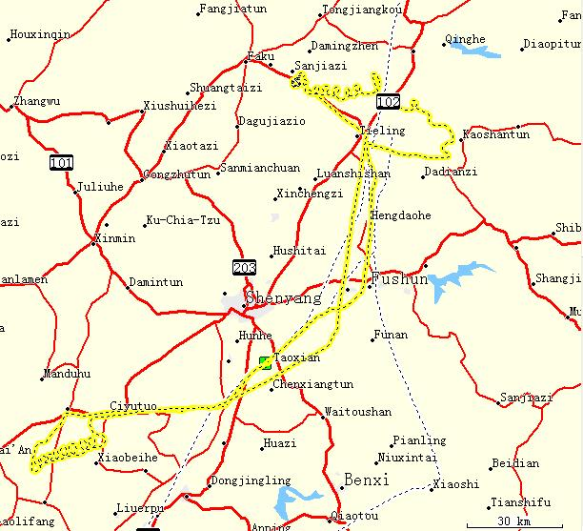  Liaozhong | 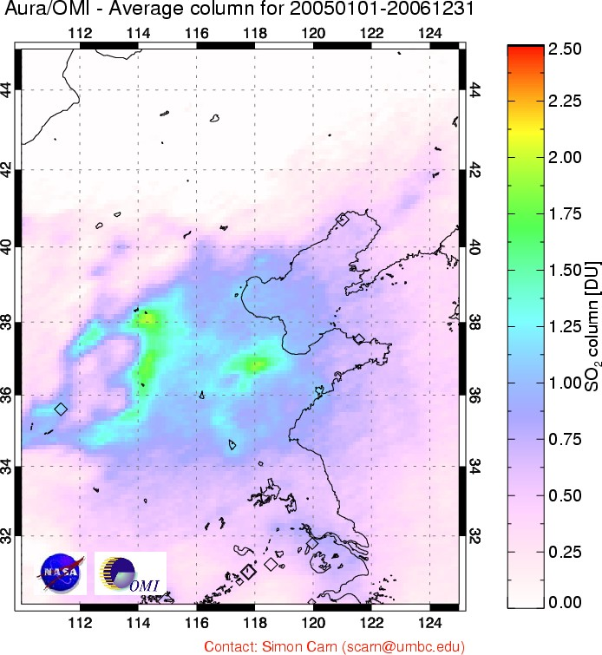
Figure 1. (Left) Flight path on April 5, 2005. Aircraft profiling flight patterns (spirals) were performed near Xiaoming (42.450N, 123.70E) and Liaozhong (41.350N, 122.648E). All flights departed from Taoxian International Airport (41.640ºN, 123.488ºE) in the Liaoning region of China. Flight paths were similar on Apr 1, 7 and 10 2005.
(http://www.atmos.umd.edu/~zli/EAST-AIRE/air_camp/air_camp.htm).
(Right) 2-year average OMI SO₂ map over Eastern China in Dobson Units (1 DU=2.69 ·10¹⁶ molecules/cm²) showing persistent areas of high SO₂ concentrations in a triangle between Beijing, Shanghai and Sichuan basin in agreement with emission inventories [Streets and Waldhoff 2000; Streets et al. 2003; Larssen et al 2006; Ohara et al 2007]. Smaller SO₂ enhancements (i.e. ~0.5 DU) over the Shenyang region in North East China (black square) are significant as compared to the background regions.

Xiaoming

Figure 2. Altitude (blue) and in-situ SO₂ (red) aircraft data as function of flight time (Local Time (LT): LT = UT + 8hours) on 5 April 2005 over northeastern China (figure 1). The amount of SO₂ increases as the altitude decreases during the flight. These raw data were converted into 3 SO₂ vertical profiles over Liaozhong (11:30LT); Xiaoming (12:30LT) and on the descent to Taoxian International airport (13:30LT). OMI overpass time (4:57UT) corresponds to 12:57LT.

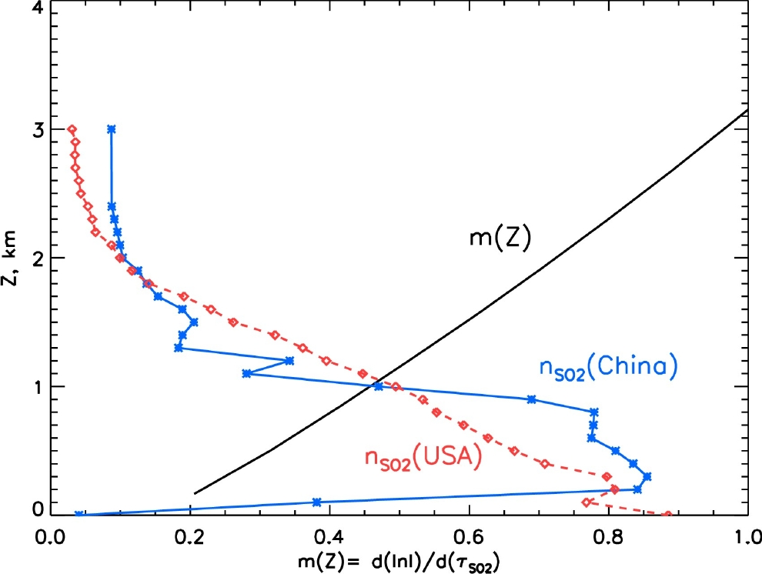 | 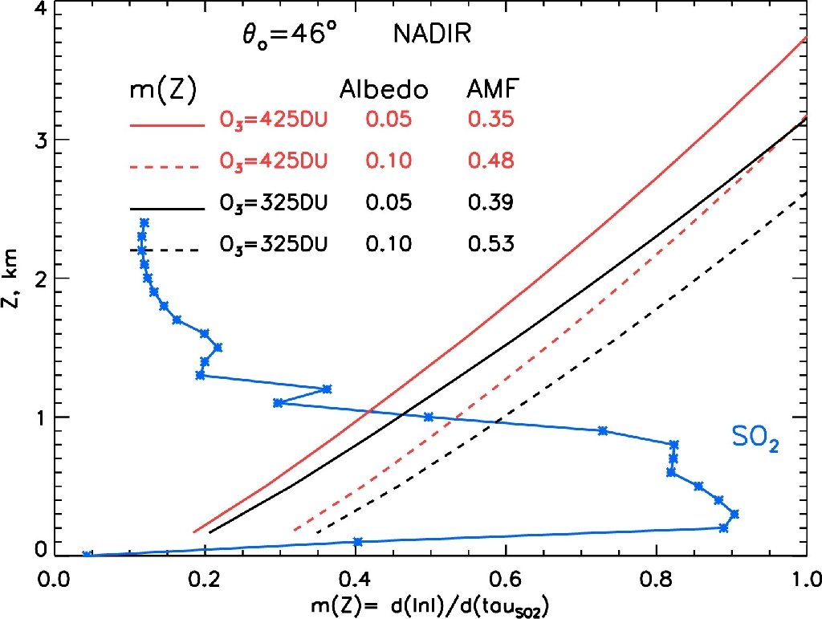
Figure 3. Left: SO₂ vertical profiles: Measured during EAST-AIRE campaign on April 5 2005 over Liaozhong, NE China (blue stars); median summer SO₂ profile over the Eastern US [Taubman et al 2006] (Red diamonds). Both SO₂ profiles are dimensionless, normalized to a unit column SO₂ amount. Black line: Vertically resolved OMI SO₂ sensitivity (local AMF) m(z, R_{S}, Ω, θ, θ_{0,} ϕ) calculated for nadir viewing direction (θ=0º), solar zenith angle θ₀= 46º, surface reflectivity R_{S},= 0.05, Ω=325DU middle latitude TOMS climatological ozone profile, no aerosols and clouds.
Right: Local AMF dependence on surface albedo, R_{S} (solid line – R_{S} =0.05; dashed line – R_{S}= 0.1) and total ozone, Ω (red color: TOMS Ω=325DU mid latitude ozone profile and black color: Ω=425DU mid latitude ozone profile).

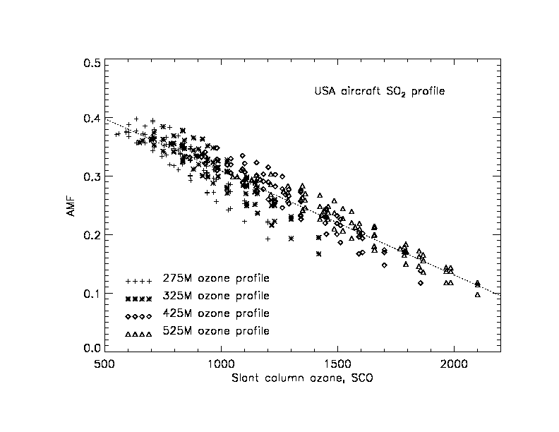
Figure 4. AMF parameterization as function of Slant Column Ozone amount (SCO): $\text{SCO}=Ω⋅\left(\text{sec}(θ)+\text{sec}(θ_{0})\right)$ in Dobson Units. Measured aircraft in-situ median summer SO₂ profile over the Eastern US [Taubman et al 2006], TOMS climatological middle latitude ozone profiles, different viewing (0º – 60º) and solar zenith angles (0º-60º), relative solar azimuth angles 60º- 120º and 0.05 surface albedo. No aerosols or clouds. Dotted line: linear regression (6) $\text{AMF}=r_{0}−r_{1}⋅\text{SCO}$ , where r_{o}= 0.486 and r₁=0.000177 [DU]⁻¹

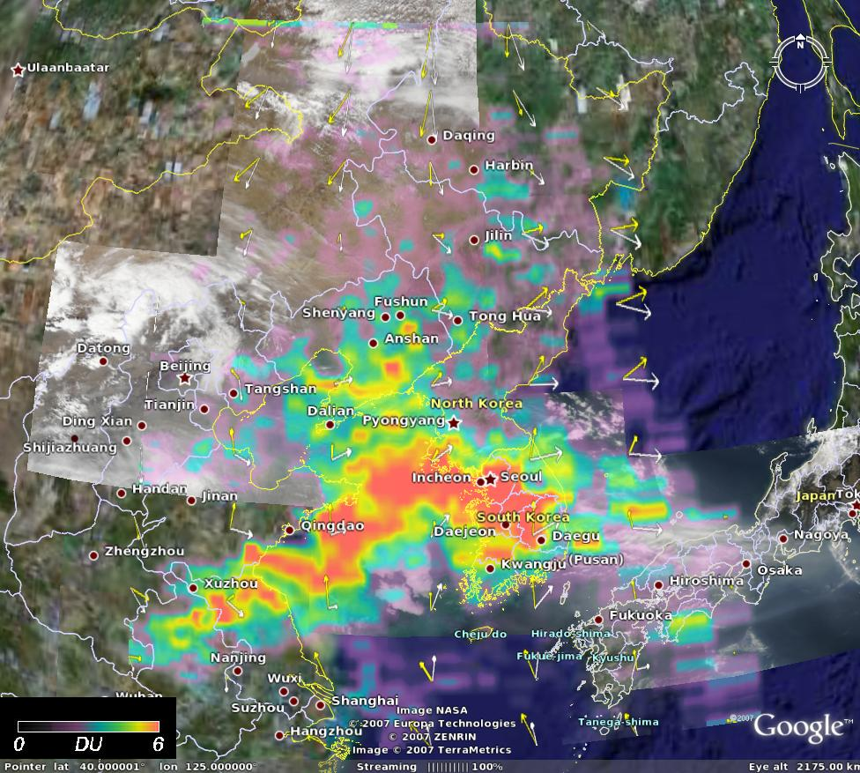  a  c  b  d  a | 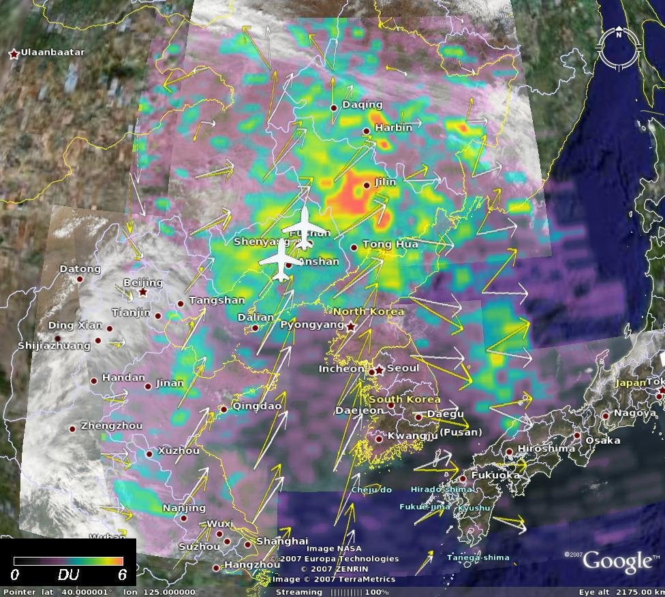
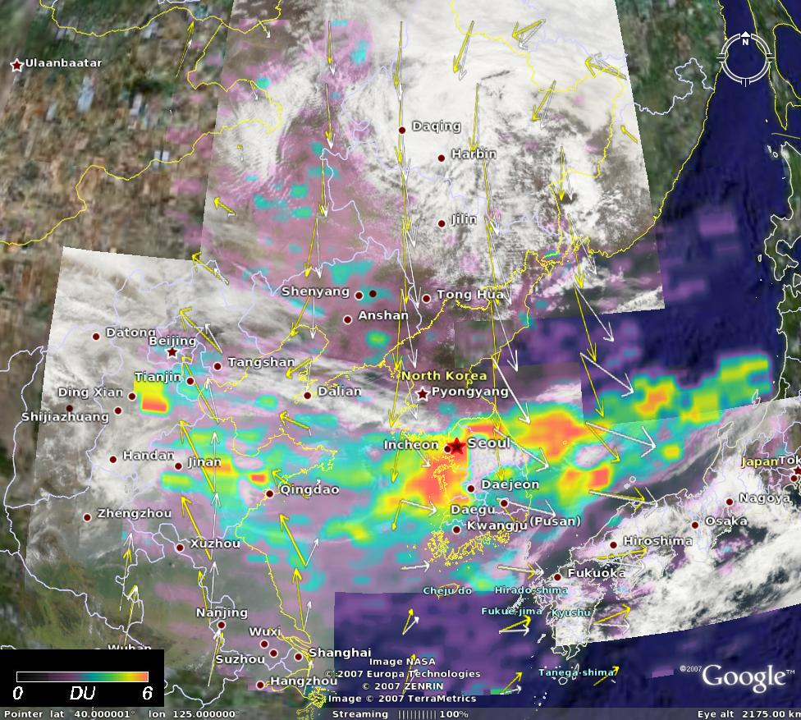 | 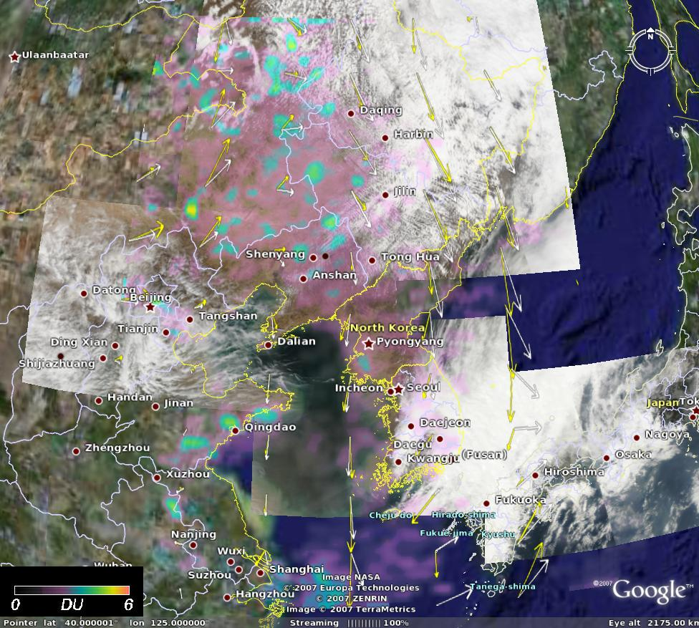
Figure 5. OMI PBL SO₂ maps (Linear color scale from 0 to 6 DU) superimposed on AQUA MODIS RGB images acquired 15 min prior OMI overpass during EAST-AIRE field campaign: (a) on April 1, (b) on April 5 (polluted seen over NE China ahead of the a cold front), (c) on April 7 (polluted air pushed off the coast), (d) on April 10, 2005. The aircraft spiral locations are shown with white aircraft symbols in (b). Apparently high SO₂ values (red colors) indicate SO₂ lifting above PBL and /or above low-level clouds, where OMI sensitivity is enhanced. Tropospheric winds are shown with yellow (surface) and white (850mb) arrows. Background maps are from Google Earth.

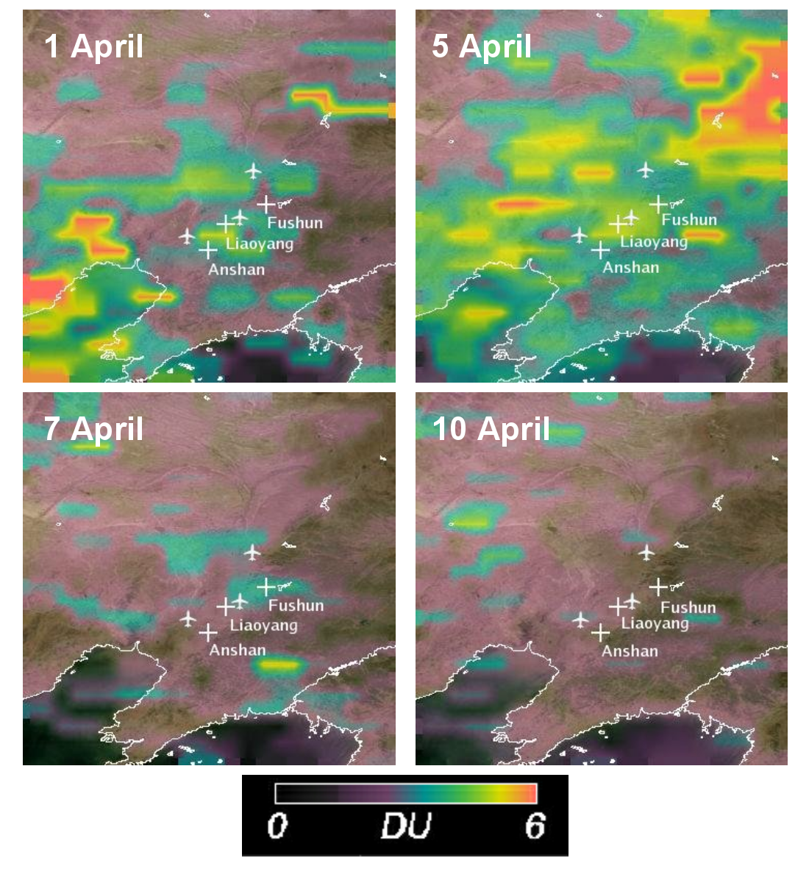

Figure 6. Operational (Collection 2) OMI PBL SO₂ data over EAST-AIRE flight region in April 2005. Background maps are from Google Earth.

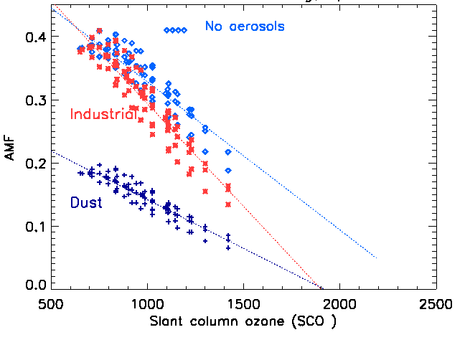
Figure 7. Left: SO₂ AMF parameterization as function of slant column ozone (SCO) for 275DU ozone profile and aircraft measured SO₂ and aerosol profiles over Liaozhong on April 5 2005 (right panel). Different viewing and solar zenith angles, relative solar azimuth 60º -120º and surface albedo 0.05. Blue diamonds - no aerosols or clouds. Red stars – OMI Industrial aerosol model (sulfate and soot mixture).
Purple crosses: dust aerosol model with the same optical parameters in the visible wavelengths.
Right: Normalized to the maximal value vertical profiles of aerosol scattering coefficient (blue lines) and SO₂ concentration (red lines) from aircraft in-situ measurements on April 5 2005. Symbols indicate different spiral location: Xiaoming (triangle); Taoxian (diamond) and Liaozhong (square).

