Published in:

Loos, E.F. (2011) Generational use of new media and the (ir)relevance of age, in: F. Colombo & L. Fortunati (eds), Broadband Society and Generational Changes, 259-273. Berlin: Peter Lang.*

* Due to costs related to the colours in the heatmaps and gazeplots these will not be printed in the book.
Prof. Dr. Eugène Loos University of Amsterdam, ASCoR, (e.f.loos@uva.nl)

Generational use of new media and the (ir)relevance of age

1 Introduction
The use of new media in our information society is constantly increasing, as is the number of older people. In the year 2000, the Council the European Union and the Commission of the European Communities presented an eEurope Action Plan entitled ‘An Information Society For All’ which set out three main objectives: the realization of a cheaper, faster, secure Internet, investment in people and skills, and encouragement to expand the use of the Internet. The second objective specifically stated that ‘the Lisbon European Council recognised that special attention should be given to disabled people and fight against info-exclusion. (…) As government services and important public information become increasingly available on-line, ensuring access to government websites for all citizens becomes as important as ensuring access to public buildings.’
It is interesting to note that, while the e-Europe Action Plan made explicit mention of disabled people, it wholly failed to address the issue of older citizens. In light of the growing number of older users in our information society, this is a group whose concerns also merit attention. The supply of digital information through websites and the like must be available to older generations, so that they have guaranteed access to the digital information sources provided by public and private organizations offering products and services they need. Some researchers argue that there is a widening generational digital gap between those people who are able to use new media and those who are not. It was Prensky (2001, pp. 1-2) who coined the notions of digital natives and digital immigrants. From an educational point of view, he considers students to be digital natives because they are ‘all native speakers of the digital language of computers, video games and the Internet. So what does that make the rest of us? Those of us who were not born into the digital world but have, at some point later in our lives, become fascinated by and adopted many or most aspects of the new technology are, and always will be compared to them, Digital Immigrants’.
Do they really exist, these digital natives, who are identified as the generations born after 1990, who have grown up with new media? And is there really an older generation of digital immigrants playing catch-up by trying to learn how to use new media? Other researchers (Lenhart & Horrigan 2003) take a different perspective. They introduced the notion of a digital spectrum, which acknowledges that people use new media to varying degrees, depending not only on age but also on factors such as gender, educational background and frequency of internet use.
If we want the supply of digital information through websites and the like to be readily available to older generations so that they are guaranteed access to the digital information sources provided by public and private organizations and the much-needed products and services offered there, we need to gain insight into their navigation behaviour. This paper therefore presents the results of an explorative case-study which focuses on the question of whether older people do indeed navigate websites differently from younger people. Or are the differences within this group arising from such factors as gender, educational background and frequency of internet use greater than the differences to be found between younger and older people?

2 Characteristics of Older Internet Users: A Quick Scan
Are there studies which offer insight into the way older people navigate websites and the factors which help or hinder their ability to gain access to such digital information? Let us first have a look at the field of research into aging. The Handbook of Communication and Aging Research, edited by Nussbaum & Coupland in 2004, offers a compilation of the research carried out in this field over the past three decades. The book is divided into seven sections, each dealing with a particular aspect of study. The first section deals with the experience of aging, the second with language, culture and social aging. The third section examines the communicative construction of relationships in later life, the fourth organisational communication, and the fifth political and mass communication. Section six addresses health communication and lastly, section seven discusses senior adult communication. In almost none of these sections is any attention paid to the use of digital information sources by older people: the only exception is in section four, where, in chapter 13 under the title ‘Marketing to Older Adults’, Balazs (2004) discusses communication with older people. However, rather than dealing with how older people browse websites in search of information, her focus is on selling products and services.
The proceedings of the 4th International Conference on Universal Access in Human-Computer Interaction in Beijing in July 2007, edited by Stephanidis, perhaps offer more insight into the way older people looking for information navigate websites. Part IV of ‘Understanding Diversity: Age’ indeed presents several studies focusing on older people using new media and how this can make their lives more comfortable. One of the studies entitled Older Adults and the Web: Lessons learned from Eye-Tracking, by Tullis, put forward empirical research results about differences between younger and older U.S. users in the way they scan web pages: ‘An eye-tracking study of a prototype website was conducted with 10 younger adults (ages 20-39) and 10 older adults (ages 50-69) to determine if there are differences in how they scan webpages. They performed the same task on the website. On the average, the older adults spent 42% more time looking at the content of the pages then did the younger adults. They also spent 51% more time looking at the navigation areas. The pattern of fixations on almost all pages showed that the older adults looked at more parts of the page then did the younger adults. (…) One thing we did not see was any difference in the likelihood of older and younger users to view page content below the fold (i.e., that they had to scroll to view)’ (Tullis, 2007, pp. 1030, 1038).
This study shows potentially significant patterns which may be validated by future comparable research. An example of similar empirical research is that done by Houtepen who conducted an explorative eye-tracking study on 13 younger users (18-25 years old) and 7 older users (over 50) in the Netherlands in 2007. As in Tullis’ study, the subjects were asked to perform a specific task, in this case, finding health care information. Two main points emerged from the study: the older users took more time to fulfil the task (nearly 6 minutes compared to the 2.5 minutes taken by the younger users); the older subjects read more and made less use of the website’s search box facility.
Both Tullis’ study and Houtepen’s research show that older users need more time and follow a different reading pattern. A measurement study conducted by Pernice & Nielsen (2002) on 20 seniors and a control croup of 20 users aged between 21 and 55 using three websites and a Web-wide task confirms the differences in time needed for task completion: 12:33 minutes for the seniors versus 7:14 minutes for the younger control group. They also offer an explanation for this difference: ‘Websites tend to be produced by young designers, who often assume that all users have perfect vision and motor control, and know everything about the Web. These assumptions are rarely upheld, even when the users are not seniors. However, as indicated by our usability metrics, seniors are hurt more by usability problems than younger users. Among the obvious physical attributes often affected by human aging process are eyesight, precision of movement, and memory.’ Pernice & Nielsen (2002, p. 4).
The studies conducted by Tullis (2007), Houtepen (2007) and Pernice & Nielsen (2002), as well as the reviews by Chisnell & Redish (2004, 2005), Andrew (2008) and Loos & Mante-Meijer (2009), offer insight into differences related to time on task and reading patterns between younger and older users. However, it should be borne in mind that the studies involved a limited number of participants, which would point to the need for more research on more users. The studies also only focused on age, omitting to take into account the role of factors such as gender, educational background and frequency of internet use. It is therefore unclear whether differences within an age group are greater than the differences between younger and older people.

3 Explorative Case-study: Research Questions and Methodology
What is needed is research based on empirical studies with larger groups of older and younger generations which take into account the role of factors like gender, educational background and frequency of internet use. If we conduct eye-tracking studies with larger groups and pay attention to these factors and not only to age we will gain a better understanding of the differences and similarities related to navigation behaviour.
The question is how to set up and conduct such a study. In this paper, I make use of the data from an eye-tracking study carried out among 29 younger and 29 older users (respectively about 21 years old and 65 years and older) in the Netherlands in April 2009. For a complete overview of all the results of this study, see Loos & Mante-Meijer (2009). Compared to earlier empirical research conducted in this field, a relatively large number of participants were recruited to our empirical study. The number of 2 x 29 participants far exceeds the minimum of 8 participants per user type in usability tests specified by the NIST CIF (Wichansky (2000) in Goldberg & Wichansky, 2003, p. 512). However, this number is still not large and the possibility of distortion remains. It is therefore accurate to characterize this case study as an exploratory one, in which we demonstrate trends rather than significant relationships. For this reason, no standard deviations and p-values are included.
Older people often are considered to be a more diverse group than younger people. Bouma (2000, p. 68) for example explains that ‘Education and job specialization have been rising all through the 20th century, and the new generations of older citizens have learned to be both assertive and active. It is certain that they will be a heterogeneous group, since cumulative life experiences vary so much more than among young adults.’ I therefore also paid attention to the effect of gender, level of education and frequency of internet use (daily or otherwise) on the navigation behaviour of older people.

User group | N
All users | 58
All older users | 29
All younger users | 29
All female users | 28
All male users | 30
All younger female users | 14
All younger male users | 15
All older female users | 14
All older male users | 15
All older users with higher education | 19
All older users without higher education | 10
All older users using internet daily | 18
All older user not using internet daily | 11

Table 1: Different user groups, source: Loos & Mante-Meijer (2009, p. 46)

Heatmaps and gaze plots are used to show the output of the eye-tracking instrument which measures the eye-movements of the different user groups. Heatmaps use different colours to show how intensely navigation areas are visited based on the number of fixations by individual users or groups of users (red for high, yellow for moderate and green for low intensity). Gaze plots provide insight into the eye movements, or saccades, of individual users by presenting the order (numbers in circles) and duration of gaze fixations (the longer the gaze fixations the bigger the circle). Red-white demarcations show where users have clicked. See McElhal (2007) for more information about eye-tracking.
The users performed a search task on the website of ANBO, a Dutch organiz-ation for senior citizens. The users had to find information about discounts related to health insurance which could be found on a specific web page of the site (Loos & Mante-Meijer (2009) for more information). Their navigation behaviour, i.e. their reading patterns and use of search box, was then analyzed, with particular attention being paid to effectiveness (whether or not the search task was completed successfully within 5 minutes), efficiency (how long they took to fulfil their search task) and user satisfaction (usability ranking); see also Frøkjaer, Herzum & Hornbaek (2000) and Johnson & Kent (2007).

independent variables intervenient variable dependent variables

age
(young/old)

gender navigation behaviour (eye-
search task at a site movements to the use of the search box and mouse clicks)

higher or lower level
of education task (successfully accomplished)
yes/no and time spent on
search task)
frequency of internet use
user satisfaction (rating usability:
note 1-10)

Figure 1: Research design, source: Loos & Mante-Meijer (2009, p. 48)

4 Results

4.1 Use of the Search Box
The heatmaps presented in section 4.2 show that the majority of users made no use of the search box during the search task. Table 2 confirms this result: only 13.8% of users in the older and 13.8% of the younger age group used the search box.
This result fails to confirm the findings of Houtepen’s study (see section 2), which showed that older people used the search box less frequently than did younger users. A possible explanation is that the search task in my eye-tracking study was rather easy to perform, so most users apparently had no need to use the search box.
Other significant differences between user groups are presented in Table 2:
The percentage of the female users making use of the search box was higher than that of the male users: 17.9% versus 10%.
Only 6.7% of the older male users made use of the search box compared with 21.4% of the older female users.
Older people with a lower level of education used the search box more often than did older people with a higher level of education: 20% against 10.5%.
Older people making daily use of the internet used the search box in 22.2 % of the cases; of the group who did not use the internet daily, not a single person made use of the search box.

 | Search box used during search task |  | Search box not used during search task
User Group | N | % | N | %
All users | 8 | 13.8 | 50 | 86.2
All older users | 4 | 13.8 | 25 | 86.2
All younger users | 4 | 13.8 | 25 | 86.2
All female users | 5 | 17.9 | 23 | 82.1
All male users | 3 | 10 | 27 | 90
All younger female users | 2 | 14.3 | 12 | 85,7
All younger male users | 2 | 13.3 | 13 | 86.7
All older female users | 3 | 21.4 | 11 | 78.6
All older male users | 1 | 6.7 | 14 | 93.3
All older users with higher education | 2 | 10.5 | 17 | 89.5
All older users without higher education | 2 | 20 | 8 | 80
All older users using internet daily | 4 | 22.2 | 14 | 77.8
All older users not using internet daily | 0 | 0 | 11 | 100

Table 2: Use of the search box, source: Loos & Mante-Meijer (2009, p .46)

4.2 Navigation Areas
The navigation patterns of older and younger users seem to be different. Though many in both the younger and the older group of users looked at the right place to click (the upper part of the third column) to arrive at the web page containing the information they were looking for, the red area on the older users’ heatmap (1) is much larger than on the younger users’ heatmap (2). This confirms Tullis’ finding that older people examine navigation areas more intensely than do younger people. Another difference is that more older users than younger users look during a longer period at the wrong place to click – in this case, the first column. This is shown by the red zone appearing in that navigation area on heatmap (1), which is absent on heatmap (2). So, at first glance, the navigation patterns of older people appear to differ from those of younger people:

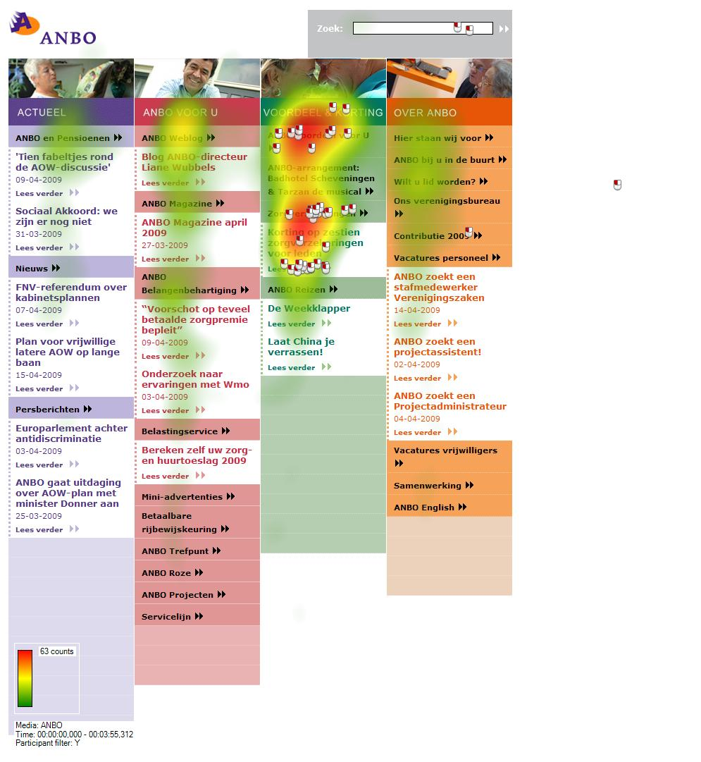
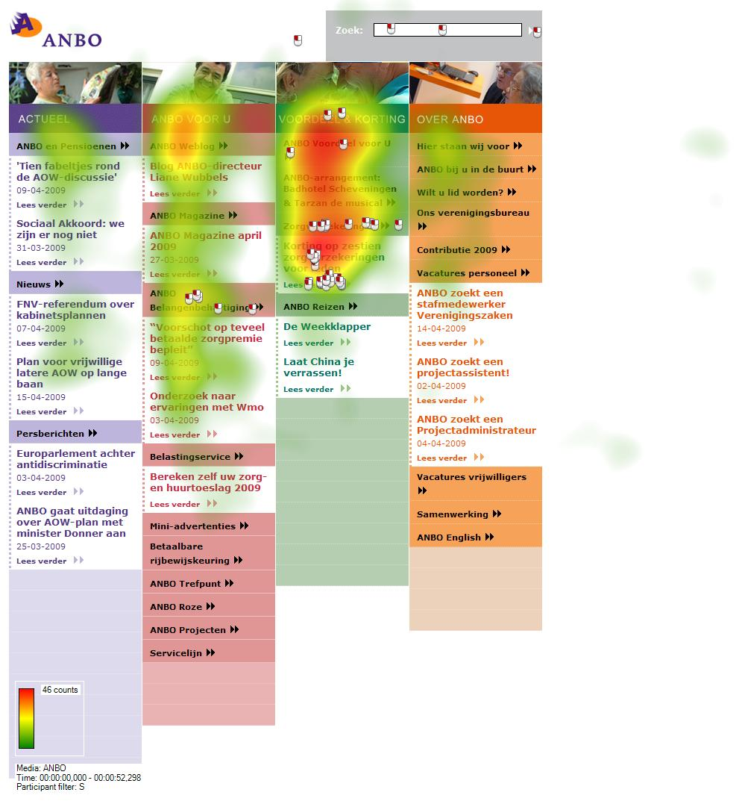

Heatmap (1): all older users Heatmap (2): all younger users
source: Loos & Mante-Meijer (2009, p. 53) source: Loos & Mante-Meijer (2009, p. 53)

However, if we compare the navigation patterns of older people using the internet daily (heatmap (3)) with those of the younger age group, these patterns are in fact not as dissimilar as first thought.

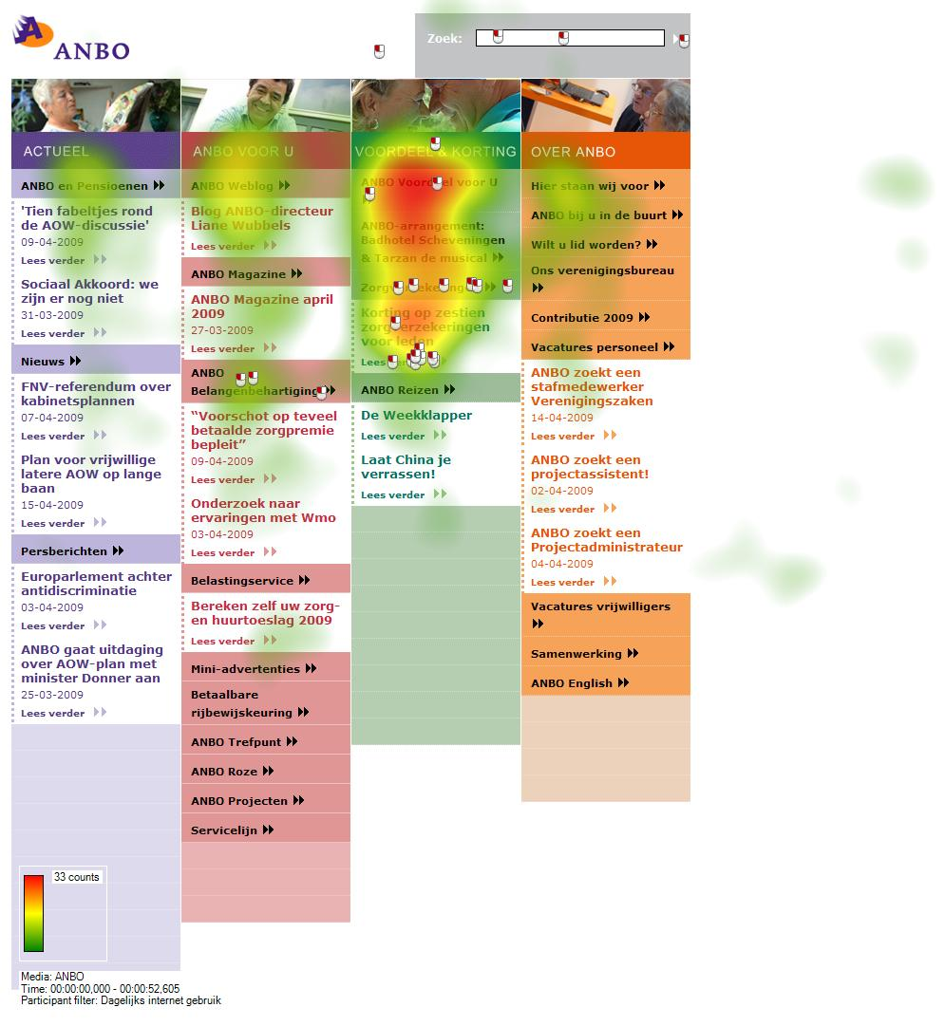

Heatmap (3): all older users using the internet daily
source: Loos & Mante-Meijer (2009,
p. 54)

This would seem to imply that the frequency of internet use impacts more heavily on our navigation patterns than does age.

4.3 Gaze Plots
I obtained the gaze plots of 12 older female users, 12 older male users, 10 younger female users and 13 younger male users looking at the homepage of the ANBO website. The gaze plots (see Appendix) show users in each of these groups who needed a low (up to 40) or high number of saccades (over 40) to get to the next webpage where the information could be found. After analysis of the gaze plots, it appeared that younger male users needed the lowest number of saccades to reach the webpage where the information could be found. Only 15% needed more than 40 saccades versus 33% of all younger female users and older male users, and 42% of older female users. The number of saccades does not necessarily predict effectiveness, efficiency and user satisfaction. Analysis of this can be found in the next section.

4.4 Effectiveness, Efficiency and User Satisfaction

4.4.1 Effectiveness (search task (not) successfully accomplished within 5 minutes)

 | Search task successfully accomplished |  | Search task not successfully accomplished
User Group | N | % | N | %
All users | 51 | 87.9 | 7 | 12.1
All older users | 24 | 82.8 | 5 | 17.2
All younger users | 27 | 93.1 | 2 | 6.9
All female users | 23 | 82.1 | 5 | 17.9
All male users | 28 | 93.3 | 2 | 6.7
All younger female users | 12 | 85.7 | 2 | 14.3
All younger male users | 15 | 100 | 0 | 0
All older female users | 11 | 78.6 | 3 | 21.4
All older male users | 13 | 86.7 | 2 | 13.3
All older users with higher  education | 16 | 84.2 | 3 | 15.8
All older users without higher  education | 8 | 80 | 2 | 20
All older users using internet daily | 16 | 88.9 | 2 | 11.1
All older users not using  internet daily | 8 | 72.7 | 3 | 27.3

Table 3: Effectiveness, source: Loos & Mante-Meijer (2009, p. 61)
Table 3 shows clearly that most users (87.9%) accomplished the search task within the 5 minute time limit, although some differences were apparent between user groups:
82.8 % of all older users accomplished the search task successfully versus 93.1% of all younger users.
82.1% of all female users accomplished the search task successfully versus 93.3% of all male users.
All younger male users succeeded in accomplishing the search task successfully versus 85.7% of all younger female users.
86.7% of all older male users succeeded in accomplishing the search task successfully versus 78.6% of all older female users.
Older users with a higher level of education were slightly more successful than less educated older users: 84.2% versus 80.0%.
Older people using the internet daily were more successful than older people who did not: 88.9% versus 72.7%.

4.4.2 Efficiency (total time spent on search task)
In order to analyse how efficient the users were in accomplishing their search task, only those users who succeeded in accomplishing this successfully within 5 minutes were taken into account.

User Group | Average search time (in seconds) | Median  (in seconds) | N
All users | 86 | 63 | 51
All older users | 111 | 76 | 24
All younger users | 64 | 45 | 27
All female users | 66 | 58 | 23
All male users | 102 | 72 | 28
All younger female users | 63 | 36 | 12
All younger male users | 64 | 48 | 15
All older female users | 69 | 60 | 11
All older male users | 146 | 77 | 13
All older users with higher education | 112 | 76 | 16
All older users with no higher education | 108 | 74 | 8
All older users using internet daily | 99 | 86 | 16
All older user not using internet daily | 135 | 77 | 8

Table 4: Efficiency, source: Loos & Mante-Meijer (2009, p. 62)
The most striking results to emerge were:
Overall, users took an average of 86 seconds to accomplish their search task.
Younger users were almost twice as fast as older users, averaging 64 seconds as against 111 seconds. The eye-tracking studies conducted by Tullis (2007) and Houtepen (2007) showed a similar result (see section 2).
Female users were almost twice as fast as male users, averaging 66 versus 102 seconds. However, it should be borne in mind that the older men in the study took an extremely long time to complete the task. Older male users and older users who did not make daily use of the internet were the slowest (respectively averaging 146 seconds and 135 seconds). Older female users, younger male users and younger female users were the fastest (respectively averaging 69 seconds, 64 seconds and 63 seconds).
Older users making daily use of the internet were faster than those who did not, averaging 99 versus 135 seconds.

4.4.3 User Satisfaction (usability rated by 1-10)

User Group | Average note | Median note | N
All users | 6.8 | 7 | 58
All older users | 7.2 | 7 | 29
All younger users | 6.4 | 7 | 29
All female users | 6.7 | 7 | 28
All male users | 6.9 | 7 | 30
All younger female users | 6.1 | 6.5 | 14
All younger male users | 6.7 | 7 | 15
All older female users | 7.2 | 7 | 14
All older male users | 7.1 | 8 | 15
All older users with higher education | 7 | 7 | 19
All older users without higher education | 7.,5 | 8 | 10
All older users using internet daily | 7.4 | 7.3 | 18
All older user not using internet daily | 6.9 | 7 | 11

Table 5: User satisfaction, source: Loos & Mante-Meijer (2009, p. 63)

The most striking results to emerge were:
ANBO’s website scored a 6.8 average for user friendliness.
Older users tended to be more satisfied with the website than younger ones: 7.2 versus 6.4. This could be explained by the fact that the ANBO website belongs to an organization for older people and that the information is related to life events which bear more relevance to them rather than to younger users. See Thomése (2001), Sap (2004) and Kalmijn et al. (2006) for more information about life events.
The average level of user satisfaction in younger female users was much lower than that of younger male users: 6.1 versus 6.7.
Older, more highly educated users tended to be less satisfied with the website than older users with a lower level of education: 7 versus 7.5.
Older users who used the internet daily tended to be much more satisfied with the website than those who did not: 7.4 versus 6.9.

5 Conclusions

5.1 The Role of Age
The results of this explorative case-study demonstrate in the first place that, to some extent, age has an impact on the way older and younger users accomplish a search task on a website, especially where efficiency and user satisfaction are concerned.
Younger users were found to be almost twice as fast as older users, averaging 64 versus 111 seconds. The eye-tracking studies conducted by Tullis (2007) and Houtepen (2007) showed a similar result (see section 2).
Another finding was that older users tended to be more satisfied with the website than the younger ones. This could be explained by the fact that the website belongs to an organization for older people and that the information is related to life events which are more relevant for older than for younger users.
Yet this explorative case-study also showed that age is not the only variable explaining differences in navigation behaviour. Gender, educational background and frequency of internet use all also play a role.

5.2 The Role of Gender, Educational Background and Frequency of Internet Use

5.2.1 Gender
- All younger male users succeeded in accomplishing the search task successfully versus 85.7% of all younger female users.
- Female users were almost twice as fast as male users, averaging 66 versus 102 seconds due to the fact that older men are extremely slow.
- Average user satisfaction of younger female users was much lower than average user satisfaction of younger male users: 6.1 versus 6.7.
- Younger male users needed fewer saccades to reach the webpage containing the relevant information than younger female users.

5.2.2 Educational Background
Older users with a higher educational level tended to be less satisfied with the website than those with a lower level of education: 7 versus 7.5. Otherwise, educational background did not play an important role.

5.2.3 Frequency of Internet Use
The heatmaps in section 4.2 clearly show that daily internet use has more impact on our navigation patterns than age does.
- Older people using the internet daily were more successful than older people who did not: 88.9% versus 72.7%.
- Older users making daily use of the internet were faster than those who did not, averaging 99 versus 135 seconds.
- Older users who use the internet daily tended to be much more satisfied with the website than those who did not: 7.4 versus 6.9.

5.3 Final Conclusion
Finally, we can conclude that, although differences in navigation behaviour are to some extent age-related, differences are also evident within the group of older people (what Dannefer (1988) refers to as intra-age variability) depending on gender, educational background and frequency of internet use. In this case study, the black-and-white distinction between Prensky’s digital natives and digital immigrants was absent. Instead, what emerged was far more a digital spectrum rather than a digital divide (Lenhart & Horrigan, 2003). If future empirical research confirms the findings of this explorative eye-tracking study, the implication for website designers (who often belong to a younger generation) might be that they should take into account diversity between and within generations by designing for dynamic diversity (Gregor, Newell & Zajicek, 2002), ‘(…) the premise of which is that older people are much more diverse in terms of life experience and levels of capability and disability than their younger counterparts (…)’ (Chisnell & Redish, 2004, p. 48).

Bibliography
Andrew, A., 2008. Web Accessibility for Older Users: A Literature Review. W3C working draft 14 May 2008. Available at: http://www.w3.org/TR/wai-age-literature.
Balazs, A., 2004. Marketing to Older Adults. In: J. Nussbaum & J. Coupland, eds. 2004. Handbook of Communication and Aging. London: Lawrence Earlbaum Associates.
Bouma, H. 2000. Document and interface design for older citizens’, In: P. Westendorp, C. Jansen & R. Punselie eds. 2000. Interface design & document design. Amsterdam: Rodopi.
Chisnell, D. & Redish, J., 2004. Designing Web Sites for Older Adults: A review of recent research. Available at: http://www.aarp.org/ olderwiserwired.
Chisnell, D. & Redish, J., 2005. Designing Web Sites for Older Adults: Expert Review of Usability for Older Adults at 50 Web Sites. Available at: http://www.aarp.org/olderwiserwired.
Council of the European Union and the Commission of the European Communities, 2000. Action Plan eEurope – An Information Society For All. Brussels
Dannefer, D., 1988. What’s in a Name? An Account of the Neglect of Variability in the Study of Aging. In: J.E. Birren & V.L. Bengtson, eds., 1988. Emergent theories of aging. New York: Springer.
Frøkjaer, E., Herzum, M. & Hornbaek, K., 2000. Measuring Usability: are Effectiveness, Efficiency, and Satisfaction Correlated? Proceedings of the SIGCHI Conference on Human Factors in Computing Systems. Den Haag.
Goldberg, J.H. & Wichansky, A.M., 2003. Eye Tracking in Usability Evaluation. In: J. Hyönä, R. Radach & H. Deubel, eds., 2003. The Mind’s Eye: Cognitive and Applied Aspects of Eye Movements Research. Amsterdam: Elsevier.
Gregor, P., Newell, A.F. & Zajicek, M., 2002. Designing for Dynamic Diversity - interfaces for older people. In: ASSETS 2002, pp. 151-156.
Houtepen, L., 2007. Op zoek naar inFormatie. Onderzoek naar het vinden en Beoordelen van Informatie op de Websites van de vijf Grootste Zorgverzekeraars. [Unpublished Master thesis] Utrecht, Utrecht University / Utrecht School of Governance.
Johnson, R. & Kent, S., 2007. Designing Universal Access: Web Application for the Elderly and Disabled, Cogn Tech Work 9.
Kalmijn, M. et al., 2006. Kwaliteit van leven: De Dynamiek van Levenslopen. Concept-Notitie voor NWO. Den Haag: NWO.
Lenhart, A. & Horrigan, J.B., 2003. Re-visualizing the Digital Divide as a Digital Spectrum. IT & Society, 5, pp. 23-39.
Loos, E.F., 2009. User-centred websites: The (Ir)relevance of Age. Include 2009 proceedings (International conference on Inclusive Design), Royal College of Art, London, 5-8 April 2009.
Loos, E.F. & Mante-Meijer, E.A., 2009. Navigatie van Ouderen en Jongeren in Beeld. Explorerend Onderzoek naar de rol van Leeftijd voor het Informatiezoekgedrag van Website-Gebruikers. Den Haag: Lemma.
Nussbaum, J. & Coupland, J. eds., 2004. Handbook of Communication and Aging. London: Lawrence Earlbaum Associates.
Pernice, K. and Nielsen, J., 2002. Web usability for senior citizens. Design Guidelines Based on Usability Studies with People Age 65 and Older. Fremont: Nielsen Norman Group.
Prensky, M., 2001. Digital Natives, Digital Immigrants. On the Horizon, 9(5), pp. 1-6.
Sap, J.C.M., 2004. Leeftijdsloze Levensloop. Utrecht: Expertisecentrum LEEFtijd.
Stephanidis, C., 2007. Universal Access in Human Computer Interaction. Coping with Diversity. Reihe: Lecture Notes in Computer Science (LNCS). New York: Springer.
Thomése, F., 2001. Het levensloopperspectief in theorie en onderzoek. Een sociaal-gerontologische blik. In: Y. Quispel & L. Christ, eds 2001. Ouder worden: Een kwestie van leeftijd? Utrecht. LBL.
Tullis, T., 2007. Older Adults and the Web: Lessons Learned from Eye-Tracking. In: C. Stephanidis, ed. 2007. Universal access in human computer interaction. Coping with diversity. Reihe: Lecture Notes in Computer Science (LNCS). New York: Springer.
Wichansky, A.M., 2000. Usability Testing in 2000 and Beyond. Ergonomics 43(7), pp. 998-1006.

Appendix
Low number of saccades (up to 40) to get to the next webpage where the information could be found.

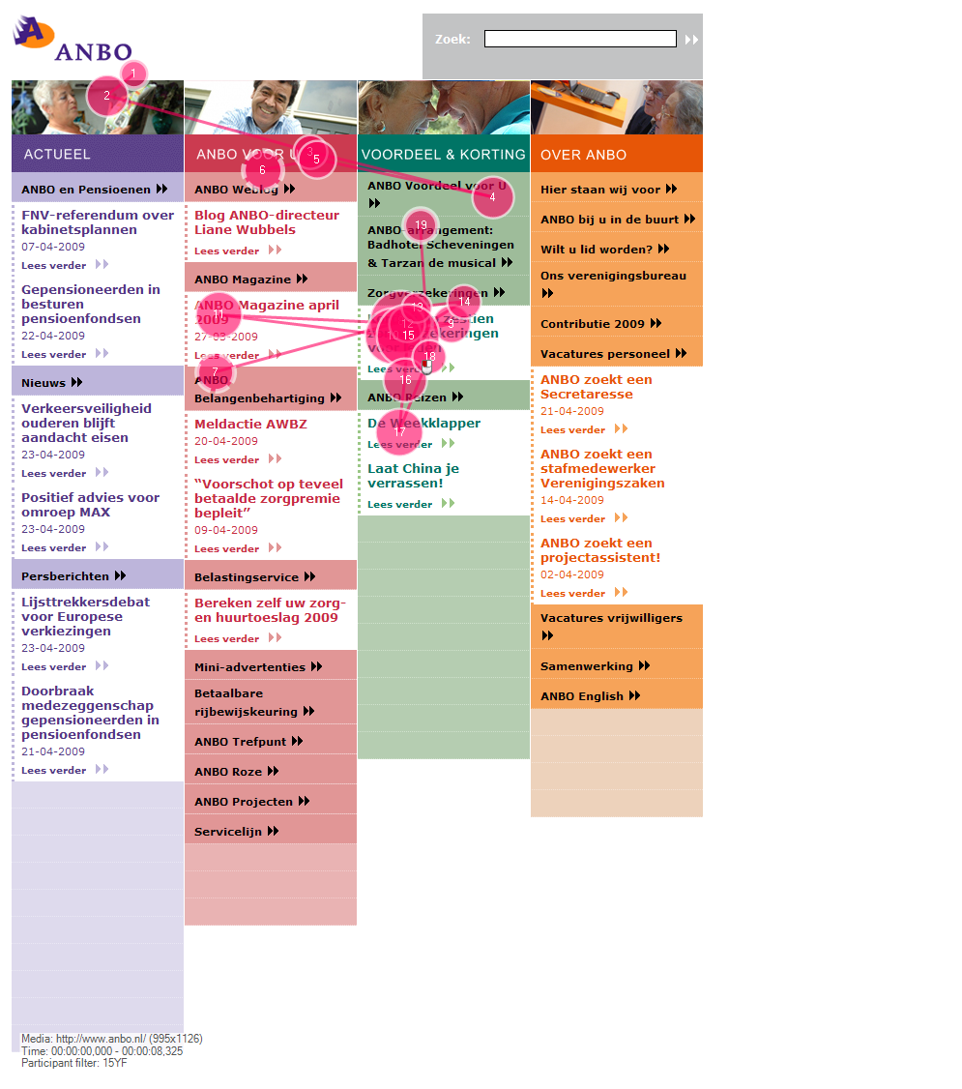
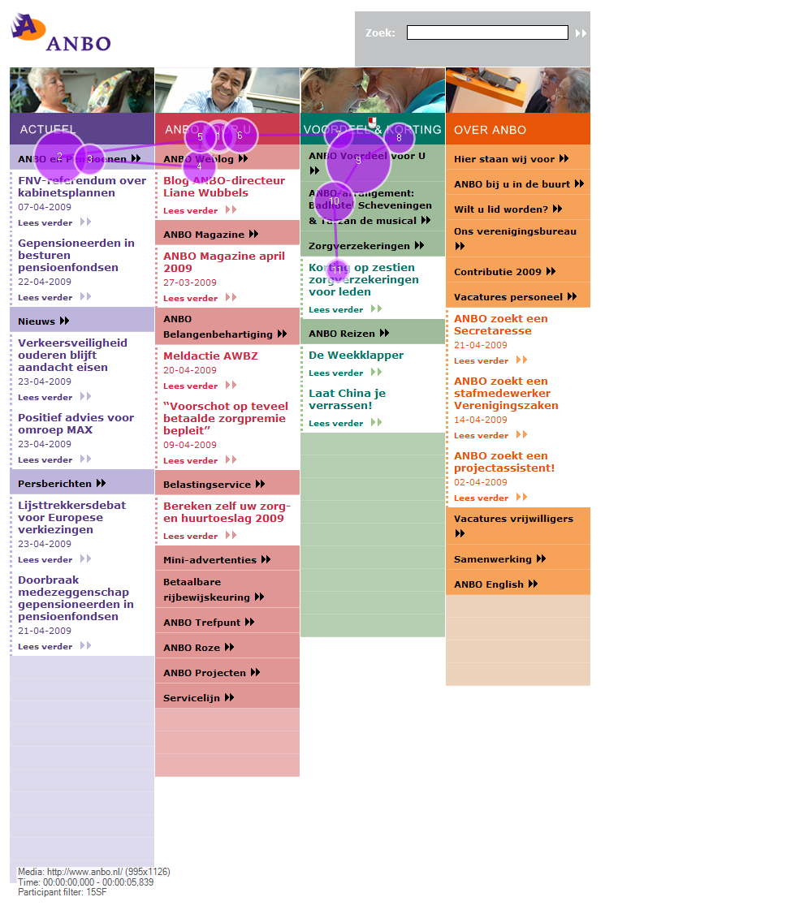

Gaze plot 1: low number of saccades / Gaze plot 2: low number of saccades /
older female user younger female user

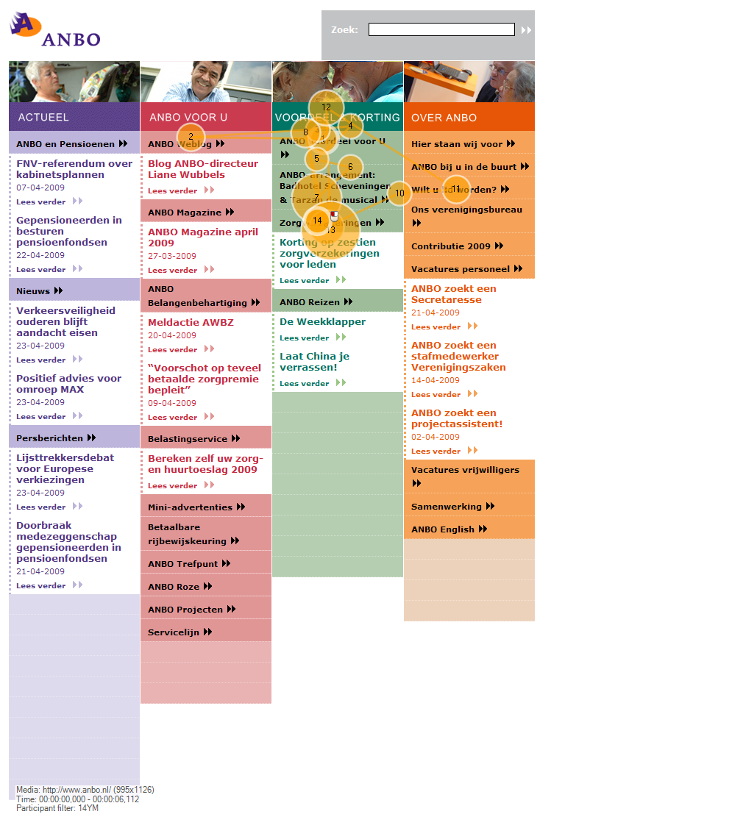
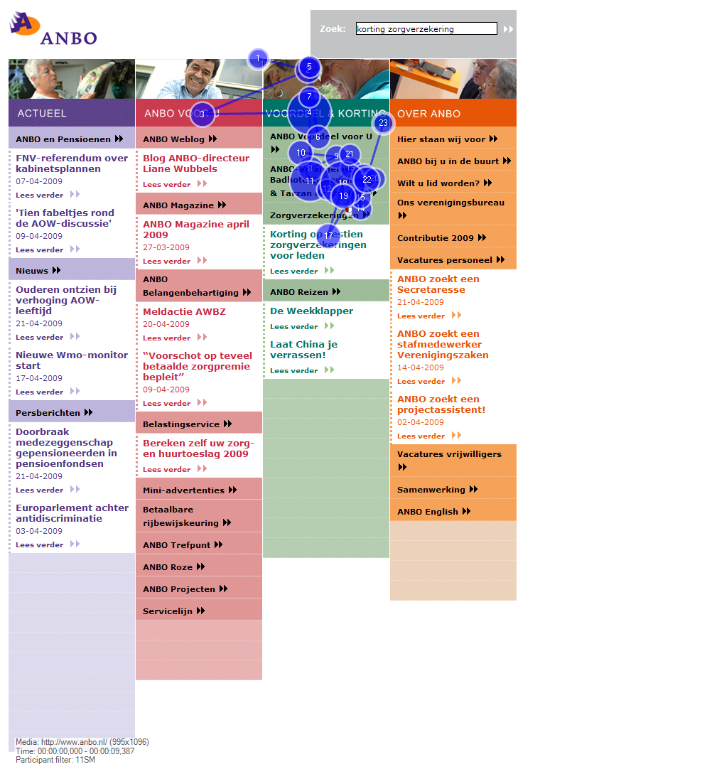

Gaze plot 3: low number of saccades / Gaze plot 4: low number of saccades /
male user younger male user

Source (gaze plots 1-4): Loos & Mante-Meijer (2009, p. 58)
High number of saccades (more than 40) to get to the next webpage where the information could be found.

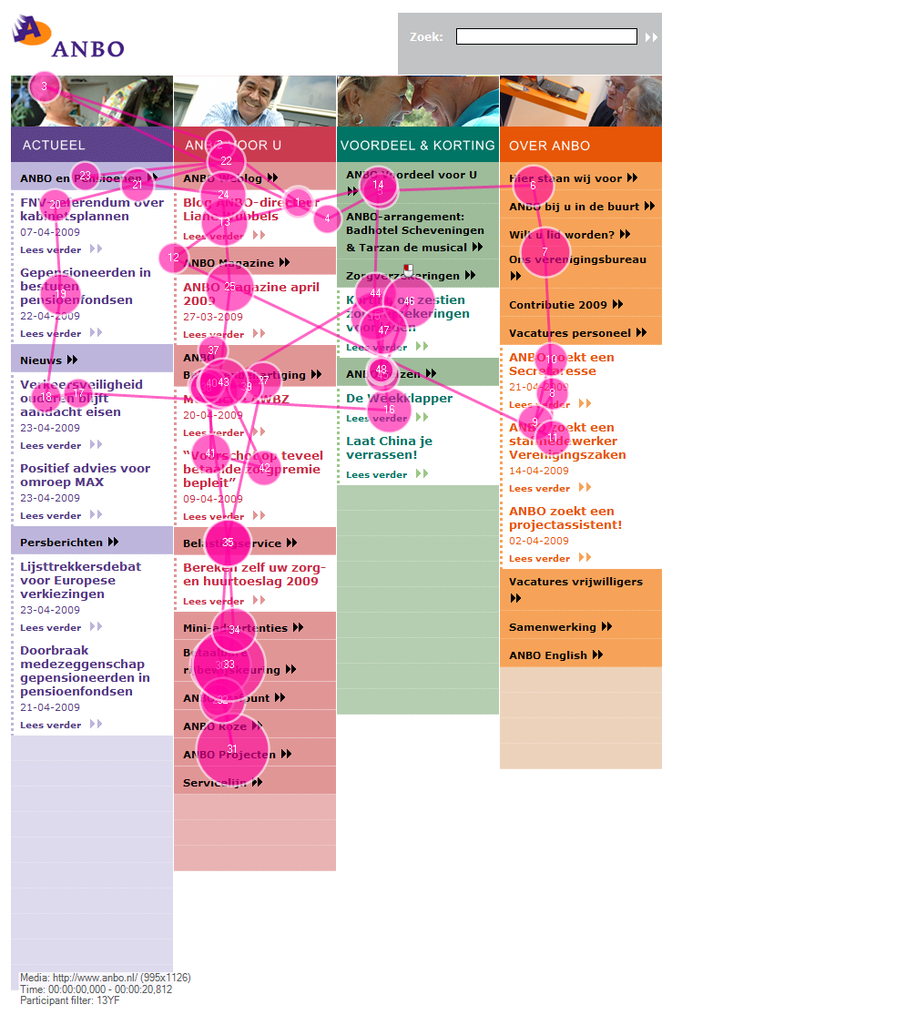
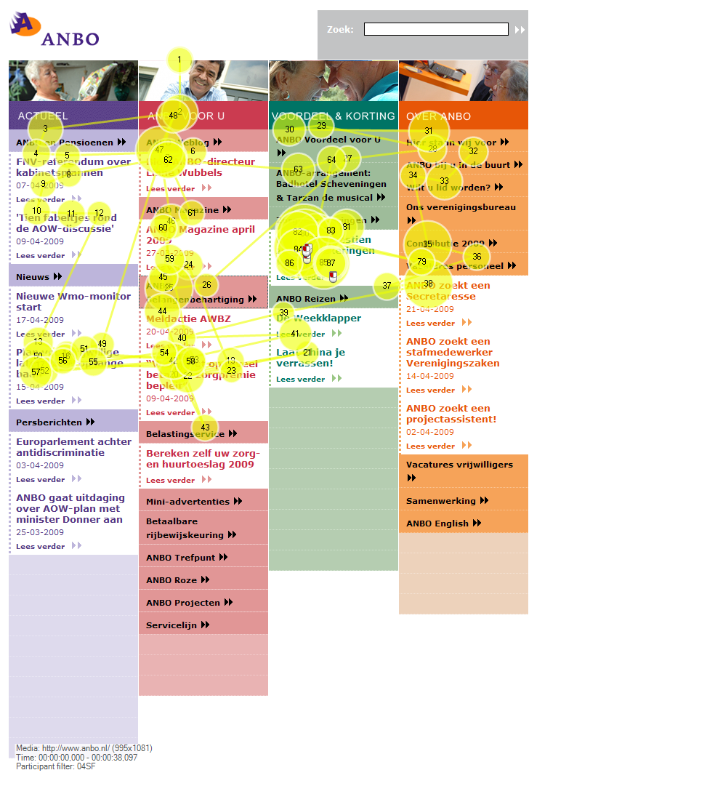

Gaze plot 5: high number of saccades / Gaze plot 6: high number of saccades / older female user younger female user

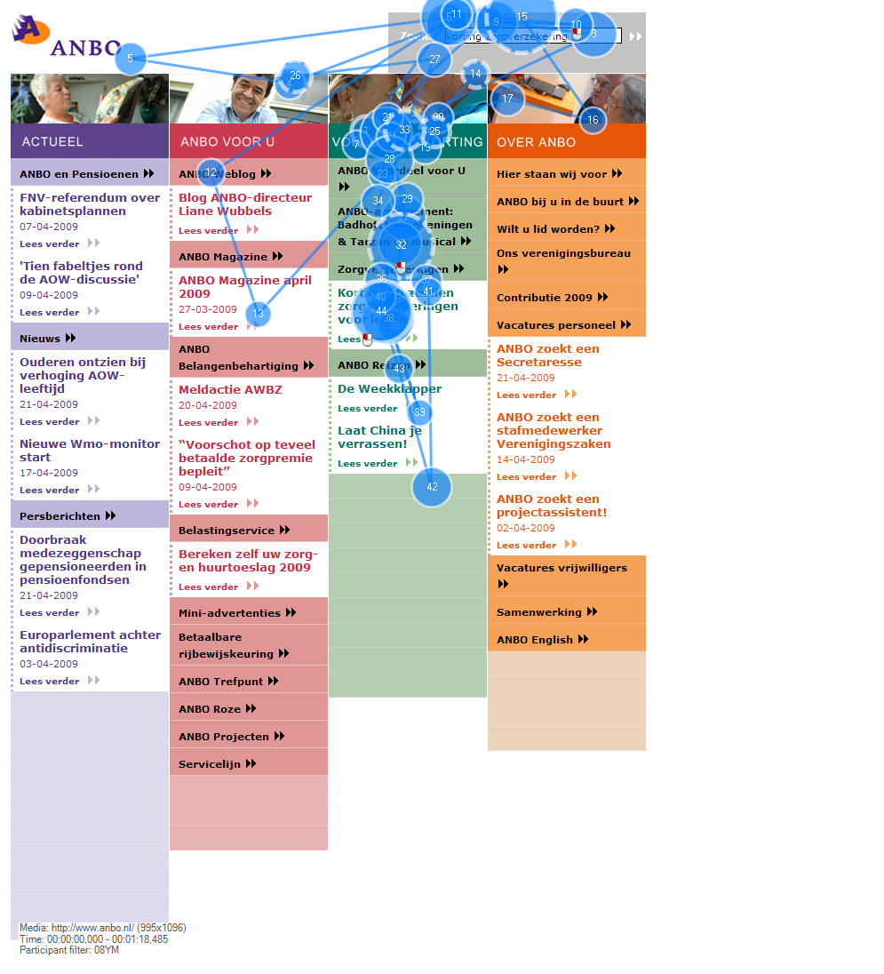
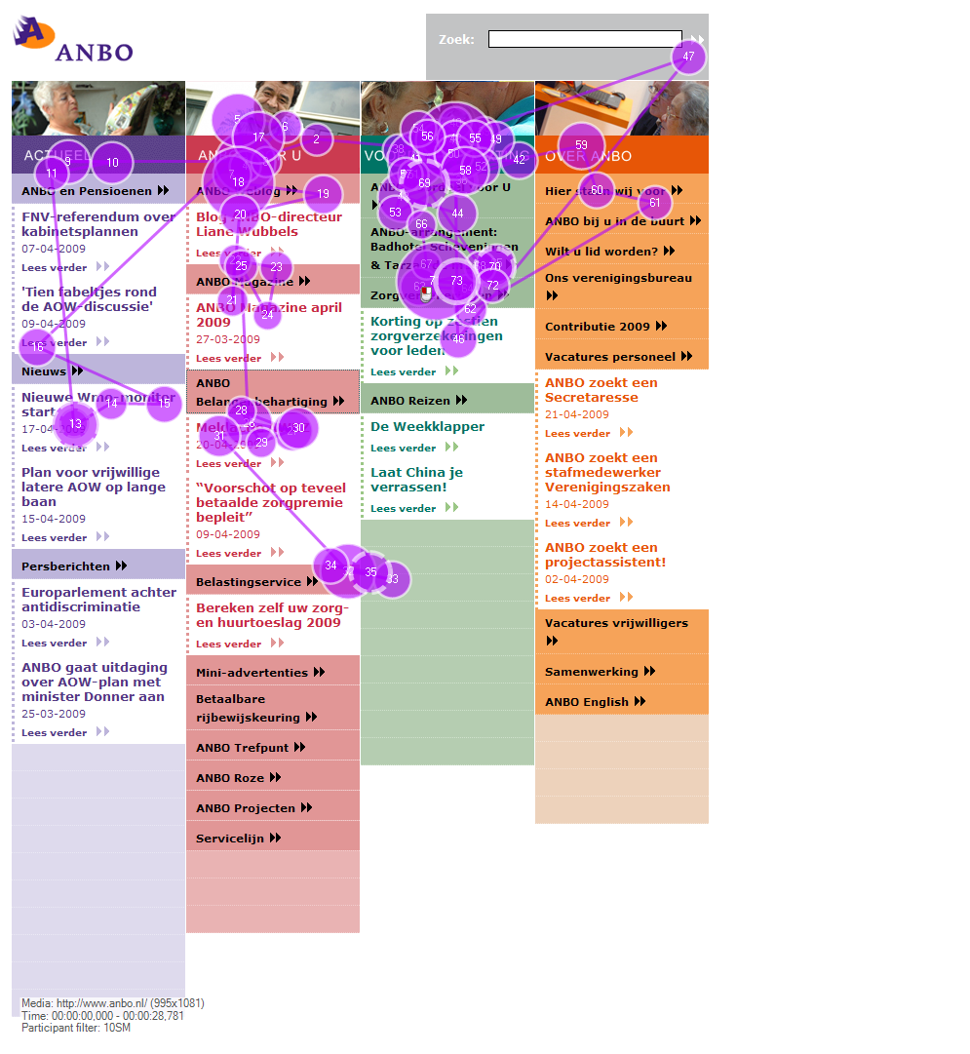

Gaze plot 7: high number of saccades / Gaze plot 8: high number of saccades /
older male user younger male user

Source (gaze plots 5-8): Loos & Mante-Meijer (2009, p. 59)

