Luminescence Stability Improvement in Liposome-Based Homogeneous Luminescence Resonance Energy Transfer

Sari Pihlasalo *ª, Jenny Granberg ª, Pekka Hänninen ª, Jouko Peltonen ^{b}, and Harri Härmä ª
sari.pihlasalo@utu.fi, +358 2 333 7069
ªLaboratory of Biophysics and Medicity Research Laboratory, University of Turku, Tykistökatu 6A, 20520 Turku, Finland
^{b}Laboratory of Physical Chemistry, Åbo Akademi University, Porthaninkatu 3-5, 20500 Turku, Finland
Short title: Liposome-based homogeneous LRET
Subject category: physical techniques

Abstract

A stable liposome-based time-resolved luminescence resonance energy transfer (TR-LRET) assay was developed based on the interaction of biotinylated lipids and streptavidin. Eu³⁺ ion chelated to 4,4,4-trifluoro-1-(2-naphthalenyl)-1,3-butanedione and trioctylphosphine oxide was incorporated into liposomes. Acceptor-labeled streptavidin bound to biotinylated lipids of the liposomes enables TR-LRET. A stable assay performance was achieved by optimization. High Eu³⁺ signal and stability, low variation, and the sensitivity below 100 pM for free biotin was achieved by incorporating the chelate into liposomes containing cholesterol in a carbonate buffer. Potentially, the stable assay compared to the assay without cholesterol offers an improved platform to liposome-based detection systems.

Keywords: Biotin, Cholesterol, Energy transfer, Liposome, Streptavidin, Time-resolved luminescence

Lanthanide chelates are popular probes in various research fields. However, many of the lanthanide chelates are relatively unstable at extreme pH [1], at high temperature, and in the presence of competing ions or ligands [2]. More stable lanthanide compounds, such as cryptates [3,4] and terpyridine chelates, have been synthesized. However, complicated structures suggest long synthesis and high costs. Simple Eu³⁺:β-diketone:TOPO chelates in detergent solution is one of the most luminescent lanthanide structures known and, therefore, of interests in bioaffinity assays. However, it is highly unstable at micromolar concentrations. This has led to new strategies to stabilize the weakly stable Eu³⁺ complex by incorporating the complex within latex or silica particles and liposomes [5,6]. Liposomes as artificial biological membranes provide an excellent host for dyes, because they mimic cell membranes. However, stability of dyes within liposomes limits their applicability. Hydrophobic chelates are incorporated into the lipid membrane. They might decrease the stability of the membrane and leak from the bilayer, unless the assay conditions and membrane components are optimized. Cholesterol is an important cell membrane steroid found in high quantities, typically approximately 30% of the lipids, in mammalian membranes [7]. Cholesterol influences on the flux of small molecules across bilayers by changing the degree of packing and thermal mobility of the lipid hydrocarbon chains [8]. Thus, it gives a natural choice to prevent or enhance leakage of molecules across the membrane.

In this study, our objective was to improve the stability, assay variation, and the magnitude of the luminescence signals in a liposome-based TR-LRET assay system [9]. The Eu³⁺ ion chelated to 4,4,4-trifluoro-1-(2-naphthalenyl)-1,3-butanedione (NTA) and trioctylphosphine oxide (TOPO) is incorporated into liposomes containing cholesterol and applied as a donor (D) in a TR-LRET assay (see Figure S1 in Supplementary Material). The proximity of acceptor Alexa Fluor® 680 labeled streptavidin (SA-Alexa, see experimental details for labeling in [9] and Supplementary Material) to Eu³⁺:NTA:TOPO chelate donors is enabled by biotinylated lipids incorporated into liposomes and the TR-LRET signal was detected between the dyes. A decreasing signal was measured with the increasing concentration of soluble biotin, as the binding of SA-Alexa to biotinylated liposomes and TR-LRET was prevented.

We carried a series of experiments to improve the Eu³⁺:NTA:TOPO chelate incorporation and to choose the most effective conditions for further stability and the assay calibration measurements. The unilamellar liposomes containing 1,2-dipalmitoyl-sn-glycero-3-phosphocholine, 1,2-dipalmitoyl-sn-glycero-3-phosphoethanolamine-N-(cap biotinyl) (mole fraction 5%), and cholesterol were prepared by extrusion through membranes with a pore size of 100 nm. Eu³⁺:NTA:TOPO was incorporated into the liposome membrane after liposome extrusion by mixing Eu³⁺:NTA:TOPO in DMSO with the liposome suspension and the free chelate was separated from the labeled liposomes by gel filtration (see experimental details for materials, instrumentation, preparation of biotinylated liposomes, and incorporation of Eu³⁺:NTA:TOPO chelate into liposome membrane in Supplementary Material). The conditions for the incorporation were optimized by testing the effect of pH and buffer components, cholesterol content, different alcohols, and temperature. The Eu³⁺ time-resolved luminescence signals of the diluted Eu³⁺:NTA:TOPO chelate labeled liposome suspensions were monitored for the comparisons. Among the tested buffers (a universal buffer with four components at 30 mM; 50 mM acetate, pH 5.0; phosphate, pH 7.0; tris(hydroxymethyl)aminomethane, pH 9.0; glycine, pH 9.0; and carbonate, pH 9.8), the highest incorporation was reached with the carbonate buffer, pH 9.8. This buffer may have created an anion flux across the membrane and assisted the partly positively charged hydrophobic chelates into the liposome bilayer (see Figure S2 and the detailed Results and Discussion in Supplementary Material).

As cholesterol is known to reduce the leakage of small water-soluble molecules or ions [7,10], we studied the effect of the cholesterol content in the liposome membrane on the Eu³⁺:NTA:TOPO chelate incorporation. The measured Eu³⁺ signal increased in a linear manner as a function of the cholesterol mole fraction in the liposome (Figure 1a), which suggested that the Eu³⁺:NTA:TOPO chelate incorporation was enhanced in the presence of cholesterol. Cholesterol increases the incorporation of hydrophobic molecules into the liposome bilayer in a gel phase due to the changes in the liposome bilayer: the membrane hydrophobicity, the membrane thickness, and the membrane order in the core of the lipid layer increase and the number of membrane defects decreases [11-14]. Thus, cholesterol causes an effective hydrophobic barrier to permeation of polar species [15] and a hydrophobic shield for water-insoluble or hydrophobic molecules, such as NTA and TOPO in the chelate, against polar environment. Moreover, the incorporation of the cation is significantly enhanced as chelated than as a free ion [10,16,17].

Although a linear relation between cholesterol content and Eu³⁺ signal was observed, a different effect was observed on the TR-LRET signals in the presence of the acceptor SA-Alexa (see Figure S3 in Supplementary Material). The TR-LRET was measured in the absence and in the presence of high 0.83 µM concentration of soluble biotin and the ratio between measured signals (B₀/B) was calculated. B₀/B increased significantly (approximately four-fold increase), as the mole fraction of cholesterol increased from 0 to 10%, but leveled out at higher cholesterol fractions. This suggests that the same enhancement of energy transfer may be applicable to natural membranes with varying cholesterol content and the natural cholesterol content may not limit the use of the assay principle in biological applications. The saturation of the TR-LRET suggests that the donor concentration is sufficient to excite the acceptors at cholesterol mole fractions higher than 10%.

The stability of Eu³⁺ signal had an effect on the TR-LRET signal. We studied the effect of the buffer pH and composition or liposome cholesterol content used during the incorporation of the chelate on the stability. The influence of universal buffer pH was small and the Eu³⁺ signal of diluted Eu³⁺:NTA:TOPO labeled liposomes was highly unstable (data not shown). However, the liposomes labeled in carbonate buffer pH 9.8 with high Eu³⁺ signal had the highest stability. Moreover, the Eu³⁺ signal stability significantly increased and the coefficient of variation decreased, as the liposome cholesterol content increased (Figure 1b). The effect of cholesterol on the stability of the liposomes incorporated with the Eu³⁺:NTA:TOPO chelate is explained by the ability of cholesterol to decrease the leakage of small water-soluble molecules or ions [10].

Our studies suggested that the most effective incorporation for the Eu³⁺:NTA:TOPO chelate into liposome membrane was achieved in the carbonate buffer at alkaline pH and liposomes with high cholesterol content. The effect of electrochemical gradient was also tested by the addition of alcohols and the raise of temperature (data not shown). However, they were not equally effective as alkaline pH and the addition of cholesterol, although positive effects were found. The highest Eu³⁺ signal measured for liposomes containing cholesterol is probably explained by the highest incorporation of the Eu³⁺:NTA:TOPO chelate and the high stability of these liposomes after the dilution in water. This implies that the structural changes of the membrane, which increase its hydrophobicity, have the most significant effect on the permeability of hydrophobic chelates. The increased permeability for ions accomplished by other tested conditions is not equally effective probably due to the differing properties between chelated and free ions.

The spectral characteristics of liposomes containing 50% cholesterol (Eu³⁺:NTA:TOPO chelate incorporation performed in carbonate buffer pH 9.8) were assessed and compared to the spectrum of liposomes without cholesterol published earlier [9]. The local emission maxima were not significantly shifted when compared to liposomes without cholesterol. Moreover, the calculated emission lifetimes for the shorter and longer lifetime components were similar for liposomes with or without cholesterol.

A calibration curve for the biotin assay was measured using 0.14 nM SA-Alexa and 0.33 pM liposome with 50% cholesterol. The assays were performed in microcentrifuge tubes in 100 mM phosphate buffer, pH 7.4, 10 mM KCl and the TR-LRET signals were measured after transferring 50 µL of the solution into microtitration wells. The corresponding curve for liposomes without cholesterol is presented as a comparison in Figure 2. After performed optimizations for the concentrations of the components, we observed similar dynamic ranges for both systems. The sensitivity below 100 pM for biotin was measured using liposomes with 50% cholesterol. This sensitivity was reached due to reduced coefficient of variation, which was proposed to decrease due to the signal stabilization. For the dynamic range, the coefficient of variation for the signal varies between 0.90 and 9% (average 4%) with cholesterol and between 8 and 20% (average 12%) without cholesterol.

In summary, the liposome-based homogeneous TR-LRET assay developed previously by us [9] was improved and higher performance was reached. Several incorporation methods for the Eu³⁺:NTA:TOPO chelate to the liposomes and different assay conditions were systematically tested. Higher signal and its stability were reached compared to the earlier incorporation setup. The most optimal chelate incorporation, in carbonate buffer at basic pH to liposomes containing 50% cholesterol, was chosen for the measurement of the biotin calibration curve. The sensitivity was high for the quantification of biotin and the coefficient of variation was clearly improved from the original assay containing non-cholesterol liposomes with the Eu³⁺:NTA:TOPO chelate incorporation in water. These improvements may provide an applicable assay principle for membrane studies, which can be further adapted for high-throughput screening applications with biologically important targets.

Acknowledgments

This work was supported by the Finnish Funding Agency for Technology and Innovation (Tekes) and the Academy of Finland (grant 258617).

References

[1] Fluorescence Detection Technologies. www.labautopedia.org/mw/index.php/Fluorescence_Detection_Technologies (accessed Oct 20, 2012).
[2] E. Lopez-Crapez, H. Bazin, E. Andre, J. Noletti, J. Grenier, G. Mathis, A homogeneous europium cryptate-based assay for the diagnosis of mutations by time-resolved fluorescence resonance energy transfer, Nucleic Acids Res. 29 (2001) e70.
[3] J.-M. Lehn, Design of organic complexing agents Strategies towards properties, Struct. Bonding (Berlin) 16 (1973) 1–69.
[4] J.-M. Lehn, Cryptates: the chemistry of macropolycyclic inclusion complexes, Acc. Chem. Res. 11 (1978) 49–57.
[5] I. Hemmilä, Fluoroimmunoassays and immunofluorometric assays, Clin. Chem. 31 (1985) 359–370.
[6] I. A. Hemmilä, Applications of Fluorescence in Immunoassays, John Wiley, New York, 1991.
[7] B. Alberts, A. Johnson, J. Lewis, M. Raff, K. Roberts, P. Walter, Molecular Biology of the Cell, 4th edition, Garland Science, New York, 2002.
[8] L.L.M. van Deenen, Chemistry of phospholipids in relation to biological membranes, Pure Appl. Chem. 25 (1971) 25–56.
[9] S. Pihlasalo, M. Hara, P. Hänninen, J.P. Slotte, J. Peltonen, H. Härmä, Liposome-based homogeneous luminescence resonance energy transfer, Anal. Biochem. 384 (2009) 231–237.
[10] D.D. Lasic, Liposomes: from Physics to Applications, Elsevier, Amsterdam, The Netherlands, 1993.
[11] A. Carruthers, D.L. Melchior, Study of the relationship between bilayer water permeability and bilayer physical state, Biochemistry 22 (1983) 5797–5807.
[12] S. Paula, A.G. Volkov, A.N. Van Hoek, T.H. Haines, D.W. Deamer, Permeation of protons, potassium ions, and small polar molecules through phospholipid bilayers as a function of membrane thickness, Biophys. J. 70 (1996) 339–348.
[13] K.R. Thulborn, G.S. Beddard, The effects of cholesterol on the time-resolved emission anisotropy of 12-(9-anthroyloxy)stearic acid in dipalmitoylphosphatidylcholine bilayers, Biochim. Biophys. Acta. 693 (1982) 246–252.
[14] M. Vincent, B. de Foresta, J. Gallay, A. Alfsen, Fluorescence anisotropy decays of n-(9-anthroyloxy) fatty acids in dipalmitoyl phosphatidylcholine vesicles. Localization of the effects of cholesterol addition, Biochim. Biophys. Res. Commun. 107 (1982) 914–926.
[15] W.K. Subczynski, A. Wisniewska, J.J. Yin, J.S. Hyde, A. Kusumi, Hydrophobic barriers of lipid bilayer membranes formed by reduction of water penetration by alkyl chain unsaturation and cholesterol, Biochemistry 33 (1994) 7670–7681.
[16] C.-B. Yuan, D.-Q. Zhao, Y.-J. Wu, F.-K. Pei, J.-Z. Ni, NMR study on the interaction of lanthanide complexes with phospholipid bilayers, Gaodeng Xuexiao Huaxue Xuebao 17 (1996) 10–13.
[17] C. Yuan, D. Zhao, Z. Bing, Y. Wu, J. Liu, J. Ni, 2D NMR and FT-Raman spectroscopic studies on the interaction of lanthanide ions and Ln-DTPA with phospholipid bilayers, Langmuir 12 (1996) 5375–5378.

Legends

Figure 1. a) Eu³⁺ signal for biotin-cap-DPPE:DPPC liposomes (liposome concentration 0.77 pM) with varying mole fractions of cholesterol. The curve is a linear fit of the data. b) Normalized Eu³⁺ signal as a function of incubation time for liposomes with different mole fractions of cholesterol (x(cholesterol) = 0-0.50).

Figure 2. Calibration curves for competitive TR-LRET biotin assay using two different liposomes (Eu³⁺:NTA:TOPO chelate incorporation in water for liposomes without cholesterol and Eu³⁺:NTA:TOPO chelate incorporation in carbonate buffer for liposomes with cholesterol x(cholesterol) = 0.50).

Figure 1a
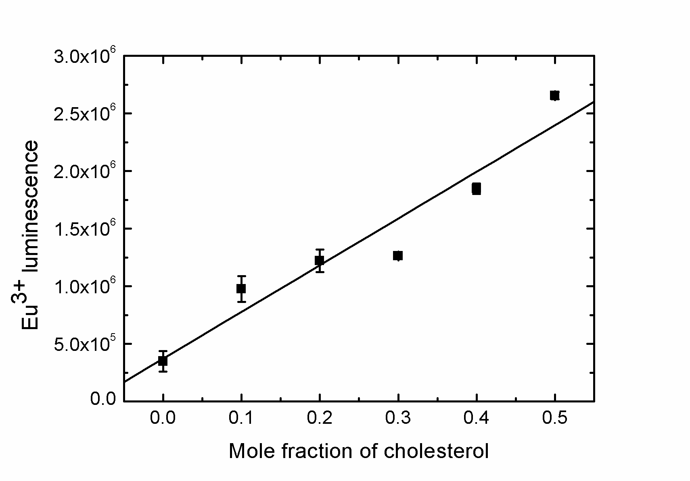
b)
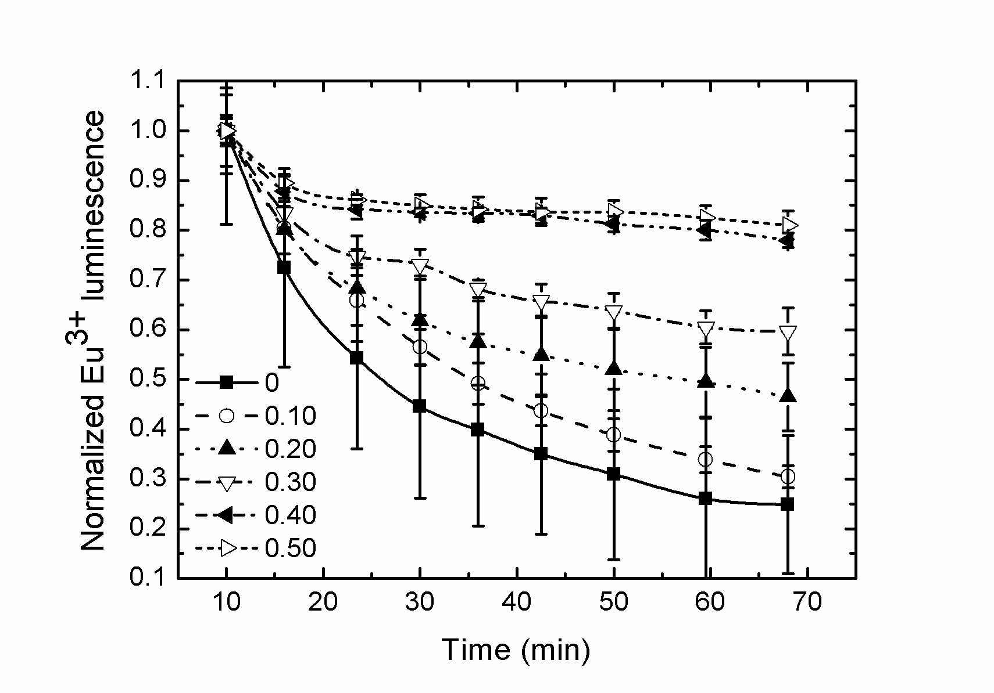

Figure 2
