Integration of Small-Scale Compressed Air Energy Storage with Wind Generation for Flexible Household Power Supply

Xinjing Zhang ¹²³, Chao (Chris) Qin ⁴, Yujie Xu ¹²³, Wen Li ¹²³, Xuezhi Zhou ³, Ruimin Li ¹², Ye Huang⁵, Haisheng Chen ^{123*}

1. Institute of Engineering Thermophysics, Chinese Academy of Sciences, Beijing, 100190, China.
2. University of Chinese Academy of Sciences, Beijing, 100190, China.
3. National Energy Large Scale Physical Energy Storage Technologies R&D Center (Bijie), Xiaoba Town, Bijie, 551712, China
4. Department of Mechanical and Aerospace Engineering, University of Virginia, Charlottesville, Virginia, 22903, USA.
5. School of the Built Environment, University of Ulster, Newtownabbey, Co. Antrim, BT37 0QB, UK

*Corresponding author: chen_hs@iet.cn

Abstract
Energy storage can help regulate energy supply and demand and facilitate utilization of distributed renewable energy. Compressed Air Energy Storage (CAES) can store surplus energy from wind generation for later use, which can help alleviate the mismatch between generation and demand. In this study, a small-scale CAES system, utilizing scroll machines for charging and discharging, was developed to integrate into a wind generation for a household load. A simulation model, which was verified by our experiments results, was constructed for investigating the performance of the small-scale energy storage system. The operation map of the expander was obtained through the simulation for illustrating the expander’s optimal parameters. A fluctuating wind generation profile was integrated into the small CAES to supply adjustable electricity. The dynamic performance of key components including compressor, expander and storage tank was assessed for the first time for a practical application. The results revealed that distributed renewables with an energy storage system become flexible and such integration can help satisfy fluctuating power demand. Efficiency of energy utilization, which was defined as the percentage of energy consumption to wind generation in a typical day, also achieved a value as high as 88.75%. At the same time, maximal installation of generating capacity coupled with the integration of the CAES system was reduced by 15%.

Keywords: compressed air energy storage, wind generation, household power supply, dynamic performance, energy utilization

1. Introduction
Energy storage is considered as a sixth value chain to the current entire electricity value chain (fuel, generation, transmission, distribution, services). In many cases, energy storage is becoming a cost-effective technology to replace conventional infrastructure, particularly in helping substations, and transmission and distribution (T&D) lines. It helps regulate energy supply and demand, and facilitate distributed renewable energy (DER) utilization by engaging distributed storage technologies for local grids, or microgrids [1, 2].
According to the BP Energy report [3], renewable energy is the fastest-growing energy source, accounting for 40% of the increase in primary energy. Renewable energy in power generation (not including hydro) grew by 16.2% of the yearly average value of the past 10 years [3]. Taking wind energy as an example, the worldwide installation has reached 539.1 GW in 2017, of which 188.4GW has been installed in China [4]. Renewable energy generation can be developed both in large-scale and small-scale applications near the user side. Distributed renewable energy systems, which generate and distribute energy for both urban and rural areas, can serve as a complement to centralized energy generation systems, or as a substitute. As the report of Energy Access Outlook states, approximately 1.1 billion people (about 14% of the global population) in 2016 still lacked access to electricity [5, 6]. Localized power networks relying on wind turbines, solar photovoltaic (PV) and diesel generators can provide electricity for these households without any infrastructure to transmit electricity beyond their service area [6-8]. Developing renewable energy to remain below the temperature thresholds established in the Paris Agreement necessitates the installation of 310 GW of electricity storage in the world by 2050, mainly to increase penetration of renewable energy resources [9]. A new report from analysts at Wood Mackenzie (Europe Residential Energy Storage Outlook 2019) forecasts 6.6 GWh of residential energy storage to be installed across Europe by 2024, or 500% growth [10].
Compressed Air Energy Storage (CAES) has long been considered a means of improving power quality, reliability, in addition to yielding other benefits [11]. Compared with battery storage technologies, the CAES system has advantages of relative low cost, long life and easy to maintain [11]. Various types of CAES systems have been investigated in industries and academia including two commercial CAES plants in Germany and USA [12, 13]. Decentralized or small-scale CAES plants have recently gained large attention. They can be operated as an alternative to typical battery storage systems, such as lithium ion or flow batteries. This small-scale CAES can be implemented in the low-voltage grid solving the challenges of renewable energy feed-in [12, 14]. A small-scale CAES system can connect renewable energy and remote communication devices to form a stand-alone system [15]. The storage system efficiency of this configuration is 57%, and the annual energy supply factor can reach up to 33% [15]. Poncet et al. proposed a small-scale trigenerative CAES system which can supply cooling and heating along with electricity (about 1 kW) [16]. In that study, a pilot small-scale CAES system was constructed utilizing a piston-type compressor and expander. The round trip electrical efficiency was very low at 3.6%, while the comprehensive efficiency of the trigenerative mode reached 15.6% [16]. A micro-scale trigenerative CAES with compression heat storage was also proposed and studied [17]. The powers of compressor and expander are 3.17kW and 2.06kW, respectively. While the temperature for compression heat storage can be as high as 200℃. And the comprehensive efficiency of the system is 27.2%. The study shows promising application of the proposed system with further improvement of main components’ performance [17]. Castellani et al reported a novel PV-integrated small-scale compressed air energy storage system utilizing reciprocating compressor and scroll expander [18]. The results showed that the small scale CAES can store as much as 96% of photovoltaic (PV) energy excess, and provide electricity of 26% of the demand, indicating the CAES prototype suitable for dwelling applications [18]. Scroll machines (scroll compressor and scroll expander) are more suitable for small-scale CAES systems [14, 19]. Scroll machines have positive properties of wide working range, high efficiency, and low level of noise and vibration due to fewer moving parts [20, 21]. The scroll compressor has been studied and applied in both industries and academics [22, 23]. It shows that the scroll compressor can operate effectively and steadily. Both scroll compressor and scroll expander can operate from hundreds of watts to about 50 kilowatts with rotation speeds up to 6000rpm. Their efficiency can be up to 80%. The scroll expander also has a vital role in the Organic Rankine Cycle (ORC) for waste heat recovery [24-26]. Sun et al. [19] proposed a hybrid system of a small wind turbine with a small CAES system. The scroll expander was utilized to generate power to smooth wind generation. The CAES system efficiency is 55%. However, the energy storage process and air state in the storage tank need to be studied in detail for a full understanding of the whole system [19].
Based on the author's knowledge, this paper is the first to combine both scroll compressor and scroll expander and study them theoretically as an integrated distributed renewable system. Detailed modelling of the scroll expander and storage tank were validated by experimental results. A newly developed strategy to run the scroll expander with optimal efficiency is also provided. For the first time, a detailed investigation was conducted considering dynamic performance of scroll compressor, optimal operation of scroll expander, and unsteady state of the storage tank. This study reveals that the hybrid distributed renewable system integrated with this novel energy storage system is flexible. In the future, such systems will help to satisfy the fluctuating power requirements of customers within flexible power grids while intermittent renewable energy is penetrating the power grid. This can significantly reduce the over-rated conventional wind turbine design for a customer.

2. Description of wind-CAES system and configuration
2.1 System description
Wind generation connects both the household and the CAES system. The configuration is shown in Figure 1. It is noted that the wind turbine noise causes annoyance to the people living around the wind farm. Certain distances between wind farms and habitations are recommended by governments or medical institutions. For example, the distance of 200 meters is recommended between a single wind turbine and habitations, and the distance of 500 meters is recommended for a large wind farm [27]. Detailed research about noise of distributed wind generation near around the habitations will be carried out in the future research. Wind generation usually fluctuates due to erratic wind speed. Moreover, the customer load is not stable but depends on residents’ varying routines. Surplus electricity charges the CAES system through the scroll compressor. The compressed air is stored in the storage tank while the compression heat is absorbed by a thermal storage system. When required, the compressed air is released and heated by the stored heat, and then drives a scroll expander. The electricity is generated to satisfy peak demand of the customers. Some compression heat stored in the thermal storage unit can be recovered for household use. The thermal storage unit consists of two tanks (cold and hot tanks) using thermal oil as the storage medium.
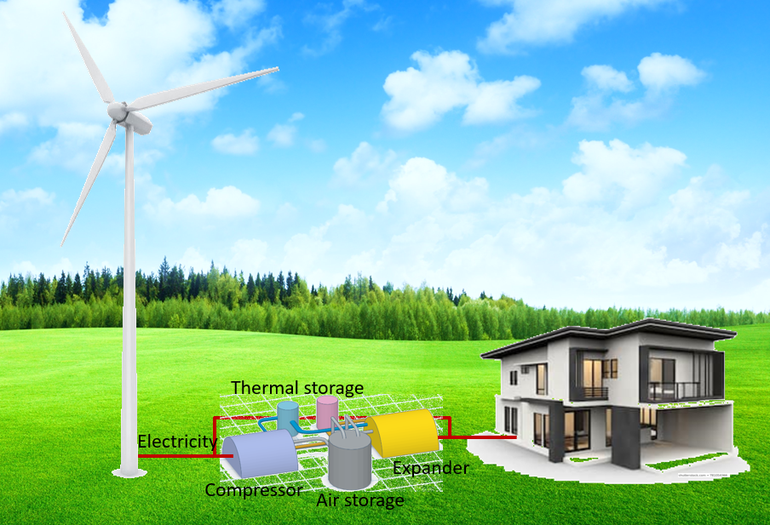
Figure 1 The wind-CAES system layout
2.2 System configuration
The system configuration strategy is shown in Figure 2. The whole system design starts with the customer load requirement. The wind generation and CAES are selected and optimized to satisfy the load. For a typical day, both wind and CAES systems operate complementarily to fulfill the load requirement. When wind generation is higher than required, the electricity drives the compressor to generate compressed air. The stored energy is later released to generate additional power for the customer. Energy balance of a whole cycle is observed by controlling the state of the air storage tank. The wind generation power rating will be adjusted, and the energy storage/release profiles will be re-designed if the supply fails to meet the demand.
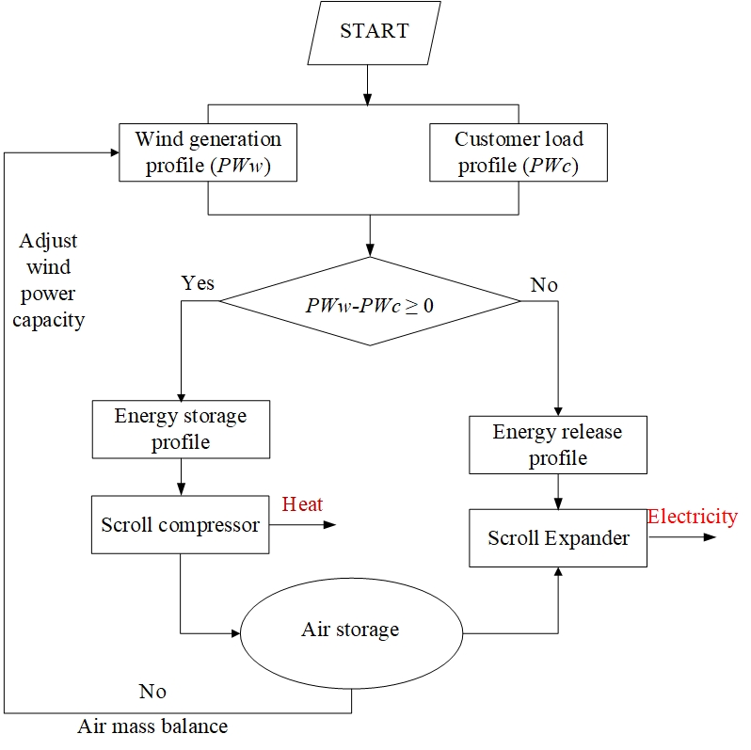
Figure 2 Wind-CAES system configuration process

3. Wind generation and customer load
As indicated in Figure 2, a wind generation and customer’s load are first presented, and the wind turbine size will be optimized. A small wind turbine generation curve versus wind speed is given in Figure 3 according to equation (1) [28]. When the wind speed profile is presented (Figure 4), the wind generation curve throughout a whole day is obtained, as shown in Figure 4. In addition, a typical household load curve is selected, as shown in Figure 4. The load curve is measured data of a building including 5 apartments in USA. This shows that trends of wind power generation are similar to trends in wind speed. There are gaps between generation and consumption. High load periods occur twice a day: at morning time and evening time, and are highly dependent on the residents’ particular routines. The mismatch between generation and consumption can be resolved through the charging and discharging of an energy storage system.
(1)
where, Pw(v) is the wind generator power output at wind speed of v, k weibull shape parameter depending upon the wind profile of the selected site as shown in reference [28], P_{R} rated electrical power output of wind turbine, v_{c} cut-in speed of the wind turbine, v_{R} rated speed of the wind turbine, v_{F} cut-out speed of the wind turbine.

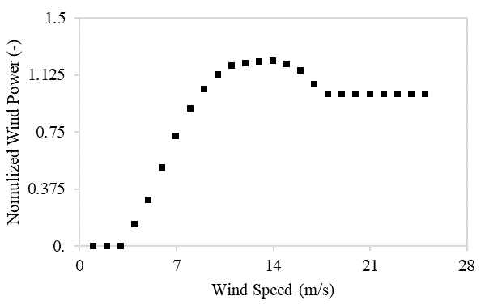
Figure 3 Wind turbine power curve
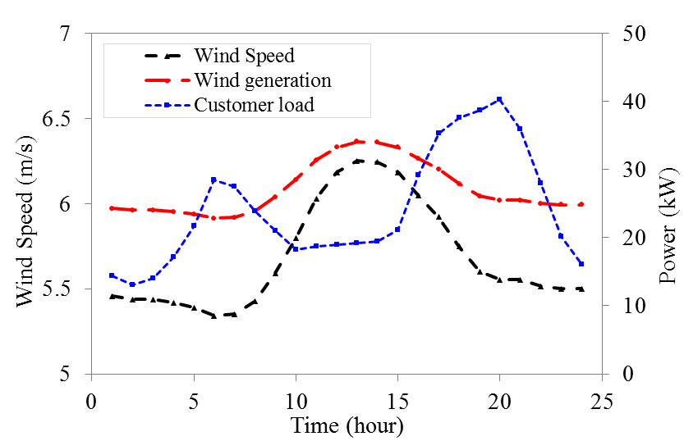

Figure 4 Wind speed, wind generation and customer load curves of a day

4. System Thermodynamic modeling and validation

4.1 Scroll machines

4.1.1 Modeling
The main structure of a scroll machine is shown in Figure 5. It consists of two scrolls. One is a static scroll and the other is a rotating scroll. The scroll compressor absorbs the air from the scroll side port and discharges from the scroll center, and the scroll expander operates in reverse from the center port to the side port.

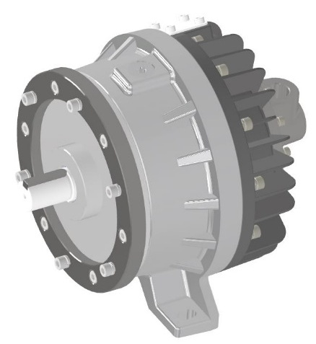 |  | 
scroll machine | rotating scroll | static scroll
Figure 5 Scroll Machine

Both scroll machines’ modelings were constructed based on quasi-dimensional thermodynamics equations [29-32].
The inlet volume of the scroll compressor was calculated with the following equation
(2)
where V_{sc} is the inlet chamber volume, P_{tc} the scroll pitch, t_{c} thickness of the scroll vane, H_{sc} height of the scroll vane, n_{sc} cycles of the compressor scroll, θ_{sc} end shaft angle of air inlet.
The ith chamber volume of the scroll compressor can be calculated by the following equation.
(3)
where θ is shaft angle at the end of the ith chamber.
The ratio of the final volume to the air inlet volume is calculated by equation (4).
(4)
where both N_{sc} and n_{sc} are cycles of compressor scroll (integer, noninteger), and θ^{c*} is the exhaust starting angle.
The working chamber volume calculation of the scroll expander is similar to the scroll compressor
(5)
where V_{ei} is the chamber volume, P_{te} the scroll pitch, t_{e} thickness of the scroll vane, H_{se} height of the scroll vane, θ shaft angle.
The ideal-gas state equations are given below.
(6)
where u is the specific internal energy of the gas flow, c_{p} constant pressure specific heat, c_{v} constant volume specific heat, R gas constant, h specific enthalpy, W expansion power.
The mass balance equation in a chamber which is taken as a control volume (the ith chamber) for both scroll compressor and expander can be expressed as follows.
(7)
where m is the gas mass in the control volume, m_{ini} leakage mass from the upper chamber and m_{outi} the mass leakage to the next one.
The energy balance equation of the control volume can be expressed as follows.
(8)
where c_{V} is constant volume specific heat, Q the heat transfer through the walls of the control volume, W the output power of the expander, h_{in} and h_{out} the inlet and outlet specific enthalpies of the control volume, u internal energy of the control mass.

(9)
(10)
where f is the gas flow coefficient and it equals 1 in the simulation, C the clearance of the leakage section, L the length of the leakage channel, ω the ration angle speed. Ψ is the flow function based on the gas flow state, which could be calculated by one of the following two equations. The subscript j stands for the jth chamber, a radial leakage, r the flank leakage.
The isentropic efficiency of the scroll compressor is defined as the compressed power through isentropic process divided by the indicated power (equation (11)) [29].
(11)
where η_{is-c} is the isentropic efficiency of the scroll compressor, FR_{c} is the flow rate, RPM_{c} is the rotation speed.
The power consumption of the compressor is calculated by the following equation.
(12)
where η_{mc} is mechanical efficiency which is set to be 0.85 [29], subscript i element time of the calculation.
The isentropic efficiency of the scroll expander is defined as the indicated power divided by the expansion power through isentropic process (equation (13)).
(13)
where η_{is-e} is the isentropic efficiency of the scroll expander, FR_{e} is the flow rate, RPM_{e} is the rotation speed.
The shaft power output of the expander is calculated by the following equation
(14)
where η_{me} is mechanical efficiency which is set to be 0.9, subscript I element time of the calculation.
The compression heat was stored and released for the energy release process. For the simplicity, the temperature differences of heat transfer between the compressed air and thermal storage for both energy storage and release process were set as 10K. And the pressure loss through the heat exchanger was neglected [33]. The stored thermal energy was calculated by the following equation.
(15)
where TES_{s} is the stored thermal energy capacity, T_{out-c} the outlet temperature of the compressor, T_{atm} is the ambient temperature.
The efficiency of the CAES system in one-day cycle can be calculated based on the powers of scroll compressor and expander along the whole day.
(16)

4.1.2 Results and Verification of Scroll Expander

A scroll expander was manufactured and tested under various conditions (Figure 5). Main parameters are given in Table 1. Both experimental (exp) and simulated (sim) results are compared as shown in Figure 6, Figure 7 and Figure 8. It can be seen that both mass flowrate and power generation are in good agreement with the experimental results (Figure 6-7). Figure 8 also shows the same trend that both simulated and experimental efficiencies are in good agreement. The relative error is less than 6%. Therefore, the modelings are reliable and can be used to simulate the scroll machines of the small-scale CAES system connected with the wind generation and customer.
Table 1 Parameters of the studied scroll expander
Item | Parameter | Value
Radius of the basic circle | a_{e}(m) | 4.138×10⁻³
Initial angle of the involute | γ_{e}(deg) | 31.154
Expansion starting angle | θ_{se}(deg) | 131.015
Expansion ending angle | θ_{de}(deg) | 720
Scroll vane height | h_{e}(m) | 4.65×10⁻²
Radial clearance | C_{re}(m) | 6.0×10⁻⁵
Axial clearance | C_{ae}(m) | 6.0×10⁻⁵

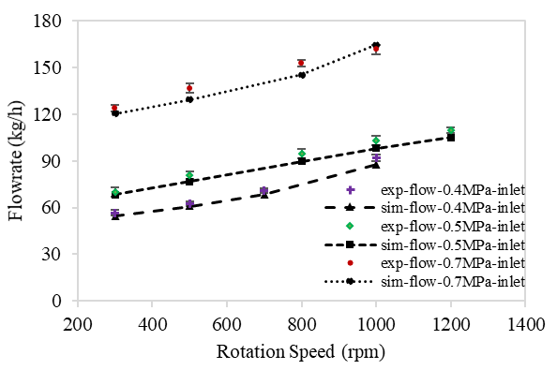
Figure 6 Comparison of mass flowrate between experiment and simulation
Figure 7 Comparison of power generation between experiment and simulation
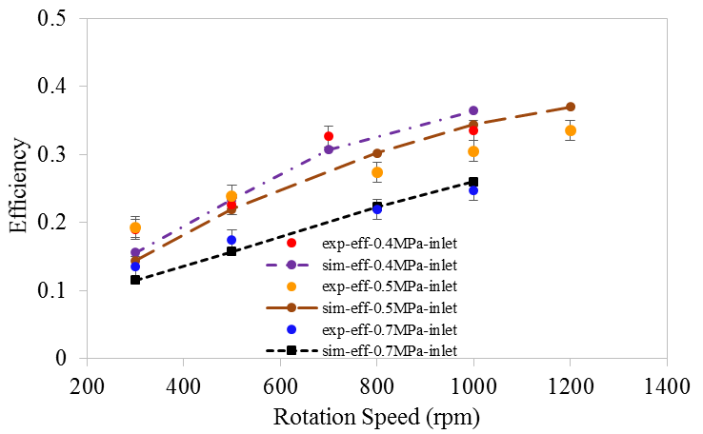
Figure 8 Comparison of efficiency between experiment and simulation

4.2 Storage tank
The storage tank of the CAES system is modeled based on mass balance and energy balance (equations (17) and (18)) [34, 35].
(17)
(18)
where m_{av} is the air mass in the storage tank, and m_{av0} is the initial air mass, kg; ṁ is the mass flowrate into or out of the storage tank; K_{v} is the heat transfer coefficient; A_{v} is the surface area of the storage tank, m²; T₀ is the ambient temperature.
The simulation results (sim) are compared with experimental results (exp) of a steel tank [35]. As shown in Figure 9, the simulation results are in line with the experimental results.
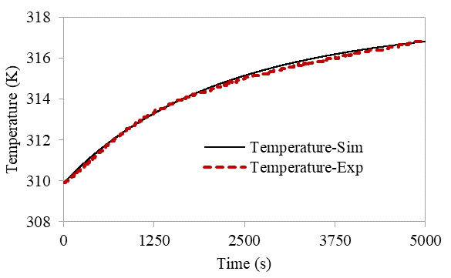
Figure 9 Comparison of temperature between experiment and simulation of storage tank

4.3 The integrated system performance
The energy utilization factor which is the energy used by the customer divided by the wind generation in one-day time was calculated with the following equation
(19)
where PW_{cd} is the household customer power demand, PW_{w} the power generation of a wind turbine.

5. Compressor and expander performance
Figure 4 displays the mismatch between generation and requirement. The curve is usually like it for a habitant building. The scroll compressor operates at the early time during the charging process. Around 6-7am, the expander operates during discharging. During the morning and at noon time, less stored power is required since the wind is blowing and generating more power. Surplus energy is stored as the compressor operates again and more air is stored for power later at peak time. Later in the evening, off-peak electricity is also used to charge CAES.

5.1 Compressor
The consumed power of a scroll compressor is determined by the rotation speed for a volumetric compressor. In addition, the mass flowrate changes along with the rotation speed. Figure 10 presents the general performance of the scroll compressor. Both power and specific work increase with the rotation speed. The consumed power is in the range of 1.4 ~ 17.7 kW, and the specific work is in the range of 219~370 kJ/kg when the rotation speed changes from 400 to 6000 rpm.
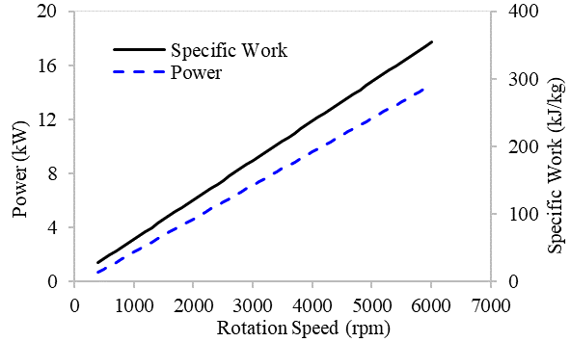

Figure 10 Compressor operation parameters

5.2 Expander performance
In this study, a scroll expander was designed suitable for this proposed hybrid system based on the one used for experiments. The basic circle radius of scrolls is 6E-3 m. The performance map of the scroll expander are presented in Figure 11 and Figure 12. Generated power increases when rotation speed and operating pressure increase (Figure 11). The expander can operate in a large range from 0 to 27.5 kW with an inlet pressure of 0.15 ~ 1 MPa, and rotation speed of 500 ~ 6000 rpm. When the operating pressure is much lower than the designed pressure, it is an over expansion process. There is no power generation at these pressure ranges, as shown in the top left part of the figure, due to the inlet pressure being too low to drive the scrolls. Figure 12 shows the isentropic efficiency contour under various pressures and rotation speeds. It reveals that the isentropic efficiency increases along with the increase of the rotation speed under a certain operation pressure when the inlet pressure is higher than 0.25 MPa, and it first increases and then decreases along with the increase of the inlet pressure under a certain rotation speed. The figure also shows that there is no value in the top left part of the figure, the same as in Figure 11. These findings confirm that there are three types of expansion process depending on the inlet air pressure once the expander is designed, namely, over expansion, normal expansion and deficient expansion [32]. Figure 12 reveals that there is an optimal operating pressure for higher efficiency under different rotation speeds, which is around 0.4 MPa. With respect to its characteristics, the scroll expander is designed to operate around this value with high efficiency.

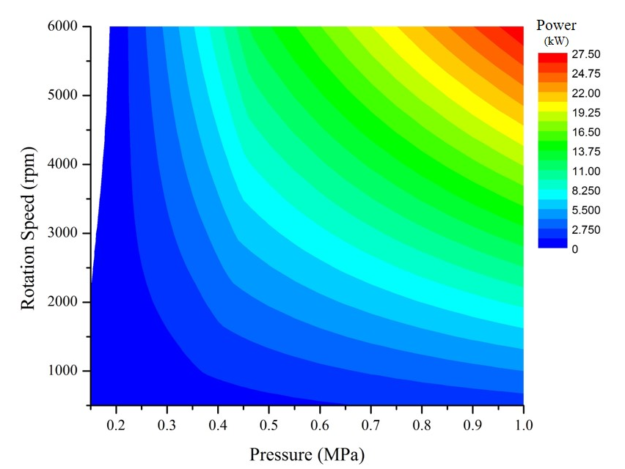
Figure 11 Power generation contour under various pressures and rotation speeds

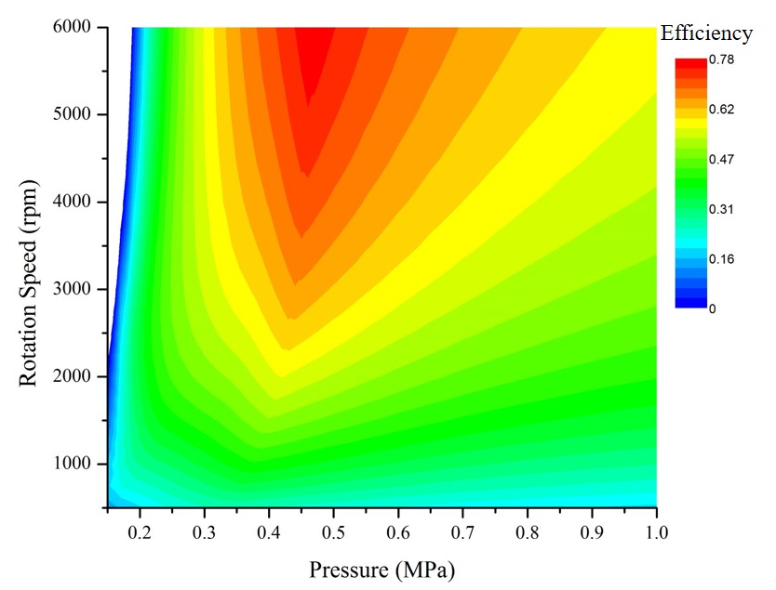
Figure 12 Efficiency contour under various pressures and rotation speeds

6. Integrated system performance and discussion
The integrated system parameters are given in table 2. Detailed performance are discussed below.
Table 2 Parameters of the integrated system
Parameters | Value | Parameters | Value
Wind turbine capacity (kW) | 40.3, 34.1 (without and with CAES) | Scroll expander efficiency (including isentropic efficiency and mechanical efficiency) (-) | 0.72
Scroll compressor capacity (kW) | 15 kW, 5000 rpm | Scroll expander mechanical efficiency (-) | 0.9
Scroll compressor design pressure ratio | 10 | Air storage tank volume and pressure (m³) | 70
Scroll compressor efficiency (including isentropic efficiency and mechanical efficiency) (-) | 0.81 | Thermal storage capacity and temperature | 267MJ, 187℃
Scroll compressor mechanical efficiency (-) | 0.9 | Total energy storage time (hours) | 16
Scroll expander capacity (kW) | 10, 5000 rpm | Total energy release time (hours) | 8
Scroll expander expansion ratio (-) | 4.5

6.1 Scroll machines
The energy storage and energy release power profile for a whole day is shown in Figure 13. Figure 14 shows the operation curve of the compressor during charging times of the CAES system. It can be seen that the compressor operates during the low-load period (as shown in Figure 4). Both rotation speed and flowrate have similar trends, which is in accordance with the difference between wind generation and customer load.

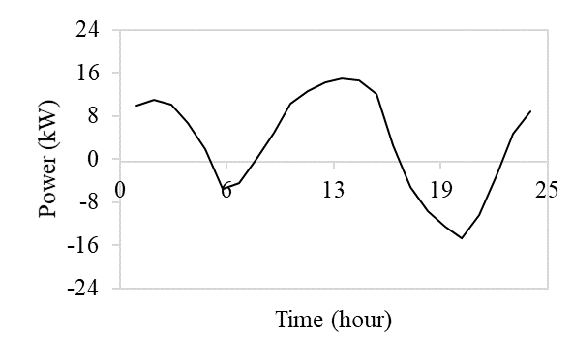
Figure 13 Energy storage / release power throughout the whole day
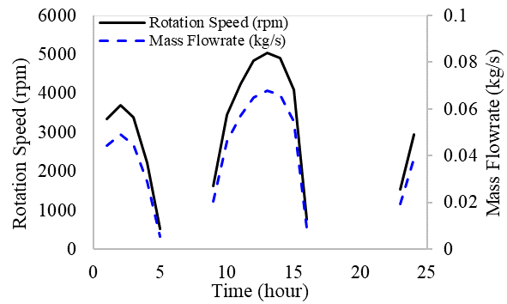
Figure 14 Compressor rotation speed and mass flowrate
Figure 15 shows the operation parameters of the scroll expander. The priority is to operate with possible highest efficiency as given in Figure 11. At 6~7am, the required power from CAES is not large (4.5~5.6 kW), both rotation speed and mass flowrate are not large. When the air is released from the storage tank, the stored air pressure decreases. The air mass flow decreases as well and the rotation speed has to be increased to generate enough power as required. During the evening time (17~22 pm), the required power from CAES first increases and then decreases, as shown in Figure 13. Thus, both rotation speed and mass flowrate first increase and then decrease. Because there is enough air stored through the charging time of 8 am to 16 pm, the trends of both rotation speed and mass flowrate are similar, and are different from their trend in the morning time.
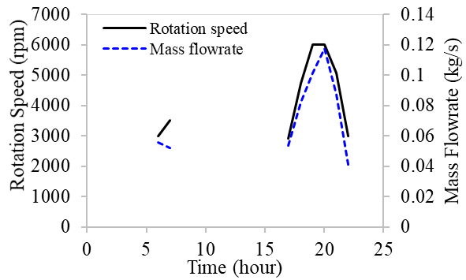

Figure 15 Expander rotation speed and mass flowrate
Figure 16 reveals the operating pressures and isentropic efficiencies. The operation pressure is around 0.35~0.55 MPa. The efficiency is almost above 60%. At 20:00 PM, the generated power is large (14.8kW), both rotation speed and operation pressures are large. There is a deficient expansion under high pressure ratio. Thus, the efficiency is a little lower than that at 19:00 PM and 21:00 PM.

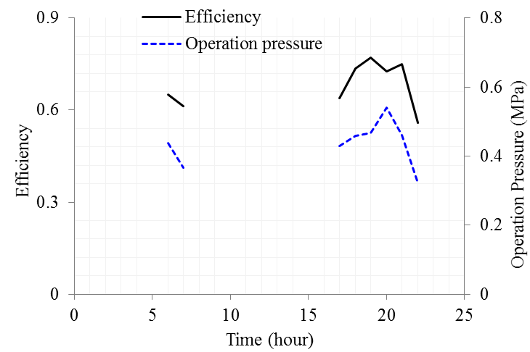
Figure 16 expander isentropic efficiency and operation pressure

6.2 Storage tank
Both storage pressure and temperature are given in Figure 17. During the charging, both air pressure and temperature increase. During the discharging, both them decrease. The air mass of the tank for a whole day cycle can stay balanced since the ending pressure in the tank is no less than the starting pressure.

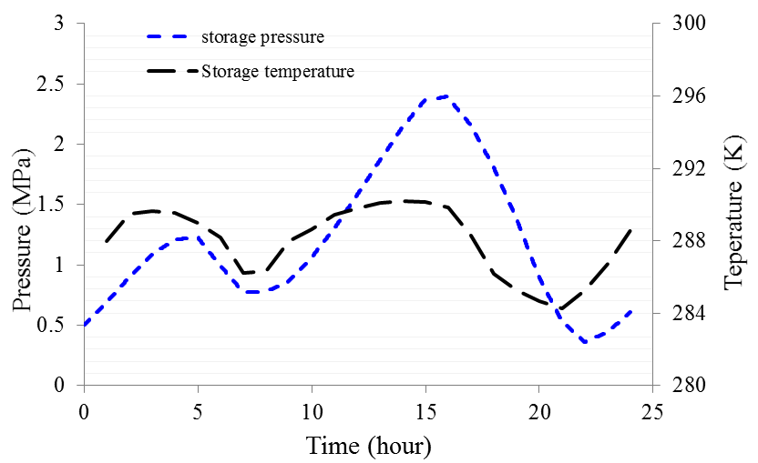
Figure 17 Pressure and temperature curves of storage tank

6.3 Integrated system performance

Energy utilization efficiency is mainly affected by the CAES system. The CAES systematic efficiency is calculated by equation (16), which is 47.35%. The integrated system efficiency, which is also the energy utilization factor defined by equation 15, is 88.75%.
In order to fully satisfy household power demand, wind generation has to be larger than the maximum power demand. Through combining CAES with renewable energy generation, the maximum generation required to meet customer demand was 34.1 kW instead of 40.3 kW, which is a 15.4% decrease in peak customer load requirements.
In this study, the benefits of an integrated energy utilization system were evaluated. As indicated in reference [36], the capital cost of a small-scale wind turbine is around 2500 $/kW. Thus, about $15,000 US dollars could be saved since the installation capacity of wind generation capacity is decreased more than 6 kW. These savings can instead be invested in the installation of a small-scale CAES system. The capacity of the small-scale CAES is 81 kWh, and the capital cost of the small-scale CAES is 200 $/kWh [37]. The total investment in a small-scale CAES is $16,200 US dollars, which is only marginally more than the money saved by reducing wind turbine size. However, if we consider the flexibility and backup functions that an energy storage system can provide to the distributed renewable generation system and to the grid as a whole, the integrated system is clearly a preferable investment.

7. Conclusion
In this study, a strategy for integrating CAES into a distributed renewable energy utilization system was developed. The proposed system can help to balance out the mismatch between generation and demand. It also improves system flexibility and reduces the rated power of the wind turbine for a certain customer. Main components and integration system performance were studied considering dynamic performance and optimal operations.
A small-scale CAES system was designed for a building utilizing scroll compressor and expander. The designed power ratings of compressor and expander are 15kW and 10kW, respectively. The storage tank is 70m³. A detailed study was conducted for use of the hybrid wind-CAES system by an energy consumer. For a one-day cycle, the systematic efficiency of CAES was 47.35%. The energy utilization factor from wind generation to household usage was 88.75%. The power rating of wind generation was cut down to be 84.60% of maximum household demand via integration of the CAES system.
Future work will include to manufacture these key components and integrate the CAES system. The whole CAES pilot system will be tested under the dynamic conditions in order to apply it to buildings.

Acknowledgement
This work was supported in part by the National Nature Science Foundation of China under grant 51676181, the National Key R&D Plan under grant 2017YFB0903605, the Beijing Nova Program under grant Z171100001117065, the China Scholarship Council under grant 201804910077, International Partnership Program, Bureau of International Cooperation of Chinese Academy of Sciences under grant 182211KYSB20170029, Science and Technology Plan Program of Guizhou Province under grant [2017]1160.

References

Nomenclature

Symbols
CAES | compressed air energy storage | Greek
RPM | rotation per minute | γ | initial angle of the involute (rad)
a | radius of the basic circle (m) | η_{mc} | mechanical efficiency of compressor
A_{v} | surface area of the storage tank (m²) | η_{me} | mechanical efficiency of expander
c_{v} | constant volume specific heat (J/(kgK)) | θ | shaft angle (rad)
FR | mass flowrate (kg/s)
h_{in} | specific enthalpy at inlet (kJ/kg)
h_{out} | specific enthalpy at outlet (kJ/kg)
Hs | height of the scroll vanes (m) | θ_{se} | starting angle of the expansion process (rad)
K_{v} | heat transfer coefficient
n | rotation speed (rpm) | θ_{de} | ending angle of the expansion process (rad)
n_{sc} | cycles of the compressor scroll (non-integer) | Ψ | the flow function
N_{sc} | cycles of the compressor scroll (integer) | ω | ration angle speed (rads⁻¹)
Pt | scroll pitch (m)
p | pressure (Pa) | Subscripts
PW_{c} | compressor power (W) | a | radial leakage
R | gas constant (Jkg⁻¹k⁻¹) | c | compressor
t | thickness of the scroll vane (m) | cd | customer load demand
T | Temperature (K) | e | expander
 |  | i, j | stands for the ith, jth chamber
u | specific internal energy of the control mass (Jkg⁻¹) | r | flank leakage (m)
V | chamber volume (m³)

