dye-LOADING INFLUENCE ON PERFORMANCES OF fluorenone/zeolite L LIGHT HARVESTER
L. Gigli,ª R. Arletti,^{b} E. Fois,^{c} G. Tabacchi,^{c} S. Quartieri,^{d} G. Vezzalini,ª G. Alberto,^{e} G. Agostini,^{e} G. Martra,^{e} J. G. Vitillo^{c,}*
a) Chemical and Geological Sciences Department, UNIMORE, Largo S. Eufemia 19, 41121 Modena, Italy. b) Earth Sciences Department, UNITO, Torino, Italy. c) Department of Science and High Technology, University of Insubria, and INSTM Unit, UNINSUBRIA, Como, Italy. d) Physics and Earth Sciences Department, UNIME, Messina, Italy. e) Department of Chemistry, NIS Center of Excellence, and INSTM Unit, UNITO, Torino, Italy.

ABSTRACT

Zeolite L (LTL), is an appealing and excellent host for the supramolecular organization of different kinds of molecules and complexes. However, relatively few experimental structural information is available about the orientation and alignment of the dye molecules in the zeolite pores. Hence, a detailed structural characterization is of great importance for understanding the functionality of these host-guest systems. Between all the possible guests, neutral dye fluorenone (C₁₃H₈O) (FL) has received a considerable attention [1,2] because of its ability to form a host-guest complex with LTL, stable if exposed at the atmosphere. Moreover, the fluorescent nature of fluorenone makes this complex interesting as a component of the energy relay system in artificial antennas. Although a detailed structural characterization is still lacking, theoretical studies have shown as the orientation of fluorenone is especially interesting as it is directly related to the light harvesting properties of fluorenone [3]. Moreover, it has shown as the presence of water can influence on the electronic spectra of this host-guest complex and then affect its performances as light harvester [3].
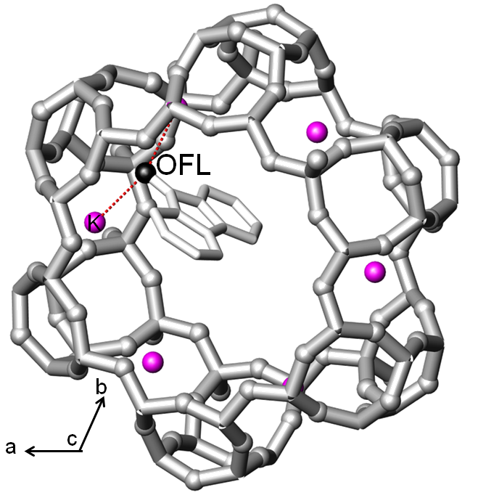
In this study, three different FL/K-LTL materials characterized by an increasing loading of FL have been synthesized by mixing in inert atmosphere the dehydrated K-LTL and FL powder in ratio of 0.5, 1.0, 1.5 and 2.0 molecules/unit cell, and then heating the samples at 120°C in air for 24 h. The vials were maintained under continuous rotation during the heating in order to optimize the contact between the zeolite and the dye. The samples so obtained were characterized by means of X-ray powder diffraction, thermo-gravimetric analysis, IR and UV-vis spectroscopies, fluorescence and nitrogen adsorption.
Figure 1. FL/KLTL
The incorporation of FL into the K-LTL channels was confirmed by a significant change of the unit cell parameters and by drastic decrease in the K-LTL surface area also at low FL loading. The strong interaction between FL carbonyl group and the extraframework potassium cation predicted by theoretical modelling [1] was confirmed by the short bond distances (2.77 Å), evidenced in the Rietveld refined structure, and by the shift of the C=O stretching frequency evidenced in the IR spectra. Such an interaction explains why FL is not displaced by water molecules when FL/K-LTL hybrid is re-exposed to the air [1].
Interestingly, although the UV-vis absorption spectrum was almost unaffected by the FL loading, the corresponding emission spectrum evidenced a strong influence: the optimum FL/K-LTL ratio was then determined in order to optimize the performances of the device as light harvester. The structural information obtained theoretically and from XRD allowed also to explain the loading dependence of the optical properties of the material and to correlate it with the relative orientation of the fluorenone molecules in the zeolite channels.

REFERENCES
[1] E. Fois, G. Tabacchi, G. Calzaferri. J. Phys. Chem. C, 2010, 114, 10572.
[2] A. Devaux, C. Minkowski, G. Calzaferri, Chem. Eur. J. 2004, 10, 2391.
[3] X. Zhou, T. A. Wesolowski, G. Tabacchi, E. Fois, G. Calzaferri, A. Devaux, PCCP, 2013, 15, 159.

