Use of Modified 3D Scaffolds to Improve Cell Adhesion and Drive Desired Cell Responses.

Salvatrice Rigogliusoª, Francesco Carfì Pavia^{b}, Valerio Brucato^{b}, Vincenzo La Carrubba^{b}, Pietro Favia^{c-d}, Francesca Intranuovo^{c}, Roberto Gristina^{d} and Giulio Ghersi*ª.

ª Dipartimento di Ingegneria Chimica, Gestionale, Informatica, Meccanica, Università degli Studi di Palermo, viale delle Scienze ed. 6, Palermo - Italia
^{b} Dipartimento di Scienze e Tecnologie Molecolari e Biomolecolari, Università di Palermo, viale delle Scienze ed. 16, Palermo –Italia.
^{c} Dipartimento di Chimica, Università di Bari, Via Orabona 4, 70126 Bari - Italia.
^{d} Istituto di Metodi Inorganici e Plasma, IMIP-CNR Via Orabona4, 70126 Bari – Italia.
* corresponding author: giulio.ghersi@unipa.it
In the most common approach of tissue engineering, a polymeric scaffold with a well-defined architecture has emerged as a promising platform for cells adhesion and guide their proliferation and differentiation into the desired tissue or organ. An ideal model for the regeneration should mimic clinical conditions of tissue injury, create a permissive microenvironment for diffusion of nutrients, gases and growth factors and permit angiogenesis. In this work, we used a 3D support made of synthetic resorbable polylactic acid (PLLA), which has considerable potential because of its well-known biocompatibility and biodegradability. One of the factors that influence cell adhesion to the scaffold is its porosity degree, but surface properties represent the main driving forces that influence the composition and orientation of proteins that will be absorbed onto material surfaces. We used scaffolds in which it was possible to control pore size and that had undergone on type-I collagen treatment, to mimic the extra cellular matrix, or plasma enhanced chemical vapor deposition (PE-CVD) combined with plasma treatment, in order to modify surface chemistry of the material. Our results show different cell affinity in non-treated scaffolds compared to type-I collagen or plasma modified ones. These surface changes are of considerable interest for tissue engineering and other areas of biomaterials science, where it can be useful to improve the surface of biomedical polymers to facilitate the colonization of the structure by the cells and obtain a more rapid regeneration or tissue replacement.
  - Introduction
Tissue engineering has always been a multidisciplinary research area focused on tissue regeneration and restoration of organs function, through implantation of cells or tissues growing outside the body. This approach involves the use of polymeric scaffolds, with a well-defined architecture, which act as temporary support for cells and drive cell proliferation and differentiation in the desired tissue or organ. According to increase in knowledge of the interactions between living organisms and biomaterials, development and diversification of biocompatible devices have brought the world of medicine to what has been the greatest therapeutic revolution of our times. The main challenge of biomaterials is not only related to "tolerance" by the body but also to its functionality; a biomaterial must be able to positively interact with tissues and exercise those functions for which it was designed and implanted. The polymer matrices used in the field of tissue engineering must have a combination of some basic properties: the material used must be biocompatible, it must possess adequate mechanical properties such as strength, stiffness and toughness, have a suitable surface to support cell adhesion and proliferation and, finally, it must be degraded in not toxic products from the body in relatively short periods of time (Williams et al.1999). A network of interconnected and biodegradable pores must characterize these structures in order to create a permissive microenvironment for the diffusion of nutrients, gases and growth factors. In this respect, an extremely important feature of the scaffold is its pores size, architecture and interconnection degree. Despite pores architecture plays a vital role in the effectiveness of the scaffold, the scientific literature does not provide information about the best pores size and their distribution in the scaffold, nevertheless it can be summarized that too small pores inhibit cell migration and may hinder nourishment and metabolites diffusion due to the formation of a compact biofilm [O’Brien et al. 2005; Harley et al. 2008; Shoichet, 2010]. On the other hand, too large pores may hinder cell adhesion, due to a reduced interfacial area. An assortment of small and large pores seems, therefore, to be the most indicated to optimize cell growth and proliferation [Karageorgiou et al. 2005; Murphy et al. 2010; Peroglio et al. 2010]. Another phenomenon of fundamental importance for the creation of the microenvironment is the angiogenesis, the generation of a vascular network within the structure of interconnected pores, which facilitates trade, both of gaseous substances and nutrients and at the same time can eliminate waste products from cellular metabolism. In this microenvironment is facilitated. Among the polymeric materials used in tissue engineering, the synthetic resorbable polylactide, such as poly (lactic acid) (PLA), poly(L-lactic acid) (PLLA), poly(D, L-lactic acid) (PDLLA), poly(glycolic acid) (PGA) and poly(L-lactic glycolic acid)PLGA have considerable potential because of their well-known biocompatibility and biodegradability (Nam et al. 1999). Another extremely important feature to improve the cell-scaffold interactions and thus promote adhesion and cell differentiation, is represented by the surface properties, that can be tailored in a controlled way, in order to improve the biocompatibility of the pristine polymeric materials [Intranuovo 2011a]. The scaffold is therefore a biodegradable synthetic 3D support emulating the extracellular matrix (Schugens et al. 1996). Growth factors and other biomolecules can be incorporated into the scaffold, along with the cells, to guide the regulation of cellular functions during tissue or organ regeneration [1 Elisseeff J. et al. 2001]. In this work, we used a polymeric 3D support made of synthetic resorbable poly(L-lactic acid) (PLLA). These scaffolds were prepared to use the method described by Carfì Pavia et al. 2007, which gave the possibility to obtain porous biodegradable foams by Thermally Induced Phase Separation (TIPS) technique, starting from PLLA/dioxane/water systems. A large variety of morphologies, in terms of average pore size and interconnection, were obtained upon modifying the demixing time and temperature, owing to the interplay of nucleation and growth processes during the residence in the metastable state. An interesting combination of micro and macroporosity was observed for long residence times in the metastable state. Not less important to consider is how cells respond to specific chemical and topographical features on the material surface. The behavior of most cell types in vivo is strictly related to specific chemical and topographical cues that characterize the extracellular environment; in particular, during their lives, cells react to topographical patterns such as those of the extracellular matrix (ECM). Surface properties represent the main driving forces that influence the composition and orientation of proteins that will be absorbed onto material surfaces, such as the trap to a controlled release of factors influencing cell growth, differentiation and motility. We used scaffolds that have been modified with Type I collagen to mimic the ECM, or plasma aided processing, following the method described by Intranuovo et al [Intranuovo 2011b] in order to modify the surface chemistry of the material. The aim of this work was to study the effect of different surface modifications on the cell behavior of 3D porous scaffolds, respect to untreated materials, in terms of cell adhesion and morphology. Indeed, we have shown that by introducing ECM components or chemical groups that act as binding sites for cells, onto the surface of polymeric 3D materials, the cell colonization inside scaffolds could be improved and accelerated. Thus, these new, chemically modified, 3D porous scaffolds could give better results in an in vivo setting, respect to untreated scaffolds, since we believe that beyond the structural parameters of scaffolds (pore size, interconnectivity and porosity), their chemical surface dictates the first steps of cell recognition and adhesion.
  - 2 Experimental.
HUVEC (Human Umbilical Vein Endothelial Cells) primary cell line from ECACC (European Collection of Cell Cultures) were used; they are primary endothelial cells obtained from human umbilical veins. They were grown in a “Complete Endothelial Cell Growth Medium” prepared by adding the growth supplements to the basal medium (this growth medium does not contain PDGF and VEGF). The polymeric PLLA scaffolds were prepared with thermally induced phase separation as described by Carfì Pavia et al. 2007 [ref]. A large variety of morphologies, in terms of average pore size and interconnection, were obtained using the method described by Brucato et al. 2009. In order to modify the surface cell affinity, the scaffolds were soaked with type-I collagen gel (Rat Tail BD Bioscences) to mimic the extracellular matrix condition, or with plasma surface modifications. The plasma processes were carried out in a stainless steel parallel-plate RF (13.56 MHz) plasma chamber and consisted in the deposition from a C₂H₄/N₂ mixture (1:3 feed ratio, 40 Pa pressure, 50 W power, 30 min deposition time), followed by H₂ post treatment (10 sccm feed, 53 Pa pressure, 10 W power, 30 s treatment time), as previously described by Intranuovo et al [Intranuovo 2011b]. Two different plasma processes were applied to PLLA scaffolds: the C₂H₄/N₂ deposition (plasma deposited ethylene:nitrogen coating, PdE:N) and the deposition followed by a H₂ post treatment (PdE:N/ H₂) to uniformly coat the 3D structure, both internal and external surfaces, with a nitrogen-rich film to enhance cell adhesion on the 3D scaffold. In some experiments plasma modifications were followed by collagen soaking and cell behavior was compared between coating with collagen and coating without collagen. Differences in cell morphology were investigated by confocal microscopy analysis; HUVEC was grown on non treated, or type-I collagen, or plasma treated scaffolds. After 48 h. cells were fixed using a solution of PBS containing 3.7% formaldehyde 5' at r t, 3 time washed and then labeled using FITC-phalloidin (Sigma)(1:500) 30', to highlight the actin cytoskeleton structures. Cell adhesion was estimated using Image J4 software.12 analyses program, for each sample almost 5 different fields were analyzed in triplicate experiments.
3. Results and Discussions
In this work, adhesion and morphology of HUVEC cells were valued on scaffolds, whose surfaces were modified by different treatments. We analyzed the influence of surface modifications on the morphology of adherent cells, in particular, PLLA scaffolds treated with plasma aided processes, followed or not by the deposition of Type I collagen. These surface modified scaffolds were compared with untreated ones.
3.1 Cell adhesion
First, we analyzed how the different types of scaffold’s surface modifications influenced the degree of cell adhesion; it is well known in fact that surface topography strongly affects implants performance and influences cell adhesion, cell shape, tissue organization as well as the production of local micro-environment. [Gristina et a. 2008] As it is possible to observe in Figure1 the scaffolds modified with type-I collagen improved cell adhesion (Figure 1A-a’) compared to the relative untreated control (Figure1A-a). The scaffolds owing surfaces modified by the two different types of plasma processes, showed differences both in terms of adhesion and morphology. In particular, in cells grown on PdE:N coated scaffolds, it is possible to observe an increase of cell-substrate interaction, compared to the same surface modified scaffolds treated also with the Type-I Collagen. In contrast, when we look at cell adhesion on PdE:N/H₂ modified scaffolds, we found that no differences are shown in the presence or not of type-I collagen. As previously described by Gristina [Gristina et a. 2008] cells grown on structured surfaces showed a more spread shape compared to cells grown on untreated control.

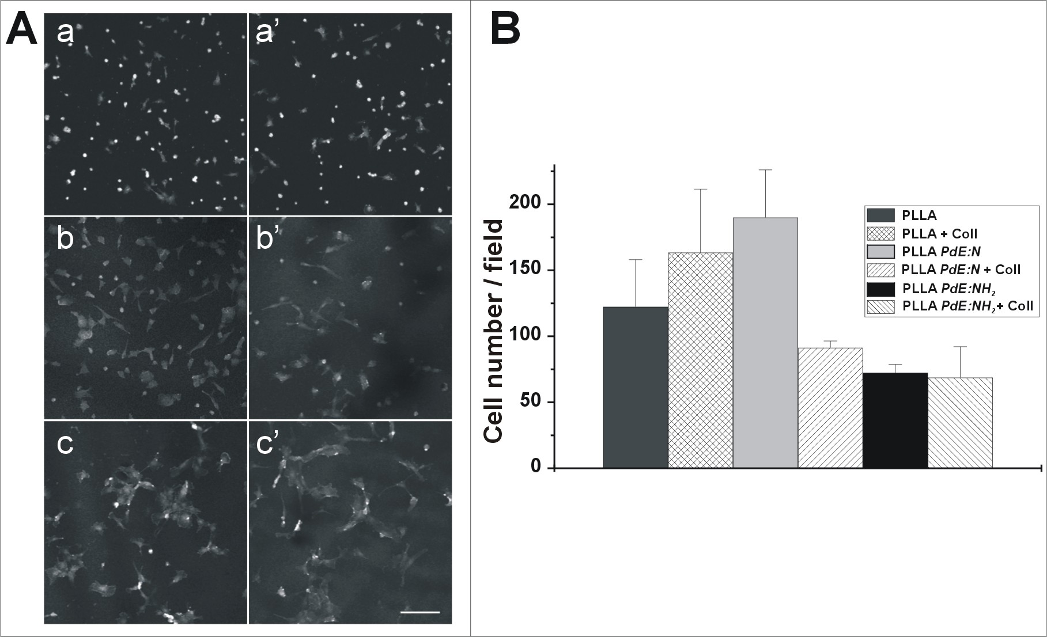
Figure 1 – HUVEC adhesion on scaffolds non treated (control) and submitted to PdE:N or PdE:N/H₂ plasma treatment. In A are shown endothelial cells growth for 48 h. on scaffolds without treatment with plasma in the absence (a) or presence (a’) of type-I collagen fibrils gel; on scaffolds by PdE:N treatment in absence (b) or in the presence of (b’) of type-I collagen fibrils gel and on scaffolds by PdE:N/H₂ treatment in absence (c) or in the presence of (c’) of type-I collagen fibrils gel. Bar = 50 mm. In B are reported the media of cell/field cultured on non-treated and plasma treated PLLA scaffolds +/- type-I collagen.
3.2 Quantitative analysis of adherent cells
A quantification of the cell adhesion degree on the different types of samples tested was performed using the software Image J. The number of cells selected from 5 different fields of each sample were counted. As it is possible to see in the histogram in Figure 1B, in the scaffold that has been modified by PdE:N plasma process, the highest degree of cell adhesion has been revealed. In contrast, the cell behavior on PDE:N/H₂ treated scaffolds, clearly show cells with an enlarged area that can suppose the possibility of cell-cell and cell-substrate interactions, inducing cells in the direction of the differentiation process types.
3.3 Confocal microscopy morphological analyses
HUVEC cells were seeded on the scaffolds that were modified with the different surface modification processes, described in section 3. The cell cultures were carried out for 48h and the morphological changes of cell interaction/adhesion on the different scaffolds were analyzed by confocal microscopy. As illustrated in Figure 2, cells grown on plasma modified scaffolds, show a greater degree of interaction with materials, compared to cells grown on untreated scaffolds. The most evident differences are in cell spreading, in particular (Fig. 2 b and c) HUVEC cells interact with scaffold material more on plasma treated scaffolds than untreated ones (Fig 2 a); condition that seems to be not influenced by the presence of a fibrils gel of type-I collagen. On the other hand, HUVEC cells seeded on PdE:N treated scaffolds show a mesenchymal phenotype, indicating cells in active proliferation/motility; differently, cells cultured on PdE:N/H2 treated scaffolds show a higher spreading respect to the other ones, starting to form cell-cell contacts and several areas of actin condensation, ascribable to focal adhesion plaques, considered a more differentiate phenotype. From the morphological point of view, the treatment with type-I collagen does not show to have any contribution, at least in cell adhesion.
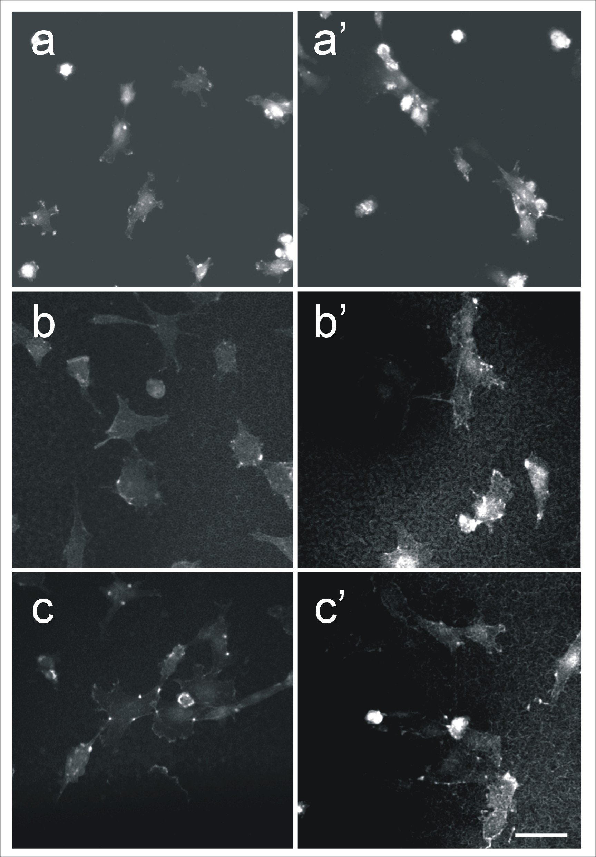
Figure 2 –HUVEC morphology by confocal microscopy image analyses. In Figure are shown endothelial cells growth for 48 h. on scaffolds without treatment with plasma in the absence (a) or presence (a’) of type-I collagen fibrils gel; on scaffolds by PdE:N treatment in absence (b) or in the presence (b’) of type-I collagen fibrils gel and on scaffolds by PdE:N/H₂ treatment in absence (c) or in the presence (c’) of type-I collagen fibrils gel. Bar = 10 mm.
  - 4. Conclusions
Reported data, also if preliminary, give indication of a better interaction of HUVEC cells with PLLA scaffolds treated with plasma processes, compared to untreated ones. Moreover, it was shown that different chemistry, acquired through the two different plasma processes, allowed different cell behavior. In fact, HUVEC cells seeded on PdE:N scaffolds showed a typical mesenchymal phenotype of endothelial cells, in active proliferation/migration state. Differently, in scaffolds treated with PdE:N/H₂ plasma process, HUVEC cells showed the classical phenotype of cells forming a differentiated endothelium. Results obtained confirm that plasma processes represent a powerful route to modify material surfaces intended to be used for biomedical purposes. In particular the two different processes of modification of the surface of the scaffold, inductors of different responses by endothelial cells, may be helpful in driving the colonization and replacement of the scaffold in tissue engineering processes replacement.
References
Carfı` Pavia F., La Carrubba V., Piccarolo S., Brucato V., 2007, Polymeric scaffolds prepared via thermally induced phase separation: Tuning of structure and morphology. Journal of Biomedical Materials Research Part A p.459-466
Elisseeff J, McIntosh W, Fu K, Blunk R, Langer R, 2001, Controlled-release of IGF-I and TGF-b1 in a photopolymerizing hydrogel for cartilage tissue engineering. J Orthop Res; (19), p. 1098–1104
Gristina R., D’Aloia E., Senesi G.S., Milella A., Nardulli M., Sardella E., Favia P., d’Agostino R.. 2008. Increasing Cell Adhesion on Plasma Deposited Fluorocarbon Coatings by Changing the Surface Topography. Journal of Biomedical Materials Research Part B: Applied Biomaterials; p.(139-149).
Harley B.A.C., Kim H.D., Zaman M.H., Yannas I.V., Lauffenburger D.A., Gibson L.J., 2008, Microarchitecture of Three-Dimensional Scaffolds Influences Cell Migration Behavior via Junction Interactions. Biophysical Journal; (95), p. 4013–4024
Karageorgiou V., Kaplan D., 2005, Porosity of 3D biomaterial scaffolds and osteogenesis. Biomaterials; (26), p.5474–549
Intranuovo F., Howard D., White L., Johal R.K.,. Ghaemmaghami A.M, Favia P.,. Howdle S.M,. Shakesheff K.M,. Alexander M.R. 2011 a. Uniform cell colonisation of porous 3D scaffolds achieved using chemistries prompting variable cell adhesion. Acta Biomaterialia, 7 (9), 3336-3344.doi: 10.1016/j.actbio.2011.05.020.
Intranuovo F., Sardella E., Gristina R., Nardulli M., White L., Howard D., Shakesheff K.M., Alexander M.R., Favia P.. 2011b PE-CVD processes improve cell affinity of polymer scaffolds for tissue engineering. Surface & Coatings Technology 205 S548–S551.
Murphy CA, Haugh MG; O’Brien FJ., 2010, The effect of mean pore size on cell attachment, proliferation and migration in collagen-glycosaminoglycan scaffolds for bone tissue engineering. Biomaterials; (31), p. 461-466
Nam YS, Park TG. 1999, Biodegradable polymeric microcellular foams by modified thermally induced phase separation method. Biomaterials (20), p.1783–1790
O’Brien F.J., Harley B.A., Yannas I.V., Gibson L.J., 2005, The effect of pore size on cell adhesion in collagen-GAG scaffolds. Biomaterials; (26), p. 433–441
Peroglio M., Gremillard L., Gauthier C., Chazeau L., Verrier S., Alibi M., Chevalier J., 2010, Mechanical properties and cytocompatibility of poly(e-caprolactone)-infiltrated biphasic calcium phosphate scaffolds with bimodal pore distribution. Acta Biomaterialia; (6), p. 4369-4379
Schugens C, Maquet V, Grandfils R, Jerome R, Teyssie P., 1996, Biodegradable and macroporous polylactide implants for cell transplantation.I. Preparation of macroporous polylactide supports by solid-liquid phase separation. Polymer; (37), p.1027–1038
Shoichet M.S., 2010, Polymer Scaffolds for Biomaterials Applications. Macromolecules; (4), p. 581–591
Williams S.F., Martin D.P., Horowitz D.M., Peoples O.P., 1999, PHA applications: Addressing the price performance issue. I. Tissue engineering. Int J Biol Macromol; (25), p. 111–121

