Supported Organocatalysts: a Powerful Tool in Organic Synthesis

Michelangelo Gruttadauria, Renato Noto and Francesco Giacalone
Department of Molecular and Biomolecular Science and Technologies (STEMBIO)
Università degli Studi di Palermo
Viale delle Scienze s/n, Edificio 17, 90128 - Palermo
Francesco.giacalone@unipa.it

Nowadays enantioselective Organocatalysis is worldwide recognized as the third pillar of asymmetric synthesis together with metal complexes- and enzyme- mediated catalysis. This new branch of organic synthesis, which employs small metal-free organic compounds as catalysts, has however the drawback that catalysts are often employed in substantial quantity, in some case up to 30 mol-%. Due to their organic nature, they can add complexity to products separation. In addition, some sophisticated and synthetically time-consuming catalysts are used but not recovered. In these cases, it became fundamental to design strategies in order to reduce costs and to facilitate the separation of the products. In this regard, the immobilization of the catalyst, covalently or not, onto the surface of an inert support represents a good approach for overcoming the above drawbaks. Beside the ease of handling, separation and recycle, the immobilization often benefits from the morphological properties of heterogeneous supports, which may have a great influence on the outcome of the reactions.
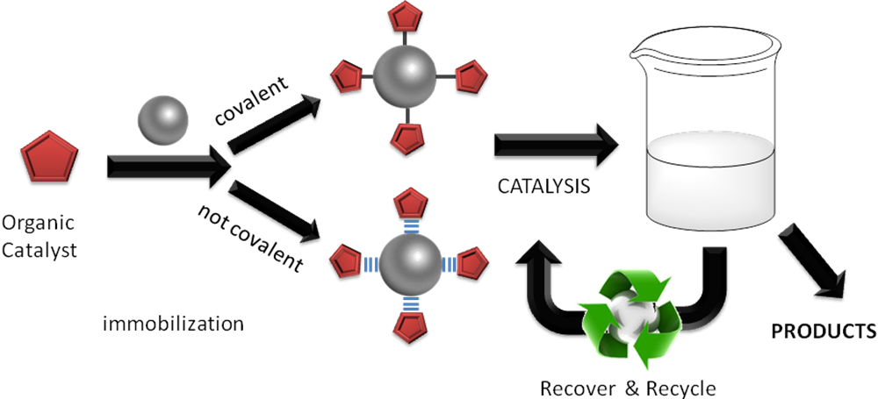
Herein, we will discuss about the successful immobilization of several organocatalysts both covalently and not covalently, and their subsequent employment in a number of organic processes such as aldol reaction, Baylis-Hillman reaction, α-selenenylation and formation of cyclic carbonates, which have been recently carried out in our group. All these materials showed high catalytic activity and were easily recovered and recycled several times with no loss in efficiency.

(a) Enantioselective Organocatalysis, Ed. Dalko, P. I., Wiley-VCH, Weinheim, 2007; (b) Dondoni, A., Massi, M., Angew. Chem. Int. Ed., 2008, 47, 4638.
Gruttadauria, M., Giacalone, F., Noto, R., Chem. Soc. Rev., 2008, 37, 1666.
(a) Aprile, C., Giacalone, F., Gruttadauria, M., Mossuto Marculescu, A., Noto, R., Revell, J. D., Wennemers, H. Green Chem., 2007, 9, 1328;( b) Gruttadauria, M., Giacalone, F., Mossuto Marculescu, A., Noto, R., Adv. Synth. Catal., 2008, 350, 1397.

