The Durability of Composite Wood-Steel Systems

Giuseppe Alaimo^{(*)}, Andrea Failla^{(**)}, Francesco Accurso, Francesco Tesè

^{(*)}Università di Palermo - Dipartimento di Progetto e Costruzione Edilizia Viale delle Scienze – 90128 Palermo alaimo@unipa.it
^{(**)}Università di Palermo - Dipartimento di Ingegneria Strutturale, Aerospaziale e Geotecnica Viale delle Scienze – 90128 Palermo

Abstract
The knowledge of the behaviour of products and complex components during the time, is a fundamental aspect in housebuildings field of technological quality, especially for technologically innovative products, no specific tests are foreseen for, by national norms, to appraise their durability.
Particularly, today it results more and more diffused the employment of composite systems or assemblages between different structural materials, like timber beams strengthened with steel plates glued in with epoxies resins.
Such systems, already studied in other experimentation concerning flexural behaviour of timber concrete system with glued connection, submit their structural effectiveness to the strength and stiffness resistance to the shear efforts and displacements, extremely reduced in case of good composite behaviour.
The aim of this study is to investigate the durability of the timber-steel glued connection characteristics, by an experimental program according to the ISO 15686.
After a first phase of study, concerning agent-action-effect, it was set a cycle of accelerate aging and conducted an investigation in a climate cell.
Then, after series of different aging tests, the connection behaviour was analyzed by a set of shear tests, like push-out tests, as shear is the principal action agent on the system, considering climatic action conditioning on the single components behaviour of the system: epoxy, steel, wood and the whole system behaviour, especially the epoxy-steel and the epoxy-timber interfaces.
The results give interesting information about system behaviour during the time. In fact, during the aging cycles, it was observed a progressive reduction of the maximum load failure and the maintenance of good stiffness characteristics, with little displacements also in more aged specimens.
Keywords: composite systems, bond characteristics, wood-epoxy-steel interfaces, accelerated aging, durability.

1. Introduction
There are various reasons for which wood is associated to other materials in structures, the most peculiar of which is to remedy its structural deficiencies in some particular conditions, like it happens for example, in composite wood-steel systems in which the flexural strength and stiffness of wooden beams is increased by steel. It often concerns innovative systems in which timber, traditional element, is associated to other structural materials, being consolidated reliability, to form new structural systems in which every components work at the best of its own capacities. An example is the composite wood-concrete system in which the connection between timber beams and concrete slab is assured by steel connectors settled up on a pierced steel plate, glued inside a timber beam by an epoxy resin.
In this system, the connection between steel plate and wooden beam, assured by resin, is a fundamental aspect, because it allows having high flexural stiffness to the wood-concrete composite system. It’s clear that there’s a variation of the stiffness of glued connection between wooden beam and steel plate during the time, it’s possible to have, as a result, a reduction of real stiffness of the composite wood-concrete section with a consequent reduction of the composite behaviour.
The use of glued connections has greater and greater applications both in new building constructions and in structural recovering. In every case, the advantage of using these innovative technologies consists in the possibility to get connection with a good capacity of restoration of the strength and stiffness of the structural components, with a good fire resistance and also aesthetically appreciable.
This system is useful, for example, in recovering old wooden floors, when it’s possible to operate only from above for the presence of decoration or similar on the lower side of timber beams or also for reconstitution timber beam edges or trusses components, with prosthesis settled to the original elements by glued bars. As it deals with innovative systems, overall for the use of synthetic adhesive, it’s important to know the reliability and the durability of glued connections, concerning the structural behaviour of the system during the time and its performance decay, since it made in service.
The research, that’s in the most general field of the evaluation of technological quality control for complex products in housebuildings, concerns to investigate the requisite of durability of a composite wood-steel system, according to the ISO 15686 - Building and Constructed Assets Service Life Planning and the UNI 11156 - 2006, Evaluation of the Durability of Building Components, just approved, relatively to the phase of the functional analysis, identification of degradation agents, choice of performance characteristics, definition of the tests program and the execution of the artificial aging and mechanical tests.
According to this methodology, analyses were conducted on the operating of examined technical elements: characterization of materials or components related to the functional requisite to investigate; individualization of agents and actions capable to degrade and make performance decay; collection of data representing the condition of climate context in which the components stay during its service life; evaluation of aging and damage modality through accelerate aging tests; monitoring of specimens performance characteristics through fracture laboratory tests.
2. Experimentation, specimens, parameters
The aim of this experimentation is to study the effects of the accelerated aging tests in laboratory on composite wood-steel elements drawn by glued laminated timber (glulam) beams strengthened with drilled steel plates glued in by a two-parts room-temperature epoxy resin.
2.1 Specimens
The geometric characteristics of the beams are brought in the following figures:
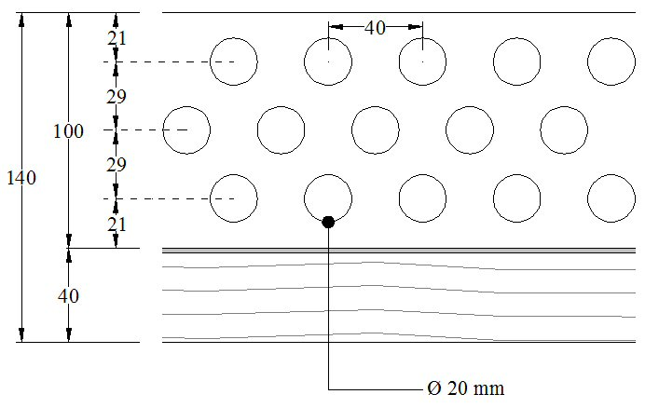
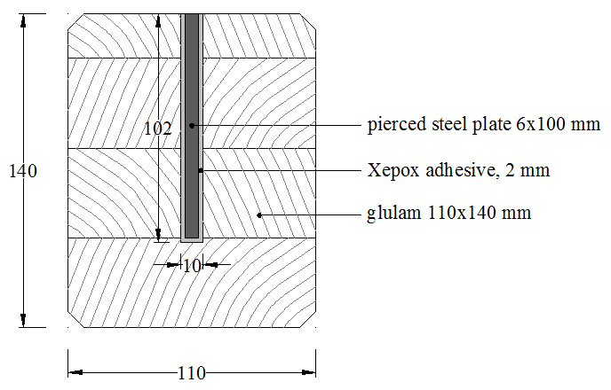

Figure 1: Longitudinal section | Figure 2: Cross section

Every beam, measuring 110x140 mm and having a length of 3,60 m, has been made gluing a steel plate of 6 mm thickness, 100 mm high, inside a groove having the dimensions of 10 x102 mm, drilled with holes according to the scheme shown in figure 1. Gluing is based on the two-part epoxy resin Xepox 40.3/5 supplied by Cenci Legno sas, Como (Italy), with the following characteristics:

Table 1: Characteristics of structural epoxy adhesive
Characteristic | Unit of measurement | Value
Glass transiton temperature | °C | 55
Compression failure load | MPa | ≥ 75
Bending-strain failure load | MPa | ≥ 45
Strain failure load | MPa | ≥ 30
Shear failure load | MPa | ≥ 45

While the characteristics of the glulam are shown in Table 2,

Table 2: Characteristics of glulam used in experimentation
Wood | : | Spruce
Adhesive | : | Melaminic
Grade | : | BS 11 (DIN 1052 1988)

The dimensions of the groove are such to allow the creation of a 2 mm adhesive thickness around the steel plate, while the holes, disposed as shown in figure 1, allow the creation of resin links from wood to wood, realizing so resin rods. The specimens to test have been drawn from the untouched zones of the beams already tested by bending tests. Altogether 60 specimens, having the dimensions of 110x100x100 mm, have been realized, being cut out from everyone the lower thickness of 40 mm. The geometric characteristics of the specimens tested in the present experimentation are given below:

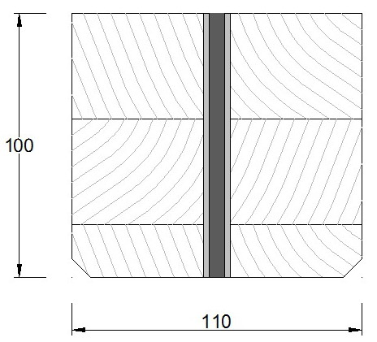
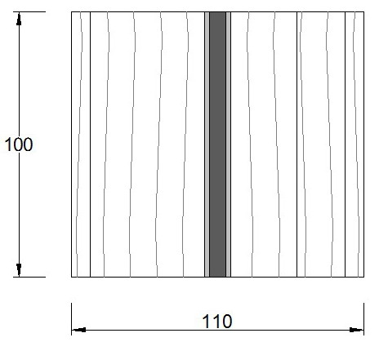
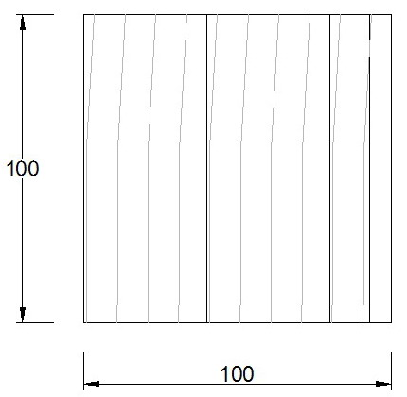

Upper | Front | Lateral
Figure 4: Geometric characteristics of specimens

2.2 Parameters
The choice of the parameters to study and the type of tests have been done considering the structural characteristics of the composite system realized with glulam beams with a concrete slab in which the connection is realized by steel shear connectors settled on the steel plate. The steel connectors take back the shear stress at the wood-concrete interface and they transfer to the steel plate that tends to slide respect to the glulam beam. In this system in fact, the wood-plate connection, assured by the epoxy resin, is subjected to shear stress, so the shear stiffness was chosen as parameter to be investigated.
2.3 Accelerated aging
In this type of glued connection, the interesting aspect is to investigate the durability of the connection, that’s the maintenance during the time of the characteristics for which it has been designed. So the specimens have been submitted to climatic cycles of accelerated aging tests, settled according to the EN 29142 standard, having general character, as well as to the ASTM 1037, giving detailed indications on the climatic cycles and mechanical fracture tests to submit the aged specimens.
The specimen aging test was conducted at the laboratory of the Department of Progetto e Costruzione Edilizia, University of Palermo, using the Challenge 1200 SP machine, able to perform articulated cycles of temperature, humidity and rain.
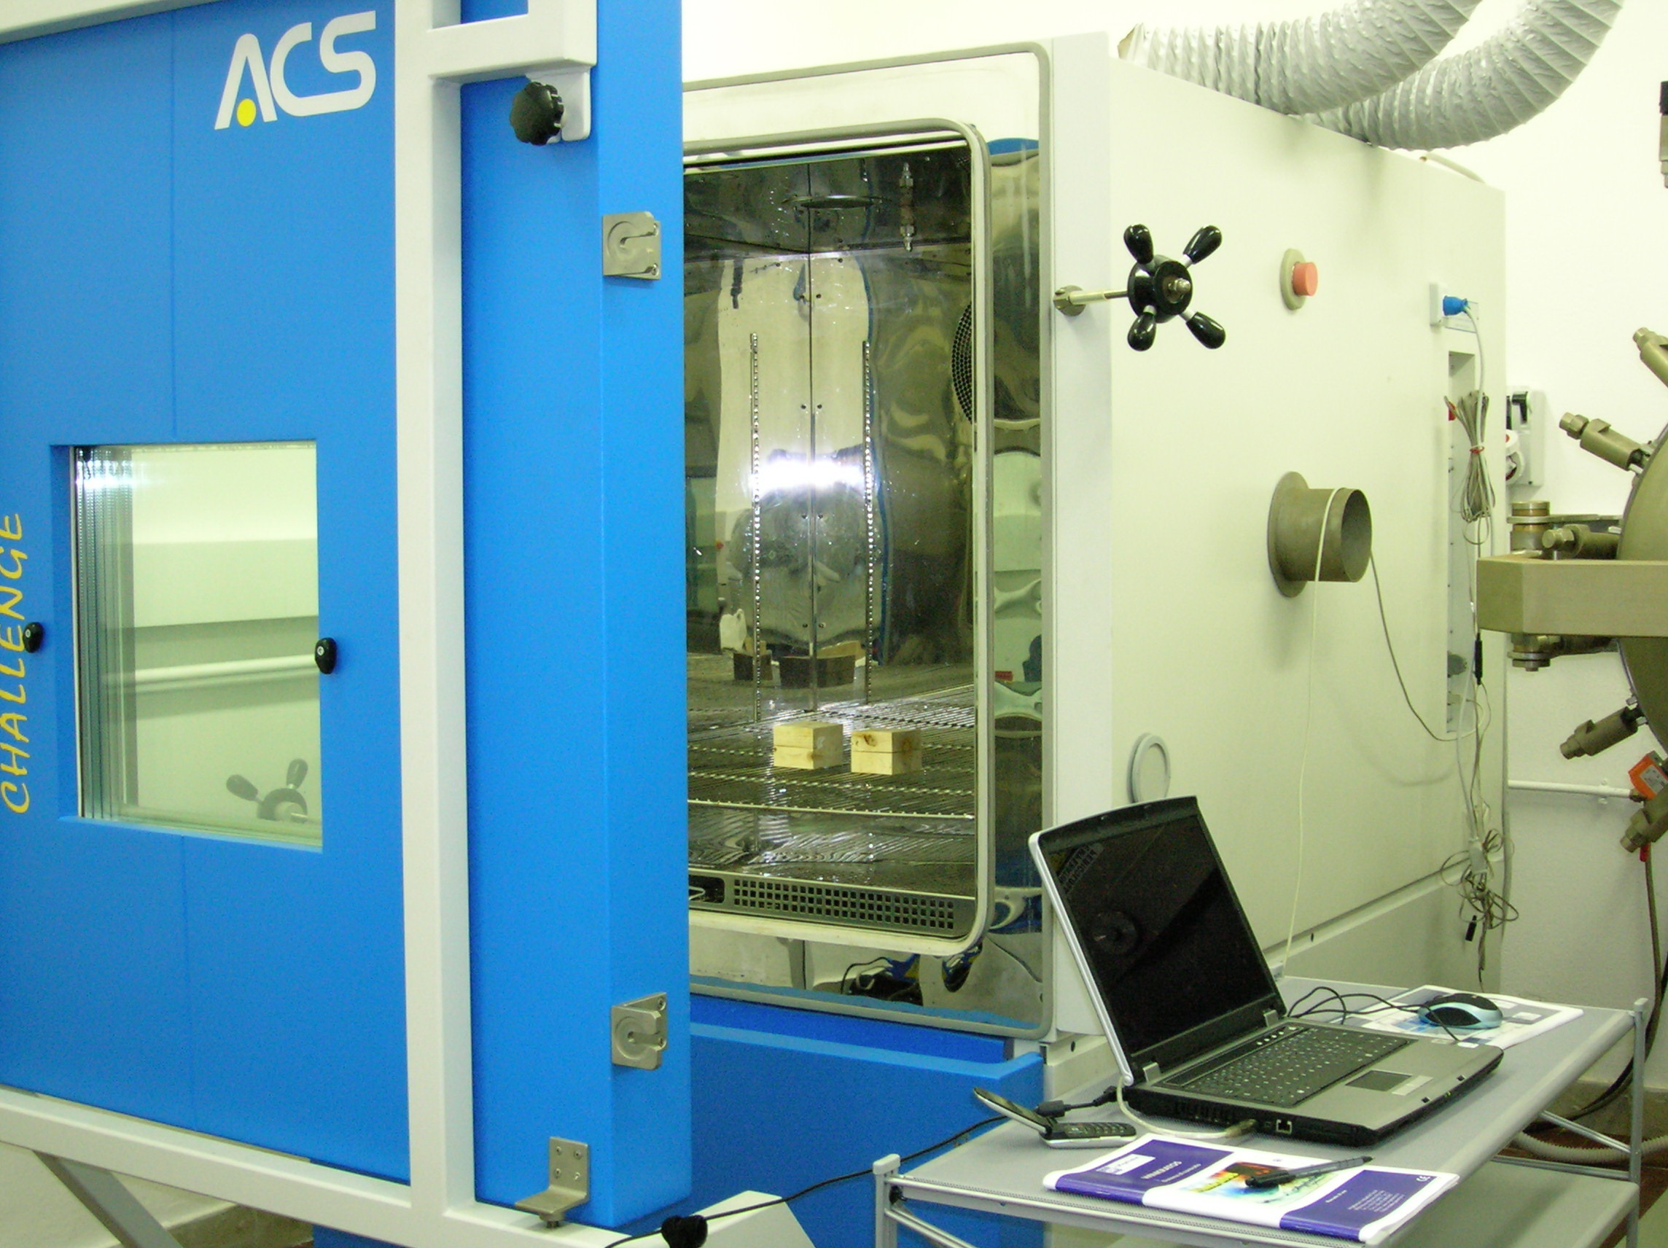

Figure 5: Challenge 1200 SP
The climatic cycle aging test was settled through a preliminary adjustment keeping in mind of the climatic actions that can influence the structural behaviour during the time of every single system component and the interfaces between components. For this reason it was reported to the quoted norms, and, because it deals with systems not specifically contemplated in the norms, it was also reported to the experiences of other conducted tests on similar systems, keeping in mind that this system is mostly sensitive to the variations of humidity and temperature. In our preliminary cycle in fact, some phases at constant temperature and relative humidity have been foreseen, exasperating the extreme values and effecting some sudden changes between a phase and the other.
The first proposed aging cycle is composed by four phases:
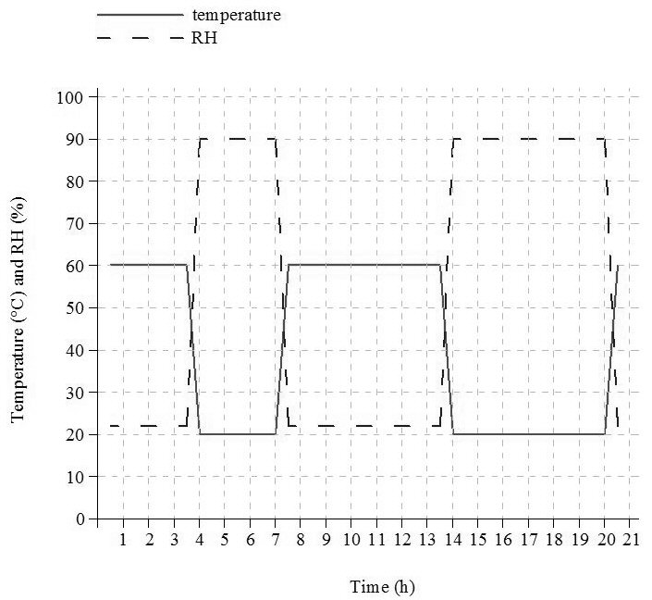
Table 3: First aging cycle phases
Phase | Temp | RH | Duration
I | 60 °C | 22% | 3 h
II | 20 °C | 90% | 3 h
III | 60 °C | 22% | 6 h
IV | 20 °C | 90% | 6 h

Figure 6: First aging cycle
There’s also a starting phase of about 30 minutes, necessary to reach the initial conditions of the cycle, departing from the environment conditions. Every phase is alternated by a transition cycle, having a duration of about 30 minutes, to allow the device to reach the climatic conditions at the beginning of every phases. The cycle had so a general duration of 20 hours and was repeated for six consecutive days, at the end of which the specimens were analyzed according to the procedures foreseen by the norms and then brought to the laboratory for the mechanical shear tests.
Together with aging cycle, the norms foresee to do a standard conditioning cycle at the constant temperature and relative humidity, respectively of 20 °C and 60% RH, to be able to effect then an analytical evaluation of the effects of the aging according to the formalities foreseen by norms. In this case the specimens were set in device and there maintained under the standard climatic conditions up to their weight and their dimensions were constant.
In the aim to find the definitive climatic cycle, together with the standard cycle, the following cycles at constant temperature and relative humidity were made, having the duration of a week each:
Table 4: Constant cycles
Cycle | Temperature | RH
Dry | 20 °C | 20%
Wet | 20 °C | 90%
Wet cold | 10 °C | 60%
Wet hot | 50 °C | 60%

At the end of every cycle, the specimens have been submitted to the shear tests.
Considering the results, it has been possible to set the definitive climatic cycle, composed by four phases of five hours and thirty minutes duration each:
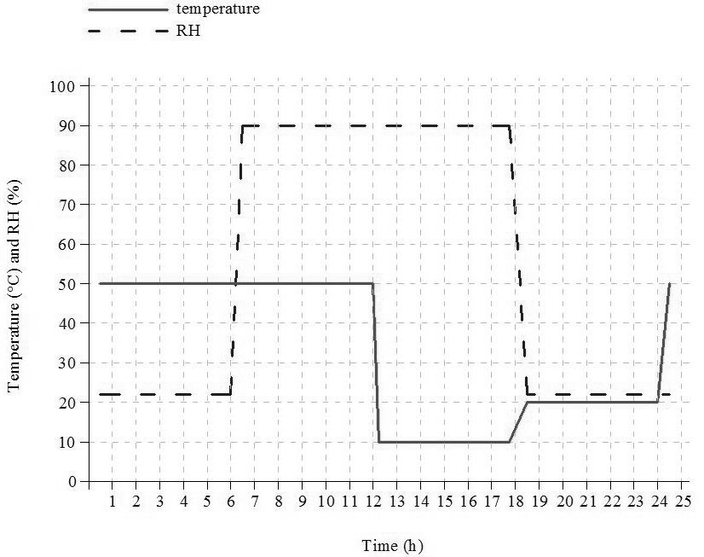
Table 5: Climate aging cycle phases
Phase |  | Temp | RH | Duration
I | Dry hot | 50 °C | 22% | 5,5 h
II | Wet hot | 50 °C | 90% | 5,5 h
III | Wet cold | 10 °C | 90% | 5,5 h
IV | Dry | 20 °C | 22% | 5,5 h

Figure 7: Climatic aging cycle
The duration of the climate cycle, considered also the transition periods, results therefore of 24 hours and it was repeated for six weeks. These aging climatic cycles were applied on a total of eighteen specimens, three of which have been drawn out at weekly cadence. In this way, it was able to monitor the effects of the climatic actions on a week, two weeks and so on to six weeks aged specimens.
2.4 Shear tests
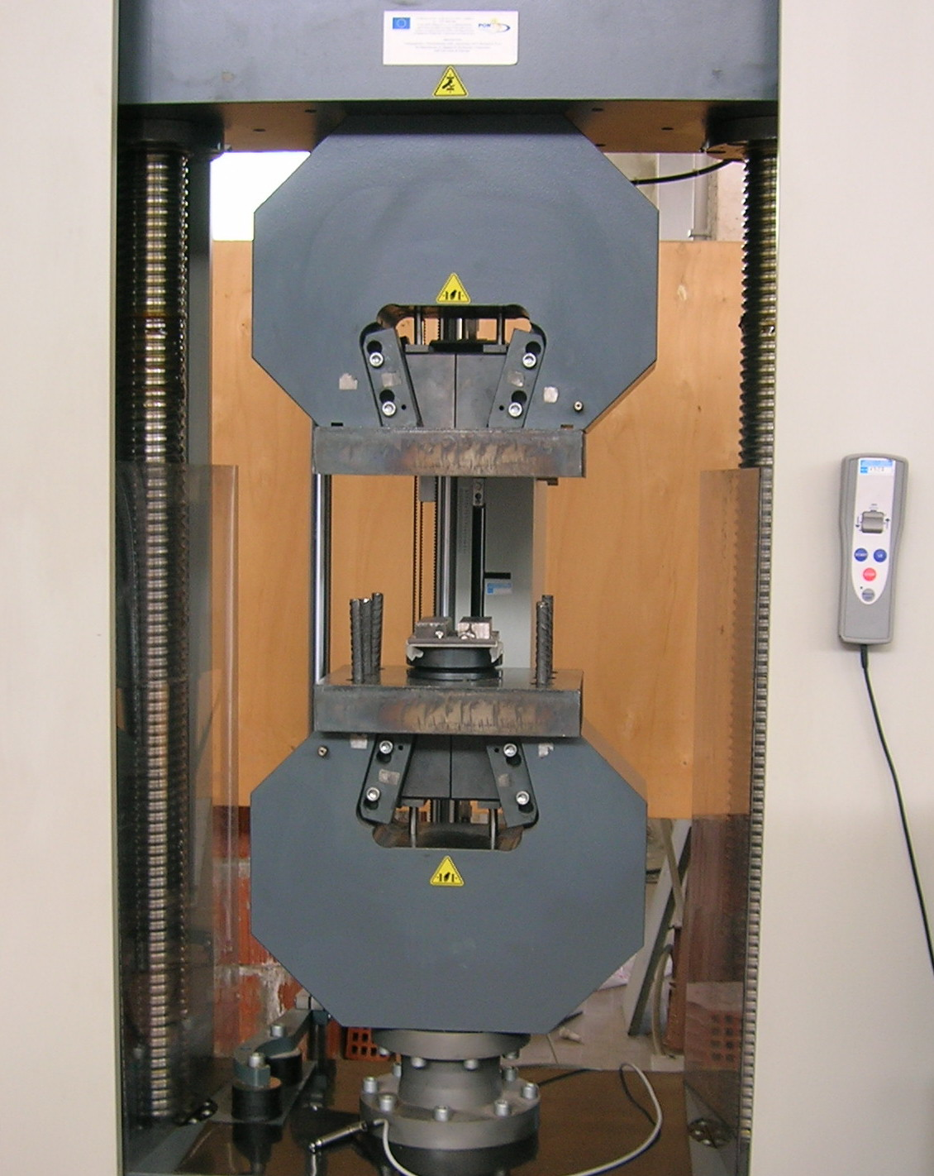
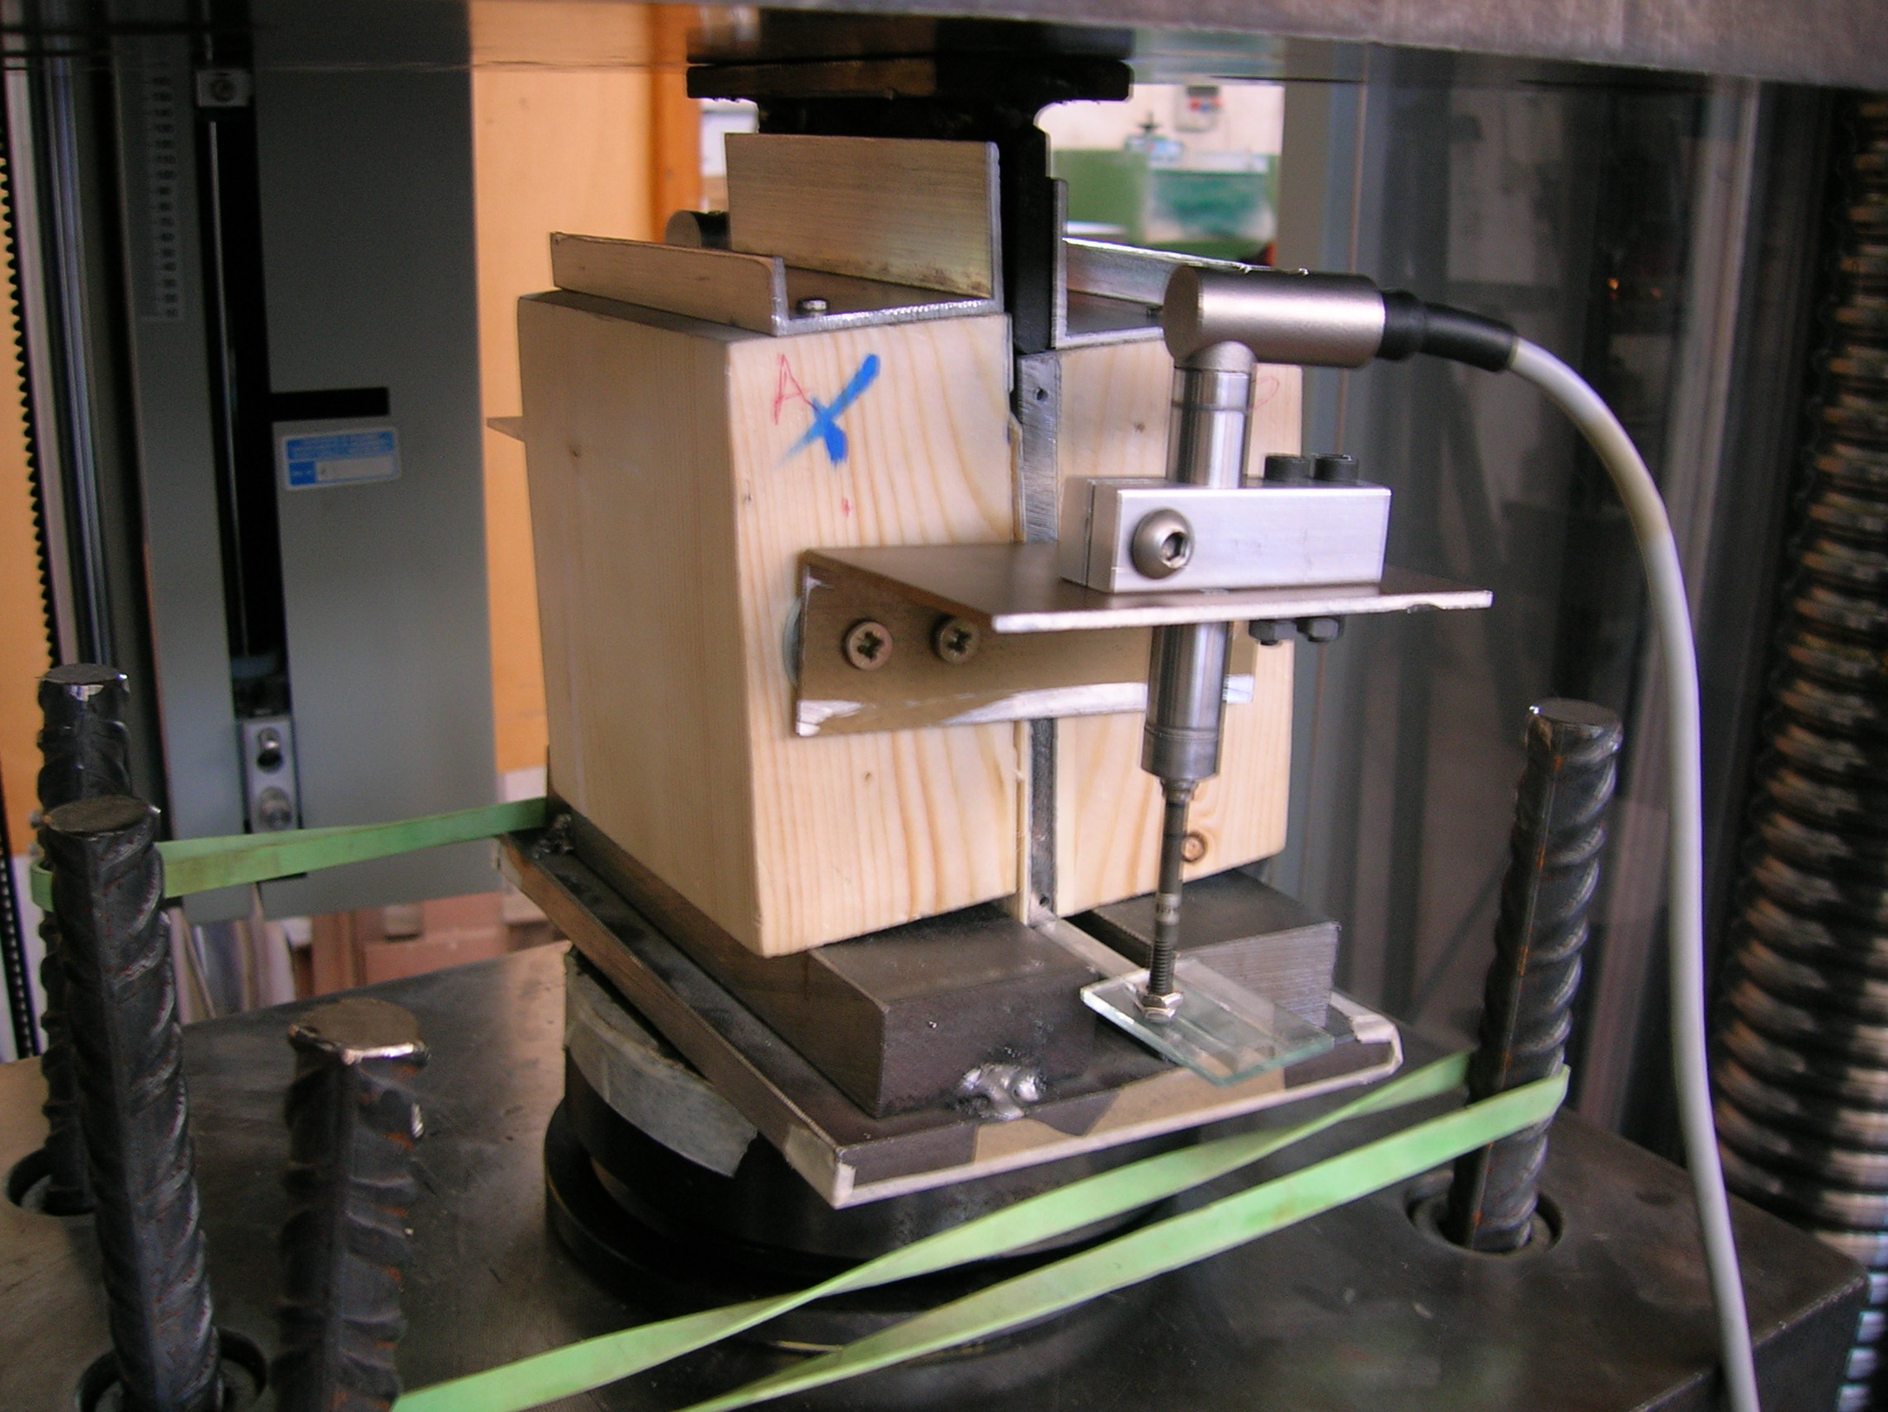
The tests have been performed according to the requirements of the EN 26891, at the laboratory of the Department of Ingegneria Strutturale, Aerospaziale e Geotecnica, University of Palermo, using the Zwick/Roell Z 600 machine:

Figure 8: Zwick/Roell Z600
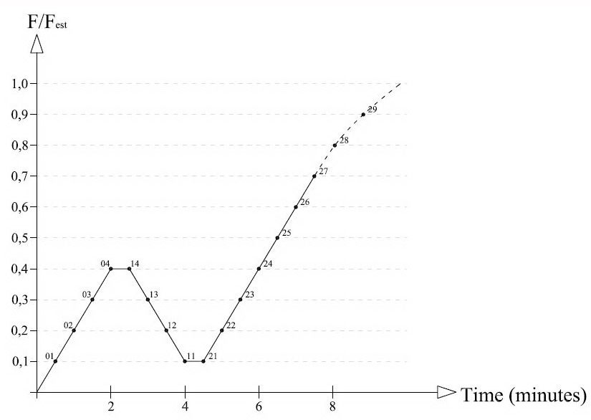
The shear tests, in the type of “push-out” tests, were performed applying the load-time curve recommended by the standard. Figure 9 shows the load-time curve type established by the norm.

Figure 9: Load-time curve for shear test
It was registered the following values, foreseen by standard: F_{max} – maximum load; F_{est} – estimated maximum load; 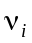- experimental initial slip, under 0,4·F_{max}; - experimental elastic slip, under 0,4·F_{max}; - slip modulus. And also we have registered the slip s_{max}, related at the reached maximum load.
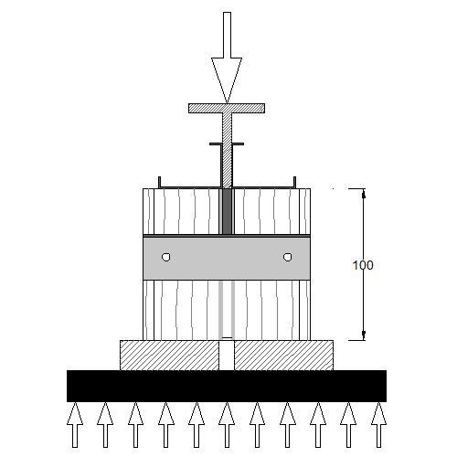
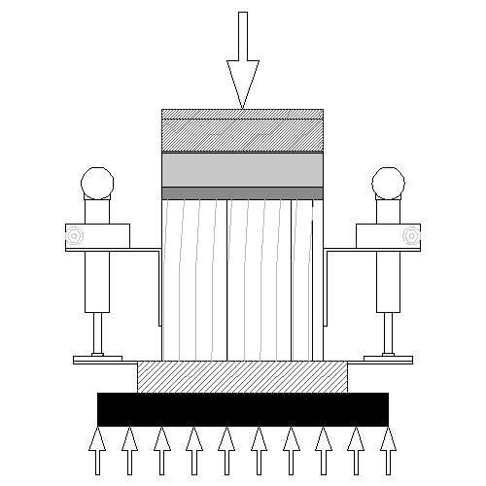
The adjustment phase in which thirty samples were tested, altogether with the observation of the results and the observations of these tests, was useful to set the aging cycle, but also to improve and to set the relative slide measurement system of the specimens submitted to shear tests, fixing the comparators with the wooden elements. In this way it was possible to measure the real slip of the steel plate in comparison to the wooden elements, without the uncertainties due to the settlement of the joint recorded in the previously system adopted. The specimens were loaded by a parallel effort to the fibres (Figure 10), the esteemed maximum load was of 80 kN. To measure the relative slip between the steel plate and the wooden element, two thousandth digital Mitutoyo comparators have been used, settled as shown in the Figure 10.

Figure 10: Specimen load scheme

2.5 Tests results
Before and after every aging cycle, a visual examination for every specimen was performed and also their dimensions, weight and wood humidity were recorded. Generally it was not observed great variation in weight and dimension, while some changes occurred on the elements surface, particularly, in the most aged ones, the oxidation on the external surface of steel plate and/or in some cases a little resin detachment to the steel surface. The examination of the shear tests results shows general high stiffness behaviour of the composite system with a very little relative slip between the two materials. The failure mode was always brittle in every specimen and in most of them the failure happened in the wood-resin interface. Only in some mostly aged specimens, it was noticed a break-up of the resin rod at the failure load. In Table 6, the medium values of the tests results are presented.
Table 6: Medium values results for shear tests performed on specimens under environmental and standard conditions and aged in laboratory tests.
 | Enviromental | Standard | I week | II weeks | III weeks | IV weeks | V weeks | VI weeks
F_{max} (kN) | 80,18 | 76,96 | 77,84 | 77,07 | 81,34 | 70,67 | 61,91 | 60,92
v_{i} (mm) | 0,06 | 0,06 | 0,05 | 0,05 | 0,06 | 0,06 | 0,04 | 0,07
k_{s} (kN/mm) | 665,98 | 583,62 | 1035,98 | 537,76 | 643,31 | 425,87 | 2926,62 | 612,74
s_{max} (mm) | 0,30 | 0,33 | 0,21 | 0,29 | 0,39 | 0,31 | 0,23 | 0,25

While in the following figures the diagrams with the middle values are shown.
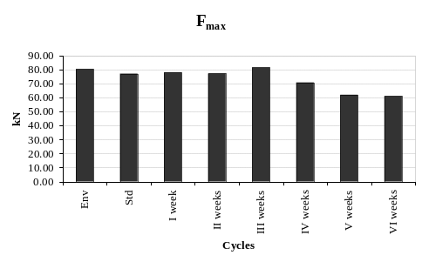 | 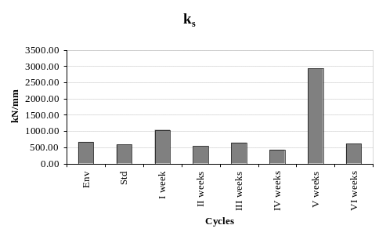
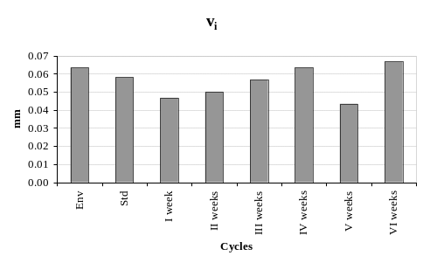 | 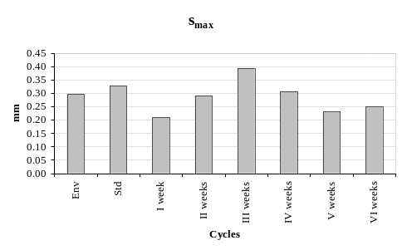
Figura 11: Medium values of F_{max}, k_{s},ν_{i} and s_{max} of aged specimens

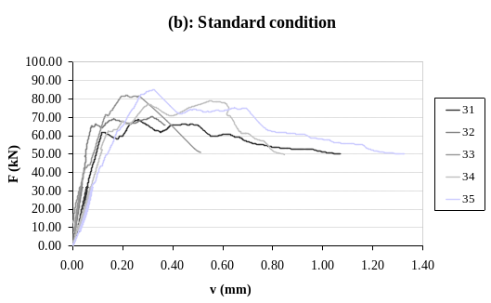
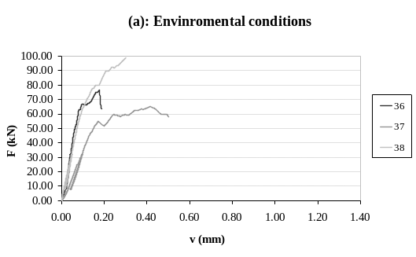
In the following figures the load-displacement diagrams related to the shear tests performed on samples maintained under environmental climatic conditions and under standard conditions (Figure 12), and artificially aged (Figures 13, a, b, c, d, e, f) are shown.

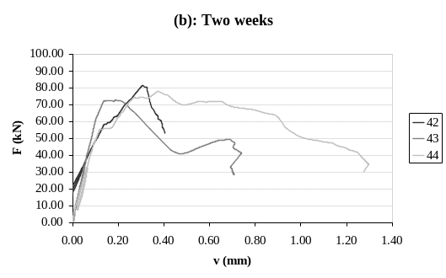
Figure 12: Load-displacement diagrams for shear tests performed on specimens maintained under environmental conditions (a) and under standard conditions (b)
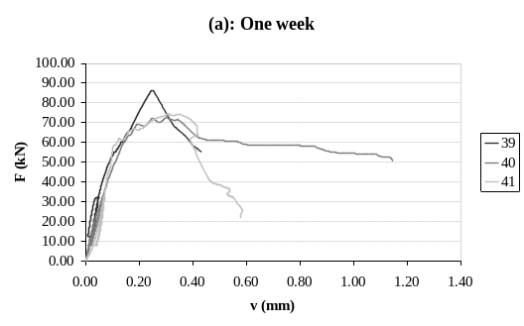

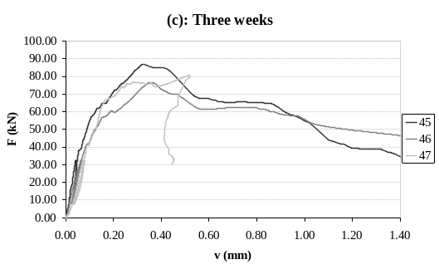
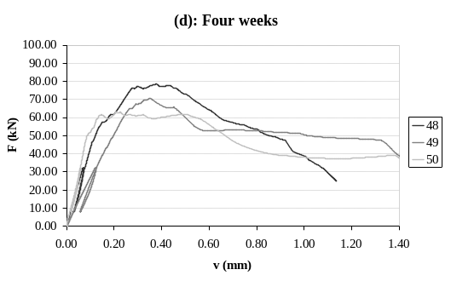

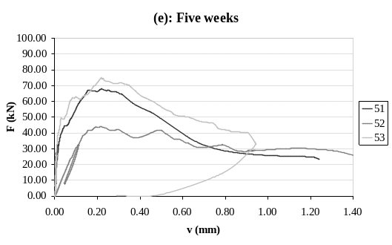
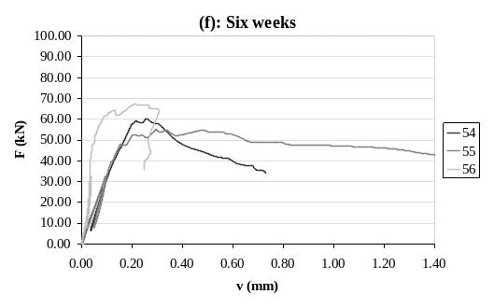

Figure 13: Load-displacement diagrams for shear test performed on specimens one week aged (a), two weeks aged (b), three weeks aged (c), four weeks aged (d), five weeks aged (e) and six weeks aged (f)
3. Conclusions
Generally the specimens have shown a very rigid behaviour, with very little displacements between steel plate and glulam and high failure loads. The failure has always been brittle, particularly in the specimens maintained under envinronmental conditions or aged under standard climate conditions, the failure has been mainly in the wood-resin interface, with the resin substantially undamaged. Carrying on the aging cycle, the structural behaviour remains quite rigid, with a little decrease of the maximum failure load and more frequently the failure of the resin rods happened, while, as we expected for a glued connection, it was observed no great changes in displacement values, neither of the s_{max} slip, recorded in correspondence of the maximum load, remaining below the millimeter. The reported diagrams in Figure 11, despite the anomalous values of the fifth week of aging cycle, confirm this general trend.
Regarding to the connection shear stiffness, it’s possible to know the efficiency of the composite action by the mechanical factor γ (see note 4). Shear stiffness k varies from the lower limit without connection, having zero stiffness, to the upper limit having infinite shear stiffness. For partially rigid connection, with 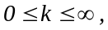 the values go from 0 to 1. So:
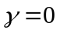 : no connection (no composite action);
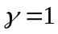 : rigid connection (full composite action);
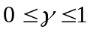: partially rigid connection (partially composite action).
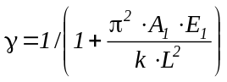
The expression of γ, given by the EN 1995-1-1, is:
reporting to the glulam beam strengthened with steel plate, we have:
A₁: cross section area of the steel plate;
E₁: Young modulus of steel;
k : slip modulus;
L : beam span.
For the glulam beam strengthened with glued in steel plate, with the geometry shown in Figures 1 to 3, it was calculated γ value for every aging phases. The results are shown in Table 7.
Table 7: Values results of γ factor for specimens under environmental and standard conditions and artificially aged
 | Enviromental | Standard | 1 week | 2 weeks | 3 weeks | 4 weeks | 5 weeks | 6 weeks
γ | 0,99 | 0,98 | 0,99 | 0,98 | 0,99 | 0,98 | 1,00 | 0,98

These results shows as the glued connection maintain its rigid characteristics despite the effects of the aging tests. In the aim to gain how much possible data about the effects of the accelerated aging tests, to the final aim to find a relationship with natural and artificial aging, and contemporarily in the aim to better understand the system behaviour under ultimate conditions, a continuation of the research is foresees with the purpose to put a comparison between an analogous solution with a no drilled steel plate (having a smooth or wrinkled surface), and therefore without resin rods certainly giving a considerable contribution to the shear stiffness.

References
Corrao R, Failla A, Lucentini M, Tesè F (2009): Indagine sperimentale per la caratterizzazione meccanica di elementi strutturali misti in legno-acciaio e legno-acciaio-calcestruzzo, Bressanone, Scienza e beni culturali XXV 2009 – atti del congresso;
Natterer J, Sandoz J L, Rey M (2004): Construction en bois – Matériau, technologie et dimensionement, Lausanne, Polytechniques et universitaires romandes;
Piazza M, Tomasi R, Modena R (2005): Strutture in legno – Materiale, calcolo e progetto secondo le nuove normative europee, Milano, Hoepli;
Scoville C R (2001): Characterizing the Durability of PF and pMDI Adhesive Wood Composites Through Fracture Testing, Blacksburg, Virginia, Department of Wood Science and Forest Products;
Schreirer A, Bathon L A, Prion H G L (2000): Determination of the Capacities of a new Composite Timber-Steel Connector, Whistler, B.C., Proc. World Conf. on Timber Engineering;
Pizzo B, Berti S, Rizzo G, Lavisci P, Lauriola M (2002): Consolidamento di strutture lignee con adesivi epossidici. Parte 1: indagine sulla durabilità degli interventi, Arkos 32-37;
Pizzo B, Berti S, Rizzo G, Lavisci P, Misani C (2002): Consolidamento di strutture lignee con adesivi epossidici. Parte 2: compatibilità strutturale tra adesivi e legno, Arkos 46-52;
Cerami A, Lo Presti S, Lucentini M (1989): Rinforzo con traliccio metallico di travi in legno – materiali per il convegno su: Analisi e sperimentazione nella ricerca per l’architettura, Genova;
Cenci G (1980): Strutture in legno – Calcolo e costruzione con riferimento alla DIN 1052, Milano.

It’s the mostly used adhesive, but poliurethane resins can also be used (bi-components) and resorcine-phenolic.
The research, Prof. G. Alaimo is responsible for, has been financed by funds (ex quota 60%, year 2007) of the University of Palermo.
Supplied by Lo Castro Legnami spa, Palermo (Italy)
The glued connection have a high stiffness, this means in the design of the composite section, it’s possible to homogenize to one of the two materials, directly applying the factor n, without reductions, differently from what happens for composite section with incomplete interaction, where it’s necessary to use the reduction γ factor.

