Developing keratin sponges with tunable morphologies and controlled antioxidant properties induced by doping with polydopamine (PDA) nanoparticles
T. Posati^{1,}∗, G. Sotgiu¹, G. Varchi¹, C. Ferroni¹, R. Zamboni¹, F. Corticelli², D. Puglia³, L. Torre³, A. Terenzi³ and A. Aluigi^{1,*}

¹Institute of Organic Synthesis and Photoreactivity – Italian National Research Council Via P. Gobetti. 101 40129 Bologna – IT

² Institute of Microelectronics and Microsystems – Italian National Research Council Via P. Gobetti. 101 40129 Bologna – IT

³ Civil and Environmental Engineering Department – UdR INSTM, University of Perugia, Terni 05100 – IT

Abstract
This work investigates the preparation of wool keratin sponges by freeze-drying procedure starting form keratin aqueous solutions. The study highlights the correlations between process parameters (protein concentration and freezing rate) and the chemical-physical properties of the final sponges.
In particular, as the keratin concentration increases from 1 to 20% wt, the mean pore size and the porosity decrease from 62 to 37µm and from 94 to 50% respectively, while the chemical stability in physiological conditions increases, as well as the thermal stability and the elastic modulus. On the other hand, the increase of the freezing rate affects the design of sponges that appear as stacked leaflets structures with oriented pores.
Moreover, in order to confer to keratin sponges antioxidant properties, polydopamine (PDA) nanoparticles were used as fillers. To this end, PDA nanoparticles of about 130 nm were successfully dispersed in the sponges, bestowing time-dependent anti-oxidant properties on the scaffolds, with no significant modification of sponges morphological structure as well as reduction of the thermal stability and mechanical behaviour.

Keywords: keratin, polydopamine, scavenging activity, pore structure, tissue engineering

Table of Content
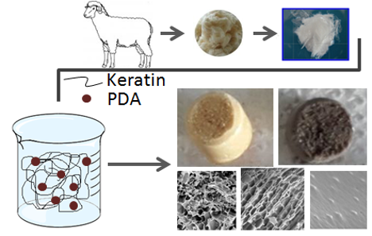

Highlights
- Porous keratin sponges were prepared through freeze-drying process starting from aqueous solutions of the protein and in the complete absence of organic solvents;
- Chemical-physical properties (e.g. morphology, chemical and thermal stability, swelling ratio and mechanical behaviour) of resulting 3D-scaffolds can be easily controlled by a fine-tuning of the initial keratin concentration and of the freezing temperature gradient;
- Solutions at higher keratin concentration generated sponges with lower pore size and porosity, but higher elastic modulus and higher chemical and thermal stability;
- Polydopamine nanoparticles were successfully dispersed in the keratin sponges and the composite scaffolds displayed a time-dependent antioxidant activity;
- The preliminary results reveal the possibility of designing highly tunable keratin-based 3D-scaffolds with very promising perspectives in the field of tissue-engineering and regenerative medicine.

1. Introduction
Tissue engineering is based on the use of three-dimensional scaffolds (3D-scaffolds) able to simulate cells adhesion and proliferation of the target tissue, thereby allowing the development of new tissue [1]. In particular, the different architectures of the target tissues require scaffolds with appropriate morphology in term of pore shape and size, such as 5 µm for neurovascularization [2], 5-15 µm for fibroblast growth [3], 20-125 µm for mammalian skin regeneration [4] and 200-900 µm for osteoblast growth [5].
In the last years, protein biopolymers such as collagen, albumin, fibroin or gelatine have attracted much attention for the design of 3D-scaffolds due to their biodegradability, biocompatibility, low immunogenicity, hydrophilic behaviour and bioactivity (ability to promote cell-cell and cell-matrix interactions) [6].
Keratin is one of the most abundant non-food proteins, being the principal component of hair, wool, feather, horns and nails of mammals, reptiles and birds, and it can be easily extracted from readily available and low cost wastes, such as raw wool not suitable for spinning, feathers from butchery and by-products of the wool textile industry. At molecular level, keratin is characterized by a high amount of the sulphur-containing amino acid cysteine, which constitutes the 7-20% of the total amino acid residues [7,8]. Moreover, wool keratin contains some important cell adhesion sequences (arginine–glycine–aspartic acid: RGD and leucine–aspartic acid–valine: LDV ) [9] while being able to improve the production of anti-inflammatory cytokines, thereby finding a valuable role in regenerative medicine. The high molecular weights that characterize wool keratin (45-60 kDa)[10], make this protein particular suitable for its processing into several types of structural materials such as films [11], sponges [12] and electrospun fibers [13].
For the aforementioned reasons, the potential applications of keratin-based materials in the biomedical field are getting more and more attractive [14,15].
Among the methodologies available for producing 3D-scaffolds from biomaterials (solvent casting particulate leaching, salt leaching/gas foaming, fibre-meshes, solvent-exchange induced gelation, etc.) [16-19], the freeze-drying process is the easiest method since it is simply based upon sublimation of ice crystals grown on a frozen polymer aqueous solution. Even if several papers report about the preparation of keratin sponges by freeze-drying process [20,21], to the best of our knowledge, this is the first work that provides a thorough study on the relationships between physical-chemical properties of the keratin sponges and the freeze-drying process parameters.
In particular, we focused our attention on the effect of keratin concentration and freezing rate conditions on scaffolds pores size and shape, as well as on the chemical, thermal and rheological behaviour of the sponges. Moreover, the use of polydopamine nanoparticles (PDA@NPs) as fillers was evaluated as an alternative strategy to modulate the morphology of the sponges and to confer them antioxidant properties. PDA is the most common type of synthetic melanin and in the last few years, it has attracted much attention in the biomedical field due to its good biocompatibility, non-toxicity, biodegradability, ability to improve the cells adhesion and to act as radical scavenger [22, 23]. Moreover, it has been demonstrated that PDA in form of nanoparticles can be used as photothermal therapeutic agent and as a novel contrast agent in photoacoustic imaging [24, 25]. Thanks to all these features, PDA has also recently emerged as a promising bio-inspired material in the field of biocomposites, where the introduction of novel biocompatible, multifunctional and easy to prepare fillers is crucial [26-28]. In this respect, PDA@NPs, have been successfully employed as additives for biocompatible polymers such as poly(vinyl alcohol) (PVA) and poly(methyl methacrylate) (PMMA) thus improving the thermal, mechanical, antioxidant and UV-shielding performance of polymers [29,30]. In this work, PDA@NPs were obtained through a simple and cost effective procedure based on the oxidation and self-polymerization of dopamine in water under alkaline condition [31]. The attractive properties of keratin and PDA@NPs are herein combined for the first time in a new multifunctional material of potential interest in tissue engineering and drug delivery fields.

2. Experimental
2.1 Materials.
Australian Merino wool (21µm fineness) was kindly supplied by Cariaggi Fine Yarns, S.p.A. All other chemicals were purchased from Sigma-Aldrich.
2.2 Preparation of porous keratin sponges.
Keratin powder was obtained through the extraction procedure from wool fibres by sulphitolysis reaction, as described in a previous work (section S1 of supporting information) [32]. Keratin sponges were prepared by freezing solutions of keratin powder dissolved in water at controlled temperature followed by lyophilization.
In order to obtain sponges with cylindrical shapes, the solutions were lyophilized in a test tube of 1 cm diameter. In particular, aqueous solutions at different keratin concentrations of 1, 5,10, 15 and 20 % wt were frozen at -18°C for 24 hours and lyophilized overnight. A portion of the solution at 20%wt was subjected to a rapid frozen process by immersion in liquid N₂ and then lyophilized overnight. The resulting sponges were immersed in acetone and stabilized with glutaraldehyde 25% (0,4 µL for mg of keratin), overnight.
2.3 Preparation of Keratin/PDA@NPs sponges.
PDA@NPs were prepared according to published methods (section S2 of supporting information)[31]. The keratin/PDA@NPs composite sponges were prepared dissolving the keratin powder in aqueous dispersion of PDA@NPs (0.5 and 1 mg/mL) in order to have a final keratin concentration of 10% wt. The keratin sponges containing respectively the 0.5 and 1% wt of melanin with respect to keratin, were prepared by freezing the prepared dispersions at -18°C for 24 hours followed by lyophilization overnight, as previously described.
The resulting sponges were immersed in acetone and stabilized with glutaraldehyde 25% (0,4 µL for mg of keratin), overnight.

2.4 Sponges characterization.
The morphology of keratin-based sponges was characterized by scanning electron microscopy (SEM) using a Zeiss EVO LS 10 LaB6 scanning electron microscope, with an acceleration voltage of 5kV and a working distance of 5 mm. Samples were gold-sputtered for 1 min before the analysis. Pore size (n=20) was measured using GIMP 2.8 as software image. The porosity (ε) was measured by liquid displacement method. Practically, the scaffolds were immersed in a known volume (V₁) of hexane in a graduated cylinder for five minutes. Hexane was used due to its ability to permeate the scaffold without swelling or shrinking the matrix. The total volume of hexane and the hexane-impregnated sponge was recorded as V₂. The hexane-impregnated sponge was then removed from the cylinder and the residual hexane volume was recorded as V₃. The porosity of the scaffold was obtained through the following equation:
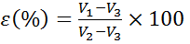 (1)
The chemical stability of the sponges was evaluated by immersing the samples in a physiological buffer (PBS, pH 7.4) at 37°C for 24 hours. The protein released in the buffer was estimated by the bicinchoninic acid assay (BCA assay) [33]. Briefly, 100 µL of the protein released in the PBS solution was added to 900µL of water milliQ; thereafter, 500 µL of the diluted protein solution was added to 500 µL of the BCA working reagent and incubated at 60°C for 2 hours. The resulting purple solutions were then measured for their absorbance at 562 nm using a UV-Visible spectrophotometer (Cary 100, Agilent Technology). Keratin standard solutions at known concentrations in the 0-30 µg/mL range were prepared and used for the calibration curve.
Swelling studies were carried out by immersing the samples, previously weighted in the dried state (W_{d}), in PBS at 37°C for 24 hours. The soaked sponges were taken out carefully and weighted in the swollen state (W_{s}). The swelling degree (SD) was calculated using the following equation:
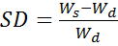 (2)
The infrared spectra were recorded using a Perkin-Elmer Spectrum BX FT-IR System in the spectral region 4000-400 cm⁻¹, with 100 scans and a resolution of 4 cm⁻¹. Before the acquisition, the samples were powdered by mixing with KBr and processed into pellets.
Differential scanning calorimetry (DSC) and thermogravimetric analysis (TGA) were used to perform the thermal characterisation of the scaffolds. DSC measurements were carried out on a TA Instruments DSC Q200 (TA Instruments Inc. USA) calibrated by an indium standard and equipped with Universal Analysis 2000 software under nitrogen atmosphere in the range of -25÷250°C at 10°C min⁻¹, applying two heating and one cooling scans. TGA experiments (Seiko Exstar 6300) were run from 30 to 600°C at 10°C min⁻¹ using Al₂O₃ crucibles, under a nitrogen atmosphere.
Rheological tests were performed in a rotational rheometer ARES, with parallel plate geometry (diameter = 8mm). Dynamic measurements were performed in order to analyze the viscoelastic properties and the influence of different level of keratin on rheological/viscoelastic behaviour of wet sponges. Preliminary strain sweep tests to determine the liner viscoelastic region were done. Frequency sweep measurements at room temperature (25°C) with a strain of 4 % in the frequency range of 0.1–100 rad/s were performed. A special tool was used in order to maintain the sample immersed in water during the test, thus avoiding any change in mechanical response due to sample drying.
The free radical scavenging activity of keratin/PDA@NPs_1% composite was evaluated using the 2,2-diphenyl-1-picrylhydrazyl (DPPH) assay according to a slightly modified literature procedure[18] and compared with the activity of keratin, and PDA@NPs. Briefly, each composite sample (10 mg) was properly wet with water and added with 4 mL of freshly prepared DPPH solution (0.1 mM) in 95% ethanol. For comparison the equivalent amount of PDA@NPs (0.1 mg) was used as a control. The scavenging activity was evaluated by monitoring the absorbance decrease at 516 nm after storing the sample in the dark for 30 min and 5 h. The DPPH radical scavenging activity was calculated using the following equation (3):
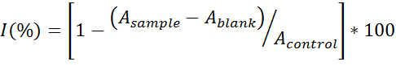 (3)
where A_{control} is the absorbance of the DPPH solution without any sample, A_{sample} is the absorbance of the sample mixed with the DPPH solution, and A_{blank} is the absorbance of each sample itself without the DPPH solution.
2.5 Statistical analysis
With exception of pore size measurements, all quantitative experiments were run in triplicate and results are expressed as mean ± standard deviation for n=3. For pore size determination, 20 measurements for each sample were considered (n=20). Statistical analysis of the data was conducted using one-way ANOVA with Tukey test for means comparison and using ORIGIN Pro 8 Software. Differences between the groups with p<0.05 were considered to be statistically significant.

3. Results and Discussion
3.1 Preparation of keratin sponges
The sulphitolysis reaction, used to extract keratin from wool, is based on the cleavage of disulphide covalent bonds of cystine (S-S) into cystein thiol (S-H) and cystein-S-sulphonated (S-SO₃⁻) residues (Bunte salts), which increase the solubility of the protein in water (reaction image in supporting information, Figure S1). A great advantage of sulphitolysis reaction is that it does not induce any molecular weight reduction (degradation) of the protein (as shown in the electrophoretic pattern of Figure S2.
Different water solutions of sulphonated keratin were then used to prepare 3D-sponges through freeze-drying of protein aqueous solutions (Figure 1).
In particular, scaffolds with different morphologies and tunable chemical-physical properties were obtained by a fine control of the protein concentration and freezing temperature gradient [34].
Moreover, keratin-based composite sponges were prepared using a bio-inspired filler such as poly-dopamine nanoparticles (Figure 1B and C) in order to confer antioxidant activity to the scaffolds. A list of the prepared samples is reported in Table 1.
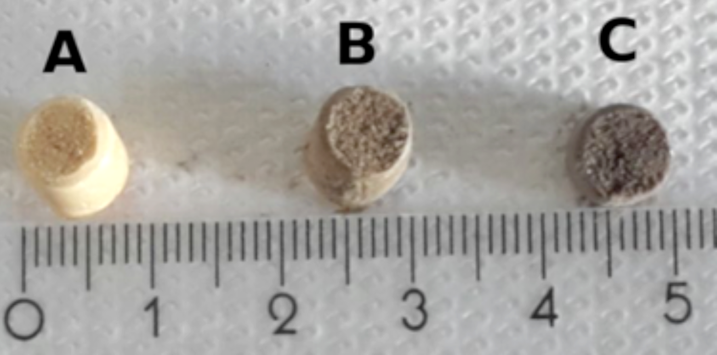
Figure 1. Visual appearance of keratin sponges (A) and keratin sponges containing PDA@NPs: 0.5% (B) and 1%(C) wt.

Table 1. Parameter conditions of prepared keratin sponges
Sample | Keratin solution  (% wt) | Freezing Condition (°C) | PDA@NPs filler  (% wt)
KS10 | 1 | -18 | #
KS50 | 5 | -18 | #
KS100 | 10 | -18 | #
KS150 | 15 | -18 | #
KS200 | 20 | -18 | #
KS200b | 20 | -196 | #
KS100/PDA@NPs_0.5 | 10 | -18 | 0.5
KS100/PDA@NPs_1 | 10 | -18 | 1

3.1 Effect of keratin concentration on sponge morphology.
SEM images of porous sponges obtained after controlled freezing (-18°C for 24h) of keratin solutions at different protein concentration (from 1 to 20% wt), and subsequent lyophilization of keratin solutions at different protein concentration (from 1 to 20% wt), are reported in Figure 2A-E. All images show 3D-porous structures made of open pores visually interconnected. The pore size distribution becomes narrower and shifted to lower value with increasing the keratin concentration (Figure 2a-e). In particular, going from 1 to 10% wt of keratin concentration, a significant decrease (p<0.001) of both the mean pore size (from 62 to 37 µm, Figure 3a) and porosity (from 94 to 50%, Figure 3b) was observed; while the mean values obtained for higher keratin concentrations did not show statistical differences. A possible explanation of this behaviour could be ascribed to the greater intermolecular packing of the protein at higher concentrations, which could promote the formation of smaller ice grains during the freezing phase, thereby producing sponges with lower pore dimensions and porosity [35].
The chemical stability of a 3D-scaffold in biological fluid is an important requirement for its application in tissue engineering. In order to evaluate this aspect, keratin sponges were immersed in PBS at 37°C and the protein release was monitored under equilibrium conditions (24 h of incubation). As expected, a remarkable protein release (80%) was observed for the sponge with the highest porosity (KS10); while it substantially decreased for the sponge with smaller porosity (KS200) which provided a total protein loss of only 4% (Figure 3c). Another important property to be considered when designing a 3D-scaffold for tissue engineering is the ability to absorb fluids (swelling ratio), which could favour cells incorporation and proliferation within the scaffold [36]. Interestingly, under physiological conditions, all the sponges displayed an appreciable swelling ratio (between 4-5), with the exception of the KS10 sponge which is almost totally dissolved (Figure 3d). There are not statistically significant differences between the mean values of swelling obtained for different sponges.
Since the KS10 sample was almost totally soluble in physiological buffer, only the sponges obtained from keratin solutions at higher protein concentration were considered for the subsequent mechanical and thermal analyses.
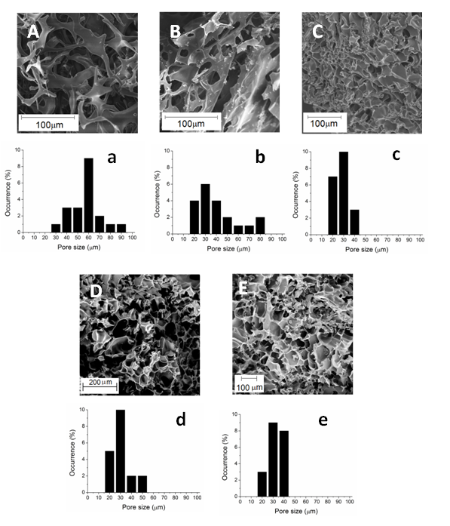

Figure 2. SEM images and related pore size distribution (n=20) of keratin sponges obtained from keratin solution at 1% (A, a), 5% (B,b), 10% (C,c), 15% (D,d) and 20% (E,e)
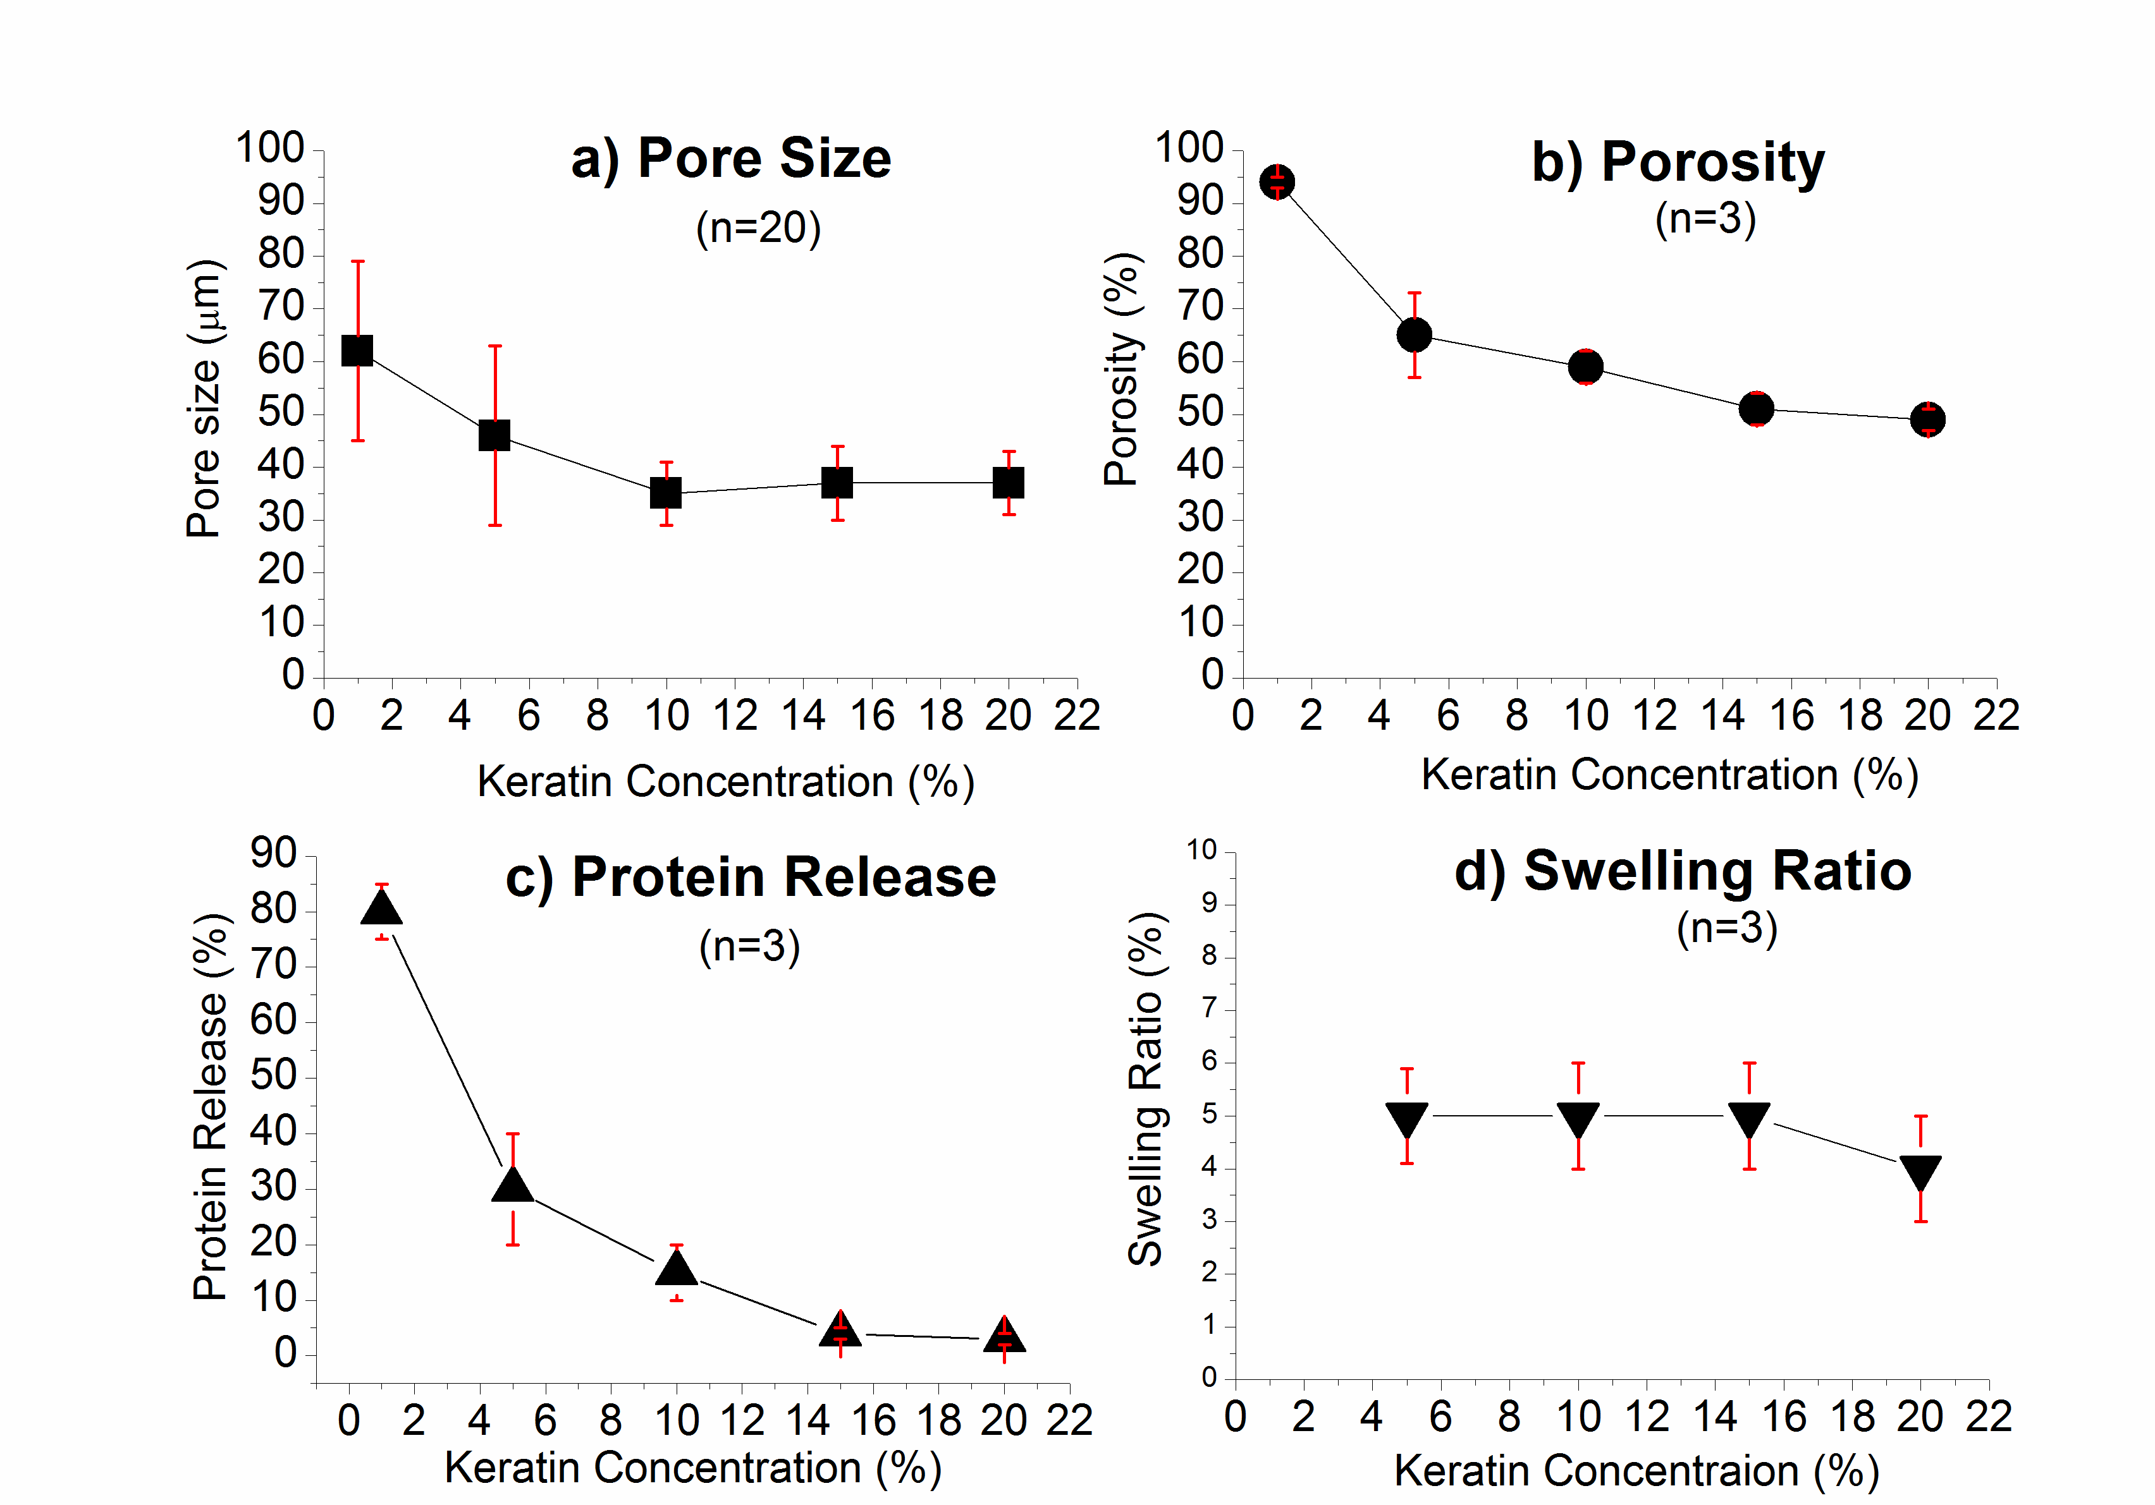
Figure 3. Effect of keratin concentration on (a) pore size, (b)porosity, (c) Protein Release and (d) Swelling Ratio
As concern the rheological behaviour, it has been reported that protein concentration directly influences the viscosity of keratin-based formulations, due to an increase of keratin chains entanglements, which could be also responsible for the higher stability of the sponges (in agreement with the chemical stability trend) [37]. All keratin sponges behaved like viscoelastic solids with conformation and structure described in terms of storage modulus (G’), loss modulus (G’’), and complex velocity (η*) as a function of frequency of oscillation (Figure 4 a and b). As can be observed, G’ is always higher than G’’ for all keratin sponges in the whole frequency range, thus indicating that the material response is prevalently elastic. KS200 showed the highest elastic modulus, while KS50 showed the lowest one: the expected increase of elastic modulus from KS50 to KS200, is likely due to an enhanced elasticity, as a result of a higher number of chain entanglements. Both the elastic modulus and viscous modulus had some frequency dependence [38].
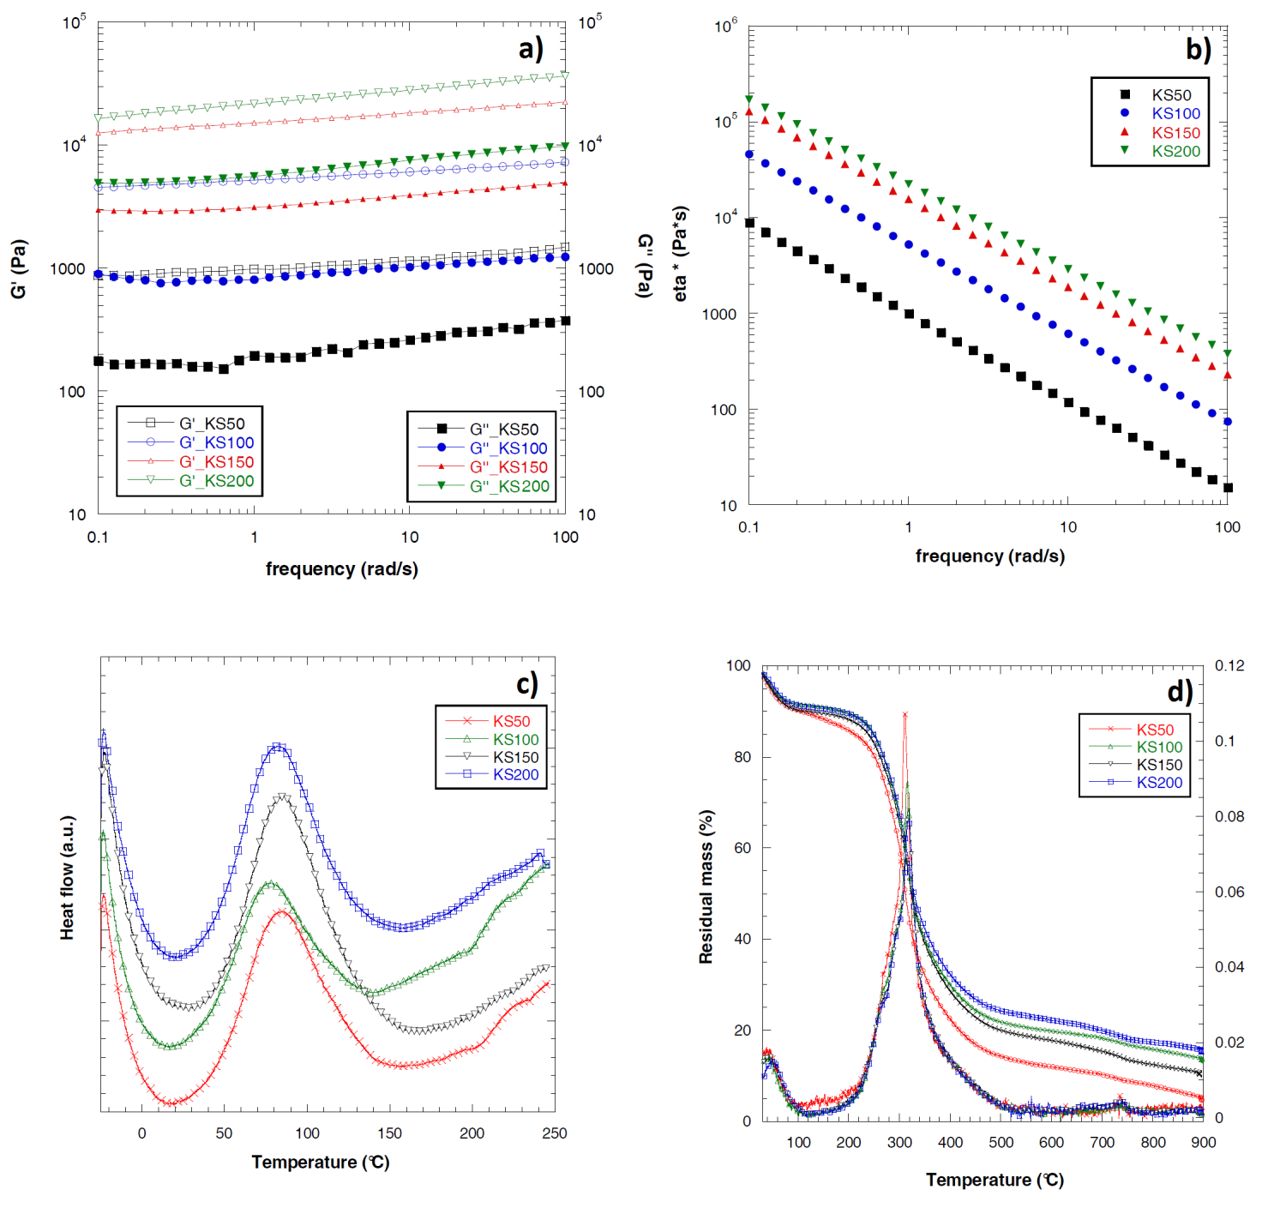
Figure 4. (a) Storage modulus (G’), loss modulus (G’’); (b) complex velocity (η*) of the keratin-based sponges as a function of frequency of oscillation; (c) DSC curves and (d) TG curves with related derivative TG curves (DTG) of keratin sponges

All DSC curves (Figure 4c) present three main thermal events: a broad endotherm peak below 100°C due to the water evaporation, a transition between 195 and 200°C due to degradation of small molecular weight keratin fractions with low thermal stability, and one endothermic peak in the 210–250°C temperature range, due to the denaturation of crystalline regions at α-helices [39,40]. The last mentioned peak did not change for the sponges obtained from solutions at different keratin content, indicating that the systems were equivalent in terms of secondary structure organization [41]. As concern the TG curves, a slight shift towards higher temperatures (from 311°C for KS50 up to 318°C for KS200) and reduced degradation rate was observed with increasing the keratin content in the sponge (Figure 4d). In addition, also the increased values of residual material at the end of the tests (5.4% for KS50 and 15.9 % for KS200) are related to the increased amount of keratin in the sponges. Therefore, the improved intermolecular chain interactions due to the chain entanglements increase is most likely responsible for the higher thermal stability of the sponges obtained from more concentrated keratin solutions.
3.2 Effect of freezing conditions.
Since the aqueous crystals growth is a function of the heat transfer rate, the morphology of the pores is highly affected by freezing conditions. In contrast with almost round pores of KS200 (obtained at -18°C), randomly distributed (Figure 2E), elongated and radially oriented pores were produced at -196°C (Figure 5a); moreover, compared to KS200 sponges (-18°C), the KS200b (-196°C) showed a significantly lower pore size from 34 to 10 µm (p<0.001) and a pore size distribution shifted to lower value (Figure 5b).
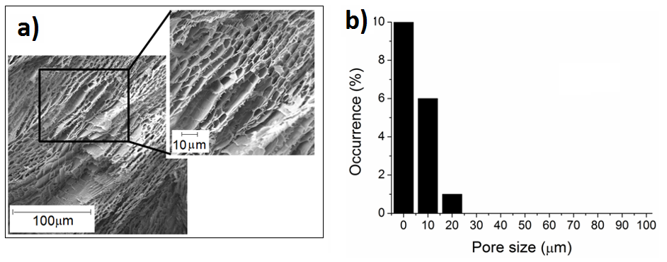
Figure 5. SEM image (a) and related pore size distribution (b) of the KS200b sponges.

These results are ascribed to two different factors: i) the higher cooling rates (i.e. lower crystallization temperatures) that induce the formation of smaller ice-crystals and ii) the nucleation mainly occurring from the cold surface toward the centre of the sample generating leaf-like structures [34]. Nevertheless, as shown in Table 2, the KS200b showed porosity higher than the KS200 (p<0.001), probably due to the leaf structure. Nevertheless, the porosity increase seems to not significantly affect the chemical stability and the swelling ratio of the sponges (Table 2).

Table 2: Comparison of physico-chemical properties between KS200 and KS200b and KS100 and KS100/PDA_1
Sample | KS200 | KS200b | KS100 | KS100/PDA@NPs_1
Pore Size (µm)  (n=20) | 34±6 | 10±3 | 35±6 | 39±8
Porosity (%)  (n=3) | 49±2 | 57±3 | 59±3 | 54±3
Swelling Ratio  (n=3) | 4±1 | 4±1 | 5±1 | 5±1
Released protein (%)  (n=3) | 4±1 | 6±1 | 15±5 | 19±2

The study on the protein supramolecular structure carried out by means of FT-IR analysis revealed that the freezing rate does not affect the secondary structure of keratin, since the sponges obtained at -18°C and -196°C are characterized by keratin having similar amounts of α-helix, β-sheet and β-turns structures (see section S2 of supporting information).
3.3 Antioxidant effect of keratin and PDA@NPs composite sponges.
The antioxidant effect of a biomaterial is an important requirement for tissue engineering application in view of preventing cells from oxidative stress. PDA is considered a good antioxidant agent thanks to the high number of phenolic groups that can easily quench active radicals via an electron transfer process [18]. In this work, PDA@NPs were incorporated into keratin sponges in order to confer them antioxidant properties. PDA@NPs of about 110−130 nm were obtained by the oxidative polymerization of dopamine in aqueous solution[31] and then characterized by UV-Vis and SEM analysis (Figure S4 and S5). The effect on the physical-chemical properties of the keratin sponges of PDA@NPs was studied for the sample obtained from 10%wt keratin solution (KS100). As shown in Figure 1B and C, PDA@NPs are homogeneously dispersed into the biopolymer matrix and the colour of composite sponges becomes deeper with increasing the PDA@NPs content. From the morphological point of view, in contrast to the smooth surface of KS100 sponge (Figure 6A) the KS100/PDA@NPs_1 composite sponge shows several circular protrusions ascribable to PDA@NPs (Figure 6B). However, the presence of PDA@NPs does not significantly change neither the pores shape (Figure 6 a and b) nor the size distribution (Figure 6C) or the other physico-chemical properties such as porosity, mean pore size and swelling ratio. On the other hand, with respect to the undoped sponge, the one doped with 1% of PDA@NPs showed a slight increase ( p<0.001) in the released protein. (Table 2).
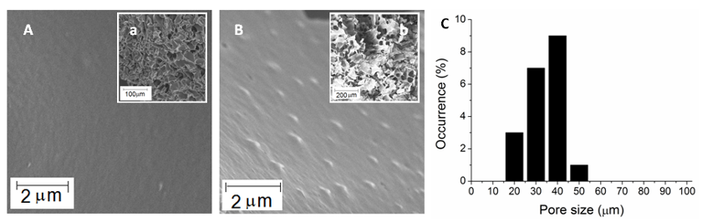
Figure.6 Surface observed at the scanning electron microscope of KS100(A, a) and KS100/PDA_1 sponges (B,b); pore size distribution of KS100/PDA_1 (C)

The compatibility between keratin and PDA@NPs was studied through infrared analysis. In Figure 7 reports the FTIR spectra of KS100 (a), KS100/PDA_1(b) and PDA@NPs (c), in the 1800-1300 cm⁻¹ range. In the considered range, keratin protein shows the characteristic adsorption peaks of Amide I (1700-1800 cm⁻¹) and Amide II (1500-1580 cm⁻¹), due to the C=O stretching vibrations and C-N stretching vibrations, respectively. On the other hand, the PDA@NPs show two characteristics adsorption peaks at 1590 cm⁻¹ and 1510 cm⁻¹, not superimposed to amide I and II of keratin and due to the ν_{ring} (C=C) and ν_{ring} (C=N) stretching modes, respectively. As can be seen, in the composite sponge (KS100/PDA_1), these two peaks are shifted towards 1626 and 1518 cm⁻¹, respectively, suggesting interactions between keratin and the indole amino groups and the cathecol hydroxyl groups of PDA.
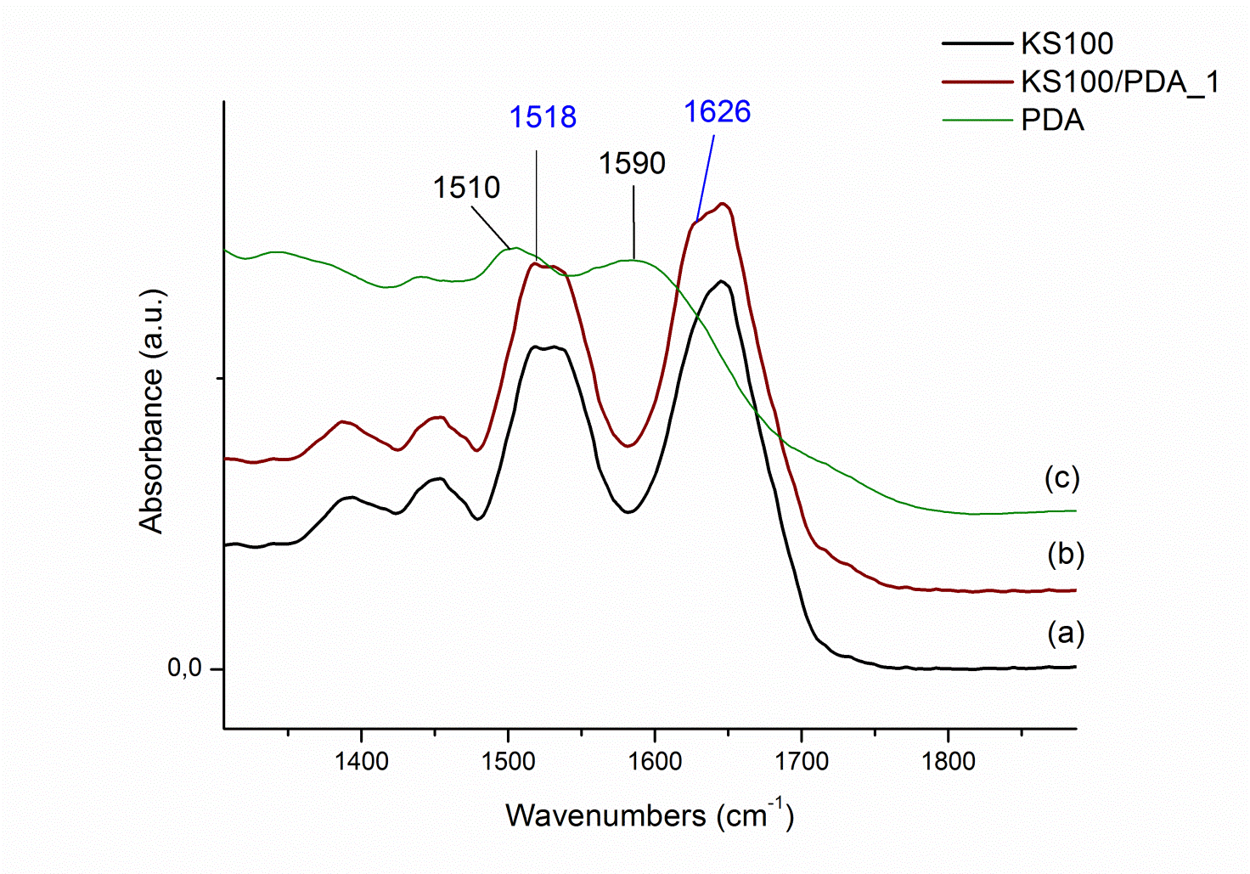
Figure 7. FTIR spectra of KS100(a), KS100/PDA_1(b) and PDA nanoparticles(c)

The thermal analysis revealed no substantial difference between the samples containing different amount of PDA@NPs, even if the endothermic peak is related, in this case, both to water loss from keratin and PDA@NPs components (Figure 8a) [42]. In addition, the presence of PDA@NPs in the keratin sponges does not significantly influence the denaturation temperature of crystalline regions at α-helices, indicating that the PDA@NPs quantity does not change their basic structure. In spite of the great similarity in the profile of these curves, slight differences are observed above 300ºC in the case of TGA profiles (Figure 8b). PDA@NPs is usually stable up to 200°C, while a strong exothermic peak due to the evolution of carbon dioxide, water and ammonia is observed upon heating at more elevated temperatures [43]. Being the degradation range of keratin and PDA@NPs overlapped, it is not possible to discriminate the contribution of both components in the main DTG peak. In the case of KS100/PDA@NPs_0.5 and KS100/PDA@NPs_1 samples, a further peak in the 600-700°C range was observed, with increased intensity according to increased amount of polydopamine, probably due to the presence of the PDA@NPs.
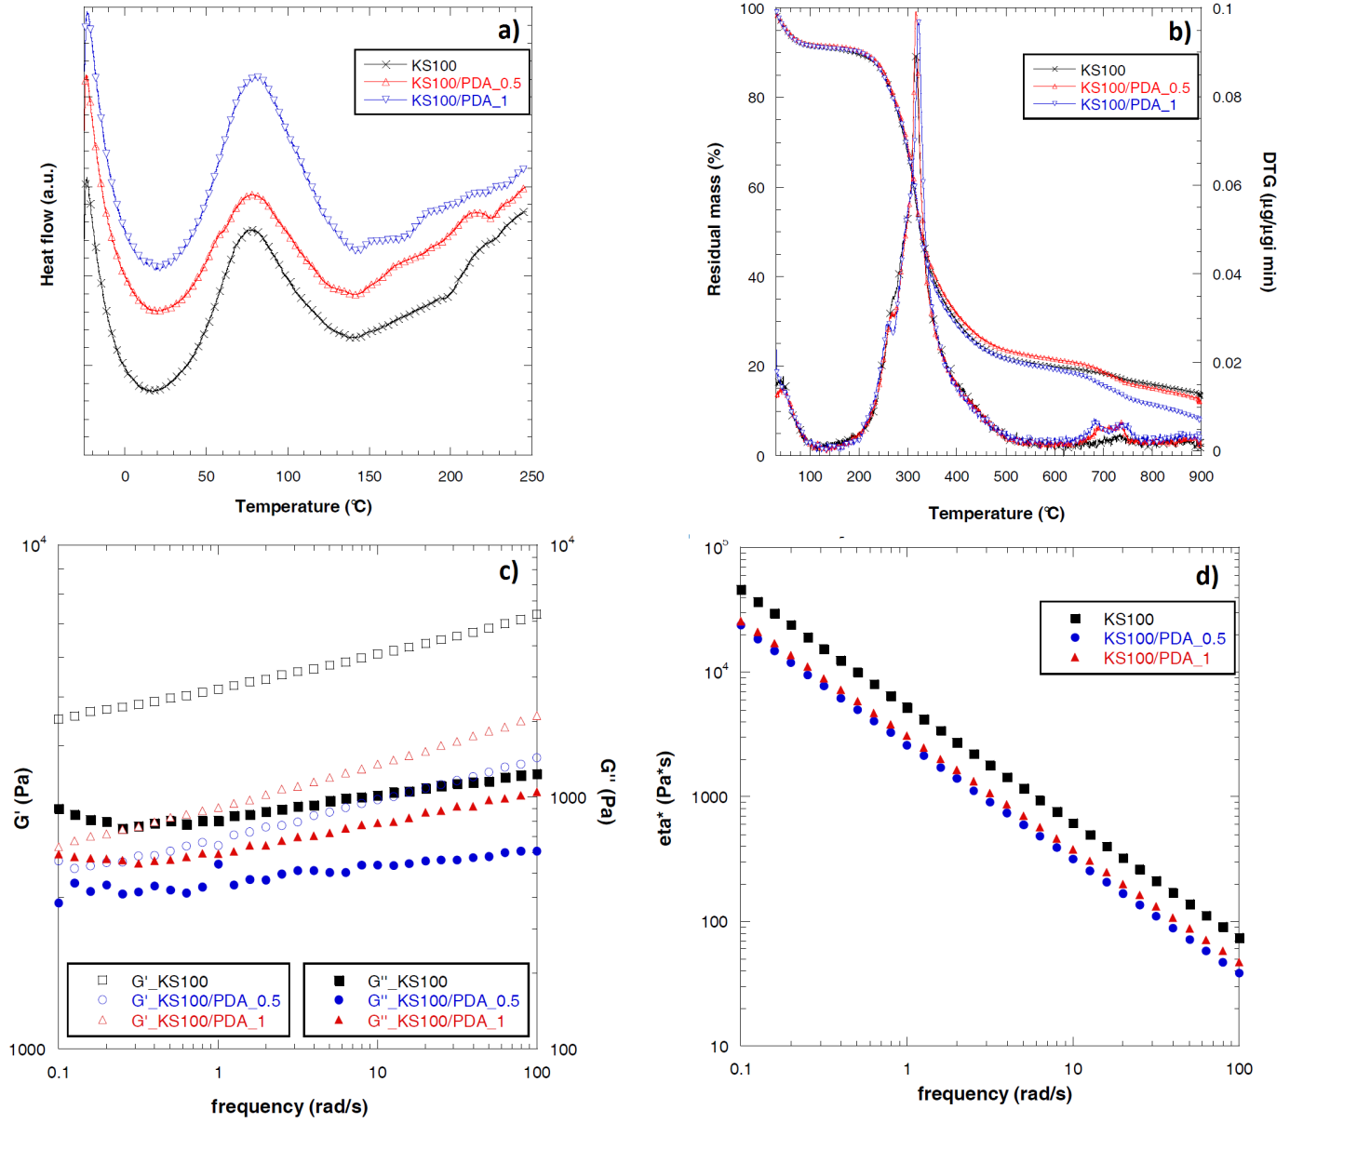
Figure 8. (a) DSC curves; (b) TG curves with related derivative TG curves (DTG) of pure keratin sponges and keratin/PDA composite sponges; (c) storage modulus (G’), loss modulus (G’’) and (b) complex velocity (η*) of pure keratin sponges and keratin/PDA composite sponges as a function of frequency of oscillation.

Frequency sweep measurements for sponges containing PDA@NPs indicated that, at any given frequency, G’ values were much higher than G’’ (Figure 8c). Moreover, both G’ and G’’ can be considered frequency independent in the linear viscoelastic regime [44]. In details, the rheological curves obtained with the samples containing PDA nanoparticles show a decrease of both modulus and viscosity in comparison to the pristine sample (KS100), while moduli and viscosity increased with PDA@NPs concentration (Figure 8d). Both lubricant effect and geometric effect are competitive in this case and, at low concentration (KS100/PDA@NPs_0.5), the geometric effect became negligible, therefore a decrease of viscosity and modulus is observed. When the concentration of PDA@NPs increases (KS100/PDA@NPs_1), the contribution of geometrical effect became predominant, suggesting an overall increase in viscosity and modulus.
The radical scavenging ability of PDA@NPs was evaluated in vitro based on 2,2-diphenyl-1-picrylhydrazyl (DPPH) assay.
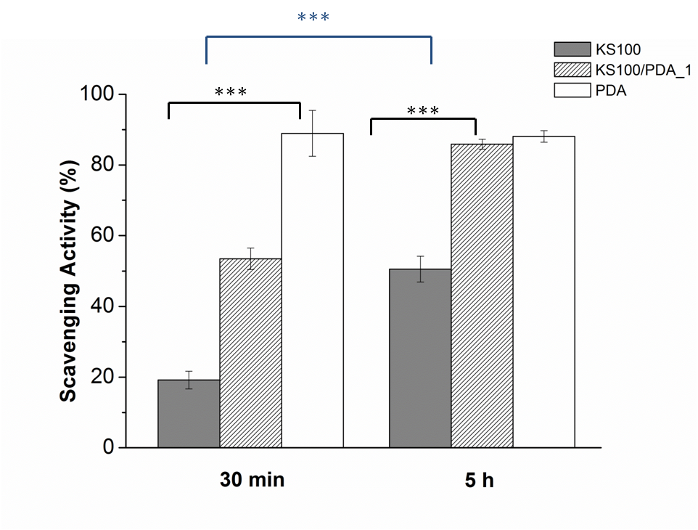
Figure 9 shows the scavenging activities of PDA@NPs, keratin sponges and keratin/PDA@NPs composites after 30 minutes and 5 h of incubation. The collected results indicate that the antioxidant effect of sponges increases with time and with the PDA@NPs presence. In particular, after 30 minutes of incubation the activity of keratin/PDA@NPs composites is about 55% versus the 20% of the undoped keratin sponge and the 90% of PDA@NPs. Whereas, after 5 h, the antioxidant activity increases up to 90% reaching the value of pure PDA@NPs. Interestingly, at each time point the effect of the pure keratin sponges is approximately 40%, whereas, after 5 h, the antioxidant activity of the composite increases to 90% reaching the value of pure PDA@NPs, indicating a time-dependent behavior. Reasonably, within the protein matrix the reactive sites of PDA@NPs are more protected and require longer time to be reached by the reagent, thus resulting in a prolonged antioxidant effect over time.
Figure 9: DPPH radical scavenging activity of PDA@NPs, keratin sponges and keratin/PDA-1% composites.
(***significant differences at p<0.001)

CONCLUSION
Porous keratin sponges were prepared directly from freeze-drying of protein aqueous solutions and in the complete absence of organic solvents. Morphological (e.g. pore size and porosity), as well as chemical-physical properties (e.g. chemical and thermal stability, swelling ratio and mechanical behaviour) of resulting 3D-scaffolds were easily controlled by a fine-tuning of the initial keratin concentration and of the freezing temperature gradient. In particular, solutions at higher keratin concentration generated sponges with lower pore size and porosity, but higher elastic modulus and higher chemical and thermal stability. Moreover, a faster freezing rate can be used to prepared sponges with stacked leaflets structures without interfering with the chemical stability, porosity, and swelling ratio. Finally, PDA@NPs were successfully dispersed in the keratin sponges and the composite scaffolds displayed a time-dependent antioxidant activity.
The preliminary results herein described, clearly reveal the possibility of designing highly tunable keratin-based 3D-scaffolds with very promising perspectives in the field of tissue-engineering and regenerative medicine.

AKNOWLEDGMENTS
The authors acknowledge Lanificio Cariaggi Fine Yarns for the Merino Wool fibres supply.

REFERENCES
[1] Madihally SV Matthew HWT Porous chitosan scaffolds for tissue engineering. Biomaterials 1999; 20(12): 1133-1142.
[2] Brauker JH, Carr-Brendel VE, Martison, LA, Crudele J, Johnston WD, Johnson RC Neurovascularization of synthetic membranes directed by membrane microarchitecture. Journal of Biomedical Material Research 1995; 29(12): 1517-1524.
[3] Klawitter JJ, Hulbert SF. Application of porous ceramics for the attachment of load bearing internal orthopedic applications. Journal of Biomedical Materials Research 1971, 5(6): 161-229.
[4] Yannas IV, Lee E, Orgill DP, Skrabut EM, Murphy GF. Synthesis and characterization of a model extracellular matrix that induces partial regeneration of adult mammalian skin. Proc. Nat. Acad. Sci. 1989, 86: 933-937.
[5] Salgado AJ; Coutinho OP, Reis RL. Bone tissue engineering: State of the art and future trends. Macromolecular Bioscience 2004, 4 (8): 743-765.
[6] Goo HC, Hwang,YS, Choi YR, Cho HN, Suh H. Development of collagenase-resistant collagen and its interaction with adult human dermal fibroblasts. Biomaterials 2003, 24 (28): 5099-5113.
[7] Dawling LM, Crewther WG, Parry AD. Secondary structure of component 8c-1 of alpha-keratin. An analysis of the amino acid sequence. Biochem. J. 1986: 236(3): 750-712.
[8] Yoshimizu H, Mimura H, Ando I. ¹³C CP/MAS NMR Study of the conformation of stretched or heated low-sulfur keratin protein films. Macromolecules 1991: 24, 862-866.
[9] Rouse, JG, Van Dyke ME A Review of Keratin-Based Biomaterials for Biomedical Applications,. Materials 2010, 3, 999−1014.
[10] Huggins ML. The structure of α-keratin. Macromolecules 1977, 10(5): 893-898.
[11] Borreli M, Joepen N, Reichl S, Finis D, Schoppe M, Geerling G, Schrader S. Keratin films for ocular surface reconstruction: evaluation of biocompatibility in an in-vivo model. Biomaterials 2015, 42: 112-120.
[12] Hamasaki S, Tachibana A, Tada D, Yamauchi K, Tanabe T. Fabrication of highly porous keratin sponges by freeze-drying in the presence of calcium laginate beads. Mat. Sci. Eng. C. 2008, 28(8): 1250-1254.
[13] Aluigi A, Corbellini A, Rombaldoni F, Zoccola M, Canetti M. Morphological and structural investigation of wool-derived keratin nanofibres crosslinked by thermal treatment. International Journal of Biological Macromolecules 2013, 57: 30-37.
[14] Xu H, Shi Z, Reddy N, Yang Y. Intrinsically water-stable keratin nanoparticles and their in vivo biodistribution for targeted delivery. Journal of Agricultural and Food Chemistry 2014, 62 (37): 9145-9150.
[15] Vasconcelos A, Cavaco-Paulo A. The use of keratin in biomedical applications. Current Drug Targets 2013, 14 (5): 612-619.
[16] Liu X, Ma PX. Polymeric scaffolds for bone tissue engineering. Annals of Biomedical Engineering 2004, 32: 477-486.
[17] Cho HS, Park TG, Park SR, Min BH. Macroporous biodegradable polymer scaffold using gas forming salt as porogen additive: Novel fabrication method for cartilage engineering. Second Smith and Nephew International Symposium - Tissue Engineering 2000: Advances in Tissue Engineering, Biomaterials and Cell Signalling 2000, 76.
[18] Freed LE, Guilak F, Guo XE, Gray ML, Tranquillo R, Holmes JW, Radisic M, Sefton MV, Kaplan D, Vunjak-Novakovic G. Advanced tools for tissue engineering: Scaffolds, bioreactors, and signalling. Tissue Engineering 2006, 12 (12): 3285-3305.
[19] Yang J, Zhang XM, Xu F. Design of cellulose nanocrystals template-assisted composite hydrogels: Insights from static to dynamic alignment. Macromolecules 2015, 48 (4): 1231-1239.
[20] de Guzman RC, Merrill MR, Richter JR, Hamzi RI, Greengauz-Roberts OK, Van Dyke ME Mechanical and biological properties of keratose biomaterials. Biomaterials 2011, 32 (32): 8205-8217.
[21] Tachibana A, Furuta Y, Takeshima H, Tanabe T, Yamauchi K. Fabrication of wool keratin sponge scaffolds for long-term cell cultivation. Journal of Biotechnology 2002, 93 (2): 165-170.
[22] Liu Y, Ai K, Lu L. Polydopamine and its derivative materials: Synthesis and promising applications in energy, environmental, and biomedical fields. Chemical Reviews 2014, 114 (9): 5057-5115.
[23] Madhurakkat Perikamana SK, Lee J, Lee YB, Shin YM, Lee EJ, Mikos AG, Shin H. Materials from Mussel-Inspired Chemistry for Cell and Tissue Engineering Applications. Biomacromolecules 2015, 16 (9): 2541-2555.
[24] Liu Y, Ai K, Liu J, Deng M, He Y, Lu L. Dopamine-melanin colloidal nanospheres: An efficient near-infrared photothermal therapeutic agent for in vivo cancer therapy. Advanced Materials 2013, 25 (9): 1353-1359.
[25] Repenko T, Fokong S, De Laporte L, Go D, Kiessling F, Lammers T, Kuehne AJC. Water-soluble dopamine-based polymers for photoacoustic imaging. Chemical Communications 2015, 51 (28): 6084-6087.
[26] Tripathi BP, Dubey NC, Subair R, Choudhury S, Stamm M. Enhanced hydrophilic and antifouling polyacrylonitrile membrane with polydopamine modified silica nanoparticles. RSC Advances 2016, 6 (6): 4448-4457.
[27] Xiong S, Wang Y, Zhu J, Yu J, Hu. Z. Poly(ε-caprolactone)-grafted polydopamine particles for biocomposites with near-infrared light triggered self-healing ability. Polymer 2016, 84: 328-335.
[28] Phua SL, Yang L, Toh CL, Guoqiang D, Lau SK, Dasari A, Lu, X. Simultaneous enhancements of UV resistance and mechanical properties of polypropylene by incorporation of dopamine-modified clay. ACS Applied Materials and Interfaces 2013, 5 (4): 1302-1309.
[29] Xiong S, Wang Y, Yu J, Chen L, Zhu J, Hu Z. Polydopamine particles for next-generation multifunctional biocomposites. Journal of Materials Chemistry A 2014, 2 (20): 7578-7587.
[30] Shanmuganathan K, Cho JH, Iyer P, Baranowitz S, Ellison CJ. Thermooxidative stabilization of polymers using natural and synthetic melanins. Macromolecules 2011, 44 (24): 9499-9507.
[31] Ju KY, Lee Y, Lee S, Park SB, Lee JK. Bioinspired polymerization of dopamine to generate melanin-like nanoparticles having an excellent free-radical-scavenging property. Biomacromolecules 2011, 12 (3): 625-632.
[32] Aluigi A, Sotgiu G, Torreggiani A, Guerrini A, Orlandi VT, Corticelli F, Varchi G. Methylene Blue Doped Films of Wool Keratin with Antimicrobial Photodynamic Activity. ACS Applied Materials and Interfaces 2015, 7 (31): 17416-17424.
[33] Klang V, Schwarz J, Hartl A, Valenta C. Facilitating in vitro tape stripping: application of infrared densitometry for quantification of porcine stratum corneum proteins. Skin Pharmacol. Physiol. 2011, 5, 256–268.
[34] Schoof H, Apel J, Heschel I, Rau G. Control of pore structure and size in freeze-dried collagen sponges. Journal of Biomedical Materials Research 2001, 58 (4): 352-357.
[35] Mao JS, Zhao LG, Yin YJ, Yao KD Structure and properties of bilayer chitosan-gelatin scaffolds. Biomaterials 2003, 24 (6): 1067-1074.
[36] Enrione J, Osorio F, López D, Weinstein-Oppenheimer C, Fuentes MA, Ceriani R, Brown DI, Albornoz F, Sánchez E, Villalobos P, Somoza RA, Young ME, Acevedo CA Characterization of a Gelatin/chitosan/hyaluronan scaffold-polymer. Electronic Journal of Biotechnology 2010, 13 (5): 1-11.
[37] Graessley WW editor. Advances in polymer science, Vol. 16 New York: Springer; 1974 p. 179.
[38] Ham TR, Lee RT, Han S, Haque S, Vodovotz Y, Gu J, Burnett LR, Tomblyn S, Saul JM. Tunable Keratin Hydrogels for Controlled Erosion and Growth Factor Delivery. Biomacromolecules 2016, 17: 225−236.
[39] Kakkar P, Madhan B, Shanmugam G. Extraction and characterization of keratin from bovine hoof: A potential material for biomedical applications. Journal of the Korean Physical Society 2014, 3 (1): 1-9.
[40] Aluigi A, Tonetti C, Rombaldoni F, Puglia D, Fortunati E, Armentano I, Santulli C, Torre L, Kenny JM Keratins extracted from Merino wool and Brown Alpaca fibres as potential fillers for PLLA-based biocomposites.
Journal of Materials Science 2014, 49 (18): 6257-6269.
[41] Wortmann FJ, Deutz H. Thermal analysis of ortho-cortical and para-cortical cells isolated from wool fibers. Journal of Applied Polymer Science 1998, 68: 1991-1995.
[42] Simonovic B, Vucelic B, Hadzi-Pavlovic A, Stepien K, Wilczok T, Vucelic D. Thermogravimetry and differential scanning calorimetry of natural and synthetic melanins. Journal of Thermal Analysis 1990, 36: 2475-2482.
[43] Deziderio SN, Brunello CA, da Silva MIN, Cotta MA, Graeff CFO. Thin films of synthetic melanin. Journal of Non-Crystalline Solids 2004, 338: 634–638.
[44] Das P, Yuran S, Yan J, Lee PS, Reches M. Sticky tubes and magnetic hydrogels co-assembled by a short peptide and melanin-like nanoparticles. Chemical Communications 2015, 51 (25): 5432-5435.

 Corresponding authors: Annalisa Aluigi, CNR-ISOF (National Research Council - Institute of Organic Synthesis and Photoreactivity) Via P. Gobetti, 101, 40129 – Bologna. Office phone number: +39 051 639 9785 e-mail: annalisa.aluigi@isof.cnr.it Tamara Posati, CNR-ISOF (National Research Council - Institute of Organic Synthesis and Photoreactivity) Via P. Gobetti, 101, 40129 – Bologna. Office phone number: +39 051 639 9766 e-mail: tamara.posati@isof.cnr.it

