Performance Evaluation of a Low-Cost Gaze Tracker for Eye Typing
Maria Barrett  IT University of Copenhagen  Rued Langgaards Vej 7,  2300 Copenhagen S, Denmark  mbarrett@itu.dk | Henrik Skovsgaard  Javier San Agustin  IT University of Copenhagen  Rued Langgaards Vej 7,  2300 Copenhagen S, Denmark  {hhje,javier}@itu.dk

Keywords
low-cost gaze tracking, eye typing, usability, universal access
Introduction
To some people with severe motor disabilities gaze interaction is the only way of communicating in their daily life. The systems must provide means for effective and efficient communication without discomfort. Gaze interaction systems built from off-the-shelf components decrease costs and increase availability for the disabled users as well as for students, researchers and developers.
Prior studies show that multimodal interaction using click activation increases the efficiency of gaze interaction with respect to gaze-based selection such as dwell (Zhang and Mackenzie, 2007). Other studies only examine single modality gaze interaction (Majaranta et al., 2004). Recent studies have shown that the performance of a low-cost gaze tracker compares well to the commercial gaze systems in target-acquisition tasks and eye typing (San Agustin et al., 2009).
The aim of this paper is to evaluate a low cost gaze tracker built from a standard web camera (less than $20) for eye typing. In the experiment, we test two robust, noise-tolerant gaze-typing applications, GazeTalk (Hansen et al., 2004) and StarGazer (Hansen et al., 2008). The activation modes used in both systems were mouse click and gaze selection with adjustable activation time.
Experiment
The two eye typing applications used in the experiment have different strategies for dealing with noise. StarGazer uses a pan/zoom, 3D interface to enlarge the objects on the screen thus making them easier to hit. From the starting position (see Figure 1), the full alphabet is visible and all characters can be activated with equal effort from the user. The user looks at the desired target, which will be enlarged and activated when the pre-defined activation time has elapsed. GazeTalk has large buttons made possible by hierarchical organization of the alphabet (see Figure 2). In GazeTalk the user activates the targets using dwell time activation. Word prediction was deactivated on both systems during the experiments but the built-in letter prediction in GazeTalk was enabled showing the six most likely letters on the main interface. The remaining 22 letters of the Danish alphabet required three keystrokes per activation.

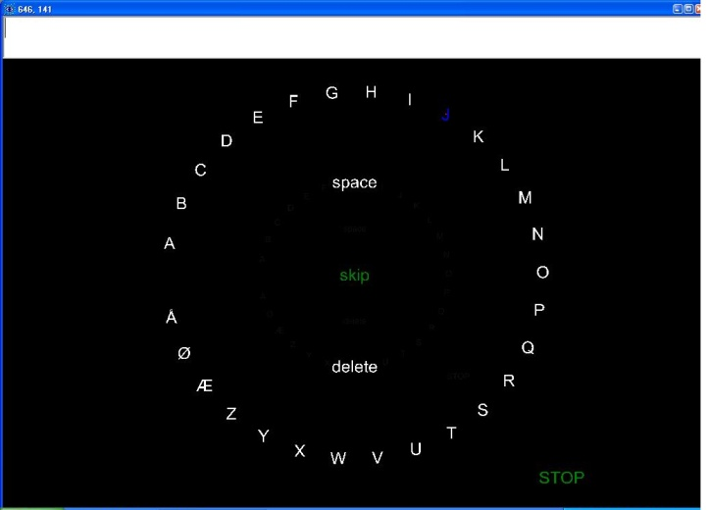  Figure 1. The StarGazer prototype system. | 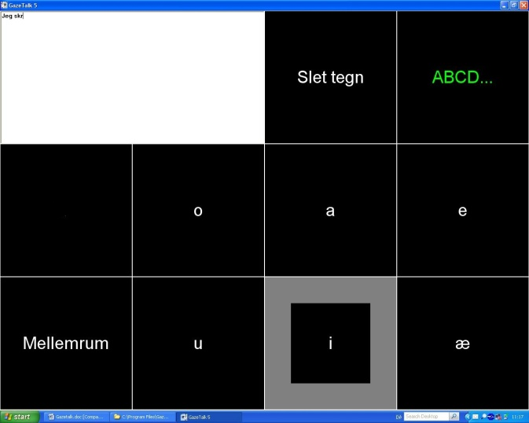  Figure 2. GazeTalk (version 5.2.2).
Participants
7 participants (2 women, 5 men, ranging from 20 to 35 years old), recruited from campus and nearby university, volunteered to participate in the experiment. All had normal or corrected-to-normal vision and 4 of the participants had prior experience with gaze interaction.
Apparatus
A 17” monitor with a resolution on 1280 x 1024 presented the typing interfaces. A 1.86 GHz Intel Dual Core PC with 3 GB RAM running Windows XP was used for the experiment. The mouse was a standard optical mouse and distance to screen was approximately 60 cm.
The gaze tracker is based on a Sandberg Nightvision web camera with a resolution of 320 x 240 pixels and 30 frames/sec. The camera has six built-in infrared lights that create a dark pupil effect. The gaze tracking algorithm tracks one eye and uses the pupil centre to determine the gazed coordinates on the screen. No hardware modifications are required.
The camera is mounted on a piece of balsawood placed between the user’s teeth. An armchair was used to provide some support for the head during the test.
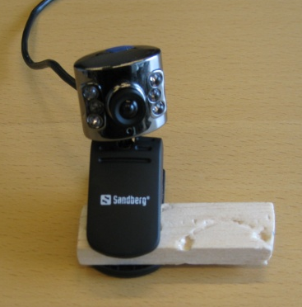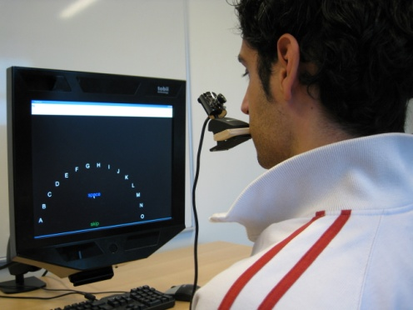
Figure 3. The input device. Sandberg web camera mounted on a piece of balsawood. | Figure 4. The input device in use. The user bites the balsawood and is depicted typing with the StarGazer application.
Task and procedure
The users were asked to type selected sentences (with an average of 25 characters per sentence) as quickly and accurately as possible. The sentences were Danish translations of the phrase set by Mackenzie and Soukoreff (2003).
No participant entered the same sentence more than once. After completing a sentence, the next was immediately shown to the user and a break was offered after five sentences. Before each block the participants were allowed to adjust the activation time themselves with an average final setting in the last session of 1375 ms for StarGazer with zoom activation and 403 ms for GazeTalk with dwell time activation.
Design
The within-subjects experiment tested the following four conditions and the design was repeated over three sessions: Stargazer with zoom activation, Stargazer with mouse click activation, GazeTalk with dwell time activation and GazeTalk with mouse click activation. A total of 420 sentences were typed (7 participants x 3 sessions x 4 conditions x 1 block x 5 sentences). The conditions were counterbalanced in order to neutralize learning effects.
The performance metrics measured were WPM (words per minute) and MSD (minimum string distance). One word is defined as five characters including space. According to Mackenzie and Soukoreff (2002) the MSD should not be reported alone as it only reflects the errors in the final sentence. Therefore, we match it to NDC (number of deleted characters).
Results
Three one-way ANOVAs were conducted to compare the effects of interaction technique (StarGazer zoom, StarGazer mouse, GazeTalk dwell, GazeTalk mouse) on WPM, MSD and NDC. Figure 5 shows the average WPM, MSD and NDC. Sentences with an MSD value above six (49 out of 420) were considered to be outliers and thus removed prior to analysis.
The grand mean for WPM was 4.90. There was a significant effect from typing method on WPM, F(3, 18) = 30.67, p < 0.05. An LSD post-hoc analysis showed that WPM with GazeTalk was significantly higher than with StarGazer. No difference was found between click activation and dwell/zoom activation within each typing technique.
Typing method did not have a significant effect on MSD, F(3, 18) = 0.417, p > 0.05, but it did on NDC, F(3, 18) = 3.51, p < 0.05. An LSD post-hoc analysis showed that GazeTalk with dwell had a lower number of deleted characters than StarGazer with mouse.
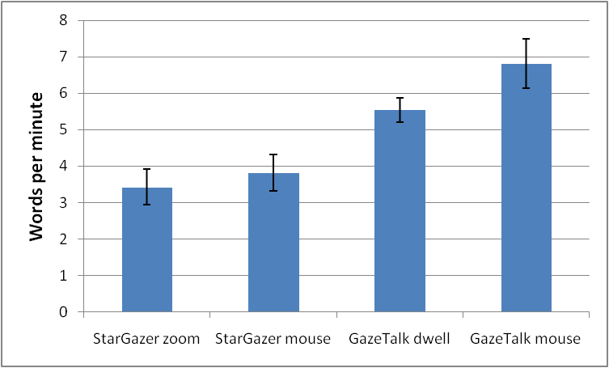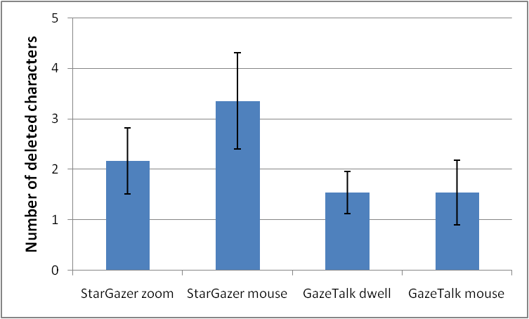
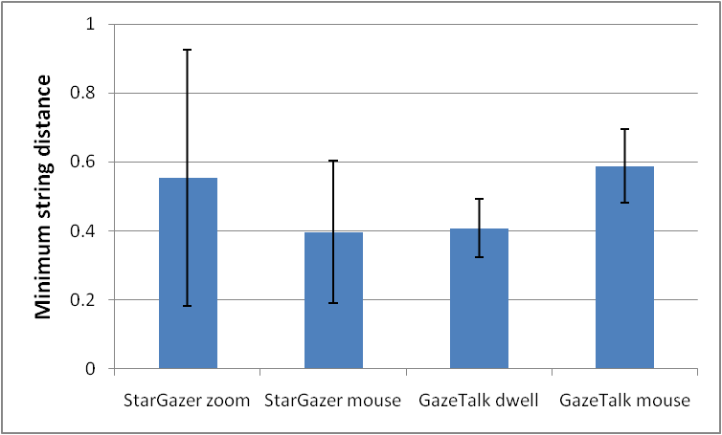
Figure 5. Average WPM, NDC and MSD for each typing method. Error bars show the standard error of the mean.
Discussion
Overall, the low-cost gaze tracker was usable for text entry with both applications. Text-entry speed was lower compared to other studies (e.g. Tuisku et al., 2008). However, in our experiments we did not use word prediction. Contrary to Zhang and Mackenzie (2007) we have not found significant effect of click activation.
GazeTalk obtained significantly higher typing speeds than StarGazer. However, typing speeds are not comparable between the applications due to the effect of letter prediction and difference in activation time. The theoretical upper limit for typing speed with the average activation time used in GazeTalk with dwell time activation in the last session (403 ms) is 29.8 WPM. This does not include reaction time and assumes that all desired letters are among the six most likely. With an activation time of 1375 ms it is not possible to produce writing speeds above 8.7 WPM. This can explain why GazeTalk produced significantly faster typing speeds than StarGazer.
After calibration of the mouth-mounted gaze tracker, even the slightest movement introduced a large offset relative to the screen which participants could compensate for by adjusting the head position in relation to the monitor. These adjustments were easier to perform in GazeTalk’s grid-based interface than in StarGazer’s zooming interface as the there are no fixed objects in StarGazer to use as reference points.
The weight of the camera and biting the balsawood did not cause any problems once the users got used to the input device. Only in the first session, the users averagely reported discomfort in mouth/jaw and on average no discomfort was reported in the succeeding sessions.
The typing speeds for GazeTalk with dwell time activation found in this experiment compare well to those found by Hansen et al. (2004) on a commercial gaze tracking system. In their experiment GazeTalk with dwell time activation (500 ms) obtained 6.26 words per minute on the second day (of two). On the third session of our experiment the users had approximately the same amount of practice with the system as the second day in Hansen et al.’s experiment due to different session lengths. In our experiment the final typing speed for GazeTalk with dwell time activation was 6.6 words per minute.
In a previous StarGazer study (Hansen et al., 2008), users typed with a fixed activation time resulting in an average speed of 4.7 WPM. The difference to the average typing speed for StarGazer with zoom activation in our experiment (3.4 WPM) can be explained by the use of a short, well known text string as typing task in Hansen et al.’s experiment.
Conclusion
Typing was possible with both eye typing applications, and click activation did not affect performance significantly. The results indicate that low-cost technology holds potential for being used for gaze interaction. The primary reason why StarGazer cannot reach the typing speed of GazeTalk is that it is possible to use shorter activation time with GazeTalk. For typing with applications designed for noisy gaze interaction, the writing speed of the low-cost gaze tracker compares well to a commercial gaze tracker. Comparing typing speeds to previous experiments, GazeTalk with dwell time activation achieves almost similar results (6.6 WPM achieved in this experiment compared to 6.26 WPM) Stargazer with zoom activation (3.4 WPM) does not quite reach the writing speeds found in earlier experiments (4.7 WPM), but the primary cause of the discrepancy is considered to be due to difference in difficulty level of the tasks.
References
Hansen, D. W., Hansen J. P., Skovsgaard H. H. and Møllenbach E. (2008) Noise Tolerant Selection by Gaze-
Controlled Pan and Zoom in 3D. Proceedings of the 2008 Symposium on Eye Tracking Research & Applications, ACM, pp. 205-212.
Hansen, J. P., Tørning K., Johansen A., Itoh K., and Aoki H. (2004) Gaze Typing Compared to Input by Head
and Hand. Proceedings of the 2004 Symposium on Eye Tracking Research & Applications, ACM, pp. 131-138.
MacKenzie, I. S. and Soukoreff, R. W. (2002) Text Entry for Mobile Computing: Models and Methods, Theory and Practice. Human-Computer Interaction, 17, Lawrence Erlbaum Associates, pp.149-198.
MacKenzie, I. S. and Soukoreff, R. W. (2003) Phrase Sets for Evaluating Text Entry Techniques. CHI '03 Extended Abstracts on Human Factors in Computing Systems, ACM, pp. 754-755.
Majaranta, P., Aula A., and Räihä, K. J. (2004) Effects of Feedback on Eye Typing With a Short Dwell Time.
Proceedings of the 2004 Symposium on Eye Tracking Research & Applications, ACM, pp. 139-146.
San Agustin, J., Skovsgaard H.H., Hansen J. P. and Hansen D. W. (2009) Low-Cost Gaze Interaction: Ready to Deliver the Promises. CHI '09 Extended Abstracts on Human Factors in Computing Systems. ACM.
Tuisku, O., Majaranta, P., Isokoski, P. and Räihä, K. Now Dasher! Dash away!: Longitudinal Study of Fast
Text Entry by Eye Gaze. Proceedings of the 2008 Symposium on Eye Tracking Research & Applications, ACM, pp. 19-26.
Zhang, X. and MacKenzie, I. S. (2007) Evaluating eye tracking with ISO 9241 - Part 9. Proceedings of HCI International 2007, Springer Heidelberg, pp. 779-788.

