Evaluating susceptibility of karst dolines (sinkholes) for collapse in Sango, Tennessee, USA

Peter P. Siska¹, Pierre Goovaerts² and I-K Hung³

Peter P. Siska
(Department of Geography and Environmental Science,) Liverpool Hope University, UK
Pierre Goovaerts

BioMedware, MI, USA

I-Kuai Hung

(College of Forestry and Agriculture,) Stephen F. Austin University, USA

¹ Department of Geography and Environmental Science, Liverpool Hope University, Liverpool, UK
²BioMedware, Ann Arbor, MI, 48104 USA
³College of Forestry and Agriculture, Stephen F. Austin University, Nacogdoches, TX, USA

Corresponding Author:

Peter Siska, Department of Geography and Environmental Science, Liverpool Hope University, Hope Park, Liverpool, L16 9JD, UK
Email: siskap@hope.ac.uk

Abstract
Dolines or sinkholes are earth depressions that develop in soluble rocks complexes such as limestone, dolomite, gypsum, anhydrite, and halite; dolines appear in a variety of shapes from nearly circular to complex structures with highly curved perimeters. The occurrence of dolines in the studied karst area is not random; they are the results of geomorphic, hydrologic, and chemical processes that have caused partial subsidence, even the total collapse of the land surface when voids and caves are present in the bedrock and the regolith arch overbridging these voids is unstable. In the study area, the majority of collapses occur in the regolith (bedrock cover) that bridges voids in the bedrock. Because these collapsing dolines may result in property damage and even cause the loss of lives, there is a need to develop methods for evaluating karst hazards. These methods can then be used by planners and practitioners for urban and economic development, especially in regions with a growing population. The purpose of this project is threefold: 1) to develop a karst feature database, 2) to investigate critical indicators associated with doline collapse, and 3) to develop a doline susceptibility model for potential doline collapse based on external morphometric data. The study has revealed the presence of short range spatial dependence in the distribution of the dolines’ morphometric parameters such as circularity, the geographic orientation of the main doline axes, and the length-to-width doline ratios; therefore, geostatistics can be used to spatially evaluate the susceptibility of the karst area for doline collapse. The partial susceptibility estimates were combined into a final probability map enabling the identification of areas where, until now, undetected dolines may cause significant hazards.
Keywords
Karst, dolines (sinkholes), geostatistics, kriging, doline morphometric parameters, GIS

I Introduction
In the classical understanding of karst science, atmospheric water enriched by carbon dioxide creates special landforms in soluble rock complexes known under the name “karst”- an adaptation of the Slavic term “kras” (Cvijic, 1893). Since the time of Jovan Cvijic, dolines (or sinkholes) have been considered to be one of the most common diagnostic karst features (Ford 2007). The Slavic term “dolina” refers to a concave shaped land surface, depression, dent, or even a valley, i.e. everything that is ‘down’ is described by the term ‘dole.’ Consequently, “dolina” is a land surface that has been shaped downwardly and probably originated from a fluvial process, tectonic activity, wind erosion, water corrosion or combination of two or more processes together. There are often inconsistences and misunderstandings in the translation of the English-Slavic karst equivalents (Kemmerly and Siska 2008), so special attention should be paid to the correct meaning of terms that were originally derived from the Dinaric karst (Sustersic 1998; Ford, 2007). Most definitions of dolines or sinkholes refer to an oval shape, a closed depression with internal drainage (Ford and Williams, 2007, Gilli and Fandel, 2011). There are several classifications of dolines used in karst science; however, the use of binary classification has been prevalent since the late 19th-century. For example, the division between the collapse and erosion dolines in Dinaric karst was a controversial subject of discussion between Tietze and Mojsisovic (Tietze, 1880). Cramer (1941) was also attributed with the first published doline classification into collapse and solution (subsidence) dolines; the collapse dolines are described by the dissolution along systematic joints or joint intersections, while solution dolines are explained by the dissolution of fractures and non-systematic joints in soluble bedrock. In contrast, Gutierrez et al. (2014) divided dolines into solution and subsidence dolines, associating the latter ones with hazards. Apparently, the structural geomorphology of dolines is more complex than binary classifications can explain. Waltham et al. (2005) introduced six types of dolines: solution, bedrock collapse, cap rock collapse, cover collapse, suffusion and buried dolines. Moreover, Gutierrez el al. (2008) proposed “process-material” based criteria for doline classification. The term ‘material’ consists of three categories depending on the origin of the doline: cover, bedrock or caprock (Dogan 2005); the ‘process’ can be collapse, suffusion or sagging, so the combination of any process and material category describes a specific doline. This study focuses on the cover-collapse dolines in the Middle-Tennessee region; however, due to the ambiguity of the term ‘cover’, we propose to use a more material specific term: ‘regolith’ and name these dolines the ‘regolith-collapse dolines’. The collapses of dolines in the study area usually occur in the cherty, clayey, and silty regolith that overlays enlarged joints in the bedrock when the regolith arch is wetted by surface or underground water. The correlation of doline collapse with the properties of regolith (cover) rather than carbonatic bedrock was first noted by Jennings (1966).
Due to the processes associated with the evolution of dolines, karst can be one of the most hazardous environments, especially when sudden vertical movements of ground occur due to cavities and voids in the bedrock. The damage caused by land subsidence and collapsing dolines in the United States has already cost millions of dollars (Galloway et al., 2000). The Florida Senate Interim Report 2011-104 notes that in the state of Florida alone, total doline/sinkhole losses for closed and open claims combined increased from $209 million in 2006 to $406 million in 2009 (Committee on Banking and Insurance, 2011). The Florida region is also considered as one of the most sinkhole infested areas in the United States based on the density of sinkholes; the calculated value of 7.94 km² is the highest among the investigated regions (Brinkmann et al., 2008). Another example is Kentucky where over half of the area is karstic, and the karst related geologic hazards are costing the state government $20 million annually; in addition, the cost of livestock and injuries to people should also be included (Current, 2012a,b). Perhaps the most publicized event in Kentucky occurred in Bowling Green where a sudden sinkhole collapse swallowed several cars at the Corvette Museum (Scholastic News 2014). In Spain, one single collapse occurring in evaporite karst in 1998 caused 18 million euros worth of damage, and another one in 2003 came to 4.8 million euros; the cost of human lives is impossible to estimate. The most recent studies from Spain (Carbonel at al., 2015) has reported significant economic losses in urban areas caused by active subsidence, predominantly in evaporite karst. Moreover, a sudden collapse in South Africa in the dolomite karst caused 34 fatalities (Gutierrez et al., 2008). Another example is in China where soluble rocks cover almost four million squared kilometers; geographically, they are located mostly in the southeastern part of the country where the population density is extremely high. According to Lei et al. (2002), over 1,400 sinkhole collapses and 45,000 collapse pits occurred in the southeastern part of China and annual losses amounted to over 1.5 billion Yuan (circa 210 mil of euros). Just one collapse in the Hongshan District, Wuhan city, Hubei Province swallowed two buildings, damaged sixteen more, and caused 900 residents to lose their homes. Given the seriousness of karst hazards, there is definitely an urgent need to assess karst susceptibility to doline collapse. Even though there is no total cost assessment available from the study area, the damages associated with annual property loss and road repairs are significant; for example, a 40 ft wide doline collapse was recently reported at Austin Peay State University (APSU 2014) causing significant property damage. The Tennessee Department of Transportation has reported using thousands of tons of rock material to plug sinkholes that damage the transportation network in Tennessee (TDoT 2016). These are just two examples where sinkholes cause loss and destruction to society every year, but there are many more such cases.
Therefore, how should experts deal with these hazards? Over the last two decades, Geographic Information Systems (GIS) has become an important tool and has been increasingly used for mapping karst and creating karst databases (Gao and Zhou, 2008; Gao and Alexander, 2003; Gao et al., 2002, Siska and Kemmerly, 2008; Kobal et al., 2014). Gutierrez et al. (2014) calls karst inventories ‘the most important step in hazard analysis.’ For the last decade, the study of dolines using remote sensing was also extended to the planet Mars where the existence of dolines in evaporite karst has drawn an increasing amount of attention from the research community (Baioni et al., 2015). The reliability of sinkhole susceptibility and hazard maps as well as the effectiveness of mitigation measures rely on the completeness, accuracy and representativeness of dolines inventories. Similarly, Galve et al. (2009), Siska and Kemmerly (2007) recognize karst inventory as the first step in predicting doline hazards. One of the most powerful functions in GIS is overlays. Florea (2005) studied the coincidence between the spatial distribution of digitized dolines and geological structures in the Kentucky karst region using GIS overlay. In addition, Yilmaz (2007) identified the impact of four groups of parameters causing doline collapse in gypsum karst in the Hafic region; these factors were: lithology, hydrology, topography and vegetation. Therefore, it is also possible to select the optimal number of factors from a large set of variables. For example, in the Ebro Valley in Spain, the six most influential variables out of 27 variables were selected for doline collapse model development. These parameters were: distance to ditches, geomorphology, alluvium thickness, lithological gradient, electrical conductivity, and gypsum saturation index (Galve et al., 2008). Koutepov et al. (2008) used GIS to map extreme parameters of possible doline collapses, in particular, the stability coefficient and the maximal doline diameter of the cavity. The diagnostic doline parameters that control the evolution of doline morphology and usage of sophisticated functions to model the relationships between basic doline parameters is highlighted also by Sustersic (1998, 2006). Simple doline parameters, such as perimeter and area, can be computed directly from digitized topographic maps; whereas new functions can be implemented to derive advanced parameters leading to karst hazards (Zboray et al., 2005; Denizman, 2003; Schoenholtz, 2006).
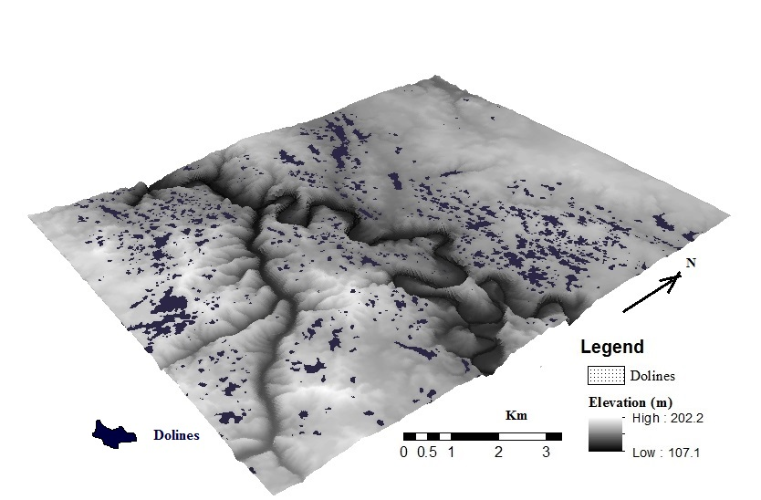
Figure 1. Distribution of dolines and topography in the studied area (topography is exaggerated).

In this project, 908 dolines (Figure 1) were digitized from the Sango topographic quadrangle and data saved in karst feature database. The set of doline parameters developed and stored in the karst feature database included: the area, depth, volume, length of the long and short doline axes, ratio between long and short axis, the azimuth of the doline long axis and circularity index (the ratio between the doline perimeter and the perimeter of a circle with the same area). The depth of each doline was estimated as the difference in elevation between the top and bottom contours using GIS two ft contour data. Lengths of the long and short doline axes, as well as the azimuth for the long doline axis orientation, were derived using X-tool subroutines. The doline volume for this database was estimated using the oblate spheroid model:
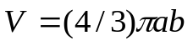 [1]
where “a” and “b” are the length of the long and short axis of the doline, respectively.
This doline volume data can be used for evaluating flood hazards, especially if houses are built below the dolines’ perimeters. Flooding occurs when rain input is greater than the drainage capacity of the doline swallets, and the doline volume parameter identifies the amount of water that can be captured and stored by a doline when its swallet either does not exist (solution dolines) or drainage by the swallet is not sufficient often due to increasing amount of sediment input. The increase of sediments in dolines is a result of urbanization and residential development because urbanization causes changes in the vegetation, soil erosion and sediment transport; this has been documented in other parts of the Tennessee karst (Hart, 2014).
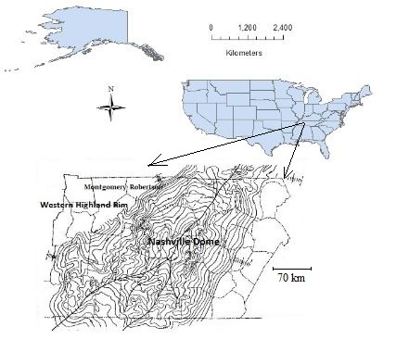
Figure 2. The Nashville Dome and Western Highland Rim.
II Study area
The Sango area is partially located within the city of Clarksville, Tennessee, a rapidly growing urban center that has expanded into the surrounding rural environment. Geologically, Sango is located north of the Nashville Dome, which is an Ordovician geologic structure that has been remodeled by erosion processes into a low significant depression known as the Central Basin (Figure 2). The Central Basin is surrounded by sharply rising questas of the carbonatic Mississippian Highland Rim that continue north into the Pennyroyal Plain. Moreover, the study area is in the northwestern part of the Highland Rim, east and southeast of the city of Clarksville in the transitional zone between the Pennyroyal Plane and the Western Highland Rim. The carbonatic rock complexes of the Pennyroyal Plain have been built by Ste. Genevieve and St. Louis limestones, and they have high levels of calcite (91% - 97%). However, the Highland Rim is built from Mississippian rock complexes (limestone, dolomite, chert, shale, siltstone and sandstone) containing a lower level of calcite (Figure 3).
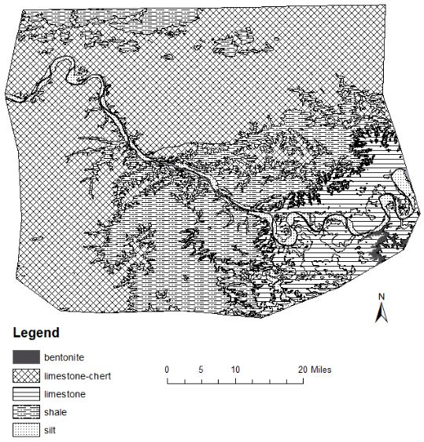
Figure 3. Geology setting (Adapted from a USGS geology map).
1 Systematic joint sets
The systems of joint sets play a significant role in the development of karst depressions and the hazards posed by them. The two major groups of joints that control the development of dolines are the three systematic joint sets (prime dolines) and the two systematic joints sets (secondary dolines). The three systematic joint sets have the following azimuths: 20º to 40º, 70⁰ to 80º and 330º to 340º in the southwest, and from 10º to 20º, 40º to 50º, and 320º to 330º in the northeast part of the area (Kemmerly 1986, 2007). Azimuth is measured clockwise from the north designated as 0. The surface of the karst terrain consist largely of a clayey, cherty residuum (regolith) covered by silty colluviums and loess. The three systematic joint sets and especially their intersection loci have provided the most efficient initial routes for surface water infiltration into the St. Louis and Ste. Genevieve geologic materials, exhibiting little primary porosity and permeability. Infiltration concentrated at points of multiple joint intersections allows the greatest volume of water to move into the subsurface. As geochemical processes continue, the carbonatic bedrock, cut by three systematic joints, weathers into regolith. Regolith defines the entire weathered zone down to the parent material.

2 Sequential regolith-collapse dolines
The residuum (regolith) derived from St. Louis and Ste. Genevieve rocks typically consists of cherty pebbles and cobbles 0 to 20 meters that are incorporated into a strongly mottled clay matrix. Depth to bedrock ranges from 4 to 15 m in thickness. The doline collapses are usually triggered by the ground water level dropping when the regolith arch loses the support of the declining water table. Due to tectonic conditions and consequently the more aggressive removal of sediments into the underground at the triple joints junctions, the development of dolines in Sango is sequential - there is a regular spatial-temporal sequence that begins with the development of the larger (prime) dolines followed by the development of solution (secondary) dolines in the proximity of prime dolines. These prime dolines have conduits beneath them, while the secondary dolines have no voids or conduits beneath them. Therefore ‘a sequential’ regolith-collapse doline classification, in which the existence of secondary depressions depends on the formation of much larger and steeper primary dolines, is more appropriate for the study area than the ‘material-process’ classification proposed by Gutierrez et al. (2008).
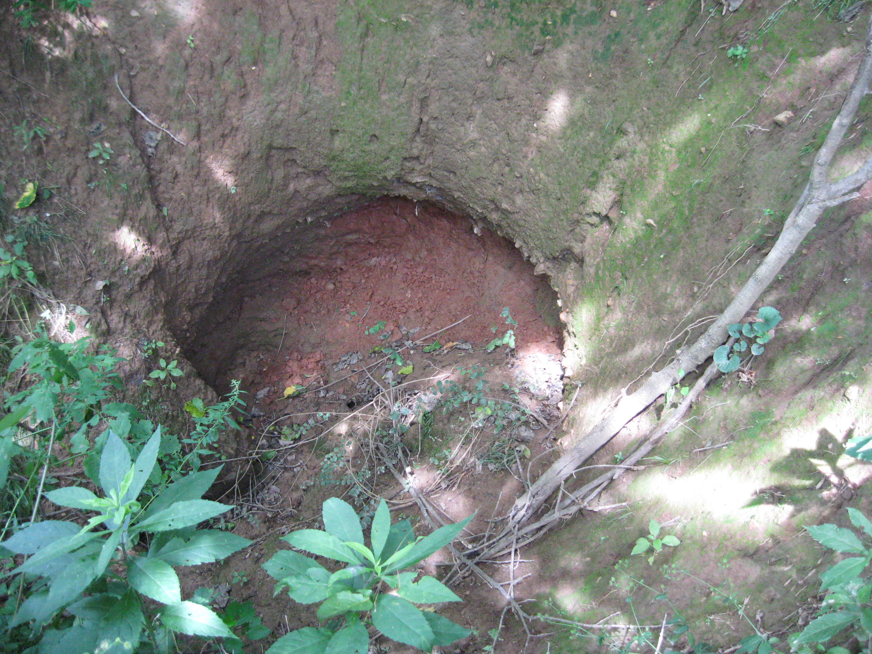
Figure 4. Swallow hole (swallet) of a newly identified doline.
The southeastern and eastern expansion of Clarksville has been facing numerous problems due to land subsidence, doline collapse, and flooding; on average, there are 5.877 dolines per square kilometer in this area. One example was a doline recently discovered by the authors about 10 km northeast of Clarksville; it measured twenty meters in diameter and was ten meters deep; it contains a one meter diameter swallet that has been draining precipitation water to an underground cave system (Figure 4). The number of dolines originated in a zone along the Red River that has created a karst canyon; the river is joined in the west by the Passenger Creek flowing from the southeast to northwest (Figure 1). The southwestern portion of Sango (west of the Passenger Creek) is largely infested by numerous dolines; this area is already inside the Clarksville urban development as is the area in the northwest. In addition, the digital elevation model overlaid by the doline layer indicates that higher elevations are infested by smaller and more circular dolines, while the lower depressions contain larger dolines with a complex morphometry (Figure 1).

III Research design and methodology
In this paper, we propose to evaluate the potential for doline collapse using basic doline morphometry and geostatistics (Figure 5). The advantage of this method is its simplicity, low cost, and effectiveness; it evaluates hazards based on externally observed characteristics that are readily available through topographic maps and/or remote sensing images.
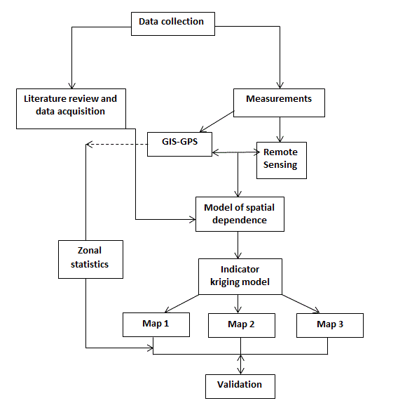
Figure 5. Flow chart of the methodology to create and validate the collapse doline susceptibility.
In addition, geostatistics is used to predict the attribute values at unsampled locations and link the model components with the data. Incorporating geostatistics into karst research is rare; Park et al. (2010) used a non-linear indicator transform method and simple kriging with varying means, integrating 2-D electrical resistivity and gravity data and producing 3-D cave imaging as well as the spatial distribution of resistivity values in the Youngweol-ri region of South Korea. Similarly, Kaufmann et al. (2009) and Kauffman (2014) used geophysical data and geostatistical methods to map zones of karstic constraints in the Walloon region, Belgium. At this point however, there have been no studies conducted to investigate the spatial continuity of doline morphometric parameters in relation to forecasting karst hazards. Our model is based on the indicator kriging method. This geostatistical approach builds on the understanding of spatial dependence in doline morphometry and non-parametric geostatistical methods. Due to the variation in environmental conditions (hydrosphere, lithosphere, pedosphere, atmosphere, biosphere and anthroposphere), the prediction of karst hazards is a complex task. We perceive doline collapse as a stochastic process that occurs with a certain level of probability; the key question is to find and model spatial parameters that are correlated with collapse.

1 Morphometric analysis and critical parameters
Dolines are complex earth features that can be described by a set of external and internal parameters. Internal characteristics of dolines such as age, lithological properties of bedrock, chemistry of water, the size of voids and cavities are not necessarily obvious to the naked eye. In contrast, the external characteristic are easy to recognize or can be directly measured in the field from remote sensing images and topographic maps. Is there a link between the external parameters and internal processes? Research indicates that the external characteristics of dolines can be indicators of more complex internal karst processes. For example, the circularity of dolines has been connected to a geologic age (Brinkman et al., 2008), and the density of dolines indicates the level of karstification (Schofner and Mills, 2001). In addition, doline spatial dispersion patterns can be measured by the nearest neighbor index and used to compare oceanic versus dry karst environments (Radulovic, 2013). Perhaps the most special group consists of indicators that are linked to doline collapse. The annual reports from Kentucky documented 247 cases of doline collapse with an average diameter of 3.1, depth 2.6 m and ratio of long versus short doline axes being equal to 1.3 (Currens, 2012). In addition, a stability coefficient developed by Koutepov et al. (2008) is inversely proportional to the sinkhole cylinder diameter. Similarly Kemmerly (1986, 2007) recorded numerous collapsed dolines in the studied area with ratios of long to short doline axes below 1.8. The field investigation conducted in the study area and adjacent neighborhood are summarized in Figures 6a and 6b. Dolines, with the long axis oriented in parallel with the three systematic joints and more circular shapes, develop hydrologic conditions conducive to the rapid removal of materials into the subsurface voids, thus increasing the risk of collapse. The line in the Figure 6a separates dolines with the length-to-width ratios greater and less than 1.8. The dolines in the upper part of the graphs indicate collapse.

2 Indicator kriging model
In order to predict and map the probability of occurrence of two particular events: 1) the alignment of the long axis of doline orientation with one of the three systematic joints, and 2) the length-to-width ratio not greater than a certain value, indicator kriging was the most appropriate method. The attribute of interest is thus binary (yes/no) or categorical, and coding the data as indicators and interpolating them using kriging was the most straightforward way to proceed
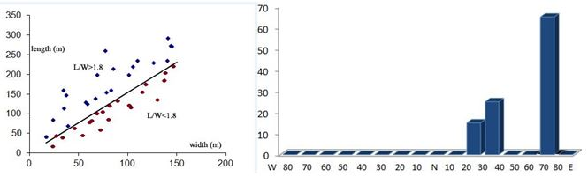
Figure 6. (a) The plot of length-to-width ratios (left). The straight line separates L/W ratios above and below the 1.8 level. Dolines below the line collapsed, while dolines above the line were stable (the data were collected in the field). (b) Number of collapsed dolines (vertical axis) and the orientation of the long doline axis in degrees of azimuth (horizontal axis).

(Goovaerts 1997). The first step was to derive the following two indicators for each doline geolocated by a vector of geographical coordinates u_{α}:

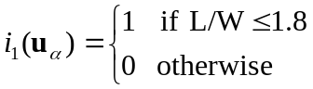 [2]
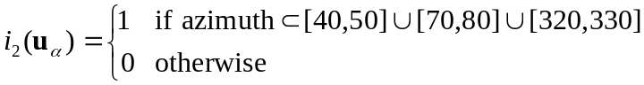 [3]
The spatial connectivity of these two sets of indicators was then quantified and modeled using the indicator variogram that was estimated as:
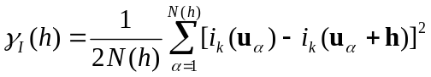 k=1,2 [4]
where the indicator value of i_{k} (length-width ratio or alignment of long axis given in degrees of azimuth) at location u_{α} is paired with another indicator value a lag distance h away. Last, the probability for the occurrence of each event was estimated at the nodes of a 200 m spacing grid by applying ordinary kriging to indicators (2) and (3). The kriging estimate at node u₀ was written as:
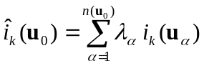 [5]
where λ_{α} are kriging weights that are solutions of the following system of linear equations:
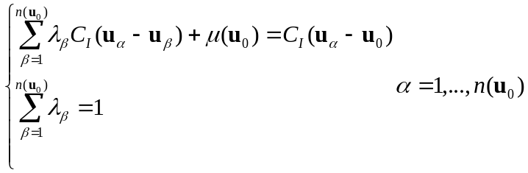 [6]
The indicator covariance function C_{I}(h) was derived by subtracting the model fitted to the experimental indicator variogram [4] from the sill.
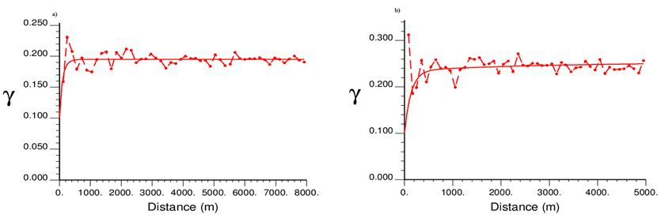
Figure 7. (a) Omnidirectional experimental indicator variograms with the model fitted to dolines (sinkholes) that run in parallel to one of the three systematic joints in the study area. (b) Omnidirectional experimental indicator variogram with the model fitted to L/W ratio that does not exceed the 1.8 cutoff value.

The 200 m spacing of the interpolation grid was derived from the indicator variograms (Figures 7a and 7b), and corresponds to the first lag of the variogram which is the shortest distance between the individual observations. The step labelled as “Model of spatial dependence” (Figure 5) involves the variogram modeling of doline morphometric parameters, and Figures 7a and 7b show the experimental indicator variograms for the two doline parameters with the model fitted using the least-square regression. Both variograms have a large nugget effect due to the significant short term variation, and the measurement errors are attributed to the accuracy of digitizing dolines from topographic maps.
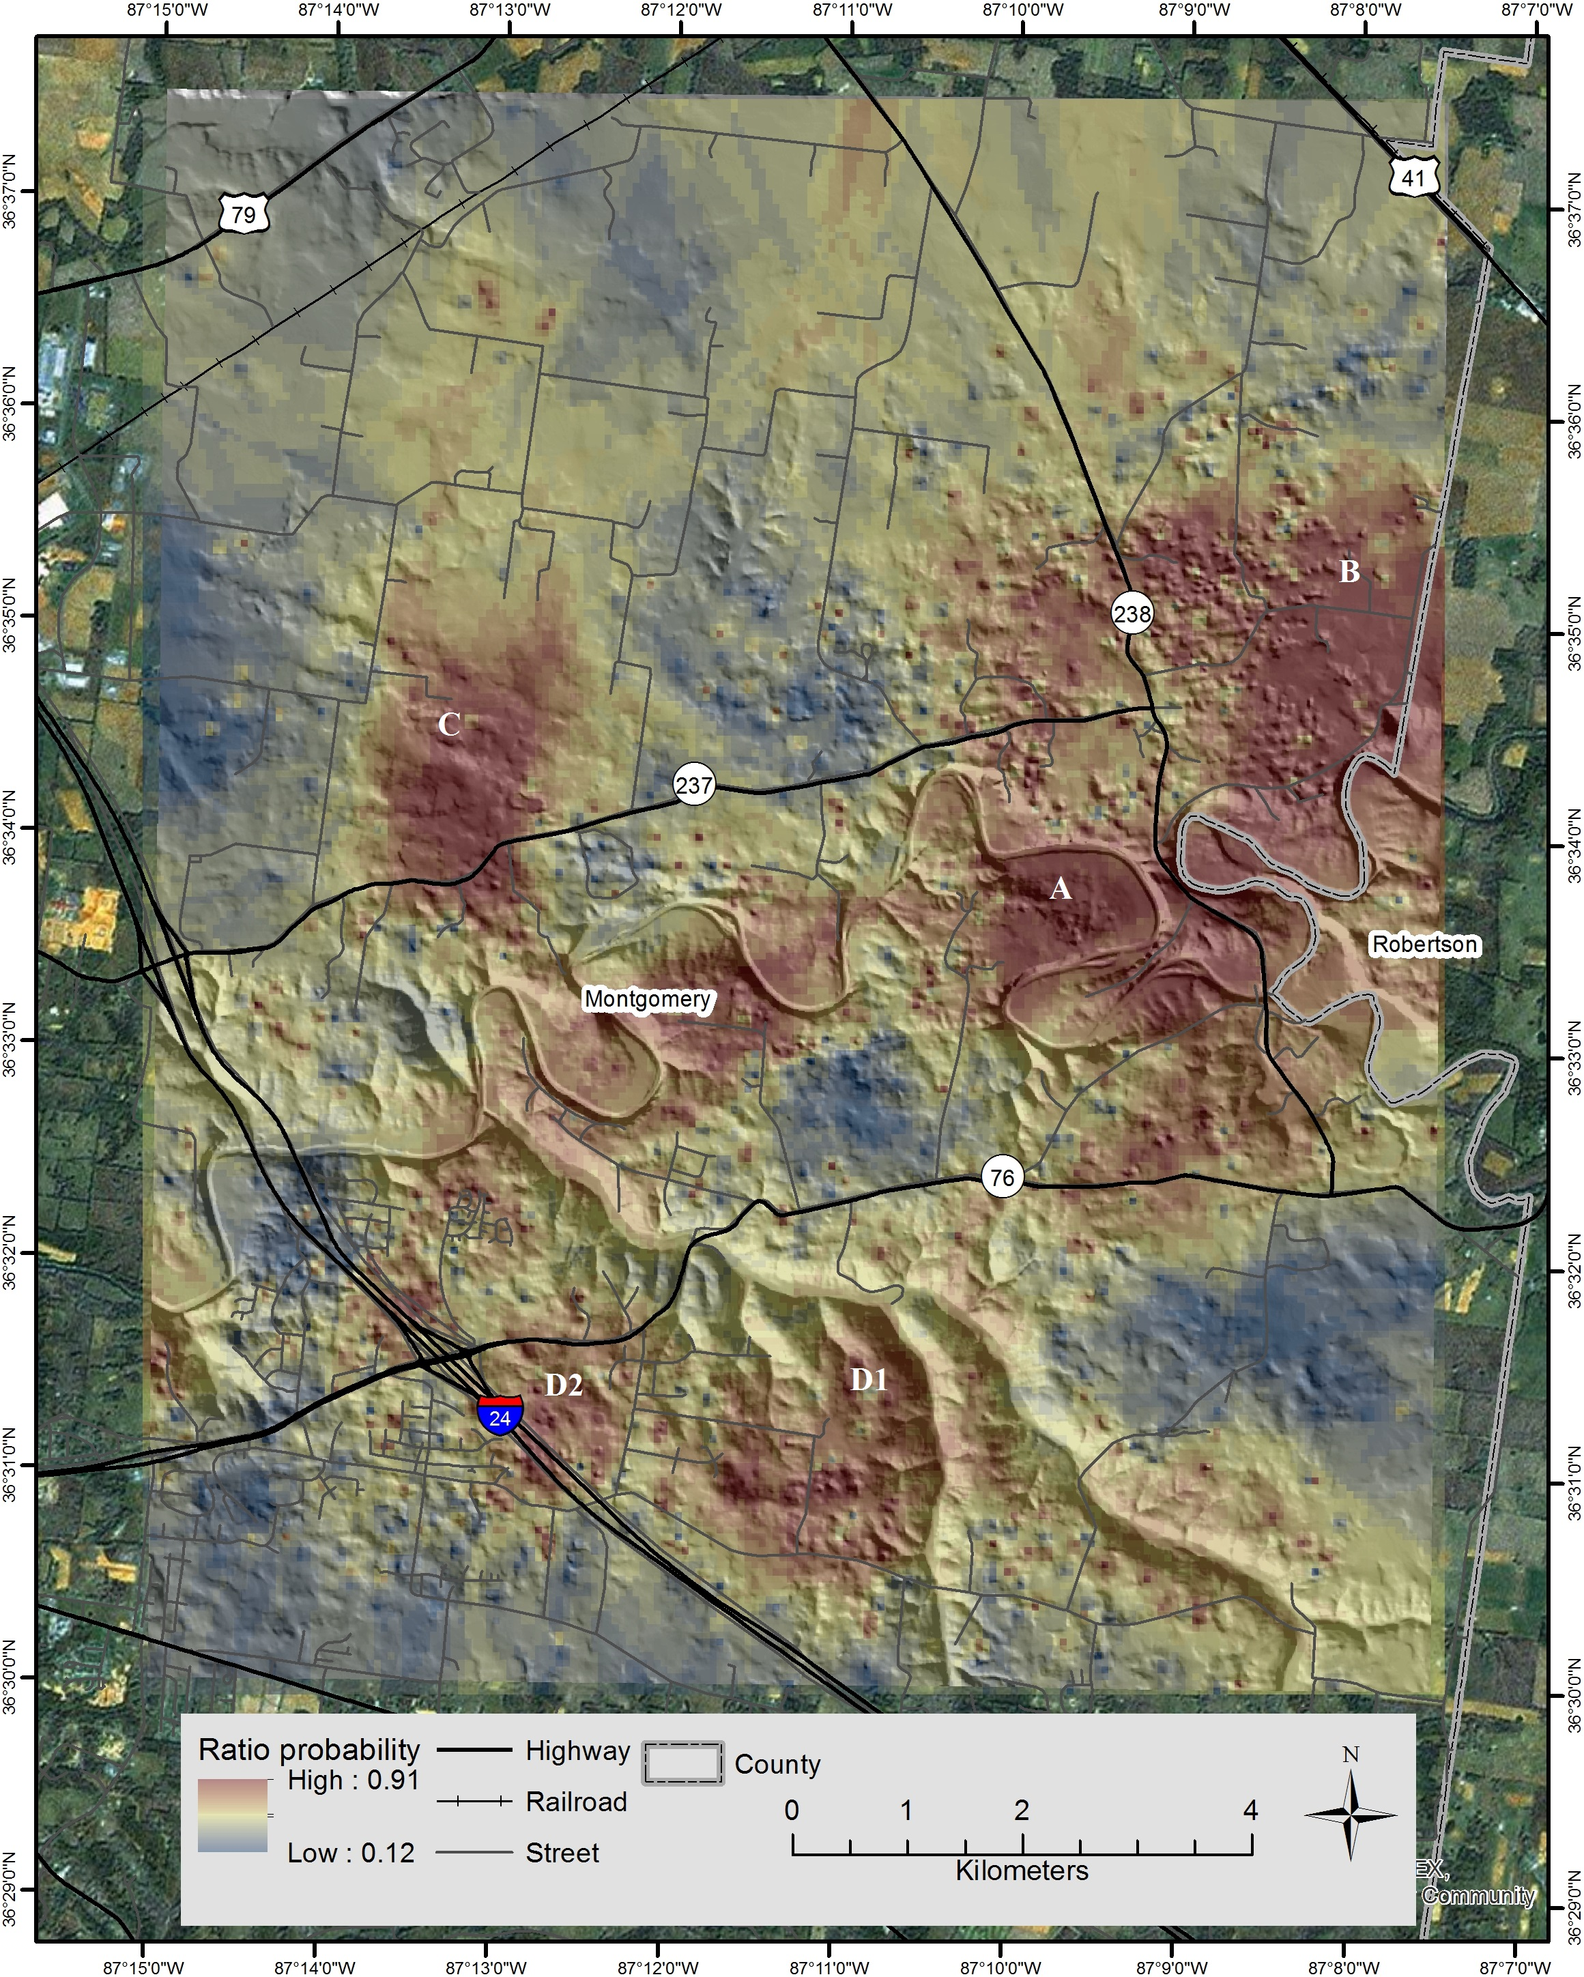
Figure 8. The length-to-width (L/W) ratio susceptibility map; higher probabilities correspond to higher risks of collapse with respect to the L?W parameter.

IV Results
The spatial variation of karst hazards in the study area provides useful information for planning urban and residential development. The results are presented in the form of three spatial models: the first indicates the susceptibility of dolines to collapse based on the probability of the length-to-width doline ratio being at or below a critical value; the second model evaluates the susceptibility using the alignment of the long doline axes; and the final analysis is based on the combination of the two previous models.

1 Doline collapse - critical parameter: length-to-width ratio
The high susceptibility regions for doline collapse have developed along the northeast – southwest direction between the Robertson County boundary in the East and Interstate Highway 24 in the West. This spatial pattern consists of several regional units that are marked in Figure 8 with capital letters. The largest hazardous patch begins along the Red River east of Ford Road towards Highway 238 (marked as A); it stretches along elongated meanders north of Port Royal and east and northeast along Sadlersville Road to the town of Sadlersville, east towards Adams, and southwest towards Clarksville (marked on the map with the symbol B). Therefore, the sub-regions A and B represent one continuous area bending north along the Robertson County boundary.

The next patch of high probabilities of doline collapse is geographically located north of Rossview Road (marked as C). This area is significantly smaller than the previous region; however, it poses a hazard to Highway 237 and to the new residential area called Stone Manor that has begun to expand as part of Clarksville’s urban development. The third region is “squeezed” between Interstate Highway 24 and Passenger Creek; it is split into two sub-regions marked on the map as D1 and D2. Even though this area indicates slightly lower probabilities of critical ratios, it is more significant due to the importance of transportation lines and pipelines that run across this area as well as the growing urbanization.

Landuse. From a planning and urban development perspective, this area is partially used for recreation and nature conservation as well as for pasture and agriculture. Geologically, it belongs to the Western Pennyroyal Karst that appears here in the form of a flatter irregularly shaped topography with fewer perennial streams. Pastures dominate inside the widely elongated Red River meanders. The distribution of these pastures, with patches of oak-hickory forests, is remarkably well aligned with the predicted high probabilities of collapse. The “Rossview” subregion is also identifiable on the surface by landuse; it is dominantly pastoral. It is noteworthy that the landuse and predicted karst hazards areas match; this indicates that the people have learned to live in an environment where natural hazards are a part of life. Nevertheless, there is some overlap between the growing residential areas of Clarksville and the existence of high risk dolines that are associated with potential collapse.

2 Doline collapse – critical parameter: long axis alignment
The primary dolines that originate at the triple joint intersection loci show a greater alignment of the long axes with regional systematic joint sets, thus leading to increased runoff and debris removal. The cone of depression develops beneath these primary dolines, and the local hydraulic gradient must be sufficient enough to remove solutes and clastic materials through the swallet (Figure 4). The most important alignment conducive to doline collapse is the long axis 70-80º orientations and 320-330º of azimuth (Figure 6b); they run parallel to three systematic joint sets in the study area (Kemmerly and Siska, 2008).The probability map (Figure 9) derived from the orientation of the axes alignment overlaps to some extent with the previous distribution; however, an isolated oval shaped patch of high risk probabilities occurs in the eastern part of the study area between the Montgomery and Robertson Counties border line (marked as A on the map); the Rossview region (E) that previously appeared as a high risk area (Figure 8) is here less pronounced;
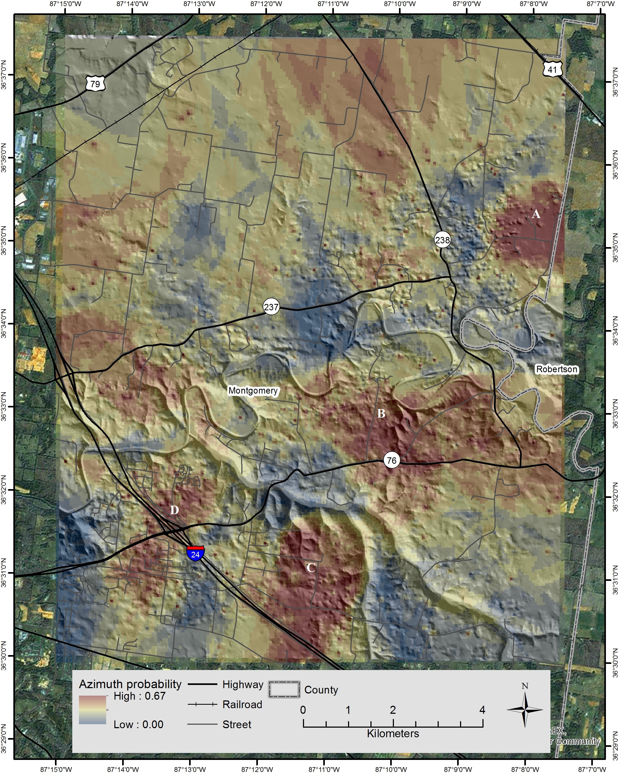
Figure 9. The directional orientation susceptibility map – the orientation of long doline axes runs parallel with one of the three systematic joints in the study area; higher probabilities correspond to higher risks of collapse.

Landuse. In terms of landuse, the urban environment has begun to play a more important role. The sub-region that draws the most attention lies between Interstate Highway 24 and the Passenger Creek (region C). This area includes some urban development as well as Interstate Highway 24. Another hazardous area is mapped within the city of Clarksville directly under the main intersections of Highway 746 and Interstate 24 (region marked as D). This is one of the most hazardous regions, and its significance increases due to city development. Another example of an urban-doline collapse scenario is Sadlersville Road running through subregion A; in addition, a few roads connect here to Highway 238.

3 Joint probability distribution
The final step in this model development is to combine the previous results into a “joint probability assessment” (JPA): JPA = Prob {R ∩ A} which is the probability that the two events R = “length-to-width doline ratio is at or below the critical value of 1.8” and A = “the long axis orientation runs parallel to one of the three systematic joints sets found in the study area” occur simultaneously. The independence of these two events was tested using the Pearson chi-square statistic. The assumption of independence was not rejected (p-value = 0.214); hence, this joint probability was obtained by multiplying the two estimated probabilities of the two separate events that were estimated by indicator kriging.
The results indicate (Figure 10) that the highest risk areas occur along the southwest-northeast hazard axis that runs from Interstate Highway 24 in the southern part of the Sango area to Sadlersville in Robertson County. The circular shaped region at the northeast end of this axis (region A) has a radius of approximately two kilometers, and it is located around Sadlersville Road and extends from the tip of the Red River Bend towards the Montgomery-Robertson County boundary. The center of this circle, with the highest probabilities of collapse, lies in a place where county boundaries run parallel with Sadlersville Road.

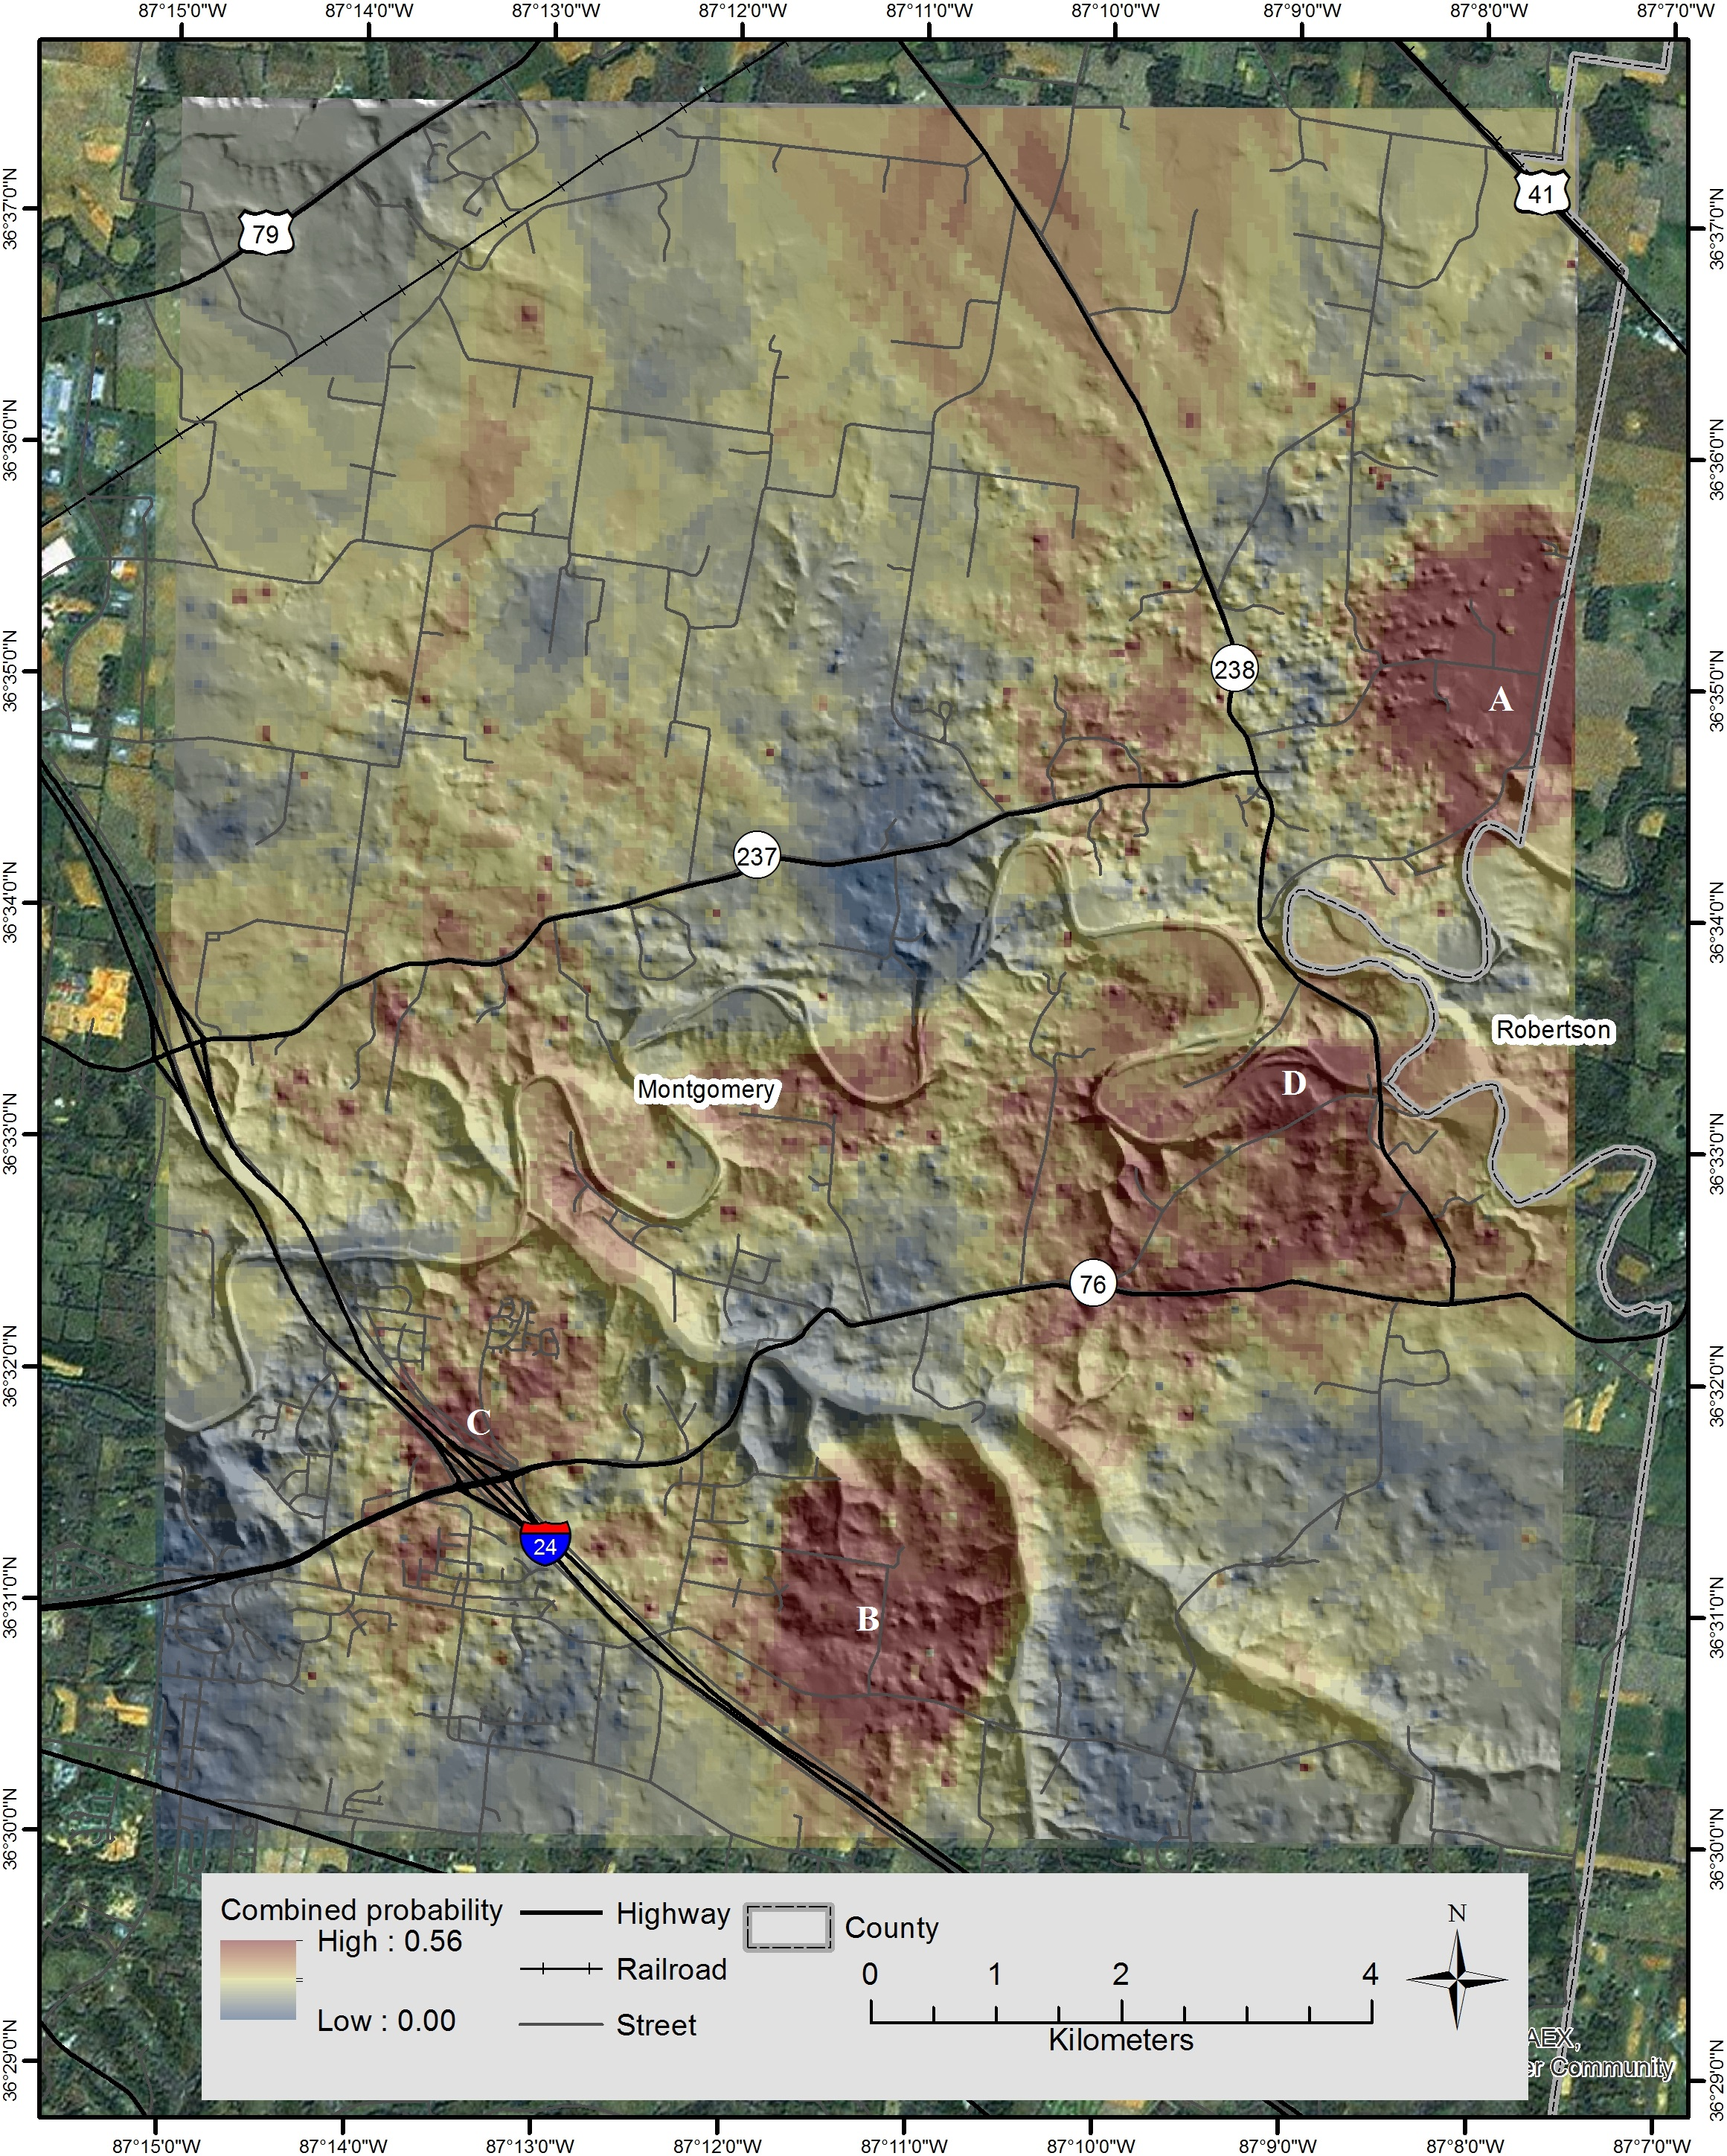
Figure 10. Map of the joint probability that doline (sinkhole) length-to-width ratio does not exceed a 1.8 cutoff value while the long axis orientation runs in parallel with one of the three systematic joints in the study area; the higher probabilities correspond to higher risks of collapse.

Currently, urban development is extending to the residential areas east of the North Woodson Road; however, this development is not recommended because it leads to the center where there is a high doline susceptibility to collapse. Eastwood Drive or the area around Prestwicke Place and Drake Road lies directly in a high risk probability (p = > 0.56) region while the area between Passenger Creek and its main western tributary is already in a safe region. Special attention should be paid to a small, high-risk patch, which is three and half kilometers west of this circle (marked C). It is located near the intersection of Interstate 24 and Highway 76 (the Martin Luther King Parkway). This intersection area is built directly above predicted high collapse joint probability. Given the traffic intensity and the importance of this highway intersection, this area should be carefully monitored by local authorities and the Tennessee Department of Transportation.
Landuse. The hazardous sub-region marked as A is overgrown mostly with pastures, woods and some agricultural fields. Therefore, it poses less danger to the population and properties. This circular shaped region has appeared on both partial probability maps and is therefore evaluated as the most hazardous region in terms of doline/sinkhole collapse. The high joint probability region south and west of Port Royal (D) is territorially the largest but slightly less hazardous than the previous three regions due to its lack of significant infrastructure and dense population as it is also mostly occupied by woods, pastures, and some arable lands. Therefore, we have provided evidence that the areas predicted as highly susceptible for doline collapse often territorially match with hickory-oaks woodlands, pastures and some agriculture lands while high density populated areas are until now usually avoiding these hazardous areas. However, increasing urban development is steadily encroaching upon sub-regions designated as hazardous areas where susceptibility of region for doline collapse is high.

4 Validation
The comprehensive validation of a proposed model is a time-consuming and expensive process. Ideally, it would require the regular monitoring of the terrain, evidencing new collapses and entering them into the database. Unfortunately, the Tennessee Geological Survey does not monitor the area for sinkhole collapse, and no official reports have been compiled for this purpose; in addition, most dolines are located on private land. Therefore, in order to maximize the existing data for validation purposes, a three-step procedure was implemented. First, the Tennessee Department of Transportation (TDT) was contacted with a request to provide information about highway repairs in the study area; from the limited evidence, four highway repair sites (damages were due to doline collapse) were acquired and recorded in GIS. In the second stage, the only available doline collapse report from the mid-1980s was georeferenced using Google Earth imagery; this is the only documented record of collapses in the study area based on field reconnaissance (Kemmerly, 1986). In the third step, the point shapefile of real doline collapses was generated in GIS and overlaid over the susceptibility predictions to compute the estimated probability for each collapse location; lastly, the results were evaluated using fundamental statistics. The validation results are displayed in Figure 11a and b along with Table 1. There is a positive correlation between the observation and model predictions. Figures 11a and 11b depicts the agreement between the spatial distribution of actual doline collapses and the prediction of collapse based on combined probabilities. About half of the doline collapses matched the higher level of predicted probabilities; thirty percent matched the medium-high probabilities, and twenty percent of collapses occurred in very low probability zones. The doline long to short axis ratio indicates even better results: almost 90% of doline collapses matches the predicted model; the doline collapses marked as 6 and 7 are well-predicted by the ratio model but were missed by the alignment and combined probability models. In addition, only 18% of doline collapses occurred in the medium level probabilities and 9% in the lower probabilities. The doline collapse marked as number 11 was missed by all models.
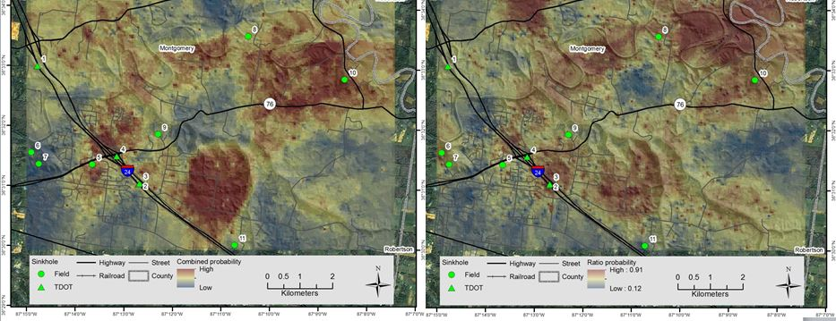
Figure 11. (a) Validation map 1: geolocated collapsed dolines superimposed on the joint probability spatial distribution. (b) Validation map 2: geolocated collapsed dolines superimposed on the length-to-width ratio spatial probability distribution.

The previous validation results are corroborated by the average probabilities displayed in Table 1. The first row of this table lists the means of all probabilities for each predictor model; the second row contains the mean of probabilities calculated only for locations where dolines actually collapsed. If the prediction model were not working, then these probabilities would be the same magnitude or even lower than the overall means. The third row in Table 1 lists the means calculated from collapses deeper inside the studied area to account for edge effects. Discarding less accurate predictions along the edges of the area highlights the predictability of the model as illustrated by the highest average probabilities. A comparison of models indicates that the alignment of the long doline axis is the weakest predictor compared to models based on length-to-width doline ratio or combined models.

V Conclusion
The proposed methodology has demonstrated a good potential for estimating doline collapse in carbonatic rock complexes. The validation results confirmed that morphometric doline parameters positively contribute to the prediction of karst hazards. In addition, morphometric parameters have at least four advantages: 1) The measurements of doline geometry can be obtained from remote sensing data or topographic maps, and their accuracy can be increased with higher resolution imagery or scale of the map. 2) The software requirements are at a reasonable cost and can be obtained free of charge if necessary. 3) The proposed model is reasonably accurate, and its accuracy can be improved by more precise data acquisition along with the addition of new parameters, which would lower the “nugget effect” of variograms (Figures 7a and 7b). 4) The cost of equipment and time spent in the field is significantly lower than direct field methods that use expensive geophysical tools. Some drawbacks of the proposed model are associated with the establishment of doline geometry, mainly doline perimeters, followed by the fitting of the doline axes. This is due to the existence of nested dolines whose precise delineation is more complex and affects the measurements of the doline axes. Overall, the results are promising and have the potential for improvement in the future.
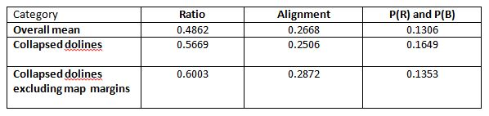
Table 1. Comparisons of the mean probabilities for the entire area and the probabilities of the locations where doline collapses have actually occurred.

Acknowledgments
The authors would like to thank everyone who positively influenced the work on this article by providing advice, help and especially constructive review comments. Special thanks to Tennessee Department of Transportation in Nashville and to M.A. Brunner at the Austin Peay State University for providing assessments for sinkhole remediation work.

Funding
The project was partially funded by grant 1R21 ES021570-01A1 from the National Cancer Institute and the initial start up fund from the Liverpool Hope University.

References
Austin Peay State University (2014) Sinkhole will not delay APSU stadium renovation. https://www.apsu.edu/news/sinkhole-will-not-delay-apsu-stadium-renovation
Baioni D and Tramontana M (2015) Evaporite karst in three interior layered deposits in Iani
Chaos, Mars. Geomorphology 245: 15-22.
Brinkmann R, Parise M and Dye D (2008) Sinkhole distribution in a rapidly developing urban
environment: Hillsborough County, Tampa Bay area, Florida. Engineering Geology 99: 169-184.
Carbonel D, Rodrigues-Tribaldos V, Gutierrez F, et al. (2005) Investigating a damaging buried
sinkhole cluster in an urban area (Zaragoza city, NE Spain) integrating multiple techniques: Geomorphological surveys, DInSAR, DEMs, GPR. ERT, and trenching. Geomorphology 229: 3-16.
Committee on Banking and Insurance 2010. (2011) Issues relating to sinkhole insurance.
www.flsenate.gov/UserContent/Session/2011/Publications/InterimReports/pdf/2011-104bi.pdf.
Cramer H (1941) Die Systematik der Karstdolinen unter Berücksichtigung der Erdfälle,
Erzschlotten und Verwendter Erscheinungen. Neues Jahrbuch für Mineralogie, Geologie and Paleontologie 85(1): 293-382.
Current J (2012a) Cover-collapse sinkholes in Kentucky, USA: geographic and temporal
distribution. Carbonates Evaporates DOI 10.1007/s13146-012-0097-2.
Current J (2012b) Model ordinance for development on karst terrain: Kentucky, USA.
Carbonates Evaporates DOI 10.1007/s13146-012-0096-3.
Cvijic J (1893) Das Karstphänomen, Versuch einer morphologischen Monographie.
Vienna: E. Hölzel.
Denizman C (2003) Morphometric and spatial distribution parameters of karstic depressions, Lower Suwannee River Basin, Florida. Journal of Cave Karst Studies 65: 29- 35.
Dogan U (2005) Land subsidence and caprock dolines used by surface gypsum dissolution and the effect of subsidence on the fluvial system in the Upper Tigris Basin (between Bismil-Batman, Turkey). Geomorphology 71: 389-401.
Ford D (2007) Jovan Cvijic and the founding of karst geomorphology. Environmental Geology 51: 675-684.
Ford D and Williams PD (2007) Karst Hydrogeology and Geomorphology. Wiley
Florea L (2005) Using state-wide GIS data to identify the coincidence between sinkholes and geologic structure. Journal of Cave and Karst Studies 67(2): 120-124.
Galloway DL, Jones DR and Ingebritsen SE (2000) Land subsidence in the
United States. USGS Fact Sheet: 165-170.
Galve JP, Gutierrez F, Lucha P, et al. (2009) Probabilistic sinkhole modeling for hazard
assessment. Earth Surface Processes and Landforms 34: 437- 452.
Galve JP, Bonachea J, Remondo J et al. (2008) Development and validation of sinkhole
susceptibility models in mantled karst settings. A case study from Ebro valley evaporite karst (NE Spain). Engineering Geology 99: 185 – 197.
Gao Y and Alexander EC (2003) A mathematical model for a map of relative sinkhole risk
in Fillmore County, Minnesota, Sinkholes and Karst. ASCE Pub: 43- 449.
Gao Y, Alexander EC and Tipping RG (2002) The development of karst feature
database for Southwestern Minnesota. J Cave Karst Stud 64: 51-57.
Gao Y and Zhou W (2008) Advances and challenges of GIS and DBMS applications in karst.
Env Geol 54: 901-904.
Gilli E and Fandel Ch (2011) Karstology: Karsts, Caves and Springs: Elements of Fundamental
and Applied Karstology. CRC Press: Paris.
Goovaerts P (1997) Geostatistics for Natural Resource Evaluation. Oxford University
Press: New York.
Gutierrez F, Johnson KS and Cooper AH (2008) Evaporite-karst processes,
landforms, and environmental problems. Environmental Geology 53:935-936.
Gutierrez F, Parise M, De Waele J and Jourde H (2014) A review on natural and human-induced
geohazards and impacts in karst. Earth-Science Reviews 138: 61-88.
Hart EA (2014) Legacy sediment stored in sinkholes: a case study of three urban watersheds
in Tennessee, United States of America. Physical Geography 35: (6) 514-531
Jennings JE (1966) Building on dolomites in Transvaal. Transactions of South African Institute
of Civil Engineering 8: 41-62.
Kaufmann G (2014) Geophysical mapping of solution and collapse sinkholes. J Appl
Geophys 111: 271-288.
Kaufmann O, Lizin P, Martin T, et al. (2009) The role of geophysical investigations in physical
planning over covered karstic areas in southern Belgium. DOI: 10.3997/2214-4609.20147050.
Kemmerly PR (1986) Exploring a contagion model for karst-terrane evolution. Geo
Soc Am Bull 97: 619-625.
Kemmerly PR (2007) Modeling doline populations with logistic growth functions. Earth
Surf Proc Land 3: 355-362.
Kemmerly PR and Siska PP (2008) Assessment of dolines hazards on Pennyroyal Plain
and Western Highland Rim. Geografický Časopis 60: 217-240.
Kobal M, Bertoncel JI and Kutnar, L (2014) Processing for defining sinkhole
characteristics under dense forest cover: a case study in the Dinaric Mountains. The International Archives of the Photogrammetry, Remote Sensing and Spatial information Sciences. XL-7, ISPRS Technical Commission VII Symposium.
Koutepov VM, Mironov OK and Tolmachev VV (2008) Assessment of suffusion-related hazrds
in karst areas using GIS technology. Environmental Geology DOI 10.007/s00254-007 888-2.
Lei M, Jiang X and Li Y (2002) New advances in karst collapse research in China.
Environmental Geology 42: 462-468.
Park G, Park S, Jong Yi, et al. (2010) Geostatistical integration using 2-D electrical resistivity
and 3-D gravity methods for detecting cavities in a karst area. Environmental Earth Sciences 60 (5): 965-974.
Radulovic MM (2013) A new view on karst genesis. Carbonates and Evaporatises DOI:
10.1007/s13146-0125-2.
Schoenholtz SH (2006) Analysis of sinkhole susceptibility and karst distribution in the
northern Shenandoah Valley, Virginia: implication for low impact development (LID) site suitability models. Virginia Water Resources Research Center Report, Virginia Polytechnic Institute and State University, Blacksburg, Virginia. http://vwrrc.vt.edu/pdfs/specialreports/sr312006.pdf .
Schofner A and Mills HH (2001) A simple map index of karstification and its relationship to
sinkhole and cave distribution in Tennessee. Journal of Cave and Karst Studies 63: 67-75.
Scholastic News (2014). Swallowed up: a sinkhole in Kentucky gobbles up valuable cars.
Reader Edition 4, March 24. 76: 2.
Siska PP and Kemmerly PR (2007) Doline feature database (DFD) development and assessment
of hazards using a co-regionalization model. In: Papers of Applied Geography Conferences 31: 34-42.
Sustersic F (1998) Rakovska Kukava, collapse or tomour doline? Acta Carsologica 27: 231-259.
Sustersic F (2006) A power function model for the basic geometry of solution dolines:
considerations from classical karst of south-central Slovenia. Earth Surf Proc Land 31: 293-302.
Tennessee Department of Transportation (TdoT) (2016) Fact report on highway 66 repairs.
http://www.tn.gov/tdot/article/highway-66-facts
Tietze E (1880) Zur geologie der karsterscheinungen. Hölder: Wien.
Waltham A, Bell F and Culshaw M (2005) Sinkholes and subsidence. Chichester: Springer.
Yilmaz I (2007) GIS based susceptibility mapping of karst depression in gypsum: A case study
from Sivas basin (Turkey). Engineering Geology 90: 89-103.
Zboray ZI, Baranyi-Kevei I and Tanacs E (2005) Defining the corrosion surface of the dolines by
means of a digital elevation model. Acta Clim Chron 38:157-162.

