Author's Accepted Manuscript (AAM)
Moneta, G. B., Schneider, B., & Csikszentmihalyi, M. (2014). A longitudinal study of the self-concept and experiential self-worth and affect across adolescence (pp. 407–435). In M. Csikszentmihalyi, Applications of flow in human development and education: The collected works of Mihaly Csikszentmihalyi. New York, Springer. DOI: 10.1007/978-94-017-9094-9_21
Copyright © 2001 Taylor & Francis Group LCC - Books. Republished with permission in journal Applied Developmental Science, Vol. 5, No. 3, pp 125–142. Authors own material, 2001, by Lawrence Erlbaum Associates, Inc.
Accepted: 15 August 2000
Published: 9 August 2014

A longitudinal study of the self-concept and experiential components of self-worth and affect across adolescence

Giovanni B. Moneta
The Chinese University of Hong Kong

Barbara Schneider
The University of Chicago

Mihaly Csikszentmihalyi
Clairemont University

Submission: December 1999
First revision: July 2000
Second revision: August 2000

Running head: SELF-CONCEPT, SELF-WORTH, AND AFFECT ACROSS ADOLESCENCE

Author Notes
Requests for reprints should be sent to Giovanni B. Moneta, The Chinese University of Hong Kong, Department of Psychology, Shatin, New Territories, Hong Kong, Tel. (852) 2609-6464, Fax (852) 2603-5019, e-mail gmoneta@psy.cuhk.edu.hk.
Abstract
Classic theories depict adolescence as a period of emotional "storm and stress". Empirical evidence, mostly from cross-sectional studies, suggests that emotional development presents a mixture of continuity, swings, and resilience. We examined longitudinally the average grade-trends in components of the self-concept and experiential components of self-worth and affect across adolescence. We followed up 1165 6-12 graders for four years by a three-wave, accelerated longitudinal design. Participants completed self-concept scales (global self-esteem and locus of control), and the Experience Sampling Method (ESM), which provided daily self-reports on self-worth (leaving up to one’s own expectations, to the expectations of others, feeling successful, and feeling in control of the activity) and affect (feeling good and happy). Multilevel modeling indicated that both self-esteem and locus of control grow linearly over grade. Self-worth components of experience showed a concave-up trend bottoming at grades 9-10, suggesting a pubertal swing and partial re-adjustment by the end of adolescence. Affect declined quadratically across adolescence. Compared to Caucasians, less positive grade-trends were found for Hispanics, Asian-Americans, and adolescents from non-traditional families; a mixed pattern emerged for African-Americans. Behind the stable growth of components of the self-concept, adolescents experience a certain degree of longitudinal discontinuity as to how they evaluate their capability to match everyday life demands, and their affect declines. The modifications in grade-trends due to ethnicity and family structure call for studies on the possible influence exercised by family processes and school environments.

A longitudinal study of the self-concept and experiential components of self-worth and affect across adolescence

Almost one century ago, Hall (1904) introduced a view of adolescence as a period of “storm and stress” characterized by three key features: mood disruptions, conflicts with parents, and risk behaviors. Although these emotional and behavioral responses can occur at any point of a person’s life, Hall believed that they are far more common among adolescents and are largely endogenous, determined by biological factors associated with pubertal development. Yet, Hall recognized that the extent to which adolescents produce the storm-and-stress pattern depends on their temperament and the culture in which they live. He claimed that adolescence was less disruptive in cultures characterized by conservative traditions, and identified urbanization as the key factor. In his view, urbanization implies greater temptations to vice and reduced opportunities for physical activity and exploration, which he regarded as an inherent and biological need of adolescents. Thus, he claimed that a significant part of the problems of adolescence were produced by the social inability to understand its nature and risks, and to adapt the social institutions accordingly.
In the following decades, classic theories of personality development have contributed to the understanding of the emotional disruptions of adolescence. Freud (1910) stated that the emotional turmoil of adolescence stems from the awakening of the sexual instinct. Adolescence corresponds to the "genital" psychosexual developmental stage that follows the "latency" stage. The latency stage is a long and seemingly quiet period during which the libido expresses itself only indirectly through playing, schooling, and socializing, and the child loses all curiosity and interest in sex. By contrast, the genital stage is the period in which the sexual drive returns and transforms itself into a mature form, and adolescents face increasing societal demands to grow in intellectual and practical abilities. Thus, Freud explained the emotional disruptions of adolescence as the result of the conflict between instinctual strivings and reality demands. Within the psychoanalytic tradition, Anna Freud (1946, 1958) argued that puberty implies abrupt increases of libidinal energy. At the same time, socialization leads to the development of a more demanding super-ego. These two simultaneous processes modify the power relation between psychological structures, reducing balance and stability, and increasing the intensity and frequency of emotional disruptions. She viewed this process as universal, and argued that the absence of emotional disruptions during adolescence reflects excessive defenses, and is therefore pathological.
Ego-psychologists departed from Freud's theory by reducing the importance attributed to the sexual instinct and attributing greater importance to the pleasure derived from mastering tasks, ego-development, and social influence. Within Erikson's (1968) paradigm, adolescence encompasses two psychosocial crises: "industry versus inferiority" and "identity versus role confusion". The onset of the first crisis coincides with schooling age, and the crisis ends during puberty. The onset of the second crisis coincides with the mid-point of adolescence, and the crisis may span through young adulthood. Thus, Erikson explained the emotional disruptions of adolescence as the result of two strivings: (a) developing competence and proving it to oneself and the others, and (b) developing a sense of identity that satisfies one's need to be unique while obtaining social acceptance and recognition. Following research by Marcia (1968, 1980) has proven that not all adolescents experience an identity crisis. Some have not thought of identity issues and have not charted directions in life and, thus, remain in a state of “identity diffusion”; others have chosen an identity suggested by significant others without constructing it by raising questions and seeking answers and, thus, are in a state of “foreclosure”. These findings suggest that the emotional disruptions of adolescence that may arise from an identity crisis are more likely among adolescents than adults, but are neither universal nor necessary.
The theories by Hall, Freud, and Erikson have profoundly influenced empirical research on adolescence in the past decades. In a review of the literature on the “storm and stress” of adolescence, Arnett (1999) concludes that the collected evidence supports the existence of all the hallmarks of adolescence: mood disruptions, conflicts with parents, and risk behaviors. Yet, not all adolescents experience this triad, and there are large individual differences in the extent to which adolescents experience each of the three components. From the cultural point of view, he argues that storm and stress is lower or even absent in traditional cultures that promote a “narrow socialization”, i.e., that impose a narrower range to the development of individual differences and put lesser emphasis on individualism (Arnett, 1995). He also advances that storm and stress may be reduced within the North American minority cultures. Thus, Arnett proposes a modified storm-and-stress view that allows for wide individual and cultural differences, wherein the key cultural component is not urbanization but breadth of socialization and emphasis on individualism.
This paper focuses on the issue of the emotional disruptions of adolescence. A large body of research has tried to answer the basic question of whether emotions are less stable in adolescence than in other periods of life. Emotions have been assessed by paper-and-pencil, one-point in time measures and by paper-and-pencil, time-contingent sampling measures of experience in daily life (Wheeler & Reis, 1991) such as the Experience Sampling Method (ESM) (Csikszentmihalyi, Larson, & Prescott, 1977; Csikszentmihalyi & Larson, 1987). While the first group of techniques are designed to measure relatively stable, person specific emotional tendencies, the second group of techniques is designed to assess the moment-to-moment, situation-to-situation variations in activity and experience and, thus, allow investigating the development of adolescents' interactions with their environment.
Research conducted by either type of technique has provided inconsistent evidence on how stable emotions are across adolescence. Some findings suggest that emotions are as stable (or unstable) during adolescence as they are during the course of adult life (Block, 1971; Rutter, Graham, Chadwick, Yule, 1976; Steinberg, 1990; Davis & Franzoi, 1991). Other findings suggest that adolescence features far greater swings of emotions (Larson, Csikszenmihalyi, & Graef, 1980) and decreasing trends from early to late adolescence (Larson & Csikszentmihalyi, 1984; Larson & Lampman-Petraitis, 1989). Thus, the dilemma concerning the emotional disruptions of adolescence is still unsolved.
There are two possible reasons for this stalemate. First, most studies conducted to date are cross-sectional (e.g., Larson & Csikszentmihalyi, 1984; Larson & Lampman-Petraitis, 1989) and, thus, exposed to potential cohort effects. If the storm and stress of adolescence is modified by unknown societal changes, then cross-sectional comparisons between adolescents of different age groups are confounded by the unknown variables. From this angle, the issue of stability can be best studied as an issue of individual change within a longitudinal study. Second, the two types of measures (traditional and experiential) have rarely been used together on the same study population and, thus, differences between the dispositional and experiential realities of emotions could not be compared. It is likely that dispositional measures imply more cognitive processing, comparative judgements, and rationalizations than experiential, in situ measures that are collected on a hourly basis. If that is the case, the two sets of measures could produce different answers to the research question. From this angle, the issue of stability can be best studied by a multi-method approach.
An interesting longitudinal study (Larson, Richards, Moneta, Holmbeck, & Duckett, 1996) investigated the average age-trend of the experience of affect during familial interactions in a large sample of adolescents from Caucasian, middle-class families. The adolescents were administered the ESM a first time when they were 10-14 years old, and a second time about 4 years later, when they were 14-18 years old. Thus, in Raudenbush’s terminology (Raudenbush & Chan, 1993; Miyazaki & Raudenbush, 1999), this was an “accelerated longitudinal design”, that constitutes an efficient mixture of cross-sectional and longitudinal study. Daily affect was operationalized as the mean of three experiential variables: feeling happy-unhappy, cheerful-irritable, and friendly-angry. The analysis focused only on those observations that were collected while the adolescents were interacting with their families. Findings indicated that the sample mean of affect with family decreases from early adolescence and increases by late adolescence returning virtually to the same level. This concave-up age-trend was more marked and lasted longer for girls. Based on the analysis of the content of familial interactions (e.g., talking vs. being in the same environment with no communication), the authors interpreted this swing in affect as the result of a process of disengagement from family and transformation of family relationships toward a more egalitarian model. The emerging pattern disconfirms the common belief that adolescence is a period of sharp conflicts with family, and suggests that adolescence is a phase of progressive transformations rather than crises.
The present study builds on Larson and coworkers’ (1996) approach in order to investigate the presence/absence of the storm and stress of adolescence in a large, representative sample of U.S. teenagers that has been followed-up longitudinally for four years. We envision the research problem as a study of continuity versus discontinuity of development, i.e., as constancy (or lack of) of group means across age (e.g., McCall, 1977; Moss & Susman, 1980). We investigate average age-trends in two dispositional variables, assessed by one-point in time surveys, and six experiential variables, assessed by the ESM. The dispositional variables are basic components of the self-concept: global self-esteem (Coopersmith, 1967; Rosenberg, 1979) and locus of control (Rotter, 1966). Four experiential variables measure self-worth in daily activities: living up to one's own expectations, leaving up to the to the expectations of others, feeling successful, and feeling in control. The remaining two experiential variables measure affect in daily activities: feeling good about oneself, and feeling happy. These variables are selected to cover a wide range of adolescents’ self-perceptions that may reflect the presence/absence and intensity of storm and stress.
For each of these variables, we model the average developmental trajectory starting from early adolescence (approximately age 12) and ending with late adolescence (approximately age 18). Evidence in favor or against the storm-and-stress view is evaluated on each variable separately by examining whether the mean developmental trajectory reveals continuity or discontinuity, wherein discontinuity supports the presence of storm-and-stress and continuity disconfirms it. We consider two basic patterns of continuity: lack of change and progressive linear change. The first pattern is the absolute continuity, the second implies a smooth build-up of self-perceptions. We consider two basic patterns of discontinuity: a concave-up trend with a minimum within adolescence and a concave-up trend with an estimated minimum projected beyond adolescence. The first pattern is a swing leading to partial or total recovery by late adolescence, the second implies an accelerated decrease with no recovery.
This study has two goals. The first goal is to provide a comprehensive description of continuity/discontinuity across adolescence. Based on this set of analyses, we aim clarifying two complementary issues: (a) whether the development of self-concept, experiential self-worth, and affect variables is continuous (and, thus, inconsistent with the storm-and-stress view) or discontinuous (and, thus, consistent with the storm-and-stress view), and (b) whether the several dispositional and experiential variables provide a consistent pattern (i.e., they all exhibit either continuity or discontinuity) or a diversified, more complex pattern (i.e., some exhibit continuity and others discontinuity).
Based on previous theoretical and empirical research, we formulate the following hypotheses. The ego-psychologists (Barron, 1993; Block, 1993; Block & Block, 1980; Funder & Block, 1989; Loevinger, 1976, 1985, 1993; White, 1959, 1960, 1963) highlight the child’s or adolescent's natural tendency to develop a firm sense of self, the ability to cope with stress, the ability to delay gratification for achieving distal goals, and the ability to establish and deepen relationships. Although the nomological network is complex, measures of the ego appear to be related to measures of self-esteem and locus of control. For example, Deci and Ryan (1985 a and b) found that ego-development (Loevinger, 1976) correlates positively with the autonomy causality orientation, representing a person’s tendency toward self-determination, and negatively with the impersonal causality orientation, representing a person’s lack of motivational structures supporting either self-determined or controlled behavior; in turn, the autonomy orientation correlates positively with self-esteem, while the impersonal orientation correlates negatively with self-esteem and positively with external locus of control. This body of research leads us to believe that the two investigated components of the self-concept (global self-esteem and locus of control) are related to ego-development and, thus, should exhibit substantial continuity across adolescence. On the other hand, Larson and coworkers’ (1996) findings on the daily experience of affect lead us to believe that feeling happy and good should be discontinuous, exhibiting a swing with a low in mid-adolescence and possibly a recovery afterwards. For what concerns the experiential variables measuring self-worth (feeling successful, in control, and up to one’s and others’ expectations) we cannot commit ourselves to specific hypotheses. Although, one could expect that these variables are related to global self-esteem and locus of control, these relationships do not guarantee that their developmental trajectories are similar.
The second goal is to shed light on whether the mean developmental trajectories in self-concept, experiential self-worth, and affect variables are modified by gender, ethnicity, and family structure. Based on this second group of analyses, we aim at clarifying whether adolescents from disadvantaged groups show natural resilience and ability to recover from swings in self-perception by the end of adolescence.
This second part of the analysis is largely exploratory. Numerous cross-sectional studies compared genders and ethnic groups, and provided somewhat intricate evidence indicating that women and minority groups are lower in self-esteem and more external in locus of control (e.g., Gaa & Shores, 1976; Wylie, 1979; Hughes & Demo, 1989; Kling, Hyde, Showers, & Buswell, 1999). Yet, no study has performed longitudinal comparisons of average developmental trajectories. Furthermore, with some exceptions (e.g., Asakawa & Csikszentmihalyi, 1998) previous studies of daily subjective experience have not focused on differences between the North American cultural majority and minorities. Lastly, to our knowledge, no study has investigated the longitudinal changes in adolescents’ self-perceptions following their parents’ separation or divorce. Thus, although exploratory, this set of analyses can provide potentially useful information and stimulate further research.
Methods
Participants
Participants were the 1309 members of the four-year follow-up Alfred P. Sloan Longitudinal Study of Youth and Social Development. Participants were recruited following a nation-wide random sampling scheme. The gender distribution of the sample was: 586 (44.7%) males and 724 (66.3%) females. The ethnic distribution was: 721 (55.0%) Caucasians, 205 (15.6%) Hispanics, 288 (22.0%) African-Americans, 82 (6.3%) Asian-Americans, 12 (.9%) Native-Americans, and 2 participants of unknown ethnicity.
Data collection proceeded in three waves (1992-1993, 1994-1995, and 1996-1997) according to an accelerated longitudinal study design. The starting sample comprised 1109 high-school students from grades 6th, 8th, 10th, and 12th, corresponding approximately to age 12, 14, 16, and 18 years. Additional participants were recruited in the second and third wave. A total of 171 (13.1%) participants completed all three data collection waves, 374 (28.5%) completed two waves, and 764 (58.3%) completed only one wave. The grade distribution by wave is shown in Table 1.
________________________
Insert Table 1 about here
________________________
Measures
In each wave of data collection, participants were administered a large survey and the Experience Sampling Method (ESM) (Csikszentmihalyi, Larson, & Prescott, 1977; Csikszentmihalyi & Larson, 1987). In this study we employed three sets of questions from the survey: (a) questions concerning family composition and structure, (b) a global self-esteem scale, and (c) a locus of control scale.
Participant's family structure was evaluated only based on the first survey taken. The family structure distribution was: 707 (53.8%) from traditional families, 243 (18.8%) from single-parent families, 175 (13.3%) from reconstituted families, 42 (3.2%) from other types of families, and 142 (10.8%) of unknown family structure.
Global self-esteem was assessed by a seven-item abridged version of Rosenberg's Self-Esteem Scale (1979). Locus of control was assessed by a six-item abridged version of Rotter's Locus of Control Scale (1966). All items were rated on a four-point scale ranging from "strongly disagree" to "strongly agree". Scores for each participant were computed by averaging the respective items. In case of non-response, the individual score was computed over the available items. For both variables, scores ranged from 1 to 4, with high values meaning high self-esteem and internal locus of control, respectively.
The adolescents' quality of daily experience was studied by the ESM. Each subject was given a programmable wristwatch and a block of identical questionnaires to carry for seven consecutive days. The wristwatch was programmed to signal eight times a day at random intervals from 7:30 a.m. to 10:30 p.m. Participants were instructed to complete a questionnaire immediately after each signal. The questionnaire contained open-ended questions for identifying the activity and its context, and scaled items for measuring a wide range of feelings associated with the activity.
In this study, we utilized six scaled variables. Four variables measured time-contingent self-worth: "Were you living up to your own expectations?”, "Were you living up to expectations of others?", "Were you succeeding at what you were doing?", "Did you feel in control of the situation?". The remaining two variables measured time-contingent affect: "Did you feel good about yourself?", and Likert scale “Sad-Happy”. The Likert scale “Sad-Happy” was scored from 1 to 7; the other five variables were scored from 1 to 9, with 1 being the most negative and 9 the most positive value.
Selections, missing data, and data structures.
In order to avoid a potentially important source of confounding, we excluded all participants of unknown family structure. We also removed the two participants of unknown ethnicity. The sample size for the analysis was 1165.
The total number of data points available for the analysis is the sum of all repeated observations performed on each subject in the sample. The dispositional variables are one-point in time measures while the experiential variables are repeated measures. Participants have only up to three repeated measures of the personality variables over follow-up (i.e., up to one per data collection wave), and up to 168 experiential measures (i.e., up to 56 per data collection wave). Thus, the number of data points for the experiential variables greatly exceeded that for the dispositional variables. After elimination of missing data, the number of data points was: 1612 for global self-esteem, 1577 for locus of control, 44393 for living up to one's own expectations, 44622 for living up to the expectations of others, 44193 for feeling successful, 44654 for feeling in control, 44725 for feeling good, and 43183 for feeling happy.
We based the main analyses of the ESM data on the original, beep-level measures, and we relied on multilevel modeling (explained later) to control for the intra-person correlation of responses. On the other hand, in all preliminary analyses conducted for evaluating the temporal stability of the variables and their inter-relationships we proceeded by aggregating the data at the individual level. For each participant and wave of data collection, we computed individual means of repeated ESM measures, that is, the average value of each scale over the entire week of the ESM application. We then utilized these individual means as if they were one-point in time test scores. After aggregation, the number of data points was: 2012 for living up to one's own expectations, 2013 for living up to the expectations of others, 2006 for feeling successful, 2014 for feeling in control, 2016 for feeling good, and 1996 for feeling happy.
Stability of the variables.
We investigated the longitudinal stability of the variables by estimating their respective test-retest correlation coefficients over waves of data collection. Table 2 shows the correlation coefficients relative to all three possible comparisons. In general, the variables show a fair stability over adolescence, indicating that the relative ranking of the individuals within the sample remain quite the same over time. The dispositional variables are the most stable, followed by the experiential variable feeling good. The least stable variable is feeling happy, which shows poor correlation coefficients from the first and second wave to the last one. This finding suggests that, compared to the other variables, daily happiness in adolescence is less of a personal tendency and more of an environmental factor.
Relationships between variables.
The eight dispositional and experiential variables had fair reciprocal correlations across waves of data collection. Focusing on the first wave only, the correlation between global self-esteem and locus of control (I-E) was .55. The highest correlation between the two personality variables and the six experiential variables was the one involving global self-esteem and feeling good (.46); the other correlations ranged from .20 to .31. The experiential variables correlated with each other in the range .17-.60.
We examined more deeply the relationships between the eight variables by conducting separate Principal Component analyses, with Varimax rotation, for each wave of data collection. The main criterion for selecting the number of factors was to include all factors with eigenvalues greater than one. In addition, we evaluated the sensitivity of this criterion by inspecting scree plots and assessing the presence of scales showing double loadings. For each wave we identified three factors. As shown in Table 3, the three-factor solutions are remarkably consistent across time. The first factor included the four experiential components of self-worth and, thus, was named "experiential self-worth". The second factor included the two dispositional variables, locus of control and self-esteem, and, thus, was named "self-concept". The third factor included feeling happy and good and, thus, was named "affect". Feeling good had a second loading on the experiential self-worth factor; thus, this salient judgement seems to involve both the evaluation of how well one is doing as well as the affective response to that evaluation.
________________________
Insert Table 3 about here
________________________
Statistical methods
Mathematical modeling of grade-trends.
In order to investigate average grade-trends in the eight selected dispositional and experiential variables, we utilized one basic mathematical model:
Dependent variable = β₀ + β₁ grade (linear) + β₂ grade (quadratic)
where β₀ is the grand mean (i.e., the mean expected value of the dependent variable when grade is equal to zero); grade (linear) is a numerical variable representing student's grade at the time the dependent variable was assessed, and β₁ is its mean effect on the dependent variable; grade (quadratic) is the same numerical variable raised to the second power, and β₂ is its mean effect on the dependent variable. All mean regression coefficients β₀ through β₂ have to be estimated based on the data, and may turn out to be either significantly different from or equal to zero. This simple model can adequately describe linear growth/decrease, curvilinear growth/decrease, or absence of both. For example, the hypothesis that global self-esteem grows linearly as a function of grade corresponds to the case β₁ > 0 and β₂ = 0. Furthermore, the hypothesis that self-esteem has a concave-up relation with grade corresponds to the case β₁ < 0 and β₀ > 0. Whether the concave-up trend ends with a total, partial, or no recovery can be determined by simple computations based on the point estimates of the regression coefficients, or by plotting the predicted values over grade.
The hypothesis that adolescence implies continuity is compatible with either (a) the absence of an average grade-trend, corresponding to absence of change, or (b) a positive average linear grade-trend, corresponding to a smooth and progressive build-up throughout adolescence. The hypothesis that adolescence implies discontinuity is compatible with three average grade-trends: (a) a negative linear trend, corresponding to a smooth and progressive decrease throughout adolescence, (b) a concave-up trend indicating an accelerated decrease throughout adolescence (if the estimated minimum falls beyond grade 12), and (c) a concave-up trend indicating a swing (if the estimated minimum falls in the range 6-12th grade) with the minimum representing a critical point of adolescence. Furthermore, concave-down trends, although unlikely, would also suggest discontinuity indicating a boosting effect (e.g., a pubertal one). We conducted the hypothesis testing on each dependent variable separately; so that, we allowed for providing different answers to the continuity/discontinuity issue for each dispositional and experiential variable.
The same mathematical model was extended to account for possible modifications of average grade-trends due to gender, family structure, and ethnicity, by adding new predictors together with their interactions involving the grade terms. For example, the gender modification was tested by adding the following terms to the regression equation:
+ β₃ gender + β₄ gender * grade (linear) + β₅ gender * grade (quadratic)
where gender was coded as 0 for males and 1 for females. The introduction of the new terms modifies the meaning of the terms that were already included in the model. Within this model, males constitute the referent group and females the contrast group. The coefficients β₀, β₁, and β₂ represent the mean grade-trend for males. The coefficients β₃, β₄, and β₅ represent the mean deviation (i.e., algebraic difference) from the mean grade-trend due to being a female, that is, the mean difference in grade-trend between females and males. Thus, assuming that all coefficients β₀ through β₅ are statistically significant, then the interpretation of the grade-trend and its modification due to gender can be easily worked out by using the regression equation to compute and plot the distinct developmental trajectories for males and females. The specific pattern of statistical significance involving the coefficients β₃ through β₅ determines the presence/absence as well complexity level of the modification due to gender. Three main cases should be considered. If all coefficients β₃ through β₅ are nonsignificant, then there is no modification due to gender; that is, males and females have the same developmental trajectory. If β₃ is significantly different from zero while β₄ and β₅ are not, then the mean trajectory for females is parallel to that of males. If instead coefficients β₃ through β₅ are all significantly different from zero, then the mean trajectory for females differ from, and is not parallel to that for males. All other intermediate cases can be easily interpreted by inspecting the graphs of predicted values of the dependent variable over grade.
It is important to point out that by introducing simultaneously main class effects and interactions with grade of gender, family structure, and ethnicity, one automatically identifies a global referent group. In all analyses, the reference groups for family structure and ethnicity were “traditional” and “Caucasian”, respectively; thus, the global referent class was: male, Caucasian, from a traditional family. By fitting the full model, the terms β₀ through β₂ define the mean trend of the dependent variable for the global referent group, and all other terms define the mean deviation from that trend due to gender, family structure, and ethnicity. Furthermore, by removing terms from the full model the referent group changes. Therefore, the correct interpretation of a final model, obtained after the elimination of nonsignificant terms, requires a careful identification of the reference group.
Multilevel modeling.
We estimated the coefficients of the mathematical model by multilevel modeling (Goldstein, 1987, 1995; Bryk & Raudenbush, 1992; Longford, 1993). Multilevel models are particularly useful to control for the within-subjects correlation of repeated measures as well as for the presence of missing data. These techniques are regression procedures for modeling data with hierarchical structures. In the case of repeated measures, the data structure is typically two-leveled, where the individuals belong to Level-2, and the single observations performed on them to Level-1. The modeling proceeds by fitting separate regressions for each individual in order to obtain an average regression model valid for the entire population from which the individuals were sampled. The estimation procedure is iterative and it provides at each step improved estimates of both person specific and population average regression coefficients until convergence is achieved. The person specific coefficients and the population average coefficients are reciprocally adjusted. Multilevel models can handle unbalanced and incomplete streams of repeated measures because the lack of information that characterizes to some extent each individual data distribution is counterbalanced by importing information from the population average model.
The multilevel modeling of grade-trends conducted in this paper represents an extension of previous applications to the longitudinal modeling of time-trends in sleep disorder (Moneta, Leclerc, Chastang, Dang Tran, & Goldberg, 1996) and grade-trends in affect (Larson et al., 1996). Extensive presentations on how multilevel models can control for the structural complexity of the ESM data were given elsewhere (Moneta & Csikszentmihalyi, 1996, 1999). In what follows, we focus on the specific characteristics of the present application.
The multilevel models of the dispositional variables were fitted on the repeated test scores, and the multilevel models of the experiential variables were fitted on the much larger number of repeated, beep-level ESM measures. The number of repeated measures per subject is the main limiting factor in the number of random coefficients that can be estimated. Due to this structural difference of the data, the model for dispositional variables contained only one random coefficient, the intercept β₀, while the model for experiential variables contained two random coefficients, the intercept β₀ and the slope β₁ of grade (linear).
For each dependent variable separately, we first fitted the basic model containing only the intercept and the linear and quadratic effects of grade. This model allowed testing for the presence or absence of a mean grade-trend relative to all participants in the sample. We then fitted the full model containing, in addition to the predictors of the basic model, all potential modifiers in the form of main class effects and their interactions with the linear and quadratic effects of grade. Lastly, by backward elimination, we selected a final model. In the selection we followed the hierarchical principle that a lower order term cannot be removed if a higher order term containing it is significant. The criterion for excluding an effect was a significance level greater than .05. The significance level was evaluated by the likelihood test. We estimated the models by means of the program ML3 (Prosser, Rasbash, & Goldstein, 1991).
We point out that the multilevel models were fitted on the full body of data, including subjects from all three waves of data collection and all available repeated observations. Given that the study adopted an accelerated longitudinal design, this implies that the grade-trends were estimated by pooling together complete longitudinal data (i.e., from all the 171 participants who were assessed in all three waves), incomplete longitudinal data, (i.e., from all subjects who were assessed in two waves only) and cross-sectional data (i.e., from subjects who were assessed in one wave only). Thus, the data set was structured in three cohorts (identified by the date of the first assessment) where each one of them was subject to attrition. This pooling procedure is open to two potential sources of bias: attrition effects and grade-by-cohort interaction effects (Cook & Campbell, 1979).
Attrition effects are present if the probability of dropping out from the study is associated with the dependent variable and the predictors. We ruled out this possibility by fitting the final models on the restricted sample of subjects with complete longitudinal data and finding no marked differences in the point estimates of the average regression coefficients. Thus, for this data set, the pooling procedure has the advantage of providing greater statistical power without introducing a noticeable bias.
Cohort effects are present if the three cohorts differ in unmeasured background variables that influence the grade-trends. We assessed the presence and size of cohort effects by the method proposed by Raudenbush and coworkers (Raudenbush & Chan, 1993; Miyazaki & Raudenbush, 1999). Two indicator variables were created for identifying each contrast between the first cohort (1992-1993) and the other two cohorts. These indicators were then included in the Level-2 model as fixed-effects predictors. For all 8 dependent variables, the cohort indicators in the basic model (containing only the linear and quadratic grade effects) turned out to be nonsignificant. These results indicate that the cohort effects were either absent or minimal and, thus, that the average grade-trends were virtually identical across cohorts. Consequently, we proceeded to the estimation of all the models without including the cohort parameters.
Results
Basic test of grade-trends
Table 4 shows the estimated average population coefficients and variance components, with standard errors in parentheses, of the basic multilevel models used to test linear and quadratic grade-trends of the self-concept, experiential self-worth, and affect variables.
________________________
Insert Table 4 about here
________________________
Both linear and quadratic grade terms for global self-esteem were nonsignificant; yet, when the quadratic effect of grade was removed, the linear trend became significantly positive (β = .018, s.e. = .006; figures not shown in Table 4). The findings imply that, on average, global self-esteem grows linearly throughout adolescence. The estimation algorithm failed to converge for locus of control. Subsequent analyses performed by adding extra terms confirmed that the cause of the problem was that the estimate of the quadratic effect was close to zero. By removing the quadratic effect, the estimation algorithm converged and the linear grade term was significantly positive. Thus, there is a mean linear trend for locus of control to become more internal from the onset to the end of adolescence. In sum, both components of the self-concept exhibit continuity in the form of a smooth, progressive build-up.
Both linear and quadratic grade terms were significant for three of the four experiential self-worth variables (living up to one's own expectations, to the expectations of others, and feeling successful), describing a concave-up trend with estimated lows at grades 9.5, 8.8, and 9, respectively (figures not shown in Table 4). On the other hand both grade terms were nonsignificant for feeling in control. Refitting the model by eliminating the quadratic term also resulted in a nonsignificant linear term. Thus, while there is no average grade-trend in the feeling of control over the activity, the other experiential components of self-worth exhibit a swing during adolescence with a low around grade 9 (figure not shown in Table 4). These findings indicate discontinuity of experiential self-worth except for the feeling of control which exhibits continuity.
Both linear and quadratic grade terms for the two affect variables, feeling good and happy, were significant, describing a concave-up trend with lows projected beyond adolescence, at grades 12.9 and 15.3, respectively (figures not shown in Table 4). Thus, unlike experiential self-worth, affect appears to decrease across the whole span of adolescence. The decrease is faster in early adolescence, and progressively slower afterwards. The trajectory is not a swing, as adolescents' affect appears not to recover. These findings indicate discontinuity in the daily affective experience.
Tests of potential modifiers of grade-trends
Table 5 shows the estimated average population coefficients and variance components, with standard errors in parentheses, of the final multilevel models used to test the possible modifications in the average grade-trends of personality and experiential variables due to gender, family structure, and ethnicity.
________________________
Insert Table 5 about here
________________________
The model of global self-esteem contains simple main class effects, implying parallel trends, and one set of interactions involving the Hispanics, implying nonparallel trends. The global referent group is: Caucasian and American-Native males not from reconstituted families. The simple main class effects indicate that females, adolescents from reconstituted families, and Asian-Americans have consistently lower self-esteem across adolescence; African-Americans have consistently higher self-esteem across adolescence. Figure 1 shows the predicted average grade-trends relative to the interaction of ethnicity with grade. The developmental trajectories refer to males not from reconstituted families. Hispanics appear to have a disadvantaged entry to adolescence relative to African-Americans and Caucasians, but not to Asian-Americans, and exhibit a spectacular recovery in global self-esteem; by grade 10 they overtake the Caucasians and American-Natives.
________________________
Insert Figure 1 about here
________________________
The model of locus of control contains only main class effects. The global referent group is: not Hispanic, not from reconstituted or single-parent families. The main class effects indicate that Hispanics and adolescents from single-parent and reconstituted families are consistently more external across adolescence.
The model of living up to one's own expectations contains only main class effects. The global referent class is: Caucasians, African-American, and American-Natives not from single-parent families. The introduction of new predictors made both the linear and quadratic grade terms nonsignificant. The model implies that perceptions of meeting one's own standards are constant across adolescence, and are consistently lower for adolescents from single families and Hispanics across adolescence.
The model of living up to the expectations of others contains four simple main class effects and one set of interactions involving adolescents from reconstituted families. The global referent group is: Caucasians and Native-Americans from traditional and other families. The simple main class effects indicate that Hispanics, African-Americans, Asian-Americans, and adolescents from single-parent families have consistently lower perceptions of matching environmental demands across adolescence. Figure 2 shows the predicted average grade-trends relative to the interaction of family structure with grade. The developmental trajectories refer to Caucasians and Native-Americans. The trends for adolescents from traditional, other, and single-parent families conform to a swing with a minimum achieved at about grade 9. Comparatively, adolescents from single-parent families score remarkably lower across adolescence. On the other hand, adolescents from reconstituted families enter adolescence as low as the adolescents from single-parent families and show a remarkable resilience that peaks at grades 9-10.
________________________
Insert Figure 2 about here
________________________
The model of feeling successful contains one simple main class effect and two sets of interactions involving adolescents from single-parent families and Asian-Americans. The global referent group is: Caucasians, African-Americans, and Native-Americans not from single-parent families. The simple main class effect indicates that Hispanics feel consistently less successful across adolescence. Figure 3 shows the two sets of predicted average grade-trends relative to the interactions of family structure and ethnicity with grade. In the graph describing the effects of family structure, the developmental trajectories refer to Caucasians, African-Americans, and Native-Americans. Adolescents from single-parent families have a disadvantaged entry to adolescence but they recover almost entirely by grade 10. In the graph describing the effects of ethnicity, the developmental trajectories refer to adolescents not from single-parent families. Although it presents a boost at grades 9-10, the trajectory for Asian-Americans is remarkably lower.
________________________
Insert Figure 3 about here
________________________
The model of feeling in control contains one simple main class effect and three sets of interactions involving family structure and ethnicity. The global referent group is: Caucasians, Hispanics, and Native-Americans from traditional and other families. The simple main class effect indicates that African-Americans feel consistently more in control of the activity. Figure 4 shows the two sets of predicted average grade-trends relative to the interactions of family structure and ethnicity with grade. In the graph describing the family structure effects, the developmental trajectories refer to Caucasians, Hispanics, and Native-Americans. Adolescents from traditional and other families exhibit a swing with a low at about grade 10, followed by a marginal recovery. Adolescents from single-parent families have a disadvantaged entry to adolescence but recover almost entirely by grade 10. Adolescents from reconstituted families enter adolescence at the same level as those from traditional families, keep growing up to about grade 9, to converge again to the adolescents from traditional families by the end of adolescence. In the graph describing ethnic effects, the developmental trajectories refer to adolescents from traditional or other families. For all ethnic groups but the Asian-Americans, the trajectory is concave-up, with a low at grades 10-11, followed by a marginal recovery. On the other hand, the Asian-Americans enter adolescence with an advantage, decline sharply, and score remarkably lower by grades 10-11.
________________________
Insert Figure 4 about here
________________________
The model of feeling good contains two simple main class effects and one set of interactions involving the Asian-Americans. The global referent group is: male Caucasians and Native-Americans. The simple main class effects indicate that females feel consistently less good about themselves across adolescence, while African-Americans score consistently higher. Figure 5 shows the predicted average grade-trends relative to the interaction of ethnicity with
grade. Developmental trajectories refer to males. Asian-Americans score significantly lower and have a more pronounced swing, bottoming at about grade 10, followed by a marginal recovery.
________________________
Insert Figure 5 about here
________________________
The model of feeling happy contains only two simple main class effects. The global referent group is: adolescents not from reconstituted families and not African-Americans. The simple main class effects indicate that adolescents from reconstituted families and African-Americans feel consistently happier across adolescence.
Discussion
In this study, we conducted two sets of analyses. In the first set of analyses, we estimated the average developmental trajectory of the self-concept, experiential self-worth, and affect across adolescence, and, for each variable separately, we identified whether its grade-trend conforms to continuous versus discontinuous development. In the second set of analyses, for each variable separately, we examined whether its average developmental trajectory varies across gender, family structure, and ethnicity, and we identified groups of adolescents with disadvantaged grade-trends.
The first set of analyses on the average developmental trajectories indicates that the adolescents' construction of the selected dispositional and experiential variables is diversified and complex. While some variables conform to the hypothesis of continuity throughout adolescence, others conform to the hypothesis of discontinuity. The pattern of results, however, is homogenous within variables that belong to the same factors. The personality measures of global self-esteem and locus of control, that contributed to the self-concept factor, conform to a linear, cumulative trend across adolescence, indicating stable growth and, thus, continuity throughout adolescence. Experiential variables that contributed to the experiential self-worth factor generally conform to a concave-up trend, declining from early adolescence up to age 15-16 and recovering partially afterwards, indicating a swing in the perception of accomplishment relative to internalized and social standards and, thus, conform to the hypothesis of discontinuity. Experiential variables that contributed to the affect factor conform to a concave-up trend that decreases throughout adolescence, indicating an irreversible decline from the comparatively high level of childhood and, thus, conform to the hypothesis of discontinuity.
The findings relative to the dispositional variables are consistent with the classic ego-psychologists' view of development as a progressive build-up of ego structures and resources. Findings relative to the experiential self-worth variables are virtually new, as previous studies of age-trends in experience investigated other, only partially related experiential components. The findings relative to the experiential affect variables are consistent with the observation that depressed mood is highly prevalent and visible during adolescence (Rutter, 1986), but they are in partial disagreement with Larson and coworkers' (1996) finding that affect during familial interactions recovers after middle adolescence in the sense that our analysis indicates no recovery. The difference in findings may be due to the fact that in this investigation we did not focus on possible differences of developmental trajectories across distinct contexts of action. Thus, it is possible that, although the aggregate level of affect declines steadily, its trajectory in specific social contexts deviates from the overall trend.
The fact that self-concept, experiential self-worth, and affect follow quite different developmental trajectories has an important implication to the assessment of the adolescent years. The dilemma on whether adolescence is more of a critical phase or more of a transformation phase heavily depends on which psychological phenomena we look at. If we focus on dispositional variables contributing to the self-concept, we infer that adolescents’ development is on average continuous. If, instead, we focus on experiential measures of self-worth and affect in daily life, we infer that adolescents’ development is on average discontinuous. In so far as discontinuity supports the storm-and-stress view and continuity disconfirms it, we have a mixed pattern of findings: while in terms of self-esteem and locus of control there is no evidence of storm and stress, the overall behavior of the experiential variables indicates the existence of storm and stress. Yet, these conclusions only refer to the average trend. The multilevel models that we estimated pointed out individual differences that we did not have the space to discuss in this paper. The presence of individual differences in grade-trends implies that individuals may deviate from the average trend by exhibiting continuity for variables that are on average discontinuous, and vice versa. Thus, these findings are consistent with Arnett’s (1999) modified stress-and-storm view.
The second set of analyses highlighted several group differences in developmental trajectories. The findings relative to the possible gender modification are ambiguous. Female adolescents scored consistently lower in global self-esteem and feeling good across adolescence; yet, their developmental trajectories in the other variables were no different from those of male adolescents. Thus, the findings are consistent with evidence that females have lower self-esteem (Kling, Hyde, Showers, & Buswell, 1999), but only partially confirm that females have more negative self-appraisal in general (Gove & Herb, 1974). The fact that females' disadvantage was limited in scope suggests that gender differences in developmental trajectories are more the result of social than biological determinants.
On the whole, adolescents from single-parent and reconstituted families had disadvantaged developmental trajectories compared to those of adolescents from traditional families; yet, the pattern was not uniform, and these adolescents showed signs of resilience. Adolescents from single-parent families scored consistently more external in locus of control and lower in living up to your own expectations, to the expectations of others, and feeling in control. Yet, they did not differ in global self-esteem and affect. Furthermore, although their scores of feelings of success were markedly lower in early adolescence, this difference vanished by middle adolescence. Single-parenthood involves a complex mixture of potential stressors such as traumatic events prior to parents' separation, financial difficulties, and social discrimination. The findings suggest that, although the effect of these stressors is visible, it does not extend to all components of the self-concept, experiential self-worth, and affect.
Compared to adolescents from traditional families, adolescents from reconstituted families scored consistently lower in self-concept, equal in experiential self-worth variables and feeling good, and higher in happiness. Thus, although these adolescents seem to pay a price in terms of personality development, their everyday life self-worth and affect appear well adjusted. On the whole, this group of adolescents appear to fair better than adolescents from single-parent families. Possible explanations include greater distance in time from traumatic events associated with parents' separation, lesser financial difficulties, and lesser social discrimination.
On the whole, ethnicity appears to be an important modifier of developmental trajectories. Differences were detected for all ethnic groups but the Native-Americans, who were too small a sub-sample to achieve statistical significance. Compared to Caucasians, African-Americans scored consistently higher in global self-esteem, feeling in control, and affect, and consistently lower in living up to the expectations of others; there were no differences in locus of control, living up to your own expectations, and feeling successful. These findings are consistent with previous cross-sectional studies showing that African-Americans have self-esteem levels at least as high as those of Caucasians (Simmons, 1978; Taylor & Walsh, 1981). Furthermore, these findings confirm the concomitance of high self-esteem and low sense of personal efficacy in African-Americans (Hughes & Demo, 1989) in the form of high global self-esteem and low perception of meeting social standards. Several explanations have been advanced for this apparent paradox such as the black militance effect and the primary role of appraisal by significant others (Simmons, 1980), or the hypothesis that institutional inequality affects personal efficacy and not judgements of self-worth (Hughes & Demo, 1989). Whatever the interpretation, this investigation extends the finding of the apparent paradox by indicating that it characterizes the entire developmental trajectory of African-American adolescents.
Compared to Caucasians, the Hispanics were consistently more external and scored consistently lower in living up to one's expectations, to the expectations of others, and feeling successful; there was no difference in the feeling of control and affect. Their global self-esteem was markedly lower in early adolescence and exhibited a complete resilience by middle adolescence. Gaa and Shores (1976) found that, compared to Caucasians, Hispanic college students are significantly more internal when experiencing success in intellectual performance, and significantly more external when facing social failure. The fact that in our analysis the Hispanics turned out to be more external and lower in experiential self-worth suggests that the lives of these adolescents may be characterized by more salient social failures and/or less salient successful experiences in academic domains.
Compared to Caucasians, the Asian-Americans scored consistently lower in global self-esteem, living up to your own expectations, to the expectations of others, feeling successful, and feeling good. Although they scored higher in early adolescence, their feeling of control over the activity decreased more rapidly and was markedly lower by middle adolescence; there were no differences in locus of control and feeling happy. These findings are difficult to evaluate because Asian-Americans have not been studied systematically to date. Yet, cross-cultural studies involving mostly Chinese adolescents and young adults have identified a self-effacing tendency which is often interpreted as a strategy for promoting group cohesion and social harmony (Wheeler, Reis, & Bond, 1989). Self-effacement applies to several person perceptions with the exception of agentic traits like assertiveness and openness to experience (Yik, Bond, & Paulhus, 1998), and results in lower frequency of positive self-statements but not in higher frequency of negative self-statements (Ip & Bond, 1995). Assuming that the Asian-Americans tend to follow the same self-effacing pattern of the Chinese, the low values of self-esteem, feeling good, and experiential self-worth measures may be at least in part due to self-effacement. By the same token, the absence of differences in locus of control, a trait that is intrinsically agentic, may be due to the absence of self-effacement. However, this interpretation is at odds with the finding that Asian-Americans report significantly more positive experience than Caucasians while studying (Asakawa & Csikszentmihalyi, 1998). Therefore, we cannot rule out the possibility that the overall lower levels of daily self-worth exhibited by the Asian-Americans are indeed indicators of developmental difficulties. Yet, the implications of these cultural differences to psychological adjustment are not straightforward. In particular, as hypothesized by Ip and Bond (1995), the Asian cultural systems offer greater social support; so that, individuals may need lower levels of self-approbation to maintain mental health.
On the whole, the findings indicate that there are marked differences in the developmental trajectories of self-concept, experiential self-worth, and affect across ethnic groups and family structures. The findings also highlight that, although some groups have less positive developmental trajectories, their disadvantage is not uniform across different personality and experiential variables, and is not in all cases permanent across adolescence. Therefore, the global pattern is far from being bleak, as all groups of disadvantaged adolescents exhibit resilience.
Three limitations of this investigation should be emphasized. First, our analysis of the experiential variables did not make any distinction between the different social contexts within which adolescents' experience develops. Consequently, we were unable to study the likely compensatory effects across social contexts. By comparing our results on daily affect with those by Larson and coworkers (1996), we suspect that the developmental trajectories may differ across social contexts. For example, while affect during familial interactions improves after the middle point of adolescence, affect may keep deteriorating in other contexts. Yet, our data allow the modeling of developmental trajectories within-contexts. In a future investigation, we will focus on two different facets of resilience: the adolescents' capability to find new, more optimal contexts for action, as well as to re-interpret and positively transform contexts for action that were no longer satisfactory.
Another limitation of this investigation concerns the focus on the issue of continuity/discontinuity, i.e., modeling only average experiential trends. We have also provided evidence on the issue of stability/instability, i.e., quantifying the extent to which the ranking of the individuals within the sample is constant over time. Yet, studies of daily experience have found that, compared to adults, adolescents have greater frequency of negative affect and higher frequency of extremely positive affect (Larson, Csikszentmihalyi, & Graef, 1980; Larson & Richards, 1994). This finding suggests that development involves increasing capacity to control and regulate negative emotions coupled with a reduced capacity to experience peaks of positive emotions. If this trade-off forms during adolescence, then the within-subject variance of emotions should become narrower with age. Yet, having modeled only average trends, we could only study the “end result” of the underlying emotional trade-offs. This type of modeling is the most natural in the presence of bipolar scales. Yet, in a future investigation, we will disentangle positive and negative sides of the scales and construct separate models for positive and negative self-perceptions in order to see whether the identified grade-trends are mostly due to an increase in the rate of negative self-perceptions and to a decrease in the rate of extremely positive self-perceptions.
Lastly, the found differences in developmental trajectories across family structures and ethnic groups originated from an exploratory analysis, as we could not find any general theory to draw specific predictions. Thus, the existence of the differences that we detected in this study has to be confirmed on different samples by possibly using different statistical methods. If confirmed, however, these differences call for a comprehensive explanation. The task requires an investigation of the potential role played by family, peers, and scholastic environments. Ideally, this line of research will lead us to identify the factors that lay behind family structure and ethnicity, possibly to the point of explaining totally the effects of family structure and ethnicity in terms of more specific underlying determinants.
References
Arnett, J.J. (1999). Adolescent storm and stress, reconsidered. American Psychologist, 54,
317-326.
Arnett, J.J. (1995). Broad and narrow socialization: The family in the context of a cultural
theory. Journal of Marriage and the Family, 57, 617-628.
Asakawa, K., & Csikszentmihalyi, M. (1998). The quality of experience of Asian American
adolescents in activities related to future goals. Journal of Youth and Adolescence, 27, 141-163.
Barron, F. (1953). An ego-strength scale which predicts response to psychotherapy. Journal
of Consulting Psychology, 17, 327-333.
Block, J. (1971). Life through time. Berkley, CA: Bancroft Books.
Block, J. (1993). Studying personality the long way. In D.C. Funder, R.D. Parke, C.
Tomlinson-Keasey, & K. Widaman (Eds.), Studying lives through time, 9-41. Washington, D.C.: American Psychological Association.
Block, J.H., & Block, J. (1980). The role of ego control and ego resiliency in the organization
of behavior. In W.A. Collins (Ed.), Development of cognitive, affect, and social relations: The Minnesota symposium in child psychology, 39-101. Hillsdale, NJ: Erlbaum.
Bryk, A., & Raudenbush, S.W. (1992). Hierarchical linear models: Applications and data
analysis methods. Newbury Park, CA: Sage Publications.
Coopersmith, S. (1967). The antecedents of self-esteem. San Francisco: W.H. Freeman.
Csikszentmihalyi, M., Larson, R., & Prescott, S. (1977). The ecology of adolescent activity
and experience. Journal of Youth and Adolescence, 6, 281-294.
Csikszentmihalyi, M., & Larson, R. (1984). Being adolescent. New York: Basic Books.
Csikszentmihalyi, M., & Larson, R. (1987) Validity and reliability of the experience-sampling
method. The Journal of Nervous and Mental Disease, 175, 526-536.
Davis, M.K., & Franzoi, S.L. (1991). Stability and change in adolescent self-consciousness
and empathy. Journal of Research in Personality, 25, 70-87.
Deci, E.L., & Ryan, R.M. (1985 a). Intrinsic Motivation and Self-determination in Human Behavior. New York: Plenum Press.
Deci, E.L., & Ryan, R.M. (1985 b). The general causality orientations scale: Self-determination in personality. Journal of Research in Personality, 19, 109-134.
Erikson, E. (1968). Identity: Youth and Crisis. New York: Norton.
Freud, A. (1946). The ego and the mechanisms of defense. New York: International Universities
Press, Inc.
Freud, A. (1958). Adolescence. Psychoanalytic Study of the Child, 15, 255-278.
Freud, S. (1910). Three contributions to the theory of sex. New York and Washinghton:
N.M.D.Pub.Co.
Funder, D.C., & Block, J. (1989). The role of ego-control, ego-resiliency, and IQ in delay of
gratification in adolescence. Journal of Personality and Social Psychology, 57, 1041-1050.
Gaa, J.P., & Shores, J.H. (1979). Domain specific locus of control among Black, Anglo, and
Chicano undergraduates. Journal of Social Psychology, 107, 3-8
Goldstein, H. (1987). Multilevel models in educational and social research. London: Griffin.
Goldstein, H. (1995). Multilevel statistical models. New York: Halsted.
Gove, W.R., & Herb, T.R. (1974). Stress and mental illness among the young: A
comparison of the sexes. Social forces, 52, 256-265.
Hall G.S. (1904). Adolescence: Its psychology and its relation to physiology, anthropology,
sociology, sex, crime, religion, and education. Englewood Cliffs, NJ: Prentice-Hall.
Hughes, M., & Demo, D.H. (1989). Self-perceptions of Black Americans: Self-esteem and
personal efficacy. American Journal of Sociology, 95, 132-159
Ip, G.W.M., & Bond, M.H. (1995). Culture, values, and the spontaneous self-concept. Asian
Journal of Psychology, 1, 29-35.
Kling, K.C., Hyde, J.S., Showers,C.J., & Buswell,B.N. (1999). Gender differences in self
-esteem: A meta-analysis. Psychological Bulletin, 125, 470-500.
Larson, R.W., Csikszentmihalyi, M, & Graef, R. (1980). Mood variability and the
psychosocial adjustment of adolescents. Journal of Youth and Adolescence, 9, 496-490.
Larson, R.W., & Lampman-Petraitis, C. (1989). Daily emotional states as reported by
children and adolescents. Child Development, 60, 1250-1260.
Larson, R. W., & Richards, M. H. (1994b). Family emotions: Do young adolescents and their
parents experience the same states? Journal of Research on Adolescence, 4, 567-583.
Larson, R.W., Richards, M.H., Moneta, G.B., Holmbeck, G., & Duckett, E. (1996). Changes
in adolescents daily interactions with their families from ages 10 to 18: disengagement versus transformation, Developmental Psychology, 32, 744-754.
Loevinger, J. (1976). Ego development: Conceptions and theories. San Francisco: Jossey
-Bass.
Loevinger, J. (1985). Revision of the Sentence Completion Test for ego development.
Journal of Personality and Social Psychology, 48, 420-427.
Loevinger, J. (1993). Measurement in personality: True or false. Psychological Inquiry, 4, 1-16.
Longford, N.T. (1993). Random coefficient models. Oxford: Oxford University Press.
Marcia, J. (1966). Development and validation of ego identity status. Journal of Personality
and Social Psychology, 3, 551-558.
Marcia, J. (1980). Identity in adolescence. In J. Adelson (Ed.), Handbook of adolescent
psychology. New York: Wiley.
McCall, R. B. (1977). Challenges to a science of developmental psychology. Child
Development, 48, 333-344.
Moneta, G.B., & Csikszentmihalyi, M (1996). The effect of perceived challenges and skills
on the quality of subjective experience. Journal of Personality, 64, 275-310.
Moneta, G.B., & Csikszentmihalyi, M (1999). Models of concentration in natural environments:
A comparative approach based on streams of experiential data. Social Behavior and Personality, 27(6), 603-637.
Moneta, G.B., Leclerc, A., Chastang, J., Dang Tran, P., & Goldberg, M., (1996). Time-trend of
sleep disorder in relation to night work: A study of sequential one-year prevalences within the GAZEL cohort. Journal of Clinical Epidemiology, 49, 1133-1141.
Moss, H. A., & Susman, E. J. (1980). Longitudinal study of personality development. In O.
Brim, Jr. & J. Kagan (Eds.), Constancy and change in human development (pp. 530-595). Cambridge, MA: Harvard University Press.
Prosser, R., Rasbash, G., and Goldstein, H. (1991). ML3 Software for three-level analysis:
Users' guide for V.2. London: Institute of Education, University of London.

Raudenbush S.W., & W.-S. Chan (1993). Application of a hierarchical linear model to the study

of adolescent deviance in an overlapping cohort design. Journal of Consulting and Clinical Psychology, 61, 941-951.
Miyazaki, Y., & Raudenbush S.W (1999). A test for linkage of multiple cohorts from an
accelerated longitudinal design. Manuscript submitted for publication.
Rosenberg, M. (1979). Conceiving the self. New York: Basic Books.
Rotter, J.B. (1966). Generalized expectancies for internal versus external control of
reinforcements. Psychological Monographs, 80 (Whole No. 609).
Rutter, M. (1986). The developmental psychopathology of depression: Issues and perspectives.
In C.E. Izard, & P.B. Read (Eds.), Depression in young people: Developmental and clinical
perspectives, pp. 3-30. New York: Guilford.
Rutter, M., Graham, P., Chadwick, O, & Yule, W. (1976). Adolescent turmoil: Fact or fiction?
Journal of Child Psychology and Psychiatry, 17, 35-36.
Simmons, R. (1978). Blacks and high self-esteem: A puzzle. Social Psychology, 41, 54-57
Steinberg, L. (1990). Autonomy, conflict, and harmony in the family relationship. In S.S.
Feldman & C.G. Elliott (Eds.), At the threshold: The developing adolescent (pp. 255-276). Cambridge, MA: Harvard University Press.
Taylor, M, & Walsh, E. (1979). Explanations of Black self-esteem: Some empirical tests. Social
Psychology Quarterly, 42, 242-253.
White, R.W (1959). Motivation reconsidered: The concept of competence. Psychological
Review, 66, 297-333.
White, R.W (1960). Competence and the psychosexual stages of development. In M.R. Jones
(Ed.), Nebraska symposium on motivation (Vol 8). Lincoln, NE: University of Nebraska Press.
White, R.W (1963). Sense of interpersonal competence: Two case studies and some
reflections on origins. In R.W. White (Ed.), The study of lives, 72-93. New York: Prentice Hall.
Wheeler, L., & Reis, H.T. (1991). Self-recording of everyday life events: Origins, types,
and uses. Journal of Personality, 59, 339-354.
Wheeler, L., Reis, H.T., & Bond, M.H. (1989). Collectivism-Individualism in everyday
social life: The middle kingdom and the melting pot. Journal of Personality and Social Psychology, 57, 79-86.
Wylie, R. (1979). The self-concept, Vol. 2, Theory and research on selected topics.
Lincoln, NE: University of Nebraska Press.
Yik, M., Bond, M.H., & Paulhus, D.L. Do Chinese self-enhance or self-efface? It's a matter
of domain. Personality and Social Psychology Bulletin, 24, 399-400.
Table 1
Participants' grade distribution by data collection waves
_____________________________________________________________________________
Grade in School
____________________________
Data collection wave 6 7 8 9 10 11 12
_________________________________________________
1st (1992-1993) 303 - 312 - 262 - 232
2nd (1994-1995) - - 215 - 190 - 187
3rd (1996-1997) 1 - - - 162 - 164
_____________________________________________________________________________
Note. Distributions refer to 1309 participants; 171 contributed to all three waves of data collection, 374 to two, and 764 to one.

Table 2
Two- and four-year test-retest correlation coefficients estimated by comparing the same measures across the three waves of data collection
_____________________________________________________________________________
Comparisons of waves of
data collection
__________________________________
1st vs. 2nd 2nd vs. 3rd 1st vs. 3rd
__________ __________ __________
Time lag (years) 2 2 4
Range of n 455-493 189-199 187-194
Global self-esteem ª .63 .65 .64
Locus of control (I-E) ª .62 .59 .51
Living up to your own expectations ^{b} .51 .48 .38
Living up to the expectations of others ^{b} .50 .55 .49
Feeling successful ^{b} .54 .53 .48
Feeling in control ^{b} .43 .42 .34
Feeling good ^{b} .60 .50 .51
Sad-happy ^{b} .55 .21 .22
_____________________________________________________________________________
Note. Correlation coefficients were computed after pair-wise elimination of missing data.
ª Correlation coefficients refer to individual test scores.
^{b} Correlation coefficients refer to individual means of repeated ESM scores.

Table 3
Factor loadings of the measures of the self-concept, experiential self-worth, and affect for each wave of data collection
___________________________________________________________________________________________________________________

Data collection waves
_________________________________________________________________________

1st (1992-1993) 2nd (1994-1995) 3rd (1996-1997)
Factors Factors Factors
____________________ ____________________ ____________________
Measures I II III I II III I II III
_________________________________________

Living up to your own expectations ^{b} .885 .125 .161 .872 .172 .200 .827 .179 .189
Living up to the expectations of others ^{b} .842 .135 -.078 .828 .121 -.061 .806 .163 -.176
Feeling successful ^{b} .736 .073 .262 .780 .122 .130 .692 .113 .227
Feeling in control ^{b} .689 .086 .366 .776 .126 .310 .625 .028 .532
Locus of control (I-E) ª .137 .899 -.027 .179 .898 -.049 .180 .901 .058
Global self-esteem ª .112 .812 .329 .142 .844 .295 .144 .848 .284
Sad-happy ^{b} .112 .010 .877 .085 .069 .919 -.067 .190 .806
Feeling good ^{b} .540 .254 .622 .558 .256 .629 .427 .168 .763
_________________________________________ ____________________ ____________________ ____________________

Explained variance 74.2% 77.2% 73.0%
Number of participants 836 448 269
____________________________________________________________________________________________________________________
Note. Factors were extracted by the method of Principal Components, subdued to Varimax rotation, and named as experiential self-worth (I), self-concept (II), and affect (III).
ª The analysis of these variables was performed on individual test scores.
^{b} The analysis of these variables was performed on individual means of repeated ESM scores.
Table 4
Multilevel models used for testing linear and quadratic grade-trends of self-concept, experiential self-worth, and affect variables: estimated average population coefficients and variance components, with standard errors in parentheses
__________________________________________________________________________________________________________________

Dependent variables ª
_______________________________________________________________________________

Predictors S-E L-C EXPY EXPO SUCC CONT GOOD HAPP
__________________________________ _________ _________ _________ _________ _________ _________ _________ _________

Fixed effects

Constant 2.807* 2.792* 7.632* 7.057* 7.626* 8.369* 9.623* 7.223*
(.244) (.021) (.663) (.702) (.474) (.610) (.573) (.308)
Grade (linear) .042 .019* -.208 -.280 -.199* -.196 -.388* -.336*
(.054) (.006) (.137) (.145) (.100) (.128) (.119) (.065)
Grade (quadratic) -.001 - .011* .016* .011* .008 .015* .011*
(.003) (.001) (.008) (.005) (.007) (.006) (.003)
Random effects

Between-subjects

Constant .135* .109* 38.500* 42.230* 13.340* 25.600* 27.340* 5.843*
(.012) (.011) (2.619) (2.871) (1.050) (1.868) (1.898) (.448)
Grade (linear) - - .382* .426* .128* .261* .266* .055*
(.027) (.030) (.011) (.019) (.019) (.005)
Constant, Grade (linear) - - -3.677* -4.054* -1.233* -2.480* -2.566* -.543*
(.264) (.291) (.106) (.191) (.195) (.045)

Within-subjects

Constant .141* .145* 5.008* 5.768* 3.980* 5.638* 3.994* 1.622*
(.008) (.009) (.034) (.039) (.027) (.038) (.027) (.011)
__________________________________________________________________________________________________________________
Note. "-" refers to effects that were not included in the model and, thus, are assumed to be equal to zero.
ª S-E=global self-esteem, L-C=locus of contol (I-E), EXPY=living up to one's own expectations, EXPO=living up the expectations of others, SUCC=feeling succesful, CONT=feeling in control, GOOD=feeling good, and HAPP=feeling happy.
* p<.05
Table 5
Final multilevel models of self-concept, experiential self-worth, and affect variables regressed on grade, gender, family structure, and ethnicity: average population coefficients and variance components, with standard errors in parentheses
__________________________________________________________________________________________________________________
Dependent variables ª
_______________________________________________________________________________

Predictors S-E L-C EXPY EXPO SUCC CONT GOOD HAPP
__________________________________ _________ _________ _________ _________ _________ _________ _________ _________

Fixed effects ^{b}

Constant 3.143 2.860 6.917 8.154 8.810 9.454 9.536 7.154
(.259) (.062) (.067) (.756) (.537) (.763) (.609) (.308)
Grade (linear) -.016 .019 - -.440 -.403 -.447 -.325 -.336
(.057) (.006) (.156) (.113) (.159) (.122) (.045)
Grade (quadratic) .002 - - .024 .021 .021 .012 .011
(.003) (.008) (.006) (.008) (.007) (.003)
GENDER
Gender -.138 - - - - - -.201 -
(.030) (.104)
Gender*Grade (linear) - - - - - - - -

Gender*Grade (quadratic) - - - - - - - -

FAMILY
Single - -.075 -.289 -.363 -4.006 -5.593 - -
(.037) (.135) (.165) (1.215) (1.598)
Reconstituted -.082 -.114 - -5.050 - -3.420 - .165
(.042) (.042) - (1.998) (1.771) (.068)
Other - - - - - - - -

Single*Grade (linear) - - - - .747 1.145 - -
(.259) (.337)
__________________________________________________________________________________________________________________
(table continued in the next page)
Table 5 (continued)
__________________________________________________________________________________________________________________
Dependent variables ª
_______________________________________________________________________________

Predictors S-E L-C EXPY EXPO SUCC CONT GOOD HAPP
__________________________________ _________ _________ _________ _________ _________ _________ _________ _________

Fixed effects ^{b}

Reconstituted*Grade (linear) - - - 1.108 - .826 - -
(.415) (.371)
Other*Grade (linear) - - - - - - - -

Single*Grade (quadratic) - - - - -.035 -.058 - -
(.014) (.018)
Reconstituted*Grade (quadratic) - - - -.059 - -.044 - -
(.022) (.020)
Other*Grade (quadratic) - - - - - - - -

ETHNICITY
Hispanic -1.709 -.143 -.393 -.866 -.542 - - -
(.724) (.042) (.145) (.181) (.112)
Afro-American .183 - - -.443 - .342 .861 .238
(.040) (.170) (.129) (.134) (.061)
Asian-American -.161 - -1.150 -.937 -4.725 6.872 4.572 -
(.061) (.219) (.263) (2.035) (2.595) (2.420)
Native-American - - - - - - - -

Hispanic*Grade (linear) .368 - - - - - - -
(.163)
Afro-American*Grade (linear) - - - - - - - -

Asian-American*Grade (linear) - - - - .875 -1.435 -1.175 -
(.420) (.531) (.489)
Native-American*Grade (linear) - - - - - - - -

__________________________________________________________________________________________________________________
(table continued in the next page)
Table 5 (continued)
____________________________________________________________________________________________________________________
Dependent variables ª
_______________________________________________________________________________

Predictors S-E L-C EXPY EXPO SUCC CONT GOOD HAPP
__________________________________ _________ _________ _________ _________ _________ _________ _________ _________

Fixed effects ^{b}

Hispanic*Grade (quadratic) -.019 - - - - - - -
(.009)
Afro-American*Grade (quadratic) - - - - - - - -

Asian-American*Grade (quadratic) - - - - -.045 .069 .061 -
(.022) (.044) (.025)
Native-American*Grade (quadratic) - - - - - - - -

Random effects

Between-subjects

Constant .127 .109 3.183 41.500 13.070 25.510 27.240 5.846
(.011) (.011) (.142) (2.836) (1.028) (1.845) (1.888) (.446)
Grade (linear) - - - .418 .128 .260 .264 .055
(.030) (.011) (.020) (.019) (.005)
Constant, Grade (linear) - - -3.986 -1.224 -2.477 -2.562 -.545
(.287) (.104) (.188) (.189) (.045)

Within-subjects

Constant .138 .145 5.439 5.768 3.979 5.635 3.994 1.622
(.008) (.009) (.037) (.039) (.027) (.038) (.027) (.011)
__________________________________________________________________________________________________________________
Note. "-" refers to effects that were excluded from the model and, thus, are assumed to be equal to zero.
ª S-E=global self-esteem, L-C=locus of contol (I-E), EXPY=living up to one's own expectations, EXPO=living up the expectations of others, SUCC=feeling succesful, CONT=feeling in control, GOOD=feeling good, and HAPP=feeling happy.
^{b} Reference groups were: Gender (male), Family (traditional), Ethnicity (Caucasian).
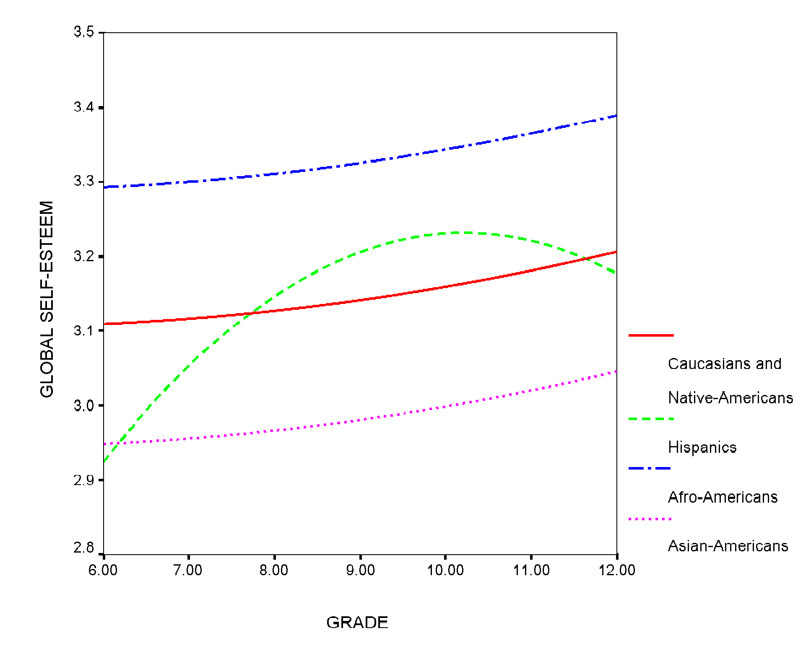
Figure Caption
Figure 1. Global self-esteem: predicted average grade-trends for adolescents from different ethnic groups. The developmental trajectories refer to males not from reconstituted families.
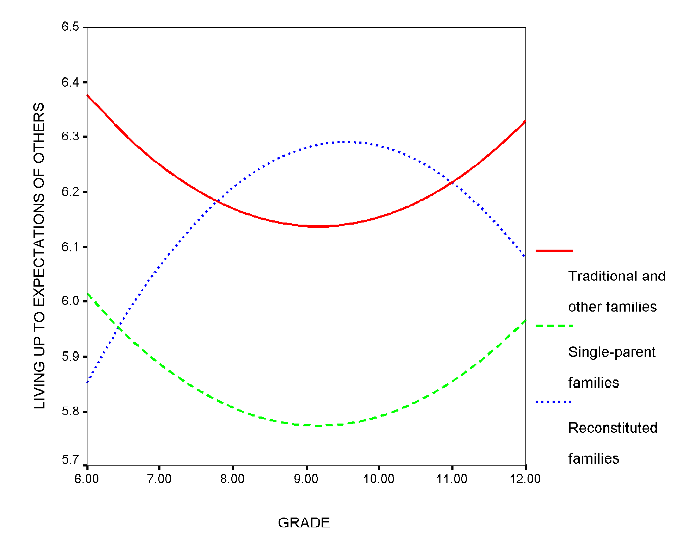
Figure Caption
Figure 2. Living up to the expectations of others: predicted average grade-trends for adolescents from different family structures. The developmental trajectories refer to Caucasians and Native-Americans.

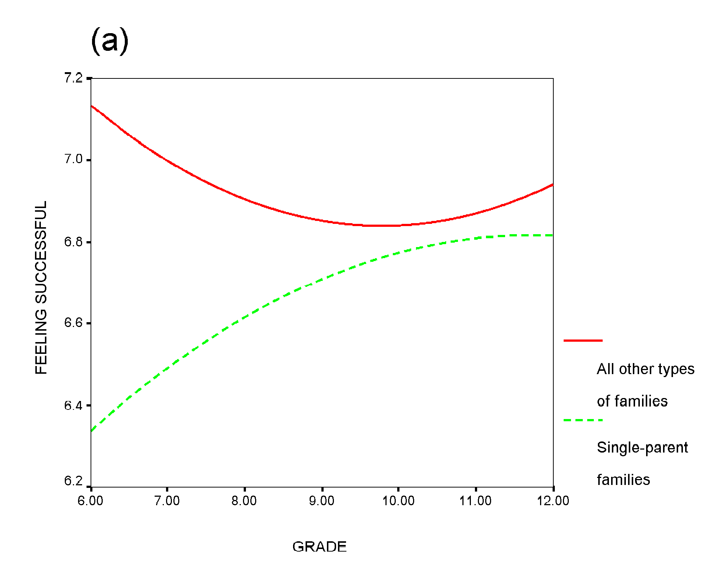
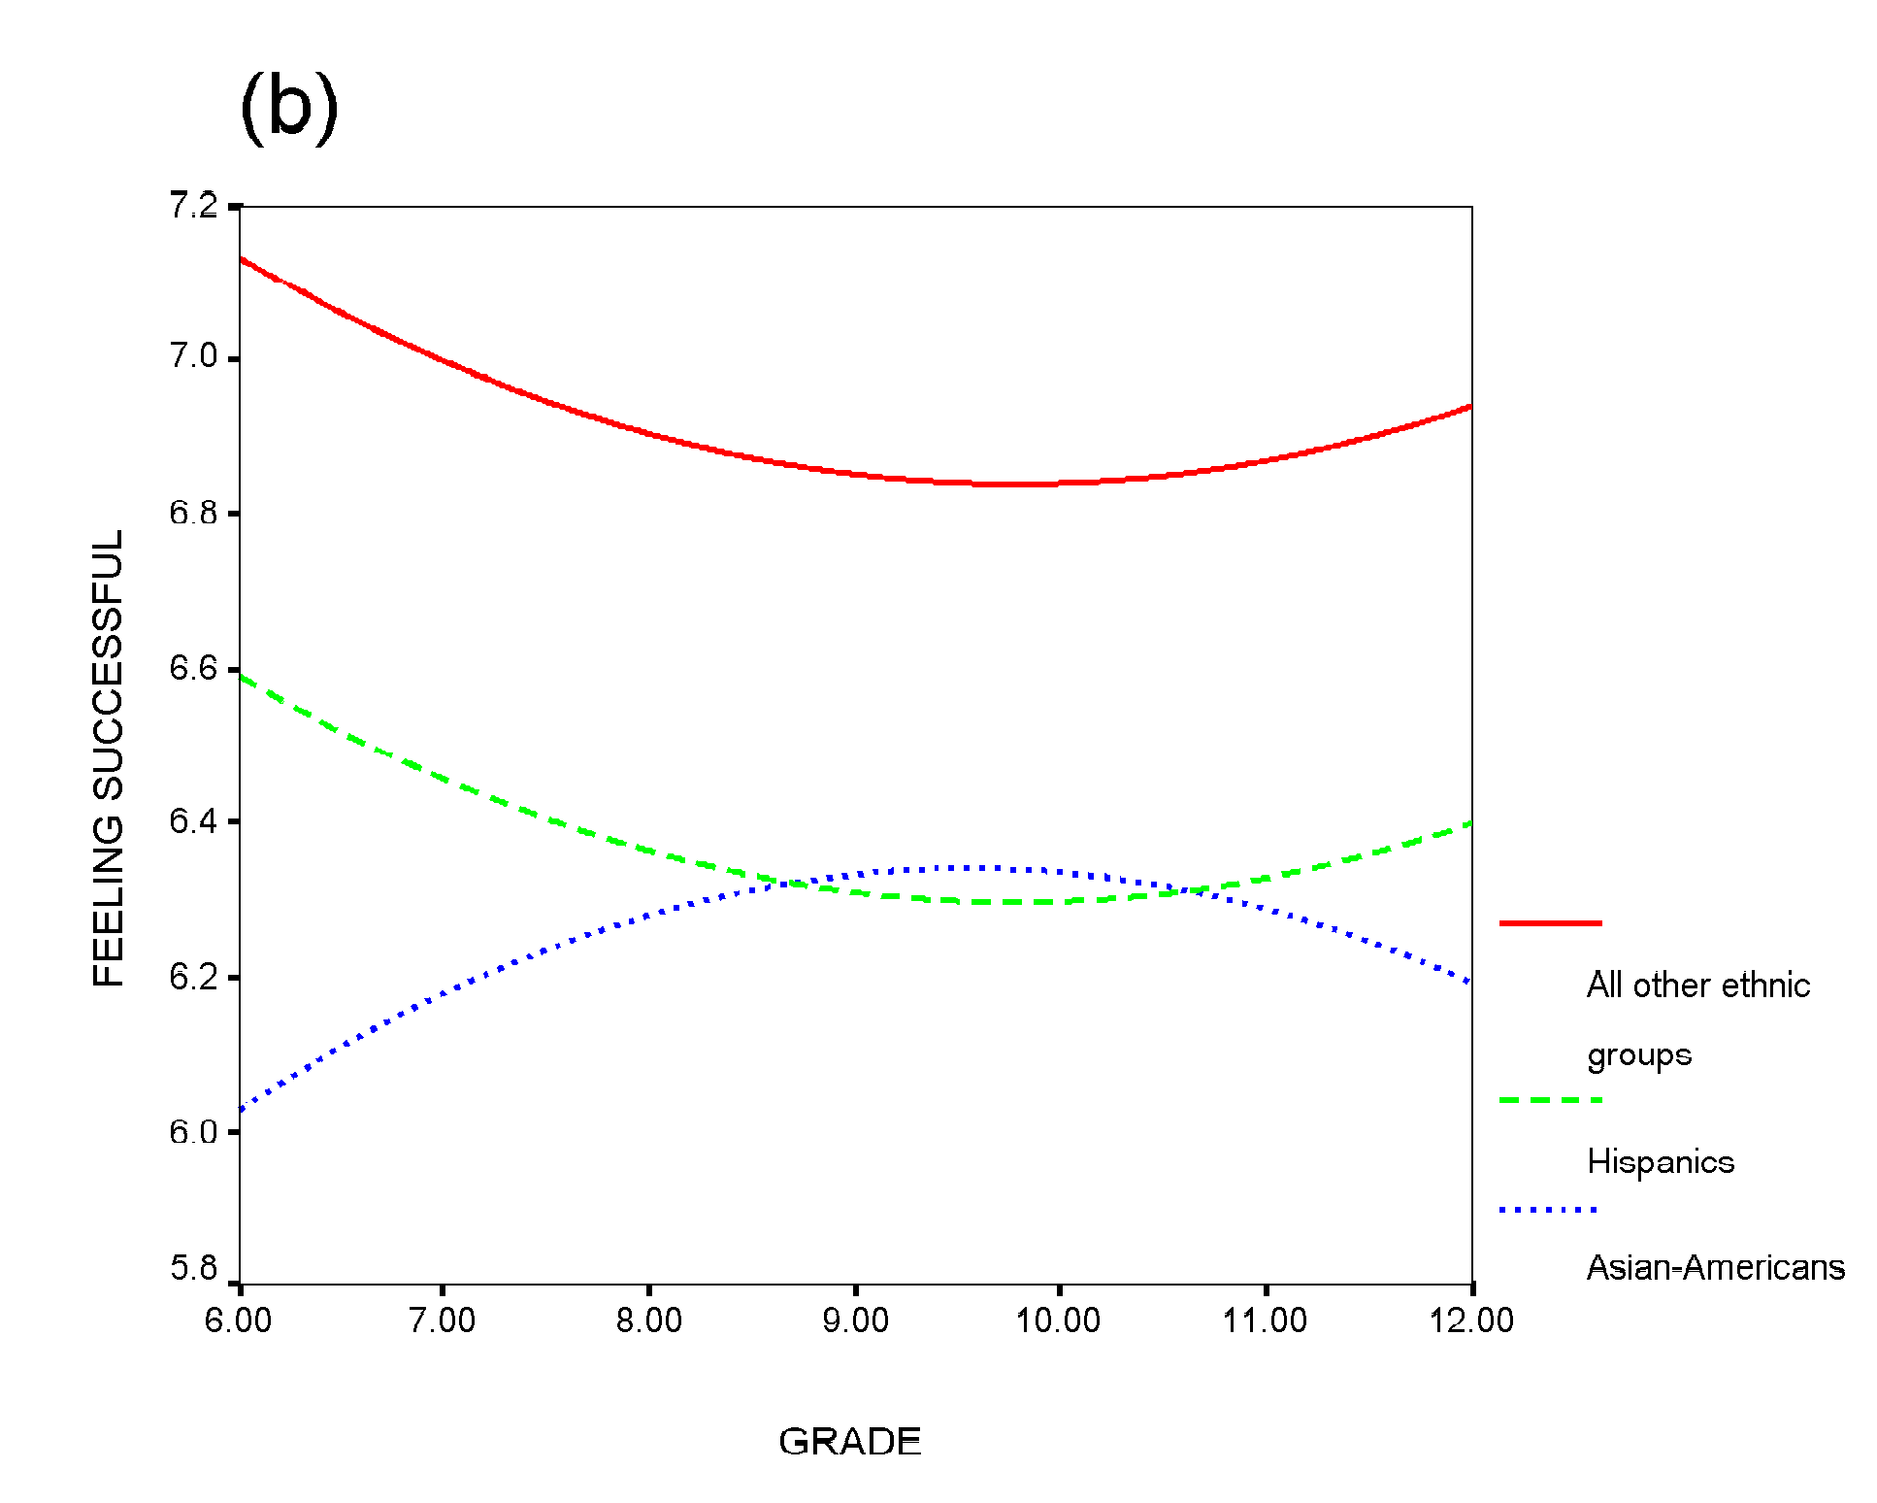
Figure Caption
Figure 3. Feeling successful: predicted average grade-trends for adolescents from (a) different family structures and (b) different ethnic groups. The developmental trajectories refer to Caucasians, Afro-Americans, and Native-Americans in graph (a), and adolescents not from single-parent families in graph (b).

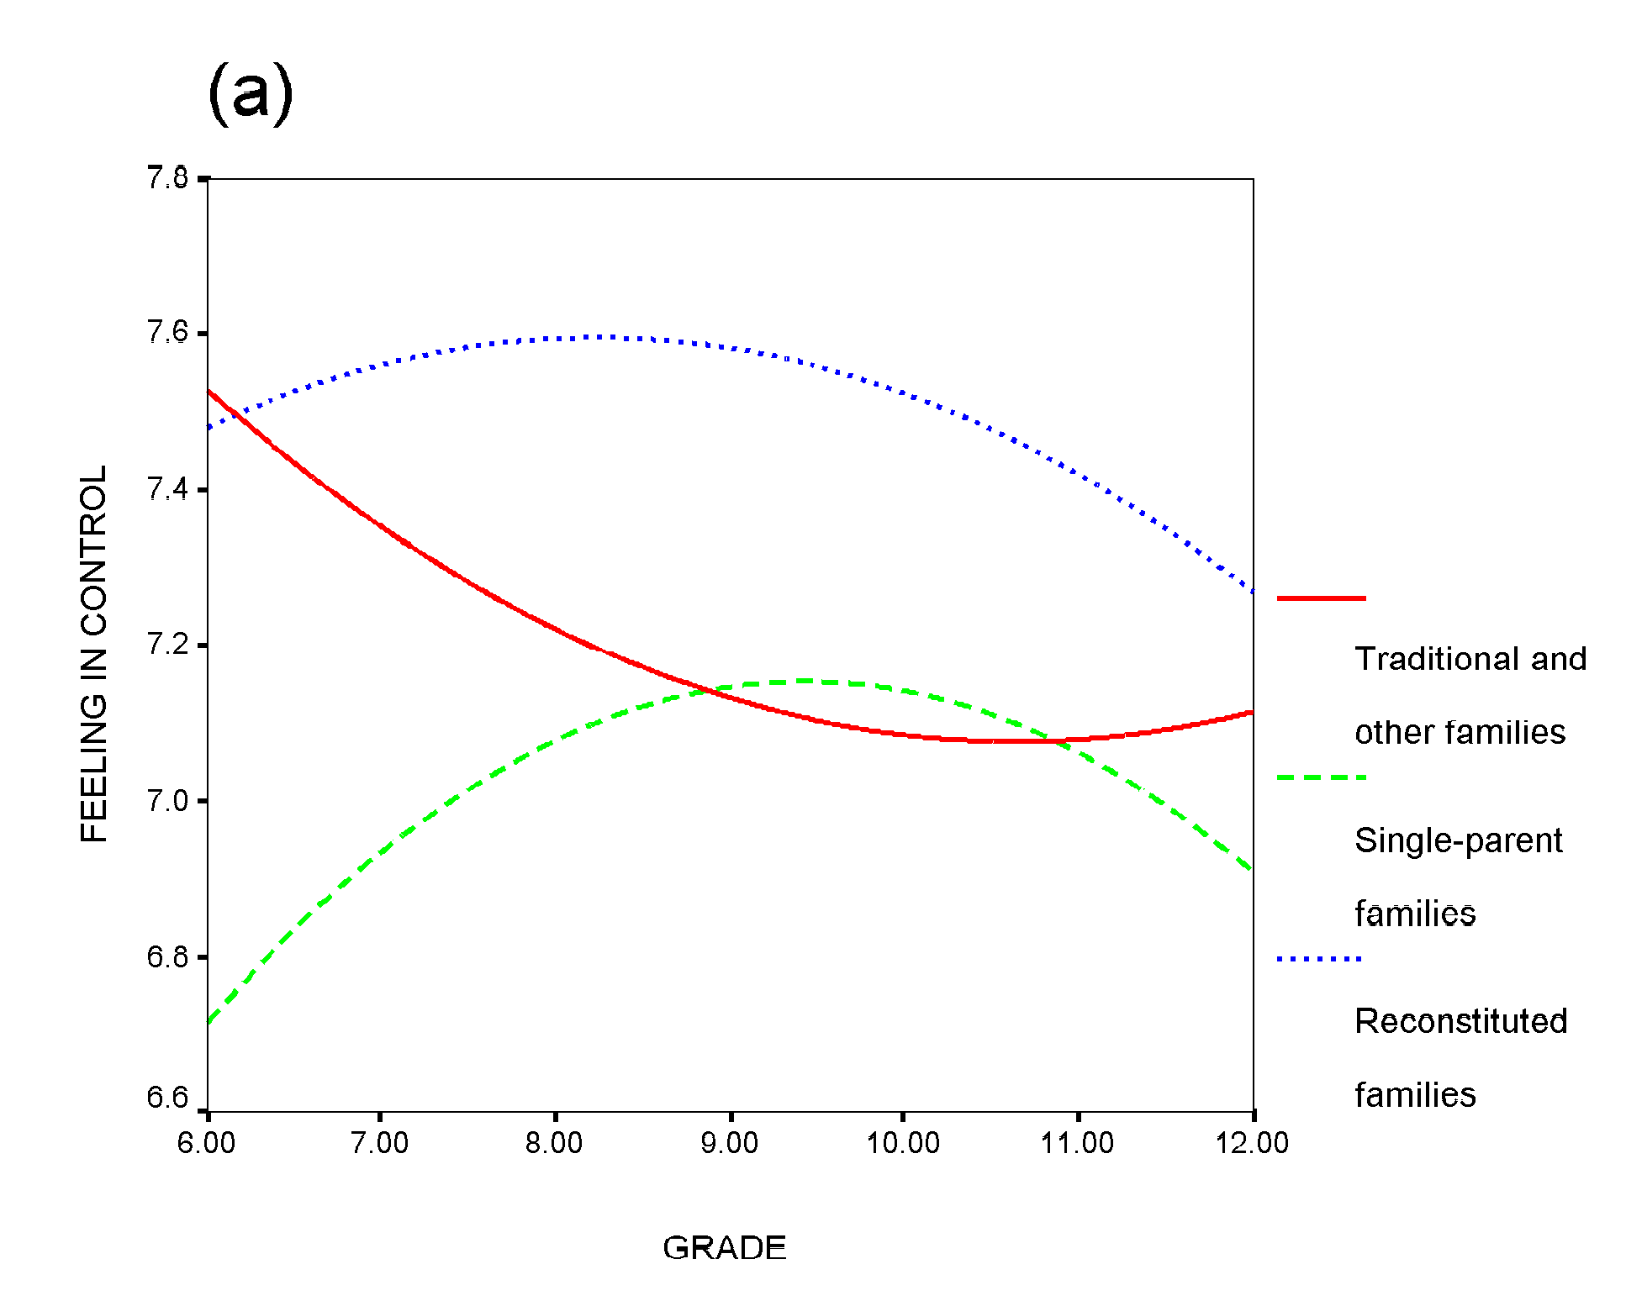
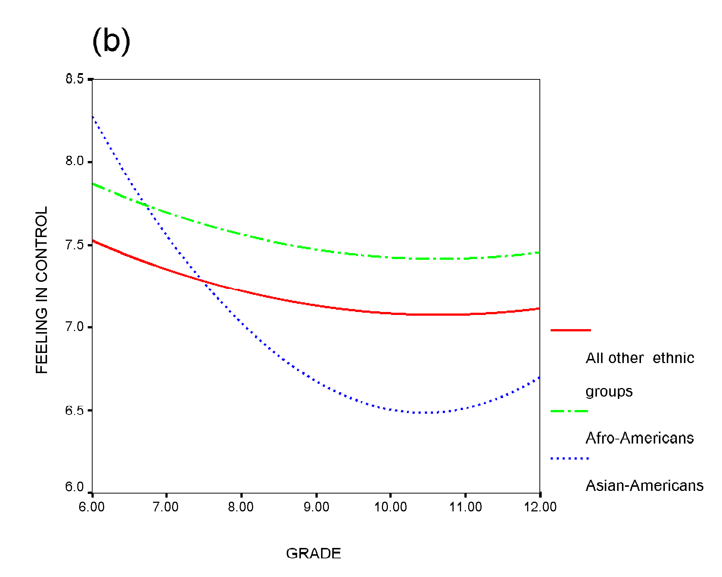
Figure Caption
Figure 4. Feeling in control: predicted average grade-trends for adolescents from (a) different family structures and (b) different ethnic groups. The developmental trajectories refer to Caucasians, Hispanics, and Native-Americans in graph (a), and adolescents from traditional or other families in graph (b).

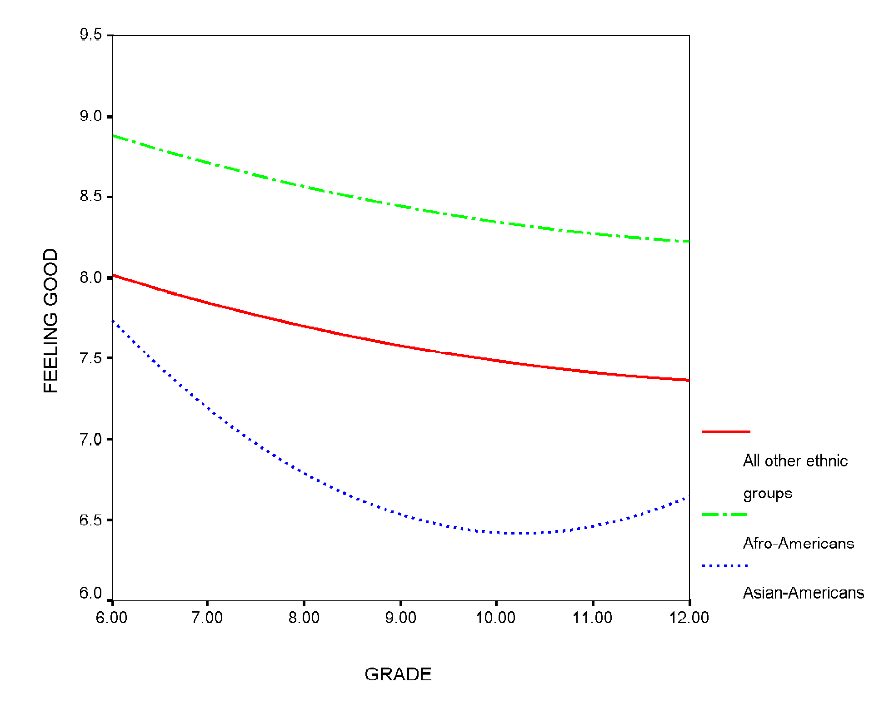
Figure Caption
Figure 5. Feeling good: predicted average grade-trends for adolescents from different ethnic groups. Developmental trajectories refer to males.

