Identifying human waste contribution of phosphorus loads to domestic wastewater

D Gilmour^{1*}, D Blackwood¹, S Comber², A Thornell³

¹ Urban Water Technology Centre, University of Abertay Dundee, Dundee, DD1 1HG
²Atkins Limited, Chilbrook Oasis Business Park Eynsham, Oxford OX29 4AH
³Risk & Policy Analysts Limited, Farthing Green House,1 Beccles Road, Loddon, Norfolk, NR14 6LT
*Corresponding author, e-mail:d.gilmour@abertay.ac.uk

ABSTRACT
This paper describes an approach to identify the phosphorus contribution of faeces and urine in domestic wastewater as part of a model verification exercise for a collaborative project between UK Water Industry Research (UKWIR), Scotland & Northern Ireland Forum for Environmental Research (SNIFFER) and UK Technical Advisory Group (UKTAG). The approach develops a methodology used in recent investigations by University of Abertay Dundee, by combining behaviour questionnaire with in sewer sampling and flow monitoring. The approach aimed to reduce the uncertainties associated with the apportionment of Total Phosphorus (TP) and Soluble Reactive Phosphorus (SRP) from domestic sources as identified during the literature review as part of the collaborative project. A domestic sub-catchment was identified which could be isolated, sampled and analysed to identify domestic contribution of SRP and TP load in domestic foul water. This data analysed with the results of product usage questionnaires, was used to verify a generic model developed to determine the significance of laundry and dishwasher phosphorus contributions to domestic wastewater. Conclusions were drawn regarding the effectiveness of this approach in identifying and quantifying the sources of phosphorus to wastewater treatment works.

Keywords: source control, phosphorus, behavioural questionnaire, sewer monitoring, wastewater, detergents

INTRODUCTION
A collaborative project for UK Water Industry Research (UKWIR), Scotland and Northern Ireland Forum for Environmental Research (SNIFFER) and UK Technical Advisory Group (UKTAG), with assistance from the Environment Agency and Scottish Environment Protection Agency has been completed to assess the impact of source control measures on the quality of wastewater received at wastewater treatment works (WwTW) and the potential implications for meeting phosphorus environmental quality standards (EQS) in the receiving waters they discharge to.

There are a number of legislative drivers to reduce phosphorus discharges to the environment. Recent legislation such as Habitats Directive, Urban Wastewater Treatment Directive (UWWTD) and Water Framework Directive (WFD) all have a requirement for Water Service Providers (WSP) to control levels of discharges from point sources including waste water treatment works. One of the mechanisms in the UK for achieving ‘good ecological status’ as required by the WFD is by regulators setting a programme of measures to control inputs to receiving waters. However there is also a need to ensure that these measures can be undertaken by WSP without incurring disproportionate costs. Accurate apportionment of phosphorus, including the domestic contribution, will provide the information required by regulators and their policy makers to effectively balance the cost effectiveness of programme of measures (including source control, end of pipe treatment and reduction of diffuse sources) with meeting the desired environmental objectives.

An apportionment model has therefore been developed as part of the UKWIR, SNIFFER and UKTAG collaborative project, in order to accurately apportion phosphorus inputs to wastewater, with a particular emphasis on determining the impact of removing phosphorus from domestic detergents. To achieve this objective, a combination of using literature sources and data held by the project partners was utilised. Domestic inputs of phosphorus to sewer include sources such as human contribution through faeces and urine, washing machine and dishwasher detergents, dosed water supply and personal care products. Uncertainties exist regarding the apportionment of these sources, in particular the human contribution because phosphorus is very widely distributed in both plant and animal foods. Furthermore, the phosphorus content and form of a food will vary according to the processing, cooking or quality of the product. In addition, the amount of phosphorus excreted by a person depends upon the diet and age of the individual. Data on human waste was drawn from two key sources which provided very similar estimates of phosphorus in urine (0.9 g-P/person/day) and faeces (0.4 g-P/person/day) (Johnson et al., 2006).

A sampling programme was undertaken by the University of Abertay Dundee in September 2007, with in-sewer sampling and flow monitoring along with a consumer behaviour questionnaire. The objective was to reduce the uncertainties associated with the apportionment of TP and SRP from domestic sources as part of the wider collaborative project. The sampling and analysis programme consisted of two parts, sub-catchment sampling, and WwTW sampling. A market town in Scotland was selected for the study as this area was used for the WaterSense project (WaterSense 2006) and therefore the catchment was already well defined, with the research group already holding 900 detailed questionnaires on detergent use within the area.

METHODOLOGY
The methodology used in the study was based on previous work undertaken by the University of Abertay. The behavioural questionnaire approach was used in the Think Before You Flush (TBYF) programme (Souter 1998, Ashley 2005) and more recently in the WaterSense Phosphate project (WaterSense 2006). In both cases the questionnaires were used to monitor the effect of educational campaigns on user behaviour.

A study undertaken by Swain (2002) combined previously used questionnaire techniques with in-sewer monitoring to measure the effectiveness of the educational campaign. This study found that the responses given in the questionnaire fitted well with what was measure in the sewer. The result of this work identified the accuracy of responses to behavioural questionnaires and these finding aided the development of the approach undertaken in the current phosphorus study.

The approach in the current study involved the identification of a domestic sub-catchment with a separate sewer system for monitoring, sampling and analysis. Twenty-four hour composite sampling was undertaken to ensure a representative quantification of phosphorus loads. This data was analysed together with the results of the product usage questionnaires to verify the apportionment of phosphorus from domestic sources as part of a model being developed by the project team.

The sub catchment sampling location was selected by balancing the need for being large enough to be able to accurately measure flows with but small enough to enable a door to door survey of every household. . A questionnaire survey was undertaken in the selected sub catchment to identify; how often washing machine and dishwashers were used, which products were used and to determine household occupancy. Concurrently, flow and sampling equipment was installed at the WwTW to allow catchment scale information to be collected. A raingauge was also installed at the treatment works for the survey period. This paper reports on the questionnaire and flow sampling activities at the subcatchment level.

QUESTIONNARE AND SUB CATCHMENT CHARACTERISTICS
A door to door questionnaire was used to identify washing machine and dishwasher ownership and use in the sub catchment. This data was collected along with occupancy data to establish the population of the sub catchment. The sub catchment profile information is shown in Table 1.

Table 1 Sub Catchment profile
Population | 113
Assumed economic profile | ABC1
Average household occupancy | 2.40
% Washing machine ownership | 100
% Dishwasher ownership | 60

The sub catchment contained 47 houses, of which household occupancy and washing machine ownership was similar to the 900 surveys undertaken as part of the WaterSense study in the same location. The likely economic profile in this study was limited to ABC1, a more affluent group, and not unexpectedly dishwasher ownership was higher than average in WaterSense of 26% and the national average of 36%.. A stratified sampling approach was used in the WaterSense study as it was important to get a representative socio economic sample. In this survey balancing measurable flows and the size of the sub catchment, rather than socio economic demographics was the priority.

Each household was also questioned on how often they used their washing machine and dishwasher as well as brand of product purchased. The brand of product information is important as different brands contain different amounts of phosphorus. A weighted average of 88g per wash was used to calculate the phosphorus loadings from the sub catchment. This figure had been developed from the general model but was found to be accurate for the sub catchment. The information for washing machines is shown in Table 2 and for dishwashers in Table 3. The number of washes for powder, tablets and liquid are shown in bracket for each brand.

Table 2 Washing machine use and product information
Products | Powder | Tablets | Liquid | Washes per month
Aerial | 1(30) | 2(24) | 2(42) | 96
Bold | 4(80) | 1(12) | 1(64) | 156
Daz | 6(152) | 1(n/a) |  | 152
Fairy | 3(20) |  | 4(112) | 132
Lidl | 1(8) |  |  | 8
Persil | 6(126) |  | 5(74) | 200
Sainsburys | 1(8) |  | 1(12) | 20
Tesco | 3(32) | 2(42) | 2(n/a) | 74
don’t know |  |  |  | 12

Table 3 Dishwasher use and product information
Products | Powder | Tablets | Liquid | Washes per month
Fairy |  | 9(160) |  | 160
Finish |  | 12(266) |  | 266
Lidl |  | 4(30) |  | 30
don’t know |  | 2(38) |  | 38
Tesco | 1(12) | 3(34) |  | 46

The generic model was developed in the collaborative UKWIR, SNIFFER and UKAG from a wide literature review and data held by the project team. The data collected during the behavioural survey was used to compare the estimated levels of detergent usage with that in the general model. The results from each activity compared well, with the only difference being that the population using dishwashers being higher due to the demographics of the sub catchment area, increasing the total detergent released for dishwasher use. Table 4 shows the comparison of sub catchment and general model for total detergent usage per person per day.

Table 4 Comparison of sub catchment and general model for total detergent per person per day
 | Dishwashers |  | Laundry
 | Sub catchment | Generic model | Sub catchment | Generic model
Number of washes per day per household | 0.68 | 0.70 | 0.64 | 0.60
% of population using dishwashers/washing machines | 60 | 36 | 100 | 100
Average household occupancy | 2.40 | 2.36 | 2.40 | 2.36
Total detergent released to sewer per person per day | 3.5 g | 2.1 g | 23.5 g | 21.5 g
MONITORING EQUIPMENT AND RESULTS
The flow monitoring and sampling programme was conducted over two one week periods, with BOD, suspended solids, TP and SRP measured within the sub-catchment. Standard flow monitoring and sampling equipment was used and attended daily during the survey. An intrinsically safe ultrasonic flow monitor was installed in the 225 mm circular pipe in the inlet to a manhole chamber located at the bottom of the sub catchment.
Figure 1 Flow monitoring equipment set up
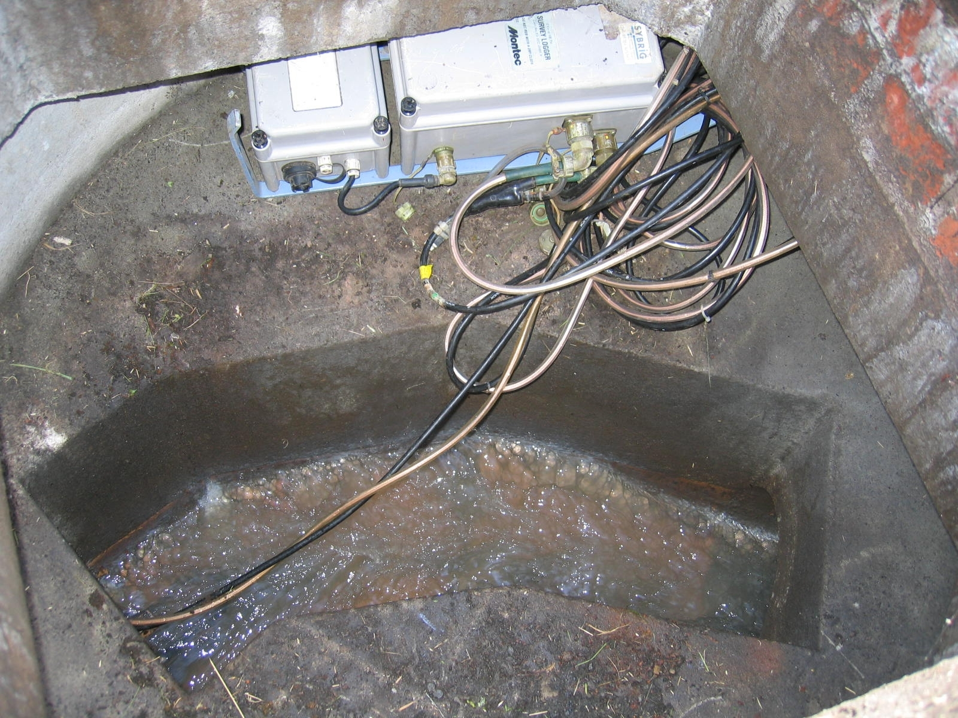 | 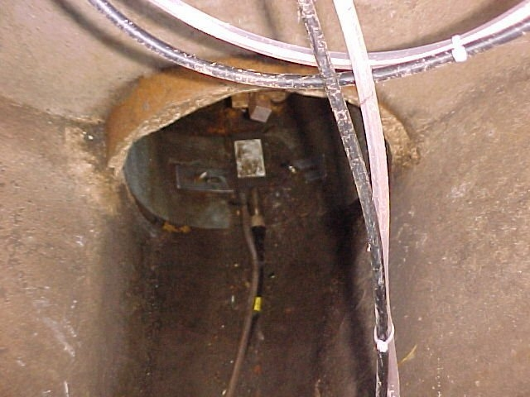

Flow Logger
Intrinsically safe Buhler Montec Xytec 7050 flow loggers were used to measure depth and velocity of wastewater entering the works and within the sub catchment. This type of logger uses a pressure transducer to measure depth and an ultrasonic transducer to measure velocity. The sensor-head is secured to a steel band and fitted into the pipe or channel with the sensors positioned at invert level. The flow loggers were programmed to measure and record depth and velocity every two minutes. The Xytec flow logger was interrogated on site and the data downloaded to a portable PC. The data was then downloaded to a desktop PC for processing and analysis. The flows are calculated using the X300 analytical software package.

Manual measurements were carried out during site visits to confirm the accuracy of the logger readings whilst installed. Depth calibrations were carried out using a calibrated measuring staff. The flow logger maintained excellent depth accuracy throughout the monitoring period and no depth calibration had to be carried out. Velocity calibrations are undertaken using a portable Valeport velocity meter but such measurements are only possible in depths over 70mm, therefore only depth measurements were taken at the sub catchment flow monitoring location. Buhler Montec 3510 I.S survey logger systems manual states the transducer head velocity sensor range 0.1-4.0 m/sec within an accuracy ± 2.5%.

The 24 hour composite samples were collected using an intrinsically safe Xylon portable wastewater sampler. This instrument uses an air pump vacuum system with a 24-bottle storage container. The sampler can be programmed for a range of sampling intervals and for the purposes of this study, a 170ml sample every 15 minutes was taken.

Flow results
The daily flow volume for the sub catchment was calculated from midnight to midnight, for the survey period and is shown in Table 5. The sample flow volumes used to calculate the loads were calculated from the sampler start time of 10:45am. These are shown in Table 6, with sample volumes having been calculated for the previous 24 hours from the dates in the table.

Table 5 Daily volumes for the sub catchment | Table 6 Sample volumes at sub catchment
  Date | Daily Volume (l)
  Mon-17/09/07 | 7,043
  Tue-18/09/07 | 24,470
  Wed-19/09/07 | 5,411
  Thu-20/09/07 | 18,221
  Fri-21/09/07 | 27,467
  Sat-22/09/07 | 6,228
  Sun-23/09/07 | 8,186
  Mon-24/09/07 | 37,595
  Date | Sample Volume (l)
  Tue-18/09/2007 | 12,484
  Wed-19/09/2007 | 24,186
  Thu-20/09/2007 | 2,809
  Fri-21/09/2007 | 34,636
  Sat-22/09/2007 | 8,566
  Sun-23/09/2007 | 11,273
  Mon-24/09/2007 | 40,670

An additional week of flow data was collected to check that the flow recorded during the initial week’s sampling was representative. Although the daily volumes vary widely, similar total volumes were recorded for each of the two, eight day periods (135 m³ versus 133 m³). However, the flow recorded on the last two days of the additional week’s data is lower than expected, probably due to sediment build up on the flow meter at the end of the measurement period. It can be concluded that the flow collected during the survey period is representative of the sub catchment. The average daily flow during the survey period corresponds with a per capita sewage discharge of 149 litres per head, which equates closely with OFWAT estimates of 151 l/person/day (OFWAT 2007).

Sample results
Sample results for the survey period from the sub catchment are shown in Table 7. The samples were analysed for soluble reactive phosphorus (SRP) and total phosphorus (TP)

Table 7 Sample results for sub catchment

Date | SRP | SRP | TP | TP
 | mg-P/l | Kg/day | mg-P/l | Kg/day
Tue 18-Sep-07 | 15.1 | 0.19 | 20.3 | 0.25
Wed 9-Sep-07 | 13.8 | 0.33 | 21.0 | 0.51
Thu 20-Sep-07 | 2.9 | 0.01 | 4.5 | 0.01
Fri 21-Sep-07 | 4.4 | 0.15 | 4.9 | 0.17
Sat 22-Sep-07 | 11.3 | 0.10 | 21.8 | 0.19
Sun 23-Sep-07 | 11.4 | 0.13 | 21.2 | 0.24
Mon 24 Sep-07 | 6.3 | 0.26 | 7.3 | 0.30

The purpose of the sampling was to identify TP and SRP concentration coming directly from the sub catchment properties. This can then be directly related to the identified washing and dishwasher use. The average SRP concentration in the wastewater from the sub-catchment was 8.8 mg-SRP/l, ranging between 2.9 and 15.1 mg-SRP/l. The highest concentrations were seen at the weekend and on Tuesdays, presumably coinciding with the days that the residents used their washing machines the most, or were at home to generate a greater amount of dishes for washing. The average TP concentration was 13.8 mg-P/l, ranging from 4.5 to 22.0 mg-TP/l, again with the highest concentrations falling on the weekends and Tuesdays.

COMPARISON OF SUB CATCHMENT AND GENERAL MODEL
A comparison of the sub catchment data with the generic model for detergent derived phosphorus load was undertaken. This process broke down the information collected from the subcatchment into the model categories as shown in Table 8. The results reflect the sub catchment population’s lower percentage usage of laundry products containing phosphorus and the higher population using dishwashers.

The total predicted detergent derived phosphorus load to sewer (g TP/person /day) for the sub catchments is broadly similar to that predicted by the general model. Table 9 combines this information to predict the total contribution of phosphorus from domestic sources. It can be seen that the sub catchment and general model predictions are very similar with the main difference is no dosing of mains supply.

Table 8 Comparison of sub catchment and general model for detergent derived
phosphorus load (UKWIR, 2008)

 | Dishwashers |  | Laundry
 | Sub catchment | Generic model | Sub catchment | Generic model
Percentage of products containing phosphorus | 100 | 96 | 4 | 17
Percentage of phosphate in products | 30 | 30 | 30 | 30
Amount of phosphorus discharged per person per day derived from use of phosphates (g-TP/person/day) | 0.26 | 0.15 g | 0.07 | 0.3 g
Percentage of products containing phosphonates | 0 | 4 | 96 | 81
Percentage of phosphonates in products | 2.5 | 2.5 | 2.5 | 2.5
Amount of phosphorus discharged per person per day derived from use of phosphonates (g-P/person/day) | 0g | 0.0006 g | 0.16g | 0.12 g
Total detergent-derived phosphorus load to sewer  (g-TP/person/day) | 0.26g | 0.15 g | 0.23g | 0.39 g
Table 9 Sub catchment and general model predictions
(UKWIR, 2008)
Source | Load to sewer  (g-TP/person/day)
 | Sub Catchment | Generic model
Laundry | 0.23 | 0.39
Automatic dishwashers | 0.26 | 0.15
Faeces | 0.50 | 0.50
Urine | 0.90 | 0.90
Mains supply | 0 | 0.12
Total | 1.89 | 2.06

An alternative method of calculating the loads per person per day using the sub catchment data has been developed to confirm that the categorisation in line with the generic model does not affect the outcome. This method is presented in Tables 10– 12. The phosphorus content of the stated washing machine products was identified using the automatic washing machine detergent marketing data information (UKWIR, 2008) where products were categorized as 30% or 2.5% phosphorus. Sainsburys' own brand was the only washing machine product identified as having 30% phosphorus concentration. In addition, any responses ‘don’t know’ were categorised as 30% phosphorus. Dishwasher products were categorised as all containing 30% phosphorus.
Table 10 Phosphorus input to sewer from washing machine products used
within the sub catchment

Products | Washes per month | Phosphorus concentration (%) | Product use per wash (g) | Phosphorus load  (g per week)
Aerial | 96 | 2.5 | 88 | 15
Bold | 156 | 2.5 | 88 | 25
Daz | 152 | 2.5 | 88 | 24
Fairy | 132 | 2.5 | 88 | 21
Lidl | 8 | 2.5 | 88 | 1
Persil | 200 | 2.5 | 88 | 32
Sainsburys | 20 | 30 | 88 | 33
Tesco | 74 | 2.5 | 88 | 12
Don’t know | 12 | 30 | 88 | 20

Table 11 Phosphorus input to sewer from dishwasher products used
within the sub catchment
Products | Washes per month | Phosphorus concentration  % | g of product per wash | Phosphorus load  g per week
Fairy | 160 | 30 | 20 | 60
Finish | 266 | 30 | 20 | 100
Lidl | 30 | 30 | 20 | 11
don’t know | 38 | 30 | 20 | 14
Tesco | 46 | 30 | 20 | 17
Table 12 Summary of phosphorus domestic detergent discharge to sewer
 | Washing Machine Phosphorus concentration |  | Dishwasher  Phosphorus concentration
 | 30 % | 2.5% | 30% | 2.5%
g per week | 53 | 130 | 203 | 0
g per person per day | 0.07 | 0.17 | 0.26 | 0

This method of calculation gives very similar results as the using the model with g per person per day for washing machines 0.23g using the model categories and 0.23g (0.24g with rounding error) using the alternative method. Dishwasher the results are also very similar with 0.26 produced by the model and by the alternative method.

HUMAN CONTRIBUTION & SUB CATCHMENT MODEL VERIFICATION
The flow and load data collected over the survey period can be used to verify the predicted loads in the sub catchment. Table 13 shows the total phosphorus per head per day recorded during the flow and load survey.
Table 13 Total phosphorus per head per day
 | Measured phosphorus load to sewer from sub catchment
Date | Total load (kg/day) | Per capita (g/head/day)
Tue 18-Sep-07 | 0.25 | 2.2
Wed 9-Sep-07 | 0.51 | 4.5
Thu 20-Sep-07 | 0.013 | 0.1
Fri 21-Sep-07 | 0.17 | 1.5
Sat 22-Sep-07 | 0.19 | 1.7
Sun 23-Sep-07 | 0.24 | 2.1
Mon 24 Sep-07 | 0.30 | 2.6

Table 9 predicted a phosphorus load of 1.89 g per person per day. The average of loads shown in Table 13 corresponds to 2.11 g per person per day, within 5 % of the predicted value. The average recorded load also confirms the generic model prediction of 2.06 g per person per day. The average load per head at the treatment works is 1.96 g per person per day.
The approach undertaken aimed to reduce the uncertainties associated with the apportionment of phosphorus from domestic sources as identified during the literature review process. During the model development process, a wide variety of literature, data and product information was available, in particular for laundry, dish washers, mains supply. In the case of human waste, the literature used to develop the generic model data was more limited (0.9 g-P/person/day) and faeces (0.4 g-P/person/day) (Johnson et al., 2006).

The closeness of the verification, in both the breakdown of the model and the comparison and the overall flow measurement gives a basis for confidence in the apportionment model overall and in turn the apportionment of human waste contribution.
CONCLUSIONS
In-sewer flow monitoring and twenty four hour composite sampling was undertaken in the sub catchment to measure actual phosphorus loads to verify the predictions above. The measured domestic contribution of total phosphorus in the sub catchment was 2.1 g per person per day, which suggest that the apportionment model is robust, although variations in the relative contributions from laundry and automatic dishwashing products reflect local demographics. The apportionment methodology in the UKWIR report was applied to this data to predict a domestic contribution of total P to the sewerage system of 1.89 g per person per day, compared to a generic model prediction of 2.06 g per person per day.
In-sewer flow monitoring and twenty four hour composite sampling was undertaken in the sub catchment to measure actual phosphorus loads to verify the predictions above. The measured domestic contribution of total phosphorus in the sub catchment was 2.1 g per person per day, which suggest that the apportionment model is robust. It is recommended that the verification exercise should be repeated in other catchments in the UK to ensure the general applicability of the apportionment model.
It can be concluded that the use of sampling, flow monitoring and questionnaires was an effective approach to identify and quantify the domestic sources of phosphorus.
ACKNOWLEDGEMENT
The authors would like to thank the contribution of UK Water Industry Research (UKWIR), Scottish and Northern Ireland Forum for Environmental Research (SNIFFER) and UK Technical Advisory Group (UKTAG) for funding this project and the Environment Agency and Scottish Environment Protection Agency for their valuable support sand contributions.

REFERENCES
Ashley , R M Blackwood D, Souter N, Hendry S, Moir J, Dunkerly J, Davies, J, Butler, D Cook A. (2005) Sustainable Disposal of Sanitary Waste. Journal of Environmental Engineering. February 2005 Volume 131, Number 2 ISSN 0733-9372.

Jonsson H., Baky A., Jeppsson U, Hellstrom D. and Karrman E. (2006) Composition of urine, faeces, greywater and biowaste for utilisation in the URWARE model. Urban water report 2005:6.

OFWAT 2007, Security of Supply (2006-2007). OFWAT, Birmingham. ISBN 1 90465 394

Souter, N, Swain, A. and Ashley, R.M. (1998) ‘Think Before You Flush’ Peoples Attitude and a methodology for change. WWTC Report WW5008R/3.

Swain, A. Souter N and Blackwood D. (2002) An assessment of the impact of promotional activities on the disposal of sanitary items via W.C. Final Report. October 2002

UKWIR (2008) Final Report: source control of phosphorus from domestic sources – options and impacts. Source Control Of Phosphorus. A report prepared for UKWIR, SNIFFER and UKTAG.. in print. Published by UK Water Industry Research Limited 1 Queen Anne’s Gate, London SW1H 9BT

WaterSense (2006) A public awareness campaign in Scotland, 2005-06, Final report.

Further information about the project and a copy of the report can be obtained from UKWIR, Queen Annes Gate, London.

