TITLE PAGE
Title: Gene-environment contributions to energy and macronutrient intakes in 9-year-old children: results from the Quebec Newborn Twin Study¹

Authors: Lise Dubois^{a,b,*}, Maikol Diasparraª, Brigitte Bédardª, Jaakko Kaprio^{c,d,e}, Bénédicte Fontaine-Bisson^{f}, Daniel Pérusse^{g}, Richard Tremblay^{h,i}, and Michel Boivin^{j}

ª Institute of Population Health, University of Ottawa, 1 Stewart St., Ottawa, ON, K1N 6N5, Canada
^{b} Department of Epidemiology & Community Medicine, University of Ottawa, 451 Smyth Road, Ottawa, ON, K1H 8M5, Canada
^{c} Hjelt Institute, Department of Public Health, University of Helsinki, P.O. Box 41 (Mannerheimintie 172), 00014 Helsinki, Finland
^{d} National Institute for Health and Welfare, Department of Mental Health and Substance Abuse Services, P.O. Box 30 (Mannerheimintie 166), 00300 Helsinki, Finland
^{e} Institute for Molecular Medicine (FIMM), University of Helsinki, P.O. Box 20 (Tukholmankatu 8), 00014 Helsinki, Finland
^{f} Nutrition Sciences Program, University of Ottawa, 43 Templeton, Ottawa, ON, K1N 6X1, Canada
^{g} Département d'anthropologie, Université de Montréal, C.P. 6128, succursale Centre-ville, Montréal, QC, H3C 3J7, Canada
^{h} Research Unit on Children’s Psychosocial Maladjustment (GRIP), Université de Montréal, 3050, Édouard-Montpetit, Montréal, QC, H3T 1J7, Canada
^{i} School of Public Health, Physiotherapy & Population Science, University College Dublin, Belfield, Dublin 4, Ireland
^{j} École de psychologie, Université Laval, 2325 rue des Bibliothèques, Québec, QC, G1V 0A6, Canada

¹Funding: This work has been supported by the Canadian Institutes of Health Research. Over the course of this work, Lise Dubois was a visiting professor funded by the Sigrid Juselius Foundation of Finland in the Department of Public Health in Helsinki under the direction of Jaakko Kaprio. The Quebec Newborn Twin Study was supported by grants from the Fonds Québécois de la Recherche sur la Société et la Culture, the Fonds de la Recherche en Santé du Québec, the Social Science and Humanities Research Council of Canada, the National Health Research Development Program, the Canadian Institutes of Health Research, and Sainte-Justine Hospital’s Research Center. Michel Boivin was supported by the Canada Research Chair Program.

*Corresponding author: L. Dubois, Department of Epidemiology and Community Medicine, Institute of Population Health, University of Ottawa, 1 Stewart St., Office 303, Ottawa, ON, Canada K1N 6N5, Tel: +1-613-562-5398, Fax: +1-613-562-5659, E-mail: lise.dubois@uottawa.ca.

ABSTRACT
Background: Few twin studies have examined nutrition-related phenotypes among children, and none has investigated energy and macronutrient intakes. Objective: The objective was to quantify genetic and environmental influences on variations in energy and macronutrient intakes among children aged 9 years. Design: We conducted a nutrition study among children participating in the Quebec Newborn Twin Study, a population-based birth cohort of twins. We derived dietary data from two multiple-pass 24-hour dietary recalls with a parent and his or her child. The analysis employed a classic twin study design and used data from 379 twin pairs. Results: Univariate analyses indicate that heritability for mean daily energy (kcal) and macronutrient (g) intakes was moderate, ranging from 0.34 (95% CI: 0.22, 0.46) to 0.42 (0.31, 0.53). Genetic effects also accounted for 0.28 (0.16, 0.40) of the variance in percent of energy from lipids, while only environmental (shared and unique) effects accounted for the variance in percent of energy from proteins and carbohydrates. The shared environment did not contribute to variations in daily intakes for most of the nutritional variables under study. Multivariate analyses suggest the presence of macronutrient-specific genetic influences for lipids and carbohydrates, estimated at 0.12 (0.04, 0.19) and 0.20 (0.11, 0.29) respectively. Conclusions: The unique environment (i.e., not shared by family members) has the largest influence on variances in daily energy and macronutrient intakes in 9-year-old children. This finding underscores the need to take obesogenic environments into account when planning dietary interventions for younger populations.

Keywords: Energy intake; Macronutrients; Children; Twins; Heritability; Environment
1. Introduction
Diet is an important element of the obesogenic environment and is a modifiable risk factor for the prevention of obesity and related chronic conditions [1]. Because diet in childhood is related to obesity and chronic diseases later in life [2], it is important to identify the major determinants of children’s diets and the strength of their influence. Various environmental factors, such as familial and cultural contexts [3, 4], shape eating patterns during childhood. What humans eat and how much they eat on a daily basis are also influenced by genetic predispositions that could be related to taste abilities [4, 5] and inner control mechanisms influencing food intake regulation [5, 6]. Over the last thirty years, researchers have used data on twins to quantify the relative importance of genetic and environmental influences on nutrition-related phenotypes, although mainly in adults [7-13].
Energy and macronutrient intakes are major elements in the energy balance equation governing weight status. Most population twin studies examining daily intakes of energy or macronutrients reported moderate heritability (between 0.20 and 0.40) among adults [7, 11, 12], suggesting that environmental influences account for a large part of the variation in intakes. Since total energy ingested is the sum of energy from macronutrients, one might expect that genetic and environmental influences on intakes of energy and its major components would be common. However, a study of adult twins detected the presence of macronutrient-specific genetic influences [14]. These, although small in magnitude, suggest that genetic factors also influence specific macronutrient selection to some extent.
Whether these findings from twin studies among adults extend to children remains unknown. To our knowledge, no twin study has yet quantified the genetic and environmental influences on daily energy and macronutrient intakes during childhood. Nutritional requirements vary over the life course [15]. Moreover, most twin studies on energy and macronutrient intakes used dietary data collected in the 1990s or earlier. Since then, the obesogenic environment has expanded dramatically. Adult subjects in earlier studies had thus not been exposed as children to food environments similar to those in which children are living today. This disparity in exposure may have resulted in a different genetic-environmental etiology for nutritional intakes. The objective of the present study was therefore to examine genetic and environmental contributions to variations in energy and macronutrient intakes among twin children, using detailed dietary information collected in the mid-2000s.

2. Subjects and methods
We collected dietary information between September 2005 and December 2006 from twin children aged 8 to 10 years (mean age 9.0, SD=0.5) participating in the Quebec Newborn Twin Study (QNTS). The QNTS is a population-based birth cohort of twins reared together. The cohort was based on all twin births in the Greater Montreal Area in the Province of Quebec, Canada, between April 1, 1995, and December 31, 1998. A total of 662 families (67%) initially enrolled in the study. QNTS criteria excluded twins with major diseases at birth from the cohort. The children were first seen at 5 months (adjusted for gestational age). Since then, they have been followed longitudinally on a regular basis, through various questionnaires, interviews, observations and laboratory measurements.
Zygosity was determined by the assessment of physical similarities between the twins at 5 months and 18 months of age, using an adapted version of the Zygosity Questionnaire for Young Twins [16]. Mouth swabs were also collected for a subsample of same-sex twins (123 pairs at 5 months; 113 pairs at 18 months). DNA was extracted from buccal cells and genetic marker analysis was performed. Comparisons of physical similarities and genotyping revealed concordances of 91.9% and 93.8% at 5 months and 18 months respectively [17]. The addition of chorionicity data obtained from the twins’ medical files allowed classifying twin pairs with 96% accuracy [17].
A total of 379 families (758 children) were participating in the nutrition study when the twins were about to reach age 9. Interviewers saw children either at home (233 families) or in a research hospital center (146 families) if the children were participating in another substudy that required taking specific laboratory measurements. Interviews of twins took place separately, on different days, to minimize reporting biases about children’s diets on the part of parents. Visits occurred on weekends, generally at one- or two-week intervals. We assigned twins randomly to the first interview. Both twins from a pair were seen on the same weekday in order to ensure identical reference periods for dietary interviews. Trained nutritionists collected data. Different interviewers saw each child in a twin pair in order to avoid potential biases related to perceived zygosity. Interviewers also had no access to other information about the twins, including zygosity.
We obtained detailed information on all food and drinks consumed by each child during the previous two days by conducting two multiple-pass 24-hour recalls with a parent and the child, starting with the most recent day. Several large-scale nutrition surveys [18, 19] have used multiple-pass dietary recalls. They incorporate specific steps to help minimize missing information, especially for food items likely to be forgotten [20]. Under this method, study participants were first asked to make a quick list of what the children had consumed during the preceding day. Next, they were asked to describe the items listed in greater detail, including quantities, brand names of commercial products, and recipes, as well as time and place of eating. Interviewers used different probing techniques to gather the important information. The final step entailed reviewing the recall to check for omissions or forgotten food or drinks. Volume food models were used to help participants report quantities consumed. Interviewers also took height and weight measurements for children according to a standardized protocol.
As was the case in other components of the study, parents gave their informed consent before participating in the nutrition study. We also obtained approvals from ethics committees at the University of Ottawa and the Sainte-Justine Hospital Research Centre.
In the days following the nutrition visit, a nutritionist responsible for data coding reviewed the data collected to ensure that information was complete and correctly reported. When clarification was needed, interviewers were contacted and, if necessary, families were telephoned to obtain additional details. The information collected through dietary recalls was coded using Nutritional Evaluation (Évaluation nutritionnelle, version 1.1.84), nutrient analysis software developed by Micro Gesta Inc. (www.microgesta.com). Large-scale nutrition surveys conducted in Quebec have used this software, which incorporates the Canadian food composition database, Canadian Nutrient File, version 2005 [21], and the US Department of Agriculture recipe file [22]. The software converted quantities of food consumed on dietary recall days into quantities of energy and nutrients ingested. Data coding applied rules and guidelines so as to standardize procedures and to ensure rigorous quality control. These procedures include coding data independently for each twin in a pair to avoid potential biases.

3. Analysis
The classic twin study design relies on comparisons between monozygotic (MZ) twins, who share 100% of their segregating genes, and dizygotic (DZ) twins, who share on average 50% of their segregating genes. The fact that MZ twins are more alike than DZ twins for a given trait suggests that genetic factors contribute to variations in this phenotype. Comparing MZ and DZ twin pairs for trait-specific similarities thus allows estimating the genetic and environmental contributions to phenotypic variation. The twin study design is based on assumptions that are extensively discussed elsewhere [23-25].
The present analyses focused more specifically on energy (kcal) and macronutrient intakes (in g, in kcal and as % of energy) as determined from data collected in dietary recall interviews. A total of 369 families provided complete and valid information for the two 24-hour recalls for both twins. The final sample for the analyses thus included 738 children, from 369 complete twin pairs (154 MZ pairs: 84 girls, 70 boys; 215 DZ pairs: 54 girls, 56 boys and 105 opposite-sex pairs).
Mean daily intakes (mean of two days) of energy, proteins, lipids and carbohydrates were calculated and standardized to z-scores. For most nutritional variables, except for carbohydrates and lipids as percent of energy, data were power-transformed (Cox-Box method) to achieve normality. Because age and sex differences can inflate twin correlations, their effects in the analyses were tested using a regression procedure [26]. Although there was a significant interaction between age and sex for some nutritional variables, the proportion of explained variance was less than 3%, and the age effect was not significant.
Intra-class correlations for MZ and DZ twin pairs (total and by sex group) were computed and compared. Model-fitting techniques [27] were then used to estimate the variance components of genetic and environmental influences for each nutritional variable. Four components of phenotypic variance are typically considered in the classic twin study design. The first component, additive genetic influences (A), represents the cumulative effects of individual alleles at all loci influencing the trait. The second component, non-additive genetic influences (D), represents genetic effects resulting from interactions between alleles (dominance) or loci (epistasis). A third component, known as common or shared environmental influences (C), refers to environmental factors or life experiences that are shared by twins. The last component, unique environmental influences (E), refers to environmental factors or life experiences that are specific to each individual. It includes measurement error. For twins reared together, as in the present study, C and D cannot be estimated simultaneously [28, 29]. In our analyses, ACE models were preferred (i.e., including C rather than D) because comparison of intraclass correlations between MZ and DZ pairs tended to satisfy the inequalities 2r_{DZ}>r_{MZ} >r_{DZ}.

3.1 Univariate and sex-limited analyses
Because twins are clustered in pairs, a hierarchical random-effect multilevel model of twin data [30] was used to test basic assumptions and to quantify the magnitude of genetic and environmental effects. Using a chi-square distribution, the basic hypothesis of equal means and variances between twins in a pair and across zygosity was tested for each variable under study. In all cases, the hypothesis of homoscedasticity was not rejected. Then a univariate ACE model was fitted, which allowed estimating phenotypic mean, additive genetic variance, shared environmental variance and unique environmental variance. Other univariate submodels were similarly specified from the ACE model, including: a CE model, without the genetic component, and an AE model, without the shared environment component.
The presence of sex-specific genetic or environmental effects on variability in energy and macronutrient intakes was also examined. To this end, for each nutritional variable, a model for boys and a model for girls were tested simultaneously, while controlling for the covariance between opposite-sex DZ twins for additive genetic and shared environment components. Details on sex-limited modeling techniques are available elsewhere [27].
As a consequence, for each nutritional variable we compared a sex-limited saturated model and a univariate saturated model by using the likelihood ratio test (-2Log) in order to verify the presence of sex-specific genetic effects. Model fitting was also performed using the mixed-effects multi-level model approach (MEMA) [31, 32], including age- and sex-adjusted data where required. Since these analyses did not improve the fit, their results were not considered further. Next, saturated and reduced models (ACE, AE, CE, E) were examined. The reduced models and the full (saturated) model were compared by using the likelihood ratio test (–2Log), Bayesian Information Criterion (BIC: chi-square + df⋅ln[n], where n=sample size) and Akaike’s Information Criterion (AIC: chi-square-2df), which took into account goodness-of-fit and parsimony in explaining the data. The lowest AIC value, along with a nonsignificant chi-square likelihood ratio test, determined the best-fitting model for each nutritional variable. Statistical analyses and model fitting for univariate and sex-limited analyses were performed using SAS 9.2/NLMIXED and MIXED and the level of statistical significance was set at .05.

3.2 Multivariate analysis
Because energy and macronutrient intakes are correlated, we used multivariate analysis to investigate to what extent genetic and environmental influences on variations in macronutrient intakes were common to genetic and environmental influences on variations in total energy intakes, and to quantify the specific influences, if any, for each macronutrient. In these analyses, energy and macronutrient intakes were expressed in kcal. Multivariate analysis was performed using OpenMx 1.2 library in R software (http://openmx.psyc.virginia.edu/).
We used multivariate genetic models to decompose intake variances and covariances for the three macronutrients into A, C and E components. We first compared three multivariate ACE models: the Cholesky decomposition, the Independent Pathway model and the Common Pathway model [33]. The Common Pathway model reflected the most parsimonious interpretation of the data and provided a better fit (see Table 1). In this ACE model, total energy intake represented the common factor (latent variable); observed variables were energy from lipids, from carbohydrates and from proteins (see Fig. 1). We also compared the full Common Pathway model to reduced AE Common Pathway models (see Table 2). Model 6, which dropped the shared environmental effect (C) for the common factor and for lipids and the additive genetic effect (A) for proteins, provided a better fit based on AIC. However, Model 8, in which no shared environmental effects were present, appeared more suitable for our sample size, as shown by the lowest BIC. Therefore, this model was preferred for estimating standardized parameters and standardized variances, these latter representing the square of path coefficients. Additional information about the additive genetic and unique environmental latent factor correlations for proteins, lipids and carbohydrates is presented in Table 3. Overall, data in the table indicate that additive genetic correlations between macronutrients were high (0.57 to 0.84), whereas environmental correlations were moderate (0.44 to 0.56).

4. Results
Table 4 presents participant characteristics. For most body size measures, no significant differences across sexes were observed (p>0.05), although girls had lower energy intakes than boys (p<0.05). Overall, the mean (±SD) energy intake was 1850 ± 15 kcal per day; 14.6 ± 0.1% came from proteins, 31.8 ± 0.2% from lipids and 55.0 ± 0.2% from carbohydrates (see Table 5). The percentage of energy from each macronutrient was similar in both sexes (all p>0.05).
Table 6 presents intra-class correlations by zygosity and sex. MZ correlations were twice as high as DZ correlations for energy, proteins (g), lipids (g), carbohydrates (g) and percent of energy from lipids, suggesting an additive genetic contribution to variations in energy and macronutrient intakes.
Table 7 presents the best-fitting models for univariate and sex-limited analyses. Overall, the magnitude of genetic and environmental contributions did not significantly differ between boys and girls (all p>0.05). For energy (kcal) and macronutrient (g) intakes, the AE model offered the best fit. Heritability estimates derived from the univariate analysis varied from 0.34 (95% CI: 0.22, 0.46) to 0.42 (0.31, 0.53). The unique environment and measurement error accounted for the remaining influence. For macronutrient intakes as percent of energy, our analyses indicated a genetic contribution for lipids only. Again, the AE model provided the best fit, with heritability estimated at 0.28 (0.16, 0.40). For percent of energy from proteins and carbohydrates, based on the best-fitting CE model, the shared environment contributed 0.20 (0.10, 0.30) and 0.23 (0.13, 0.33) of the variance respectively, while the unique environment made the remaining contribution (including measurement error). Overall, this nonshared environment (and error) accounted for at least 0.58 of the variance for the nutritional variables, indicating a strong contribution by the unique environment (and error) to variations in nutritional intakes among 9-year-old children.
Multivariate analysis was performed to verify the presence of macronutrient-specific genetic and environmental influences, which would be independent of the genetic and environmental influences on variance in total daily energy intakes. Fig. 2 presents standardized parameter estimates for the partial AE Common Pathway model selected for the multivariate analysis. Fig. 3 presents standardized variance estimates. Relative genetic influences common to energy and macronutrient intakes were estimated to be 0.27 (0.17, 0.39) for lipids, 0.17 (0.10, 0.25) for carbohydrates and 0.29 (0.18, 0.41) for proteins. Common relative influences from the unique environment (including error) were estimated to be 0.36 (0.27, 0.47), 0.22 (0.16, 0.30) and 0.38 (0.28, 0.49) respectively. Still, we observed macronutrient-specific genetic influences of 0.12 (0.04, 0.19) for lipids and 0.20 (0.11, 0.29) for carbohydrates. Specific influences from the unique environment (and error) were also observed for each macronutrient; variance estimates were 0.26 (0.18, 0.35) for lipids, 0.40 (0.32, 0.50) for carbohydrates and 0.33 (0.26, 0.41) for proteins.

5. Discussion

5.1 Genetic influences
Results of the present study suggest that genetic influences contribute moderately to variations in total energy (kcal) and macronutrient (g) intakes among children aged 9 years. The relative importance of lipids as a source of energy also appears to be subject to genetic influences to a certain extent, whereas our analyses detected no genetic influences for protein and carbohydrate intakes as percent of energy.
Our heritability estimates for energy intakes agree with most recent twin population studies that have examined this phenotype among adults [7, 11, 12]. A higher heritability estimate (0.65) has also been reported in an earlier adult twin study [13]. Although the variations in these results could reflect methodological differences between studies, the similarities between our estimates for children and most comparable results for adults suggest that the magnitude of these genetic influences could be relatively stable over the life course.
In the present study, heritability estimates for macronutrient quantities ingested in grams were generally similar to heritability estimates for total energy intakes. This is in line with the findings of most recent adult twin studies that examined absolute macronutrient intakes [12, 13]. These similarities in heritability estimates for energy and absolute macronutrient intakes could be explained by the presence of common genetic influences. To date, very few twin studies have tried to verify the existence of macronutrient-specific genetic influences. One study of 54 adult twin pairs that used laboratory measures of ad libitum intakes from buffet meals detected the presence of macronutrient-specific familial influences, but it could not determine whether those influences were related to genetic or environmental factors [35]. However, a population study of 265 adult twin pairs that used 7-day food diaries indicated the presence of specific genetic influences for each macronutrient, estimated at between 0.07 and 0.10 [14]. Our study found similar results among children for lipids and carbohydrates, although our estimates were higher. This result suggests that gene effects underlie not only total dietary intakes but also the selection of specific energy components, particularly carbohydrates and lipids.
Interestingly, when we examined variations in macronutrient intakes as percent of energy, genetic effects were also observed for lipids. Since lipids provide twice as much energy per gram as the two other major macronutrients, they have the potential to increase substantially total daily energy intakes and consequently to influence the whole energy balance equation toward excess weight. Our findings concerning heritability for lipid intakes, both in absolute and relative quantities, thus demonstrate the importance of taking into account this major nutrient while investigating gene-diet interactions in obesity. The findings also appear to be in line with the literature suggesting the existence of a heritable preference for fat related to obesity [36] and supporting the role of sensory mechanisms associated with the ingestion of lipids in regulating appetite and energy intakes in humans [5]. The heritability of lipid intake may partly be explained by genes involved in oral fat perception. One candidate gene is the cell surface transmembrane protein CD36 responsible for the transport of long chain fatty acids [37]. More important, the CD36 protein has been found to be expressed on taste bud cells in humans [38]. Polymorphisms in the CD36 gene influence oral fat perception and fat preference in Caucasian and African American adults [39, 40]. Other polymorphisms in the CD36 gene were also associated with obesity among African American adults and European adolescents [39, 41]. Although CD36 polymorphisms did not affect fat intake among obese adults [40], whether they can affect fat intake among children is unknown.

5.2 Environmental influences
In our twin study, the main contributor to variations in energy and macronutrient intakes, both in absolute and relative quantities, was the unique environment. Even though estimates for this variance component include measurement error, these results support the notion that the obesogenic environment has considerable influence on children’s dietary intakes. Conversely, the shared environment does not appear to have much influence on the variance of most nutritional variables under study.
These findings remain in overall agreement with other twin studies that examined some of these phenotypes among adults [7, 11, 13]. The findings contrast, however, with two child twin studies that indicated that the shared environment contributes to variations in preferences for specific food categories among preschoolers [42] and in consumption of food and beverages among 7-year-old children [43]. It could be that these influences from the shared environment do not extend to the total quantity of energy and macronutrients ingested over a day. It may also be that, as children get older and become more independent, they take more meals outside the home and make their own choices in a made-to-measure food environment. Under such circumstances the relative influence of the shared environment on energy and macronutrient intakes tends to diminish. This supposition can at least cite support from some twin studies among adults that did not find much effect from the shared environment for different eating phenotypes [8-10]. Still, there is a need for more twin research among children of varying ages in order to clarify the relative influence of the shared environment on nutrition-related phenotypes. Meanwhile, our results suggest that the environment works to increase differences—rather than similarities—in energy and macronutrient intakes within families.

5.3 Strengths and limitations
The present research has important strengths. First, it used recent and detailed dietary data collected from a population of young twins under a rigorous methodology. Repeated 24-hour dietary recalls provide accurate group-mean estimates of energy and macronutrient intakes [44], including among populations of children [45]. Although the method is subject to memory biases and misreporting, the standardized multiple-pass approach used in the present study, with trained interviewers, is known to improve accuracy and completeness in reporting dietary information [19, 44, 45]. The presence of both parent and child during interviews, referred to as consensus recall, is also recognized as a way to increase the accuracy of dietary data collected among younger populations [46].
Other strengths of this study include our relatively large population-based sample of healthy twins living together, which focuses on a specific period during childhood (i.e., before onset of puberty). Still, a larger sample size would have afforded more statistical power to obtain greater precision in sex-limited and multivariate analyses.
Finally, we went to considerable lengths to minimize bias when collecting dietary information from twins living together so that it reflected food consumption in a real-life environment. It is noteworthy that overall, even though the study collected data on food intakes on different days for twin pairs, the differences we observed between MZ and DZ twins tend to reinforce our observations.
In conclusion, children today need to learn how to make sensible dietary choices in an environment characterized by an abundance of foods. Because the environment has the potential to influence the expression of genetic predispositions [47], it would appear from our results that food availability in environments where children are living could have a substantial impact on the consumption of foods rich in lipids and carbohydrates. Among these are a variety of snack foods and beverages, readily available almost everywhere, that are often low in nutritional value. Our findings thus reinforce the relevance of dietary interventions that target obesogenic environments to prevent chronic diseases among younger populations.
Conflict of Interest
None of the authors declared a conflict of interest.

Acknowledgements
We are grateful to the children and parents of the Quebec Newborn Twin Study (QNTS). We also thank Jocelyn Malo for coordinating the data collection and Robert Sullivan for assisting with manuscript editing.
References
[1] WHO. Obesity: preventing and managing the global epidemic: report of a WHO consultation. Geneva: WHO; 2000. WHO Technical Report Series no. 894.
[2] Dubois L. Food, nutrition, and population health: from scarcity to social inequalities. In: Heymann J, Hertzman C, Barer ML, Evans RG, editors. Healthier societies. From analysis to action, New York: Oxford University Press; 2006, p.135-72.
[3] Birch LL, Davison KK. Family environmental factors influencing the developing behavioral controls of food intake and childhood overweight. Pediatr Clin North Am 2001;48:893-907.
[4] Wardle J, Cooke L. Genetic and environmental determinants of children’s food preferences. Br J Nutr 2008;99:S15-21.
[5] Little TJ, Feinle-Bisset C. Effects of dietary fat on appetite and energy intake in health and obesity: oral and gastrointestinal sensory contributions. Physiol Behav 2011;104:613-20.
[6] de Castro JM. The control of food intake of free-living humans: putting the pieces back together. Physiol Behav 2010;100:446-53.
[7] Hasselbalch AL, Heitmann BL, Kyvik KO, Sorensen TI. Studies of twins indicate that genetics influence dietary intake. J Nutr 2008;138:2406-12.
[8] Keskitalo K, Silventoinen K, Tuorila H, Perola M, Pietilainen KH, Rissanen A, et al. Genetic and environmental contributions to food use patterns of young adult twins. Physiol Behav 2008;93:235-42.
[9] Teucher B, Skinner J, Skidmore PM, Cassidy A, Fairweather-Tait SJ, Hooper L, et al. Dietary patterns and heritability of food choice in a UK female twin cohort. Twin Res Hum Genet 2007;10:734-48.
[10] van den Bree MB, Eaves LJ, Dwyer JT. Genetic and environmental influences on eating patterns of twins aged ≥50 y. Am J Clin Nutr 1999;70:456–65.
[11] McCaffery JM, Poque-Geile MF, Muldoon MF, Debski TT, Wing RR, Manuck SB. The nature of the association between diet and serum lipids in the community: a twin study. Health Psychol 2001;20:341–50.
[12] Hur YM, Bouchard TJ Jr, Eckert E. Genetic and environmental influences on self-reported diet: a reared-apart twin study. Physiol Behav 1998;64:629–36.
[13] de Castro JM. Genetic influences on daily intake and meal patterns of humans. Physiol Behav 1993;53:777–82.
[14] de Castro JM. Behavioral genetics of food intake regulation in free living humans. Nutrition 1999;15:550-4.
[15] Food and Nutrition Board, Institute of Medicine. Dietary reference intakes for energy, carbohydrate, fiber, fat, fatty acids, cholesterol, protein, and amino acids (macronutrients).Washington, DC: National Academy Press; 2005.
[16] Goldsmith HH. A zygosity questionnaire for young twins: a research note. Behav Genet 1991;21:257-69.
[17] Forget-Dubois N, Pérusse D, Turecki G, Girard A, Billette JM, Rouleau G, et al. Diagnosing zygosity in infant twins: physical similarity, genotyping, and chorionicity. Twin Res 2003;6:479-85.
[18] Health Canada. Canadian Community Health Survey, cycle 2.2, nutrition (2004). A
guide to accessing and interpreting the data. Ottawa: Publications, Health Canada;
2006.

[19] Conway JM, Ingwersen LA, Vinyard BT, Moshfegh AJ. Effectiveness of the US Department of Agriculture 5-step multiple-pass method in assessing food intake in obese and nonobese women. Am J Clin Nutr 2003;77:1171-8.
[20] Gibson, RS. Principles of nutritional assessment. 2nd ed. New York: Oxford University Press; 2005.
[21] Health Canada. Canadian Nutrient File, 2005 version. Ottawa: Nutrition Research Division; 2005.
[22] U.S. Department of Agriculture, Agricultural Research Service [Internet]. USDA National Nutrient Database for Standard Reference, Release 18. c2005 [cited 2012 June 6]. Available from: http://www.nal.usda.gov/fnic/foodcomp/Data/.
[23] Boomsma D, Busjahn A, Peltonen L. Classical twin studies and beyond. Nat Rev Genet 2002;3:872-82.
[24] Derks EM, Dolan CV, Boomsma DI. A test of the equal environment assumption (EEA) in multivariate twin studies. Twin Res Hum Genet 2006;9:403-11.
[25] Visscher PM, Hill WG, Wray NR. Heritability in the genomics era: concepts and misconceptions. Nat Rev Genet 2008;9:255-66.
[26] McGue M, Bouchard TJ. Adjustment of twin data for the effects of age and sex. Behav Genet 1984;14:325-43.
[27] Neale MC, Cardon LR. Methodology for genetic studies of twins and families. Dordrecht: Kluwer Academic Publishers; 1992.
[28] Grayson DA. Twins reared together: minimizing shared environmental effects. Behav Genet 1989;19:593-604.
[29] Hewitt JK. Of biases and more in the study of twins reared together: a reply to Grayson. Behav Genet 1989;19:605-8.
[30] Guo G, Wang J. The mixed or multilevel model for behavior genetic analysis. Behav Genet 2002;32:37-49.
[31] McArdle JJ, Prescott CA. Mixed-effects variance components models for biometric family analyses. Behav Genet 2005;35:631-52.
[32] Singer JD. Using SAS Proc Mixed to fit multilevel models, hierarchical models, and individual growth models. J Educ Behav Stat 1998;23:323-55.
[33] Gillespie NA, Martin NG. Multivariate genetic analysis. In: Everitt BS, Howell DC, editors. Encyclopedia of statistics in behavioral science, Chichester: Wiley; 2005, 3:1363-70.
[34] Cole TJ, Bellizzi MC, Flegal KM, Dietz WH. Establishing a standard definition for child overweight and obesity worldwide: international survey. BMJ 2000;320:1240.
[35] Faith MS, Rha SS, Neale MC, Allison DB. Evidence for genetic influences on human energy intake: results from a twin study using measured observations. Behav Genet 1999;29:145-54.
[36] Reed DR, Bachmanov AA, Beauchamp GK, Tordoff MG, Price RA. Heritable variation in food preferences and their contribution to obesity. Behav Genet 1997;27:373-87.
[37] Hajri T, Abumrad NA. Fatty acid transport across membranes: relevance to nutrition and metabolic pathology. Annu Rev Nutr 2002;22:383-415.
[38] Simons PJ, Kummer JA, Luiken JJ, Boon L. Apical CD36 immunolocalization in human and porcine taste buds from circumvallate and foliate papillae. Acta Histochem 2011;113:839-43.
[39] Keller KL, Liang LC, Sakimura J, May D, van Belle C, Breen C, et al. Common variants in the CD36 gene are associated with oral fat perception, fat preferences, and obesity in African Americans. Obesity (Silver Spring) 2012;20:1066-73.
[40] Pepino MY, Love-Gregory L, Klein S, Abumrad NA. The fatty acid translocase gene CD36 and lingual lipase influence oral sensitivity to fat in obese subjects. J Lipid Res 2012;53:561-6.
[41] Bokor S, Legry V, Meirhaeghe A, Ruiz JR, Mauro B, Widhalm K, et al. Single-nucleotide polymorphism of CD36 locus and obesity in European adolescents. Obesity (Silver Spring) 2010;18:1398-403.
[42] Breen FM, Plomin R, Wardle J. Heritability of food preferences in young children. Physiol Behav 2006;88:443–7.
[43] Faith MS, Rhea SA, Corley RP, Hewitt JK. Genetic and shared environmental influences on children’s 24-h food and beverage intake: sex differences at age 7 y. Am J Clin Nutr 2008;87:903-11.
[44] Tucker KL. Assessment of usual dietary intake in population studies of gene-diet interaction. Nutr Metab Cardiovasc Dis 2007;17:74-81.
[45] Goran MI. Measurement issues related to studies of childhood obesity: assessment of body composition, body fat distribution, physical activity and food intake. Pediatrics 1998;101:505-18.
[46] Eck LH, Klesges RC, Hanson CL. Recall of a child's intake from one meal: are parents accurate? J Am Diet Assoc 1989;89:784-9.
[47] Johnson W, Turkheimer E, Gottesman II, Bouchard TJ Jr. Beyond heritability: twin studies in behavioral research. Curr Dir Psychol Sci 2009;18:217-20.

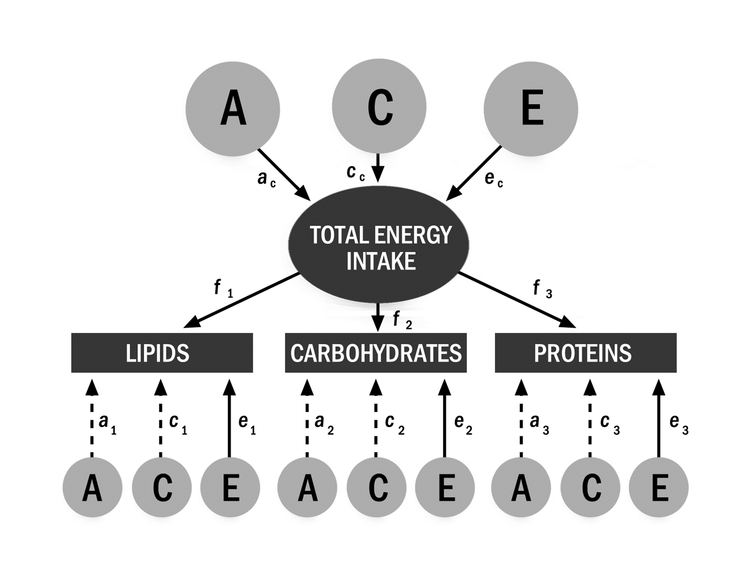
Fig. 1. Common Pathway diagram of standardized parameter estimates in the multivariate analysis. Total energy intake represents the common factor (latent variable), while energy from lipids, energy from carbohydrates and energy from proteins are observed variables. According to this model, common additive genetic influences on the variance of each macronutrient are given by the relative influence of the common factor (f²) multiplied by additive genetic effects on the common factor (a_{c}²). Unique or specific additive genetic influences (a²), if present, are added to common additive genetic influences (f²a_{c}²) to make up the total additive genetic influence (f²a_{c}² + a²). The same principle applies to environmental influences (total, common and specific) on the variance of each macronutrient.

Note. A = additive genetic influences; C = shared environmental influences; E = unique environmental influences; a_{c} = common additive genetic influences; a₁ = specific additive genetic influences for lipids; a₂ = specific additive genetic influences for carbohydrates; a₃ = specific additive genetic influences for proteins; c_{c} = common shared environmental influences; c₁ = specific shared environmental influences for lipids; c₂ = specific shared environmental influences for carbohydrates; c₃ = specific shared environmental influences for proteins; e_{c} = common unique environmental influences; e₁ = specific unique environmental influences for lipids; e₂ = specific unique environmental influences for carbohydrates; e₃ = specific unique environmental influences for proteins; f = common factor.

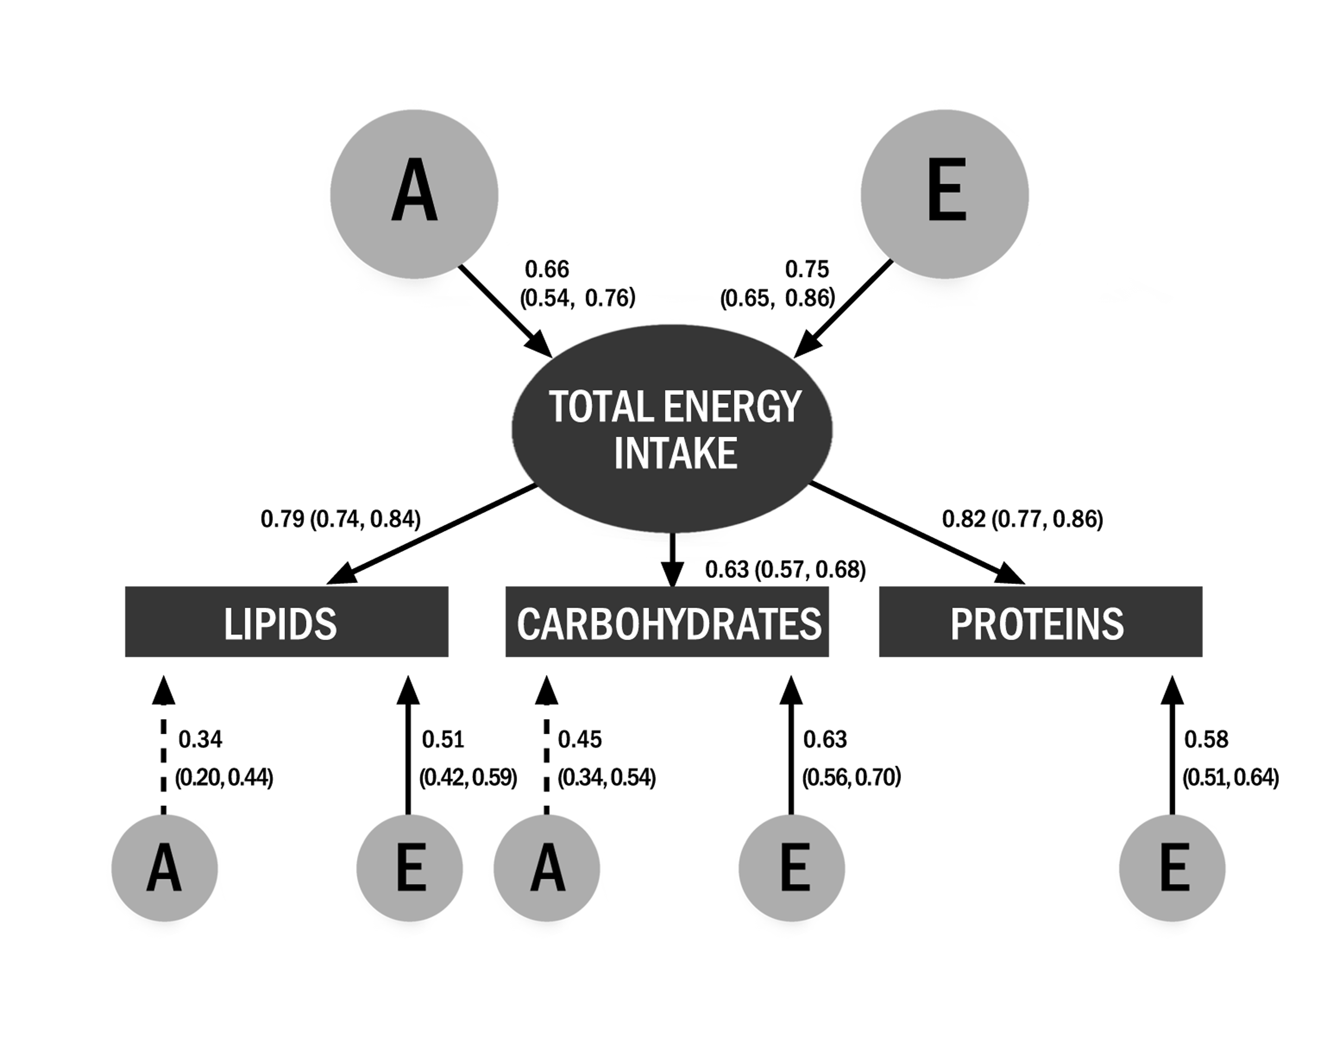
Fig. 2. Standardized parameter estimates (and 95% CIs) of the best partial AE - Common Pathway model for macronutrient intakes (kcal). This model dropped the additive genetic influences (A) for proteins and all shared environmental influences (C).

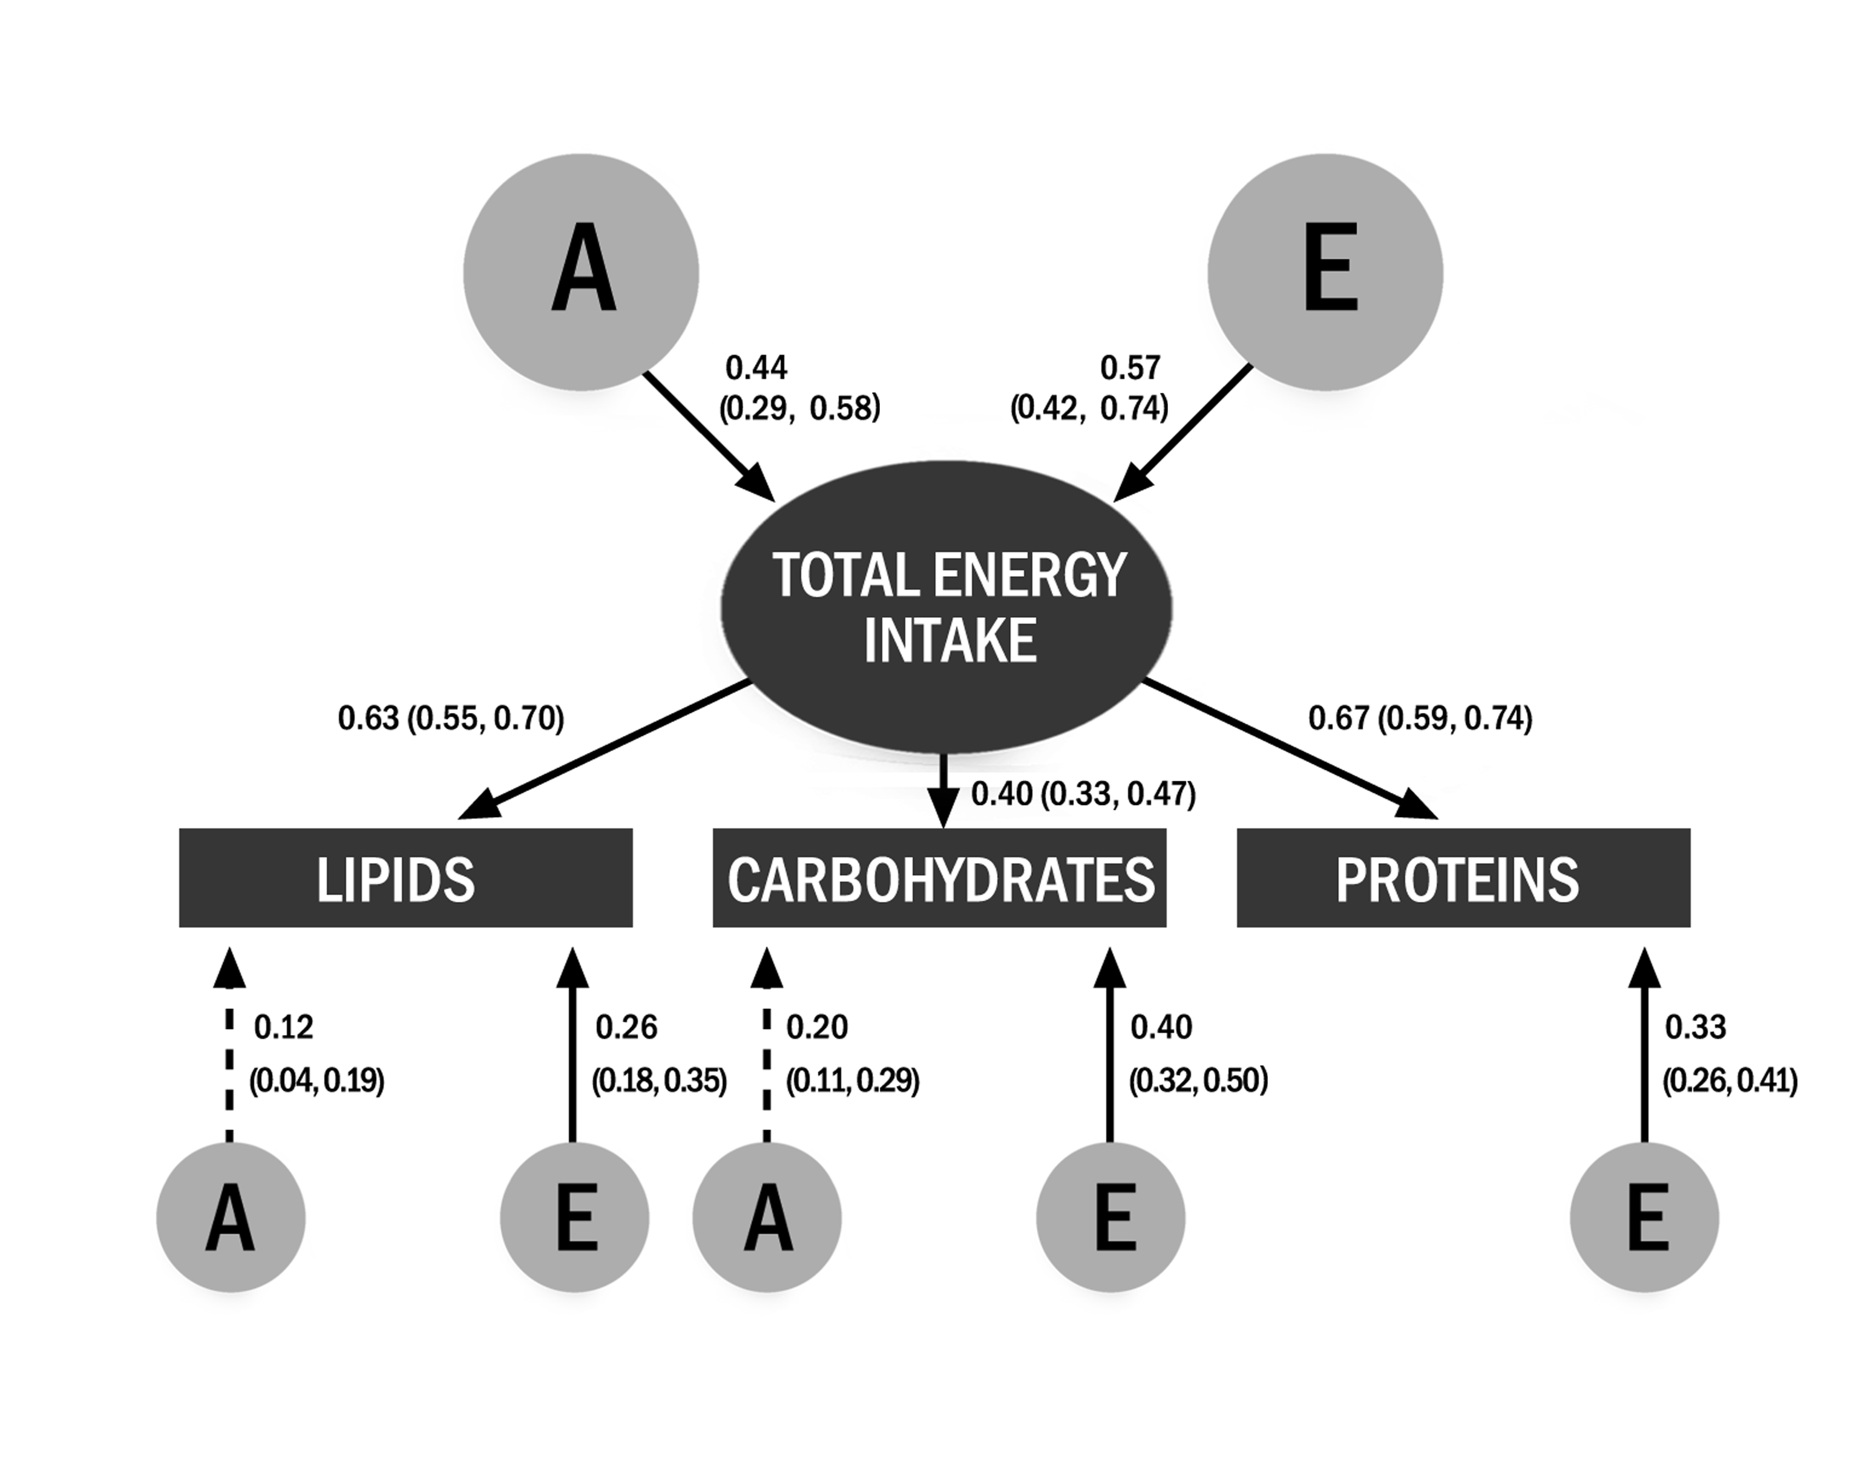
Fig. 3. Standardized variance estimates (and 95% CIs) of the best partial AE - Common Pathway model for macronutrient intakes (kcal). This model dropped the additive genetic influences (A) for proteins and all shared environmental influences (C). Variance estimates represent the square of path coefficients.

Table 1
Comparison of multivariate ACE models for macronutrient intakes
Model | Name | ep | -2LL | df | Δχ2 | Δdf | p | AIC | BIC
1 | Cholesky decomposition | 21 | 5521.30 | 2193 | - | - | - | 1135.30 | -7441.08
2 | Independent Pathway | 21 | 5519.53 | 2193 | -1.77 | 0 | 1.00 | 1133.53 | -7442.85
3 | Common Pathway | 18 | 5523.08 | 2197 | 1.79 | 4 | 0.78 | 1129.08 | -7462.94
Note. A = additive genetic influences; C = shared environmental influences; E = unique environmental influences; ep = estimated parameters; -2LL = -2 log likelihood; Δχ² = change in chi-square test from the Cholesky decomposition; Δ df = change in degrees of freedom; AIC= Akaike Information Criterion; BIC = Bayesian Information Criterion. Best model is in bold (based on lowest AIC and on likelihood ratio chi-square test with Δdf as a measure of goodness of fit).

Table 2
Comparison of selected multivariate Common Pathway models for macronutrient intakes
Model | Common Pathway Model | ep | -2LL | df | Δχ² | Δ df | p | AIC | BIC
1 | Full ACE | 18 | 5523.08 | 2197 | - | - | - | 1129.08 | -7462.93
2 | Partial AE (drop c_{c} and c₁) | 16 | 5523.08 | 2199 | 0 | 2 | 1.00 | 1125.08 | -7474.75
3 | Partial AE (drop c_{c}, c₁ and a₂) | 15 | 5528.65 | 2200 | 5.57 | 3 | 0.13 | 1128.65 | -7475.10
4 | Partial AE (drop c_{c}, c₁, a₂ and a₃) | 14 | 5528.75 | 2201 | 5.67 | 4 | 0.23 | 1126.75 | -7480.91
5 | Partial AE (drop c_{c}, c₁, c₃, a₂ and a₃) | 13 | 5538.19 | 2202 | 15.11 | 5 | 0.01 | 1134.19 | -7477.38
6 | Partial AE (drop c_{c}, c₁, and a₃) | 15 | 5523.13 | 2200 | 0.04 | 3 | 1.00 | 1123.13 | -7480.62
7 | Partial AE (drop c_{c}, c₁, c₃ and a₃) | 14 | 5528.64 | 2201 | 5.55 | 4 | 0.24 | 1126.63 | -7481.02
8 | Partial AE (drop c_{c}, c₁, c₂, c₃ and a₃) | 13 | 5530.65 | 2202 | 7.71 | 5 | 0.11 | 1126.79 | -7484.78
9 | Partial AE (drop c_{c}, c₁, c₂ and a₃) | 14 | 5530.65 | 2201 | 7.52 | 4 | 0.11 | 1128.65 | -7479.01
Note. ep = estimated parameters; -2LL = -2 log likelihood; Δχ² = change in chi-square test from the full ACE Common Pathway model; Δ df = change in degrees of freedom; AIC = Akaike Information Criterion; BIC = Bayesian Information Criterion; A = additive genetic influences; C = shared environmental influences; E = unique environmental influences; a₂ = specific additive genetic influences for carbohydrates; a₃ = specific additive genetic influences for proteins; c_{c} = common shared environmental influences; c₁ = specific shared environmental influences for lipids; c₂ = specific shared environmental influences for carbohydrates; c₃ = specific shared environmental influences for proteins. Best model is in bold (based on lowest BIC and on likelihood ratio chi-square test with Δdf as a measure of goodness of fit).

Table 3
Additive geneticª and unique environmental^{b} latent factor correlations (and 95% CIs) for proteins, lipids and carbohydrates
Variable | Proteins | Lipids | Carbohydrates
Proteins | - | 0.84 (0.73-0.94) | 0.68 (0.56- 0.80)
Lipids | 0.56 (0.47-0.64) | - | 0.57 (0.43-0.70)
Carbohydrates | 0.44 (0.36-0.51) | 0.46 (0.37-0.54) | -
ª Above diagonal.
^{b} Below diagonal.

Table 4
Characteristics of the sample
 | Boys | Girls
Sex | 48.4 % | 51.6 %
Age (y) | 9.0 ± 0.5 | 9.0 ± 0.6
Anthropometric measures
Weight (kg) | 30.0 ± 5.5 | 29.2 ± 6.8
Height (m) | 1.3 ± 0.1 | 1.3 ± 0.1
BMI (kg/m²) | 16.9 ± 2.4 | 16.70 ± 2.8
Overweight or obesity | 15.3% | 17.3%
Dietary measures
Energy (kcal/d) | 1973.0 ± 425.1 | 1734.4 ± 371.1ª
Protein (% energy) | 14.6 ± 2.8 | 14.6 ± 2.8
Fat (% energy) | 31.9 ± 5.0 | 31.8 ± 5.1
Carbohydrate (% energy) | 54.9 ± 6.1 | 55.1 ± 6.2
Note. Values are mean ± SD (mean of two days for dietary measures), except for "Sex" and "Overweight or obesity" (%). n=738 twins, except for anthropometric measures (n=730 twins). "Overweight or obesity" is based on age- and sex-specific cut-offs for BMI [34]. Hierarchical linear models (HLM) were used to examine mean differences between sexes for each outcome.
ª Significantly different from boys (p < 0.05).

Table 5
Daily energy and macronutrient intakes by zygosity and sex
 | MZ Twins |  |  |  | DZ Twins |  |  |  |  |  |  | All Twins
Variable | Boys | Girls | All |  | Boys | Girls | All
 | (n=140) | (n=168) | (n=308) |  | (n=217) | (n=213) | (n=430) |  |  |  | (n=738)
Energy (kcal) | 1984.6 ± 33.6 | 1690.3 ± 30.7 | 1824.1 ± 23.7 |  | 1965,6 ± 27.0 | 1769,1 ± 27.2 |  | 1868.2 ± 20.0 |  |  |  | 1849.8 ± 15.3
Proteins (g) | 71.1 ± 1.6 | 60.9 ± 1.4 | 65.5 ± 1.1 |  | 71,9 ± 1.3 | 64,5 ± 1.3 |  | 68.3 ± 0.9 |  |  |  | 67.1 ± 0.7
Lipids (g) | 70.7 ± 1.6 | 59.6 ± 1.4 | 64.6 ± 1.1 |  | 70,3 ± 1.2 | 63,3 ± 1.3 |  | 66.8 ± 0.9 |  |  |  | 65.9 ± 0.7
Carbohydrates (g) | 273.7 ± 5.1 | 234.2 ± 4.7 | 252.1 ± 3.6 |  | 268,1 ± 4.1 | 241,8 ± 4.1 |  | 255.1 ± 3.0 |  |  |  | 253.9 ± 2.3
Proteins (% energy) | 14.4 ± 0.2 | 14.5 ± 0.2 | 14.4 ± 0.2 |  | 14.8 ± 0.2 | 14.7 ± 0.2 |  | 14.8 ± 0.1 |  |  |  | 14.6 ± 0.1
Lipids (% energy) | 31.9 ± 0.4 | 31.4 ± 0.4 | 31.6 ± 0.3 |  | 32.0 ± 0.3 | 32.0 ± 0.3 |  | 32.0 ± 0.2 |  |  |  | 31.8 ± 0.2
Carbohydrates (% energy) | 55.2 ± 0.5 | 55.7 ± 0.5 | 55.5 ± 0.3 |  | 54,6 ± 0.4 | 54.7 ± 0.4 |  | 54.7 ± 0.3 |  |  |  | 55.0 ± 0.2
Note. All values are mean ± SD (mean of two days). MZ = monozygotic; DZ = dizygotic.

Table 6
Intraclass correlations (and 95% CIs) for mean daily energy and macronutrient intakes for twin pairs by zygosity and sex
 | MZ Twins |  |  |  | DZ Twins
Variable | Boys | Girls | All |  | Boys | Girls | Opposite Sexª | All
 | (n=70 pairs) | (n=84 pairs) | (n=154 pairs) |  | (n=56 pairs) | (n=54 pairs) | (n=105 pairs) | (n=215 pairs)
Energy (kcal) | 0.39  (0.19, 0.59) | 0.33  (0.13, 0.52) | 0.43^{b}  (0.31, 0.56) |  | 0.23  (0.00, 0.47) | 0.28  (0.03, 0.52) | 0.05  (0.00, 0.24) | 0.21^{b}  (0.08, 0.34)
Proteins (g) | 0.37  (0.17, 0.57) | 0.24  (0.04, 0.44) | 0.36  (0.22, 0.49) |  | 0.15  (0.00, 0.41) | 0.15  (0.00, 0.41) | 0.13  (0.00, 0.32) | 0.17  (0.04, 0.30)
Lipids (g) | 0.24  (0.02, 0.46) | 0.34  (0.15, 0.53) | 0.36^{b}  (0.22, 0.50) |  | 0.31  (0.07, 0.54) | 0.02  (0.00, 0.28) | 0.01  (0.00, 0.20) | 0.15^{b}  (0.02, 0.28)
Carbohydrates (g) | 0.41  (0.22, 0.61) | 0.31  (0.11, 0.50) | 0.42^{b}  (0.29, 0.55) |  | 0.19  (0.00, 0.45) | 0.37  (0.14, 0.60) | 0.13  (0.00, 0.32) | 0.23^{b}  (0.11, 0.36)
Proteins (% energy) | 0.21  (0.00, 0.43) | 0.15  (0.00, 0.36) | 0.18  (0.03, 0.33) |  | 0.22  (0.00, 0.47) | 0.17  (0.00, 0.43) | 0.21  (0.03, 0.40) | 0.21  (0.08, 0.33)
Lipids (% energy) | 0.30  (0.08, 0.51) | 0.29^{b}  (0.09, 0.48) | 0.29  (0.15, 0.44) |  | 0.35  (0.13, 0.58) | 0.00^{b}  (0.00, 0.00) | 0.14  (0.00, 0.33) | 0.16  (0.03, 0.29)
Carbohydrates (% energy) | 0.26  (0.04, 0.48) | 0.30  (0.10, 0.49) | 0.28  (0.14, 0.43) |  | 0.25  (0.01, 0.50) | 0.06  (0.00, 0.33) | 0.19  (0.00, 0.37) | 0.18  (0.05, 0.31)
Note. n=369 twin pairs. MZ = monozygotic; DZ = dizygotic.
ª Raw data not sorted by sex.
^{b} Intraclass correlation for MZ is significantly (p < 0.05) different from DZ.

Table 7
Best-fitting models of the univariate and sex-limited (if applicable) analyses for mean daily energy and macronutrient intakes
Variable | Model | χ2 | df | p | AIC | BIC | Sex | a² | c² | e²
Energy | AE | 2.35 | 3 | 0.50 | 2056.73 | 2068.46 | Both | 0.42 (0.31, 0.53) | - | 0.58 (0.47, 0.69)
(kcal) | AE (sex-limited) | 7.90 | 6 | 0.25 | 2009.35 | 2028.90 | Boys | 0.36 (0.23, 0.48) | - | 0.64 (0.52, 0.77)
 |  |  |  |  |  |  | Girls | 0.38 (0.26, 0.50) | - | 0.62 (0.50, 0.74)
Proteins | AE | 3.58 | 3 | 0.31 | 2070.88 | 2082.61 | Both | 0.35 (0.24, 0.47) | - | 0.65 (0.53, 0.76)
(g) | AE (sex-limited) | 4.21 | 5 | 0.52 | 2042.80 | 2066.26 | Boys | 0.35 (0.17, 0.53) | - | 0.65 (0.47, 0.83)
 |  |  |  |  |  |  | Girls | 0.29 (0.12, 0.45) | - | 0.71 (0.55, 0.88)
Lipids | AE | 3.70 | 3 | 0.30 | 2072.33 | 2084.06 | Both | 0.34 (0.22, 0.46) | - | 0.66 (0.54, 0.78)
(g)
Carbohydrates | AE | 0.94 | 3 | 0.82 | 2057.21 | 2068.94 | Both | 0.42 (0.31, 0.53) | - | 0.58 (0.47, 0.69)
(g) | AE (sex-limited) | 3.28 | 5 | 0.66 | 2021.09 | 2044.56 | Boys | 0.41 (0.23, 0.58) | - | 0.59 (0.42, 0.77)
 |  |  |  |  |  |  | Girls | 0.36 (0.21, 0.51) | - | 0.64 (0.49, 0.79)
Proteins | CE | 2.63 | 3 | 0.45 | 2084.56 | 2096.30 | Both | - | 0.20 (0.10, 0.30) | 0.80 (0.70, 0.90)
(% energy)
Lipids | AE | 4.44 | 3 | 0.22 | 2080.05 | 2091.78 | Both | 0.28 (0.16, 0.40) | - | 0.72 (0.60, 0.84)
(% energy)
Carbohydrates | CE | 5.89 | 3 | 0.12 | 2079.21 | 2090.95 | Both | - | 0.23 (0.13, 0.33) | 0.77 (0.67, 0.87)
(% energy)
Note. Best models based on lowest AIC and nonsignificant likelihood ratio chi-square test of model against saturated model (p > 0.05). 95% CIs in parentheses.
χ2 = chi-square test; AIC = Akaike Information Criterion; BIC = Bayesian Information Criterion; a² = proportion of variance explained by additive genetic influences; c² = proportion of variance explained by shared environmental influences; e² = proportion of variance explained by unique environmental influences.

