REVIEW PAPER

Infrared Thermography and NDT: 2050 Horizon
Fariba Khodayar, Saeed Sojasi and Xavier Maldague
Computer Vision and Systems Laboratory, Electrical and Computer Engineering Dep., Université Laval, Quebec City (Quebec), G1K 7P4, Canada
Corresponding author
Email: fariba.khodayar.1@ulaval.ca

(Received: 24 December 2015; accepted …)

Infrared Thermography and NDT: 2050 Horizon
Society is changing fast, new technologies and materials have been developed which require new inspection approaches. Infrared Thermography (IRT) has emerged in the recent years as an attractive and reliable technique to address complex non-destructive testing (NDT) problems. Companies are now providing turn-key IRT-NDT systems, but the question we ask now is “What is next?”. Even though the future is elusive, we can consider the possible future developments in IR NDT. Our analysis shows that new developments will take place in various areas such as: acquisition, stimulation, processing and obviously an always enlarging range of applications with new materials which will have particular inspection requirements. This paper presents the various developments in the field of IRT which have evolved to lead to the current situation, and then examines the potential future trend in IRT-NDT.
Keywords: Infrared thermography; future technology; smart sensors; new detectors

1. Introduction
Infrared thermography (IRT) is an attractive method to analyze the thermal information obtained from a specimen. This technique detects energy emitted from the specimen under investigation and converts it to temperature variation. The output is an image of temperature variation from the specimen. IR refers to the radiations located between visible and microwave in electromagnetic bands [1-3]. Generally, IR bands are divided into four parts: short-wave-infrared (SWIR), mid-wave-infrared (MWIR), long-wave-infrared (LWIR), and Far-infrared (FIR), which are respectively from 0.75 to 3 μm, 3 to 5 μm, 8-12 μm, and 50 to 1000 μm [1]. IR radiation was unknown until more than 200 years ago, when Herschel conducted the first experiment with a thermometer. He built a crude monochromator in which a thermometer was used to detect radiative energy under sunlight [4].
Non-destructive testing (NDT) is a method for testing materials without destroying them. More specifically, these methods are used to evaluate and inspect processes and materials so as to identify the differences in characteristics, and components for discontinuities. The NDT methods are attractive and useful to determine ductility and impact resilience, fatigue strength, fracture, flaws, abnormal operations, etc. NDT is used in many industrial applications in order to evaluate the quality and integrity of parts and equipment. For industrial systems, temperature monitoring is known as one of the most important criteria to evaluate proper operation. Detection of abnormal temperature patterns is useful to avoid potential future problems [5].
In fact, various non-destructive testing and measuring techniques are applied in maintenance processes to determine equipment status and conduct repairs before a costly breakdown occurs [6]. For instance, non-destructive testing methods ensure that a large variety of equipment is maintained both safe and reliable. This includes: electrical systems such as switchboards, distribution systems, mechanical systems, steam systems, boilers, motor controllers, diesel engines, power electronics, etc. [7]. The NDT technique is widely used in science and industry, especially since it has no damaging effect on materials [8, 9].
IR thermography is one of the useful techniques that has been used in non-destructive testing. Using IR technology has many advantages such as the fact that it is a non-contact method, non-destructive and fast technique, which does not emit any harmful radiations, etc. [10, 11]. The current paper will offer insight into the future developments of IR thermography based on an overview of literature from the past to the present, including IR applications, progress and processing, and IR markets. The vision of IRT and future trends in IRT will be examined based on an overview of the developments which have led to the current situation in the field. IR thermography strives towards using equipment offering high performance, high accuracy and low cost. IR thermography may soon involve the use of robots in dangerous environments, which will be discussed as well. The new technologies and advances in IR thermography have created new markets such as: intelligent building, automotive and environment control [12].

2. Background and history

2.1. Short history of IR thermographic technology
The development of IR began after the discovery of IR light in 1800, and the establishment of important laws such as Stefan-Boltzmann’s Law and Planck’s law [13-15]. After the discovery of the transistor in 1947, the emergence of the first cryogenic cooled IR detectors led to a revolution in IR thermography (typical coolant was liquid nitrogen maintained at 77K - 196.15°C in a Dewar vessel). These detectors were based on various technologies such as lead selenide (PbSe), lead telluride (PbTe), indium antimonide (InSb) or mercury cadmium telluride (HgCdTe) with good spectral detectivity D* (expressed in mW⁻¹Hz^{1/2}) in the spectral range 3-5 μm (8-14 μm for HgCdTe) [15]. Such technological development in detectors was shortly followed by the availability of the first (1965) commercial IR cameras featuring a single detector coupled to an optical-mechanical scanning mechanism to acquire the scene images. During that period, the role of IRT as an effective tool in NDT became more prominent [16]. In the 1970-80s decades, the first bidimensional arrays were produced and cooled Focal Plane Arrays (FPA) with more pixels have started to appear on the market in the 1990s (nowadays largest arrays are 2048 x 2048). In that time, the uncooled FPA technology based on microbolometers emerged with acceptable performances. With respect to cooled FPA IR cameras, uncooled FPA IR cameras have a lower D* (at least lower by an order of magnitude) and a lower cost since the cryogenic unit (often a stirling engine nowadays) is replaced by a cheaper temperature stabilization heat sink (generally based on a Peltier element). The “revolution” in thermal imaging has really been the emergence of uncooled IR arrays based on thermal detectors with the ability to work at room temperature. Thermal detectors had been used before in scanning imagers, but they had a slow response. With a low bandwidth, these thermal detectors were useful for example for scanning 2D electronic arrays [4]. Nowadays arrays of thermal detectors achieve interesting capabilities hence opening new application prospects.
The other main technology is IR photodetector technology which underwent rapid development in the last decades of the 20th century. Two IR detectors were especially well developed: indium antimonide (InSb) and mercury cadmium telluride (HgCdTe-based ) detectors. They are now commercially available and their developments have continued to progress over the last few years [17]. Molecular beam epitaxy (MBE) was used in the growth of mercury cadmium telluride (MCT) detectors in 2000. At that time, most of the published research covered two main subjects: MCT on silicon substrates and Long-wavelength infrared (LWIR) detectors. LWIR detection was an extension of Short-wavelength infrared (SWIR) and Mid-wavelength infrared (MWIR) [17, 18]. Towards 2010, IR community users have devoted more attention to portable equipment in the field of active thermography [18, 19]. Ongoing research has improved the performance of room-temperature devices in terms of improved detectivity [2, 13]. Table 1 summarizes the history of IR development.
Table 1. The history of IR development [20-22].
Date | IR event
1800 | In England, William Herschel discovers IR rays.
1833 | Development of Thermopile consisting of 10 in-line Sb-Bi thermal pairs by L. Nobili and M. Melloni
1835 | Formulation of the hypothesis that light and electromagnetic radiation are of the same nature by A. M. Ampère
1859 | Relationship between absorption and emission by G. Kirchoff
1864 | Theory of electromagnetic radiation by J.C. Maxwell
1873 | Discovery of photoconductive effect in selenium by W. Smith
1880 | Study of absorption characteristics of the atmosphere through a Pt bolometer resistance by S.P. Langley
1883 | Study of transmission characteristics of IR−transparent materials by M. Melloni
1884 | Thermodynamic derivation of the Stefan law by L. Botzmann
1887 | Observation of photoelectric effect in the ultraviolet by H. Hertz
1890 | J. Elster and H. Geitel constructed a photoemissive detector consisting of an alkali−metal cathode
1894-1900 | Derivation of the wavelength relation of blackbody radiation by J.W. Rayleigh and W. Wien
1900 | Discovery of quantum properties of light by M. Planck
1903 | Temperature measurements of stars and planets using IR radiometry and spectrometry by W.W. Coblentz
1917 | T.W. Case developed the first IR photoconductor from substance composed of thallium and sulphur
1930 | IR direction finders based on PbS quantum detectors in the wavelength range 1.5–3.0 μm for military applications (Gudden, Görlich and Kutscher), increased range in World War II to 30 km for ships and 7 km for tanks (3–5 μm)
1934 | First IR image converter
1955 | Mass production start of IR seeker heads for IR guided rockets begins in the USA (PbS and PbTe detectors, later InSb detectors for Sidewinder rockets)
1957 | Discovery of HgCdTe ternary alloy as IR detector material by W.D. Lawson, S. Nelson, and A.S. Young
1961 | Discovery of extrinsic Ge:Hg and its application (linear array) in the first LWIR FLIR systems
1977 | Discovery of the broken−gap type−II InAs/GaSb superlattices by G.A. Sai-Halasz, R. Tsu and L. Esaki
1980 | Development and production of second generation systems [cameras fitted with hybrid HgCdTe (InSb)/Si(readout) FPAs]. First demonstration of two-colour back-to-back SWIR GaInAsP detector by J.C. Campbell, A.G. Dental, T.P. Lee, and C.A. Burrus
1985 | Development and mass production of cameras fitted with Schottky diode FPAs (platinum silicide)
1990 | Development and production of quantum well IR photoconductor (QWIP) hybrid 2nd generation systems
1995 | Production begins of IR cameras with uncooled FPAs (microbolometer-based and pyroelectric FPAs)
2000 | Development and production of third generation IR systems
2000-2010 | Multicolour functionality and other on−chip functions (Mems FPAs, Two-colour type-II FPAs, two-colour QDIP FPAs, two-colour megapixel FPAs,147 megapixel FPAs)
2013 | On February 14 researchers developed a neural implant that gives rats the ability to sense IR light which for the first time provides living creatures with new abilities, instead of simply replacing or augmenting existing abilities

2.2. Thermography: a multifaceted technique for NDE
Infrared thermography or IRT is an engineering discipline with a combination of stimulation, acquisition, and thermal information analysis. In general IRT approaches have been divided into two main groups, which are passive and active thermography. This categorization refers to using or not using an external excitation in order to have a thermal contrast between the sound area (non-defect area) and defect area [23]. To induce a significative thermal contrast, various types of energy sources can be used in active thermography, the most common forms being divided into optical, mechanical (vibrothermography), and electromagnetic (microwaves, terahertz…) [23, 24]. There are two main classical types of active thermography techniques if we consider the way to deliver the energy, which are pulsed thermography (PT), and modulated or lock-in thermography (LT) [1].
Pulsed thermography is one of the most attractive and popular methods in the field of non-destructive testing. The use of PT in NDT had increased in 1996 due to progress in IR camera technology [25-27]. PT is a very fast and effective technique which utilizes a high power laser, flash lamp or microwave heating source to heat the specimen in a short time. The duration of the pulse is from a few milliseconds (2–15 ms using flashes) to a few seconds (using lamps).
Modulated thermography (MT) or lock-in thermography (LT), proposed by Carlomagno and Berardi [28], was pioneered by several groups leaded by Busse [29-32] and by other groups [33-35]. Dynamic precision contact thermography (DPCT) was applied as a first lock-in thermography technique with the temperature sensitivity below 1mK and with a spatial resolution of approximately 30 μm [36, 37]. The use of lock-in thermography was developed, and in 2005, frequency modulated thermal wave imaging (FMTWI) was proposed by Mulaveesala and Tuli. This approach was a combination of the advantages of modulated and pulse phase thermography (PPT) techniques. PPT is itself a combination of pulsed and lock-in thermography, developed by Maldague and Marinetti in 1996. In the FMTWI method, the thermal waves stimulate the specimen in a desired range of frequencies, while the phase information from the observed thermal response is extracted [38].
Vibro-thermography is a mechanical excitation which is also used to inspect the specimen (often metallic). In the late 80s, Hennecke et al. proposed this method and almost twenty years later, VT was propagated by several groups [39-43]. In this method, the mechanical energy is transformed into thermal energy due to the acoustical damping. A IR camera is used to measure the temperature which rises in the surface close to the defects [44].

3. IR detectors
An IR detector is sensitive to IR radiation energy and reacts to this energy and converts it into a quantifiable form. A review of IR detectors indicates that there have been three significant developments in IR detectors: the first one dealt with scanning systems, the second one was staring array systems and the third involved multicolor detectors [45]. Some consequential parameters which affect the performance of IR detectors are signal to noise ratio, spectral detectivity D*, noise equivalent temperature difference (NETD), spectral response and acquisition time [46, 47]. There are different types of IR detectors, which can be classified according to different criteria such as wavelength, sensitivity, power dissipation, and bandwidth [48]. A certain type of classification divides IR detectors into two general types: the first type is thermal or bolometer detectors, which are low-cost and do not depend on wavelength, but they have inferior performance with high production volume. Their cost is dependent on the cooling system to a significant extent (they are often temperature stabilized using Peltier elements). The second type is the quantum type or the photon detector that is dependent on wavelength, requires expensive cryogenic cooling mechanisms and has a lower production volume with high cost. Their sensitivity and response time are typically higher than bolometer detectors [2, 22, 46, 47, 49, 50].

3.1. Current IR detectors
Nowadays, IR detectors are based on three important technologies; one of them is mercury cadmium telluride (MCT), an expensive technology. The indium antimonide (InSb) detector is another type of detector, which is photovoltaic, and where the indium antimonide requires periodic recalibration. The InSb detector is a function of thickness near the band edge photons and it has 100% internal quantum efficiency [2, 49, 50]. Quantum-well infrared photodetectors (QWIPs) represent another existing IR technology which is dependent on the wavelength range and can cover a wide range of wavelengths. Since this technology operates at low temperature and requires cryogenic systems, it is expensive: but in comparison with MCT, it has a lower cost [2, 49-51].

3.2. Future developments
Recent research on IR thermal detector technologies has focussed on the following goals: lower cost, higher performance, larger detectivities, portable devices, the use of focal plan array to obtain the highest number of pixels, the ability to work at higher temperatures and elimination of cryogenic cooling [2, 15, 49, 50, 52-54]. One of the new technologies is quantum dot based infrared detectors (QDIPs), which perform well in the MWIR as well as the LWIR range [55]. They are very similar to QWIPs but with some advantages such as: normal incident detection, low dark current, high absorption coefficient, ability to work at higher temperatures, multicolor detection, and lower cost [2, 49, 50, 56, 57].
Looking to the future, IR thermal detector technologies will continue to aim for higher sensitivity, higher efficiency and better performance at a lower cost. These detectors will be further developed to increase their operating temperature, reduce power dissipation and eliminate cooling system and cryogenic components. Future work will be directed towards increasing pixel density, embedding detectors with smart algorithms, improving response time, increasing spatial resolution, reducing non-uniformity and pixel size, as well as enabling multispectral capabilities. One important issue is however the (huge) investment required by the industry. In that sense we might see a reduced pace to performances related to the necessity to first provide a return on investments with the current technology.

4. Smart sensors
Smart sensors are defined as sensing elements with embedded intelligence [58]. They can perform many functions such as: data conversion, logic function, decision making, bidirectional communication, signal detection, signal processing, and data interpretation [58, 59]. Applications of smart sensors are divided into the following groups: optical sensors, IR detector arrays, accelerometers, multisensory integration, etc. [47, 59].
IR thermography involves very small signals, which are very sensitive to noise [47, 59]. IR temperature measurement could be combined with digital technology through smart IR sensors [60]. Smart sensors have several advantages such as: high reliability, simplified design, high performance, minimum cost and small size. Smart Sensing has led to considerable developments in consolidated Solid State Very Large Integration Microcircuits VLSI including MEMs technology [61] and in the new emerging nanotechnology. Nanotechnology allows sensors to be smaller, smarter and less costly [61]. These new sensors are being developed with carbon nanotubes, graphenes and nanoparticles [55]. Future trends in thermal detectors indicate an increasing usage of intelligent sensors. Smart sensors will be able to extract signals, conduct signal processing and select information. The Smart sensors of the future will provide higher accuracy, higher performance with increased speed at a lower cost [47, 62, 63].

5. Multi-band detector
A critical issue for capability development of active and passive remote sensing in the UV to far-infrared spectroscopy is the development of multi-band detectors [64]. Multi-band detectors are used in numerous applications such as medical imaging, military, remote sensing, etc. A multi-band detector is formed of a stacked arrangement of different materials in which the longer wavelength detector has been located below the shorter wavelength detector [64]. The shorter wavelength detector absorbs the shorter wavelength, and the longer wavelength detector absorbs only the longer wavelength [64]. In other words, the desired wavelength band is absorbed by a suitable detector and the rest of the spectrum, without significant losses, is transmitted to and absorbed by other appropriate detectors. Inspecting a component at various wavelengths provides more information about it and its behavior under test conditions. In that sense, multi-band detectors enable a more complete inspection, especially when coupled with data fusion of the recorded signals.

6. Terahertz technology
Recent works in optical NDT technology have improved sensitivity, the accuracy of detection, signal multiplexing, in addition to finding solutions for eliminating electromagnetic interference. Among these advances, the term “terahertz” (THz) has been used to refer to a part of the electromagnetic spectrum which is located between IR light and microwaves (frequency range: 300 GHz to 3 THz with corresponding wavelength range: 1 mm to 100 μm). There are various THz systems which can be divided into two principal kinds: continuous wave (CW) and picosecond pulses. CW could be generated by two near IR lasers of adjacent wavelengths which are spatially overlapped. This technique has some advantages such as: high resolution, spectral selectivity, and superior SNR values [65]. Femtosecond lasers generate Pulsed terahertz radiation. The ultrashort (ultrafast) laser pulses produce a fast current transient. This laser emits electromagnetic waves in the terahertz range [66]. In the last few years, terahertz detectors and sources have been developed considerably and used as one of the new non-destructive testing technologies.
By analyzing changes in the THz signal, the internal structure of the object can be determined and the defects can be identified [67-69]. In comparison to other NDT techniques, THz has the particular advantage of being able to detect internal defects in non-metallic materials. THz radiation penetrates clothing and many other opaque materials; it is also selectively absorbed by water and organic substances. These unique qualities make THz radiation interesting and informative. When a source with a fixed-frequency and a single detector is applied, the continuous wave (CW) terahertz does not have the capability of providing any depth, frequency-domain or time-domain information. CW imaging is less complex than a pulsed THz system, since the CW imaging does not require a pump probe system, and also it is a compact, simple system [69]. Terahertz is safe to use on living organisms (non ionizing radiation) and has a shorter wavelength and higher spatial resolution than microwave radiation. It is increasingly been used in a large range of fields such as spectroscopy, medicine, non-destructive testing, chemistry, agriculture, food industry, materials science, biology and pharmacy [69-74].
This technique has been used through fiber stretchers with kilohertz acquisition rates [69], and also, with porous polymer fibers designed to guide terahertz radiation. One of the particularities of THz detection methods is using semiconductor quantum dot detectors to detect a single THz photon. Two detection technologies which use THz cameras have been improved in the recent years: 1) Plasma-wave detectors and arrays 2) Uncooled bolometer detectors and arrays [75]. In the last few years, THz has been increasingly applied in the field of NDT, for example in the aerospace industry for defect detection, and stress damage evaluation in airplanes and spacecrafts [67].
Some companies such as Terasense and NeTHIS are developing THz technology and reaching interesting performance, simply, and in a less expensive fashion. Terasense proposes plasmonic detectors in the terahertz range which have high sensitivity and low cost [76]. The detector in the array measures the dispersion of magnetoplasma and plasma excitations (resonance) in an electron system whose edges are formed by a voltage applied to a metallic gate [67]. For generation, they use an IMPATT (IMPact ionization Avalanche Transit-Time) diode which is a high-power diode used in microwave electronics and sub-THz devices (frequency range 3 – 400 GHz). Another example of innovation is the TeraCam camera which is produced by NeTHIS. This camera is a Multispectral camera (IR and terahertz). The TeraCam has been designed for laser beam metrology, 2D and 3D imaging, and non-destructive testing of insulating materials [77]. NeTHIS uses a transfer process in which THz radiation heats a surface imaged by the IR camera, the IR camera being fitted with a “photothermal converter” type of adapter [78].
In the future, THz technologies will strive toward cost reduction, increased spatial resolution, with real-time capability imaging [68, 69, 74, 79]. The development of THz technology will continue as the technology evolves to reach a certain threshold, upon which the mature technology will most certainly attract considerable attention [80].

7. Data processing algorithms for IRT-NDT
One of the most important steps in IR imaging is data processing to extract the desired information. Data processing involves a series of advanced mathematical operations which are performed on the data to transform it into useful information. IR images are strongly influenced by vignetting, spectrometer drift, radial distortion, environment reflections, emissivity variation, non-uniform radiation, fixed pattern noise, etc. [81, 82]. The purpose of signal processing is to eliminate unwanted signals and noise [83]. There are many data processing algorithms and the selection of the method depends on the objectives of the research. Some of the most useful techniques are [83-97]: Thermal signal reconstruction (TSR), Differential absolute contrast (DAC), Pulsed phase thermography (PPT), Principal component thermography (PCT), Partial least square thermography (PLST), Supervised principal component analysis (SPCA) and the machine learning techniques can be used for the inspection performance in order to detect the deeper defects in the composite material. These methods are summarized below.
Thermographic signal reconstruction (TSR) was proposed by Shepard [98]. The TSR is known as an efficient processing technique which uses PT data: a low order polynomial function is fitted over the data from PT inspection in order to reconstruct the temperature evolution. The most important advantages of using this method with respect to PT raw data is, its simplicity and noise reduction capabilities (due to the fitting procedure) which lead to an improved accuracy of the quantitative data inversion, improvement of the contrast between non-defective and defective areas (thanks to its ability to produce time derivative images) [86, 97, 99, 100]. Calculation of the first and second time derivatives from synthetic data reduces blurring present in temperature raw data [93, 99, 101].
Differential absolute contrast (DAC) is also known as a classical processing technique which is generally utilized to eliminate the requirement of selecting a sound area when performing classical thermal contrast computations [86, 102]. It is one of the first techniques developed as an alternative to the classical thermal contrast computations and its poor handling of non-uniform heating, emissivity variations, and environmental reactions [91, 103]. The DAC method provides an alternative to the selection of a sound area temperature through the local (pixel per pixel) 1D solution of the Fourier equation for homogeneous and semi-infinite materials stimulated with a Dirac impulse. This model, in its simplest form, does not include the sample thickness. Therefore, the DAC accuracy decreases as time elapses when the heat front reaches the opposite sample face and heat losses (by convection) becomes dominant with respect to the initial heating pulse [93, 104].
One of the most popular data processing methods is the Pulsed Phase Thermography (PPT) method which is based on Fourier Transform (FT) [105]. In a sense, PPT is a combination of pulsed thermography, for which data acquisition is fast and lock-in thermography, for which depth retrieval is relatively straightforward. The FT extracts thermal waves from a thermal pulse, each one at a specific frequency, amplitude, and phase delay [88, 106, 107]. The FT is one of the different transform algorithms which is used to extract amplitude and phase information in PPT. It is possible to use other algorithms such as the Wavelet Transform (WT) which have additional advantages with respect to FT. The WT algorithm keeps the time information while it is lost in the FT due to the infinite nature of the sine and cosine used in the decomposition [-∞, +∞]. Wavelets are periodic waves of finite duration. They enable a better reproduction of a transient signal and usage of different scales or resolutions [108, 109]. However WT requires challenging parameters to be adjusted (scaling and translation factors) precluding its spreading use. In that sense PPT is still one of the most popular approaches since results are readily obtained, directly from the FT.
Principal Component Analysis (PCA), was initiated by Pearson in 1901 and developed by Hotelling in 1933. It finds applications in various fields such as system and control theory, communications, face recognition, remote sensing, image compression and in fact in fields with datasets of high dimensions. Principal Component Thermography (PCT) was derived from PCA and enables the extraction of features while reducing undesirable information in thermographic sequences. Basically, PCA decomposes the dataset in its various elements of orthogonal variance. The first element will contain the element with the highest variance, the second one with the highest variance in what is remaining, etc. For a PT experiment, the first element in the PCT decomposition will be related to the non-uniform heating [110].
Partial Least Square (PLS) is a statistical decomposition method which originated from social science and was proposed by Herman Wold in the 1960s [111]. PLS enables relations to be made between sets of observed variables by means of latent variables. PLS comprises regression and classification tasks as well as dimension reduction techniques and modeling tools [112, 113]. As a regression method, it seeks to model a dependent variable Y (predicted) in terms of an independent variable X (predictor). PLS generalizes and combines features of two techniques: principal component regression and multivariate linear regression [95, 114, 115].
Partial Least Square Thermography (PLST) decomposes the data set similarly to PCT with the difference that the time information is kept so that the data set can later be reconstructed from the decomposed elements (called loadings) [95]. This decomposition-reconstruction process makes the PLST attractive because one can play with the loadings. For example, as for PCT, the first loading is related to non-uniform heating in PLST and can be omitted in the reconstruction process. Once reconstructed other techniques can be applied for various needs such as PPT (for quantitative inversion), DAC (defect visibility enhancement), etc. All this makes this processing technique versatile indeed [102].
IRT-NDT data processing techniques have some advantages and limitations such as defect detection enhancement on one hand, but sometimes exhibit slow computing or require interactions with an operator to select algorithm parameters on the other hand (ex: selection of a non-defect area which could affect final results). The performance of these techniques can be evaluated quantitatively with methods such as: signal to noise ratio, Tanimoto criterion and Probability of detection (PoD). PoD is very important for industry since it is a quantitative accepted measurement of reliability. In the future, these techniques will likely see enhancements while others will be proposed (such as PLST which has been known in the field of economics for decades but was only proposed recently in IR-NDT). A brief overview of these methods is provided below.
The signal-to-noise ratio (SNR) is an effective criterion to characterize the performance of signal processing techniques. Using the quantification of the SNR, it is possible to analyze the relationship between the desired signal strength and the level of background noise at the maximum signal contrast. This quantification helps to determine and qualify the advantages and limitations of each processing technique based on the inspection parameters, thermal properties of the material and aspect ratio of defects [86, 116].
The heuristic approach to qualitative defect detection can be illustrated with the so-called Tanimoto criterion which is used for data comparison [20]. The missed and false defects are combined in the Tanimoto criterion [21]. Defect detection is performed by an operator or an automatic device. Operators are guided by some heuristic rules which are not well understood even if it is clear that pixel amplitudes, defect pattern size, and shape are crucial in decision making [21].
The probability of detection (PoD) analysis is a quantitative measuring approach which is utilized to evaluate the inspection limit and reliability of an NDT technique. It provides the probability that a flaw of given size is detected, i.e. it could be detected reliably by the NDT technique, in given conditions [117, 118].
Quantitative extraction of information is still on the agenda in IRT and has seen considerable efforts. It is expected that advances in that direction will be achieved through the coupling of IRT image processing as described above, coupled with appropriate thermal models of the studied processes. An example was shown recently using a thermal quadrupole based model whose parameters were adjusted recursively by non-linear least square minimization enabling the computation of local thermal diffusivity [119].

8. IRT applications: NDT and more
In the few past years, IR thermography has been considerably developed and has found applications in analysis, detection in various fields such as medicine, industry, military, civil engineering, animal and veterinary sciences, sports, surveillance and security, etc. [120]. Some of the most important applications of IR thermography include the following [121, 122]: inspections for predictive maintenance, non-destructive evaluation of thermal and mechanical properties, building science, military reconnaissance and weapons guidance, and medical imaging.
- IR thermography is widely used in NDT, both in industry and R&D, to detect a wide variety of defects. NDT and Condition Monitoring (CM) are tools used to locate defects in materials and machinery, to investigate and control materials and processes without causing any damage. The quality of engineering materials and the safety of engineering structures can be evaluated with NDT. A new trend is that NDT can also be used virtually in industry to ensure that final products do not have any defects related to possible difficulty of assembly on the production line. Virtual NDT inspection proceeds at the design stage of the component enabling the anticipation of how (well) a given part could be verified by NDT [123]. This is very important in airplanes and engines, nuclear plants, ships and satellites, etc. [122].
- For the first time, Hippocrates used the sense of touch to detect the anomalies of skin temperature for the diagnosis of a patient’s pain and illnes [124], or localised the center of a pleurisys by the obervation of the heating rate and the subsequent change of color of a mud poultice put on the back of a patient [125]. Today, thermal imaging is used in medicine as a monitoring tool for the diagnosis of different types of diseases due to temperature change in the body’s surface (i.e. the skin).
It is applied to the diagnosis and monitoring of pain, human body tumours, breast cancer diagnosis, Raynaud’s disease, arthritis, heart failure, chronic fatigue, stress, toxicity, etc. However medical applications of IRT are challenging due to the many factors that affect skin temperature such as: environment factors (ambient temperature, room size, atmosphere pressure, etc.), individual factors (sex, age, skin emissivity, metabolic rate, etc.), and technical factors (camera features, statistical analysis, etc.) [126]. Figure 1 shows two examples of the use of IR images in the field of medicine.
Recently, thermal imaging has been applied to measure the skin temperature of athletes during the matches and different types of exercise. It is useful to detect potential injuries, manage injury evolution, understand of human body thermal interactions, etc. [120, 127, 128].
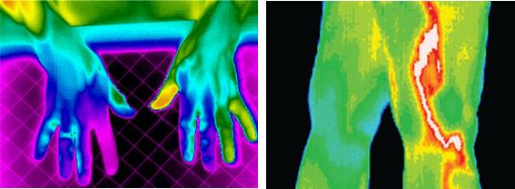
(a) (b)
Figure 1. (a) The diagnosis of Raynaud's syndrome, (b) The diagnosis of a vascular inflammatory condition [129, 130]
- IR thermography is widely used in civil engineering. IR thermography is a powerful tool for the detection of defects and damage in various cases such as buildings and construction. For example, IR techniques are used to determine moisture content, to conduct quality control of buildings, to identify the exact position of heating pipes, to investigate hardened concert, etc. [131, 132]. In the figure 2, the specified region near the windows in the IR image, indicate moisture penetration.
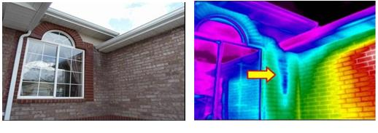(a) (b)
Figure 2. (a) a RGB photo, (b) a IR image that shows moisture penetration near the window [133]
- Another recent application of IR technology is in race cars to manage the car temperatures to ensure the reliability, assess the efficiency of brakes, engine components, tires, etc. [134]. In figure 3, the use of IR systems in racing cars is shown.
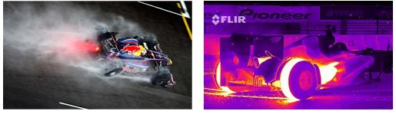(a) (b)
Figure 3. (a) and (b) Thermal cameras show the temperature differences in race cars [134]
IR imaging is also used in other fields such as: in the military (military surveillance, target tracking, night vision, etc.), in industry (analyzing the thermal efficiency of processes and machinery, inspection in industry, monitoring the environment, etc.), in agriculture (measuring the nitrate-state nitrogen in fresh leaves, analysis of soil nutrient status, plant growth and soil water deficit, etc.) [135, 136], in the environment (to acquire information about climate, to monitor water pollution, to acquire information about landfill sites, etc. [124], in remote sensing (to predict climate change, to locate materials, etc.), in art and cultural heritage (to preserve the state of the artefacts, to monitor musical wind instrument’s temperature, to monitor the conservation status of paintings in museums over time, to detect the temperature anomalies on ancient monuments such as the pyramids of Egypt, etc. [120]), in chemical industries (to identify molecular structure and composition and their emission and absorption, etc.) [121, 122] among other applications. With the falling price of IR cameras and computers even more applications of IRT will emerge, in any field where a non-contact change of temperature witnesses a phenomenon of interest. Figure 4 shows two applications of thermography technology such as the state inspection for cultural heritage (figure 4(a)) and the monitoring of ocean features (figure 4(b)).
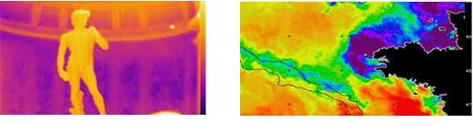
(a) (b)
Figure 4. Examples of application fields for thermography: (a) cultural heritage conservation [137]; (b) remote sensing from space [138]

9. Recent and new IR technologies
Future IR technologies strive to develop detectors which are portable and have a high sensitivity, lower cost, high resolution, etc. [56]. Some of the new systems and devices are described below.
The first is the Heat-Wave, which is a 3D device combined with a thermal camera, color camera and a range sensor (RGB-D camera and single additional thermal camera). The fact that the Heat-Wave is a light-weight thermal IR camera is a great advantage.
All sensors in this device have a closed format and are mounted on an ergonomic handle for portable deployment [139]. The various viewpoints recorded improve the accuracy. The Heat-Wave can be used in different applications such as: energy efficiency monitoring, energy losses, mechanical and electrical assessment, construction monitoring, fire detection, first responders and non-invasive medical diagnosis, etc. [139-141]. This system can also be used in NDT, since it can locate sources of energy losses in buildings and can identify faulty components with abnormal temperatures in industry [139-141]. Figure 5 shows a 3D thermal map of a chiller water pump system and a HeatWave 3D thermography device. In figure 5 (a), the top right photo shows a RGB image, the middle-right photo illustrates a thermal image, the (b) right image represents an operator working with a HeatWave 3D thermography device, and the extreme left image is a 3D thermal map. In these applications the advantage is obviously the projection of thermal data on the 3D shape of the object, enabling a better understanding of the IR signature.
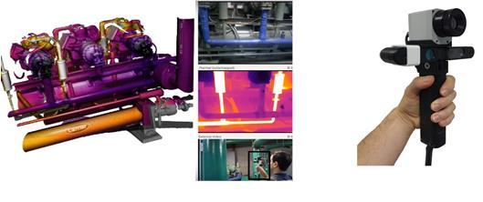
- (b)
Figure 5. (a) 3D thermal map of a chiller water pump system using the iron-bow color palette. (b) HeatWave 3D thermography device [139-142].
Other interesting systems are small low cost IR detectors [55]. One of the new areas of interest in IR technologies is the panoramic IR technology, which is designed to capture 360 degree images [55]. In the future, this technology could be used in low cost and low resolution systems in vehicles and boats to increase safety, especially at night or in conditions of poor visibility (smoke conditions, etc.). High-resolution systems which are more expensive would be suitable for use in ships and submarines. In a panoramic system, the frame rate is very important [55]. If the frame rate of the scanned system which rotates to provide a photo is too slow, the camera would not be able to recognize the target and enable the tracking [55]. In some instances, a “pyramidal-shaped” mirror can be used in front of the IR camera to acquire a 360° image at once. Such images are however distorted and need correction before being displayed. This technology can be very useful in the field of non-destructive testing, in the field of medicine, because it can be applied to cylindrical objects and offers a global internal thermal view.
Robots have recently been combined with other IR technologies, in a variety of applications (see Figure 6). Robots can be used in automated NDT, in complex geometries, and in hazardous areas [143]. In the future, the robotic technology will produce humanoid robots, similar to the one shown in Figure 6 (b) which could hold an IR camera in one hand and a heat source in the other, and inspect a variety of specimens. In the next 25 years, NDT robots will be equipped with a thermal camera, a color camera and a range sensor in their “eyes”. The robot’s vision system will detect the defects with the help of an analytical system using data processing algorithms, all embedded in the robot’s “brain” [144]. This is in fact the new trend of the so-called Industry 4.0 and the Internet of things (IOT), seen by some as the next industrial revolution [145]. IOT is the network of physical objects or “things” including robots, IR cameras embedded with electronics, software, sensors and connectivity to enable the IOT network to achieve greater value and service by exchanging data with the manufacturer, operator and/or other connected devices [146]. IR-NDT will exploit these novelties as well, as explained briefly below.
Today, microbolometers arrays are becoming more popular. Their launch price was over ten thousand dollars, but elementary complete systems could be purchased for several hundred dollars in 2015 [55]. Such systems have been used in thermography, automotive applications, and other fields for a few years already, and low-cost arrays have increased the popularity of thermal imaging (example FLIR Lepton - see below - offered in kits on popular microcontroler platforms such as Raspberry Pi or Arduino). Another recent example is the FLIR ONE which is a thermal imager for smartphones that was unveiled in January 2014 (see Figure 6 (d)). Its cost is $350 and includes a visible camera and a microbolometer camera that is presented on the smartphone screen [55]. The small thermal camera in this case is a very low-cost microbolometer-based core (called Lepton). The Lepton is an 80-by-60-pixel array with 17 μm pitch detectors. Its sensitivity band is in the range of 8 to 12 μm (LWIR) and the fitted lens has a 50-degree horizontal field of view [55]. FLIR ONE can be used to locate warm or cold air leaks in homes, heat losses through windows and insulation, identify moisture in buildings, detect overloaded electrical connections, locate pipes behind walls and under floors and control radiant floor heating and even more applications depending on the user’s imagination [147]!
Therm-App from Opgal Optronic is another thermography application which was released for the android phones. Using this Therm-App, an android phone becomes an attractive thermography tool [148]. Therm-App offers many advantages such as: easy to use, lightweight (138 grams), small size (55 x 65 x40 mm), low power consumption (less than 0.5W), with resolution (384 x 288 pixels) and long range (see figure 7) [148].

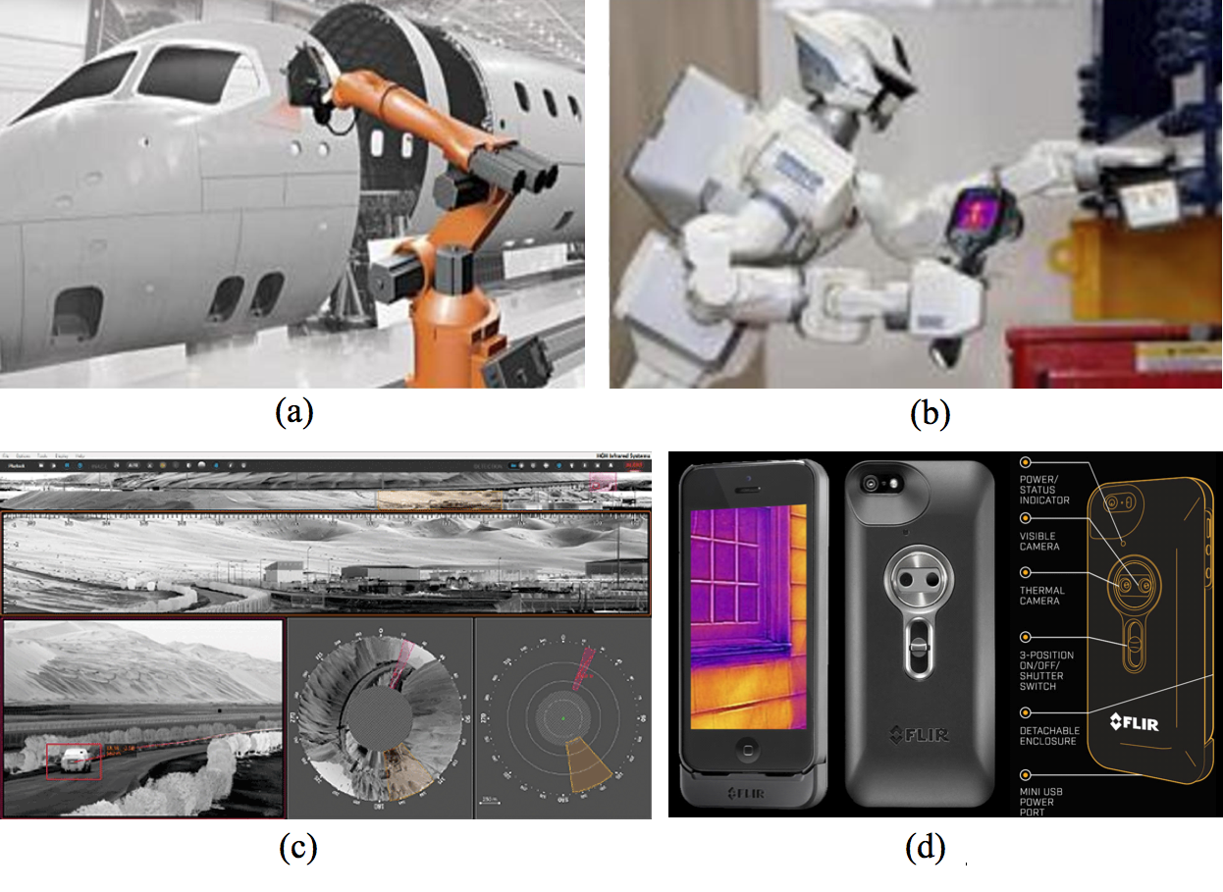
Figure 6. (a and b) The robots in NDT, (c) Panoramic IR image, (d) FLIR One IR camera (image courtesy of FLIR) [26,149]

The Seek thermal camera is another thermal imaging camera which uses more than 32,000 (206 x 156) thermal pixels to create a IR image displayed on iOS and android devices (see Figure 7). This type of camera is very small and has a plug adaptor for USB ports. This camera does not require batteries or special cables. The software is similar to that of Flir One. This camera has a spot meter function to display surface temperatures [149].
The reduction in price of IR sensors (and in the price of more powerful pocket size computers) will enable the emergence of “stand-alone dedicated IR systems”. For example, PC computers are now available on a USB key (ex: Intel’s “Compute Stick”. The same for IR sensors with an USB interface: a full system including Bluetooth, WI-FIis thus available for a minimum hardware cost of less than 350 $ (PC: 149$ + IR: 199 $).
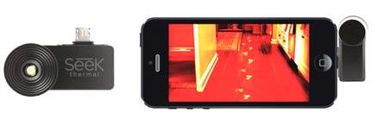
(a) (b)
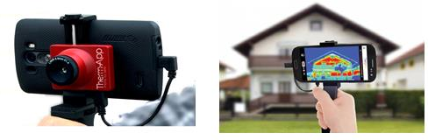
(c) (d)
Figure 7. (a) front-view of Seek thermal camera for smartphone, (b) the camera plugged into a smartphone , showing the achieved miniaturisation and the quality of the obtained thermal image [149], (c) Therm-App IR camera for Android [150], (d) a building inspection by Therm-App [151]
The price will most likely continue to decrease in the years ahead. Such USB-IRT-PC could be loaded with IR image processing software for special applications such as in monitoring overheating in electric cabinets, detection of subsurface defects on production lines, etc. WIFI could be used to communicate automated diagnosis to a central unit and, in case of IR-NDT, activate stimulating sources (such as pulse heating). In the competitive environment of IR thermography and IR imaging, there are many companies with different market shares such as: FLIR systems, Fluke, InfraTec, IRIsys, IRnova, Jen Optik, Opgal, Seek thermal, Telops, Xenics, etc. Due to the competitive environment, companies attempt to increase their market shares by producing IR cameras with higher resolution, lower weight, smaller size and lower price [152].
In the future, at even lower cost, size and weight, these systems could even be deployed permanently inside critical (electrical cabinets, etc.) components for continuous check-up following the previously discussed IOT trend. All technologies related to IR are developing very rapidly [43] . Today with changes in detectors, camera sensors, and IR systems, it is important to have high resolution, high performance, and low cost systems. These goals will become even more obvious in the future as illustrated in Figure 8 which shows the expected reduction in IR camera cost accompanied by an increase in pixel capability.

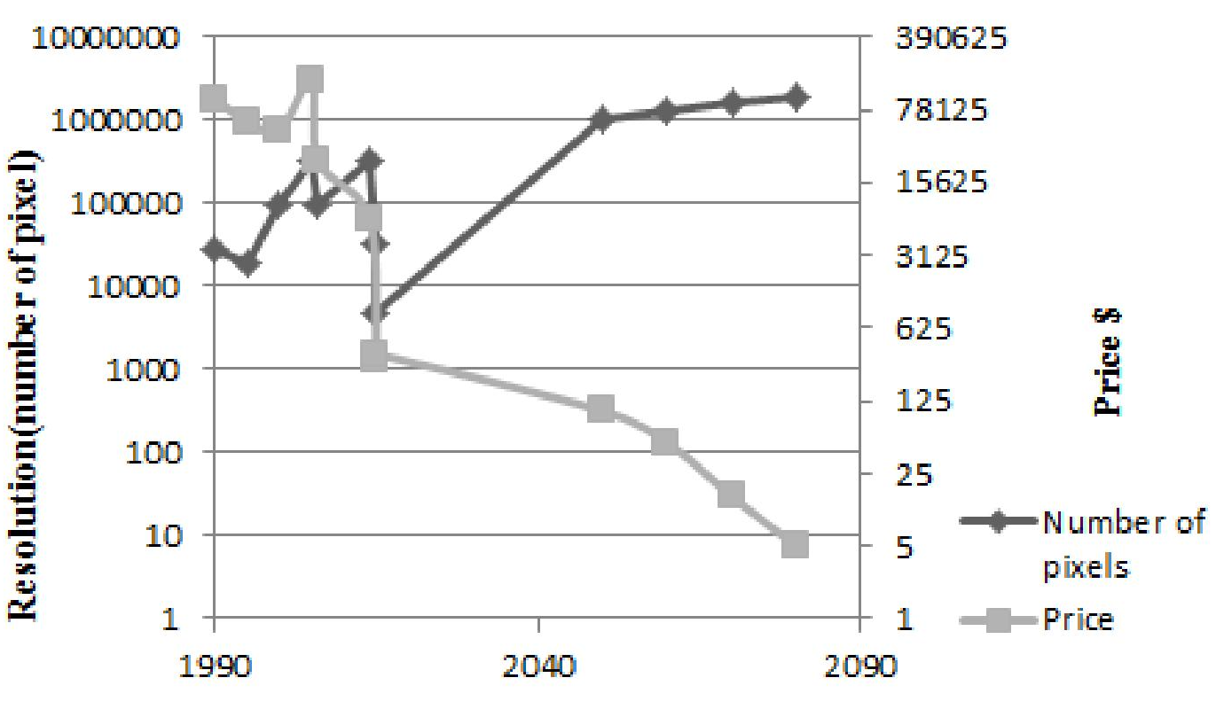
Figure 8. Diagram of the changes of IR camera cost and resolution from 1990 to 2080.

10. Conclusion
In the future, with respect to detectors, IRT will continue to develop with higher resolution and lower cost due to the continuous development of uncooled FPAs (microbolometers) and cooled FPAs (photonics, quantum detectors for high-end applications). With regard to image processing, IRT has evolved from digital functional imaging to pattern analysis, detection and quantitative analysis. Further developments are expected as well especially since new processors will be able to handle more complex algorithms (such as real-time thermal quadrupoles manipulation or complex thermal models for instance). Internet of things will also revolutionize IRT with a widespread use of internet connected low-cost smart IR sensors distributed in many places for a given application, in NDT and other fields. These improvements in IRT will lead to a greater acceptance in industry and elsewhere (even by the general public) and a variety of “hot applications” will emerge. This will for instance include humanoid robots which will be fitted with IRT as well.
References

