Intra-operative digital specimen radiology reduces re-operation rates in therapeutic mammaplasty for breast cancer

Majdak-Paredes EJ, Schaverien MV, Szychta P, Raine C, Dixon JM

Edinburgh Breast Unit
Western General Hospital
Crewe Road
Edinburgh EH4 2XU

Corresponding Author:
Ms Ewa Majdak-Paredes PhD
Email: emajdak@doctors.net.uk
Tel: 0131 537 1000

Original Article
Presented at Association of Breast Surgery Meeting Manchester May 2013

Abstract
Background: The aim of this study was to evaluate our experience with intra-operative imaging of therapeutic mammaplasty specimens at Edinburgh Breast Unit.
Methods: A retrospective review was performed of patients who underwent therapeutic mammaplasty in Edinburgh Breast Unit between 2007 and 2013 who had intraoperative specimen radiography.
Results: 98 (100%) patients who underwent therapeutic mammaplasty for breast cancer had intra-operative imaging using the faxitron® system. 3 out of those 97 (3%) patients had a re-operation because of positive margins confirmed pathologically on cavity excision specimens, but only 1 out of 3 (1%) patients had residual breast cancer present within the re-excision specimen. None required mastectomy. Median age was 58 (range 34-81). Median follow up was 3.1 years (range 6 months – 5.5 years). There was no local recurrence or conversion to mastectomy in this group.
Conclusion: Complete excision rate in patients who had intra-operative imaging during therapeutic mammaplsty procedure was 97% in our group. Faxitron® system is a useful adjunct in helping to achieve low incomplete excision rates.

Introduction
Breast cancer is the most common cancer in women in the UK and accounts for 30% of all new cases of cancer in females (1). It is managed in multidisciplinary setting to optimize overall outcome and maintain quality of life. Oncoplastic breast conserving surgery (OBCS) is a technique whereby a breast carcinoma is excised with a margin of healthy tissue by wide local excision (WLE) with immediate re-distribution of the remaining breast parenchyma using either breast advancement flaps or breast reduction patterns with or without surgery on the contra-lateral breast. In order to maximize the oncological safety of this technique it is imperative to ensure complete excision of breast tumor during the initial WLE. It is estimated that 15-47% of patients who have BCS will need a further operation because of an initial incomplete excision (2, 3, 4). Preliminary reports suggest that intra-operative imaging of WLE specimen to assess the excision margins in breast cancer reduces the rate of positive margins significantly (5, 6, 7). The aim of this study was to evaluate our experience with intra-operative imaging of therapeutic mammaplasty specimens in the Edinburgh Breast Unit.

Material and Methods
We conducted a retrospective case-note review from a prospectively maintained database and indentified 98 patients who underwent therapeutic mammaplasty for breast cancer in the Edinburgh Breast Unit between 2007 and 2013. The study was approved by the local Ethical Committee. Data analysis included demographic, operative, radiological and pathological characteristics. All patients underwent triple assessment to confirm the diagnosis which included history (or screening), clinical examination and image guided core biopsy (n=98; 100%). In all these patients tumor markers were inserted under ultrasound image guidance. 69 patients (70%) had preoperative needle localization of the tumor with ultrasound or stereotactic guidance. The indications comprised impalpable or multifocal cancers or those treated with neoadjuvant hormone or chemotherapy.
53 patients (54%) received neoadjuvant hormonotherapy prior to mammaplasty (n=42 letrozole in postmenopausal women; n=5 tamoxifen in premenopausal women) and 9 patients (10%) received neoadjuvant chemotherapy. 98 WLEs with therapeutic mammaplasties and 89 contralateral symmetrising breast reductions were performed. The median age at diagnosis in this group was 58 [range 34-81]. 37 (36%) cancers were screen detected. Stereotacitc localization of the tumor with ultrasound guided wires (from 1 to 5 wires) was performed in 69 patients (70%). All therapeutic mammaplasties were performed by a team consisting of a breast surgeon and a plastic surgeon. Our approach is to remove the breast tumor first as a standard wide local excision (WLE) with cavity margins as part of breast reduction and then plan reshaping of the breast parenchyma to match the contralateral site.
Therapeutic mammoplasty is performed by multidisciplinary team members consisting of a breast and plastic surgeon working simultaneously. WLE and excision of cavity margins is performed by the breast surgeon. At the same time, the plastic surgeon performs contralateral breast reduction to create the ideal breast to match the cancer site. Once the WLE and cavity margins were excised the breast and plastic surgeon reshape the remaining parenchyma.
Our surgical technique has been previously described (8). Anterior and posterior margins were always the same: subcutaneous fat and the pectoral fascia. The WLE specimen was marked carefully with liga-clips to orientate the specimen for intraoperative specimen radiography as shown in Figure 1 in all patients. Intraoperative X-ray image was taken in the operating theatre (Faxitron BioVision Digital Specimen Radiography System). The results are available within 30 seconds for the surgeon to make a decision whether any further excision of any specific margins is indicated. In the majority of cases further margins were excised as part of reduction mammoplasty. Faxitron image of WLE was taken intraoperatively in the theatre in all cases. Further cavity margins were removed in all cases as part of breast reduction procedure. However, in cases were faxitron image of WLE specimen raised any suspicion on margin involvement; we deliberately included this particular area in our reduction (cavity margin) specimen. All cavity margin specimens were placed in faxitron. Faxitron image was guiding the surgeon into removing all suspicious areas adjacent to WLE in the first instance in order to maximize complete excision margins for oncological reasons. Only then, the pedicle was designed to safely transfer the nipple areola complex to the desired position and reshape the remaining parenchyma.
The digital mammographic image of the breast tumor was also compared in the operating theatre with the faxitron image to ensure the whole of the mammographic abnormality was excised. All patients received adjuvant radiotherapy as a standard treatment in breast conserving surgery.

Results
The mean tumor size on ultrasound was 39.3mm and on pathology 32.1mm. Multifocal disease was present in 20 (20%) patients. Of the 98 patients, 19% (n=19) had DCIS, 8% (n=8) had invasive lobular carcinoma with LCIS, 47% (n=46) were of invasive cancer of no special type with DCIS and 26% (n=25) were invasive cancers of no special type without DCIS, The mean specimen weight of WLE specimen was 83.5g, the mean weight of the WLE with cavity margins was 154g and contralateral breast weight 259.5g. The mean duration of neoadjuvant hormonotherapy was 4.18 months (1-12 months). 19% (n=20) of those who received neoadjuvant hormonotherapy had extensive DCIS without an invasive component and all achieved the same response mammographically. 10% (n=9) of patients received neoadjuvant chemotherapy. Initial WLE specimen pathology (without cavity margins) showed tumor present at margins on specimen radiography and pathology in 16 (15.4%) patients. In the 15.4% excision margins were converted from positive to negative by removing further tissue from the involved margin (cavity margins). After excision of appropriate cavity margins in these patients, only 3 (3%) patients had incompletely excised breast cancer confirmed by positive pathology on cavity margins (p<0.002). All these patients underwent re-excision. No cancer was found in 2 patients and DCIS was present in 1 patient that was clear of the new margin. 5 patients (5%) received adjuvant chemotherapy and 74 patients (75%) received adjuvant hormonotherapy (70: letrozole and 5: tamoxifen) for 5 years.

Discussion
The main objective in breast conserving surgery (BCS) is to obtain negative margins as local recurrence is significantly the most common in patients with involved margins (7, 9, 10). Traditionally the assessment of margins has relied on histological evaluation of specimen following lumpectomy. In order to reduce incomplete excision rate intraoperative specimen mammography was introduced. However, this modality needs specific availability or co-ordination between the breast surgery unit and radiology department which is not always possible. A disadvantage of specimen radiology in a mammography department is compression of the specimen which may obscure the accuracy of margin assessment, the involvement of another specialist (radiologist), transport of the specimen to the mammography unit and the time it requires when the patient is under general anaesthetic. An alternative is to use intra-operative imaging with faxitron® system located in the operating theatre. The operating surgeon is responsible for marking the WLE specimen according to our AMI system (see Figure 1) and placing it in faxitron® in a consistent manner. The most recent mammographic image of breast tumor is displayed in the operating room for comparison. The operating surgeon interprets the specimen X-ray but a radiologist is also available for immediate advice and can see the intraoperative image within their own department. Our data are consistent with other preliminary reports that have shown that intraoperative specimen radiography with a faxitron® significantly reduces incomplete excision rates (2, 3, 4, 11). Nowadays therapeutic mammaplasty is a technique whereby a breast carcinoma is excised with a margin of healthy tissue by WLE with immediate re-distribution of the remaining breast parenchyma using either breast advancement or rotation flaps or breast reduction patterns with or without surgery to the contralateral breast. Because of immediate manipulation of the breast parenchyma whilst reshaping the breast at the time of WLE, it can be more difficult to find the appropriate margins should the re-excision be required. In Edinburgh Breast Unit the same breast surgeon who is involved in therapeutic mammoplasty initially would perform re-excision when required. Therefore finding the appropriate margins would have been less of a problem. Still, any re-excision means an additional surgery, general anaesthetic, time off work and anxiety to the patients.
In therapeutic mammaplasty it is of paramount importance to maximize efforts to ensure complete excision with clear histological margins during the primary procedure. Our philosophy of therapeutic mammaplasty is to perform WLE with immediate intra-operative imaging to guide the surgeon into specific areas where cavity margins must be removed to maximize oncological clearance. The design of breast pedicles to reshape the breast parenchyma was decided after oncological clearance was macroscopically achieved. In those cases where intraoperative faxitron image of WLE was oncologically satisfactory, further excision around the cavity margins was tailored to optimal reshaping of the breast parenchyma in order to achieve the maximum aesthetic result.
Our series has proven that intra-operative imaging of WLE has allowed us to reduce the incomplete excision rates from 84.6% to 97%. This is the first study which reports experience with intra-operative imaging of WLE in application to therapeutic mammaplasty. Muttalib et al. reported that faxitron® image led to cavity margin biopsies in 50% of cases of which 16% of excisions were converted to from incomplete to complete in the context of BCS without therapeutic mammaplasty (6). The criticism of that study lies in subjecting 34% of patients to an unnecessary larger aesthetic excision following WLE with corresponding larger potential defects and poorer aesthetic outcomes. In the context of therapeutic mammaplasty, further excisions to produce negative margins does not result in a patient having poorer aesthetic outcome because the breast parenchyma needs to be reduced and reshaped as part of the procedure (12). The concept of using intraoperative imaging assessed by the surgeon is not new. Surgeons in other specialties routinely use digital X-rays without the assistance of radiologist in orthopaedic and hand surgery for intraoperative assessment and management of fractures (image intensifier). In breast cancer surgery, it is important to involve an experienced multidisciplinary setting with the assistance of the radiologist. Preoperative images are viewed in a multidisciplinary setting and images after neoadjuvant treatment reviewed as the reduction in visible abnormalities can affect the intra-operative faxitron® image in an individual patient. The surgeon together with the radiologist and radiographer discusses the planning of wires and then interprets intraoperative faxitron® images in the operating room on an individual basis.
In our series neoadjuvant hormone therapy and chemotherapy were commonly used and this can make assessment of excision margins more challenging. Neoadjuvant chemotherapy causes tumor cell death and scarring which can reduce tumor density and it can also reduce the extent of microcalcifications (see Figure 2) (13, 14, 15, 16). On the other hand, neoadjuvant hormone therapy reduces tumor volume in a concentric fashion but in some patients also dramatically reduces density (see Figure 3) (17, 18). In our series mean duration of hormonotherapy was 4.18 months ranging from 1 to 12 months. The effect of neoadjuvant treatment may be reflected by smaller tuomor size preoperatively seen on imaging and the tumor size on the final pathology specimen (39.3 vs 32.1mm).
DCIS remains a challenge during assessment of intra-operative excision margins using faxitron® due to the limited sensitivity and specificity of mammographically detecting all DCIS (see Figure 4). It may be beneficial to remove further cavity margins in all patients with DCIS with or without neoadjuvant therapy in the context of therapeutic mammaplasty to increase the rate of complete excisions. This is the first study to report a significant benefit on complete excision rates and reduce re-excision of use of the faxitron® in patients who had undergone therapeutic mammaplasty. The faxitron® system is easy to use, saves time, allows the surgeon to excise further tissues as directed by the specimen radiograph. It is one of the reasons for the low rate of margin involvement in this series. Our indications for therapeutic mammoplasty include patients with breast cancer in any location in whom the anticipated aesthetic outcome following traditional WLE would be poor or small breast cancers in patients with larger breasts who will benefit by reduction in complications of adjuvant radiotherapy. A key factor in minimising the risk of incomplete excision is inserting markers into the breast at the time of core biopsy and using mulitple wires when appropriate to adequately localize the mass or calcifications prior to performing wide local excision. The faxitron® is a useful adjunct in obtaining clear margins in patients with invasive and non-invasive breast cancer undergoing therapeutic mammaplasty.

Literature
- Cancer Statistics. Cancer Research UK. http://www.cancerresearchuk.org/cancer-info/cancerstats/types/breast/incidence/uk-breast-cancer-incidence-statistics
- Ananthakrishnan P, Balci FL, Crowe JP. Optimizing surgical margins in breast conservation. Review. Int J Surg Oncol 2012; 2012: 585670
- Lovrics PJ, Cornacchi SD, Farrokhyar F. The relationship between surgical factors and margin status after breast conservation surgery for early stage breast cancer. Am J Surg 2009; 197(6):740-46
- Acosta A, Greenlee JA, DeanGubler K, Goepfert CJ, Ragland JJ. Surgical margins after needle-localization breast biopsy. Am J Surg 1995; 170(6): 643-46
- Kurzl R, Baltzer J, Lohe KJ. Intraoperative specimen radiography in mammographically suspect, non palpable brest lesins. Experiences with the Faxitron unit. Fortschr Med 1979;97(38):1688-90
- Muttalib M, Tisdall M, Scawn R, Shousha S, Cummins RS, Sinnett HD. Intra-operative specimen analysis using faxitron microradiography for excision of mammographically suspicious, non-palpable breast lesions. Breast 2004;13(4):307-15
- Ihrai T, Quaranta D, Fouche Y, Machiavello JC, et al. Intraoperative radiological margin assessment in breast-conserving surgery. Eur J Surg Oncol 2014;40(4):449-53
- Schaverien MV, Raine C, Majdak-Paredes E, Dixon JM. Therepeutic mammaplasty – extending indications and achieving low incomplete excision rates. Eur J Surg Oncol 2013; 39(4):329-33
- Singletary S. Surgical margins in patients with early-stage breast cancer treated with breast conservation therapy. Am J Surg 2002;184:383-93
- Pinotti JA, Carvalho FM. Intraoperative pathological monitorization of surgical margins: a method to reduce recurrences after conservative treatment of breast cancer. Eur J Gyanecol Oncol 2002;23(1): 11-6
- Bathla L, Harris A, Davey M, Sharma P, Silva E. High-resolution intra-operative two-dimensional specimen mammography and its impact on second operation for re-excision of positive margins at final pathology after breast conservation surgery. Am J Surg 2011;2002(4):387-94
- Heil J, Breitkreuz K, Golatta M, Czink E, Dahlkamp J et al. Do re-excisions impair aesthetic outcome in breast conservation surgery? Exploratory analysis of a prospective cohort study. Ann Surg Oncol 2012;19(2):541-7
- Li JJ, Chen C, Gu Y, Di G, Wu J, Liu G, Shao Z. The role of mammographic calcifications in the neoadjuvant therapy of breast cancer imaging evaluation. PLoS One 2014; 9(2):e88853
- Tomberg BJ, Cerussi A, Shah N, Compton M, Durking A, Hsiang D, Butler J, Mehta R. Imaging in breast cancer: diffuse optics in breast cancer: detecting tumors in pre-menopausal women and monitoring neoadjuvant chemotherapy. Breast Cancer 2005;7(6):279-85
- Esserman LE, d’Almeida M, Da Costa D, Gerson DM, Poppiti RJ. Mammographic apperance of microcalcifications: can they change after neoadjuvant chemotherapy? Breast J 2006; 12(1):86-7
- Fadul D, Rapelyea J, Schwartz AM, Brem RF. Development of malignant breast microcalcifications after neoadjuvant chemotherapy in advanced breast cancer. Breast J 2004; 10(2):141-5
- Miller WR, Dixon JM, Cameron DA, Anderson TJ. Biological and clinical effects of aromatase inhibitors in neoadjuvant therapy. J Steroid Biochem Mol Biol 2001; 79(1-5):103-7
- Dixon JM, Love CD, Bellamy CO, Cameron DA, Leonard RC, Smith H, Miller WR. Letrozole as primary medical therapy for locally advanced and large operable breast cancer. Breast Cancer Res Treat 2001; 66(3):191-9

Figure 1. Faxitron image of specimen markings system used in our unit (AMI system: one clip on the anterior margin; two clips on medial margin and three clips on inferior margin)

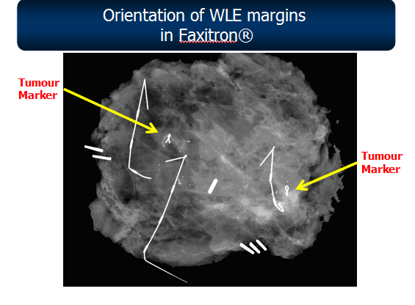

Figure 2. Post-neoajduvant chemotherapy WLE specimen on faxitron showing scattered appearance with microcalcification (resembles multifocal tumor but it is not).
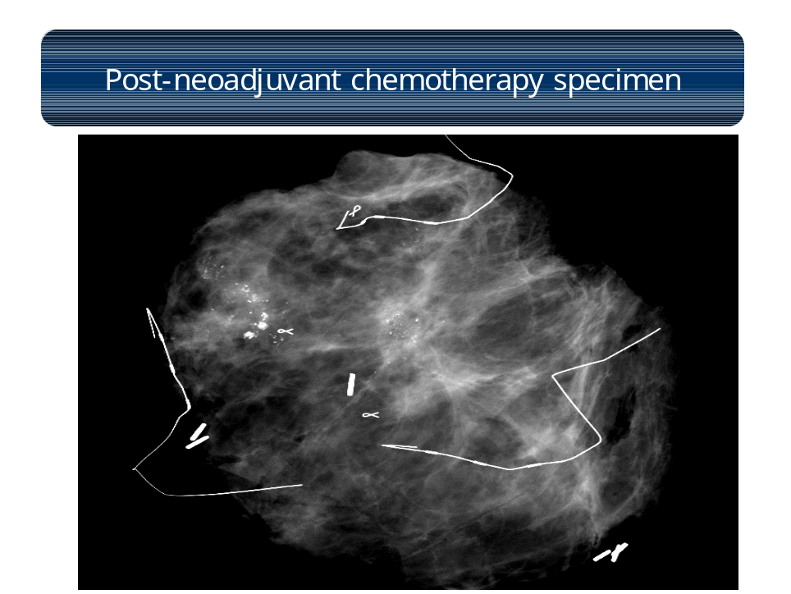
Figure 3. WLE specimen treated with neoadjuvant hormonoterapy. Hormonotherapy causes concentric shrinkage of breast cancer.
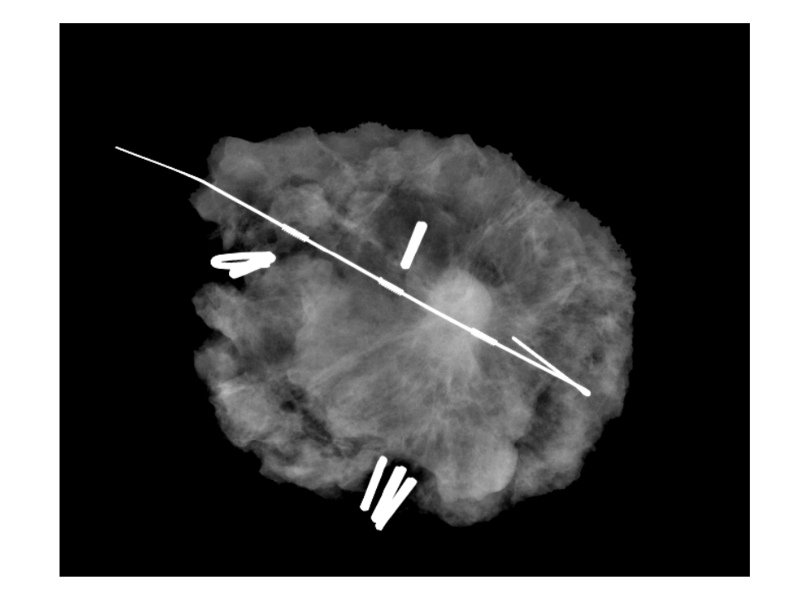
Figure 4. Diffuse appearance of WLE DCIS on faxitron
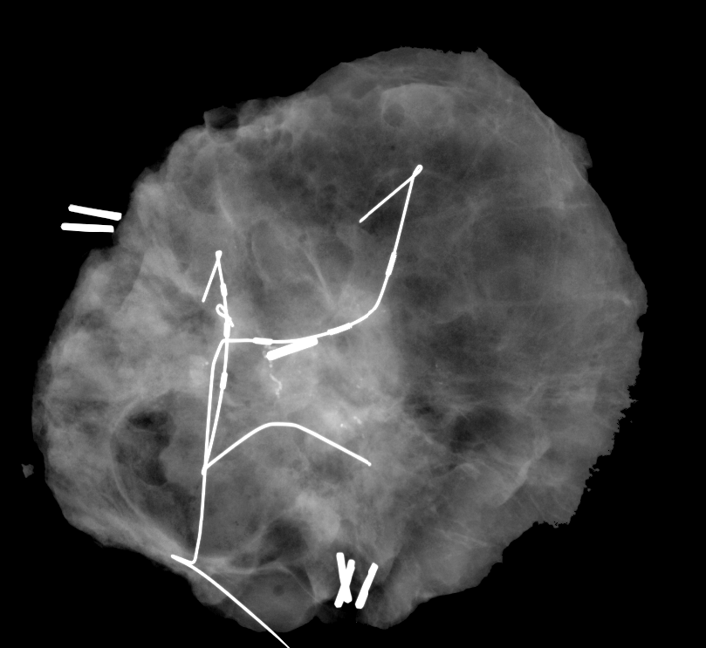

No conflict of interest

