Abstract— Titanium is a light metal and finds application majorly in the aerospace and bio medicals. This paper presents the influence of scanning speed and energy density on the evolving microstructure and microhardness of laser deposited Ti6Al4V/Cu composites. The laser power, powder flow rates and gas flow rates were kept constant while varying the scanning speed. From the microscopic analysis, α acicular structures were found growing from the top of the cross section of the composite and broke into the β-phase and the grain boundary of the (α+β) phase, and found to disappear gradually as the scanning speed increases. Widmanstettan was also found in all the samples. Sample S21 of energy density 240 J/mm² deposited with a laser power of 1200 W and a scanning speed of 5 mm/secs shows the highest hardness value of 541±20 HV_{0.5} while Sample S27 of energy density of 48 J/mm² deposited with a laser power of 1200 W and a scanning speed of 25 mm/secs shows the lowest hardness value of 405±12 HV_{0.5}. This was attributed to the Cu content added and plays a vital role in stabilizing and strengthening the β-phase.
Influence of Scanning Speed and Energy Density on the Evolving Properties of Laser Deposited Ti6Al4V/Cu Composites
Mutiu F Erinosho¹, Esther T Akinlabi², Sisa Pityana³

Keywords— laser metal deposition, microstructure, microhardness, Ti6Al4V/Cu composite

INTRODUCTION
Powder metallurgy has been widely used for the production of partial and completed jobs in the field of engineering and other related fields [1]. The deposition of metal powders using the laser is accepted in the aerospace, bio medical and marine industries [2]. The laser metal deposition of titanium and its alloy in the surface and coating technology is one of the means to improve its surface integrity especially in aerospace and biomedical [3]. The addition of alloying elements to titanium and its alloys have commonly enhanced their mechanical properties [4-6]. A low energy density provides low bonding and insufficient melting with the substrate; and that for a material to behave well in service, it should possess good mechanical properties such as high hardness and good bond strength [7]. A metal matrix composite layer with a nickel based alloy was deposited on the surface of AISI 316 stainless via laser cladding for the purpose of improving the hardness. Good coatings were achieved with the energy density between 20-80 J/mm² [8]. The mechanical property of Ti6Al4V alloy was improved with the addition of 1, 4 and 10 weight percent of Cu. The results showed an increase in the bulk hardness of the alloys [9]. Cu was reported to be a strong β-stabilizing element and its atomic mobility into the titanium lattices has resulted in the formation of β-Ti [10]. 4 % of Cu was added to Ti6Al4V to improve the corrosion behavior of the alloy. The microstructural results led to the formation of acicular α grain in the β grains and were found to be finer than the grains in the Ti6Al4V alloy [11]. Information on the LMD of Ti6Al4V/Cu alloying composite is still very limited despite the general acceptance of this primary alloy in several engineering applications.

This paper therefore reports the effect of scanning speed and energy density on the evolving microstructures and microhardness of the laser deposited Ti6Al4V/Cu composites. In this experiment, the laser power, powder flow rate and the gas flow rate were kept constant while varying the scanning speed. The energy density of every sample was also characterised.

Experimental setup

The experiment was conducted on the Ytterbium laser system apparatus (YLS-2000-TR) powered at 2000 W. The system is equipped with a Kuka robot to perform the cladding and other deposition processes. Attached to the end effector is a three way nozzle that supplies the powders and the laser beam onto the substrate. The deposited composite is protected by an argon shield gas to prevent oxidation from the environment. Fig. 1 shows a typical schematic view of the nozzle head coupled with the hoses for flow of powders.
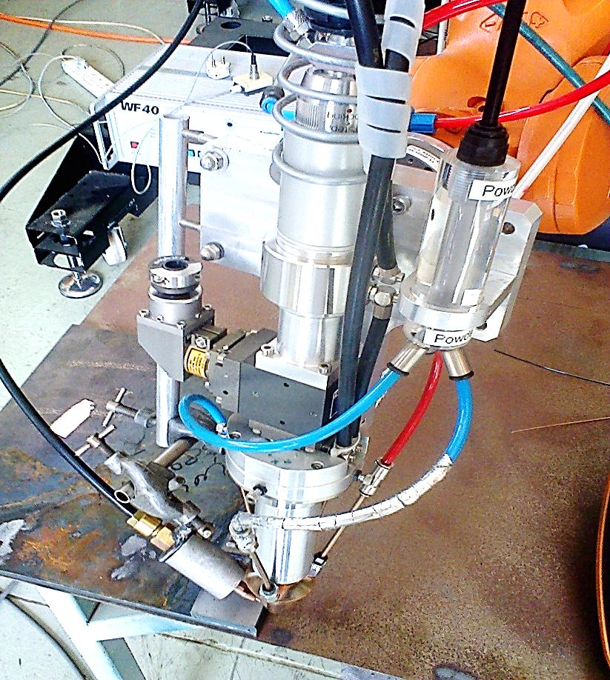
Fig. 1 Schematic view of the nozzle head

Material and Matrix
A 99.6 % Ti6Al4V alloy plate of 102 mm X 102 mm X 7.45 mm dimension was used as the substrate. The two powders used for the formation of the composites are Ti6Al4V and Cu powders; and both were fed from two seperate feeders (hoppers) and directly into the laser system via the hose connections. The particle sizes of the Ti6Al4V and Cu powders are varied between 150 and 200 µm. The surface of the substrate was grit-blasted to enhance good metallurgical bonding and to remove the surface contaminants. Table I shows the process parameters used in the present study.

TABLE I
Experimental matrix
Sample Name | Laser Power (W) | Scanning Speed (mm/sec) | Energy Density (J/mm²)
S21 | 1200 | 5 | 240
S22 | 1200 | 8.3 | 144.58
S23 | 1200 | 11.67 | 102.83
S24 | 1200 | 15 | 80
S25  S26  S27 | 1200  1200  1200 | 18.33  21.67  25 | 65.47  55.38  48

The laser power of 1200 W, powder flow rate of 2.5 rpm and 0.1 rpm for Ti6Al4V and Cu and gas flow rate of 3 l/min and 1 l/min for Ti6Al4V and Cu were all kept constant while the scanning speed was varied between 5 mm/sec and 25 mm/sec respectively. 3 weight percent of Cu powder was deposited with Ti6Al4V to form the complete composites. The beam diameter of 4 mm and a standoff distance of 12 mm were used throughout the experimental setup. The permutation of the laser power, the scanning speed and the beam diameter constitute the energy density output as shown in equation 1. Seven deposits were made on the substrate and labelled S21 to S27. The composites were metal brushed to remove the flux on them.
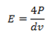 (1)

Where E denotes the Energy density, J/mm², P denotes the Laser power, W, d is Beam diameter, mm, and v is the scanning speed, mm/s.

Microstructure
The composites were sectioned laterally and mounted in polyfast prior to microscopic observation. The Kroll’s reagent was prepared with 100 ml H₂O, 2-3 ml HF and 4-6 ml HNO₃ according to the guidelines stated in the Struers application note of metallurgical preparation of titanium [12]. The samples were observed under the optical microscope (Olympus BX51M) to view the macrographs and the microstructures at low and high magnifications. The duration of etching was between 10-15 secs.

Microhardness
The microhardness characterization was conducted on EMCOTEST Dura scan Vickers hardness machine. Seven indentations were made on the lateral view of the composites. A load of 500 g and a dwell time of 15 secs were used throughout the hardness tests according E384 -11e1 ASTM standard [13].

Result and discussion
The results obtained from this present study are presented and discussed in this section.

Microstructural Evaluation
An analysis was carried out on the Ti6Al4V and Cu powders under the SEM. Figs. 2 (a) and (b) show the morphology of the Ti6Al4V and Cu powder used for the deposition.

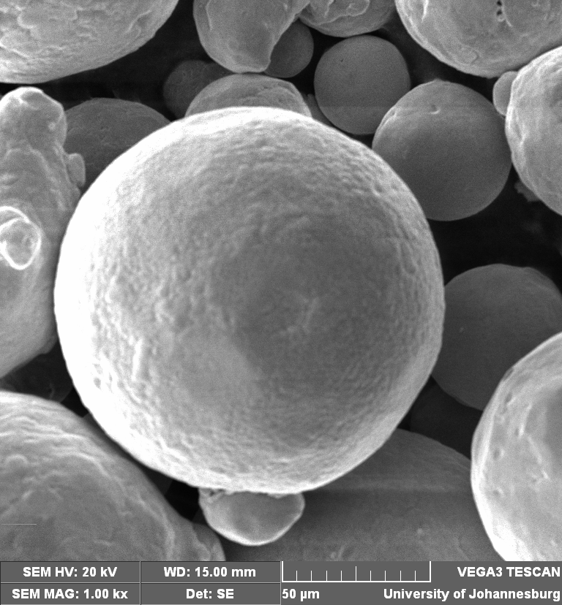
. (a)

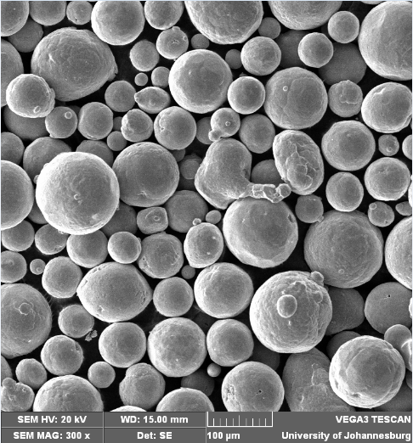

(b)

Fig. 2 (a) The SEM morphology of Ti6Al4V powder, (b) The SEM morphology of Cu powder

The morphologies of the two powders are spherically oriented and equiaxed. The Cu particles are heavier and denser than that of the Ti6Al4V particles.

Figs. 3 (a) to (d) show the macrograph and the microstructures of the composites. Figs. 3 (a and b) show the macrograph and the microstructure of sample S21 (Ti6Al4V/Cu composite) deposited with a laser power of 1200 W and scanning speed of 5 mm/sec. Fig. 3c shows the microstructure of sample S23 at the top left view and Fig. 3d shows the microstructure of sample S26 deposited with a laser power of 1200 W and scanning speed of 21.67 mm/sec.

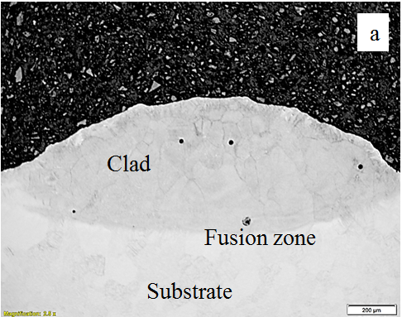

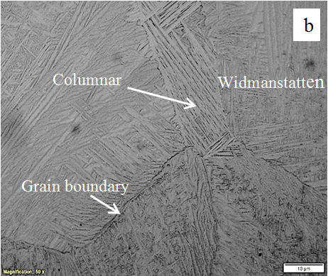

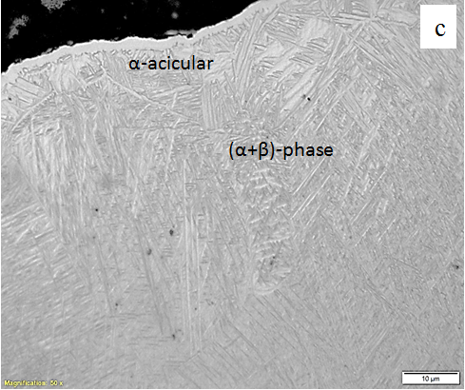

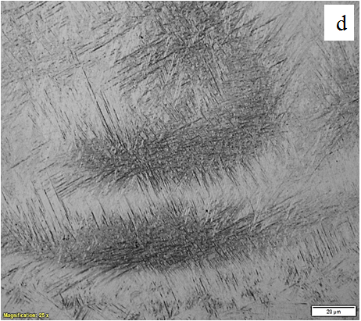
Fig. 3: (a) and (b) Macrograph and microstructure of sample S21 deposited at a scanning speed of 5 mm/sec respectively; (c) microstructure of sample S23 deposited at a scanning speed of 11.67 mm/secs; (d) microstructure of sample S26 deposited at a scanning speed of 21.67 mm/secs

A critical observation was put in place in studying the microstructures of the composites. It was found out the volume of the composites and porosities decreases as the scanning speed increases. α, β and (α+β) phases were observed. α-acicular structures were found a few microns height from the top of the composite to grow into the β grains [11] and break into the closer grain boundaries of the α+β grains. The α-acicular were also found disappearing and this could be attributed to the decrease in the energy density as the scanning speed increases. The grain boundaries of the (α+β) phase were observed to be larger than the β-phase. The closure of (α+β) phase boundary with another was also observed to create a macroscopic banding. Columnar grains were likewise found layering between the boundaries of two Widmanstettan structures and this was observed in sample S21 deposited with a laser power of 1200 W and scanning speed of 5 mm/sec. The growth of the grain boundaries terminates at the fusion zone. The surface of the composites becomes rougher as the energy density decreases. This energy density is inversely proportional to the scanning speed. The martensitic structure in the α-phase region was also found decreasing as the scanning speed increases. A wormlike structure attached with clusters of spines were similarly observed on sample S26 as shown in Fig. 3d and their formation could be as a result of the decrease in the martensitic phases at high scanning speed.

Microhardness Profiling
The microhardness profiling was carried out on the lateral view of all the samples from S21 to S27.
Fig. 4 shows the Vickers hardness HV_{0.5} results of sample S21 to S27. The average of seven indentations is represented as the average hardness and its standard deviation.

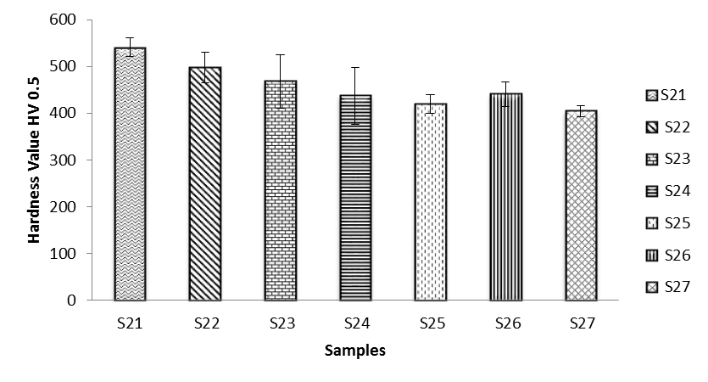
Fig. 4 Average hardness of the Ti6Al4V/Cu composites

It can be deduced that the scanning speed is inversely proportional to the hardness value and the energy density. A high energy density and low scanning speed have a great influence on the hardness of the Ti6Al4V/Cu composites. The formation of martensite reduced, and thus improves the ductility of the samples. This trend was related to the previous work done on the effect on powder flow rate and gas flow rate of Ti6Al4V/Cu [14]. Sample S21 with the energy density of 240 J/mm² shows the highest hardness value of 541±20 HV_{0.5} as compared to the hardness values of other samples; however the hardness values obtained in this present work was improved when compared to the hardness values obtained in the previous studies with the addition of 1 % Cu [14]. Invariably, the hardness values have been superseded and improved with the addition of 3 wt % of Cu to Ti6Al4V alloy.

Conclusion
Laser metal deposition of Ti6Al4V/Cu composite was successfully implemented and characterised. The addition of 3 weight % Cu has greatly enhanced the mechanical property of the primary alloy. It can be inferred that the scanning speed is inversely proportional to the energy density; and the microstructural analysis shows the formation of α-acicular and disappears as the scanning speed increases. Very little porosities formed were also observed to decrease with the increase in the speed of scan. Hardness value obtained shows an improvement on the Ti6Al4V/Cu composites with the 3 weight % of Cu added as compared to the primary alloy. Cu is a great stabilizer to the titanium lattice especially the β-phase. Further work needs to be carried out on wear to test their coefficient of friction for sliding application.

Nomenclatures

α alpha.
β beta.
wt weight.
W power, watts.
µ microns
ml milliliter
rpm revolution per minutes
g grams

Acronyms
HV Vickers hardness.
H₂O water.
HF hydrofluoric acid.
HNO₃ Nitric acid

Ackowledgement
This work is supported by the Rental Pool Programme of National Laser Centre, Council of Scientific and Industrial Research (CSIR), Pretoria, South Africa and also, acknowledgement goes to the African Laser Centre for the bursary award to Mr M. F Erinosho.

References
[1] A Global Market Review,
http://www.ipmd.net/shop/powder_metallurgy. IPMD 15th edition 2012-2013, Assessed 2013.
[2] C. Leyens and M. Peters, Titanium and Titanium Alloys. Fundamentals and Applications. Edited by ChristophLeyens, Manfred Peters Copyright © 2003 WILEY-VCH Verlag GmbH & Co. KGaA, WeinheimISBN: 3-527-30534-3 pp 2-3 (2003).
[3] M. F Erinosho, E. T Akinlabi and S. Pityana , Effect of powder flow rate and gas flow rate on the microstructure and microhardness of deposited Ti6Al4V/Cu composite, Advanced Materials Research 1016, pp 177-182 (2014a).
[4] I. Sen, K. Gopinath, R. Datta and U. Ramamurty, Acta Materialia, vol. 58 pp 6799 (2010).
[5] A. K. Gogia, T.K. Nandy, K. Muraleedharan and D. Banerjee, “Material Science and Engineering” A vol. 159, pp 73 (1992).
[6] Y. Okazaki, Y. Ito, A. Ito, and T. Tateishi, Material Transaction JIM, vol. 34, pp 1217 (1993).
[7] R. L Sun, D. Z Yang, L. X Guo and S. L Dong, Microstructure and wear resistance of NiCrBSi laser clad layer on titanium alloy substrate, Surface and coatings technology, vol. 132, pp 251-255 (2000).
[8] F. T Cheng, K. H Lo and H. C Man, A preliminary study of laser cladding of AISI 316 stainless steel using preplaced NiTi wire, Materials Science and Engineering, A vol. 380, pp 20-29 (2004).
[9] T. Aoki, I .C. I. Okafor, I. Watanabe, M. Hattori, Y. Oda and T. Okabe, Mechanical properties of cast Ti-6Al-4V-XCu alloys, Journal of Oral Rehabilitation, vol. 31, pp 1109-1114 (2004).
[10] M. Ghosh and S. Chauerjee, Diffusion bonded transition joints of titanium to stainless steel with improved properties, Material Science Engineering, A vol. 358, pp 152-158 (2003).
[11] M. Koike, Z. Cai, Y. Oda, M. Hattori, H. Fujii and T. Okabe, Corrosion Behavior of Cast Ti-6Al-4V Alloyed with Cu, J Biomed Mater Res Part B: Applied Biomaterial, vol. 73B pp 368-374 (2005).
[12] Struers Application Note on Titanium.
http://www.struers.com/resources/elements/12/104827/Application_Note_Titanium _English.pdf. Assessed 2013.
[13] ASTM E384 - 11e1, Standard Test Method for Knoop and Vickers Hardness of Materials”, ASTM International Book of Standards, Vol. 03.01. (2011).
[14] M. F Erinosho, E. T Akinlabi and S. Pityana, Laser Metal Deposition of Ti6Al4V/Cu Composite: A Study of the Effect of Laser Power on the Evolving Properties, Proceedings of the World Congress on Engineering, vol. II, pp 1203-1208 (2014b).

 Mutiu F. Erinosho is a doctorate candidate in the Department of Mechanical Engineering Science, University of Johannesburg, Auckland Park Kingsway Campus, Johannesburg, South Africa, 2006. (Phone-+27747425924; E-mail: mferinosho@uj.ac.za). Esther T. Akinlabi is an Associate Professor in the Department of Mechanical Engineering Science, University of Johannesburg, Auckland Park Kingsway Campus, Johannesburg, South Africa, 2006. (E-mail: etakinlabi@uj.ac.za). Sisa Pityana is a Professor/Research Scientist in the National Laser Centre of Council of Scientific and Industrial Research (CSIR), Pretoria, 0001 South Africa (E-mail: Spityana@csir.co.za)

