Structural Design of a Silicon Six-Wafer Micro-Combustor under the
Effect of Heat Transfer Boundary Condition at the Outer Walls
Lin Zhu^{1, 2}, Tien-Chien Jen², Mei Zhu¹, Cheng-Long Yin¹, Xiao-Ling Kong¹
¹ School of Engineering, Anhui Agricultural University, Hefei, 230036, P. R. China
² Mechanical Engineering Department, University of Wisconsin, Milwaukee, WI 53211, USA

Abstract
The aim of this investigation was to establish a methodology for designing highly stressed micro fabricated structures by studying the structural design issues associated with a silicon six–wafer micro combustor under the effect of heat transfer boundary condition at the outer walls.
Some experimental and numerical simulation results have indicated that the flame can not be sustained in the micro combustor if the poor heat transfer coefficients at the outer wall are present. This could cause the combustor wall temperature higher than the auto ignition temperature of reactants and results in the upstream burning. Since silicon has relatively poor high temperature strength and creep resistance when the temperature is above the brittle to ductile transition temperature (BDTT), e.g. 900K, the combustion in the recirculation jacket could possibly damage the micro combustor due to the high wall temperature.
In order to explore the structural design of the micro combustor with the flame burning in the recirculation jacket, combustion characteristics of the combustor were first analyzed using 2D computational Fluid Dynamics (CFD) simulation when the flow rate and the equivalence ratio of the hydrogen/air mixture were fixed. The 3D Finite Element Method was then employed for thermo-mechanical analysis on the micro-combustor. The simulation results identified that the locations of the critical failure could possibly occur at the burning areas in the recirculation jacket because of the poor bonding strength, the high temperature and the significant residual stress. The results of this study can be used for the design and improvement of the micro combustors.
Keywords: Structural design, micro-combustor, heat transfer condition
1. Introduction
With the rapid development of various kinds of miniature devices such as notebook computers, mobile phones, medical devices, and walking robots, the availability of compact, highly mobile and efficient micro power supply systems is becoming increasingly important in our daily lives. Currently, most of these devices are powered by batteries. They can only supply power for a certain period of time and require frequent recharges, which limits its portability [1]. Developing a continuous, light weight, high power density and efficient micro power source is imperative to allow more portable devices to improve the quality of life. A combustion-based micro gas turbine engine is one of the promising micro power sources because of its higher power density, smaller volume and generates less pollution than any other type of micro-power sources, e.g., micro fuel cells, etc [2].
The MIT group proposed the conceptual design of the micro gas turbine engine and has also studied the combustion behavior in a stand-alone micro combustor without the rotating parts of the micro compressor and micro turbine numerically and experimentally. The results show that [3] combustion could occur within the combustion chamber under certain designed operating conditions in the laboratory. However, under more realistic conditions, the performance of the micro combustor may be adversely affected by many factors such as loading variation, and environmental condition changes. Meanwhile, it has been observed [2-4], in both experiments and numerical simulations, that the flame burns in the recirculation jacket of the micro gas turbine engine under lower outer wall heat loss conditions. Consequently, the combustor wall temperature could be higher than the upper limit of the material’s allowable temperature, which could lead to a short lifetime of the combustor. Note that the micro-combustor from MIT is derived from silicon, and the adiabatic flame temperature of premixed stoichiometric hydrogen/air mixture can reach as high as 2400K [3]. This extreme high temperature could cause the yield strength of silicon to decrease rapidly, resulting in the transitions from a brittle to a plastic material and subsequent creep failure when the temperature rises above 900K [4]. So, it is essential to investigate the thermo-mechanical issues on the structural design of the micro-combustor. Currently, very few have reported on the structural design of the micro-combustor under different operation conditions. Therefore, this study focuses on the numerical simulation of the 3D structural analysis on the micro-combustor under the different heat transfer coefficients on the outer wall when the flow rate and the equivalence ratio of the hydrogen/air mixture are fixed.
2. CFD model and simulation approach
2.1 Model geometry
The micro-gas turbine engine proposed by the MIT group was fabricated using MEMS technology. It is composed of six wafers. Based on the geometries in [2, 3], the geometry of the 2D micro-combustor in this study was constructed in Gambit using Frame Modeling Method. The modeled combustor involved the important static components of the micro gas turbine engine, including the recirculation jacket, flame holder, combustion chamber and stators of compressor and turbine. Since the combustion characteristics of the micro combustor are the primary objective of this study, the effects of the rotating parts of compressor and turbine as well as the fuel injector in this model are not considered in this study. A schematic of the 2D micro-combustor model structure is illustrated in Fig. 1.
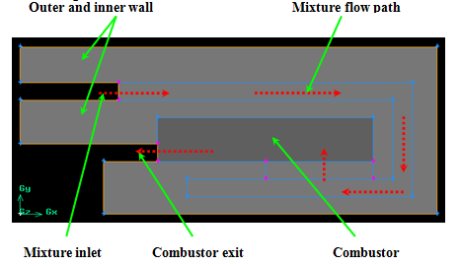

Fig.1. Schematic of half of the axisymmetric 6-wafer silicon micro combustor

As seen in Fig.1, the hydrogen/air mixture is injected through the combustor inlet to the top recirculation jacket and mixes with each other as it flows through recirculation jacket, enters the combustion chamber through a set of inlet ports along the combustor’s axial direction, reacts in the annular combustion chamber, and finally exhausts through the outlet.
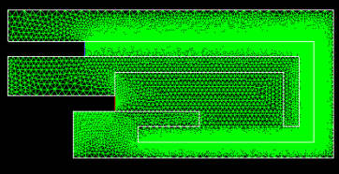
2.2 CFD modeling

Fig.2 CFD mesh for micro combustor

Fig.2 shows the meshed CFD model of the micro combustor. The CFD model comprises of the hydrogen/air flow path, combustion chamber, as well as the conjugated heat transfer model in solid engine walls. Fluent 6.0 was used to perform the numerical analyses on fluid flow, heat transfer and the chemical reactions in the micro combustor.
Distinguished from [2], CHEMKIN models in Fluent 6.0 were used to express the detailed chemical kinetics of hydrogen/air combustion. The detailed gas phase mechanism involved 19 reversible reactions and 9 species similar to those used in [2]. A double precision, segregated solution solver was utilized to solve the governing equations.
The boundary conditions for the CFD modeling were defined to match the experimental conditions reported in [3] as closely as possible. Symmetric boundary conditions were used to the two radial section model. Since the details of the compressor were not considered in this model due to the lack of the required data. Uniformly distributed temperature and velocity were assumed at the combustor inlet. For all simulations in this paper, the inlet temperature of hydrogen/air was assumed to be 300K, a fixed pressure of 1.01325 × 10⁵ Pa was specified at the combustion chamber outlet, no-slip boundary condition and no species flux normal to the wall surface were applied at the wall. The convective and radiative heat losses to the ambient at the external wall were also considered. For simplicity, constant convective heat transfer coefficient and radiative emissivity were assumed at the outer walls. Besides, the thermal conductivity of the micro-combustor wall was assumed to have a constant value at 149W/(m·K) for all the simulations in this paper.
3. Results and discussions
Because size of micro-combustion chamber is decreased to millimeter level, the surface area to volume ratio in micro-combustors becomes rather high, (.500m⁻¹), which is two orders of magnitude larger than that of a typical combustor [5]. Energy loss due to heat transfer at the walls of the micro-combustor must not be neglected, because the heat loss through the wall plays a very important role in stabilizing the combustion in the micro-chambers. The high thermal conductivity of silicon and small length scales produce low heat resistance of the wall, which enhances the effect of heat loss through the outer wall [2].
In order to study the effect of heat transfer conditions at the outer walls on the combustion in the micro combustor, 2D Computational Fluid Dynamics (CFD) simulation was employed here. Moreover, in order to compare the computing results in the paper with [2], some related parameters were chosen as follows:
;;;;
equivalence ratio equals to 0.5.
The temperature distributions of the micro combustor under the various heat transfer coefficients (a), (b) 150, (c) 250 are presented in Fig.3. The calculated results from [2] are also given in Table 1 and in Fig.4.
Table.1. Calculated temperature and efficiency for different heat transfer coefficient conditions

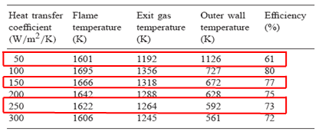

As seen from Fig.3 (b) and (c), it could draw a conclusion that the combustion could stabilize in the micro chambers, and the exit gas temperature as well as the outer wall temperature decreases correspondingly with the increase of the heat transfer coefficients at the outer wall, which are in qualitative agreement with those in [3]. Note that in literature [3], there are no related temperature distributions to compare with the results in this study. This is attributed to the fact that the ratio of heat lost to that generated scales with the hydraulic diameter:
(1)
The hydraulic diameter of a micro combustor is on the order of millimeters, hundreds of times smaller than that of a typical combustor. So, the ratio of the heat lost to that generated may be as much as two orders of magnitude greater than that of a large-scale combustor. The effect of this large surface heat loss on homogeneous gas phase combustion is twofold. First, it has a direct impact on overall combustor efficiency. Also it could increase kinetic times and narrow flammability limits by lowering reaction temperatures. This can exacerbate the constrains of short residence time, consequently dropping the effective Damkohler number. Furthermore, the structure fabricated for the micro combustor is etched from silicon, which has a high thermal conductivity. This combined with the short heat conduction paths at the micro scale leads to Biot number much less than unity (of order 0.01) and the structures tend to be isothermal. Therefore, the heat generated is more likely to be conducted away through the structure than transferred through a thermal boundary layer to the bulk flow. This can further reduce power density.
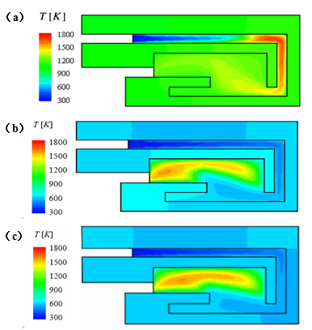

Fig.3.Temperature distributions on the micro combustor with different heat transfer coefficients: (a) 50, (b) 150, and (c) 250W/(m²·k).

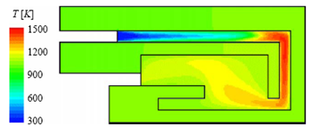

Fig.4 Temperature distribution on the cross section of the micro combustor at heat transfer coefficient = 50W (m²·k)[2]

Comparing the temperature distribution in Fig. 3(a) with the results from [2] in Fig.4, it could be seen that when the heat transfer coefficient at the outer wall equals to 50 w/m²K, the flame front propagates to the upstream of the fuel/air mixture flow, and burns in the recirculation jacket, resulting in the wall temperature near the fame reaches as high as 1200K. Therefore, it is believed that the simulation results in this study are correct.
However, between Fig. 3(a) and Fig.4 there exist some minor differences, in particular, on the magnitude of the temperature and its distribution of the flame burning in the recirculation jacket. This may be due to the distinct approach from [2] was used in this study to express the detailed chemical kinetics of hydrogen/air combustion. The authors in [2] used the program DETCHEM, which did not have all the details of chemical kinetics required for the study, while CHEMKIN model in Fluent 6.0 has the ability in expressing all the detailed chemical kinetics of the mixture combustion. Also, there exists insufficient data on some geometric dimensions when constructing the CFD model structure of the micro combustor, even though some assumptions were made based on [2]. These simplified assumptions may have some impacts on the final simulation results.
It is worth paying special attention to Fig. 3(a), where the upstream burning was observed. Due to the high thermal conductivity of the silicon, the heat transfer through the outside wall plays significant role in heat removal from the micro combustor. When the heat transfer coefficient is too low, as in this case (50 w/m²K), insufficient heat can be removed from the outside environment. This causes the temperature at the combustor wall to increase significantly. The cold incoming reactants could be heated up in the recirculation jacket, and may burn in upstream of the recirculation jacket if their temperatures exceed the mixture ignition temperature, e.g. 858K. The combustion in recirculation jacket not only compromises the insulating properties of the jacket, but also has the possibility to damage the device [2-4]. It was reported in [4] that the fracture toughness of single crystal silicon was found to be temperature independent below BDTT, and that, if the temperature is higher than BDTT, the material behavior of silicon becomes increasingly nonlinearly elastic and then ductile. For example, its yield strength is reduced to less than 50 MPa as the temperature approaches 1200K [4]. Therefore, the operation of micro combustor should be avoided if the heat transfer rate of the outer wall is too low.
4. Structural analysis
In order to further investigate the behavior of the micro-combustor under the various heat transfer coefficients when the flow rate and the equivalence ratio of the hydrogen/air mixture are constant, it is essential to perform the structural analysis on the micro combustor, especially when the heat loss through the outer wall is sufficiently low. The micro combustor is etched from single crystal silicon using MEMS fabrication technique. Currently, the fracture strength of silicon under the room temperature is reported to be extremely sensitive to the surface processing method [4, 7-8] and there are several fabrication issues that have to be resolved before multilayered structures can be successfully built [7]. All of these have a great effect on the structural strength of the micro combustor. Moreover, the order of magnitude of thermal stresses can be as high as the available material yield strength if the structural temperature and temperature gradient are sufficiently high. Therefore, 3D finite Element Analysis Method based on commercial software COSMOS\Soildworks is utilized to explore the thermo-mechanical issues on the structural design of the micro-combustor in this study.
4.1 Analysis on fabrication process of the micro combustor
The fabrication of the combustor required ten deep dry anisotropic etches and two shallow etches, in which a total of 13 masks were needed including one global alignment mask. The process consisted of deep reactive ion etching, photolithography and aligned fusion bonding [6]. Currently, during constructing the multi-layered structures there exist several bonding issues to resolve [7]; they are ① surface contamination issues, ②stiffness related issues (increased stiffness), ③ bonding tool effects, and ④defect propagation. Among them, items ①, ② and ③ are considered to be more serious.
For ①, although it is possible to successfully bond several prime silicon wafers, the same task can be difficult to achieve with processed wafers because of the presence of residual films on which the surfaces to be bonded are contaminated (see Figure 5).
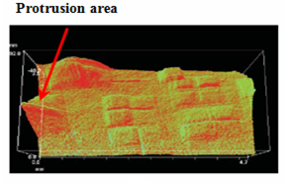
For②, multi-stack bonding becomes increasingly difficult when thick wafers or previously bonded stacks are used as a result of bow and warpage. The failing interface is located between wafer 3 and wafer 4 in the experiment because of the large stiffness.
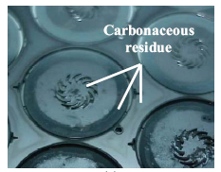

Fig.5.Carbonaceous residue observed on some surface after DRIE
Fig.6.Surface image of the propagated defects.

For item ③, the presence of particulates on surfaces to be bonded as well as the appearance of protrusions that locally distort a wafer surface can have a deleterious effect on yield or preclude additional bonds. A postmortem analysis indicated that the source of the defects was located at the interface between wafers 3 and 4, and the defects created protrusions on the surface of the fourth wafer that was to be bonded to the subsequent fifth wafer (see Fig.6).
4.2 Analysis on the structure of the micro combustor
As depicted above, when the heat loss through the outer wall is sufficiently low, the flame front could propagate to the upstream of the fuel/air mixture flow, burns in the recirculation jacket, and causes the wall temperature near the flame to be as high as 1200K. This may further enhance the bow and warpage effect on the wafers, especially between wafer 3, 4 and 5. Before performing the structural analysis on the micro-combustor, three important assumptions are made to make the problem tractable [5- 8]. Some discussions about these assumptions are listed as follows:
●Neglect the high-temperature oxidation results of silicon
It has been proven that the “active-oxidation” of silicon is not an overriding concern for this particular application. A careful examination of the results obtained from the experiment indicates that the structure of the micro combustor remains intact even after exposure to a combustion environment for over 8 hours at atmospheric pressures and flow temperatures in excess of 2000 K. So, it is reasonable to neglect the high-temperature oxidation results of silicon when performing the structural analysis on the micro combustor.
● Ignore residual stress from the fabrication process of the micro combustor
Numerical simulation results have shown that thermal stress is more influential on fatigue life although its value is smaller than residual stress. However, there exist insufficient data on the residual stress in the fabrication process. The effect of residual stresses is therefore inconclusive.
● Emphasize the creep result of silicon due to the high temperature above BDTT
Creep failure has been proved to be the primary failure mode for silicon in high temperature micro combustor environments.
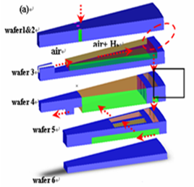
Therefore, this study focuses on thermal stress and strain analysis on the structure at high temperatures.

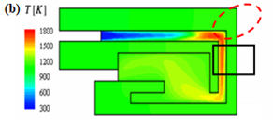

Figure.7. (a) Flow of the mixture in an exploded view, (b) temperature distribution on the micro combustor with the flame burning in the recirculation jacket.

As illustrated in Fig. 7, the creep failures may occur at the two locations of the micro-combustor when the flame is burning in the recirculation jacket. The first one is located at the junction of wafers 1, 2, and 3(see the red dashed ellipse), because there are sharp angles that the stress could be congregated enough to promote creep failure easily due to the impact of large periodic thermal power input. The other lies at the junction of wafers 3 and 4. It was observed in the experiment that the defects were located at the interface between wafers 3 and 4 (see the black rectangle), and they created protrusions on the surface of the fourth wafer that was to be bonded to the subsequent fifth wafer (see Fig.6). Under the impact of the large periodic thermal power inputs, the protrusions on the wafer 4 may become larger than before, which may consequently result in a poor bonding strength and causes the failure.
4.1 Finite element analysis on wafers 1, 2, and 3
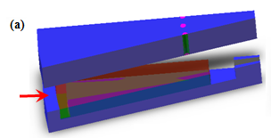
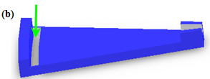

Figure.8. (a) Schematic of wafers1&2&3, (b)
schematic of wafer 3.

Having carefully analyzed Fig. 8 and the fabrication process of the micro-combustor, we found out that the failure location at the junction of wafers 1, 2, and 3 was actually at the bonded position between the tail of wafer 3 and wafers 1 and 2 (see the red arrowhead in Fig. 8). This can be explained as follows: bow and warpage may occur at this location due to stress concentration in the process of fabrication, and the high temperature, 1700～1800K in the recirculation jacket and 1000～1200K on the outer wall. Therefore, a FEM analysis was preformed on the tail of wafer 3 (see (b) in Fig.8), where the green arrowhead indicated the flow direction of the mixture.
The grid convergence test showed grid size of11302 nodes and 6526 elements yielded the reliable results. The material used here was single crystal silicon, whose physical properties are [5]:
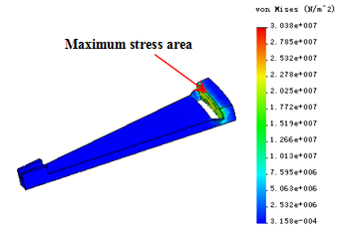
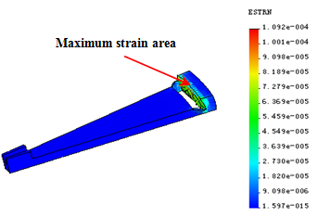
; ; ; ; ; ;.

Figure.9 Thermal stress distribution in the wafer 3
Figure.10 Thermal strain distribution in the wafer 3

It can be seen from Fig.9 that the peak stress occurs at the junction of wafers 1, 2 and 3, namely the bonded location of wafers 1, 2 and 3. The maximum stress is found to be at 30.38MPa. At the same location there exists the maximum strain, which equals to (see Fig. 10). The highest thermal stress as well as the maximum thermal strain may have a deleterious effect on the bonded location between wafers 1, 2 and 3. Consequently, under the combined effects of the congregated stress, the poor bonding, the highest thermal stress and the maximum thermal strain, the failure may occur at the junction of wafers 1, 2 and 3 during the combustion processes in the micro-combustor.
4.2 Finite element analysis on wafers 3 and 4
Similarly, as a result of the poor bonding in the process of fabrication and the high temperature from the flame burning in the recirculation jacket, the failure location at the junction of wafers 3 and 4 is also believed to lie at the bonded position between the tail of wafer 4 and wafers 1, 2 and 3(see the yellow arrowhead in Fig.11). A FEM analysis is carried out on the tail of wafer 4 (see (b) in Fig.11), where the red arrowhead indicates the flow direction of the mixture.
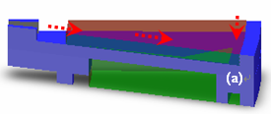
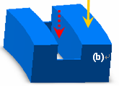

Fig.11. Schematic of (a) wafers 3 and 4, (b) the tail of wafer 4.

A total of 10568 nodes and 6401 elements were used in this case study after performing grid convergence test.
From Fig. 12, it can be seen that the peak stress occurs at the junction of wafers 3 and 4, and the maximum stress of its outer fringe is 29.98MPa. Similarly, at the same location there exists the maximum strain, which equals to (see Fig.13). This reveals that the bow and warpage due to high temperature occur at the bonded locations. Therefore, it is considered that the high thermal stress and strain could further enhance the bow and warpage from the fabrication process, making the protrusions on the surface of the fourth wafer（see Fig.6）become larger than before. Consequently, this may significantly decrease the bonding strength in the fifth wafer, and result in combustion chamber failure.
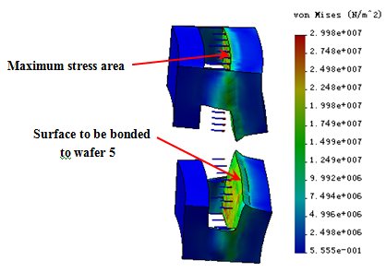
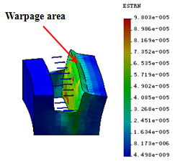

Fig.12. Thermal stress distribution on the tail of wafer 4
Fig.13.Thermal strain distribution on the tail of wafer 4

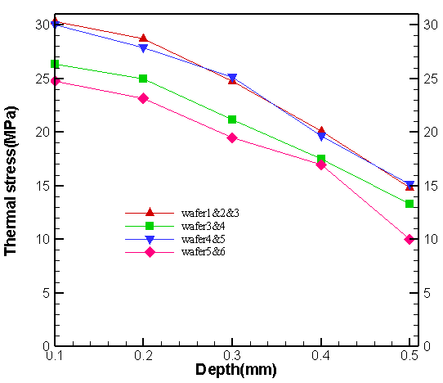

Fig.14. Thermal stress distribution on the
junctions of wafers

In order to further verify the deleterious effect resulting from wafers1, 2 and 3 as well as wafers 4 and 5 during the combustion processes, other junctions of wafers in the combustor, e.g. the junction between wafer 4 and 5, the junction between 5 and 6, were also simulated by FEA. The results are illustrated in Fig.16, where depth denotes the distance measured from the inner wall toward the outer wall. The depth simulated is up to 0.5 mm.
From Fig.14, it could be inferred that the thermal stresses on either wafers 1&2&3 or wafers 4&5 are much higher than the ones on wafers 3&4 and wafers 5&6, and that the thermal stresses decreases when the depth approaches to the fringe of the outer wall.
It is worth noting that the thermal stresses (30.38 MPa and 29.98MPa) calculated in this study are comparable to the available strength (~50MPa) at the current level of temperature (>1200K). Since the data on the residual stresses in the fabrication process of the micro-combustor are insufficient, precise numerical results on the junctions of wafers are unable to obtain. However, considering the fact that residual stresses are higher than thermal stresses [8], and that the residual stresses are neglected here, the real total stresses must be much higher than the calculated stresses due to the high temperature. Some experimental results have shown [10, 11] that the residual stresses on a 300µm thick silicon substrate (12 μm thick oxide film) vary from -40 to 50MPa during a 500℃ thermal cycle. Therefore, under the combined impacts of the congregated stress, the poor bonding, the high thermal stress and the residual stresses, the bonding junctions of wafers 1&2&3 as well as wafers 4 & 5 could be weakened so much that fatigue failure may occur.
5．Conclusion
Under different heat transfer conditions at the outer walls, the 2D CFD based numerical simulation results show that the flame could be sustained in the micro combustor if the heat transfer coefficients are sufficiently low. This can cause the combustor wall temperature higher than the auto ignition temperature of reactants. The results obtained in this study are in agreement with those in the relevant literature. Since very high temperature of the outer wall possibly damages the device due to the upstream burning, optimizing the heat transfer coefficient on the outer wall is a most effective approach to manage the combustor wall temperature.
For a silicon six-wafer micro-combustor, the thermal stress may be a significant design restriction in the stationary structure due to the higher temperature (and lower strength). Thus, thermo-mechanical analysis on static structure is required to provide the information on the overall micro-combustor engine redesign.
Based on the CFD simulated temperature distribution on the micro-combustor, 3D FEM method is utilized to explore the structural design of the micro combustor. The results indicate that the thermal stress due to very high temperature may further weaken the strength of bonding and accelerate the failure of the combustor. The results from this study can be used to define geometric parameters for optimal design of the micro combustor.
6. Acknowledgments
Dr. Zhu Lin would like to thank the financial support for the project from the Chinese National Foundation (50721140651), Anhui Province National Foundation (KJ2009B004Z). Dr. Tien-Chien Jen would also like to acknowledge the partial financial support from EPA (RD833357) and Research Growth Initiative II from University of Wisconsin, Milwaukee.
7. References
[1] Alan H. Epstein, Millimeter-scale, MEMS gas turbine engines. Proceedings of ASME Turbo Expo 2003 Power for Land, Sea, and Air , pp. 16~19, Atlanta, Georgia, USA, (6)2003.
[2] Jin Song Hua, Meng Wu, and Kurichi Kumar, Numerical simulation of the combustion of hydrogen air mixture in micro-scaled chambers Part II: CFD analysis for a micro-combustor. Chemical Engineering Science 60，pp.3507～3515, 2005.
[3] Amit Mehra, Development of a high power density combustion system for a silicon micro gas turbine engine, Ph.D.Thesis, Massachusetts Institute of Technology, Cambridge, MA, February 2000.
[4] Kuoshen Chen, Materials characterization and structural design of ceramic micro turbo machinery, Ph.D.Thesis,Massachusetts Institute of Technology, Cambridge, MA, February 1999.
[5] Spadaccini,C. Medit, Lee, Jin, and Zhang, Xin, High power density silicon combustion system for micro gas turbine engines. Journal of Engineering for Gas Turbines and Power 125, pp.709～719, 2003.
[6] Ni Miki and Xin Zhang, Multi-stack silicon-direct wafer bonding for 3D MEMS manufacturing, Sensors and Actuators A vol.103,pp. 194~201, 2003.
[7]Amit Mehra and Arturo A. Ayon,Microfabrication of high temperature silicon devices using wafer bonding and deep reactive ion etching, IEEE Journal of Microelectromechanical Systems, Vol. 8, No. 2,(3),pp. 152~160, 1999.
[8] Junhyub Park and Hyeon-Chang Choi, FEM analysis of multilayered MEMS device under thermal and residual stress. Journal of Microsystem Technology ,Vol.11, pp. 925~933, 2005.
[9]Emit H. Klaasen, Kint Petersen, and Jite M. Noworolskil, Silicon fusion bonding and deep reactive ion etching: A new technology for microstructures. Sensors and Actuators A vol. 52, pp. 132～139, 1996.
[10]Xin Zhang, Rin Ghodssi, and Kuoshen Chen, Residual stress characterization of thick PECVD TEOS Film for Power MEMS Applications. Solid-State Sensor and Actuator Workshop, Hilton Head Island, South Carolina, pp.316~319, 2000.
[11] Xin Zhang and Kuoshen Chen, Residual stress and fracture of thick dielectric films for Power MEMS Applications. IEEE Journal of Microelectromechanical Systems, Vol.11, No.1, (6), pp. 164~167, 2002.

