Sea grass like arranged TiO₂ nanorods sensitized by natural dyes for solar cell applications

Akila Yuvapragasam^{1*}, Muthukumarasamy.N¹, Agilan.S¹, S.Senthilarasu² Dhayalan Velauthapillai³
^{1, 2, 3} Department of Physics, Coimbatore Institute of Technology, Coimbatore, Tamilnadu, India. E.mail: akilayuva@gmail.com, vishnukutty2002@yahoo.co.in, santhanam.agilan@gmail.com.
²Environment and Sustainability Institute, University of Exeter, Penryn, Cornwall TR10 9FE United Kingdom
³Faculty of Engineering and Business Administration, Bergen University College, Bergen, Norway
ABSTRACT
Rutile phase sea grass like arranged TiO₂ nanorods have been synthesized by low temperature template free hydrothermal method. These TiO₂ nanorods have been sensitized by flowers of Sesbania grandiflora, leaves of Camellia sinensis and roots of Rubia tinctorum. The sensitized TiO₂ nanorods based films have been used as photoanode in natural dye sensitized solar cells. The films were photoelectrochemically active and the fabricated solar cells had short circuit photocurrent densitiy(J_{SC}) lying in the range of 3.7mAcm⁻² to 4.7mAcm⁻². The efficiency of the fabricated natural dye sensitized solar cells were found to lie in the range of 0.6% to 1.036% respectively.
Keywords:
Hydrothermal method, TiO₂ nanorods, Natural dyes, Dye sensitized solar cell.

GRAPHICAL ABSTRACT
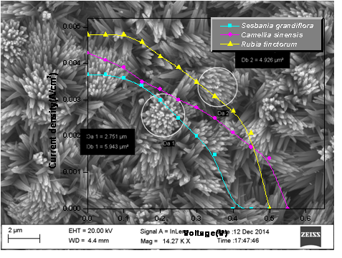
1. Introduction
Solar energy is considered to be the ultimate solution to the energy crisis. The conversion from solar energy to electricity is fulfilled by solar-cell devices based on the photovoltaic effect. Many photovoltaic devices have already been developed over the past five decades [1–3]. However, wide-spread use is still limited by two significant challenges, namely conversion efficiency and cost. In principle, the single-crystalline silicon semiconductor can reach 92% of the theoretical attainable energy conversion, with 20% conversion efficiency in commercial designs. However, because of the considerably high material cost, thin-film solar cells have been developed to address the product costs [4, 5]. Today, commercial roof products are available that operate at ~15% efficiency. Bridging the gap between single-crystalline silicon and amorphous silicon is the polycrystalline silicon film, for which a conversion efficiency of around 18% is obtained [6].
Compound semiconductors, such as gallium arsenide (GaAs), cadmium telluride (CdTe), and copper indium gallium selenide (CIGS), have received much attention because they have direct energy gap, can be doped to either p-type or n-type, have band gaps matching the solar spectrum, and have high optical absorbance[7–9]. Although the photovoltaic devices built using silicon or compound semiconductors have high efficiency for practical use, they still require major breakthroughs to meet the long-term goal of cost reduction. With an aim to further reduce the production cost, dye sensitized solar cells based on oxide semiconductors and organic dyes or metal organic-complex dyes have recently emerged as a promising approach to achieve efficient solar-energy conversion. The dye sensitized solar cell is a photo-electrochemical system, which has a porous-structured oxide film with adsorbed dye molecules as the photosensitized anode. A platinized fluorine-doped tin oxide (FTO) glass acts as the counter electrode (i.e., cathode), and a liquid electrolyte that traditionally contains I⁻/I³⁻ redox couple serves as a conductor to electrically connect two electrodes. Compared with the conventional single crystal silicon-based or compound-semiconductor thin-film solar cells, dye sensitized solar cells are thought to be advantageous as a photovoltaic device possessing both high efficiency and cost effectiveness.
The achievement of acceptable conversion efficiency puts great confidence in the ability of dye sensitized solar cells to challenge the high cost of commercially available solar cells based on silicon or compound semiconductors. Dye sensitized solar cell technology based on ZnO has been explored extensively. ZnO is a wide-band-gap semiconductor that possesses an energy-band structure and physical properties similar to those of TiO₂.The conversion efficiency of 0.4–5.8% obtained for ZnO are much lower than that of 11% for TiO₂ [10]. It is also important to mention that semiconductor TiO₂ still gives the highest efficiency of the many other metal oxide systems which have been tested, such as ZnO, SnO₂, and Nb₂O₅. Besides these simple oxides, ternary oxides, such as SrTiO₃ and Zn₂SnO₄, have also been investigated, as well as core-shell structures, like ZnO-coated SnO₂ have also been studied. TiO₂ is a stable, nontoxic oxide, which has a high refractive index (n = 2.4-2.5) and is widely used as a white pigment in paint, toothpaste, sunscreen, self-cleaning materials and food (E171). Several crystal forms of TiO₂ occur naturally: rutile, anatase and brookite. Rutile is the thermodynamically most stable form.
The morphology of the TiO₂ film used strongly affects the dye sensitized solar cell performance since the electron recombination rate is influenced by it. The photo-sensitizer plays an important role in determining the overall conversion efficiency of a dye sensitized solar cell. Some of the requirements of the dye molecule to serve as a photo-sensitizer are: strong absorption in the visible region and near infrared region, it must carry carboxylate or phosphonate attachment groups to bind strongly with the semiconductor surface, capable of injecting the electrons upon excitation, it should be more stable in order to withstand many oxidation and reduction cycles without undergoing any degradation and it should be cost effective in nature [11, 12].
Natural dyes are considered as a viable alternative to the synthetic ones because of the advantages such as easy preparation, inexpensive nature, eco friendly nature, biodegradable nature and wide availability. Different parts of the plant have been used as photo-sensitizer over the last two decades. The pigments responsible for producing colour in plants are classified as chlorophylls, carotenoids, flavonoids, and betalains. Some of the conversion efficiencies of natural dye sensitized solar cells reported by researchers are given in Table 1.
Table 1: Performance of DSSCs based on naturally extracted dyes [13, 14]
Natural Dye | Jsc(mA/cm²) | Voc (V) | FF | η (%) | Ref
Rosella | 1.63 | 0.404 | 0.57 | 0.37 | 13
Blue Pea | 0.37 | 0.372 | 0.33 | 0.05 | 13
Ivy gourd fruits | 0.24 | 0.644 | 0.49 | 0.076 | 14
Purple cabbage | 2.08 | 0.66 | 0.53 | 0.75 | 14
Red frangipani flowers | 0.94 | 0.495 | 0.65 | 0.301 | 14
The currently most efficient dye sensitized solar cells also called as Gratzel cells and are still slightly less efficient in comparison to standard silicon-based solar cells. But as a result of the light absorption mechanism of the pigments, they work even in low-light conditions. Therefore, dye sensitized solar cells are able to work under cloudy skies and indirect sunlight, whereas inorganic semiconductor-based photovoltaic cells would suffer a cut-off at some lower limit of illumination. Since the cut-off of dye sensitized solar cells is so low, they are even proposed for indoor use, collecting energy for small devices from the light inside buildings [15].
In the present work, we report about the chemical synthesis of TiO₂thin films using a facile and low cost hydrothermal method without using any templates. The TiO₂films were made of well-defined nanorods with compact structure covering the entire substrate. Further, the synthesized TiO₂ nanorods were sensitized using natural dyes obtained from plants. The sensitized TiO₂ films were used as working electrode in the dye sensitized solar cells and the performance of the solar cells has been studied.

2. Experimental details
2.1 Synthesis of TiO₂ nanorods
Titanium butoxide (Ti [O (CH₂)₃CH₃]₄, 97%), was purchased from Sigma -Aldrich and was used as received. TiO₂ nanorods were synthesized through a two step process. The FTO substrates were ultrasonically cleaned in acetone, ethanol and deionized water respectively for 15 min and finally dried. In hydrothermal synthesis, HCl and deionized water were taken in the ratio 1.5:1 respectively, mixed and stirred for 15 minutes. Glacial acetic acid and titanium butoxide are taken in the ratio 5:1 respectively. Glacial acetic acid is added to the above stirred mixture and stirred for 15 minutes. Now titanium butoxide is added as droplets to the above mixture and stirred for about half an hour. Now this mixture is transferred to teflon - lined stainless steel autoclave (50 ml). The autoclave containing the substrate was sealed and heated in an oven at 180° C for 4 hours. Then, the autoclave was cooled to room temperature. The substrate was finally washed with de ionized water, followed by drying in ambient air.
2.2 Extraction of natural dye sensitizers
The different dyes used to sensitize the TiO₂ film have been extracted from the Sesbania grandiflora, leaves of Camellia sinensis and roots of Rubia tinctorum. Petals of Sesbania grandiflora were removed, cleaned and dried. After drying, it was cut into small pieces and soaked in 100ml of ethanol at room temperature for 24 hours and then the solid residues were filtered out. Few drops of concentrated HCl has been added so that the solution becomes deep violet in color (pH = 1). This was directly used as dye solution for sensitizing TiO₂ electrodes.
Leaves of Camellia sinensis were cleaned and dried. After drying, it was cut into small pieces and soaked in 100 ml of acetone at room temperature for 12 hours and then the solid residues were filtered out. This was directly used as dye solution for sensitizing TiO₂ electrodes.
Rubia tinctorum L. commonly known as madder root was cut into small pieces and little amount of distilled water was added to it. The above mixture was heated to a temperature of 60°C and maintained at the same temperature for 1 hr, so that the root absorbs water and the liquid becomes reddish. The liquid with the solid residues was kept as such for 6 hours. Now the solid residues were filtered out. This was directly used as dye solution for sensitizing TiO₂ electrodes.
2.3 Adding mordant to the film
The preparation of mordant for the film has been carried out according to Akila et al., 2015 [16]. 100 mg of powdered potash alum is dissolved in little amount of hot water. To this, hot distilled water is added and left as such for 10 minutes. Now the as prepared TiO₂ sample is dipped in this hot beaker and left for 1 hour. During this period the temperature of the mordant is maintained around 80°C.
Now the TiO₂ films with mordant is dipped into the beakers containing the dye extracted from the flowers of Sesbania grandiflora, for obtaining Sesbania grandiflora sensitized film, the leaves of Camellia sinensis for obtaining Camellia sinensis sensitized film and the madder root dye extract for obtaining madder root dye sensitized film respectively. The TiO₂ electrode immersed in the extracted dye solution at room temperature in the dark for 12 hours forms the dye sensitized TiO₂ photo electrode.
2.4 DSSC assembly
The dye sensitized TiO₂ photo electrode acts as the working electrode. The platinized FTO glass used as counter electrode was placed on the top of the dye sensitized TiO₂ photo anode and sealed with a 30-mm thick thermal adhesive film. The electrolyte solution [0.6 M tetrapropylammonium iodide, 0.1 M iodine, 0.1 M lithium iodide, 0.5 M 4-tert-butylpyridine (TBP) in 3- ethoxpropiponitrile] was filled into the space between the photo electrode and the counter electrode through a hole made on the counter electrode using capillary action. The hole was closed using the adhesive film. The active area of the cell was 0. 5 cm².
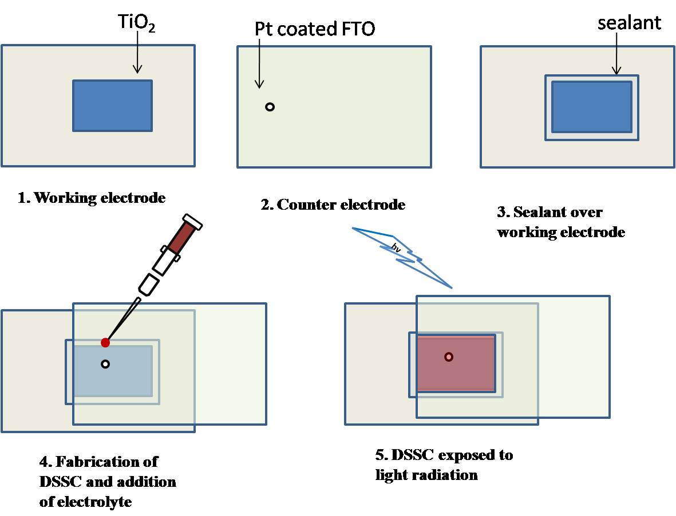
Figure 1. Schematic diagram of assembly and fabrication of DSSC
2.3 Characterization
The structural properties of the prepared samples have been studied using a X-ray diffractometer (RigakuRint 2000 series). The surface morphology was studied using field-emission scanning electron microscope (FE-SEM, ZEISS, SIGMA, UK). The high-resolution transmission electron microscope images of the films have been recorded using a JEOL, JEM-2100 microscope. The transmittance spectra of the films have been recorded using spectrophotometer (Jasco V-570). The thicknesses of the films were measured using surface profileometer. The IV curves of dye sensitized solar cells were obtained using a Keithley 2400 digital source meter under an irradiation of 100mW/cm².
3. Results and discussions
The FESEM images of the prepared TiO₂ films are shown in Figure 2. From the images it is clear that the rods look like sea grass. Fig. 1a shows the arrangement of nanorods. The nanorods are found to be grouped together forming bunches. The diameter of the bunch was in the range of 2 -2.75 µm. Figure 2 (b - d) shows the average length and breadth of sea grass like arranged TiO₂ nanorods. The length of TiO₂ nanorods were found to be in the range of 1.79 – 4.4 µm whereas its breadth is in the range 180.9 – 412.5 nm.
The morphology and crystalline phase of the prepared TiO₂ films strongly depends on the hydrochloric acid concentration. The crystalline phase is closely related to the morphology of TiO₂ nanostructure. HCl is indispensable for the hydrothermal synthesis of rutile TiO₂ nanorod arrays because titanium alkoxides are very reactive with water; so, HCl is used for controlling the TiO₂ hydrolysis and nucleation rates. Glacial acetic acid is used as stabilizing agent against hydrolysis. Glacial acetic acid modifies the co-ordination sphere of titania and makes it more stable against hydrolysis. Ti⁴⁺ moiety owing to its extremely high reactivity with water requires a pre-stabilization against hydrolysis. Therefore glacial acetic acid was used as a stabilizing /catalyzing agent. Titanium butoxide stabilized with acetic acid usually follows a condensation pattern producing linear chains that result in high surface area. The reaction starts with the addition of titanium butoxide to glacial acetic acid. Glacial acetic acid modifies the coordination sphere of titanium to a more stable state. According to Wang et al [17], the added acetic acid is consumed to modify the titanium precursor by replacing the isopropoxyl with an acetate ion, and the hydrolysis rate of the titanium precursor is modulated by the ligand exchange reaction. In a 1:2 solution of HCl: CH₃COOH, the titanium precursor is replaced by titanium acetate by ligand exchange with the help of the strongly acidic HCl. Afterwards, the 1 - D TiO₂ nanorods start to grow preferentially on the entire FTO substrate and are aligned in an array towards a direction perpendicular to the substrate surface[18]. This observation indicates that adding acetic acid to the HCl solution led to the formation of more aligned TiO₂nanorods in the c - axis direction against the FTO substrate.
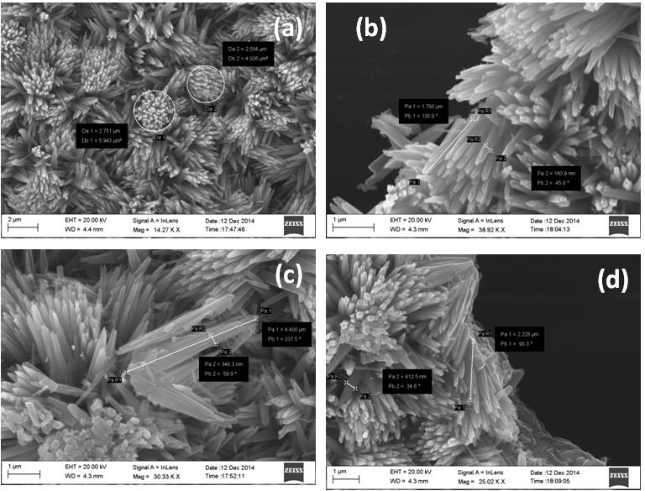
Figure 2. FESEM images of TiO₂ nanorods synthesized by hydrothermal method
The X - ray diffraction pattern of the prepared TiO₂ film is shown in Figure 3. The diffraction pattern has peaks corresponding to the (110), (101), (200), (111), (210), (211) and (220) planes of rutile phase of TiO₂. The peak positions clearly indicate that the prepared samples are of rutile phase. No peak corresponding to anatase or brookite phase has been observed in the diffraction pattern.

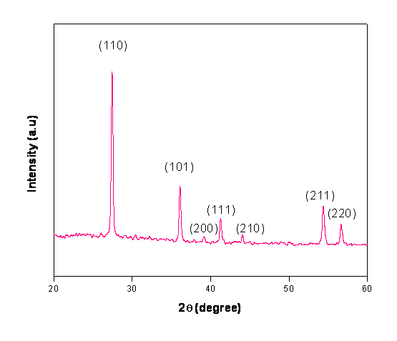
Figure 3. X-ray diffraction pattern of TiO₂nanoords grown by hydrothermal method
The TEM images of the TiO₂ nanorods are shown in Figure 4. It is observed that the nanorods have grown in a unique manner without any clusters. The rods shown in the TEM images appear like herbaceous stem grown smoothly without any imperfection on its surface. The addition of glacial acetic acid to the precursor stabilizes the hydrolysis of titanium butoxide and prevents the synthesized TiO₂ nanorods from being etched leading to the formation of single nanorods than clusters since the precursor solution is acidic.
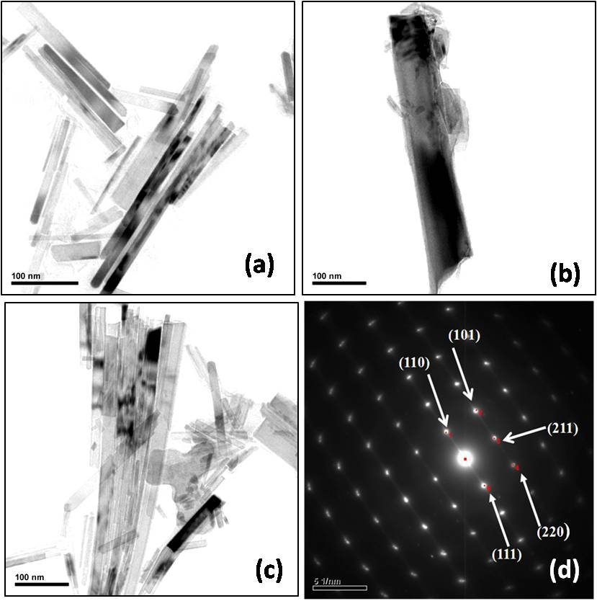
Figure 4. TEM images and SAED pattern of TiO₂ film
The SAED pattern of the film is shown in the Figure 4. The pattern shows the presence of spots. The distribution of spots in the image clearly shows that the aligned nanorods are single crystalline TiO₂ nanorods with rutile structure. The planes identified using the spots in the SAED pattern agree well with the results of the X-ray diffraction pattern.

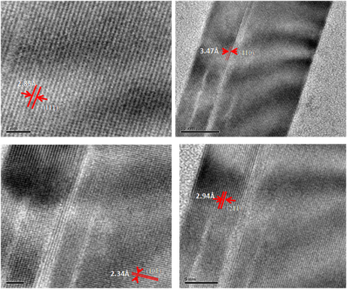
Figure. 5 HRTEM images of TiO₂ film
The HRTEM image of the TiO₂ film is shown in Figure 5. The image shows lattice fringes and the fringes exhibit a lattice d - spacing of 2.85 Å, 2.34 Å, 3.47 Å and 2.94 Å which corresponds to the (111), (101), (110) and (211) planes of rutile TiO₂. The HRTEM image clearly shows that TiO₂ nanorods with rutile phase are formed. The prepared TiO₂ films have been sensitized using natural dyes and used as photo electrode in solar cell. It is likely that the high nanorod density will result in reduced effective surface area and thus weak dye absorption [19]. In order to make the TiO₂ film to absorb more dye, the film is treated with mordant. The mordant links to specific functional groups of the dye molecule by covalent and coordination bonds and the pigments are precipitated as in-soluble metal dye complexes in alkaline solution [20]. The prepared TiO₂ films treated using mordant has been sensitized using the dyes extracted from flowers, leaves and roots. The sea grass like arranged TiO₂ nanorods based thin films were kept immersed in the dye solution in the dark. The dye gets adsorbed into the TiO₂ film which is clearly observed by the change of colour of the film and these results in sensitization of TiO₂ films.
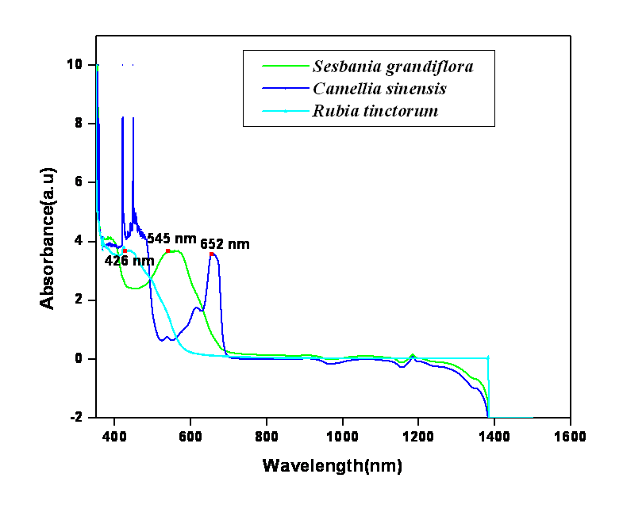
Figure 6. Absorbance of dye solutions extracted from the flowers of Sesbania grandiflora, leaves of Camellia sinensis and roots of Rubia tinctorum
The Figure 6 shows the absorption spectra of natural dyes extracted from the flowers of Sesbania grandiflora, leaves of Camellia sinensis and roots of Rubia tinctorum. The absorbance of Sesbania grandiflora, Camellia sinensis and Rubia tinctorum dye lies at 545nm, 652 nm, 426 nm respectively.

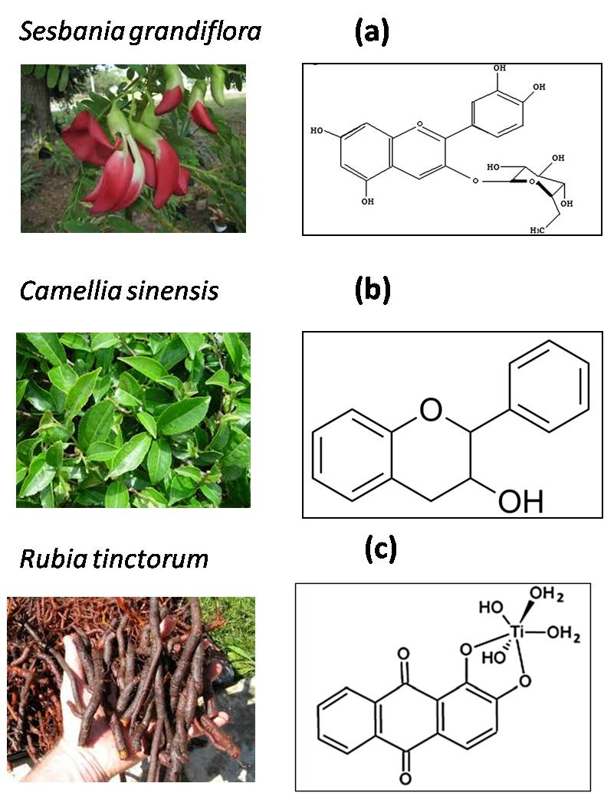
Figure 7. (a) Structure of the cyanidin 3-O-glucoside (b) structure of Flavan - 3 –ol (c) chelation of Alizarin with TiO₂
Flowers of Sesbania grandiflora contain several anthocyanins having different substituents and functional groups. Sesbania grandiflora anthocyanins are mostly in the form of glycosides and they have sugar molecules chemically attached to them. The acyl groups can contribute greatly to color stability. The compounds in the flowers of Sesbania grandiflora are essentially cyanidin glucosides and molecules derived from them. They are cyanidin-3-glucoside, cyanidin- 3,5-diglucoside, and several others (mainly cyanidin- 3-(sinapoyl) diglucoside). The chemical structure of the cyanidin-3-(sinapoyl) diglucoside-5-glucoside present in Sesbania grandiflora is shown in Figure 7a. It is generally accepted that the chemical adsorption of the dye takes place due to condensation of alcoholic - bound protons with the hydroxyl groups in the surface of nanostructured TiO₂. Therefore, this chemical attachment affects the energy levels of the highest occupied molecular level (HOMO) and the lowest unoccupied molecular level (LUMO) of these pigments which eventually affects the band gap of these materials and introduces a shift in the peak of the absorption spectra [21].
Tea leaf (Camellia sinensis) contains very large amount of polyphenols, which is the most specific feature of tea. The main flavonoids found in tea are flavan- 3-ols, accounting for more than 90% of the total flavonoid content in tea, the remaining flavonoids are flavonols [22]. The structure of flavan -3 -ol is shown in Figure 7b. Tennakone et al. [23] have investigated the use of tannins and related phenolic substances extracted from black tea, nuts or pomegranate bark, as well as the photosensitization promoted by anthocyanin extracted from leaves [24]. Flavonoids are good chelating agents towards metal ions and, in the case of iron and copper, the favoured places of chelation are catechol groups, hydroxyl groups adjacent to oxo groups, and 1-oxo-3-hydroxyl-containing moieties [25, 26].
The leading example of anthraquinone derivative used as a dye is alizarin, known as Turkish red or Mordant Red 11. Alizarin naturally occurs in the roots of the madder plant (Rubia tinctorum). Alizarin is a good photosensitizer and arouses great interest as a modifier in dye sensitized solar cells. Alizarin forms a strong chelate with titanium dioxide nanoparticles apparently involving the 1, 2 hydroxyl groups. On the other hand, this molecule bears two redox-active quinoid fragments, the 9, 10-dioxo and the 1, 2-catechol-like fragment which may act as electron acceptor and electron-donor groups, respectively. It has been recently shown that these properties are necessary to account for the development of anodic and cathodic photocurrents under visible irradiation [27]. Chelation of alizarin with TiO₂ is shown in Figure 7c. The anthraquinone family offers a wide range of excited state properties that can modulate the photoelectron chemistry of a hybrid system with preserved (in most cases) photosensitizer-semiconductor binding mode [28].
3.1 Performance of Dye Sensitized Solar Cells
The J–V characteristic of the cell was recorded using a Keithley2400 digital source meter. A xenon lamp source (Oriel, USA) with an irradiance of 100 mW/cm² was used to illuminate the solar cell (equivalent to AM1.5 irradiation).The solar cell parameters fill factor (FF) and efficiency (η) have been calculated using the following equations [29]
FF = (J_{m}V_{m})/(J_{sc}V_{oc})
η = ((FF x J_{sc} x V_{oc})/ P_{in}) x 100
where J_{sc} is the short circuit photocurrent density (mA cm⁻²), V_{oc} the open circuit voltage (volts), P_{in} is the intensity of the incident light (Wcm⁻²) and J_{m} (mA cm⁻²) and V_{m} (volts) are the maximum current density and voltage in the J-V curve, respectively at point of maximum power output.

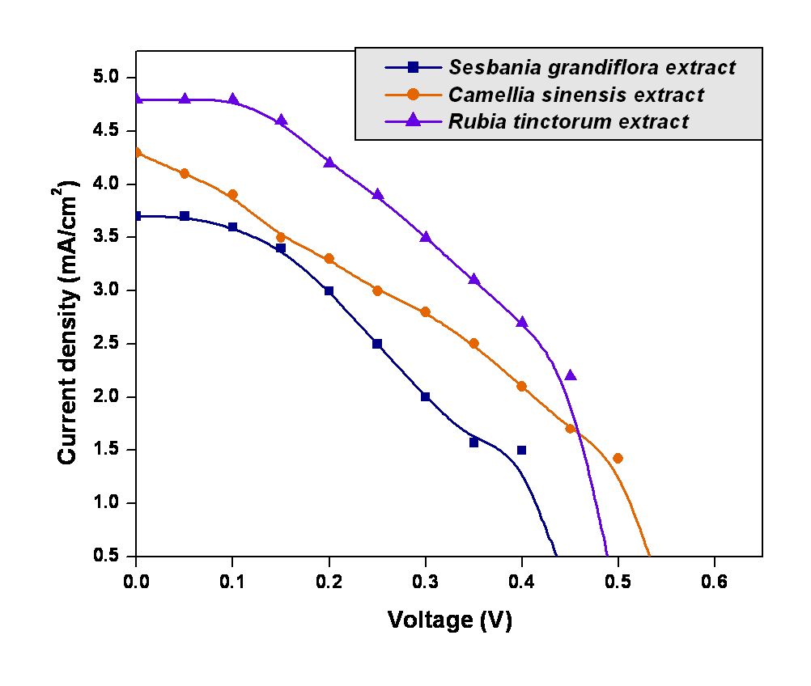
Figure 8. J - V characteristics of TiO₂ based solar cells sensitized by natural dyes extracted from flowers of Sesbania grandiflora, leaves of Camellia sinensis and roots of Rubia tinctorum.
Figure 8 shows the J - V characteristics of TiO₂ based solar cells sensitized by natural dyes extracted from flowers of Sesbania grandiflora, leaves of Camellia sinensis and roots of Rubia tinctorum. The photo electrochemical activity is dependent on the morphology of the photo anode, therefore morphology control of TiO₂ is supposed to be an effective way to improve the DSSCs performance [30]. The solar cell fabricated using TiO₂ sensitized with the flowers of Sesbania grandiflora dye extract exhibited a power conversion efficiency of 0.6 % with a short circuit current density (Jsc) of 3.7 mA/cm², open circuit voltage (Voc) of 0.43 V and fill factor (FF) of 0.377. The power conversion efficiency exhibited by the solar cell fabricated using TiO₂ sensitized by leaves of Camellia sinensis and roots of Rubia tinctorum are 0.86% and 1.036% respectively.
Table 2: Solar cell parameters of the fabricated TiO₂ based solar cells.
Dye sensitized solar cells | V_{OC} (V) | J_{SC} (mA/cm²) | FF | Efficiency (%)
Sesbania grandiflora | 0.43 | 3.7 | 0.377 | 0.6
Camellia sinensis | 0.53 | 4.3 | 0.379 | 0.86
Rubia tinctorum | 0.48 | 4.7 | 0.459 | 1.036
The solar cell parameters of the fabricated natural dye sensitized solar cells are given in Table 2. The short circuit current density, fill factor, open circuit voltage and the efficiency obtained by the TiO₂ based solar cell sensitized by leaves of Camellia sinensis were found to be 4.3mA/cm², 0.379, 0.53V and 0.86% respectively. The solar cell parameters obtained by the TiO₂ based solar cell sensitized by the leaves of Camellia sinensis are found to be better than the solar cell parameters reported by Gokilamani et al. [31]. The efficiency obtained by the TiO₂ based solar cell sensitized by roots of Rubia tinctorum shows comparatively high efficiency of 1.036% with a short circuit current density of 4.7mA/cm² and fill factor of 0.459. Additional research about better anchoring of dye to the TiO₂ film will definitely pave way for the use of natural dye as sensitizer for solar cells.
4. Conclusion
Sea grass like arranged TiO₂ nanorods have been synthesized by hydrothermal method. FESEM and TEM images show the formation and growth of sea grass like arrangedTiO₂ nanorods with a high surface area. The X - ray diffraction result reveals the formation of rutile phase TiO₂ nanorods. The TiO₂ nanorods were sensitized using natural dyes from flowers of Sesbania grandiflora, leaves of Camellia sinensis and roots of Rubia tinctorum. The pigments cyanidin -3-o glucoside, flavon - 3 ols and alizarin present in flowers of Sesbania grandiflora, leaves of Camellia sinensis and roots of Rubia tinctorum respectively, sensitized TiO₂ nanorods. Solar cells were fabricated using natural dye sensitized TiO₂ nanorods as working electrode. The solar cell parameters V_{OC}, J_{SC}, FF and efficiency were determined. The efficiency of the solar cells fabricated using TiO₂nanorods based films sensitized by natural dye extracts from flowers of Sesbania grandiflora, leaves of Camellia sinensis and roots of Rubia tinctorum were found to be 0.6%, 0.86% and 1.036% respectively. These results show that natural pigments can be used as photo sensitizers in dye sensitized solar cells.

5. References
- Jun Liu, Guozhong Cao, Zhenguo Yang, Donghai Wang, Dan Dubois, Xiaodong Zhou, Gordon L Graff, Larry R Pederson, and Ji‐Guang Zhang, ChemSusChem 1 (8‐9), 676 (2008).
- Adolf Goetzberger and Christopher Hebling, Solar energy materials and solar cells 62 (1), 1 (2000).
- Adolf Goetzberger, Christopher Hebling, and Hans-Werner Schock, Materials Science and Engineering: R: Reports 40 (1), 1 (2003).
- KL Chopra, PD Paulson, and V Dutta, Progress in Photovoltaics: Research and Applications 12 (2‐3), 69 (2004).
- RB Bergmann, Applied physics A 69 (2), 187 (1999).
- A. Rohatgi, S. Narasimha, S. Kamra and C. P. Khattak, IEEE Electron Device Letters 17, 401 (1996).
- MA Green, Solar energy 76 (1), 3 (2004).
- JS Ward, K Ramanathan, FS Hasoon, TJ Coutts, J Keane, MA Contreras, T Moriarty, and R Noufi, Progress in Photovoltaics: Research and Applications 10 (1), 41 (2002).
- Mohammad Afzaal and Paul O'Brien, Journal of Materials Chemistry 16 (17), 1597 (2006).
- Qifeng Zhang, Christopher S Dandeneau, Xiaoyuan Zhou, and Guozhong Cao, Advanced Materials 21 (41), 4087 (2009).
- Monishka Rita Narayan, Renewable and Sustainable Energy Reviews 16 (1), 208 (2012).
- Michael Grätzel, Journal of Photochemistry and Photobiology C: Photochemistry Reviews 4 (2), 145 (2003).
- Khwanchit Wongcharee, Vissanu Meeyoo, and Sumaeth Chavadej, Solar Energy Materials and Solar Cells 91 (7), 566 (2007).
- Vinoth Shanmugam, Subbaiah Manoharan, A Sharafali, Sambandam Anandan, and Ramaswamy Murugan, Spectrochimica Acta Part A: Molecular and Biomolecular Spectroscopy 135, 947 (2015).
- Adriano Sacco, Lidia Rolle, Luciano Scaltrito, Elena Tresso, and Candido Fabrizio Pirri, Applied Energy 102, 1295 (2013).
- Akila Yuvapragasam, N Muthukumarasamy, S Agilan, Dhayalan Velauthapillai, TS Senthil, and Senthilarasu Sundaram, Journal of Photochemistry and Photobiology B: Biology 148, 223 (2015).
- Xiaoyue Wang, Yong Liu, Xiang Zhou, Baojun Li, Hai Wang, Wenxia Zhao, Hong Huang, Chaolun Liang, Xiao Yu, and Zhong Liu, Journal of Materials Chemistry 22 (34), 17531 (2012).
- Yun Jeong Hwang, Chris Hahn, Bin Liu, and Peidong Yang, Acs Nano 6 (6), 5060 (2012).
- Hong-En Wang, Zhenhua Chen, Yu Hang Leung, Chunyan Luan, Chaoping Liu, Yongbing Tang, Ce Yan, Wenjun Zhang, Juan Antonio Zapien, and Igor Bello, Applied Physics Letters 96 (26), 263104 (2010).
- C Clementi, B Doherty, PL Gentili, C Miliani, A Romani, BG Brunetti, and A Sgamellotti, Applied Physics A 92 (1), 25 (2008).
- JMRC Fernando and GKR Senadeera, Curr. Sci 95 (5), 10 (2008).
- K Tennakone, GRRA Kumara, AR Kumarasinghe, PM Sirimanne, and KGU Wijayantha, Journal of Photochemistry and Photobiology A: Chemistry 94 (2), 217 (1996).
- Kumarasinghe Tennakone, AR Kumarasinghe, GRRA Kumara, KGU Wijayantha, and PM Sirimanne, Journal of photochemistry and photobiology A: chemistry 108 (2), 193 (1997).
- K.Tennakone, A.R.Kumarasinghe, G.R.R.A.Kumara, K.G.U. Wijayantha, and P.M. Sirimane, Journal of photochemistry and photobiology A: chemistry 108, 193 (1997).
- Jun Ren, Sheng Meng, Ch E Lekka, and Efthimios Kaxiras, The Journal of Physical Chemistry B 112 (6), 1845 (2008).
- JMRC Fernando and GKR Senadeera, Curr. Sci 95 (5), 10 (2008).
- Yesica Di Iorio, Rodrigo Parra, Konrad Szaciłowski, and Maria A Grela, New Journal of Chemistry 37 (4), 969 (2013).
- Justyna Mech, Maria A Grela, and Konrad Szaciłowski, Dyes and Pigments 103, 202 (2014).
- Michael Grätzel, Progress in photovoltaics: research and applications 8 (1), 171 (2000).
- SS Mali, SK Desai, DS Dalavi, CA Betty, PN Bhosale, and PS Patil, Photochemical & Photobiological Sciences 10 (10), 1652 (2011).
- N Gokilamani, N Muthukumarasamy, M Thambidurai, A Ranjitha, and Dhayalan Velauthapillai, Applied Nanoscience 5 (3), 297 (2015).

