Non-Vitamin K Antagonist Oral Anticoagulants in Elderly (> 85) Patients with Newly-Diagnosed Atrial Fibrillation. Changing Clinical Practice and Outcomes for Stroke Prevention in a Nationwide Cohort Study

Wen-Han Cheng, M.D. ^{1,2}, Tze-Fan Chao, M.D.^{1,2}, Chern-En Chiang, M.D.^{1,2,3}, Yenn-Jiang Lin, M.D.^{1,2}, Shih-Lin Chang, M.D.^{1,2}, Li-Wei Lo, M.D.^{1,2}, Yu-Feng Hu, M.D.^{1,2}, Ta-Chuan Tuan, M.D.^{1,2,}, Jo-Nan Liao, M.D.^{1,2}, Fa-Po Chung, M.D. ^{1,2}, Tzeng-Ji Chen, M.D.⁴, Gregory Y. H. Lip, M.D.⁵*, Shih-Ann Chen, M.D.^{1,2}*
¹Division of Cardiology, Department of Medicine, Taipei Veterans General Hospital, Taipei, Taiwan. ²Institute of Clinical Medicine, and Cardiovascular Research Center, National Yang-Ming University, Taipei, Taiwan. ³General Clinical Research Center, Taipei Veterans General Hospital, Taipei, Taiwan. ⁴Department of Family Medicine, Taipei Veterans General Hospital, Taipei, Taiwan. ⁵Liverpool Centre for Cardiovascular Science, University of Liverpool & Liverpool Heart and Chest Hospital, Liverpool, United Kingdom; and Aalborg Thrombosis Research Unit, Department of Clinical Medicine, Aalborg University, Aalborg, Denmark.
[*Joint senior authors]
Running title: Influence of NOACs on stroke prevention and outcomes in elderly AF patients
Total word count:
Address for correspondence (Tze-Fan Chao, M.D. and Gregory Y.H. Lip, M.D.)
Tze-Fan Chao, M.D.
Division of Cardiology, Department of Medicine, Taipei Veterans General Hospital,
No. 201, Sec. 2, Shih-Pai Road, Taipei, Taiwan.
Tel: 886-2-2875-7156; Fax: 886-2-2873-5656 E-Mail: eyckeyck@gmail.com
Gregory Y.H. Lip, M.D.
Liverpool Centre for Cardiovascular Science, University of Liverpool, United Kingdom;
E-Mail: gregory.lip@liverpool.ac.uk
Abstract
Background: The underuse of oral anticoagulants (OACs), such as warfarin, for stroke prevention in atrial fibrillation (AF) is an issue worldwide, especially amongst the elderly. Non-vitamin K antagonist OACs (NOACs) could enhance rates of appropriate use of OACs for stroke prevention given their safey and convenience. In the present nationwide cohort study, we investigated the influences of NOACs on rates of initiations of OACs and outcomes amongst elderly AF patients.
Methods: From January 1, 2009 to December 31, 2015, 33,539 newly-diagnosed AF patients older than 85 years old who survived more than 180 days after AF diagnosis were studied. Temporal trends about OACs initiation rates after incident AF were analyzed. The 1-year risks of ischemic stroke, intracranial hemorrhage (ICH) and mortality of incident AF patients diagnosed each year were compared to that of year 2009.
Results: Initiation rates of OACs after AF was newly diagnosed in the elderly significantly increased from 9.5% to 34.3%, mainly due to the introduction of NOACs (from 0% to 26.2%). Several clinical factors were associated with OACs underuse, including HAS-BLED score≥3, chronic obstructive pulmonary disease, anemia and history of bleeding. The 1-year risks of ischemic stroke after AF diagnosis decreased in the era of NOACs compared to the year 2009 (adjusted HR 0.752 in year 2012; 0.831 in 2013; 0.764 in 2014; 0.487 in year 2015; all p values<0.001, except for year 2013[p = 0.063]). Also, the risks of mortality were lower in years 2012 to 2015, while the risk of ICH remained unchanged.
Conclusions: Initiation rates of OACs after AF was newly diagnosed in the elderly significantly increased following the introduction of NOACs. A lower risk of ischemic stroke, mortality and composite adverse events was observed, temporally associated with the increasing prescription rates of OACs.
Key words: atrial fibrillation, NOACs, trend, ischemic stroke, mortality
Introduction
Stroke prevention with oral anticoagulants (OACs) is the cornerstone of holistic management of atrial fibrillation (AF).^{1,2} Although warfarin effectively reduce the risks of AF-associated stroke by 64% and all-cause mortality by 26% compared to control/placebo,³ the underuse of warfarin remains a worldwide issue, especially for elderly AF population.⁴⁻⁶ In a previous report from Taiwan, the percentage of warfarin prescription according to guideline recommendations was only 13%.⁶ Regional differences in OACs use are clearly evident.⁷
There are several reasons responsible for the underuse of warfarin, such as the need for frequent blood monitoring due to unpredictable anticoagulant effects and narrow therapeutic range, numerous drug and food interactions, as well as the fear of severe bleeding, especially intracranial hemorrhage (ICH). This leads to poor adherence and premature cessation, resulting in worse outcomes amongst patients with AF.⁸
The non-vitamin K antagonist OACs (NOACs), such as dabigatran, rivaroxaban, apixaban and edoxaban, are at least as effective as warfarin in stroke prevention, and much safer especially with regard to the risk of ICH.⁹ Besides, routine measurements of anticoagulant effects and the concentrations of medications are not necessary. Therefore, the safey and convenience of NOACs compared to warfarin could enhance the rates of the appropriate use of OACs for stroke prevention. Recent data from the NCDR PINNACLE registry in the United States of America showed that the rate of the use of overall OACs increased from 52.4% to 60.7% with warfarin use decreasing from 52.4% to 34.5% and NOACs use increasing from 0% to 25.8%.¹⁰ However, whether the risk of ischemic stroke and mortality of AF patients has decreased due to the associated increase in the rate of appropriate use of OACs remains unclear.
In the present natiowide cohort study, we investigated the influence of introducing NOACs on rates of OACs initiations amongst elderly patients with newly diagnosed AF and the outcomes of these patients.
Methods
This study used the “National Health Insurance Research Database (NHIRD)” provided by Health and Welfare Data Science Center (HWDC), Ministry of Health and Welfare (MOHW), Taiwan. The National Health Insurance (NHI) system is a mandatory universal health insurance program that offers comprehensive medical care coverage to all Taiwanese residents. NHIRD consists of detailed health care data from over 23 million enrollees, representing more than 99% of Taiwan’s population. In this cohort dataset, the patients’ original identification numbers have been encrypted to protect their privacy, but the encrypting procedure was consistent, so that a linkage of the claims belonging to the same patient was feasible within the NHI database and can be followed continuously. The descriptions about Taiwan NHIRD have been reported in our previous studies.¹¹⁻¹⁸
Study cohort and study design
From January 1, 2009 to December 31, 2015, a total of 44,226 patients aged over 85 years who experienced new-onset AF were identified from NHIRD. AF was diagnosed using the International Classification of Diseases (ICD), Ninth Revision, Clinical Modification (ICD-9-CM) codes (427.31). To ensure the accuracy of diagnosis, we defined patients with AF only when it was a discharge diagnosis or confirmed for at least 2 times in the outpatient department. The diagnostic accuracy of AF using this definition in NHIRD has been validated previously.¹⁹ Among the study population, 33,539 of them who survived over 180 days after AF was diagnosed constituted the study cohort. The flowchart of study design and the number of incident AF patient diagnosed at each year is shown in Figure 1.
Oral anticoagulants
We checked the initiation rates of OACs (warfarin or NOACs) based on prescription fills within 180 days after the date of AF diagnosis. Patients were categorized based on the date when incident AF was diagnosed. In Taiwan, dabigatran was introduced in June 2012, rivaroxaban in February 2013, and apixaban in June 2014. Edoxaban was not available in Taiwan until 2017, and thus, is not part of our analysis.
In the era without NOACs (years 2009-2011), clinical factors associated with the use of warfarin versus no treatment with warfarin were analyzed. In the era with NOACs (years 2012-2015), the factors associated with the use of OACs (warfarin or NOACs) versus no OACs and the use of NOACs versus warfarin were also studied.
Calculation of scores and clinical outcomes
The CHA₂DS₂-VASc score was calculated for each patient by assigning 1 point each for age between 65 and 74 years, history of hypertension, diabetes, congestive heart failure, vascular disease (myocardial infarction or peripheral artery disease), and female gender, and 2 points each for a history of a stroke, transient ischemic attack, or age≥75 years.²⁰ The HAS-BLED score was calculated by assigning 1 point each for hypertension, abnormal renal or liver function, stroke, bleeding history, age 65 years or older, and antiplatelet drug or alcohol use.²¹ Since the information of international normalized ratio (INR) of warfarin was not available in the Taiwan registry database, the component of “labile INR,” was excluded from the HAS-BLED score in the present study, consistent with prior registry studies. Also, abnormal renal and liver function were defined by the ICD-9-CM codes rather than laboratory data.
We analyzed the 1-year risk of several clinical events after AF was diagnosed, including ischemic stroke, ICH, major bleeding, all-cause mortality and composite adverse events (ischemic stroke or ICH or major bleeding or all-cause mortality). Ischemic stroke was diagnosed using ICD-9-CM codes, with concomitant imaging studies of the brain, including computed tomography or magnetic resonance imaging. The accuracy of diagnosis of ischemic stroke in Taiwan’s NHIRD has been reported to be around 94%.²² Another validation study also demonstrated that the diagnostic accuracy of ischemic stroke in NHIRD was high, with the positive predictive value and sensitivity of 88.4% and 97.3%, respectively.²³ The safety endpoint was the occurrence of ICH necessitating admissions to intensive care units. Major bleeding was defined as ICH or bleeding from gastrointestinal or genitourinary or respiratory tract requiring hospitalization. Ischemic stroke, ICH or major bleeding which occurred before the dates when OACs were first prescribed within 180 days after AF was diagnosed were not counted for events.
Statistical analysis
Data are presented as the mean value (standard deviation [SD]) for continuous variables and proportions for categorical variables. The differences between normally distributed continuous values were assessed using one-way analysis of variance (ANOVA). The differences between nominal variables were compared by Chi-square test. The clinical factors associated with the use of warfarin or NOACs were identified using logistic regression analysis with results presented as odds ratio with 95% confidence interval (CI). Factors with a p value<0.1 in the univariate analysis were included in the multivariate model. Incidence rate (per 100 person-years) of adverse events was calculated from dividing the number of event by person-time at risk. The 1-year risk of ischemic stroke, ICH, major bleeding, mortality and adverse events of incident AF patients diagnosed in each year was compared to those diagnosed in year 2009 using the Cox regression analysis adjusted for age, sex, CHA₂DS₂-VASc score, HAS-BLED score, hyperlipidemia, autoimmune diseases, cancer and anemia. All statistical significances were set at a p < 0.05.
Results
Clinical characteristics of incident AF patients of each year
Table 1 presents the characteristics of elderly incident AF patients diagnosed in each year. The mean age augmented from 88.8 years old in 2009 to 89.0 years old in 2015. Also, the prevalence of some important comorbidities at the time of AF diagnosis increased from year 2009 to 2015, including hypertension, diabetes mellitus, vascular diseases and hyperlipidemia (p values for trend all <0.001). The CHA₂DS₂-VASc scores of elderly incident AF patients each year revealed a significant trend to be higher (from 5.23 in year 2009 to 5.47 in year 2015, trend p value<0.001).
Temporal trends of OACs and factors associated with its prescriptions
The temporal trends of OACs prescription rates among elderly newly-diagnosed AF patients are shown in Figure 2. Initiations of OACs multiplied from 9.5% (year 2009 Q1) to 34.3% (year 2015 Q4) during the study period (p for trend<0.001). Use of warfarin reduced from 9.5% to 8.1%, while NOACs use multiplied from 0% to 26.2%. In 2015 Q4, 34.3% of elderly incident AF patients were prescribed with OACs after AF was newly diagnosed (warfarin in 8.1%, dabigatran in 6.4%, rivaroxaban in 14.5%, and apixaban in 5.3%). NOACs consisted of approximately 76.4% of overall OACs prescribed for elderly newly-diagnosed AF patients.
In the era without NOACs (year 2009-2011), the prescription rate of warfarin slightly increased from 9.5% (year 2009 Q1) to 13.2% (year 2011 Q4) (p for trend<0.001). After NOACs were available since year 2012, the prescription rate of OACs rapidly increased from 15.7% (year 2012 Q1) to 34.3% (year 2015 Q4) driven by the increased use of NOACs (from 0.4% to 26.2%).
Factors associated with the use of warfarin in the era without NOACs (year 2009-2011) are shown in Figure 3. Patients factors associated with lower rates of use of warfarin included chronic obstructive pulmonary disease (COPD), anemia and history of bleeding. Patients with hyperlipidemia were more likely to receive warfarin.
In the era of NOACs (year 2012-2015), factors associated with the use of OACs (warfarin or NOACs) are shown in Figure 4. Patients factors associated with lower rates of use of OACs included HAS-BLED score >3, COPD and anemia. Patients with hyperlipidemia were more likely to receive OACs.
Figure 5 shows the factors associated with the use of NOACs or warfarin in the era of NOACs (year 2012-2015). NOACs were more likely to be prescribed for patients with hyperlipidemia. Patients with renal dysfunction and anemia were more likely to receive warfarin rather than NOACs.
Temporal trends of ischemic stroke, ICH, major bleeidng, mortality and composite adverse events
The incidences and adjusted hazard ratios (HRs) of 1-year risk of ischemic stroke, ICH, major bleeding, mortality and composite adverse events of incident AF patients diagnosed in each year compared to those in year 2009 are shown in Figure 6. Compared to year 2009, the risk of ischemic stroke was significantly lower in year 2012 (adjusted HRs [95% CI]=0.752 [0.615-0.920], p=0.006), year 2014 (0.764 [0.627-0.930], p=0.007), year 2015 (0.487 [0.391-0.606], p<0.001) and a trend in year 2013 (0.831 [0.638-1.010], p=0.063).
Likewise, mortality risk was significantly lower in the era of NOACs compared to year 2009 (adjusted HR [95% CI]=0.859 [0.765-0.965] in year 2012; 0.850 [0.758-0.954] in year 2014 and 0.821 [0.732-0.920] in year 2015).
The 1-year risk of ICH after incident AF diagnosed in each year was not statistically significant compared to year 2009 (adjusted HR [95% CI]=0.704 [0.442-1.121] in year 2010; 0.777 [0.496-1.217] in year 2011; 0.712 [0.453-1.120] in year 2013; 0.721 [0.464-1.120] in year 2014 and 0.692 [0.446-1.074] in year 2015). Similarly, the risk of major bleeding did not differ significantly in each year compared to year 2009, except for year 2015.
Regarding the risk of composite adverse events, a significant trend of lower event rates compared to year 2009 was observed (adjusted HR [95% CI]=0.902 [0.822-0.911] in year 2011; 0.837 [0.762-0.919] in year 2012; 0.872 [0.795-0.956] in year 2013; 0.861 [0.785-0.944] in year 2014 and 0.751 [0.684-0.825] in year 2015).
Discussion
In the present study, we investiaged the trends of OACs use among newly diagnosed elderly AF patients and their clinical outcomes. Our principal findings are as follows: (i) the initiation rates of OACs after AF was newly diagnosed in the elderly significantly increased from 9.5% to 34.3%, mainly due to the introduction of NOACs; (ii) several clinical factors were associated with the underuse of OACs even in the era of NOACs, including HAS-BLED score>3, COPD and anemia; and (iii) the 1-year risks of ischemic stroke, mortality and composite adverse events after AF diagnosis were lower in the era of NOACs, when compared to year 2009.
Several studies have investigated the temporal trends of OACs prescriptions after NOACs were introduced.^{10,24-26} Data from 2 global registry studies demonstrated that the overall OACs use rates significantly increased from 57.4% in year 2010-2011 to 71.1% in year 2014-2015 in GARFIELD-AF,²⁴ and from 52.4% to 60.7% in GLORIA-AF.²⁵ These significant increments in the rate of OACs use were largely attributable to the increase in NOACs prescriptions (from 4.2% to 37% in GARFIELD-AF and from 0% to 25.8% in GLORIA-AF).^{24,25} Another nationwide study from Denmark showed that the initiation rates of OACs within 180 days from date of AF diagnosis increased from 40-50% before year 2010 to 66.5% in year 2015, and NOACs accounted for 72.5% of all OACs prescribed in incident AF patients.²⁶ However, data are more limited from elderly Asian populations where the OACs have generally been underused.
In the present nationwide study, we investigated the trends of the initiations of OACs among newly-diagnosed Taiwan AF elderly patients, and showed that the initiation rates significantly increased from 9.5% to 34.3%, largely from the prescriptions of NOACs. Compared to previous studies, we showed a greater than 3-fold) increase in the prescription rates of OACs in Taiwan, especially since the previous initiation rates for OACs in elderly incident AF patients was very low (9.5%) in the era without NOACs. Indeed, our results show that the introduction of NOACs increased the use of OACs for stroke prevention for Asian elderly AF patients.
Although NOACs significantly increased the OACs initiation rate in Taiwan, there still remains a large gap since almost two-thirds (65.7%) of incident AF patients did not receive OACs for stroke prevention. In the present study, we identified several clinical factors associated with the underuse of OACs in the era of NOACs, including HAS-BLED score>3, COPD and anemia. These results suggested that physicians may worry about the risk of bleeding with OACs for the fragile (COPD and anemia) patients and those with a high HAS-BLED score. More efforts from the professional societies are necessary to emphasize the concept that a high HAS-BLED score should not be used to exclude elderly patients from OACs therapy but allows clinicians to consider the correctable risk factors for bleeding, and identify those patients for early scheduled review and followup (eg. 4 weeks, rather than 4 months).^{27,28} Furthermore, additional studies are necessary to investigate or confirm the net clinical benefits of OACs for stroke prevention among subgroups of AF patients, such as COPD, since data are limited.
In the present study, we further analyzed the temporal trends of 1-year risk of ischemic stroke, ICH, mortality and composite adverse events after AF was newly-diagnosed in the elderly in the era of NOACs compared to year 2009, which has not been well investigated before. We showed that the risks of ischemic stroke, mortality and adverse events in the era with NOACs were lower compared to year 2009. Even though the CHA₂DS₂-VASc score of elderly incident AF patients were increasingly higher year by year, ischemic stroke risk was significantly lower in year 2012, 2014 and 2015. The results that we observed might be related the increasing rates of OACs initiations for incident elderly AF patients in the era of NOACs. In spite the fact that the rate of OACs use increased, ICH risk did not significantly increase which again might be owing to NOACs safety. Most importantly, the rates of composite adverse events balancing risks of stroke, bleeding and mortality, were lower when NOACs were introduced although the CHA₂DS₂-VASc and HAS-BLED scores of incident AF patients in each year were gradually higher.
Limitations
There are several limitations of the present study. First, the diagnosis of AF and occurrence of ischemic stroke were based on the diagnostic codes registered by the physicians responsible for the treatments of patients; nonetheless, the accuracy of diagnosis of AF and ischemic stroke in Taiwan’s NHIRD has been previously validated.^{19,22,23} Second, although we have showed a trend of increase in the prescriptions of NOACs and decrease in the risk of ischemic stroke, mortality and adverse events, we cannot conclude that the improvement in patient outcome are solely due to OACs use since the potential confounders are probably present. Last, the present study was performed among a nationwide AF cohort with a previously very low initiation rate of OACs , and whether the results we presented here could be applied to other populations with a higher OACs use rate before NOACs are uncertain.
Conclusion
In this nationwide AF cohort, we demontrated that the initiation rates of OACs after AF was newly diagnosed in the elderly significantly increased from 9.5% to 34.3%, and is mainly due to the introduction of NOACs. A lower risk of ischemic stroke, mortality and composite adverse events was observed, temporally associated with the increasing prescription rates of OACs.
Acknowledgments
1. This work was supported in part by grants from the Ministry of Science and Technology (MOST 107-2314-B-075-062-MY3), Taipei Veterans General Hospital (V108B-015, V108B-027, V108C-090), Research Foundation of Cardiovascular Medicine and Szu-Yuan Research Foundation of Internal Medicine, Taipei, Taiwan.
2. This study is based on data provided by Health and Welfare Data Science Center (HWDC), Ministry of Health and Welfare (MOHW), Taiwan. The interpretation and conclusions contained herein do not represent those of HWDC, MOHW, Taiwan.
Conflicts of Interest
None relevant to this work

Table 1. Characteristics and percentages of events of incident AF patients diagnosed in each year
Variables | 2009  n = (3668) | 2010  n = (4190) | 2011  n = (4502) | 2012  n = (4938) | 2013  n = (4977) | 2014  n = (5416) | 2015  n = (5848) | P value
Age, mean (SD) | 88.8 (3.42) | 88.75 (3.39) | 88.80 (3.48) | 88.83 (3.42) | 88.81 (3.47) | 88.93 (3.474) | 89.02 (3.54) | 0.001
Sex (male), n (%) | 1686 (46.0) | 1988 (47.4) | 2053 (45.6) | 2360 (47.8) | 2316 (46.5) | 2573 (47.5) | 2731 (46.7) | 0.276
Comorbidities, n (%)
Hypertension | 3194 (87.1) | 3674 (87.7) | 4005 (89.0) | 4403 (89.2) | 4492 (90.3) | 4922 (90.9) | 5349 (91.5) | < 0.001
Diabetes mellitus | 1198 (32.7) | 1478 (35.3) | 1637 (36.4) | 1810 (36.7) | 1950 (39.2) | 2192 (40.5) | 2421 (41.4) | < 0.001
Heart failure | 1878 (51.2) | 2077 (49.6) | 2274 (50.5) | 2456 (49.7) | 2569 (51.6) | 2708 (50.0) | 2997 (51.2) | 0.269
Prior stroke/TIA | 1513 (41.2) | 1807 (43.1) | 1979 (44.0) | 2133 (43.2) | 2213 (44.5) | 2430 (44.9) | 2661 (45.5) | 0.002
Vascular diseases | 557 (15.2) | 640 (15.3) | 707 (15.7) | 800 (16.2) | 845 (17.0) | 954 (17.6) | 1065 (18.2) | < 0.001
COPD | 1963 (53.5) | 2243 (53.5) | 2368 (52.6) | 2703 (54.7) | 2643 (53.1) | 2911 (53.7) | 3160 (54.0) | 0.497
Hyperlipidemia | 1121 (30.6) | 1386 (33.1) | 1719 (38.2) | 2036 (41.2) | 2224 (44.7) | 2585 (47.7) | 2985 (51.0) | < 0.001
Autoimmune diseases | 307 (8.4) | 388 (9.3) | 427 (9.5) | 517 (10.5) | 555 (11.2) | 615 (11.4) | 695 (11.9) | < 0.001
Cancer | 617 (16.8) | 715 (17.1) | 813 (18.1) | 921 (18.7) | 983 (19.8) | 1037 (19.1) | 1213 (20.7) | < 0.001
Abnormal renal function | 638 (17.4) | 732 (17.5) | 838 (18.6) | 995 (20.1) | 1142 (22.9) | 1326 (24.5) | 1491 (25.5) | < 0.001
Abnormal liver function | 825 (22.5) | 936 (22.3) | 1154 (25.6) | 1338 (27.1) | 1390 (27.9) | 1570 (29.0) | 1804 (30.8) | < 0.001
Anemia | 1032 (28.1) | 1183 (28.2) | 1317 (29.3) | 1499 (30.4) | 1537 (30.9) | 1707 (31.5) | 1845 (31.5) | < 0.001
History of bleeding | 1428 (38.9) | 1624 (38.8) | 1879 (41.7) | 2079 (42.1) | 2212 (44.4) | 2446 (45.2) | 2711 (46.4) | < 0.001
Alcohol excess/abuse, n (%) | 24 (0.7) | 29 (0.7) | 34 (0.8) | 38 (0.8) | 42 (0.8) | 55 (1.0) | 61 (1.0) | 0.227
Use of anti-platelet drugs, n (%) | 1447 (39.4) | 1737 (41.5) | 1701 (37.8) | 1817 (36.8) | 1802 (36.2) | 1674 (30.9) | 1596 (27.3) | < 0.001
Use of NSAIDs, n (%) | 221 (6.0) | 245 (5.8) | 207 (4.6) | 239 (4.8) | 227 (4.6) | 234 (4.3) | 245 (4.2) | < 0.001
CHA2DS2-VASc score, mean (SD) | 5.23 (1.59) | 5.27 (1.55) | 5.34 (1.56) | 5.30 (1.56) | 5.40 (1.58) | 5.41 (1.57) | 5.47 (1.56) | < 0.001
HAS-BLED score, mean (SD) | 3.51 (1.23) | 3.55 (1.21) | 3.60 (1.21) | 3.62 (1.23) | 3.70 (1.25) | 3.69 (1.25) | 3.71 (1.26) | < 0.001

AF = atrial fibrillation; COPD = chronic obstructive pulmonary disease; NSAIDs = NSAIDs= non-steroidal anti-inflammatory drugs; SD = standard deviation; TIA = transient ischemic attack
Figure Legends
Figure 1 A flowchart of the enrollment of the study cohort. From January 1, 2009 to December 31, 2015, a total of 44,226 patients aged ≥85 years have experienced new-onset AF. Among these patients, 33,539 of them who survived over 180 days after AF was diagnosed constituted the study cohort.
AF = atrial fibrillation; NHIRD = National Health Insurance Research Database

Figure 2 Temporal trends of the initiation rates of OACs among the elderly newly-diagnosed AF patients. The initiation rates of OACs after AF was newly diagnosed in the elderly significantly increased from 9.5% to 34.3%, and is mainly due to the introduction of NOACs (from 0% to 26.2%).
NOACs = non-vitamin K antagonist oral anticoagulants; OACs = oral anticoagulants; Q=quarter

Figure 3 Factors associated with the use of warfarin in the era without NOACs (year 2009-2011). Patients factors associated with lower rates of use of warfarin included COPD, anemia and history of bleeding. Patients with hyperlipidemia were more likely to receive warfarin.
*Clinical factors with a p value < 0.05 in the multivariate model
CI = confidence interval; COPD = chronic obstructive pulmonary disease; NOACs = non-vitamin K antagonist oral anticoagulants

Figure 4 Factors associated with the use of OACs (warfarin or NOACs) in the era with NOACs (year 2012-2015). Patients factors associated with lower rates of use of OACs (warfarin or NOACs) included HAS-BLED score >3, COPD and anemia. Patients with hyperlipidemia were more likely to receive OACs.
*Clinical factors with a p value<0.05 in the multivariate model
CI = confidence interval; COPD = chronic obstructive pulmonary disease; NOACs = non-vitamin K antagonist oral anticoagulants; OACs = oral anticoagulants

Figure 5 Factors associated with the use of NOACs rather than warfarin in the era with NOACs (year 2012-2015). Patients with renal dysfunction and anemia were more likely to receive warfarin rather than NOACs. NOACs were more likely to be prescribed for patients with hyperlipidemia.
*Clinical factors with a p value<0.05 in the multivariate model
CI = confidence interval; COPD = chronic obstructive pulmonary disease; NOACs = non-vitamin K antagonist oral anticoagulants

Figure 6 Risks and trends of clinical outcomes among elderly newly-diagnosed AF patients from year 2009 to 2015. Generally, the risks of ischemic stroke, mortality and composite adverse events were lower in the era with NOACs, while the risks of ICH and major bleeding did not significantly increase.
AF = atrial fibrillation; CI = confidence interval; HR = hazard ratio; ICH = intracranial hemorrhage

Figure 1
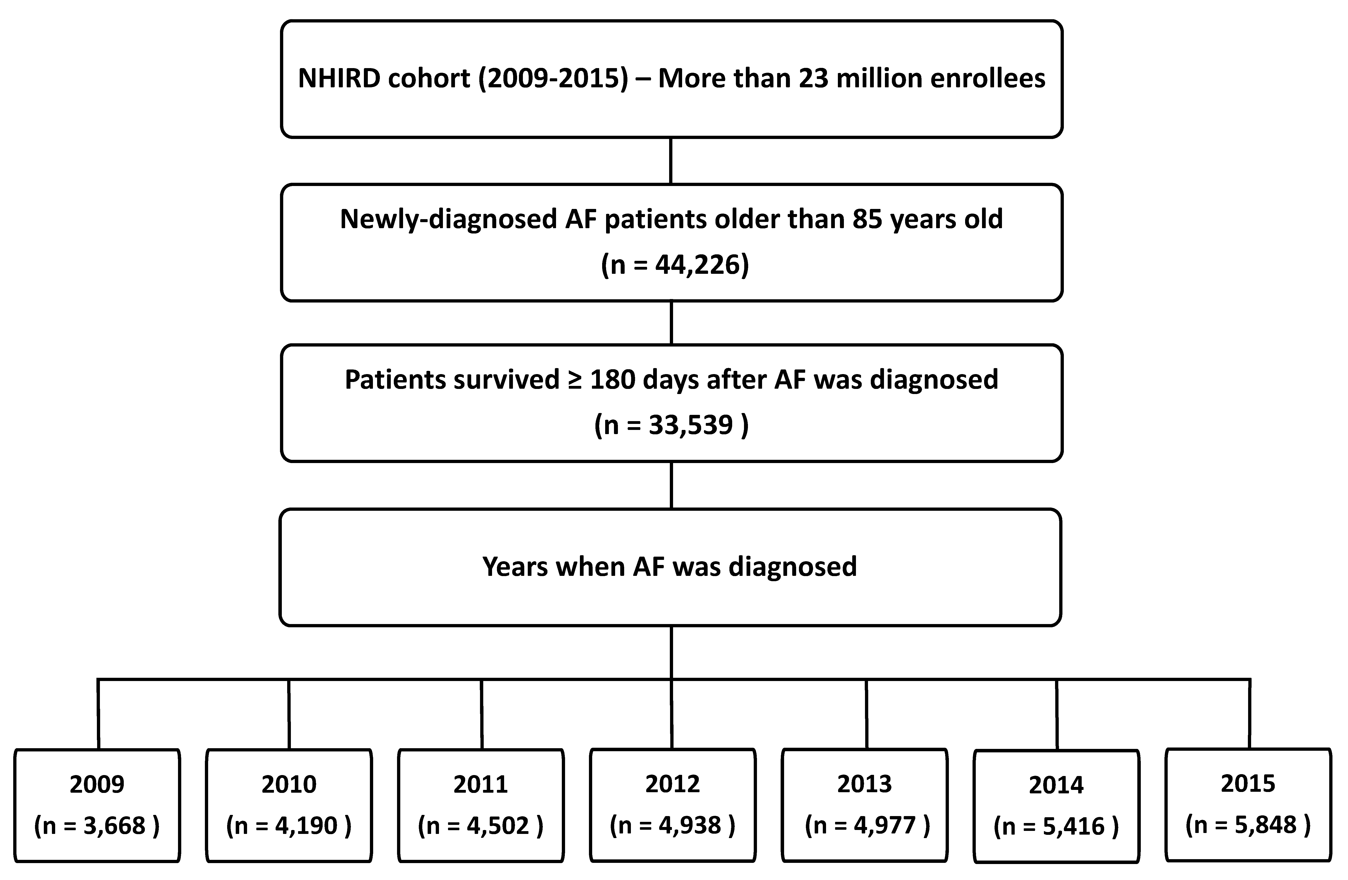
Figure 2
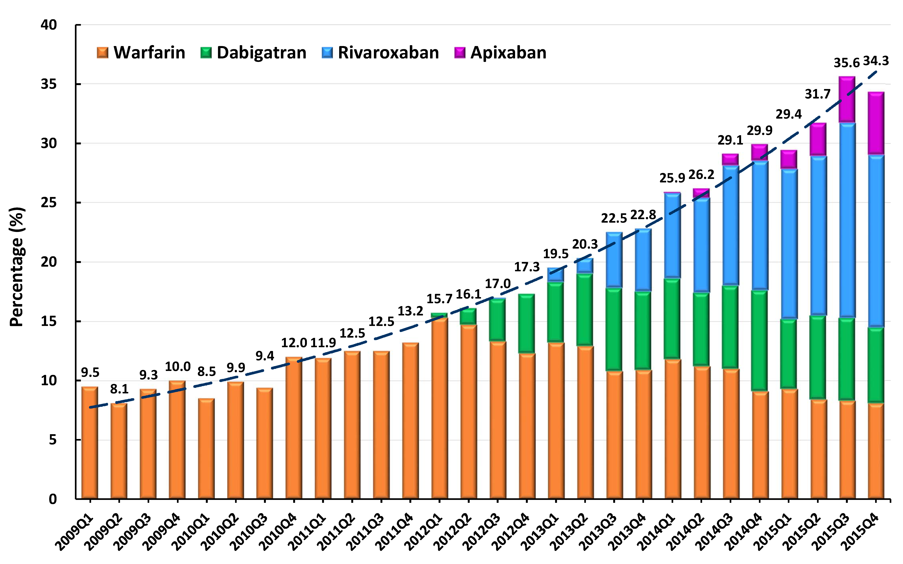
Figure 3
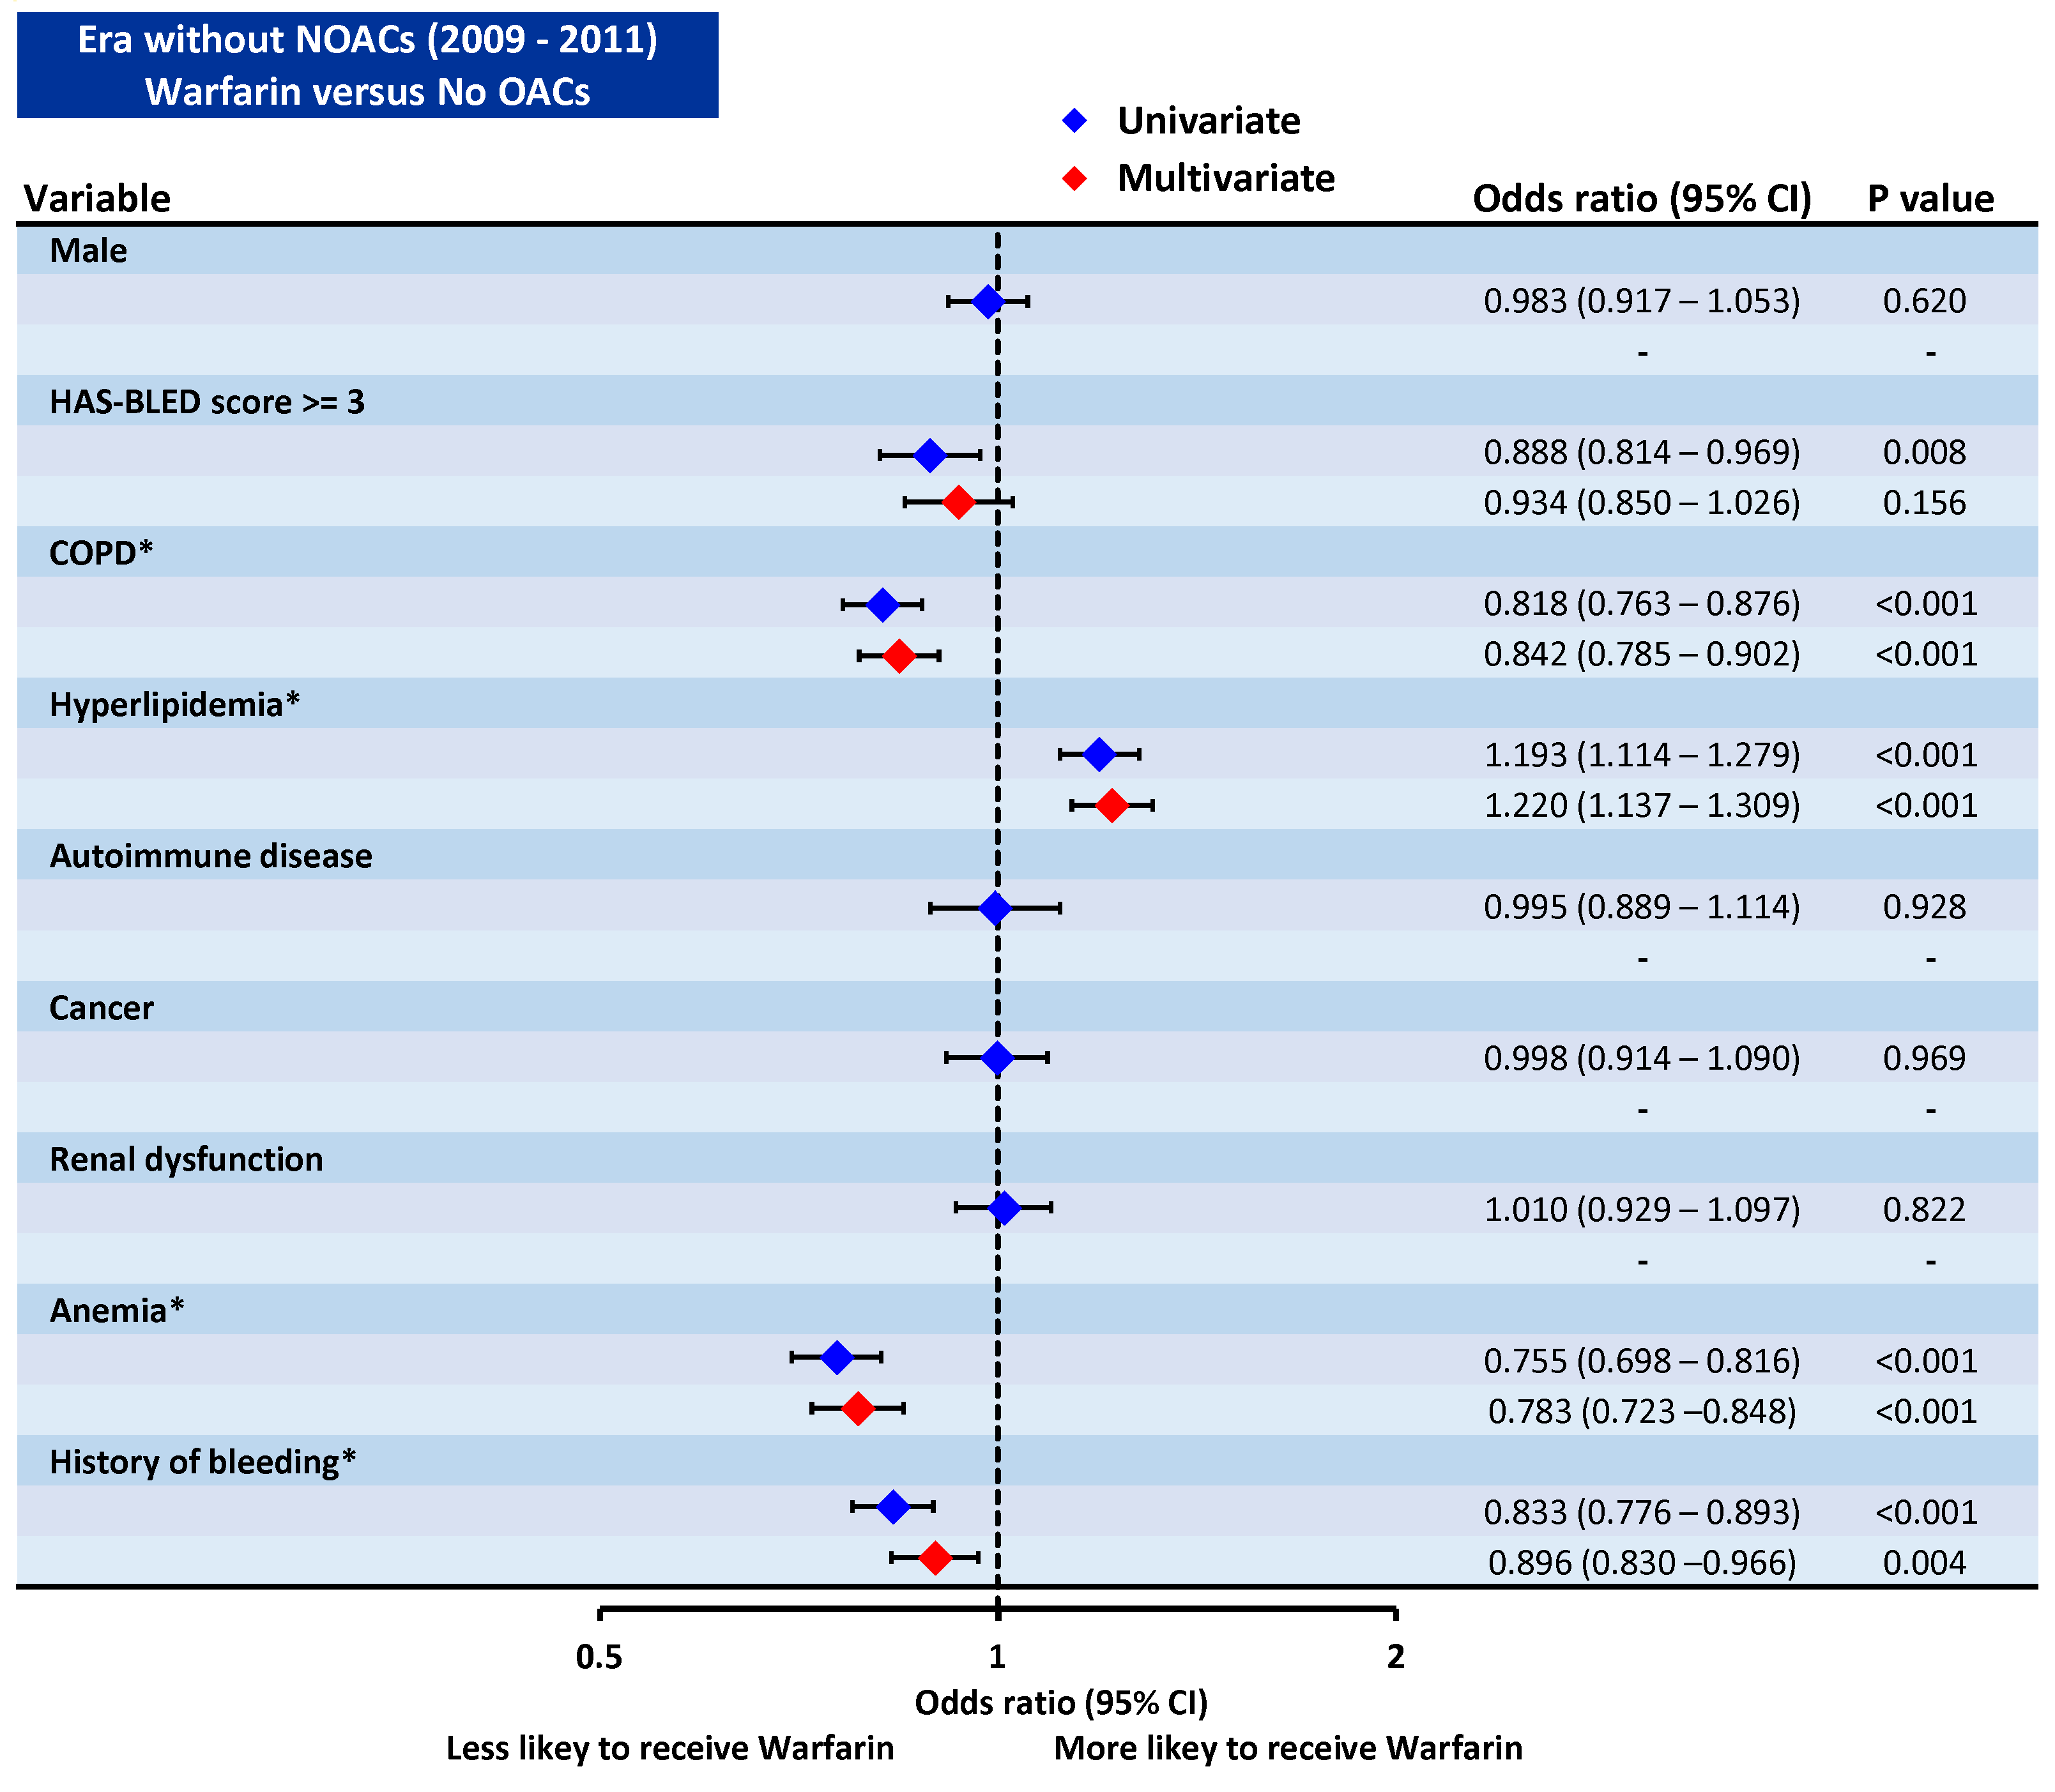
Figure 4
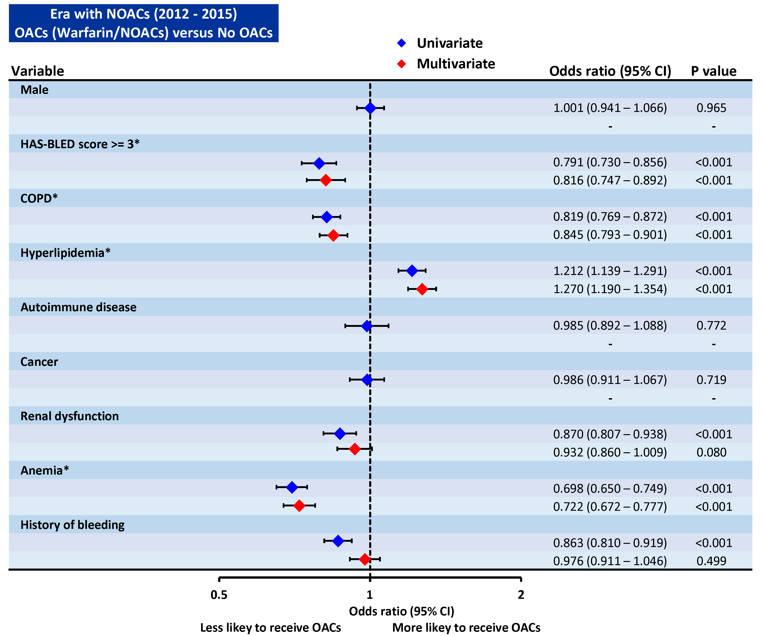
Figure 5
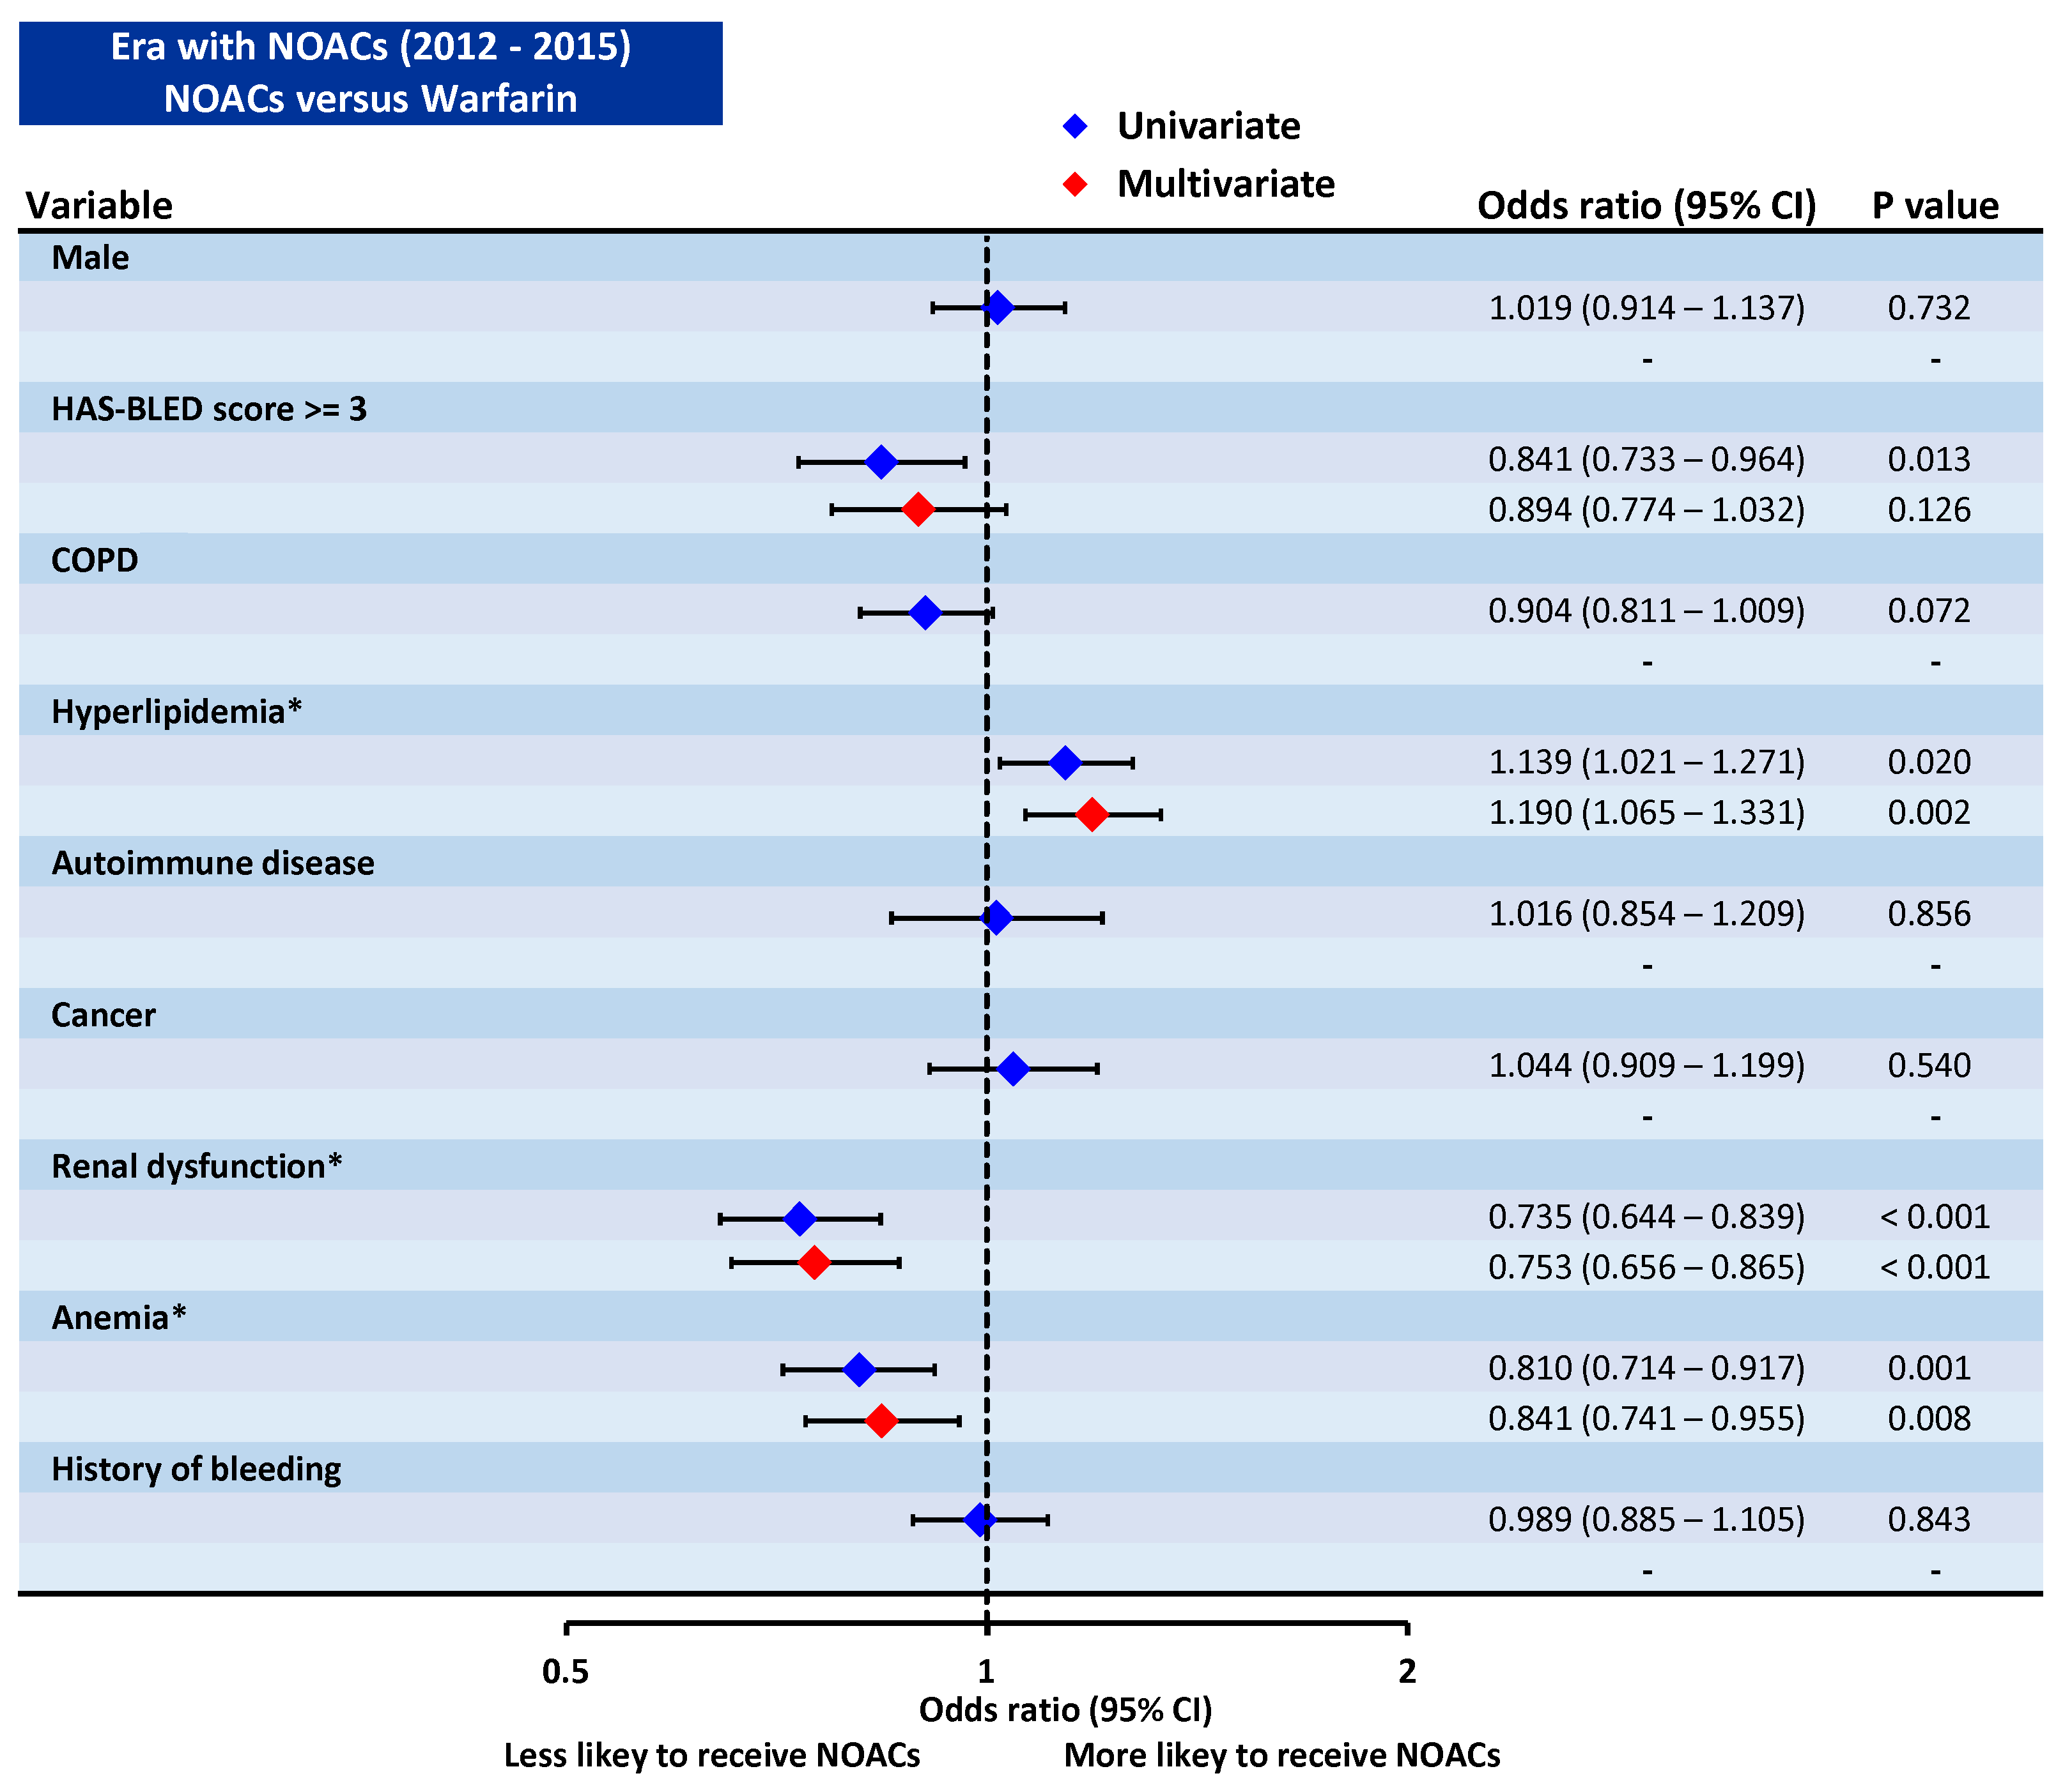
Figure 6
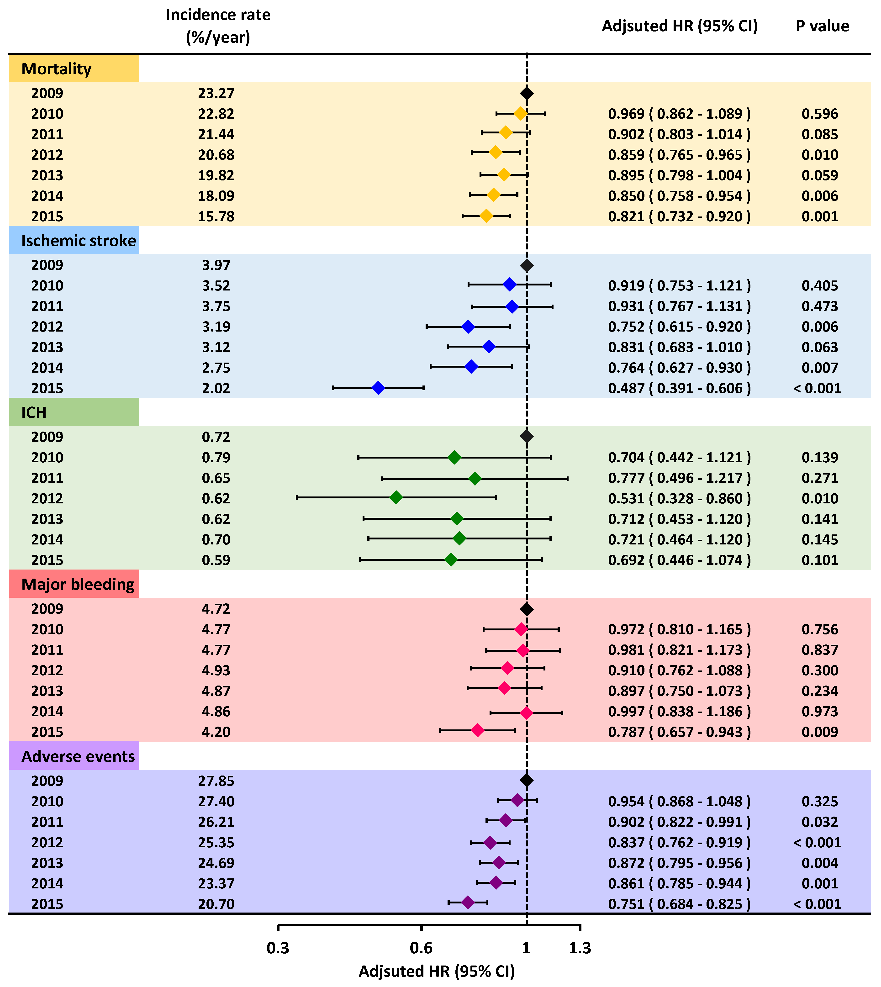

References
1. Lip G, Freedman B, De Caterina R, Potpara TS. Stroke prevention in atrial fibrillation: Past, present and future. Comparing the guidelines and practical decision-making. Thromb Haemost 2017;117:1230-1239.
2. Lip GYH. The ABC pathway: an integrated approach to improve AF management. Nat Rev Cardiol 2017;14:627-628.
3. Hart RG, Pearce LA, Aguilar MI. Meta-analysis: antithrombotic therapy to prevent stroke in patients who have nonvalvular atrial fibrillation. Ann Intern Med 2007;146:857-867.
4. Zimetbaum PJ, Thosani A, Yu HT, Xiong Y, Lin J, Kothawala P, Emons M. Are atrial fibrillation patients receiving warfarin in accordance with stroke risk? Am J Med 2010;123:446-453.
5. Ogilvie IM, Newton N, Welner SA, Cowell W, Lip GY. Underuse of oral anticoagulants in atrial fibrillation: a systematic review. Am J Med 2010;123:638-645 e634.
6. Li CH, Liu CJ, Chou AY, Chao TF, Tuan TC, Chen SJ, Wang KL, Lin YJ, Chang SL, Lo LW, Hu YF, Chung FP, Liao JN, Chen TJ, Wu TJ, Chen SA. European Society of Cardiology Guideline-Adherent Antithrombotic Treatment and Risk of Mortality in Asian Patients with Atrial Fibrillation. Sci Rep 2016;6:30734.
7. Mazurek M, Huisman MV, Rothman KJ, Paquette M, Teutsch C, Diener HC, Dubner SJ, Halperin JL, Ma CS, Zint K, Elsaesser A, Lu S, Lip GYH, Investigators G-A. Regional Differences in Antithrombotic Treatment for Atrial Fibrillation: Insights from the GLORIA-AF Phase II Registry. Thromb Haemost 2017;117:2376-2388.
8. Rivera-Caravaca JM, Roldan V, Esteve-Pastor MA, Valdes M, Vicente V, Lip GYH, Marin F. Cessation of oral anticoagulation is an important risk factor for stroke and mortality in atrial fibrillation patients. Thromb Haemost 2017;117:1448-1454.
9. Ruff CT, Giugliano RP, Braunwald E, Hoffman EB, Deenadayalu N, Ezekowitz MD, Camm AJ, Weitz JI, Lewis BS, Parkhomenko A, Yamashita T, Antman EM. Comparison of the efficacy and safety of new oral anticoagulants with warfarin in patients with atrial fibrillation: a meta-analysis of randomised trials. Lancet 2014;383:955-962.
10. Marzec LN, Wang J, Shah ND, Chan PS, Ting HH, Gosch KL, Hsu JC, Maddox TM. Influence of Direct Oral Anticoagulants on Rates of Oral Anticoagulation for Atrial Fibrillation. J Am Coll Cardiol 2017;69:2475-2484.
11. Chao TF, Liu CJ, Wang KL, Lin YJ, Chang SL, Lo LW, Hu YF, Tuan TC, Chen TJ, Lip GY, Chen SA. Using the CHA2DS2-VASc score for refining stroke risk stratification in 'low-risk' Asian patients with atrial fibrillation. J Am Coll Cardiol 2014;64:1658-1665.
12. Chao TF, Liu CJ, Wang KL, Lin YJ, Chang SL, Lo LW, Hu YF, Tuan TC, Chen TJ, Lip GY, Chen SA. Should atrial fibrillation patients with 1 additional risk factor of the CHA2DS2-VASc score (beyond sex) receive oral anticoagulation? J Am Coll Cardiol 2015;65:635-642.
13. Chao TF, Wang KL, Liu CJ, Lin YJ, Chang SL, Lo LW, Hu YF, Tuan TC, Chung FP, Liao JN, Chen TJ, Chiang CE, Lip GY, Chen SA. Age Threshold for Increased Stroke Risk Among Patients With Atrial Fibrillation: A Nationwide Cohort Study From Taiwan. J Am Coll Cardiol 2015;66:1339-1347.
14. Chao TF, Liu CJ, Tuan TC, Chen SJ, Wang KL, Lin YJ, Chang SL, Lo LW, Hu YF, Chen TJ, Chiang CE, Chen SA. Rate-control treatment and mortality in atrial fibrillation. Circulation 2015;132:1604-1612.
15. Chao TF, Liu CJ, Liao JN, Wang KL, Lin YJ, Chang SL, Lo LW, Hu YF, Tuan TC, Chung FP, Chen TJ, Lip GY, Chen SA. Use of Oral Anticoagulants for Stroke Prevention in Patients With Atrial Fibrillation Who Have a History of Intracranial Hemorrhage. Circulation 2016;133:1540-1547.
16. Chao TF, Lip GYH, Liu CJ, Lin YJ, Chang SL, Lo LW, Hu YF, Tuan TC, Liao JN, Chung FP, Chen TJ, Chen SA. Relationship of Aging and Incident Comorbidities to Stroke Risk in Patients With Atrial Fibrillation. J Am Coll Cardiol 2018;71:122-132.
17. Chao TF, Liu CJ, Lin YJ, Chang SL, Lo LW, Hu YF, Tuan TC, Liao JN, Chung FP, Chen TJ, Lip GYH, Chen SA. Oral Anticoagulation in Very Elderly Patients With Atrial Fibrillation: A Nationwide Cohort Study. Circulation 2018;138:37-47.
18. Chao TF, Lip GYH, Lin YJ, Chang SL, Lo LW, Hu YF, Tuan TC, Liao JN, Chung FP, Chen TJ, Chen SA. Age threshold for the use of non-vitamin K antagonist oral anticoagulants for stroke prevention in patients with atrial fibrillation: insights into the optimal assessment of age and incident comorbidities. Eur Heart J 2019;40:1504-1514.
19. Chang CH, Lee YC, Tsai CT, Chang SN, Chung YH, Lin MS, Lin JW, Lai MS. Continuation of statin therapy and a decreased risk of atrial fibrillation/flutter in patients with and without chronic kidney disease. Atherosclerosis 2014;232:224-230.
20. Lip GY, Nieuwlaat R, Pisters R, Lane DA, Crijns HJ. Refining clinical risk stratification for predicting stroke and thromboembolism in atrial fibrillation using a novel risk factor-based approach: the euro heart survey on atrial fibrillation. Chest 2010;137:263-272.
21. Pisters R, Lane DA, Nieuwlaat R, de Vos CB, Crijns HJ, Lip GY. A novel user-friendly score (HAS-BLED) to assess 1-year risk of major bleeding in patients with atrial fibrillation: the Euro Heart Survey. Chest 2010;138:1093-1100.
22. Cheng CL, Kao YH, Lin SJ, Lee CH, Lai ML. Validation of the National Health Insurance Research Database with ischemic stroke cases in Taiwan. Pharmacoepidemiol Drug Saf 2011;20:236-242.
23. Hsieh CY, Chen CH, Li CY, Lai ML. Validating the diagnosis of acute ischemic stroke in a National Health Insurance claims database. J Formos Med Assoc 2015;114:254-259.
24. Camm AJ, Accetta G, Ambrosio G, Atar D, Bassand JP, Berge E, Cools F, Fitzmaurice DA, Goldhaber SZ, Goto S, Haas S, Kayani G, Koretsune Y, Mantovani LG, Misselwitz F, Oh S, Turpie AG, Verheugt FW, Kakkar AK, Investigators G-A. Evolving antithrombotic treatment patterns for patients with newly diagnosed atrial fibrillation. Heart 2017;103:307-314.
25. Huisman MV, Rothman KJ, Paquette M, Teutsch C, Diener HC, Dubner SJ, Halperin JL, Ma CS, Zint K, Elsaesser A, Bartels DB, Lip GY, Investigators G-A. The Changing Landscape for Stroke Prevention in AF: Findings From the GLORIA-AF Registry Phase 2. J Am Coll Cardiol 2017;69:777-785.
26. Gadsboll K, Staerk L, Fosbol EL, Sindet-Pedersen C, Gundlund A, Lip GYH, Gislason GH, Olesen JB. Increased use of oral anticoagulants in patients with atrial fibrillation: temporal trends from 2005 to 2015 in Denmark. Eur Heart J 2017;38:899-906.
27. Camm AJ, Lip GY, De Caterina R, Savelieva I, Atar D, Hohnloser SH, Hindricks G, Kirchhof P. 2012 focused update of the ESC Guidelines for the management of atrial fibrillation: an update of the 2010 ESC Guidelines for the management of atrial fibrillation--developed with the special contribution of the European Heart Rhythm Association. Europace 2012;14:1385-1413.
28. Lip GY, Lane DA. Bleeding risk assessment in atrial fibrillation: observations on the use and misuse of bleeding risk scores. J Thromb Haemost 2016;14:1711-1714.

