Identification of elemental markers in historical musical instruments through XRF spectroscopy combined with Principal Component Analysis

Fichera G.V.⁽¹⁾, Rovetta T.⁽¹⁾, Fiocco G.⁽¹⁾, Licchelli M.^{(1,2)}, Malagodi M.^{(1,3)}

(1) Arvedi Laboratory of Non-Invasive Diagnostics, University of Pavia, Via Bell’Aspa 3, Cremona, Italy
(2) Chemistry Department, University of Pavia, Via Taramelli 12, Pavia, Italy
(3) Department of Musicology and Cultural Heritage, University of Pavia, Corso Garibaldi 178, Cremona, Italy

The history of bowed stringed musical instruments hides centuries of experimentation performed by violin makers on shapes and materials. In several cases, these peculiar characteristics can help to identify the making period, the geographical provenance and, rarely, the Master’s workshop [1]. These objects of art, played a lot over time, suffered in few cases of severe damage (i.e. crackings, woodworms) requiring substitution of some parts. Gaetano (1878-1959) and Pietro (1903-1990) Sgarabotto, two of the most eminent violin makers and restorer of the 20th century, collected lots of these substituted parts. These fragments represent groups of several Italian instruments of historical significance, made over a long-time period (1500-1800) and coming from different geographical areas. We had the unique opportunity to perform non-invasive and non-destructive analyses through portable X-ray fluorescence spectrometry (PXRF) [2] on 26 of them. Principal Component Analysis was applied to classify relics highlighting the most relevant elements in the data set. The principle of transformation is the extraction of maximum variance for each successive new variable. This procedure leads to a separation of valuable information from noise and to a selection of few influential and statistically significant variables [3]. The application of PCA lead us to (i) assess the existence of elemental markers of specific historic periods and/or production areas, (ii) identify correlations between different fragments. Preliminary results validated the application of PCA on XRF data set, as shown in Figure 1. Several groups of XRF data have been isolated from others for their PCA scores values with respect to the variation of the elements identified in the fragments.

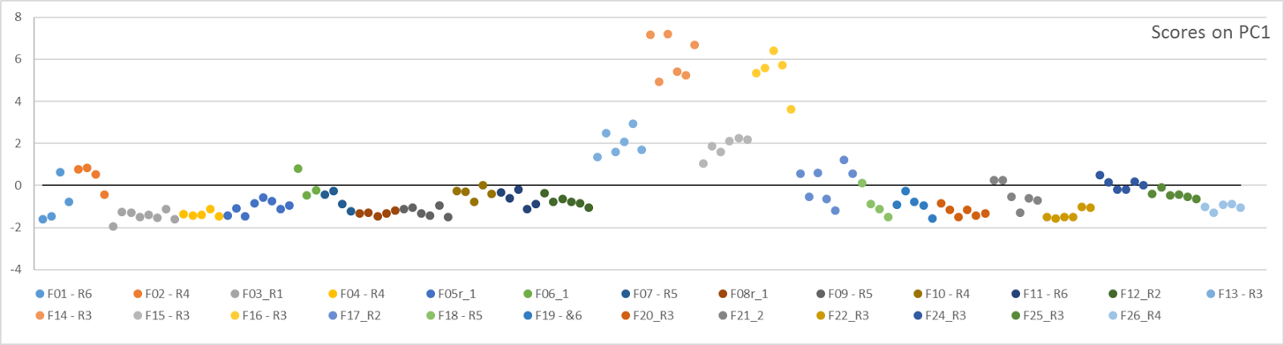
Figure 1. Scores on PC1 variation of selected XRF data collected on the musical instruments fragments

[1] K. Jalovec Italian violin makers, 1958, Crown Publishers INC, New York
[2] J.P. Echard, Spectrochimica Acta Part B 59, 2004, 1663–1667
[3] R. Broa and A.K. Smildea, Anal. Methods 6, 2014, 2812–2831

